Form Approved

OMB No. 0920-New

Expiration Date: XX/XX/XXXX

Preferences for Longer-Acting Preexposure Prophylaxis (PrEP) Methods Among Persons in US Populations at Highest Need: A Discrete Choice Experiment

**Attachment #7**

**Client DCE Survey**

Public reporting burden of this collection of information is estimated to average 25 minutes per response, including the time for reviewing instructions, searching existing data sources, gathering and maintaining the data needed, and completing and reviewing the collection of information. An agency may not conduct or sponsor, and a person is not required to respond to a collection of information unless it displays a currently valid OMB control number. Send comments regarding this burden estimate or any other aspect of this collection of information, including suggestions for reducing this burden to CDC/ATSDR Reports Clearance Officer; 1600 Clifton Road NE, MS D-74, Atlanta, Georgia 30333; Attn: OMB-PRA (0920-New)

**C4P Client DCE Survey**

**Survey link:** [https://survey.rti.org/SE/1/ClientSurveyDev](https://nam04.safelinks.protection.outlook.com/?url=https%3A%2F%2Fsurvey.rti.org%2FSE%2F1%2FClientSurveyDev&data=05%7C01%7Cemoore%40rti.org%7Cb9ef48fc4af245bccf7508da337218bd%7C2ffc2ede4d4449948082487341fa43fb%7C0%7C0%7C637878867144649355%7CUnknown%7CTWFpbGZsb3d8eyJWIjoiMC4wLjAwMDAiLCJQIjoiV2luMzIiLCJBTiI6Ik1haWwiLCJXVCI6Mn0%3D%7C3000%7C%7C%7C&sdata=ZdABfNBLo1GFugn4%2BgB4ZIqquVCDbxie%2FzBhPuNtqdc%3D&reserved=0)

Note: text in blue indicate instructions for programming.

** Indicates item used to assess eligibility

U Indicates single response option only in question allowing multiple responses

Participants will be able to skip questions that they prefer not to answer; if a question on screen is not answered and the participant selects to move forward in the survey, the survey will note to the participant that an item is not answered and confirm if they would like to move forward and leave the question unanswered. The survey will code this response as a refusal.

We thank you for your interest in this survey and appreciate your time.

The survey will take approximately **25 minutes** and is designed to be completed in one sitting. If you are not able to take 25 minutes now, we recommend you come back when you have enough time.

Some survey questions are about sensitive topics, and we recommend that you complete the survey in a location where no one else can see your responses. We also recommend that you use headphones to listen to video content, if possible.

As a reminder, here is key information about the study and your rights.

**Title of the research study:** Choices for Prevention (C4P)

**Principal Investigator:** Dr. Sarah Roberts, RTI International

**Study Sponsor:** The Centers for Disease Control and Prevention (CDC) Division of HIV Prevention

**KEY INFORMATION**

* You are invited to join a research study funded by the Centers for Disease Control and Prevention (CDC) and conducted by a non-profit research organization named RTI International.
* Participation in this study is completely voluntary. You may choose not to take part in the study or leave the study at any time without any consequences.
* The purpose of this study is to understand how different features of HIV prevention services affect people’s decisions to use PrEP, or pre-exposure prophylaxis, for HIV prevention. PrEP is medicine people can take to prevent getting HIV from sex or injection drug use. We especially want to understand how access to new, longer acting PrEP products will affect people’s decisions.
* All participants that complete the online survey will receive a $20 Visa gift card. The $20 gift card may be withheld if it is determined that you do not meet the eligibility criteria, you do not complete the survey, or there is evidence of fraud.
* You may be uncomfortable answering some questions about yourself. You can choose not to answer questions at any time.
* The study has a low level of risk. The main risk is a small chance of a loss of confidentiality. To help lower this risk, your personally identifying information (e.g., name, email address) will be kept separate from your answers to survey questions and can only be accessed by the research staff at RTI International.

[Page break]

Scientists are developing new HIV prevention products with medicines that are long acting – meaning they last for at least a month and do not need to be used every day or every time you have sex. PrEP, or pre-exposure prophylaxis, is a prescription medicine that will prevent HIV infection if you are exposed to the virus.

We would like to ask you about your opinions of new long-acting PrEP products and about what other features of HIV prevention services are most important to you when choosing to use an HIV prevention option.

This survey will include a set of 11 questions where we will ask you to compare two possible long-acting PrEP delivery options and think about which one you would prefer to use. The options will be described by 5 independent features. Each time you are shown a delivery option, it will have a different combination of the 5 features. You may like some of the features and dislike others. You will need to weigh the advantages and disadvantages of each option when making your choice.

We will first describe each of the 5 features. The first feature describes different long-acting PrEP products that are in development or have recently been approved by the FDA. We will then present the other features of PrEP deliverythat we would like you to consider.

Please click on the video below to learn more about long-acting PrEP.

[Introduction Video link]

# [Page break]

* 1. What products are you currently using for HIV prevention? Please select all that apply.
* Male condom
* Female condom
* Oral PrEP
* Post exposure prophylaxis (PEP)
* Other, please specify: ________________ [max characters: 100]
* U I am currently not using any products

[Page break]

### **Product Type**

As you heard in the video, there are different types of long-acting HIV prevention products. Each product has a different form and is used with different frequency, but all provide protection against HIV when used as directed.

Because some of these products are still being studied, information on possible side effects may not be complete. The most common side effects reported from studies so far are described with each product.

Other important details about the products are also still unknown. To help you make your decisions, please assume:

* The products have similar protection against HIV (over 99% reduction in HIV risk).
* For all products, you’ll have to come to the clinic for HIV and STI testing at least every 3-6 months.
* Evidence so far suggests that all products would be safe to use along side any other medications you are taking, including birth control or hormones
* All products may be recommended for anyone who has sexual behaviors or drug injection practices that place them at ongoing risk of HIV exposure, regardless of gender, sexual identity, or source of HIV exposure.

Please go to the next screen.

**Monthly Oral Pill**

The first product is an oral pill taken once every month. Please click on the video below to learn about the pill.

[Insert video link]

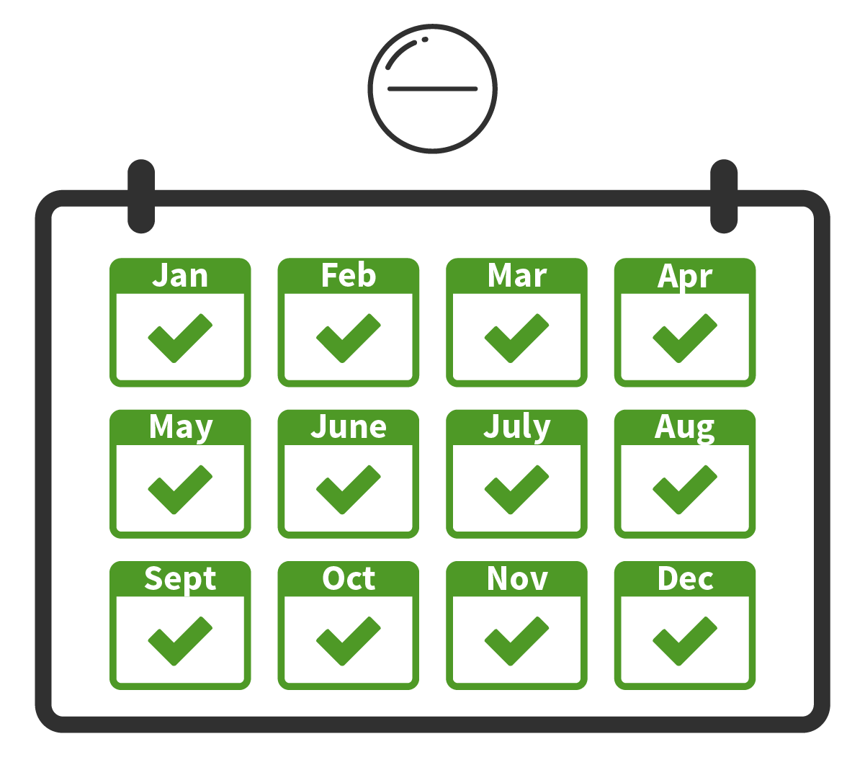

Potential Side Effects

Almost all were mild or moderate and most went away within a few weeks after starting to take the pill.

* About 1 in 20 people reported nausea or diarrhea
* About 1 in 10 people reported headaches

[Page break]

**Implant**

The next product is an implant that lasts for 12 months. The implant is placed under the skin of the upper arm using an applicator. Please click on the video below to learn about the implant.

[Insert Implant video]

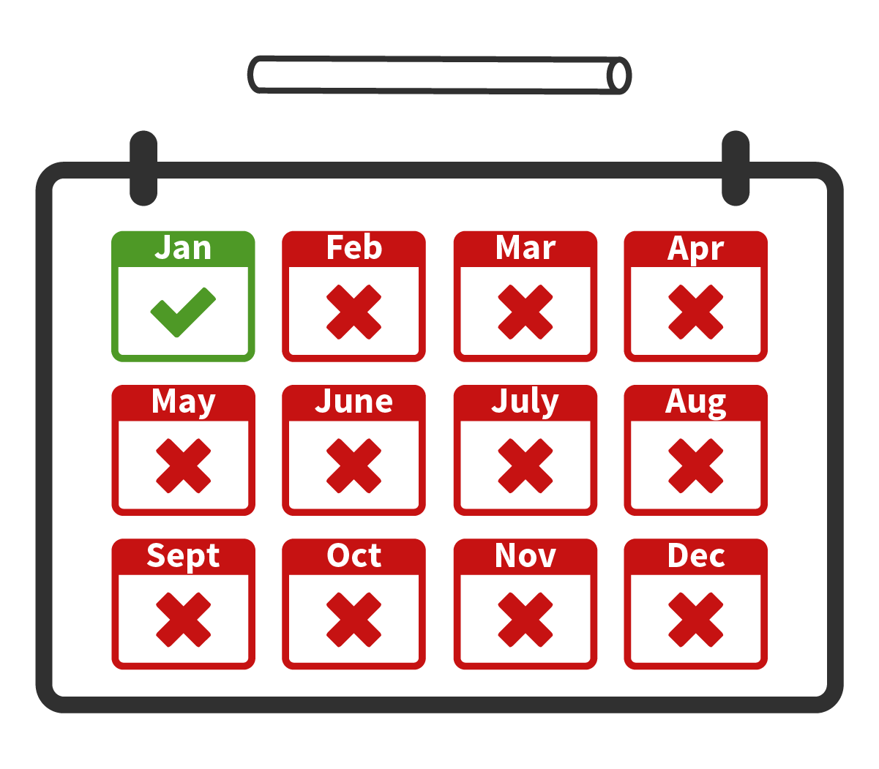

Potential Side Effects

* About 2 in 3 people reported temporary reactions at the site where the implant was placed: bruising, swelling, itching, skin thickening, tenderness, and/or pain
* About 1 in 6 people reported headaches

All were mild or moderate and most went away within the first month after insertion.

[Page break]

* 1. Have you ever used an implant for medical reasons (birth control or pregnancy prevention, treatment of opioid dependency, hormone therapy, or other indications)?
* Yes, please describe: _________________ [max characters: 200]
* No

[Page break]

**Injection**

Another product is an injection given every 2 months into the buttock by a health care provider. Please click on the video below to learn about the 2-month injection.

[Insert video]

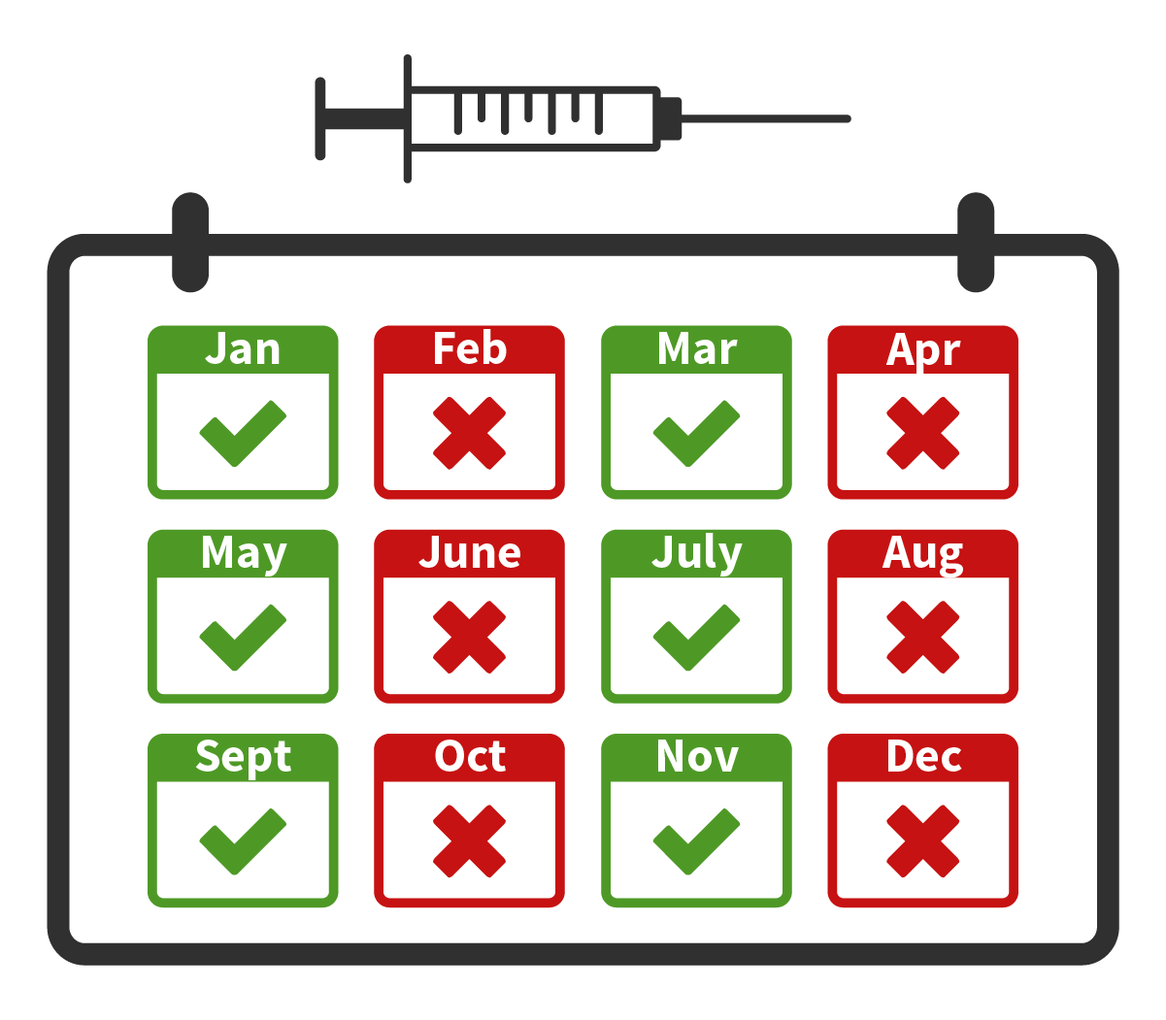

Potential Side Effects

Almost all were mild to moderate and temporary. Most went away a few days after receiving each injection and became less common with each additional injection over time.

* Most people have temporary reactions at the site of the injection: pain, discomfort, tenderness, swelling, and/or small lumps at the location of the injection.

[Page break]

**Two Injections**

The last product is two injections given every 6 months into the skin over the belly by a health care provider. Please click on the video below to learn about the 6-month injections.

[Insert video]

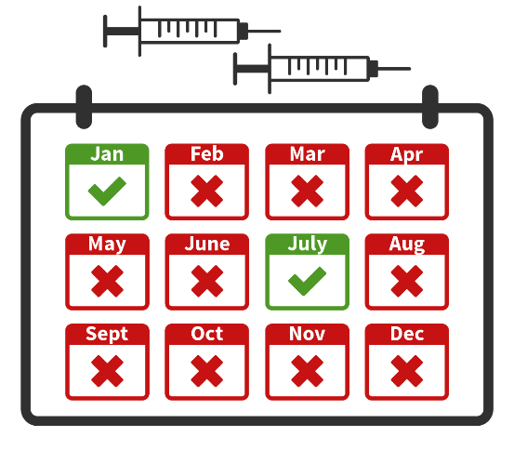

Potential Side Effects

Almost all were mild to moderate. Most side effects went away a few days after receiving the injections.

* About 1 in 2 people have temporary reactions at the site of the injection: pain, discomfort, tenderness, swelling, and/or small lumps at the location of the injection. The small lumps lasted longer for some people, up to several months, but were mild and could be felt but not seen.

|  |  |
| --- | --- |
| Product Type | |
| Oral pill every  1 month | Oral pill taken by mouth that requires use every month to continue to provide protection from HIV. |
| Implant every  12 months | An implant that is placed under the skin on the upper arm and slowly releases PrEP medicine. The implant would need to be replaced with a new one every 12 months to continue to provide protection from HIV. |
| Injection every  2 months | An injection is given in the buttocks to deliver PrEP medicine. An injection would be needed every 2 months to continue to provide protection from HIV. |
| Two injections every  6 months | Two injections are given in the skin over the belly to deliver PrEP medicine. Two injections would be needed every 6 months to continue to provide protection from HIV. |

[Page break]

To summarize, the table below lists each possible long-acting PrEP product type.

[Page break]

* 1. If all long-acting PrEP products were available, which would you choose to use for HIV prevention?

|  |  |  |  |  |
| --- | --- | --- | --- | --- |
| Oral pill  every  1 month | Implant  every  12 months | Injection  every  2 months | Two injections  every  6 months | I would not use any of these products |
|  |  |  |  |  |

[Page break]

* 1. [If Q3. !=” I would not use any of these products”] Why is the [Q3. insert product chosen] your preferred product? Please select all that apply.
* How often you have to use it
* How the product is taken (swallowed by mouth, injected, implanted)
* The types of potential side effects
* It can be removed or stopped if you experience side effects
* It can be used without your partner or other people knowing
* Other, specify: ________________ [max characters: 100]

[Page break]

* 1. [[If Q3 does not=” I would not use any of these products”] How likely would you be to use each of the long-acting HIV prevention methods if they were available?

|  |  |  |  |  |  |
| --- | --- | --- | --- | --- | --- |
|  | Not at all likely | A little likely | Somewhat likely | Very likely | Extremely likely |
| Oral pill every  1 month |  |  |  |  |  |
| Implant every  12 months |  |  |  |  |  |
| Injection every  2 months |  |  |  |  |  |
| Two injections every 6 months |  |  |  |  |  |

[Page break]

Next, we will describe other things about long-acting HIV prevention products that we would like you to think about. One factor is the type of product, but there are other features that may influence your willingness to use long-acting PrEP. When choosing between PrEP options, you may need to weigh the advantages and disadvantages of each option. There might not be an option that offers everything you prefer.

In what follows, we will describe the following 4 features of the PrEP delivery options presented in this survey:

* Your experience of potential side effects
* The clinic where the product is available
* Time required for your first appointment
* Cost

Please read these descriptions carefully. This information will help you answer the questions later in the survey.

[Page break]

### **Your Experience of Potential Side Effects**

Sometimes people who use long-acting HIV prevention products experience side effects. Potential side effects of each product were described to you with each of the products.

For most people, these side effects are temporary, lasting for a few days, and only happen when they start using the product. These problems usually go away after your body has adjusted to the medicine.

The side effects you experience may be mild (do not interfere with your daily activities) or moderate (make daily activities harder).

|  |  |
| --- | --- |
| Your experience of potential side effects | |
| Mild | You experience mild side effects, only lasting for a few days after starting the product or getting a new dose.  They do not interfere with your daily activities. You do not need to get help from a doctor. |
| Moderate | You experience moderate side effects, lasting for a few days or weeks after starting the product or getting a new dose.  It is harder to do your day to day activities (such as going to work, shopping, cooking, things you do for fun) . You may need to get help from a doctor to feel better. |

[Page break]

* 1. Have you ever stopped using a medicine because of side effects in the past?
* Yes
* No

[Page break]

### **Clinic Where It Is Available**

When the long-acting HIV prevention products are available for use, you might be able to get them from different places. You could get them from your regular primary care health clinic. You might also be able to get it from a specialized clinic that focuses on providing sexual health services like PrEP and sexually transmitted infection (STI) testing.

|  |  |
| --- | --- |
| Clinic Type | |
| Primary care | A primary care, general medicine health clinic, or community health center. |
| Sexual health / HIV prevention clinic | A clinic that specializes in sexual health and focuses on providing HIV prevention services and STI testing. |

[Page break]

### **Time Required for First Appointment**

When you are ready to start one of the long-acting HIV prevention products, you will need to meet with a health care provider for HIV testing, consultation, lab work, and to receive a prescription, injection, or have an implant placed.

The first visit you have could take different lengths of time.

|  |  |
| --- | --- |
| First Appointment Duration | |
| 30 minutes | Your first appointment will take 30 minutes. |
| 1 hour | Your first appointment will take 1 hour, 60 minutes. |

[Page break]

### **Cost**

Most cost for HIV prevention medicines can be covered through health plans. If you’re uninsured or your out-of-pocket-costs are high, there are assistance programs that can help, but you might still be expected to pay some amount.

If you use a long-acting PrEP product for one year, your out-of-pocket costs could vary. You could pay $0 per month, $25 per month, or $50 per month. This is how much you would pay after any contributions from insurance or assistance programs.

|  |  |
| --- | --- |
| Cost | |
| Free, $ 0 per year ($ 0 per month) | The long-acting PrEP product could be free of cost, $0 per month. |
| $ 300 per year ($ 25 per month) | The long-acting PrEP product could cost you $ 25 per month (which is $300 per year). |
| $ 600 per year ($ 50 per month) | The long-acting PrEP product could cost you $ 50 per month (which is $ 600 per year). |

[Page break]

We are going to ask you a series of questions comparing two different PrEP options.

Please look at the example below, where 2 long-acting HIV prevention options, PrEP Option A and PrEP Option B, are presented in the table.

The first column in the table describes the 5 different features we want you to consider (which product you would receive, your experience of side effects, where you receive it, how long your first appointment will take, and how much it costs).

The second and third column describe the two possible long-acting PrEP options (PrEP Option A and PrEP Option B respectively) in terms of these features. We will ask you to select which of these two options you would use for HIV prevention. If you would not use either, you can select the “neither, I would use my current HIV prevention method” in the fourth column.

|  |  |  |  |
| --- | --- | --- | --- |
|  | **PrEP Option A** | **PrEP Option B** | **Neither** |
| **Product Type** | Implant  every 12 months | Injection  every 2 months | I would use my current HIV prevention method |
| **Side Effects** | Mild | Moderate |
| **Clinic Type** | Specialized STD/ PrEP clinic | Primary care |
| **First Appointment Length** | 1 hour | 30 minutes |
| **Cost** | $ 300 per year  ($ 25 per month) | $ 600 per year  ($ 50 per month) |

For more instruction on how to answer this type of question, please watch this short video:[Insert DCE video]

[Page break]

* 1. Based on the information in the table below, which HIV prevention option takes 30 minutes of consultation for your first appointment?
* PrEP Option A
* PrEP Option B
* Don’t know or not sure

|  |  |  |  |
| --- | --- | --- | --- |
|  | **PrEP Option A** | **PrEP Option B** | **Neither** |
| **Product Type** | Implant  every 12 months | Injection  every 2 months | I would use my current HIV prevention method |
| **Side Effects** | Mild | Moderate |
| **Clinic Type** | Specialized STD/ PrEP clinic | Primary care |
| **First Appointment Length** | 1 hour | 30 minutes |
| **Cost** | $ 300 per year  ($ 25 per month) | $ 600 per year  ($ 50 per month) |

[Page break]

[If Q7 = “ PrEP Option B”]

|  |  |  |  |
| --- | --- | --- | --- |
|  | **PrEP Option A** | **PrEP Option B** | **Neither** |
| **Product Type** | Implant  every 12 months | Injection  every 2 months | I would use my current HIV prevention method |
| **Side Effects** | Mild | Moderate |
| **Clinic Type** | Specialized STD/ PrEP clinic | Primary care |
| **First Appointment Length** | 1 hour | 30 minutes |
| **Cost** | $ 300 per year  ($ 25 per month) | $ 600 per year  ($ 50 per month) |

Yes, the fourth row in the table shows that with PrEP Option B it will take 30 minutes for your first appointment, when you want to start using the product.

Please go to the next screen.

[Page break]

[If Q7 = “ PrEP Option A” or Q7= “Don’t know or not sure”]

|  |  |  |  |
| --- | --- | --- | --- |
|  | **PrEP Option A** | **PrEP Option B** | **Neither** |
| **Product Type** | Implant  every 12 months | Injection  every 2 months | I would use my current HIV prevention method |
| **Side Effects** | Mild | Moderate |
| **Clinic Type** | Specialized STD/ PrEP clinic | Primary care |
| **First Appointment Length** | 1 hour | 30 minutes |
| **Cost** | $ 300 per year  ($ 25 per month) | $ 600 per year  ($ 50 per month) |

Remember, the fourth row in the table describes how long it will take for your first appointment, when you want to start using the product.

The table shows that with Option B it will take 30 minutes of consultation with a provider for your first appointment.

Please go to the next screen.

[Page break]

### **Thinking About Long-acting HIV Prevention Options**

Suppose that you are exploring your options for HIV prevention methods and that there are 2 long-acting HIV prevention services that you can use: PrEP Option A or PrEP Option B. Both will provide medicines that protect against HIV, but they will differ in other ways.

In the next **11** questions, we will show you different pairs of possible options for long-acting HIV prevention services.

For each question:

* Please consider options presented in each table, reviewing each, and choose the one that you would use. If you don’t like either option, you can select “I would use my current HIV prevention method”
* The 2 options will have a different combination of the 5 features. You will need to weigh the advantages and disadvantages of each option, since there might not be an option that offers everything you prefer.

There are no right or wrong answers; we are interested in your personal opinion.

NOTE: Each participant will be randomly assigned to one version (of 8 possible). They will answer 10 questions from their assigned version. All participants will see one additional question (called fixed choice set).

Each participant will be assigned number 1-8 to participants identified from the screener to be invited. This data will be preloaded for branching logic for this section.

VERSION = [number 1-8] then skip to display questions for subsequent version number.

Version: 1

Question: 1/10

Which of the following HIV prevention options would you use?

|  |  |  |  |
| --- | --- | --- | --- |
|  | **PrEP Option A** | **PrEP Option B** | **Neither** |
| **Product Type** | Oral pill  every 1 month | Injection  every 2 months | I would use my current HIV prevention method |
| **Side Effects** | Mild | Moderate |
| **Clinic Type** | Primary care | Sexual health / HIV prevention clinic |
| **First Appointment Length** | 30 min | 1 hour |
| **Cost** | Free, $ 0 per year ($ 0 per month) | $ 600 per year  ($ 50 per month) |
|  | |  |  |  |
| **Which HIV prevention option would you use?** |  |  |  |

[Page break]

Version: 1

Question: 2/10

Which of the following HIV prevention options would you use?

|  |  |  |  |
| --- | --- | --- | --- |
|  | **PrEP Option A** | **PrEP Option B** | **Neither** |
| **Product Type** | Two injections every 6 months | Implant  every 12 months | I would use my current HIV prevention method |
| **Side Effects** | Mild | Moderate |
| **Clinic Type** | Primary care | Sexual health / HIV prevention clinic |
| **First Appointment Length** | 1 hour | 30 min |
| **Cost** | $ 600 per year  ($ 50 per month) | $ 300 per year  ($ 25 per month) |
|  | |  |  |  |
| **Which HIV prevention option would you use?** |  |  |  |

[Page break]

Version: 1

Question: 3/10

Which of the following HIV prevention options would you use?

|  |  |  |  |
| --- | --- | --- | --- |
|  | **PrEP Option A** | **PrEP Option B** | **Neither** |
| **Product Type** | Injection  every 2 months | Implant  every 12 months | I would use my current HIV prevention method |
| **Side Effects** | Mild | Moderate |
| **Clinic Type** | Sexual health / HIV prevention clinic | Primary care |
| **First Appointment Length** | 30 min | 1 hour |
| **Cost** | $ 300 per year  ($ 25 per month) | $ 600 per year  ($ 50 per month) |
|  | |  |  |  |
| **Which HIV prevention option would you use?** |  |  |  |

[Page break]

Version: 1

Question: 4/10

Which of the following HIV prevention options would you use?

|  |  |  |  |
| --- | --- | --- | --- |
|  | **PrEP Option A** | **PrEP Option B** | **Neither** |
| **Product Type** | Oral pill  every 1 month | Two injections every 6 months | I would use my current HIV prevention method |
| **Side Effects** | Moderate | Mild |
| **Clinic Type** | Primary care | Sexual health / HIV prevention clinic |
| **First Appointment Length** | 30 min | 1 hour |
| **Cost** | $ 600 per year  ($ 50 per month) | Free, $ 0 per year ($ 0 per month) |
|  | |  |  |  |
| **Which HIV prevention option would you use?** |  |  |  |

[Page break]

Version: 1

Question: 5/10

Which of the following HIV prevention options would you use?

|  |  |  |  |
| --- | --- | --- | --- |
|  | **PrEP Option A** | **PrEP Option B** | **Neither** |
| **Product Type** | Two injections every 6 months | Oral pill  every 1 month | I would use my current HIV prevention method |
| **Side Effects** | Moderate | Mild |
| **Clinic Type** | Sexual health / HIV prevention clinic | Primary care |
| **First Appointment Length** | 30 min | 1 hour |
| **Cost** | Free, $ 0 per year ($ 0 per month) | $ 300 per year  ($ 25 per month) |
|  | |  |  |  |
| **Which HIV prevention option would you use?** |  |  |  |

[Page break]

Version: 1

Question: 6/10

Which of the following HIV prevention options would you use?

|  |  |  |  |
| --- | --- | --- | --- |
|  | **PrEP Option A** | **PrEP Option B** | **Neither** |
| **Product Type** | Injection  every 2 months | Implant  every 12 months | I would use my current HIV prevention method |
| **Side Effects** | Moderate | Mild |
| **Clinic Type** | Primary care | Sexual health / HIV prevention clinic |
| **First Appointment Length** | 1 hour | 30 min |
| **Cost** | $ 300 per year  ($ 25 per month) | $ 600 per year  ($ 50 per month) |
|  | |  |  |  |
| **Which HIV prevention option would you use?** |  |  |  |

[Page break]

Version: 1

Question: 7/10

Which of the following HIV prevention options would you use?

|  |  |  |  |
| --- | --- | --- | --- |
|  | **PrEP Option A** | **PrEP Option B** | **Neither** |
| **Product Type** | Oral pill  every 1 month | Two injections every 6 months | I would use my current HIV prevention method |
| **Side Effects** | Mild | Moderate |
| **Clinic Type** | Sexual health / HIV prevention clinic | Primary care |
| **First Appointment Length** | 1 hour | 30 min |
| **Cost** | Free, $ 0 per year ($ 0 per month) | $ 300 per year  ($ 25 per month) |
|  | |  |  |  |
| **Which HIV prevention option would you use?** |  |  |  |

[Page break]

Version: 1

Question: 8/10

Which of the following HIV prevention options would you use?

|  |  |  |  |
| --- | --- | --- | --- |
|  | **PrEP Option A** | **PrEP Option B** | **Neither** |
| **Product Type** | Implant  every 12 months | Injection  every 2 months | I would use my current HIV prevention method |
| **Side Effects** | Moderate | Mild |
| **Clinic Type** | Sexual health / HIV prevention clinic | Primary care |
| **First Appointment Length** | 1 hour | 30 min |
| **Cost** | $ 300 per year  ($ 25 per month) | $ 600 per year  ($ 50 per month) |
|  | |  |  |  |
| **Which HIV prevention option would you use?** |  |  |  |

[Page break]

Version: 1

Question: 9/10

Which of the following HIV prevention options would you use?

|  |  |  |  |
| --- | --- | --- | --- |
|  | **PrEP Option A** | **PrEP Option B** | **Neither** |
| **Product Type** | Implant  every 12 months | Oral pill  every 1 month | I would use my current HIV prevention method |
| **Side Effects** | Mild | Moderate |
| **Clinic Type** | Primary care | Sexual health / HIV prevention clinic |
| **First Appointment Length** | 30 min | 1 hour |
| **Cost** | Free, $ 0 per year ($ 0 per month) | $ 600 per year  ($ 50 per month) |
|  | |  |  |  |
| **Which HIV prevention option would you use?** |  |  |  |

[Page break]

Version: 1

Question: 10/10

Which of the following HIV prevention options would you use?

|  |  |  |  |
| --- | --- | --- | --- |
|  | **PrEP Option A** | **PrEP Option B** | **Neither** |
| **Product Type** | Two injections every 6 months | Injection  every 2 months | I would use my current HIV prevention method |
| **Side Effects** | Mild | Moderate |
| **Clinic Type** | Sexual health / HIV prevention clinic | Primary care |
| **First Appointment Length** | 1 hour | 30 min |
| **Cost** | $ 300 per year  ($ 25 per month) | Free, $ 0 per year ($ 0 per month) |
|  | |  |  |  |
| **Which HIV prevention option would you use?** |  |  |  |

[Page break]

Fixed choice task – every participant should see this question

Which of the following HIV prevention options would you use?

|  |  |  |  |
| --- | --- | --- | --- |
|  | **PrEP Option A** | **PrEP Option B** | **Neither** |
| **Product Type** | Injection  every 2 months | Implant  every 12 months | I would use my current HIV prevention method |
| **Side Effects** | Mild | Moderate |
| **Clinic Type** | Primary care | Sexual health / HIV prevention clinic |
| **First Appointment Length** | 30 min | 1 hour |
| **Cost** | $ 600 per year  ($ 50 per month) | $ 300 per year  ($ 25 per month) |
|  | |  |  |  |
| **Which HIV prevention option would you use?** |  |  |  |

[Page break]

* 1. If you were selecting a product for HIV prevention right now, how important would each of the following things be to you in making your choice?

|  |  |  |  |
| --- | --- | --- | --- |
|  | Not Important | Somewhat important | Very important |
| How well it works to prevent HIV |  |  |  |
| How the product is taken (swallowed by mouth, injected, implanted) |  |  |  |
| How often you have to use it (daily, monthly, every 2 months, etc.) |  |  |  |
| Whether it can be removed or stopped if you experience side effects |  |  |  |
| Where you have to go to get it |  |  |  |
| How much it costs |  |  |  |

[Page break]

* 1. What is the most you would be willing to pay per month for any long-acting HIV prevention product?

$ __________________ per month [numeric entry only]

[Page break]

* 1. We would like to ask you more about injections.

Consider that with injections, the HIV medicine in the injection slowly leaves the body over 12 months (1 year) after the last injection.  At some point, the amount of medicine still in the body is too little to protect you from HIV, but is enough to put you at risk of getting resistant HIV. (Resistant HIV is HIV infection where the virus has learned how to grow even when the medication is present). After stopping the injection, someone may need to take oral PrEP pills daily for up to 1 year to protect against resistant HIV. This is important until the HIV medicine from the injection is completely gone from the body. We are interested to know whether this affects your opinion about the injection.

How likely would you be to use an injection every two months if you also needed to take daily oral PrEP pills for 1 year after stopping use of the injection?

* Not at all likely
* A little likely
* Somewhat likely
* Very likely
* Extremely likely

[Page break]

* 1. [If Q1 does not equal “Oral PrEP” (3) AND S11 [Clients screener S11]= No] Have you ever taken oral PrEP?
* Yes
* No
* I don’t know

[Page break]

* 1. [If Q11=Yes OR Q1 = “Oral PrEP” OR S11 [Clients screener S11]= Yes] When did you start taking oral PrEP?

_ _ _ Month [drop down options with months Jan-Dec]

_ _ _ _ Year [numeric entry; validation >1999]

[Page break]

* 1. [If (Q11=Yes AND Q1 does not= “Oral PrEP”) OR (S11 [Clients screener S11]= Yes AND Q1 does not= “Oral PrEP”)] Why did you stop?

____________________________________________

[max characters: 200]

[Page break]

* 1. How worried are you about getting HIV in the next year?
* Very worried
* Somewhat worried
* A little worried
* Not at all worried

[Page break]

Now we will ask some questions about you and your experiences.

* 1. What is thehighest level of schooling you have completed?
* Less than high school
* Some high school
* High school or equivalent (e.g., GED)
* Some college but no degree
* Technical school
* Associate degree (2-year college degree)
* 4-year college degree (e.g., BA, BS)
* Graduate or professional degree (e.g., MBA, MS, MD, PhD)

[Page break]

* 1. Which of the following best describes your current employment?
* Employed full-time
* Employed part-time
* Self-employed
* Homemaker
* Student
* Retired
* Disabled/unable to work
* Unemployed but looking for work
* Unemployed and not looking for work

[Page break]

* 1. What type of health insurance, if any, do you have? Please select all that apply.
* Private insurance that I pay for myself
* Private insurance that my employer or the employer of my spouse’s/domestic partner’s pays all or part of
* Medicaid
* Medicare
* Veterans’ Health Insurance (e.g., TRICARE)
* Other
* I don’t know or not sure
* I do not have health insurance

[Page break]

* 1. Which of the following best represents how you think of yourself?
* Lesbian or gay
* Straight, that is, not lesbian or gay
* Bisexual
* Something else
* I don’t know

[Page break]

* 1. How many people have you had sex with in the past 6 months?

____________ [numeric entry only]

[Page break]

* 1. Do you currently have a primary sex partner? By primary sex partner, we mean a person you have sex with on a regular basis or who you consider to be your main partner.
* Yes
* No

[Page break]

* 1. [If Q20= yes] Does your primary partner have HIV?
* Yes, I know my primary partner has HIV
* I suspect my primary partner has HIV
* No, my primary partner has told me they don’t have HIV
* I don’t know

[Page break]

* 1. [If Q21 = “yes, I know my primary partner has HIV” OR = “I suspected my primary partner has HIV”] Is your primary partner taking antiretroviral treatment (ARVs)?
* Yes
* No
* I don’t know

[Page break]

* 1. What type of housing describes where you live now?
* A house, condo, apartment, or room you rent
* A house, condo, or apartment you own
* Living at someone else's home (i.e., couch surfing)
* Institution (group home, substance use treatment, transitional home)
* A motel, hotel, boarding house, or SRO
* Homeless/Shelter
* Other, please describe:______________ [max characters: 100]

[Page break]

* 1. In the past four weeks, how often did you worry that you would not have enough food?
* Never
* Rarely (once or twice)
* Sometimes (3-10 times)
* Often (more than 10 times)

[Page break]

* 1. [If Client Screener S3=”Female”] Now, I would like to talk about family planning. Family planning refers to the various methods that a person can use to delay or avoid pregnancy. Often these are called birth control methods.

Which of the following methods for family planning have you ever used? Please select all that apply.

* Oral pills
* IUD
* Injectable (or shot)
* Implant
* Male condoms
* Female condoms
* Emergency contraception
* Female sterilization (tubal ligation/hysterectomy)
* Natural methods (rhythm, fertility awareness, calendar)
* Other: Is there any other method you have used for family planning?
* (specify): __________________ [max characters: 100]
* U I have never used a family planning method

[Page break]

Thank you for taking the time to complete this survey! We truly value your opinions and the information you have provided.

If you are interested in learning more about PrEP, please visit [www.cdc.gov/hiv/basics/prep.html](https://www.cdc.gov/hiv/basics/prep.html) or [https://www.pleaseprepme.org/#](https://www.pleaseprepme.org/).

To find a PrEP provider or other HIV testing, prevention, and treatment services near you, visit: <https://www.greaterthan.org/find-services/>.