ATTACHMENT 9

Contractor’s Request for Charts Part 1

0920-0976

Public reporting burden of this collection of information is estimated at 30 minutes per response, including the time for reviewing instructions, searching existing data sources, gathering and maintaining the data needed, and completing and reviewing the collection of information. An agency may not conduct or sponsor, and a person is not required to respond to, a collection of information unless it displays a currently valid OMB control number. Send comments regarding this burden estimate or any other aspect of this collection of information, including suggestions for reducing this burden to CDC/ATSDR Information Collection Review Office, 1600 Clifton Road, NE, MS D-74, Atlanta, GA 30333, ATTN: PRA 0920-0976.

Finalist name

Preparing a list of Patients with hypertension control (Numerator)

[Contractor] has reviewed your measure specification, measurement period, and patient population information. For the next validation step, we need a full list of the patients you counted as meeting the criteria for hypertension control. With these instructions is an Excel file for listing your numerator population.
In addition to the Excel file, please send the following documents:

- Hypertension control report exported from your EHR or Registry system (i.e., the denominator and numerator counts submitted in the application)
- Measure specifications from the data reporting system

Instructions for creating and Sending a List of Numerator Patients to [sub-contractor]

Step 1: Open the provided “Numerator Data” Excel file. For each numerator patient:
- Enter, in column 1, the patient’s unique ID (e.g., chart ID or patient ID). The patient’s Unique ID must be the same as the ID that is visible on the patient’s chart. We will use the IDs in column 1 to confirm that the charts sent match the charts selected from your list.
- Enter, in column 2, the patient’s DOB.
Note that when chart review occurs, the patient’s unique ID will be used if questions arise.

Step 2: After your list of patients is complete, send the Excel file through [sub-contractor’s name] secure login site, [name of sub-contractor’s secure login site] (instructions below).

Do not enter any patient’s ID or DOB in the text area of the [name of sub-contractor’s secure login site] file submission. Submit your data as an attached file in [name of sub-contractor’s secure login site].

[name of sub-contractor’s secure login site] Instructions

Before attempting to upload your numerator data, verify that you have installed the latest version of Java: Version X Update XXX. For the most recent version of Java, go to http://www.java.com and run the “Do I have Java” test. (Internet Explorer is the recommended browser; Chrome does not support the Java Plugin.)

- You will receive an e-mail asking you to click on a link. Note that this link will expire after 7 days.
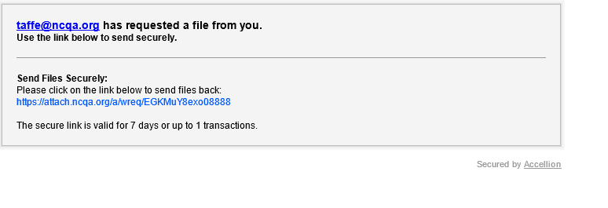
- When you click the link, you will be directed to the [name of sub-contractor’s secure login site] site, where you can choose files/folders to upload.

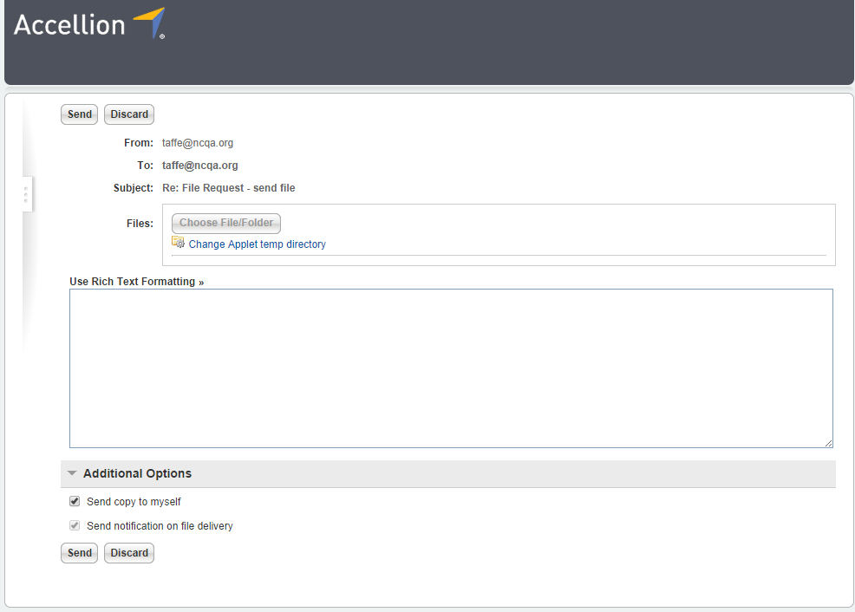

- Hit the Send button to send the requested files securely to [sub-contractor’s name].

If you have questions or problems when uploading your numerator data through [name of sub-contractor’s secure login site], contact [contractor’s name and email].

