Justification for Non-Substantive Changes for Electronic Consent Based Social Security Number Verification
20 CFR 401.100
OMB No. 0960-0817

Background
We are transitioning registration for Electronic Consent Based Social Security Number Verification (eCBSV) to the EAZE Management Portal. The transition to the EAZE Management Portal will not impact the eCBSV customers or our business process. After an entity has successfully registered for EAZE, entity’s representatives will have access to the EAZE Management Portal, which is the place that they can update their registration information (i.e. issuer URL or technical email address) in a self-service manner. In addition, they could view a list of OIDC/OAuth2 Client IDs and enrolled business services.

After registering, entities will have access to the Entity Management page shown below:

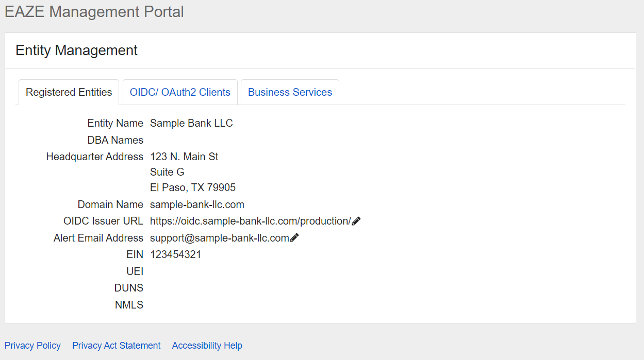

Justification for Non-Substantive Changes to the Collection

We are making the following revisions to this collection:

- Change #1: The EAZE Management Portal will give users the ability to change the OIDC Issuer URL in a self-service manner.
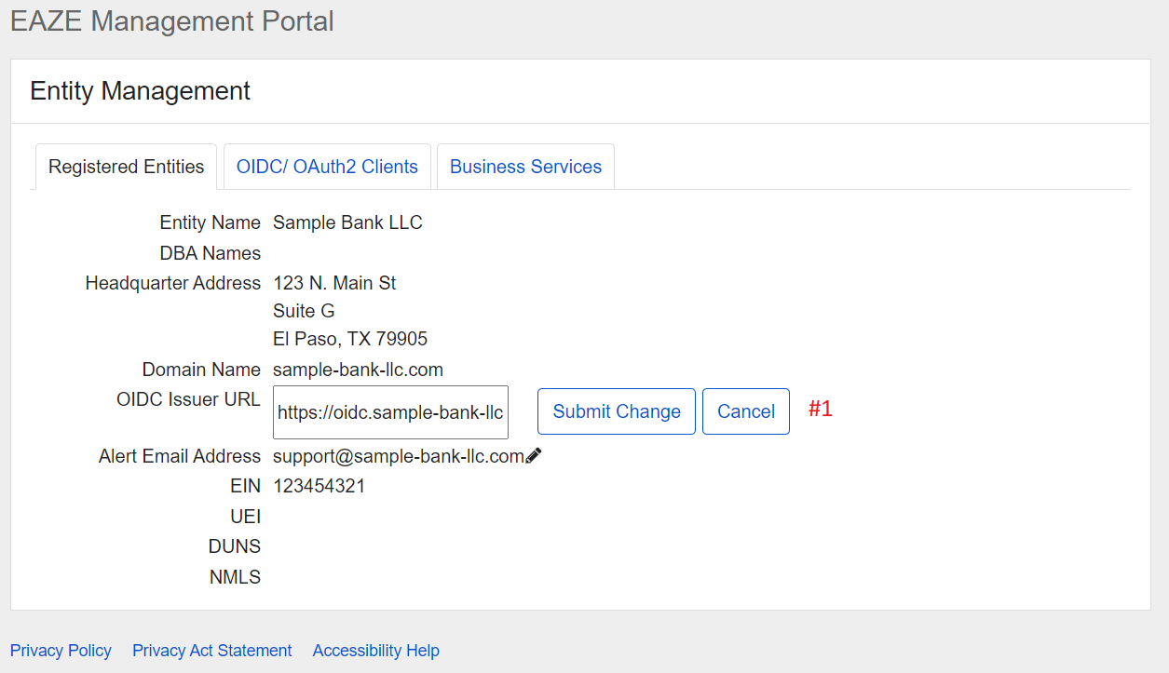

Justification #1: This new option will save time for the users, help desk representatives, and database administrators from having to coordinate to update this information manually.

- Change #2: The EAZE Management Portal will give users the ability to change the Alert Email Address in a self-service manner.

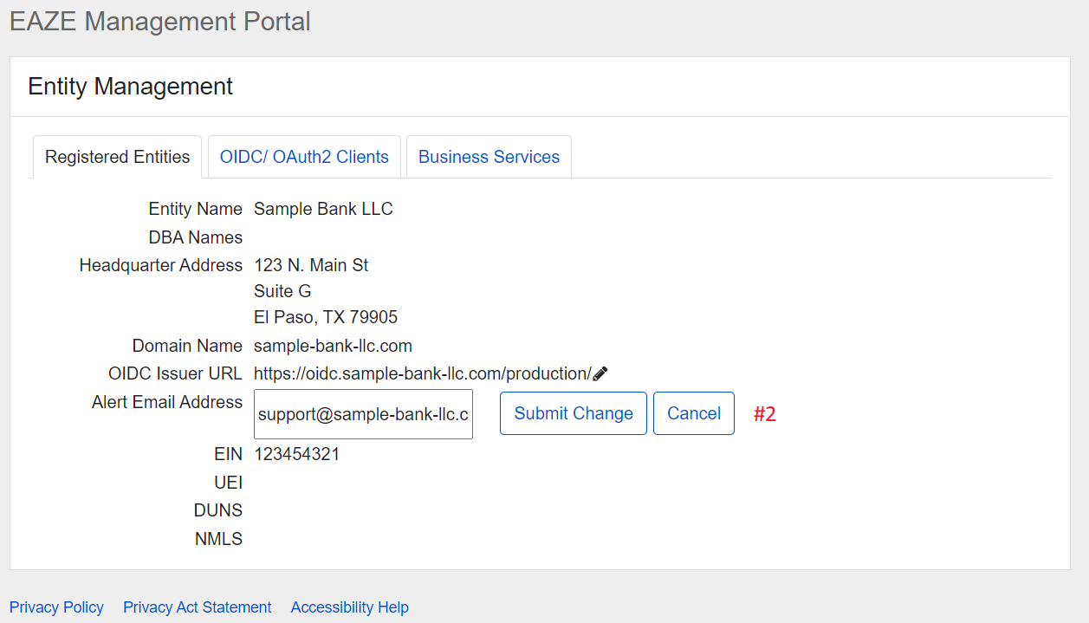

Justification #2: This new option will save time for the users, help desk representatives, and database administrators from having to coordinate to update this information manually.

- Change #3: The OIDC/OAuth2 Clients tab will give users the ability to view their entity’s list of OIDC/OAuth2 Client IDs in a self-service manner.

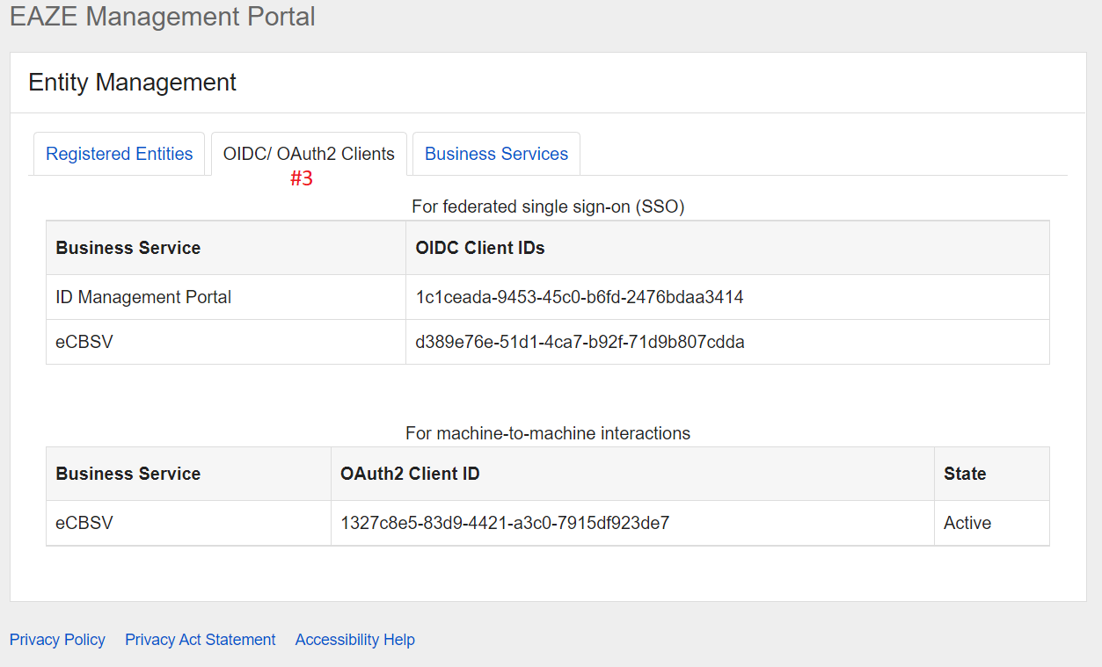

Justification #3: This new option will save time for the users, help desk representatives, and database administrators from having to coordinate to obtain this information manually.

- Change #4: The Business Services tab will give users the ability to view their entity’s list of enrolled Business Services in a self-service manner.

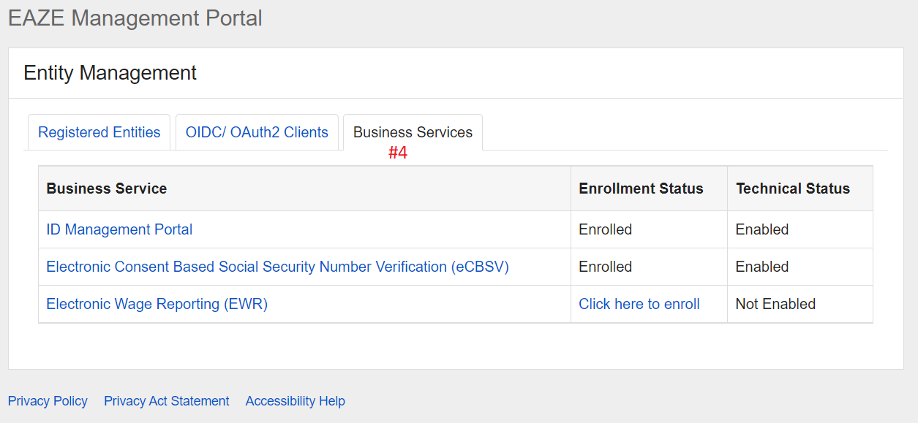

Justification #4: This new option will save time for the users, help desk representatives, and database administrators from having to coordinate to obtain this information manually.

SSA will implement these IT Modification changes upon OMB approval.

These actions do not affect the public reporting burden.

We hope to include these screens as part of a release scheduled for October 15, 2022.

