The NAS Alert System Registration form (https://nas.er.usgs.gov/AlertSystem/Register.aspx) has both the OMB control number and expiration date contained in the document. On initial page load, the user is presented with an informational pop-up window containing the Paperwork Reduction Act and Privacy Act statements (see below).
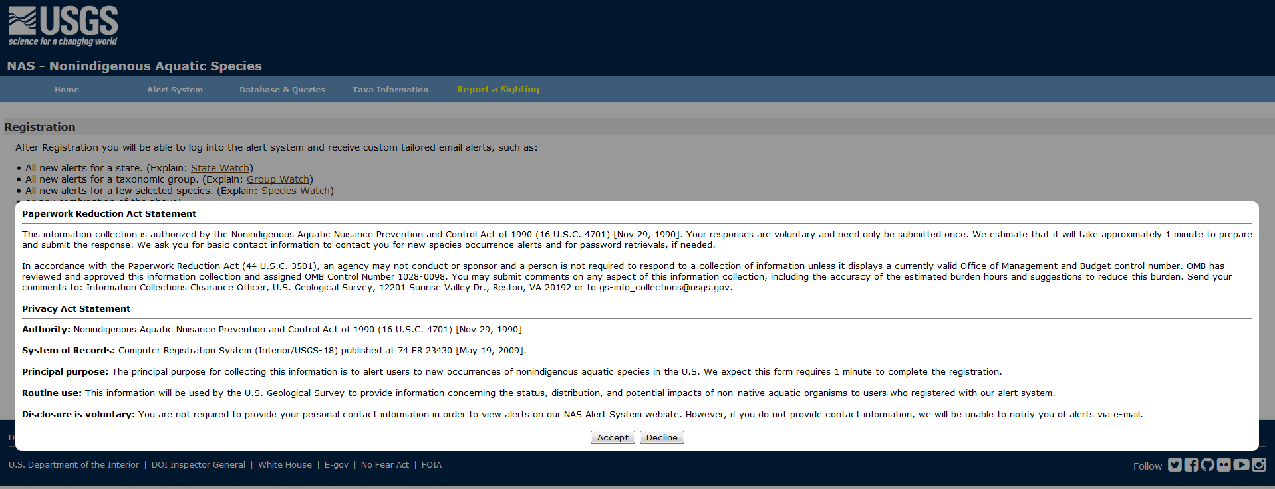
This pop-up window contains the OMB Control Number, but not the expiration date. When the user clicks on the ‘Accept’ button, the user can interact with the form. When the user scrolls to the bottom of the page, the OMB Control Number and the expiration date become visible:
