Login for OE/AAA system with privacy statement

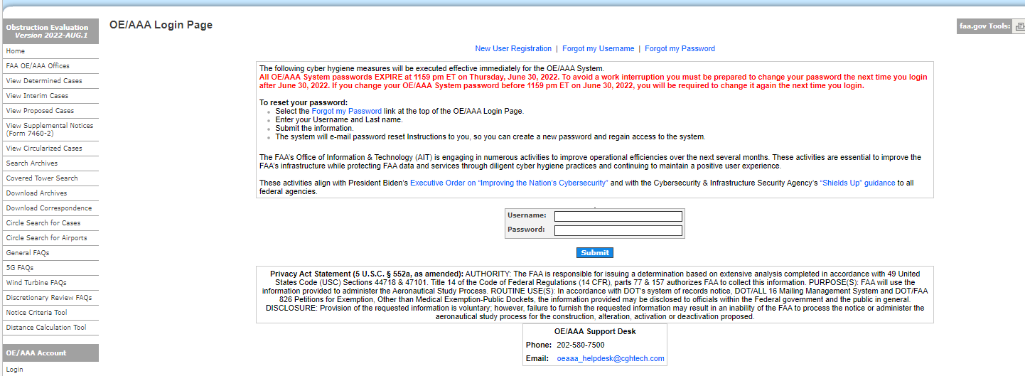

Notice for Construction, Alteration and Deactivation of Airports Online Entry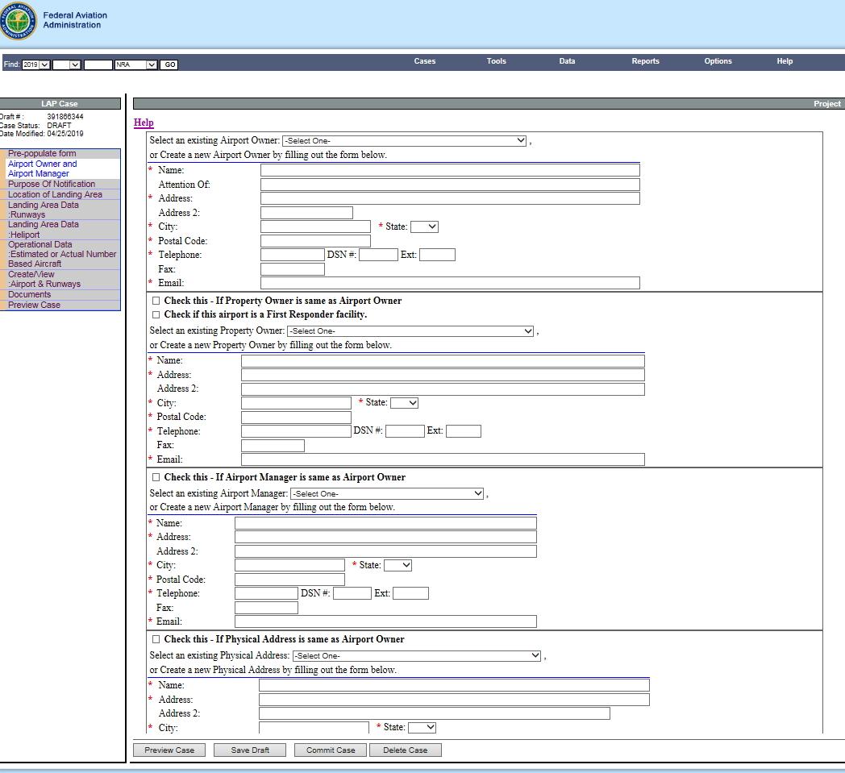

# Paperwork Reduction Act Burden Statement

A federal agency may not conduct or sponsor, and a person is not required to respond to, nor shall a person be subject to a penalty for failure to comply with a collection of information subject to the requirements of the Paperwork Reduction Act unless that collection of information displays a currently valid OMB Control Number. The OMB Control Number for this information collection is 2120-0036. Public reporting for this collection of information is estimated to be approximately 60 minutes per response, including the time for reviewing instructions, searching existing data sources, gathering and maintaining the data needed, completing and reviewing the collection of information.

All responses to this collection of information are required if the proponent wishes to have the airport on file with the FAA, as required by Title 14 Code of Federal Regulations Part 157, and entered into the National Airspace System. No assurances of confidentiality are given. Send comments regarding this burden estimate or any other aspect of this collection of information, including suggestions for reducing this burden to: Information Collection Clearance Officer, Federal Aviation Administration, 10101 Hillwood Parkway, Fort Worth, TX 76177-1524.

OMB CONTROL NUMBER: 2120-0036

EXPIRATION DATE: X/XX/20XX



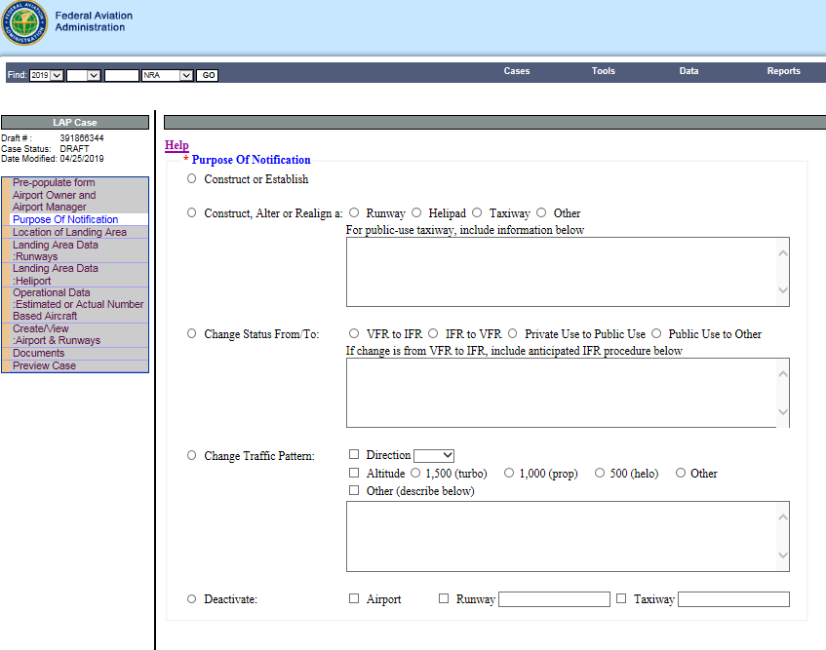

Helipad/Vertipad

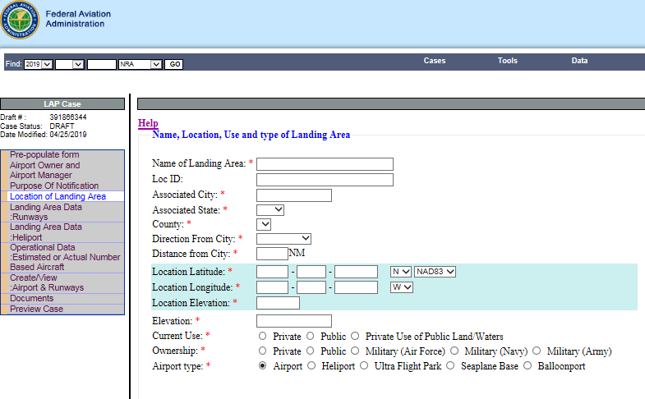

(**If Heliport**, choose:

Ambulance

Law Enforcement

Fire Protection)

Vertiport

Other

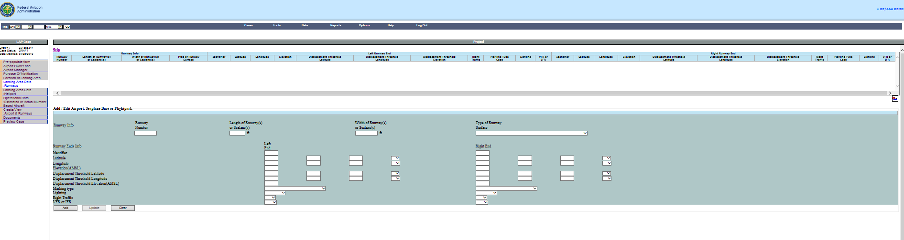

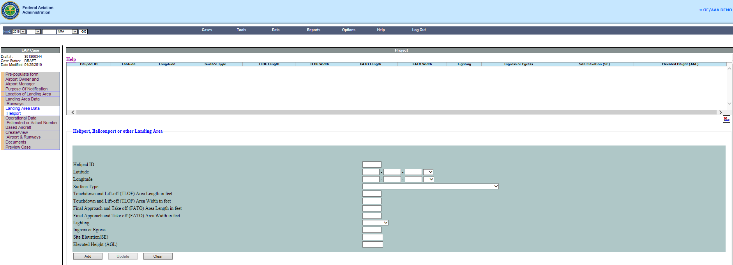

**Heliport, Vertiport or other Landing Area**

Helipad or Vertipad ID

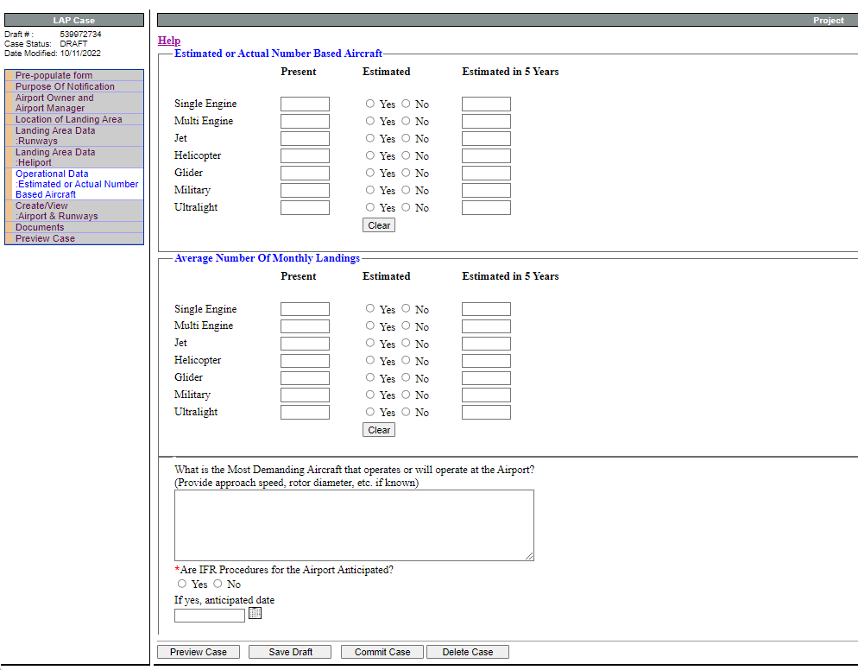

vTOL

Yes

No





vTOL

Yes

No