TOXIC EXPOSURE SCREEN 09/01/22 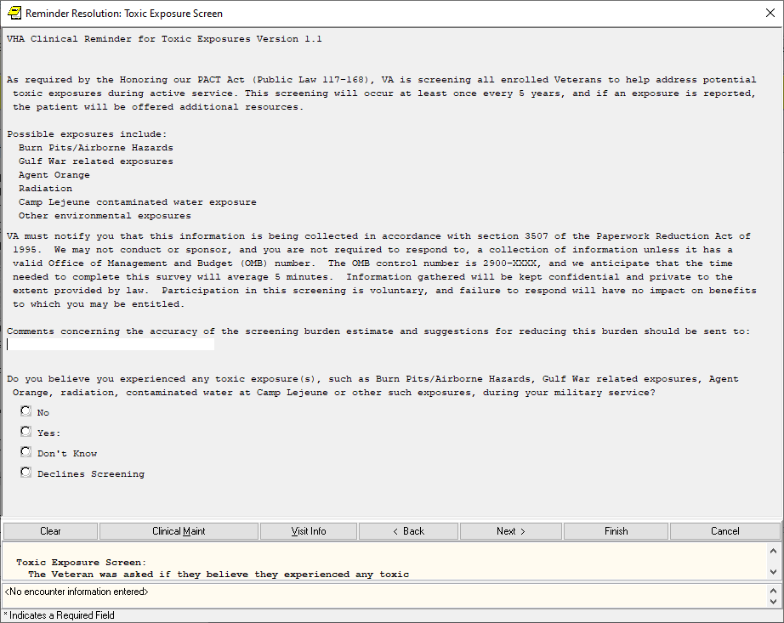

LOCAL FACILITY CONTACT INFORMATION AUTO POPULATES HERE

No, expanded:

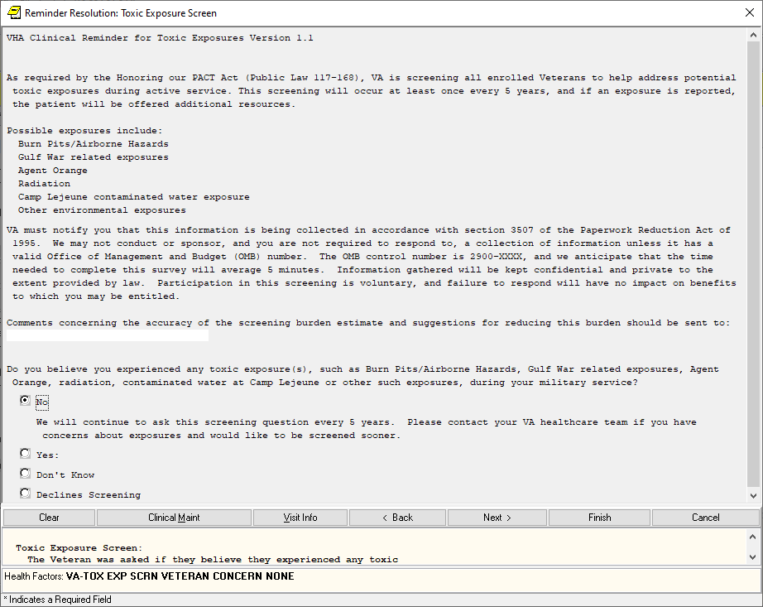

Yes, expanded:

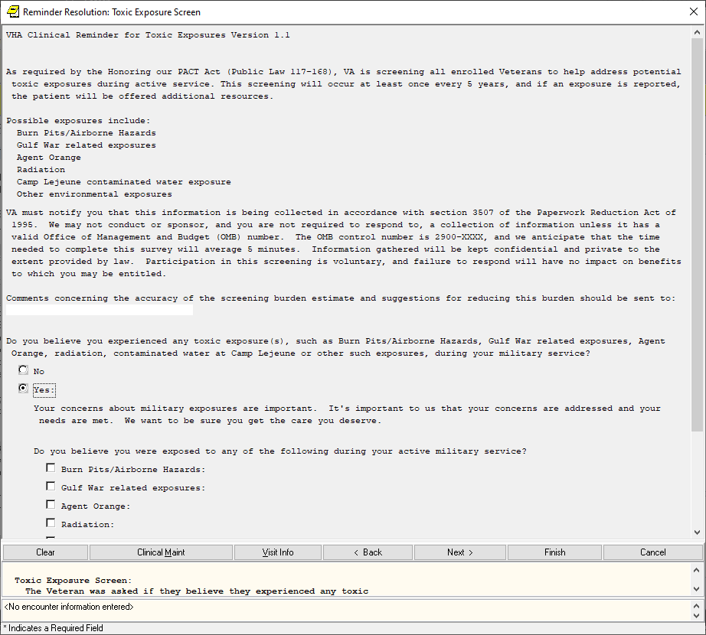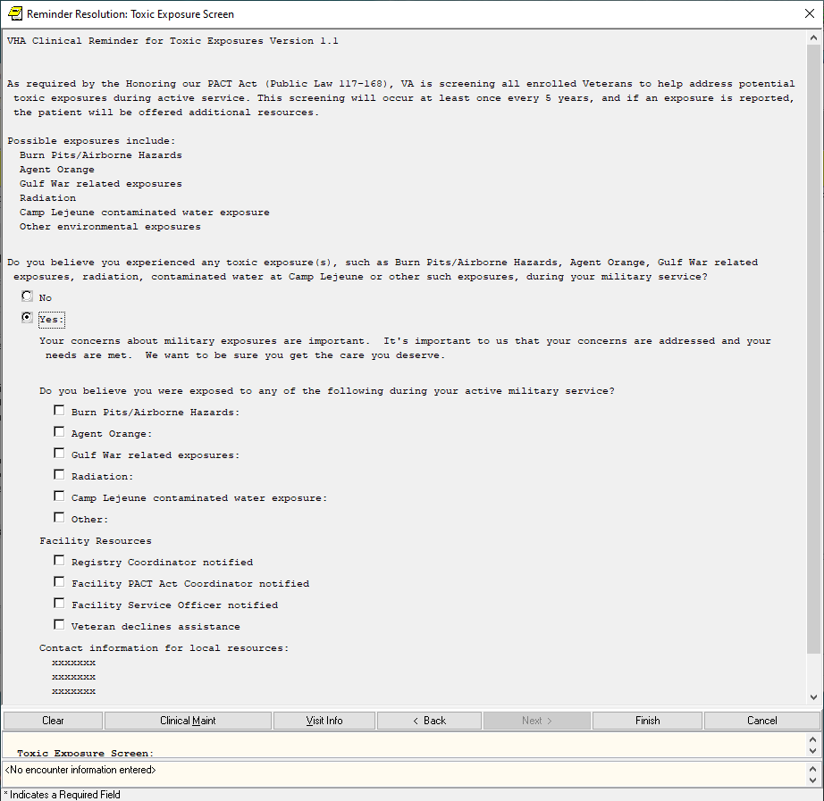

Resources option will be sent out disabled and sites can enable and edit if they have a local process

Yes, expanded all exposures expanded – 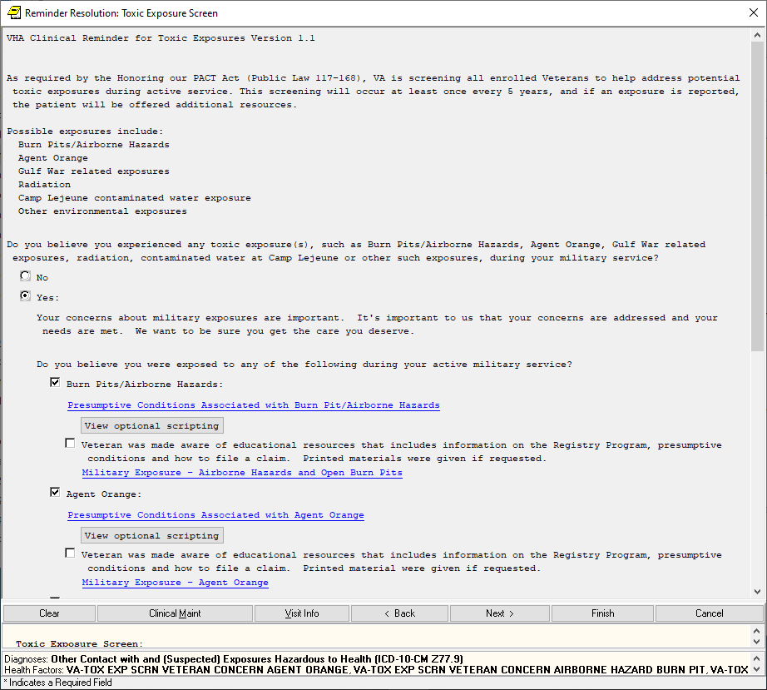

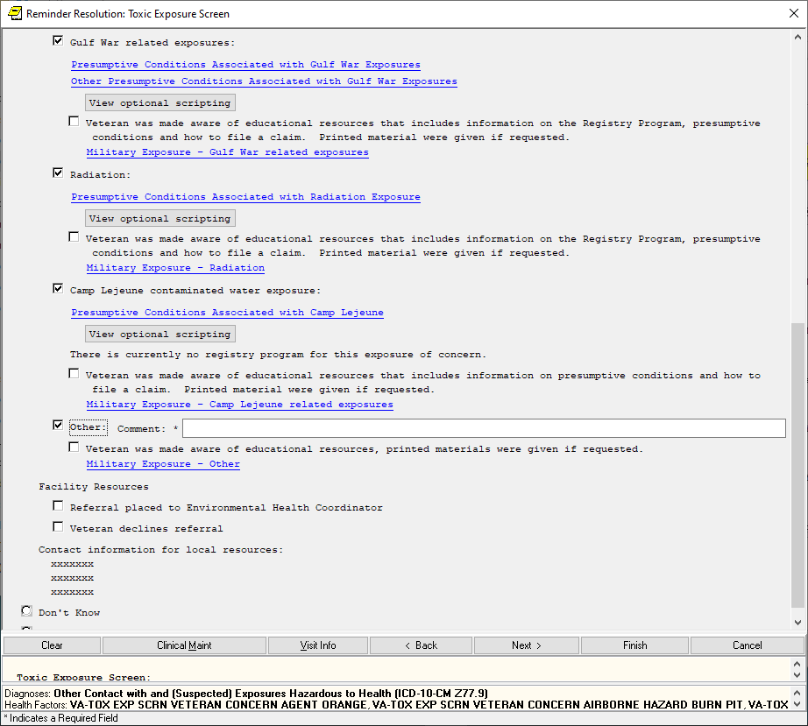

The “view optional scripting” pop ups are all similar as follows:

1. Conditions are only wording changes between the first 5:

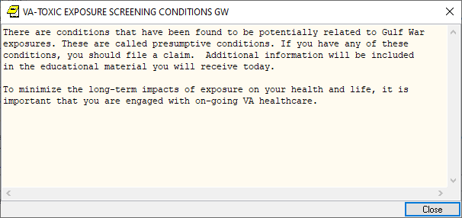

Don’t Know, expanded:

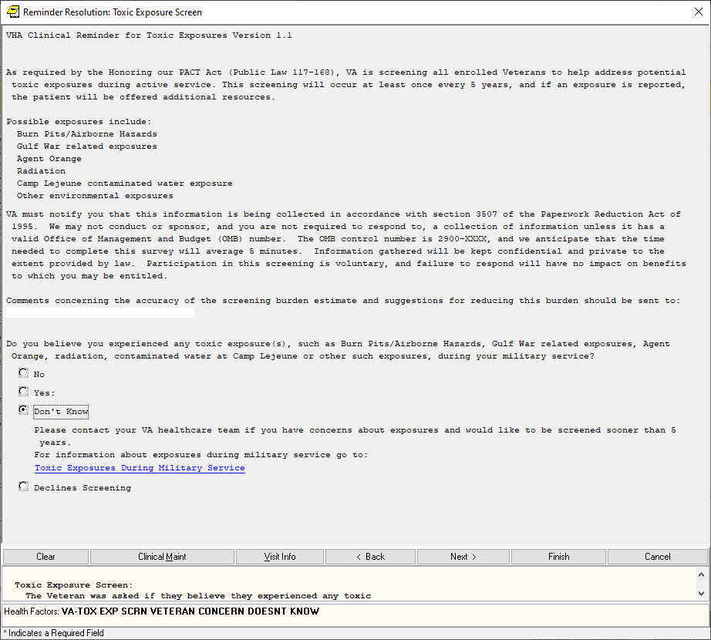

Declines, expanded:

