Supporting Statement - A for Paperwork Reduction Act (PRA)

Veteran Rapid Retraining Assistance Program (VRRAP) 30, 60, 90,
180-Day Experience Survey, and VRRAP Experience Survey After Employment

2900-XXXX

- JUSTIFICATION

- Explain the circumstances that make the collection of information necessary. Identify legal or administrative requirements that necessitate the collection of information.

Executive Order 12862 directs Federal agencies to provide service to the public that matches or exceeds the best service available in the private sector. In order to work continuously to ensure that our programs are effective and meet our customers’ needs, the Department of Veterans Affairs (hereafter “VA”) seeks to obtain OMB approval of Surveys to collect qualitative feedback on our service delivery for Veterans Health Administration (VHA); Veterans Benefits Administration (VBA); and National Cemetery Administration (NCA). By qualitative feedback, we mean information that provides useful insights on perceptions and opinions, but not statistical surveys that yield quantitative results that can be generalized to the population of study.

This collection of information is necessary to enable these Administrations of the Department of Veterans Affairs to garner customer and stakeholder feedback in an efficient and timely manner, in accordance with our commitment to improving service delivery. The information collected from our customers and stakeholders will help ensure that users have an effective, efficient, and satisfying experience with the Agency’s programs, particularly, the Veteran Rapid Retraining Assistance Program (VRRAP). This feedback will provide insights into customer or stakeholder perceptions, experiences, and expectations; provide an early warning of issues with service; or focus attention on areas where communication, training, or changes in operations might improve delivery of products or services. These collections of information will allow for ongoing, collaborative, and actionable communications between the Agency and its customers and stakeholders. They will also allow feedback to contribute directly to the improvement of program management.

- Indicate how, by whom, and for what purposes the information is to be used; indicate actual use the agency has made of the information received from current collection.

These VRRAP Surveys submitted for OMB’s approval through regular ICR 3-year collection for the Collection of Qualitative Feedback on Agency Service Delivery” is being submitting based on the recently enacted “Training in High-demand Roles to Improve Veteran Employment Act” (THRIVE ACT) legislation. This new Pub. L 117-16 amended the Veteran Rapid Retraining Assistance Program (VRRAP), Pub. L. 117-2 Section 8006 by requiring VA, in coordination with Department of Labor (DOL), to contact each Veteran who completes a covered program of education under the retraining assistance program 30, 60, 90, and 180 days after the Veteran completes the program of education to ask about their experience in the retraining assistance program and their employment status.

The Thrive Act legislation also specifies that a Veteran participating in a covered program of education solely through distance learning on a half-time basis or less would not receive a housing stipend, and it clarifies the housing stipend amount provided to a Veteran when participating in a program on a half-time basis or less. The Thrive Act also requires VA, in consultation with the DOL to contact each participating Veteran no later than 30 days after the date the Veteran begins the program of education, to notify them of employment placement services available upon completion of the program; and to, no later than 14 days after the date the Veteran completes, or terminates participation in the program, to facilitate the provision of employment placement services to the Veteran.
The Thrive Act also requires VA to enter into a Memorandum of Understanding with one or more qualified nonprofit organizations to facilitate the employment of Veterans who participate in the retraining assistance program. A qualified non-profit organization is an organization that is an association of businesses and has at least two years of experience providing job placement services for Veterans. And finally, the legislation requires DOL, no later than one year after the date of the Thrive Act enactment, to submit a report to the Committees on Veterans’ Affairs of the Senate and House of Representatives.
The report must contain the percentage of Veterans who found employment before the end of the second calendar quarter after exiting the program; the percentage of Veterans who found employment before the end of the fourth calendar quarter after exiting the program; the median earnings of Veterans for the second quarter after exiting the program; and the percentage of Veterans who attain a recognized postsecondary credential during the 12-month period after exiting the program, and would require the Comptroller General of the United States to submit a report to Congress on the outcomes and effectiveness of the retraining program not later than 180 days after the termination of the retraining assistance program, December 11, 2022. Feedback from the Surveys will be used for that purpose.
The feedback will also provide insights into the eligible beneficiaries’ perceptions, experiences and expectations, provide an early warning of issues with service, or focus attention on areas where communication, training, or changes in operations might improve delivery of products or services. This collection will allow for ongoing, collaborative and actionable communications between VA and Veteran Rapid Retraining Assistance Program (VRRAP) participants regarding their needs for employment assistance. It will also allow feedback to contribute directly to the improvement of the VRRAP program management.
Improving agency programs requires ongoing assessment of service delivery, by which we mean systematic review of the operation of a program compared to a set of explicit or implicit standards, as a means of contributing to the continuous improvement of the program. VA will collect, analyze, and interpret information gathered through this regular ICR submission survey to identify strengths and weaknesses of current services and make improvements in service delivery based on feedback. The solicitation of feedback will target areas such as: timeliness, appropriateness, accuracy of information, courtesy, efficiency of service delivery, and resolution of issues with service delivery. Responses will be assessed to plan and inform efforts to improve or maintain the quality of service offered to the public. If this information is not collected, vital feedback from customers and stakeholders on VA’s services will be unavailable.
The type of regular ICR survey collection is limited only as:
- Web-Based or other forms of Social Media and email

- Describe whether, and to what extent, the collection of information involves the use of automated, electronic, mechanical, or other technological collection techniques or other forms of information technology, e.g., permitting electronic submission of responses, and the basis for the decision for adopting this means of collection. Also describe any consideration of using information technology to reduce burden.

If appropriate, agencies will collect information electronically and/or use online collaboration tools to reduce burden.

- Describe efforts to identify duplication. Show specifically why any similar information already available cannot be used or modified for use for the purposes described in Item 2 above.

The information obtained through this collection is unique and is not already available for use or adaptation from another cleared source.

- If the collection of information impacts small businesses or other small entities, describe any methods used to minimize burden.

There is no impact on academic institutions, or small businesses or entities for the information collection. The information collection involves Veterans and their eligible beneficiaries. The information may be collected directly from individuals via, email. The information may also be submitted voluntarily.

- Describe the consequences to Federal program or policy activities if the collection is not conducted or is conducted less frequently, as well as any technical or legal obstacles to reducing burden.

Without these types of feedback, VA will not have timely information to adjust its services to meet customer needs.

- Explain any special circumstances that would cause an information collection to be conducted more often than quarterly or require respondents to prepare written responses to a collection of information in fewer than 30 days after receipt of it; submit more than an original and two copies of any document; retain records, other than health, medical, government contract, grant-in-aid, or tax records for more than three years; in connection with a statistical survey that is not designed to produce valid and reliable results that can be generalized to the universe of study and require the use of a statistical data classification that has not been reviewed and approved by OMB.

There are no special circumstances. The information collected will be voluntary and will not be used for statistical purposes.

- a. If applicable, provide a copy and identify the date and page number of publication in the Federal Register of the sponsor’s notice, required by 5 CFR 1320.8(d), soliciting comments on the information collection prior to submission to OMB. Summarize public comments received in response to that notice and describe actions taken by the sponsor in responses to these comments. Specifically address comments received on cost and hour burden.

In accordance with 5 CFR 1320.8(d), a 60-day notice of Proposed Information Collection Activity was published in the Federal Register on May 2, 2022, Volume 87, Number 84, Page 25701. There was one comment received in response to this notice, which is indicated below. 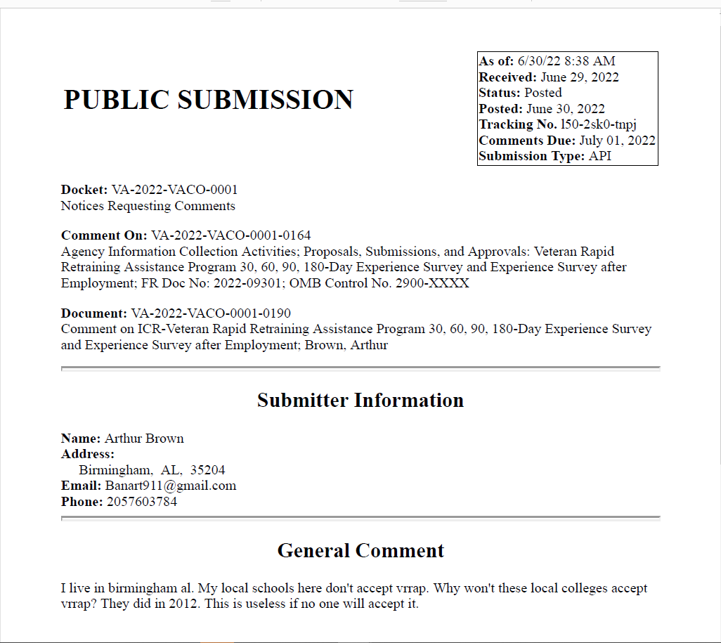

VA Response: Thanks for your comment. The purpose of the surveys pertaining to this supporting statement is for VA to garner eligible customers’ and stakeholders’ feedback in an efficient and timely manner, in accordance with our commitment to improving service delivery.
Unlike the prior “VRRAP” program you’ve mentioned, this VRRAP program is the second of its type. Congress included a specific payment scheme in the current VRRAP program. As such, many facilities were unwilling or unable to agree to the new payment terms required for participation. As a result, some schools do not participate in the new VRRAP program.
You may consult with your School Certifying Official (SCO) for additional information regarding participation. If your school already participates in the new VRRAP program, you may apply online from the GI Bill® website using this link: Veteran Rapid Retraining Assistance Program (VRRAP) | Veterans Affairs (va.gov). Click on the “Apply for VRRAP Education Benefits” button. You will then need to create an account through ID.me. After those steps are completed, the application will ask a series of questions, and based on the answers you provide, the system will complete the form and then send it electronically to the correct claims processing office.
You can search for answers in the Frequently Asked Questions portal and register to be notified of any updates to the information. Use Ask VA to submit an inquiry for a specific question. These contact methods are available 24 hours a day, 7 days a week.
If you have additional questions, you can call 1-888-GIBILL-1 (1-888-442-4551) to speak with a Customer Service Representative.
V/r,
VA-Education Service-Procedures
b. Describe efforts to consult with persons outside the agency to obtain their views on the availability of data, frequency of collection, clarity of instructions and recordkeeping, disclosure or reporting format, and on the data elements to be recorded, disclosed or reported. Explain any circumstances which preclude consultation every three years with representatives of those from whom information is to be obtained.
No additional consultation apart from soliciting public comments through the Federal Register was conducted for this submission.
- Explain any decision to provide any payment or gift to respondents, other than remuneration of contractors or grantees.

No payments or gifts are being offered to respondents as an incentive to participate in the collection.

- Describe any assurance of privacy, to the extent permitted by law, provided to respondents and the basis for the assurance in statute, regulation, or agency policy.

A Privacy Act Statement is not required for this collection because we are not requesting indvididuals to furnish personal information for a system of records.

- Provide additional justification for any questions of a sensitive nature (Information that, with a reasonable degree of medical certainty, is likely to have a serious adverse effect on an individual's mental or physical health if revealed to him or her), such as sexual behavior and attitudes, religious beliefs, and other matters that are commonly considered private; include specific uses to be made of the information, the explanation to be given to persons from whom the information is requested, and any steps to be taken to obtain their consent

No questions considered sensitive are being asked in this collection.

- Estimate of the hour burden of the collection of information:

The number of respondents, frequency of responses, annual hour burden, and explanation for each form is reported as follows:
The survey instruments will be used to collect information from respondents. The number of respondents is 6,225 annually. The annual burden hours requested is 830, which are based on the number of survey collections VA expects to conduct over the requested period for this regular 3-year ICR submission request. This calculation is derived by taking the number of respondents and multiplying by 4 surveys annually;
1 survey per quarter for each participant X 2 minutes, then dividing the sum by 60 minutes: (6,225 X 4 X 2 / 60 = 830 burden hours).

The annual burden hours requested is 830 hours total, as shown also in the chart below:

a. Burden Hours: 6,225 total surveys X 4 per ann X 2min / 60min.

Burdent Time = 2 minutes

Frequency = 4 per ann

Estimated Annual Reporting Burden
Type of Collection | Total No. of Respondents | Annual Frequency per Response | Hours per Response | Total Burden Hours
Customer Satisfaction Surveys (30/60/90/180-Day, and Experience After Meaningful Employment | 6,225 | 4 | 2 min | 830
Focus Groups | - | - | - | -
Customer Comment Cards | - | - | - | -
Small discussion groups | - | - | - | -
Cognitive laboratory studies | - | - | - | -
Qualitative customer satisfaction surveys | - | - | - | -
In-person observation testing | - | - | - | -
Patient surveys | - | - | - | -
Total | 6,225 |  |  | 830

b. If this request for approval covers more than one form, provide separate hour burden estimates for each form and aggregate the hour burdens in Item 13.
See chart in subparagraph 12a above.
c. Provide estimates of annual cost to respondents for the hour burdens for collections of information. The cost of contracting out or paying outside parties for information collection activities should not be included here. Instead, this cost should be included in Item 14.
VA cannot make assumptions about the population of respondents because of the variability of factors, such as the educational background and wage potential of respondents. Therefore, VA uses general wage data to estimate the respondents’ costs associated with completing the information collection.

The Bureau of Labor Statistics (BLS) gathers information on full-time wage and salary workers. According to the latest available BLS data, the mean weekly earnings of full-time wage and salary workers are $1,120.40. Assuming a forty (40) hour work week, the mean hourly wage is $28.01 based on the BLS wage code – “00-0000 All Occupations.” This information was taken from the following website: https://www.bls.gov/oes/current/oes_nat.htm May 2021).

Legally, respondents may not pay a person or business for assistance in completing the information collection. Therefore, there are no expected overhead costs for completing the information collection. VBA estimates the total cost to all respondents to be $23,248.30 (830 burden hours x $28.01 per hour).

- Provide an estimate of the total annual cost burden to respondents or recordkeepers resulting from the collection of information. (Do not include the cost of any hour burden shown in Items 12 and 14).

a. There are no capital, start-up, operation, equipment, computer software, or maintenance costs.
b. Cost estimates are not expected to vary widely. The only cost, is that for the time of the respondent.
c. There is no anticipated recordkeeping burden beyond that which is considered usual and customary.

- Provide estimates of annual cost to the Federal Government. Also, provide a description of the method used to estimate cost, which should include quantification of hours, operation expenses (such as equipment, overhead, printing, and support staff), and any other expense that would not have been incurred without this collection of information. Agencies also may aggregate cost estimates from Items 12, 13, and 14 in a single table.

The marginal cost of this collection to VA is de minimis.
Grade | Step | Burden Time  Employee | Hourly Rate | Cost Per Response | Total Responses | Total
13 | 05 | 2 minutes | $51.25 | $1.70 | 6,225 | $ 10,634.37
-- | -- | -- | -- | -- | -- | --
Overhead at 100% Salary |  |  |  |  |  | $10,634.37
Overhead costs are 100% of salary and are the same as the wage listed above; and the amount is included in the total. |  |  |  |  |  | $10,634.37
Processing I Analyzing Costs |  |  |  |  |  | $10,634.37
Printing and Production Costs (postage)  Equipment Costs  Software Purchases Costs  Licensing Costs  Other Costs |  |  |  |  |  | $0.00  $0.00  $0.00  $0.00  $.0.00
Total Cost to Government |  |  |  |  |  | $10,634.37

Note: The hourly wage information above is based on the hourly 2022 General Schedule (Base) Pay. https://www.opm.gov/policy-data-oversight/pay-leave/salaries-wages/salary-tables/pdf/2022/RUS_h.pdf
The processing time estimates above are based on the actual amount of time employees of the grade level spend to process to completion, a claim received on this form.
- Explain the reason for any burden hour changes or adjustments reported in items 13 or 14.

No change in burden. This is a new collection with a new associated burden. This ICR request for an OMB approval of the VRRAP Surveys is being submitted based on enactment of the “Training in High-demand Roles to Improve Veteran Employment Act” (Thrive Act), Pub L. 117-16, and the “American Rescue Plan Act of 2021”.

- For collections of information whose results will be published, outline plans for tabulation and publication. Address any complex analytical techniques that will be used. Provide the time schedule for the entire project, including beginning and ending dates of the collection of information, completion of report, publication dates, and other actions.

Feedback collected under this regular ICR submission provides useful information but does not yield data that can be generalized to the overall population. Findings will be used for general service improvement but are not for publication or other public release.

Although the Agency does not intend to publish its findings, the Agency may receive requests to release the information (e.g., Congressional inquiry, Freedom of Information Act requests). VA will disseminate the findings when appropriate, strictly following the Agency's "Guidelines for Ensuring the Quality of Information Disseminated to the Public” and will include specific discussion of the limitation of the qualitative results discussed above.

- If seeking approval to omit the expiration date for OMB approval of the information collection, explain the reasons that display would be inappropriate.

We are not seeking approval to omit the display of the expiration date of the OMB approval on the collection instruments.

- Explain each exception to the certification statement identified in Item 19, “Certification for Paperwork Reduction Act Submissions,” of OMB 83-I.

We are not requesting any exceptions to the provisions stated in 5 CFR 1320.9. These activities comply with the requirements in 5 CFR 1320.9 – and there are no exceptions.

