SUPPORTING STATEMENT B
U.S. Department of Commerce
U.S. Census Bureau
Boundary and Annexation Survey
OMB Control No. 0607-0151

B. Collections of Information Employing Statistical Methods
There are no statistical methods involved in the collection of this information.

Describe (including a numerical estimate) the potential respondent universe and any sampling or other respondent selection method to be used. Data on the number of entities (e.g., establishments, State and local government units, households, or persons) in the universe covered by the collection and in the corresponding sample are to be provided in tabular form for the universe as a whole and for each of the strata in the proposed sample. Indicate expected response rates for the collection as a whole. If the collection had been conducted previously, include the actual response rate achieved during the last collection.

The potential respondent universe for the Boundary and Annexation Survey (BAS) is an estimated 40,000 governments. The annual BAS response rate goal and expected participation is currently 85% or above. The table below shows the response rate for the previous 2020 BAS cycle.
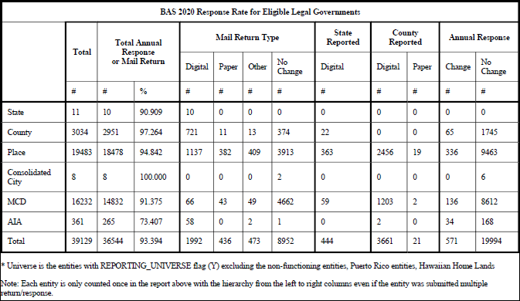
- Describe the procedures for the collection of information including:
  - Statistical methodology for stratification and sample selection,
  - Estimation procedure,
  - Degree of accuracy needed for the purpose described in the justification,
  - Unusual problems requiring specialized sampling procedures, and
  - Any use of periodic (less frequent than annual) data collection cycles to reduce burden.

  - Statistical methodology for stratification and sample selection is not applicable,
  - Estimation procedure is not applicable,
  - Degree of accuracy needed for the purpose described in the justification is not applicable,
  - Unusual problems requiring specialized sampling procedures is not applicable, and
  - Any use of periodic (less frequent than annual) data collection cycles to reduce burden is not applicable.
BAS has been conducted annually and is planned to continue annually for the foreseeable future.

Describe methods to maximize response rates and to deal with issues of non-response. The accuracy and reliability of information collected must be shown to be adequate for intended uses. For collections based on sampling, a special justification must be provided for any collection that will not yield "reliable" data that can be generalized to the universe studied.
Tribal, state, and local governments that do not respond to annual response or those governments that indicate they have updates to provide are followed up with during BAS non-response follow-up (NRFU). NRFU is conducted through email and over the phone.
Governments that have not responded to annual response, along with those that indicated they have boundary changes to report, are first contacted through email. The email reminds participants to respond through an online form if they have legal boundary, census designed place (CDP), or contact updates to report. Those governments that indicated they have boundary updates to report are requested to submit those updates to the Census Bureau by the BAS program deadline.
Partners that still have not responded are contacted by phone later in the program cycle. Governments are requested to provide a response over the phone on whether they have legal boundary, CDP, or contact updates to report. Again, those governments that indicated they have boundary updates to report are reminded to submit those updates to the Census Bureau by the program deadline.

Describe any tests of procedures or methods to be undertaken. Testing is encouraged as an effective means of refining collections of information to minimize burden and improve utility. Tests must be approved if they call for answers to identical questions from 10 or more respondents. A proposed test or set of tests may be submitted for approval separately or in combination with the main collection of information.
BAS does not conduct a test phase or test sampling.

Provide the name and telephone number of individuals consulted on statistical aspects of the design and the name of the agency unit, contractor(s), grantee(s), or other person(s) who will actually collect and/or analyze the information for the agency.
Mike Clements, Supervisory Geographer
Spatial Data Collection and Products Branch, Geography Division
U.S. Census Bureau
O: 301.763.9124
E: michael.j.clements@census.gov

Ryan Short, Branch Chief
Spatial Data Collection and Products Branch, Geography Division
U.S. Census Bureau
O: 301.763.9047 | M: 202.740.4572
E: ryan.l.short@census.gov

Laura Waggoner, Assistant Division Chief
Geographic Data Collection and Products, Geography Division
U.S. Census Bureau
O: 301.763.9079 | M: 202.329.0462
E: laura.l.waggoner@census.gov

