NWS Weather.gov Visitor Experience Survey

A TABLE OF CONTENTS

SCREENER 2
GENERAL INFORMATION: PROFILING, NEEDS, USE 6
CURRENT CONTENT AND UX 10
BARRIERS OF USE OF DEDICATED WEATHER WEBSITES 18
ADDITIONAL FUNCTIONALITY, TOOLS, SERVICES 21

QUESTION FORMAT:

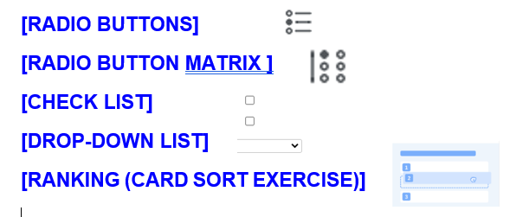
NOTE: SURVEY WILL BE OPTIMIZED FOR MOBILE VIEW WITH MATRIX QUESTIONS SHOWN IN “ACCORDION-STYLE” FORMAT:
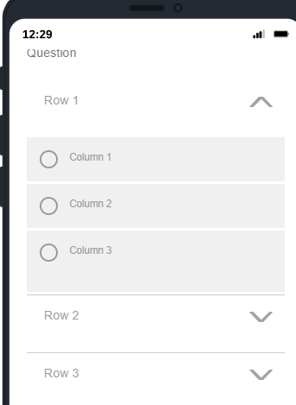
[PROGRAMMER: ASK ALL, UNLESS OTHERWISE SPECIFIED]

Intro.
In this survey, we are going to talk about your use of websites that provide weather, water, or climate information (moving forward, we will refer to them as “weather websites”).
We will also show you some examples of websites. Some of them may show a specific web page within the website or information about a specific location. Please keep in mind that these are just examples; we are asking about websites broadly (not about web pages of specific locations).
We are looking for a mix of frequent and infrequent visitors to understand why they use or don’t use certain websites, and what can be done to better meet their needs.

Public Burden Statement

A Federal agency may not conduct or sponsor, and a person is not required to respond to, nor shall a person be subject to a penalty for failure to comply with an information collection subject to the requirements of the Paperwork Reduction Act of 1995 unless the information collection has a currently valid OMB Control Number. The approved OMB Control Number for this information collection is 0648-XXXX. Without this approval, we could not conduct this Weather.gov Visitor Experience Survey. Public reporting for this information collection is estimated to be approximately 10 minutes per response, including the time for reviewing instructions, searching existing data sources, gathering and maintaining the data needed, and completing and reviewing the information collection. All responses to this information collection are voluntary. Send comments regarding this burden estimate or any other aspect of this information collection, including suggestions for reducing this burden to the Dr. Tyra Brown Harris, DOC/NOAA/NWS/DISS, 11691 SW 17th Street, Miami, FL 33165-2149, (202) 468-8972, tyra.brown@noaa.gov.

SCREENER

S1. In which language would you prefer to take this survey? / [INSERT TEXT IN SPANISH] (Select one)
[RADIO BUTTONS]
English
Spanish [SHOW INSTRUCTION ON HOW TO SWITCH TO SPANISH]
I’m not comfortable taking the survey in English or Spanish [TERMINATE]

S2. Which of the following best describes you as a visitor of weather websites?
Please note: we are asking about the dedicated weather websites that you access through a browser (not about apps or weather widgets on your phone screen or other websites). (Select one)
[RADIO BUTTONS]
- Non-visitor [ASK ONLY THESE Q’S: S4-S10, G2, C1-C4_2, Z1_1-Z5_2, A1, A2]
- Occasional visitor
- Frequent, but non-regular visitor (visit them frequently, but only in certain seasons/when concerned about severe/hazardous weather impacting life and property)
- Frequent and regular visitor (visit them at least several times per week)

[ASK WEATHER WEBSITE VISITORS ONLY]
S3. What is your primary goal when visiting weather websites? (Select one)
[RADIO BUTTONS]
- To find information for my personal/family needs
- To find information for my work/professional activity
- To find information for my academic research

S4. What is your zip code? [NUMERIC BOX, 5 DIGITS]
99. Prefer to not answer

[ASK IF PANEL SAMPLE]
S6. What is your age? (Select one)

- Less than 18 [ASK IF PANEL SAMPLE]
- 18-24
- 25-34
- 35-44
- 45-54
- 55-64
- 65+

[ASK IF PANEL SAMPLE]
S7. Are you:
[RADIO BUTTONS]

01. Male
02. Female
03. Prefer to self-describe
04. Prefer not to answer

[ASK IF PANEL SAMPLE]
S8_1. Are you of Hispanic, Latino, or Spanish origin? (Select one)
[RADIO BUTTONS]
01. No, not of Hispanic, Latino, or Spanish origin
02. Yes, Mexican, Mexican American, Chicano
03. Yes, Puerto Rican
04. Yes, Cuban
05. Yes, another Hispanic, Latino, or Spanish origin (specify)___[OPEN TEXT RESPONSE]
99. Prefer to not answer

[ASK IF PANEL SAMPLE]
S8_2. What is your race? (Select all that apply)
[CHECK LIST; RANDOMIZE]

- American Indian or Alaska Native
- Asian or Asian American
- Black or African American
- Native Hawaiian or Pacific Islander
- White
- Other race (please specify)___ [OPEN TEXT RESPONSE; ANCHOR]
- Prefer not to answer [ANCHOR; EXCLUSIVE]

[ASK IF PANEL SAMPLE]
S9. What is the highest level of education you have completed? (Select one)
[RADIO BUTTONS]

- Some high school or less
- High school degree or equivalent (i.e., GED)
- Some college - no degree
- 2-year college/technical degree (e.g., associate degree or certificate of completion)
- 4-year college degree (i.e., bachelor’s degree)
- Graduate degree (e.g., master’s degree, doctoral degree)
99. Prefer not to answer

[ASK IF PANEL SAMPLE]
S10. Which range best describes the total combined annual gross income of all members of your household (before taxes)? (Select one)
[RADIO BUTTONS]

- Less than $20,000 [10,000]
- $20,000 to less than $50,000 [35,000]
- $50,000 to less than $100,000 [75,000]
- $100,000 to less than $150,000 [125,000]
- $150,000 to less than $200,000 [175,000]
- $200,000 or more [250,000]
- Don't know
- Prefer not to answer

NOTE: FORRESTER WILL SET QUOTAS BY GENDER, AGE, REGION, ETHNICITY, EUCATION, INCOME, TO ENSURE NATURALLY REPRESENTATIVE SAMPLE

[ASK WEATHER WEBSITE VISITORS ONLY, IF PARTNER SAMPLE OR S3=2-3]
S11. Which of the following best describes your professional activity? (Select one)
[RADIO BUTTONS]

- Media / Public Relations
- Academia / Research
- Education
- Military
- Government
- Nonprofit programs/services
- Emergency Management / Responder (incl. firefighting, etc.)
- Energy
- Aviation
- Transportation
- Agriculture and Natural Resources (Land and Water)
- Public Health Services / Healthcare
- Public Works and Engineering
- Other business (specify)_____[OPEN TEXT RESPONSE]
- Other (specify)_____[OPEN TEXT RESPONSE]

[ASK WEATHER WEBSITE VISITORS ONLY, IF PARTNER SAMPLE OR S3=2-3]
S12. Does your organization provide services for historically underserved and socially vulnerable communities (HUSVCs) in the U.S. and Territories? (Select one)
[RADIO BUTTONS]

- Yes, as a primary focus of our activity
- Yes, as one of our focus areas
- No, but we may start doing this in the future
- No
- Don’t know

GENERAL INFORMATION: PROFILING, NEEDS, USE

[ASK WEBSITE VISITORS ONLY IF PANEL SAMPLE AND S3=1]
G1. For what purposes do you use information from weather websites? (Select all that apply)
[CHECK LIST]

[RANDOMIZE 1-4]
- As a hobby/general interest
- For daily outdoor planning
- To ensure personal/family safety
- Other (specify)___[OPEN TEXT RESPONSE]

[ASK IF PANEL SAMPLE; CANDIDATE FOR REMOVAL IF WE NEED TO SHORTEN THE SURVEY]
G2. How would you estimate the risk of the following natural disasters happening in your area in a typical year? (Select one in each row)
[RADIO BUTTON MATRIX]
[ROWS – RANDOMIZE]
- Tornadoes and severe storms
- Hurricanes and tropical storms
- Severe winter weather
- Floods
- Wildfires
- Drought

[COLUMNS]
- No risk
- Minor risk
- Medium risk
- Major risk
- Don’t know

[ASK WEBSITE VISITORS ONLY, IF PARTNER SAMPLE]
G3. For what purposes do you use information from weather websites? [OPEN TEXT RESPONSE]

[ASK WEATHER WEBSITE VISITORS ONLY]
G4. Have you ever visited the Weather.gov website? (Select one)

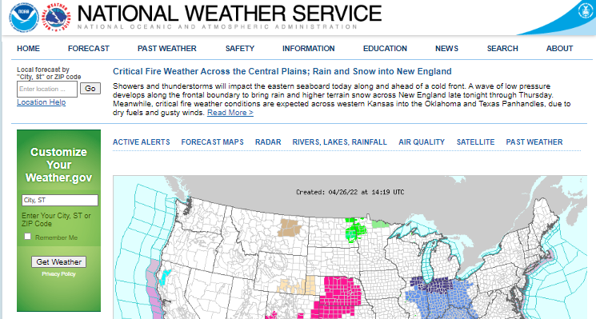
- Yes, within the past 12 months
- Yes, more than 12 months ago
- No never

[ASK WEATHER WEBSITE VISITORS ONLY]
G5. What is your go-to website for weather, climate, or water information/forecasts? (Select one)

*Please note: The U.S. government does not endorse any website listed. This question is for research information only.
[RADIO BUTTONS]

- [SHOW IF SELECTED 1-2 IN G4] Weather.gov
- Weather.com
- Accuweather.com
- Wunderground.com
- Weatherbug.com
- Weather web page of my local TV/radio station
- Other (specify)____[OPEN TEXT RESPONSE]

[ASK WEATHER WEBSITE VISITORS ONLY]
G6. How do you most often navigate to weather websites? (Select one)
[RADIO BUTTONS]
[RANDOMIZE 1-7]
- Type in the address in my browser
- Through a search engine
- Always keep it open in my tabs
- Open it from Bookmarks/Favorites
- Click on a link in my social media feed
- Click on an ad on a different website/search engine
- Through an app
- Other (specify)___[OPEN TEXT RESPONSE]

CURRENT CONTENT AND UX

C1. What geographic area are you typically interested in for weather, water, or climate information in the U.S. and Territories? (Select all that apply)
[CHECK LIST]

- National
- Region/state
- County
- My current location
- A specific location somewhere else (e.g., where my family members live or where I’m planning to travel for work or leisure)
- Location(s) with active tornadoes, floods, hurricanes, wildfires, etc.
- Other (specify)___[OPEN TEXT RESPONSE]

C2. Please rank what timeframe you are most interested in with weather, water, and climate information (from 1=most interested to 6=least interested).

Please drag and drop the options until they are in the right order (with the one you are most interested in being at the top).
[RANKING (CARD SORT EXERCISE)]

- Past (e.g., recent rainfall amounts, yesterday's high temperatures)
- Current weather conditions (radar, satellite, observation)
- Today’s forecast
- This week's forecast
- Week 2 forecast
- Seasonal outlooks

C3. Which of the following types of weather, water, and climate information would you prefer to:
- see on the main page of a weather website (keep in mind that you can’t select too many for this option as it will make the main page look too busy),
- have easy access to/from the main page of a weather website,
- be available but hidden,
- wouldn’t mind not having access to it at all?

[RADIO BUTTON MATRIX]
[ROWS – RANDOMIZE THE BLOCKS AND STATEMENTS WITHIN THE BLOCKS; KEEP 5-9 TOGETHER AND ANCHOR]\

CURRENT
- Current weather conditions (temperature, wind, clouds, rain)
- Active alerts for hazardous weather impacting life and property
- Weather radar (weather map including areas of rain, snow, etc. in different colors)
- Weather satellite (images of the Earth from space)
FUTURE (FORECASTS AND WEATHER/CLIMATE OUTLOOKS)
- Today’s hourly weather forecast
- Daily weather forecast for next 7 days
- Weather forecast for next 14 days
- Seasonal outlooks
- Long-term global warming/climate projections
- The range of possible weather conditions, including the most likely and least likely scenarios
- River forecasts near me
PAST (HISTORICAL INFORMATION)
- Climate information (records, observed high/low temperatures, precipitation, snowfall)
NEWS/INFORMATION/TEXT CONTENT
- Weather education (e.g., how tornadoes form, what is high pressure, etc.)
- Detailed weather analysis from local experts
[COLUMNS]
- Don’t need this at all
- Available but hidden
- Easy access from the main page
- Shown on the main page
C4_1. In what format would you prefer to view the daily weather forecast? (Select one)
[RADIO BUTTONS]
[ROWS – RANDOMIZE 1-4, KEEP 1-2 TOGETHER]
- Graphics/icons
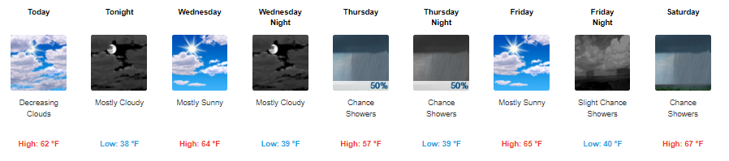
- Graphics/icons with forecaster comments
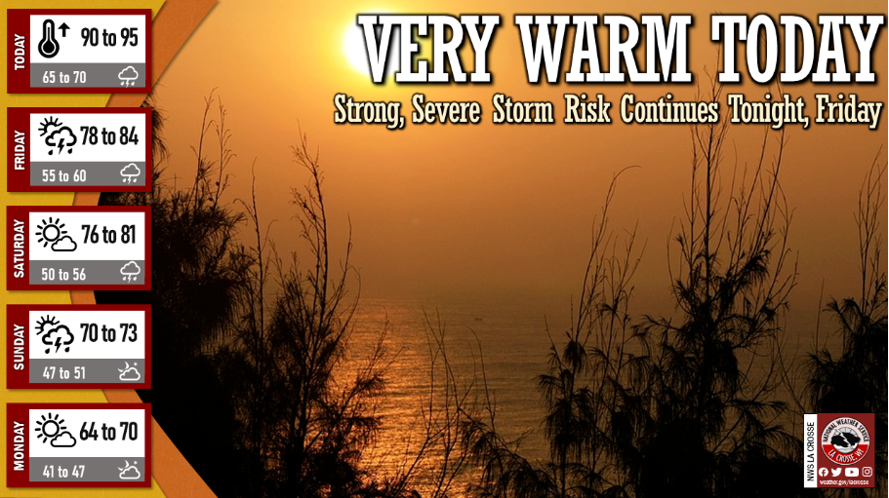
- Short text (e.g., “Today: Mostly sunny, with a high near 71. Northwest wind around 8 mph”)
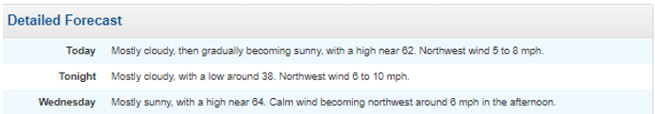

- Other (specify)___[OPEN TEXT RESPONSE]

C4_2. In what format would you prefer to view hazardous weather alerts? (Select one)
[RADIO BUTTONS]
[ROWS; ADD SCREENSHOTS]
- Graphics/icons
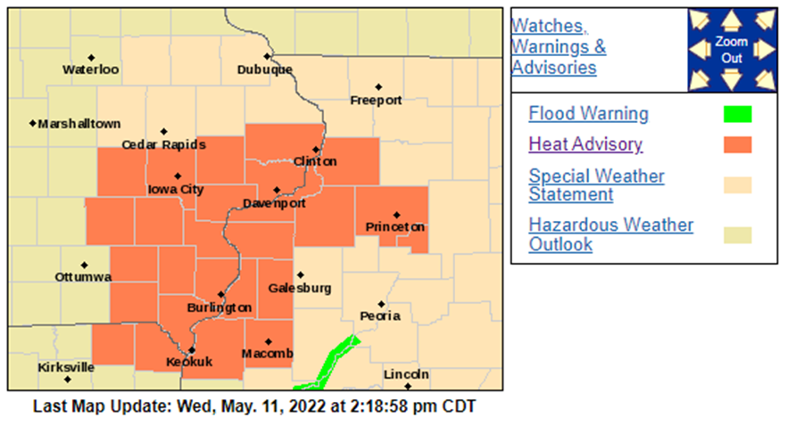
- Graphics/icons with forecaster comments
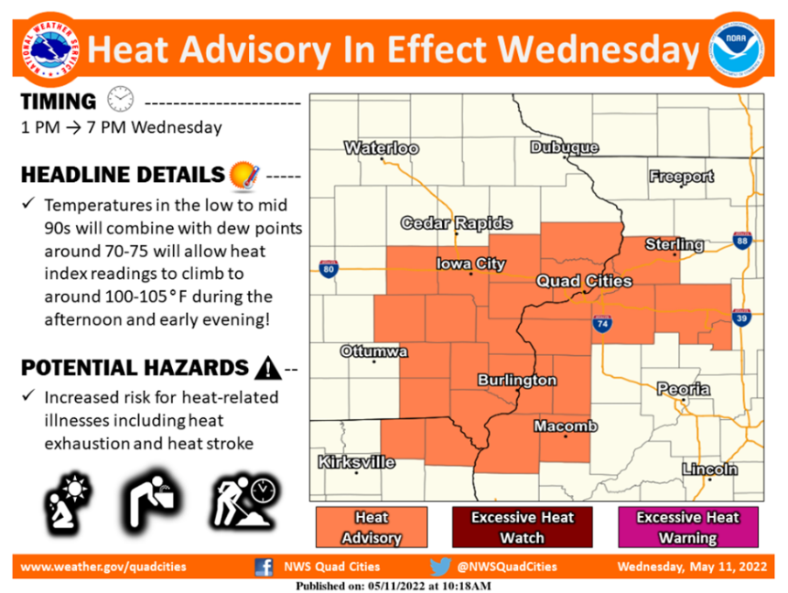
- Short text description
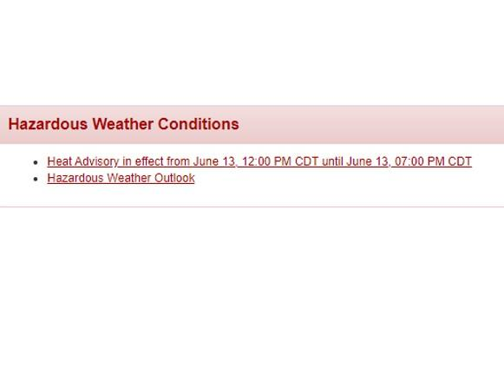
- Long text description with detailed information
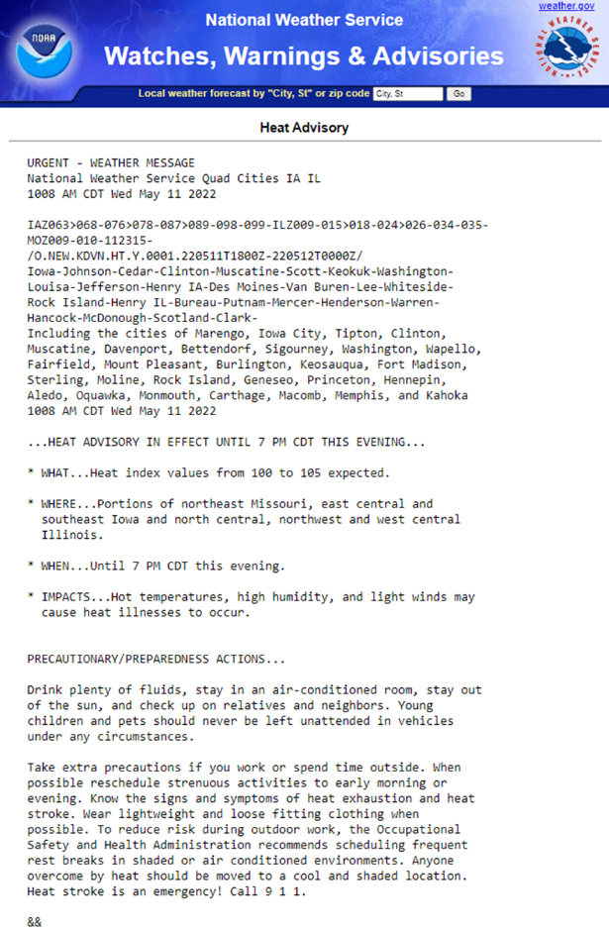
- Other (specify)___[OPEN TEXT RESPONSE]

[ASK WEATHER WEBSITE VISITORS ONLY]
X1. What weather and/or water information should Weather.gov provide so you can be better prepared? [OPEN TEXT RESPONSE]

[ASK WEATHER WEBSITE VISITORS ONLY IF G4=1 (WEATHER.GOV PAST 12M VISITORS)]
C5. How frequently do you typically visit the following web pages on Weather.gov? (Select one in each row)
[RADIO BUTTON MATRIX]
[ROWS – RANDOMIZE 2-3]
- Main page of Weather.gov
- National Weather Service point forecast web pages
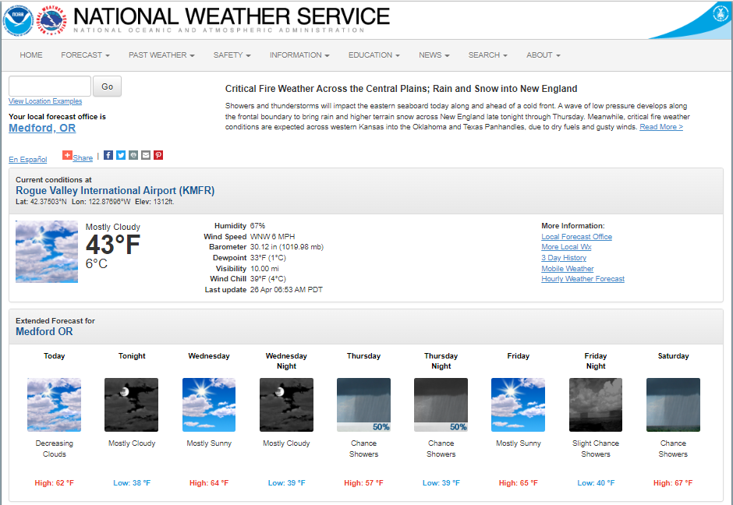
- National Weather Service Weather Forecast Office home page (as a reminder, we are asking about visiting any weather forecast office home page; the image of the Medford, OR Weather Forecast Office home page is just an example)
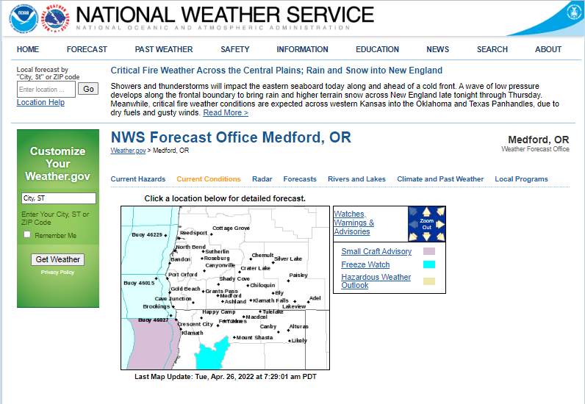

[COLUMNS]
- Never
- Rarely (less than once per month)
- 1-3 times per month
- Once a week
- Daily or multiple times per week
- Don’t remember

[ASK WEATHER WEBSITE VISITORS ONLY IF G4=1 (WEATHER.GOV PAST 12M VISITORS)]
C6. Do you (or would you) visit any of the following web pages on Weather.gov more or less frequently when inclement or hazardous weather is expected? (Select one in each row)
[RADIO BUTTON MATRIX]
[ROWS]
- Main page of Weather.gov
- National Weather Service point forecast web pages
- National Weather Service Weather Forecast Office home page (as a reminder, we are asking about visiting any weather forecast office home page; the image of the Medford, OR Weather Forecast Office home page is just an example)
[COLUMNS]
- Less frequently
- As often as in normal weather
- More frequently

BARRIERS OF USE OF DEDICATED WEATHER WEBSITES
Z1_1. What is your preferred way of getting information about weather most of the time? (Select one)
[RADIO BUTTONS]
[RANDOMIZE, BUT KEEP 1-5, 6-8, 9-12 TOGETHER, ANCHOR OPTION 12]
- [SHOW IF S2=2-4] Dedicated weather website (e.g., weather.gov)
- A local website not dedicated to weather
- Weather app
- Weather widget on your phone screen
- Weather information on a non-weather website that you visit often
- TV
- Radio
- Newspapers
- YouTube
- Twitter
- Facebook
- Receiving information pushed to your mobile device
- Someone else in your family typically monitors this [ANCHOR]
- Not interested in this kind of information [ANCHOR]
- Other (specify)___[ANCHOR, OPEN TEXT RESPONSE]

Z1_2. What is your preferred way of getting information about hazardous weather that may impact life and property? (Select one)
[RADIO BUTTONS]
[RANDOMIZE, BUT KEEP 1-5, 6-8, 9-12 TOGETHER, ANCHOR OPTION 12]
- [SHOW IF S2=2-4] Dedicated weather website (e.g., weather.gov)
- A local website not dedicated to weather
- Weather app
- Weather widget on your phone screen
- Weather information on a non-weather website that you visit often
- TV
- Radio
- Newspapers
- YouTube
- Twitter
- Facebook
- Receiving information pushed to your mobile device
- Someone else in your family typically monitors this [ANCHOR]
- Not interested in this kind of information [ANCHOR]
- Other (specify)___[ANCHOR, OPEN TEXT RESPONSE]

[ASK IF Z1_1 = 1-12]
Z2_1. Why do you prefer [PIPE IN FROM Z1_1] for information about weather most of the time? (Select all that apply)
[CHECK LIST]

[RANDOMIZE 1-10]
- I like it when somebody walks me through the data/provides commentary
- I prefer the conversational style of how the information is delivered
- I trust this source the most
- I am familiar/comfortable using this source
- [SHOW IF Z1_1 NOT SELECTED 6, 7, 12] It is easy to navigate
- The content is easy to understand
- The content is presented in a more interesting way vs. other sources
- I can get information faster this way
- [SHOW IF Z1_1 SELECTED 2-12] I don’t need to do anything proactively
- [SHOW IF Z1_1 SELECTED 3, 10, 11]: I like receiving push notifications on my phone
- Other (specify)___[OPEN TEXT RESPONSE]
[ASK IF Z1_2 = 1-12]
Z2_2. Why do you prefer [PIPE IN FROM Z1_2] for information about hazardous weather that may impact life and property? (Select all that apply)
[CHECK LIST]
[RANDOMIZE 1-10]
- I like it when somebody walks me through the data/provides commentary
- I prefer the conversational style of how the information is delivered
- I trust this source the most
- I am familiar/comfortable using this source
- [SHOW IF Z1_2 NOT SELECTED 6, 7, 12] It is easy to navigate
- The content is easy to understand
- The content is presented in a more interesting way vs. other sources
- I can get information faster this way
- [SHOW IF Z1_2 SELECTED 2-12] I don’t need to do anything proactively
- [SHOW IF Z1_2 SELECTED 3, 10, 11]: I like receiving push notifications on my phone
- Other (specify)___[OPEN TEXT RESPONSE]

[ASK IF G4 = 2 (VISITED WEATHER.GOV MORE THAN 12 MONTHS AGO)]
Z3. You mentioned that you are familiar with the Weather.gov website. Why haven’t you used it in the past 12 months? (Select all that apply)
[CHECK LIST]
[RANDOMIZE 1-6]
- I get information from other National Weather Service sources (social media, alerts) (please explain)___[OPEN TEXT RESPONSE]
- The information wasn’t relevant to me when I last visited it
- The information lacked graphical representation when I last visited it
- I couldn’t find what I wanted on the website when I last visited it (please explain)___ [OPEN TEXT RESPONSE]
- I prefer to access information about weather on my phone, and Weather.gov is not easy to navigate from a mobile device
- I forgot about this website
- I typically get information about weather from other sources
- Other (specify)___[OPEN TEXT RESPONSE]

[ASK Z5 TO PANEL SAMPLE IF SELECTED 4-5 FOR ANY OPTION IN C5 – VISIT WEATHER.GOV AT LEAST ONCE A WEEK. POTENTIALLY ASK PARTNERS AS WELL – DEPENDING ON SURVEY LENGTH]
Z5_1. What do you DISLIKE about [HYPERLINK: Weather.gov]? [OPEN TEXT RESPONSE]
Z5_2. What do you LIKE about [HYPERLINK: Weather.gov]? [OPEN TEXT RESPONSE]

ADDITIONAL FUNCTIONALITY, TOOLS, SERVICES

A1. How useful would you find the following features, tools or improvements related to Weather.gov? (Select one in each row)
[RADIO BUTTON RATING]
[ROWS – RANDOMIZE, BUT KEEP 1-2 TOGETHER]
- Website customized for you based on your past history of visits
- An opportunity to create a profile and select what information will be displayed every time you log in
- [ASK IF PANEL SAMPLE] An opportunity to subscribe to alerts about severe/hazardous weather impacting life and property on the website
- Weather.gov app
[COLUMNS]
- 1 – Not useful at all
- 2
- 3
- 4
- 5 – Very useful
- Don’t know

A2. What language do you primarily use to search for/read information online? (Select one)
[RADIO BUTTONS]
- English
- Spanish
- Chinese (Mandarin, Cantonese, etc.)
- Tagalog (Filipino)
- Vietnamese
- French/French Creole
- Arabic
- Korean
- Russian
- German
- Other (specify)___[OPEN TEXT RESPONSE]

