Exhibit S: Final MAC Adjustment and Overlap Resolution Letter

Exhibit S: Findings
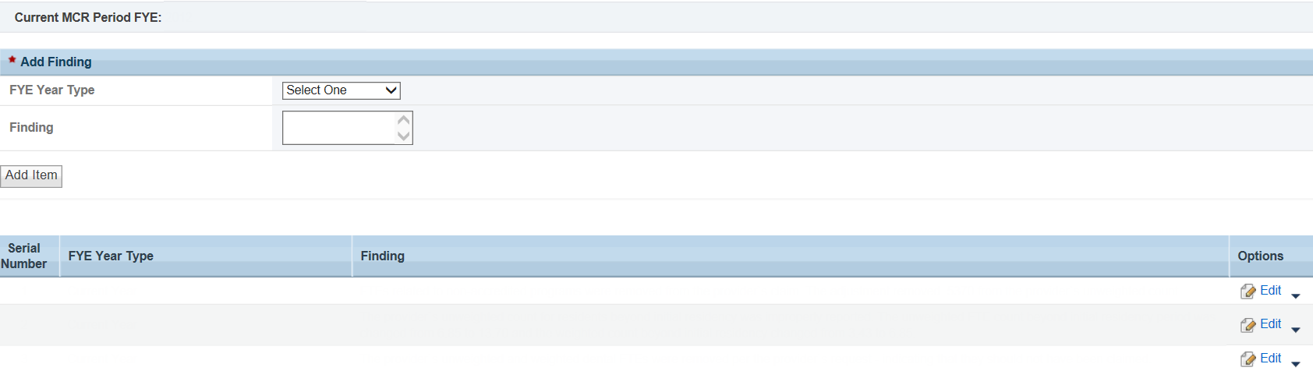

Exhibit S: Recommendations/Conditions
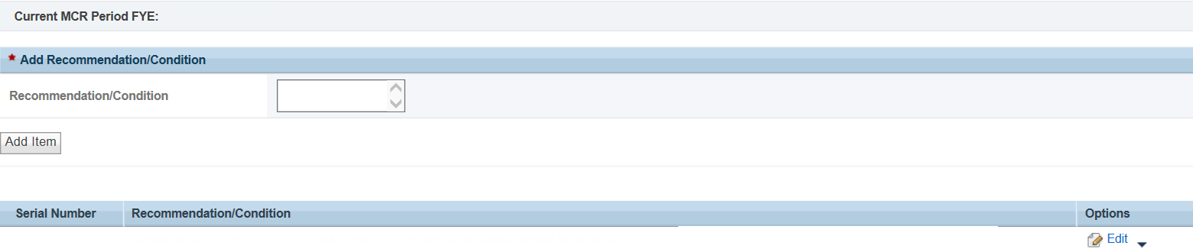

Exhibit S: Field Review Activities
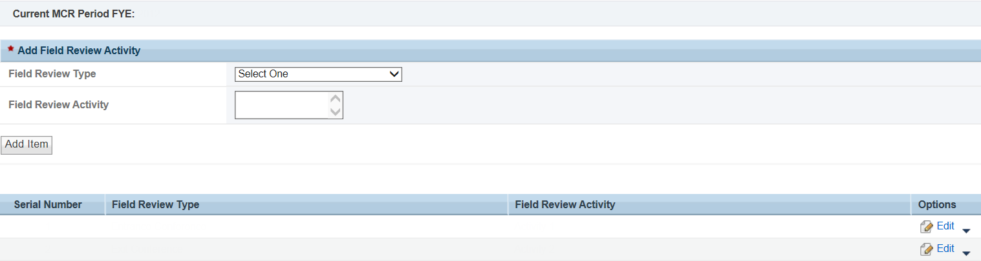

Exhibit S: Medicare Intermediary
