OMB Control No. 0920-1154
Exp. Date 03/31/2026
The public reporting burden of this collection of information is estimated to average 1 minutes per response, including the time for reviewing instructions, searching existing data sources, gathering and maintaining the data needed, and completing and reviewing the collection of information. An agency may not conduct or sponsor, and a person is not required to respond to a collection of information unless it displays a currently valid OMB control number. Send comments regarding this burden estimate or any other aspect of this collection of information, including suggestions for reducing this burden to - CDC/ATSDR Reports Clearance Officer; 1600 Clifton Road NE, MS D-74, Atlanta, Georgia 30333 ATTN: PRA (0920-1154).

GenIC Clearance for CDC/ATSDR
Formative Research and Tool Development

Formative Research for Spanish-Language
Drug Overdose Messages

Attachment 11 - Recruitment Materials (e.g., Standard Invitation, Sample Posts, Sample Images)

Contact: Brittney A. Curtis
Communication Branch
Division of Overdose Prevention (DOP)
National Center for Injury Prevention and Control (NCIPC)
Centers for Disease Control and Prevention (CDC)
4770 Buford Hwy NE, MS S106
Atlanta, Georgia 30341
Phone: 770-488-5423
Email: gnk2@cdc.gov

Standard Invitation
Hello,
We would like to invite you to participate in a study on prevention and education about drug use.

If selected, you’ll receive a $[Insert Amount] after participating in a 90-minute, online focus group or 60-minute individual interview.

Please take a moment to see if you qualify for our paid discussion by accessing the survey link below:

[INSERT LINK]

If you prefer, you may call and speak with [Insert Name of Recruiter] (will take 5-7 minutes). She will also be available to answer any questions you may have.

v [Insert Name of Recruiter] - (610) 356-1800 9am-5pm Eastern Time

v After Hours Calling: Please call (610) 356-1800

Thank you for your time!

Jillian Wales • Recruitment Manager
Research America
Tel: 610-356-1800

Philadelphia • Pottsville • Cincinnati • Willow Grove • Detroit • Lehighton • Rochester • Buffalo • Totowa • Orlando • Sacramento

Click here to unsubscribe

Recruitment Language
Facebook Post Copy
Research America is conducting a study on Health & Wellness, specifically, prevention of and education about drug use.
We invite individuals to participate in our study and to share your experiences.
In return for your time, you will receive at minimum a $[Insert amount] Amazon gift card.
To see if you qualify, [insert link]

Craigslist Post Copy
$[Amount] Paid Health & Wellness Study
Research America is conducting a Health & Wellness Study, specifically, prevention of and education about drug use.
- If selected, you’ll receive a $[amount] gift card after participating in a 90-minute, online focus group or 60-minute individual interview.
- Your survey responses will be anonymous and remain confidential.
- A sales call will never result from your participation in our research.
Copy and paste the link below into your browser to answer a few questions to confirm you qualify.
[Insert Link]
Thank you for your time!
www.researchamericainc.com

Recruitment Sample Images

Below are sample images that may be used in social media recruitment posts. These, and similar images, will be used for recruitment via social media.

 |  | 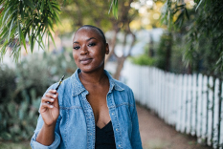
 | 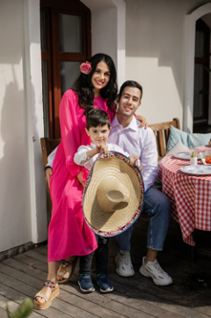
 |  | 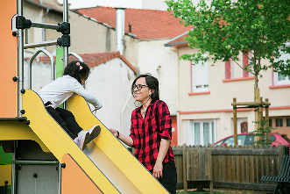
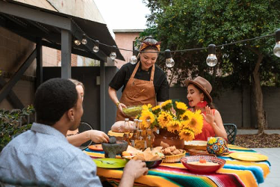 | 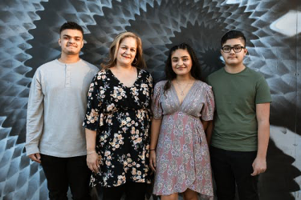
 | 