FORMS VERSION F SERIES
Released: September 25, 2019

GENERAL INSTRUCTIONS FOR NIH AND
OTHER PHS AGENCIES

SF424 (R&R) Application Packages

Guidance developed and maintained by NIH for preparing and submitting applications via Grants.gov to NIH and other PHS
agencies using the SF424 (R&R)

TABLE OF CONTENTS

TABLE OF CONTENTS | 2

G.100 - How to Use the Application Instructions | 3

G.110 - Application Process | 6

G.120 - Significant Changes | 10

G.130 - Program Overview | 13

G.200 - SF 424 (R&R) Form | 25

G.210 - PHS 398 Cover Page Supplement Form | 46

G.220 - R&R Other Project Information Form | 52

G.230 - Project/Performance Site Location(s) Form | 68

G.240 - R&R Senior/Key Person Profile (Expanded) Form | 74

G.300 - R&R Budget Form | 89

G.310 - R&R Subaward Budget Attachment(s) Form | 110

G.320 - PHS 398 Modular Budget Form | 114

G.330 - PHS 398 Training Budget Form | 119

G.340 - PHS 398 Training Subaward Budget Attachment(s) Form | 125

G.350 - PHS Additional Indirect Costs Form | 128

G.360 - SF 424C Budget Information – Construction Programs | 131

G.400 - PHS 398 Research Plan Form | 136

G.410 - PHS 398 Career Development Award Supplemental Form | 154

G.420 - PHS 398 Research Training Program Plan Form | 176

G.430 - PHS Fellowship Supplemental Form | 193

G.440 - SBIR/STTR Information Form | 217

G.500 - PHS Human Subjects and Clinical Trials Information | 225

G.600 - PHS Assignment Request Form | 268

Form Screenshots | i

G.100 - How to Use the Application Instructions

Use these application instructions to fill out the forms that are posted in your funding opportunity announcement.
View the How to Apply Video Tutorials.
Quick Links
Step 1. Become familiar with the application process
Step 2. Use these instructions, together with the forms and information in the funding opportunity announcement, to complete your application
Step 3. Choose an application instruction format
Step 4. Complete the appropriate forms
Step 5. Stay informed of policy changes and updates Step 6. Understand what data NIH makes public
Helpful Links
The information on the following pages may be useful in the application process
- OER Glossary
- Grants Policy Statement
- Guide to Grants and Contracts
- Frequently Asked Questions
Step 1. Become familiar with the application process.
Understanding the application process is critical to successfully submitting your application.
Use the G.110 - Application Process section of these instructions to learn the importance of completing required registrations before submission, how to submit and track your application, where to find page limits and formatting requirements, and more information about the application process.

Step 2. Use these instructions, together with the forms and information found in the funding opportunity announcement, to complete your application.
The funding opportunity announcement (FOA) will include specific instructions and the forms needed for your application submission.
Remember that the FOA instructions always supersede these application instructions.
Step 3. Choose an application instruction format.

Do you know your activity code, but don’t know which application instructions to use? Refer to NIH’s table on Selecting the Correct Application Instructions to determine which set of application instructions applies to your grant program.

Comprehensive Instructions | Program-Specific Instructions
Use the General (G) instructions, available in both HTML and PDF format, to complete the application forms for any type of grant program. | Take advantage of the filtered PDFs to view specific application instructions for:  - Research (R)  - Career Development (K)  - Training (T)  - Fellowship (F)  - Multi-project (M)  - SBIR/STTR (B)
Step 4. Complete the appropriate forms.
Unless otherwise specified in the FOA, follow the standard instruction, as well as any additional
program-specific instructions for each form in your application.
Program-specific instructions are presented in gray call-out boxes that are color coded throughout the application instructions. Consult the G.130 - Program Overview section for context for program specific instructions.

Step 5. Stay informed of policy changes and updates.
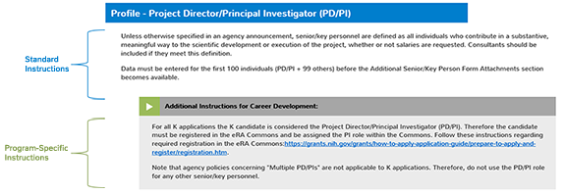
- Refer to the G.120 - Significant Changes section for the most recent changes to these application instructions.
- Review Notices of NIH Policy Changes since the posting of the Application Guide.
Step 6. Understand what data NIH makes public.
Information submitted as part of the application will be used by reviewers to evaluate the scientific merit of the application and by NIH staff to make the grant award and monitor the grant after award. The exception to this is the G.600 - PHS Assignment Request Form, which is only seen by staff in the Division of Receipt and Referral (DRR), Center for Scientific Review (CSR).
If the application is funded, the following fields will be made available to the public through the NIH Research Portfolio Online Reporting Tool (RePORTER) and will become public information:
- Name of Project Director/Principal Investigator (PD/PI), to also include Project Leaders on sub- projects to multi-project projects
- PD/PI title
- PD/PI email address
- Organizational name
- Institutional address
- Project summary/abstract
- Public health relevance statement
In addition, key elements related to ongoing funded projects will be made available to the public, including those listed in the data dictionary at ExPORTER. Additional elements may be made available after announcements through the NIH Guide for Grants and Contracts, a weekly electronic publication that is available on NIH’s Funding page, or additions to the NIH Grants Policy Statement, as needed.

G.110 - Application Process

Understanding the application process is critical to successfully submitting your application. Use this section of this guide to learn the importance of completing required registrations before submission; how to submit and track your application; where to find information about page limits, formatting requirements, due dates, and submission policies; and more information about the application process. This application process information is also available on our How to Apply – Application Guide page.
Quick Links
Prepare to Apply and Register Write Application
Submit
Related Resources

Prepare to Apply and Register

Systems and Roles
Learn about the main systems involved in application submission and the role you and your colleagues play in the submission process. The main systems are Grants.gov, eRA Commons, and ASSIST.
Register
Determine your registration status. Organizations, organizational representatives, investigators, and others need to register in multiple federal systems in order to for you to submit a grant application. Registration can take six weeks or more to complete. Start today! See NIH’s Registration website.
Understand Funding Opportunities
Identify the right funding opportunity announcement (FOA) for your research and learn about key information you will find in the FOA.
Types of Applications
Are you submitting a new, renewal, revision, or resubmission application? Learn about the different types of applications and special submission requirements.
Submission Options
Determine which system is most convenient for your application submission: NIH’s ASSIST web- based application submission system, Grants.gov Workspace, or, if applicable, your organization’s own submission system.

Obtain Software
Applicants must have the free Adobe Reader software, a PDF generator, and a web browser to submit an application. Learn which versions are compatible with our systems.

Write Application

Write Your Application
Read tips for developing a strong application that helps reviewers evaluate its science and merit.
Develop Your Budget
Learn about the kinds of costs you may include in your budget submission, the difference between modular and detailed budgets, and more about how to develop your budget.
Format Attachments
Follow these requirements for preparing the documents you attach to your application. Requirements include criteria for the PDF files, fonts, margins, headers and footers, paper size, citations, formatting pages, etc.
Rules for Text Fields
Learn the rules for form text fields – allowable characters, cutting and pasting, character limits, and formatting.
Page Limits
Follow the page limits specified in this table for your specific grant program, unless otherwise specified in the FOA.
Data Tables
Find instructions, blank data tables, and samples to use with institutional research training applications.
Reference Letters
Some types of programs, such as fellowships and some career development awards, require the submission of reference letters by the referee. Learn about selecting a referee and find instructions for submission.
Biosketches
Biosketches are required in both competing applications and progress reports. Find instructions, blank format pages, and sample biosketches.

Submit

Submit, Track and View
Learn how to submit your application, and about your responsibility for tracking your application and viewing the application image in the eRA Commons before the application deadline. If you can’t view your application in eRA Commons, we can’t review it.

How We Check for Completeness
Your application will be checked at Grants.gov, by eRA systems, and by federal staff before it is referred for review.
Changed/Corrected Applications
You will need to submit a changed/corrected application to correct issues that either you or our systems find with your application. Learn how and when you may submit a changed/corrected application.

Related Resources

Due Dates and Policies Due Dates
View standard due dates for competing applications. The FOA will identify whether to follow
standard due dates or whether to follow an alternative due date.
Submission Policies
Learn the nuances of application submission policies, including when late applications might be allowed, what to do if due dates fall on a weekend or holiday, whether we allow post-submission materials, how to document system issues, the rules around resubmission applications, etc.
Dealing with System Issues
Are you experiencing system issues with ASSIST, Grants.gov, System for Award Management (SAM), or the eRA Commons that you believe threaten your ability to submit on time? NIH will not penalize applicants who experience confirmed issues with federal systems that are beyond their control. You must report the problem before the submission deadline.

After Submission Receipt and Referral
Understand how and when applications are given an application identification number and
assigned to a review group and an NIH Institute or Center (IC) for possible funding.
Peer Review
Learn about our two phase peer review process, including initial peer review, Council review, review criteria, scoring, and summary statements.
Pre-award Process
Learn what happens between peer review and award for applications that have been deemed highly meritorious in the scientific peer review process. Be ready: if you received a great score in peer review, you’ll have to submit Just-in-Time information.
Post award Monitoring and Reporting
If you receive a grant from the NIH, you will need a lot of information to be a successful steward of federal funds. This page provides a brief overview of grantee monitoring and reporting requirements.

Resources
News - Items of Interest
The NIH eSubmission Items of Interest page provides comprehensive information, in an informal format, on the changes impacting application development and submission.
Annotated Form Sets
These handy documents are a great visual resource for understanding many of the validation checks we will run against your submitted application.
Contacting NIH Staff
NIH staff is here to help. We strongly encourage NIH applicants and grantees to communicate with us throughout the grant life cycle. Understanding the roles of NIH staff can help you contact the right person at each phase of the application and award process.
Contacting Staff at Other PHS Agencies
Applicants are strongly encouraged to communicate with agency staff throughout the entire application review and awards process.

Systems
ASSIST
eRA Commons Grants.gov
Information Collection Authorization
The PHS Act establishes the authority with which NIH and other PHS agencies award grants and
collect information related to grant awards.
Paperwork Burden
The paperwork burden provides the estimated time for completing a grant application.
Collection of Personal Demographic Data
NIH collects personal data through the eRA Commons Personal Profile. The data is confidential and is maintained under the Privacy Act record system.

The Application Instructions are updated and released 2-3 times per year as needed. Additionally, minor revisions may be made outside of these releases.
This section details all significant changes and revisions made to the instructions since the last major release.
Within the instructions, new instructions will be marked with this symbol.
In the web version, use your mouse to hover over the icon to read an explanation of the change.
In a PDF version, this symbol will be visible but will not display hover text. For more information, see the explanation in the Significant Changes section below.
G.120 - Significant Changes

Release Notes - Month XX, 2019

SF 424 Research and Related (R&R) Form Changes

FORMS-F application packages incorporate the latest versions of the federal-wide forms managed by Grants.gov (OMB Number: XXXX, Expiration Date: XX/XX/20XX).
SF 424 (R&R) Form
- Clarified instructions regarding Agency Routing Identifier.
- Updated general and SBIR/STTR instructions for the Type of Applicant question, as “Women Owned” and “Socially and Economically Disadvantaged” information is now collected though SAM.

R&R Other Project Information Form
- Project Summary/Abstract instructions updated to indicate that graphics are not allowed.

R&R Senior/Key Person Profile (Expanded) Form
- Added instructions for Career Development and Fellowship applications for the “Credential, e.g., agency login” field.

Forms-F Changes

PHS 398 Cover Page Supplement Form
- Updated OMB Expiration Date to XX/XX/XXXX

PHS 398 Modular Budget Form
- Updated OMB Expiration Date to XX/XX/XXXX

PHS 398 Training Budget Form
- Updated OMB Expiration Date to XX/XX/XXXX

PHS 398 Training Subaward Budget Attachment(s) Form
- Updated OMB Expiration Date to XX/XX/XXXX

PHS Additional Indirect Costs Form
- Updated OMB Expiration date to XX/XX/XXXX

PHS 398 Research Plan Form
- Updated OMB Expiration Date to XX/XX/XXXX
- Added instructions to the “Specific Aims” field indicating that the section is limited to text only.

PHS 398 Career Development Award Supplemental Form
- Updated OMB Expiration Date to XX/XX/XXXX
- Added instructions to the “Specific Aims” field indicating that the section is limited to text only.
- Added instructions about rigor, experimental design, and quantitative approaches to the “Candidate Information and Goals for Career Development” section.
- Added new “Description of Candidate’s Contribution to Program Goals” attachment.
- Renumbered form fields.
- Made minor text edits.

PHS 398 Research Training Program Plan Form
- Updated OMB Expiration Date to XX/XX/XXXX
- Added instructions to the “Proposed Training” section of the “Program Plan” about rigor, experimental design, and quantitative approaches.
- Added instructions for the “Plan for Instruction in Methods for Enhancing Reproducibility” attachment.
- Updated instructions for the “Progress Report (for Renewal applications)” attachment.
- Removed instructions regarding policies, procedures, and oversight to prevent harassment and discrimination in the “Letters of Support” attachment, as these are now collected through eRA Commons.
- Made minor text edits.

PHS Fellowship Supplemental Form
- Updated OMB Expiration Date to XX/XX/XXXX

- Added instructions about rigor, experimental design, and quantitative approaches to the “Training Goals and Objectives” section of the “Applicant’s Background and Goals for Fellowship Training” attachment.
- Added instructions to the “Specific Aims” field indicating that the section is limited to text only.
- Added instructions regarding rigor to the “Significance” and “Approach” sections of the “Research Strategy” attachment.
- Added instructions for the “Authentication of Key Biological and/or Chemical Resources” field.
- Added new “Description of Candidate’s Contribution to Program Goals” attachment.
- Renumbered form fields.
- Made minor text edits.

PHS Human Subjects and Clinical Trials Information
- Updated OMB Expiration date to XX/XX/XXXX
- Changes were made to the form’s organization in the following sections:
  - Who should use the PHS Human Subjects and Clinical Trials Information form
  - Using the PHS Human Subjects and Clinical Trials Information form
  - Use of Human Specimens and/or Data
- Clarified and updated instructions throughout. Significant changes were made for the following fields:
  - “Provide the ClinicalTrials.gov Identifier”
  - “Section 2 – Study Population Characteristics” instructions now reflect updated exceptions for required questions.
  - Study Timeline
  - “Data and Safety Monitoring Plan” attachment
- Added new “Inclusion of Individuals Across the Lifespan” attachment.
- Updated instructions for the “Inclusion of Women and Minorities” attachment to reflect separate “Inclusion of Individuals Across the Lifespan” attachment.
- Added new “Inclusion Enrollment Report Title” field.
- Removed the “Brief Summary” field.
- Changed the “Narrative Study” field to “Detailed Description.”
- Renumbered form fields.

PHS Assignment Request Form
- Updated OMB Expiration Date to XX/XX/XXXX
- Updated language in the form to clarify that this form is for suggestions.
- Removed the “Do Not Assign to Awarding Component” and “Do Not Assign to Study Section” fields and instructions.
- Added new “Rationale for assignment suggestions” field.

G.130 - Program Overview

Quick Links
Research and Other ("R" Series).
Individual Research Career Development Award (CDA) Application ("K" Series). Institutional Research Training and Career Development Program Applications ("T" Series). Individual Fellowship Applications ("F" Series).
Multi-project Applications ("M" Series).
Small Business Innovation Research (SBIR) and Small Business Technology Transfer (STTR).

Research and Other ("R" Series)

The purpose of research and other awards is to provide support for health-related research and development based on the mission of the NIH. Some examples of support include pilot studies; conferences and scientific meetings; small research projects; institutional training and director program projects; resource programs; and new, exploratory, and developmental research projects. Awards may be in the form of grants or cooperative agreements.
Additional research instructions will be denoted by a gray call-out box with yellow color coding and with the heading “Additional Instructions for Research” throughout these application instructions.
Additional Instructions for Research:

Before Applying:
- Become familiar with Activity Code: Applicants should become familiar with the activity code for which support is being requested. These include many “R” activity codes, as well as some “DP,” “G," “S,” and “U” activity codes. A comprehensive list of all activity codes, with their descriptions, is available on NIH’s Activity Codes Search Results website.
- Refer to your specific FOA: Refer to your FOA for specific information associated with the award mechanism, including the eligibility requirements, review criteria, award provisions, any special application instructions, and names of individuals who may be contacted for additional or clarifying information prior to application submission.
- Contact Awarding Component: Applicants are encouraged to consult with the NIH Scientific/Research contact of the appropriate awarding component prior to submitting an application, as eligibility criteria, support levels, and availability of awards may vary among NIH Institutes or Centers and other PHS agencies.
The following chart provides a summary of the existing research programs; however, the chart is not a comprehensive list of activity codes. Since this information is subject to change, prospective

applicants are encouraged to review NIH’s Types of Grant Programs for the most current program information.

Summary of Research Award Programs*

Activity Code | Program Description
R01 | Research Project
R03 | NIH Small Grant Program
R13 | Conference
R15 | NIH Academic Research Enhancement Award (AREA)
R21 | NIH Exploratory/Developmental Research Grant Award
R25 | Education Projects
U01 | Research Project – Cooperative Agreements
U13 | Conference - Cooperative Agreements
G07 | Resources Improvement Grant
S10 | Biomedical Research Support Shared Instrumentation Grants
DP1 | NIH Director's Pioneer Award (NDPA)
*This is not a comprehensive list of activity codes.

Individual Research Career Development Award (CDA) Application ("K" Series)

The purpose of the career development award (CDA) program is to provide candidates at the postdoctoral, early career, and mid-career stages with opportunities to build on their initial research training and to further develop their research careers through individual or institutional awards.
This section provides instructions for candidates applying for individual career development awards. Applicants for institutional career development programs, such as the K12 award, should follow the guidance provided in the "Additional Instructions for Training" sections.
Reference Letters: Instructions for submitting the required reference letters for applicable programs are not contained in these application instructions. Instead, follow the instructions on NIH’s Reference Letters page. Referees must submit reference letters through the eRA Commons by the application due date.
Additional career development instructions will be denoted by a gray call-out box with green color coding and with the heading “Additional Instructions for Career Development” throughout these application instructions.
Additional Instructions for Career Development:

Before Applying:
- Become familiar with Activity Code: Applicants should become familiar with the K activity code for which support is being requested. A listing of “K” series activity codes, with their descriptions, is available on the Research Career Development Awards page.
- Refer to your specific FOA: Refer to your FOA for specific information associated with the award mechanism, including the eligibility requirements, requirements for a mentor or mentors, review criteria, award provisions, any special application instructions, and names of individuals who may be contacted for additional or clarifying information prior to application submission.
  - FOAs and other guidelines are available on the NIH K Kiosk.
  - Announcements for various career award opportunities are issued periodically in the NIH Guide for Grants and Contracts, a weekly electronic publication, that is available on NIH’s Funding page.
  - Some individual K-series programs supported by the NIH include a delayed- award activation and/or two award phases (e.g., K22, K99/R00). NIH intramural researchers may be eligible to apply for these awards. The FOA will include any additional and/or specific instructions that must be followed when applying for such support.
- Contact Awarding Component: Applicants are encouraged to consult with the NIH Scientific/Research contact of the appropriate awarding component prior to submitting an application, as eligibility criteria, support levels, and availability of awards may vary among NIH Institutes or Centers and other PHS agencies.
The following chart provides a summary of the existing individual career development programs. Since this information is subject to change, prospective applicants are encouraged to review the K Kiosk for the most current program information.

Summary of Research Career Development Award Programs

Program | Description | Mentor | Reference Letter
K01 | Mentored Research Scientist Career Development Award | Yes | Yes
K02 | Independent Research Scientist Development Award | No | No
K05 | Senior Research Scientist Award | No | No
K07 | Academic Career Development Award | * | *
K08 | Mentored Clinical Scientist Research Career Development Award | Yes | Yes
K18 | Research Career Enhancement Award for Established Investigators | Yes | Yes
K22 | Career Transition Award | * | Yes

Program | Description | Mentor | Reference Letter
K23 | Mentored Patient-Oriented Research Career Development Award | Yes | Yes
K24 | Mid-Career Investigator Award in Patient-Oriented Research | No | No
K25 | Mentored Quantitative Research Career Development Award | Yes | Yes
K26 | Mid-Career Investigator Award in Biomedical and Behavioral Research | No | No
K43 | Emerging Global Leader Award | Yes | Yes
K76 | Emerging Leaders Career Development Award | Yes | Yes
K99/R00 | Pathways to Independence Award | Yes | Yes
*Varies with career status and source of award. Check the FOA.
Institutional Research Training and Career Development Program Applications ("T" Series)
The purpose of research training awards is to provide support for institutional research training programs and opportunities for trainees at the undergraduate, graduate, and postdoctoral levels.
Training-specific instructions apply both to NIH-supported Ruth L. Kirschstein National Research Service Award (NRSA) institutional research training programs (e.g., T32, T34, T35, T36, T90) and to non-NRSA training and career development programs (e.g. T15, T37, D43, D71, K12, U2R).
Additional training instructions will be denoted by a gray call-out box with blue color coding and with the heading “Additional Instructions for Training” throughout these application instructions.
Additional Instructions for Training:
NRSA Programs: These programs help ensure that a diverse pool of highly trained scientists is available in adequate numbers and in appropriate research areas to carry out the nation’s biomedical and behavioral research agenda. Certain specialized training grants, such as undergraduate training grants (T34), are provided under this authority.
Non-NRSA Programs: Non-NRSA training and career development programs operate under different regulatory authorities than NRSA programs. While much of the information may be the same, individuals interested in those programs should carefully read the applicable Funding Opportunity Announcement (FOA) for specific program information and special application instructions. Non-NRSA training programs may have eligibility requirements, due dates, award provisions, and review criteria that differ from those of NRSA programs.
Payback Service Requirement: For NRSA programs that include postdoctoral trainees, the program director must explain the terms of the payback service requirement to all prospective

postdoctoral training candidates. A complete description of the service payback obligation is available in the NIH Grants Policy Statement, Section 11.4.3: Payback.

Before Applying:
- Become familiar with Activity Code: Applicants should become familiar with the activity code and the purpose of the specific program for which support is being requested. A listing of “T” series activity codes, with their descriptions, is available on the Institutional Training Grants page.
- Refer to your specific FOA: Refer to your FOA for specific information associated with the award mechanism and the names of individuals who may be contacted for additional or clarifying information prior to application submission.
  - FOAs and other guidelines are available on the NIH T Kiosk.
  - Announcements for various training programs are issued periodically in the NIH Guide for Grants and Contracts, a weekly electronic publication, that is available on NIH’s Funding page.
- Contact Awarding Component: Applicants are encouraged to consult with the NIH Scientific/Research contact of the appropriate awarding component prior to submitting an application, as eligibility criteria, support levels, and availability of awards may vary among NIH Institutes or Centers and other PHS agencies.
The following chart provides a summary of the existing training programs. Since this information is subject to change, prospective applicants are encouraged to review the T Kiosk for the most current program information.

Summary of Institutional Training Programs

Activity Code | Program Description | NRSA?
D43 | International Research Training Grants | No
D71 | International Research Training Planning Grant | No
K12 | Clinical Scientist Institutional Career Development Program Award | No
T32 | Institutional National Research Service Award (NRSA) | Yes
T34 | Undergraduate National Research Service Award (NRSA) Institutional Research Training Grant | Yes
T35 | National Research Service Award (NRSA) Short-Term Institutional Research Training Grant | Yes
T36 | National Research Service Award (NRSA) Short-Term Institutional Research Training Grant | Yes
T90 | Interdisciplinary Research Training Award | Yes
U2R | International Research Training Cooperative Agreement | No

Individual Fellowship Applications (“F” Series)

The purpose of individual fellowship awards is to provide individual research training opportunities to fellows at the graduate and postdoctoral levels. This section contains information for preparing Kirschstein-NRSA (NRSA) fellowship and non-NRSA fellowship applications.
Additional fellowship instructions will be denoted by a gray call-out box with orange color coding and with the heading “Additional Instructions for Fellowship” throughout these application instructions.
Additional Instructions for Fellowship:
NRSA Programs: The NRSA program helps ensure that a diverse pool of highly trained scientists is available in adequate numbers and in appropriate research areas to carry out the nation’s biomedical and behavioral research agenda. NRSA fellowships are awarded as a result of national competition for research training in specified health-related areas. Certain specialized individual fellowships, such as the predoctoral fellowships (F31 and F30), postdoctoral fellowships (F32), senior fellowships (F33), and other institute-specific fellowship programs, are provided under this authority.
Non-NRSA Programs: Fogarty International Center (FIC) and National Library of Medicine (NLM) also have unique funding authorities for fellowships that are not under the NRSA authority. Note that non-NRSA programs may have eligibility requirements, due dates, award provisions, and review criteria that differ from those of NRSA programs. Applicants should refer to their FOA.
Reference Letters: Instructions for submitting the required reference letters for applicable programs are not contained in these application instructions. Instead, follow the instructions on NIH’s Reference Letters page. Referees must submit reference letters through the eRA Commons by the application due date.
Payback Service Requirement: For NRSA programs that include postdoctoral fellows, the program director must explain the terms of the payback service requirement to all prospective postdoctoral fellowship candidates. A complete description of the service payback obligation is available in the NIH Grants Policy Statement, Section 11.4.2: Implementation.

Before Applying:
- Become familiar with Activity Code: Applicants should become familiar with the “F” activity code for which support is being requested. A listing of “F” series activity codes, with their descriptions, is available on the NIH F Kiosk and the AHRQ-Sponsored Training Opportunities page.
- Refer to your specific FOA: Refer to your specific FOA for specific information associated with the award mechanism, including the eligibility requirements, requirements for a mentor, review criteria, award provisions, any special application instructions, and names of individuals who may be contacted for additional or clarifying information prior to application submission.
  - FOAs and other guidelines are available on the NIH F Kiosk.
  - Guidelines for the AHRQ fellowships may be found on AHRQ's Research Training and Education website.

- Contact Awarding Component: Applicants are encouraged to consult with the appropriate NIH IC or AHRQ staff prior to submitting an application, as not all predoctoral, postdoctoral, and senior fellowships are supported by each IC or AHRQ.
  - A list of contacts specifically for extramural training at the NIH ICs can be found on the NIH Training Advisory Committee Roster.
  - For contacts at AHRQ, see AHRQ’s Research Training Staff Contacts website.
The following chart provides a list of fellowship activity codes. Since this information is subject to change, prospective applicants are encouraged to review the F Kiosk for the most current program information.

Summary of Individual Fellowship Award Programs

Activity Code | Program Description | NRSA?
F05 | International Research Fellowships | No
F30 | Individual Predoctoral National Research Service Award (NRSA) for M.D./Ph.D. and Other Dual Degree Fellowships | Yes
F31 | Predoctoral Individual National Research Service Award | Yes
F32 | Postdoctoral Individual National Research Service Award | Yes
F33 | National Research Service Awards for Senior Fellows | Yes
F37 | Medical Informatics Fellowships | No
F38 | Applied Medical Informatics Fellowships | No
F99/K00 | Individual Predoctoral to Postdoctoral Fellow Transition Award | No

Multi-project Applications ("M" Series)

A multi-project application is a single submission with multiple, interrelated components that share a common focus or objective.
A component is a distinct, reviewable part of a multi-project application for which there is a business need to gather detailed information as defined in a particular funding opportunity announcement (FOA). Components typically include general information (component organization, project period, project title, etc.), information about performance sites, information about proposed work to be accomplished, and a budget.
Additional multi-project instructions will be denoted by a gray call-out box with red color coding and with the heading “Additional Instructions for Multi-project” throughout these application instructions.
Additional Instructions for Multi-project:
Although multi-project applications use the same forms used for single-project applications, there are some differences in the way multi-project applications are structured. Every multi- project application includes:

- A Single Overall Component: The Overall Component describes the entire application and provides an overview of how each of the other components fit together.
- One or more Other Component Types: Other Component types (e.g., Admin Core, Project Core) will vary by opportunity and will be specified in the FOA.
- Summaries: Information is automatically compiled from the data provided by the applicant in the individual components and included as part of the Overall Component in the agency- assembled application to help reviewers and staff work with the application. The following summaries are generated:
  - Component
  - Performance Sites
  - Human Subjects - Clinical Trials – Vertebrate Animals- hESC
  - Human Embryonic Stem Cell Lines
  - Budget
  - Program Income
  - Senior/Key Personnel
  - Biosketches
For information on how your application will be automatically assembled for review and funding consideration after submission, see the How eRA Assembles Multi-project Applications file.

Before Applying:
- Become familiar with Activity Code: Applicants should become familiar with the activity code(s) for which support is being requested. A comprehensive list of all activity codes, with their descriptions, is available on the Activity Codes Search Results website.
- Refer to your specific FOA: Refer to your specific FOA for specific information associated with the award mechanism, including special application instructions.
  - The FOA will specify the types of Other Components that should be used when preparing the application, whether each component is optional or required, and any restrictions on the number of times each component can be included in an application.
- Contact Awarding Component: Applicants are encouraged to consult with the NIH Scientific/Research contact of the appropriate awarding component prior to submitting an application, as eligibility criteria, support levels, and availability of awards may vary among NIH Institutes or Centers and other PHS agencies.

Collaborating with Other Organizations
Multi-project applications often include a number of collaborating organizations in addition to the applicant organization. The applicant organization always has primary responsibility for and leads the Overall Component. A collaborating organization may be responsible for a small part of a component or have lead responsibility for an entire Other Component within the application.
Depending on the role of the collaborating organization(s) in the project, there are two approaches to structuring a component:

Collaborating Organization as the Lead of a Component:
When the bulk of the leadership and work on a component (other than the Overall Component) is performed by a collaborating organization, then that organization can be set up as the lead organization for that component. All the component forms (including the SF 424 R&R Form and the R&R Budget Form) are completed using the collaborating organization’s information. On the R&R Budget Form, use the Budget Type “Project” to identify it as the primary budget for the component and provide the collaborating organization’s DUNS number and name. Any other organizations involved in the component (including the applicant organization) are included in subaward/consortium budget forms.
From an administrative perspective, the entire component (minus any work done by the applicant organization) is treated as a subaward/consortium to the applicant organization. The structure of the application reflects where the proposed work is being done, not the flow of funds. eRA systems use the DUNS numbers included on budget forms to determine the flow of funds.

Collaborating Organization as a Consortium in a Component:
When a collaborating organization does not have a leadership role for a component, then the applicant organization is the component lead, and any collaborating organizations are included using the subaward/consortium budget form.

Multi-project Application Component Forms
You must complete a set of forms for each component.
The assembled application image created for a multi-project application has a predefined order. For information on multi-project application assembly, see the How eRA Assembles Multi-project Applications file.
The chart below summarizes which forms must be completed for each component.

Component Data Forms

Form | Overall | Admin Core, Core Project, Other named components | Indiv Career Dev | Career Dev | NRSA  Training
SF424 R&R cover
PHS 398 Cover Page Supplement
R&R Other Project Information
Project/Performance Sites
R&R Sr/Key Person Profile (Expanded)
PHS Human Subjects and Clinical Trials Information

Form | Overall | Admin Core, Core Project, Other named components | Indiv Career Dev | Career Dev | NRSA  Training
PHS Assignment Request Form | Optional
R&R Budget
R&R Subaward Budget Attachment |  | Optional | Optional | Optional
PHS 398 Training Budget
Training Subaward Budget Attachment Form |  |  |  |  | Optional
PHS Additional Indirect Costs | Optional
PHS 398 Research Plan
PHS 398 Career Development Award Supplemental Form
PHS 398 Research Training Program Plan
Small Business Innovation Research (SBIR) and Small Business Technology Transfer (STTR)
The SBIR and STTR programs, also known as America’s Seed Fund, are one of the largest sources of early-stage capital for technology commercialization in the United States. These programs allow US-owned and operated small businesses to engage in federal research and development that has a strong potential for commercialization.
Additional SBIR/STTR instructions will be denoted by a gray call-out box with purple color coding and with the heading “Additional Instructions for SBIR/STTR” throughout these application instructions.
Additional Instructions for SBIR/STTR:

New to SBIR/STTR?
View our SBIR/STTR Application Process Infographic. View the Three-Phase Program description page.
Confirm Small Business Eligibility Criteria.

Develop an Innovative Research Idea with Commercial Potential
Determine which SBIR/STTR funding opportunity announcement (FOA) is most appropriate for your idea. The Omnibus SBIR/STTR solicitations allow researchers to submit their own ideas to NIH. Targeted SBIR/STTR FOAs are more focused around specific research areas.
Before starting the application process, you should speak with an HHS SBIR/STTR representative at the NIH IC or PHS agency to which you are applying.

Required Registrations
The registration process may take 6 – 8 weeks, so it is important to start early. Learn about the Electronic Submission Process, including the SBA Company Registration, which is unique to SBIR/STTR applicants. Small businesses are encouraged to submit via ASSIST.

Three Phase Program:
Both the SBIR and STTR programs are divided into three phases:
  - Phase I: Feasibility and Proof of Concept,
  - Phase II: Research/Research and Development, and
  - Phase III: Commercialization.
Additionally, the Commercialization Readiness Pilot (CRP) Program, if reauthorized, uses SBIR funding (as such, applicants must be a SBIR-eligible Small Business), and follows all Phase II instructions (although it is not a Phase I, II, IIB, or III award).
The chart below provides a summary of details for each of those phases.

Application Name | Definition | Budget / Time Guidelines* | Participating HHS Com-  ponent | Commercialization Plan? | Grant Type
Phase I | Establish the tech- nical merit and feas- ibility of the proposed R&D efforts | $150,000  total costs, 6 - 12  months | NIH, CDC, FDA | No | New/Resub
Fast-Track | One application for Phase I and Phase II that is submitted and reviewed together | $150,000 +  $1,000,000  total costs, 2.5-3 years | NIH | Yes | New/Resub
Direct Phase II (SBIR Only) | Bypass Phase I if feasibility studies are completed | $1,000,000  total costs, for 2 years | NIH | Yes | New/Resub
Phase II | Full R&D Award | $1,000,000  total costs, for 2 years | NIH, CDC, FDA | Yes | Renewal
Phase IIB | For projects that require extraordin- | $1,000,000  total costs | NIH | Yes | Renewal

Application Name | Definition | Budget / Time Guidelines* | Participating HHS Com-  ponent | Commercialization Plan? | Grant Type
 | ary time and effort in the R&D phase | per year for up to 3 years
Commercialization Readiness  (CRP) Pilot Pro- gram | The CRP may fund commercialization activities that are not typically sup- ported through SBIR/STTR Phase II or Phase IIB awards.  *Must have Phase II or IIB to apply* | Up to  $300,000 or  $3 million for up to 2 or 3 years | NIH, CDC | Yes | Renewal
Phase III | Commercialization activities (e.g.: Dir- ect sales, part- nerships, licensing deals, mergers, and acquisitions) | N/A | Typically not supported by HHS | N/A | N/A
* At NIH, deviations from the budget guidelines are acceptable, but must be well justified and discussed with NIH program staff prior to application submission. According to statutory guidelines, total funding support (direct costs, indirect costs, and fee) normally may not exceed
$150,000 for Phase I awards and $1,000,000 for Phase II awards; however, with appropriate justification from the applicant, Congress will allow awards to exceed these amounts by up to 50% as a hard cap ($225,000 for Phase I and $1,500,000 for Phase II). However, NIH has also received a waiver from SBA, as authorized by the statute, to exceed the hard cap (of $225,000 for Phase I and $1,500,000 for Phase II) for specific topics. The list of approved topics can be found on the SBIR/STTR Funding page. Applicants are strongly encouraged to contact program officials prior to submitting any application in excess of the guidelines and early in the application planning process. In all cases, applicants should propose a budget that is reasonable and appropriate for completion of the research project.

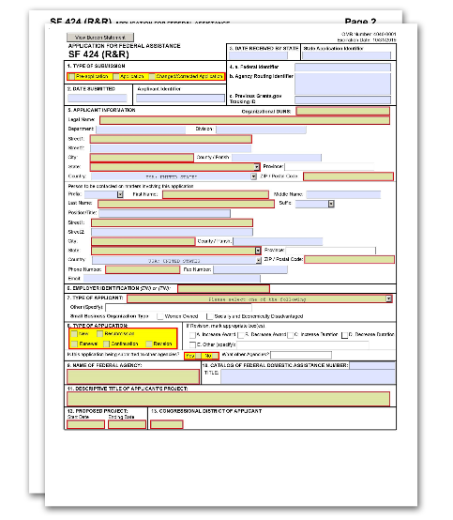
G.200 - SF 424 (R&R) Form

The SF 424 (R&R) Form is used in all grant applications. This form collects information including type of submission, applicant information, type of applicant, and proposed project dates.
View larger image

Quick Links
- Type of Submission
- Date Submitted and Applicant Identifier
- Date Received by State and State Application Identifier 4a. Federal Identifier
4b. Agency Routing Identifier
4c. Previous Grants.gov Tracking ID 5. Applicant Information
6. Employer Identification 7. Type of Applicant
- Type of Application
- Name of Federal Agency
- Catalog of Federal Domestic Assistance Number and Title 11. Descriptive Title of Applicant's Project
- Proposed Project
- Congressional District of Applicant
- Project Director/Principal Investigator Contact Information 15. Estimated Project Funding
16. Is Application Subject to Review by State Executive Order 12372 Process? 17. Certification
18. SFLLL (Disclosure of Lobbying Activities) or Other Explanatory Documentation 19. Authorized Representative
- Pre-application
- Cover Letter Attachment

Overall Component: Fill in all the SF424 (R&R) Form fields, as they are all collected.
Other Components: You need to fill in only a subset of fields in the SF424 (R&R) Form. Skip the other fields, as any information provided in them will be discarded. The fields you must fill in are:
5. Applicant Information
7. Type of Applicant (Optional)
- Descriptive Title of Applicant's Project
- Proposed Project
Additional Instructions for Multi-project:

1. Type of Submission

This field is required. Check one of the "Type of Submission" boxes:

Pre-application:
The pre-application option is not used by NIH or other PHS agencies unless specifically noted in a funding opportunity announcement (FOA).

Application:
An "Application" is a request for financial support of a project or activity submitted on specified forms and in accordance with NIH instructions. (See NIH Types of Applications for an explanation of the types of applications).

Changed/Corrected Application:
Check this box if you are correcting either system validation errors or application assembly problems that occurred during the submission process. Changed/corrected applications must be submitted before the application due date.
When you submit a changed/corrected application, follow these guidelines:
- After submission of an application, there is a two-day application viewing window. Prior to the due date, you may submit a changed/corrected application. Submitting a changed/corrected application will replace the previous submission and remove the previous submission from consideration.
- If you check the “Changed/Corrected Application” box, then "Field 4.c Previous Grants.gov Tracking ID” is required.
- Do not use the “Changed/Corrected Application” box to denote a resubmission application. Resubmission applications will be indicated in “Field 8. Type of Application.” See NIH Glossary for the definition of Resubmission.
SBIR/STTR Phase II/IIB Applications: To maintain eligibility to seek Phase II or IIB support, a Phase I awardee should submit a Phase II application, and a Phase II
Additional Instructions for SBIR/STTR:

awardee should submit a Phase IIB application, within the first six due dates
following the expiration of the Phase I or II budget period, respectively.

2. Date Submitted and Applicant Identifier

The “Date Submitted” field will auto-populate upon application submission.
Fill in the “Applicant Identifier” field, if applicable. The Applicant Identifier is reserved for applicant use, not the federal agency to which the application is being submitted.

3. Date Received by State and State Application Identifier

Skip the “Date Received by State” and “State Application Identifier” fields.

4.a. Federal Identifier

New Applications without Pre-application: Leave this field blank.
New Applications following Pre-application: Enter the agency-assigned pre-application number.
Resubmission, Renewal, and Revision Applications: The Federal Identifier is required. Include only the IC and serial number of the previously assigned application/award number (e.g., use CA987654 from 1R01CA987654-01A1).
When submitting a Phase II application, enter the Phase I SBIR/STTR grant number in this field.
For more information on applying for SBIR/STTR Phase II or Phase IIB awards, see SBIR/STTR Frequently Asked Questions.
Additional Instructions for SBIR/STTR:

4.b. Agency Routing Identifier

Skip the “Agency Routing Identifier” field unless otherwise specified in the FOA or notice in the NIH Guide for Grants & Contracts.
Applications in response to a NIH Notice of Special Interest require the notice number (e.g., NOT- IC-FY-XXX) to be entered into this field in order to assign and track applications and awards for the described initiative.

4.c. Previous Grants.gov Tracking ID

The “Previous Grants.gov Tracking ID” field is required if you checked the “Changed/Corrected Application” box in “Field 1. Type of Submission.” A Tracking ID number is of the form, for example, GRANT12345678.

5. Applicant Information

The "Applicant Information" fields reflect information for the applicant organization, not a specific individual.
Other Components: The “Applicant Information” section is required and applies to the lead organization of the component.
Additional Instructions for Multi-project:
The small business concern is always the applicant organization for an SBIR or STTR award (e.g., ABC Incorporated).
The small business concern must be located in the United States.
Additional Instructions for SBIR/STTR:

Organizational DUNS:
This field is required.
Enter the DUNS or DUNS+4 number of the applicant organization.
This DUNS or DUNS+4 number must match the number entered in the eRA Commons Institutional Profile (IPF) for the applicant organization. The applicant’s Authorized Organization Representative (AOR) is encouraged to confirm that a DUNS has been entered into the eRA Commons IPF prior to application submission. The same DUNS should be used in the eRA Commons IPF, Grants.gov, System for Award Management (SAM) registration, and in the DUNS field in the application.
If your organization does not already have a DUNS number, you will need to go to the Dun & Bradstreet website to obtain the number.
Other Components: If a component is led by an organization other than the applicant organization, then you must provide the lead organization’s DUNS or DUNS+4. However, the lead organization does not need to be registered in SAM or in eRA Commons at the time of application. SAM registration is encouraged since it helps staff process your application if you are selected for funding.
Additional Instructions for Multi-project:

Legal Name:
Enter the legal name of the organization.

Department:
Enter the name of the primary organizational department, service, laboratory, or equivalent level within the organization.

Division:
Enter the name of the primary organizational division, office, major subdivision, or equivalent level within the organization.

Street1:
This field is required. Enter the first line of the street address for the applicant organization.

Street2:
Enter the second line of the street address for the applicant organization.

City:
This field is required. Enter the city for the address of the applicant organization.

County/Parish:
Enter the county/parish for the address of the applicant organization.

State:
This field is required if the applicant organization is located in the United States or its territories. Enter the state or territory where the applicant organization is located.

Province:
If “Country” is Canada, enter the province of the applicant organization; otherwise, skip the “Province” field.

Country:
This field is required. Select the country for the address of the applicant organization.

ZIP/Postal Code:
The ZIP+4 is required if the applicant organization is located in the United States. Otherwise, the postal code is optional. Enter the ZIP+4 (nine-digit postal code) or postal code of the applicant organization.

Person to be contacted on matters involving this application

This information is for the administrative contact (e.g., AOR or business official), not the PD/PI. This person is the individual to be notified if additional information is needed and/or if an award is made.

Prefix:
Enter or select the prefix, if applicable, for the name of the person to contact on matters related to this application.

First Name:
This field is required. Enter the first (given) name of the person to contact on matters related to this application.

Middle Name:
Enter the middle name of the person to contact on matters related to this application.

Last Name:
This field is required. Enter the last (family) name of the person to contact on matters related to this application.

Suffix:
Enter or select the suffix, if applicable, for the name of the person to contact on matters related to this application.

Position/Title:
Enter the position/title for the person to contact on matters related to this application.

Street1:
This field is required. Enter the first line of the street address for the person to contact on matters related to this application.

Street2:
Enter the second line of the street address for the person to contact on matters related to this application.

City:

This field is required. Enter the city for the address of the person to contact on matters related to this application.

County/Parish:
Enter the county/parish for the address of the person to contact on matters related to this application.

State:
This field is required if the person to contact on matters related to this application is located in the United States or its Territories. Enter the state or territory where the person to contact on matters related to this application is located.

Province:
If “Country” is Canada, enter the province for the person to contact on matters related to this application; otherwise, skip the “Province” field.

Country:
Select the country for the address of the person to contact on matters related to this application.

ZIP/Postal Code:
The ZIP+4 is required if the person to contact on matters related to this application is in the United States. Otherwise, the postal code is optional. Enter the ZIP+4 (nine-digit postal code) or postal code of the person to contact on matters related to this application.

Phone Number:
This field is required. Enter the daytime phone number for the person to contact on matters related to this application.

Fax Number:
Enter the fax number for the person to contact on matters related to this application.

E-mail:
Enter the e-mail address for the person to contact on matters related to this application. Only one e-mail address is allowed, but it may be a distribution list.

6. Employer Identification

This field is required.
Enter either the organization’s Taxpayer Identification Number (TIN) or Employer Identification Number (EIN) as assigned by the Internal Revenue Service. If your organization is not in the United States, enter 44-4444444. Your EIN may be 12 digits, and if this is the case, enter all 12 digits.
The small business must be located in the United States or a U.S. territory.
Additional Instructions for SBIR/STTR:

7. Type of Applicant

This field is required.
In the first field under “7. Type of Applicant,” enter the appropriate applicant type. If your applicant type is not specified (e.g., for eligible Agencies of the Federal Government), select “X: Other (specify),” and indicate the name (e.g., the appropriate federal agency) in the space below.
The information in “7. Type of Applicant” is for the applicant organization, not a specific individual authorized organization representative (AOR) or fellowship PD/PI.
Additional Instructions for Fellowship:
Other Components: You may fill out “7. Type of Applicant,” but it is optional.
Additional Instructions for Multi-project:
Select “R. Small Business.”
The applicant organization must certify (through Just-in-Time pre-award procedures) that it will qualify as a small business concern at the time of award.
Additional Instructions for SBIR/STTR:

Other (Specify):
Complete only if “X. Other (specify)” is selected as the "Type of Applicant."

Women Owned:
Do not use the "Women Owned" checkbox.

Socially and Economically Disadvantaged:
Do not use the "Socially and Economically Disadvantaged" checkbox.
Note: NIH, CDC, and FDA use the Business Type information provided in the System for Award Management entity record for the applicant organization, rather than the “Woman Owned” and “Socially and Economically Disadvantaged” checkboxes, to determine the small business organization type. For more information, see the NIH Guide Notice on Small Business

Organization Type Information Pulled from System for Award Management Record Rather than Grant Application Form.

8. Type of Application

This field is required.
Select the type of application. Check only one application type. Use the following list of existing definitions to determine what application type you have. For more information, see NIH Types of Applications.
  - New. Check this option when submitting an application for the first time or in accordance with other submission policies. See the NIH Grants Policy Statement, Section 2.3.7.4: Submission of Resubmission Application.
  - Resubmission. Check this option when submitting a revised (altered or corrected) or amended application. See also the NIH Application Submission Policies. If your application is both a “New/Revision/Renewal” and a “Resubmission,” check only the “Resubmission” box.
  - Renewal. Check this option if you are requesting additional funding for a period subsequent to that provided by a current award. A renewal application competes with all other applications and must be developed as fully as if the applicant were applying for the first time.
  - Continuation. The box for “Continuation” is used only for specific FOAs.
  - Revision. Check this option for competing revisions and non-competing administrative supplements. For more information on competing revisions, see NIH Competing Revisions. For more information on administrative supplements, see NIH Administrative Supplements.
The applicant should generally check “New” or “Resubmission.” Unless otherwise specified in the FOA, individual career development awards usually cannot be renewed, supplemented, or revised. Contact the awarding component staff or refer to the FOA if clarification is needed.
Additional Instructions for Career Development:
The applicant should generally check “New” or “Resubmission.” Unless otherwise specified in the FOA, individual fellowship awards usually cannot be renewed, supplemented, or revised. Contact the awarding institute or center staff or refer to the FOA if clarification is needed.
Additional Instructions for Fellowship:
For more information about SBIR/STTR application types, see the SBIR/STTR Frequently Asked Questions.
Additional Instructions for SBIR/STTR:

If Revision, mark appropriate box(es).
You may select more than one.

  - Increase Award
  - Decrease Award
  - Increase Duration
  - Decrease Duration
  - Other (specify)
If “E. Other (specify)” is selected, specify in the space provided.
The boxes for options B, C, D, and E will generally not be used and should not be selected unless specifically addressed in a particular FOA.

Is this application being submitted to other agencies? What Other Agencies?
In the field “Is this application being submitted to other agencies?” check “Yes” if one or more of the specific aims submitted in your application is also contained in a similar, identical, or essentially identical application submitted to another federal agency.
Otherwise, check "No."
If you checked "Yes," indicate the agency or agencies to which the application has been submitted.

9. Name of Federal Agency

The “Name of Federal Agency” field is pre-populated from the opportunity package and reflects the agency from which assistance is being requested with this application.

10. Catalog of Federal Domestic Assistance Number and Title

This field is pre-populated from the opportunity package and reflects the Catalog of Federal Domestic Assistance (CFDA) number of the program under which assistance is requested.
This field may be blank if you are applying to an opportunity that references multiple CFDA numbers. When this field is blank, leave it blank. The appropriate CFDA number will be automatically assigned by the agency once the application is assigned to the appropriate awarding component.

11. Descriptive Title of Applicant’s Project

This field is required.
Other Components: The “Descriptive Title of Applicant’s Project” section is required.
Additional Instructions for Multi-project:
Enter a brief descriptive title of the project.
The descriptive title is limited to 200 characters, including spaces and punctuation.
New Applications: You must have a title different than any other NIH or other PHS Agency project submitted for the same application due date with the same Project Director/Principal Investigator (PD/PI).

Resubmission or Renewal Applications: You should normally have the same title as the previous grant or application; however, if the specific aims of the project have significantly changed, choose a new title.
Revision Applications: You must have the same title as the currently funded grant.
An SBIR/STTR Phase II application should have the same title as the previously awarded Phase I grant.
Additional Instructions for SBIR/STTR:

12. Proposed Project
Other Components: The “Proposed Project” section is required.
Additional Instructions for Multi-project:

Start Date:
This field is required. Enter the proposed start date of the project. The start date is an estimate, and is typically at least nine months after application submission. The project period should not exceed what is allowed in the FOA.
The usual start date for an institutional training grant is July 1, but there are other possible start dates. Refer to the Table of IC-Specific Information, Requirements and Staff Contacts in your FOA or contact the awarding component staff for further information.
Additional Instructions for Training:

Ending Date:
This field is required. Enter the proposed ending date of the project.
Phase I: Routinely, SBIR Phase I awards do not exceed six months, and STTR Phase I awards do not exceed one year.
Phase II and Commercialization Readiness Pilot (CRP): Routinely, both SBIR and STTR Phase II awards do not exceed two years.
Under special circumstances, applicants to NIH may propose longer periods of time for completion of the research project (e.g., feasibility demonstration). Such requests must be thoroughly justified. Project duration deviations apply to NIH only, as CDC, FDA, and ACF do not make awards for periods longer than the stated guidelines.
Additional Instructions for SBIR/STTR:

13. Congressional District of Applicant

Enter the Congressional District as follows: a 2-character state abbreviation, a hyphen, and a 3- character district number. Examples: CA-005 for California’s 5th district, VA-008 for Virginia’s 8th district.

If outside the United States, enter 00-000.
For States and U.S. Territories with only a single congressional district, enter “001” for the district number.
For jurisdictions with no representative, enter “099.”
For jurisdictions with a nonvoting delegate, enter “098” for the district number. Example: DC-098 or PR-098.
If you do not know your Congressional District: Go to The United States House of Representatives website and search for your Congressional District by entering your ZIP+4. If you do not know your ZIP+4, look it up on the USPS Look Up Zip Code website.

14. Project Director/Principal Investigator Contact Information

This information is for the PD/PI. The PD/PI is the individual responsible for the overall scientific and technical direction of the project.
In the eRA Commons profile, the person listed here in “14. Project Director/Principal Investigator Contact Information” must be affiliated with the applicant organization entered in “5. Applicant Information.” If you are proposing research at an institute other than the one you are currently at, do not create a separate Commons account with the proposed applicant organization. For additional information on creating affiliations for users in the eRA Commons, see eRA Account Management System's Online Help.
If submitting an application reflecting multiple PD/PIs, the individual listed here as the Contact PD/PI in “14. Project Director/Principal Investigator Contact Information” will be the first PD/PI listed in G.240 - R&R Senior/Key Person Profile (Expanded) Form.
See G.240 - R&R Senior/Key Person Profile (Expanded) Form for additional instructions for multiple PD/PIs. To avoid potential errors and delays in processing, ensure that the information provided in this section is identical to the PD/PI profile information contained in the eRA Commons.
Provide the name of the individual candidate (considered the PD/PI for career development award programs). If the PD/PI is not located at the applicant organization at the time the application is submitted, the information should reflect where the candidate can be reached prior to the requested award start date. If the PD/PI is not located at the applicant organization at the time of submission, the Commons account for the PD/PI must be affiliated with the applicant organization.
If your proposed career award is at a different site than your current institution, the proposed sponsoring institution will be the applicant organization. You must affiliate your Commons account with the institution so that you have access to records submitted on your behalf. Do not create a separate Commons account with the proposed sponsoring institution.
Note: For some career transition award programs (e.g., K22) the applicant may apply without an institutional affiliation. These individuals should refer to the specific FOA for application instructions.
Multiple PD/PIs cannot apply for individual career development awards.
Additional Instructions for Career Development:

Provide the name of the individual fellowship applicant (considered the PD/PI for fellowship award programs). If the PD/PI is not located at the applicant organization at the time the application is submitted, the information should reflect where the fellowship applicant can be reached prior to the requested award start date.
If your proposed fellowship is at a different site than your current institution, the proposed sponsoring institution will be the applicant organization. You must affiliate your Commons account with the institution so that you have access to records submitted on your behalf. Do not create a separate Commons account with the proposed sponsoring institution.
Multiple PD/PIs cannot apply to fellowship applications.
Additional Instructions for Fellowship:

Additional Instructions for SBIR/STTR:
For Single PD/PI Applications: Name the one person responsible to the applicant small business concern (SBC) for the scientific and technical direction of the project in the “14. PD/PI Contact Information” section.
For Multiple PD/PI Applications: Name the contact PD/PI here in “14. PD/PI Contact Information.” The Contact PD/PI (as designated here in “14. PD/PI Contact Information”) must be listed first in the G.240 - R&R Senior/Key Person Profile (Expanded) Form and must be affiliated with the applicant organization in the PD/PI’s eRA Commons profile.
NIH and PHS staff conduct official business only with the named PD/PIs and organizational/institutional officials.
A revision/supplemental application must have the same contact PD/PI as the currently funded grant.

SBIR
Phase I, Phase II, and CRP: The primary employment of the PD/PI must be with the SBC at the time of award and during the conduct of the proposed project. Primary employment means that more than one half (greater than 50%) of the PD/PI’s time is spent in the employ of the SBC. Primary employment with an SBC precludes full- time employment at another organization. Occasionally, deviations from this requirement may occur. Such deviations must be approved in writing by the grants management officer after consultation with the NIH SBIR/STTR Program Coordinator.
Phase I, Phase II, and CRP Multiple PD/PI applications: The PD/PI listed here in “14. PD/PI Contact Information" must be affiliated with the applicant SBC organization submitting the application and will serve as the contact PD/PI. The primary employment of the “Contact PD/PI” must be with the SBC at the time of award and during the conduct of the proposed project. As noted above, occasionally, deviations from this requirement may occur. Such deviations must be approved in writing by the grants management officer after consultation with the NIH SBIR/STTR Program Coordinator.

PD/PI Definition: As defined in 42 CFR 52, the PD/PI(s) is or are the “…individual(s) judged by the applicant organization to have the appropriate level of authority and responsibility to direct the project or program supported by the grant and who is or are responsible for the scientific and technical direction of the project.” When the proposed PD/PI clearly does not have sufficient qualifications to assume this role, the application is not likely to receive a favorable evaluation.
Verification of PD/PI Eligibility: If the application has the likelihood for funding, the awarding component will require documentation to verify the eligibility of the PD/PI, if at the time of submission of the application, the PD/PI meets any of the following criteria:
    - is a less-than-full-time employee of the SBC;
    - is concurrently employed by another organization;
    - gives the appearance of being concurrently employed by another organization, whether for a paid or unpaid position.
If the PD/PI is employed or appears to be employed by an organization other than the applicant organization in any capacity (such as Research Fellow, Consultant, Adjunct Professor, Clinical Professor, Clinical Research Professor, or Associate), a letter must be provided by each employing organization confirming that, if an SBIR grant is awarded to the applicant SBC, the PD/PI is or will become a less-than-half- time employee of such organization and will remain so for the duration of the SBIR project. If the PD/PI is employed by a university, such a letter must be provided by the Dean's office or equivalent; for other organizations, the letter must be signed by a corporate official.
This requirement applies also to those individuals engaged currently as the PD/PI on an active SBIR project. All current employment and all other appointments of the PD/PI must be identified in his or her “Biographical Sketch” required as part of the application. Be certain that correct beginning and ending dates are indicated for each employment record listed.

STTR
Phase I and Phase II: The primary employment of the principal investigator must be with the SBC or the research institution at the time of award and during the conduct of the proposed project. Primary employment means that more than one half (greater than 50%) of the PD/PI's time is spent in the employ of the SBC or the research institution. Primary employment with an SBC or research institution precludes full-time employment at another organization. An SBC may replace the principal investigator on an STTR Phase I or Phase II award, subject to approval in writing by the Funding Agreement Officer. For purposes of the STTR Program, personnel obtained through a Professional Employer Organization or other similar personnel leasing company may be considered employees of the awardee. This is consistent with SBA's size regulations, 13 CFR 121.106—Small Business Size Regulations.
For Multiple PD/PI Applications: The PD/PI listed here in “14. PD/PI Contact Information” must be affiliated with the applicant SBC submitting the application and will serve as the Contact PD/PI. The Contact PD/PI may be from either the SBC or the single partnering research institution.

Note: The Contact PD/PI must have a formal appointment with or commitment to the SBC, which must be in the form of an official relationship between the parties, but need not include a salary or other form of remuneration.
PD/PI Eligibility: The PD/PI must commit a minimum of 10% (1.2 calendar months) effort to the project and must have a formal appointment with or commitment to the applicant SBC, which is characterized by an official relationship between the SBC and that individual. Such a relationship does not necessarily involve a salary or other form of remuneration. In all cases, however, the PD/PI’s official relationship with the grantee must entail sufficient opportunity for the PD/PI to carry out his or her responsibilities for the overall scientific and technical direction of the project. Although documentation (e.g., consortium and contractual arrangements) describing the official relationship of the PD/PI with the applicant SBC should NOT be submitted with the grant application, a copy must be furnished upon the request of the NIH awarding component.
Following is guidance for such documentation (describing the official relationship of the PD/PI with the applicant SBC), which is required prior to award. The letter should be prepared on the letterhead of the independent PD/PI and addressed to the SBC. One page is recommended. At a minimum, the letter should (1) verify the PD/PI’s commitment to the project; (2) refer to the specific project by name; and (3) specify what assets or services the PI will contribute (e.g. expertise, number of hours/percent effort) as well as the PD/PI’s remuneration. The letter should also indicate that the PD/PI and the SBC have reached an agreement on proprietary interests (e.g., intellectual property).
Signatures of the authorized organization representative (AOR or signing official) for the applicant organization on the Authorized Representative section and the signature of the duly authorized representative of the research institution certifies, among other things, that the PD/PI has a formal relationship with/commitment to the SBC when the PD/PI is an employee of the Research Institute.
The following are examples of situations describing the official relationship of the PD/PI with the applicant small business organization:
    - PD/PI with a full-time, university appointment may also have appointments with other organizations (with or without salary) and still appropriately consider his or her commitment to the university to be “full-time,” consistent with the personnel policies and procedures of the university applied on a routine basis. The PD/PI’s commitment to the university and other organizations (including the applicant SBC) cannot exceed 100% of his or her total professional effort.
    - PD/PI with a full-time, 12-month appointment with an SBC would be considered to have a commitment to the applicant organization of 100% of his or her total professional effort.
    - PD/PI who has a part-time appointment with an SBC and has concurrent commitments or appointments with organizations in addition to the small business concern would deem each commitment as a portion of 100% of his or her total professional effort.

As responsible stewards of funds, the NIH is concerned that the PD/PI has the time
available to carry out the proposed STTR research activities. Therefore, it should be clear in the application that the time proposed for the PD/PI on a particular project is reasonable and it should be clear that the PD/PI has sufficient time (minimum 10% effort, which is 1.2 calendar months) from among his or her total professional commitments to devote to this project.

Prefix:
Enter or select the prefix, if applicable, for the name of the PD/PI.

First Name:
This field is required. Enter the first (given) name of the PD/PI.

Middle Name:
Enter the middle name of the PD/PI.

Last Name:
This field is required. Enter the last (family) name of the PD/PI.

Suffix:
Enter or select the suffix, if applicable, for the PD/PI. Do not use this field to record degrees (e.g., Ph.D. or M.D.). Degrees for the PD/PI are requested separately in the R&R Senior/Key Person Profile (Expanded) Form.

Position/Title:
Enter the position/title of the PD/PI.

Organization Name:
This field is required. This field may be pre-populated from the applicant information section in this form.

Department:
Enter the name of primary organizational department, service, laboratory, or equivalent level within the organization of the PD/PI.

Division:
Enter the name of primary organizational division, office, major subdivision, or equivalent level within the organization of the PD/PI.

Street1:
This field is required. Enter first line of the street address for the PD/PI.

Street2:
Enter the second line of the street address for the PD/PI.

City:
This field is required. Enter the city for the address of the PD/PI.

County/Parish:
Enter the county/parish for the address of the PD/PI.

State:
This field is required if the PD/PI is located in the United States or its Territories. Enter the state or territory where the PD/PI is located.

Province:
If “Country” is Canada, enter the province for the PD/PI; otherwise, skip the “Province” field.

Country:
Select the country for the PD/PI.

ZIP/Postal Code:
The ZIP+4 is required if the PD/PI address is in the United States. Otherwise, the postal code is optional. Enter the ZIP+4 (nine-digit postal code) or postal code of the PD/PI.

Phone Number:
This field is required. Enter the daytime phone number for the PD/PI.

Fax Number:
Enter the fax number for the PD/PI.

E-mail:
This field is required. Enter the e-mail address for the PD/PI.

15. Estimated Project Funding

All four fields in “15. Estimated Project Funding” are required.

Total Federal Funds Requested
Enter the total federal funds, including Direct Costs and F&A Costs (Indirect Costs), requested for the entire project period.
Applicants should refer to the NIH Research Training and Career Development website for current stipend and other budgetary levels. Enter the total amount requested for the entire period of support. This amount should include the applicable stipend amount, the actual tuition and fees, and the standard institutional allowance.
If new stipend or other payment levels for Kirschstein-NRSA fellowships are announced after the time of application, these amounts will be automatically adjusted at the time of award.
Extraordinary Costs: Additional funds may be requested by the institution when the training of a fellow involves extraordinary costs for travel to field sites remote from the sponsoring institution or accommodations for fellows who are disabled, as defined by the Americans with Disabilities Act. The funds requested for extraordinary costs must be reasonable in relationship to the total dollars awarded under a fellowship and must be directly related to the approved research training project. Such additional funds shall be provided only in exceptional circumstances that are fully justified and explained by the institution in the application.
Additional Instructions for Fellowship:

Enter total federal funds, including Direct Costs, F&A Costs (Indirect Costs), and Fee, requested for the entire project period.
According to statutory guidelines, total funding support (direct costs, indirect costs, fee) normally may not exceed $150,000 for Phase I awards and $1,000,000 for Phase II awards. With appropriate justification from the applicant, Congress will allow awards to exceed these amounts by up to 50% ($225,000 for Phase I and
$1,500,000 for Phase II, a hard cap). As written in the statute and under appropriate circumstances, NIH can apply for a waiver from SBA to issue an award exceeding
$225,000 for Phase I or $1,500,000 for Phase II, if this hard cap will interfere with NIH's ability to meet its mission. Award waivers from the SBA are not guaranteed and may delay the release of funds. Applicants are strongly encouraged to contact NIH program officials prior to submitting any award in excess of the guidelines. In all cases, applicants should propose a budget that is reasonable and appropriate for completion of the research project. Note: CDC, FDA, and ACF do not make awards above these statutory guidelines.
Additional Instructions for SBIR/STTR:

Total Non-Federal Funds
For applications to NIH and other PHS agencies, enter “0” in this field unless cost sharing is a requirement for the specific FOA.

Total Federal & Non-Federal Funds
Enter the total federal and non-federal Funds requested. The amount in this field will be the same as the amount in the “Total Federal Funds Requested” field unless the specific FOA indicates that cost sharing is a requirement.

Estimated Program Income
Indicate any program income estimated for this project, if applicable.
Enter "0," as the "Estimated Program Income" does not apply to training applications.
Additional Instructions for Training:
Enter “0," as the “Estimated Program Income” does not apply to fellowship applications.
Additional Instructions for Fellowship:
16. Is Application Subject to Review by State Executive Order 12372 Process?

Applicants should check “No, Program is not covered by E.O. 12372.”

17. Certification

This field is required.

The list of NIH and other PHS agencies Certifications, Assurances, and other Policies is found in the NIH Grants Policy Statement, Section 4: Public Policy Requirements and Objectives.
The applicant organization is responsible for verifying its eligibility and the accuracy, validity, and conformity with the most current institutional guidelines of all the administrative, fiscal, and scientific information in the application, including the Facilities and Administrative rate.
Deliberate withholding, falsification, or misrepresentation of information could result in administrative actions, such as withdrawal of an application, suspension and/or termination of an award, debarment of individuals, as well as possible criminal and/or civil penalties. The signer further certifies that the applicant organization will be accountable both for the appropriate use of any funds awarded and for the performance of the grant-supported project or activities resulting from this application. The grantee institution may be liable for the reimbursement of funds associated with any inappropriate or fraudulent conduct of the project activity.
Check “I agree” to provide the required certifications and assurances.

18. SFLLL (Disclosure of Lobbying Activities) or Other Explanatory Documentation

If applicable, attach the SFLLL or other explanatory document as per FOA instructions.
If unable to certify compliance with the Certification in the “17. Certification” section above, attach an explanation. Additionally, as applicable, attach the SFLLL (Standard Form LLL, Disclosure of Lobbying Activities) or other documents in this item.

For more information:
See the NIH Grants Policy Statement, Section 4.1.17: Lobbying Prohibition, and the NIH Lobbying Guidance for Grantee Activities page.

19. Authorized Representative

The authorized representative is equivalent to the individual with the organizational authority to sign for an application. This individual is otherwise known as the authorized organization representative (AOR) in Grants.gov or the signing official (SO) in eRA Commons.

Prefix:
Enter or select the prefix, if applicable, for the name of the AOR/SO.

First Name:
This field is required. Enter the first (given) name of the AOR/SO

Middle Name:
Enter the middle name of the AOR/SO.

Last Name:
This field is required. Enter the last (family) name of the AOR/SO.

Suffix:
Enter or select the suffix, if applicable, for the AOR/SO.

Position/Title:
This field is required. Enter the position/title of the name of the AOR/SO.

Organization Name:
This field is required. Enter the name of the organization for the AOR/SO.

Department:
Enter the name of the primary organizational department, service, laboratory, or equivalent level within the organization for the AOR/SO.

Division:
Enter the name of the primary organizational division, office, major subdivision, or equivalent level within the organization for the AOR/SO.

Street1:
This field is required. Enter the first line of the street address for the AOR/SO.

Street2:
Enter the second line of the street address for the AOR/SO.

City:
This field is required. Enter the city for the address of the AOR/SO.

County/Parish:
Enter the county/parish for the address of the AOR/SO.

State:
This field is required if the AOR/SO is located in the United States or its Territories. Enter the state or territory where the AOR/SO is located.

Province:
If “Country” is Canada, enter the province for the AOR/SO; otherwise, skip the “Province” field.

Country:
Select the country for the address of the AOR/SO.

ZIP/Postal Code:
The ZIP+4 is required if the AOR/SO is in the United States. Otherwise, the postal code is optional Enter the ZIP+4 (nine-digit postal code) or postal code of the AOR/SO.

Phone Number:
This field is required. Enter the daytime phone number for the AOR/SO.

Fax Number:
Enter the fax number for the AOR/SO.

Email:
This field is required. Enter the e-mail address for the AOR/SO.

Signature of Authorized Representative:
Grants.gov will record the electronic signature for the AOR/SO who submits the application.
It is the organization’s responsibility to assure that only properly authorized individuals sign in this capacity and/or submit the application to Grants.gov.

Date Signed:
Grants.gov will generate this date upon application submission.

20. Pre-application

Unless specifically noted in a FOA, NIH and other PHS agencies do not use pre-applications. The "Pre-application" attachment field should not be used for any other purpose.
If permitted by your FOA, attach this information as a PDF.

21. Cover Letter Attachment

The cover letter is for internal use only and will not be shared with peer reviewers.

Who must complete the “Cover Letter Attachment:”
Refer to the “content” list below for items that are permitted, as well as for specific situations in which a cover letter must be included.
A cover letter must not be included with post-award submissions, such as administrative supplements, change of grantee institution, or successor-in-interest.

Format:
Attach the cover letter, addressed to the Division of Receipt and Referral, in accordance with the FOA and/or these instructions.
Attach the cover letter in the correct location, specifically verifying that the cover letter has not been uploaded to the “20. Pre-application” field which is directly above the “21. Cover Letter Attachment” field. This will ensure the cover letter attachment is kept separate from the assembled application in the eRA Commons and made available only to appropriate staff.

Content:
The letter should contain any of the following information, as applicable:
  - Application title.
  - Title of FOA (PA or RFA).
  - For late applications (see Late Application policy on NIH's Application Submission Policies) include specific information about the timing and nature of the delay.
  - For changed/corrected applications submitted after the due date, a cover letter is required, and it must explain the reason for late submission of the changed/corrected applications. If you already submitted a cover letter with a previous submission and are now submitting a late change/corrected application, you must include all previous cover letter text in the revised cover letter attachment. The system does not retain any previously submitted cover letters; therefore, you must repeat all information previously submitted in the cover letter as well as any additional information.
  - Explanation of any subaward budget components that are not active for all budget periods of the proposed grant (see G.310 – R&R Subaward Budget Attachment(s) Form).
  - Statement that you have attached any required agency approval documentation for the type of application submitted. This may include approval for applications that request
$500,000 or more, approval for Conference Grant or Cooperative Agreement (R13 or

U13), etc. It is recommended that you include the official communication from an NIH official as part of your cover letter attachment.
  - When intending to submit a video as part of the application, the cover letter must include information about the intent to submit it; if this is not done, the video will not be accepted. See NIH Grants Policy Statement, Section 2.3.7.7: Post Submission Grant Application Materials for additional information.
  - Include a statement in the cover letter if the proposed studies will generate large-scale human or non-human genomic data as detailed in the NIH Genomic Data Sharing Policy (see the NIH Grants Policy Statement, Section 2.3.7.10: NIH Genomic Data Sharing and Section 8.2.3.3: Genomic Data Sharing (GDS) Policy/Policy for Genome-Wide Association Studies (GWAS)).
Mentored Career Development Award (CDA) applicants must include a cover letter that contains a list of referees (including name, departmental affiliation, and institution).
Non-mentored CDA applicants are encouraged, but not required, to include a cover letter. The cover letter should include a list of referees (including name, departmental affiliation, and institution).
Additional Instructions for Career Development:
Individual fellowship applicants must include a cover letter that contains a list of referees (including name, departmental affiliation, and institution).
Additional Instructions for Fellowship:
If Phase I or Phase II was a contract or awarded from another federal agency, include the contract or award number.
Additional Instructions for SBIR/STTR:

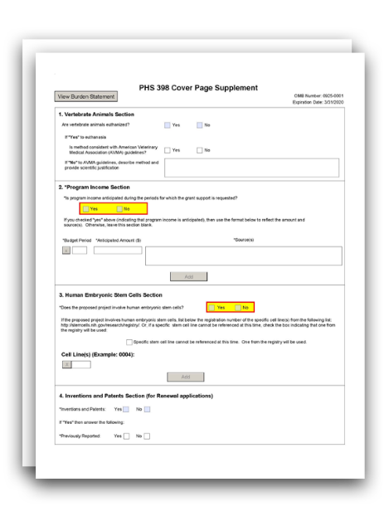
G.210 - PHS 398 Cover Page Supplement Form

The PHS 398 Cover Page Supplement Form is used for all grant applications except fellowships. This form collects information on human subjects, vertebrate animals, program income, human embryonic stem cells, inventions and patents, and changes of investigator/change of institution.
View larger image

Quick Links
- Vertebrate Animals Section 2. Program Income Section
- Human Embryonic Stem Cell Section
- Inventions and Patents Section (for Renewal applications) 5. Change of Investigator/Change of Institution Section

1. Vertebrate Animals Section

Are vertebrate animals euthanized?
You must answer this question if you answered “Yes” to the question “Are Vertebrate Animals Used?” on the G.220 – R&R Other Project Information Form.
Check "Yes" or "No" to indicate whether vertebrate animals in the project are euthanized.
Overall Component: If vertebrate animals will be euthanized in any Component, then you must answer “Yes” to the “Are vertebrate animals euthanized?” question.
Additional Instructions for Multi-project:

If “Yes” to euthanasia: Is method consistent with American Veterinary Medical Association (AVMA) guidelines?
You must answer this question if you answered “Yes” to the “Are vertebrate animals euthanized?” question above. Check “Yes” or “No” to indicate whether the method of euthanasia is consistent with the AVMA Guidelines for the Euthanasia of Animals.
For more information: See AVMA Guidelines for the Euthanasia of Animals.

If “No” to AVMA guidelines, describe method and provide scientific justification:
If you answered “No” to the “Is method consistent with AVMA guidelines?” question, you must describe (in 1000 characters or fewer) the method of euthanasia and provide a scientific

justification for its use. This justification will be reviewed by Office of Laboratory Animal Welfare (OLAW).
If you answered “Yes” to the “Is method consistent with AVMA guidelines” question, skip this question.

2. Program Income Section

Is program income anticipated during the periods for which the grant support is requested?
This field is required.
If program income is anticipated during the periods for which grant support is requested, check “Yes,” and complete the rest of the “Program Income” section.
If no program income is anticipated, check “No” and skip the rest of the “Program Income” section.
Check “No” for the “Is program income anticipated during the periods for which the grant support is requested?” question.
Additional Instructions for Training:
Overall Component: If you anticipate program income on any component, then answer "Yes." Skip the other fields, as any information provided in them will be discarded. Instead of program income information being provided in the Overall Component, a system-generated summary of all program income information that you provide in Other Components will be included in the summaries section of the assembled application image.
Other Component: If you anticipate program income on any component, then answer "Yes." Provide the budget period, anticipated amount, and source information.
Additional Instructions for Multi-project:

Budget Period:
Enter the budget periods for which program income is anticipated. If the application is funded, the Notice of Grant Award will provide specific instructions regarding the use of such income.

Anticipated Amount ($):
Enter the amount of anticipated program income for each budget period listed.

Source(s):
Enter the source of anticipated program income for each budget period listed.

3. Human Embryonic Stem Cells Section

Use the following instructions to complete the fields in this section.
For additional guidance, see the NIH Grants Policy Statement, Section 4.1.13: Human Stem Cell Research.

Does the proposed project involve human embryonic stem cells?
This field is required.
If the proposed project involves human embryonic stem cells (hESC), check “Yes” and complete the rest of the “Human Embryonic Stem Cells” section.
If the proposed project does not involve hESC, check “No” and skip the rest of the “Human Embryonic Stem Cells” section.
Check “Yes” if training plans include or potentially will include involvement of trainees in projects that include hESC. Note that trainees may only conduct research with hESC lines that are approved for use in NIH-funded research; these cell lines are listed on the NIH hESC Registry. Use of the cell lines must be in accordance with the NIH Guidelines for Human Stem Cell Research.
Additional Instructions for Training:
Overall Component: If human embryonic stem cells are used in any Component, then you must answer “Yes.”
Additional Instructions for Multi-project:

Specific stem cell line cannot be referenced at this time. One from the registry will be used.
If you will use hESC but a specific line from the NIH hESC Registry cannot be chosen at the time of application submission, check this box.
If you cannot specify which cell lines will be used at the time of application submission, specific cell line information will be required as Just-in-Time information prior to award.
If you cannot choose an appropriate cell line from the registry at this time, provide a justification in the G.400 - PHS 398 Research Plan Form, Research Strategy attachment.
Additional Instructions for Research:
If you cannot choose an appropriate cell line from the registry at this time, provide a justification in the G.410 - PHS 398 Career Development Award Supplemental Form, Research Strategy attachment.
Additional Instructions for Career Development:
When individual project hESC line information is requested as Just-in-time (JIT), the NIH will require information regarding project title, mentor, and specific cell line(s) from the registry (NIH hESC Registry) for each trainee utilizing human embryonic stem cells. Trainees may not participate in hESC related research until this information has been provided.
Additional Instructions for Training:

Overall and Other Components: If you cannot choose an appropriate cell line from the registry at this time, provide a justification in the G.400 - PHS 398 Research Plan Form, Research Strategy attachment.
Additional Instructions for Multi-project:
If you cannot choose an appropriate cell line from the registry at this time, provide a justification in the G.400 - PHS 398 Research Plan Form, Research Strategy attachment.
Additional Instructions for SBIR/STTR:

Cell Line(s):
List the 4-digit registration number of the specific cell line(s) from the NIH hESC Registry (e.g. 0123). Up to 200 lines can be added.
Overall Component: Skip the "Cell Line(s)" field, as any information provided here will be discarded. Instead of cell line information being provided in the Overall Component, a system-generated summary of all cell line information that you provide in Other Components will be included in the summaries section of the assembled application image.
Other Component: Provide any cell line information relevant to the work being done in that component.
Additional Instructions for Multi-project:

For more information:
See NIH’s Stem Cell Information page for additional information on stem cells, Federal policy statements, and guidelines on federally funded stem cell research.

4. Inventions and Patents Section (for Renewal applications)

Who must complete the “Invention and Patents” section:
Complete the "Inventions and Patents" section only if you are submitting a renewal application or a resubmission of a renewal application.

Inventions and Patents:
If no inventions were conceived or reduced to practice during the course of work under this project, check “No” and skip the remainder of the “Inventions and Patents” section.
If any inventions were conceived or first actually reduced to practice during the previous period of support, check “Yes.”
NIH recipient organizations must promptly report inventions to the Division of Extramural Inventions and Technology Resources (DEITR) Branch of the Office of Policy for Extramural Research Administration (OPERA), OER, NIH, 6705 Rockledge Drive, Bethesda, MD 20892-2750,
(301) 435-1986. You must report inventions in compliance with regulations at 37 CFR 401.14, which are described at Interagency Edison (iEdison). The grantee is required to submit reports electronically using iEdison. See the NIH Grants Policy Statement, Section 8.4.1.6: Invention Reporting.

Skip the “Inventions and Patents” section, as it is not applicable.
Additional Instructions for Career Development:
Skip the “Inventions and Patents” section, as it is not applicable.
Additional Instructions for Training:

Previously Reported:
If you answered “Yes” to the “Inventions and Patents” question, indicate whether this information has been reported previously to the NIH or PHS agency or to the applicant organization official responsible for patent matters.

5. Change of Investigator/Change of Institution Section

Change of Project Director/Principal Investigator:
Check this box if your application reflects a change in project director/principal investigator (PD/PI) from that indicated on your previous application or award. Note that this box not applicable to a new application, nor is a change in PD/PI permitted for revision applications.
For a multiple PD/PI application, check this box if this application represents a change in the contact PI.
If you check the box, fill in the rest of the “Change of PD/PI” section with the information for the former PD/PI according to the instructions below.
Skip the “Change of Project Director/Principal Investigator” section, as changes in PD/PI are not allowed for career development awards.
Additional Instructions for Career Development:
Skip the “Change of Project Director/Principal Investigator” section, as changes in PD/PI are not allowed for fellowship awards.
Additional Instructions for Fellowship:

Prefix:
Enter or select the prefix, if applicable, for the former PD/PI.

First Name:
Enter the first (given) name of the former PD/PI.

Middle Name:
Enter the middle name of the former PD/PI.

Last Name:
Enter the last (family) name of the former PD/PI.

Suffix:
Enter or select the suffix, if applicable, for the former PD/PI.

Change of Grantee Institution:
Check this box if your application reflects a change in grantee institution from that indicated on your previous application or award. This question is not applicable to new applications.

Name of Former Institution:
Enter the name of the former institution if this application reflects a change in grantee institution.

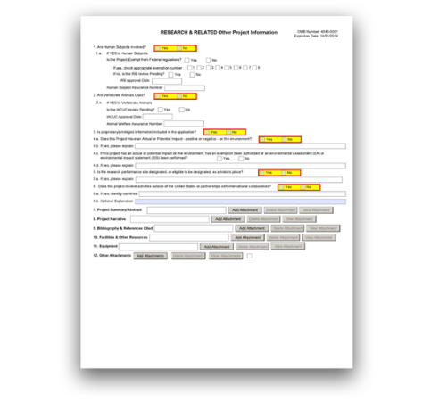
G.220 - R&R Other Project Information Form

The R&R Other Project Information Form is used for all grant applications. This form includes questions on the use of human subjects, vertebrate animals, and environmental impact. This form also has fields to upload an abstract, project narrative, references, information on facilities, and equipment lists.
View larger image

Quick Links
- Are Human Subjects Involved? 1a. If YES to Human Subjects
- Are Vertebrate Animals Used? 2a. If YES to Vertebrate Animals
- Is proprietary/privileged information included in the application? 4. Environmental Questions
5. Is the research performance site designated, or eligible to be designated, as a historic place? 6. Does this project involve activities outside of the United States or partnerships with inter- national collaborators?
7. Project Summary/Abstract 8. Project Narrative
9. Bibliography & References Cited 10. Facilities & Other Resources 11. Equipment
- Other Attachments

This R&R Other Project Information Form should be completed in consultation with the sponsor and administrative officials at the sponsoring institution.
Additional Instructions for Fellowship:

1. Are Human Subjects Involved?

This field is required.

If activities involving human subjects are planned at any time during the proposed project at any performance site, check “Yes.” Check “Yes” even if the proposed project is exempt from regulations for the Protection of Human Subjects, or if activities involving human subjects are anticipated within the period of award but plans are indefinite.
If activities involving human subjects are not planned at any time during the proposed project at any performance site, select “No” and skip the rest of the "Are Human Subjects Involved" section.
Whether you answer “Yes” or “No” to the “Are Human Subjects Involved?” question here, your answer will populate the relevant field in the G.500 – PHS Human Subjects and Clinical Trials Information form (see exception for Training Applications in the Training-specific instructions). Follow the G.500 – PHS Human Subjects and Clinical Trials Information form instructions to complete the relevant questions in that form.
K12 and D43 applicants: The general instructions above apply to you (i.e., your answer to “Are Human Subjects Involved?” will populate the relevant field in the PHS Human Subjects and Clinical Trials Information form).
All other Training applicants: The PHS Human Subjects and Clinical Trials Information form is not applicable and will not be available to you.
Additional Instructions for Training:
Need help determining whether your application includes human subjects? Check out the NIH Research Involving Human Subjects website for information, including an Infopath Questionnaire designed to walk applicants through the decision process.
Note on the use of human specimens or data: Applications involving the use of human specimens or data may or may not be considered to be research involving human subjects, depending on the details of the materials to be used. If you check “No” to “Are Human Subjects Involved?” but your application proposes using human specimens or data, you will be required to provide a clear justification about why this use does not constitute human subjects research.
Follow the G.500 – PHS Human Subjects and Clinical Trials Information form instructions.
For more information on human biospecimens or data: Refer to the NIH page on Frequently Asked Questions on Human Specimens, Cell Lines, or Data and the Research Involving Private Information or Biological Specimens flowchart.
Check “Yes” if training plans include or potentially will include involvement of trainees in projects that include human subjects as defined by 45 CFR 46.
Most Training grant application packages do not include the G.500 - PHS Human Subjects and Clinical Trials Information form. Although it is not required, applicants can provide additional information regarding potential or current involvement of appointed trainees in human subjects research in the "Proposed Training" section of the Program Plan attachment on the G.420 - PHS Research Training Program Plan Form.
In many instances, trainees supported by institutional training grants will participate in research that is supported by separate research project grants for which Institutional Review Board (IRB) approval or a determination of exemption exists. Existing IRB approval may be sufficient for trainees, provided that the IRB
Additional Instructions for Training:

determines the research would not be substantially modified by the participation
of a trainee.
Trainees may participate only in non-exempt human subjects research that is being conducted by an institution that has an approved Federalwide Assurance (FWA) on file with the Office of Human Research Protections (OHRP) and that has IRB approval. The awardee institution is responsible for maintaining documentation of FWA and IRB approvals for all trainee research projects and for providing this information to NIH if requested.
Trainees may not design or conduct independent human subjects research as part of the training award unless the institution where the research will be conducted has an approved FWA on file with OHRP and IRB approval. The institution must also submit certification of the date of IRB approval and must comply with NIH requirements for human subjects protections (see the NIH Grants Policy Statement, Section 4.1.15: Human Subjects Protections).
Trainees who will be involved in the design or conduct of research involving human subjects must receive training in human subjects protections. It is the institution’s responsibility to ensure that trainees are properly supervised when working with human subjects.
These policies apply to all Performance Sites.
K12 and D43 applicants applying to FOAs that accept clinical trials (e.g., 'clinical trial optional'): Follow the instructions in your FOA to determine whether you must provide information in the G.500 - PHS Human Subjects and Clinical Trials Information form.
In many instances, the fellow will be participating in research supported by a research project grant for which the IRB review of human subjects is already complete or an exemption has been designated. This review or exemption designation is sufficient, provided that the IRB determines that participation of the Fellow does not substantially modify the research.
Additional Instructions for Fellowship:
Overall Component: If activities involving human subjects are planned at any time during the proposed project at any performance site and/or on any Other Component, check “Yes” to the “Are Human Subjects Involved?” question and complete the remaining questions as instructed.
Other Components: Answer only the “Are Human Subjects Involved?” and “Is the Project Exempt from Federal regulations?” questions.
Additional Instructions for Multi-project:

1.a. If YES to Human Subjects
Your answers here in question “1.a. If YES to Human Subjects” will populate the corresponding fields in the G.500 – PHS Human Subjects and Clinical Trials Information form.

Is the Project Exempt from Federal regulations? Yes/No
If the project is exempt from federal regulations, check “Yes” and check the appropriate exemption number.
Human subjects research should only be designated as exempt if all of the proposed research projects in an application meet the criteria for exemption.
If the project is not exempt from federal regulations, check “No.”
For more information, see the NIH’s Exempt Human Subjects Research infographic.

If yes, check appropriate exemption number 1, 2, 3, 4, 5, 6, 7, 8:
If you selected “Yes” to “Is the Project Exempt from Federal Regulations,” select the appropriate exemption number.
The categories of research that qualify for exemption are defined in the Common Rule for the Protection of Human Subjects. These regulations can be found at 45 CFR 46.
Need help determining the appropriate exemption number? Refer to NIH's Research Involving Human Subjects Frequently Asked Questions.
The Office of Human Research Protections (OHRP) guidance states that appropriate use of exemptions described in 45 CFR 46 should be determined by an authority independent from the investigators (for more information, see OHRP's Frequently Asked Questions). Institutions often designate their Institutional Review Board (IRB) to make this determination. Because NIH does not require IRB approval at the time of application, the exemptions designated often represent the opinion of the PD/PI, and the justification provided for the exemption by the PD/PI is evaluated during peer review.
Overall Component: Check all the exemptions identified in all the Other Components.
Other Components: If the Overall Component exemption is only E4 (box 4 is checked) then no other exemption number can be set for any Other Component.
Additional Instructions for Multi-project:

If no, is the IRB review Pending? Yes/No
If IRB review is pending, check “Yes.”
Applicants should check “Yes” to the question “Is the IRB review Pending?” even if the IRB review/approval process has not started by the time of submission.
If IRB review is not pending (e.g., if the review is complete), check “No.”
Other Components: Skip the "If no, is the IRB review Pending?" question.
Additional Instructions for Multi-project:

IRB Approval Date:
Enter the latest IRB approval date (if available). Leave blank if IRB approval is pending.
An IRB approval date is not required at the time of submission when IRB review is pending. This may be requested later in the pre-award cycle as a Just-In-Time requirement. See the NIH Grants Policy Statement, Section 2.5.1: Just-in-Time Procedures for more information.

Other Components: Skip the “IRB Approval Date” question.
Additional Instructions for Multi-project:

Human Subject Assurance Number:
Enter the approved Federalwide Assurance (FWA) number that the applicant has on file with OHRP. Enter the 8-digit number. Do not enter “FWA” before the number.
Enter “None” if the applicant organization does not have an approved FWA on file with OHRP. In this case, the applicant organization, by the signature in the Certification section on the G.200 - SF424 (R&R) Form, is declaring that it will comply with 45 CFR 46 and proceed to obtain a FWA (see Office for Human Research Protections website). Do not enter the FWA number of any collaborating institution.
If research proposed in the fellowship application has been previously reviewed and approved by an IRB and is covered by an approved FWA, provide the FWA number and the latest IRB approval date for the proposed activities. The latest IRB approval date must be within one year of the application due date.
Additional Instructions for Fellowship:
Other Components: Skip the “Human Subject Assurance Number” field.
Additional Instructions for Multi-project:

2. Are Vertebrate Animals Used?

This field is required.
If activities involving vertebrate animals are planned at any time during the proposed project at any performance site, check “Yes.” Otherwise, check “No” and skip the rest of the “2. Are Vertebrate Animals Used?” section.
Note that the generation of custom antibodies constitutes an activity involving vertebrate animals.
If animal involvement is anticipated within the period of award but plans are indefinite, check "Yes."
If you have answered “Yes” to the “Are Vertebrate Animals Used?” question, you must also provide an explanation and anticipated timing of animal use in G.400 - PHS 398 Research Plan Form, Vertebrate Animals. This attachment must be submitted and reviewed prior to the involvement of animals in any research studies.
Additional Instructions for Research:
If you have answered “Yes” to the “Are Vertebrate Animals Used?” question, you must also provide an explanation and anticipated timing of animal use in G.410 - PHS 398 Career Development Award Supplemental Form, Vertebrate Animals. This
Additional Instructions for Career Development:

attachment must be submitted and reviewed prior to the involvement of animals in
any research studies.

Additional Instructions for Training:
In many instances, trainees supported by institutional training grants will participate in research that is supported by a separate research project grant for which the IACUC review and approval exist. This existing IACUC approval is sufficient for trainees provided that the research would not be substantially modified by the participation of a trainee.
Note that trainees may only participate in vertebrate animal research that is being conducted at an institution that has an approved Animal Welfare Assurance on file with the Office of Laboratory Animal Welfare (OLAW) and that has IACUC approval. The awardee institution is responsible for maintaining documentation of the Animal Welfare Assurance and IACUC approvals for all trainee research projects and providing this information to NIH if requested.
Trainees may not design or conduct independent vertebrate animal research as part of the training award unless the institution has an approved Animal Welfare Assurance on file with OLAW and IACUC approval has been obtained. Verification of IACUC approval (within 3 years) must be submitted to NIH, and NIH requirements for research involving vertebrate animals must be addressed.
Prior to conducting any animal activities, the grantee must submit the detailed information about the use of animals as required in the instructions in G.420 - PHS 398 Research Training Program Plan, Vertebrate Animals. This detailed information must be submitted to the NIH awarding IC for prior approval.
The institution must ensure that trainees are enrolled in the institution's animal welfare training and occupational health and safety programs for personnel who have contact with animals. It is the institution's responsibility to ensure that trainees are properly supervised when working with live vertebrate animals.
These policies apply to all Performance Sites.
In many instances, the fellow will be participating in research supported by a research project grant for which the IACUC review has been completed and approval obtained. This review is sufficient, provided that participation of the fellow does not substantially modify the research. The appropriate grant(s) must be identified along with the IACUC approval date(s).
The sponsoring institution must ensure that the fellow is enrolled in the institution’s animal welfare training and safety programs for personnel who have contact with animals, as appropriate. It is also the sponsoring institution’s responsibility to ensure that the fellow is properly supervised when working with live vertebrate animals.
If you have answered “Yes” to the “Are Vertebrate Animals Used?” question, you must also provide an explanation and anticipated timing of animal use in G.430 - PHS Fellowship Supplemental Form, Vertebrate Animals. This attachment must be
Additional Instructions for Fellowship:

submitted and reviewed prior to the involvement of animals in any research
studies.
Overall Component: If activities involving vertebrate animals are planned at any time during the proposed project at any performance site and/or on any Other Component, check “Yes” and complete the remaining questions as instructed.
Other Components: Answer only the “Are Vertebrate Animals Used?” question. Skip the questions in 2.a.
Additional Instructions for Multi-project:
If you have answered “Yes” to the “Are Vertebrate Animals Used?” question, you must also provide an explanation and anticipated timing of animal use in G.400 - PHS 398 Research Plan Form, Vertebrate Animals. This attachment must be submitted and reviewed prior to the involvement of animals in any research studies.
Additional Instructions for SBIR/STTR:

2.a. If YES to Vertebrate Animals

Is the IACUC review Pending?
If an Institutional Animal Care and Use Committee (IACUC) review is pending, check "Yes."
Applicants should check “Yes” to the "Is the IACUC review Pending?" question even if the IACUC review/approval process has not started by the time of submission.
If IACUC review is not pending (e.g. if the review is complete), check “No."
Overall Component: Complete the “Is the IACUC review Pending?” question when the answer is “Yes” to “Are Vertebrate Animals Used?”
Other Components: Skip the “Is the IACUC review Pending?” question.
Additional Instructions for Multi-project:

IACUC Approval Date:
Enter the latest IACUC approval date (if available). Leave blank if IACUC approval is pending. IACUC approval must have been granted within three years of the application submission date to be valid.
An IACUC approval date is not required at the time of submission. NIH does not require verification of review and approval of the proposed research by the IACUC before peer review of the application. However, this information is required under the NIH Grants Policy Statement Section 2.5.1: Just-in-Time Procedures.
Other Components: Skip the “IACUC Approval Date” question.
Additional Instructions for Multi-project:

Animal Welfare Assurance Number
Enter the federally approved assurance number, if available.

Enter “None” if the applicant organization does not have an Office of Laboratory Animal Welfare (OLAW)-approved Animal Welfare Assurance.
To determine whether the applicant organization holds an Animal Welfare Assurance with an associated number, see the lists of Domestic and Foreign Assured institutions. Do not enter the Animal Welfare Assurance number for a Project/Performance Site of a collaborating institution.
When an applicant organization does not have an Animal Welfare Assurance number, the authorized organization representative’s signature on the application constitutes declaration that the applicant organization will submit an Animal Welfare Assurance when requested by OLAW.
If the animal work will be conducted at an institution with an Animal Welfare Assurance and the applicant organization does not have the following:
  - an animal care and use program;
  - facilities to house animals and conduct research on site; and
  - IACUC;
then, the applicant must obtain an Inter-institutional Assurance from OLAW prior to an award.
Other Components: Skip the “Animal Welfare Assurance Number” question.
Additional Instructions for Multi-project:

3. Is proprietary/privileged information included in the application?

This field is required.
Patentable ideas; trade secrets; or privileged, confidential commercial, or financial information should be included in applications only when such information is necessary to convey an understanding of the proposed project.
If the application includes such information, check “Yes” and clearly mark each line or paragraph on the pages containing the proprietary/privileged information with a statement similar to: “The following contains proprietary/privileged information that (name of applicant) requests not be released to persons outside the government, except for purposes of review and evaluation.” This statement can be included at the top of each page as applicable.
If a grant is awarded as a result of or in connection with the submission of this application, the government shall have the right to use or disclose the information to the extent authorized by law. Although the grantee institution and the PD/PI will be consulted about any such disclosure, the NIH and other PHS agencies will make the final determination. Any indication by the applicant that the application contains proprietary or privileged information does not automatically shield the information from release in response to a Freedom of Information Act (FOIA) request should the application result in an award (see 45 CFR 5). Additionally, if an applicant fails to identify proprietary information at the time of submission as instructed here, a significant substantive justification will be required to withhold the information if requested under FOIA.

4. Environmental Questions

Question 4 pertains to the environmental impact of the proposed research.

Does this Project Have an Actual or Potential Impact - positive or negative - on the envir- onment?
This field is required.
Indicate whether or not this project has an actual or potential impact on the environment.
Most NIH research grants are not expected to individually or cumulatively have a significant effect on the environment, and NIH has established several categorical exclusions allowing most applicants to answer “No” unless a specific FOA indicates that the National Environmental Policy Act (NEPA) applies. However, if an applicant expects that the proposed project will have an actual or potential impact on the environment, or if any part of the proposed research and/or project includes one or more of the following scenarios, check “Yes.”
    - The potential environmental impacts of the proposed research may be of greater scope or size than other actions included within a category.
    - The proposed research threatens to violate a federal, state, or local law established for the protection of the environment or for public health and safety.
    - Potential effects of the proposed research are unique or highly uncertain.
    - Use of especially hazardous substances or processes is proposed for which adequate and accepted controls and safeguards are unknown or not available.
    - The proposed research may overload existing waste treatment plants due to new loads (volume, chemicals, toxicity, additional hazardous wasted, etc.).
    - The proposed research may have a possible impact on endangered or threatened species.
    - The proposed research may introduce new sources of hazardous/toxic wastes or require storage of wastes pending new technology for safe disposal.
    - The proposed research may introduce new sources of radiation or radioactive materials.
    - Substantial and reasonable controversy exists about the environmental effects of the proposed research.

If yes, please explain:
If you answered “Yes” to Question 4.a., you must provide an explanation here as to the actual or potential impact of the proposed research on the environment. Your entry is limited to 55 characters.

If this project has an actual or potential impact on the environment, has an exemption been authorized or an environmental assessment (EA) or environmental impact statement (EIS) been performed? Yes/No.
This field is required if you answered “Yes” to Question 4.a. Check “Yes” or “No.”

If yes, please explain:
Enter additional details about the EA or EIS here. Your entry is limited to 55 characters.
5. Is the research performance site designated, or eligible to be designated, as a historic place?
This field is required.

If any research performance site is designated, or eligible to be designated, as a historic place, check the “Yes” box. Otherwise, check “No.”

5.a. If yes, please explain:
If you checked “Yes” to indicate that any performance site is designated, or eligible to be designated, as a historic place, provide the explanation here. Your entry is limited to 55 characters.
6. Does this project involve activities outside of the United States or partnerships with international collaborators?
This field is required.
Indicate whether this project involves activities outside of the United States or partnerships with international collaborators. Check “Yes” or “No.”
Applicants to NIH and other PHS agencies must check “Yes” if the applicant organization is a foreign institution or if the project includes a foreign component. See NIH Glossary for a definition of a foreign component.
If you have checked “Yes” to Question 6, you must include a “Foreign Justification” attachment in Field 12, Other Attachments. Describe special resources or characteristics of the research project (e.g., human subjects, animals, disease, equipment, and techniques), including the reasons why the facilities or other aspects of the proposed project are more appropriate than a domestic setting. In the body of the text, begin the section with a heading indicating “Foreign Justification” and name the file “Foreign Justification.”
If you have checked “Yes” to Question 6, your justification must include a description of how the foreign training is more appropriate than in a domestic setting. Include reasons why the facilities, the sponsor, and/or other aspects of the proposed experience are more appropriate in a foreign setting. The justification is evaluated in terms of the scientific advantages of the foreign training as compared to the training available domestically. Foreign training will be considered for funding only when the scientific advantages are clear. The foreign justification should be provided as a separate attachment in the "12. Other Attachments" section in G.220 - R&R Other Project Information Form.
Additional Instructions for Fellowship:
Overall Component: If the answer to Question 6 is “Yes” for any Other Component, then you must answer “Yes” for the Overall Component.
Additional Instructions for Multi-project:

If yes, identify countries:
This field is required if you answered “Yes” to Question 6. Enter the countries with which international cooperative activities are planned.
You may use abbreviations. Your entry is limited to 55 characters.

Optional Explanation:
This field is optional. Enter an explanation for involvement with outside entities. Your entry is limited to 55 characters.

7. Project Summary/Abstract

The "Project Summary/Abstract" attachment is required.
The project summary is a succinct and accurate description of the proposed work and should be able to stand on its own (separate from the application). This section should be informative to other persons working in the same or related fields and understandable to a scientifically literate reader. Avoid both descriptions of past accomplishments and the use of the first person. Please be concise.

Format:
This section is limited to 30 lines of text, and must follow the required font and margin specifications. Graphics (including images, charts, and graphs) are not allowed in this section. A summary that exceeds the 30-line limit will be flagged as an error by the Agency upon submission, and a summary that includes graphics will generate a warning by the Agency upon submission.
Attach this information as a PDF file. See the Format Attachments page.

Content:
State the application's broad, long-term objectives and specific aims, making reference to the health relatedness of the project (i.e., relevance to the mission of the agency). Describe the research design and methods for achieving the stated goals. Be sure that the project summary reflects the key focus of the proposed project so that the application can be appropriately categorized.
Do not include proprietary, confidential information or trade secrets in the project summary. If the application is funded, the project summary will be entered into an NIH database and made available on the NIH Research Portfolio Online Reporting Tool (RePORT) and will become public information.
Note that the "Project Summary/Abstract" attachment is not same as the "Research Strategy" attachment.
In addition to summarizing the research project to be conducted under the career development award, describe the candidate’s career development plan, the candidate’s career goals, and the environment in which the career development will take place. The entire “Project Summary/Abstract” attachment is limited to 30 lines of text.
Additional Instructions for Career Development:
In addition to the content described above, also summarize the objectives, rationale and design of the research training program. Provide information regarding the research areas and scientific disciplines encompassed by the program. Include a brief description of the level(s) (i.e., undergraduate, predoctoral, postdoctoral, faculty) and duration of the proposed training, and the projected number of participating trainees. The entire “Project Summary/Abstract” attachment is limited to 30 lines of text.
Additional Instructions for Training:

In addition to summarizing the research project to be conducted under the fellowship award, describe the fellowship training plan and the environment in which the research training will take place. The entire “Project Summary/Abstract” attachment is limited to 30 lines of text.
Additional Instructions for Fellowship:
Overall and Other Components: A project summary is required for both the Overall Component and all Other Components. Each project summary attachment is limited to 30 lines of text.
Additional Instructions for Multi-project:

8. Project Narrative

The "Project Narrative" attachment is required.

Content:
Describe the relevance of this research to public health in, at most, three sentences. For example, NIH applicants can describe how, in the short or long term, the research would contribute to fundamental knowledge about the nature and behavior of living systems and/or the application of that knowledge to enhance health, lengthen life, and reduce illness and disability. If the application is funded, this public health relevance statement will be combined with the project summary (above) and will become public information.
Overall Component: The "Project Narrative" attachment is required.
Other Components: Refer to the specific FOA to determine whether the "Project Narrative" attachment is required for any Other Components. Note: The form may show ‘*’ indicating it is a required field, but it is only required for the Overall Component and the ‘*’ can be ignored for Other Components.
Additional Instructions for Multi-project:

9. Bibliography & References Cited

Who must complete the “Bibliography & References Cited” attachment:
The “Bibliography & References Cited” attachment is required unless otherwise noted in the FOA.

Format:
Attach this information as a PDF file. See the Format Attachments page.

Content:
See the following instructions for which references to include in the “Bibliography and References Cited” attachment.

The “Bibliography & References Cited” attachment should include any references cited in G.400 - PHS 398 Research Plan Form and in the G.500 - PHS Human Subjects and Clinical Trials Information form.
Additional Instructions for Research:
The “Bibliography & References Cited” attachment should include any references cited in G.410 - PHS 398 Career Development Award Supplemental Form and in the G.500 - PHS Human Subjects and Clinical Trials Information form.
Additional Instructions for Career Development:
The “Bibliography & References Cited” Attachment should include any references cited in G.420 - PHS 398 Research Training Program Plan Form and in the G.500 - PHS Human Subjects and Clinical Trials Information form.
Additional Instructions for Training:
The “Bibliography & References Cited” attachment should include any references cited in G.430 - PHS Fellowship Supplemental Form and in the G.500 - PHS Human Subjects and Clinical Trials Information form.
Additional Instructions for Fellowship:
Overall and Other Components: The “Bibliography & References Cited” attachment should include any references cited in G.400 - PHS 398 Research Plan Form and in the G.500 - PHS Human Subjects and Clinical Trials Information form.
Additional Instructions for Multi-project:
The “Bibliography & References Cited” attachment should include any references cited in G.400 - PHS 398 Research Plan Form and in the G.500 - PHS Human Subjects and Clinical Trials Information form.
Additional Instructions for SBIR/STTR:

When citing articles that fall under the Public Access Policy, were authored or co-authored by the applicant, and arose from NIH support, provide the NIH Manuscript Submission reference number (e.g., NIHMS97531) or the PubMed Central (PMC) reference number (e.g., PMCID234567) for each article. If the PMCID is not yet available because the Journal submits articles directly to PMC on behalf of their authors, indicate “PMC Journal – In Process.” NIH maintains a list of such journals.
Citations that are not covered by the Public Access Policy, but are publicly available in a free, online format may include URLs or PubMed ID (PMID) numbers along with the full reference. The references should be limited to relevant and current literature. While there is not a page limitation, it is important to be concise and to select only those literature references pertinent to the proposed research.
You are allowed to cite interim research products. Note: interim research products have specific citation requirements. See related Frequently Asked Questions for more information.

The "Bibliography & References Cited" attachment should be used only to cite references supporting the need, rationale, and approach for the training program described in the G.420 - PHS 398 Research Training Program Plan. Do not include lists of publications of project directors, mentors or trainees in this section, as this information will be included in the Biosketches and Data Tables.
Additional Instructions for Training:
Overall and Other Components: Unless specific instructions are provided in the FOA, applicants have the option of including the "Bibliography & References Cited" attachment in the Overall Component, Other Components, or both. User-defined bookmarks provided in the Bibliography & References Cited attachment will be included with the bookmarks of the assembled application image in eRA Commons. If you include the “Bibliography & References Cited” attachment only in the Overall Component, you may want to use bookmarks to organize references by component.
Additional Instructions for Multi-project:

10. Facilities & Other Resources

Format:
The “Facilities & Other Resources” attachment is required unless otherwise specified in the FOA.

Content:
Describe how the scientific environment in which the research will be done contributes to the probability of success (e.g., institutional support, physical resources, and intellectual rapport). In describing the scientific environment in which the work will be done, discuss ways in which the proposed studies will benefit from unique features of the scientific environment or from unique subject populations or how studies will employ useful collaborative arrangements.
If there are multiple performance sites, describe the resources available at each site.
Describe any special facilities used for working with biohazards and any other potentially dangerous substances. Note: Information about select agents must be described in the Research Plan, Select Agent Research.
For early stage investigators (ESIs), describe institutional investment in the success of the investigator. See NIH's New and Early Stage Investigator Policies. Your description may include the following elements:
    - resources for classes, travel, or training;
    - collegial support, such as career enrichment programs, assistance and guidance in the supervision of trainees involved with the ESI’s project, and availability of organized peer groups;
    - logistical support, such as administrative management and oversight and best practices training;
    - financial support, such as protected time for research with salary support.

Include a detailed description of the institutional facilities and resources available to the candidate. The information provided is of major importance in establishing the feasibility of the goals of the career development plan.
Additional Instructions for Career Development:
Describe the facilities and resources that will be used in the proposed training program, including any foreign performance sites. Indicate how the applicant organization will support the program, financial or otherwise. This could include, for example, supplementation of stipends, shared space and/or laboratory facilities and equipment, funds for curriculum development, support for student activities, release time for the PD/PI and participating faculty (e.g., protected time for mentoring), support for additional trainees in the program, or any other creative ways to improve the environment for the establishment and growth of the research training program.
Additional Instructions for Training:
Include a detailed description of the institutional facilities and resources available to the fellowship applicant. The information provided is of major importance in establishing the feasibility of the goals of the fellowship training plan.
Additional Instructions for Fellowship:
Unless specific instructions are provided in the FOA, applicants have the option of including the "Facilities & Other Resources" attachment in the Overall Component, Other Components, or both.
Additional Instructions for Multi-project:
The research to be performed by the applicant small business concern and its collaborators must be in United States facilities that are available to and under the control of each party for the conduct of each party’s portion of the proposed project. Foreign sites must be approved by the funding officer.
Additional Instructions for SBIR/STTR:

11. Equipment

The “Equipment” attachment is required.

Format:
Attach this information as a PDF file.

Content:
List major items of equipment already available for this project and, if appropriate, identify the equipment's location and pertinent capabilities.

Unless specific instructions are provided in the FOA, applicants have the option of including the "Equipment" attachment in the Overall Component, Other Components, or both (whichever is most appropriate for your application). User- defined bookmarks provided in the Equipment attachment will be included with the bookmarks of the assembled application image in eRA Commons. If you include the “Equipment” attachment only in the Overall Component, you may want to use bookmarks to organize equipment by component.
Additional Instructions for Multi-project:

12. Other Attachments

Attach a file to provide additional information only in accordance with the FOA and/or agency- specific instructions.
If applicable, attach a “Foreign Justification” here. (See Question 6 above).
NIH, CDC, SBIR, and CRP Applicants Only:
SBIR Application Certification for small business concerns that are majority- owned by multiple venture capital operating companies, hedge funds, or private equity firms (e.g. majority VCOC-owned): You are required to submit a Certification with your application per the SBIR Policy Directive. Follow the instructions below.
Certain applicant small business concerns do not have to fill out the Certification. Applicant small business concerns that are more than 50% directly owned and controlled by one or more individuals (who are citizens or permanent resident aliens of the United States), other business concerns (each of which is more than 50% directly owned and controlled by individuals who are citizens or permanent resident aliens of the United States), or any combination of these (i.e. NOT majority VCOC-owned) should NOT fill out this certification and should NOT attach it to their application package.
- Download the “SBIR Application VCOC Certification” at the NIH Forms & Applications page.
- Answer the 3 questions and check the certification boxes.
- The authorized business official must sign the certification.
- Save the certification using the original filename (“SBIR Application VCOC Certification”). DO NOT CHANGE OR ALTER THE FILENAME OR TYPE. Changing the filename may cause delays in the processing of your application.
- Attach this Certification PDF in Question 12.
Additional Instructions for SBIR/STTR:

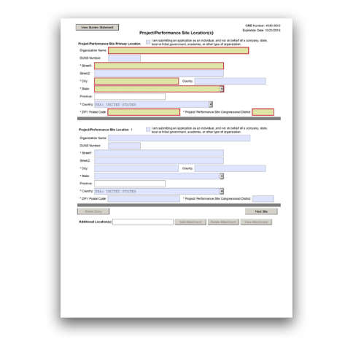

The Project/Performance Site Location(s) Form is used for all grant applications. It is used to report the primary location and any other locations at which the project will be performed.
View larger image
Quick Links
Project/Performance Site Primary Location Project/Performance Site Location 1 Additional Location(s)
G.230 - Project/Performance Site Location(s) Form

Using the Project/Performance Site Location(s) Form:
This form allows for the collection of multiple performance sites. If you need to add more project/performance site locations than the form allows, enter the information in a separate file and add it to the “Additional Locations” section.

Project/Performance Site Primary Location

Generally, the primary location should be that of the applicant organization or identified as off- site in accordance with the conditions of the applicant organization’s negotiated Facilities and Administrative (F&A) agreement. This information must agree with the F&A information on the budget form of the application.
Provide an explanation of resources available from each project/performance site on the "Facilities and Resources" attachment of the G.220 - R&R Other Project Information Form.
If the proposed project involves human subjects or live vertebrate animals, it is up to the applicant organization to ensure that all sites meet certain criteria:
Human Subjects: If a project/performance site is engaged in research involving human subjects, the applicant organization is responsible for ensuring that the project/performance site operates under an appropriate Federal Wide Assurance for the protection of human subjects and complies with 45 CFR 46 and other NIH human subject related policies described in the NIH Grants Policy Statement, Section 4.1.15: Human Subjects Protections.
Vertebrate Animals: For research involving live vertebrate animals, the applicant organization must ensure that all project/performance sites hold an Office of Laboratory Animal Welfare (OLAW)-approved Animal Welfare Assurance. If the animal work will be conducted at an institution with an Animal Welfare Assurance and the applicant organization does not have the following:

    - an animal care and use program;
    - facilities to house animals and conduct research on site; and
    - an IACUC;
then applicant must obtain an Inter-institutional Assurance from OLAW prior to an award.
Describe any consortium/contractual arrangements in the "Consortium/Contractual Arrangements" attachment in G.400 – PHS 398 Research Plan Form.
Additional Instructions for Research:
Indicate where the work described in the Research and Career Development Plans will be conducted. Include any foreign sites (if applicable). If there is more than one site, including any Department of Veterans Affairs (VA) facilities or foreign sites, list them all in the fields provided for Location 1, and additional locations, as necessary.
Describe any consortium/contractual arrangements in the "Consortium/Contractual Arrangements" attachment in G.410 – PHS 398 Career Development Award Supplemental Form.
Additional Instructions for Career Development:
List all of the locations where training, program management, and the research training experiences described in the Research Training Program Plan will be performed, including any foreign sites (when applicable).
Describe any consortium/contractual arrangements in the "Consortium/Contractual Arrangements" attachment in G.420 – PHS 398 Research Training Program Plan Form.
Human Subjects: If investigators and trainees at a project/performance site will be engaged in research involving human subjects, the applicant organization is responsible for ensuring that all investigators and trainees at the project/performance sites comply with the human subject protection regulations in 45 CFR 46 and with other NIH policies for the protection of human subjects.
Vertebrate Animals: For research involving live vertebrate animals, the applicant organization must supply information for all training sites where animals will be used by trainees. The applicant organization is responsible for assuring that all project/performance sites have a current Animal Welfare Assurance and comply with the PHS Policy on Humane Care and Use of Laboratory Animals.
Additional Instructions for Training:
One of the sites indicated must be the sponsoring organization, and generally, the sponsoring organization is the primary location. Indicate where the training described in the Research Training Plan will be conducted. If there is more than one training site, including any Department of Veterans Affairs (VA) facilities or foreign
Additional Instructions for Fellowship:

sites, list them all in the fields provided for Location 1, and additional locations, as
necessary.
If there are unusual circumstances involved in the research training proposed, such as fieldwork or a degree sought from an institution other than the one in which the research training will take place, describe these circumstances in G.220 - R&R Other Project Information Form, Facilities and Resources.
Overall Component: Include only the primary site for the entire application, which is typically the applicant organization.
Other Components: List the primary site for the component, which is typically the lead organization of the component. Describe any consortium/contractual arrangements in the "Consortium/Contractual Arrangements" attachment in G.400
– PHS 398 Research Plan Form.
Additional Instructions for Multi-project:

Additional Instructions for SBIR/STTR:
Describe any consortium/contractual arrangements in the "Consortium/Contractual Arrangements" attachment in G.400 – PHS 398 Research Plan Form.
One of the performance sites indicated must be that of the applicant small business concern (SBC).
Phase I, Phase II, and CRP Applications: The research or R&D project activity must be performed in the United States. However, based on a rare and unique circumstance (for example, if a supply or material or the study design [e.g., patient population] is not available in the United States), NIH may allow that particular portion of the research or R&D work to be performed or obtained in a foreign sponsorship country. Investigators must thoroughly justify the use of these sites in the application. These rare and unique situations will be considered on a case-by- case basis, and they should be discussed with NIH staff prior to submission of the application. Approval by the funding officer for such specific condition(s) must be in writing prior to issuance of an award. Whenever possible, non-SBIR/STTR funds should be used for other work outside of the United States that is necessary to the overall completion of the project.
The research and analytical work performed by the grantee organization is to be conducted in research space occupied by, available to, and under the control of the SBIR/STTR grantee for the conduct of its portion of the proposed project. However, when required by the project activity, access to special facilities or equipment in another organization is permitted, as in cases where the SBIR/STTR awardee has entered into a subcontractual agreement with another institution for a specific, limited portion of the research project.
Whenever a proposed SBIR/STTR project is to be conducted in facilities other than those of the applicant organization, the awarding component will request that the SBC provide a letter from the organization stating that leasing/rental arrangements have been negotiated for appropriate research space. This letter must be signed by an authorized official of the organization whose facilities are to

be used for the SBIR/STTR project and must certify that the SBC (grantee
organization) will have access to and control over the research space. In addition, the letter must include a description of the facilities and, if appropriate, equipment that will be leased/rented to the grantee organization. If the letter is included with the application, it is excluded from the page limitations. Attach this letter to the G.400 - PHS 398 Research Plan Form, Consortium/Contractual Arrangements.

“I am submitting an application as an individual, and not on behalf of a company, state, local or tribal government, academia, or other type of organization”:
Do not check the box for “I am submitting an application as an individual, and not on behalf of a company, state, local or tribal government, academia, or other type of organization” unless otherwise specified by the FOA.

Organization Name:
This field is required. Enter the organization name of the primary site where the work will be performed.

DUNS Number:
This field is required for the primary performance site.
Enter the DUNS or DUNS+4 number associated with the organization where the project will be performed.

Street1:
This field is required. Enter the first line of the street address of the primary performance site location.

Street2:
Enter the second line of the street address of the primary performance site location.

City:
This field is required. Enter the city for the address of the primary performance site location.

County:
Enter the county of the primary performance site location.

State:
This field is required if the site is located in the United States or its Territories. Enter the state or territory where the primary performance site is located.

Province:
If “Country" is Canada, enter the province for the primary performance site; otherwise, skip the “Province” field.

Country:
This field is required. Select the country of the address for the primary performance site location.

ZIP/Postal Code:
The ZIP+4 is required if the primary performance site location is in the United States. Otherwise, the postal code is optional. Enter the ZIP+4 (nine-digit postal code) or postal code of the primary performance site.

Project/Performance Site Congressional District:
Enter the Congressional District as follows: a 2-character state abbreviation, a hyphen, and a 3- character district number. Examples: CA-005 for California’s 5th district, VA-008 for Virginia’s 8th district.
It is likely this field will be identical to the “Congressional District of Applicant” field provided elsewhere in the application.
If the program/project is outside the United States, enter 00-000.
For States and U.S. territories with only a single congressional district, enter “001” for the district number.
For jurisdictions with no representative, enter “099.”
For jurisdictions with a nonvoting delegate, enter “098” for the district number. Example: DC-098 or PR-098.
If all districts in a state are affected, enter “all” for the district number. Example: "MD-all" for all congressional districts in Maryland.
If nationwide (all districts in all states), enter "US-all."
If you do not know the Congressional District: Go to the United States House of Representatives website and search for the Congressional District by entering the ZIP+4. If you do not know the ZIP+4, look it up on the USPS Look Up Zip Code website.

Project/Performance Site Location 1

Use this “Project/Performance Site Location 1” block to provide information on performance sites in addition to the Primary Performance Site listed above, if applicable. Include any VA facilities and foreign sites.
Other Components: List all performance sites that apply to the specific component.
Additional Instructions for Multi-project:

Organization Name:
Enter the organization name of the performance site location.

DUNS Number:
Enter the DUNS or DUNS+4 number associated with the performance site.

Street1:
This field is required. Enter first line of the street address of the performance site location.

Street2:
Enter the second line of the street address of the performance site location.

City:
This field is required. Enter the city for the address of the performance site location.

County:
Enter the county of the performance site location.

State:
This field is required if the project performance site is located in the United States or its Territories. Enter the state or territory where the performance site is located.

Province:
If “Country” is Canada, enter the province for the performance site; otherwise, skip the “Province” field.

Country:
This field is required. Select the country of the performance site location.

ZIP/Postal Code:
The ZIP+4 is required if the performance site location is in the United States. Otherwise, the postal code is optional. Enter the ZIP+4 (nine-digit postal code) of the performance site location.

Project/Performance Site Congressional District:
Enter the Congressional District as follows: a 2-character state abbreviation, a hyphen, and a 3- character district number. Examples: CA-005 for California’s 5th district, VA-008 for Virginia’s 8th district.
If the program/project is outside the United States, enter 00-000.
For States and U.S. territories with only a single congressional district enter “001” for the district number.
For jurisdictions with no representative, enter “099.”
For jurisdictions with a nonvoting delegate, enter “098” for the district number. Example: DC-098 or PR-098.
If all districts in a state are affected, enter “all” for the district number. Example: "MD-all" (for all congressional districts in Maryland).
If nationwide (all districts in all states), enter "US-all."
If you do not know the Congressional District: Go to the United States House of Representatives website and search for your Congressional District by entering your ZIP+4. If you do not know the ZIP+4 look it up on the USPS Look Up Zip Code website.

Additional Location(s)

If you need to add more project/performance site locations than the form allows, enter the information in a separate file and add it to the “Additional Locations” section.
A format page for Additional Performance Sites can be found on NIH's Additional Performance Site Format Page.

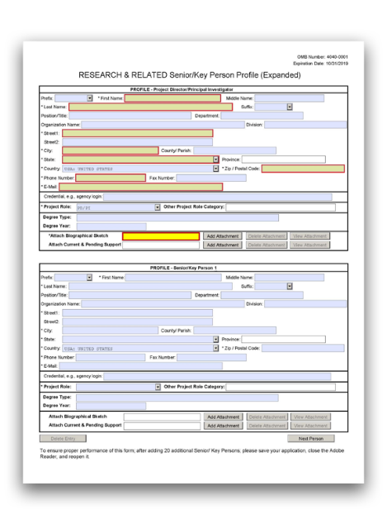

The R&R Senior/Key Person Profile (Expanded) Form is used for all grant applications, and allows the collection of data for all senior/key persons associated with the project. Some information for the PD/PI may be pre- populated from the SF424 (R&R) form. See instructions in G.200 - SF 424 (R&R) Form if these fields are empty.
View larger image
Quick Links
Profile - Project Director/Principal Investigator Instructions for a Biographical Sketch
Profile - Senior/Key Person
Additional Senior/Key Person Profile(s)
G.240 - R&R Senior/Key Person Profile (Expanded) Form

Using the R&R Senior/Key Person Profile (Expanded) Form
This form allows for the data collection for a PD/PI and up to 99 other senior/key individuals (including any multi-PD/PIs). After the first 100 individuals have been entered, use the “Additional Senior/Key Person Profiles Format Page” to attach any remaining data.
To ensure proper performance of this form, save your work frequently.

Who qualifies as a Senior/Key Person?
Unless otherwise specified in a FOA, senior/key personnel are defined as all individuals who contribute in a substantive, meaningful way to the scientific development or execution of the project, whether or not salaries are requested. Consultants should be included in this “Senior/Key Person Profile (Expanded)” Form if they meet this definition.
List individuals that meet the definition of senior/key regardless of what organization they work for.

Profile - Project Director/Principal Investigator

Enter data in this “Profile – Project Director/Principal Investigator” section for the Project Director/Principal Investigator (PD/PI).
The PD/PI must have an eRA Commons account with the PI role, and the account must be affiliated with the applicant organization. If you are proposing research at an institute other than the one you are currently at, do not create a separate Commons account with the proposed applicant organization. For information on eRA Commons account administration, see the eRA Account Management System’s Online Help.

Special Instructions for Multiple PD/PIs: When submitting an application involving multiple PD/PIs, list the “Contact” PD/PI in this field. List all additional PD/PIs in the Senior/Key Person section(s) below.
For all career development award applications, the candidate is considered the PD/PI. Therefore, the candidate must have an eRA Commons account with the PI role and the account must be affiliated with the applicant organization. For additional information on eRA Commons account administration, see the eRA Account Management System’s Online Help.
If your proposed career development award will be at a different site than your current institution, the proposed sponsoring institution will be the applicant organization. You must affiliate your Commons account with that institution so that you have access to records submitted on your behalf. Do not create a separate Commons account with the proposed sponsoring institution.
Note that “multiple PD/PIs” are not applicable to career development award applications, so do not use the PD/PI role for any other senior/key personnel.
Additional Instructions for Career Development:
If multiple PD/PIs are proposed, explain the rationale for how this will facilitate program administration in the Program Plan attachment (in G.420 - PHS 398 Research Training Program Plan Form, Program Plan). Additionally, the application must include a Multi-PD/PI Leadership Plan (in G.420 - PHS 398 Research Training Program Plan Form, Multiple PD/PI Leadership Plan) describing how multi-PD/PIs will benefit the program and the trainees.
Additional Instructions for Training:
For all fellowship applications, the applicant is considered the PD/PI. Therefore, the applicant must have an eRA Commons account with the PI role, and the account must be affiliated with the applicant organization. For additional information on eRA Commons account administration, see the eRA Account Management System’s Online Help.
If your proposed fellowship is at a different site than your current institution, the proposed sponsoring institution will be the applicant organization. You must affiliate your Commons account with the institution so that you have access to records submitted on your behalf. Do not create a separate Commons account with the proposed sponsoring institution.
Note that “multiple PD/PIs” are not applicable to fellowship applications, so do not use the PD/PI role for any other senior/key personnel.
Additional Instructions for Fellowship:
Overall Component: List the PD/PI (or Contact PD/PI if submitting a multi-PD/PI application) for the entire application.
Additional Instructions for Multi-project:

Other Components: List the component lead.
STTR Applications:
The STTR applicant organization must officially affiliate the PD/PI with the small business concern (SBC) in the eRA Commons if the PD/PI is not an employee of the SBC. For additional information on creating user affiliations in the eRA Commons, see the eRA Account Management System's Online Help.
Additional Instructions for SBIR/STTR:

Prefix:
This field may be pre-populated from the SF 424 (R&R) and reflects the prefix, if applicable, for the name of the PD/PI.

First Name:
This field is required. This field may be pre-populated from the SF 424 (R&R) and reflects the first (given) name of the PD/PI.

Middle Name:
This field may be pre-populated from the SF 424 (R&R) and reflects the middle name of the PD/PI.

Last Name:
This field is required. This field may be pre-populated from the SF 424 (R&R) and reflects the last (family) name of the PD/PI.

Suffix:
This field may be pre-populated from the SF 424 (R&R) and reflects the suffix for the name of the PD/PI.

Position/Title:
This field may be pre-populated from the SF 424 (R&R) and reflects the position/title of the PD/PI.

Department:
This field may be pre-populated from the SF 424 (R&R) and reflects the name of the primary organizational department, service, laboratory, or equivalent level within the organization of the PD/PI.

Organization Name:
This field is required. This field may be pre-populated from the SF 424 (R&R) and reflects the name of the organization of the PD/PI.

Division:
This field may be pre-populated from the SF 424 (R&R) and reflects the name of the primary organizational division, office, major subdivision, or equivalent level within the organization of the PD/PI.

Street1:
This field is required. This field may be pre-populated from the SF 424 (R&R) and reflects the first line of the street address for the PD/PI.

Street2:
This field may be pre-populated from the SF 424 (R&R) and reflects the second line of the street address for the PD/PI.

City:
This field is required. This field may be pre-populated from the SF 424 (R&R) and reflects the city for the address of the PD/PI.

County/Parish:
This field may be pre-populated from the SF 424 (R&R) and reflects the county/parish for the address of the PD/PI.

State:
This field is required if the PD/PI is located in the United States or its Territories. This field may be pre-populated from the SF 424 (R&R) and reflects the state or territory in which the PD/PI is located.

Province:
If “Country” is Canada, enter the province for the PD/PI; otherwise, skip the “Province” field. This field may be pre-populated from the SF 424 (R&R) and reflects the province in which the PD/PI is located.

Country:
This field may be pre-populated from the SF 424 (R&R) and reflects the country for the address of the PD/PI.

ZIP/Postal Code:
The ZIP+4 is required if the PD/PI address is in the United States. Otherwise, the postal code is optional. This field may be pre-populated from the SF 424 (R&R) and reflects the postal code of the address of the PD/PI.

Phone Number:
This field is required. This field may be pre-populated from the SF 424 (R&R) and reflects the daytime phone number for the PD/PI.

Fax Number:
This field may be pre-populated from the SF 424 (R&R) and reflects the fax number for the PD/PI.

E-mail:
This field is required. This field may be pre-populated from the SF 424 (R&R) and reflects the e- mail address for the PD/PI.

Credential, e.g., agency login:
This field is required. Enter the assigned eRA Commons username for the project’s PD/PI. The eRA Commons username must hold the PI role and be affiliated with the applicant organization.
Applications will not pass agency validation requirements without a valid eRA Commons username.
Special Instructions for Multiple PD/PI: The Commons username must be provided for all individuals assigned the Project Role of PD/PI on the application.

Enter the eRA Commons username for the PD/PI (Career Development candidate). The eRA Commons Personal Profile associated with the username entered in the Credential field must include an ORCID ID (e.g., orcid.org/0000-0002-1825-0097) to pass NIH validation requirements. For more information on linking an ORCID ID to an eRA Commons Personal Profile, see the ORCID ID topic in the eRA Commons online help.
Additional Instructions for Career Development:
Enter the eRA Commons username for the PD/PI (Fellowship candidate). The eRA Commons Personal Profile associated with the username entered in the Credential field must include an ORCID ID (e.g., orcid.org/0000-0002-1825-0097) to pass NIH validation requirements. For more information on linking an ORCID ID to an eRA Commons Personal Profile, see the ORCID ID topic in the eRA Commons online help.
Additional Instructions for Fellowship:

Project Role:
Enter "PD/PI" for the Project Role for the PD/PI.
Other Components: For the “Profile – Project Director/Principal Investigator” section, enter “Other (Specify)” and enter “Project Lead” for the “Other Project Role Category” field, unless otherwise specified in the FOA. The PD/PI role is used only in the Overall Component.
Additional Instructions for Multi-project:

Other Project Role Category:
Skip the “Other Project Role Category” field, as no other role can be added to the PD/PI role.

Degree Type:
Enter the highest academic or professional degree or other credentials (e.g., R.N.).

Degree Year:
Enter the year the highest degree or other credential was obtained.

Attach Biographical Sketch
Provide a biographical sketch for each PD/PI. See instructions below on how to complete a biographical sketch.

Attach Current & Pending Support:
Do not use this attachment upload for NIH and other PHS agency submissions unless otherwise specified in the FOA.
While this information is not required at the time of application submission, it may be requested later in the pre-award cycle. If and when this occurs, refer to the NIH Grants Policy Statement, Section 2.5.1: Just-in-Time Procedures.

Instructions for a Biographical Sketch

These instructions apply to Research (R), Career Development (K), Training (T), Fellowship (F), Multi-project (M), and SBIR/STTR (B).

Who must complete the “Biographical Sketch” section:
All senior/key personnel and other significant contributors (OSCs) must include biographical sketches (biosketches).

Format:
Use the sample format on the Biographical Sketch Format Page to prepare this section for all grant applications.
Figures, tables (other than those included in the provided format pages), or graphics are not allowed in the biosketch. Do not embed or attach files (e.g. video, graphics, sound, data).
The biosketch may not exceed five pages per person. This five-page limit includes the table at the top of the first page.
Attach this information as a PDF file. See the Format Attachments page.

Content:
Note that the instructions here follow the format of Biographical Sketch Format Page.

Name:
Fill in the name of the senior/key person or other significant contributor in the “Name” field of the Biosketch Format Page.

eRA Commons User Name:
If the individual is registered in the eRA Commons, fill in the eRA Commons User Name in the “eRA Commons User Name” field of the Biosketch Format Page.
The “eRA Commons User Name” field is required for the PD/PI (including career development and fellowship applicants), primary sponsors of fellowship applicants, all mentors of candidates for mentored career development awards, and candidates for diversity and reentry research supplements.
The “eRA Commons User Name” field is optional for other project personnel.

The eRA Commons User Name should match the information provided in the Credential field of the R&R Senior/Key Person Profile (Expanded) Form in your grant application.
Position Title:
Fill in the position title of the senior/key person or other significant contributor in the “Position Title” field of the Biosketch Format Page.

Education/Training
Complete the education block. Begin with the baccalaureate or other initial professional education, such as nursing. Include postdoctoral, residency, and clinical fellowship training, as applicable, listing each separately.
For each entry provide:

    - the name and location of the institution
    - the degree received (if applicable)
    - the month and year of end date (or expected end date). For fellowship applicants only, also include the month and year of start date.
    - the field of study (for residency entries, the field of study should reflect the area of residency training)
Following the education block, complete Sections A-D of the biographical sketch.

Personal Statement
Briefly describe why you are well-suited for your role(s) in this project. Relevant factors may include: aspects of your training; your previous experimental work on this specific topic or related topics; your technical expertise; your collaborators or scientific environment; and/or your past performance in this or related fields.
You may cite up to four publications or research products that highlight your experience and qualifications for this project. Research products can include, but are not limited to, audio or video products; conference proceedings such as meeting abstracts, posters, or other presentations; patents; data and research materials; databases; educational aids or curricula; instruments or equipment; models; protocols; and software or netware.
You are allowed to cite interim research products. Note: interim research products have specific citation requirements. See related Frequently Asked Questions for more information.

Note the following additional instructions for ALL applicants/candidates:
  - If you wish to explain factors that affected your past productivity, such as family care responsibilities, illness, disability, or military service, you may address them in this “A. Personal Statement” section.
  - Indicate whether you have published or created research products under another name.
  - You may mention specific contributions to science that are not included in Section C. Do not present or expand on materials that should be described in other sections of this Biosketch or application.
  - Figures, tables, or graphics are not allowed.

Note the following instructions for specific subsets of applicants/candidates:
  - For institutional research training, institutional career development, or research education grant applications, faculty who are not senior/key persons are encouraged, but not required, to complete the "A. Personal Statement" section.
  - Applicants for dissertation research awards (e.g., R36) should, in addition to addressing the points noted above, also include a description of their career goals, their intended career trajectory, and their interest in the specific areas of research designated in the FOA.
  - Candidates for research supplements to promote diversity in health-related research should, in addition to addressing the points noted above, also include a description of their general scientific achievements and/or interests, specific research objectives, and career goals. Indicate any current source(s) of educational funding.

Positions and Honors
List in chronological order the positions you’ve held that are relevant to this application, concluding with your present position. High school students and undergraduates may include any previous positions. For individuals who are not currently located at the applicant organization, include the expected position at the applicant organization and the expected start date.
List any relevant academic and professional achievements and honors. In particular:
  - Students, postdoctorates, and junior faculty should include scholarships, traineeships, fellowships, and development awards, as applicable.
  - Clinicians should include information on any clinical licensures and specialty board certifications that they have achieved.

Contributions to Science
Who should complete the “Contributions to Science” section:
All senior/key persons should complete the “Contributions to Science” section except candidates for research supplements to promote diversity in health-related research who are high school students, undergraduates, and post-baccalaureates.

Format:
Briefly describe up to five of your most significant contributions to science. The description of each contribution should be no longer than one half page, including citations.
While all applicants may describe up to five contributions, graduate students and postdoctorates may wish to consider highlighting two or three they consider most significant.

Content:
For each contribution, indicate the following:
  - the historical background that frames the scientific problem;
  - the central finding(s);
  - the influence of the finding(s) on the progress of science or the application of those finding(s) to health or technology; and
  - your specific role in the described work.
For each contribution, you may cite up to four publications or research products that are relevant to the contribution. If you are not the author of the product, indicate what your role or contribution was. Note that while you may mention manuscripts that have not yet been accepted for publication as part of your contribution, you may cite only published papers to support each contribution. Research products can include audio or video products (see the NIH Grants Policy Statement, Section 2.3.7.7: Post-Submission Grant Application Materials); conference proceedings such as meeting abstracts, posters, or other presentations; patents; data and research materials; databases; educational aids or curricula; instruments or equipment; models; protocols; and software or netware.
You are allowed to cite interim research products. Note: interim research products have specific citation requirements. See related Frequently Asked Questions for more information.

You may provide a URL to a full list of your published work. This URL must be to a Federal Government website (a .gov suffix). NIH recommends using My Bibliography. Providing a URL to a list of published work is not required.
Descriptions of contributions may include a mention of research products under development, such as manuscripts that have not yet been accepted for publication. These contributions do not have to be related to the project proposed in this application.

Additional Information: Research Support and/or Scholastic Performance
Note the following instructions for specific subsets of applicants/candidates:
  - High school students are not required to complete Section D. Additional Information: Research Support and/or Scholastic Performance.
  - Career development award applicants should complete the "Research Support" section but skip the “Scholastic Performance” section.
  - Generally, the following types of applicants can skip the “Research Support” section and must complete only the “Scholastic Performance” section. However, when these applicants also have Research Support, they may complete both sections.
    - applicants for predoctoral and postdoctoral fellowships
    - applicants to dissertation research grants (e.g., R36)
    - candidates for research supplements to promote diversity in health-related research from the undergraduate through postdoctoral levels

Research Support
These instructions apply to all applicants who are completing the “Research Support” section.
List ongoing and completed research projects from the past three years that you want to draw attention to. Briefly indicate the overall goals of the projects and your responsibilities. Do not include the number of person months or direct costs.
Do not confuse “Research Support” with “Other Support.” Other Support information is not collected at the time of application submission.
  - Research Support: As part of the Biosketch section of the application, “Research Support” highlights your accomplishments, and those of your colleagues, as scientists. This information will be used by the reviewers in the assessment of each your qualifications for a specific role in the proposed project, as well as to evaluate the overall qualifications of the research team.
  - Other Support: NIH staff may request complete and up-to-date “other support” information from you as part of Just-in-Time information collection.

Scholastic Performance
Predoctoral applicants/candidates (including undergraduates and post-baccalaureates): List by institution and year all undergraduate and graduate courses, with grades. In addition, explain any grading system used if it differs from a 1-100 scale; an A, B, C, D, F system; or a 0-4.0 scale.
Also indicate the levels required for a passing grade.

Postdoctoral applicants: List by institution and year all graduate scientific and/or professional courses with grades. In addition, explain any grading system used if it differs from a 1-100 scale; an A, B, C, D, F system; or a 0-4.0 scale. Also indicate the levels required for a passing grade.
Each Senior/Key Person, including the PD/PI, is allowed one biosketch for the entire application. If an individual will participate on multiple components, attach the biosketch to any single component.
Additional Instructions for Multi-project:

Profile – Senior/Key Person 1

Enter data in this “Profile – Senior/Key Person 1” section to provide information on a senior/key person (other than the PD/PI listed above), if applicable.

Format:
List all senior/key person profiles, followed by other significant contributors (OSC) profiles.

Content – Who to include in the “Profile – Senior/Key Person” section:
Senior/Key Persons: Fill in a separate “Profile – Senior/Key Person” block for each senior/key personnel. Those with a postdoctoral role should be included if they meet the NIH Glossary definition of senior/key personnel. A biosketch is required for all senior/key persons.
Other Significant Contributors: Also use the “Profile – Senior/Key Person” section to list any other significant contributors (OSCs). Consultants should be included if they meet the NIH Glossary definition of OSC. OSCs should be listed after all other senior/key persons.
A biosketch is required for all OSCs. The biosketch should highlight the OSC’s accomplishments as a scientist. Reviewers assess these pages during peer review. For more information on review criteria, see the Review Criteria at a Glance document. Although Other Support information is required as a just-in-time submission, Other Support information will NOT be required or accepted for OSCs since considerations of overlap do not apply to these individuals.
Should the level of involvement increase for an individual listed as an OSC, thus requiring measurable effort on the award, the individual must be redesignated as “senior/key personnel.” This change must be made before any compensation is charged to the project.

For more information:
For more information, refer to these NIH Senior/Key Personnel Frequently Asked Questions.
Who to include in the “Profile – Senior/Key Person” information section: Mentored career development awards require a primary mentor, and there may also be co-mentor(s). Mentors and co-mentors, should be identified as senior/key
personnel, even if they are not committing any specified measurable effort to the proposed project, and they must provide an eRA Commons username.
In addition to involving mentor(s), applications may also involve collaborators, consultants, and advisory committee members. These individuals are usually not considered senior/key personnel unless they contribute in a substantive, meaningful way to the career development of the candidate or the career
Additional Instructions for Career Development:

development project. In determining which individuals to identify as “Senior/Key,”
mentored career development award applicants may wish to keep in mind that those listed as senior/key personnel on the application should not be asked to provide reference letters, as such letters are expected to be from individuals not directly involved in the application. For more information, see NIH's Reference Letters page.
Who to include in the “Profile – Senior/Key Person” information section:
The Program Director(s) (in case of multiple PD/PIs), and any other individuals whose contributions are critical to the development, management, and execution of the Research Training Program Plan in a substantive, measurable way (whether or not salaries are reimbursed) should be included as senior/key persons. Include program staff as applicable. Since the efforts of the senior/key persons are not project related research endeavors, they should not be identified in the "Other Support" information (which is required as a Just-in-Time submission).
Who not to include in the “Profile – Senior/Key Person” information section: Do not include proposed mentors and training faculty members (except in the rare cases where they are also senior/key persons). Biographical sketches for mentors
and other participating faculty will be included in the “Participating Faculty Biosketches” attachment of the G.420 - PHS 398 Research Training Program Plan Form.
Additional Instructions for Training:
Who to include in the “Profile – Senior/Key Person” information section: Fellowship awards require a primary sponsor, and there may also be co-sponsor(s). Sponsors and co-sponsors should be identified as senior/key personnel, even if
they are not committing any specified measurable effort to the proposed project, and they must provide an eRA Commons username.
In addition to involving sponsors and co-sponsors, fellowship applications may also involve collaborators, consultants, advisory committee members, and contributors. These individuals are usually not considered senior/key personnel unless they contribute in a substantive, meaningful way to the project. In determining which individuals to identify as “Senior/Key,” applicants may wish to keep in mind that those listed as senior/key personnel on the application should not be asked to provide reference letters, as such letters are expected to be from individuals not directly involved in the application. For more information, see NIH's Reference Letters page.
Additional Instructions for Fellowship:

Prefix:
Enter or select the prefix, if applicable, for the name of the senior/key person.

First Name:
This field is required. Enter the first (given) name of the senior/key person.

Middle Name:
Enter the middle name of the senior/key person.

Last Name:
This field is required. Enter the last (family) name of the senior/key person.

Suffix:
Enter or select the suffix, if applicable, for the senior/key person.

Position/Title:
Enter the position/title of the senior/key person.

Department:
Enter the name of the primary organizational department, service, laboratory, or equivalent level within the organization of the senior/key person.

Organization Name:
This field is required. Enter the name of the organization of the senior/key person.

Division:
Enter the name of the primary organizational division, office, major subdivision, or equivalent level within the organization of the senior/key person.

Street1:
This field is required. Enter the first line of the street address for the senior/key person.

Street2:
Enter the second line of the street address for the senior/key person.

City:
This field is required. Enter the city for the address of the senior/key person.

County/Parish:
Enter the county/parish for the address of the senior/key person.

State:
This field is required if the Senior/Key person is located in the United States or its Territories. Enter the state or territory where the senior/key person is located.

Province:
If “Country” is Canada, enter the province for the senior/key person; otherwise, skip the “Province” field.

Country:
This field is required. Select the country for the address of the senior/key Person.

ZIP/Postal Code:
The ZIP+4 is required if the Senior/Key Person is in the United States. Otherwise, the postal code is optional. Enter the ZIP+4 (nine-digit postal code) or postal code of the senior/key person.

Phone Number:
This field is required. Enter the daytime phone number for the senior/key person.

Fax Number:
Enter the fax number for the senior/key person.

E-mail:
This field is required. Enter the e-mail address for the senior/key person.

Credential, e.g., agency login:
If you have an established eRA Commons personal profile, enter the senior/key person's username. If you do not have an eRA Commons personal profile, skip the “Credential” field.
For Multiple PD/PI Applications: The eRA Commons username must be entered in this field for any senior/key person with the PD/PI Project Role.
Candidates for diversity and reentry research supplement support must provide an eRA Commons Username.
Additional Instructions for Research:
For senior/key person who are the primary mentor, an eRA Commons username must be provided in the “Credential” field. For more information, see the NIH Guide Notice on eRA Commons Username Requirements for Primary Mentors.
Additional Instructions for Career Development:
For senior/key person who are the primary sponsor, an eRA Commons username must be provided in the “Credential” field. For more information, see the NIH Guide Notice on eRA Commons Username Requirements for Sponsors of Fellowship Applications.
Additional Instructions for Fellowship:

Project Role:
Select a project role. Use "Other (Specify)" if the desired category is not available.
Special Instructions for Multiple PD/PIs: All PD/PIs must be assigned the “PD/PI” role, even those at organizations other than the applicant organization. The role of “Co-PD/PI” is not currently used by NIH or other PHS agencies to designate a multiple PD/PI application. In order to avoid confusion, do not use the role of “Co-PD/PI.”
Note on OSCs: For OSCs, enter “Other (Specify)” for the “Project Role” field, and enter “Other Significant Contributor” in the “Other Project Role Category” field.
For mentors and co-mentors, enter “Other Professional” for the “Project Role” field, and enter “Mentor” or “Co-mentor” as applicable in the “Other Project Role Category” field.
“Multiple PD/PIs” are not applicable to career development applications. The PD/PI role must be used only for the candidate and not for any other senior/key personnel.
Additional Instructions for Career Development:

For sponsors and co-sponsors, enter “Other (Specify)” for the “Project Role” field, and enter the appropriate role (e.g., Sponsor) in the “Other Project Role Category” field.
“Multiple PD/PIs” are not applicable to fellowship applications. The PD/PI role must be used only for the applicant and not for any other senior/key personnel.
Additional Instructions for Fellowship:

Other Project Role Category:
Complete this field (e.g., Engineer, Chemist, Sponsor, Mentor) if you selected “Other Professional” or “Other (Specify)” in the “Project Role” field.

Degree Type:
Enter the highest academic or professional degree or other credentials (e.g., R.N.).

Degree Year:
Enter the year the highest degree or other credential was obtained.

Attach Biographical Sketch:
Provide a biographical sketch for each senior/key person and each OSC. See instructions above on how to complete a biographical sketch.

Attach Current & Pending Support:
Note: The terms “current and pending support,” “other support,” and “active and pending support” are used interchangeably.
Do not use the "Current & Pending Support" attachment upload for NIH or other PHS agency submissions unless otherwise specified in the FOA (see exception for career development applications in the Career Development-specific instructions below).
While this information is not required at the time of application submission, it may be requested later in the pre-award cycle. If and when this occurs, refer to the NIH Grants Policy Statement, Section 2.5.1: Just-in-Time Procedures for instructions and use the Current and Pending Support Format Page.
Who must complete the “Current & Pending Support” field:
For mentored career development award applications, you must include "Current and Pending Support" pages for each of the mentor and co-mentor(s). You do not need to include "Current and Pending Support" pages for the candidate.
Format:
Attach this information as a PDF. See the Format Attachments page. See also the Current and Pending Support Format Page.
Content:
Provide information on the following items for each of the mentor’s and co- mentor’s current and pending research support relevant to the candidate’s
Additional Instructions for Career Development:

research plan. Each mentor/co-mentor(s)’s “Current & Pending Support”
attachment is limited to 3 pages.
Project Number: If applicable, include a code or identifier for the project.
Source: Identify the agency, institute, foundation, or other organization that is providing the support.
Major Goals: Provide a brief statement of the overall objectives of the project, subproject, or subcontract.
Dates of Approved/Proposed Project: Indicate the inclusive dates of the project as approved/proposed. For example, in the case of NIH support, provide the dates of the approved/proposed competitive segment.
Annual Direct Costs: In the case of an active project, provide the current year’s direct cost budget. For a pending project, provide the proposed direct cost budget for the initial budget period.
Do not include information on “percent effort/person months” or on “overlap.”
For more Information:
For more information on “Other Support Information,” see the NIH Grants Policy Statement, Section 2.5.1: Just-in-Time Procedures.

Additional Senior/Key Person Profile(s)

If you need to add more Senior/Key Person Profiles than the form allows, enter the information in a separate file and attach it as a PDF.
A format page for Additional Senior/Key Person Profiles can be found at NIH's Additional Senior/Key Person Form page.

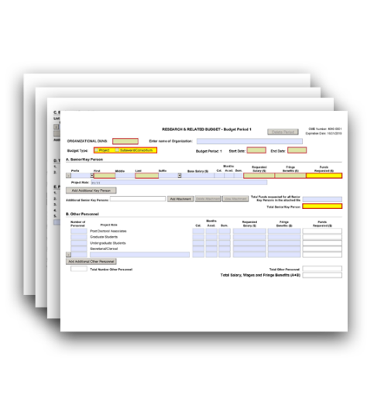

The R&R Budget Form is used in the majority of applications; however, it is important to refer to your specific FOA for guidance on which budget form(s) are allowed for your application.
Some application forms packages include two optional budget forms — (1) the R&R Budget Form and, (2) PHS 398 Modular Budget Form. Include only one of these forms, but not both, in your application.
View larger image
Quick Links
Introductory Fields
A. Senior/Key Person B. Other Personnel
C. Equipment Description D. Travel
E. Participant/Trainee Support Costs F. Other Direct Costs
G. Direct Costs H. Indirect Costs
I. Total Direct and Indirect Costs J. Fee
K. Total Costs and Fee L. Budget Justification
Research & Related Budget - Cumulative Budget
G.300 - R&R Budget Form

Who should use the R&R Budget Form?
There are two primary types of Budget Forms: detailed R&R and PHS 398 modular. Generally, you must use the R&R Budget Form if you are applying for more than $250,000 per budget period in direct costs, and you must use the Modular Budget Form if you are applying for less than $250,000. However, some grant mechanisms or programs (e.g., training grants) may require other budget forms to be used. Refer to your FOA and to the following instructions for guidance on which Budget Form to use.
Note: The terms “detailed budget” and “R&R Budget” are used interchangeably.
If you are requesting a budget with $500,000 or more in direct costs for any budget period, contact the awarding component to determine whether you must obtain prior approval before submitting the

application. For more information on applications that request $500,000 or more in direct costs, see the NIH Grants Policy Statement, Section 2.3.7.2: Acceptance for Review of Unsolicited Applications Requesting $500,000 or More in Direct Costs.
Special Instructions for Foreign Organizations (Non-domestic [non-U.S.] Entities): All competing (new, renewal, resubmission, and revision) grant applications from foreign (non-U.S.) institutions must use the R&R Budget Form. Do not use the PHS 398 Modular Budget Form. For additional information, see NIH Guide Notice on the Requirement for Detailed Budget Submissions from Foreign Institutions and the NIH Grants Policy Statement, Section 13.3.1: Budget. Applications from foreign organizations must request budgets in U.S. dollars.
Note on Subawards/Consortiums: If you have a subaward/consortium, you must use the R&R Subaward Budget Attachment(s) Form in conjunction with the R&R Budget Form. The prime must extract the R&R Subaward Budget Attachment(s) from the R&R Subaward Budget Attachment(s) Form and send the extracted file to the subaward/consortium. The consortium should complete the R&R Subaward Budget Attachment, following the instructions here and in G.310 – R&R Subaward Budget Attachment(s) Form.

For more information:
For more information on how to prepare your budget, see NIH's Develop Your Budget page.
Who should use the R&R Budget Form?
All career development applications must use the R&R Budget Form. The PHS 398 Modular Budget Form is not permissible.
Refer to your FOA for information regarding allowable costs for the candidate and any allowable research development or other costs. Contact the targeted awarding component if you are uncertain about allowable amounts for the applicable career development award mechanism. Keep in mind that amounts vary with awarding components.
Transitional Career Award applications: NIH intramural candidates applying for transitional career award support (e.g., K22, K99/R00) should follow instructions in the applicable FOA. For the mentored phase of these awards, budgets are negotiated with the sponsoring intramural laboratory. For awardees who receive approval to transition to the extramural phase, a budget will be required as part of the extramural sponsored application.
Additional Instructions for Career Development:
Who should use the R&R Budget Form?
T90/R90 applications: Use the R&R Budget Form in conjunction with the PHS 398 Training Budget Form for the R90 portion of the application.
K12, D43, D71, T37, and U2R applications: Use only the R&R Budget Form.
All other Training applications: Most training applications should use the PHS 398 Training Budget Form. Use the R&R Budget Form only when allowed or
Additional Instructions for Training:

required in an FOA. See also instructions in G.420 - PHS 398 Research Training
Program Plan Form.

Additional Instructions for Multi-project:
Developing a Multi-project Budget: The structure of a Multi-project application reflects where the work will be done and not necessarily the flow of funds. If most of the work for a particular component is done by a collaborating organization, then that organization can be set up as the lead organization for that component.
The main budget form for the component must reflect the DUNS for the lead organization and Project for the Budget Type. If the applicant organization is responsible for a portion of the work for that component, then their costs would be reflected on a Subaward Budget Form with the applicant organization DUNS and Subaward/Consortium for the Budget Type. Subaward Budget Forms simply record budget data. They do not indicate that funds must flow through the lead organization for the component.
The DUNS on each budget form is used to identify the budget data associated with each organization. When the DUNS on the budget form is the same as the DUNS on the Overall Component’s SF424 R&R form, the budget data is associated with the applicant organization. When the DUNS is different, it is seen as belonging to a subaward.
For more information, refer to NIH's Frequently Asked Questions on Applying Electronically.
Overall Component: Most budget data is collected within the Other Components. Complete only the G.200 - SF 424 (R&R) Form, Estimated Project Funding section and the G.350 - PHS Additional Indirect Costs Form (if applicable). The PHS Additional Indirect Costs Form is used to gather any additional information allowable under the grantee's negotiated F&A rate agreement needed to calculate the F&A rate for the Overall Component's first $25,000 on each subaward that leads an entire component. The PHS Additional Indirect Costs Form should not be used when all components are led by the applicant organization.
System-generated budget summaries (including a Composite Application Budget Summary) based on budget data collected within the Other Components are included in the summaries section of the assembled application image.
Budget summaries will:
- appear in the Overall section of the assembled application image in eRA Commons;
- will be compiled from R&R budget data collected in the Other Components; and
- will be generated upon submission.
Fast-Track SBIR/STTR Applications: You will need to create three separate budget periods to cover your Phase I and Phase II overall budget period: one budget period (6-12 months) for Phase I and two budget periods (one year each)
Additional Instructions for SBIR/STTR:

for Phase II. Complete a separate G.300 R&R Budget Form for each of the three
budget periods.

Using the R&R Budget Form:
The location of the R&R Budget Form may vary with the type of submission (e.g., under an “Optional Forms” tab).
You must complete a separate detailed budget for each budget period requested. The form will generate a cumulative budget for the total project period. If no funds are requested for a required field, enter “0.”
You must round to the nearest whole dollar amount in all dollar fields.
Competing Revision Applications: For a supplemental/revision application, complete fields for which additional funds are requested in addition to all required fields. If the initial budget period of the supplemental/revision application is less than 12 months, prorate the personnel costs and other appropriate items of the detailed budget.

Introductory Fields

Organizational DUNS:
This field is required. This field may be pre-populated and should reflect the DUNS or DUNS+4 number of the applicant organization (or of the lead organization for the component of a multi- project application).

Enter name of Organization:
This field may be pre-populated. Enter the name of the organization.

Budget Type:
This field is required. Check the appropriate box for your budget type, following these guidelines:
  - Project: The budget being requested is for the primary applicant organization.
  - Subaward/Consortium: The budget being requested is for subaward/consortium organization(s). Note, separate budgets are required only for subaward/consortium organizations that perform a substantive portion of the project. For subawards/consortiums that do not perform a substantive portion of the project, then you must include their costs in Field F5. Subawards/Consortium/Contractual Costs and in the prime’s Section L. Budget Justification.
If you are preparing an application that includes a subaward/consortium that performs a substantive portion of the project, in addition to completing this form, see also the instructions for G.310 - R&R Subaward Budget Attachment(s) Form.
Project: The budget being requested is for the organization leading the component.
Subaward/Consortium: The budget being requested is for other organizations performing work for the component. When the applicant organization is participating on a component, but not leading that component, their costs should
Additional Instructions for Multi-project:

be reflected on a Subaward/Consortium budget. This is true even if the money will
not flow through the lead organization. The budget justification can be used to clarify the flow of funds.

Budget Period:
This field is required.
Identify the specific budget period (for example, 1, 2, 3, 4, 5).

Start Date:
This field is required and may be pre-populated from the SF 424 R&R Form. Enter the requested/proposed start date of the budget period. For period 1, the start date is typically the same date as the Proposed Project Start Date on the G.200 - SF 424 (R&R) Form.

End Date:
This field is required. Enter the requested/proposed end date of the budget period.

A. Senior/Key Person

Who to include in A. Senior/Key Person:
Include the names of senior/key persons at the applicant organization, (or organization leading the component of a multi-project application), who are involved on the project in a particular budget period. Include all collaborating investigators and other individuals who meet the senior/key person definition if they are from the applicant organization.
Consultants designated as senior/key persons in the Senior/Key Person Profile Form can be included in the "A. Senior/Key Person" section only if they are also employees of the applicant organization. Otherwise, consultant costs should be included in Consultant Services in Question F of this form.

Who not to include in A. Senior/Key Person:
Do not list details of collaborators at other institutions here, as they will be provided in the Subaward Budget for each subaward/consortium organization.
Personnel listed as other significant contributors who are not committing any specific measurable effort to the project should not be included in the Personnel section (sections "A. Senior/Key Person" and "B. Other Personnel") since no associated salary and/or fringe benefits can be requested for their contribution.
Include information only for the candidate in the “A. Senior/Key Person" section. Do not include the mentor(s) or any other senior/key persons. For the candidate, provide the base salary, person months, and requested salary and fringe benefits. career development programs include a minimum effort requirement, usually 75% or nine person months.
Salary description: For the salary column, most NIH ICs limit the amount of salary contribution provided for career development programs. However, applicants should include information on actual institutional base salary and fringe benefits, and the actual amount of salary and fringe being requested. ICs may request
Additional Instructions for Career Development:

updated salary information prior to award. Any adjustments based on policy
limitations will be made at the time of the award.
The total salary requested must be based on a full-time staff appointment. The salary must be consistent both with the established salary structure at the institution and with salaries actually provided by the institution from its own funds to other staff of equivalent qualifications, rank, and responsibilities in the department concerned. If full-time, 12-month salaries are not currently paid to comparable staff members, the salary proposed must be appropriately related to the existing salary structure. The total salary contribution provided by the NIH may not exceed the legislatively mandated salary cap. See NIH's Salary Cap Summary.
Salary supplements: The sponsoring institution may supplement the NIH salary contribution up to a level that is consistent with the institution's salary scale.
However, supplementation may not be from federal funds unless specifically authorized by the federal program from which such funds are derived. In no case may PHS funds be used for salary supplementation. Institutional supplementation of salary must not require extra duties or responsibilities that would interfere with the purpose of the career award.

Prefix:
Enter the prefix (e.g., Mr., Mrs., Rev.), if applicable, for the name of the senior/key person.

First Name:
This field is required. Enter the first (given) name of the senior/key person.

Middle Name:
Enter the middle name of the senior/key person.

Last Name:
This field is required. Enter the last (family) name of the senior/key person.

Suffix:
Enter the suffix (e.g., Jr., Sr., PhD), if applicable, of the senior/key person.

Base Salary ($):
Enter the annual compensation paid by the employer for the senior/key person. This includes all activities such as research, teaching, patient care, and other. An applicant organization may choose to leave this blank; however, NIH or other PHS Agency staff will request this information prior to award.

Months (Cal./Acad./Sum.):
NIH and other PHS agencies use the concept of “person months” as a metric for determining percent of effort. For more information about calculating person months, see NIH's Frequently Asked Questions on Person Months.
Identify the number of months the senior/key person will devote to the project in the applicable box (i.e., calendar, academic, summer).
Use either calendar months OR a combination of academic and summer months. Measurable effort is required for every senior/key person entry.

For an explanation of "measurable effort," see the Frequently Asked Questions on Senior/Key Personnel.
If effort does not change throughout the year, it is OK to use only the calendar months column.
However, you may use both the academic and summer months columns if your institutional business process requires noting each separately even if effort remains constant. If effort varies between academic and summer months, leave the calendar months column blank and use only the academic and summer months columns.
If your institution does not use a 9-month academic year or a 3-month summer period, indicate your institution’s definition of these in Section L. Budget Justification.

Requested Salary ($):
This field is required. Regardless of the number of months being devoted to the project, indicate the salary being requested for this budget period for the senior/key person.
Salary limitations. Some PHS grant programs are currently subject to a legislatively imposed salary limitation. Any adjustment for salary limits will be made at the time of award; therefore, requested salary should be based on institutional base salary at the time the application is submitted and not adjusted for any limitation. For guidance on current salary limitations, see the NIH's Salary Cap Summary or contact your office of sponsored programs.
Graduate student compensation: NIH grants also limit compensation for graduate students. Compensation includes salary or wages, fringe benefits, and tuition remission. While actual institutional-based compensation should be requested and justified, this may be adjusted at the time of the award. For more guidance on this policy, see the NIH Grants Policy Statement, Section 2.3.7.9: Graduate Student Compensation.

Fringe Benefits ($):
Enter the amount of requested fringe benefits, if applicable, for the senior/key person.

Funds Requested ($):
This field is automatically calculated and will reflect the total requested salary and fringe benefits for the senior/key person.

Project Role:
This field is required. Identify the project role of each senior/key person. Roles should correspond to the roles included on the G.240 - R&R Senior/Key Person Profile (Expanded) Form. Note that there must be at least one PD/PI per budget period.
STTR: If the budget type is “project,” you do not have to list a PD/PI; list the PD/PI in the Subaward/Consortium budget.
Additional Instructions for SBIR/STTR:

Additional Senior/Key Persons:
If you are requesting funds for more senior/key persons than the form allows, you must include an attachment listing the additional senior/key person(s) in this “Additional Senior/Key Persons” field. Use the same format as the budget form and include all the information identified in this section.

Total Funds requested for all persons in the attached file:
If you have attached a file with additional senior/key persons, enter the total funds requested for everyone listed in the attachment in the “Total Funds requested for all Senior/Key Persons in the attached file” field.

Total Senior/Key Persons:
This total will be automatically calculated based on the sum of the “Funds Requested” column and the “Total Funds requested for all Senior/Key Persons in the attached file” field.
Special Instructions for Joint University and Department of Veterans Affairs (V.A.) Appointments: Individuals with joint university and V.A. appointments may request the university’s share of their salary in proportion to the effort devoted to the research project. The individual’s salary with the university determines the base for computing that request. The signature by the institutional official on the application certifies that: (1) the individual is applying as part of a joint appointment specified by a formal Memorandum of Understanding between the university and the V.A.; and (2) there is no possibility of dual compensation for the same work, or of an actual or apparent conflict of interest regarding such work. Additional information may be requested by the awarding components.

B. Other Personnel
Skip the "B. Other Personnel" section.
Additional Instructions for Career Development:

Number of Personnel:
For each project role category, identify the number of personnel proposed.
Administrative, Secretarial, and Clerical Support Salaries: In most circumstances, the salaries of administrative, secretarial, or clerical staff at educational institutions and nonprofit organizations are included as part of indirect costs (Section H. Indirect Costs). However, examples of situations where direct charging of administrative or clerical staff salaries may be appropriate may be found at: 45 CFR 75.403.
Inclusion of such costs may be appropriate only if all of the following conditions are met:
- Administrative or clerical services are integral to a project or activity;
- Individuals involved can be specifically identified with the project or activity;
- Such costs are explicitly included in the budget or have prior written approval of the federal awarding agency; and
- The costs are not also recovered as indirect costs.
Requests for direct charging for secretarial/clerical personnel (i.e., administrative and clerical staff) must be appropriately justified in Section L. Budget Justification. For all individuals classified as administrative/secretarial/clerical, provide a justification (in the Budget Justification) documenting how they meet all four conditions. NIH ICs may request additional information for these positions in order to assess allowability.

Postdoctoral and Graduate Students: For all postdoctoral associates and graduate students not already named in "Section A. Senior/Key Person," individually list names, roles (e.g., postdoctoral associates or graduate student), associated months, and requested salary and fringe benefits in Section L. Budget Justification.

Project Role:
List any additional project role(s) (e.g., engineer, IT professionals, etc.) in the blank(s) provided. Identify the number of each personnel proposed.
You may have up to six named roles. If you have more than six, you must combine project roles here and add an explanation about the named roles in Section L. Budget Justification.
Do not include consultants in this section. Consultants are included below in Section F. Other Direct Costs.

Months (Cal./Acad./Sum.):
NIH and other PHS agencies use the concept of “person months” as a metric for determining percent of effort. For more information about calculating person months, see: NIH's Frequently Asked Questions on Person Months.
Identify the number of months devoted to the project in the applicable box (i.e., calendar, academic, summer) for each project role category.
Use either calendar months OR a combination of academic and summer months.
If effort does not change throughout the year, it is OK to use only the calendar months column.
However, you may use both academic and summer months columns if your institutional business process requires noting each separately, even if effort remains constant. If effort varies between academic and summer months, leave the calendar months column blank and use only the academic and summer months columns.
If your institution does not use a 9-month academic year or a 3-month summer period, indicate your institution’s definition of these in Section L. Budget Justification.

Requested Salary ($):
Regardless of the number of months being devoted to the project, indicate only the amount of salary/wages being requested for this budget period for each project role. The amount entered should reflect the total amount of funds requested for all personnel within a project role.
Salary limitations: Some PHS grant programs are currently subject to a legislatively imposed salary limitation. Any adjustment for salary limits will be made at the time of award; therefore, requested salary should be based on institutional base salary at the time the application is submitted and not adjusted for any limitation. For guidance on current salary limitations, see the NIH's Salary Cap Summary or contact your office of sponsored programs.
Graduate student compensation: NIH grants also limit the compensation for graduate students. Compensation includes salary or wages, fringe benefits, and tuition remission. While actual institutional-based compensation should be requested and justified, this may be adjusted at the time of the award. For more guidance on this policy, see the NIH Grants Policy Statement, Section 2.3.7.9: Graduate Student Compensation.

Fringe Benefits ($):
Enter the amount of requested fringe benefits, if applicable, for this project role category. The amount entered should reflect the total amount of fringe benefits requested for all personnel

within a project role.

Funds Requested ($):
This field will be automatically calculated and will reflect the total requested salary and fringe benefits for each project role category.

Total Number of Other Personnel:
This total will be automatically calculated based on the Number of Personnel for each project role category.

Total Other Personnel:
This total will be automatically calculated based on the sum of the Funds Requested for all Other Personnel.

Total Salary, Wages and Fringe Benefits (A+B):
This total will be automatically calculated and represents the total Funds Requested for all Senior/Key persons and all Other Personnel.

C. Equipment Description

The “C. Equipment Description” section is for you to list items and dollar amount for each item exceeding $5,000 (unless the organization has established lower levels).
Skip the “C. Equipment Description” section.
Additional Instructions for Career Development:

Equipment Item:
Equipment is defined as an item of property that has an acquisition cost of $5,000 or more (unless the organization has established lower levels) and an expected service life of more than one year.
List each item of equipment separately and justify each in Section L. Budget Justification. Allowable items ordinarily will be limited to research equipment not already available for the conduct of the work.
Other Components: You are allowed to add up to 100 equipment items in this list. For additional equipment items, you must list them in the “Additional Equipment” attachment.
Additional Instructions for Multi-project:

Funds Requested:
This information is required. List the estimated cost of each item, including shipping and any maintenance costs and agreements.

Additional Equipment:
If you're requesting funds for more equipment than the form allows, you must include an attachment listing the additional equipment items in this “Additional Equipment” field. Enter the information in a separate file and attach it as a PDF. List each additional item and the funds

requested for each individual item. The dollar amount for each item should exceed $5,000 (unless the organization has established lower levels).

Total funds requested for all equipment listed in the attached file:
If you have attached a file with additional equipment, enter the total funds requested for all the equipment listed in the attachment.

Total Equipment:
This total will be automatically calculated based on the sum of the “Funds Requested” column and the “Total funds requested for all equipment listed in the attached file” field.

D. Travel
Skip the "D. Travel" section.
Additional Instructions for Career Development:

Domestic Travel Costs (Incl. Canada, Mexico, and U.S. Possessions):
Enter the total funds requested for domestic travel. Domestic travel includes destinations in the U.S., Canada, Mexico, and U.S. possessions. In Section L. Budget Justification, include the purpose, destination, dates of travel (if known), and the number of individuals for each trip. If the dates of travel are not known, specify the estimated length of trip (e.g., 3 days).

Foreign Travel Costs:
Identify the total funds requested for foreign travel. Foreign travel includes any destination outside of the U.S., Canada, Mexico, or U.S. possessions. In Section L. Budget Justification, include the purpose, destination, dates of travel (if known), and the number of individuals for each trip. If the dates of travel are not known, specify the estimated length of trip (e.g., 3 days).

Total Travel Cost:
This total will be automatically calculated based on the sum of the Domestic and Foreign Funds Requested fields.

E. Participant/Trainee Support Costs

Unless specifically stated otherwise in a FOA, NIH and other PHS agencies applicants should skip Section E. Participant/Trainee Support Costs. Note: Tuition remission for graduate students should be included in Section F. Other Direct Costs when applicable.

Tuition/Fees/Health Insurance:
List the total funds requested for Participant/Trainee Tuition/Fees/Health Insurance.

Stipends:
List the total funds requested for Participant/Trainee stipends.

Travel:
List the total funds requested for Participant/Trainee travel.

Subsistence:
List the total funds requested for Participant/Trainee subsistence.

Other:
Describe any other Participant/Trainee support costs and list the total funds requested for all other Participant/Trainee costs described.

Number of Participants/Trainees:
List the total number of proposed Participants/Trainees. Value cannot be greater than 999.

Total Participant/Trainee Support Costs:
This field is required if any data has been entered in “Section E. Participant/Trainee Support Costs.” This total will be automatically calculated based on the sum of the Funds Requested column in "Section E. Participant/Trainee Support Costs."

F. Other Direct Costs

Materials and Supplies:
List the total funds requested for materials and supplies. In Section L. Budget Justification, indicate general categories such as glassware, chemicals, animal costs, etc., including an amount for each category. Categories with amounts less than $1,000 are not required to be itemized.
In the "Material and Supplies" field, enter the total research development support being requested for the initial budget period of the career development award.
Usually, a specific total amount is allowed for research development and other costs (tuition, fees, research supplies, equipment, computer time, travel, etc.) that do not require individual cost category identification. Unless instructed differently in the applicable FOA, applicants should enter only the total requested research development support (RDS) amount in this box. All remaining budget fields in this section should be left blank.
Please note that while this method of entering only the total requested research development support costs in "Section F. Other Direct Cost" will be simplest for most applicants, some applicants, including some system-to-system applicants, may instead choose to enter those costs in the applicable detailed budget categories. When choosing this option, it is still the applicant’s responsibility to make certain the total research development support costs do not exceed the allowable total.
Additional Instructions for Career Development:

Publication Costs:
List the total funds requested for publication costs. The proposal budget may request funds for the costs of documenting, preparing, publishing, or otherwise making available to others, the findings and products of the work conducted under the award. Include supporting information in Section L. Budget Justification.

Consultant Services:
List the total funds requested for all consultant services. Identify the following items in Section L. Budget Justification, as applicable:
  - each consultant, the services he/she will perform, total number of days, travel costs, and the total estimated costs;

  - the names and organizational affiliations of all consultants, other than those involved in consortium/contractual arrangements;
  - consulting physicians in connection with patient care; and
  - persons who are confirmed to serve on external monitoring boards or advisory committees to the project. Describe the services to be performed.

Automatic Data Processing (ADP)/Computer Services:
List the total funds requested for ADP/computer services. The cost of computer services, including computer-based retrieval of scientific, technical, and education information may be requested. In Section L. Budget Justification, include the established computer service rates at the proposing organization, if applicable.

Subawards/Consortium/Contractual Costs:
List the total funds requested for:
- all subaward/consortium organization(s) proposed for the project and
- any other contractual costs proposed for the project.
This line item should include both direct and indirect costs for all subaward/consortium organizations.
Contractual costs for support services, such as laboratory testing of biological materials, clinical services, or data processing, are occasionally sufficiently high to warrant a categorical breakdown of costs. When this is the case, provide detailed information as part of Section L. Budget Justification.
NIH policy provides for exclusion of consortium/contractual F&A costs when determining if an applicant is in compliance with a direct cost limitation. However, you must include the full cost of consortium/subawards in this field. See the NIH Grants Policy Statement, Section 2.3.7.1: Applications that Include Consortium/Contractual F&A Costs for policy related to the exclusion of consortium/subaward amounts in determining whether an applicant is in compliance with a direct cost limitation.

Equipment or Facility Rental/User Fees:
List the total funds requested for equipment or facility rental/user fees. In Section L. Budget Justification, identify and justify each rental user fee.

Alterations and Renovations:
List the total funds requested for alterations and renovations (A&R). In Section L. Budget Justification, itemize by category and justify the costs of alterations and renovations, including repairs, painting, and removal or installation of partitions, shielding, or air conditioning. Where applicable, provide the square footage and costs.
Under certain circumstances the public policy requirements that apply to construction activities may also apply to A&R activities. Refer to the NIH Grants Policy Statement, Section 10.10: Construction Grants – Public Policy Requirements and Objectives for more information.
Special Instructions for Foreign Organizations (Non-domestic [non-U.S.] Entities): Minor A&R costs (≤$500,000) are allowable on applications from foreign organizations and domestic institutions with foreign components. When requesting minor A&R costs under this policy, please provide detailed information on the planned A&R in the budget justification.

Other:
Add descriptions for any “other” direct costs not requested above. Use Section L. Budget Justification to further itemize and justify.
List funds requested for each of the items in lines "8-10 Other.” Use lines 8-10 for costs such as patient care and tuition remission. If requesting patient care costs, request inpatient and outpatient costs separately, using lines 8 and 9.
Lines "8-10 Other" may also be used to request direct costs related to the use of single Institutional Review Board (sIRB) for multi-site human subjects research.
For more information on charging direct and indirect costs for single IRB activities, see the Scenarios to Illustrate the Use of Direct and Indirect Costs for Single IRB Review under the NIH Policy on the Use of a Single IRB for Multi-Site Research. Note: If you intend to request an
exception to the sIRB policy based on compelling justification, do not account for this exception in your proposed budget. the proposed budget must reflect all necessary sIRB costs without an exception (i.e. applicants should not assume that an exception will be granted when considering what sIRB costs to include in the budget). See the FAQs on Costs of the NIH Policy on the Use of a Single IRB for Multi-Site Research for more information.
Special Instructions for Patient Care Costs: If inpatient and/or outpatient costs are requested, provide the names of any hospitals and/or clinics and the amounts requested for each in the Budget Justification.
State whether each hospital or clinic has a currently effective HHS-negotiated research patient care rate agreement and, if not, what basis is used for calculating costs. If an applicant does not have a HHS-negotiated rate, the PHS awarding component can approve a provisional rate. Indicate, in detail, the basis for estimating costs in this category, including the number of patient days, estimated cost per day, and cost per test or treatment. If multiple sites are to be used, provide detailed information by site.
Include information regarding projected patient accrual for the project/budget periods and relate this information to the budget request for patient care costs. If patient accrual is anticipated to be lower at the start or during the course of the project, plan budget(s) accordingly.
Provide specific information regarding anticipated sources of Other Support for patient care costs, e.g., third party recovery or pharmaceutical companies. Include any potential or expected utilization of the Clinical and Translational Science Awards (CTSA) program.
Additional Instructions for Research:
Other Components, Special Instructions for Patient Care Costs: If inpatient and/or outpatient costs are requested, provide the names of any hospitals and/or clinics and the amounts requested for each in the Budget Justification.
State whether each hospital or clinic has a currently effective HHS-negotiated research patient care rate agreement and, if not, what basis is used for calculating costs. If an applicant does not have a HHS-negotiated rate, the PHS awarding
Additional Instructions for Multi-project:

component can approve a provisional rate. Indicate, in detail, the basis for
estimating costs in this category, including the number of patient days, estimated cost per day, and cost per test or treatment. If multiple sites are to be used, provide detailed information by site.
Include information regarding projected patient accrual for the project/budget periods and relate this information to the budget request for patient care costs. If patient accrual is anticipated to be lower at the start or during the course of the project, plan budget(s) accordingly.
Provide specific information regarding anticipated sources of Other Support for patient care costs, e.g., third party recovery or pharmaceutical companies. Include any potential or expected utilization of the Clinical and Translational Science Awards (CTSA) program.

Additional Instructions for SBIR/STTR:
Special Instructions for Technical Assistance Costs: NIH offers distinct technical assistance programs to SBIR and STTR Phase I and Phase II awardees. These programs offer specialized, strategic business training and provide access to a vast network of industry experts. If you wish to utilize your own technical assistance provider/vendor, you are required to include this as a consultant in your budget and to provide a detailed budget justification.
You may request up to $6,500 per year for a Phase I and up to $50,000 per Phase II project (across all years) for assistance. You may request up to these amounts for each Phase in a Fast-Track application. Reimbursement is limited to services received that comply with 15 U.S.C. § 638(q):
To provide small business concerns engaged in SBIR or STTR projects with technical and business assistance services, such as access to a network of scientists and engineers engaged in a wide range of technologies, product sales, IP protections, market research, market validation, development of regulatory plans, manufacturing plans, or access to technical and business literature available through on-line data bases, for the purpose of assisting such concerns in:
    - making better technical decisions concerning such projects;
    - solving technical problems which arise during the conduct of such projects;
    - minimizing technical risks associated with such projects; and
    - developing and commercializing new commercial products and processes resulting from such projects, including intellectual property protections.
To request technical assistance from your own provider:
    - Label the requested cost “Technical Assistance” on one of the lines from 8-10.
    - Include a detailed description of the technical or business assistance that your vendor will provide, including the name of the vendor and the expected benefits and results of the technical or business assistance provided in the Budget Justification.

Total Other Direct Costs:
This total will be automatically calculated based on the sum of the Funds Requested column in "Section F. Other Direct Cost."

G. Direct Costs

This total will be automatically calculated based on the sum of the Total funds requested for all direct costs (sections A-F).

H. Indirect Costs

Indirect costs (Facilities & Administrative [F&A] costs) are defined as costs that are incurred by a grantee for common or joint objectives and that, therefore, cannot be identified specifically with a particular project or program. See the NIH Glossary's definition of Indirect Costs.

For more information:
You are encouraged to visit the following Defense Finance and Accounting Services (DFAS) Websites or call DFAS staff at 301-496-2444 for guidance: Main DFAS website, DFAS Frequently Asked Questions. The following website has a listing of unallowable and unallocable costs and the related Federal Acquisition Regulation (FAR) citation for each: NIH Office of Management's Unallowable/Unallocable Costs.
Refer to the NIH Grants Policy Statement, Section 7.4: Reimbursement of Facilities and Administrative Costs for more information.
In accordance with the Small Business Innovation Development Act of 1982 and the Small Business Technology Transfer Act of 1992, irrespective of the time period in which the costs are incurred, no SBIR/STTR funds can be used to “support” any commercialization (Phase III activities). “Support” in this case includes both direct and indirect costs.
The Small Business Administration’s SBIR and STTR Program Policy Directives defined terms:
SBIR agencies must establish an SBIR Program by reserving, in each fiscal year, not less than 3.2 percent (FY 2018) of its extramural budget for awards to SBCs for R/R&D. “R&D activities” include any activities directed toward reducing the technical risk of the technology.
- Commercialization. The process of developing marketable products or services and producing and delivering products or services for sale (whether by the originating party or by others) to government or commercial markets.
- Phase III is the period during which Phase II innovation moves from the laboratory into the marketplace. No SBIR funds support this phase. The small business must find funding in the private sector or other non-SBIR federal agency funding.
Additional Instructions for SBIR/STTR:

Based on this position, when NIH is negotiating indirect costs with SBIR/STTR
grantees/contractors, we are disallowing all indirect costs applicable to commercialization activities related to SBIR/STTR awards.
Commercialization cost categories: Below is a list of cost categories NIH considers to be commercialization.
- marketing and sales;
- market research;
- business development/product development/market plans;
- legal fees;
- travel and other costs relating to license agreements and partnerships; and
- labor costs for the Marketing Director and Director of Business Development, as well as sales and marketing staff who are grantee/contractor employees or contractors hired for those purposes.

Special Instructions for Foreign Organizations (Non-domestic [non-U.S.] Entities): Foreign institutions and international organizations may request funds for limited F&A costs (8% of modified total direct costs less equipment) to support the costs of compliance with HHS and NIH requirements including, but not limited to, those related to the protection of human subjects, animal welfare, invention reporting, financial conflict of interest, and research misconduct. Foreign organizations may not include any charge-back of customs and import fees, such as consular fees, customs surtax, value-added taxes (VAT), and other related charges.

Indirect Cost Type:
Enter the type of indirect cost (e.g., Salary & Wages, Modified Total Direct Costs, etc.) and whether the cost is off-site. If more than one rate or base is involved for a given type of indirect cost, then list them as separate entries. If you do not have a current indirect (F&A) rate(s) approved by a federal agency, indicate “None--will negotiate” and include information for a proposed rate. Use Section L. Budget Justification if additional space is needed.
Indicate the Indirect Cost type as Modified Total Direct Costs.
Additional Instructions for Career Development:

Indirect Cost Rate (%):
Enter the most recent indirect cost rate(s) established with the cognizant federal office, or in the case of for-profit organizations, the rate(s) established with the appropriate agency. If you have a cognizant/oversight agency and are selected for an award, you must submit your indirect rate proposal to the NIH awarding IC or to the PHS awarding office for approval. If you do not have a cognizant/oversight agency, contact the awarding agency. This field should be entered using a rate such as “55.5.”
Enter the indirect cost rate as 8%. For all career development award applications, indirect costs are reimbursed at 8% of modified total direct costs (exclusive of
Additional Instructions for Career Development:

tuition and fees and expenditures for equipment) rather than on the basis of a
negotiated rate agreement.

Additional Instructions for SBIR/STTR:
If you have an indirect cost rate: If the applicant small business concern has a currently effective negotiated indirect cost rate with a federal agency, that rate should be used when calculating proposed indirect costs. However, these rates must be adjusted for independent [self-sponsored] research and development expenses, which are not allowable by HHS.
If applicable, indicate your organization’s most recent indirect cost rate established with NIH’s Division of Financial Advisory Services (DFAS) or with another federal agency. If your applicant organization is in the process of negotiating or renegotiating a rate, use that rate in the application.
If you don’t have an indirect cost rate: If the applicant organization does not have a current negotiated rate, it should develop a provisional rate for application purposes. Follow the guidelines below.
SBIR and STTR Phase I Applicants: If your organization does not have a currently effective negotiated indirect cost rate with a federal agency, then propose estimated F&A costs at a rate not to exceed 40% of the total direct costs. If awarded at a rate of 40% or less of total direct costs, the rate used to charge actual F&A costs to projects cannot exceed the awarded rate. NIH will not negotiate F&A rates for Phase I awards.
SBIR and STTR Phase II and CRP Applicants: SBIR and STTR applicants who propose in the application an F&A rate of 40 percent of total direct costs or less will not be required to provide further justification at the time of award, and F&A costs will be awarded at the requested rate. However, DFAS will retain the authority to require well-documented proposals for F&A rates on an ad hoc basis. If the applicant SBC has a currently effective negotiated indirect cost rate(s) with a federal agency, such rate(s) should be used when calculating proposed F&A costs for an NIH application. (However, the rates(s) must be adjusted for IR&D expenses, which are not allowable under HHS awards.) SBCs are reminded that only actual F&A costs may be charged to projects. If awarded at a rate of 40 percent or less of total direct costs, the rate used to charge actual F&A costs to projects cannot exceed the awarded rate unless the SBC negotiates an indirect cost rate(s) with DFAS. DFAS will negotiate F&A/IDC rates for SBCs receiving Phase II awards if the requested rate is greater than 40 percent of total direct costs. For more detailed information, see NIH Guide Notice on the Negotiation of F&A/Indirect Costs for Phase II SBIR/STTR Grants.

Indirect Cost Base ($):
Enter the amount of the base for each indirect cost type.

Funds Requested ($):
Enter the funds requested for each indirect cost type.

Total Indirect Costs:
This total will be automatically calculated from the “Funds Requested” column in "Section H. Indirect Cost."

Cognizant Federal Agency:
Enter the name of the cognizant Federal Agency and the name and phone number of the individual responsible for negotiating your rate (your point of contact). If no cognizant agency is known, enter “None.”
You may either follow the general instructions above to complete the "Cognizant Federal Agency" field or you may enter “Not Applicable.” Either response is acceptable since indirect costs will be reimbursed as 8% of modified total direct costs rather than on the basis of a negotiated rate agreement.
Additional Instructions for Career Development:

I. Total Direct and Indirect Costs

This total will be automatically populated from the sum of Total Direct Costs (from Section G. Direct Cost) and the Total Indirect Costs (from Section H. Indirect Costs).
Award Limits: According to statutory guidelines, total funding support (direct costs, indirect costs, fee) normally may not exceed $150,000 for Phase I awards and
$1,000,000 for Phase II awards.
SBA may occasionally update these budget guidelines and, therefore, the hard caps listed below for inflation.
For more information, see the SBIR and STTR websites.
NIH deviations from statutory guidelines: The ability to deviate from the statutory guidelines applies to NIH only. With appropriate justification from the applicant, Congress will allow awards to exceed these amounts by up to 50% ($225,000 for Phase I and $1,500,000 for Phase II, a hard cap). As written in the statute and under appropriate circumstances, NIH can apply for a waiver from SBA to issue an award exceeding $225,000 for Phase I or $1,500,000 for Phase II, if this hard cap will interfere with NIH’s ability to meet its mission.
Award waivers from the SBA are not guaranteed and may delay the release of funds. Applicants are strongly encouraged to contact NIH program officials prior to submitting any award in excess of the guidelines. In all cases, applicants should propose a budget that is reasonable and appropriate for completion of the research project.
The ability to deviate from the statutory guidelines applies to NIH ONLY.
SBIR Phase I applications to CDC and FDA are limited to a total cost of $150,000. SBIR Phase II applications to CDC and FDA are limited to a total cost of $1,000,000.
Additional Instructions for SBIR/STTR:

J. Fee

Do not include a fee in your budget, unless the FOA specifically allows inclusion of a “fee.” If a fee is allowable, enter the requested fee.

Additional Instructions for SBIR/STTR:
A reasonable fee, not to exceed 7% of total costs (direct and indirect) for each Phase (I and II) of the project, is available with SBIR/STTR awards. The fee is intended to be a reasonable profit factor available to for-profit organizations, consistent with normal profit margins provided to profit-making firms for research and development work.
Example:
$70,000 direct costs (includes all third party costs) + $28,000 F&A costs (40% * 70,000) = $98,000.
Maximum allowable fee = 7% * $98,000 = $6,860 fee. Total Award = $104,860.
Explain the basis and the amount requested for the fee in Section L. Budget Justification.
The amount requested for the fee should be based on the following guidelines:
    - it must be consistent with that paid under contracts by the PHS for similar research conducted under similar conditions of risk;
    - it must take into account the complexity and innovativeness of the research to be conducted under the SBIR/STTR project; and
    - it must recognize the extent of the expenditures for the grant project for equipment and for performance by other than the grantee organization through consultant and subaward agreements.
The fee is not a direct or indirect "cost" item and may be used by the small business concern for any purpose, including additional effort under the SBIR/STTR award.
The fee applies solely to the small business concern receiving the award and not to any other participant in the project. However, the grantee may pay a profit/fee to a contractor providing routine goods or services in accordance with normal commercial practice.
Note: The electronic system automatically rounds up. If you get an error “The fee must be less than 7%,” try using 6.99% as the rate.

K. Total Costs and Fee

This total will be automatically calculated from the sum of Total Direct Costs and Fee (from sections “I. Total Direct and Indirect Costs” and “J. Fee”).

L. Budget Justification

The “Budget Justification” attachment is required. Attach only one file.
Use the Budget Justification to provide the additional information requested in each budget category identified above and any other information the applicant wishes to submit to support the budget request. If you have a quote(s), you may include it here. The following budget categories must be justified, where applicable: equipment, travel, participant/trainee support, and other direct cost categories.

In addition to the justifications described in the above sections, also include a justification for any significant increases or decreases from the initial budget period. Justify budgets with more than a standard escalation from the initial to the future year(s) of support.
Also use the Budget Justification to explain any exclusions applied to the F&A base calculation.
If your application includes a subaward/consortium budget, a separate Budget Justification must be submitted. See G.310 - R&R Subaward Budget Attachment(s) Form.
Use the Budget Justification to provide a detailed description and justification for specific items within the Research Development Support costs (e.g., all equipment, supplies, and other personnel that will be used to help achieve the career development and research objectives of this award).
Additional Instructions for Career Development:

Research & Related Budget - Cumulative Budget

All values on this form are automatically calculated, and the fields are pre-populated. They present the summations of the amounts you entered previously, under Sections A through K, for each of the individual budget periods. Therefore, no data entry is allowed or required to complete this “Cumulative Budget” section.
If any of the amounts displayed on this form appear to be incorrect, you may correct it by adjusting one or more of the values that contribute to that total. To make any such corrections, you will need to revisit the appropriate budget period form(s).

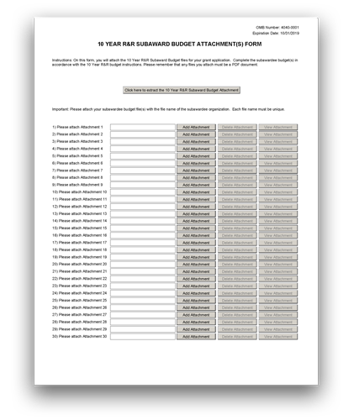

The R&R Subaward Budget Attachment(s) Form is used for applications with a subaward or consortium.
This form is required only when the prime grantee is submitting an R&R Budget Form and has subaward/consortium budgets.
Applicants using the Modular Budget Form should see G.320 - Modular Budget Form for instructions concerning information on consortium budgets.
View larger image
G.310 - R&R Subaward Budget Attachment(s) Form

Who should use the R&R Subaward Budget Attachment(s) Form?
The R&R Subaward Budget Attachment(s) Form is required if you have a subaward/consortium and are using the G.300 - R&R Budget Form.
Do not use this form if you are using the PHS Modular Budget Form or if you do not have a subaward/consortium.
Each consortium grantee organization that performs a substantive portion of the project must complete an R&R Subaward Budget Attachment, including the Budget Justification section.

Consortium/Contractual F&A Costs:
These instructions on Consortium/Contractual F&A Costs do not apply.
Additional Instructions for SBIR/STTR:
NIH policy provides for the exclusion of consortium/contractual F&A costs when determining if an applicant is in compliance with a direct cost limitation. However, you must include the full cost of subaward/consortium in the Subawards/Consortium Costs field (G.300 - R&R Budget Form, Section F. Other Direct Costs, Question 5). If a subaward/consortium is not performing a substantive portion of the project, they do not need to complete an R&R Subaward Budget Form; however, their costs must be included in the prime grantee’s R&R Budget Form. All F&A costs count toward the direct cost limit.
Refer to the NIH Grants Policy Statement, Section 2.3.7.1: Applications That Include Consortium/Contractual F&A Costs for policy related to the exclusion of consortium/subaward amounts in determining whether an applicant is in compliance with a direct cost limitation.

Applicants should document how their budget falls below the direct cost limit in their Budget Justification on the R&R Subaward Budget Form.

Note on Project Roles for Consortium Lead Investigators:
It is appropriate and expected that someone may serve as the consortium lead investigator responsible for ensuring proper conduct of the project or program at each subaward or consortium site.
Unless you are submitting your application under the multiple PD/PI policy, consortium lead investigators are NOT considered PD/PIs for the “Project Role” field. This individual should be assigned some other project role on the G.300 - R&R Budget Form and in the G.240 – R&R Senior/Key Person Profile (Expanded) Form. However, the project role of “PD/PI” should be used for a consortium lead investigator if they also serve as PD/PI for the entire application under the multiple PD/PI policy.

Using the R&R Subaward Budget Attachment(s) Form:
The location of the R&R Subaward Budget Attachment(s) Form may vary with the type of submission (e.g., under an “Optional Forms” tab).
The steps needed to include a subaward budget in your application vary by submission method. If submitting using the Grants.gov Workspace, the prime applicant can extract a copy of the R&R Budget Form from the R&R Subaward Budget Attachment(s) Form and send the extracted file to the consortium for completion. After the consortium completes the R&R Budget Form, following the instructions here and in G.300 – R&R Budget Form, the prime grantee must then upload the R&R Budget Form to the R&R Subaward Budget Attachment(s) Form.
For all submission methods, the R&R Budget Form with a "Budget Type" of Subaward/Consortium is used to collect subaward budget data. However, ASSIST and other system-to-system solutions may present a different interface than the R&R Subaward Budget Attachment Form shown here.
This form accommodates a set number of separate subaward budgets. If you need to add more subaward budgets than the form allows, include the remaining budgets as part of Budget Justification in G.300 – R&R Budget Form.
Regardless of how many subaward budgets you include, the sum of all subaward budgets (those attached within the R&R Subaward Budget Attachment(s) Form and those provided as part of the project budget’s Budget Justification), must be included in G.300 - R&R Budget Form, Section F. Other Direct Costs, Question 5. Subawards/Consortium/Contractual Costs of the project budget.

Format:
All attachments, including all Subaward Budget Forms and Budget Justifications, must be PDF files. The R&R Budget Forms are already PDFs when extracted. Do not alter the format.

Content:
On this R&R Subaward Budget Attachment(s) Form, you will attach the R&R Subaward Budget files for your application. Each consortium should complete the Subaward Budget(s) in accordance with the G.300 - R&R Budget Form instructions.

Submitting Subaward Budgets that are not Active for all Periods of the Prime Grant:
The R&R Budget Forms do not allow for “empty” budget periods.
Subaward/consortiums organizations should complete all budget periods in the R&R Subaward Budget Form for their subaward budgets, aligning the budget period numbers, start dates, and end dates with the budget periods of the prime grant.

Example: The prime fills out an R&R Budget Form with the following periods:
- period 1 - Jan 1, 2017 – Dec 31, 2017
- period 2 - Jan 1, 2018 – Dec 31, 2018
- period 3 - Jan 1, 2019 – Dec 31, 2019
- period 4 - Jan 1, 2020 – Dec 31, 2020
- period 5 - Jan 1, 2021 – Dec 31, 2021
The budget period numbers and dates should be the same in all the R&R Subaward Budget Forms included in the R&R Subaward Budget Attachment(s) Form.
The R&R Subaward Budget Forms include several required fields which must be completed (even for inactive periods) in order to successfully submit the application. Provide the following information for inactive budget periods in subaward/consortium budgets:
- Organization DUNS
- Budget Type = Subaward/Consortium
- Budget Period Start/End Dates (align with budget periods and dates of the prime budget)
- In Question "A: Senior/Key Person," provide a single entry including the following:
  - PD/PI or subaward lead First and Last names
  - Project Role (may default to PD/PI; can be adjusted as needed)
  - Calendar Months = .01 (smallest amount effort allowed in the field)
  - Requested Salary = $0
  - Fringe Benefits = $0
- Explanation of the inactive budget periods in the Budget Justification of the subaward/consortium's R&R Subaward Budget Form
SBIR
Phase I and Phase II: The basis for determining the percentage of work to be performed by each of the cooperative parties will be the total of the requested costs (direct and F&A/indirect, and fee) attributable to each party, unless otherwise described and justified in G.400 - PHS 398 Research Plan Form, Consortium/Contractual Arrangements.
Phase I: Normally, a minimum of two-thirds or 67% of the research or analytical effort must be carried out by the small business concern (SBC). The total amount of all consultant and contractual arrangements to third parties for portions of the scientific and technical effort generally may not exceed 33% of the total amount requested (direct, F&A/indirect, and fee).
Phase II and CRP: Normally, a minimum of one-half or 50% of the research or analytical effort must be carried out by the SBC. The total amount of all consultant and contractual arrangements to third parties for portions of the scientific and
Additional Instructions for SBIR/STTR:

technical effort generally may not exceed 50% of the total Phase II amount requested (direct and F&A/indirect, and fee).

STTR
Phase I and Phase II: At least 40% of the work must be performed by the SBC and at least 30% of the work must be performed by the single partnering research institution. The basis for determining the percentage of work to be performed by each of the cooperative parties will be the total of the requested costs (direct and F&A/indirect, and fee) attributable to each party, unless otherwise described and justified in G.400 - PHS 398 Research Plan Form, Consortium/Contractual Arrangements.
The single “partnering” research institution must provide a letter to the applicant SBC certifying that at least 30% of the work of the STTR project will be performed by the research institution. The SBC will include this letter as an attachment upload in G.400 - PHS 398 Research Plan Form, Consortium/Contractual Arrangements.
In addition, an SBC must negotiate a written agreement between the small business and the research institution allocating intellectual property rights to carry out follow-on research, development, or commercialization. See the STTR Model Agreement for the Allocation of Rights. This agreement is required to receive support under the STTR program but is NOT submitted with the application. A copy of the Agreement must be furnished upon request of the NIH awarding component.

SBIR/STTR
An SBC may subcontract a portion of its SBIR or STTR award to a federal laboratory within the limits above. A federal laboratory, as defined in 15 U.S.C. § 3703, means any laboratory, any federally funded research and development center, or any center established under 15 U.S.C. §§ 3705 & 3707 that is owned, leased, or otherwise used by a federal agency and funded by the Federal Government, whether operated by the Government or by a contractor. An SBC may subcontract a portion of its STTR award to a Federally Funded Research and Development Center (FFRDC), either in its capacity as the Research Institution or as a participant in the STTR project in another capacity. However, STTR funds may not be used to pay for laboratory resources of non-FFRDCs, and no STTR funds may be used to pay for subcontracting any portion of the STTR award back to the issuing agency or to any other federal government unit unless a waiver is granted by the Small Business Administration.
A fee cannot be entered for a subaward/consortium budget. A fee is allowable only for the SBC budget page.
STTR only: If more than one subaward is included in the STTR application, identify the single, partnering research institution (RI) on the RI Subaward Budget Justification page.

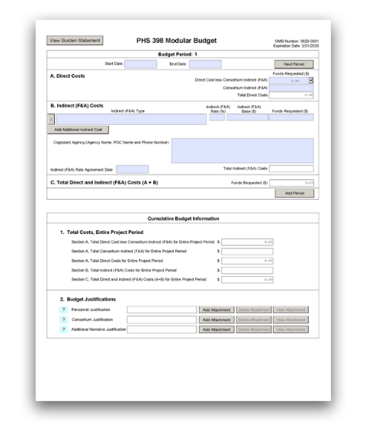
G.320 - PHS 398 Modular Budget Form

Some application forms packages include two budget forms — (1) the R&R Budget Form and (2) the PHS 398 Modular Budget Form. Include only one of these forms, but not both, in your application.
Generally, the PHS 398 Modular Budget Form is applicable only to research applications from domestic organizations that are requesting $250,000 or less per budget period in direct costs, but there are exceptions.
Refer to your specific FOA and these instructions for guidance on which budget form(s) to use.
View larger image

Quick Links
Budget Period 1
- Direct Costs
- Indirect (F&A) Costs
- Total Direct and Indirect (F&A) Costs (A+B)
Cumulative Budget Information
1. Total Costs, Entire Project Period 2. Budget Justifications

Who should use the PHS 398 Modular Budget Form?
There are two primary types of Budget Forms: the detailed R&R and PHS 398 modular. Generally, you must use the PHS Modular Budget Form if you are submitting a research grant application from a domestic organization and you are applying for $250,000 or less per budget period in direct costs. You must use the R&R Budget Form if you are applying for more than $250,000 per budget period in direct costs. However, there are exceptions and other distinctions. Refer to your FOA and to the following instructions for guidance on which Budget Form to use.
Special Instructions for Foreign Organizations (Non-domestic [non-U.S.] Entities): Foreign organizations must use the R&R Budget Form in G.300 - R&R Budget Form.
Note: The terms “detailed budget” and “R&R Budget” are used interchangeably.

For more information:
For more information on how to prepare your budget, see NIH's Develop Your Budget page. Also see NIH's Modular Research Grant Applications page.

Modular Budget Guidelines:
Modular budgets are simplified; therefore, detailed categorical information is not to be submitted with the application.
For all modular budgets, request total direct costs (in modules of $25,000), reflecting appropriate support for the project. There will be no future year escalations. A typical modular grant application will request the same number of modules in each budget period. Provide an additional narrative budget justification (in the Additional Narrative Justification section) for any variation in the number of modules requested.
Prior to award, NIH may request additional budget justification in exceptional circumstances.

Using the Modular Budget Form:
The Modular Budget Form provides budget fields for up to 5 periods of support (e.g., Budget Periods 1 - 5). A budget period is typically 1 year of support. If requesting fewer than 5 periods/years of support, complete only the applicable budget periods and leave the others blank. The fields are the same for all budget periods.
The form will generate information for the Cumulative Budget Information section, which reflects information for the total project period.
The following instructions (under “Budget Period 1”) can be used for each Budget Period (1-5).

Budget Period 1

Start Date:
This field is required. Enter the requested/proposed start date of the budget period. Use the following format: MM/DD/YYYY. For period 1, the start date is typically the same date as the Proposed Project Start Date on the SF 424 (R&R) Form.

End Date:
This field is required. Enter the requested/proposed end date of the budget period. Use the following format: MM/DD/YYYY.

A. Direct Costs

Direct Cost less Consortium Indirect (F&A):
This field is required.
Enter the amount of direct costs, but do not include actual consortium indirect (F&A) costs. This figure must be in $25,000 increments, and it may not exceed $250,000 in a budget period. See the NIH Glossary’s definitions of Direct Cost and Indirect Cost.

Consortium Indirect (F&A):
If this project involves a subaward/consortium, enter the actual consortium indirect (F&A) costs for the budget period. If this project does not involve a subaward/consortium, leave the field blank.

Total Direct Costs:
This field will be automatically calculated based on the sum of the “Direct Cost less Consortium Indirect (F&A)” and “Consortium Indirect (F&A)” fields.

B. Indirect (F&A) Costs

Indirect costs (Facilities & Administrative [F&A] costs) are defined as costs that are incurred by a grantee for common or joint objectives and that, therefore, cannot be identified specifically with a particular project or program. See the NIH Glossary's definition of Indirect Costs.

For more information:
You are encouraged to visit the following Defense Finance and Accounting Services (DFAS) Websites or call DFAS staff at 301-496-2444 for guidance: Main DFAS website, DFAS Frequently Asked Questions. The following website has a listing of unallowable and unallocable costs and the related Federal Acquisition Regulation (FAR) citation for each: NIH Office of Management's Unallowable/Unallocated costs.
Refer to the NIH Grants Policy Statement, Section 7.4: Reimbursement of Facilities and Administrative Costs for more information.

Indirect (F&A) Type:
Enter the type/base of indirect cost (e.g., Salary & Wages, Modified Total Direct Costs, etc.) and whether the cost is off-site. If more than one rate or base is involved for a given type of indirect cost, then list them as separate entries. If you do not have a current indirect (F&A) rate(s) approved by a federal agency, indicate “None—will negotiate” and include information for a proposed rate. Use the Budget Justification if additional space is needed.

Indirect (F&A) Rate (%):
Indicate the most recent Indirect (F&A) cost rate(s) established with the cognizant federal office, or in the case of for-profit organizations, the rate(s) established with the appropriate agency. If you have a cognizant/oversight agency and are selected for an award, you must submit your indirect rate proposal to the NIH awarding IC or to the PHS awarding office for approval. If you do not have a cognizant/oversight agency, contact the awarding agency. This field should be entered using a rate such as “55.5.”

Indirect (F&A) Base ($):
Enter the amount of the base for each indirect cost type.

Funds Requested ($):
Enter the funds requested for each indirect cost type.

Cognizant Agency (Agency Name, POC Name and Phone Number):
Enter the name of the cognizant Federal Agency and the name and phone number of the individual responsible for negotiating your rate (your point of contact). If no cognizant agency is known, enter “None.”

Indirect (F&A) Rate Agreement Date:
If you have a negotiated rate agreement, enter the agreement date.

Total Indirect (F&A) Costs:
This field will be automatically calculated based on the sum of the "Funds Requested" fields from all of the Indirect (F&A) Costs.

C. Total Direct and Indirect (F&A) Costs (A+B)

Funds Requested ($):
This field will be automatically calculated based on the sum of the “Total Direct Costs” and “Total Indirect (F&A) Costs” fields.

Cumulative Budget Information

1. Total Costs, Entire Project Period

All values for the “Total Costs, Entire Project Period” section are automatically calculated and the fields are pre-populated. They present the summations of the amounts you entered for each of the individual budget periods. Therefore, no data entry is allowed or required in the “Total Costs, Entire Project Period” section.
If any of the amounts displayed in this “Total Costs, Entire Project Period” section appear to be incorrect, you may correct it by adjusting one or more of the values that contribute to that total. To make any such corrections, you will need to revisit the appropriate budget period form(s).

2. Budget Justifications

Personnel Justification: Format:
Attach this information as a PDF file. See NIH’s Format Attachments page.

Content:
List all personnel, including names, percent effort (use the Person Months metric), and roles on the project.
Do not provide individual salary information. You must use the current legislatively imposed salary limitation when estimating the number of modules. For guidance on current salary limitations, contact your office of sponsored programs.
Administrative, Secretarial, and Clerical Support Salaries: In most circumstances, the salaries of administrative, secretarial, or clerical staff at educational institutions and nonprofit organizations are included as part of indirect costs. However, examples of situations where direct charging of these salaries may be appropriate may be found at 45 CFR 75.403.
Inclusion of such costs may be appropriate only if all of the following conditions are met:
- Administrative or clerical services are integral to a project or activity;
- Individuals involved can be specifically identified with the project or activity;

- Such costs are explicitly included in the budget or have prior written approval of the federal awarding agency; and
- The costs are not also recovered as indirect costs.
Requests for direct charging for administrative, secretarial, or clerical personnel must be appropriately justified here in the “Personnel Justification.” For each individual classified as administrative/secretarial/clerical, provide the name; percent effort; role; and a justification documenting how they meet all four conditions. NIH ICs may request additional information for these positions in order to assess allowability.
Graduate student compensation: NIH grants also limit compensation for graduate students. Compensation includes salary or wages, fringe benefits, and tuition remission. While actual institutional-based compensation should be requested and justified, this may be adjusted at the time of award. This limit should also be used when estimating the number of modules. For more guidance on this policy, see the NIH Grants Policy Statement, Section 2.3.7.9: Graduate Student Compensation.

Consortium Justification: Format:
Attach this information as a PDF file. See the NIH's Format Attachment page.

Content:
Provide an estimate of total consortium/subaward costs (direct costs plus indirect [F&A] costs) for each budget period, rounded to the nearest $1,000.
List the individuals/organizations with whom consortium or contractual arrangements have been made and indicate whether the collaborating institution is foreign or domestic.
List all personnel, including names, percent effort (use the Person Months metric), and roles on the project.
Do not provide individual salary information.

Additional Narrative Justification:
Note: The Additional Narrative Justification is not needed in applications to FOAs with direct cost limits that do not spread evenly across budget periods (e.g., R21 FOAs that allow $275,000 in direct costs over two years).

Format:
Attach this information as a PDF file. See the NIH's Format Attachment page.

Content
If the requested budget requires any additional justification (e.g., variations in the number of modules requested), include that information in the Additional Narrative Justification attachment. If you have a quote(s), you may include it here.
Additional justification should include explanations for any variations in the number of modules requested annually. Also, this section should describe any direct costs that were excluded from the total direct costs (such as equipment, tuition remission) and any work being conducted off- site, especially if it involves a foreign study site or an off-site F&A rate.

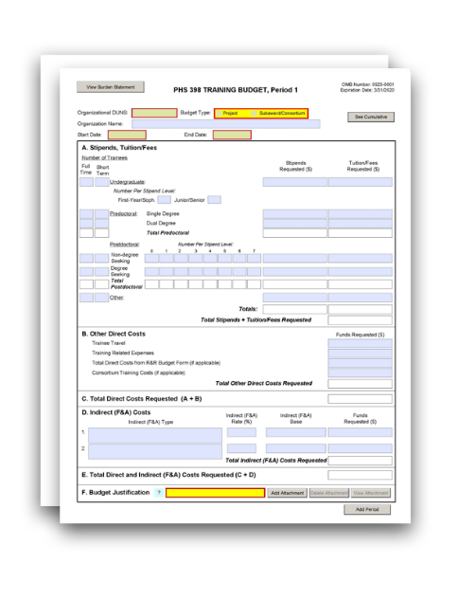
G.330 - PHS 398 Training Budget Form

The PHS 398 Training Budget Form is used only for Training applications (e.g., T15, T32, T34, T35, T36, T90) and Multi-project applications with a training component.
The PHS 398 Training Budget Form is not applicable for the K12, T37, D43, D71, or U2R activity codes. Applicants to these activity codes should follow the instructions for the R&R Budget Form and the instructions in the FOA (if applicable).
For current stipend levels and allowable costs, refer to the relevant FOA, NIH’s Research Training & Career Development website, or consult the PHS awarding component.
View larger image

Quick Links
Introductory Fields
A. Stipends, Tuition/Fees B. Other Direct Costs
C. Total Direct Costs Requested (A+B) D. Indirect (F&A) Costs
E. Total Direct and Indirect (F&A) Costs Requested (C+D) F. Budget Justification
PHS 398 Training Budget, Cumulative Budget

Who should use the PHS 398 Training Budget Form?
Use this form if you will be submitting certain types of Training Applications (e.g., T15, T32, T34, T35, T36, or T90), regardless of the amount of the requested budget.
If you are requesting a budget with $500,000 or more in direct costs for any budget period, contact the awarding component to determine whether you must obtain prior approval before submitting the application. For more information on applications that request $500,000 or more in direct costs, see the NIH Grants Policy Statement, Section 2.3.7.2: Acceptance for Review of Unsolicited Applications Requesting $500,000 or More in Direct Costs.
Certain types of Training Applications, such as K12, T37, D43, D71, and U2R, do not use the PHS 398 Training Budget Form. These applications use the R&R Budget Form.

Note on Subawards/Consortiums: If you have a subaward/consortium, you must use the PHS 398 Training Subaward Budget Attachment(s) Form in conjunction with the PHS 398 Training Budget Form. The prime must extract the PHS 398 Training Subaward Budgets from the PHS 398 Training Subaward Budget Attachment(s) Form and send the extracted file to the subaward/consortium. The consortium should complete the PHS 398 Training Subaward Budget, following the instructions here and in G.340 – PHS 398 Training Subaward Budget Attachment(s) Form.

Using the PHS 398 Training Budget Form:
You must complete a separate training budget for each budget period requested. The form will generate a cumulative budget for the total project period. If no funds are requested for a required field, leave the field blank.
You must round to the nearest whole dollar amount in all dollar fields.

Introductory Fields

Organizational DUNS:
This field is required. This field may be pre-populated from the SF 424 (R&R) Form and should reflect the DUNS or DUNS+4 number of the applicant organization.

Budget Type:
This field is required. Check the appropriate box for your budget type, following these guidelines.
Project: The budget being requested is for the primary applicant organization.
Subaward/Consortium: The budget being requested is for the subaward/consortium organization(s). Note: Separate budgets are required only for subaward/consortium organizations that perform a substantive portion of the project.
If you are preparing an application that includes a subaward/consortium, in addition to completing this form, also see G.340 – PHS 398 Training Subaward Budget Attachment(s) Form.

Organization Name:
This field may be pre-populated from the G.200 - SF 424 (R&R) Form.

Start Date:
This field is required and may be pre-populated from the G.200 - SF 424 (R&R) Form. Enter the requested/proposed start date of the budget period. For period 1, the start date is typically the same as the Proposed Project Start Date on the SF 424 (R&R) Form.

End Date:
This field is required. Enter the requested/proposed end date of the budget period.

A. Stipends, Tuition/Fees

Number of Trainees
Enter the number of trainees for each category (undergraduate, predoctoral, postdoctoral, and other), distinguishing between full-time training positions (i.e., a full year of training) and short term trainees.

Note that some programs do not allow all categories of trainees (e.g., undergraduates are not eligible for T32 applications). Refer to your FOA regarding the eligible types of trainees for your specific application.
- For undergraduate trainees: list separately the number that will be at the First- Year/Sophomore stipend level and the number that will be at the Junior/Senior stipend level in the boxes provided.
- For predoctoral trainees: list separately the number that will be pursuing single degrees and the number that will be pursuing dual degrees in the boxes provided. The "Total Predoctoral" fields will be automatically calculated.
- For postdoctoral trainees: list separately the number that are non-degree seeking and the number that are degree seeking in the boxes provided. If a category (non-degree seeking or degree seeking) contains various stipend levels (e.g., for varying levels of postdoctoral experience or for varying appointment periods), itemize the number of postdoctoral trainees by stipend level in the boxes provided. The "Total Postdoctoral" fields will be automatically calculated.

Stipends Requested ($)
Enter the total stipend amount requested for each trainee type.
For current stipend levels and allowable costs, refer to the FOA or consult the PHS awarding component. For more information, see the NIH’s Research Training and Career Development website.
The “Total Stipends Requested” field will be automatically calculated.

Tuition/Fees Requested ($)
Enter the total tuition/fees requested for each trainee type.
See the NIH Grants Policy Statement, Section 11.3.8: Allowable and Unallowable Costs for NIH policy regarding payment of tuition and fees.
Tuition at the postdoctoral level is limited to that required for specified courses that are to be described in Section F. Budget Justification and may depend on whether the program supports postdoctoral individuals in formal degree-granting training.
The “Total Tuition/Fees Requested” field will be automatically calculated.
You should request full needs for tuition and fees. The awarding component will determine the amount of tuition and fees to be provided according to the policies current at the time of award. The formula currently in effect will be applied by the NIH awarding component at the time an award is calculated. Do not include health insurance in the tuition/fees fields.

Total Stipends + Tuition/Fees Requested
This total will be automatically calculated.

B. Other Direct Costs

Enter the total funds requested for Trainee Travel and Training Related Expenses (TRE). If applicable, enter the Total Direct Costs from the R&R Budget Form and Consortium Training Costs.

Trainee Travel
Enter the total funds requested for trainee travel in the "Trainee Travel" field.
Some NIH awarding components provide a pre-determined amount for travel for each full time trainee. Refer to the FOA and/or contact the awarding component to determine the amount provided for travel and enter it here. If the awarding component does not provide a pre- determined amount, enter the requested amount here and provide an explanation in Section F. Budget Justification, stating the purpose of any travel, giving the number of trips involved, the destinations, and the number of trainees for whom funds are requested. PHS policy requires coach class air travel be used. Justify any foreign travel in detail, describing its importance to the training experience.

Training Related Expenses
Enter the total funds requested for TRE. You must base your requested amount on the number of trainees at the predetermined rate.
Funds to defray other costs of training, such as health insurance, staff salaries, consultant costs, equipment, research supplies, staff travel, etc., are requested as a lump sum based on the amounts specified in the FOA and in the NIH Grants Policy Statement, Section 11.3.8.4: Training- Related Expenses for each predoctoral and postdoctoral trainee.
Health insurance may be covered by TRE only to the extent that the same health insurance fees are charged to non-federally-supported students and postdoctoral fellows.
TRE will be awarded as a lump sum. No further itemization or explanation is required in Section F. Budget Justification.
The awarding component will apply the TRE level established for institutional programs for the relevant fiscal year at the time of award.

Total Direct Costs from R&R Budget Form (if applicable)
Certain FOAs allow funds to cover direct costs for items other than those specified above. Use the R&R Budget Form to submit those costs. The Total Direct Costs from the R&R Budget Form (G.300 - R&R Budget Form, Section G. Direct Costs) should be inserted here. This line should not include any indirect costs.
Skip the “Total Direct Costs from R&R Budget Form” field, as Kirschstein-NRSA Training components do not include the R&R Budget Form.
Additional Instructions for Multi-project:

Consortium Training Costs (if applicable)
If training occurs at more than one institution and there is a transfer of funds between organizations, you must complete the G.340 - PHS 398 Training Subaward Budget Attachment(s) Form. Total the direct costs from the Training Subaward Budget Attachment Forms and insert the total here. The applicant institution is responsible and accountable for any arrangements, expenditures, and submission of all required application forms when more than one institution is involved in the research training program.

Total Other Direct Costs Requested
This total will be automatically calculated based on the sum of the funds requested in "B. Other Direct Costs."

C. Total Direct Costs Requested (A+B)

This total will be automatically calculated based on the sum of the funds requested in both "A. Stipends, Tuition/Fees" and "B. Other Direct Costs."

D. Indirect (F&A) Costs

Indirect costs (Facilities & Administrative [F&A] costs) are defined as costs that are incurred by a grantee for common or joint objectives and that, therefore, cannot be identified specifically with a particular project or program. See the NIH Glossary's definition of Indirect Costs.
Equipment and consortium costs are also excluded from the F&A costs on those training grants where TRE are not calculated and awarded on a lump-sum basis, such as the Maximizing Access to Research Careers Program (MARC).
State and local government agencies will receive the full F&A cost rate.

For more information:
You are encouraged to visit the following Defense Finance and Accounting Services (DFAS) Websites or call DFAS staff at 301-496-2444 for guidance: Main DFAS website, DFAS Frequently Asked Questions. The following website has a listing of unallowable and unallocable costs and the related Federal Acquisition Regulation (FAR) citation for each: NIH Office of Management's Unallowable/Unallocable Cost.

Indirect (F&A) Type:
Enter “F&A.”

Indirect (F&A) Rate (%):
Enter “8.”
Facilities and Administrative (F&A) costs under Institutional Kirschstein-NRSA awards, other than those issued to U.S., state, or local government agencies, will be awarded at 8%.
State and local government agencies should enter their full F&A cost rate.

Indirect (F&A) Base ($):
Enter the sum of the stipends and the Total Other Direct Costs requested, regardless of whether those direct costs were listed on the PHS 398 Training Budget Form or on the R&R Budget Form. Indirect costs are not paid on Tuition/Fees, equipment, or sub-grants and contracts in excess of
$25,000.

Funds Requested ($):
Enter the product of Indirect (F&A) Rate and the Indirect (F&A) Base. Refer to the NIH Grants Policy Statement, Section 7.4: Reimbursement of Facilities and Administrative Costs for more information.

E. Total Direct and Indirect (F&A) Costs Requested (C+D)

This total will be automatically calculated based on the sum of the "C. Total Direct Costs Requested" and "D. Total Indirect (F&A) Costs Requested" fields.

F. Budget Justification

A Budget Justification attachment is required. Attach one file for the entire project period.
Explain in detail the composition of any of the above costs, as necessary, according to the guidelines listed here:
- Itemize tuition and individual fees. If tuition varies, (e.g., in-state, out-of-state, student status) list these separately. Do not include health insurance in the tuition and fees category.
- If tuition is requested for postdoctoral trainees, the specific courses or formal degree- granting program must be described.
- If the awarding component does not provide a pre-determined amount for travel for each full time trainee, explain the requested amount and describe the purpose of any travel, indicating the expected number of trips involved, the likely destinations, and the number of trainees for whom funds are requested, bearing in mind that PHS policy requires coach class air travel be used.
- Any foreign travel must be justified in detail. Describe its importance to the training experience and how those opportunities differ from and complement those offered by the grantee institution. Also describe the relationship of the proposed off-site training experience to the career stage of the grantee.
- Justify the number of training slots (e.g., predoctoral and/or postdoctoral) requested. For postdoctoral training slots, justify the stipend levels requested.
Note for Applicants Using both the PHS 398 Training Budget Form and the R&R Budget Form: Generally, the Budget Justification included in the PHS 398 Training Budget Form should reflect only funds requested on the PHS 398 Training Budget Form. When the R&R Budget Form is also used, two separate Budget Justifications are required, each covering the costs requested in the respective Budget Form.

PHS 398 Training Budget, Cumulative Budget

All values on this form are automatically calculated, and the fields are pre-populated. They present the summations of the amounts you entered previously for each of the individual budget periods. Therefore, no data entry is allowed or required to complete the “Cumulative Budget” section.
If any of the amounts displayed on this form appear to be incorrect, you may correct it by adjusting one or more of the values that contribute to that total. To make any such corrections, you will need to revisit the appropriate budget period form(s).

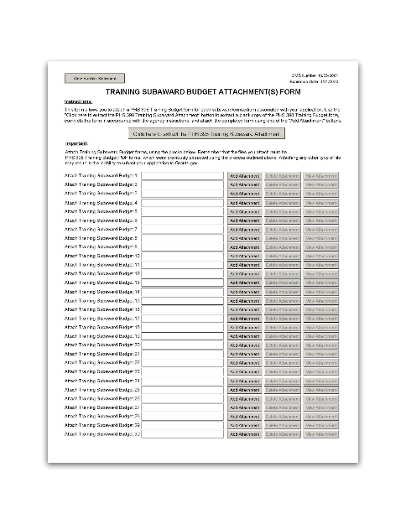
Who should use the PHS 398 Training Subaward Budget Attachment(s) Form?

The PHS 398 Training Subaward Budget Attachment(s) Form is used for applications with a subaward or consortium.
This form is required only when the prime grantee is submitting a PHS 398 Training Budget Form and has subaward/consortium budgets.
Applicants using the R&R Budget Form should see G.300 - R&R Budget Form.
View larger image
G.340 - PHS 398 Training Subaward Budget Attachment(s) Form
The PHS 398 Training Subaward Budget Attachment(s) Form is required if you have a subaward/consortium and are using the PHS 398 Training Budget Form.
Do not use this form if you do not have a subaward/consortium.
Each subaward/consortium that performs a substantive portion of the project must complete a Training Subaward Budget, including the Budget Justification section. For most programs, this is not common but is usually encountered when a portion of the training program takes place at a site other than the applicant organization via a collaborative or consortium arrangement. In such situations, the applicant organization is responsible and accountable for acceptable training arrangements, expenditure of funds, and submission of all required forms.

Consortium/Contractual F&A Costs:
NIH policy provides for the exclusion of consortium/contractual F&A costs when determining if an applicant is in compliance with a direct cost limitation. However, you must include the full cost of consortium/subawards in the Subawards/Consortium Costs field. If a subaward/consortium is not performing a substantive portion of the project, they do not need to complete a Training Subaward Budget; however, their costs must be included in the prime grantee’s Training Budget Form. All F&A costs count toward the direct cost limit.
See the NIH Grants Policy Statement, Section 2.3.7.1: Applications That Include Consortium/Contractual F&A Costs for policy related to the exclusion of consortium/subaward amounts in determining whether an applicant is in compliance with a direct cost limitation.
Applicants should document how their budget falls below the direct cost limit in the Budget Justification of the Training Subaward Budget.

Note on Project Roles for Consortium Lead Investigators:
It is appropriate and expected that someone may serve as the consortium lead investigator responsible for ensuring proper conduct of the project or program at each subaward or consortium site.
Unless you are submitting your application under the multiple PD/PI policy, consortium lead investigators are NOT considered PD/PIs for the “Project Role” field. This individual should be assigned some other project role on the PHS 398 Training Budget Form and in the G.240 – R&R Senior/Key Person Profile (Expanded) Form. However, the project role of “PD/PI” should be used for a consortium lead investigator if they also serve as PD/PI for the entire application under the multiple PD/PI policy.

Using the PHS 398 Training Subaward Budget Attachment(s) Form:
The location of the PHS 398 Training Subaward Budget Attachment(s) Form may vary with the type of submission (e.g., under an “Optional Forms” tab).
The steps needed to include a subaward budget in your application vary by submission method. If submitting using the Grants.gov Workspace, the prime applicant can extract a copy of the Training Subaward Budget Form from the Training Subaward Budget Attachment(s) Form and send the extracted file to the consortium for completion. After the consortium completes the Training Subaward Budget Form, following the instructions here and in G.330 – PHS 398 Training Budget Form, the prime grantee must then upload all the Training Subaward Budget Forms to the Training Subaward Budget Attachment(s) Form.
For all submission methods, the Training Subaward Budget Form with a "Budget Type" of Subaward/Consortium is used to collect subaward budget data. However, ASSIST and other system- to-system solutions may present a different interface than the Training Subaward Budget Attachment Form shown here.
This form accommodates a set number of separate subaward budgets. If you need to add more subaward budgets than the form allows, include the remaining budgets as part of the "Section F. Budget Justification" of the project budget.
Regardless of how many subaward/consortium budgets you include, the sum of ALL subaward/consortium budgets (those attached within the PHS 398 Training Subaward Budget Attachment(s) Form and those provided as part of the parent budget’s Budget Justification), must be included in the G.330 - PHS 398 Training Budget, Part B. Consortium Training Costs.

Format:
All attachments, including all Training Subaward Budget Forms and all Budget Justifications, must be PDF files. The Training Budget Forms are already PDFs when extracted. Do not alter the format.

Content:
On this PHS 398 Training Subaward Budget Attachment(s) Form, you will attach the Training Subaward Budget files for your application. Each subaward/consortium will complete the Subaward Budget in accordance with the G.330 - PHS 398 Training Budget Form instructions.

Submitting Subaward Budgets that are not Active for all Periods of the Prime Grant:
The Training Budget Forms do not allow for “empty” budget periods.
Subaward/consortium organizations should complete all budget periods in the Training Subaward Budget Form for their subaward budgets, aligning the budget period numbers, start dates, and end dates with the budget periods of the prime grant.

Example: The prime fills out a PHS 398 Training Budget Form with the following periods:
- period 1 - Jan 1, 2017 – Dec 31, 2017
- period 2 - Jan 1, 2018 – Dec 31, 2018
- period 3 - Jan 1, 2019 – Dec 31, 2019
- period 4 - Jan 1, 2020 – Dec 31, 2020
- period 5 - Jan 1, 2021 – Dec 31, 2021
The budget period numbers and dates should be the same in all Training Subaward Budgets included in the PHS 398 Training Subaward Budget Attachment(s) Form.
The PHS 398 Training Subaward Budget Forms include several required fields which must be completed (even for inactive periods) in order to successfully submit the application. Provide the following information for inactive budget periods in subaward/consortium budgets:
- Organization DUNS
- Budget Type = Subaward/Consortium
- Budget Period Start/End Dates (align with budget periods and dates of the prime budget)
- Explanation of the inactive budget periods in the Budget Justification (of the subaward/consortium's Training Subaward Budget)

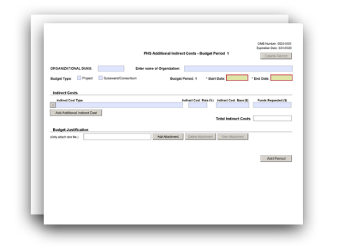

The PHS Additional Indirect Costs Form is used only for multi-project applications. The applicant organization responsible for the Overall Component should use this form to detail its first $25,000 F&A costs on each subaward organization that leads a component.
View larger image
Quick Links
Introductory Fields Indirect Costs Budget Justification
PHS Additional Indirect Cost - Cumulative Budget
G.350 - PHS Additional Indirect Costs Form

Who should use the PHS Additional Indirect Costs Form:
The PHS Additional Indirect Costs Form is used only for multi-project applications.
The applicant organization responsible for the Overall Component should use this form to detail its first $25,000 indirect (Facilities and Administrative [F&A]) costs on each subaward organization that leads a component.

Introductory Fields

Organizational DUNS:
This field is required. Enter the DUNS or DUNS+4 number of the applicant organization.

Enter name of Organization:
This field may be pre-populated from the SF 424 (R&R) Form. Enter the name of the organization.

Budget Type:
This field is required. "Project" should be selected.

Budget Period:
This field is required.
Identify the specific budget period (for example, 1, 2, 3, 4, 5, 6, 7, 8, 9, 10).

Start Date:
This field is required and may be pre-populated from the SF 424 (R&R) Form. Enter the requested/proposed start date of the budget period.

End Date:
This field is required. Enter the requested/proposed end date of the budget period.

Indirect Costs

Indirect Cost Type:
Enter the type of indirect cost (e.g., Salary & Wages, Modified Total Direct Costs, etc.) and whether the cost is off-site. If more than one rate or base is involved for a given type of indirect cost, then list them as separate entries. If you do not have a current indirect (F&A) rate(s) approved by a federal agency, indicate “None—will negotiate” and include information for a proposed rate. Use the Budget Justification in this form if additional space is needed.

Indirect Cost Rate (%):
Enter the most recent indirect cost rate(s) established with the cognizant federal office, or in the case of for-profit organizations, the rate(s) established with the appropriate agency. If you have a cognizant/oversight agency and are selected for an award, you must submit your indirect rate proposal to the NIH awarding IC or to the PHS awarding office for approval. If you do not have a cognizant/oversight agency, contact the awarding agency.
This field should be entered using a rate such as “55.5.”

Indirect Cost Base ($):
Enter the amount of the base for each indirect cost type.

Funds Requested ($):
Enter the funds requested for each indirect cost type.
See the NIH Grants Policy Statement, Section 7.4: Reimbursement of Facilities and Administrative Costs for more information.

Total Indirect Costs:
This total will be automatically calculated from the “Funds Requested” column.

Budget Justification

The “Budget Justification” attachment is required. Attach only one file. Attach this information as a PDF.
Use the Budget Justification to provide the additional information requested in each budget category identified above and any other information that supports the budget request. The following budget categories must be justified, where applicable: equipment, travel, participant/trainee support, and other direct cost categories.

PHS Additional Indirect Cost – Cumulative Budget

Indirect Costs Totals ($):
All values on this form are automatically calculated and the fields pre-populated. They present the summations of the amounts you entered in the “Indirect Costs” section above, for each of the

individual budget periods. Therefore, no data entry is allowed or required to complete this “Cumulative Budget” section.
If any of the amounts displayed on this form appear to be incorrect, you may correct it by adjusting one or more of the values that contribute to that total. To make any such corrections, you will need to revisit the appropriate budget period form(s).

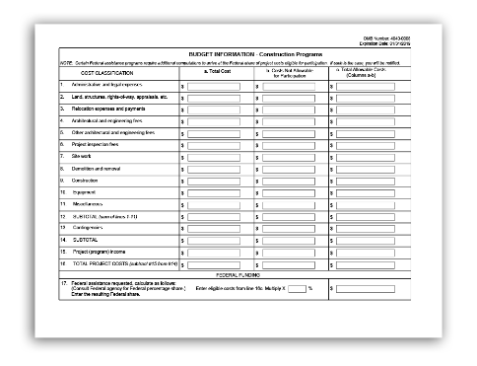
G.360 - SF 424C Budget Information – Construction Programs

The SF 424C Budget Information – Construction Programs form is used only in construction grant applications and repair, renovation, and modernization grant applications (activity codes C06, G20, and UC6). If you are applying to one of these activity codes, the SF 424C Budget Information – Construction Programs form is the only budget form you need to fill out with your application. Refer to your FOA for specific instructions regarding your application. When FOA-specific instructions deviate from those in these instructions, follow the FOA-specific instructions.
View larger image

Quick Links
Cost Classification Federal Funding

Who should use the SF 424C Budget Information – Construction Programs form?
Use the SF 424C Budget Information – Construction Programs form only if you are submitting an application for a research construction program grant (such as to activity code C06), or a resource program (such as activity code G20), or a construction cooperative agreement grant (such as activity code UC6). The SF 424C Budget Information – Construction Programs form is the only budget form you will need to submit with your application.

For more information:
For more information on construction, modernization, or major alteration and renovation of research facilities, see the NIH Grants Policy Statement, Section 10: Construction, Modernization, or Major Alteration and Renovation of Research Facilities.

Using the SF 424C Budget Information – Construction Programs form:
If no funds are requested for a required field, enter “0” or leave the field blank.
Use the SF 424C Budget Information – Construction Programs form to attach a budget page, if specified in your FOA, for the total requested funds.

Cost Classification

Administrative and legal expenses: 1a. Total Cost
Enter the total funds requested for administrative and legal expenses.

1b. Costs Not Allowable for Participation
Enter the costs not allowable for participation in administrative and legal expenses. Refer to your FOA to determine whether there are any special instructions for costs not allowable.

1c. Total Allowable Costs (Columns a-b)
This field will be automatically calculated and will reflect the total allowable costs (the value in column a minus the value in column b) for administrative and legal expenses.

Land, structures, rights-of-way, appraisals, etc.: 2a. Total Cost
Enter the total funds requested for land, structures, rights-of-way, appraisals, etc. expenses. Refer to your FOA to determine whether there are any special instructions for costs not allowable.

2b. Costs Not Allowable for Participation
Enter the costs not allowable for participation in land, structures, rights-of-way, appraisals, etc.

2c. Total Allowable Costs (Columns a-b)
This field will be automatically calculated and will reflect the total allowable costs (the value in column a minus the value in column b) for land, structure, rights-of-way, appraisals, etc.

Relocation expenses and payments: 3a. Total Cost
Enter the total funds requested for relocation expenses and payments.

3b. Costs Not Allowable for Participation
Enter the costs not allowable for participation for relocation expenses and payments.

3c. Total Allowable Costs (Columns a-b)
This field will be automatically calculated and will reflect the total allowable costs (the value in column a minus the value in column b) for relocation expenses and payments.

Architectural and engineering fees: 4a. Total Cost
Enter the total funds requested for architectural and engineering fees.

4b. Costs Not Allowable for Participation
Enter the costs not allowable for participation for architectural and engineering fees.

4c. Total Allowable Costs (Columns a-b)
This field will be automatically calculated and will reflect the total allowable costs (the value in column a minus the value in column b) for architectural and engineering fees.

Other architectural and engineering fees: 5a. Total Cost
Enter the total funds requested for other architectural and engineering fees.

5b. Costs Not Allowable for Participation
Enter the costs not allowable for participation for other architectural and engineering fees.

5c. Total Allowable Costs (Columns a-b)
This field will be automatically calculated and will reflect the total allowable costs (the value in column a minus the value in column b) for other architectural and engineering fees.

Project inspection fees: 6a. Total Cost
Enter the total funds requested for project inspection fees.

6b. Costs Not Allowable for Participation
Enter the costs not allowable for participation for project inspection fees.

6c. Total Allowable Costs (Columns a-b)
This field will be automatically calculated and will reflect the total allowable costs (the value in column a minus the value in column b) for project inspection fees.

Site work:
7a. Total Cost
Enter the total funds requested for site work expenses.

7b. Costs Not Allowable for Participation
Enter the costs not allowable for participation for site work.

7c. Total Allowable Costs (Columns a-b)
This field will be automatically calculated and will reflect the total allowable costs (the value in column a minus the value in column b) for site work.

Demolition and removal: 8a. Total Cost
Enter the total funds requested for demolition and removal expenses.

8b. Costs Not Allowable for Participation
Enter the costs not allowable for participation for demolition and removal.

8c. Total Allowable Costs (Columns a-b)
This field will be automatically calculated and will reflect the total allowable costs (the value in column a minus the value in column b) for demolition and removal.

Construction:
9a. Total Cost
Enter the total funds requested for construction expenses.

9b. Costs Not Allowable for Participation
Enter the costs not allowable for participation for construction.

9c. Total Allowable Costs (Columns a-b)
This field will be automatically calculated and will reflect the total allowable costs (the value in column a minus the value in column b) for construction.

Equipment:
10a. Total Cost
Enter the total funds requested for equipment expenses.

10b. Costs Not Allowable for Participation
Enter the costs not allowable for participation for equipment.

10c. Total Allowable Costs (Columns a-b)
This field will be automatically calculated and will reflect the total allowable costs (the value in column a minus the value in column b) for equipment.

Miscellaneous: 11a. Total Cost
Enter the total funds requested for miscellaneous expenses.

11b. Costs Not Allowable for Participation
Enter the costs not allowable for participation for miscellaneous expenses.

11c. Total Allowable Costs (Columns a-b)
This field will be automatically calculated and will reflect the total allowable costs (the value in column a minus the value in column b) for miscellaneous expenses.

SUBTOTAL (sum of lines 1-11):
These fields (12a, 12b, and 12c) will be automatically calculated and will reflect the sub of the values in fields 1-11 for each of the columns (a, b, and c).

Contingencies: 13a. Total Cost
Enter the total funds requested for contingency expenses.

13b. Costs Not Allowable for Participation
Enter the costs not allowable for participation for contingencies.

13c. Total Allowable Costs (Columns a-b)
This field will be automatically calculated and will reflect the total allowable costs (the value in column a minus the value in column b) for contingencies.

SUBTOTAL:
These fields (14a, 14b, and 14c) will be automatically calculated and will reflect the sum of the values in fields 12 and 13 for each of the columns (a, b, and c).

Project (program) income: 15a. Total Cost
Enter the total anticipated program income.

15b. Costs Not Allowable for Participation
Enter the program income not allowable for participation.

15c. Total Allowable Costs (Columns a-b)
This field will be automatically calculated and will reflect the total project (program) income (the value in column a minus the value in column b).

TOTAL PROJECT COSTS (subtract #15 from #14):
These fields (16a, 16b, and 16c) will be automatically calculated and will reflect the difference of the values in fields 14 and 15 for each of the columns (a, b, and c).

Federal Funding

Federal assistance requested
Consult the NIH or other PHS Agency to which you are applying for the applicable federal percentage share. Enter that amount into field 17.

17c. Federal assistance requested, Total Allowable Costs
This field will be automatically calculated and will reflect the total allowable federal assistance requested (the product of the value in field 17 and the value in field 16c).

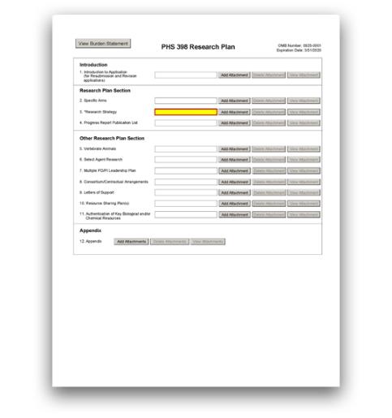
G.400 - PHS 398 Research Plan Form

The PHS 398 Research Plan form is used only for research, multi-project, and SBIR/STTR applications.
This form includes fields to upload several attachments, including the Specific Aims and Research Strategy.
The Research Plan, together with the rest of your application, should include sufficient information needed for evaluation of the project, independent of any other documents (e.g., previous application). Be specific and informative, and avoid redundancies.
View larger image

Quick Links
Introduction

- Introduction to Application (for Resubmission and Revision applications)
Research Plan Section
- Specific Aims
- Research Strategy
- Progress Report Publication List
Other Research Plan Section
- Vertebrate Animals
- Select Agent Research
- Multiple PD/PI Leadership Plan
- Consortium/Contractual Arrangements 9. Letters of Support
- Resource Sharing Plan(s)
- Authentication of Key Biological and/or Chemical Resources

Appendix

- Appendix

Your application should represent a sound approach to the investigation of an important biomedical research, behavioral research, technological, engineering, or scientific question, and be worthy of support under the stated criteria of the FOA. It should be self-contained and written with the care and thoroughness accorded to papers for publication.

Review the application carefully to ensure you have included information essential for evaluation. The scientific and technical merit of the proposed research is the primary concern for all research supported by the National Institutes of Health (NIH) and other PHS agencies.
Read all the instructions in the FOA before completing this form to ensure that your application meets all IC-specific criteria.

Who should use the PHS 398 Research Plan Form:
Use the PHS 398 Research Plan Form only if you are submitting a research, multi-project, or SBIR/STTR application.
You are strongly encouraged to contact agency program staff for pre-application guidance and/or for more specific information on the research topics described in the solicitation.
The applicant small business must not propose market research, patent applications, or litigation. The research proposed in this application may, however, be carried out through construction and evaluation of a laboratory prototype, where necessary.
CRP uses SBIR funding, but is not a Phase I/II/IIB or Fast-Track application. However, CRP applications should follow all Phase II-specific instructions.
Additional Instructions for SBIR/STTR:

Applicants must follow all policies and requirements related to formatting, page limits, and proprietary information. See the following pages for more information:
- Format Attachments
- Page Limits
- NIH Grants Policy Statement, Section 2.3.11.2: Confidentiality of Information
- NIH Grants Policy Statement, Section 2.3.11.2.2: The Freedom of Information Act

Introduction

1. Introduction to Application (for Resubmission and Revision applications)

Who must complete the “Introduction to Application” attachment:
An "Introduction to Application" attachment is required only if the type of application is resubmission or revision or if the FOA specifies that one is needed. An introduction is not allowed for new or renewal applications.
Descriptions of different types of applications are listed here: NIH Types of Applications.

Format:
Follow the page limits for the introduction in the NIH Table of Page Limits unless otherwise specified in the FOA.
Attach this information as a PDF file. See NIH's Format Attachments page.

Content:
Resubmission applications: See specific instructions on the content of the introduction on the NIH's Resubmission Applications page.
Competing Revisions: See specific instructions on the content of the introduction on the NIH's Competing Revisions page.
Overall Component: The “Introduction” attachment is required for all resubmission and revision applications.
Other Components: The "Introduction” attachment is optional for resubmissions and revisions applications. Although the “Introduction” attachment is optional, you may get a system warning if there is no attachment.
Additional Instructions for Multi-project:

Research Plan Section

2. Specific Aims

Who must complete the "Specific Aims" attachment:
The “Specific Aims” attachment is required unless otherwise specified in the FOA.

Format:
Follow the page limits for the Specific Aims in the NIH Table of Page Limits unless otherwise specified in the FOA.This section is limited to text only. Graphics (including images, charts, and graphs) are not allowed in this section. A “Specific Aims” attachment that exceeds the page limit will be flagged as an error by the Agency upon submission, and a “Specific Aims” attachment that includes graphics will generate a warning by the Agency upon submission.
Attach this information as a PDF file. See NIH's Format Attachments page.

Content:
State concisely the goals of the proposed research and summarize the expected outcome(s), including the impact that the results of the proposed research will have on the research field(s) involved.
List succinctly the specific objectives of the research proposed (e.g., to test a stated hypothesis, create a novel design, solve a specific problem, challenge an existing paradigm or clinical practice, address a critical barrier to progress in the field, or develop new technology).
Overall Component: The "Specific Aims" attachment is required.
Other Components: The "Specific Aims" attachment is required.
Additional Instructions for Multi-project:

Phase I Applications: State the specific objectives of the Phase I research and development effort, including the technical questions you will try to answer to determine the Phase I feasibility of the proposed approach and the impact that the results of the proposed research will exert on the research field(s) involved. State concisely and realistically what the proposed research is intended to accomplish in terms of its potential for technological innovation and commercial application.
Define the proposed product, process or service to ultimately be developed. Include milestones for each of the aims as these will be used in the evaluation process.
Phase II, Phase IIB, and CRP Applications: State the specific objectives of the Phase II research and development effort including the impact that the results of the proposed research will exert on the research field(s). State concisely and realistically what the proposed research is intended to accomplish in terms of its potential for technological innovation and commercial application. Define the proposed product, process, or service to ultimately be developed. Include milestones for each of the aims as these will be used in the evaluation process.
Fast-Track Applications: Create a heading titled “Phase I Specific Aims” and follow the instructions above for “Phase I Applications.” Note that your Phase I milestones must be clear, appropriate, and measurable. Failure to adequately address these criteria may negatively affect the application's impact score. Next, create a heading titled “Phase II Specific Aims” and follow the instructions above for “Phase II Applications.” Note that the page limit applies to both phases in combination, not to each phase individually.
Additional Instructions for SBIR/STTR:

3. Research Strategy

Who must complete the "Research Strategy" attachment:
The “Research Strategy” attachment is required.

Format:
Follow the page limits for the Research Strategy in the NIH Table of Page Limits, unless otherwise specified in the FOA. Although multiple sections of information are required in the Research Strategy as detailed below, the page limit applies to the entirety of the single "Research Strategy" attachment.
Attach this information as a PDF file. See NIH's Format Attachments page.

Content:
Organize the Research Strategy in the specified order and use the instructions provided below unless otherwise specified in the FOA. Start each section with the appropriate heading – Significance, Innovation, Approach.
Cite published experimental details in the Research Strategy attachment and provide the full reference in G.220 - R&R Other Project Information Form, Bibliography and Reference Cited.

Note for Applications Proposing the Involvement of Human Subjects and/or Clinical Trials:
- Do not duplicate information in the Research Strategy and the PHS Human Subjects and Clinical Trials Information form. Use the Research Strategy attachment to discuss the overall strategy, methodology, and analyses of your proposed research. Use the PHS Human Subjects and Clinical Trials Information form to provide detailed information for human subjects studies and clinical trials.
- The PHS Human Subjects and Clinical Trials Information form will capture detailed study information, including eligibility criteria; inclusion of women, minorities, and children; protection and monitoring plans; and statistical design and power.
- You are encouraged to refer to information in the PHS Human Subjects and Clinical Trials Information form as appropriate in your discussion of the Research Strategy (e.g., see Question 2.4 Inclusion of Women and Minorities).
Note for Applicants with Multiple Specific Aims: You may address the Significance, Innovation, and Approach either for each Specific Aim individually or for all of the Specific Aims collectively.

Significance
  - Explain the importance of the problem or critical barrier to progress that the proposed project addresses.
  - Describe the strengths and weaknesses in the rigor of the prior research (both published and unpublished) that serves as the key support for the proposed project.
  - Explain how the proposed project will improve scientific knowledge, technical capability, and/or clinical practice in one or more broad fields.
Describe how the concepts, methods, technologies, treatments, services, or preventative interventions that drive this field will be changed if the proposed aims are achieved.
Additional Instructions for Research:
Overall and Other Components: Describe how the concepts, methods, technologies, treatments, services, or preventative interventions that drive this field will be changed if the proposed aims are achieved.
Additional Instructions for Multi-project:
Explain the project’s potential to lead to a marketable product, process, or service.
Phase II, CRP, Fast-Track, and Phase IIB Competing Renewals: Explain how the commercialization plan demonstrates a high probability of commercialization.
Additional Instructions for SBIR/STTR:

Innovation
  - Explain how the application challenges and seeks to shift current research or clinical practice paradigms.

  - Describe any novel theoretical concepts, approaches or methodologies, instrumentation or interventions to be developed or used, and any advantage over existing methodologies, instrumentation, or interventions.
  - Explain any refinements, improvements, or new applications of theoretical concepts, approaches or methodologies, instrumentation, or interventions.

Approach
  - Describe the overall strategy, methodology, and analyses to be used to accomplish the specific aims of the project. Describe plans to address weaknesses in the rigor of the prior research that serves as the key support for the proposed project. Describe the experimental design and methods proposed and how they will achieve robust and unbiased results. Unless addressed separately in the Resource Sharing Plan, include how the data will be collected, analyzed, and interpreted, as well as any resource sharing plans as appropriate. Resources and tools for rigorous experimental design can be found at the Enhancing Reproducibility through Rigor and Transparency website.
  - For trials that randomize groups or deliver interventions to groups, describe how your methods for analysis and sample size are appropriate for your plans for participant assignment and intervention delivery. These methods can include a group- or cluster- randomized trial or an individually randomized group-treatment trial. Additional information is available at the Research Methods Resources webpage.
  - Discuss potential problems, alternative strategies, and benchmarks for success anticipated to achieve the aims.
  - If the project is in the early stages of development, describe any strategy to establish feasibility, and address the management of any high risk aspects of the proposed work.
  - Explain how relevant biological variables, such as sex, are factored into research designs and analyses for studies in vertebrate animals and humans. For example, strong justification from the scientific literature, preliminary data, or other relevant considerations, must be provided for applications proposing to study only one sex. Refer to the NIH Guide Notice on Sex as a Biological Variable in NIH-funded Research for additional information.
  - Point out any procedures, situations, or materials that may be hazardous to personnel and the precautions to be exercised. A full discussion on the use of select agents should appear in the Select Agent Research attachment below.
  - If research on Human Embryonic Stem Cells (hESCs) is proposed but an approved cell line from the NIH hESC Registry cannot be chosen, provide a strong justification for why an appropriate cell line cannot be chosen from the registry at this time.
Provide a tentative sequence or timetable for the project.
Additional Instructions for SBIR/STTR:

As applicable, also include the following information as part of the Research Strategy, keeping within the three sections (Significance, Innovation, and Approach) listed above.

Preliminary Studies for New Applications:
For new applications, include information on preliminary studies. Discuss the PD/PI’s preliminary studies, data, and or experience pertinent to this application. Except for Exploratory/Developmental Grants (R21/R33), Small Research Grants (R03), and Academic Research Enhancement Award (AREA) Grants (R15), preliminary data can be an essential part of a research grant application and can help to establish the likelihood of success of the proposed project. Early stage investigators should include preliminary data.
Phase I Applications: Preliminary data are not required for Phase I Applications; however, such results may assist reviewers in assessing the likelihood of success of the proposed project and may be included in the Research Strategy attachment.
Fast-Track Applications: Preliminary data are expected for Fast-Track Applications.
SBIR Direct Phase II (if this is an allowable application type): Summarize the specific aims of the preliminary work that forms the basis for this Phase II application, quantitative milestones (i.e., a quantitative definition of success) for each aim, and the importance of the findings. Additionally, emphasize the progress made toward each aim’s achievement. Describe the technology developed, its intended use, and who will use it. Provide data or evidence of the capability, completeness of design, and efficacy, along with the rationale for selection of the criteria used to validate the technology, prototype, or method. Describe the current status of the product (e.g., under development, commercialized, in use, discontinued). If applicable, describe the status of FDA approval for your product, process, or service (e.g., continuing pre-IND studies, filed on IND, in Phase I (or II or
III) clinical trials, applied for approval, review ongoing, approved, not approved). List the generic and/or commercial names of products. A list of publications, patents, and other printed materials should be included in Item 5 (Progress Report Publication List) – do not include that information here.
Additional Instructions for SBIR/STTR:

Progress Report for Renewal and Revision Applications:
Note that the Progress Report falls within the Research Strategy and is therefore included in the page limits for the Research Strategy.
For renewal/revision applications, provide a Progress Report. Provide the beginning and ending dates for the period covered since the last competitive review. In the Progress Report, you should:
  - Summarize the specific aims of the previous project period and the importance of the findings, and emphasize the progress made toward their achievement.
  - Explain any significant changes to the specific aims and any new directions, including changes resulting from significant budget reductions.
  - Discuss previous participant enrollment (e.g., recruitment, retention, inclusion of women, minorities, children, etc.) for any studies meeting the NIH definition for clinical research. Use the Progress Report section to discuss, but not duplicate information collected elsewhere in the application.
Do not include a list of publications, patents, or other printed materials in the Progress Report. That information will be included in the "Progress Report Publication List" attachment.

Phase II, Phase IIB, and CRP Competing Renewal and Revision Applications: In the Progress Report, in addition to what’s listed above, describe the technology developed from this SBIR/STTR, its intended use, and who will use it. Describe the current status of the product (e.g., under development, commercialized, in use, discontinued). If applicable, describe the status of FDA approval for your product, process, or service (e.g., continuing pre-IND studies, filed on IND, in Phase I (or II or
III) clinical trials, applied for approval, review ongoing, approved, not approved).
Additional Instructions for SBIR/STTR:

4. Progress Report Publication List

Who must complete the “Progress Report Publication List” attachment:
A “Progress Report Publication List” attachment is required only if the type of application is renewal.
Descriptions of different types of applications are listed here: NIH's Types of Applications.

Format:
Attach this information as a PDF file. See NIH’s Format Attachments page.

Content:
List the titles and complete references to all appropriate publications, manuscripts accepted for publication, patents, and other printed materials that have resulted from the project since it was last reviewed competitively.
You are allowed to cite interim research products. Note: interim research products have specific citation requirements. See related Frequently Asked Questions on citing interim research products and claiming them as products of your NIH award.
Provide the NIH Manuscript Submission reference number (e.g., NIHMS97531) or the PubMed Central (PMC) reference number (e.g., PMCID234567) for each of the following:
  - Articles that fall under the Public Access Policy,
  - Articles that were authored or co-authored by the applicant and arose from NIH support,
  - Articles that were authored or co-authored by the applicant and arose from AHRQ funding provided after February 19, 2016 (see the Guide Notice on Policy for Public Access to AHRQ-Funded Scientific Publications).
If the PMCID is not yet available because the Journal submits articles directly to PMC on behalf of their authors, indicate “PMC Journal – In Process.” NIH maintains a list of such journals.
Citations that are not covered by the Public Access Policy, but are publicly available in a free, online format may include URLs or PubMed ID (PMID) numbers along with the full reference.
Overall and Other Components: If you include a "Progress Report Publication List" attachment, you can include it in either the Overall Component or within each Other Component, but do not attach the same information in multiple locations.
Additional Instructions for Multi-project:

Phase II, Phase IIB, and CRP Applications: List the titles and complete references to all appropriate publications, manuscripts accepted for publication, patents, copyrights, trademarks, invention reports and other printed materials, if any, that resulted from the Phase I or describe patent status, trade secrets or other demonstration of IP protection, and other printed materials that have resulted from the Phase I effort.
Additional Instructions for SBIR/STTR:

Other Research Plan Section

5. Vertebrate Animals

Who must complete the “Vertebrate Animals” attachment:
Include a “Vertebrate Animals” attachment if you answered “Yes” to the question “Are Vertebrate Animals Used?” on the G.220 - R&R Other Project Information Form.

Format:
Attach this information as a PDF file. See NIH's Format Attachments page.
Do not use this attachment to circumvent the page limits of the Research Strategy.

Content:
If live vertebrate animals are involved in the project, address each of the following criteria:
- Description of Procedures: Provide a concise description of the proposed procedures to be used that involve live vertebrate animals in the work outlined in the “Research Strategy” attachment. The description must include sufficient detail to allow evaluation of the procedures. Identify the species, strains, ages, sex, and total numbers of animals by species, to be used in the proposed work. If dogs or cats are proposed, provide the source of the animals.
- Justifications: Provide justification that the species are appropriate for the proposed research. Explain why the research goals cannot be accomplished using an alternative model (e.g. computational, human, invertebrate, in vitro).
- Minimization of Pain and Distress: Describe the interventions including analgesia, anesthesia, sedation, palliative care and humane endpoints that will be used to minimize discomfort, distress, pain, and injury.
Each of the criteria must be addressed. Failure to adequately address the criteria may negatively affect the application’s impact score. In addition to the 3 criteria above, you should also:
  - Identify all project performance (or collaborating) sites and describe the proposed research activities with vertebrate animals that will be conducted at those sites.
  - Explain when and how animals are expected to be used if plans for the use of animals have not been finalized.

See the following pages for more information:
- NIH’s Office of Laboratory Animal Welfare website
- NIH's Vertebrate Animals Section Worksheet
- See the NIH Grants Policy Statement, Section 4.1.1: Animal Welfare Requirements (an applicable Animal Welfare Assurance will be required if the grantee institution does not have one)
Overall Component: The “Vertebrate Animals” attachment is optional unless specifically requested in the FOA.
Other Components: Complete the “Vertebrate Animals” section if you answered “Yes” to the question “Are Vertebrate Animals Used?” on the G.220 - R&R Other Project Information Form.
Additional Instructions for Multi-project:

6. Select Agent Research

Who must complete the “Select Agent Research” attachment:
Include a “Select Agent Research” attachment if your proposed activities involve the use of select agents at any time during the proposed project period, either at the applicant organization or at any performance site.

Format:
Attach this information as a PDF file. See NIH's Format Attachments page.

For more information:
Select agents are hazardous biological agents and toxins that have been identified by HHS or the U.S. Department of Agriculture (USDA) as having the potential to pose a severe threat to
public health and safety, to animal and plant health, or to animal and plant products. The Centers for Disease control and Prevention (CDC) and the Animal APHIS Select Agent Programs jointly maintain a list of these agents. See the Federal Select Agent Program website.
See also the NIH Grants Policy Statement, Section 4.1.24.1.1: Select Agents.

Content:
Excluded select agents: If the activities proposed in the application involve only the use of a strain(s) of select agents which has been excluded from the list of select agents and toxins as per 42 CFR 73.3, the select agent requirements do not apply. Use this “Select Agent Research” attachment to identify the strain(s) of the select agent that will be used and note that it has been excluded from this list. The CDC maintains a list of exclusions, which is available on the Select Agents and Toxins Exclusions website.
Applying for a select agent to be excluded: If the strain(s) is not currently excluded from the list of select agents and toxins but you have applied or intend to apply to HHS for an exclusion from the list, use this section to indicate the status of your request or your intent to apply for an exclusion and provide a brief justification for the exclusion.

All applicants proposing to use select agents: Address the following three points for each site at which select agent research will take place. Although no specific page limitation applies to this section, be succinct.
- Identify the select agent(s) to be used in the proposed research.
- Provide the registration status of all entities* where select agent(s) will be used.
  - If the performance site(s) is a foreign institution, provide the name(s) of the country or countries where select agent research will be performed.
  - *An “entity” is defined in 42 CFR 73.1 as “any government agency (Federal, State, or local), academic institution, corporation, company, partnership, society, association, firm, sole proprietorship, or other legal entity.”
- Provide a description of all facilities where the select agent(s) will be used.
  - Describe the procedures that will be used to monitor possession, use, and transfer of select agent(s).
  - Describe plans for appropriate biosafety, biocontainment, and security of the select agent(s).
  - Describe the biocontainment resources available at all performance sites.

7. Multiple PD/PI Leadership Plan

Who must complete the “Multiple PD/PI Leadership Plan” attachment:
Any applicant who designates multiple PD/PIs (on the G.240 - R&R Senior/Key Person Profile (Expanded) Form) must include a Multiple PD/PI Leadership Plan. For applications designating multiple PD/PIs, all such individuals must be assigned the PD/PI role on the G.240 - R&R Senior/Key Profile (Expanded) Form, even those at organizations other than the applicant organization.
Do not submit a Multiple PD/PI Leadership Plan if you are not submitting a multiple PD/PI application.
Overall Component: The “Multiple PD/PI Leadership Plan” attachment is required if more than one PD/PI is specified on the Overall Component's G.240 - R&R Senior/Key Profile (Expanded) Form.
Additional Instructions for Multi-project:

Format:
Attach this information as a PDF file. See NIH's Format Attachments page.

Content:
A rationale for choosing a multiple PD/PI approach should be described. The governance and organizational structure of the leadership team and the research project should be described, including communication plans, processes for making decisions on scientific direction, and procedures for resolving conflicts. The roles and administrative, technical, and scientific responsibilities for the project or program should be delineated for the PD/PIs and other collaborators.

If budget allocation is planned, the distribution of resources to specific components of the project or the individual PD/PIs should be delineated in the Multiple PD/PI Leadership Plan. In the event of an award, the requested allocations may be reflected in a footnote on the Notice of Grant Award.

For more information:
For background information on the multiple PD/PI initiative, see NIH's Multiple Principal Investigators page.

8. Consortium/Contractual Arrangements

Who must complete the “Consortium/Contractual Arrangements” attachment:
Include a “Consortium/Contractual Arrangements” attachment if you have consortiums/contracts in your budget.

Format:
Attach this information as a PDF file. See NIH's Format Attachments page.

Content:
Explain the programmatic, fiscal, and administrative arrangements to be made between the applicant organization and the consortium organization(s). If consortium/contractual activities represent a significant portion of the overall project, explain why the applicant organization, rather than the ultimate performer of the activities, should be the grantee.
Note: The signature of the authorized organization representative in G.200 - SF 424 (R&R), Authorized Representative signifies that the applicant and all proposed consortium participants understand and agree to the following statement:
The appropriate programmatic and administrative personnel of each organization involved in this grant application are aware of the agency’s consortium agreement policy and are prepared to establish the necessary inter-organizational agreement(s) consistent with that policy.

For more information:
Refer to the NIH Grants Policy Statement, Section 15: Consortium Agreements for more information.
Overall and Other Components: Unless otherwise specified in the FOA, you have the option to:
- include a single consolidated “Consortium/Contractual Arrangements” attachment in the Overall Component, or
- include component-specific “Consortium/Contractual Arrangements” attachment(s) within the components that include subawards, or
- include a “Consortium/Contractual Arrangements” attachment in the Overall Component and include component-specific attachments within the components that include subawards. Each filename must be unique.
Additional Instructions for Multi-project:

Additional Instructions for SBIR/STTR:
SBIR:
Phase I Applications: Normally, a minimum of two-thirds or 67% of the research or analytical effort must be carried out by the small business concern (SBC). The total amount of all consultant and contractual arrangements to third parties for portions of the scientific and technical effort generally may not exceed 33% of the total amount requested (direct, F&A/indirect, and fee). Occasionally, deviations from these requirements may occur. Deviations must be approved in writing by the funding agreement officer after consultation with the agency SBIR Program Manager/Coordinator.
Phase II and Phase IIB Applications: Normally, a minimum of one-half or 50% of the research or analytical effort must be carried out by the SBC. The total amount of consultant and contractual arrangements to third parties for portions of the scientific and technical effort generally may not exceed 50% of the total Phase II amount requested (direct, F&A/indirect, and fee). Occasionally, deviations from these requirements may occur. Deviations must be approved in writing by the funding agreement officer after consultation with the agency SBIR Program Manager/Coordinator.
Phase I and Phase II Applications: The basis for determining the percentage of work to be performed by each of the cooperative parties in Phase I or Phase II will be the total requested costs (direct, F&A/indirect, and fee) attributable to each party, unless otherwise described and justified in this attachment.
Fast-Track SBIR Applications: Create two separate sections entitled “Phase I Consortium/Contractual Arrangements” and “Phase II Consortium/Contractual Arrangements,” and complete the sections following the instructions provided above for each phase.

STTR:
Phase I, Phase II and Phase IIB STTR Applications: At least 40% of the work must be performed by the SBC and at least 30% of the work must be performed by the single partnering research institution. The basis for determining the percentage of work to be performed by each of the cooperative parties will be the total of the requested costs (direct, F&A/indirect, and fee) attributable to each party, unless otherwise described and justified in this attachment.
Certification showing the cooperative R&D arrangement between the SBC and the research institution will be requested prior to an award.
The single partnering research institution must certify at the time of application that at least 30% of the work of the STTR project will be performed by the research institution. This 30% requirement applies to the single collaborating organization identified as the “research institution.”
The requisite signature, printed name, title, and date of signature of the duly authorized representative of the research institution affirming certifications made by the research institution must be included in a letter stating:
“The small business concern and the research institution certify jointly that: (1) the proposed STTR project will be conducted jointly by the small business

concern and the research institution in which not less than 40 percent of the
work will be performed by the small business concern and not less than 30 percent of the work will be performed by the research institution (“cooperative research and development”); (2) the proposed STTR project is a cooperative research or research and development effort to be conducted jointly by the small business concern and the research institution in which not less than 40 percent of the work will be performed by the small business concern and not less than 30 percent of the work will be performed by the research institution (“performance of research and analytical work”); and (3) regardless of the proportion of the proposed project to be performed by each party, the small business concern will be the primary party that will exercise management direction and control of the performance of the project.
If the research institution is a contractor-operated Federally Funded Research and Development Center (FFRDC), the duly authorized representative of the contractor-operated Federally funded research and development center certifies, additionally, that it: “(4) is free from organizational conflicts of interests relative to the STTR program; (5) did not use privileged information gained through work performed for an STTR agency or private access to STTR agency personnel in the development of this STTR grant application; and (6) used outside peer review, as appropriate, to evaluate the proposed project and its performance therein.”
The applicant SBC should convert the letter from the partnering research institution into a PDF attachment, and include it as part of this attachment.
Fast-Track STTR Applications: Create two separate sections entitled “Phase I Consortium/Contractual Arrangements” and “Phase II Consortium/Contractual Arrangements,” and complete the sections following the instructions provided above for each phase.

9. Letters of Support

Format:
Combine all letters of support into a single PDF file and attach this information here. Do not place these letters in the Appendix.
Follow the attachment guidelines on NIH's Format Attachments page.

Content:
Attach a file with all letters of support, including any letters necessary to demonstrate the support of consortium participants and collaborators such as Senior/Key Personnel and Other Significant Contributors included in the grant application.
Letters should stipulate expectations for co-authorship, and whether cell lines, samples, or other resources promised in the letter are freely available to other investigators in the scientific community or will be provided to the particular investigators only.
For consultants, letters should include rate/charge for consulting services and level of effort/number of hours per budget period anticipated. In addition, letters ensuring access to core facilities and resources should stipulate whether access will be provided as a fee-for-service.

Letters are not required for personnel (such as research assistants) not contributing in a substantive, measurable way to the scientific development or execution of the project.
Do not include consultant biographical sketches in the “Letters of Support” attachment, as consultant biosketches should be in the “Biographical Sketch” section (see exception for SBIR/STTR Applications in the SBIR/STTR-specific instructions).
Overall and Other Components: Unless specific instructions are provided in the FOA, applicants have the option of including the “Letters of Support” attachment in the Overall Component, Other Components, or both. To avoid duplication, each letter should appear only once in the application. Letters that apply to the entire application (or to multiple components) should be presented in the Overall Component as a single PDF, while letters that apply only to a particular individual component should be presented in that component as a single PDF.
Additional Instructions for Multi-project:
Involvement of consultants and collaborators in the planning and research stages of the project is permitted. With the application, include letters from each individual and/or collaborator confirming their role(s) in the project. The letter(s) should be prepared on the consultant or collaborator’s letterhead and addressed to the SBC. One page is recommended.
At a minimum, each consultant and collaborator letter should (1) verify their commitment to the project; (2) refer to the specific project by name, acknowledging the PD/PI as the lead on the project; and (3) specify what services/tasks the consultant or collaborator will contribute (e.g. expertise, number of hours/ percent of effort, summary of tasks to be completed). For consultants, the letter should also include the rate/charge for consulting services. Also include biographical sketches for each consultant.
Letters of interest from potential commercial partners or investors and letters of commitment of funds or other resources that will enhance the likelihood of commercialization should be placed following the letters of support for consultants and collaborators.
STTR only: The single “partnering” research institution must provide a letter to the applicant small business concern certifying that at least 30% of the work of the STTR project will be performed by the research institution.
Additional Instructions for SBIR/STTR:

10. Resource Sharing Plan(s)

Format:
Attach this information as a PDF file. See NIH's Format Attachments page.

Content:
Data Sharing Plan: Investigators seeking $500,000 or more in direct costs (exclusive of consortium F&A) in any budget period are expected to include a brief 1-paragraph description of how final research data will be shared, or explain why data-sharing is not possible (for example human subject concerns, the Small Business Innovation Development Act provisions, etc.).

Specific FOAs may require that all applications include this information regardless of the dollar level. Applicants are encouraged to read the FOA carefully and discuss their data-sharing plan with their program contact at the time they negotiate an agreement with the Institute/Center (IC) staff to accept assignment of their application. For more information, see the NIH Data Sharing Policy or the NIH Grants Policy Statement, Section 2.3.7.10: NIH Genomic Data Sharing and Section 8.2.3.3: Genomic Data Sharing (GDS) Policy/ Policy for Genome-Wide Association Studies (GWAS).
Sharing Model Organisms: Regardless of the amount requested, all applications where the development of model organisms is anticipated are expected to include a description of a specific plan for sharing and distributing unique model organisms or state why such sharing is restricted or not possible. For more information, see the NIH Grants Policy Statement, Section 8.2.3.2: Sharing Model Organisms.
Genomic Data Sharing (GDS): Applicants seeking funding for research that generates large- scale human or non-human genomic data are expected to provide a plan for sharing of these data. Examples of large-scale genomic data include genome-wide association studies (GWAS), single nucleotide polymorphisms (SNP) arrays, and genome sequence, transcriptomic, epigenomic, and gene expression data. Supplemental Information to the NIH GDS provides examples of genomic research projects that are subject to the Policy. For more information see the NIH GDS Policy, the NIH Grants Policy Statement, Section 8.2.3.3: Genomic Data Sharing (GDS) Policy/ Policy for Genome-Wide Association Studies (GWAS), and the GDS website.
Note on GDS: For proposed studies generating human genomic data under the scope of the GDS Policy, an institutional certification may be submitted at the time of application submission, but it is not required at that time. The institutional certification, however, will be requested as Just-in-Time (JIT) information prior to award. The institutional certification, or in some cases, a provisional institutional certification, must be submitted and accepted before the award can be issued.

For more information:
NIH considers the sharing of unique research resources developed through NIH-sponsored research an important means to enhance the value and further the advancement of the research. When resources have been developed with NIH funds, and the associated research findings published or provided to NIH, it is important that they be made readily available for research purposes to qualified individuals within the scientific community. See the NIH Grants Policy Statement, Section 8.2.3: Sharing Research Resources.

11. Authentication of Key Biological and/or Chemical Resources

Format:
Attach this information as a PDF file. See NIH's Format Attachments page.

Content:
If applicable to the proposed science, briefly describe methods to ensure the identity and validity of key biological and/or chemical resources used in the proposed studies. A maximum of one page is suggested.

For more Information:
Key biological and/or chemical resources are characterized as follows.

- Key biological and/or chemical resources may or may not have been generated with NIH funds and: 1) may differ from laboratory to laboratory or over time; 2) may have qualities and/or qualifications that could influence the research data; and 3) are integral to the proposed research. These include, but are not limited to, cell lines, specialty chemicals, antibodies, and other biologics.
- Standard laboratory reagents that are not expected to vary do not need to be included in the plan. Examples are buffers and other common biologicals or chemicals.
- See NIH's page on Rigor and Reproducibility for more information.

Appendix

12. Appendix

Refer to the FOA to determine whether there are any special appendix instructions for your application. See the updated NIH Guide Notice on the Appendix Policy.
Overall and Other Components: The "Appendix” attachment is optional.
Additional Instructions for Multi-project:
Phase I SBIR/STTR Applications: Do not include appendices unless specifically solicited by NIH.
Additional Instructions for SBIR/STTR:

Format:
A maximum of 10 PDF attachments is allowed in the Appendix. If more than 10 allowable appendix attachments are needed, combine the remaining information into attachment #10.
Use filenames for attachments that are descriptive of the content.
A summary sheet listing all of the items included in the Appendix is encouraged but not required. When including a summary sheet, it should be included in the first appendix attachment.

Content:
The only allowable appendix materials are:
- Blank data collection forms, blank survey forms, and blank questionnaire forms - or screenshots thereof
- Simple lists of interview questions
Note: In your blank forms and lists, do not include items such as: data, data compilations, lists of variables or acronyms, data analyses, publications, manuals, instructions, descriptions or drawings/figures/diagrams of data collection methods or machines/devices.
- Blank informed consent/assent forms
- Other items only if they are specified in the FOA as allowable appendix materials

No other items are allowed in the Appendix. Simply relocating disallowed materials to other parts of the application will result in a noncompliant application.
Some FOAs may have different instructions for the Appendix. Always follow the instructions in your FOA if they conflict with these instructions.
Note: Applications will be withdrawn and not reviewed if they do not follow the appendix requirements in these instructions or in your FOA.
Information that expands upon or complements information provided in any section of the application – even if it is not required for the review – is not allowed in the Appendix unless it is listed in the allowed appendix materials above or in your FOA. For example, do not include material transfer agreements (MTA) in the appendix unless otherwise specified in the FOA.

For more information:
- The NIH Guide Notice on Reminder: NIH Applications Must Be Complete and Compliant With NIH Policy and Application Instructions At Time of Submission.
- Failure of reviewers to address non-required appendix materials in their reviews is not an acceptable basis for an appeal of initial peer review. For more information, see the NIH Grants Policy Statement, Section 2.4.2: Appeals of Initial Scientific Review.
- Appendix Policy Frequently Asked Questions

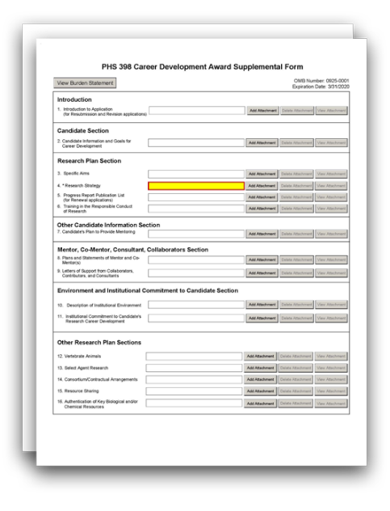
G.410 - PHS 398 Career Development Award Supplemental Form

The PHS 398 Career Development Award Supplemental Form is used only for career development applications and multi-project applications with an "Indiv. Career Dev" Component.
This form includes fields to upload several attachments including the Specific Aims, Research Strategy, and Candidate Background and Goals.
See NIH's Reference Letters page for information including instructions for referees and how to submit letters.
The attachments in this form, together with the rest of your application, should include sufficient information needed for evaluation of the project and the candidate, independent of any other documents (e.g., previous application). Be specific and informative, and avoid redundancies.

Quick Links
Introduction
- Introduction to Application (for Resubmission and Revision applications)
Candidate Section
- Candidate Information and Goals for Career Development
Research Plan Section

- Specific Aims
- Research Strategy
- Progress Report Publication List (for Renewal applications) 6. Training in the Responsible Conduct of Research
Other Candidate Information Section
7. Candidate's Plan to Provide Mentoring
Mentor, Co-Mentor, Consultant, Collaborators Section

View larger image

- Plans and Statements of Mentor and Co-Mentor(s)
- Letters of Support from Collaborators, Contributors, and Consultants
Environment and Institutional Commitment to Candidate Section
- Description of Institutional Environment
- Institutional Commitment to Candidate's Research Career Development 12. Description of Candidate’s Contribution to Program Goals
Other Research Plan Sections
- Vertebrate Animals
- Select Agent Research
- Consortium/Contractual Arrangements 16. Resource Sharing
- Authentication of Key Biological and/or Chemical Resources

Appendix

- Appendix

Citizenship

- U.S. Citizen or Non-Citizen National?

Who should use the PHS 398 Career Development Award Supplemental Form:
Use the PHS 398 Career Development Award Supplemental Form only if you are submitting a career development application or a multi-project application that has an "Indiv. Career Dev" Component.
Some sections of the PHS 398 Career Development Award Supplemental Form are required for all career development award applications, while others are to be used only when required by the FOA.
Read all the instructions in the FOA before completing this section to ensure your application meets all IC-specific criteria.

Applicants must follow all policies and requirements related to formatting, page limits, and proprietary information. See the following pages for more information:
- Format Attachments
- Page Limits
- NIH Grants Policy Statement, Section 2.3.11.2: Confidentiality of Information
- NIH Grants Policy Statement, Section 2.3.11.2.2: The Freedom of Information Act

Introduction

1. Introduction to Application (for Resubmission and Revision applications)

Who must complete the “Introduction to Application” attachment:
An "Introduction to Application" attachment is required only if the type of application is resubmission or revision. An introduction is not allowed for new or renewal applications.
Descriptions of different types of applications are listed here: NIH Types of Applications.

Format:
Follow the page limits for the Introduction in the NIH Table of Page Limits unless otherwise specified in the FOA.
Attach this information as a PDF file. See NIH's Format Attachments page.

Content:
Resubmission applications: See specific instructions on the content of the Introduction on the NIH's Resubmission Applications page.
Competing Revisions: See specific instructions on the content of the Introduction on the NIH's Competing Revisions page.
Other Components: The "Introduction” attachment is optional for resubmissions and revisions applications. Although the “Introduction” attachment is optional, you may get a system warning if there is no attachment.
Additional Instructions for Multi-project:

Candidate Section

2. Candidate Information and Goals for Career Development

Who must complete the "Candidate Information and Goals for Career Development" attachment:
The “Candidate Information and Goals for Career Development” attachment is required.

Format:
Follow the page limits for Candidate Information and Goals for Career Development in the NIH Table of Page Limits, unless otherwise specified in the FOA.
Attach this information as a PDF file. See NIH's Format Attachments page.

Content:
Organize your attachment into three sections, following the headings and specified order below, and discuss each of the points listed below. Start each section with the appropriate section heading – Candidate’s Background, Career Goals and Objectives, and Candidate’s Plan for Career

Development/Training Activities During Award Period. Also include any additional information requested in the FOA.

Candidate’s Background:
  - Describe your past scientific history, indicating how the award fits into past and future research career development.
  - If there are consistent themes or issues that have guided previous work, these should be made clear. Alternatively, if your work has changed direction, indicate the reasons for the change.

Career Goals and Objectives:
  - Describe your short-term and long-term career development goals.
  - Justify the need for the award by describing how the career development award will enable you to develop and/or expand your research career.
  - If applicable (e.g., K24), describe how this award will help you to serve as a mentor to early career investigators.

Candidate’s Plan for Career Development/Training Activities During Award Period:
  - Describe the new or enhanced research skills and knowledge you will acquire as a result of the proposed award, including, expertise in rigorous research design, experimental methods, quantitative approaches, and data analysis and interpretation, as applicable.
  - For non-mentored career development awards, describe any planned release from teaching, administrative, and/or clinical duties that will help you focus on your research activities, and if applicable, your mentoring activities.
  - For mentored career development awards, describe any structured activities that are part of the developmental plan, such as coursework or workshops that will help you learn new techniques or develop needed professional skills.
  - Briefly discuss each of the activities, other than research, in which you expect to participate.
  - For each activity, other than research, explain how it relates to the proposed research and to the career development plan. Indicate the percentage of time to be dedicated to each activity by year, expressed in person months. For more information about calculating person months, see NIH's Frequently Asked Questions on Person Months.
  - You are encouraged to include a timeline, including plans to apply for subsequent grant support.

Research Plan Section

A Research Plan is required for all types of individual career development awards.
The information in these introductory paragraphs to the Research Plan Section applies to all four Research Plan attachments: Specific Aims, Research Strategy, Progress Report Publication List, and Training in the Responsible Conduct of Research.

The Research Plan is a major part of the overall career development goal. It is important to relate the proposed research to the candidate's scientific career goals. Describe how the research, coupled with other developmental activities, will provide the experience, knowledge, and skills necessary to achieve the objectives of the career development plan. Also describe how the research and other developmental activities will enable the candidate to launch and conduct an independent research career or enhance an established research career.
For most types of research, the Research Plan Section should include:
  - a specific hypothesis,
  - a list of the specific aims and objectives that will be used to examine the hypothesis,
  - a description of the methods/approaches/techniques to be used in each aim,
  - a discussion of possible problems and how they will be managed, and
  - alternative approaches that might be tried if the initial approaches do not work.
A Career Development Award (CDA) Research Plan is expected to be tailored to the experience level of the candidate and to allow him/her to develop the necessary skills needed for further career advancement. Reviewers will evaluate the plan accordingly. The plan should be achievable within the requested time period. Pilot or preliminary studies and routine data gathering are generally not appropriate as the sole part(s) of a CDA Research Plan.
Although candidates for mentored career development awards are expected to write the Research Plan, the mentor should review a draft of the plan and discuss it in detail with the candidate. Review by other knowledgeable colleagues is also helpful. Although it is understood that CDA applications do not require the extensive detail usually incorporated into regular research grant applications, a fundamentally sound Research Plan that includes a reasonably detailed Research Strategy section should be provided.

3. Specific Aims

Who must complete the “Specific Aims” attachment:
The "Specific Aims" attachment is required unless otherwise specified in the FOA.

Format:
Follow the page limits for the Specific Aims in the NIH Table of Page Limits, unless otherwise specified in the FOA. This section is limited to text only. Graphics (including images, charts, and graphs) are not allowed in this section. A “Specific Aims” attachment that exceeds the page limit will be flagged as an error by the Agency upon submission, and a “Specific Aims” attachment that includes graphics will generate a warning by the Agency upon submission.
Attach this information as a PDF file. See NIH's Format Attachments page.

Content:
State concisely the goals of the proposed research and summarize the expected outcome(s), including the impact that the results of the proposed research will have on the research field(s) involved.
List succinctly the specific objectives of the research proposed (e.g., to test a stated hypothesis, create a novel design, solve a specific problem, challenge an existing paradigm or clinical practice, address a critical barrier to progress in the field, or develop new technology).

4. Research Strategy

Who must complete the "Research Strategy" attachment:
The “Research Strategy” attachment is required.

Format:
Follow the page limits for the Research Strategy in the NIH Table of Page Limits, unless otherwise specified in the FOA.
Attach this information as a PDF file. See NIH's Format Attachments page.

Content:
Organize the Research Strategy in the specified order and use the instructions provided below. Start each section with the appropriate heading – Significance, Innovation, Approach.
Cite published experimental details in the Research Strategy section and provide the full reference in G.220 - R&R Other Project Information Form, Bibliography and References Cited.
In general, less detail will be expected in descriptions of research planned for the future years of the proposed CDA compared to the initial years’ descriptions. However, sufficient detail should be provided to enable peer reviewers to determine that the plans for those years, including the approach to be used, are worthwhile and are likely to enable the candidate to achieve the objectives of the Research Plan.
Note for mentored CDA applications: Explain the relationship between the candidate’s research on the CDA and the mentor’s ongoing research program.
Note for non-mentored CDA applications: In general, non-mentored CDA applicants are expected to have independent, peer-reviewed research support. Applications should include a brief description of currently funded research, along with a more extensive description of any new research to be supported by the CDA.

Note for Applications Proposing the Involvement of Human Subjects and/or Clinical Trials:
- Use the Research Strategy section to discuss the overall strategy, methodology, and analyses of your proposed research, but do not duplicate information collected in the PHS Human Subjects and Clinical Trials Information form.
- The PHS Human Subjects and Clinical Trials Information form will capture detailed study information, including eligibility criteria; inclusion of women, minorities, and children; protection and monitoring plans; and statistical design and power.
- You are encouraged to refer to information in the PHS Human Subjects and Clinical Trials Information form as appropriate in your discussion of the Research Strategy (e.g., see Question 2.4 Inclusion of Women and Minorities).
Note for Applicants with Multiple Specific Aims: You may address the Significance, Innovation, and Approach either for each Specific Aim individually or for all of the Specific Aims collectively.

Significance
  - Explain the importance of the problem or critical barrier to progress that the proposed project addresses.

  - Describe the strengths and weaknesses in the rigor of the prior research (both published and unpublished) that serves as the key support for the proposed project.
  - Explain how the proposed project will improve scientific knowledge, technical capability, and/or clinical practice in one or more broad fields.
  - Describe how the concepts, methods, technologies, treatments, services, or preventative interventions that drive this field will be changed if the proposed aims are achieved.

Innovation
  - Explain how the application challenges current research or clinical practice paradigms.
  - Describe any novel theoretical concepts, approaches or methodologies, instrumentation or interventions to be developed or used, and any advantage over existing methodologies, instrumentation, or interventions.

Approach
  - Describe the overall strategy, methodology, and analyses to be used to accomplish the specific aims of the project. Describe plans to address weaknesses in the rigor of the prior research that serves as the key support for the proposed project. Describe the experimental design and methods proposed and how they will achieve robust and unbiased results. Unless addressed separately in the Resource Sharing Plan section, include how the data will be collected, analyzed, and interpreted, as well as any resource sharing plans as appropriate. Resources and tools for rigorous experimental design can be found at the Enhancing Reproducibility through Rigor and Transparency website.
  - For trials that randomize groups or deliver interventions to groups, describe how your methods for analysis and sample size are appropriate for your plans for participant assignment and intervention delivery. These methods can include a group- or cluster- randomized trial or an individually randomized group-treatment trial. Additional information is available at the Research Methods Resources webpage.
  - Discuss potential problems, alternative strategies, and benchmarks for success anticipated to achieve the aims.
  - If the project is in the early stages of development, describe any strategy to establish feasibility, and address the management of any high risk aspects of the proposed work.
  - Explain how relevant biological variables, such as sex, are factored into research designs and analyses for studies in vertebrate animals and humans. For example, strong justification from the scientific literature, preliminary data, or other relevant considerations, must be provided for applications proposing to study only one sex. Refer to NIH Guide Notice on Sex as a Biological Variable in NIH-funded Research for additional information.
  - Point out any procedures, situations, or materials that may be hazardous to personnel and precautions to be exercised. A full discussion on the use of select agents should appear in the Select Agent Research section below.
  - If research on Human Embryonic Stem Cells (hESCs) is proposed but an approved cell line from the NIH hESC Registry cannot be chosen, provide a strong justification for why an appropriate cell line cannot be chosen from the registry at this time.

  - If you are proposing to gain clinical trial research experience (i.e., you will not be leading an independent clinical trial), briefly describe your role on the clinical trial.

As applicable, also include the following information as part of the Research Strategy, keeping within the three sections (Significance, Innovation, and Approach) listed above.
Preliminary Studies (for New Applications):
For new applications, include information on preliminary studies. Discuss the PD/PI’s preliminary studies, data, and or experience pertinent to this application.

Progress Report (for Renewal and Revision Applications):
Most career development applicants will not complete this attachment. However, if you are required to do so, note that the Progress Report falls within the Research Strategy and is therefore included in the page limits for the Research Strategy.
For renewal/revision applications, provide a Progress Report. Provide the beginning and ending dates for the period covered since the last competitive review. In the Progress Report, you should:
  - Summarize the specific aims of the previous project period and the importance of the findings, and emphasize the progress made toward their achievement.
  - Explain any significant changes to the specific aims and any new directions, including changes resulting from significant budget reductions.
  - Discuss previous participant enrollment (e.g., recruitment, retention, inclusion of women, minorities, children, etc.) for any studies meeting the NIH definition for clinical research. Use the Progress Report section to discuss, but not duplicate information collected elsewhere in the application.
Do not include a list of publications, patents, or other printed materials in the Progress Report. That information should be included in the "Progress Report Publication List" attachment.

5. Progress Report Publication List (for Renewal applications)

Who must complete the “Progress Report Publication List” attachment:
A “Progress Report Publication List” attachment is required only if the type of application is renewal. Most career development applicants will not complete this attachment.
Descriptions of different types of applications are listed here: NIH's Types of Applications.

Format:
Attach this information as a PDF file. See NIH's Format Attachments page.

Content:
List the titles and complete references to all appropriate publications, manuscripts accepted for publication, patents, and other printed materials that have resulted from the project since it was last reviewed competitively.
You are allowed to cite interim research products. Note: interim research products have specific citation requirements. See related Frequently Asked Questions on citing interim research products and claiming them as products of your NIH award.

Provide the NIH Manuscript Submission reference number (e.g., NIHMS97531) or the PubMed Central (PMC) reference number (e.g., PMCID234567) for the following:
  - Articles that fall under the Public Access Policy,
  - Articles that were authored or co-authored by the applicant and arose from NIH support,
  - Articles that were authored or co-authored by the applicant and arose from AHRQ funding provided after February 19, 2016 (see the Guide Notice on Policy for Public Access to AHRQ-Funded Scientific Publications).
If the PMCID is not yet available because the Journal submits articles directly to PMC on behalf of their authors, indicate “PMC Journal – In Process.” NIH maintains a list of such journals.
Citations that are not covered by the Public Access Policy, but are publicly available in a free, online format may include URLs or PubMed ID (PMID) numbers along with the full reference.
Overall and Other Components: If you include a “Progress Report Publication List” attachment, you can include it in either the Overall Component or within each Other Component, but do not attach the same information in multiple locations.
Additional Instructions for Multi-project:

6. Training in the Responsible Conduct of Research

Who must complete the "Training in the Responsible Conduct of Research" attachment:
The “Training in the Responsible Conduct of Research” attachment is required.

Format:
Follow the page limits for the Training in the Responsible Conduct of Research in the NIH Table of Page Limits unless otherwise specified in the FOA.
Attach this information as a PDF file. See NIH's Format Attachments page.

Content:
Mentored CDA applications should describe a plan to acquire instruction in the responsible conduct of research (RCR).
Non-mentored (independent) CDA applications should describe a plan to obtain or provide instruction in RCR, depending on your level of experience with RCR.
Attach a description of plans for obtaining or providing instruction in RCR. This section should document prior instruction or participation in RCR training during the applicant’s current career stage (including the date instruction was last completed). This section should also propose plans to either receive instruction or provide instruction (e.g., to participate as a course lecturer) to meet the frequency requirement of RCR training (see the “For more information section” below).
The plan must address the five required instructional components outlined in the NIH Policy on Instruction in the Responsible Conduct of Research (RCR), as more fully described in the NIH Grants Policy Statement, Section 12.4.1.4: Training in the Responsible Conduct of Research.
- Format: Describe the required format of instruction, i.e., face-to-face lectures, coursework, and/or real-time discussion groups (a plan with only on-line instruction is not acceptable).

- Subject Matter: Describe the breadth of subject matter (e.g., conflict of interest, authorship, data management, human subjects and animal use, laboratory safety, research misconduct, research ethics).
- Faculty Participation: Describe the role of the mentor(s) and other faculty involvement in the instruction.
- Duration of Instruction: Describe the number of contact hours of instruction, taking into consideration the duration of the program.
- Frequency of Instruction: Instruction must occur during each career stage and at least once every four years. Document any prior instruction during the applicant’s current career stage, including the inclusive dates instruction was last completed.
The plan may include career stage-appropriate individualized instruction or independent scholarly activities. Instruction and activities should enhance the applicant’s understanding of ethical issues related to their specific research activities and the societal impact of that research. The role of the mentor in RCR instruction must be described.
Renewal Applications: Describe the RCR instruction activities undertaken during the previous project period as well as future plans for RCR instruction.

For more information:
See the NIH Grants Policy Statement, Section 12.4.1.4: Training in the Responsible Conduct of Research.

Other Candidate Information Section

7. Candidate’s Plan to Provide Mentoring

Who must complete the “Candidate’s Plan to Provide Mentoring” attachment:
Include the “Candidate’s Plan to Provide Mentoring” attachment only when required by the FOA, (e.g., K05 and K24).

Format:
Follow the page limits for the Candidate’s Plan to Provide Mentoring in the NIH Table of Page Limits unless otherwise specified in the FOA.
Attach this information as a PDF file. See NIH's Format Attachments page.

Content:
The plan should provide information about both the candidate’s commitment to serve as a mentor to other investigators and the candidate’s previous mentoring activities. State the candidate’s proposed percent effort commitment to the mentoring plan, expressed in person months. For more information about calculating person months, see NIH's Frequently Asked Questions on Person Months.
Describe proposed mentoring activities: Describe the setting for mentoring and provide information about the available pool of mentees with appropriate backgrounds and similar interests in science as the candidate. Include information sufficient for reviewers to evaluate the quality of the proposed mentoring experience, including the professional levels of mentees and

the frequency and kinds of mentoring interactions between the candidate and mentees. Describe the productivity of the mentoring relationship for the scientific development of the new scientists as judged by their publications and current research activities.
Describe past mentoring activities: Include sufficient information on the candidate’s past mentees so that reviewers can evaluate the quality of prior mentoring experiences. Include information such as the professional levels of mentees, and the frequency and kinds of mentoring interactions between the candidate and mentees.
Senior level (K05) candidates: Describe any financial and material support from your own funded research and research resources that will be available to your mentees.

Mentor, Co-Mentor, Consultant, Collaborators Section

8. Plans and Statements of Mentor and Co-Mentor(s)

Who must complete the “Plans and Statements of Mentor and Co-Mentor(s)” attachment:
Any candidate applying for a mentored CDA (see Summary of Career Development Award Mechanisms table) must include a "Plans and Statement of Mentor and Co-Mentor(s)" attachment.
All mentored career development applications should identify any and all co-mentors involved with the proposed research and career development program. The mentor and each co-mentor must provide a statement as described below.

Format:
Follow the page limits for the Plans and Statements of Mentor and Co-mentor(s) in the NIH Table of Page Limits unless otherwise specified in the FOA.
The plans and statements must be appended together and uploaded as a single PDF file. See NIH's Format Attachments page.

Content:
The mentor and co-mentor(s) (if applicable) must each document their role and willingness to participate in the project, and explain how they will contribute to the development of the candidate's research career. Each statement should include all of the following:
- The plan for the candidate's training and research career development. Include information not only about research, but also about other developmental activities, such as seminars, scientific meetings, training in RCR, and presentations. Discuss expectations for publications over the entire period of the proposed project. Define what aspects of the proposed research project the candidate will be allowed to continue to pursue as part of his/her independent research program.
- The source of anticipated support for the candidate’s research project for each year of the award period.
- The nature and extent of supervision and mentoring of the candidate, and commitment to the candidate's development that will occur during the award period.

- The candidate's anticipated teaching load for the award period (number and types of courses or seminars), clinical responsibilities, committee and administrative assignments, and the portion of time available for research.
- A plan for transitioning the candidate from the mentored stage of his/her career to the independent investigator stage by the end of the project period of the award. Describe the mentor's (or co-mentor’s) previous experience as a mentor, including type of mentoring (e.g., graduate students, career development awardees, postdoctoral fellows), number of persons mentored, and career outcomes.
Note for co-mentor statements: Co-mentors must also address the nature of their role in the career development plan and how the responsibility for the candidate’s development is shared with the mentor. Describe respective areas of expertise and how they will be combined to enhance the candidate’s development. Also describe the nature of any resources that will be committed to this CDA.
Note: If the applicant is proposing to gain experience in a clinical trial as part of his or her research career development, then the mentor or a member of the mentoring team should include information in the statement to document leadership of the clinical trial (in addition to the information above). Include the following:
- Source of funding;
- ClinicalTrials.gov Identifier (e.g., NCT87654321), if applicable;
- A description of how your expertise is appropriate to guide the applicant in any proposed clinical trials research experience; and
- A statement/attestation that the mentor will be responsible for the clinical trial.
- The mentor must have primary responsibility for leading and overseeing the trial and must describe how she/he will provide this oversight (be careful not to overstate the candidate’s responsibilities).
- Include details on the specific roles/responsibilities of the applicant and mentor, keeping in mind that the terms of a CDA award do not always permit the candidate to lead a clinical trial.
Do not place these statements from the mentor(s) and co-mentor(s) in the Appendix.

9. Letters of Support from Collaborators, Contributors, and Consultants

Note that letters of support are not the same as letters of reference (also known as reference letters), which are required for some K applications. For more information about letters of reference, see the NIH's Reference Letters page.

From whom are letters of support required? From whom are letters not required?
Letters of support from collaborators, contributors, and consultants will be required for any such person who will contribute to the scientific development or execution of CDA application’s proposed project. Follow the requirements for letters of support as listed in the FOA.
Letters are not required for personnel (such as research assistants) not contributing in a substantive, measurable way to the scientific development or execution of the project.

Format:
Follow the page limits for the Letters of Support from Collaborators, Contributors, and Consultants in the NIH Table of Page Limits unless otherwise specified in the FOA.
Attach all appropriate letters of support. The letters must be appended together and uploaded as a single PDF file. See NIH's Format Attachments page.

Content:
Letters from consultants should include rates/charges for consulting services.
Mentored CDA applications should identify collaborators, contributors, and consultants involved with the proposed research and career development program, and not already included in the “Plans and Statements of Mentor(s) and Co-Mentor(s)” section. Letters should briefly describe their anticipated contributions and document their role and willingness to participate in the project. The letters should also briefly describe research materials, data, guidance, or advice each person will provide.
Non-mentored CDA applications should include letters from collaborators, consultants, and contributors. Letters should list proposed roles and document their willingness to participate in the project. The letters should also briefly describe research materials, data, guidance, or advice each person will provide.

Environment and Institutional Commitment to Candidate Section

10. Description of Institutional Environment

Who must complete the "Description of Institutional Environment" attachment:
The “Description of Institutional Environment” attachment is required.

Format:
Follow the page limits for the Description of Institutional Environment in the NIH Table of Page Limits unless otherwise specified in the FOA.
Attach this information as a PDF file. See NIH's Format Attachments page.

Content:
Mentored CDA applicants: Describe the institution’s research and career development opportunities related to your area(s) of interest, including the names of key faculty members and other investigators relevant to your proposed developmental plan and capable of productive collaboration with the candidate. Indicate how the necessary facilities and other resources will be made available for both career enhancement and the research proposed in this application – refer to the resources description in G.220 - R&R Other Project Information Form, Facilities and Other Resources in your “Description of Institutional Environment” attachment. Describe opportunities for intellectual interactions with other investigators, including courses offered, journal clubs, seminars, and presentations.
Non-mentored CDA applicants: Describe the institution’s research and career development opportunities related to your area(s) of interest, including the names of other faculty members who are willing to collaborate with you. Indicate how the necessary facilities and other resources will be made available for both career enhancement and the research proposed in this

application – refer to the resources description in G.220 - R&R Other Project Information Form, Facilities and Other Resources in your “Description of Institutional Environment” attachment. Describe opportunities for intellectual interactions with other investigators, including journal clubs, seminars, and presentations.

11. Institutional Commitment to Candidate’s Research Career Development

Who must complete the "Institutional Commitment to Candidate's Research Career Development" attachment:
The “Institutional Commitment to Candidate’s Research Career Development” attachment is required.

Format:
Follow the page limits for the Institutional Commitment to Candidate’s Research Career Development in the NIH Table of Page Limits unless otherwise specified in the FOA.
Attach this information as a PDF file. See NIH's Format Attachments page.

Content:
The sponsoring institution must provide a document on institutional letterhead that describes its commitment to the candidate and the candidate’s career development, independent of the receipt of the CDA. It is also essential to document the institution's commitment to the retention, development, and advancement of the candidate during the period of the award.
The “Institutional Commitment to Candidate’s Research Career Development” attachment should generally document the institution’s agreement to provide adequate time, support, equipment, facilities, and resources to the candidate for research and career development activities. See the list below for specific items to include in the document.
In the document describing its institutional commitment, the applicant organization must:
- Agree to release the candidate from other duties and activities so that the candidate can devote the required percentage of time for development of a research career, as specified by the FOA. For most K awards, commitment of at least 75 percent or nine person months of time is required.
  - NIH and other PHS agencies use the concept of "person months" as a metric for determining percent of effort. For more information about calculating person months, see NIH's Frequently Asked Questions on Person Months.
- Describe actions that will be taken to ensure that the candidate can devote the required time to research career development (e.g., reduction of the candidate's teaching load, committee and administrative assignments, and clinical or other professional activities for the current academic year). If the candidate’s clinical or teaching responsibilities will be reduced, describe how this will be accommodated (e.g., hiring additional staff, reassigning staff, etc.).
- Describe the candidate's academic appointment, bearing in mind that the appointment must be full-time, and that the appointment (including all rights and privileges pertaining to full faculty status if in an academic setting) and the continuation of salary should not be contingent upon the receipt of this award.

- Describe the proportion of time currently available for the candidate's research and what the candidate's institutional responsibilities will be if an award is made.
- Describe how the institution will provide the candidate with appropriate office and laboratory space, equipment, and other resources (including access to clinical and/or other research populations) to carry out the proposed Research Plan.
- Describe how the institution will be supportive of any proposed mentor(s), other staff, and/or collaborations with other faculty consistent with the career development plan.

Signatures:
The institutional commitment must be dated and signed by the person who is authorized to commit the institution to the agreements and assurances listed above. In most cases, this will be the dean or the chairman of the department. The signature must appear over the signer's name and title at the end of the statement. If the candidate will be working outside of the applicant institution (i.e., sponsoring institution), signatures from both the applicant/sponsoring institution and host institutions are required.
The sponsoring institution, through the submission of the application and in the institutional commitment section, certifies that all items outlined above will be provided and that the institution will abide by the applicable assurances and PHS policies.
Note: For applicable assurances, see the NIH Grants Policy Statement, Section 4: Public Policy Requirements, Objectives and Other Appropriation Mandates.

12. Description of Candidate’s Contribution to Program Goals

Who must complete the "Description of Candidate’s Contribution to Program Goals" attachment:
Applicants to diversity-related FOAs (e.g., diversity-related K01 and diversity-related K22s):
The “Description of Candidate’s Contribution to Program Goals” attachment is required.
All other Career Development applicants: Skip the “Description of Candidate’s Contribution to Program Goals” attachment, as it is not required.

Format:
Follow the page limits for the Description of Candidate’s Contribution to Program Goals in the NIH Table of Page Limits unless otherwise specified in the FOA.
Attach this information as a PDF file. See NIH’s Format Attachments page.

Content:
The sponsoring institution must provide a document on institutional letterhead that explains how the candidate’s participation will further the goals of the career development program to promote diversity in health-related research.
For more information, refer to the Notice of NIH’s Interest in Diversity).NOT-OD-20-031(

Signatures:
The “Description of Candidate’s Contribution to Program Goals” attachment must be dated and signed by an institutional official. In most cases, this will be the dean or the chairman of

the department. The signature must appear over the signer's name and title at the end of the statement. If the candidate will be working outside of the applicant institution (i.e., sponsoring institution), signatures from both the applicant/sponsoring institution and host institutions are required.

Other Research Plan Sections

13. Vertebrate Animals

Who must complete the “Vertebrate Animals” attachment:
Include the “Vertebrate Animals” attachment if you answered “Yes” to the question “Are Vertebrate Animals Used?” on the G.220 - R&R Other Project Information Form.

Format:
Attach this information as a PDF file. See NIH's Format Attachments page.
Do not use the Vertebrate Animals attachment to circumvent the page limits of the Research Strategy.

Content:
If live vertebrate animals are involved in the project, address each of the following criteria:
- Description of Procedures: Provide a concise description of the proposed procedures to be used that involve live vertebrate animals in the work outlined in the “Research Strategy” attachment. The description must include sufficient detail to allow evaluation of the procedures. Identify the species, strains, ages, sex, and total numbers of animals by species, to be used in the proposed work. If dogs or cats are proposed, provide the source of the animals.
- Justifications: Provide justification that the species are appropriate for the proposed research. Explain why the research goals cannot be accomplished using an alternative model (e.g. computational, human, invertebrate, in vitro).
- Minimization of Pain and Distress: Describe the interventions including analgesia, anesthesia, sedation, palliative care, and humane endpoints that will be used to minimize discomfort, distress, pain, and injury.
Each of the criteria must be addressed. Failure to adequately address the criteria may negatively affect the application’s impact score. In addition to the 3 criteria above, you should also:
- Identify all project performance (or collaborating) sites and describe the proposed research activities with vertebrate animals that will be conducted at those sites.
- Explain when and how animals are expected to be used if plans for the use of animals have not been finalized.

See the following pages for more information:
- NIH’s Office of Laboratory Animal Welfare website
- NIH's Vertebrate Animals Section Worksheet

- NIH Grants Policy Statement, Section 4.1.1: Animal Welfare Requirements (an applicable Animal Welfare Assurance will be required if the grantee institution does not have one)

14. Select Agent Research

Who must complete the “Select Agent Research” attachment:
Include the “Select Agent Research” attachment if your proposed activities involve the use of select agents at any time during the proposed project period, either at the applicant organization or at any performance site.

Format:
Attach this information as a PDF file. See NIH's Format Attachments page.

For more information:
Select agents are hazardous biological agents and toxins that have been identified by HHS or the
U.S. Department of Agriculture (USDA) as having the potential to pose a severe threat to public health and safety, to animal and plant health, or to animal and plant products. The Centers for Disease Control and Prevention (CDC) and the Animal APHIS Select Agent Programs jointly maintain a list of these agents. See the Federal Select Agent Program website.
See also the NIH Grants Policy Statement, Section 4.1.24.1: Public Health Security and Bioterrorism Preparedness and Response Act (Select Agents).

Content:
Excluded select agents: If the activities proposed in your application involve only the use of a strain(s) of select agents which has been excluded from the list of select agents and toxins as per 42 CFR 73.3, the select agent requirements do not apply. Use this “Select Agent Research” section to identify the strain(s) of the select agent that will be used and note that it has been excluded from this list. The CDC maintains a list of exclusions which is available on the Select Agents and Toxins Exclusions website.
Applying for a select agent to be excluded: If the strain(s) is not currently excluded from the list of select agents and toxins but you have applied or intend to apply to HHS for an exclusion from the list, use this section to indicate the status of your request or your intent to apply for an exclusion and provide a brief justification for the exclusion.
All applicants proposing to use select agents: Address the following three points for each site at which select agent research will take place. Although no specific page limitation applies to this section, be succinct.
  - Identify the select agent(s) to be used in the proposed research.
  - Provide the registration status of all entities* where select agent(s) will be used.
    - If the performance site(s) is a foreign institution, provide the name(s) of the country or countries where select agent research will be performed.
    - *An “entity” is defined in 42 CFR 73.1 as “any government agency (Federal, State, or local), academic institution, corporation, company, partnership, society, association, firm, sole proprietorship, or other legal entity.”
  - Provide a description of all facilities where the select agent(s) will be used.

    - Describe the procedures that will be used to monitor possession, use and transfer of select agent(s).
    - Describe plans for appropriate biosafety, biocontainment, and security of the select agent(s).
    - Describe the biocontainment resources available at all performance sites.

15. Consortium/Contractual Arrangements

Who must complete the “Consortium/Contractual Arrangements” attachment:
Include the “Consortium/Contractual Arrangements” attachment if you have consortium/contracts in your budget.

Format:
Attach this information as a PDF file. See NIH's Format Attachments page.

Content:
Explain the programmatic, fiscal, and administrative arrangements to be made between the applicant organization and the consortium organization(s). If consortium/contractual activities represent a significant portion of the overall project, explain why the applicant organization, rather than the ultimate performer of the activities, should be the grantee.
Note: The signature of the authorized organization representative in G.200 – SF 424 (R&R), Authorized Representative signifies that the applicant and all proposed consortium participants understand and agree to the following statement:
The appropriate programmatic and administrative personnel of each organization involved in this grant application are aware of the agency’s consortium agreement policy and are prepared to establish the necessary inter-organizational agreement(s) consistent with that policy.

For more information:
Refer to the NIH Grants Policy Statement, Section 15: Consortium Agreements for more information.
Overall and Other Components: Unless otherwise specified in the FOA, you have the option to:
- include a single consolidated “Consortium/Contractual Arrangements” attachment in the Overall Component, or
- include component-specific “Consortium/Contractual Arrangements” attachment(s) within the components that include subawards, or
- include a “Consortium/Contractual Arrangements” attachment in the Overall Component and include component-specific attachments within the components that include subawards. Each filename must be unique.
Additional Instructions for Multi-project:

16. Resource Sharing

Format:
Attach this information as a PDF file. See NIH's Format Attachments page.

Content:
Data Sharing Plan: Investigators seeking $500,000 or more in direct costs (exclusive of consortium F&A) in any budget period are expected to include a brief 1-paragraph description of how final research data will be shared, or explain why data-sharing is not possible (for example human subject concerns, the Small Business Innovation Development Act provisions, etc.).
Specific FOAs may require that all applications include this information regardless of the dollar level. Applicants are encouraged to read the FOA carefully and discuss their data-sharing plan with their program contact at the time they negotiate an agreement with the Institute/Center (IC) staff to accept assignment of their application. For more information, see the NIH Data Sharing Policy or the NIH Grants Policy Statement, Section 8.2.3.1: Data Sharing Policy.
Sharing Model Organisms: Regardless of the amount requested, all applications where the development of model organisms is anticipated are expected to include a description of a specific plan for sharing and distributing unique model organisms or state why such sharing is restricted or not possible. For more information, see the NIH Grants Policy Statement, Section 8.2.3.2: Sharing Model Organisms.
Genomic Data Sharing (GDS): Applicants seeking funding for research that generates large- scale human or non-human genomic data are expected to provide a plan for sharing of these data. Examples of large-scale genomic data include genome-wide association studies (GWAS), single nucleotide polymorphisms (SNP) arrays, and genome sequence, transcriptomic, epigenomic, and gene expression data. Supplemental Information to the NIH GDS provides examples of genomic research projects that are subject to the Policy. For more information, see the NIH GDS Policy, the NIH Grants Policy Statement, Section 8.2.3.3: Genomic Data Sharing (GDS) Policy/ Policy for Genome-Wide Association Studies (GWAS), and the GDS website.
Note on GDS: For proposed studies generating human genomic data under the scope of the GDS Policy, an Institutional Certification may be submitted at the time of application submission, but it is not required at that time. The Institutional Certification, however, will be requested as Just-in-Time (JIT) information prior to award. The Institutional Certification, or in some cases, a Provisional Institutional Certification, must be submitted and accepted before the award can be issued.

For more information:
NIH considers the sharing of unique research resources developed through NIH-sponsored research an important means to enhance the value and further the advancement of the research. When resources have been developed with NIH funds, and the associated research findings published or provided to NIH, it is important that they be made readily available for research purposes to qualified individuals within the scientific community. See the NIH Grants Policy Statement, Section 8.2.3: Sharing Research Resources.

17. Authentication of Key Biological and/or Chemical Resources

Format:
Attach this information as a PDF file. See NIH's Format Attachments page.

Content:
If applicable to the proposed science, briefly describe methods to ensure the identity and validity of key biological and/or chemical resources used in the proposed studies. A maximum of one page is suggested.

More information:
Key biological and/or chemical resources are characterized as follows:
- Key biological and/or chemical resources may or may not have been generated with NIH funds and: 1) may differ from laboratory to laboratory or over time; 2) may have qualities and/or qualifications that could influence the research data; and 3) are integral to the proposed research. These include, but are not limited to, cell lines, specialty chemicals, antibodies, and other biologics.
- Standard laboratory reagents that are not expected to vary do not need to be included in the plan. Examples are buffers and other common biologicals or chemicals.
- See NIH's page on Rigor and Reproducibility for more information.

Appendix

18. Appendix

Refer to the FOA to determine whether there are any special appendix instructions for your application. See the updated NIH Guide Notice on the Appendix Policy.
Overall and Other Components: The "Appendix” attachment is optional.
Additional Instructions for Multi-project:

Format:
A maximum of 10 PDF attachments is allowed in the Appendix. If more than 10 allowable appendix attachments are needed, combine the remaining information into attachment #10.
Use filenames for attachments that are descriptive of the content.
A summary sheet listing all of the items included in the Appendix is encouraged but not required. When including a summary sheet, it should be included in the first appendix attachment.

Content:
The only allowable appendix materials are:
- Blank data collection forms, blank survey forms, and blank questionnaire forms - or screenshots thereof
- Simple lists of interview questions
Note: In your blank forms and lists, do not include items such as: data, data compilations, lists of variables or acronyms, data analyses, publications, manuals, instructions, descriptions or drawings/figures/diagrams of data collection methods or machines/devices.

- Blank informed consent/assent forms
- Other items only if they are specified in the FOA as allowable appendix materials
No other items are allowed in the Appendix. Simply relocating disallowed materials to other parts of the application will result in a noncompliant application.
Some FOAs may have different instructions for the Appendix. Always follow the instructions in your FOA if they conflict with these instructions.
Note: Applications will be withdrawn and not reviewed if they do not follow the appendix requirements in these instructions or in your FOA.
Information that expands upon or complements information provided in any section of the application – even if it is not required for the review – is not allowed in the Appendix unless it is listed in the allowed appendix materials above or in your FOA. For example, do not include material transfer agreements (MTA) in the appendix unless otherwise specified in the FOA.

For more information:
- The NIH Guide Notice on Reminder: NIH Applications Must Be Complete and Compliant With NIH Policy and Application Instructions At Time of Submission.
- Failure of reviewers to address non-required appendix materials in their reviews is not an acceptable basis for an appeal of initial peer review. For more information, see the NIH Grants Policy Statement, Section 2.4.2: Appeals of Initial Scientific Review.
- Appendix Policy Frequently Asked Questions

Citizenship

Information on Citizenship Requirements for CDA Applicants:
The candidate must be a citizen or non-citizen national of the United States or its possessions and territories, or must have been lawfully admitted to the United States for permanent residence by the time of award EXCEPT if any of the following apply:
  - candidate is applying to the K99/R00 award program;
  - candidate is applying to the K43 award program; or
  - the FOA specifies otherwise.
Note for permanent residents: Before an award is issued, a permanent resident will be required to submit a notarized statement that the candidate holds a current and valid Permanent Resident Card or some other valid verification from the U.S. Immigration and Naturalization Service of legal admission to the U.S. as a permanent resident.
Note for candidates whose citizenship status changes or is expected to change: For those career development award programs that require candidates to be U.S. citizens or permanent residents, an individual who has applied for permanent residence and expects to have obtained such status prior to the time award may submit an application recognizing that no award will be made until legal verification of permanent resident status is provided. If a candidate’s citizenship status changes after submission of the application, the new status should be reported in the candidate’s Personal Profile in the eRA Commons.

Note on K99/R00 applicants on temporary visas: It is the responsibility of the applicant organization to determine and document in the application that the candidate’s visa will allow him or her to remain in the U.S. long enough to complete the phase of the award (e.g., K99 or R00) covered by the application. Information may be requested by the NIH or another PHS Agency prior to issuance of an award as a Just-in-Time submission.
Check the applicable boxes for the following questions:

19. U.S. Citizen or Non-Citizen National?

Check “Yes” if the candidate is either a U.S. Citizen or a Non-Citizen national; otherwise check “No.”
Non-Citizen nationals are people who, although not citizens of the United States, owe permanent allegiance to the United States. They generally are people born in outlying possessions of the United States (e.g., American Samoa and Swains Island).

If no, select most appropriate Non-U.S. Citizen option:
Please select the most appropriate response from the options provided.

With a Permanent U.S. Resident Visa:
Check this box if the candidate has been lawfully admitted for permanent residence (i.e., is in the possession of a current and valid Permanent Resident Card or other legal verification of such status). A notarized statement will be required as part of the pre-award process.

With a Temporary U.S. Visa:
Check this box if the candidate currently holds a temporary U.S visa. This box is applicable only to specific programs that do not require U.S. citizenship or permanent residency (e.g., K99/R00).

Not Residing in the U.S.:
Check this box if the candidate is a citizen of a country other than the U.S. and plans to pursue career development outside of the U.S. This box is applicable only to specific programs (e.g., K43).

If you are a non-U.S. citizen with a temporary visa applying for an award that requires per- manent residency status, and expect to be granted a permanent resident visa by the start date of the award, check here:
Check this box to indicate that permanent resident status is pending (i.e., if the candidate is not a
U.S citizen but has applied for permanent residence and expects to hold a permanent resident visa by the earliest possible start date of the award). A notarized statement will be required as a part of the pre-award process. The statement must show that a licensed notary has seen the career development applicant’s valid Permanent Resident Card (USCIS Form I-551) or other valid verification from the U.S. Immigration and Naturalization Service of legal admission to the U.S.

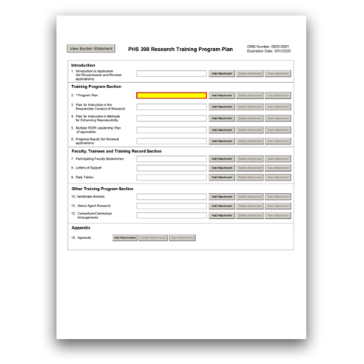

G.420 - PHS 398 Research Training Program Plan Form

The PHS 398 Research Training Program Plan Form is used only for Training applications and Multi-project applications with an "NRSA Training" Component.
This form includes fields to upload several attachments including the Program Plan, Faculty Biosketches, and Data Tables.
The attachments in this form, together with the rest of your application, should include sufficient information needed for evaluation of the training plan, independent of any other documents (e.g., previous application). Be specific and informative, and avoid redundancies.
View larger image

Quick Links
Introduction

- Introduction to Application (for Resubmission and Revision applications)
Training Program Section
- Program Plan
- Plan for Instruction in the Responsible Conduct of Research 4. Plan for Instruction in Methods for Enhancing Reproducibility 5. Multiple PD/PI Leadership Plan (if applicable)
- Progress Report (for Renewal applications)
Faculty, Trainees, and Training Record Section
- Participating Faculty Biosketches 8. Letters of Support
- Data Tables
Other Training Program Section
- Vertebrate Animals
- Select Agent Research
- Consortium/Contractual Arrangements

Appendix

13. Appendix

Who should use the PHS 398 Research Training Program Plan Form:
Use the PHS 398 Research Training Program Plan Form only if you are submitting a training application or a multi-project application that has an "NRSA Training" Component.
Read all the instructions in the FOA before completing this section to ensure that your application meets all IC-specific criteria.
Note on required tables: The instructions for the required Data Tables (1-8) are located on the NIH's Data Tables page. Please read the “Introduction to Data Tables” before beginning to prepare your data tables. The Introduction to Data Tables includes important definitions that should be used consistently both in the "Data Tables" attachment of your application and in all other parts of the application. The Data Tables must be included in the "Data Tables" attachment to avoid being counted against the page limits of other attachments.
Note on non-required tables: Additional tables (i.e., those that are generated by the applicant or not required by the FOA) should be identified by letter, rather than number, to avoid confusion with the sequentially numbered required tables.

Applicants must follow all policies and requirements related to formatting, page limits, and proprietary information. See the following pages for more information:
- Format Attachments
- Page Limits
- NIH Grants Policy Statement, Section 2.3.11.2: Confidentiality of Information
- NIH Grants Policy Statement, Section 2.3.11.2.2: The Freedom of Information Act

Introduction

1. Introduction to Application (for Resubmission and Revision applications)

Who must complete the “Introduction to Application” attachment:
An "Introduction to Application" attachment is required only if the type of application is resubmission or revision or if the FOA specifies that one is needed. An introduction is not allowed for new or renewal applications.
Descriptions of different types of applications are listed here: NIH Types of Applications.

Format:
Follow the page limits for the Introduction in the NIH Table of Page Limits unless otherwise specified in the FOA. Note that page limits for the Introduction may differ based on the type of application (i.e., resubmission or revision).
Attach this information as a PDF file. See NIH's Format Attachments page.

Content:
Resubmission Applications: See specific instructions on the content of the Introduction on the NIH's Resubmission Applications page.
Competing Revision Applications: See specific instructions on the content of the Introduction on the NIH's Competing Revisions page.
Other Components: The "Introduction” attachment is optional for resubmissions and revisions applications. Although the “Introduction” attachment is optional, you may get a system warning if there is no attachment.
Additional Instructions for Multi-project:

Training Program Section

2. Program Plan

Who must complete the “Program Plan” attachment:
The “Program Plan” attachment is required.

Format:
Follow the page limits for the Program Plan in the NIH Table of Page Limits unless otherwise specified in the FOA. The Program Plan (including sections "A. Background;" "B. Program Plan;" and "C. Recruitment Plan to Enhance Diversity," when applicable) must fit within the Program Plan page limit unless otherwise specified in the FOA.
Note that Data Tables may be referred to or summarized in this section; however, the actual tables are not to be included in this attachment.
Attach this information as a PDF file. See NIH's Format Attachments page.

Content:
Organize the Program Plan attachment in the specified order and use the instructions provided below unless otherwise specified in the FOA. Start each section with the appropriate heading – Background, Program Plan, and Recruitment Plan to Enhance Diversity. In addition, start each subsection of the Program Plan with the appropriate subheading.
Check the FOA and the instructions for the Data Tables to determine which tables should be included in the application and discussed in the Program Plan subsection.

Background
Provide the rationale for the proposed research training program, the relevant background history, and the need for the proposed research training.
Indicate how the proposed program relates to current training activities at the applicant institution.
Summarize the research training activities of the major participating unit(s) and department(s) represented in the proposed program.

If required, complete Tables 1-3 (these tables will be included in the Data Tables attachment), and summarize the data here using the guidance below. In your narrative, refer to specific tables as applicable.
Table 1. Census of Participating Departments and Interdepartmental Programs: Describe the organization of the proposed training program, the participating departments and interdepartmental programs, and the extent to which faculty, graduate students, and/or postdoctorates from those departments/interdepartmental programs participate in the programmatic activities to be supported by the training grant.
Table 2. Participating Faculty Members: Describe the distribution of participating faculty by academic rank, department or interdepartmental program and areas of research emphasis. Describe the rationale for the faculty selected to participate in the training grant. Analyze the data in terms of the overall experience of the faculty in training predoctorates and/or postdoctorates. Comment on the inclusion of faculty whose mentoring records may suggest limited, recent training experience at either training level (predoctoral or postdoctoral).
Table 3. Federal Institutional Research Training Grant and Related Support Available to Participating Faculty Members: Summarize the level of research training support at the institution. Comment on instances where the tabular data indicate that there may be substantial overlap of participating faculty.

Program Plan
Note: Applicants for institutional career development awards (e.g., K12) must complete a Research Career Development Program Plan instead of the Training Program Plan. Refer to specific instructions in the FOA.

Program Administration
Program Director information: Describe the program director's qualifications for providing leadership of the program, including relevant scientific background, current research areas, and experience in research training. Indicate the program director's percent effort in the proposed program.
Administrative information: Describe the administrative structure of the program and the distribution of responsibilities within it, including the means by which the program director will obtain continuing advice with respect to the operation of the program.
Special Instructions for Multiple PD/PI: If multiple PD/PIs are proposed, explain in this section your rationale for how this will facilitate program administration. In addition, you must complete the Multiple PD/PI Leadership Plan attachment in this form.

Program Faculty
Referring to the data presented in Table 2. Participating Faculty Members, describe each faculty member's research that is relevant to the program and indicate how trainees will participate in the research. Provide information on the extent to which participating faculty members have cooperated, interacted, and collaborated in the past, including joint publications and joint sponsorship of student research.
Use this section to document the ability of the faculty to support the research activities of the proposed trainees, the training record of the participating faculty members, and the success of their trainees in generating publishable research results. For any proposed participating faculty

(i.e., program faculty) members lacking research training experience, describe a plan to ensure that they will successfully guide trainees. Describe the criteria used to appoint and remove faculty as program faculty and to evaluate their participation.
If required, complete Tables 4-5 (these Tables will be included in the Data Tables attachment), and summarize the data here using the guidance below. In your narrative, refer to specific tables, as applicable.
Table 4. Research Support of Participating Faculty Members: Analyze the data in terms of total and average grant support. Additionally, comment on the inclusion of faculty without research grant support and explain how the research of trainees who may work with these faculty members would be supported.
Table 5A-C. Publications of Those in Training: Summarize these data, including, for example, the average number of publications, and how many students have published their work. For pre- and postdoctoral training programs, indicate how many trainees are published as first author, and how many completed their doctoral or postdoctoral training without any first-author publication.
Note for New Applications: List publications for students and/or postdoctorates who are representative of those who would be appointed if the grant is awarded.

Proposed Training
Describe the proposed training program. Indicate the training level(s) and number of trainees, the academic and research background needed to pursue the proposed training, and, as appropriate, plans to accommodate differences in preparation among trainees. For postdoctoral trainees, indicate the proposed distribution by degree (e.g., M.D., Ph.D.). Describe course work, research opportunities and the extent to which trainees will participate directly in research, activities designed to develop technical and/or professional skills, and the duration of training, i.e., usual period of time required to complete the training offered.
Describe how the program and faculty will provide training in scientific reasoning, rigorous research design, relevant experimental methods, quantitative approaches, and data analysis and interpretation, appropriate to the level and prior preparation of the trainees.
For multi-disciplinary and/or multi-departmental programs, indicate how the individual disciplinary and/or departmental components of the program are integrated and coordinated and how they will relate to an individual trainee's experience.
For training programs that emphasize research training for clinicians, describe the interactions with basic science departments and scientists. Include plans for ensuring that the training of these individuals will provide a substantive foundation for a competitive research career.
Generally, a minimum of 2 years of research training is expected for all postdoctoral trainees with health professional degrees. Describe fully any trainee’s access to and responsibility for patients, including time commitment.
Training programs that anticipate offering trainees opportunities to be involved in human subjects research funded by other research grants may include a brief description of those opportunities in this section, although such a description is not required.
Provide representative examples of programs for individual trainees. Include curricula, degree requirements, didactic courses, laboratory experiences, qualifying examinations, and other training activities, such as seminars, journal clubs, etc. Describe how the mentor and research areas are chosen, how each trainee's program will be guided, and how the trainee's performance will be monitored and evaluated. Include detailed mentoring plans as appropriate.

Training Program Evaluation
Describe an evaluation plan to review and determine the quality and effectiveness of the training program. This should include plans to obtain feedback from current and former trainees to help identify weaknesses in the training program and to provide suggestions for program improvements. Specified evaluation metrics should be tied to the goals of the program. In addition, describe plans for assessing the career development and progression of trainees, including publications, degree completion, and post-training positions.
Renewal Applications: Discuss evaluation results, and indicate whether the program has been modified as a result.

Trainee Candidates
Describe, in general terms, the size and qualifications of the pool of trainee candidates, including information about the types of prior clinical and research training and the career level required for the program. Describe specific plans to recruit candidates and explain how these plans will be implemented (see also "Section C. Recruitment Plan to Enhance Diversity" within the Program Plan). Describe the nomination and selection process to be used to select candidates who will be offered admission to the program and criteria for trainees’ reappointment to the program.
If required, complete Tables 6A and/or 6B (these Tables will be included in the Data Tables attachment), and summarize the data here using the guidance below. In your narrative, refer to specific tables as applicable.
Tables 6A and/or 6B. Applicants, Entrants, and their Characteristics for the Past Five Years (Predoctoral and Postdoctoral). Summarize the data in terms of the overall numbers of potential trainees, their credentials, their characteristics, their eligibility for support, and enrollment trends.

Institutional Environment and Commitment to Training
Include information in the application that documents the support and commitment of the applicant organization and participating units and departments to the goals of the proposed program. This could include, for example, space, shared laboratory facilities and equipment, funds for curriculum development, release time for the PD/PI and participating faculty, support for additional trainees in the program, or any other creative ways to improve the environment for the establishment and growth of the research training program.
Include a signed letter, on institutional letterhead, that describes the applicant organization’s commitment to the planned program (see instructions in the Letters of Support section).
Institutions with ongoing research training, student development, or career development programs that receive external funding should explain what distinguishes the proposed program from existing ones at the same trainee level; how the programs will synergize, if applicable; whether trainees are expected to transition from one support program to another; and how the training faculty, pool of potential trainees, and resources are sufficiently robust to support the proposed program in addition to existing ones.

Qualifications of Trainee Candidates and Admissions and Completion Records
Describe the ability of the participating departments/programs to recruit and retain trainees through the completion of their training, the selectivity of the admissions process, and the success of the departments/programs in recruiting individuals from diverse backgrounds (see also Section C. Recruitment Plan to Enhance Diversity within the Program Plan).

Discuss the quality and depth of the applicant pools, including both training-grant eligible and non-training-grant eligible individuals, the competitiveness of the program, and the characteristics of current program participants, referring to the data in Tables 6A and/or 6B, as applicable.
Use all of this information to justify the number of positions requested.
If required, complete Tables 7-8 (these Tables will be included in the Data Tables attachment) and summarize the data using the guidance below. In your narrative, refer to specific tables as applicable.
Table 7. Appointments to the Training Grant for Each Year of the Current Project Period: Describe the utilization of awarded training positions. If any trainee positions were not filled, if any trainees terminated early, or if the distribution of appointed positions differs from the distribution of awarded positions, provide an explanation.
Table 8A-D. Program Outcomes: Referring to relevant components of Table 8 (e.g. 8A, 8B, 8C and/or 8D, as appropriate), describe how training positions are used (i.e., distribution by mentor, year in program, years of support per trainee), and the success of the program in achieving its training objectives. For those who have completed their training, describe the extent of their current involvement in research, including research grant support received subsequent to completion of the training program.
Renewal applications: Discuss the selectivity of appointments to the training grant, and if any postdoctoral trainee with a health professional degree was appointed to a Kirschstein- NRSA training grant for less than 2 years of research training, explain why.

Recruitment Plan to Enhance Diversity
Who must complete the “Recruitment Plan to Enhance Diversity:”
A Recruitment Plan to Enhance Diversity is required for all training grant activity codes except T34, T36, U2R, and all D-series activity codes. All other applications without a Recruitment Plan to Enhance Diversity will be considered incomplete and will not be reviewed.

Content:
History and Achievements
Describe efforts to recruit individuals from underrepresented groups, including Diversity Groups A, B, and C, as potential candidates for the existing training program. Refer to the Notice of NIH’s Interest in Diversity (NOT-OD-20-031) for the descriptions of Diversity Groups. As applicable, refer to the data presented in Tables 6 and 7. Use these data to document the program’s past record of recruiting trainees who are underrepresented and to provide information on their support.

Proposed Plans
Describe steps to be taken during the proposed award period to identify and recruit graduate students and postdoctorates from Diversity Groups A, B, and C. Refer to the Notice of NIH’s Interest in Diversity (NOT-OD-20-031) for the descriptions of Diversity Groups. Consider the success and/or failures of recruitment strategies used in the past. In particular, describe the specific efforts to be undertaken by the training program and how these might relate to the recruitment efforts of the medical school, graduate school, and/or the university at large. In most cases, centralized institutional efforts alone will not satisfy the requirement to recruit individuals from

underrepresented groups, and training grant faculty are expected to be actively involved in recruitment efforts.
New Applications: Include a description of plans to enhance recruitment, including the strategies that will be used to enhance the recruitment of potential trainees from underrepresented groups.
Renewal Applications: Include a detailed account of experiences in recruiting individuals from underrepresented groups during the previous funding period, including successful and unsuccessful recruitment strategies. Information should be included on how the proposed plan reflects the program’s past experiences in recruiting individuals from underrepresented groups.

For more information:
Refer to the Notice of NIH’s Interest in Diversity (NOT-OD-20-031).

3. Plan for Instruction in the Responsible Conduct of Research

Who must complete the “Plan for Instruction in the Responsible Conduct of Research” attachment:
A “Plan for Instruction in the Responsible Conduct of Research (RCR)” attachment is required for all training grant activity codes except T36, unless otherwise noted in the FOA. Applications lacking a Plan for Instruction in RCR will not be reviewed.

Format:
Follow the page limits for the Plan for Instruction in the Responsible Conduct of Research in the NIH Table of Page Limits unless otherwise specified in the FOA.
Attach this information as a PDF file. See NIH's Format Attachments page.

Content:
The plan must address the five required instructional components outlined in the NIH Policy on Instruction in RCR, as more fully described in the NIH Grants Policy Statement, Section 11.3.3.5: Training in the Responsible Conduct of Research:
- Format: Describe the required format of instruction, i.e., face-to-face lectures, coursework, and/or real-time discussion groups. A plan with only on-line instruction is not acceptable.
- Subject Matter: Describe the breadth of subject matter, e.g., conflict of interest, authorship, data management, human subjects and animal use, laboratory safety, research misconduct, and research ethics.
- Faculty Participation: Describe the roles of mentor(s) and other faculty involvement in the instruction.
- Duration of Instruction: Describe the total number of contact hours of instruction.
- Frequency of Instruction: Instruction must occur during each career stage and at least once every four years. Document any prior instruction during the applicant’s current career stage, including the inclusive dates instruction was last completed.
The plan must also describe how participation in RCR instruction will be monitored.

Renewal Applications: Describe any changes in formal instruction over the past project period and plans for the future that address any weaknesses in the current RCR instruction. All training faculty who served as course directors, speakers, lecturers, and/or discussion leaders during the past project period must be named in the application.

For more information:
See the NIH Grants Policy Statement, Section 11.3.3.5: Training in the Responsible Conduct of Research.

4. Plan for Instruction in Methods for Enhancing Reproducibility

Who must complete the “Plan for Instruction in Methods for Enhancing Reproducibility” attachment:
A “Plan for Instruction in Methods for Enhancing Reproducibility” attachment is required for all training grant activity codes except D71, unless otherwise noted in the FOA. Applications lacking a Plan for Instruction in Methods for Enhancing Reproducibility will not be reviewed.

Format:
Attach this information as a PDF file. See NIH's Format Attachments page.

Content:
The plan must describe how trainees will be instructed in principles important for enhancing research reproducibility. These principles include, at a minimum, the following:
- evaluation of the foundational research underlying a project (i.e., the rigor of the prior research);
- rigorous experimental design and data interpretation;
- consideration of relevant biological variables such as sex;
- authentication of key biological and/or chemical resources; and
- transparency in reporting.
Include a description of how instructional strategies will be integrated into the overall training program at multiple stages of trainee development and in a variety of formats and contexts.
Describe how program faculty will reiterate and augment key elements of methods for enhancing reproducibility in the context of trainees’ research projects.

5. Multiple PD/PI Leadership Plan (if applicable)

Who must complete the “Multiple PD/PI Leadership Plan” attachment:
Any applicant who designates multiple PD/PIs (on the G.240 - R&R Senior/Key Person Profile (Expanded) Form) must include a Multiple PD/PI Leadership Plan. For applications designating multiple PD/PIs, all such individuals must be assigned the PD/PI role on the G.240 - R&R Senior/Key Profile (Expanded) Form, even those at organizations other than the applicant organization.
Do not submit a leadership plan if you are not submitting a multiple PD/PI application.

Overall Component: The “Multiple PD/PI Leadership Plan” attachment is required only in the Overall Component.
Additional Instructions for Multi-project:

Format:
Attach this information as a PDF file. See NIH's Format Attachments page.

Content:
The emphasis in a training grant's Multiple PD/PI Leadership Plan should be on how multiple PD/PIs will benefit the program and the trainees. A single PD/PI must be designated as Contact PD/PI (in G.200 - SF 424 (R&R) Form, PD/PI Contact Information) for the purpose of communicating with the NIH, although other individuals may contact the NIH on behalf of the Contact PD/PI when necessary. Because training programs are intended to be coherent, NIH will not allocate the budget or training positions between multiple PD/PIs. A single award will be made. Multiple PD/PI plans should include reasonable numbers of PD/PIs and each should be included for a specific and clearly stated purpose.
A rationale for choosing a multiple PD/PI approach should be described. The governance and organizational structure of the leadership team and the training program should be described, including communication plans, processes for making decisions, and procedures for resolving conflicts. The roles and administrative, technical, and other responsibilities for the training program should be delineated for the PD/PIs and other collaborators.

For more information:
For background information on the multiple-PD/PI initiative, see NIH's Multiple Principal Investigators page.

6. Progress Report (for Renewal applications)

Who must complete the “Progress Report” attachment:
A “Progress Report” attachment is required only if the type of application is renewal.

Format:
Follow the page limits given below, unless otherwise specified in the FOA. Attach this information as a PDF file. See NIH's Format Attachments page.

Content:
Organize the Progress Report according to the specified sections. Start each section with the appropriate heading – Program Overview or Progress of Those Appointed to the Grant.

Program Overview (Page limit: 5 pages)
Provide an overview of accomplishments and progress achieved in the period since the last competitive review. Focus on elements specific to the training program (rather than on opportunities generally available in the institution’s other departments or other programs). Describe how the funds provided under Training Related Expenses were used to benefit the program.
List any workshops or seminars sponsored by the program. Include the workshop/seminar titles, speakers, and relevance to the theme and training objectives of the program.

Indicate whether the training program uses Individual Development Plans (IDPs). If so, describe how IDPs were used in this reporting period to help manage the trainees’/scholars’ training and career development.
Note: Do not include actual IDPs or blank IDP forms.
Note for AHRQ trainees: Neither IDPs nor information about IDPs is required.
You may refer to information that is included elsewhere in the application, such as the Program Plan or the Training Data Tables, but do not repeat that information in the Progress Report.

Progress of Those Appointed to the Grant (Page limit: 1 page per appointee)
For each trainee or scholar appointed to the grant in the period covered since the last competitive review, provide a summary of his or her training and progress, including the following information, as applicable:
  - Degrees in progress or received;
  - Mentor(s);
  - Description of the trainee/scholar’s research project and progress;
  - Career development activities (e.g., individualized coursework or workshops attended);
  - Conference presentations;
  - A description of the trainee’s contribution to any planned or published papers resulting from research conducted while supported by this award (e.g., designed or conducted experiment, analyzed data, drafted paper); and
  - Honors, awards, fellowships, and any other support received during the period of training. Note: Support before and after the appointment is reported in the Data Tables and should not be reported here.
Do not include the following, either in the Progress Report or elsewhere in the application (including the Appendix), unless otherwise specified in the FOA:
  - Biosketches of current or former trainees/scholars;
  - Any personally identifiable information, such as photographs or any other individual demographic information;
  - Actual IDPs or blank IDP forms;
  - Promotional material for workshops, seminars, or other events (flyers, agendas etc.);
  - Course syllabi; and
  - Program brochures.
Applications that include any of these materials will be withdrawn and not reviewed.
Note: A My Bibliography report of publications arising from work conducted by trainees while supported by the training grant is not required in the application. However, it will be collected in the Interim Final Research Performance Progress Report.
Overall and Other Components: If you include a “Progress Report Publication List” attachment, you can include it in either the Overall Component or within the Other Component, but do not attach the same information in multiple locations.
Additional Instructions for Multi-project:

Faculty, Trainees, and Training Record Section

7. Participating Faculty Biosketches

Format:
Combine all participating faculty biosketches into a single PDF and attach this information here. Follow the attachment guidelines on NIH's Format Attachments page.

Content:
Faculty biosketches for participating faculty must follow the instructions for a biographical sketch (refer to G.240 - Senior/Key Person Profile (Expanded) Form) with the following exception: a personal statement, while encouraged, is not required.
Please note that the biosketches of the PD/PI and any other senior/key personnel (e.g., co- directors, if applicable, and program staff) should not be included here, but they should instead be included in the G.240 - R&R Senior/Key Person Profile (Expanded) Form.

8. Letters of Support

Format:
Combine all Letters of Support into a single PDF file and attach this information here. Do not place these letters in the Appendix. Follow the attachment guidelines on NIH's Format Attachments page.

Content:
Attach letters here from:
  - Consultants, if applicable. Letters should include rate/charge for consulting services and confirm their role(s) in the project.
  - Senior Administration Officials. This letter should be a signed letter on institutional letterhead, and it should describe the applicant institution’s commitment to the planned program.
Check the FOA (particularly for non-NRSA programs) to determine whether any additional program-specific letters of support are required.

9. Data Tables

Format:
The information provided in the required data tables (Data Tables 1-8 described below) will not be counted toward the page limitation. These tables should be numbered consecutively and titled as instructed. Start each numbered table on a new page.
Bookmark each table separately in the PDF attachment. Many PDF generators will automatically create bookmarks from text formatted using predefined Heading styles in Word.

Combine all Data Tables into a single PDF file and attach it here. See NIH's Format Attachments page.

Content:
Instructions for Data Tables 1-8 are located on NIH's Data Tables page. These instructions include an Introduction to the Data Tables that provides instructions applicable to all tables, specific instructions for each table, and Sample Data Tables. The sample data tables illustrate the kind of data to include in each table for training grant applications.
If not using the Extramural Trainee Reporting and Career Tracking (xTRACT) system to prepare data tables, be sure to choose the Instruction and Blank Data Table set that correspond to both the type of application you are submitting (e.g., new application, renewal or revision application) and the kind of training to be provided (e.g., predoctoral only, postdoctoral only, pre and postdoctoral mixed, etc.).

Other Training Program Section

10. Vertebrate Animals

Who must complete the “Vertebrate Animals” attachment:
Include a “Vertebrate Animals” attachment if you answered “Yes” to the question “Are Vertebrate Animals Used?” on the G.220 - R&R Other Project Information Form.

Format:
Attach this information as a PDF file. See NIH's Format Attachments page.
Do not use the Vertebrate Animals attachment to circumvent the page limits of the Program Plan.

Content:
Trainee Participation Only in Research Involving Vertebrate Animals that is Part of Other Research Project Grants: Describe how the institution will ensure that trainees participate only in IACUC-approved vertebrate animal research if the following two conditions apply:
  - the training program uses live vertebrate animals only as part of other research project grants, and
  - the training grant does not support the purchase, use, or husbandry of live vertebrate animals.
Independent Trainee Research Involving Vertebrate Animals: In training programs where trainees will design and conduct their own independent vertebrate animal research, follow the instructions below:
Address each of the following criteria:
- Description of Procedures: Provide a concise description of the proposed procedures to be used that involve live vertebrate animals in the work outlined in the “Program Plan” attachment. The description must include sufficient detail to allow evaluation of the procedures. Identify the species, strains, ages, sex, and total numbers of animals by species, to be used in the proposed work. If dogs or cats are proposed, provide the source of the animals.

- Justifications: Provide justification that the species are appropriate for the proposed research. Explain why the research goals cannot be accomplished using an alternative model (e.g. computational, human, invertebrate, in vitro).
- Minimization of Pain and Distress: Describe the interventions, including analgesia, anesthesia, sedation, palliative care, and humane endpoints, that will be used to minimize discomfort, distress, pain, and injury.
Each of the criteria must be addressed. Failure to adequately address the criteria may negatively affect the application's impact score. In addition to the three criteria above, you should also:
  - Identify all project performance (or collaborating) sites and describe the proposed research activities with vertebrate animals that will be conducted at those sites.
  - Explain when and how animals are expected to be used if plans for the use of animals have not been finalized.

See the following pages for more information:
- NIH’s Office of Laboratory Animal Welfare website
- NIH's Vertebrate Animals Section Worksheet
- NIH Grants Policy Statement, Section 4.1.1: Animal Welfare Requirement (an applicable Animal Welfare Assurance will be required if the grantee institution does not have one)

11. Select Agent Research

Who must complete the “Select Agent Research” attachment:
Include a “Select Agent Research” attachment if the proposed training activities will involve the use of select agents at any time during the proposed project period, either at the applicant organization or at any performance site.

Format:
Attach this information as a PDF file. See NIH's Format Attachments page.

For more information:
Select agents are hazardous biological agents and toxins that have been identified by HHS or the
U.S. Department of Agriculture (USDA) as having the potential to pose a severe threat to public health and safety, to animal and plant health, or to animal and plant products. The Centers of Disease Control and Prevention (CDC) and the Animal APHIS Select Agent Programs jointly maintain a list of these agents. See the Federal Select Agent Program website.
See also the NIH Grants Policy Statement, Section 4.1.24.1: Public Health Security and Bioterrorism Preparedness and Response Act (Select Agents).

Content:
If participating faculty proposed in the training program are conducting or plan to conduct research involving select agents in which trainees may participate, follow the instructions below.
Excluded select agents: If the activities proposed in the application involve only the use of a strain(s) of select agents which has been excluded from the list of select agents and toxins as per 42 CFR 73, the select agent requirements do not apply. Use this “Select Agent Research” attachment to identify the strain(s) of the select agent that will be used and note that it has been

excluded from this list. The CDC maintains a list of exclusions, which is available on the Select Agents and Toxins Exclusions website.
Applying for a select agent to be excluded: If the strain(s) is not currently excluded from the list of select agents and toxins but you have applied or intend to apply to HHS for an exclusion from the list, use this section to indicate the status of your request or your intent to apply for an exclusion and provide a brief justification for the exclusion.
All applicants proposing to use select agents: Address the following three points for each site at which select agent research will take place. Although no specific page limitation applies to this section, be succinct.
  - Identify the select agent(s) to be used in the proposed research.
  - Provide the registration status of all entities* where select agent(s) will be used.
    - If the performance site(s) is a foreign institution, provide the name(s) of the country or countries where select agent research will be performed.
    - *An “entity” is defined in 42 CFR 73.1 as “any government agency (federal, state, or local), academic institution, corporation, company, partnership, society, association, firm, sole proprietorship, or other legal entity.”
  - Provide a description of all facilities where the select agent(s) will be used.
    - Describe the procedures that will be used to monitor possession, use and transfer of select agent(s).
    - Describe plans for appropriate biosafety, biocontainment, and security of the select agent(s).
    - Describe the biocontainment resources available at all performance sites.

12. Consortium/Contractual Arrangements

Who must complete the “Consortium/Contractual Arrangements” attachment:
Include the “Consortium/Contractual Arrangement” attachment if you have consortiums/contracts in your budget.

Format:
Attach this information as a PDF file. See NIH's Format Attachments page.

Content:
Explain the programmatic, fiscal, and administrative arrangements to be made between the applicant organization and the consortium organization(s). If consortium/contractual activities represent a significant portion of the overall project, explain why the applicant organization, rather than the ultimate performer of the activities, should be the grantee.
Note: The signature of the authorized organization representative on the G.200 - SF 424 (R&R) Form, Authorized Representative signifies that the applicant and all proposed consortium participants understand and agree to the following statement:
The appropriate programmatic and administrative personnel of each organization involved in this grant application are aware of the agency’s consortium agreement policy and are prepared to establish the necessary inter-organizational agreement(s) consistent with that policy.

For more information:
Refer to the NIH Grants Policy Statement, Section 15: Consortium Agreements for more information.

Appendix

13. Appendix

Refer to the FOA to determine whether there are any special appendix instructions for your application. See the updated NIH Guide Notice on the Appendix Policy.
Overall and Other Components: The "Appendix" attachment is optional.
Additional Instructions for Multi-project:

Format:
A maximum of 10 PDF attachments is allowed in the Appendix. If more than 10 appendix attachments are needed, combine the remaining information into attachment #10.
As a reminder, tables other than the required Data Tables 1-8 must be incorporated into the Program Plan (and will count toward the Program Plan’s page limits), and must not be included in the Appendix. Follow the page limits for Institutional Training Grants specified in the NIH Table of Page Limits, unless otherwise specified in the FOA.
Use filenames for attachments that are descriptive of the content.
A summary sheet listing all of the items included in the Appendix is encouraged but not required. When including a summary sheet, it should be included in the first appendix attachment.

Content:
The only allowable appendix materials are:
- Blank data collection forms, blank survey forms, and blank questionnaire forms - or screenshots thereof
- Simple lists of interview questions
Note: In your blank forms and lists, do not include items such as: data, data compilations, lists of variables or acronyms, data analyses, publications, manuals, instructions, descriptions or drawings/figures/diagrams of data collection methods or machines/devices.
- Blank informed consent/assent forms
- Other items only if they are specified in the FOA as allowable appendix materials
No other items are allowed in the Appendix. Simply relocating disallowed materials to other parts of the application will result in a noncompliant application
Some FOAs may have different instructions for the Appendix. Always follow the instructions in your FOA if they conflict with these instructions
Note: Applications will be withdrawn and not reviewed if they do not follow the appendix requirements in these instructions or in your FOA.

Information that expands upon or complements information provided in any section of the application - even if it is not required for the review - is not allowed in the Appendix unless it is listed in the allowed appendix materials above or in your FOA. For example, do not include material transfer agreements (MTA) in the Appendix unless otherwise specified in the FOA.

For more information:
- The NIH Guide Notice on Reminder: NIH Applications Must Be Complete and Compliant With NIH Policy and Application Instructions At Time of Submission.
- Failure of reviewers to address non-required appendix materials in their reviews is not an acceptable basis for an appeal of initial peer review. For more information, see the NIH Grants Policy Statement, Section 2.4.2: Appeals of Initial Scientific Review.
- Appendix Policy Frequently Asked Questions

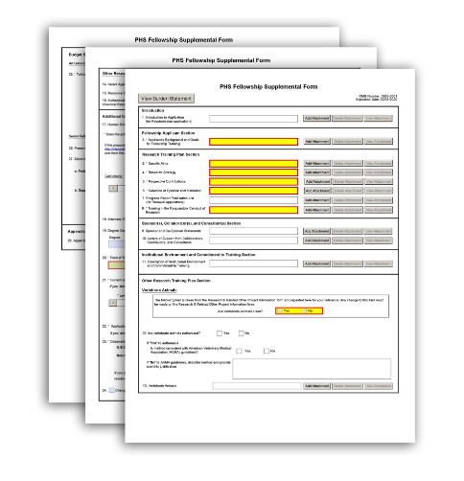

G.430 - PHS Fellowship Supplemental Form

The PHS Fellowship Supplemental Form is used only for fellowship applications.
This form includes fields to upload several attachments including the Specific Aims, Research Strategy, and Applicant Background and Goals.
The attachments in this form, together with the rest of your application, should include sufficient information needed for evaluation of the project and fellow, independent of any other documents (e.g., previous application). Be specific and informative, and avoid redundancies.

View larger image

Quick Links
Introduction

- Introduction to Application (for Resubmission applications)
Fellowship Applicant Section
- Applicant's Background and Goals for Fellowship Training
Research Training Plan Section
- Specific Aims
- Research Strategy
- Respective Contributions
- Selection of Sponsor and Institution
- Progress Report Publication List (for Renewal applications) 8. Training in the Responsible Conduct of Research
Sponsor(s), Collaborator(s), and Consultant(s) Section
- Sponsor and Co-Sponsor Statements
- Letters of Support from Collaborators, Contributors, and Consultants
Institutional Environment and Commitment to Training Section
- Description of Institutional Environment and Commitment to Training 12. Description of Candidate’s Contribution to Program Goals
Other Research Training Plan Section

Vertebrate Animals
13. Are vertebrate animals euthanized? 14. Vertebrate Animals
15. Select Agent Research 16. Resource Sharing Plan
- Authentication of Key Biological and/or Chemical Resources
Additional Information Section
- Human Embryonic Stem Cells 19. Alternate Phone Number
20. Degree Sought During Proposed Award 21. Field of Training for Current Proposal
22. Current or Prior Kirschstein-NRSA Support? 23. Applications for Concurrent Support?
- Citizenship
- Change of Sponsoring Institution
Budget Section
- Tuition and Fees
- Present Institutional Base Salary
- Stipends/Salary During First Year of Proposed Fellowship

Appendix

- Appendix

Who should use the PHS Fellowship Supplemental Form:
Use the PHS Fellowship Supplemental Form only if you are submitting a fellowship application.
Fellowship applicants and sponsors are strongly encouraged to speak with a PHS Program Official for Institute- or Center (IC)-specific guidance before preparing this application. Refer to the Table of IC- specific Information, Requirements, and Staff Contacts in your FOA. In addition, a list of contacts specifically for extramural training at the NIH ICs can be found at NIH Training Advisory Committee Roster. For AHRQ, see Research Training Staff Contacts. You are encouraged to check these websites for the most current contact information.
It is important that the attachments in this form be developed in collaboration with your sponsor, but they should be written by you, the fellowship applicant.
Read all the instructions in the FOA before completing this section to ensure that your application meets all IC-specific criteria.

Applicants must follow all policies and requirements related to formatting, page limits, and proprietary information. See the following pages for more information:
- Format Attachments
- Page Limits
- NIH Grants Policy Statement, Section 2.3.11.2: Confidentiality of Information
- NIH Grants Policy Statement, Section 2.3.11.2.2: The Freedom of Information Act

Introduction

1. Introduction to Application (for Resubmission applications)

Who must complete the “Introduction to Application” attachment:
An "Introduction" attachment is required only if the type of application is resubmission or if the FOA specifies that one is needed. An introduction is not allowed for new or renewal applications.
Descriptions of different types of applications are listed here: NIH Types of Applications.

Format:
Follow the page limits for the Introduction in the NIH Table of Page Limits unless otherwise specified in the FOA.
Attach this information as a PDF file. See NIH's Format Attachments page.

Content:
Resubmission applications: See specific instructions on the content of the Introduction on the NIH's Resubmission Applications page.

Fellowship Applicant Section

2. Applicant’s Background and Goals for Fellowship Training

Who must complete the "Applicant's Background and Goals for Fellowship Training" attachment:
The “Applicant’s Background and Goals for Fellowship Training” attachment is required.

Format:
Follow the page limits for Applicant’s Background and Goals for Fellowship Training in the NIH Table of Page Limits unless otherwise specified in the FOA.
Attach this information as a PDF file. See NIH's Format Attachments page.

Content:
Organize the Applicant’s Background and Goals for Fellowship Training attachment in the specified order and use the instructions provided below unless otherwise specified in the FOA.

Start each section with the appropriate heading - Doctoral Dissertation and Research Experience, Training Goals and Objectives, and Activities Planned Under this Award.

Doctoral Dissertation and Research Experience
Briefly summarize your past research experience, results, and conclusions, and describe how that experience relates to the proposed fellowship. In some cases, a proposed fellowship may build directly on previous research experiences, results, and conclusions. In other situations, past research experiences may lead a candidate to apply for a fellowship in a new or different area of research. Do not list academic courses in this section.
Applicants with no research experience: Describe any other scientific experiences.
Advanced graduate students (i.e., those who have or will have completed their comprehensive examinations by the time of award): Include a narrative of your planned doctoral dissertation (may be preliminary).
Postdoctoral fellowship applicants: Specify which areas of your proposed research were part of your predoctoral thesis or dissertation and which, if any, were part of a previous postdoctoral project.

Training Goals and Objectives
  - Describe your overall training goals for the duration of the fellowship and how the proposed fellowship will enable the attainment of these goals.
  - Identify the skills, theories, conceptual approaches, etc., to be learned or enhanced during the award, including expertise in rigorous research design, experimental methods, quantitative approaches, and data analysis and interpretation, as applicable.
  - Discuss how the proposed research will facilitate your transition to the next career stage, if applicable.

Activities Planned Under this Award
The activities planned under this award should be individually tailored and well-integrated with your research project.
  - Describe, by year, the activities (research, coursework, professional development, clinical activities, etc.) you will be involved in during the proposed award. Estimate the percentage of time to be devoted to each activity. The percentage should total 100 for each year.
  - Describe the research skills and techniques that you intend to learn during the award period.
  - Provide a timeline detailing the proposed research training, professional development, and clinical activities for the duration of the fellowship award. Detailed timelines of research activities involving animals, human subjects, or clinical trials are requested in other sections of the fellowship application and should not be included here. The timeline you provide here should be distinct from the Study Timeline in the PHS Human Subjects and Clinical Trials Information form.

Research Training Plan Section

A Research Training Plan is required for all types of fellowship awards and is a major part of the fellowship application. It is important to relate the proposed research to the applicant's scientific career goals. Explain the relationship between the applicant’s research on the fellowship award and the sponsor’s ongoing research program.
The information in these introductory paragraphs to the Research Training Plan Section applies to all Research Training Plan Section attachments: Specific Aims, Research Strategy, Respective Contributions, Selection of Sponsor and Institution, Progress Report Publication List, and Training in the Responsible Conduct of Research.
For most types of research, the plan should include:
  - a specific hypothesis,
  - a list of the specific aims and objectives that will be used to examine the hypothesis,
  - a description of the methods/approaches/techniques to be used in each aim,
  - a discussion of possible problems and how they will be managed, and
  - alternative approaches that might be tried if the initial approaches do not work.
The Research Training Plan is expected to be tailored to the experience level of the applicant and to allow him/her to develop the necessary skills for further career advancement. Reviewers will evaluate the plan accordingly. The plan should be achievable within the requested time period. Pilot or preliminary studies and routine data gathering are generally not appropriate as the focus of the Research Training Plan.
Although applicants for fellowship awards are expected to write the Research Training Plan, the sponsor should review a draft of the plan and discuss it in detail with the applicant. Review by other knowledgeable colleagues is also helpful. Although it is understood that fellowship applications do not require the extensive experimental detail usually incorporated into regular research grant applications, a fundamentally sound Research Training Plan should be provided.

3. Specific Aims

Who must complete the "Specific Aims" attachment:
The “Specific Aims” attachment is required unless otherwise specified in the FOA.

Format:
Follow the page limits for Specific Aims in the NIH Table of Page Limits, unless otherwise specified in the FOA. This section is limited to text only. Graphics (including images, charts, and graphs) are not allowed in this section. A “Specific Aims” attachment that exceeds the page limit will be flagged as an error by the Agency upon submission, and a “Specific Aims” attachment that includes graphics will generate a warning by the Agency upon submission.
Attach this information as a PDF. See NIH's Format Attachments page.

Content:
State concisely the goals of the proposed research and summarize the expected outcome(s), including the impact that the results of the proposed research will have on the research field(s)

involved.
List succinctly the specific objectives of the research proposed (e.g., to test a stated hypothesis, create a novel design, solve a specific problem, challenge an existing paradigm or clinical practice, address a critical barrier to progress in the field, or develop new technology).

4. Research Strategy

Who must complete the "Research Strategy" attachment:
The “Research Strategy” attachment is required.

Format:
Follow the page limits for the Research Strategy in the NIH Table of Page Limits unless otherwise specified in the FOA. Although multiple sections of information are required in the Research Strategy as detailed below, the page limit applies to the entirety of the single Research Strategy attachment.
Attach this information as a PDF file. See NIH's Format Attachments page.

Content:
Organize the Research Strategy in the specified order and use the instructions provided below, unless otherwise specified in the FOA. Start each section with the appropriate section heading – Significance, Approach, etc. Cite published experimental details in the Research Strategy and provide the full reference in G.220 - R&R Other Project Information Form, Bibliography and References Cited.

Note for Applications Proposing the Involvement of Human Subjects and/or Clinical Trials:
- Use the Research Strategy section to discuss the overall strategy, methodology, and analyses of your proposed research, but do not duplicate information collected in the PHS Human Subjects and Clinical Trials Information form.
- The PHS Human Subjects and Clinical Trials Information form will capture detailed study information, including eligibility criteria; inclusion of women, minorities, and children; and protection and monitoring plans.
- You are encouraged to refer to information in the PHS Human Subjects and Clinical Trials Information form as appropriate in your discussion (e.g., see Question 2.4 Inclusion of Women and Minorities).
Note for Applicants with Multiple Specific Aims: you may address the Significance and Approach either for each Specific Aim individually or for all of the Specific Aims collectively.

Significance
  - Explain the importance of the problem or critical barrier to progress that the proposed project addresses.
  - Describe the strengths and weaknesses in the rigor of the prior research (both published and unpublished) that serves as the key support for the proposed project.
  - Explain how the proposed project will improve scientific knowledge, technical capability, and/or clinical practice in one or more broad fields.

  - Describe how the concepts, methods, technologies, treatments, services, or preventative interventions that drive this field will be changed if the proposed aims are achieved.

Approach
  - Describe the overall strategy, methodology, and analyses to be used to accomplish the specific aims of the project. Describe plans to address weaknesses in the rigor of the prior research that serves as the key support for the proposed project. Describe the experimental design and methods proposed and how they will achieve robust and unbiased results. Unless addressed separately in the Resource Sharing Plan attachment, include how the data will be collected, analyzed, and interpreted, as well as any resource sharing plans, as appropriate. Resources and tools for rigorous experimental design can be found at the Enhancing Reproducibility through Rigor and Transparency website.
  - For trials that randomize groups or deliver interventions to groups, describe how your methods for analysis and sample size are appropriate for your plans for participant assignment and intervention delivery. These methods can include a group- or cluster- randomized trial or an individually randomized group-treatment trial. Additional information is available at the Research Methods Resources webpage.
  - Discuss potential problems, alternative strategies, and benchmarks for success anticipated to achieve the aims.
  - If the project is in the early stages of development, describe any strategy to establish feasibility, and address the management of any high risk aspects of the proposed work.
  - Explain how relevant biological variables, such as sex, are factored into research designs and analyses for studies in vertebrate animals and humans. For example, strong justification from the scientific literature, preliminary data, or other relevant considerations, must be provided for applications proposing to study only one sex. Refer to NIH Guide Notice on Sex as a Biological Variable in NIH-funded Research for additional information.
  - Point out any procedures, situations, or materials that may be hazardous to personnel and the precautions to be exercised. If applicable, a full discussion on the use of select agents should appear in the Select Agent Research attachment below.
  - If research on Human Embryonic Stem Cells (hESCs) is proposed, but an approved cell line from the NIH hESC Registry cannot be chosen, provide a strong justification for why an appropriate cell line cannot be chosen from the registry at this time.
  - If you are proposing to gain clinical trial research experience (i.e., you will not be leading an independent clinical trial), briefly describe your role on the clinical trial.

As applicable, also include the following information as part of the Research Strategy, keeping within the two sections (Significance and Approach) listed above.
Preliminary Studies for New Applications:
For new applications, include information on preliminary studies (including data collected by others in the lab), if any. Discuss the applicant's preliminary studies, data, and/or experience pertinent to this application.

Progress Report for Renewal Applications:
Renewal applications for individual Fellowships are rare. You should consult with your program official before preparing such an application.
Note that the Progress Report falls within the Research Strategy and is therefore included in the page limits for the Research Strategy. If you are submitting a renewal application, provide a Progress Report. Provide the beginning and ending dates for the period covered since the last competitive review. In the Progress Report, you should:
    - Summarize the specific aims of the previous project period and the importance of the findings, and emphasize the progress made toward their achievement.
    - Explain any significant changes to the specific aims and any new directions, including changes resulting from significant budget reductions.
    - Discuss previous participant enrollment (e.g., recruitment, retention, inclusion of women, minorities, children, etc.) for any studies meeting the NIH Glossary definition for clinical research. Use the Progress Report section to discuss, but do not duplicate information collected elsewhere in the application.
Do not include a list of publications, manuscripts accepted for publication, patents, or other printed materials in the Progress Report. That information will be included in the "Progress Report Publication List" attachment.

5. Respective Contributions

Who must complete the "Respective Contributions" attachment:
The “Respective Contributions” attachment is required.

Format:
Follow the page limits for Respective Contributions in the NIH Table of Page Limits unless otherwise specified in the FOA.
Attach this information as a PDF file. See NIH's Format Attachments page.

Content:
Describe the collaborative process between you and your sponsor/co-sponsor(s) in the development, review, and editing of this Research Training Plan. Also discuss your respective roles in accomplishing the proposed research.

6. Selection of Sponsor and Institution

Who must complete the "Selection of Sponsor and Institution" attachment:
The “Selection of Sponsor and Institution” attachment is required.

Format:
Follow the page limits for Selection of Sponsor and Institution in the NIH Table of Page Limits unless otherwise specified in the FOA.
Attach this information as a PDF file. See NIH's Format Attachments page.

Content:
Describe the rationale/justification for the selection of both the sponsor and the institution.
- Explain why the sponsor, co-sponsor (if any), and institution were selected to accomplish the research training goals. If the proposed research training is to take place at a site other than the applicant organization, provide an explanation here.
- Foreign Institution: If you are proposing a research training experience at a foreign institution, describe how the foreign institution and sponsor offer special opportunities for training that are not currently available in the United States. Key factors in the selection of a foreign institution should be described. The need for and level of proficiency in reading, speaking, and comprehending the foreign language should be addressed.
- Postdoctoral and Senior Fellowship Applicants requesting training at their Doctorate or Current Institution: Training is expected to broaden a fellow's perspective. Therefore, if you are requesting training at either your doctorate institution or any institution where you have been training for more than a year, you must explain why further training at that institution would be valuable. Individuals applying for senior fellowships who are requesting training at the institution at which they are employed should provide a similar explanation.

7. Progress Report Publication List (for Renewal applications)

Who must complete the “Progress Report Publication List” attachment:
A “Progress Report Publication List” is required only if the type of application is renewal. Descriptions of different types of applications are listed here: NIH Types of Applications.

Format:
Attach this information as a PDF file. See NIH's Format Attachments page.

Content:
In the rare instance that you are submitting a renewal application, list the titles and complete references to all appropriate publications, manuscripts accepted for publication, patents, and other printed materials that have resulted from the project since it was last reviewed competitively.
You are allowed to cite interim research products. Note: Interim research products have specific rules and citation requirements. See related Frequently Asked Questions on citing interim research products and claiming them as products of your NIH award.
Provide the NIH Manuscript Submission reference number (e.g., NIHMS97531) or the PubMed Central (PMC) reference number (e.g., PMCID234567) for the following types of articles:
- Articles that fall under the Public Access Policy;
- Articles that were authored or co-authored by the fellowship applicant and arose from NIH support;
- Articles that were authored or co-authored by the fellowship applicant and arose from AHRQ funding provided after February 19, 2016 (see Guide Notice on Policy for Public Access to AHRQ-Funded Scientific Publications).

If the PMCID is not yet available because the Journal submits articles directly to PMC on behalf of their authors, indicate “PMC Journal – In Process.” NIH maintains a list of such journals.
Citations that are not covered by the NIH Public Access Policy, but are publicly available in a free, online format may include URLs or PMCID numbers along with the full reference. Note that copies of these publications are not accepted as appendix material.

8. Training in the Responsible Conduct of Research

Who must complete the "Training in the Responsible Conduct of Research" attachment:
The “Training in the Responsible Conduct of Research” attachment is required.

Format:
Follow the page limits for Training in the Responsible Conduct of Research in the NIH Table of Page Limits unless otherwise specified in the FOA.
Attach this information as a PDF file. See NIH's Format Attachments page.

Content:
The plan must address the five required instructional components outlined in the NIH Policy on Instruction in the Responsible Conduct of Research (RCR), as more fully described in the NIH Grants Policy Statement, Section 11.2.3.4: Responsible Conduct of Research:
- Format: Describe the required format of instruction (i.e., face-to-face lectures, coursework, and/or real-time discussion groups). A plan with only on-line instruction is not acceptable.
- Subject Matter: Describe the breadth of subject matter (e.g., conflict of interest, authorship, data management, human subjects and animal use, laboratory safety, research misconduct, and research ethics).
- Faculty Participation: Describe the role of the sponsor/mentor(s) and other faculty involvement in the instruction.
- Duration of Instruction: Describe the total number of contact hours of instruction, taking into consideration the duration of the program.
- Frequency of Instruction: Instruction must occur during each career stage and at least once every four years. Document any prior instruction during the applicant’s current career stage, including the inclusive dates instruction was last completed.
Senior fellows may fulfill the requirement for instruction in RCR by participating as lecturers and discussion leaders.

For more information:
See the NIH Grants Policy Statement, Section 11.2.3.4: Responsible Conduct of Research.

Sponsor(s), Collaborator(s), and Consultant(s) Section

9. Sponsor and Co-Sponsor Statements

Who must complete the “Sponsor and Co-Sponsor Statement” attachment:
The “Sponsor and Co-Sponsor Statement” attachment is required. The sponsor and each co- sponsor must provide statements as described below.

Format:
Follow the page limits for Sponsor and Co-Sponsor Statements in the NIH Table of Page Limits unless otherwise specified otherwise in the FOA.
The Sponsor and Co-Sponsor Statements must be appended together and uploaded as a single PDF file. See NIH's Format Attachments page.

Content:
Complete these items as comprehensively as possible so that a meaningful evaluation of the training environment can be made by the reviewers.
Create a heading at the top of the first page titled “Sponsor and Co-Sponsor Statements.” Organize each statement in the specified order and use the instructions below, unless otherwise specified in the FOA. Start each section with the appropriate section heading – Research Support Available; Sponsor’s/Co-Sponsor’s Previous Fellows/Trainees; Training Plan, Environment, Research Facilities; Number of Fellows/Trainees to be Supervised During the Fellowship; and Applicant’s Qualifications and Potential for a Research Career.
Each sponsor and co-sponsor statement must address all of the following sections (A-E).

Research Support Available
In a table, list all current and pending research and research training support specifically available to the applicant for this particular training experience. Include funding source, complete identifying number, title of the research or training program, name of the PD/PI, start and end dates, and the amount of the award. If the sponsor’s research support will end prior to the end of the proposed training period, the sponsor should describe a contingency plan for how the fellow’s research will be supported.
The role of the sponsor/co-sponsor in the Research Training Plan should be described. If one or more co-sponsors is proposed, this plan should describe the role of each sponsor and how they will communicate and coordinate their efforts to mentor the applicant effectively.

Sponsor's/Co-Sponsor’s Previous Fellows/Trainees
State the total number of predoctoral and postdoctoral individuals previously sponsored. Select up to five that are representative, and for those five, provide information on their time spent in the lab, their present employing organizations, and their present position titles or occupations.

Training Plan, Environment, Research Facilities
The applicant’s Research Training Plan should be individualized for the applicant, keeping in mind the candidate’s strengths and any gaps in needed skills. The Research Training Plan should be designed to enhance both research and clinical training (if applicable).
Describe the Research Training Plan that you have developed specifically for the fellowship applicant. Be sure to include the following points:
  - Include items such as classes, seminars, opportunities for interaction with other groups and scientists, and any professional skills development opportunities.
  - Describe the research environment and available research facilities and equipment.
  - Indicate the relationship of the proposed research training to the applicant's career goals.
  - Describe the skills and techniques that the applicant will learn. Relate these to the applicant's career goals.
The information contained in the “Training Plan, Environment, Research Facilities” section of the Sponsor’s and Co-sponsors’ Statements should be coordinated with information provided under the Description of Institutional Environment and Commitment to Training attachment below.
F30 Applications: The Research Training Plan should provide opportunities to integrate clinical experiences during the research training component; a plan for a smooth transition to the clinical training component; and should have the potential to facilitate the applicant’s transition to a residency or other program appropriate for his/her career goals. Sponsors and co-sponsors should discuss these clinical aspects of the applicant’s training as well.
F31, F32, F33 Applications: The Research Training Plan should facilitate the applicant's transition to the next stage of his/her career. Sponsors and co-sponsors should discuss this aspect of the applicant's training as well.

Number of Fellows/Trainees to be Supervised During the Fellowship
Indicate how many pre- and/or post- doctoral fellows/trainees the Sponsor/Co-sponsor is expected to supervise during the award period. Co-sponsor statements must also include this information.

Applicant's Qualifications and Potential for a Research Career
Describe how the fellowship applicant is suited for this research training opportunity based on his/her academic record and research experience level. Include information about how the Research Training Plan, and your own expertise as the sponsor or co-sponsor, will assist in producing an independent researcher.
Note: If the applicant is proposing to gain experience in a clinical trial as part of his or her research training, then the sponsor or co-sponsor should include information in the statement to document leadership of the clinical trial (in addition to the information above). Include the following:
  - Source of funding;
  - ClinicalTrials.gov Identifier (e.g., NCT87654321), if applicable;
  - A description of how your expertise is appropriate to guide the applicant in any proposed clinical trials research experience; and

  - A statement/attestation that the sponsor will be responsible for the clinical trial.
  - The sponsor must have primary responsibility for leading and overseeing the trial and must describe how he/she will provide this oversight (be careful to not overstate the fellow’s responsibilities).
  - Include details on the specific roles/responsibilities of the fellow and sponsor, keeping in mind that the terms of a fellowship award do not permit the fellow to lead a clinical trial.

10. Letters of Support from Collaborators, Contributors, and Consultants

Note that Letters of Support are not the same as Reference Letters, which are required for some fellowship award applications. For more information about Reference Letters see the NIH Reference Letters page.

Format:
Follow the page limits for Letters of Support from Collaborators, Contributors, and Consultants in the NIH Table of Page Limits unless otherwise specified in the FOA.
Letters of support must be appended together and uploaded as a single PDF file. See NIH's Format Attachments page.

Content:
If any collaborators, consultants, or advisors are expected to contribute to the scientific development or execution of the fellow’s planned project and research training, attach letters of support from those individuals here, describing their anticipated role and contributions.

Institutional Environment and Commitment to Training Section

11. Description of Institutional Environment and Commitment to Training

Who must complete the “Description of Institutional Environment and Commitment to Training” attachment:
The “Description of Institutional Environment and Commitment to Training” attachment is required, and includes “Educational Information” for F30 and F31 applications.

Format:
Follow the page limits for the Description of Institutional Environment and Commitment to Training in the NIH Table of Page Limits unless otherwise specified in the FOA.
Attach this information as a PDF file. See NIH's Format Attachments page.

Content:
Document a strong, well-established research program related to the candidate's area of interest. Describe opportunities for intellectual interactions with other individuals in training and other investigators, including courses offered, journal clubs, seminars, and presentations.
Indicate the facilities and other resources that will be made available for both career enhancement and the research proposed in this application. Refer to the resources description

in G.220 - R&R Other Project Information Form, Facilities and Other Resources, and information provided in the Sponsor and Co-sponsor Statements attachment.

F30 and F31 applications: Educational Information
Describe the institution’s dual-degree (F30) or graduate (F31) program in which the applicant is enrolled. This description should include the structure of the program, the required milestones and their usual timing, the number of courses, any teaching commitments, clinical requirements, qualifying exams, and the average time to degree over the past 10 years. Describe the progress/status of the applicant in relation to the program’s timeline, and the frequency and method by which the program formally monitors and evaluates a student’s progress.
For F30 applications specifically, describe any clinical tutorials during the graduate research years and any activities to ease transition from the graduate to the clinical years of the dual- degree program. Describe any research-associated activities during the clinical years of the dual-degree program.
Include the name of the individual providing this information at the end of the description. This information is typically provided by the director of the graduate program or the department chair.

12. Description of Candidate’s Contribution to Program Goals

Who must complete the "Description of Candidate’s Contribution to Program Goals" attachment:
Applicants to diversity-related FOAs (e.g., diversity-related F31): The “Description of Candidate’s Contribution to Program Goals” attachment is required.
All other Fellowship applicants: Skip the “Description of Candidate’s Contribution to Program Goals” attachment, as it is not required.

Format:
Follow the page limits for the Description of Candidate’s Contribution to Program Goals in the NIH Table of Page Limits unless otherwise specified in the FOA.
Attach this information as a PDF file. See NIH’s Format Attachments page.

Content:
The sponsoring institution must provide a document on institutional letterhead that explains how the candidate’s participation will further the goals of fellowship program to promote diversity in health-related research.
For more information, refer to the Notice of NIH’s Interest in Diversity()NOT-OD-20-031.

Signatures:
The “Description of Candidate’s Contribution to Program Goals” attachment must be dated and signed by an institutional official. In most cases, this will be the dean or the chairman of the department. The signature must appear over the signer's name and title at the end of the statement. If the candidate will be working outside of the applicant institution (i.e.,

sponsoring institution), signatures from both the applicant/sponsoring institution and host institutions are required.

Other Research Training Plan Section

Vertebrate Animals

Are Vertebrate Animals Used?
This field is pre-populated from the G.220 - R&R Other Project Information Form.

If you have answered “No” for activities involving vertebrate animals and activities involving vertebrate animals are not planned at any time during the proposed project at any performance site: Skip Questions 13 and 14 below.
If you have answered “Yes” for activities involving vertebrate animals: Answer Questions 13 and 14 below in consultation with both your Sponsor and AO.

13. Are vertebrate animals euthanized?

An answer is required if you answered “Yes” to “Are Vertebrate Animals Used?” above. Check "Yes" or "No" to indicate whether animals in the project are euthanized.

If “Yes” to euthanasia, is method consistent with AVMA guidelines?
An answer is required if you answered “Yes” to “Are Vertebrate Animals Euthanized?”
Check “Yes” or “No” to indicate whether the method of euthanasia is consistent with the American Veterinary Medical Association (AVMA) Guidelines for the Euthanasia of Animals.
For more information: See AVMA Guidelines for the Euthanasia of Animals.

If “No” to AVMA guidelines, describe method and provide scientific justification:
If you answered “No” to “Is method consistent with AVMA guidelines?,” you must describe (in 1000 characters or fewer) the method of euthanasia and provide a scientific justification for its use.
If you answered “Yes” to “Is method consistent with AVMA guidelines?” skip this question and scientific justification.

14. Vertebrate Animals

Who must complete the “Vertebrate Animals” attachment:
Include a “Vertebrate Animals” attachment if you answered “Yes” to the question “Are Vertebrate Animals Used?” on the G.220 - R&R Other Project Information Form.

Format:
Attach this information as a PDF file. See NIH's Format Attachments page.
Do not use the Vertebrate Animals attachment to circumvent the page limits of the Research Strategy.

Content:
If live vertebrate animals are involved in the project, address each of the following criteria:
- Description of Procedures: Provide a concise description of the proposed procedures to be used that involve live vertebrate animals in the work outlined in the “Research Strategy” attachment. The description must include sufficient detail to allow evaluation of the procedures. Identify the species, strains, ages, sex, and total numbers of animals by species, to be used in the proposed work. If dogs or cats are proposed provide the source of the animals.
- Justifications: Provide justification that the species are appropriate for the proposed research. Explain why the research goals cannot be accomplished using an alternative model (e.g., computational, human, invertebrate, in vitro).
- Minimization of Pain and Distress: Describe the interventions including analgesia, anesthesia, sedation, palliative care, and humane endpoints that will be used to minimize discomfort, distress, pain, and injury.
Each of the criteria must be addressed. Failure to adequately address the criteria may negatively affect the application's impact score. In addition to the 3 criteria above, you should also:
  - Identify all project performance (or collaborating) sites and describe the proposed research activities with vertebrate animals that will be conducted at those sites.
  - Explain when and how animals are expected to be used if plans for the use of animals have not been finalized.

See the following pages for more information:
- NIH’s Office of Laboratory Animal Welfare website
- NIH's Vertebrate Animals Section Worksheet
- NIH Grants Policy Statement, Section 4.1.1.1: Animal Welfare Assurance Requirements (an applicable Animal Welfare Assurance will be required if the grantee institution does not have one)

15. Select Agent Research

Who must complete the “Select Agent Research” attachment:
Include a “Select Agent Research” attachment if your proposed activities involve the use of select agents at any time during the proposed project period, either at the applicant organization or at any performance site.

Format:
Attach this information as a PDF file. See NIH's Format Attachments page.

For more information:
Select agents are hazardous biological agents and toxins that have been identified by HHS or the
U.S. Department of Agriculture (USDA) as having the potential to pose a severe threat to public health and safety, to animal and plant health, or to animal and plant products. The Centers for Disease Control and Prevention (CDC) and the Animal APHIS Select Agent Programs jointly maintain a list of these agents. See the Federal Select Agent Program website.

See also the NIH Grants Policy Statement, Section 4.1.24.1: Public Health Security and Bioterrorism Preparedness and Response Act (Select Agents).

Content:
Excluded select agents: If the activities proposed in the application involve only the use of a strain(s) of select agents which has been excluded from the list of select agents and toxins as per 42 CFR 73.3, the select agent requirements do not apply. Use this “Select Agent Research” attachment to identify the strain(s) of the select agent that will be used and note that it has been excluded from this list. The CDC maintains a list of exclusions, which is available on the Select Agents and Toxins Exclusions website.
Applying for a select agent to be excluded: If the strain(s) is not currently excluded from the list of select agents and toxins but you have applied or intend to apply to HHS for an exclusion from the list, use this section to indicate the status of your request or your intent to apply for an exclusion and provide a brief justification for the exclusion.
All applicants proposing to use select agents: Address the following three points for each site at which select agent research will take place. Although no specific page limitation applies to this section, be succinct.
  - Identify the select agent(s) to be used in the proposed research.
  - Provide the registration status of all entities* where select agent(s) will be used.
    - If the performance site(s) is a foreign institution, provide the name(s) of the country or countries where select agent research will be performed.
    - *An “entity” is defined in 42 CFR 73.1 as “any government agency (federal, state, or local), academic institution, corporation, company, partnership, society, association, firm, sole proprietorship, or other legal entity.”
  - Provide a description of all facilities where the select agent(s) will be used.
    - Describe the procedures that will be used to monitor possession, use, and transfer of select agent(s).
    - Describe plans for appropriate biosafety, biocontainment, and security of the select agent(s).
    - Describe the biocontainment resources available at all performance sites.

16. Resource Sharing Plan

Format:
Attach this information as a PDF file. See NIH's Format Attachments page.

Content:
Data Sharing Plan: Investigators seeking $500,000 or more in direct costs (exclusive of consortium F&A) in any budget period are expected to include a brief 1-paragraph description of how final research data will be shared, or explain why data-sharing is not possible (for example human subject concerns, the Small Business Innovation Development Act provisions, etc.).
Specific FOAs may require that all applications include this information regardless of the dollar level. Applicants are encouraged to read the FOA carefully and discuss their data-sharing plan with their program contact at the time they negotiate an agreement with the Institute/Center

(IC) staff to accept assignment of their application. For more information, see the NIH Data Sharing Policy or the NIH Grants Policy Statement, Section 8.2.3.1: Data Sharing Policy.
Sharing Model Organisms: Regardless of the amount requested, all applications where the development of model organisms is anticipated are expected to include a description of a specific plan for sharing and distributing unique model organisms or state why such sharing is restricted or not possible. For more information, see the NIH Grants Policy Statement, Section 8.2.3.2: Sharing Model Organisms.
Genomic Data Sharing (GDS): Applicants seeking funding for research that generates large- scale human or non-human genomic data are expected to provide a plan for sharing of these data. Examples of large-scale genomic data include genome-wide association studies (GWAS), single nucleotide polymorphisms (SNP) arrays, and genome sequence, transcriptomic, epigenomic, and gene expression data. Supplemental Information to the NIH GDS provides examples of genomic research projects that are subject to the Policy. For more information, see the NIH GDS Policy, the NIH Grants Policy Statement, Section 8.2.3.3: Genomic Data Sharing (GDS) Policy/Policy for Genome-Wide Association Studies (GWAS), and the GDS website.
Note on GDS: For proposed studies generating human genomic data under the scope of the GDS Policy, an Institutional Certification may be submitted at the time of application submission, but it is not required at that time. The Institutional Certification, however, will be requested as Just-in-Time (JIT) information prior to award. The Institutional Certification, or in some cases, a Provisional Institutional Certification, must be submitted and accepted before the award can be issued.

For more information:
NIH considers the sharing of unique research resources developed through NIH-sponsored research an important means to enhance the value and further the advancement of the research. When resources have been developed with NIH funds and the associated research findings published or provided to NIH, it is important that they be made readily available for research purposes to qualified individuals within the scientific community. See NIH Grants Policy Statement, Section 8.2.3: Sharing Research Resources.

17. Authentication of Key Biological and/or Chemical Resources

Format:
Attach this information as a PDF file. See NIH's Format Attachments page.

Content:
If applicable to the proposed science, briefly describe methods to ensure the identity and validity of key biological and/or chemical resources used in the proposed studies. A maximum of one page is suggested.

More information:
Key biological and/or chemical resources are characterized as follows:
- Key biological and/or chemical resources may or may not have been generated with NIH funds and: 1) may differ from laboratory to laboratory or over time; 2) may have qualities and/or qualifications that could influence the research data; and 3) are integral to the proposed research. These include, but are not limited to, cell lines, specialty chemicals, antibodies, and other biologics.

- Standard laboratory reagents that are not expected to vary do not need to be included in the plan. Examples are buffers and other common biologicals or chemicals.
- See NIH's page on Rigor and Reproducibility for more information.

Additional Information Section

18. Human Embryonic Stem Cells

Use the following instructions to complete the fields in this section.
For additional guidance, see the NIH Grants Policy Statement, Section 4.1.13: Human Stem Cell Research.

Does the proposed project involve human embryonic stem cells (hESC)?
An answer to this question is required.
If the proposed project involves hESC, check “Yes” and complete the rest of the fields in the Human Embryonic Stem Cells section.
If the proposed project does not involve hESC, check “No” and skip the rest of fields in the Human Embryonic Stem Cells section.

Specific stem cell line cannot be referenced at this time. One from the registry will be used.
If you will use hESC but a specific line from the NIH hESC Registry cannot be chosen at the time of application submission, check this box. Additionally, provide a strong justification (in the Research Strategy) for why an appropriate cell line cannot be chosen from the registry at this time.
If you cannot specify which cell lines will be used at the time of application submission, specific cell line information will be required as Just-in-Time information prior to award.

Cell Line(s):
List the 4-digit registration number of the specific cell line(s) from the NIH hESC Registry (e.g. 0123). Up to 200 lines can be added.

19. Alternate Phone Number

Enter an alternate phone number (e.g., cell phone) for the fellowship applicant. This should be a different number than the one provided in the PD/PI contact information in the G.200 - SF424 (R&R) Form.

20. Degree Sought During Proposed Award

Complete the following fields if you will be working toward a degree while receiving fellowship support.

Degree:
Select the type of degree you will be working toward during the proposed award. If the degree is not on the drop down menu, please select “OTH: Other.”

If “other,” indicate degree type:
If you selected “OTH: Other” for the “Degree,” indicate the type of degree you will be working toward during the proposed award.

Expected Completion Date (MM/YYYY):
Enter the expected completion date of the degree sought during the proposed award.

21. Field of Training for Current Proposal

An answer to this field required.
Select a single "Field of Training" code that best describes the proposed area of research training. This information is used for reporting purposes only and is not used for study section assignments.

22. Current or Prior Kirschstein-NRSA Support?

Current or Prior Kirschstein-NRSA Support? Yes/No
An answer to this question is required. Check the appropriate box to indicate whether you currently have or have had prior Kirschstein-NRSA support.

If yes, identify current and prior Kirschstein-NRSA support below:
Select the appropriate “Level” and “Type” of Kirschstein-NRSA support. “Level” indicates either predoctoral or postdoctoral level (not the level of experience). “Type” indicates either individual fellowship or institutional research training grant.
If known, enter the start and end dates (month, day, and year) of the support and the grant number (e.g., T32 GM123456 or F31 HL345678) of the current and/or prior support.
You may enter up to four separate listings for current and/or prior support.
Note on Kirschstein-NRSA time limits: An individual cannot receive more than five years of cumulative predoctoral Kirschstein-NRSA support and three years cumulative postdoctoral Kirschstein-NRSA support (the total of institutional grants and individual fellowships) without a waiver from the awarding component. The awarding components have different policies on waiving the statutory limits on support. Therefore, the fellowship applicant must request a waiver from the probable awarding IC before requesting a period of support that would exceed these limits. Refer to the Table of IC-specific Information, Requirements, and Staff Contacts in your FOA. The fellow’s sponsor and AOR must endorse the request. The request must include justification and specify the amount of additional support for which approval is sought. Individuals seeking additional support beyond the third year of postdoctoral support are strongly advised to consult with their awarding IC Program Officer before submitting a waiver request. It is important to read carefully the applicable FOA that may have an overall approval to exceed these limits (e.g., the F30 programs allow for up to six years of predoctoral support).
If you receive additional Kirschstein-NRSA support while this application is pending, you must promptly report such information to the awarding component to which this application has been assigned.

23. Applications for Concurrent Support?

Applications for Concurrent Support? Yes/No
An answer to this question is required. Check the appropriate box to indicate whether the fellowship applicant has applied or will be applying for other support that would run concurrently with the period covered by this application.

If yes, describe in an attached file:
Attach this information as a PDF file. See NIH's Format Attachments page.
If you answered “Yes” to the “Applications for Concurrent Support?” question, you must provide a description of the concurrent support. Include the type, dates, source(s), and amount in the attachment.
If you receive any support from these other applications while this application is pending, you must promptly report such information to the awarding component to which this application has been assigned.

24. Citizenship

Information on Citizenship Requirements for Fellowship Applicants:
Individual Kirschstein-NRSA Fellowship Requirements: To be eligible for a Kirschstein-NRSA individual fellowship (F30, F31, F32, F33), the fellowship applicant must be a citizen or non-citizen national of the United States or of its possessions or territories, or must have been lawfully admitted to the United States for permanent residence by the time the award is issued.
Individuals on temporary student visas are not eligible for NRSA support unless otherwise specified in the FOA.
Non-NRSA Requirements: If you are applying for a non-NRSA fellowship program supported by the NIH for which citizenship or permanent residency is not required (e.g., Fogarty International Center programs, F99/K00), you must have a valid visa in your possession that allows you to remain in the United States (or in a foreign research training setting, if applicable) long enough to be productive on the proposed fellowship project. It is the responsibility of the sponsoring institution to determine and document in the application that the individual fellowship applicant’s visa will allow him or her to remain in the proposed research training setting for the period of time necessary to complete the proposed fellowship. Information may be requested by the NIH or another PHS Agency prior to issuance of an award.

All Fellowship Applicants:
Check the applicable boxes for the following questions:

U.S. Citizen: U.S. Citizen or Non-Citizen National? Yes/No
Check “Yes” if the candidate is a U.S. Citizen or Non-Citizen national; otherwise check “No.”
Non-Citizen nationals are people who, although not citizens of the United States, owe permanent allegiance to the United States. They generally are people born in outlying possessions of the United States (e.g., American Samoa and Swains Island).
If you answered “Yes,” skip the rest of “Question 31. Citizenship” and you can continue with “Question 32. Change of Sponsoring Institution.”

If you answered “No,” please continue to fill out the rest of “Question 31. Citizenship” following the instructions below.

If “No” to U.S. Citizen or Non-Citizen National, please select the most appropriate response from the options provided:
Non-U.S. Citizen With a Permanent U.S. Resident Visa:
Check this box if the fellowship applicant has been lawfully admitted for permanent residence (i.e., is in the possession of a current and valid Permanent Resident Card or other legal verification of such status).
A notarized statement will be required before an award is issued. The statement must show that a licensed notary has seen the fellowship applicant’s valid Permanent Resident Card (USCIS Form I-551) or other valid verification from the U.S. Immigration and Naturalization Service of legal admission to the U.S.

Non-U.S. Citizen With a Temporary U.S. Visa:
Check this box if the fellowship applicant currently holds a temporary U.S. visa.

If you are a non-U.S. citizen with a temporary visa applying for an award that requires permanent residency status, and expect to be granted a permanent resident visa by the start date of the award, check here:
If the fellowship applicant has applied for permanent residence and expects to hold a permanent resident visa by the earliest possible start date of the award, please check this box to indicate that permanent residence status is pending. A notarized statement will be required as a part of the pre-award process.

25. Change of Sponsoring Institution

Check this box if you are submitting your application with a change of sponsoring institution. If the box is checked, you must also provide the name of the former sponsoring institution.

Budget Section

26. Tuition and Fees

Who must complete the “Tuition and Fees” section:
All fellowship applicants must complete this “Tuition and Fees” section.

Content:
Indicate whether funds are being requested for tuition and fees by checking the appropriate box (“None Requested” or “Funds Requested”).
Predoctoral Fellowship Applicants: List, by year, the estimated costs of tuition and fees.
Postdoctoral and Senior Fellowship Applicants: List, by year, the costs associated with specific course work (or a degree-granting program, if applicable) that supports the research training experience and that are identified and described in the “Activities Planned Under this Award” section of the Applicant’s Background and Goals for Fellowship Training attachment.

For more information:
In accordance with the NIH Grants Policy Statement, Section 11.2.9.4: Institutional Allowance, funds to offset the costs of health insurance are included in the standard Institutional Allowance, and are not to be requested as part of Tuition and Fees.
Refer to the NIH Research Training and Career Development website for helpful resources and FAQs about tuition and fees.

27. Present Institutional Base Salary

Who must complete the “Institutional Base Salary” section:
Only senior fellowship applicants should complete the “Institutional Base Salary” section.

Amount:
Provide your present base salary. The value must be in U.S. dollars.

Academic Period:
Indicate the period of time on which the salary is determined (e.g., academic year of 9 months, full-time 12 months, etc.).

Number of Months:
Indicate the number of months per year you receive your base salary. The number may not be more than 12, but may include a decimal to indicate partial months (e.g., 9.5).

28. Stipends/Salary During First Year of Proposed Fellowship

Who must complete the “Stipends/Salary During First Year of Proposed Fellowship” section:
Only senior fellowship applicants should complete the “Stipends/Salary During First Year of Proposed Fellowship” section.

Federal Stipend Requested: Amount and Number of Months
Enter the amount of the stipend being requested for the initial period of support (i.e., the first year of proposed fellowship) and the number of months requested.

Supplementation from Other Sources: Amount, Number of Months, Type, and Source
Enter the anticipated amount and the number of months (during the first year of the proposed fellowship) for any stipend/salary supplementation. Also enter the type of supplementation expected (e.g., sabbatical leave, salary, etc.) and the source of such funding.

Appendix

29. Appendix

Refer to the FOA to determine whether there are any special appendix instructions for your application. See the updated NIH Guide Notice on the Appendix Policy.

Format:
A maximum of 10 PDF attachments is allowed in the Appendix. If more than 10 allowable appendix attachments are needed, combine the remaining information into attachment #10.
Use filenames for attachments that are descriptive of the content.
A summary sheet listing all of the items included in the Appendix is encouraged but not required. When including a summary sheet, it should be included in the first appendix attachment.

Content:
The only allowable appendix materials are:
  - Blank data collection forms, blank survey forms, and blank questionnaire forms - or screenshots thereof
  - Simple lists of interview questions
Note: In your blank forms and lists, do not include items such as: data, data compilations, lists of variables or acronyms, data analyses, publications, manuals, instructions, descriptions or drawings/figures/diagrams of data collection methods or machines/devices.
  - Blank informed consent/assent forms
  - Other items only if they are specified in the FOA as allowable appendix materials
No other items are allowed in the Appendix. Simply relocating disallowed materials to other parts of the application will result in a noncompliant application.
Some FOAs may have different instructions for the Appendix. Always follow the instructions in your FOA if they conflict with these instructions.
Note: Applications will be withdrawn and not reviewed if they do not follow the appendix requirements in these instructions or in your FOA.
Information that expands upon or complements information provided in any section of the application - even if it is not required for the review - is not allowed in the Appendix unless it is listed in the allowed appendix materials above or in your FOA. For example, do not include material transfer agreements (MTA) in the Appendix unless otherwise specified in the FOA.

For more information:
  - The NIH Guide Notice on Reminder: NIH Applications Must Be Complete and Compliant With NIH Policy and Application Instructions At Time of Submission.
  - Failure of reviewers to address non-required appendix materials in their reviews is not an acceptable basis for an appeal of initial peer review. For more information, see the NIH Grants Policy Statement, Section 2.4.2: Appeals of Initial Scientific Review.
  - Appendix Policy Frequently Asked Questions

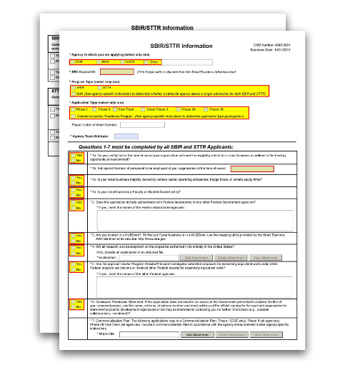
G.440 - SBIR/STTR Information Form

NIH, CDC, FDA, and ACF SBIR/STTR grant applicants must complete and submit the SBIR/STTR Information Form in conjunction with the other SF424 (R&R) forms and PHS 398 forms.
View larger image

Quick Links
Introductory Fields
1a. Certification of Small Business Eligibility 1b. Anticipated Number of personnel to be
employed at your organization at the time of award
1c. Is your small business majority owned by venture capital operating companies, hedge funds, or private equity firms?
1d. Is your small business a Faculty or Student-Owned entity? 2. Subcontracts with Federal Government agencies
- Are you located in a HUBzone?
- Will all research and development on the project be performed in its entirety in the United States?
- Essentially Equivalent Work
- Disclosure Permission Statement 7. Commercialization Plan
SBIR-Specific Questions
8. Have you received SBIR Phase II awards from the Federal Government? 9. Primary employment of PD/PI at time of award
STTR-Specific Questions
10. Commitment and effort 11. Joint R&D
12. Provide DUNS Number of non-profit research partner for STTR

Who should use the SBIR/STTR Information Form:
All SBIR and STTR grant applicants must complete this form.

Introductory Fields

Agency to which you are applying (select only one):
A selection is required.
Check the correct box to indicate the agency to which you are applying. If you select “Other,” provide the agency in the space provided. Note: Check HHS for all NIH, CDC, and FDA submissions.
- DOE
- HHS
- USDA
- Other

SBC Control ID:
This field is required.
Enter the nine digit SBC Control ID (e.g., SBC_123456789). This number is obtained from the Small Business Administration (SBA) website.
You will receive a unique SBC Control ID when you complete your SBC Company Registration.
To complete SBA Registration: The SBA Company Registry recommends verification with System for Award Management (SAM), but a SAM account is not required to complete the registration. In order to be verified with SAM, your email address must match one of the contacts in SAM. If you are unsure what is listed in SAM for your company, you may verify the information on the SAM site. Confirmation of your company's DUNS is necessary to verify your email address in SAM. Follow the following steps to register.
- Navigate to the SBA Company Registry.
- Fill out the required fields to complete your SBA Company Registration and to receive your 9 digit SBA Control ID.
- If you are a previous SBIR/STTR awardee from any agency, search for your small business by Company Name, EIN/Tax ID, or DUNS in the "Have you Registered” section.
For questions and for technical assistance concerning the SBA Company Registry, contact SBA.

Program Type (select only one):
A selection is required.
Check the correct box to indicate whether you are applying under the SBIR program or the STTR program. Note: HHS does not accept ‘Both’ as a choice.
- SBIR
- STTR
- Both

Application Type (select only one):
A selection is required.
Check the correct box to indicate whether you are submitting an application for:

- Phase I
- Phase II
- Fast-Track
- Direct Phase II
- Phase IIB
- Commercialization Readiness Program

Note the following:
- HHS does not accept Phase IIA applications.
- Only check Direct Phase II, Phase IIB, or Commercialization Readiness Program if the Funding Opportunity Announcement (FOA) allows those Application Types.
- Direct Phase II for STTR is not allowed.
- When submitting a Phase II, IIB, or Commercialization Readiness Program Application following an awarded Phase I, II, or IIB respectively, please include the Phase I SBIR/STTR grant number in the "Federal Identifier" field on the G.200 - SF 424 (R&R) Form, Federal Identifier.

Phase I Letter of Intent Number:
Enter "0" or "N/A", as this field is not applicable for any HHS (NIH, CDC, FDA) submissions.

Agency Topic/Subtopic:
Leave blank. This field is not applicable for all HHS (NIH, CDC, FDA) submissions.

Questions 1-7 must be completed by all SBIR and STTR Applicants:

1a. Certification of Small Business Eligibility

A selection is required.
If you certify that at the time of award your organization will meet the eligibility criteria for a small business as defined in the FOA, check “Yes.” Otherwise, check “No.”
1b. Anticipated Number of personnel to be employed at your organization at the time of award.
This information is required. Enter the number of personnel anticipated to be employed by the small business at the time of award.
1c. Is your small business majority owned by venture capital operating companies, hedge funds, or private equity firms?
A selection is required.
If your small business is majority owned by venture capital operating companies, hedge funds, or private equity firms, check “Yes.” Otherwise, check “No.”

If you answer “Yes” to this question, you must submit the VCOC certification as an Other Attachment in the G.220 - R&R Other Project Information Form.
See the Small Business Eligibility Criteria webpage for definitions.

1d. Is your small business a Faculty or Student-Owned entity?

A selection is required.
If your small business is a faculty- or student-owned entity, check “Yes”. Otherwise, check “No.”
2. Does this application include subcontracts with Federal laboratories or any other Federal Government agencies?
A selection is required.
If this application includes subcontracts with federal laboratories or any other Federal Government agencies, check “Yes” and insert the name of the federal laboratories/agencies in the space provided. Otherwise, check “No.”

3. Are you located in a HUBZone?

A selection is required.
If you are located in a HUBZone, check “Yes.” Otherwise, check “No.”
To find out whether your business is in a HUBZone, use the mapping utility provided on the Small Business Administration website.
4. Will all research and development on the project be performed in its entirety in the United States?
A selection is required.
If all research and development on the project will be performed in its entirety in the United States, check “Yes.” Otherwise, check “No.”
If you have answered "No" to this question, provide an explanation of the research and development that is being performed outside the United States in an “Explanation” attachment. Attach this information as a PDF file. See NIH's Format Attachments page.
5. Has the applicant and/or Program Director/Principal Investigator submitted proposals for essentially equivalent work under other Federal program solicitations or received other Federal awards for essentially equivalent work?
A selection is required.
If the applicant and/or PD/PI has submitted proposals for essentially equivalent work under other federal program solicitations or received other federal awards for essentially equivalent work, check “Yes” and enter the names of the other federal agencies in the space provided.
Otherwise, check “No.”

6. Disclosure Permission Statement

A selection is required.
If this application does not result in an award, is the Government permitted to disclose the title of your proposed project, and the name, address, telephone number, and e-mail address of the official signing for the applicant organization to state-level economic development organizations that may be interested in contacting you for further information (e.g., possible collaborations, investment), check “Yes.” Otherwise check “No.”
Your response will not affect any peer review or funding decisions.

7. Commercialization Plan

Who must complete the "Commercialization Plan" section:
If you are submitting a Phase II, Direct Phase II, Phase IIB, Phase I/Phase II Fast-Track, or Commercialization Readiness Program (CRP) Application, you must include a "Commercialization Plan" attachment.

Format:
Follow the page limits for the Commercialization Plan in the NIH Table of Page Limits unless otherwise specified in the FOA. You do not have to use the maximum number of pages allowed for your Commercialization Plan.
Attach this information as a PDF file. See NIH's Format Attachments page.

Content:
The Commercialization Plan must be written in accord with the solicitation and these instructions.
Organize your Commercialization Plan into six separate sections, following the headings and order below. Start each section with the appropriate heading – Value of the SBIR/STTR Project, Expected Outcomes, and Impact; Company; Market, Customer, and Competition; Intellectual Property Protection; Finance Plan; and Revenue Stream. Provide a description for each of the following areas:

Value of the SBIR/STTR Project, Expected Outcomes, and Impact
Describe, in layperson's terms, the proposed project and its key technology objectives. State the product, process, or service to be developed in Phase III. Clarify the need that is addressed, specifying weaknesses in the current approaches to meet this need. In addition, describe the commercial applications of the research and the innovation inherent in this application. Be sure to also specify the potential societal, educational, and scientific benefits of this work. Explain the non-commercial impacts to the overall significance of the project. Explain how the SBIR/STTR project integrates with the overall business plan of the company.

Company
Give a brief description of your company, including corporate objectives, core competencies, present size (annual sales level and number and types of employees), history of previous federal and non-federal funding, regulatory experience, commercialization, and any current products/services that have significant sales. Include a short description of the origins of the company. Indicate your vision for the future, how you will grow/maintain a sustainable business

entity, and how you will meet critical management functions as your company evolves from a small technology R&D business to a successful commercial entity.

Market, Customer, and Competition
Describe the market and/or market segments you are targeting and provide a brief profile of the potential customer. Tell what significant advantages your innovation will bring to the market (e.g., better performance; lower cost; faster, more efficient or effective, new capability). Explain the hurdles you will have to overcome in order to gain market/customer acceptance of your innovation.
Describe any strategic alliances, partnerships, or licensing agreements you have in place to get FDA approval (if required) and to market and sell your product.
Briefly describe your marketing and sales strategy. Give an overview of the current competitive landscape and any potential competitors over the next several years. A thorough understanding of the competition is essential to a successful application.

Intellectual Property (IP) Protection
Describe how you are going to protect the IP that results from your innovation. Also note other actions you may take that will constitute at least a temporal barrier against others aiming to provide a solution similar to yours.

Finance Plan
Describe the necessary financing you will require to commercialize the product, process, or service, and when it will be required. Describe your plans to raise the requisite financing to launch your innovation into Phase III and begin the revenue stream. Plans for this financing stage may be demonstrated in one or more of the following ways:
  - Letter of commitment of funding.
  - Letter of intent or evidence of negotiations to provide funding, should the Phase II project be successful and the market need still exist.
  - Letter of support for the project and/or some in-kind commitment (e.g., to test or evaluate the innovation).
  - Specific steps you are going to take to secure Phase III funding.

Production and Marketing Plan
Describe how the production of your product/process/service will occur (e.g., in-house manufacturing, contract manufacturing). Describe the steps you will take to market and sell your product/process/service. For example, explain plans for licensing, Internet sales, etc.

Revenue Stream
Explain how you plan to generate a revenue stream for your company should this project be a success. Examples of revenue stream generation include, but are not limited to, manufacture and direct sales, sales through value added resellers or other distributors, joint venture, licensing, and service. Describe how your staffing will change to meet your revenue expectations.
Your Phase III funding may be from any of a number of different sources, including, but not limited to:
  - the SBIR/STTR firm itself;
  - private investors or “angels;”

  - venture capital firms;
  - investment companies;
  - joint ventures;
  - R&D limited partnerships;
  - strategic alliances;
  - research contracts;
  - sales of prototypes (built as part of this project);
  - public offering;
  - state finance programs;
  - non SBIR-funded R&D or production commitments from a federal agency with the intention that the results will be used by the United States government; or
  - other industrial firms.
Applicants are encouraged to seek commitment(s) of funds and/or resources from an investor or partner organization for commercialization of the product(s) or service(s) resulting from the SBIR/STTR grant. Place any relevant letters in the G.400 - PHS 398 Research Plan Form, Letters of Support attachment, following letters from consultants and collaborators.

SBIR-Specific Questions
8. Have you received SBIR Phase II awards from the Federal Government? If yes, provide a company commercialization history in accordance with agency-specific instructions using this attachment.

A selection is required if you are submitting this application under the SBIR program.
If you have received SBIR Phase II awards from the Federal Government, check “Yes” and attach a statement or a company commercialization history in accordance with the instructions below.
Attach this information as a PDF file. See NIH's Format Attachments page. Otherwise, check “No.”
If the applicant small business has received an SBIR Phase II awards issued by NIH or any other Federal Government agency, attach a file that includes either:
- a statement indicating that the applicant small business has not received more than 15 SBIR Phase II awards from the Federal Government during the preceding five fiscal years; or
- a company commercialization history if the applicant small business has received more than 15 Phase II SBIR awards from the Federal Government during the preceding five fiscal years.
  - The company commercialization history must document the extent to which the company was able to secure Phase III funding to develop concepts resulting from previous Phase II SBIR awards.
  - For each Phase II award, the history must include: (1) name of awarding agency; (2) award number and date; (3) amount of award; (4) title of project; (5) source, date, and

amount of Phase III funding agreement; and (6) commercialization status of each Phase II award.
9. Will the Project Director/Principal Investigator have his/her primary employment with the small business at the time of award?
A selection is required if you are submitting this application under the SBIR program.
If the PD/PI will have his/her primary employment with the small business at the time of award, check “Yes.” Otherwise, check “No.”

STTR-Specific Questions
10. Does the Project Director/Principal Investigator have a formal appointment or commitment either with the small business directly (as an employee or a contractor) OR as an employee of the Research Institution, which in turn has made a commitment to the small business through the STTR application process; AND will the Project Director/Principal Investigator devote at least 10% effort to the proposed project?

A selection is required if you are submitting this application under the STTR program. Check “Yes” if both of the following conditions are true:
- The PD/PI has a formal appointment or commitment either with the small business directly (as an employee or a contractor) OR as an employee of the Research Institution, which in turn has made a commitment to the small business through the STTR application process; and
- The PD/PI will devote at least 10% effort to the proposed project. Check “No” if either or both of these two conditions is false.
11. In the joint research and development proposed in this project, does the small business perform at least 40% of the work and the research institution named in the application perform at least 30% of the work?
A selection is required if you are submitting this application under the STTR program.
If in the joint research and development proposed in this project, the small business performs at least 40% of the work and the research institution named in the application performs at least 30% of the work, check “Yes.” Otherwise, check “No.”

12. Provide DUNS Number of non-profit research partner for STTR.

This field is required if you are submitting this application under the STTR program.
Enter the DUNS or DUNS+4 number of the non-profit research partner for the STTR applicant.
If the non-profit research partner does not already have a DUNS number, you will need to go to the Dun & Bradstreet website to obtain the number.

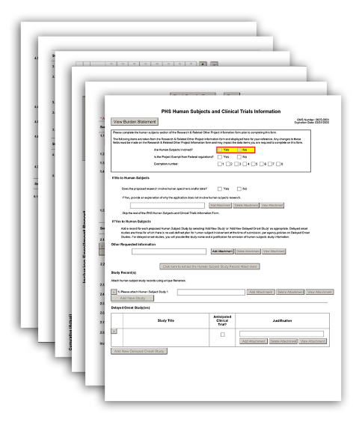

G.500 - PHS Human Subjects and Clinical Trials Information

The PHS Human Subjects and Clinical Trials Information form is used to collect information on human subjects research, clinical research, and/or clinical trials, including study population characteristics, protection and monitoring plans, and a protocol synopsis.
This form accommodates the full spectrum of all types of clinical trials, including, but not limited to, behavioral, exploratory/development, mechanistic, pilot/feasibility, early phase, efficacy, effectiveness, group-randomized, and others.
Read all the instructions in the Funding Opportunity Announcement (FOA) before completing this form to ensure your application meets all IC-specific criteria. "Section II. Award Information" of the FOA will indicate whether clinical trials are or are not allowed and whether clinical trial research experience is or is not
allowed. The designation of your FOA will determine how to use these instructions, and subsequently, how to fill out this form.
The PHS Human Subjects and Clinical Trials Information form, together with the rest of your application, should include sufficient information for the evaluation of the project, independent of any other documents (e.g., previous application). Be specific, describe each study clearly, and avoid redundancies. Be especially careful to avoid redundancies with your research strategy.
View larger image

Quick Links
PHS Human Subjects and Clinical Trials Information Use of Human Specimens and/or Data
If No to Human Subjects If Yes to Human Subjects
Other Requested Information Study Record(s)
Delayed Onset Study(ies)
Study Record: PHS Human Subjects and Clinical Trials Information Section 1 - Basic Information

  - Study Title (each study title must be unique)
  - Is this Study Exempt from Federal Regulations? 1.3 Exemption Number
  - Clinical Trial Questionnaire
  - Provide the ClinicalTrials.gov Identifier (e.g. NCT87654321) for this trial, if applicable.
Section 2 - Study Population Characteristics
2.1 Conditions or Focus of Study 2.2 Eligibility Criteria
2.3 Age Limits
2.3.a Inclusion of Individuals Across the Lifespan 2.4 Inclusion of Women and Minorities
2.5 Recruitment and Retention Plan 2.6 Recruitment Status
  - Study Timeline
  - Enrollment of First Participant 2.9 Inclusion Enrollment Report(s)
Section 3 - Protection and Monitoring Plans
  - Protection of Human Subjects
  - Is this a multi-site study that will use the same protocol to conduct non-exempt human subjects research at more than one domestic site?
  - Data and Safety Monitoring Plan
  - Will a Data and Safety Monitoring Board be appointed for this study? 3.5 Overall Structure of the Study Team
Section 4 - Protocol Synopsis
  - Study Design
  - Outcome Measures
  - Statistical Design and Power 4.4 Subject Participation Duration
4.5 Will the study use an FDA-regulated intervention? 4.6 Dissemination Plan
Section 5 - Other Clinical Trial-related Attachments
5.1 Other Clinical Trial-related Attachments
Complete the PHS Human Subjects and Clinical Trials Information form after you have completed the G.220 - R&R Other Project Information Form.

This form accommodates the full spectrum of all types of clinical trials, including, but not limited to, exploratory/development, mechanistic, pilot/feasibility, early phase, efficacy, effectiveness, group- randomized, and others.

Who should use the PHS Human Subjects and Clinical Trials Information form:
The designation of your FOA will determine how to use these instructions, and subsequently, how to fill out this form.
All applicants must use the PHS Human Subjects and Clinical Trials Information form regardless of your answer to the question “Are human subjects involved?” on the G.220 - R&R Other Project Information Form.
K12 and D43 applicants: If you are proposing any human subject studies in your application, then at the time of application, you must use the PHS Human Subjects and Clinical Trials Information form to submit delayed onset studies. Do not fill in Study Records. Follow the instructions in your FOA. Post award, you will submit Study Records if applicable.
All other Training applicants: This form is not applicable and will not be available to you.
Additional Instructions for Training:
Note for studies involving only the secondary use of identifiable biospecimens or data: For studies where the only involvement of human subjects is the use of identifiable biospecimens or data originally collected for another purpose, complete the PHS Human Subjects and Clinical Trials Information form with information specific to the current study and not the original collection unless the information associated with the original collection is pertinent to the proposed study. If information about the original collection is necessary, provide context and clearly distinguish between the current study and historical information.

Using the PHS Human Subjects and Clinical Trials Information form:
Everyone must complete the "Use of Human Specimens and/or Data" section of the PHS Human Subjects and Clinical Trials Information form. However, your answer to the “Are human subjects involved?” question will determine which other sections of the PHS Human Subjects and Clinical Trials Information form you must complete. Once you have completed the "Use of Human Specimens and/or Data" section, follow instructions on the form that are specific to your answer to the "Are human subjects involved?" question on the G.220 - R&R Other Project Information Form:
- if you answered "Yes" to the question "Are human subjects involved?" on the G.220 - R&R Other Project Information Form, see the "If Yes to Human Subjects" section for instructions.
- if you answered "No" to the question "Are human subjects involved?" on the G.220 - R&R Other Project Information Form, see the "If No to Human Subjects" section for instructions.
The PHS Human Subjects and Clinical Trials Information form allows you to add Study Record(s) and/or Delayed Onset Study(ies), as applicable.
Within each Study Record, you will add detailed information at the study level. Do not duplicate studies within your application. Each study within the application should be unique and should have a unique study title. Each Study Record is divided into numbered sections:

- Section 1 - Basic Information
- Section 2 – Study Population Characteristics (includes Inclusion Enrollment Report)
- Section 3 – Protection and Monitoring Plans
- Section 4 – Protocol Synopsis
- Section 5 – Other Clinical Trial-related Attachments
Note: The PHS Human Subjects and Clinical Trials Information form will capture detailed information at the study level. Although you are encouraged to refer to information in the PHS Human Subjects and Clinical Trials Information form in your discussion of the Research Strategy, do not duplicate information between the Research Strategy attachment and the PHS Human Subjects and Clinical Trials Information form.
For more information on what a “study” is for the purposes of the PHS Human Subjects and Clinical Trials Information form, see the relevant FAQ on the Applying Electronically FAQ page.

The PHS Human Subjects and Clinical Trials Information form is dynamic and may eliminate sections that are not relevant to your application. The dynamic form behavior may not be enabled on all submission methods.
Note: Some fields in this form match fields within ClinicalTrials.gov and are identified as such within these instructions. Additional information about the fields can be found on the ClinicalTrials.gov Protocol Registration Data Element Definitions website.
R25 applicants who are proposing to provide clinical trial research experience for their participants (i.e., participants will not be leading an independent clinical trial): You will generally follow the standard instructions to complete the PHS Human Subjects and Clinical Trials Information form, but follow relevant Research instructions where they are given. Make sure you are applying to a FOA that allows Clinical Trial Research Experience (this is noted in “Section II. Award Information” of the FOA). Additionally, your mentor or co-mentor is required to include a statement to document leadership of the clinical trial. The statement must include the following:
- Source of funding;
- ClinicalTrials.gov identifier (e.g., NCT87654321), if applicable;
- A description of how the mentor's expertise is appropriate to guide participants in any proposed clinical trials research experience; and
- A statement/attestation that the mentor will be responsible for the clinical trial.
  - The mentor must have primary responsibility for leading and overseeing the trial and must describe how she/he will provide this oversight.
  - Include details on the specific roles/responsibilities of the mentor and participants.
This statement must be included in the “Other Attachments” attachment in the G.220 – R&R Other Project Information Form.
Additional Instructions for Research:

R36 applicants who are proposing to gain clinical trial research experience
under a mentor’s supervision (i.e., you will not be leading an independent clinical trial): You will generally follow the standard instructions to complete the PHS Human Subjects and Clinical Trials Information form, but follow relevant Research instructions where they are given. Make sure you are applying to a FOA that allows Clinical Trial Research Experience (this is noted in “Section II. Award Information” of the FOA). Additionally, your mentor or co-mentor is required to include a statement to document leadership of the clinical trial. The statement must include the following:
- Source of funding;
- ClinicalTrials.gov identifier (e.g., NCT87654321), if applicable;
- A description of how your expertise is appropriate to guide the applicant in any proposed clinical trials research experience; and
- A statement/attestation that the mentor will be responsible for the clinical trial.
  - The mentor must have primary responsibility for leading and overseeing the trial and must describe how she/he will provide this oversight (be careful not to overstate the candidate’s responsibilities).
  - Include details on the specific roles/responsibilities of the applicant and mentor.
This statement must be included in the “Letters of Support” attachment in the G.400 - PHS 398 Research Plan Form.
All other Research applicants: Follow the standard instructions to complete the PHS Human Subjects and Clinical Trials Information form.
There are three primary situations by which K applicants can apply for human subjects and/or clinical trial research.
Career Development Award (CDA) applicants who are not proposing a clinical trial: Follow the standard instructions to complete the PHS Human Subjects and Clinical Trials Information form.
CDA applicants who are proposing an independent clinical trial: Make sure you are applying to a FOA that allows independent clinical trials (this is noted in “Section II. Award Information” of the FOA). Follow the standard instructions to complete the PHS Human Subjects and Clinical Trials Information form. (Note that not every Study Record within your application has to be a clinical trial).
For more information on independent clinical trials, see:
- NIH Glossary definitions of Independent Clinical Trial and Ancillary Study
- NIH Definition of Clinical Trial Case Studies
- FAQ on Ancillary Studies
- FAQs on the Human Subjects and Clinical Trials Information form, including a specific FAQ on K99/R00 applications.
Additional Instructions for Career Development:

  - FAQs on Clinical Trial-specific FOAs, including a specific FAQ on K99/R00 applications.
CDA applicants who are proposing to gain clinical trial research experience under a mentor’s supervision (i.e., you will not be leading an independent clinical trial): You will generally follow the standard instructions to complete the PHS Human Subjects and Clinical Trials Information form, but follow relevant Career Development instructions where they are given. Make sure you are applying to a FOA that allows Clinical Trial Research Experience (this is noted in “Section II. Award Information” of the FOA). Additionally, the mentor or co-mentor is required to include a statement to document leadership of the clinical trial. The statement must include the following:
  - Source of funding;
  - ClinicalTrials.gov identifier (e.g., NCT87654321), if applicable;
  - A description of how your expertise is appropriate to guide the applicant in any proposed clinical trials research experience; and
  - A statement/attestation that the mentor will be responsible for the clinical trial.
    - The mentor must have primary responsibility for leading and overseeing the trial and must describe how she/he will provide this oversight (be careful not to overstate the candidate’s responsibilities).
    - Include details on the specific roles/responsibilities of the applicant and mentor, keeping in mind that the terms of a CDA award do not always permit the candidate to lead a clinical trial.
This statement must be included in the “Plans and Statements of Mentor and Co- Mentor(s)” attachment in the G.410 - PHS 398 Career Development Award Supplemental Form.
Fellowship applicants are permitted to conduct research involving human subjects; however, they are NOT permitted to lead an independent clinical trial.
For more information, see:
- FAQs on Clinical Trial-specific FOAs, especially the items related to Fellowship awards:
  - FAQ about whether F awards allow clinical trials
  - FAQ about why Fellows are not allowed to lead an independent clinical trial
  - FAQ about whether there is a list of responsibilities that a Fellow must assume with a clinical trial research experience
  - FAQ about who is responsible for the conduct of clinical trials proposed in a Fellowship application
Fellowship applicants who are not proposing a clinical trial: Follow the standard instructions to complete the PHS Human Subjects and Clinical Trials Information form.
Additional Instructions for Fellowship:

Fellowship applicants who are proposing to gain clinical trial research
experience under a sponsor’s supervision (i.e., you will not be leading an independent clinical trial): You will generally follow the standard instructions to complete the PHS Human Subjects and Clinical Trials Information form, but follow relevant Fellowship instructions where they are given. Make sure you are applying to a FOA that allows Clinical Trial Research Experience (this is noted in “Section II. Award Information” of the FOA). Additionally, the sponsor or co-sponsor is required to include a statement to document leadership of the clinical trial. The statement must include the following:
- Source of funding;
- ClinicalTrials.gov identifier (e.g., NCT87654321), if applicable;
- A description of how the sponsor or co-sponsor’s expertise is appropriate to guide the applicant in any proposed clinical trials research experience; and
- A statement/attestation that the sponsor will be responsible for the clinical trial
  - The sponsor must have primary responsibility for leading and overseeing the trial and must describe how she/he will provide this oversight (be careful not to overstate the fellow’s responsibilities).
  - Include details on the specific roles/responsibilities of the fellow and sponsor, keeping in mind that the terms of a fellowship award do not permit the fellow to lead a clinical trial.
This statement must be included in the “Sponsor and Co-Sponsor Statements” attachment of the G.430 - PHS Fellowship Supplemental Form.
For multi-project applications with studies that are self-contained within a single component:
Overall Component: Do not complete a Study Record.
Other Component: Complete a separate Study Record for each human subjects study that is self-contained within a single component.
For multi-project applications with studies that span components:
Overall Component: Complete one Study Record for each study if it spans multiple components. This Study Record must include sufficient information for all components that are involved in the particular study. This might occur when an application includes a data coordinating center or recruitment core, or when participant assessments for one study are conducted across multiple components (e.g., the study includes an imaging core and clinical site).
Additional Instructions for Multi-project:

Applicants must follow all policies and requirements related to formatting, proprietary information, human subjects, and clinical trials. See the following pages for more information:
- Format Attachments
- Rules for Text Fields
- NIH Grants Policy Statement, Section 2.3.11.2: Confidentiality of Information

- NIH Grants Policy Statement, Section 2.3.11.2.2: The Freedom of Information Act
- NIH's Human Subjects Research website
- NIH's Clinical Trials website
Note: There are no page limits for any attachments in the PHS Human Subjects and Clinical Trials Information form.

PHS Human Subjects and Clinical Trials Information
Applicants must complete the human subjects questions on the G.220 - R&R Other Project Information Form prior to completing this form.

Use of Human Specimens and/or Data

Regardless of your answer to the question “Are Human Subjects Involved?” on the G.220 - R&R Other Project Information Form, answer the following question(s) about the use of human specimens and/or human data.
Does any of the proposed research in the application involve human specimens and/or data?
Select “Yes” or “No” to indicate whether the proposed research involves human specimens and/or data.
Note: Applications involving the use of human specimens or data may not be considered to be research involving human subjects, depending on the details of the materials to be used.
Note: If you answered “No” to the “Does the proposed research involve human specimens and/or data?” question, skip the rest of the PHS Human Subjects and Clinical Trials Information form unless otherwise directed by your FOA.

Provide an explanation for any use of human specimens and/or data not considered to be human subjects research.
If you answered “No” to the “Does any of the proposed research in the application involve human specimens and/or data?” question, you do not need to attach an explanation here.
If you answered “Yes” to the “Does any of the proposed research in the application involve human specimens and/or data?” question, you must provide an explanation for any use of human specimens and/or data not considered to be human subjects research. To help determine whether your research is classified as human subjects research, refer to the Research Involving Private Information or Biological Specimens flowchart. For any human specimens and/or data that is considered human subjects research, you will add a Study Record. Do not duplicate the information in your explanation in any of your Study Records.
Attach the explanation as a PDF file. See NIH’s Format Attachments page. This explanation should include:
  - information on who is providing the data/biological specimens and their role in the proposed research;

  - a description of the identifiers that will be associated with the human specimens and data;
  - a list of who has access to subjects’ identities; and
  - information about the manner in which the privacy of research participants and confidentiality of data will be protected.
Please complete the human subjects section of the Research & Related Other Project Information form prior to completing this form.

Are Human Subjects Involved? Yes/No
This field is pre-populated from the G.220 - R&R Other Project Information Form. If the value in this field appears to be incorrect, you may correct it by adjusting it on the G.220 - R&R Other Project Information Form.

Is the Project Exempt from Federal regulations? Yes/No
This field is pre-populated from the G.220 - R&R Other Project Information Form. If the value in this field appears to be incorrect, you may correct it by adjusting it on the G.220 - R&R Other Project Information Form.

Exemption number: 1, 2, 3, 4, 5, 6, 7, 8
This field is pre-populated from the G.220 - R&R Other Project Information Form. If the value in this field appears to be incorrect, you may correct it by adjusting it on the G.220 – R&R Other Project Information Form.
Note: If you change your answer to the “Are Human Subjects Involved” question on the G.220 - R&R Other Project Information Form after you have started entering information into the PHS Human Subjects and Clinical Trials Information form, your data in the PHS Human Subjects and Clinical Trials Information form may be lost.

If No to Human Subjects

If you answered "No" to the question “Are Human Subjects Involved?” on the G.220 - R&R Other Project Information Form, skip the rest of the PHS Human Subjects Clinical Trials Information form unless otherwise directed by your FOA.

If Yes to Human Subjects

If you answered “Yes” to the question “Are Human Subjects Involved?” on the G.220 - R&R Other Project Information Form, add a Study Record for each proposed study involving human subjects by selecting “Add New Study” or “Add New Delayed Onset Study,” as appropriate.

Other Requested Information

Who may provide Other Requested Information:
Follow the instructions below and any instructions in your FOA to determine whether you are permitted to include the “Other Requested Information” attachment.

Format:
Attach this information as a PDF file. See NIH’s Format Attachments page.

Content:
Content is limited to what is described in your FOA or in these instructions. Do not use the “Other Requested Information” attachment to include any other information.
Renewal applications: When preparing a renewal (or resubmission of a renewal), you can provide a list of ongoing studies or ClinicalTrials.gov identifiers (e.g., NCT87654321).
For multi-project applications with studies that span components: Overall Component: For each study that spans components, describe the components involved with the study.
Other Components: Each component should include an attachment that indicates that the details of the study are included in the Overall component within this attachment.
For more information, see the “Where do I enter my human subjects study information in my multi-project application” FAQ on the Applying Electronically FAQ page.
Additional Instructions for Multi-project:

Study Record(s)

Adding Study Record Attachment(s):
Add a study record for each proposed study involving human subjects. If specific plans for your study involving human subjects can be described in the application but will not begin

immediately (i.e., your study has a delayed start), you must add a Study Record for that study. If your study anticipates involving human subjects within the period of award but specific plans cannot be described in the application (i.e., delayed onset), see the instructions for Delayed Onset Study(ies).
For all submission methods, the Study Record is used to collect human subjects study data. Note: The steps to add a Study Record attachment(s) may vary with the submission method. For example, from the ASSIST Human Subjects and Clinical Trials tab, use the ‘Add New Study’ button to access the data entry screens to enter Study Record information directly into ASSIST. With other submission methods, you may have to extract a blank copy of the Study Record, complete it offline, and then attach it to your application.
Note on Grouping Studies into Study Records: While there may be more than one way to split or group studies into Study Records, you are encouraged to group studies that use the same human subjects population and same research protocols into a single Study Record, to the extent that the information you provide is accurate and understandable to NIH staff and reviewers.
If information in any attachment is identical across studies, include the complete information only in the first Study Record for which the information is relevant. In the subsequent Study Records for which the identical information is needed, upload an attachment that says, “See information for attachment X in Study Record entitled [include study title]." No other information is needed in the attachment. Do not submit attachments that are duplicated from one Study Record to another. Note that you should not name Study Records by number. Examples of attachments that may be identical across studies include, but are not limited to, the 3.1 Protection of Human Subjects and 3.5 Overall Structure of the Study Team attachments.
See the NIH Glossary definitions of Study and Study Record.
The PHS Human Subjects and Clinical Trials Information form accommodates up to 150 separate Study Records.

Format:
All attachments must be PDF files. If you extract a Study Record, it will already be in a fillable PDF format. Please use this PDF file and do not alter the format of the Study Record file. Use unique filenames for each human subject study record. The filename for each attachment within a study must be unique within the application (i.e., do not use the same filename in multiple Study Records).

Content:
Follow the instructions in the “Study Record: PHS Human Subjects and Clinical Trials Information” section below.

Delayed Onset Study(ies)
K12 and D43 applicants: At the time of application, you must use the PHS Human Subjects and Clinical Trials Information form to submit delayed onset studies if you are proposing any human subject studies in your application. Follow the instructions in your FOA. Post award, you will submit Study Records if applicable.
Additional Instructions for Training:

If you anticipate conducting research involving human subjects but cannot describe the study at the time of application (i.e., your study is a delayed onset human subject study), enter a Delayed Onset Study Record as instructed below.
Generally, for any study that you include as a delayed onset study in this section, you will provide a study title, indicate whether the study is anticipated to include a clinical trial, and include a justification attachment. Since by definition, information for a delayed onset study is not available at the time of application, you will not be given the option to complete a full Study Record for a delayed onset study. For delayed onset studies, the Delayed Onset Study Record is sufficient.

Notes on delayed onset studies:
  - Delayed onset does NOT apply to a study that can be described but will not start immediately (i.e., delayed start). Refer to the NIH Glossary definition of Delayed Onset Study and Delayed Start.
  - If you anticipate multiple delayed onset studies, you can include them together in a single Delayed Onset Study Record.

Study Title
This field is required.
The Study Title can have a maximum of 600 characters.
Enter a brief, unique title that describes the study the participants will be involved in. Each study within your application must have a unique Study Title. The first 150 characters will display in the application image bookmarks.
Note on multiple delayed onset studies: If you are including multiple delayed onset studies in one delayed onset study entry, you may enter “Multiple Delayed Onset Studies” as the title of this record.

Anticipated Clinical Trial?
This field is required.
Check this box if you anticipate that this study will be a clinical trial. For help determining whether your study meets the definition of clinical trial, see the Clinical Trial Questionnaire below.
Read your FOA carefully to determine whether clinical trials are allowed in your application.
Note on multiple delayed onset studies: If you are including multiple delayed onset studies in one delayed onset study entry, and you anticipate that any of these studies will be a clinical trial, check the “Anticipated Clinical Trial?” checkbox.
Career Development Award (CDA) applicants who are not proposing a clinical trial: Follow the standard instructions.
CDA applicants who are proposing an independent clinical trial: Follow the standard instructions.
CDA applicants who are proposing to gain clinical trial research experience under a mentor’s supervision (i.e., you will not be leading an independent clinical trial): Do not check the “Anticipated Clinical Trial?” box.
Additional Instructions for Career Development:

Do not check the “Anticipated Clinical Trial?” box. Fellowship FOAs do not allow independent clinical trials.
Additional Instructions for Fellowship:

Justification Attachment
This attachment is required.
Attach the justification as a PDF file. See NIH’s Format Attachments page.
  - All delayed onset studies must provide a justification explaining why human subjects study information is not available at the time of application.
  - If NIH’s Single Institutional Review Board (sIRB) policy will apply to your study, this justification must also include information regarding how the study will comply with the policy and state that you will provide a single IRB plan prior to initiating any multi-site study.
  - If NIH’s Policy on the Dissemination of NIH-Funded Clinical Trial Information will apply to your study, this justification must also include the dissemination plan.
Note on multiple delayed onset studies: If you are including more than one delayed onset study in any given delayed onset study entry, address all the included studies in a single justification attachment.

Study Record: PHS Human Subjects and Clinical Trials Information

Section 1 - Basic Information

Who must complete “Section 1 – Basic Information:”
“Section 1 – Basic Information” is required for all studies involving human subjects.

1.1 Study Title (each study title must be unique)

The “Study Title” field is required.
The Study Title can have a maximum of 600 characters.
Enter a brief title that describes the study the participants will be involved in. If there is more than one study (i.e., you are including more than one Study Record and/or delayed onset study in your application), each one must have a unique study title. The first 150 characters will display in the bookmarks of the application image.
Note: When registering a clinical trial in ClinicalTrials.gov, all study titles across your organization must be unique.
Note: This field matches a ClinicalTrials.gov field (Official Title).

1.2 Is this Study Exempt from Federal Regulations?

An answer to the “Is this Study Exempt from Federal Regulations?” question is required.
Indicate whether the study is exempt from Federal regulations for the Protection of Human Subjects.
For more information, see the NIH's Definition of Human Subjects Research website.

1.3 Exemption Number

The “Exemption Number” field is required if you selected “Yes” to the “Is this Study Exempt from Federal Regulations?” question.
Select the appropriate exemption number(s) for this particular study. Multiple selections are permitted. Regardless of whether these exemptions may apply to you in the future, you must fill out your application following the instructions below.

For more information:
The categories of research that qualify for exemption are defined in the Common Rule for the Protection of Human Subjects. These regulations can be found at 45 CFR 46.
Need help determining the appropriate exemption number?
- Refer to NIH's Human Subjects FAQs.
- See the NIH's Human Subjects Frequently Asked Questions section on Exemptions.
The Office of Human Research Protections (OHRP) guidance states that appropriate use of exemptions described in 45 CFR 46 should be determined by an authority independent from the investigators (for more information, see OHRP's Frequently Asked Questions). Institutions often designate their Institutional Review Board (IRB) to make this determination. Because NIH does not require IRB approval at the time of application, the exemptions designated often represent the opinion of the PD/PI, and the justification provided for the exemption by the PD/PI is evaluated during peer review.

1.4 Clinical Trial Questionnaire

The Clinical Trial Questionnaire is required.
Note for basic and mechanistic studies involving human participants: The NIH definition of a clinical trial encompasses a broad range of studies, including studies using human participants that aim to understand fundamental aspects of phenomena, the pathophysiology of a disease, or the mechanism of action of an intervention. This includes many mechanistic studies and studies submitted to Basic Experimental Studies with Humans FOAs.
Answer “Yes” or “No” to the following questions to determine whether this study involves a clinical trial. Answer the following questions based only on the study you are describing in this Study Record.
Note: The answer to question “1.4.a Does the study involve human participants?” will be pre- populated with “Yes” for all study records. You will not be able to change this answer.

Does the study involve human participants? Yes/No
    - Are the participants prospectively assigned to an intervention? Yes/No
    - Is the study designed to evaluate the effect of the intervention on the participants? Yes/No
    - Is the effect that will be evaluated a health-related biomedical or behavioral out- come? Yes/No
If you answered “Yes” to all the questions in the Clinical Trial Questionnaire, this study meets the definition of a clinical trial.
Refer to the table below for information about what sections of this form are required, based on your answers to Question 1.4 "Clinical Trial Questionnaire."

Form Section | If you answered "yes" to all the questions in the Clinical Trial Questionnaire | If you answered "no" to any of the questions in the Clinical Trial Questionnaire
Section 2 - Study Population Characteristics | Required | Required
Section 3 - Protection and Monitoring Plans | Required | Required
Section 4 - Protocol Synopsis | Required | Do not complete
Section 5 - Other Clinical Trial- related Attachments | Required if specified in the FOA | Do not complete
R25 applicants who are proposing to provide clinical trial research experience for their participants (i.e., participants will not be leading an independent clinical trial): Even if you answered “Yes” to all the questions in the Clinical Trial Questionnaire, only certain fields of the PHS Human Subjects and Clinical Trials Information form are required (and other fields are not allowed) because the study is not an independent clinical trial. Do not provide information in “Section 4 – Protocol Synopsis” or in “Section 5 – Other Clinical Trial-related Attachments” of the Study Record. Inputting information into these sections will result in errors and will prevent your application from being accepted.
R36 applicants who are proposing to gain clinical trial research experience under a mentor’s supervision (i.e., you will not be leading an independent clinical trial): Even if you answered “Yes” to all the questions in the Clinical Trial Questionnaire, only certain fields of the PHS Human Subjects and Clinical Trials Information form are required (and other fields are not allowed) because the study is not an independent clinical trial. Do not provide information in “Section 4 –
Additional Instructions for Research:

Protocol Synopsis” or in “Section 5 – Other Clinical Trial-related Attachments” of the
Study Record. Inputting information into these sections will result in errors and will prevent your application from being accepted.
CDA applicants who are proposing to gain clinical trial research experience under a mentor’s supervision (i.e., you will not be leading an independent clinical trial): Even if you answered “Yes” to all the questions in the Clinical Trial Questionnaire, only certain fields of the PHS Human Subjects and Clinical Trials Information form are required (and other fields are not allowed) because the study is not an independent clinical trial. Do not provide information in “Section 4 – Protocol Synopsis” or in “Section 5 – Other Clinical Trial-related Attachments” of the Study Record. Inputting information into these sections will result in errors and will prevent your application from being accepted.
You will generally follow the standard instructions to complete the PHS Human Subjects and Clinical Trials Information form, but follow relevant Career Development instructions where they are given.
Additional Instructions for Career Development:
Fellowship applicants who are proposing to gain clinical trial research experience under a sponsor’s supervision (i.e., you will not be leading an independent clinical trial): Even if you answered “Yes” to all the questions in the Clinical Trial Questionnaire, only certain fields of the PHS Human Subjects and Clinical Trials Information form are required (and other fields are not allowed) because the study is not an independent clinical trial. Do not provide information in “Section 4 – Protocol Synopsis” or in “Section 5 – Other Clinical Trial-related Attachments” of the Study Record. Inputting information into these sections will result in errors and will prevent your application from being accepted.
You will generally follow the standard instructions to complete the PHS Human Subjects and Clinical Trials Information form, but follow relevant Fellowship instructions where they are given.
Additional Instructions for Fellowship:

For more information:
      - NIH Glossary’s definition of an NIH-defined clinical trial
      - NIH's Definition of a Clinical Trial page
      - NIH Definition of Clinical Trials Case Studies page
      - FAQs on the NIH Clinical Trial Definition
      - NIH’s decision tool will help determine whether your human subjects research study is an NIH-defined clinical trial
      - Your study may also be subject to additional regulations. Read NIH’s Requirements for Registering & Reporting NIH-funded Clinical Trials in ClinicalTrials.gov.

1.5. Provide the ClinicalTrials.gov Identifier (e.g., NCT87654321) for this trial, if applicable
If a clinical trial has already been entered into ClinicalTrials.gov, enter the ClinicalTrials.gov identifier (e.g., NCT87654321) for this trial. Enter the identifier only if you are proposing to work on that specific clinical trial. If you are only getting samples and/or data from a clinical trial that has already been entered into ClinicalTrials.gov, do NOT enter the identifier.
If you are building on an existing study (e.g., ancillary study), enter the ClinicalTrials.gov identifier only for the ancillary study (if registered separately), not the parent study.
Note: The number you enter in this field should match the ClinicalTrials.gov identifier assigned by ClinicalTrials.gov.

Section 2 - Study Population Characteristics

Who must complete “Section 2 - Study Population Characteristics:”
All of “Section 2 – Study Population Characteristics” is required (see exceptions for Question 2.7 Study Timeline and for Question 2.8 Enrollment of First Subject) for all human subjects studies unless the following applies to you:
- If you selected only Exemption 4 and no other exemptions on the "1.3 Exemption Number" question, then “Section 2 – Study Population Characteristics” is not required.

2.1 Conditions or Focus of Study

At least 1 entry is required, and up to 20 entries are allowed (enter each entry on its own line). Each entry is limited to 255 characters.
Identify the name(s) of the disease(s) or condition(s) you are studying, or the focus of the study. If available, use appropriate descriptors from NLM's Medical Subject Headings (MeSH) so the application can be categorized. Include an entry for each condition.
Note: This field matches a ClinicalTrials.gov field (Primary Disease or Condition Being Studied in the Trial, or the Focus of the Study).

2.2 Eligibility Criteria

List the study’s inclusion and exclusion criteria. To provide a bulleted list, use a dash (or other character) followed by a space (“- “) at the start of each bullet. Be sure to check the formatting in the assembled application image. Further explanation or justification should be included in the Recruitment and Retention plan.
Your text entry is limited to 15,000 characters (but typically needs only 500 characters).
Note: This field matches a ClinicalTrials.gov field (Eligibility Criteria).
For more information about formatting text entry fields, see NIH's Rules for Text Fields page and the ClinicalTrials.gov's Protocol Registration and Results System User's Guide.

2.3 Age Limits

Minimum Age
Enter the numerical value for the minimum age a potential participant can be to be eligible for the study. Provide the relevant units of time (i.e., years, months, weeks, days, hours, or minutes). If there is no lower limit or no lower limit is known, enter “N/A (No Limit)” and do not enter a unit of time.

Maximum Age
Enter the numerical value for the maximum age a potential participant can be to be eligible for the study. Provide the relevant units of time (i.e., years, months, weeks, days, hours, or minutes). If there is no upper limit or no upper limit is known, enter “N/A (No Limit)” and do not enter a unit of time.
Note: This field matches a ClinicalTrials.gov field (Age Limits).

2.3.a Inclusion of Individuals Across the Lifespan

Format:
Attach this information as a PDF file. See NIH’s Format Attachments page.

Content:
Discuss each of the points listed below. Also include any additional information requested in the FOA.
You will also have to complete an Inclusion Enrollment Report (IER). Note that you may need to include multiple IERs for each study. Refer to the instructions for the IER below for more information.

Inclusion of Individuals Across the Lifespan
For the purposes of the Inclusion of Individuals Across the Lifespan, exclusion of any specific age or age range group (e.g., children or older adults) should be justified in this section. In addition, address the following points:
  - Individuals of all ages are expected to be included in all NIH-defined clinical research unless there are scientific or ethical reasons not to include them. Discuss whether individuals will be excluded based on age and provide a rationale for the minimum and maximum age of study participants, if applicable. Additionally, if individuals will be excluded based on age, provide a scientific or ethical rationale for their exclusion. See the NIH Policy and Guidelines on the Inclusion of Individuals Across the Lifespan as Participants in Research Involving Human Subjects for additional information about circumstances that may justify the exclusion of individuals based on age.
  - Include a description of the expertise of the investigative team for working with individuals of the ages included, the appropriateness of the available facilities to accommodate individuals in the included age range, and how the age distribution of participants will contribute to a meaningful analysis relative to the purpose of the study.

When children are involved in research, the policies under HHS’ 45 CFR 46, Subpart D - Additional Protections for Children Involved as Subjects in Research apply and must be addressed in the Protection of Human Subjects attachment.
Existing Datasets or Resources. If you will use an existing dataset, resource, or samples that may have been collected as part of a different study, you must address inclusion, following the instructions above. Generally, you must provide details about the sex/gender, race, and ethnicity of the existing dataset/resource and justify the details as appropriate to the scientific goals of the proposed study.
For more information about what is considered an existing dataset or resource for inclusion policy, see the NIH FAQs on Monitoring Inclusion When Working with Existing Datasets and/or Resources.

For more information, see:
  - NIH Policy Implementation Page on Inclusion Across the Lifespan
  - Inclusion Across the Lifespan: Guidance for Applying the Policy infographic
  - NIH FAQs on Inclusion Across the Lifespan
  - HHS’ 45 CFR 46 Subpart D – Additional Protections for Children
  - NIH Grants Policy Statement, Section 4.1.15.7: Inclusion of Individuals Across the Lifespan as Participants in Research Involving Human Subjects

2.4 Inclusion of Women and Minorities

Format:
Attach this information as a PDF file. See NIH’s Format Attachments page.

Content:
Discuss each of the points listed below and include any additional information requested in the FOA.
You will also have to complete an Inclusion Enrollment Report (IER). Note that you may need to include multiple IERs for each study. Refer to the instructions for the IER below for more information.

Inclusion of Women and Minorities
Address the following points:
  - Describe the planned distribution of subjects by sex/gender, race, and ethnicity.
  - Describe the rationale for selection of sex/gender, racial, and ethnic group members in terms of the scientific objectives and proposed study design. The description may include, but is not limited to, information on the population characteristics of the disease or condition under study.
  - Describe proposed outreach programs for recruiting sex/gender, racial, and ethnic group members.
  - Inclusion and Excluded Groups: Provide a reason for limiting inclusion of any group by sex/gender, race, and/or ethnicity. In general, the cost of recruiting certain groups

and/or geographic location alone are not acceptable reasons for exclusion of particular groups. See the Inclusion of Women and Minorities as Participants in Research Involving Human Subjects - Policy Implementation Page for more information.
Existing Datasets or Resources. If you will use an existing dataset, resource, or samples that may have been collected as part of a different study, you must address inclusion, following the instructions above. Generally, you must provide details about the sex/gender, race, and ethnicity of the existing dataset/resource and justify the details as appropriate to the scientific goals of the proposed study.
For more information about what is considered an existing dataset or resource for inclusion policy, see the NIH FAQs on Monitoring Inclusion When Working with Existing Datasets and/or Resources.
NIH-Defined Phase III Clinical Trials. If the proposed research includes an NIH-Defined Phase III Clinical Trial, the “Inclusion of Women and Minorities” attachment MUST address plans for how sex/gender, race, and ethnicity will be taken into consideration in the design and valid analysis of the trial. See the instructions for “Valid Analysis” and “Plans to test for Differences in Effect among Sex/gender, Racial, and/or Ethnic Groups” below.
Additional information about valid analysis is available on the NIH Policy and Guidelines on The Inclusion of Women and Minorities as Subjects in Clinical Research page.
Valid Analysis (for NIH-Defined Phase III Clinical Trials only): Address the following issues for ensuring valid analyses:
    - Inclusive eligibility criteria – in general, the cost of recruiting certain groups and/or geographic location alone are not acceptable reasons for exclusion of particular groups;
    - Allocation of study participants of both sexes/genders and from different racial and/or ethnic groups to the intervention and control groups by an unbiased process such as randomization;
    - Unbiased evaluation of the outcome(s) of study participants; and
    - Use of unbiased statistical analyses and proper methods of inference to estimate and compare the intervention effects by sex/gender, race, and/or ethnicity, particularly if prior evidence strongly suggests that such differences exist.
Plan to Test for Differences in Effect among Sex/gender, Racial, and/or Ethnic Groups (for NIH- Defined Phase III Clinical Trials only):
Applicants also should address whether they plan to test for differences in effect among sex/gender, racial, and/or ethnic groups and why such testing is or is not appropriate.
This plan must include selection and discussion of one of the following analysis plans:
    - Plans to conduct analyses to detect significant differences in intervention effect among sex/gender, racial, and/or ethnic subgroups when prior studies strongly support these significant differences among one or more subgroups, or
    - Plans to include and analyze sex/gender, racial, and/or ethnic subgroups when prior studies strongly support no significant differences in intervention effect between subgroups. (Representation of sex/gender, racial, and ethnic groups is not required as subject selection criteria, but inclusion is encouraged.), or

    - Plans to conduct valid analyses of the intervention effect in sex/gender, racial, and/or ethnic subgroups (without requiring high statistical power for each subgroup) when the prior studies neither support nor negate significant differences in intervention effect among subgroups.

For more information, see:
  - NIH's Policy Implementation Page on the Inclusion of Women and Minorities
  - HHS’ 45 CFR 46 Subpart B – Additional Protections for Pregnant Women, Fetuses, and Neonates
  - NIH Grants Policy Statement, Section 4.1.15.8: Inclusion of Women and Minorities as Subjects in Clinical Research and Reporting Sex/Gender, Racial, and Ethnic Participation

2.5 Recruitment and Retention Plan

Who must complete the "Recruitment and Retention Plan" attachment:
The “Recruitment and Retention Plan” attachment is required unless the following applies to you:
  - You selected only Exemption 4 and no other exemptions on the “1.3 Exemption Number” question.

Format:
Attach this information as a PDF file. See NIH’s Format Attachments page.

Content:
Describe how you will recruit and retain participants in your study. You should address both planned recruitment activities as well as proposed engagement strategies for retention.

2.6. Recruitment Status

Who must complete the "Recruitment Status" question:
The “Recruitment Status” question is required unless the following applies to you:
  - You selected only Exemption 4 and no other exemptions on the “1.3 Exemption Number” question.

Content:
From the dropdown menu, select the "Recruitment Status" that best describes the proposed study, based upon the status of the individual sites. If any facility in a multi-site study has an individual site status of “recruiting,” then choose “recruiting” for this question. Only one selection is allowed. Choose from the following options:
  - Not yet recruiting
  - Recruiting
  - Enrolling by invitation
  - Active, not recruiting

  - Completed
  - Suspended
  - Terminated (Halted Prematurely)
  - Withdrawn (No Participants Enrolled)
Note: This field matches a ClinicalTrials.gov field (Overall Recruitment Status).

2.7. Study Timeline

Who must complete the "Study Timeline" attachment:
The “Study Timeline” attachment is required if you answered "Yes" to all the questions in the "Clinical Trial Questionnaire" (i.e., your study is a clinical trial).
The "Study Timeline" attachment is optional if either of the following apply to you:
  - You selected only Exemption 4 and no other exemptions on the “1.3 Exemption Number” question.
  - You answered "No" to any of the questions in the "Clinical Trial Questionnaire" (i.e., your study is not a clinical trial).

Format:
Attach this information as a PDF file. See NIH's Format Attachments page.

Content:
Provide a description or diagram describing the study timeline. The timeline should be general (e.g., "one year after notice of award"), and should not include specific dates.
Note: Additional milestones or timelines may be requested as just-in-time information or post- award.

2.8. Enrollment of First Participant

Who must complete the "Enrollment of First Participant" question:
Do not complete this field if you will answer "Yes" to the question "Using an Existing Dataset or Resource" in the Inclusion Enrollment Report.
The “Enrollment of First Participant” question is otherwise required unless the following applies to you:
  - You selected only Exemption 4 and no other exemptions on the “1.3 Exemption Number” question.

Content:
Enter the date (MM/DD/YYYY) of the enrollment of the first participant into the study. From the dropdown menu, select whether this date is anticipated or actual.

2.9. Inclusion Enrollment Report(s)

Who must complete the Inclusion Enrollment Report(s):
An Inclusion Enrollment Report is required for all human subjects studies unless, on Question 1.3 “Exemption Number,” you selected only Exemption 4 and no other exemptions.

Using the Inclusion Enrollment Report:
Each proposed study, unless it falls under Exemption 4, must contain at least one Inclusion Enrollment Report (IER). However, more than one IER per study is allowed.
Once you have added an IER for a given study, you may edit, remove, or view it.
Note: You can add a maximum of 20 IERs per Study Record. These can be a combination of planned and cumulative reports.
Multi-site studies: Generally, if the application includes a study recruiting subjects at more than one site/location, investigators may create one IER or separate, multiple IERs to enable reporting by study or by site, depending on the scientific goals of the study and whether monitoring of inclusion enrollment would benefit from being combined or separated. At a minimum, participants enrolled at non-U.S. sites must be reported separately from participants enrolled at U.S. sites, even if they are part of the same study. Please review the FOA to determine whether there are any other specific requirements about how to complete the IER.
Duplicative Inclusion Reports: It is important that the IER for a given study be associated with only one application and be provided only once in a given application (e.g., do not submit the same IER on both the data coordinating center and the research site). If submitting individual application(s) as part of a network or set of linked applications, please provide the IER with the individual site applications unless otherwise directed by the FOA.
Renewal applications: When preparing a renewal (or resubmission of a renewal), investigators should provide a narrative description regarding the cumulative enrollment from the previous funding period
(s) as part of the progress report section of the research strategy attachment in the application. The IER should NOT be used for this purpose. If a given study will continue with the same enrollment or additional enrollment, or if new studies are proposed, provide a new IER for each as described in the instructions below.
Resubmission applications: If IERs were provided in the initial submission application, and if those studies will be part of the resubmission application, complete the IER and submit again with the resubmission application, regardless of whether the enrollment has changed or not. Also, provide any new (additional) IERs.
Revision applications: Provide an IER if new studies are planned as part of the Revision and they meet the NIH definition for clinical research.
For multi-project applications with studies that are self-contained within a single component:
Other Component: Include the IER(s) with the component(s) that involves the study(s), unless otherwise directed by the FOA.
For multi-project applications with studies that span components:
Additional Instructions for Multi-project:

Overall Component: Should the study span more than one component, include
the IER with the Study Record in the Overall Component and insert a comment in the comment field of the IER to indicate what other components it is associated with.

For more information:
Refer to the Inclusion of Women and Minorities as Participants in Research Involving Human Subjects - Policy Implementation Page.

1. Inclusion Enrollment Report Title
The “Inclusion Enrollment Report Title” field is required.
The “Inclusion Enrollment Report title can have a maximum of 600 characters.
Enter a unique title for each IER. The title should indicate specific criteria that uniquely identify each report. If the Project Title is pre-populated, you may edit it so that each IER title is unique.

2. Using an Existing Dataset or Resource?
The “Using an Existing Dataset or Resource” question is required.
If the study involves analysis of an existing dataset or resource (e.g., biospecimens) only, answer “Yes” to this question. If the study involves prospective recruitment or new contact with participants answer “No” to this question. Use separate IERs for studies involving use of existing datasets or resources only and for studies that involve prospective recruitment or new contact with study participants.
For additional guidance on what is considered an existing dataset, refer to the NIH FAQs on Monitoring Inclusion When Working with Existing Datasets and/or Resources.

3. Enrollment Location Type (Domestic/Foreign)
The “Enrollment Location Type” field is required.
Select whether the participants described in the IER are based at a U.S. (Domestic) or at a non-
U.S. (Foreign) site. Participants at U.S. and non-U.S. sites must be reported separately (i.e., on separate IERs), even if it is for the same study.
For additional guidance on how to complete the IER if you will be working with non-U.S. populations, refer to these FAQs on Inclusion on the Basis of Sex/Gender and Race/Ethnicity.

4. Enrollment Country(ies)
The “Enrollment Country(ies)” field is optional.
Indicate the country or countries in which participants will be enrolled. Multiple U.S. sites can be reported together in one IER. Foreign countries can be reported together in one IER. However, you must use separate IERs for U.S. and non-U.S. sites. You can add up to 200 countries per IER.

5. Enrollment Location(s)
The “Enrollment Location(s)” field is optional.
Indicate the type of enrollment location (e.g., hospital, university, or research center), not the name of the enrollment location.

Enrollment locations are typically where the research is conducted, and can be different from the recruitment site.

6. Comments
Your comments are limited to 500 characters.
Enter information you wish to provide about this IER. This includes, but is not limited to, addressing information about distinctive subpopulations if relevant to the scientific hypotheses being studied. If inclusion monitoring is conducted on another study or NIH grant (e.g., data coordinating center or research site), please indicate here.
Revision applications: If there are no updates to the IER(s) in your original grant application, do not include an IER in your Revision application. Instead, provide a comment in this field to the effect that previous IER(s) are still applicable. If you are revising the IER(s) in your original grant application, provide a comment here to that effect.
For multi-project applications with studies that span components:
Overall Component: Should the study span more than one component, include the IER with the Study Record in the Overall Component and insert a comment here in the comment field to indicate what other components it is associated with.
Additional Instructions for Multi-project:
Planned

Who must complete planned enrollment tables:
All studies must enter planned enrollment counts unless your proposed study will use only an existing dataset or resource. Planned enrollment generally means that individuals will be recruited into the study and/or that individuals have already been recruited and continue to be part of the study.
For more information about what is considered an existing dataset or resource for inclusion policy, see the NIH FAQs on Inclusion on the Basis of Sex/Gender and Race/Ethnicity.
For more information on racial categories, see the NIH Glossary definition of Racial Categories. For more information on ethnic categories, see the NIH Glossary definition of Ethnic Categories.

Racial Categories
American Indian/Alaska Native:
These fields are required.
Enter the expected number of females and males (in the respective fields) who are both American Indian/Alaska Native and Not Hispanic or Latino. Enter the expected number of females and males (in the respective fields) who are both American Indian/Alaska Native and Hispanic or Latino.

Asian:
These fields are required.
Enter the expected number of females and males (in the respective fields) who are both Asian and Not Hispanic or Latino. Enter the expected number of females and males (in the respective fields) who are both Asian and Hispanic or Latino.

Native Hawaiian or Other Pacific Islander:
These fields are required.
Enter the expected number of females and males (in the respective fields) who are both Native Hawaiian or Other Pacific Islander and Not Hispanic or Latino. Enter the expected number of females and males (in the respective fields) who are both Native Hawaiian or Other Pacific Islander and Hispanic or Latino.

Black or African American:
These fields are required.
Enter the expected number of females and males (in the respective fields) who are both Black or African American and Not Hispanic or Latino. Enter the expected number of females and males (in the respective fields) who are both Black or African American and Hispanic or Latino.

White:
These fields are required.
Enter the expected number of females and males (in the respective fields) who are both White and Not Hispanic or Latino. Enter the expected number of females and males (in the respective fields) who are both White and Hispanic or Latino.

More than One Race:
These fields are required.
Enter the expected number of females and males (in the respective fields) who both identify with more than one racial category and are Not Hispanic or Latino. Enter the expected number of females and males (in the respective fields) who both identify with more than one racial category and are Hispanic or Latino.

Total:
The total fields at the bottom will be automatically calculated and reflect the totals of all racial categories for females, males, and individuals of unknown/not reported sex/gender who are Not Hispanic or Latino and of all racial categories for females, males, and individuals of unknown/not reported sex/gender who are Hispanic or Latino. The “Total” fields in the right column will be automatically calculated to total all individuals.

Cumulative (Actual)

Who must complete cumulative (actual) enrollment tables:
You must enter cumulative enrollment counts if your proposed study will use an existing dataset or resource.
For more information about what is considered an existing dataset or resource for inclusion policy, see the NIH FAQs on Inclusion on the Basis of Sex/Gender and Race/Ethnicity.
For more information on racial categories, see the NIH Glossary definition of Racial Categories. For more information on ethnic categories, see the NIH Glossary definition of Ethnic Categories.

Racial Categories
American Indian/Alaska Native:
These fields are required.

Enter the number of females and males (in the respective fields) who are both American Indian/Alaska Native and Not Hispanic or Latino. Enter the number of females and males (in the respective fields) who are both American Indian/Alaska Native and Hispanic or Latino. Use the “Unknown/Not Reported” fields as needed (i.e., race and/or ethnicity is unknown).

Asian:
These fields are required.
Enter the number of females and males (in the respective fields) who are both Asian and Not Hispanic or Latino. Enter the expected number of females and males (in the respective fields) who are both Asian and Hispanic or Latino. Use the “Unknown/Not Reported” fields as needed (i.e., race and/or ethnicity is unknown).

Native Hawaiian or Other Pacific Islander:
These fields are required.
Enter the number of females and males (in the respective fields) who are both Native Hawaiian or Other Pacific Islander and Not Hispanic or Latino. Enter the expected number of females and males (in the respective fields) who are both Native Hawaiian or Other Pacific Islander and Hispanic or Latino. Use the “Unknown/Not Reported” fields as needed (i.e., race and/or ethnicity is unknown).

Black or African American:
These fields are required.
Enter the number of females and males (in the respective fields) who are both Black or African American and Not Hispanic or Latino. Enter the expected number of females and males (in the respective fields) who are both Black or African American and Hispanic or Latino. Use the “Unknown/Not Reported” fields as needed (i.e., race and/or ethnicity is unknown).

White:
These fields are required.
Enter the number of females and males (in the respective fields) who are both White and Not Hispanic or Latino. Enter the expected number of females and males (in the respective fields) who are both White and Hispanic or Latino. Use the “Unknown/Not Reported” fields as needed (i.e., race and/or ethnicity is unknown).

More than One Race:
These fields are required.
Enter the number of females and males (in the respective fields) who both identify with more than one racial category and are Not Hispanic or Latino. Enter the expected number of females and males (in the respective fields) who both identify with more than one racial category and are Hispanic or Latino. Use the “Unknown/Not Reported” fields as needed (i.e., race and/or ethnicity is unknown).

Unknown or Not Reported:
These fields are required.
Enter the number of females, males, and individuals of unknown/not reported sex/gender (in the respective fields) whose race is unknown/not reported and who are Not Hispanic or Latino. Enter the number of females, males, and individuals of unknown/not reported sex/gender (in the respective fields) whose race is unknown/not reported and who are Hispanic or Latino. Enter the

number of females, males, and individuals of unknown/not reported sex/gender (in the respective fields) who are both of unknown/not reported race and of unknown/not reported ethnicity. Use the “Unknown/Not Reported” fields as needed (i.e., race and/or ethnicity is unknown).

Total:
The total fields at the bottom will be automatically calculated and reflect the totals of all racial categories for females, males, and individuals of unknown/not reported sex/gender who are Not Hispanic or Latino and of all racial categories for females, males, and individuals of unknown/not reported sex/gender who are Hispanic or Latino. Use the “Unknown/Not Reported” fields as needed (i.e., race and/or ethnicity is unknown). The “Total” fields in the right column will be automatically calculated to total all individuals.

Section 3 – Protection And Monitoring Plans

Who must complete “Section 3 – Protection and Monitoring Plans:”
All of “Section 3 – Protection and Monitoring Plans” is required for all studies involving human subjects, unless otherwise noted.

3.1 Protection of Human Subjects

The “Protection of Human Subjects” attachment is required.

Format:
Attach this information as a PDF file. See NIH’s Format Attachments page.
Do not use the “Protection of Human Subjects” attachment to circumvent the page limits of the Research Strategy.
For Human Subjects Research Claiming Exemptions: If you are claiming that your human subjects research falls under any exemptions, justify why the research meets the criteria for the exemption(s) that you have claimed. This justification should explain how the proposed research meets the criteria for the exemption claimed. Do not merely repeat the criteria or definitions themselves.
For Studies that involve Non-Exempt Human Subjects Research: For any proposed non- exempt study involving human subjects, NIH requires a Protection of Human Subjects attachment that is commensurate with the risks of the study, its size, and its complexity. Organize your attachment into four sections, following the headings and specified order below, and discuss each of the points listed below. Start each section with the appropriate section heading – Risks to Human Subjects, Adequacy of Protection Against Risks, Potential Benefits of the Proposed Research to Research Participants and Others, and Importance of the Knowledge to be Gained. Also include any additional information requested in the FOA.

Risks to Human Subjects
  - Human Subjects Involvement, Characteristics, and Design
    - Briefly describe the overall study design.
    - Describe the subject population(s) to be included in the study; the procedures for assignment to a study group, if relevant; and the anticipated numbers of subjects for each study group.
    - List any collaborating sites where human subjects research will be performed, and describe the role of those sites and collaborating investigators in performing the proposed research.

Study Procedures, Materials, and Potential Risks
    - Describe all planned research procedures (interventions and interactions) involving study subjects; how research material, including biospecimens, data, and/or records, will be obtained; and whether any private identifiable information will be collected in the proposed research project.
    - For studies that will include the use of previously collected biospecimens, data or records, describe the source of these materials, whether these can be linked with living individuals, and who will be able to link the materials.
    - Describe all the potential risks to subjects associated with each study intervention, procedure or interaction, including physical, psychological, social, cultural, financial, and legal risks; risks to privacy and/or confidentiality; or other risks. Discuss the risk level and the likely impact to subjects.
    - Where appropriate, describe alternative treatments and procedures, including their risks and potential benefits. When alternative treatments or procedures are possible, make the rationale for the proposed approach clear.

Adequacy of Protection Against Risks
  - Informed Consent and Assent
    - Describe the process for obtaining informed consent. Include a description of the circumstances under which consent will be sought and obtained, who will seek it, the nature of the information to be provided to prospective subjects, and the method of documenting consent. When appropriate, describe how potential adult subjects’ capacity to consent will be determined and the plans for obtaining consent from a legally authorized representative for adult subjects not able to consent.
o For research involving children: If the proposed studies will include children, describe the process for meeting HHS regulatory requirements for parental permission and child assent (45 CFR 46.408). See the HHS page on Research with Children FAQs and the NIH page on Requirements for Child Assent and Parent/Guardian Permission.
    - If a waiver of some or all of the elements of informed consent will be sought, provide justification for the waiver. Do not submit informed consent document(s) with your application unless you are requested to do so.

Protections Against Risk
    - Describe planned strategies for protecting against or minimizing all potential risks identified, including strategies to manage and protect the privacy of participants and confidentiality of research data.
    - Where appropriate, discuss plans for ensuring necessary medical or professional intervention in the event of adverse effects on participants.
    - Describe plans for handling incidental findings, such as those from research imaging, screening tests, or paternity tests.

Vulnerable Subjects, if relevant to your study
Explain the rationale for the involvement of special vulnerable populations, such as fetuses, neonates, pregnant women, children, prisoners, institutionalized individuals, or others who may be considered vulnerable populations. 'Prisoners' includes all subjects involuntarily incarcerated (for example, in detention centers).
Pregnant Women, Fetuses, and Neonates or Children
If the study involves vulnerable subjects subject to additional protections under Subparts B and D (pregnant women, fetuses, and neonates or children), provide a clear description of the risk level and additional protections necessary to meet the HHS regulatory requirements.
    - HHS’ Subpart B - Additional Protections for Pregnant Women, Fetuses, and Neonates
    - HHS’ Subpart D - Additional Protections for Children
    - OHRP Guidance on Subpart D Special Protections for Children as Research Subjects and the HHS 407 Review Process
Prisoners
If the study involves vulnerable subjects subject to additional protections under Subpart C (prisoners), describe how proposed research meets the additional regulatory requirements, protections, and plans to obtain OHRP certification for the involvement of prisoners in research.
Refer to HHS regulations, and OHRP guidance:
    - HHS’ Subpart C - Additional Protections Pertaining to Prisoners as Subjects
    - OHRP Subpart C Guidance on Involvement of Prisoners in Research

Potential Benefits of the Proposed Research to Research Participants and Others
- Discuss the potential benefits of the research to research participants and others.
- Discuss why the risks to subjects are reasonable in relation to the anticipated benefits to research participants and others.
- Note: Financial compensation of subjects should not be presented as a benefit of participation in research.

Importance of the Knowledge to be Gained
- Discuss the importance of the knowledge to be gained as a result of the proposed research.
- Discuss why the risks to subjects are reasonable in relation to the importance of the knowledge that reasonably may be expected to result.

For more information:
- Refer to the NIH’s Human Subjects Research website.
3.2 Is this a multi-site study that will use the same protocol to conduct non- exempt human subjects research at more than one domestic site?
Select "Yes" or "No" to indicate whether this is a multi-site study that will use the same protocol to conduct non-exempt human subjects research at more than one domestic site.
Select “N/A” only if any of the following apply (do not select “N/A” if none of the following apply):
  - You answered “Yes” to “Question 1.2 Is this Study Exempt from Federal Regulations? (Yes/No)”
  - You are a career development applicant
  - You are a training applicant
  - You are a fellowship applicant
Applicants who check “Yes” are expected to use a single Institutional Review Board (sIRB) to conduct the ethical review required by HHS regulations for the Protections of Human Subjects Research unless review by a sIRB would be prohibited by a federal, tribal, or state law, regulation, or policy.
Note: The NIH sIRB policy applies to participating domestic sites. Foreign sites participating in NIH-funded, multi-site studies are not expected to follow this policy.
Check “N/A,” as the sIRB policy does not apply to career development awards.
Additional Instructions for Career Development:
Check “N/A,” as the sIRB policy does not apply to training awards.
Additional Instructions for Training:
Check “N/A,” as the sIRB policy does not apply to fellowship awards.
Additional Instructions for Fellowship:

For more information:
  - HHS regulations and requirements for the Protections of Human Subjects can be found at 45 CFR 46.
  - See NIH’s Single IRB Policy for Multi-site Research for more information.
  - See the FAQ about answering “No” for this question on the Applying Electronically FAQ page.

If yes, describe the single IRB plan Format:
Attach this information as a PDF file. See NIH’s Format Attachments page.

Although one sIRB attachment per application is sufficient, you must include a file for each study within your application. All filenames within your application must be unique. You may either attach the same sIRB plan (with different filenames) to different studies or attach a file that refers to the sIRB plan in another study within your application. For example, you may attach a file that says “See sIRB plan in the 'My Unique Study Name' study.”

Content:
The sIRB plan should include the following elements:
  - Describe how you will comply with the NIH Policy on the Use of sIRB for Multi-Site Research.
  - If available, provide the name of the IRB that you anticipate will serve as the sIRB of record.
  - Indicate that all identified participating sites will agree to rely on the proposed sIRB and that any sites added after award will rely on the sIRB.
  - Briefly describe how communication between sites and the sIRB will be handled.
  - Indicate that all participating sites will, prior to initiating the study, sign an authorization/reliance agreement that will clarify the roles and responsibilities of the sIRB and participating sites.
  - Indicate which institution or entity will maintain records of the authorization/reliance agreements and of the communication plan.
  - Note: Do not include the authorization/reliance agreement(s) or the communication plan(s) documents in your application.
  - Note: If you anticipate research involving human subjects but cannot describe the study at the time of application, include information regarding how the study will comply with the NIH single Institutional Review Board (sIRB) policy prior to initiating any multi-site study in the delayed onset study justification.
For Studies with Legal-, Regulatory-, or Policy-based Claims for Exception as described by the sIRB Policy: Indicate that review by an sIRB will not be possible for all or some sites (specify which sites) because local IRB review is required by an existing federal/state/tribal law or policy. Include a specific citation to the relevant law, policy, or regulation.
For sites requesting an exception based on compelling justification: Indicate which site(s) is requesting an exception to the use of the sIRB and provide compelling justification based on ethical or human subjects protection issues or other well-justified reasons. NIH will determine whether to grant an exception following an assessment of the need. Note: If you intend to request an exception to the sIRB policy based on compelling justification, do not account for this exception in your proposed budget. The proposed budget must reflect any necessary sIRB costs without an exception (i.e., applicants should not assume that an exception will be granted when considering what sIRB costs to include in the budget).

For more information:
  - NIH's Single IRB Policy for Multi-site Research page
  - NIH's FAQs on Single IRB Policy for Multi-site Research
  - NIH's Office of Science Policy's FAQs on NIH Policy on the Use of a Single IRB for Multi- Site Research Costs

  - NIH's Office of Science Policy's FAQs on Implementation of the sIRB policy
  - NIH Guide Notice on the Final NIH Policy on sIRB

3.3 Data and Safety Monitoring Plan

A “Data and Safety Monitoring Plan” attachment is required if you answered “Yes” to all the questions in the “Clinical Trial Questionnaire.” The “Data and Safety Monitoring Plan” attachment is optional for all other human subjects research.
For human subjects research that does not involve a clinical trial: Your study, although it is not a clinical trial, may have significant risks to participants, and it may be appropriate to include a data and safety monitoring plan. If you choose to include a data and safety monitoring plan, you may follow the content criteria listed below, as appropriate.

Format:
Attach this information as a PDF file. See NIH’s Format Attachments page.

Content:
CDA applicants who are proposing to gain clinical trial research experience under a mentor’s supervision (i.e., you will not be leading an independent clinical trial): Include only the following information in your data and safety monitoring plan (i.e., do not follow the standard instructions for the data and safety monitoring plan):
- The names of the individual(s) or group that will be responsible for trial monitoring (i.e., the lead investigator of the clinical trial)
- If applicable, the name of an independent safety monitor or a data and safety monitoring board
Additional Instructions for Career Development:
Fellowship applicants who are proposing to gain clinical trial research experience under a sponsor’s supervision (i.e., you will not be leading an independent clinical trial): Include only the following information in your data and safety monitoring plan (i.e., do not follow the standard instructions for the data and safety monitoring plan):
- The names of the individual(s) or group that will be responsible for trial monitoring (i.e., the lead investigator of clinical trial)
- If applicable, the name of an independent safety monitor or a data and safety monitoring board
Additional Instructions for Fellowship:

For any proposed clinical trial, NIH requires a data and safety monitoring plan (DSMP) that is commensurate with the risks of the trial, its size, and its complexity. Provide a description of the DSMP, including:

  - Indicate how many people and what type of entity will provide the monitoring. Include such details as whether a single person, multiple people, or a data safety monitoring board will provide monitoring. Also indicate what type of entity will provide the monitoring (e.g., PD/PI, Independent Safety Monitor/Designated Medical Monitor, Independent Monitoring Committee, Safety Monitoring Committee, Data and Safety Monitoring Board, etc.).
  - The overall framework for safety monitoring and what information will be monitored.
  - The frequency of monitoring, including any plans for interim analysis and stopping rules (if applicable).
  - The process by which Adverse Events (AEs), including Serious Adverse Events (SAEs) such as deaths, hospitalizations, and life threatening events and Unanticipated Problems (UPs), will be managed and reported, as required, to the IRB, the person or group responsible for monitoring, the awarding IC, the NIH Office of Biotechnology Activities, and the Food and Drug Administration.
  - The individual(s) or group that will be responsible for trial monitoring and advising the appointing entity. Because the DSMP will depend on potential risks, complexity, and the nature of the trial, a number of options for monitoring are possible. These include, but are not limited to, monitoring by a:
    - PD/PI: While the PD/PI must ensure that the trial is conducted according to the approved protocol, in some cases (e.g., low risk trials, not blinded), it may be acceptable for the PD/PI to also be responsible for carrying out the DSMP.
    - Independent safety monitor/designated medical monitor: a physician or other expert who is independent of the study.
    - Independent Monitoring Committee or Safety Monitoring Committee: a small group of independent experts.
    - Data and Safety Monitoring Board (DSMB): a formal independent board of experts including investigators and biostatisticians. NIH requires the establishment of DSMBs for multi-site clinical trials involving interventions that entail potential risk to the participants, and generally, for all Phase III clinical trials, although Phase I and Phase II clinical trials may also need DSMBs. If a DSMB is used, please describe the general composition of the Board without naming specific individuals.

For more information:
  - NIH Grants Policy Statement, Section 4.1.15.6: Data and Safety Monitoring
  - NIH Policies and IC Guidance for Data and Safety Monitoring of Clinical Trials

3.4 Will a Data and Safety Monitoring Board be appointed for this study?

The “Data Safety and Monitoring Board” question is required if you answered “Yes” to all the questions in the “Clinical Trial Questionnaire.” This question is optional for all other human subjects research.
Check the appropriate box to indicate whether a Data Safety and Monitoring Board (DSMB) will be appointed for this study.

3.5 Overall Structure of the Study Team

The “Overall Structure of the Study Team” attachment is optional. Refer to your specific FOA for specific instructions on the "Overall Structure of the Study Team" attachment.

Format:
Attach this information as a PDF file. See NIH’s Format Attachments page.

Content:
Provide a brief overview of the organizational/administrative structure and function of the study team, particularly the administrative sites, data coordinating sites, enrollment/participating sites, and any separate laboratory or testing centers. The attachment may include information on study team composition and key roles (e.g., medical monitor, data coordinating center), the governance of the study, and a description of how study decisions and progress are communicated and reported.
Note: Do not include study team members’ individual professional experiences (i.e., biosketch information).

Section 4 – Protocol Synopsis

Who must complete “Section 4 – Protocol Synopsis:"
If you answered "Yes" to all the questions in the "Clinical Trial Questionnaire:" All the questions in the “Protocol Synopsis” section are required.
If you answered “No” to any question in the “Clinical Trial Questionnaire:” Do not provide information in this section. Inputting information in this section will result in errors and will prevent your application from being accepted.
R25 applicants who are proposing to provide clinical trial research experience for their participants (i.e., participants will not be leading an independent clinical trial): Do not provide information in “Section 4 - Protocol Synopsis.” Inputting information in this section will result in errors and will prevent your application from being accepted.
R36 applicants who are proposing to gain clinical trial research experience under a mentor’s supervision (i.e., you will not be leading an independent clinical trial): Do not provide information in “Section 4 - Protocol Synopsis.” Inputting information in this section will result in errors and will prevent your application from being accepted.
Additional Instructions for Research:
CDA applicants who are proposing to gain clinical trial research experience under a mentor’s supervision (i.e., you will not be leading an independent clinical trial): Do not provide information in “Section 4 - Protocol Synopsis.”
Additional Instructions for Career Development:

Inputting information in this section will result in errors and will prevent your
application from being accepted.
K12 and D43 applicants who are proposing to provide clinical trial research experience for their Scholars/Trainees (i.e., Scholars/Trainees will not be leading an independent clinical trial): At the time of your application, do not provide information in “Section 4 – Protocol Synopsis.” Inputting information in this section will result in errors and will prevent your application from being accepted. Post-award, while you will be required to fill out Study Records, you must still not provide information in “Section 4 – Protocol Synopsis.”
Additional Instructions for Training:
Fellowship applicants proposing to gain clinical trial research experience under a sponsor’s supervision (i.e., you will not be leading an independent clinical trial): Do not provide information in “Section 4 - Protocol Synopsis.” Inputting information in this section will result in errors and will prevent your application from being accepted.
Additional Instructions for Fellowship:

4.1. Study Design

Detailed Description
Enter a narrative description of the protocol. Studies differ considerably in the methods used to assign participants and deliver interventions. Describe your plans for assignment of participants and delivery of interventions. You will also need to show that your methods for sample size and data analysis are appropriate given those plans. For trials that randomize groups or deliver interventions to groups, special methods are required; additional information is available at the Research Methods Resources webpage. The Narrative Study Description is not meant to be a repeat of the Research Strategy.
The narrative description is limited to 32,000 characters (but typically needs only 5,000 characters), should be written in layperson’s terms, and may repeat some of the information in the Research Strategy.
Note: This field matches a ClinicalTrials.gov field (Detailed Description).
For more information about formatting text entry fields, see NIH's Rules for Text Fields page.

Primary Purpose
Enter or select from the dropdown menu a single "Primary Purpose" that best describes the clinical trial. Choose from the following options:
      - Treatment
      - Prevention
      - Diagnostics
      - Supportive Care
      - Screening
      - Health Services Research

      - Basic Science
      - Device Feasibility
      - Other (If you select “Other,” provide a description in the space provided. Your response is limited to 255 characters.)
Note: This field matches a ClinicalTrials.gov field (Primary Purpose).

Interventions
Complete the “Interventions” fields for each intervention to be used in your proposed protocol. If an arm of the study to which subjects will be assigned (as discussed in 4.1.a. Detailed Description) includes more than one intervention (e.g., drug plus educational intervention), complete this section for each intervention. You can add up to 20 interventions.
Intervention Type: Enter or select from the dropdown menu the intervention type the clinical trial will administer during the proposed award. Choose from the following options:
      - Drug (including placebo)
      - Device (including sham)
      - Biological/Vaccine
      - Procedure/Surgery
      - Radiation
      - Behavioral (e.g., Psychotherapy, Lifestyle Counseling)
      - Genetic (including gene transfer, stem cell, and recombinant DNA)
      - Dietary Supplement (e.g., vitamins, minerals)
      - Combination Product
      - Diagnostic Test
      - Other
Name: Enter the name of the intervention. The name is limited to 200 characters.
Description: Enter a description of the intervention. The description is limited to 1,000 characters.
Note: This field matches a ClinicalTrials.gov field. (Interventions, including Intervention Type and Intervention Name(s)).
For more information on how to answer this question for behavioral research trials, refer to the relevant FAQ on the Applying Electronically FAQ page.

Study Phase
Enter or select from the dropdown menu a "Study Phase" that best describes the clinical trial. If your study involves a device or behavioral intervention, choose “Other.”
Choose from the following options:
      - Early Phase 1 (or Phase 0)
      - Phase 1
      - Phase 1/2
      - Phase 2

      - Phase 2/3
      - Phase 3
      - Phase 4
      - N/A

Is this an NIH-defined Phase III clinical trial? Yes/No
Select "Yes" or "No" to indicate whether the study includes an NIH-defined Phase III clinical trial. Device and behavioral intervention studies may select “Yes” here even if the answer above is “Other”.
For more information on how to answer this question for devices or behavioral interventions, refer to the relevant FAQ on the Applying Electronically FAQ page.

Intervention Model
Enter or select from the dropdown menu a single "Intervention Model" that best describes the clinical trial. If you select “Other,” provide a description in the space provided. Choose from the following options:
      - Single Group
      - Parallel
      - Cross-Over
      - Factorial
      - Sequential
      - Other (If you select “Other,” provide a description in the space provided. Your response is limited to 255 characters.)
Note: This field matches a ClinicalTrials.gov field (Interventional Study Model).
For more information: Definitions of intervention models may be found in ClinicalTrials.gov’s Glossary of Common Site Terms or in the ClinicalTrials.gov’s description of Study Design.

Masking
Select "Yes" or "No" to indicate whether the protocol uses masking. Note that masking is also referred to as “blinding.”
If you answered “Yes” to the “Masking” question, select one or more types of masking that best describes the protocol. Choose from the following options:
      - Participant
      - Care Provider
      - Investigator
      - Outcomes Assessor
Note: This field matches a ClinicalTrials.gov field (Masking).

Allocation
Enter or select from the dropdown menu a single "Allocation" that best describes how subjects will be assigned in your protocol. If allocation is not applicable to your clinical trial, select “N/A” (e.g., for a single-arm trial). Choose from the following options:

      - N/A
      - Randomized
      - Non-randomized
Note: This field matches a ClinicalTrials.gov field (Allocation).

4.2. Outcome Measures

Complete the “Outcome Measures” fields for each primary, secondary, and other important measures to be collected during your proposed clinical trial. You may have more than one primary outcome measure, and you can add up to 50 outcome measures.
Name: Enter the name of the individual outcome measure. The outcome measure must be unique within each Study Record.
Type: Enter or select from the dropdown menu the type of the outcome measure. Choose from the following options:
      - Primary – select this option for the outcome measures specified in your protocol that are of greatest importance to your study
      - Secondary – select this option for outcome measures specified in your protocol that are of lesser importance to your study than your primary outcomes
      - Other – select this option for additional key outcome measures used to evaluate the intervention.
Time Frame: Indicate when a measure will be collected for analysis (e.g., baseline, post- treatment).
Brief Description: Describe the metric used to characterize the outcome measure if the metric is not already included in the outcome measure name. Your description is limited to 999 characters.
NIH-Defined Phase III Clinical Trials: If the proposed research includes an NIH-Defined Phase III Clinical Trial, then outcomes for required analyses by sex/gender, race, and ethnicity should be entered.
Additional information about valid analysis is available on the NIH Policy and Guidelines on The Inclusion of Women and Minorities as Subjects in Clinical Research page.
Note: This field matches a ClinicalTrials.gov field (e.g., Primary Outcome Measure Information, which includes Title, Description, and Time Frame).

For more information:
      - Refer to the relevant FAQ for question 4.2 Outcome Measures on the Applying Electronically FAQ page.

4.3. Statistical Design and Power

Format:
Attach this information as a PDF file. See NIH’s Format Attachments page.

Content:
Specify the number of subjects you expect to enroll, the expected effect size, the power, and the statistical methods you will use with respect to each outcome measure you listed in 4.2 Outcome Measures.
You will need to show that your methods for sample size and data analysis are appropriate given your plans for assignment of participants and delivery of interventions. For trials that randomize groups or deliver interventions to groups, special methods are required; additional information is available at the Research Methods Resources webpage.

4.4 Subject Participation Duration

Enter the time (e.g., in months) it will take for each individual participant to complete all study visits. If the participation duration is unknown or not applicable, write “unknown” or “not applicable.” The subject participation duration is limited to 255 characters.

4.5 Will the study use an FDA-regulated intervention?

Select "Yes" or "No" to indicate whether the study will use an FDA-regulated intervention (see the definition of “FDA Regulated Intervention” under the Oversight section of the ClinicalTrials.gov Protocol Registration Data Element Definitions for Interventional and Observational Studies page).

If yes, describe the availability of Investigational Product (IP) and Investigational New Drug (IND)/Investigational Device Exemption (IDE) status:
This attachment is required if you answered “Yes” to the “Will the study use an FDA-regulated intervention?” question.

Format:
Attach this information as a PDF file. See NIH’s Format Attachments page. This attachment’s typical length is approximately 3,000 characters.

Content:
Provide a summary describing the availability of study agents and support for the acquisition and administration of the study agent(s).
Please indicate, if applicable, the IND/IDE status of the study agent, including whether a clinical investigation is exempt from the IND/IDE requirement. Also indicate whether the investigators have had any interactions with the FDA (e.g., indicate if the FDA has stated that research may proceed). If the study agent currently has an IND/IDE number, provide that information.
Do not include the IND/IDE application, manufacturer’s product specifications, study protocol, or protocol amendments in this attachment.
Additional information such as FDA letters or correspondence with the FDA may be requested in the FOA.
Note: The awarding component may request consultation with the FDA and the IND/IDE sponsor about the proposed clinical trial after peer review and prior to award.

4.6 Dissemination Plan

Format:
Attach this information as a PDF file. See NIH’s Format Attachments page.
Although one Dissemination Plan per application is sufficient, you must include a file for each study within your application. All filenames within your application must be unique. You may either attach the same Dissemination Plan to different studies or attach a file that refers to the Dissemination Plan in another study within your application. For example, you may attach a file that says “See Dissemination Plan in the 'My Unique Study Name' study.”

Content:
Explain briefly your plan for the dissemination of NIH-funded clinical trial information and address how the expectations of the policy will be met. The plan must contain sufficient information to assure the following:
      - the applicant will ensure that clinical trial(s) under the award are registered and results information is submitted to ClinicalTrials.gov as outlined in the policy and according to the specific timelines stated in the policy;
      - informed consent documents for the clinical trial(s) will include a specific statement relating to posting of clinical trial information at ClinicalTrials.gov; and
      - the recipient institution has an internal policy in place to ensure that clinical trials registration and results reporting occur in compliance with policy requirements.
Note: Do not include informed consent documents in the Dissemination Plan attachment.
Note: If your human subjects study meets the definition of “Delayed Onset,” include the Dissemination Plan attachment in the delayed onset study justification.

For more information:
      - See the NIH Policy on the Dissemination of NIH-Funded Clinical Trial Information
      - See the NIH Guide Notice on the Delayed Enforcement and Short-Term Flexibilities for Some Requirements Affecting Prospective Basic Science Studies Involving Human Participants
      - See the NIH Grants Policy Statement, Section 4.1.3.1 NIH Policy on Dissemination of NIH- Funded Clinical Trial Information.

Section 5 – Other Clinical Trial-related Attachments

Who must complete “Section 5 – Other Clinical Trial-related Attachments:"
If you answered “Yes” to all the questions in the “Clinical Trial Questionnaire:” Include an attachment only if your FOA specifies that an attachment(s) is required or permitted; otherwise, do not include any Other Clinical Trial-related attachments.

If you answered “No” to any question in the “Clinical Trial Questionnaire:” Do not provide information in this section. Inputting information in this section will result in errors and will prevent your application from being accepted.
R25 applicants who are proposing to provide clinical trial research experience for their participants (i.e., participants will not be leading an independent clinical trial): Do not provide information in “Section 5 – Other Clinical Trial-related Attachments.” Inputting information in this section will result in errors and will prevent your application from being accepted.
R36 applicants who are proposing to gain clinical trial research experience under a mentor’s supervision (i.e., you will not be leading an independent clinical trial): Do not provide information in “Section 5 – Other Clinical Trial-related Attachments.” Inputting information in this section will result in errors and will prevent your application from being accepted.
Additional Instructions for Research:
CDA applicants who are proposing to gain clinical trial research experience under a mentor’s supervision (i.e., you will not be leading an independent clinical trial): Do not provide information in “Section 5 – Other Clinical Trial-related Attachments.” Inputting information in this section will result in errors and will prevent your application from being accepted.
Additional Instructions for Career Development:
K12 and D43 applicants who are proposing to provide clinical trial research experience for their Scholars/Trainees (i.e., Scholars/Trainees will not be leading an independent clinical trial): At the time of your application, do not provide information in “Section 5 – Other Clinical Trial-related Attachments.” Inputting information in this section will result in errors and will prevent your application from being accepted. Post-award, while you will be required to fill out Study Records, you must still not provide information in “Section 5 – Other Clinical Trial-related Attachments.”
Additional Instructions for Training:
Fellowship applicants proposing to gain clinical trial research experience under a sponsor’s supervision (i.e., you will not be leading an independent clinical trial): Do not provide information in “Section 5 – Other Clinical Trial-related Attachments.” Inputting information in this section will result in errors and will prevent your application from being accepted.
Additional Instructions for Fellowship:

5.1 Other Clinical Trial-related Attachments

Format:
Attach this information as a PDF file. See NIH’s Format Attachments page.

A maximum of 10 PDF attachments is allowed in the “Other Clinical Trial-related Attachments” section.

Content:
Provide additional trial-related information only if your FOA specifically requests it. Include only attachments requested in the FOA, and use requested filenames. If a specific filename is not given in the FOA, use a meaningful filename since it will become a bookmark in the assembled application image.

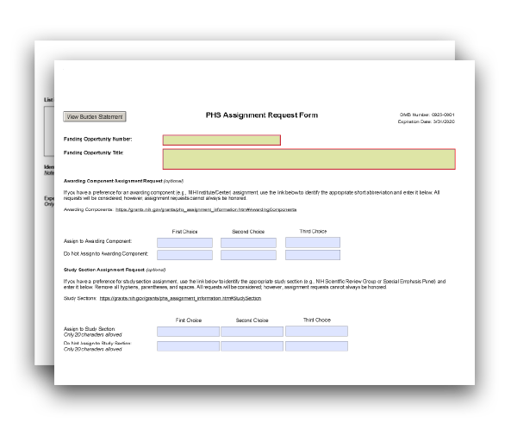

The PHS Assignment Request Form may be used to communicate specific application assignment and review preferences to the Division of Receipt and Referral (DRR) and to Scientific Review Officers (SROs).
This information will not be part of your assembled application, and it will neither be made available to program staff nor provided to reviewers. It is used specifically to convey additional, optional information about your preference(s) for assignment and review of your application to DRR and SROs.
View larger image
G.600 - PHS Assignment Request Form

Completing the PHS Assignment Request Form:
This form is optional. Use it only if you wish to communicate
specific awarding component assignments or review preferences. There is no requirement that all fields or all sections be completed. You have the flexibility to make a single entry or to provide extensive information using this form.
Note on Application Assignments: The Division of Receipt and Referral (DRR), Center for Scientific Review (CSR) is responsible for assigning applications to awarding components such as NIH Institutes/Centers (ICs) and other PHS agencies for funding consideration. DRR also assigns applications to NIH Scientific Review Groups (SRGs) and Special Emphasis Panels (SEPs).

Awarding Component Assignment Suggestions (optional)

To facilitate accurate communication of any assignment preferences to NIH referral and review staff, use the short abbreviation (e.g., NCI for the National Cancer Institute).
All assignment suggestions will be considered; however, not all assignment suggestions can be honored. Applications are assigned based on relevance of your application to an individual awarding component mission and scientific interests in addition to administrative requirements such as IC participation in the funding opportunity announcement used to submit your application.
Descriptions of the scientific areas covered by all NIH ICs and links to other PHS agency information can be found on the PHS Assignment Information website.
You do not need to make entries in all three boxes of the “Awarding Component Assignment Suggestions” section.

Suggested Awarding Component(s):
You may enter up to three preferences for primary assignment in the boxes in the “Suggested Awarding Component(s)” row. Note: Your application will be assigned based on the most

appropriate match between it, the terms of the FOA, and the mission of each possible awarding component, with your preference(s) taken into consideration when possible.

Study Section Assignment Suggestions (optional)

To facilitate accurate communication of any review assignment preferences to NIH referral and review staff, use the short abbreviation of the SRG/SEP you would prefer. For example, enter “CAMP” for the NIH Cancer Molecular Pathobiology study section or enter “ZRG1HDMR” for the NIH Healthcare Delivery and Methodologies SBIR/STTR panel for informatics. Be careful to remove all hyphens, parentheses, and spaces when you type in the suggestion. Freeform text (such as "special emphasis panel" or "member conflict SEP") should not be entered.
All suggestions will be considered; however, not all assignment suggestions can be honored.
More information about how to identify CSR and NIH SRGs and SEPs, including their short abbreviations, can be found on CSR Study Sections and Special Emphasis Panel. A list of all NIH SRGs and SEPs is also available.
While the majority of NIH research grant and fellowship applications are reviewed by CSR, some are assigned to individual IC review groups and some are clustered for review in SRGs/SEPs, depending on existing locus of review agreements within NIH and other PHS agencies. This limits flexibility for honoring assignment preferences.
You do not need to make an entry in all three boxes of the "Study Section Assignment Suggestions" section.

Suggested Study Sections:
You may enter up to three preferences for SRGs/SEPs in the boxes in the “Suggested Study Sections” row. Use one box per individual SRG/SEP preference suggestion. All review preferences will be considered. Note: Your application will be assigned based on the most appropriate match between it, the terms of the FOA, and the guidelines for each SRG/SEP, with your preference(s) taken into consideration when possible.
Note: This information is not applicable if you are submitting an application to an RFA.

Rationale for assignment suggestions (optional)

Enter the rationale (i.e., why you think the assignment is appropriate) for your Awarding Component and Study Section suggestions.
Your answer can have a maximum of 1000 characters.

List individuals who should not review your application and why (optional)

You may list specific individuals, if any, who should not review your application and why they should not review your application. Provide sufficient information (e.g., name, organizational affiliation) so that the SRO can correctly identify the individual. Be prepared to provide additional information to the SRO if needed. Simply stating “Dr. John Smith is in conflict with my application” is not helpful.
Your answer can have a maximum of 1000 characters.

Identify scientific areas of expertise needed to review your application (optional)

You may list up to five general or specific types of expertise needed for the review of your application. Limit your answers to areas of expertise – do not enter names of individuals you would like to review your application.
Each field can have a maximum of 40 characters.

Form Screenshots

Quick Links
SF 424 (R&R) Form
PHS 398 Cover Page Supplement Form R&R Other Project Information Form Project/Performance Site Location(s) Form
R&R Senior/Key Person Profile (Expanded) Form R&R Budget Form
R&R Subaward Budget Attachment(s) Form PHS 398 Modular Budget Form
PHS 398 Training Budget Form
PHS 398 Training Subaward Budget Attachment(s) Form PHS Additional Indirect Cost Form
SF 424C Budget Information - Construction Programs PHS 398 Research Plan Form
PHS 398 Career Development Award Supplemental Form PHS 398 Research Training Program Plan Form
PHS Fellowship Supplemental Form SBIR/STTR Information Form
PHS Human Subjects and Clinical Trials Information PHS Assignment Request Form

SF 424 (R&R) Form
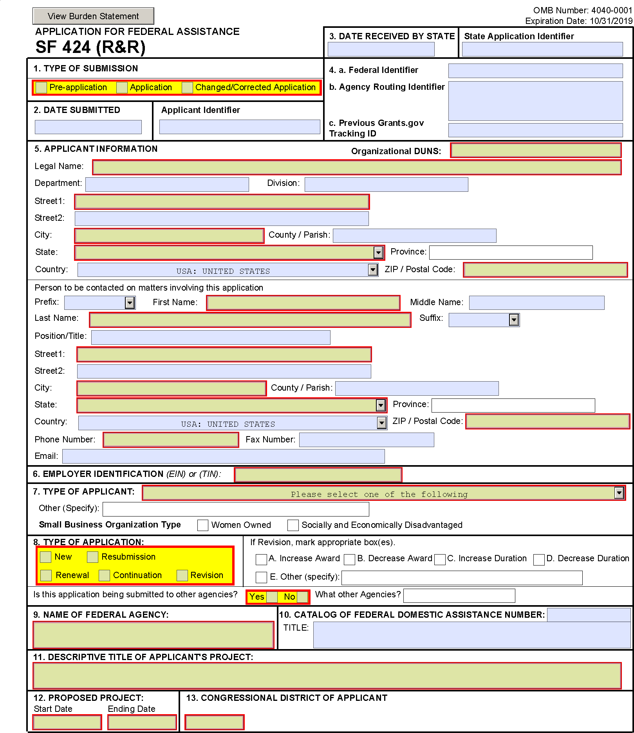

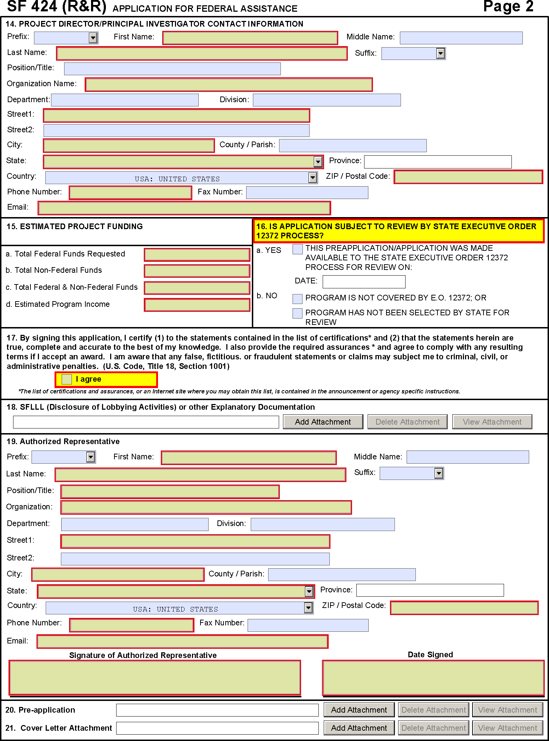

PHS 398 Cover Page Supplement Form
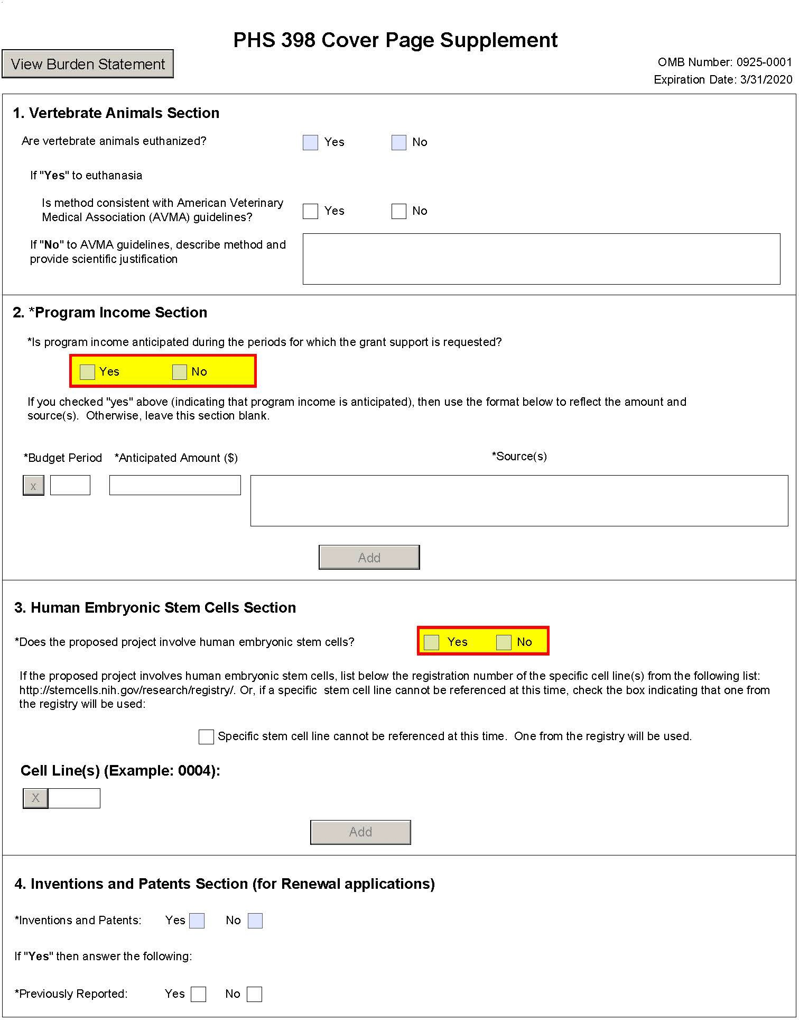

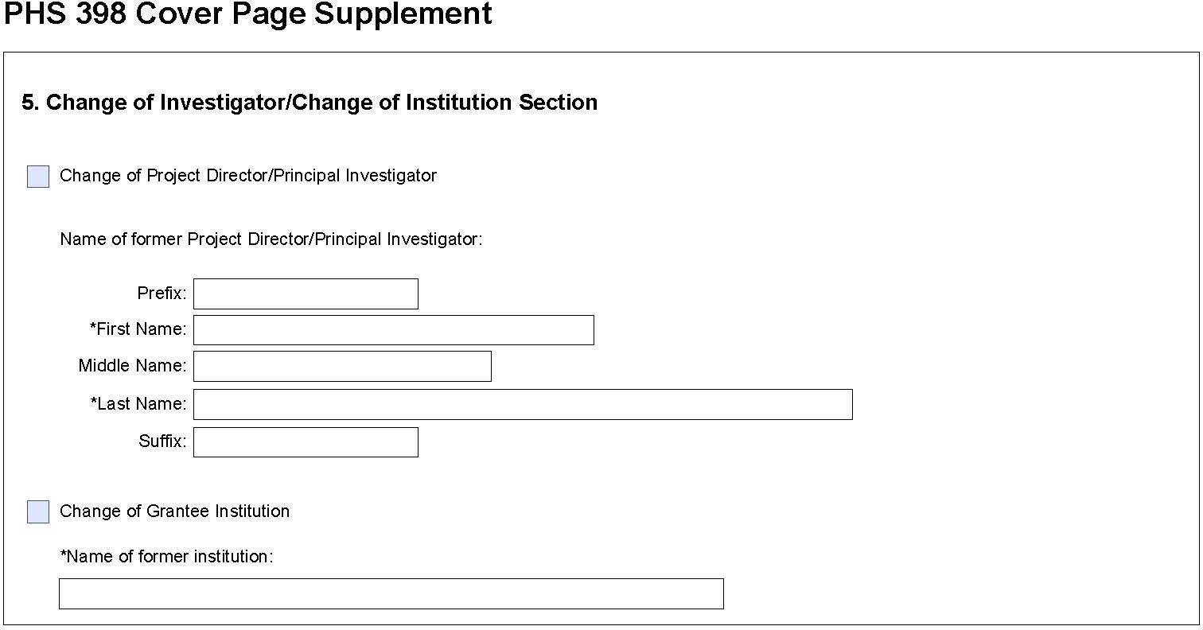

R&R Other Project Information Form
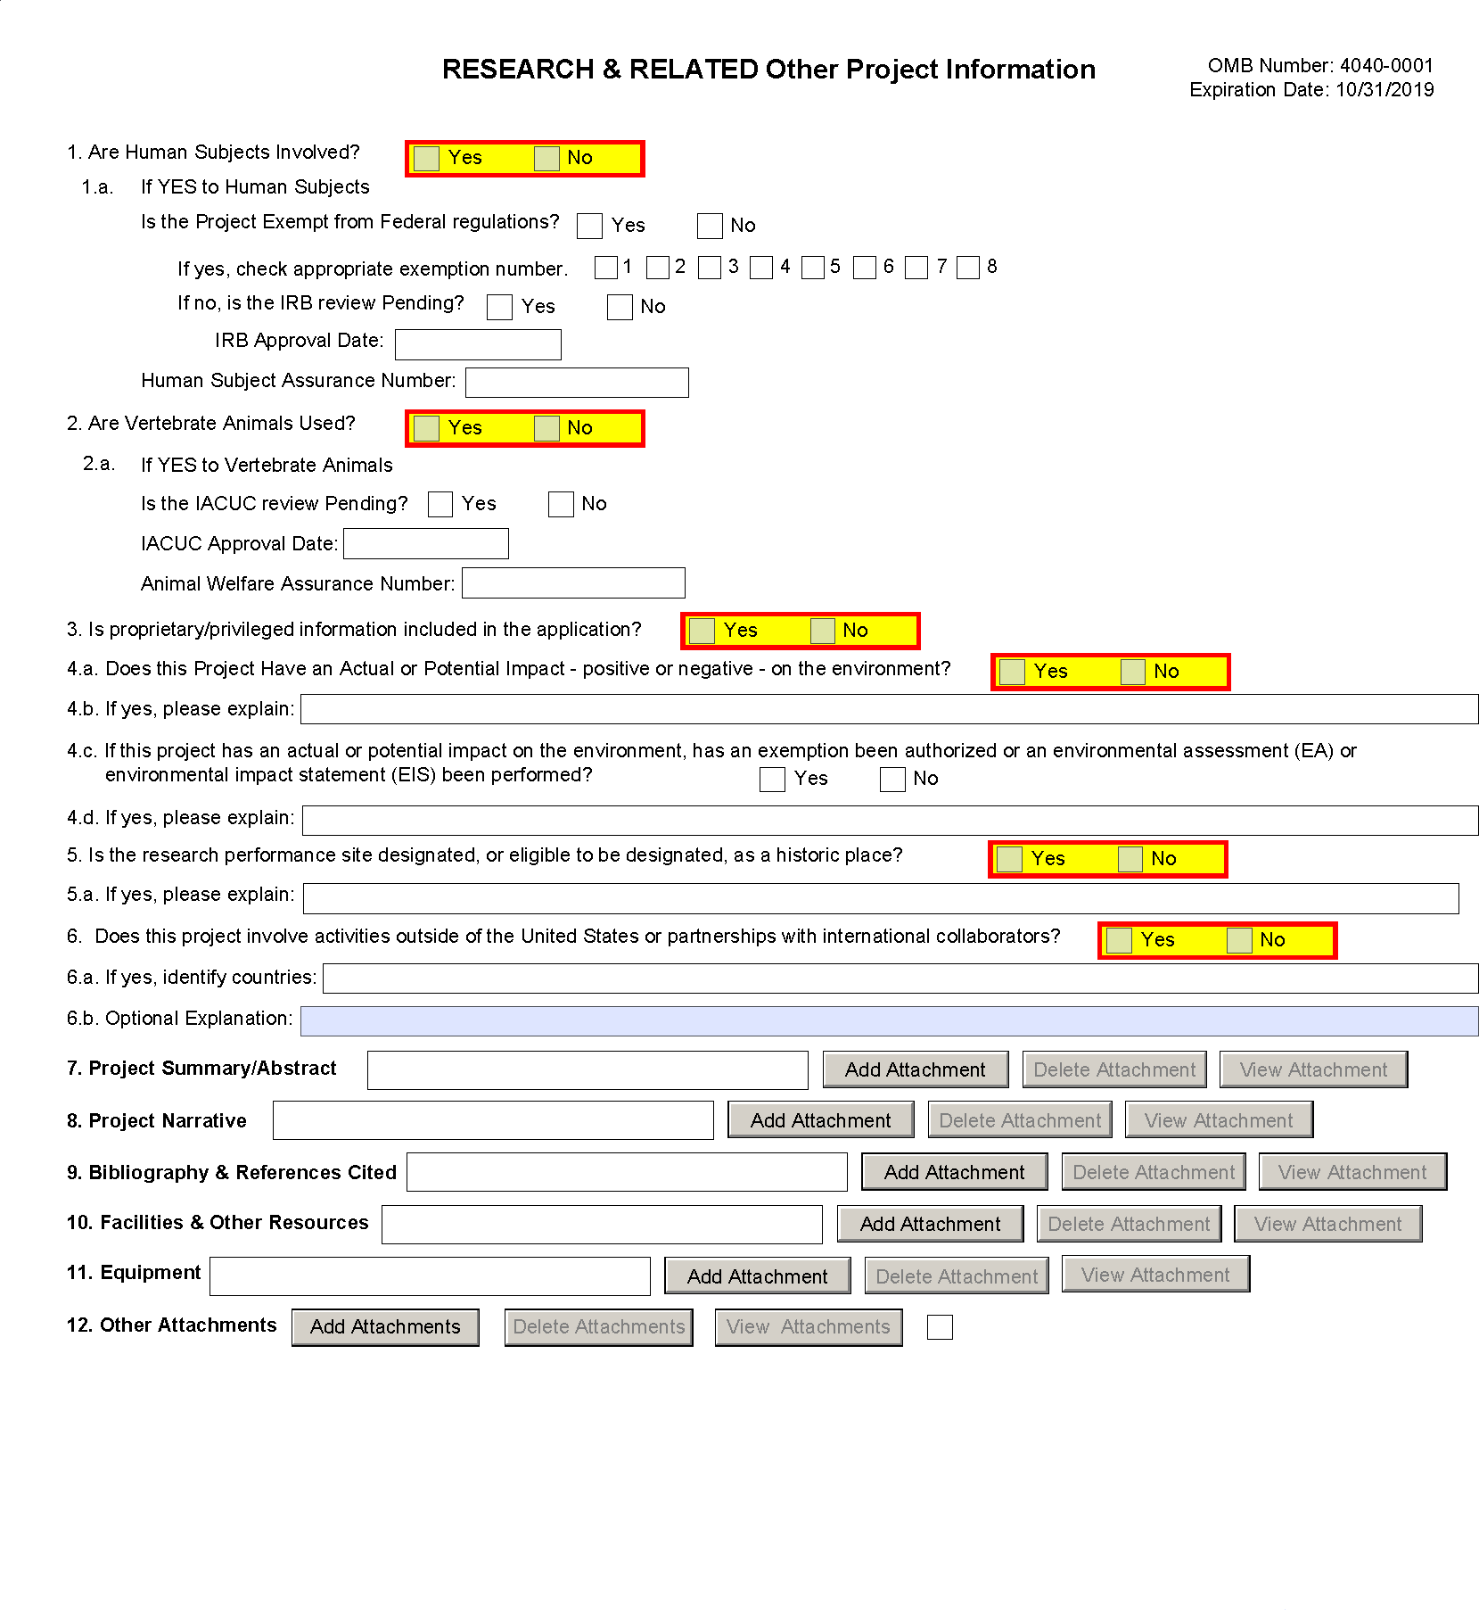

Project/Performance Site Location(s) Form
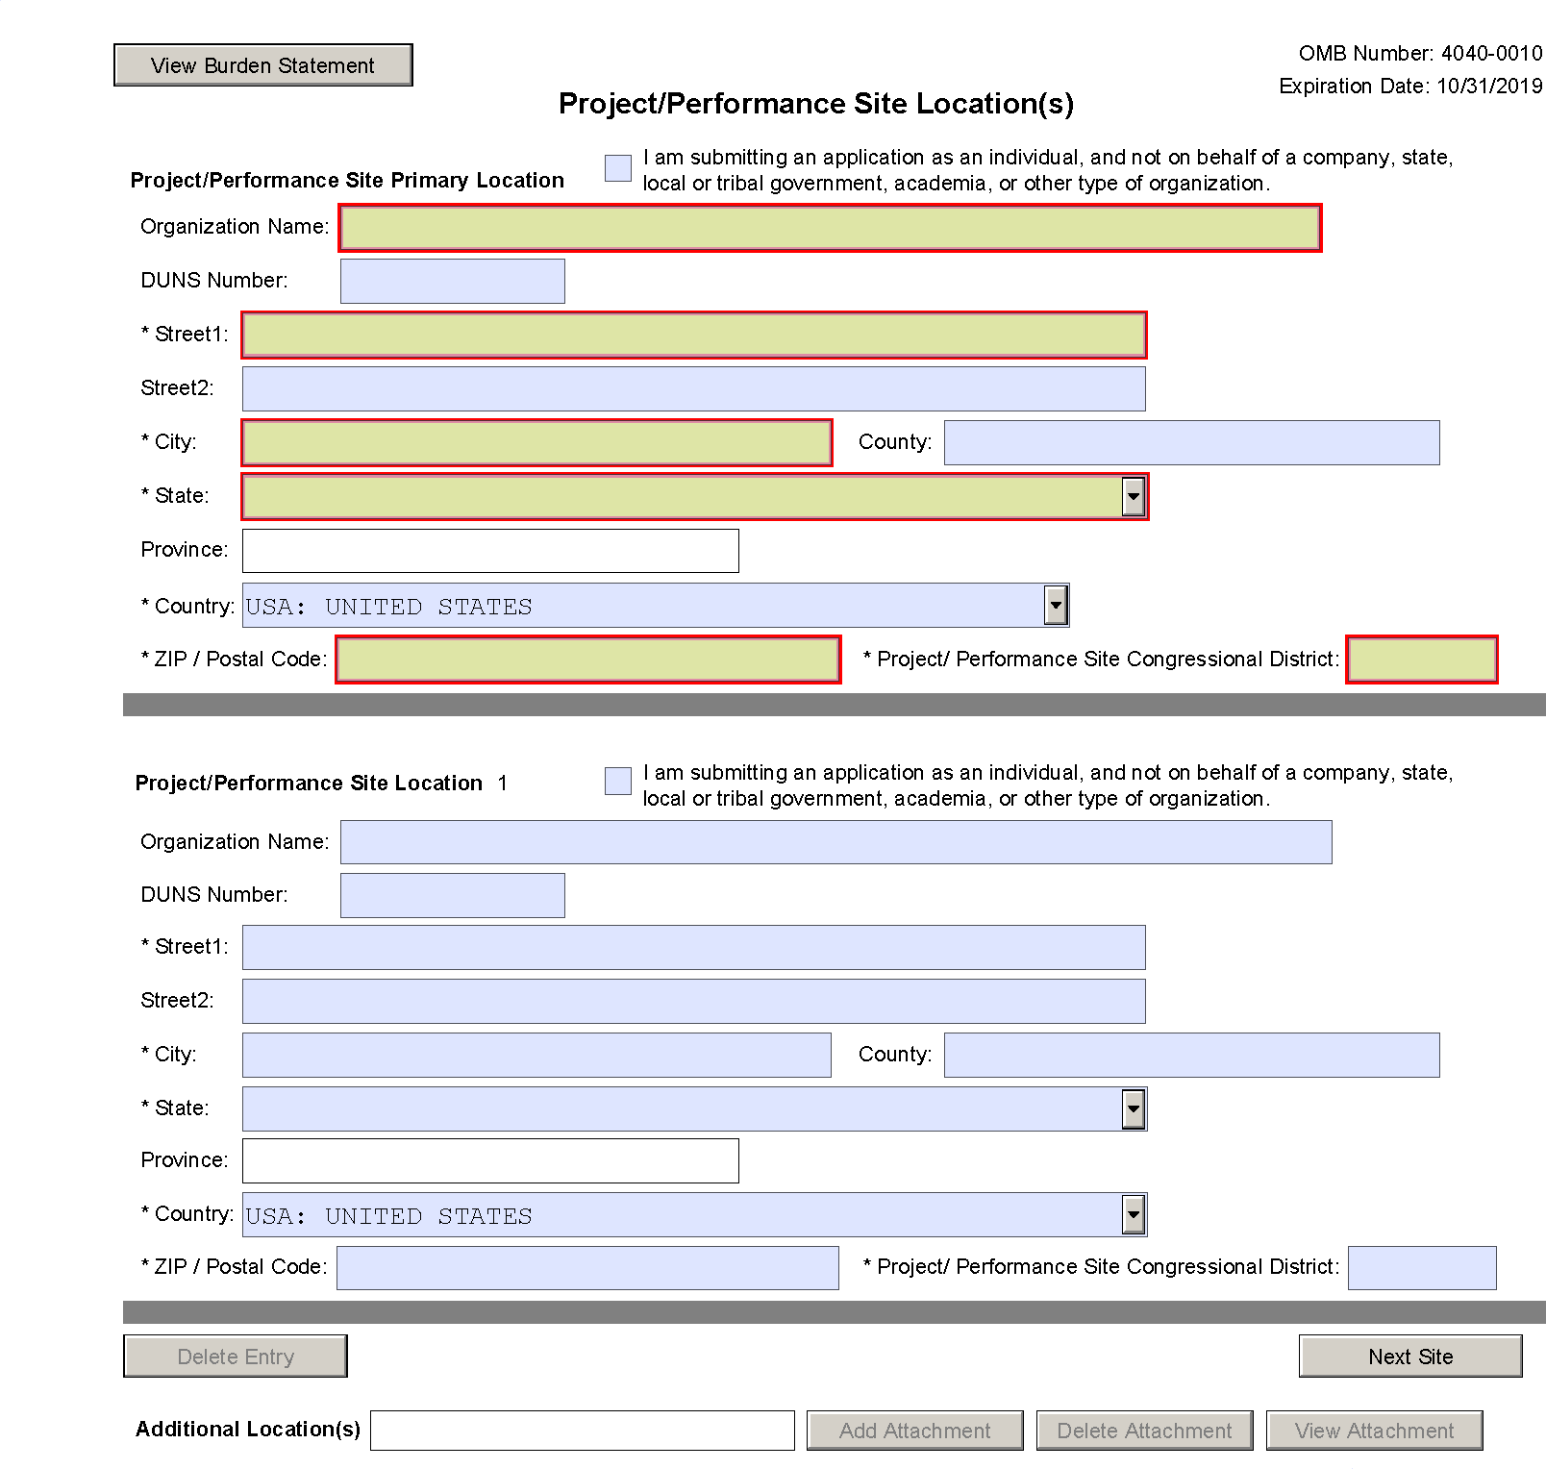

R&R Senior/Key Person Profile (Expanded) Form
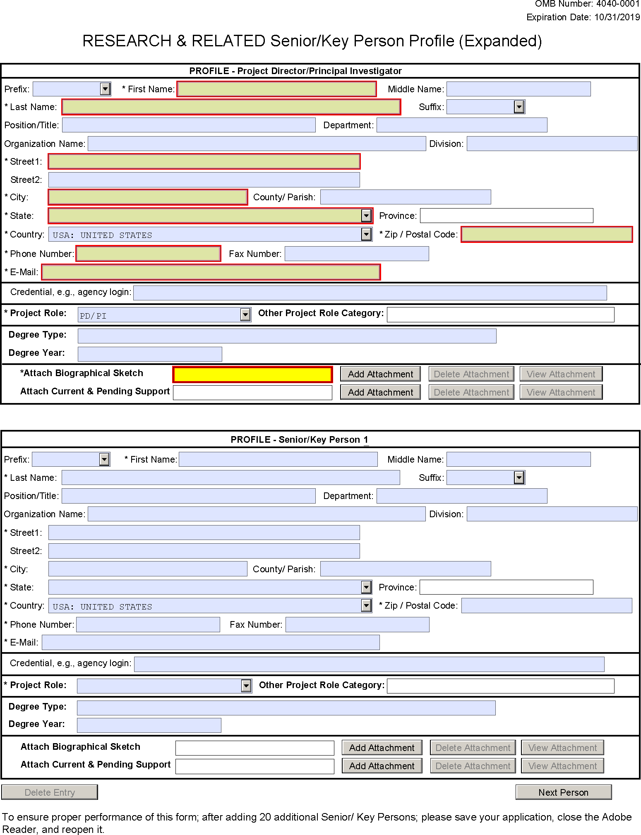

R&R Budget Form

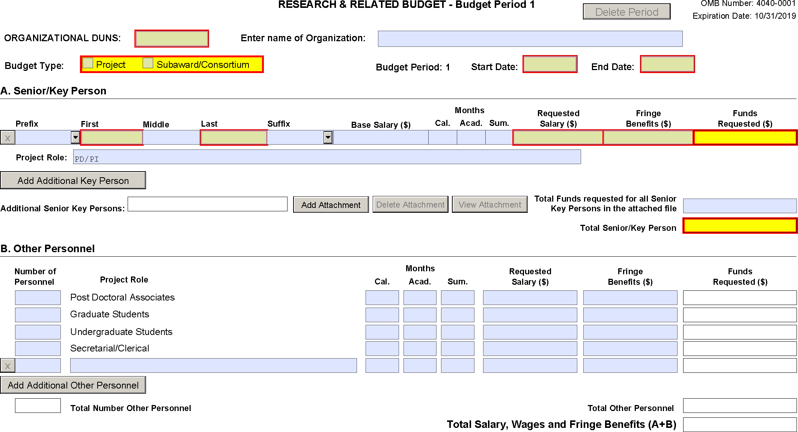

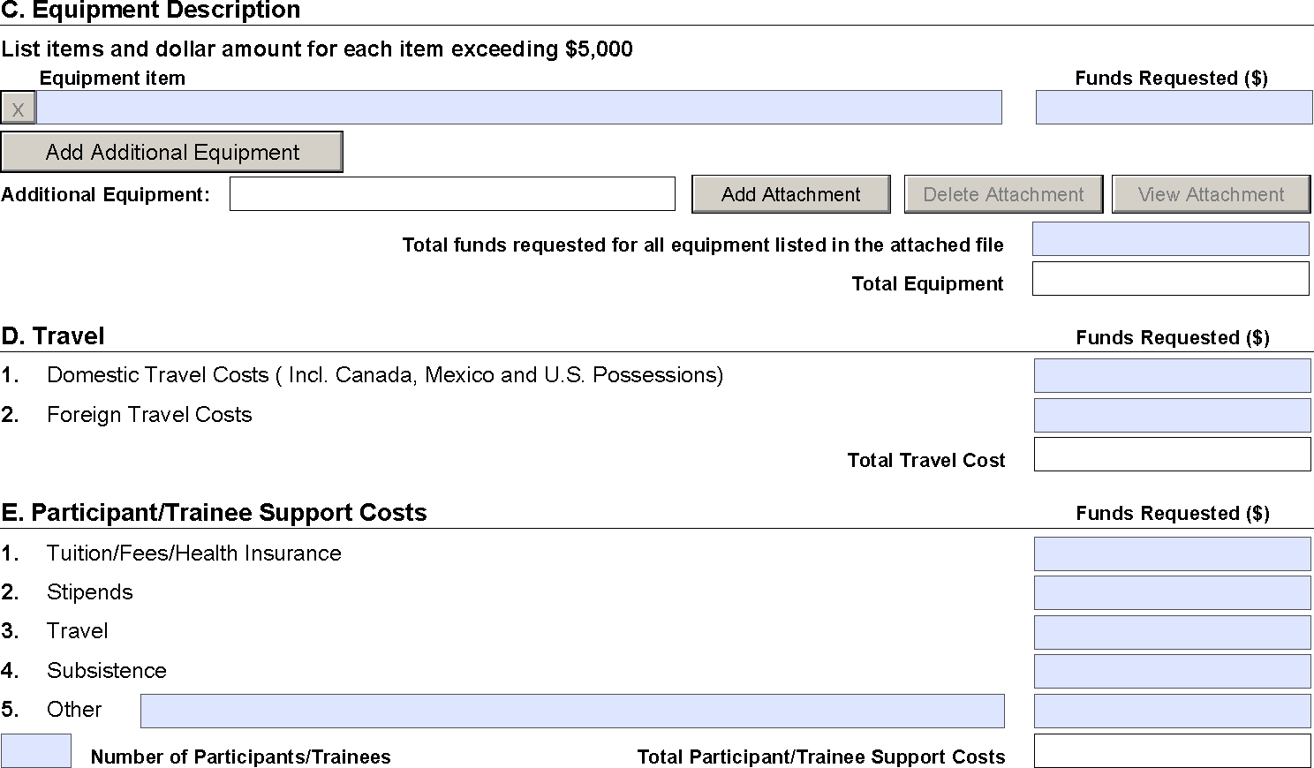

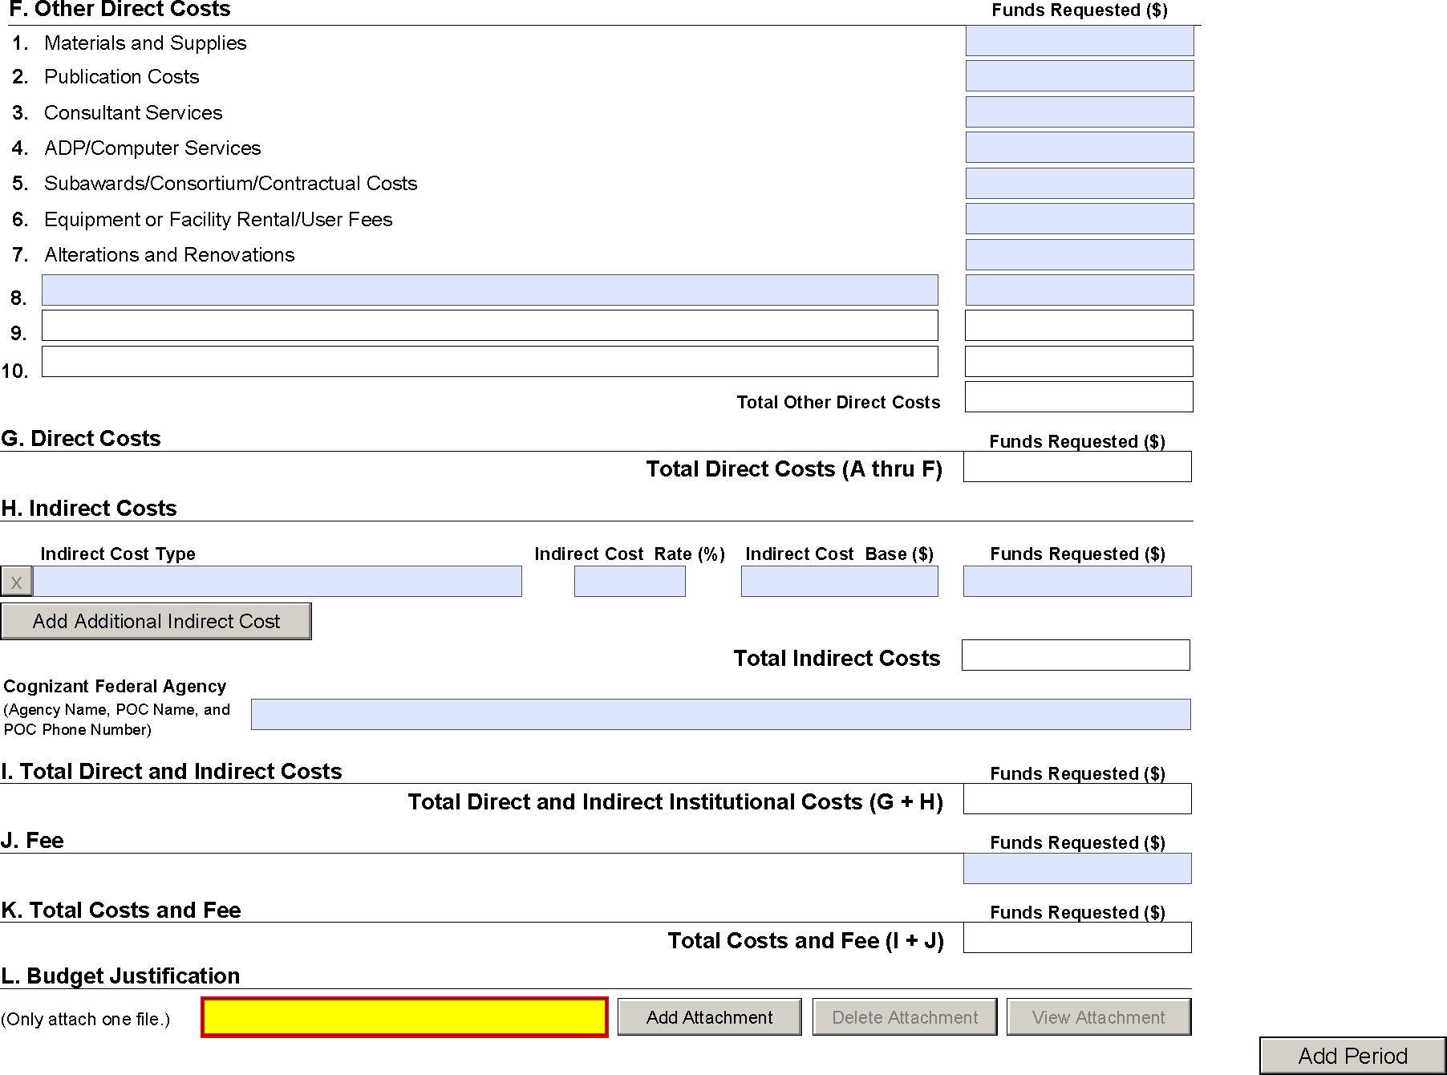

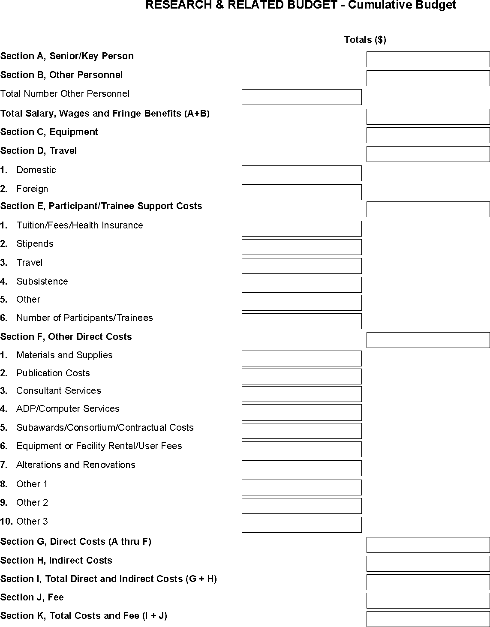

R&R Subaward Budget Attachment(s) Form
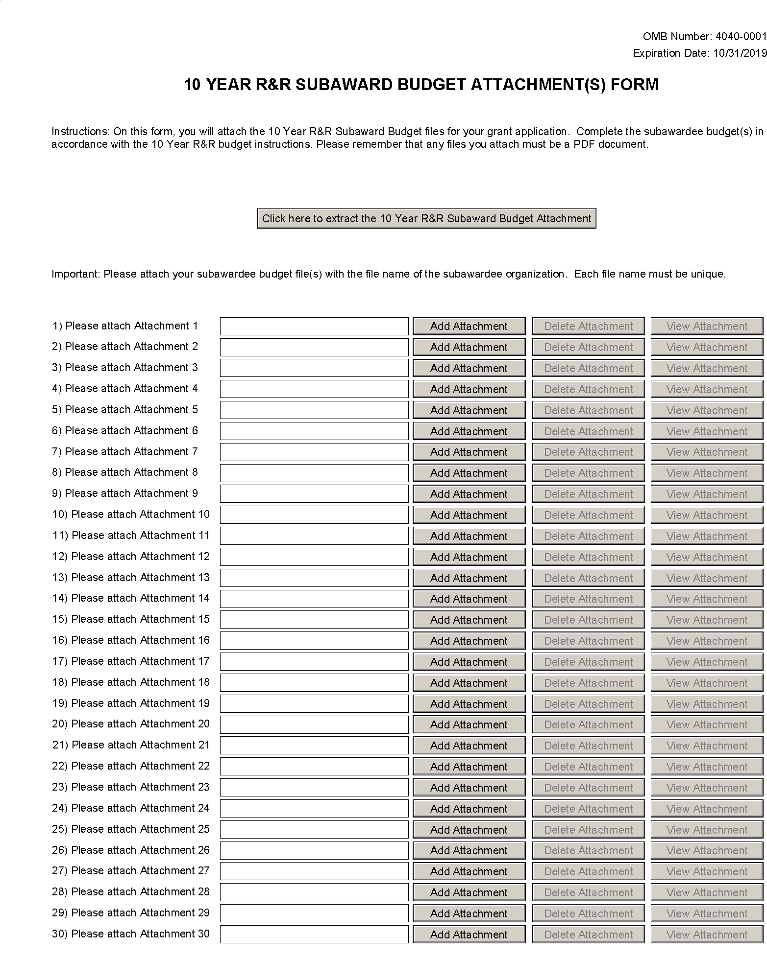

PHS 398 Modular Budget Form

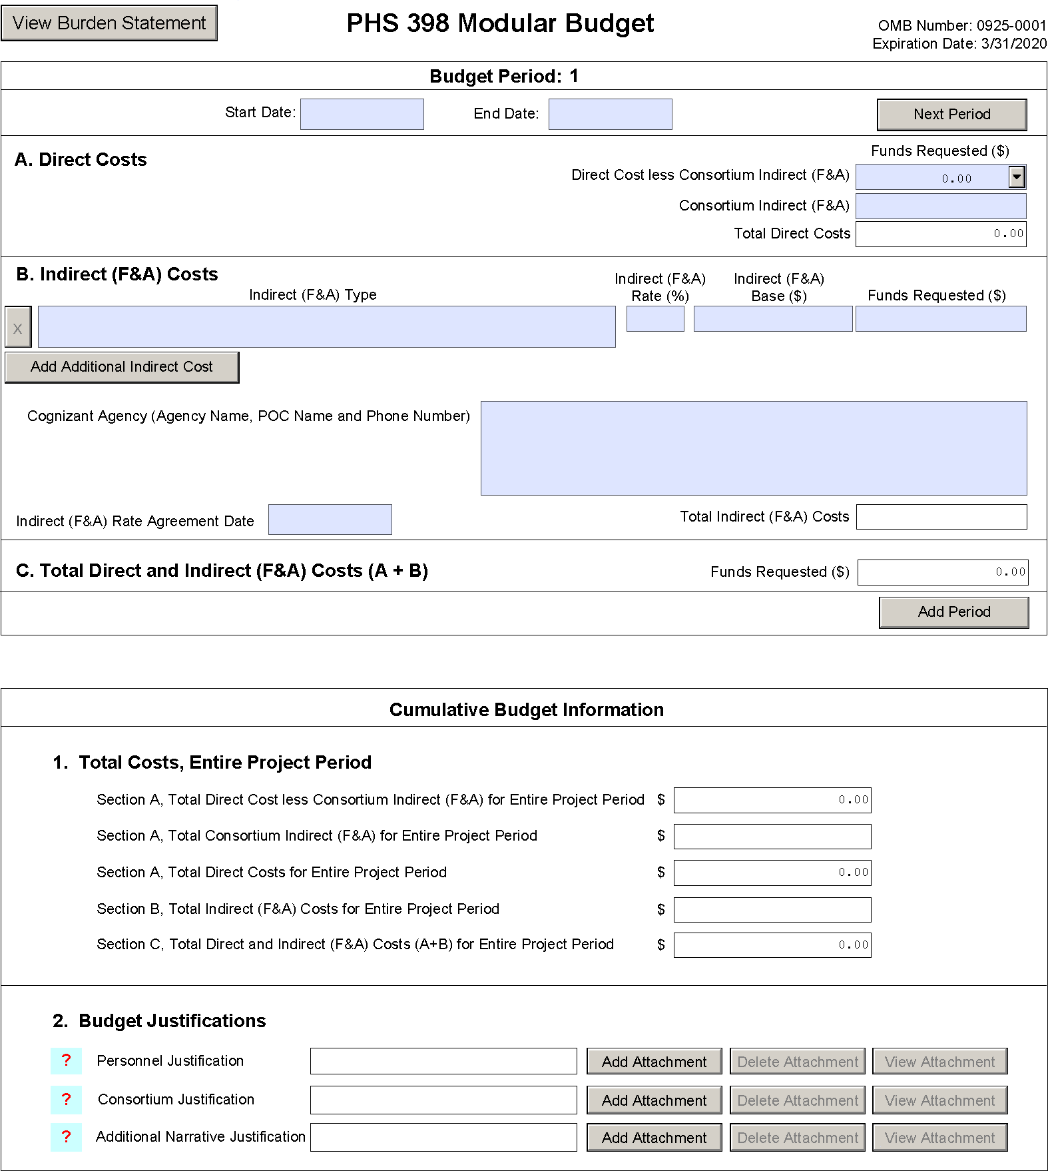

PHS 398 Training Budget Form
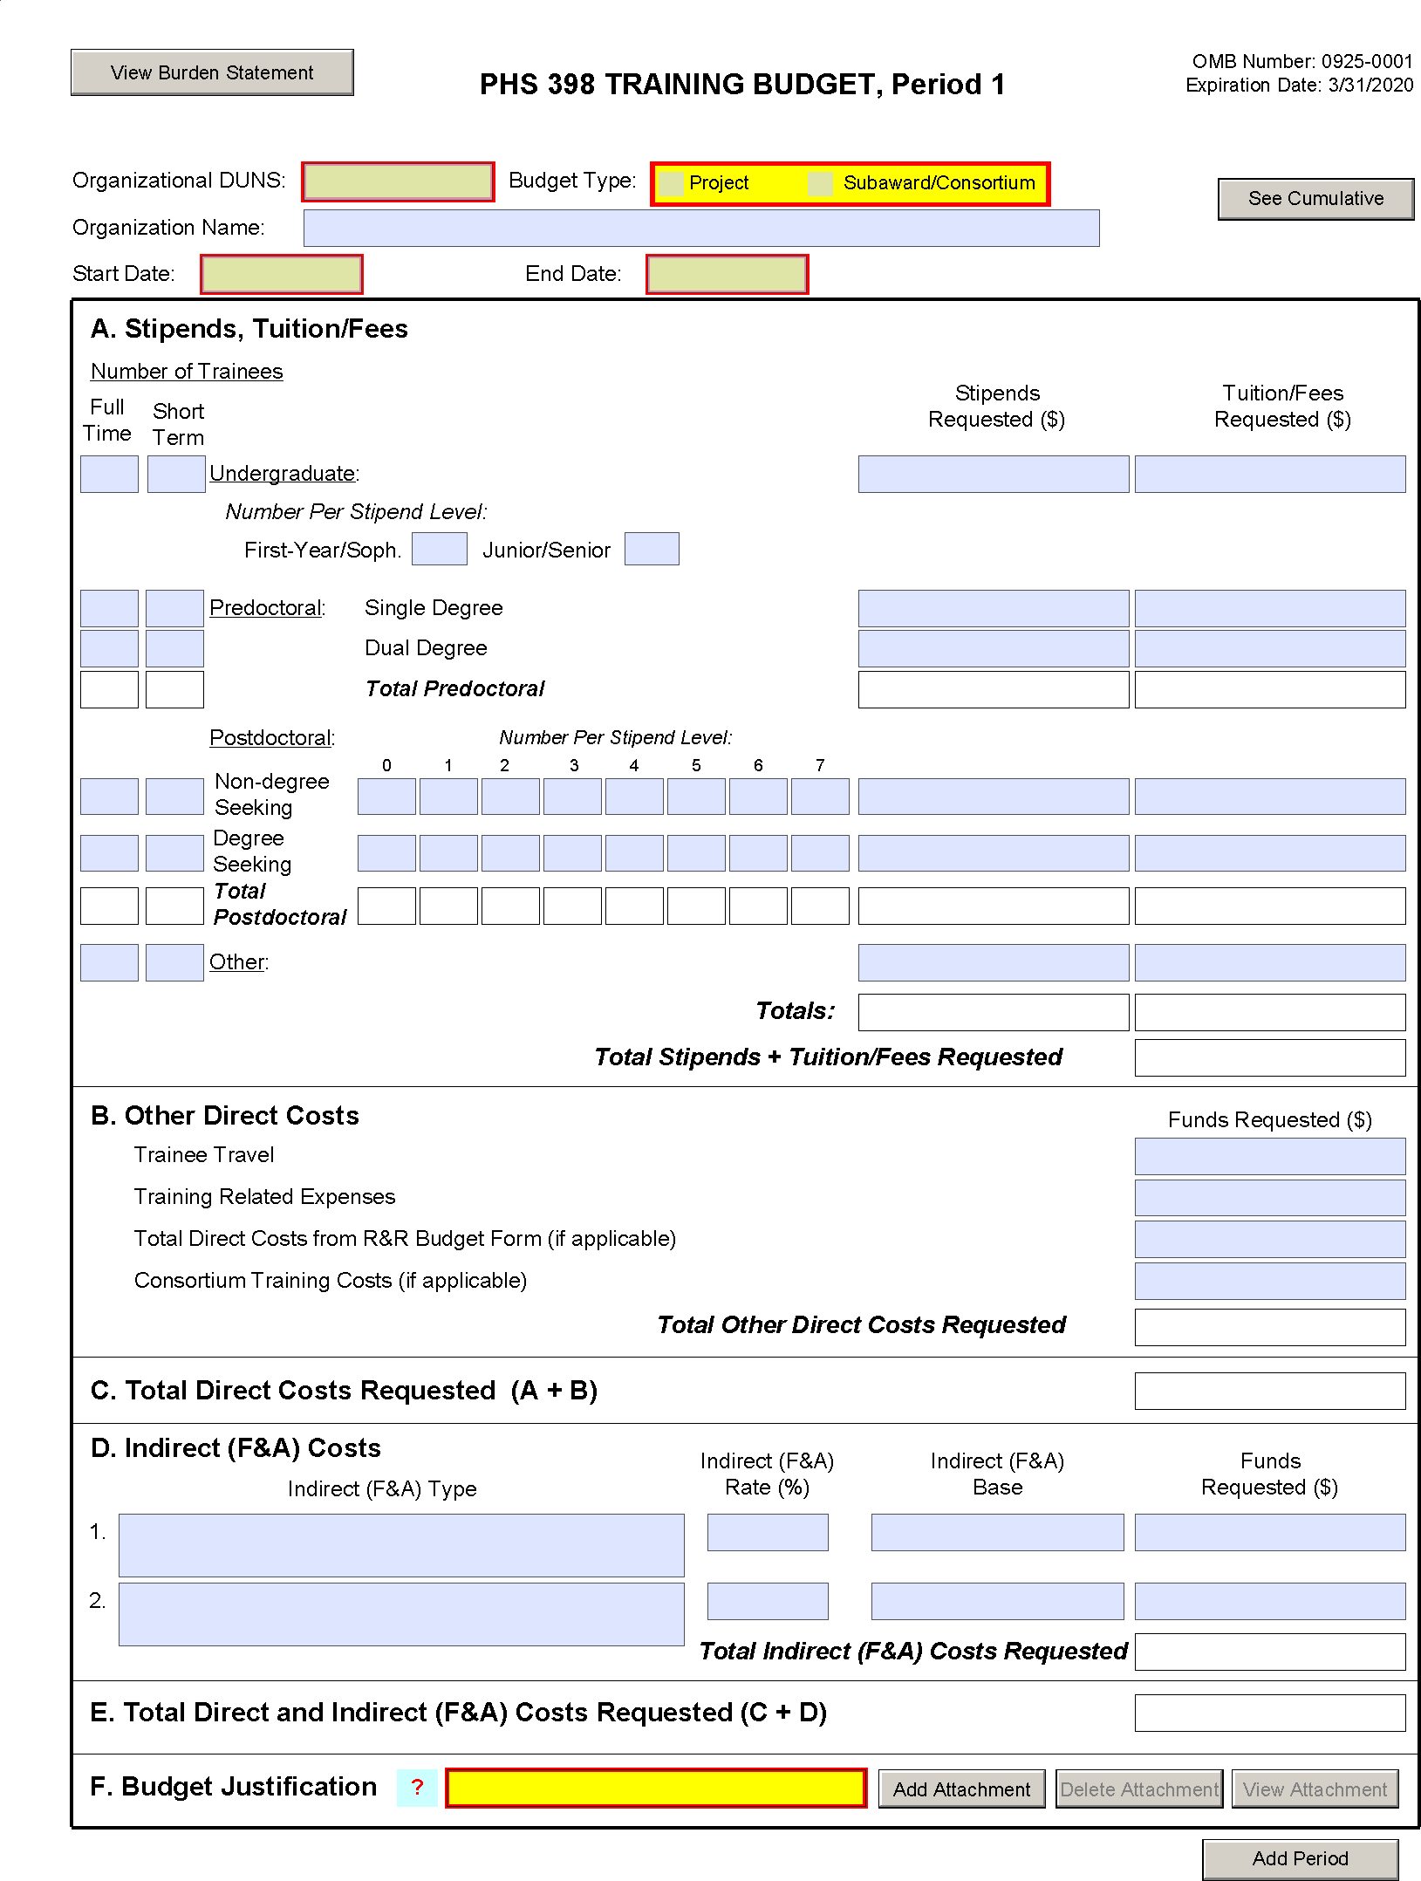

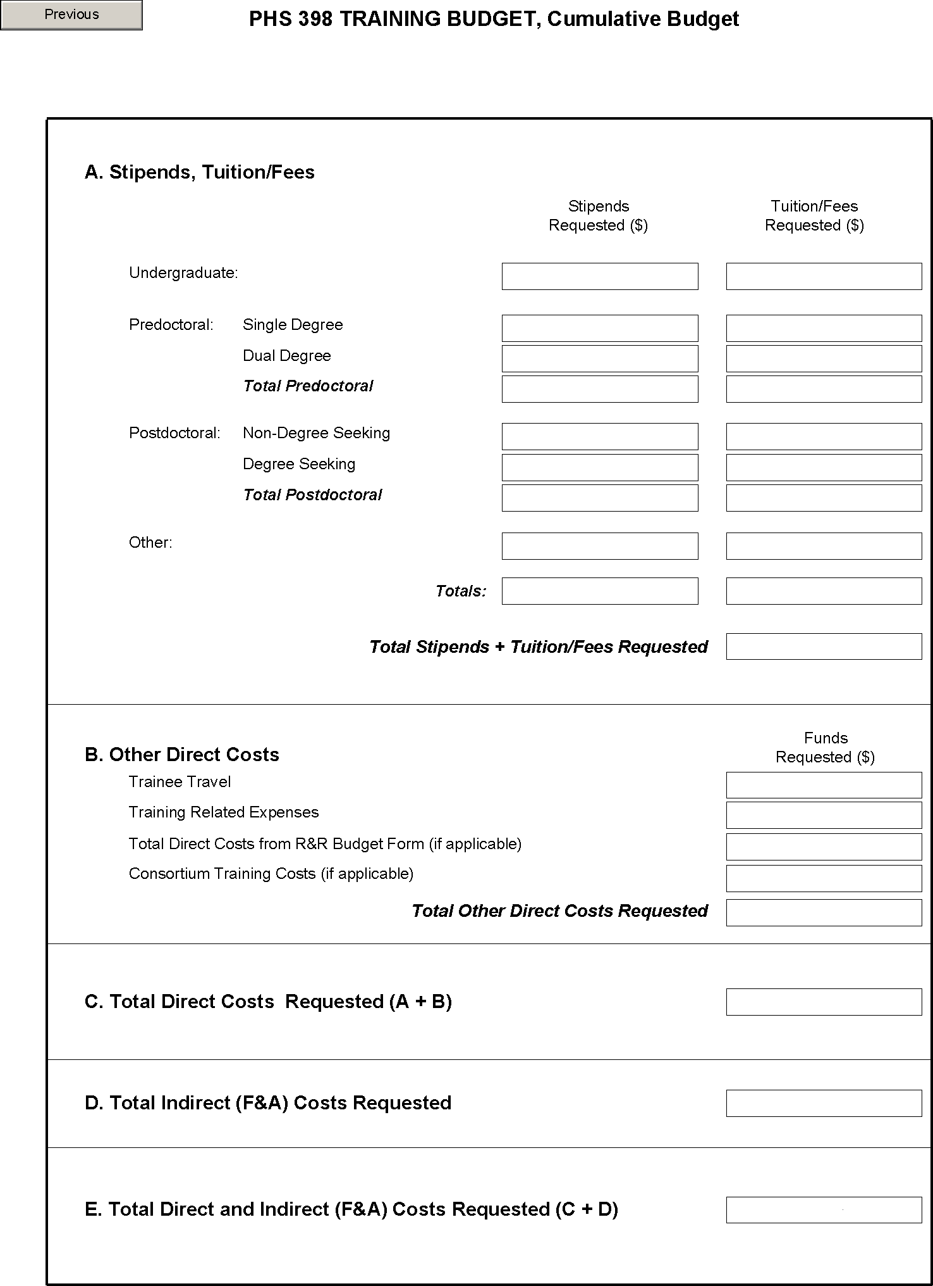

PHS 398 Training Subaward Budget Attachment(s) Form

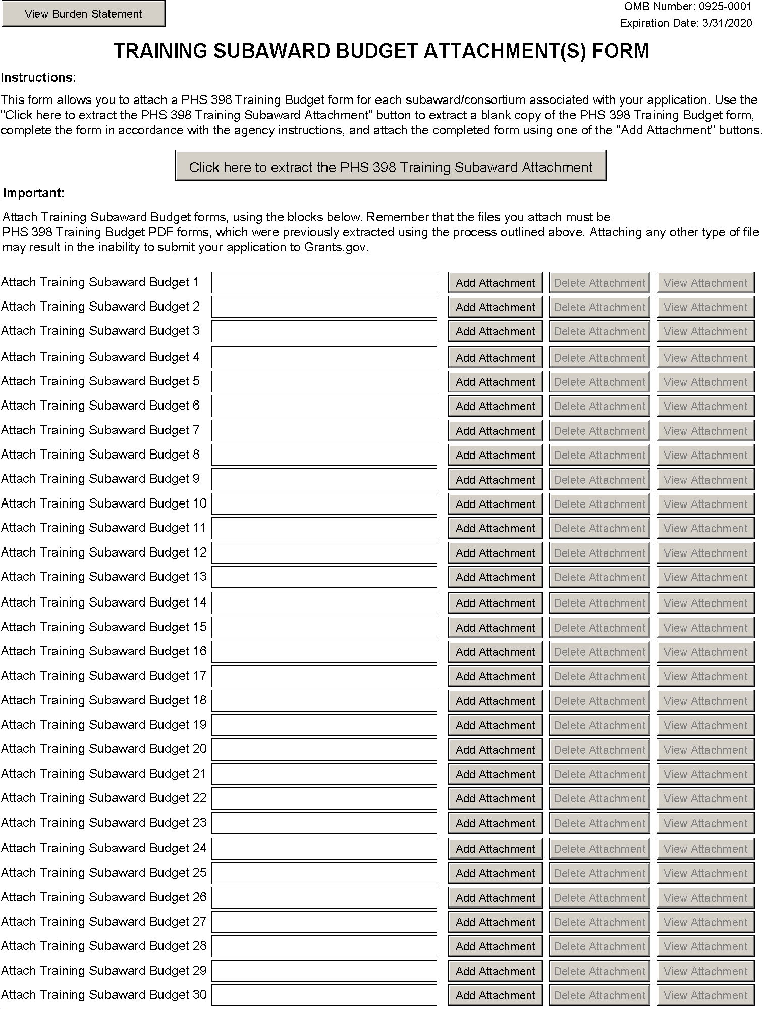

PHS Additional Indirect Cost Form
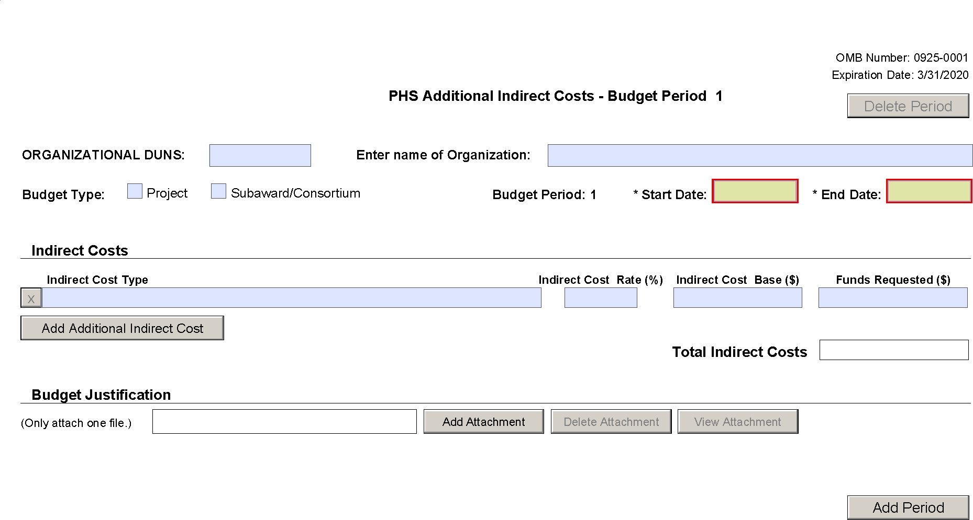

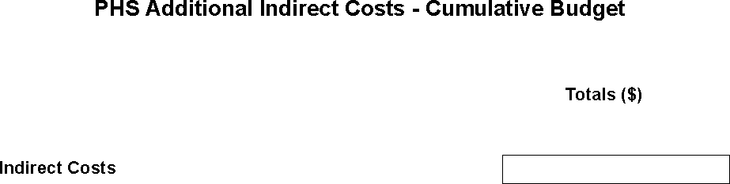

SF 424C Budget Information - Construction Programs
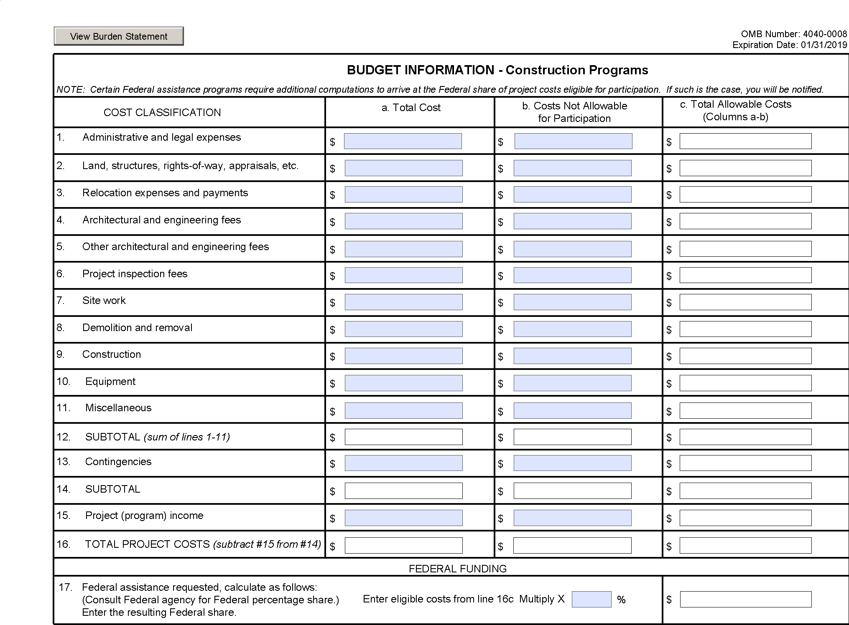

PHS 398 Research Plan Form
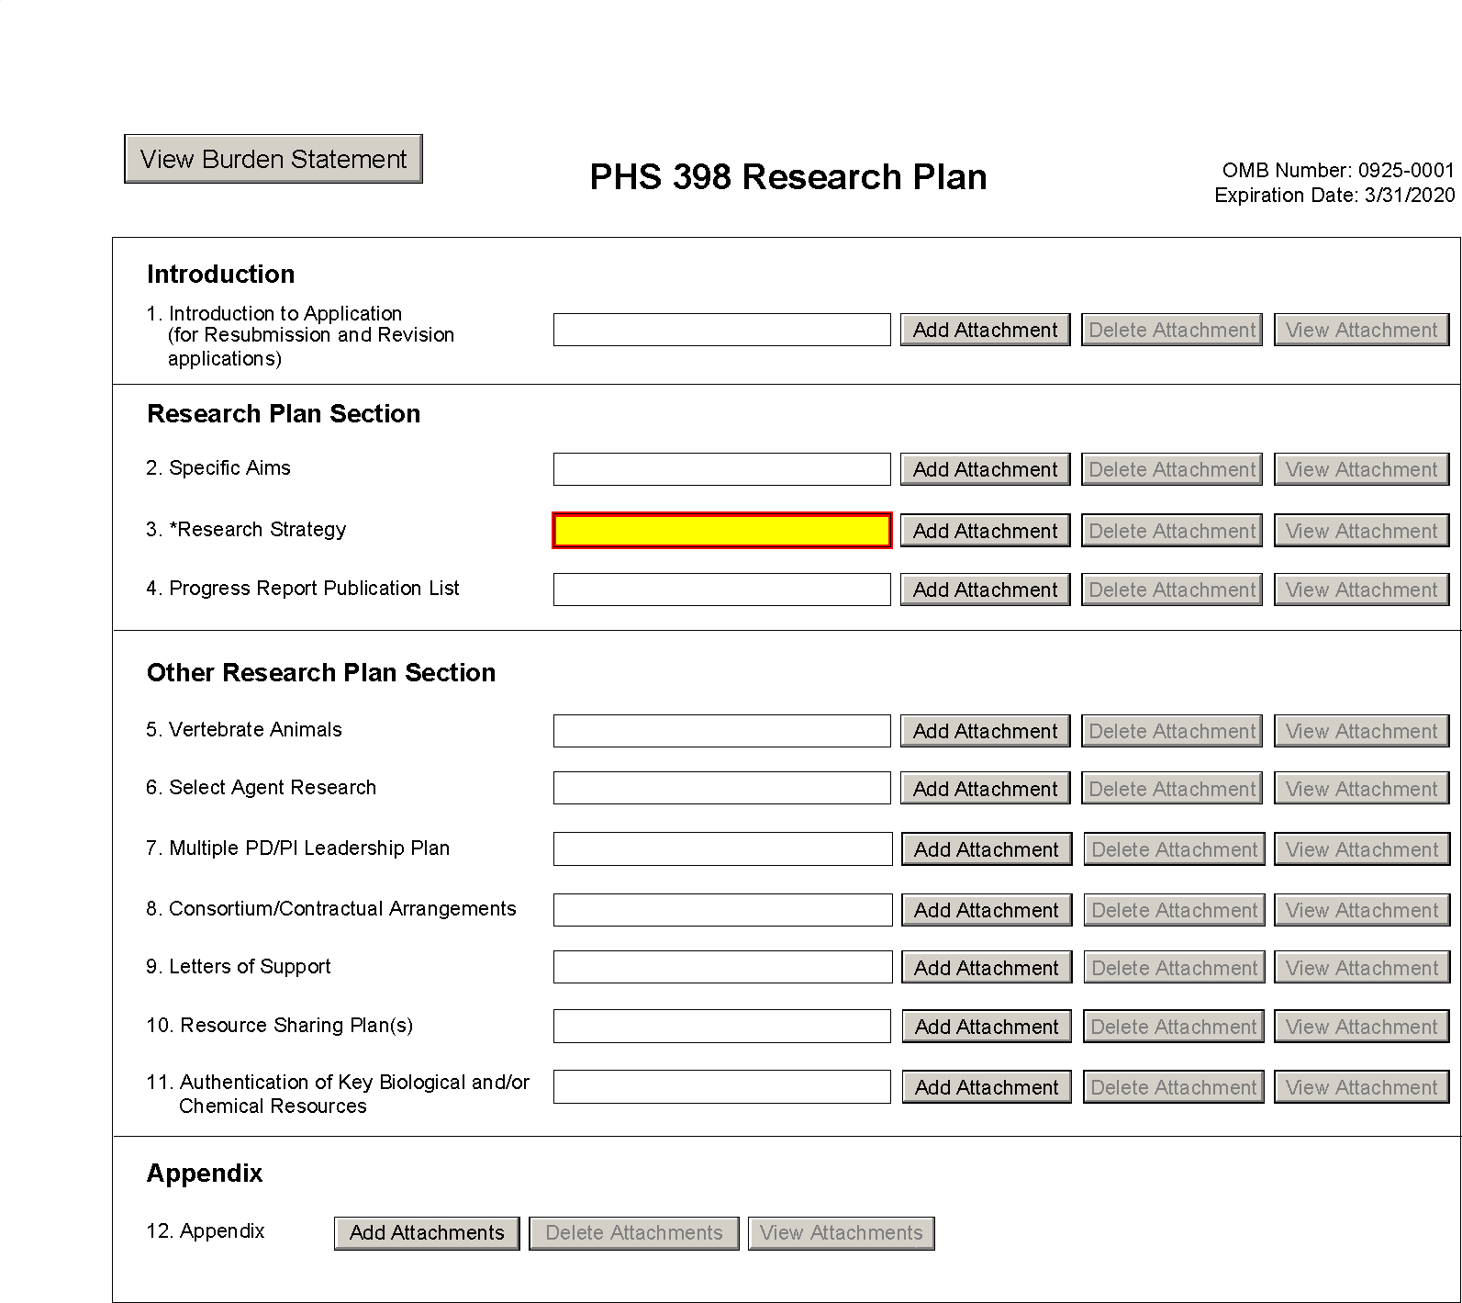

PHS 398 Career Development Award Supplemental Form
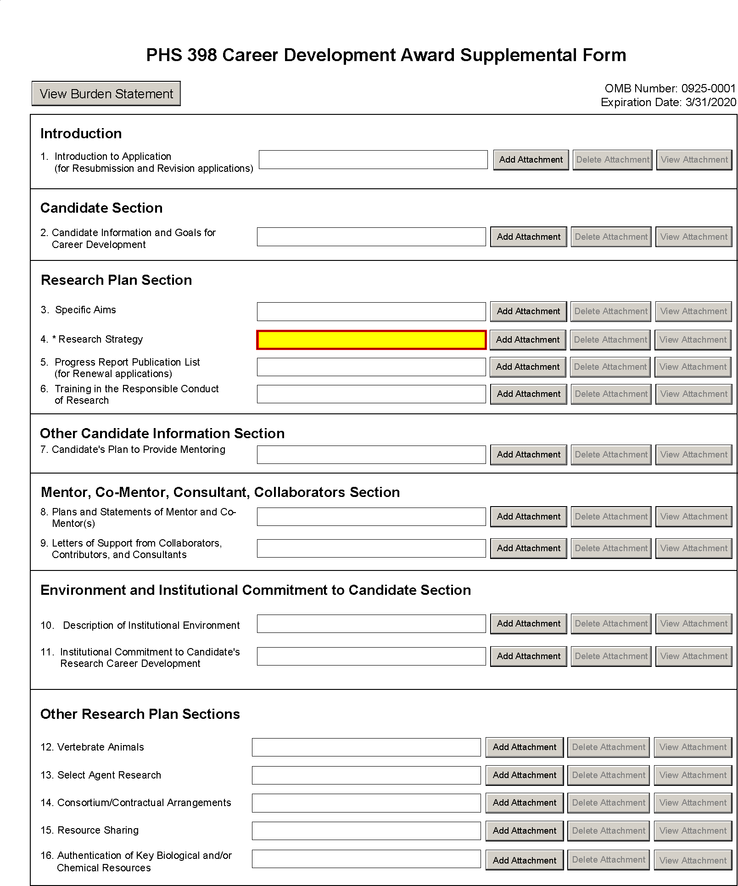

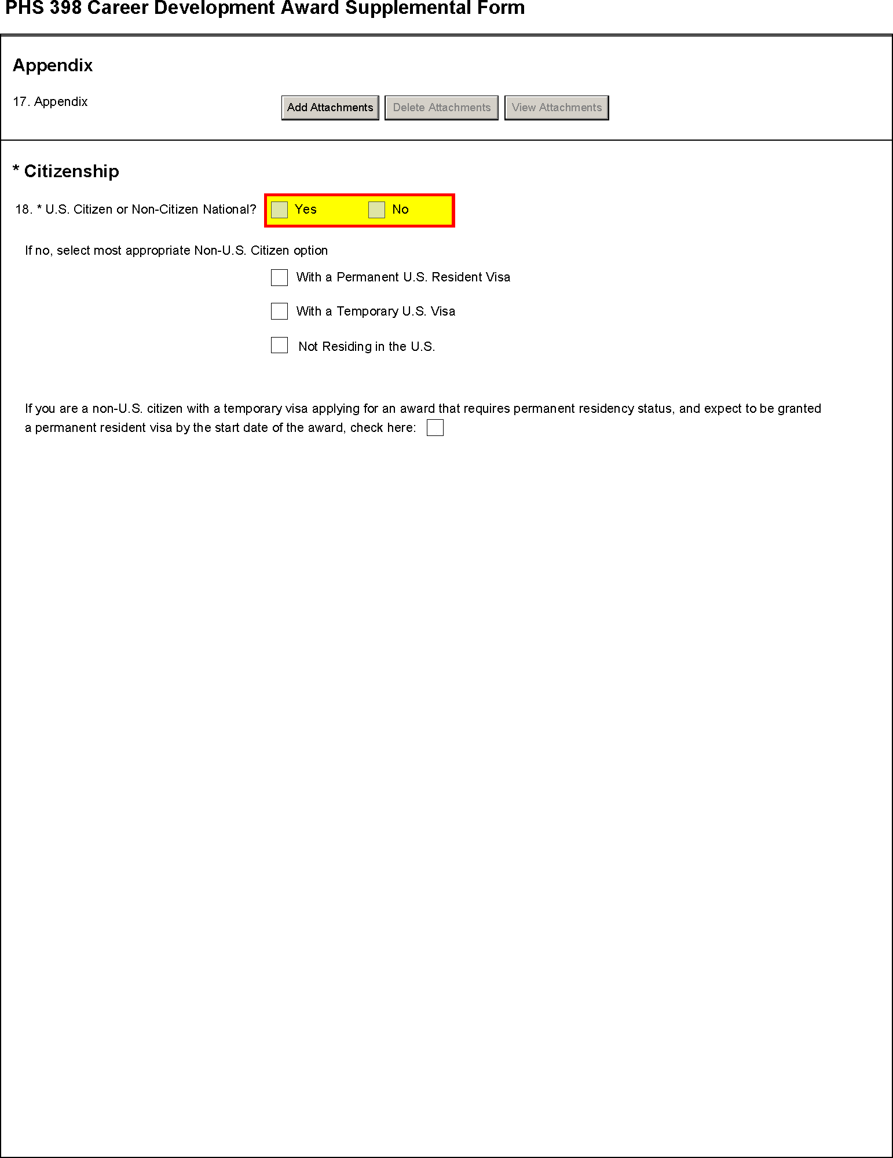

PHS 398 Research Training Program Plan Form
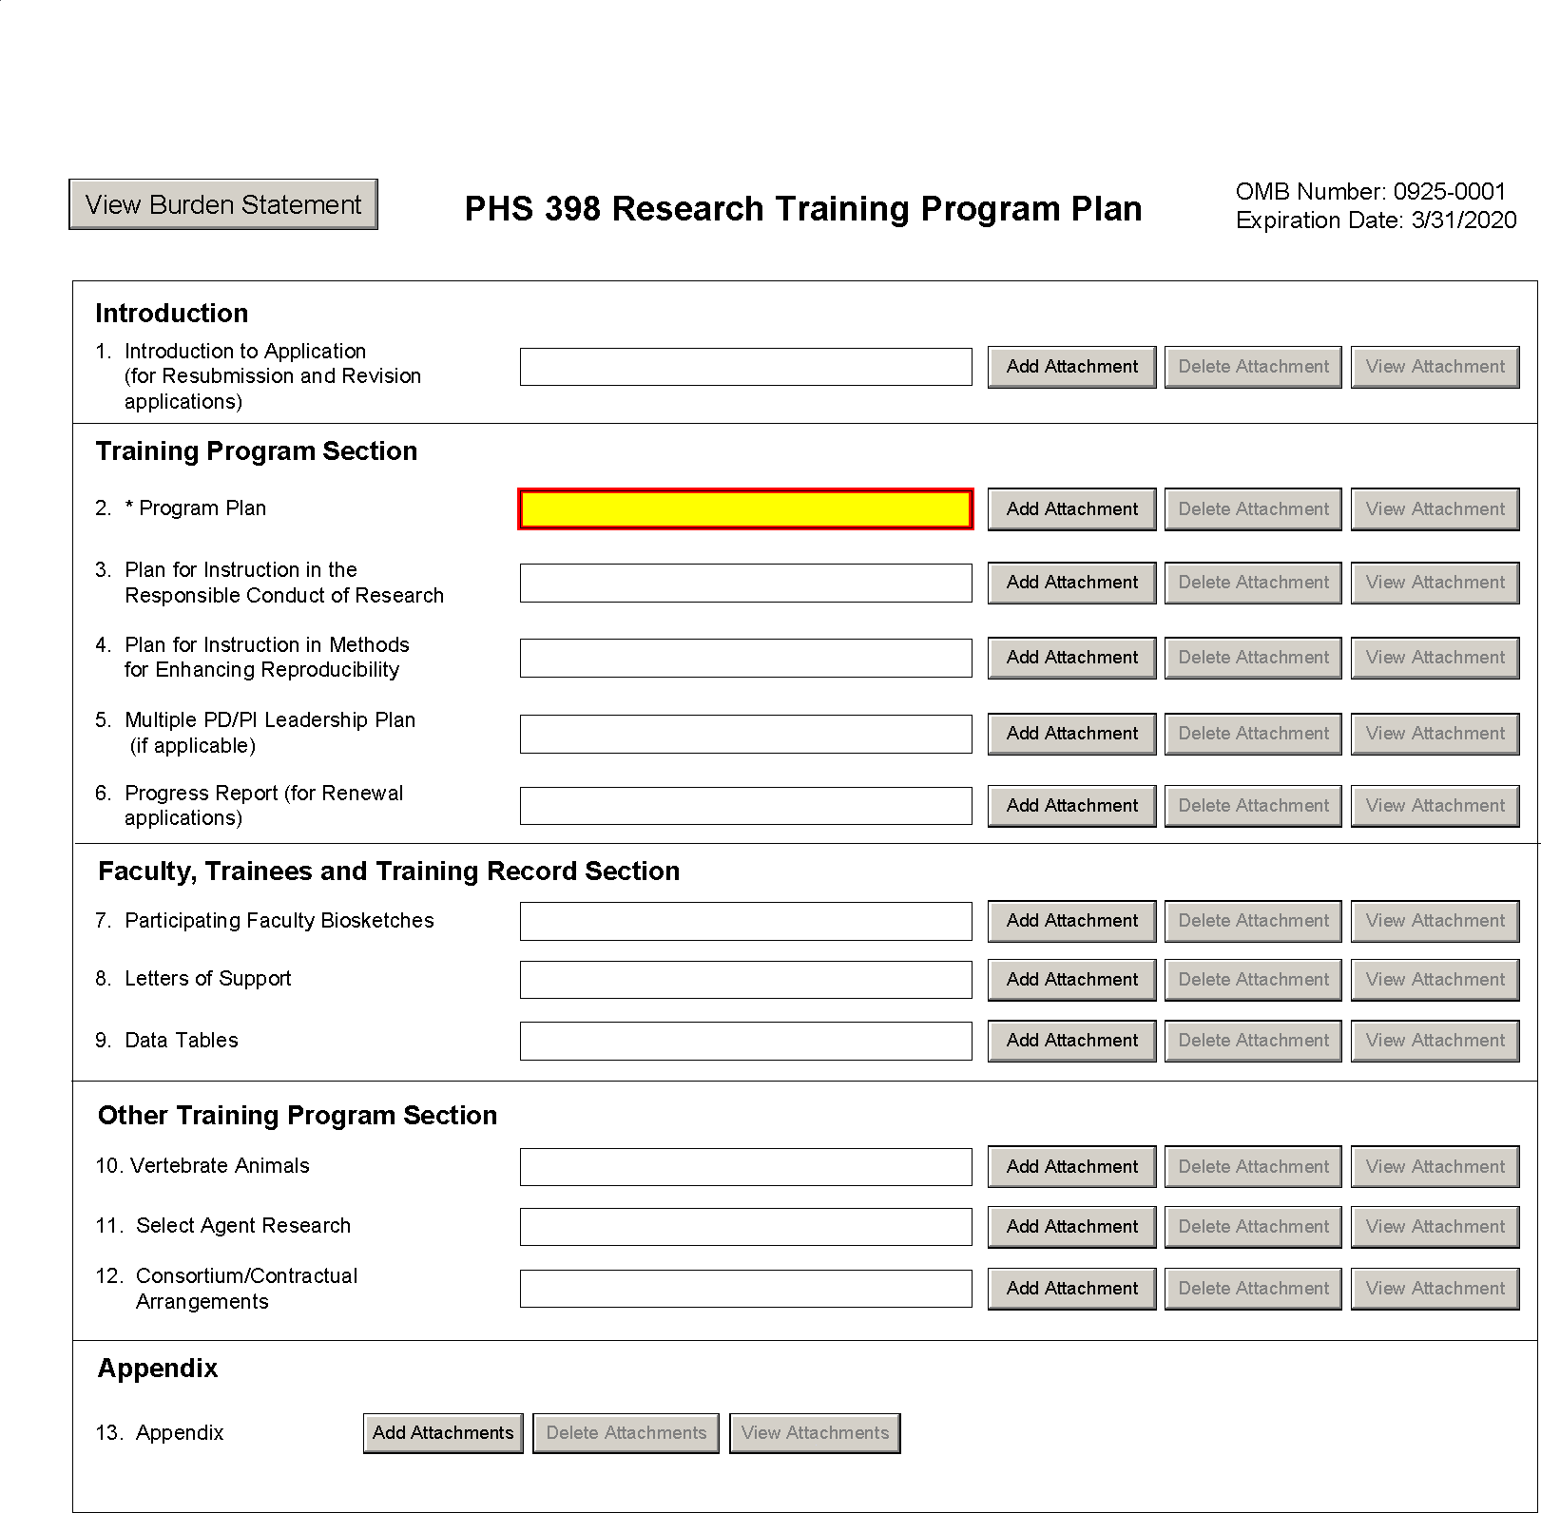

PHS Fellowship Supplemental Form
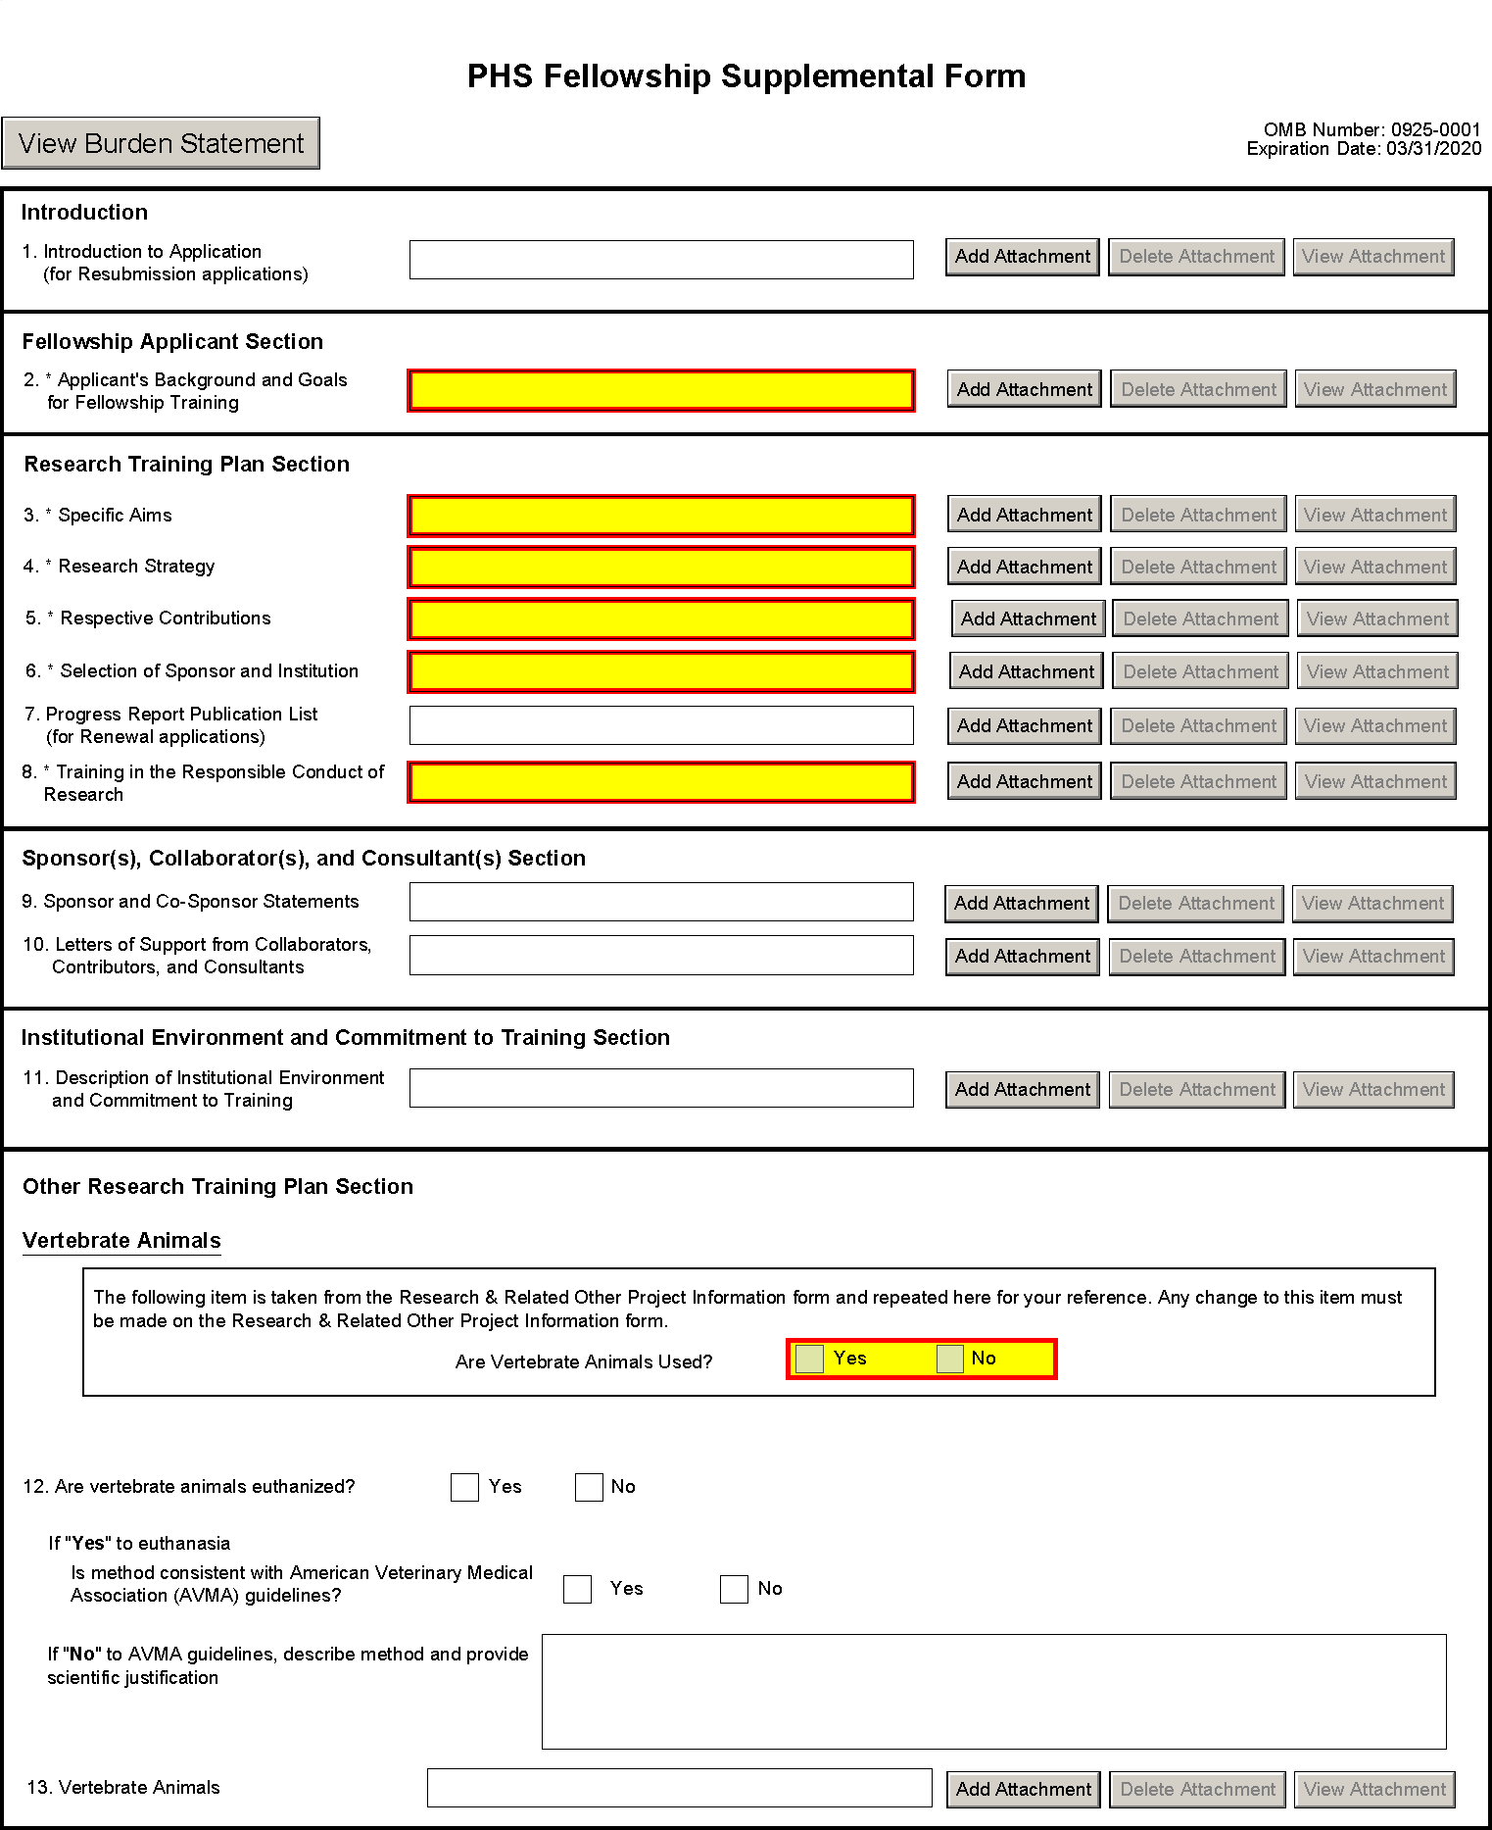

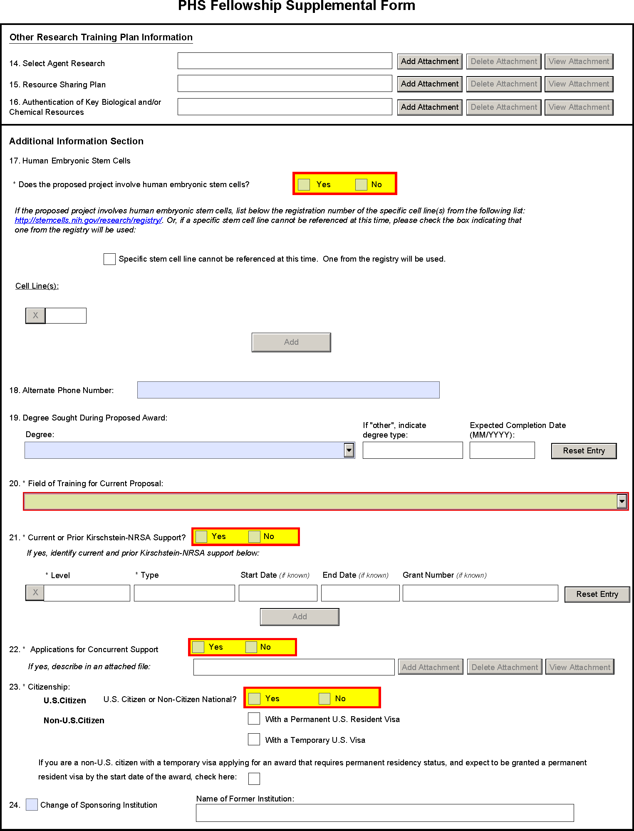

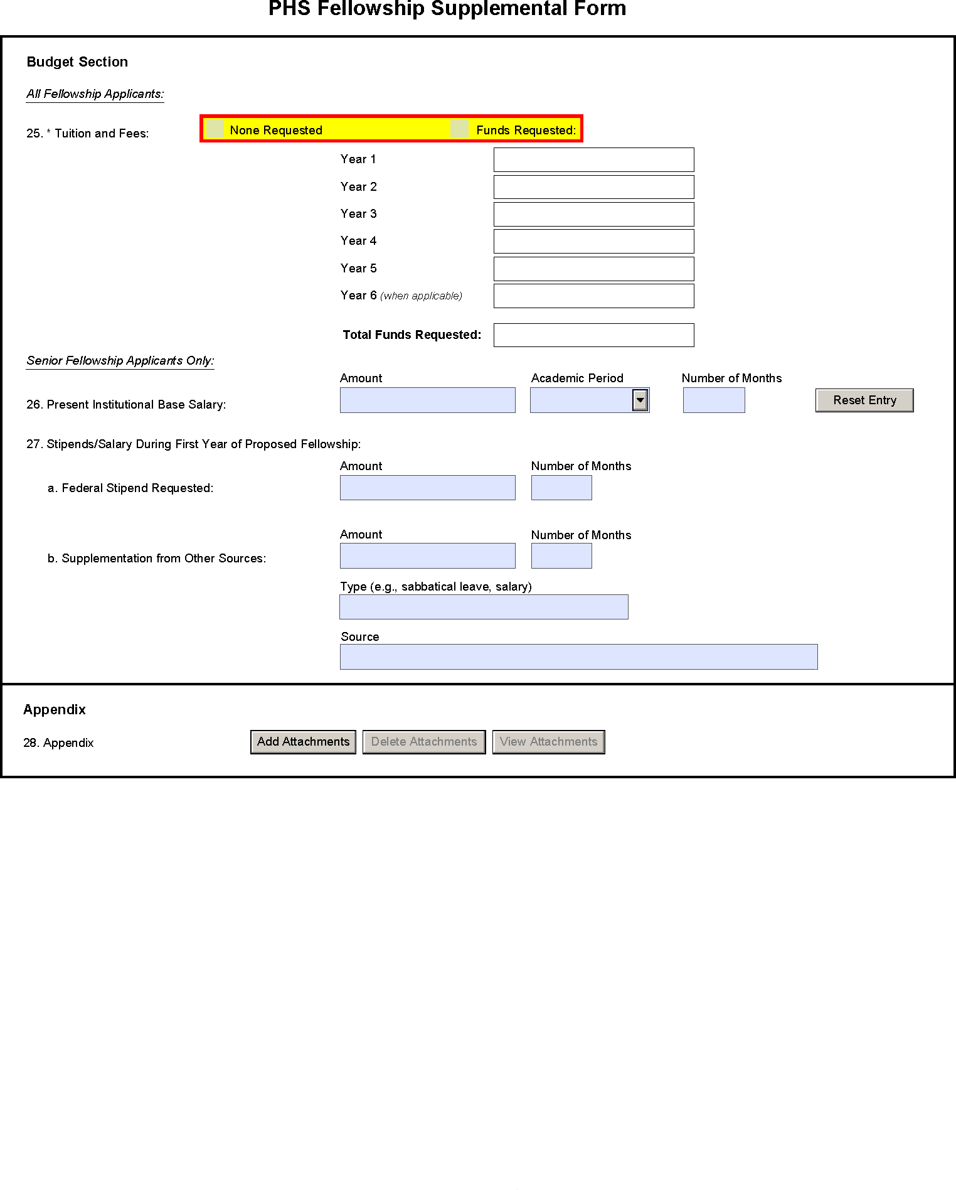

SBIR/STTR Information Form
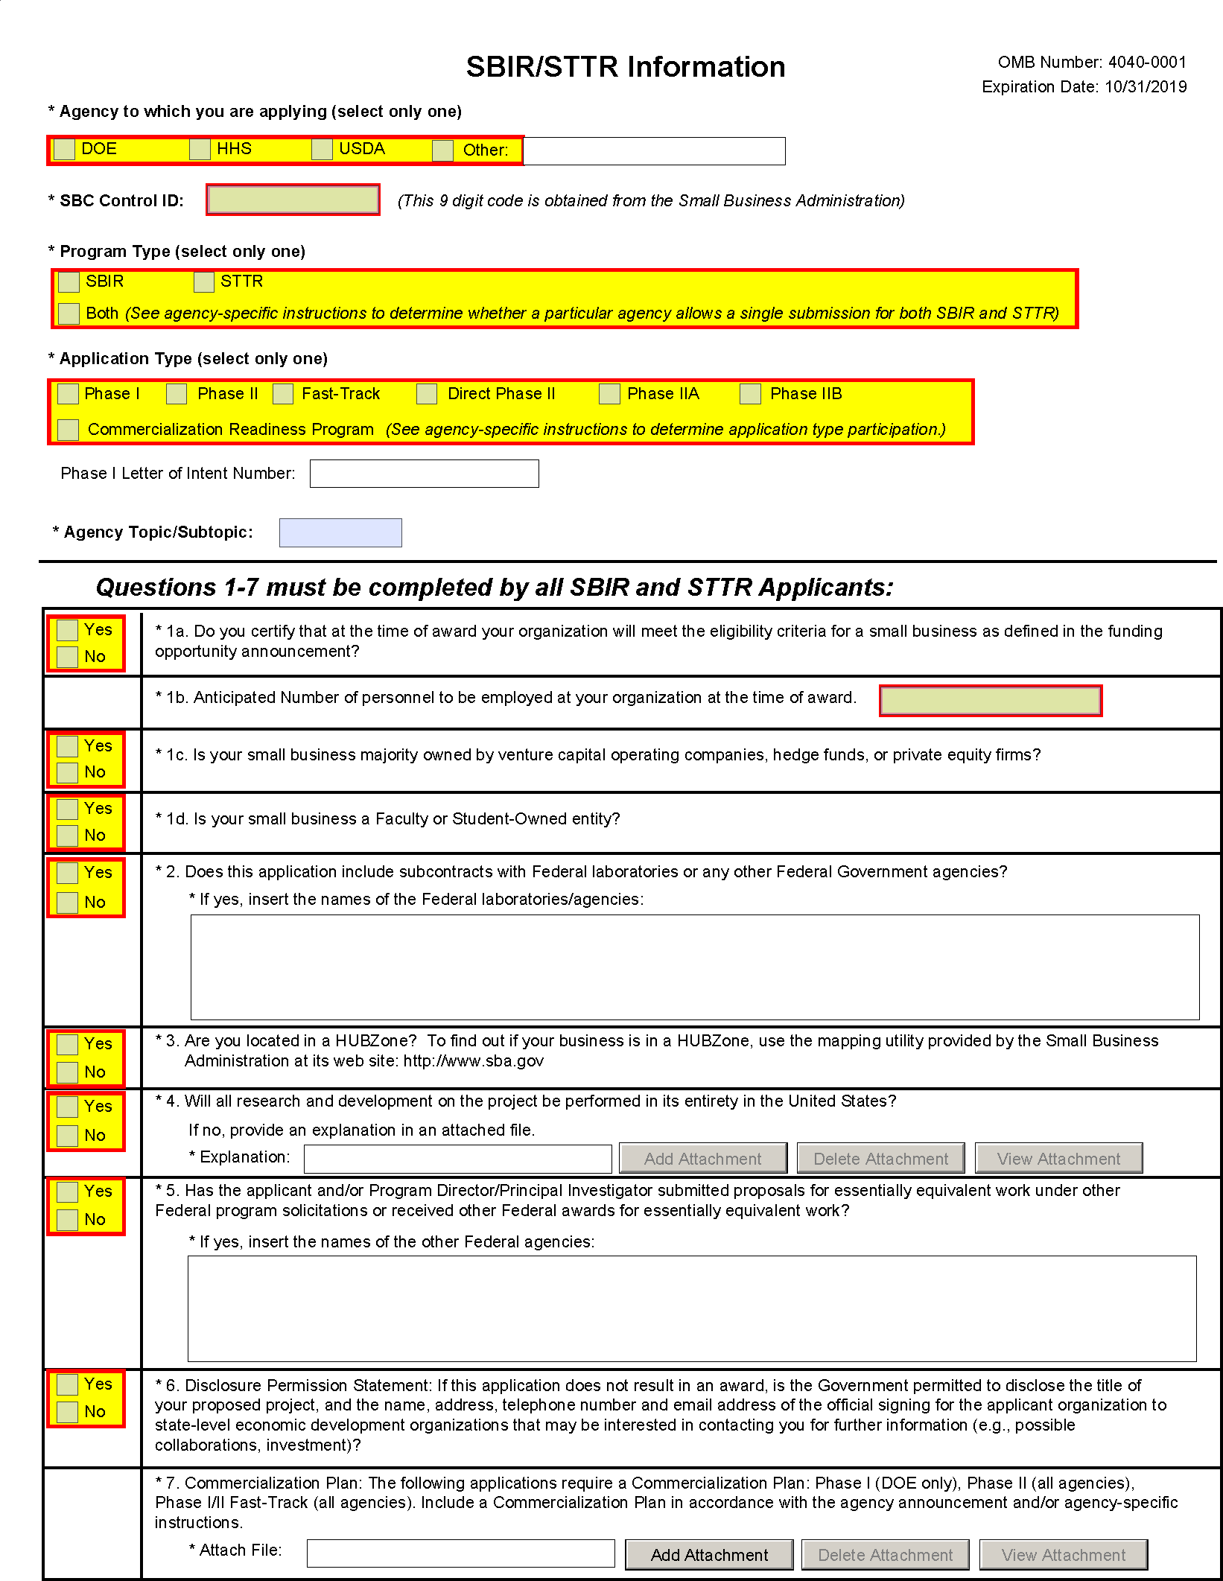

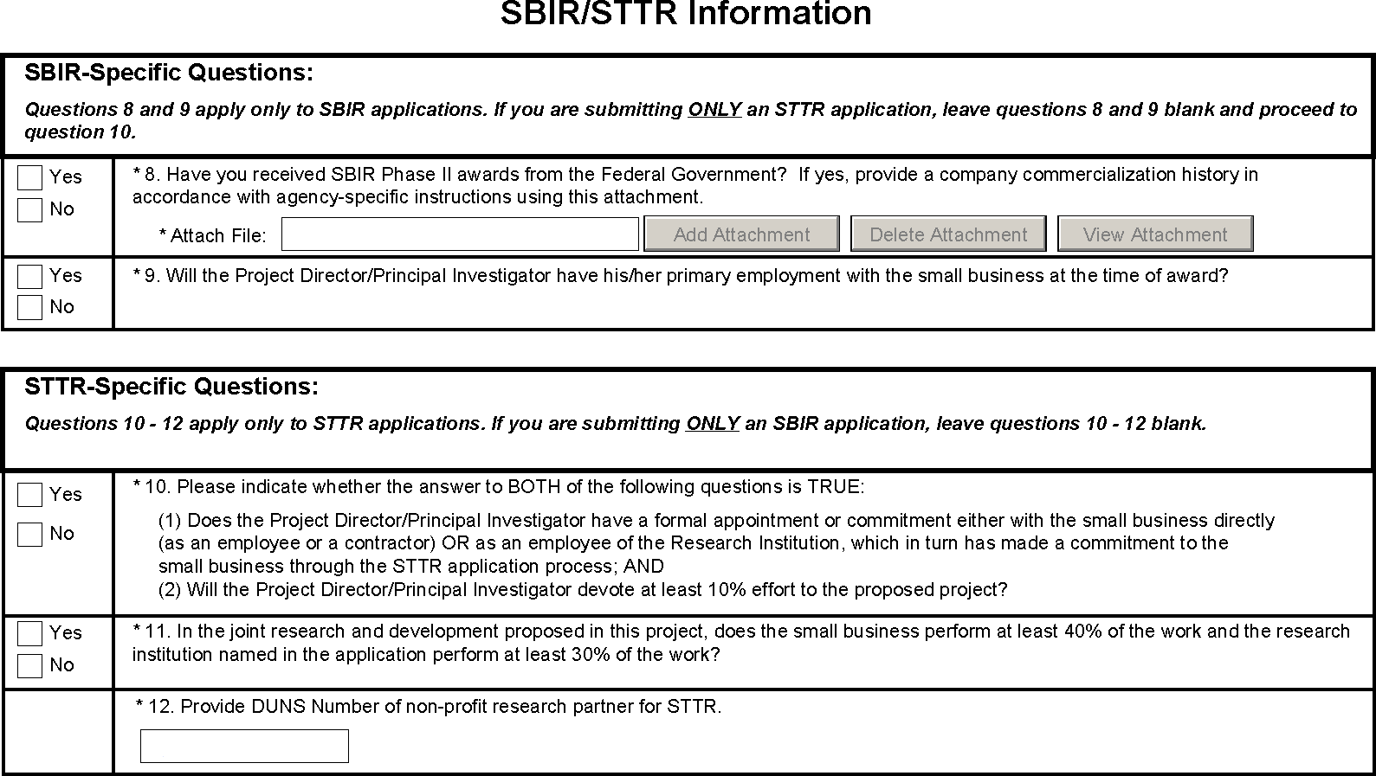

PHS Human Subjects and Clinical Trials Information
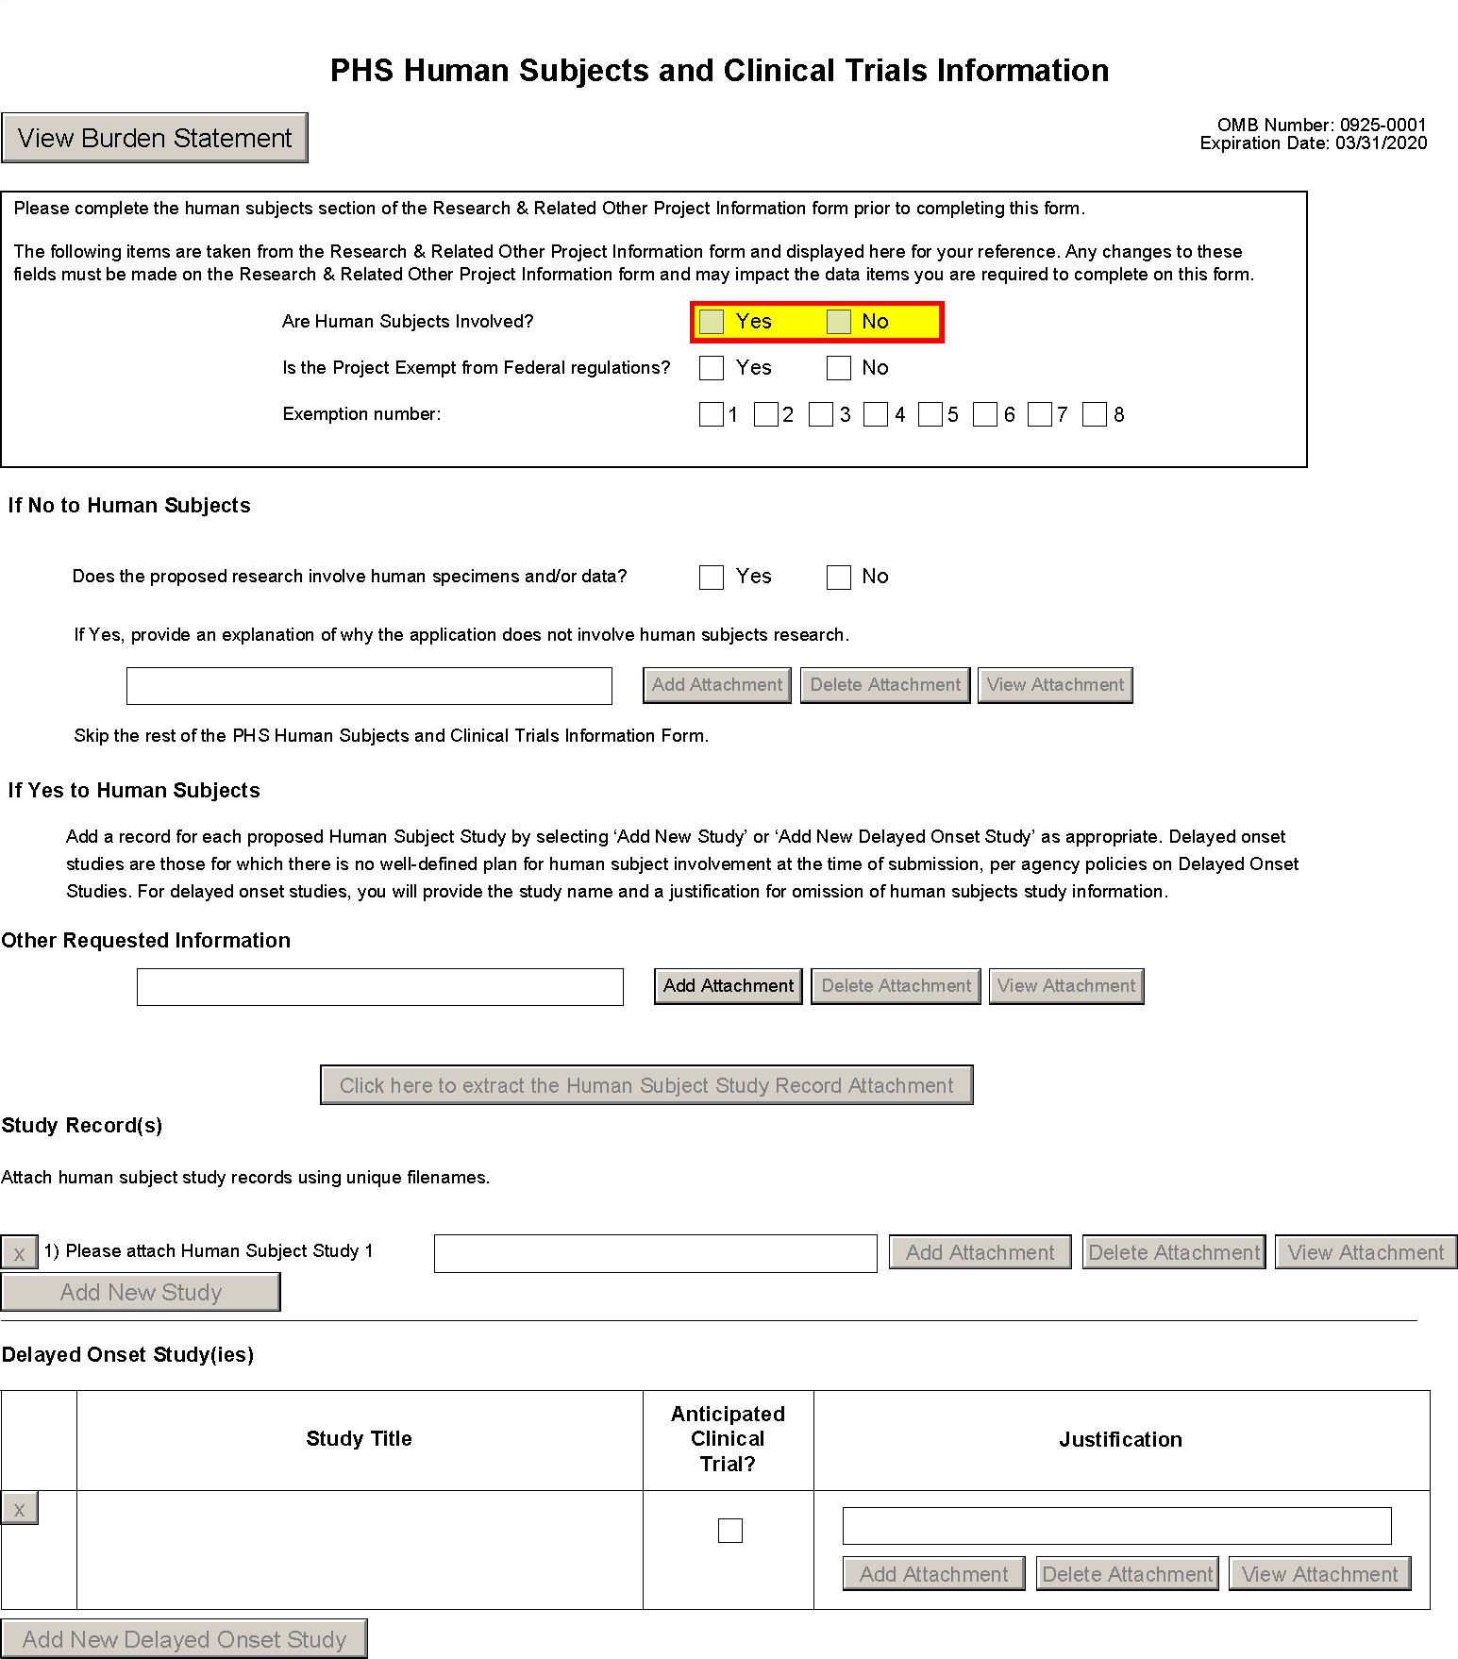

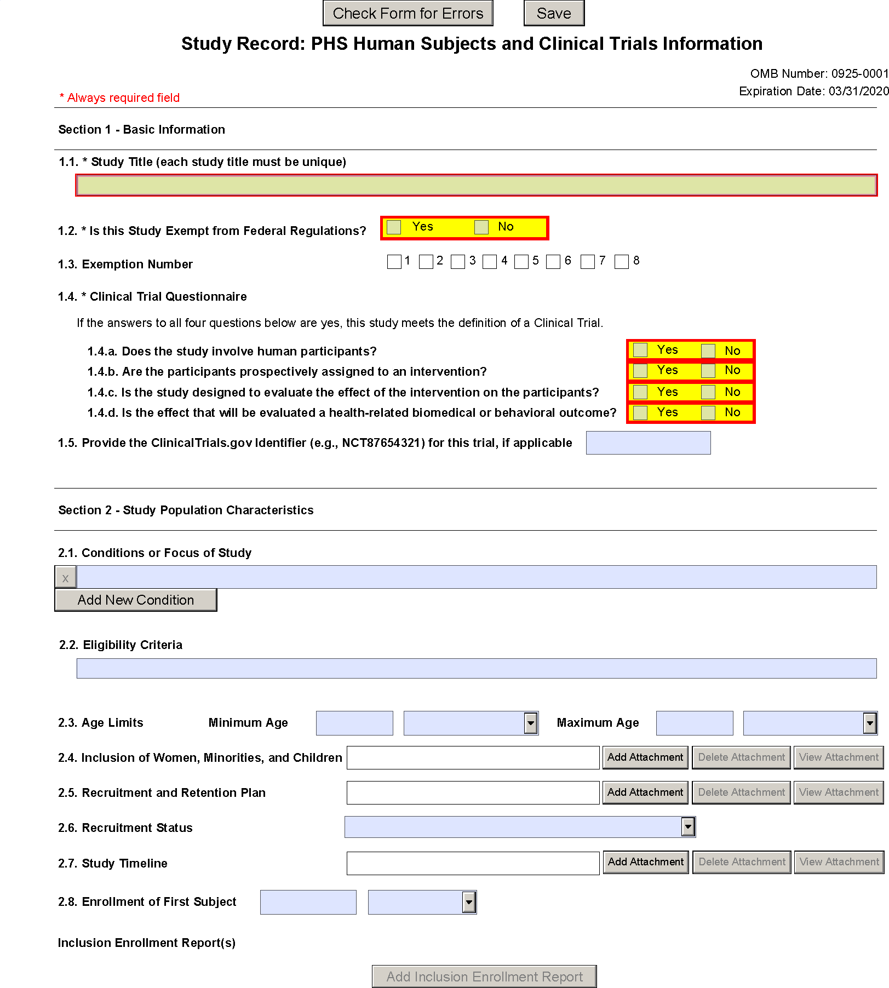

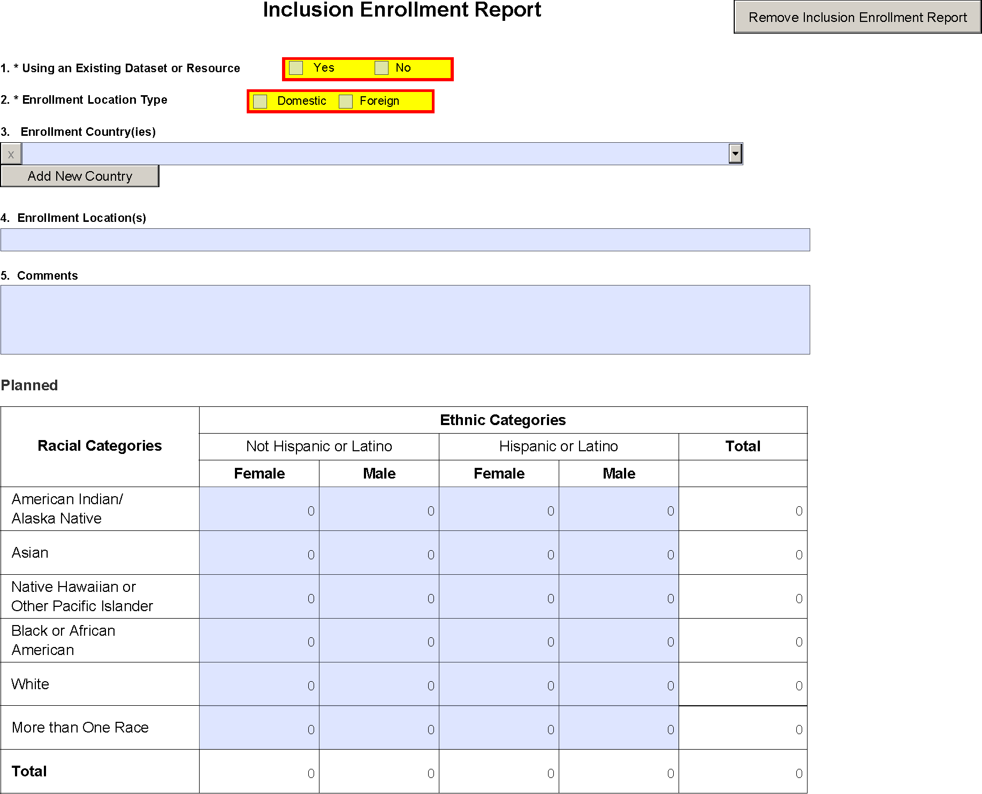

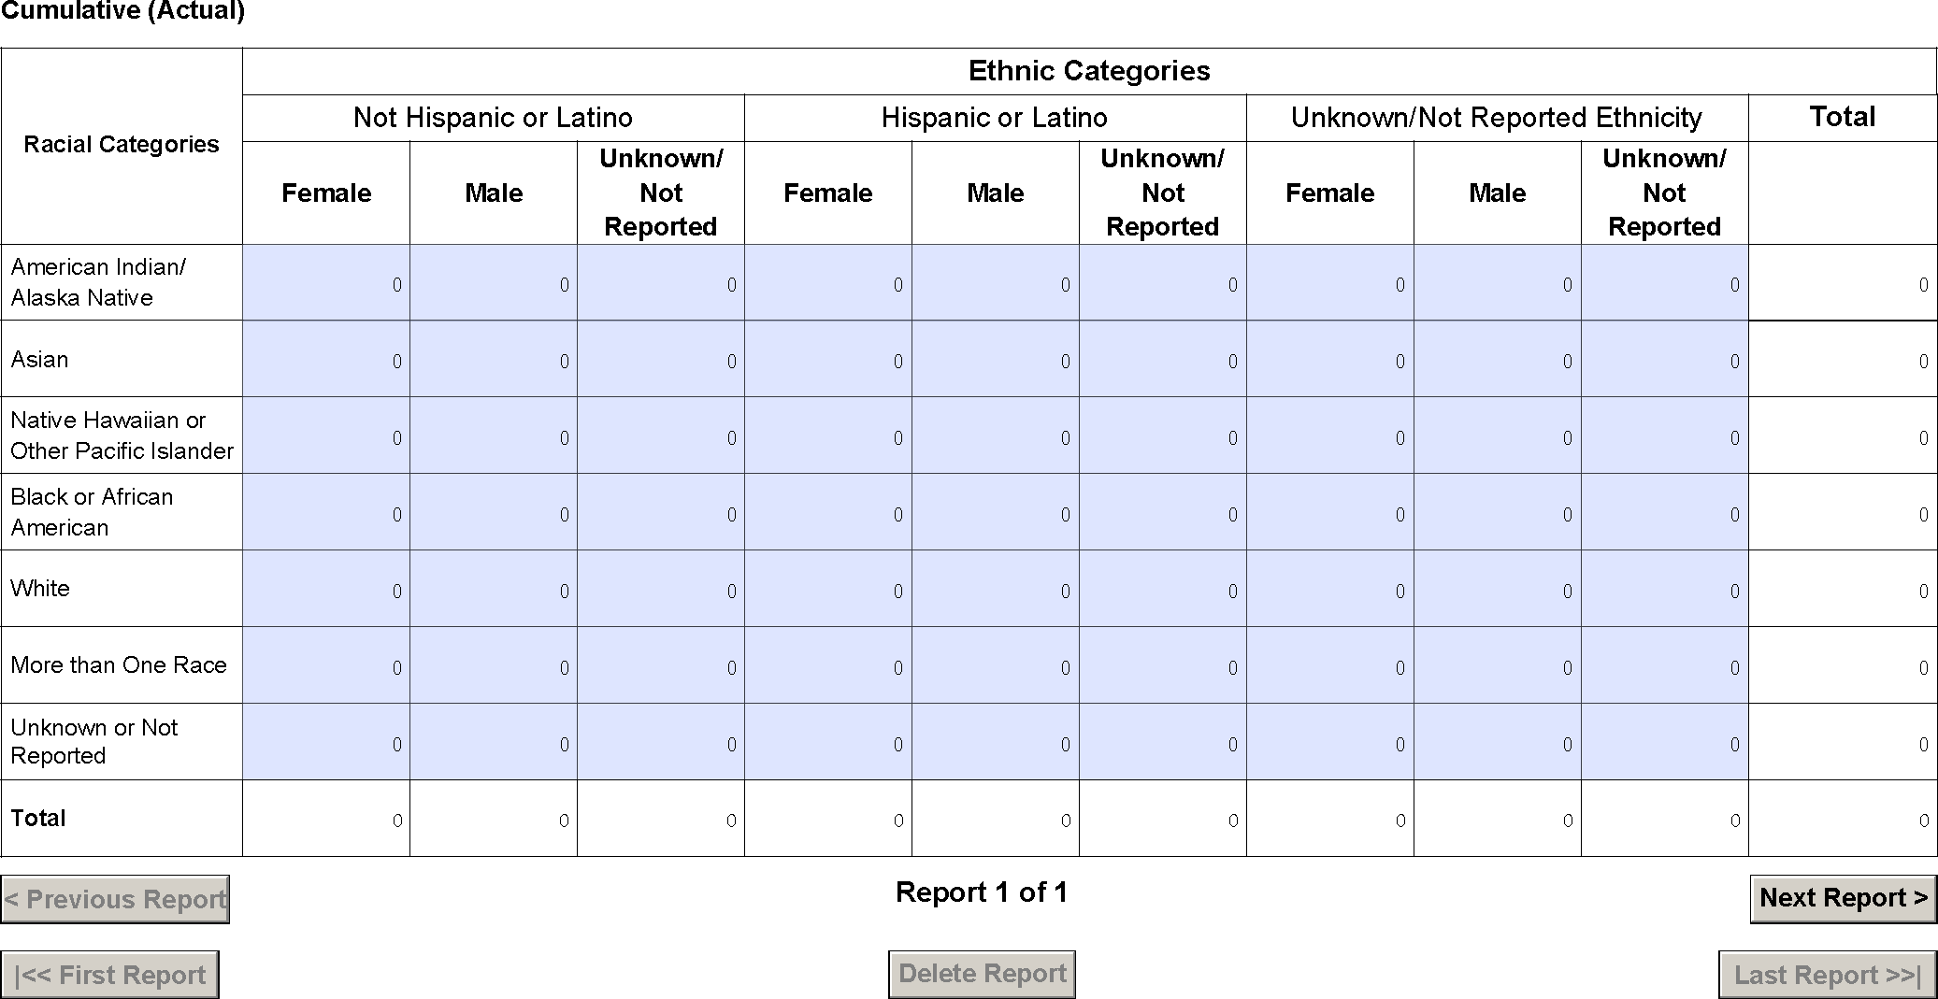

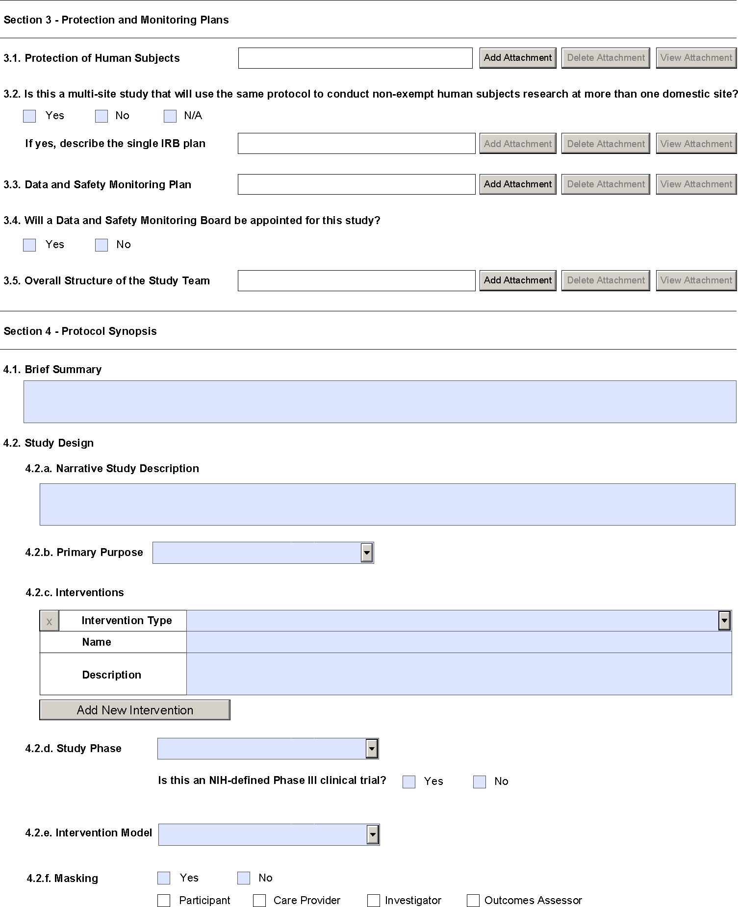

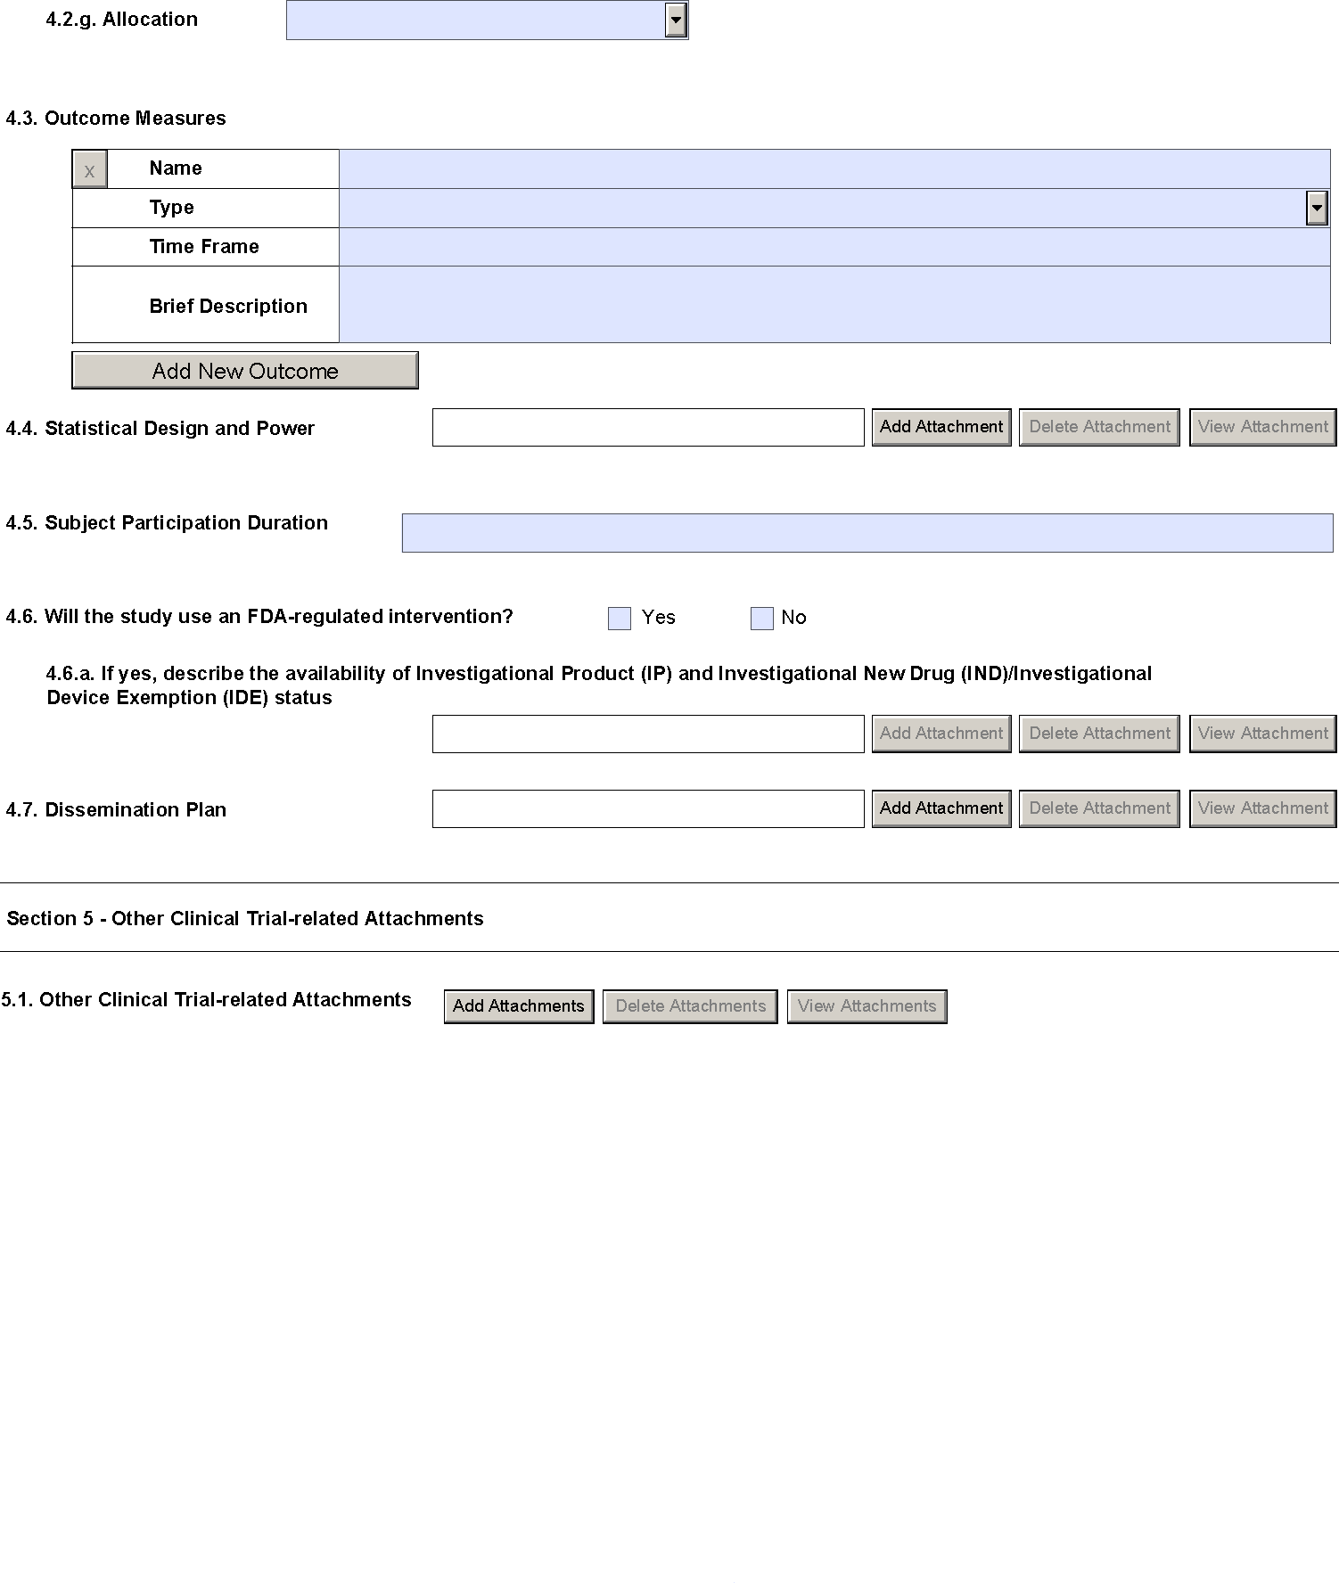

PHS Assignment Request Form
