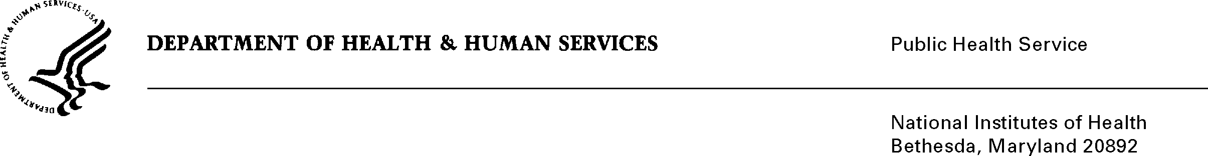

DATE: July 13, 2022

TO: NIH OMB Desk Officer
Office of Management and Budget (OMB)
Reports Clearance Officer, DHHS

FROM: Mikia P. Currie
Chief, Project Clearance Branch

SUBJECT: Change Request to a Currently Approved Form
(OMB # 0925-0001 and 0925-0002, Expiration Date 9/30/2024)

This is a request for OMB to approve a non-substantial modification to the following forms. The changes are outlined below.

- (OMB #0925-0001, 0925-0002) Changes to the Biographical Sketch Format Page and Other Support Format Page are requested to align with federal-wide efforts related to National Security Presidential Memorandum 33 (NSPM-33). NIH is implementing a new, optional field for the Biosketch and Other Support Format Pages for applicant senior/key personnel to provide a Digital Persistent Identifier that can be consistently used NIH-and-federal-wide to identify the individual. NIH is also implementing a signature and certification statement to the Biosketch Format Page. This new element will align the signature and certification statement on the Other Support Format Page. These items are critical for the senior/key personnel to certify the submission of their individual-level disclosure information. The certification statement was also updated for clarity and to specify legislative citations and consequences for violation of disclosure requirements. Additional details are specified below:

Biosketch Format Page (Fellowship and Non-Fellowship):
- Add field for applicants to provide a Persistent Identifier of the Senior/Key Person (PID) (e.g., ORCID ID). This optional element is added in alignment with National Security Presidential Memorandum 33 (NSPM-33).
- Add signature field and accompanying certification statement in alignment with the Other Support format page.
- Updates to the Application Instructions for the Biosketch to align with the new elements noted above.
- Provide the correct attachment version for the Non-Fellowship Biosketch format page, removing the ‘Start Date’ column in alignment with the previously approved instructions.

Other Support Format Page:
- Add field for applicants to provide a Persistent Identifier of the Senior/Key Person (PID) (e.g., ORCID ID). This optional element is added in alignment with National Security Presidential Memorandum 33 (NSPM-33).
- Updates to the certification statement within the signature field for clarity and to specify legislative citations for consequences of disclosure requirements.
- Updates to the Other Support instructions to align with the changes noted above.

- (OMB #0925-0001) Updated language in the SBIR Funding Agreement Certification and STTR Funding Agreement Certification to incorporate the latest policy directive language mandated by the Small Business Administration (SBA). This information is required for NIH to determine whether the business is eligible for a Small Business Innovation Research (SBIR) program or Small Business Technology Transfer (STTR) program award in accordance with SBA regulations.

- (OMB#0925-0002) Provide the correct attachment version of the RPPR Instruction Guide. Changes to the RPPR instrument updates were approved as part of the last revision submission, but the latest version of the instruction guide was inadvertently omitted from supporting documentation submitted. This version also includes recent, non-substantive RPPR module system look and feel updates (e.g., new menu buttons for actions and new table tools for navigation).

Attachments:

Biosketch Format Page Fellowship

Biosketch Format Page Non-Fellowship

General (Non-Fellowship) and Fellowship Biosketch Instructions

Other Support Format Page

Instructions for Completing Other Support

SBIR Funding Agreement Certification

STTR Funding Agreement Certification
RPPR Instruction Guide

Your full consideration is appreciated.

