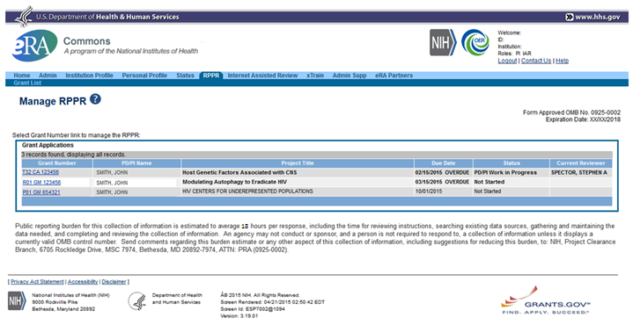

- Cover Page
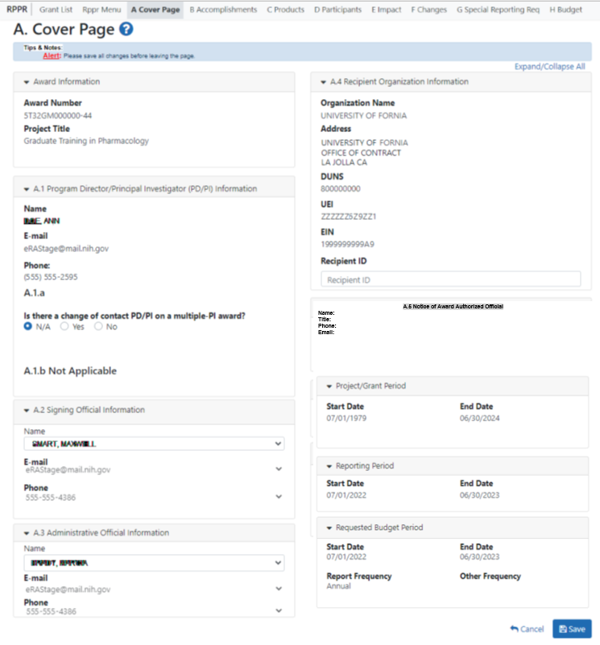

- Accomplishments (B1-3)

Accomplishments (B4-6)

- Products (C1)

Products (C2-5)
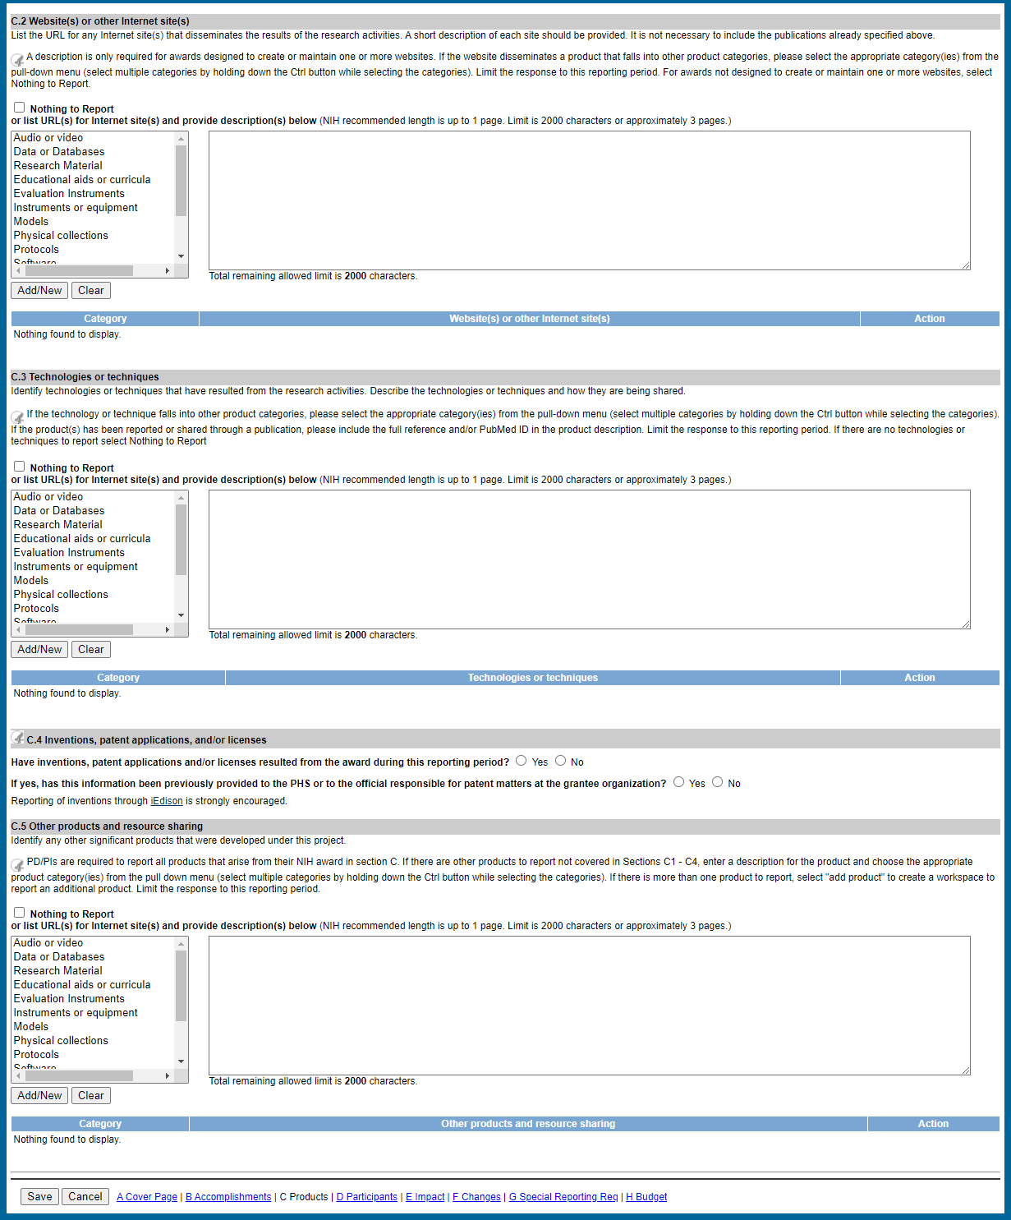
Products (C6) – System development mock-up in progress
C.6 Data Management and Sharing
C.6. a. Has scientific data been generated and shared during this reporting period? Describe activities related to the approved Data Management and Sharing Plan. Enter response below.

C.6.b. Are there changes to the Data Management and Sharing Plan?
- No Change
- Enter description of change and upload revised Data Management and Sharing Plan

- Participants (D1)

Participants (D2)

- Impact (E1-4)
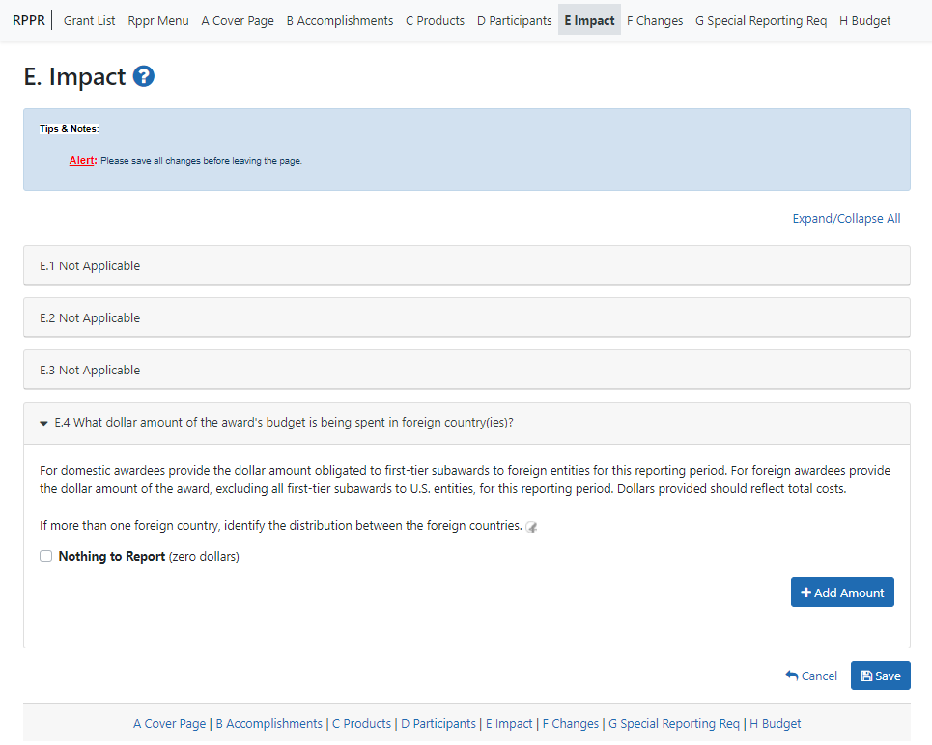

- Changes (F1-3)

- Special Reporting Requirements (G1-7)

Special Reporting Requirements (G8-13)

- Budget (H1-2)

- Outcomes (I1)
