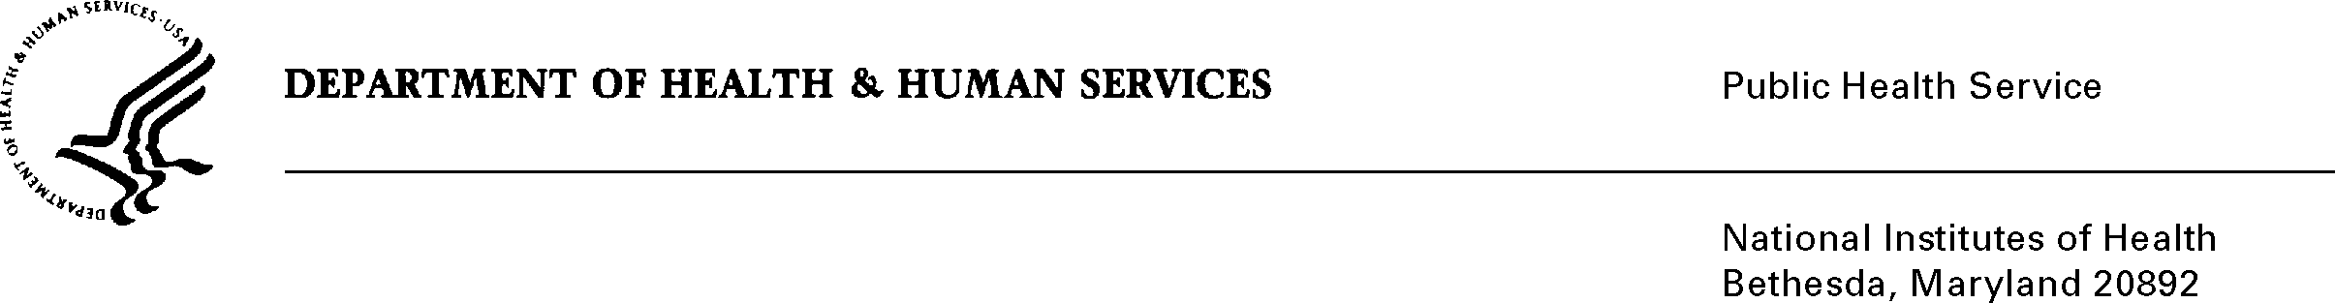

DATE: October 3rd, 2022

TO: NIH OMB Desk Officer
Office of Management and Budget (OMB)
Reports Clearance Officer, DHHS

FROM: Mikia P. Currie
Chief, Project Clearance Branch

SUBJECT: Change Request to a Currently Approved Form
(OMB # 0925-0740 Conference, Meeting, Workshop, and Poster Session Registration Generic Clearance (OD)

This is a request for OMB to approve a non-substantial modification to the above referenced clearance to revise the title. This reinstatement with change request was approved on September 21st, 2022 and included challenges and competitions as a means of promoting innovative solutions. As a result of including challenges and competitions, the title of this generic was revised but not corrected in ROCIS. The new title as mentioned in the supporting statement is “Conference, Meeting, Workshop, Registration and Challenges Generic Clearance (OD)”

Your full consideration is appreciated.

