**SUPPORTING STATEMENT**

**Part B**

*Online Submission Form for Supplemental Evidence and Data for Systematic Reviews for the Evidence-based Practice Center Program*

**Version:** *June 28, 2022*

Agency of Healthcare Research and Quality (AHRQ)

**Table of Contents**

**B. Collections of Information Employing Statistical Methods** 3

B1. The Potential Respondent Universe and any Sampling or other Respondent Selection Methods to be Used……………………………………………………………………….. 3

B2. The Procedures for the Collection of Information 3

B3. Methods to Maximize Response Rates and to Deal with Issues of Non-response…… 3

B4. Tests of Procedures or Methods to be Undertaken…………………………………… 3

**Appendixes**

Appendix A. Website Portal for Submission of Supplemental Evidence and Data for Systematic

Reviews

Appendix B. Opportunity to Submit Scientific Information E-mail

Appendix C. Federal Register Notice

**B. Collections of Information Employing Statistical Methods**

***B1. The Potential Respondent Universe and any Sampling or other Respondent Selection Methods to be Used***

AHRQ contacts industry stakeholders such as investigators, pharmaceutical and device manufacturers, app developers, and other non-governmental institutions and professional associations through the Effective Health Care Program (EHC) listserv and Evidence-based Practice Center listserv for the purposes of supplementing evidence and data (SEADS) collected from published and grey literature searches. 189,923 people are included on EHC listserv, and 129,326 are subscribed to the EPC listserv. Subscription to the listserves are voluntary. In some cases, we also post a note about the opportunity to submit SEADS through a Federal Register notice.

***B2. The Procedures for the Collection of Information***

The online submission form (OSF; see Attachment A) is set up to retrieve this information without creating a heavy burden on the responder. However, other than the OSF, stakeholders are able to respond to the request via email.

The OSF was developed to provide stakeholders with flexibility in how they respond to the request. At a minimum, respondents are requested to input their name along with the information packet.

Each SEADS submission portal is a single unique event reflecting the topic chosen by AHRQ and its partners that is not repeated unless it is deemed ready for an update at an undetermined future date.

***B3. Methods to Maximize Response Rates and to Deal with Issues of Non-response***

The information collection process is initiated with an email notification of the opportunity to submit SEADS via the EHC and EPC listservs (see Attachment B). In cases where AHRQ determines that a more general notice to the public is necessary, such as when there are not specific manufacturers of products under review, AHRQ may issue a Federal Register notice (see Attachment C) of the opportunity to submit SEADS.

***B4. Tests of Procedures or Methods to be Undertaken***

This approach has been used by AHRQ for over 5 years. Tests have been done to ensure that the OSF or user interface does not cause any confusion. AHRQ consults with the EHC webteam to ensure that best practices are used for the OSF and webpage. AHRQ regularly reviews SEADS submissions and any reports of issues with the EHC webteam to identify issues and ensure smooth functioning.

**Attachment A -- Website Portal for Submission of Supplemental Evidence and Data for Systematic Reviews**

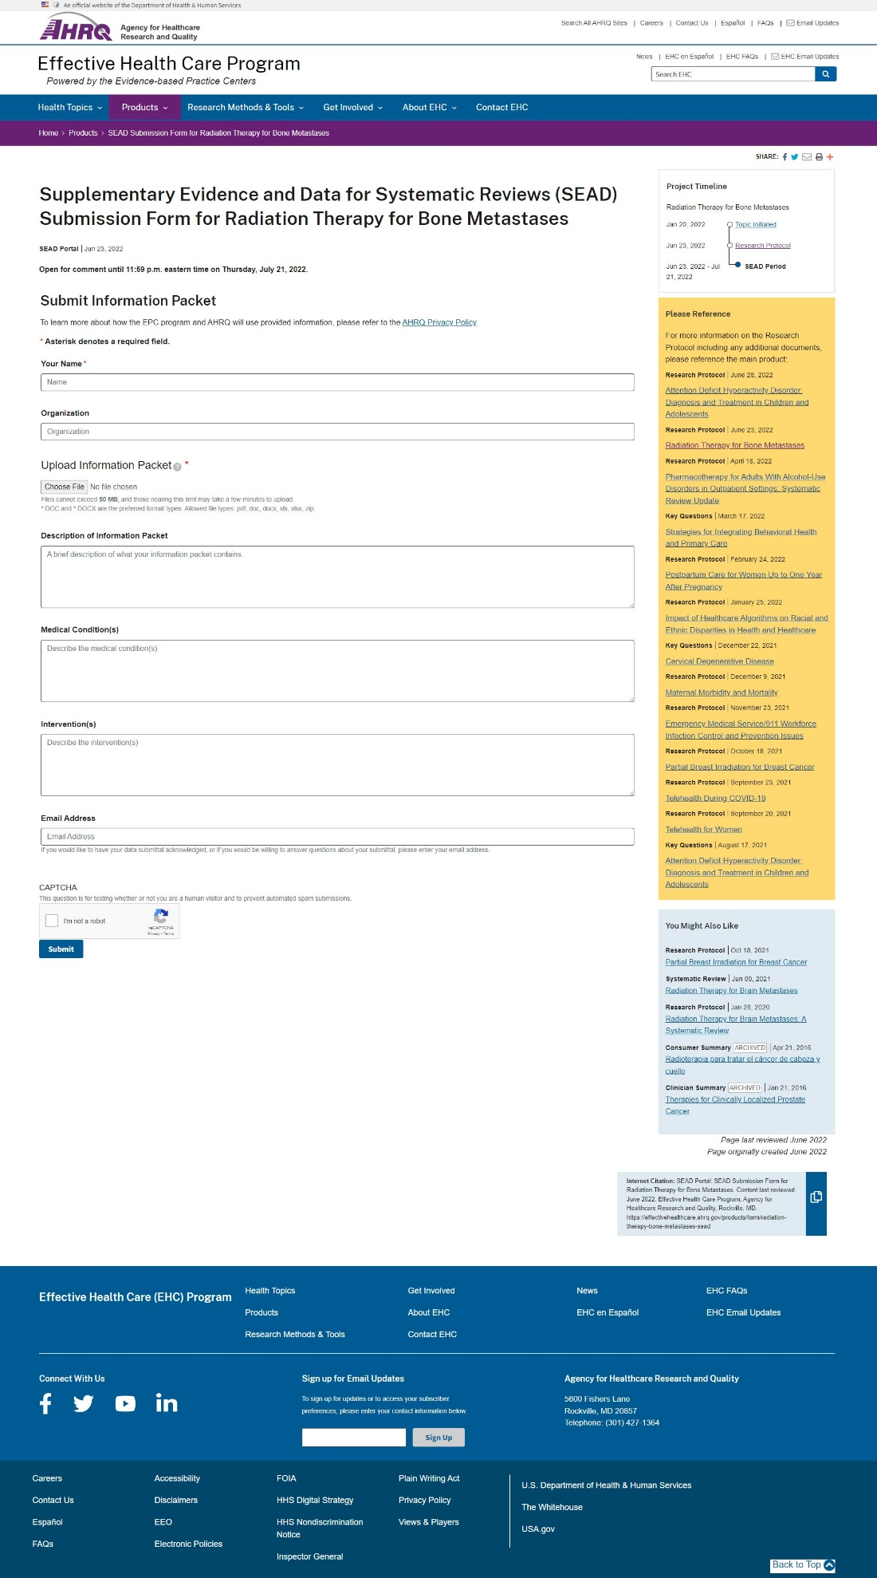

**Attachment B -- Opportunity to Submit Scientific Information E-mail**

|  |  |
| --- | --- |
| **From:** Agency for Healthcare Research and Quality (AHRQ) <updates@subscriptions.ahrq.gov> **Sent:** Thursday, March 10, 2022 5:23 PM **To:** Benns, Jenae (AHRQ/CEPI) <Jenae.Benns@ahrq.hhs.gov> **Subject:** EHC Program Update: Protocol on Postpartum Management of Women who Experience Hypertensive Disorders of Pregnancy Now Available |  |

|  |
| --- |
|  |
|  |

**Attachment C -- Federal Register Notice**

Billing Code: 4160-90-P

**DEPARTMENT OF HEALTH AND HUMAN SERVICES**

**Agency for Healthcare Research and Quality**

**Supplemental Evidence and Data Request on** **Pharmacotherapy for Adults with Alcohol-Use Disorders in Outpatient Settings: Systematic Review Update**

**AGENCY:** Agency for Healthcare Research and Quality (AHRQ), HHS.

**ACTION:** Request for Supplemental Evidence and Data Submissions

SUMMARY: The Agency for Healthcare Research and Quality (AHRQ) is seeking scientific information submissions from the public. Scientific information is being solicited to inform our review on *Pharmacotherapy for Adults with Alcohol-Use Disorders in Outpatient Settings: Systematic Review Update,* which is currently being conducted by the AHRQ’s Evidence-based Practice Centers (EPC) Program. Access to published and unpublished pertinent scientific information will improve the quality of this review.

**DATES:** *Submission Deadline* on or before [INSERT DATE 30 DAYS AFTER DATE OF PUBLICATION IN THE FEDERAL REGISTER].

**ADDRESSES:**

*E-mail submissions:* epc@ahrq.hhs.gov

*Print submissions*:

Mailing Address:

Center for Evidence and Practice Improvement

Agency for Healthcare Research and Quality

ATTN: EPC SEADs Coordinator

5600 Fishers Lane

Mail Stop 06E53A

Rockville, MD 20857

Shipping Address (FedEx, UPS, etc.):

Center for Evidence and Practice Improvement

Agency for Healthcare Research and Quality

ATTN: EPC SEADs Coordinator

5600 Fishers Lane

Mail Stop 06E77D

Rockville, MD 20857

**FOR FURTHER INFORMATION CONTACT:**

Jenae Benns, Telephone: 301-427-1496 or Email: epc@ahrq.hhs.gov.

**SUPPLEMENTARY INFORMATION:**

The Agency for Healthcare Research and Quality has commissioned the Evidence-based Practice Centers (EPC) Program to complete a review of the evidence for *Pharmacotherapy for Adults with Alcohol-Use Disorders in Outpatient Settings: Systematic Review Update.* AHRQ is conducting this systematic review pursuant to Section 902 of the Public Health Service Act, 42 U.S.C. 299a.

The EPC Program is dedicated to identifying as many studies as possible that are relevant to the questions for each of its reviews. In order to do so, we are supplementing the usual manual and electronic database searches of the literature by requesting information from the public (e.g., details of studies conducted). We are looking for studies that report on Pharmacotherapy for Adults with Alcohol-Use Disorders in Outpatient Settings: Systematic Review Update*,* including those that describe adverse events. The entire research protocol is available online at:

[https://effectivehealthcare.ahrq.gov/products/alcohol-misuse-drug-therapy/protocol](https://gcc02.safelinks.protection.outlook.com/?url=https%3A%2F%2Feffectivehealthcare.ahrq.gov%2Fproducts%2Falcohol-misuse-drug-therapy%2Fprotocol&data=04%7C01%7CJenae.Benns%40ahrq.hhs.gov%7Ce2b90e346d2a4cddbd6c08da1c8a3a24%7Cd58addea50534a808499ba4d944910df%7C0%7C0%7C637853677242934696%7CUnknown%7CTWFpbGZsb3d8eyJWIjoiMC4wLjAwMDAiLCJQIjoiV2luMzIiLCJBTiI6Ik1haWwiLCJXVCI6Mn0%3D%7C3000&sdata=FtIFTMY70%2FAMWCTuiOC1%2BqjNKnfIHEhkhDpHE67rZHQ%3D&reserved=0)

This is to notify the public that the EPC Program would find the following information on Pharmacotherapy for Adults with Alcohol-Use Disorders in Outpatient Settings: Systematic Review Update helpful:

* A list of completed studies that your organization has sponsored for this indication. In the list, please indicate whether results are available on ClinicalTrials.gov along with the ClinicalTrials.gov trial number.
  + For completed studies that do not have results on ClinicalTrials.gov, a summary, including the following elements: study number, study period, design, methodology, indication and diagnosis, proper use instructions, inclusion and exclusion criteria, primary and secondary outcomes, baseline characteristics, number of patients screened /eligible /enrolled /lost to follow-up /withdrawn /analyzed, effectiveness/efficacy, and safety results.
* A list of ongoing studies that your organization has sponsored for this indication. In the list, please provide the ClinicalTrials.gov trial number or, if the trial is not registered, the protocol for the study including a study number, the study period, design, methodology, indication and diagnosis, proper use instructions, inclusion and exclusion criteria, and primary and secondary outcomes.
* Description of whether the above studies constitute ALL Phase II and above clinical trials sponsored by your organization for this indication and an index outlining the relevant information in each submitted file.

Your contribution is very beneficial to the Program. Materials submitted must be publicly available or able to be made public. Materials that are considered confidential; marketing materials; study types not included in the review; or information on indications not included in the review cannot be used by the EPC Program. This is a voluntary request for information, and all costs for complying with this request must be borne by the submitter.

The draft of this review will be posted on AHRQ’s EPC Program website and available for public comment for a period of 4 weeks. If you would like to be notified when the draft is posted, please sign up for the e-mail list at: <https://www.effectivehealthcare.ahrq.gov/email-updates>.

*The systematic review will answer the questions below. This information is provided as background and AHRQ is not requesting that the public provide answers to these questions.*

Key Questions (KQ)

**KQ 1a**: Which medications are efficacious for improving consumption outcomes for adults with alcohol-use disorders in outpatient settings?

**KQ 1b**: How do medications for adults with alcohol-use disorders compare for improving consumption outcomes in outpatient settings?

**KQ 2a**: Which medications are efficacious for improving health outcomes (including functioning and quality-of-life outcomes) for adults with alcohol-use disorders in outpatient settings?

**KQ 2b**: How do medications for adults with alcohol-use disorders compare for improving health outcomes (including functioning and quality-of-life outcomes) in outpatient settings?

**KQ 3a**: What adverse effects are associated with medications for adults with alcohol-use disorders in outpatient settings?

**KQ 3b**: How do medications for adults with alcohol-use disorders compare for adverse effects in outpatient settings?

**KQ 4:** Are medications for treating adults with alcohol-use disorders effective in primary care settings?

**KQ 5:** Are any of the medications more or less effective than other medications for older adults, younger adults, smokers, or those with co-occurring disorders?

**PICOTS (Populations, Interventions, Comparators, Outcomes, Timing, and Setting)**

* Population(s)
  + Adults (age 18 years or older) with alcohol-use disorders
* Interventions
  + Pharmacotherapy for relapse prevention. This includes:
    - Medications approved by FDA for treating alcohol dependence:
      * acamprosate
      * disulfiram
      * naltrexone (oral or injectable)
    - Certain medications in use off label that are available in the United States:
      * baclofen
      * gabapentin
      * ondansetron
      * topiramate
      * prazosin
      * varenicline
  + Studies evaluating pharmacotherapy that used co-interventions with other treatments for AUDs (e.g., behavioral counseling, cognitive behavioral therapy, motivational enhancement therapy, psychosocial treatments, or self-help such as 12-step programs [e.g., Alcoholics Anonymous]) will be eligible for inclusion, as long as they meet other inclusion/exclusion criteria.
  + This review will not include pharmacotherapy for alcohol withdrawal.
* Comparators
  + Studies must compare one of the medications listed above with placebo or another eligible medication.
* Outcomes
  + Consumption outcomes
    - abstinence/any drinking
* rates of continuous abstinence
* percentage of days abstinent
* time to first drink/lapse
* time to heavy drinking/relapse
  + - reduction in alcohol consumption
* number of heavy drinking days
* percentage of subjects with no heavy drinking days
* number of drinking days
* drinks per drinking day
* drinks per week
  + Health outcomes
    - accidents
    - injuries
    - quality of life
    - function
    - mortality
  + Adverse effects of intervention(s)
    - withdrawals due to adverse events
    - nausea/vomiting
    - diarrhea
    - anorexia
    - palpitations
    - headache
    - dizziness
    - cognitive dysfunction
    - taste abnormalities
    - paresthesias (numbness, tingling)
    - metabolic acidosis
    - glaucoma
    - vision changes
    - suicidal ideation
    - insomnia
    - anxiety
    - rash
    - tiredness
    - weakness
    - constipation
* Timing
  + Studies with at least 12 weeks of planned pharmacologic treatment and followup from the time of medication initiation
* Setting
  + Outpatient healthcare settings; KQ 4 applies to primary care settings only (i.e., internal medicine, family medicine, obstetrics/gynecology, or college and university health clinics)

Dated:

**Marquita Cullom,**

*Associate Director.*