Expiration Date: XX/XXXX
APPENDIX A - Registration Screen Shots
Image 1

Self-Assign User ID and Password Page Example
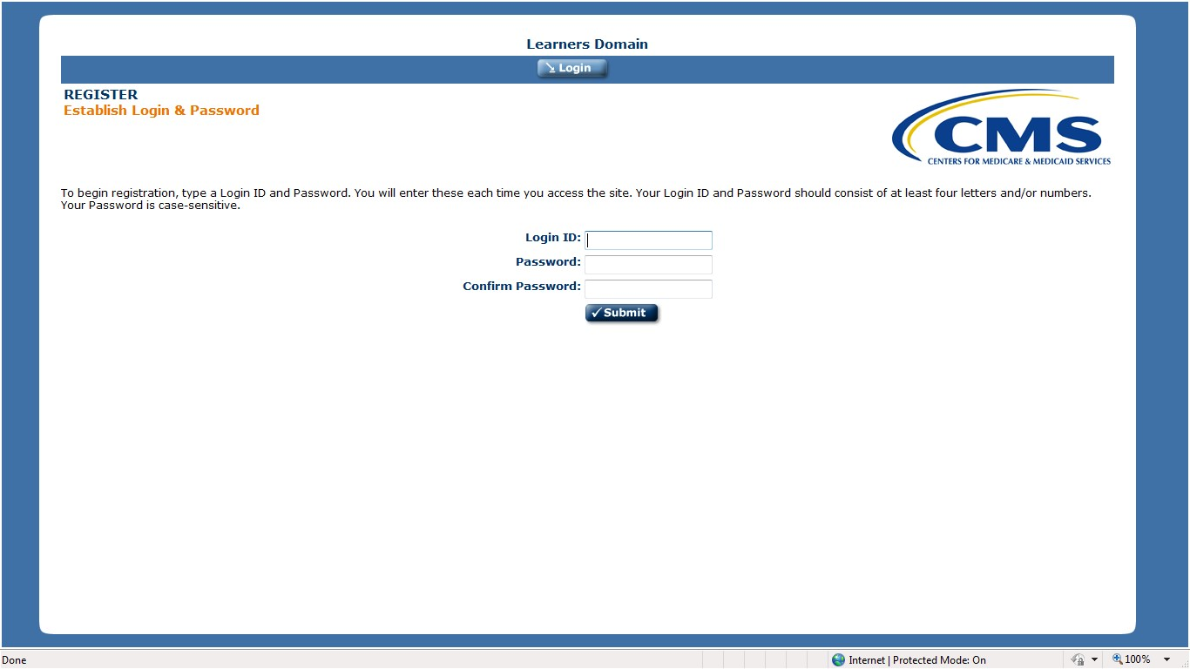

Registration Page Example
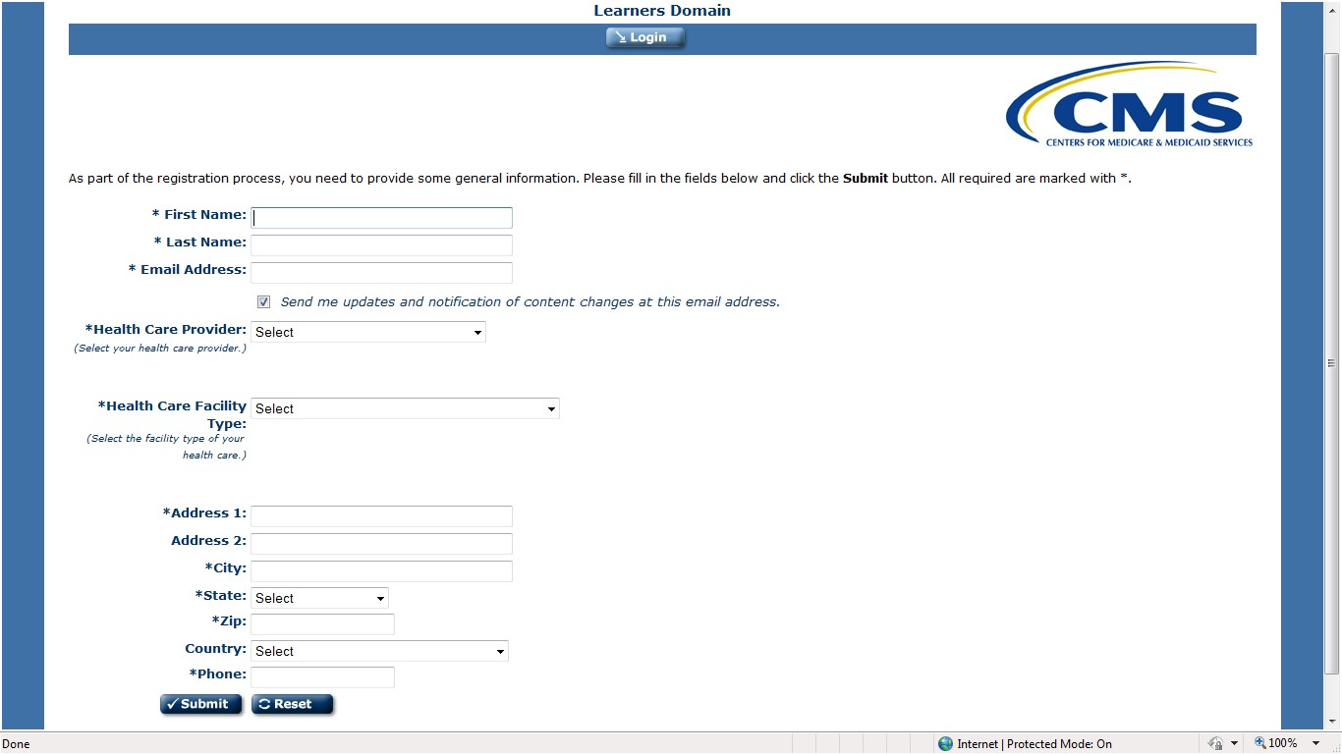

Curriculum Page Example

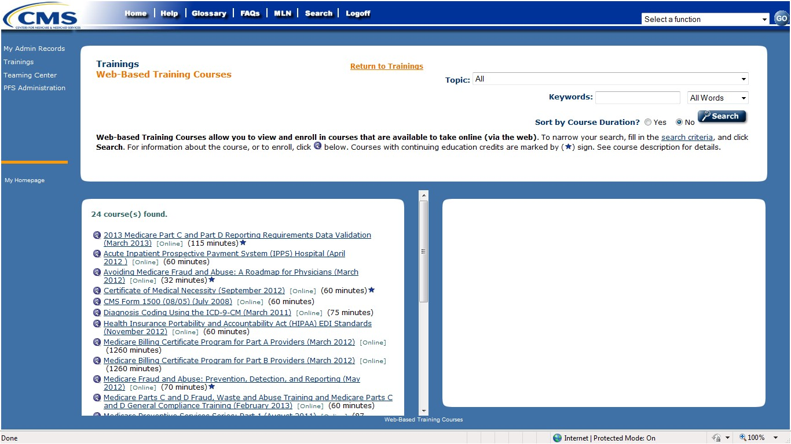

Transcript Page Example
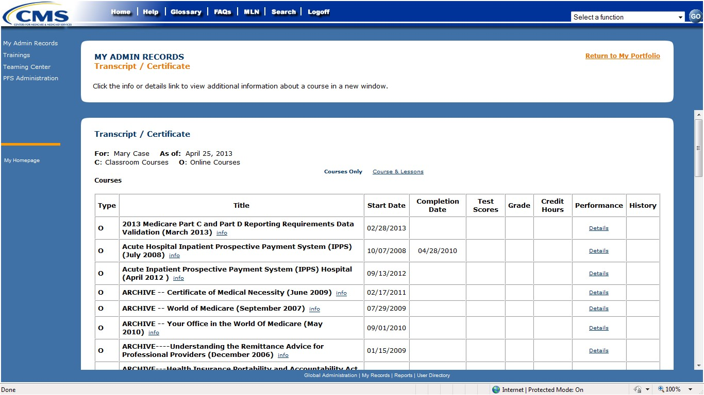

Certificate Example

