

DCIA Aging and Compliance Data Requirements

**for Guaranty Agencies**

**October 2022**

Financial Management Group

Financial Reporting and Analysis Division

*[This page intentionally left blank.]*

Table of Contents

1. Introduction 1

Aging Specifications

1. DCIA Aging Requirements 5

Data Set Specifications

1. Preparation of the Data Sets 11
2. MR-24 Collection Terminations Write-Off Data Set 13
3. MR-32 Loan Ending Balance Aging Data Set 21
4. MR-32 & MR-41 Loan Ending Balance Disposition Data Set 25
5. Submission to FSA 48

Appendixes…………………………………………………………………………………………………………….50

Appendix A – Sample GAFR / ED Form 2000 A

Appendix B – Presentation of MR-32 & MR-41 Loan Ending Balance Disposition Data Set in Microsoft Excel Format B

Appendix C – Mapping GA TOP Referral Business Rules to MR-32 & MR-41 Loan Ending Balance Disposition Data Set Lines C

Appendix D – Guaranty Agency List D

Appendix E – Glossary of Acronyms E

|  |  |  |  |
| --- | --- | --- | --- |
| **Version Control** | | | |
| **Version** | **Author** | **Date** | **Changes** |
| 1.0 | C. Alsop | 10/02/2019 | Approved by FSA and released for PRA clearance |
| 1.1 | C. Alsop | 1/13/2020 | Updated planned implementation date, Date Acquired Aging Methodology table, Title IV claim types table, and glossary |
| 1.2 | C. Carleton | 10/5/2022 | Minor edits; updated GA and FSA contacts |

# Introduction

Federal Student Aid (FSA) uses data supplied by its loan servicers to satisfy mandatory and ad- hoc debt collection reporting requirements related to receivables due from the public. FSA is required to submit receivable information to the United States Department of the Treasury (Treasury), the Office of Management and Budget (OMB), and the Chief Financial Officers’ Council (CFOC).

Treasury, OMB, and the CFOC use receivable financial data to:

* monitor the effectiveness of government-wide receivable management processes via performance metrics;
* improve data transparency by publicly releasing agency receivable data on a quarterly basis; and
* inform the United States Congress (Congress) annually of agency debt collection regulation compliance as required by the Debt Collection Improvement Act of 1996, as amended (DCIA).

## Purpose

The purpose of this document is to:

* communicate debt aging requirements per DCIA;
* capture detailed information pertaining to the status and collection of Federal Family Education Loan (FFEL) Program loans authorized by the Higher Education Act of 1965, as amended (HEA) and defined by Title IV of the HEA (Title IV) that is not currently available via the Guaranty Agency Financial Report (GAFR) (also known as the ED Form 2000);
* enable FSA to report complete and accurate data to Treasury, as required; and
* permit FSA to monitor Guaranty Agency (GA) compliance with DCIA.

### Limited Purpose of this Document

This specification document requires the GAs prepare three individual Data Sets, collectively called the DCIA Aging and Compliance Data Set (DCIA Compliance Data Set). To prepare the DCIA Compliance Data Set, this document references accounting transactions and GA-specific operational requirements (i.e., the GAFR, Internal Revenue Service (IRS) Form 1099-C reporting, etc.). Any references are solely intended to facilitate the GA’s efforts to prepare a compliant DCIA Data Set and are not intended to provide requirements beyond the scope of preparing the DCIA Compliance Data Set.

### Points of Contact for Technical Questions

Post-implementation, please submit any technical questions about these requirements via email to the following email addresses:

To: [FSAFinancePortfolio@ed.gov](mailto:FSAFinancePortfolio@ed.gov) CC: [callis.carleton@ed.gov](mailto:callis.carleton@ed.gov)

To facilitate identification, please enter “DCIA Compliance Technical Question” in the email subject line.

## Scope

The scope of this requirements document is the DCIA-specific aging and compliance data requirements. The scope of each of the three Data Sets is discussed later in this document. The three Data Sets are:

* MR-24 Collection Terminations Write-Off Data Set
* MR-32 Loan Ending Balance Aging Data Set
* MR-32 & MR-41 Loan Ending Balance Disposition Data Set

### Scope Limitations

The guidance contained in this document is based upon FSA’s policies and business processes as of the date of this document, unless otherwise noted. Any future revision to FSA’s policies and/or business processes may require FSA to update and reissue these requirements.

## Frequency

GAs must prepare and submit the individual Data Sets on a monthly or annual basis as follows:

***Table 1.3 Data Set Frequency***

|  |  |
| --- | --- |
| **Data Set** | **Frequency** |
| MR-24 Collection Terminations Write-Off Data Set (Write-Off Data) | Annually |
| MR-32 Loan Ending Balance Aging Data Set (Aging Data) | Monthly |
| MR-32 & MR-41 Loan Ending Balance Disposition Data Set (Disposition Data) | Monthly |

## Document Organization

This document is organized into the following sections:

***Table 1.4 Organization of Requirements Document***

|  |  |
| --- | --- |
| **Section** | **Section Description** |
| 1.0 | Introduction: This section provides an overview of the purpose, scope, and frequency requirement for the reports listed in this document. |
| **Aging Specifications** | |
| 2.0 | DCIA Aging Requirements: This section summarizes the DCIA- compliant aging methodologies applicable to Title IV debt held by GAs. |
| **Data Set Specifications** | |
| 3.0 | Preparation of the Data Sets: This section provides important information necessary to prepare the DCIA Compliance Data Set. |
| 4.0 through 6.0 | DCIA Compliance Data Set Specifications: These sections provide details regarding each Data Set’s purpose, scope, frequency, and layout. Line-by-line instructions and a presentation view of the Data Set are also included in each section. |
| 7.0 | Submission to FSA: This section explains how to package the files for submission to FSA. |
| **Appendixes** | |
| A | This appendix presents an example of an approved GAFR. |
| B | This appendix presents an example of the Disposition Data Set when uploaded to Microsoft Excel. |
| C | This appendix provides a mapping of GA TOP Referral Business Rules to the Disposition Data Set lines. |
| D | This appendix lists active GAs by their GA codes. |
| E | This appendix lists commonly used acronyms referenced throughout this document. |

*[This page intentionally left blank.]*

# DCIA Aging Requirements

## Background

This section describes the compliant methodologies for aging Title IV loan debt for DCIA purposes1. This section also explains how to determine a loan’s eligibility for referral to the Treasury Offset Program (TOP) based upon the loan’s age of delinquency (i.e., greater than 120 days delinquent). This section also explains how to age DCIA-aged debt in accordance with the United States Department of Education (the Department) and Treasury’s Office of General Counsel (OGC) guidance. The methodology described in this section is independent of the methodologies followed to age debt for other purposes including for Title IV. As such, this guidance is not intended to revise or replace any of other aging methodologies the GAs are required to follow.

## Definitions of Key DCIA-Related Terms

Listed below are key DCIA-related terms used later in this section and throughout this document. To facilitate identifying these terms, all key terms are capitalized.

* **DCIA Aging Methodology for Title IV Loan Debt**: The methodology to age Title IV loan debt for DCIA purposes including determining a debt’s eligibility for referral to TOP based upon its age. Section 2.3 of this document includes a full description of the DCIA Aging Methodologies including: 1) criteria for identifying debt to apply the methodology, 2) methodology for determining debt age in number of days, 3) methodology for calculating dollar amount to report, and 4) criteria for transitioning to another aging methodology.
* ***Title IV* Default:** Per *Title IV*, a loan enters default if the loan exceeds 270 days of delinquency. 2 Based upon existing business processes, all *Title IV* debt held and serviced by a GA is in *Title IV* Default.

1 The aging methodology to follow and consequently how to age GA-held debt is independently determined for each individual debt.

2 20 U.S.C. 1085(*l*)

* ***Title IV* Claim Types:** Per *Title IV*, a GA can request reimbursement from FSA for Defaults and other FFEL Program claims it paid to lenders. Claims paid to lenders and included in the federal receivable3 are aged. Claims paid to lenders and not included in the federal receivable are not aged and, as a result, neither of the two GA-applicable DCIA Aging Methodologies are applicable.

|  |  |  |
| --- | --- | --- |
| ***Title IV* Claim Types** | **Included**  **in the Federal Receivable and Aged for DCIA** | **Not Included**  **in the Federal Receivable and Not Aged for DCIA** |
| * Defaults | * Death/Disability4 |
| * Exempt/Lender-of-Last- Resort (LLR) | * Closed School/False Certification |
|  | * Bankruptcy |
|  | * Unpaid Refunds |
|  | * Other Discharges5 |

## DCIA Aging Methodologies Applicable to GAs

Per DCIA, there are two distinct aging methodologies applicable to GAs. The appropriate methodology is determined by the *Title IV* Claim Type of the debt (i.e., Defaults, Exempt/LLR are included in the federal receivable and aged; all other claim types are not included in the federal receivable nor aged).

The remainder of this section describes each of the two DCIA aging methodologies in more detail. Note, per DCIA, there are only two possible DCIA Delinquency Statuses – Current or Delinquent. Based upon existing business processes, debt held by a GA is always “delinquent” for DCIA purposes.

3 The federal receivable is defined as the amount reported on MR-32 Ending Balance of Defaulted Loans. The amount reported on MR-32 is reported on FSA’s financial statements.

4 Disability claims are also called Total and Permanent Disability Discharge (TPD Discharge) claims.

5 Other discharges include Teacher Loan Forgiveness Program discharges and partial discharges of consolidation loans.

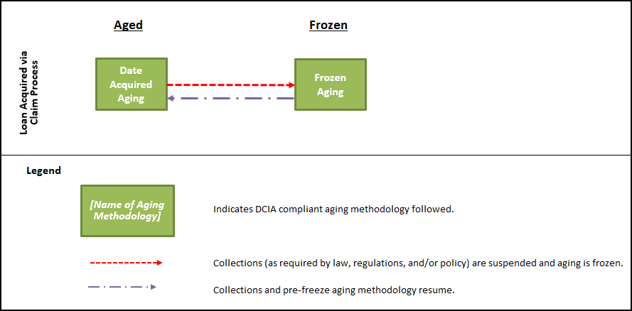

**Figure 1 - Relationship between DCIA Aging Methodologies for Debt Held by GAs**

### Date Acquired Aging

For DCIA purposes, a debt in the Default Title IV Loan Status should be aged using the Date Acquired Aging Methodology unless the Frozen Aging Methodology is triggered.

The following table describes the Date Acquired Aging Methodology.

***Table 2.3.1 Date Acquired Aging Methodology***

|  |  |  |
| --- | --- | --- |
| **Date Acquired Aging Methodology** | **Applicability and Criteria** | |
| *Applicable for Title IV*  *Claim Types* | * Defaults * Exempt/LLRs |
| *Criteria to Start Aging Methodology:* | * Default claim debt acquired by FSA via the FFEL claim process (i.e., GA pays a lender’s default claim). |
| **Methodology** | |
| *Determining Age* | * Number of days delinquent (i.e., delinquency) equals current date less date the GA paid the lender’s claim (claim date). (Note: If collection on a default claim is suspended, aging should resume from the date the GA restarts its   collection efforts.) |
| *Valid DCIA*  *Delinquency Status(es)* | * Delinquent6 |
| *Determining Dollar Value of Delinquency* | * Dollar value of delinquency is the accelerated full balance due including principal, interest, and fees. |
| **Transition to Another DCIA Aging Methodology** | |
| *Aging Methodology*  *and Criteria for Switching:* | * Frozen Aging – Collections on a default claim debt are suspended as required by law, regulation, and/or policy. |

6 “Delinquent” is the only valid DCIA Delinquency Status for this aging methodology because based upon existing business processes, all *Title IV* debt held by GAs is delinquent.

### Frozen Aging

For DCIA purposes, a debt in the Default Title IV Loan Status should be aged using the Frozen Aging Methodology unless the Date Acquired Aging Methodology is triggered. This methodology should be followed for the duration of the event that triggered the suspension of collection efforts and froze the age of the debt.

The following table describes the Frozen Aging methodology.

***Table 2.3.2 Frozen Aging Methodology***

|  |  |  |
| --- | --- | --- |
| **Frozen Aging Methodology** | **Applicability and Criteria** | |
| *Applicable for Title IV*  *Claim Types* | * Defaults * Exempt/LLRs |
| *Criteria to Start Aging Methodology:* | * GA suspends collection efforts for a default claim debt as required by law, regulation, and/or policy.7 |
| **Methodology** | |
| *Determining Age:* | * Age of debt is frozen as of the date the loan entered the Frozen Aging Methodology. |
| *Valid DCIA*  *Delinquency Status(es):* | * Delinquent8 |
| *Determining Dollar Value of Delinquency:* | * Dollar value of delinquency is the accelerated full balance due as of entering the Frozen Aging Methodology (since the accrual of interest and fees is also frozen). |
| **Transition to Another DCIA Aging Methodology** | |
| *Aging Methodology and Criteria for*  *Switching:* | * Date Acquired Aging – For default claim debt, the GA resumes collection efforts. |

7 Events that may warrant suspended collections include a defaulted debt meeting the criteria for the military deployment benefit, pending discharge due to death, pending discharge due to TPD, and bankruptcy stay/hold.

8 Delinquent” is the only valid DCIA Delinquency Status for this aging methodology because based upon existing business processes, all *Title IV* debt held by GAs is delinquent.

*[This page intentionally left blank.]*

# Preparation of the Data Sets

## Common Requirements

Sections 4.0–6.0 provide line-by-line instructions explaining the specific information required for each Data Set requirement. Appendixes B and C contain supplemental information which should be used when developing and preparing the Disposition Data.

### Common Requirements

The collective DCIA Compliance Data Set must comply with the requirements listed below.

***Table 3.1.1 Common Requirements for the DCIA Compliance Data Set***

|  |  |
| --- | --- |
| **Common Requirements** | |
| 1. | Report *“*Number” as the quantity of debts (i.e., number of loans). |
| 2. | Report “Dollars” as the sum of all amount types (i.e., principal, interest, and other fees9, if applicable) that result in activity or a balance. |
| 3. | Sum all activity and balances for a line. If the total results in a debit balance, report the amount as positive. If the total results in a credit balance, report the amount as negative. |
| 4. | Do not use commas for amounts that have four or more digits. For example,  $2,758.39 should be entered as 2758.39; 1,078 debts should be entered as 1078. |
| 5. | Enter all dollar amounts rounded to the nearest cent/penny. Enter all debt quantities as whole numbers without cents/pennies. |
| 6. | Enter a debt number of “0” and dollar amount of “0.00”, unless otherwise stated, if there are no debts that meet the reporting requirements for a given line. |
| 7. | Do not password protect report files unless required to by FSA or your agency’s data protection policies (i.e., because the files contain personally identifiable information or sensitive data). |
| 8. | Submit each data requirement as a Comma-Separated Value [Comma Delimited] (CSV) file and follow the layout specified. |

9 Examples of possible other fees include late charges, collection costs, and attorney’s fees.

## Section Outline

Each Data Set requirement section follows a consistent outline or format. Specifically, each requirement contains the following sections:

* Purpose
* Scope
* Frequency
* A high-level overview/summary of the Data Set requirement
* Line-by-line instructions
* A presentation of the Data Set in Microsoft (MS) Excel format.

## File Layout Requirement

Each Data Set requirement references the following file layout terms:

|  |  |
| --- | --- |
| **File Layout Term** | **Description** |
| Data Element Name | Required field (or “column”) name |
| Line Name | Required line (or “row”) name |
| Portfolio Data | Loan data that meets the criteria for each Line Name (i.e., Number and Dollars values reflected in the GA’s system of record) |
| Identifier Data | GA Code and Reporting Period information required for each line |

The specific requirements for each report’s Data Element Names, Line Names, Portfolio Data, and Identifier Data are described in the following sections. GAs should follow the file layout requirement presented for each Data Set requirement as it will ensure that FSA will be able to consolidate data received from multiple GAs across multiple periods of time.

The remainder of this document and the examples presented will focus on a fictitious GA (i.e., GA 999) and its DCIA Compliance Data Set submission for the month-ending March 31, fiscal year (FY) 2020.

# MR-24 Collection Terminations Write-Off Data Set

### Purpose

The MR-24 Collections Terminations Write-Off Data Set (Write-Off Data) is required in order to monitor GA compliance with IRS Form 1099-C reporting.

### Scope

The scope of the data is debt reported on GAFR line MR-24 Collection Terminations during the previous calendar year (CY) (i.e., January through December).

***Table 4.2 Reporting Period Scope of Collection Terminations***

|  |  |  |  |  |  |
| --- | --- | --- | --- | --- | --- |
| **Current Reporting Period** | | | |  | **Reporting Period Scope of Collection Terminations to Report**  **(I.E., Previous Calendar Year)** |
| **FY** | **Quarter** | **Reporting Cycle Calendar Month/Year** | |  |
| **FY 2023** | Q1 | October | 2022 |  | Collection terminations reported during the previous CY (i.e., 2021). |
| November | 2022 | = |
| December | 2022 |  |
| Q2 | January | 2023 |  | Collection terminations reported during the previous CY (i.e., 2022)*. |
| February | 2023 |  |
| March | 2023 |  |
| Q3 | April | 2023 |  |
| May | 2023 | = |
| June | 2023 |  |
| Q4 | July | 2023 |  |
| August | 2023 |  |
| September | 2023 |  |

* Per IRS requirements, if filing electronically, reporting entities must submit Form 1099-C to the IRS by the end of March immediately following the end of the CY being reported (i.e., Form 1099-Cs for collection terminations reported during calendar 2022 should be submitted to the IRS by March 2023).

### Frequency

Each GA must prepare Write-Off Data annually. Per IRS requirements, electronically filed Form 1099-Cs are due by the end of March immediately following the end of the CY being reported. Therefore, in accordance with the IRS’ March 31st deadline for electronically filed Form 1099-Cs, Write-Off Data is due to FSA in the following month (i.e., in April of each year).

### Overview of Data Set Requirement

The Write-Off Data Set captures information related to activity reported on MR-24 during the previous CY and allocates it by disposition type (i.e., reported to the IRS, not reported to the IRS because the amount was less than $600, and not reported to the IRS for other reasons). The Write-Off Data is reported to FSA via the following Data Elements:

* + - Disposition status (i.e., line name)
    - Number
    - Dollars
    - GA code
    - Calendar year.

### Data Set Requirements

#### Line 1 - Data Element Names

Report the five required Data Element Names as shown in the table below.

|  |  |
| --- | --- |
| **Data Element** | **Data Element Name** |
| 1 | DISPOSITION_OF_COLLECTION_TERMINATIONS |
| 2 | NUMBER |
| 3 | DOLLARS |
| 4 | GA_CODE |
| 5 | CALENDAR_YEAR |

Line 1 should display as follows:



#### Line 2 - Collection Terminations Reported During the Previous Calendar Year

Report the total collection terminations reported on MR-24 during the previous CY.

The table below lists the Data Elements and criteria to report.

|  |  |  |
| --- | --- | --- |
| **Data Element** | **Criteria** | **Example** |
| DISPOSITION_ OF  _COLLECTION  _TERMINATIONS | Line Name | Report “Collection Terminations Reported During the Previous Calendar Year”. |
| NUMBER | Number (i.e., quantity of debts) that meets the scope of the line. | If 5,478 loans meet the criteria for this line, report the value as “5478”. |
| DOLLARS | Dollar (i.e., debt/loan amount) value that meets the scope of the line. | If $879,652.15 meets the criteria for this line, report the value as “879652.15”. |
| GA_CODE | 3-digit GA Code | Report “999”. |
| CALENDAR_YEAR | 4-digit CY | Report “2019”. |

|  |
| --- |
| **Note About Line 2 Collection Terminations Reported During the Previous Calendar Year** |
| Line 2 serves as a control and must agree to the sum of principal, interest and other amounts for the preceding 12-month CY as reported on GAFR line MR-24. If a GA submits this Data Set and Row 2 does not agree to the preceding 12-month CY MR-24 total, FSA will reject the GA’s submission and return it for correction. |

Line 2 should display as follows:



#### Line 3 - Reported to IRS on Form 1099-C

Report the amount of total collection terminations reported on MR-24 during the previous CY (i.e., reported on Line 2) and reported to the IRS via Form 1099-C.

The table below lists the Data Elements and criteria to report.

|  |  |  |
| --- | --- | --- |
| **Data Element** | **Criteria** | **Example** |
| DISPOSITION_ OF  _COLLECTION  _TERMINATIONS | Line Name | Report “Reported to IRS on Form 1099-C”. |
| NUMBER | Number (i.e., quantity of debts) that meets the scope of the line. | If 72 loans meet the criteria for this line, report the value as “72”. |
| DOLLARS | Dollar (i.e., debt/loan amount) value that meets the scope of the line. | If $24,893.54 meets the criteria for this line, report the value as “24893.54”. |
| GA_CODE | 3-digit GA Code | Report “999”. |
| CALENDAR_YEAR | 4-digit CY | Report “2022”. |

Line 3 should display as follows:



#### Line 4 - Not Reported and Eligible for 1099-C but Not Required (Less than $600)

Report the amount of total collection terminations reported on MR-24 during the previous CY (i.e., reported on Line 2) that were eligible for 1099-C reporting but were not reported to the IRS via Form 1099-C.

The table below lists the Data Elements and criteria to report.

|  |  |  |
| --- | --- | --- |
| **Data Element** | **Criteria** | **Example** |
| DISPOSITION_ OF  _COLLECTION  _TERMINATIONS | Line Name | Report “Not Reported and Eligible for 1099-C but Not Required (Less than $600)”. |
| NUMBER | Number (i.e., quantity of debts) that meets the scope of the line. | If 10 loans meet the criteria for this line, report the value as "10”. |
| DOLLARS | Dollar (i.e., debt/loan amount) value that meets the scope of the line. | If $5,789.87 meets the criteria for this line, report the value as “5789.87”. |
| GA_CODE | 3-digit GA Code | Report “999”. |
| CALENDAR_YEAR | 4-digit CY | Report “2022”. |

Line 4 should display as follows:



#### Line 5 - Not Reported to IRS on Form 1099-C (Must Footnote)

Subtract Line 3 and Line 4 from Line 2.

The table below lists the Data Elements and criteria to report.

|  |  |  |
| --- | --- | --- |
| **Data Element** | **Criteria** | **Example** |
| DISPOSITION_ OF  _COLLECTION  _TERMINATIONS | Line Name | Report “Not Reported to IRS on Form 1099-C (Must Footnote)”. |
| NUMBER | The balance remaining after subtracting the Number value of Line 3 and Line 4 from Line 2. | Report the Numbers result of subtracting Line 3 and Line 4  from Line 2 (i.e., 5,396) as  “5396”. |
| DOLLARS | The balance remaining after subtracting the Dollars amount of Line 3 and Line 4 from Line 2. | Report the Dollars result of subtracting Line 3 and Line 4 from Line 2 (i.e., $84,8968.74) as “848968.74”. |
| GA_CODE | 3-digit GA Code | Report “999”. |
| CALENDAR_YEAR | 4-digit CY | Report “2022”. |

**Note About Line 5 Not Reported to IRS on Form 1099-C**

Line 5 should represent collection terminations from the prior CY that were not reported to the IRS on Form 1099-C due to reasons other than being less the $600. The reason(s) for not reporting to the IRS debt included on this line must be explained in a separate footnote. The explanation can be included in the body of the submission email or added as a separate MS Word file attachment. See Section 7.0 Submission to FSA for more information.

Line 5 should display as follows:



### File Naming

The GAs should use the following file naming configuration.

***Table 4.6 Write-Off Data File Naming Configuration***

|  |  |
| --- | --- |
| **Required File Naming Configuration** | **Example** |
| yyyymm-WOFF-ccc  *Where*   * “yyyy” = 4-digit fiscal reporting year * “mm” = 2-digit fiscal reporting month * “WOFF” = data set short name * “ccc” = 3-digit GA code | GA 999 will name the CSV or text file for Write-Off Data as of March 31, 2023 as follows:   * 202306-WOFF-999.csv |

### Presentation

If the Write-Off Data Set is prepared correctly, when uploaded to MS Excel or MS Access, the Data Set will display as shown:

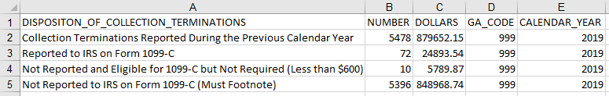

**Note About Abnormal Balances**

The expected sign for all debt quantities and dollar amounts for this Data Set is positive. Any abnormal balances must be researched and explained. The explanation can be included in the body of the submission email or added as a separate MS Word file attachment. See Section 7.0 Submission to FSA for more information.

*[This page intentionally left blank.]*

# MR-32 Loan Ending Balance Aging Data Set

### Purpose

The MR-32 Loan Ending Balance Aging Data Set (Aging Data) is required in order to age debt per DCIA and to facilitate determining a debt’s eligibility for TOP referral.

### Scope

The scope of the data is debt reported on GAFR line MR-32 Ending Balance of Defaulted Loans as of fiscal month-end.

### Frequency

Each GA must prepare the Aging Data as of each fiscal month-end for which it also prepares a GAFR report (i.e., monthly).

### Overview of Data Set Requirement

The Aging Data captures additional information related to the ending balance of defaulted debt reported on MR-32. The debt is aged per the applicable DCIA aging methodologies (see Section 2.0) and grouped into categories based on the number of days the debt is delinquent. The Aging Data is reported to FSA via the following Data Elements:

* + - Aging category (i.e., days delinquent)
    - Number
    - Dollars
    - GA code,
    - Fiscal year
    - Fiscal month

### Data Set Requirements

#### Line 1 - Data Element Names

Report the six required Data Element Names as shown in the table below.

|  |  |
| --- | --- |
| **Data Element** | **Data Element Name** |
| 1 | AGING_CATEGORY |
| 2 | NUMBER |
| 3 | DOLLARS |

|  |  |
| --- | --- |
| **Data Element** | **Data Element Name** |
| 4 | GA_CODE |
| 5 | FISCAL_YEAR |
| 6 | FISCAL_MONTH |

Line 1 should display as follows:



#### Line 2–13 - Debt by Age of Delinquency

Report the quantity of debts and loan ending balance by the age category10.

The required Line Names are the aging categories listed in the table below. The categories are listed by line number.

|  |  |
| --- | --- |
| **Line** | **AGING_CATEGORY** |
| 2 | 1–30 Days Delinquent |
| 3 | 31–60 Days Delinquent |
| 4 | 61–90 Days Delinquent |
| 5 | 91–120 Days Delinquent |
| 6 | 121–150 Days Delinquent |
| 7 | 151–180 Days Delinquent |
| 8 | 181–270 Days Delinquent |
| 9 | 271–365 Days Delinquent |
| 10 | 1–2 Years Delinquent |
| 11 | 2–6 Years Delinquent |
| 12 | 6–10 Years Delinquent |
| 13 | Over 10 Years Delinquent |

10 The loan ending balance is derived from the GA’s system of record and corresponds to the balance the GA reported on GAFR line MR-32 as of the month-end reporting date.

|  |
| --- |
| **Note About Aging Categories** |
| FSA customized the age categories for the Aging Data Set to reflect unique requirements of HEA *Title IV* debt. Specifically, FSA segregated the age categories into 30-day increments to allow breaks at 120, 180, and 270 days delinquent. |

As an example, the table below lists the Data Elements and criteria to report for Line 2, 1–30 Days Delinquent. Note: Lines 3–13 would follow the same format.

|  |  |  |
| --- | --- | --- |
| **Data Element** | **Criteria** | **Example** |
| AGING_CATEGORY | Debt that is 1 to 30 days delinquent. | Report “1-30_DAYS_DELINQUENT”. |
| NUMBER | Number (i.e., quantity of debts) that meets the scope of the line. | If 5,742 loans meet the criteria for this line, report the value as “5742”. |
| DOLLARS | Dollar (i.e., debt/loan amount) value that meets the scope of the line. | If $800,457.00 meets the criteria for this line, report the value as “800457.00”. |
| GA_CODE | 3-digit GA Code | Report “999”. |
| FISCAL_YEAR | 4-digit FY | Report “2020”. |
| FISCAL_MONTH | 2-digit fiscal month | Report “06”. |

Line 2 should display as follows:



|  |
| --- |
| **Note About Lines 2**–**13** |
| The sum of the total Dollars value of Lines 2–13 must equal the Dollars value reported on MR-32 of the GAFR. If a GA submits this Data Set and the total of these lines does not equal MR-32, FSA will reject the GA’s submission and return it for correction. |

### File Naming

The GAs should use the following file naming configuration.

***Table 5.6 Aging Data File Naming Configuration***

|  |  |
| --- | --- |
| **Required File Naming Configuration** | **Example** |
| yyyymm-AGNG-ccc  *Where*   * “yyyy” = 4-digit fiscal reporting year * “mm” = 2-digit fiscal reporting month * “AGNG” = data set short name * “ccc” = 3-digit GA code | GA 999 will name the CSV for Aging Data as of March 31, 2023 as follows:   * 202306-AGNG-999.csv |

### Presentation

If the Aging Data Set is prepared correctly, when uploaded to MS Excel or MS Access, the data will display as shown:

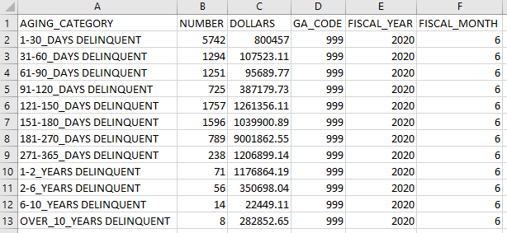

**Note About Abnormal Balances**

The expected sign for all debt quantities and dollar amounts for this Data Set is positive. Any abnormal balances must be researched and explained. The explanation can be included in the body of the submission email or added as a separate MS Word file attachment. See Section 7.0 Submission to FSA for more information.

# MR-32 & MR-41 Loan Ending Balance Disposition Data Set

### Purpose

The MR-32 & MR-41 Loan Ending Balance Disposition Data Set (Disposition Data) is needed to monitor GA compliance with DCIA TOP Referral reporting.

### Scope

The scope of the data is debt reported on GAFR lines MR-32 Ending Balance of Defaulted Loans and MR-41 Ending Balance on Bankruptcies as of the fiscal month-end.

### Frequency

Each GA must prepare the Disposition Data as of each fiscal month-end for which it also prepares a GAFR report (i.e., monthly).

### Overview of Data Set Requirement

The Disposition Data captures the combined debt quantities and loan ending balances from the GA’s system of record that correspond to the balances the GA reported on GAFR lines MR-32 and MR-41 as of the same month-end. It summarizes and reports amounts according to the disposition of these debts in the most recent (weekly) TOP referral process executed by the GA before month-end (TOP Referral Process Disposition) and further classifies them by Delinquency Group.

The Disposition Data is reported to FSA via the following ten Data Elements:

#### Line Name

* + 1. Line prefix
    2. Line suffix
    3. BizOps number
    4. Line short name
    5. Delinquency group

#### Portfolio Data

* + 1. Number
    2. Dollars

#### Identifier Data

* + 1. GA code
    2. Fiscal year
    3. Fiscal month

Each debt is mapped to the Disposition Data based on its TOP Referral Process Disposition as identified by the most recent (weekly) TOP referral process executed prior to month-end for the reporting period and is reported on one line only. Data Elements 1–4 collectively identify each

unique TOP Referral Process Disposition reportable as of month-end, while Data Element 5 further classifies the identified debt quantities and dollar amounts into one of three delinquency groups (1-120 days delinquent, 121-180 days, or > 180 days delinquent) using the DCIA Aging methodology described in Section 2.0 of this document. As a result, each TOP Referral Process Disposition is mapped to three consecutive lines ordered by delinquency group. The unique set of values on each line in Data Elements 1–5 comprise the Line Name and provide the reporting scope criteria for the Portfolio Data elements NUMBER and DOLLARS as of the reporting date.

The ten Data Elements that make up the Disposition Data have the following definitions:

|  |  |  |
| --- | --- | --- |
| **Value** | **Definition** | **Purpose** |
| a | Certified AND Active | Identifies the disposition of debts (within scope as of the reporting date) in the most recent (weekly) GA TOP Referral Process. |
| b | Not Subject to TOP |
| c | Due Process Pending Completion |
| d | Excluded/Inactivated via DCIA Compliant Exclusion |
| e | Excluded/Inactivated via FSA business rule exception |
| f | Debt Rejected by Treasury and temporarily excluded |
| g | Debt excluded via FSA Temporary Generic Hold11 |
| h | Debt excluded via FSA’s Unenforceable Debt Discharge business process12 |
| i | Debt not referred/inactivated that did not meet the requirements to report in any prior category | Identifies debts within scope as of the reporting date, not previously reported. |

|  |  |  |
| --- | --- | --- |
|  |  |  |
|  |  |  |
|  |  |
|  |  |
|  |  |
|  |  |
|  |  |
|  |  |
|  |  |
|  |  |  |

|  |  |  |
| --- | --- | --- |
| **Data Element** | **Data Element Name** | **Data Element Definition** |
| 1 | LINE_PREFIX | 1-character code (“a” through “i”) assigned by FSA to group reported portfolio data into one of nine categories as follows: |

11 Category not applicable to GAs

12 This policy exemption is tracked as a separate category in DMCS; in the GA Disposition Data it is included in section “e” with all the other identified TOP referral business rule exemptions.

|  |  |  |
| --- | --- | --- |
| **Data Element** | **Data Element Name** | **Data Element Definition** |
| 2 | LINE_SUFFIX | 3-digit code (“000”–“999”)13 assigned by FSA to identify the reporting sequence of each reporting line short name within each “LINE_PREFIX” report category. |
| 3 | BIZOPS_NO | 3-digit code (“001”–“999” or “N/A” (Not Applicable)) assigned by FSA to identify the TOP Referral Exclusion/ Exception/Instruction business rule and definition per Appendix C that defines the debt to be reported on the line, based on debt’s disposition in the most recent weekly TOP referral. Appendix C maps each FSA TOP Referral business rule to the corresponding Disposition Data line number. Leading zeros are added to the FSA TOP Referral BizOps Number to produce the corresponding three-digit BIZOPS_NO code.  E.g., “1” becomes “001”, “10” becomes “010”, etc.  If debt was not excluded from TOP referral based on an FSA business rule (e.g., because debt WAS referred, or debt was not in portfolio at time of last TOP referral, etc.) then no business rule is applicable and “N/A” is entered in this field. |
| 4 | LINE_SHORT_NAME | Text required by FSA that briefly describes the disposition post-TOP referral of debt to be reported on the line. |

13 The Disposition Data Set format is designed to facilitate FSA’s consolidation of data received from GAs and DMCS into one data set for analysis. The DMCS-only reporting categories in the Data Elements BIZOPS_NO, LINE_PREFIX, and LINE_SUFFIX have been omitted, resulting in gaps in the sequence numbers

|  |  |
| --- | --- |
| **Permitted value** | **Definition** |
| 1–120_DAYS | At least one*, but no more than 120 days delinquent |
| 121–180_DAYS | At least 121, but no more than 180 days delinquent |
| OVER_180_DAYS | More than 180 days delinquent |

|  |  |  |
| --- | --- | --- |
| **Data Element** | **Data Element Name** | **Data Element Definition** |
| 5 | DELINQUENCY_GROUP | One of three delinquency categories that describe, as of the reporting month-end date, the number of days the debt reported on the line is delinquent, per DCIA- compliant aging (as described in Section 2.0 of this document).  \**If a debt is acquired via a FFEL default claim on the month- end reporting date, then its calculated age will be zero days delinquent. However, since ALL debts acquired via a default claim are considered delinquent from the moment of acquisition, such debts must be reported in the “1-120_DAYS” delinquency group.*  **Note**: The aging methodology used for the Disposition Data is identical to that used for the Aging Data, except that for the Disposition Data all debts are aggregated into one of only three delinquency groups. |
| 6 | NUMBER | Number (i.e., quantity of debts) that meets the scope of the line as defined by the Line Name, as of the reporting date. |
| 7 | DOLLARS | Dollar (i.e., debt/loan amount) value that meets the scope of the line as defined by the Line Name. |
| 8 | GA_CODE | 3-digit GA Code |
| 9 | FISCAL_YEAR | 4-digit FY |
| 10 | FISCAL_MONTH | 2-digit fiscal month |

### Data Set Requirements

#### Line 1 - Data Element Names

Report the ten required Data Element Names as shown in the table below.

|  |  |
| --- | --- |
| **Data Element** | **Data Element Name** |
| 1 | LINE_PREFIX |
| 2 | LINE_SUFFIX |
| 3 | BIZOPS_NO |
| 4 | LINE_SHORT_NAME |
| 5 | DELINQUENCY_GROUP |
| 6 | NUMBER |
| 7 | DOLLARS |
| 8 | GA_CODE |
| 9 | FISCAL_YEAR |
| 10 | FISCAL_MONTH |

Line 1 should display as follows:



For the Disposition Data lines 2–124, the Identifier Data elements will have identical values on every line for each GA in any given reporting period. If GA 999 prepared Disposition Data as of March 31, 2023, it would report the following values on every line:

|  |  |  |
| --- | --- | --- |
| **Identifier Data Element** | **Criteria** | **Example** |
| GA_CODE | 3-digit GA Code | Report “999”. |
| FISCAL_YEAR | 4-digit FY | Report “2023”. |
| FISCAL_MONTH | 2-digit FY month | Report “06”. |

Therefore, the remainder of this section omits the above-mentioned Data Elements from the tables presented.

**Note About the Disposition Data Line Name Values**

The Disposition Data format is designed to facilitate FSA’s consolidation of data received from GAs and DMCS into one data set for analysis. The DMCS-only reporting categories for the Data Elements BIZOPS_NO, LINE_PREFIX, and LINE_SUFFIX, have been omitted, resulting in gaps in the sequence numbers.

#### Lines 2–4: Debt Certified and Active

Report on each line (as Number and Dollars respectively) the combined debt quantities and loan ending balances from the GA’s system of record that correspond to the balances the GA reported on GAFR lines MR-32 and MR-41 as of the month-end reporting date that, based on the most recent weekly TOP Referral prior to the reporting month-end, have a TOP Referral Process Disposition “Debt Certified and Active” AND meet the line’s DELINQUENCY_GROUP criteria. If GA 999 identified the following debt:

|  |  |  |  |  |  |  |  |
| --- | --- | --- | --- | --- | --- | --- | --- |
| **Line** | **Debt in Scope on Reporting Date with TOP Referral Process Disposition:**  **“Debt Certified and Active”** | | | | | | |
| **Line Name** | | | | | **Portfolio Data** | |
| **LINE_ PREFIX** | **LINE_ SUFFIX** | **BIZOPS**  **_NO** | **LINE_ SHORT_NAME** | **DELINQ- UENCY_**  **GROUP** | **NUMBER** | **DOLLAR** |
| 2 | a | 10 | N/A | Debts Certified  and Active | 1-120  _DAYS | 207 | 55,700.56 |
| 3 | a | 10 | N/A | Debts Certified  and Active | 121-180  _DAYS | 3,008 | 1,815,062.46 |
| 4 | a | 10 | N/A | Debts Certified  and Active | OVER_180  _DAYS | 1,012 | 9,999,950.12 |

Based on the criteria above, the sample Lines 2–4 would display as follows:



#### Lines 5–118: Debt Not Certified/Inactivated Based on TOP Referral Business Rule

Report on each line (as Number and Dollars respectively) the combined debt quantities and loan ending balances from the GA’s system of record that correspond to the balances the GA reported on GAFR lines MR-32 and MR-41 as of the month-end reporting date for any debts NOT “Certified and Active” (or, if previously certified, inactivated) because, based on the most recent weekly TOP Referral prior to the reporting month-end, they have a TOP Referral Process Disposition that meets the requirements of the FSA TOP Referral business rule in Appendix C that maps to the line’s required BIZOPS_NO value AND meet the line’s DELINQUENCY_GROUP criteria. If GA 999 identified the following debt:

|  |  |  |  |  |  |  |  |
| --- | --- | --- | --- | --- | --- | --- | --- |
| **Line** | **Debt in Scope on Reporting Date with TOP Referral Process Disposition:**  **“Debt Not Certified/Inactivated Based on TOP Referral Business Rule”** | | | | | | |
| **Line Name** | | | | | **Portfolio Data** | |
| **LINE_ PREFIX** | **LINE_ SUFFIX** | **BIZOPS**  **_NO** | **LINE_ SHORT_NAME** | **DELINQ-**  **UENCY_ GROUP** | **NUMBER** | **DOLLAR** |
| 5 | b | 10 | 1 | Zero Balance  (Closed) Debts | 1-120  _DAYS | 2 | - |
| 6 | b | 10 | 1 | Zero Balance  (Closed) Debts | 121-180  _DAYS | - | - |
| 7 | b | 10 | 1 | Zero Balance  (Closed) Debts | OVER_180  _DAYS | - | - |
| 8 | b | 20 | 53 | Credit Balance  Debts | 1-120  _DAYS | 3 | (2,000.22) |
| 9 | b | 20 | 53 | Credit Balance  Debts | 121-180  _DAYS | - | - |
| 10 | b | 20 | 53 | Credit Balance  Debts | OVER_180  _DAYS | - | - |
| 11 | b | 30 | 2 | Debts 0-120 days delinquent per  65DN Agreement | 1-120  _DAYS | 8,115 | 805,847.47 |
| 12 | b | 30 | 2 | Debts 0-120 days  delinquent per 65DN Agreement | 121-180  _DAYS | - | - |
| 13 | b | 30 | 2 | Debts 0-120 days  delinquent per 65DN Agreement | OVER_180  _DAYS | - | - |
| 14 | c | 10 | 24 | Due process not initiated (Awaiting Treasury  Address) | 1-120  _DAYS | - | - |

|  |  |  |  |  |  |  |  |
| --- | --- | --- | --- | --- | --- | --- | --- |
| **Line** | **Debt in Scope on Reporting Date with TOP Referral Process Disposition:**  **“Debt Not Certified/Inactivated Based on TOP Referral Business Rule”** | | | | | | |
| **Line Name** | | | | | **Portfolio Data** | |
| **LINE_ PREFIX** | **LINE_ SUFFIX** | **BIZOPS**  **_NO** | **LINE_ SHORT_NAME** | **DELINQ-**  **UENCY_ GROUP** | **NUMBER** | **DOLLAR** |
| 15 | c | 10 | 24 | Due process not initiated (Awaiting Treasury  Address) | 121-180  _DAYS | 3 | 6,000.00 |
| 16 | c | 10 | 24 | Due process not initiated (Awaiting Treasury  Address) | OVER_180  _DAYS | 9 | 68,043.06 |
| 17 | c | 20 | 23 | Due process not  initiated (deliverable) | 1-120  _DAYS | - | - |
| 18 | c | 20 | 23 | Due process not initiated  (deliverable) | 121-180  _DAYS | 4 | 11,300.14 |
| 19 | c | 20 | 23 | Due process not  initiated (deliverable) | OVER_180  _DAYS | 1 | 2,600.00 |
| 20 | c | 30 | 22 | In due process,  period not expired | 1-120  _DAYS | - | - |
| 21 | c | 30 | 22 | In due process,  period not expired | 121-180  _DAYS | 2 | 4,000.00 |
| 22 | c | 30 | 22 | In due process,  period not expired | OVER_180  _DAYS | 2 | 54,000.17 |
| 23 | d | 10 | 3 | Debt balance >$0  but < $25 | 1-120  _DAYS | - | - |
| 24 | d | 10 | 3 | Debt balance >$0  but < $25 | 121-180  _DAYS | 52 | 100.00 |
| 25 | d | 10 | 3 | Debt balance >$0  but < $25 | OVER_180  _DAYS | 15 | 100.00 |
| 26 | d | 20 | 4 | Pseudo-SSN  (Begins with 9) | 1-120  _DAYS | - | - |
| 27 | d | 20 | 4 | Pseudo-SSN  (Begins with 9) | 121-180  _DAYS | 1 | 2,000.00 |

|  |  |  |  |  |  |  |  |
| --- | --- | --- | --- | --- | --- | --- | --- |
| **Line** | **Debt in Scope on Reporting Date with TOP Referral Process Disposition:**  **“Debt Not Certified/Inactivated Based on TOP Referral Business Rule”** | | | | | | |
| **Line Name** | | | | | **Portfolio Data** | |
| **LINE_ PREFIX** | **LINE_ SUFFIX** | **BIZOPS**  **_NO** | **LINE_ SHORT_NAME** | **DELINQ-**  **UENCY_ GROUP** | **NUMBER** | **DOLLAR** |
| 28 | d | 20 | 4 | Pseudo-SSN  (Begins with 9) | OVER_180  _DAYS | 1 | 2,000.00 |
| 29 | d | 30 | 5 | Request for Formal Review/Document  ation | 1-120  _DAYS | - | - |
| 30 | d | 30 | 5 | Request for Formal Review/Document  ation | 121-180  _DAYS | 2 | 1,500.00 |
| 31 | d | 30 | 5 | Request for Formal Review/Document  ation | OVER_180  _DAYS | 2 | 1,500.00 |
| 32 | d | 40 | 6 | Pending  Discharge - Death (non-grant) | 1-120  _DAYS | - | - |
| 33 | d | 40 | 6 | Pending Discharge - Death  (non-grant) | 121-180  _DAYS | 3 | 6,203.00 |
| 34 | d | 40 | 6 | Pending Discharge - Death  (non-grant) | OVER_180  _DAYS | 3 | 106,203.18 |
| 35 | d | 50 | 7 | Pending Discharge - Disability (TPD)  (non-grant) | 1-120  _DAYS | - | - |
| 36 | d | 50 | 7 | Pending Discharge - Disability (TPD)  (non-grant) | 121-180  _DAYS | 5 | 17,001.42 |
| 37 | d | 50 | 7 | Pending Discharge - Disability (TPD)  (non-grant) | OVER_180  _DAYS | 5 | 9,500.00 |

|  |  |  |  |  |  |  |  |
| --- | --- | --- | --- | --- | --- | --- | --- |
| **Line** | **Debt in Scope on Reporting Date with TOP Referral Process Disposition:**  **“Debt Not Certified/Inactivated Based on TOP Referral Business Rule”** | | | | | | |
| **Line Name** | | | | | **Portfolio Data** | |
| **LINE_ PREFIX** | **LINE_ SUFFIX** | **BIZOPS**  **_NO** | **LINE_ SHORT_NAME** | **DELINQ-**  **UENCY_ GROUP** | **NUMBER** | **DOLLAR** |
| 38 | d | 60 | 8 | Pending Discharge - Closed School  (non-grant) | 1-120  _DAYS | - | - |
| 39 | d | 60 | 8 | Pending Discharge - Closed School  (non-grant) | 121-180  _DAYS | 3 | 5,100.00 |
| 40 | d | 60 | 8 | Pending Discharge - Closed School  (non-grant) | OVER_180  _DAYS | 3 | 5,100.00 |
| 41 | d | 70 | 9 | Pending Discharge - False Certification  (FFEL, FISL, DL) | 1-120  _DAYS | - | - |
| 42 | d | 70 | 9 | Pending Discharge - False Certification  (FFEL, FISL, DL) | 121-180  _DAYS | 1 | 10,003.17 |
| 43 | d | 70 | 9 | Pending Discharge - False Certification  (FFEL, FISL, DL) | OVER_180  _DAYS | 1 | 52,003.98 |
| 44 | d | 80 | 10 | Pending Discharge - Unpaid Refund  (FFEL, FISL, DL) | 1-120  _DAYS | - | - |
| 45 | d | 80 | 10 | Pending Discharge - Unpaid Refund  (FFEL, FISL, DL) | 121-180  _DAYS | 2 | 4,000.00 |

|  |  |  |  |  |  |  |  |
| --- | --- | --- | --- | --- | --- | --- | --- |
| **Line** | **Debt in Scope on Reporting Date with TOP Referral Process Disposition:**  **“Debt Not Certified/Inactivated Based on TOP Referral Business Rule”** | | | | | | |
| **Line Name** | | | | | **Portfolio Data** | |
| **LINE_ PREFIX** | **LINE_ SUFFIX** | **BIZOPS**  **_NO** | **LINE_ SHORT_NAME** | **DELINQ-**  **UENCY_ GROUP** | **NUMBER** | **DOLLAR** |
| 46 | d | 80 | 10 | Pending Discharge - Unpaid Refund  (FFEL, FISL, DL) | OVER_180  _DAYS | 2 | 4,000.00 |
| 47 | d | 100 | 12 | Pending Discharge - ID Theft (FFEL,  FISL, DL) | 1-120  _DAYS | - | - |
| 48 | d | 100 | 12 | Pending Discharge - ID Theft (FFEL,  FISL, DL) | 121-180  _DAYS | 1 | 2,055.00 |
| 49 | d | 100 | 12 | Pending Discharge - ID Theft (FFEL,  FISL, DL) | OVER_180  _DAYS | 1 | 2,055.00 |
| 50 | d | 110 | 13 | Bankruptcy  Exclusion | 1-120  _DAYS | - | - |
| 51 | d | 110 | 13 | Bankruptcy  Exclusion | 121-180  _DAYS | 100 | 20,000.00 |
| 52 | d | 110 | 13 | Bankruptcy  Exclusion | OVER_180  _DAYS | 599 | 492,500.83 |
| 53 | d | 120 | 14 | Military Exclusion | 1-120  _DAYS | - | - |
| 54 | d | 120 | 14 | Military Exclusion | 121-180  _DAYS | 7 | 14,000.00 |
| 55 | d | 120 | 14 | Military Exclusion | OVER_180  _DAYS | 7 | 14,000.00 |
| 56 | d | 130 | 16 | Adversary  Proceeding Exclusion | 1-120  _DAYS | - | - |
| 57 | d | 130 | 16 | Adversary Proceeding  Exclusion | 121-180  _DAYS | 53 | 201,000.99 |

|  |  |  |  |  |  |  |  |
| --- | --- | --- | --- | --- | --- | --- | --- |
| **Line** | **Debt in Scope on Reporting Date with TOP Referral Process Disposition:**  **“Debt Not Certified/Inactivated Based on TOP Referral Business Rule”** | | | | | | |
| **Line Name** | | | | | **Portfolio Data** | |
| **LINE_ PREFIX** | **LINE_ SUFFIX** | **BIZOPS**  **_NO** | **LINE_ SHORT_NAME** | **DELINQ-**  **UENCY_ GROUP** | **NUMBER** | **DOLLAR** |
| 58 | d | 130 | 16 | Adversary Proceeding  Exclusion | OVER_180  _DAYS | 5 | 701,000.36 |
| 59 | d | 150 | 18 | Formal Appeals | 1-120  _DAYS | - | - |
| 60 | d | 150 | 18 | Formal Appeals | 121-180  _DAYS | 20 | 48,153.13 |
| 61 | d | 150 | 18 | Formal Appeals | OVER_180  _DAYS | 15 | 40,000.00 |
| 62 | d | 160 | 19 | SSA Disabled  Match (non-grant) | 1-120  _DAYS | - | - |
| 63 | d | 160 | 19 | SSA Disabled  Match (non-grant) | 121-180  _DAYS | 3 | 6,233.00 |
| 64 | d | 160 | 19 | SSA Disabled  Match (non-grant) | OVER_180  _DAYS | 3 | 6,233.00 |
| 65 | d | 170 | 20 | FEMA Disaster  Area | 1-120  _DAYS | - | - |
| 66 | d | 170 | 20 | FEMA Disaster  Area | 121-180  _DAYS | 2 | 5,090.00 |
| 67 | d | 170 | 20 | FEMA Disaster  Area | OVER_180  _DAYS | 2 | 5,090.00 |
| 68 | d | 190 | 25 | PIF via AWG | 1-120  _DAYS | - | - |
| 69 | d | 190 | 25 | PIF via AWG | 121-180  _DAYS | 2 | 5,901.00 |
| 70 | d | 190 | 25 | PIF via AWG | OVER_180  _DAYS | 2 | 5,901.00 |
| 71 | d | 200 | 27 | Post 65DN Rehab  (5 on-time payments) | 1-120  _DAYS | - | - |
| 72 | d | 200 | 27 | Post 65DN Rehab (5 on-time  payments) | 121-180  _DAYS | 16 | 8,000.00 |

|  |  |  |  |  |  |  |  |
| --- | --- | --- | --- | --- | --- | --- | --- |
| **Line** | **Debt in Scope on Reporting Date with TOP Referral Process Disposition:**  **“Debt Not Certified/Inactivated Based on TOP Referral Business Rule”** | | | | | | |
| **Line Name** | | | | | **Portfolio Data** | |
| **LINE_ PREFIX** | **LINE_ SUFFIX** | **BIZOPS**  **_NO** | **LINE_ SHORT_NAME** | **DELINQ-**  **UENCY_ GROUP** | **NUMBER** | **DOLLAR** |
| 73 | d | 200 | 27 | Post 65DN Rehab (5 on-time  payments) | OVER_180  _DAYS | 11 | 8,000.00 |
| 74 | d | 210 | 36 | Pending  Consolidation | 1-120  _DAYS | - | - |
| 75 | d | 210 | 36 | Pending  Consolidation | 121-180  _DAYS | 5 | 49,919.00 |
| 76 | d | 210 | 36 | Pending  Consolidation | OVER_180  _DAYS | 5 | 11,000.00 |
| 77 | d | 220 | 45 | Restitution Debts  (bRestitn) | 1-120  _DAYS | - | - |
| 78 | d | 220 | 45 | Restitution Debts  (bRestitn) | 121-180  _DAYS | 1 | 2,650.00 |
| 79 | d | 220 | 45 | Restitution Debts  (bRestitn) | OVER_180  _DAYS | 1 | 2,650.00 |
| 80 | d | 230 | 48 | VA Disabled  Match (non-grant) | 1-120  _DAYS | - | - |
| 81 | d | 230 | 48 | VA Disabled  Match (non-grant) | 121-180  _DAYS | 1 | 2,220.00 |
| 82 | d | 230 | 48 | VA Disabled  Match (non-grant) | OVER_180  _DAYS | 1 | 2,220.00 |
| 83 | d | 240 | 47 | Hardship | 1-120  _DAYS | - | - |
| 84 | d | 240 | 47 | Hardship | 121-180  _DAYS | 11 | 7,500.15 |
| 85 | d | 240 | 47 | Hardship | OVER_180  _DAYS | 1 | 3,500.00 |
| 86 | d | 250 | 50 | Court-Ordered  Settlement | 1-120  _DAYS | - | - |
| 87 | d | 250 | 50 | Court-Ordered  Settlement | 121-180  _DAYS | 1 | 2,100.00 |
| 88 | d | 250 | 50 | Court-Ordered  Settlement | OVER_180  _DAYS | 32 | 2,100.00 |

|  |  |  |  |  |  |  |  |
| --- | --- | --- | --- | --- | --- | --- | --- |
| **Line** | **Debt in Scope on Reporting Date with TOP Referral Process Disposition:**  **“Debt Not Certified/Inactivated Based on TOP Referral Business Rule”** | | | | | | |
| **Line Name** | | | | | **Portfolio Data** | |
| **LINE_ PREFIX** | **LINE_ SUFFIX** | **BIZOPS**  **_NO** | **LINE_ SHORT_NAME** | **DELINQ-**  **UENCY_ GROUP** | **NUMBER** | **DOLLAR** |
| 89 | d | 260 | 51 | Litigation Hold | 1-120  _DAYS | - | - |
| 90 | d | 260 | 51 | Litigation Hold | 121-180  _DAYS | 1 | 3,500.00 |
| 91 | d | 260 | 51 | Litigation Hold | OVER_180  _DAYS | 1 | 73,598.44 |
| 92 | e | 10 | 26 | SSN Change | 1-120  _DAYS | - | - |
| 93 | e | 10 | 26 | SSN Change | 121-180  _DAYS | 1 | 1,950.00 |
| 94 | e | 10 | 26 | SSN Change | OVER_180  _DAYS | 1 | 1,950.00 |
| 95 | e | 70 | 33 | Pending Discharge - 9/11 Survivors (Grants,  FFEL, FISL) | 1-120  _DAYS | - | - |
| 96 | e | 70 | 33 | Pending Discharge - 9/11 Survivors (Grants,  FFEL, FISL) | 121-180  _DAYS | 1 | 3,750.00 |
| 97 | e | 70 | 33 | Pending Discharge - 9/11 Survivors (Grants,  FFEL, FISL) | OVER_180  _DAYS | 1 | 3,750.00 |
| 98 | e | 100 | 40 | Borrower Defense  (FFEL, Perkins) | 1-120  _DAYS | - | - |
| 99 | e | 100 | 40 | Borrower Defense  (FFEL, Perkins) | 121-180  _DAYS | 1 | 2,670.00 |
| 100 | e | 100 | 40 | Borrower Defense  (FFEL, Perkins) | OVER_180  _DAYS | 1 | 9,541.60 |
| 101 | e | 120 | 15 | Unenforceable Debt Discharge  Process | 1-120  _DAYS | - | - |

|  |  |  |  |  |  |  |  |
| --- | --- | --- | --- | --- | --- | --- | --- |
| **Line** | **Debt in Scope on Reporting Date with TOP Referral Process Disposition:**  **“Debt Not Certified/Inactivated Based on TOP Referral Business Rule”** | | | | | | |
| **Line Name** | | | | | **Portfolio Data** | |
| **LINE_ PREFIX** | **LINE_ SUFFIX** | **BIZOPS**  **_NO** | **LINE_ SHORT_NAME** | **DELINQ-**  **UENCY_ GROUP** | **NUMBER** | **DOLLAR** |
| 102 | e | 120 | 15 | Unenforceable Debt Discharge  Process | 121-180  _DAYS | 2 | 4,259.00 |
| 103 | e | 120 | 15 | Unenforceable  Debt Discharge Process | OVER_180  _DAYS | 1 | 2,000.00 |
| 104 | e | 130 | 46 | Pending  Subrogation | 1-120  _DAYS | - | - |
| 105 | e | 130 | 46 | Pending  Subrogation | 121-180  _DAYS | 20 | 18,000.54 |
| 106 | e | 130 | 46 | Pending  Subrogation | OVER_180  _DAYS | 5 | 812,000.77 |
| 107 | e | 140 | 44 | Mixed (Debit/Credit)  Balance Debts | 1-120  _DAYS | - | - |
| 108 | e | 140 | 44 | Mixed  (Debit/Credit) Balance Debts | 121-180  _DAYS | 1 | 4,500.00 |
| 109 | e | 140 | 44 | Mixed (Debit/Credit)  Balance Debts | OVER_180  _DAYS | 1 | 4,500.00 |
| 110 | e | 150 | 52 | Closed debt with  debit balance | 1-120  _DAYS | - | - |
| 111 | e | 150 | 52 | Closed debt with  debit balance | 121-180  _DAYS | 1 | 1,900.00 |
| 112 | e | 150 | 52 | Closed debt with  debit balance | OVER_180  _DAYS | 1 | 1,900.00 |
| 113 | e | 160 | 54 | Unrelated EIN matches borrower  SSN | 1-120  _DAYS | - | - |
| 114 | e | 160 | 54 | Unrelated EIN matches borrower  SSN | 121-180  _DAYS | 1 | 1,000.00 |

|  |  |  |  |  |  |  |  |
| --- | --- | --- | --- | --- | --- | --- | --- |
| **Line** | **Debt in Scope on Reporting Date with TOP Referral Process Disposition:**  **“Debt Not Certified/Inactivated Based on TOP Referral Business Rule”** | | | | | | |
| **Line Name** | | | | | **Portfolio Data** | |
| **LINE_ PREFIX** | **LINE_ SUFFIX** | **BIZOPS**  **_NO** | **LINE_ SHORT_NAME** | **DELINQ-**  **UENCY_ GROUP** | **NUMBER** | **DOLLAR** |
| 115 | e | 160 | 54 | Unrelated EIN matches borrower  SSN | OVER_180  _DAYS | 1 | 1,000.00 |
| 116 | f | 10 | 38 | Treasury Reject | 1-120  _DAYS | 103 | 55,800.96 |
| 117 | f | 10 | 38 | Treasury Reject | 121-180  _DAYS | 15 | 2,635.00 |
| 118 | f | 10 | 38 | Treasury Reject | OVER_180  _DAYS | 1 | 2,635.00 |

Based on the criteria above, sample Lines 5–10 would display as follows:

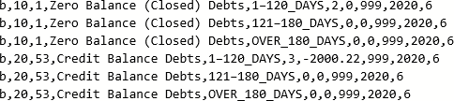

**Note About Disposition Data Lines 8, 9 and 10**

Disposition Data Lines 8, 9 and 10 report debts with a credit balance. Enter the debt quantity (NUMBER) as a positive number but the amount (DOLLAR) as a negative amount. These are the only data lines where a negative dollar amount will be reported, unless the net amount meeting the reporting criteria for any other line is abnormal.

#### Lines 119–121: Debt Not Tested

Report on each line (as Number and Dollar respectively) the combined debt quantities and loan ending balances from the GA’s system of record that correspond to the balances the GA reported on GAFR lines MR-32 and MR-41 as of the month-end reporting date for debts that were not tested for TOP Referral Disposition because they were not in scope at the time of the last (weekly) TOP referral before month-end AND also meet the line’s DELINQUENCY_GROUP criteria. If GA 999 identified the following debt:

|  |  |  |  |  |  |  |  |
| --- | --- | --- | --- | --- | --- | --- | --- |
| **Line** | **Debt in Scope on Reporting Date with TOP Referral Process Disposition:**  **“Debt Not Tested”** | | | | | | |
| **Line Name** | | | | | **Portfolio Data** | |
| **LINE_ PREFIX** | **LINE_ SUFFIX** | **BIZOPS**  **_NO** | **LINE_ SHORT_NAME** | **DELINQ- UENCY_**  **GROUP** | **NUMBER** | **DOLLAR** |
| 119 | i | 5 | N/A | Debt not in portfolio at time of last TOP  referral | 1-120  _DAYS | 3 | 3,000.01 |
| 120 | i | 5 | N/A | Debt not in portfolio at time of last TOP  referral | 121-180  _DAYS | - | - |
| 121 | i | 5 | N/A | Debt not in portfolio at time of last TOP  referral | OVER_18 0  _DAYS | - | - |

Based on the criteria above, sample Lines 119–121 would display as follows:



#### Lines 122–124: Debt Not Otherwise Classified

Report on each line (as Number and Dollar respectively) the combined debt quantities and loan ending balances from the GA’s system of record that correspond to the balances the GA reported on GAFR lines MR-32 and MR-41 as of the month-end reporting date for debts that did not meet the reporting criteria for any prior line (i.e., Lines 2–121) AND also meet the line’s DELINQUENCY_GROUP criteria. If GA 999 identified the following debt:

|  |  |  |  |  |  |  |  |
| --- | --- | --- | --- | --- | --- | --- | --- |
| **Line** | **Debt in Scope on Reporting Date with TOP Referral Process Disposition:**  **“Debt Not Otherwise Classified”** | | | | | | |
| **Line Name** | | | | | **Portfolio Data** | |
| **LINE_ PREFIX** | **LINE_ SUFFIX** | **BIZOPS**  **_NO** | **LINE_ SHORT_NAME** | **DELINQ-**  **UENCY_ GROUP** | **NUMBER** | **DOLLAR** |
| 122 | i | 10 | N/A | Debt does not meet definition for any prior  report line | 1-120  _DAYS | - | - |
| 123 | i | 10 | N/A | Debt does not meet definition for any prior  report line | 121-180  _DAYS | - | - |
| 124 | i | 10 | N/A | Debt does not meet definition for any prior  report line | OVER_180  _DAYS | - | - |

Based on the criteria above, sample lines 122–124 would display as follows:



|  |
| --- |
| **Note About Disposition Data Lines 122–124 Debt Not Otherwise Classified** |
| Since the TOP referral process is designed to identify the appropriate disposition of every debt within the GA portfolio that meets the scope definition on the date the TOP referral process is executed, no dollar amount or debt quantity is expected to be reported on these lines. Any valid dollar amount and debt quantity reported represents either debt that was incorrectly mapped or debt with characteristics that the referral or reporting process did not identify. The GA must fully research any such debt quantity or dollar amount reported and provide a detailed written explanation when the Disposition Data Set is submitted, either included in the body of the submission email or attached as a separate MS Word file. |

### Data Validation

|  |
| --- |
| **Note About Validation of Data Before Submission** |
| It is FSA’s expectation that GAs will carefully review the Disposition Data Set each month prior to submission to ensure on-going compliance with the Disposition Data requirements. The review should include, but is not limited to, the following Data Validation Tests.  FSA will reject the Disposition Data submitted if it does not comply with requirements or if a required explanation is not provided. |

#### Validation Test 1 – Validate Number of Disposition Data Lines Against Requirement

The Disposition Data Requirements detailed in Section 6.5 above explicitly require that each GA submit Disposition Data that includes 124 lines (including the Data Element Names in Line 1).

FSA will reject the Disposition Data if the total number of lines is not equal to 124.

|  |
| --- |
| **Note About Disposition Data Validation Test 1** |
| Validation Test 1 serves as a control for the Disposition Data and must result in a calculated line number variance of zero. If a GA submits Disposition Data where this test results in a variance other than zero, FSA will reject the GA’s submission and return it for correction. |

#### Validation Test 2 – Validate Disposition Data Against Control Total

The Disposition Data requirements described in Section 6.5 above are designed to capture the combined debt quantities and loan ending balances from the GA’s system of record that correspond to the balances the GA reported on GAFR lines MR-32 and MR-41 as of the month- end reporting date. FSA will validate the Disposition Data submitted by each GA against the sum of the MR-32 and MR-41 GAFR lines the GA submitted for the same reporting period. For example, assume GA 999 submitted a GAFR and Disposition Data with the following data as of March 31, 2023:

|  |  |
| --- | --- |
| **Validation - Debt in Scope on Reporting Date** | |
| **Data Source** | **Dollar Amount** |
| GAFR Line MR–32 | 15,169,908.06 |
| GAFR Line MR–41 | 563,824.23 |
| **Subtotal: Disposition Data Control Total** | **15,733,732.29** |
| Total Dollar amount reported in Disposition Data Element “Dollars”, Lines 2–124 | 15,733,732.29 |
| **Control Difference:** | **0.00** |

Since the Control Difference is zero, the Disposition Data would PASS Validation Test

|  |
| --- |
| **Note About Disposition Data Validation Test 2** |
| Validation Test 2 serves as a control for the Disposition Data and must result in a calculated Control Difference value of zero. If a GA submits Disposition Data where this test results in a Control Difference value other than zero, FSA will reject the GA’s submission and return it for correction. |

### Naming Configuration

The GAs should use the following file naming configuration.

***Table 6.7 Disposition Data File Naming Configuration***

|  |  |
| --- | --- |
| **Required File Naming Configuration** | **Example** |
| yyyymm- DISP-ccc  *Where*   * “yyyy” = 4-digit fiscal reporting year * “mm” = 2-digit fiscal reporting month * “DISP” = data set short name * “ccc” = 3-digit GA code | GA 999 will name the Disposition Data as of March 31, 2023 as follows:   * 202306-DISP-999.csv |

### Presentation

If the Disposition Data Set is prepared correctly, when uploaded to MS Excel or MS Access, the data will display as shown:

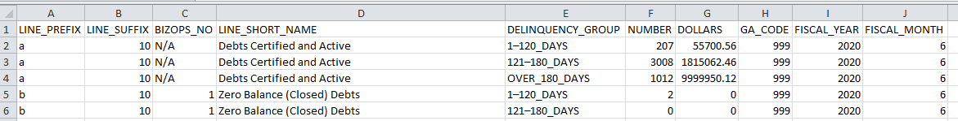

The above image shows only the first few lines of the Disposition Data. For a complete example, please refer to Appendix B.

**Note About Abnormal Balances**

Except for Lines 8–10, the expected sign for all debt quantities and dollar amounts in this Data Set is positive. Any abnormal balances must be researched and explained. The explanation can be included in the body of the submission email or added as a separate MS Word file attachment. See Section 7.0 Submission to FSA for more information.

*[This page intentionally left blank.]*

# Submission to FSA

|  |
| --- |
| **Note About Validation of Data Before Submission** |
| To ensure on-going compliance with the DCIA Compliance Data Set requirements, FSA will perform a quality control review of the GA’s submission package for each reporting period. This review will include confirming that the GA’s submission agrees with the related GAFR MR lines and that variance explanations have been provided when required. FSA will reject the submission if it does not reconcile to the highlighted MR lines or if a required explanation is not provided. GAs must therefore review their submissions carefully prior to delivery. |

### Contents of the DCIA Compliance Data Set Submission

GAs can prepare the DCIA Compliance Data Set in Excel; however, the files must be saved and submitted to FSA as individual CSV files. For example, if a GA submits a GAFR for a reporting period that has FFEL Program activity or balances, then the GA must also submit separate CSV files - one for each of the required Data Sets.

GAs must submit the following as appropriate:

* + - The applicable individual Data Set files,
    - The Disposition Data explanation (i.e., for “Debt Not Otherwise Classified”), if necessary,
    - The required Write-Off Data explanation, if necessary and
    - Any abnormal activity or balance explanations, if necessary.

Explanations can be included in the body of the submission email or added as a separate MS Word file attachment. Additionally, submitted files should not be password protected unless required by the GA’s or FSA’s data protection policies (i.e., because the files contain personally identifiable information or sensitive data).

### Delivery Instructions

GAs should prepare an email with the contents of the submission package attached and send it to the following FSA email addresses:

To: [FSAFinancePortfolio@ed.gov](mailto:FSAFinancePortfolio@ed.gov) CC: [callis.carleton@ed.gov](mailto:callis.carleton@ed.gov)

Please indicate the reporting month and FY in the subject line of the email as follows:

***Table 7.2 Submission Email Subject Line***

|  |  |
| --- | --- |
| **Subject Line** | **Example** |
| DCIA Compliance Data Set mm–yyyy  Where   * “mm” = 2-digit fiscal reporting month * “yyyy” = 4-digit fiscal reporting year | For the reporting period ending March 31, 2023, the subject line should be as follows:   * DCIA Compliance Data Set 06-2023 |

### Due Date

GAs must submit the DCIA Compliance Data Set no later than close of business (COB) on the due date specified below.

***Table 7.3 DCIA Compliance Data Set Due Dates***

|  |  |  |  |
| --- | --- | --- | --- |
| **FY Reporting Period End Date** | **Applicable to the Following Months** | **Due Date** | **Number of Data Sets Required to Be Submitted** |
| If month-end… | Oct, Nov, Jan, Feb, April, May, Jul, and Aug | COB 12th business day of the following month. | 2 Data Sets* |
| If quarter-end… | Mar | COB 8th business day of the following month. | 3 Data Sets** |
| If quarter-end… | Dec, Jun, and Sep | COB 8th business day of the following month. | 2 Data Sets* |

*\* Write-Off Data Set isn’t required*

*\*\* Write-Off Data Set is required*

Business day is based upon the Federal government calendar. COB is 5 p.m. Eastern time.

# Appendixes

*[This page left intentionally blank.]*

## Appendix A – Sample GAFR / ED Form 2000

### Appendix A – Sample GAFR / ED Form 2000

Note: The sample GAFR presented below is for example purposes only. Its purpose is to highlight the relationship between specific GAFR MR lines and the DCIA Compliance Data Set.

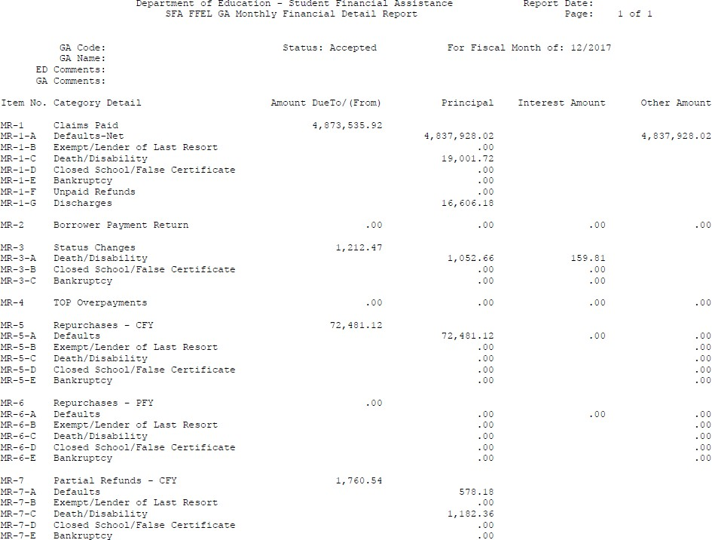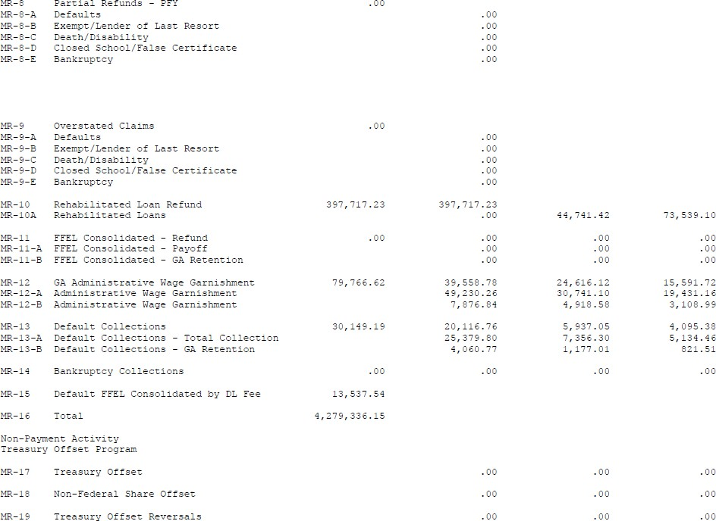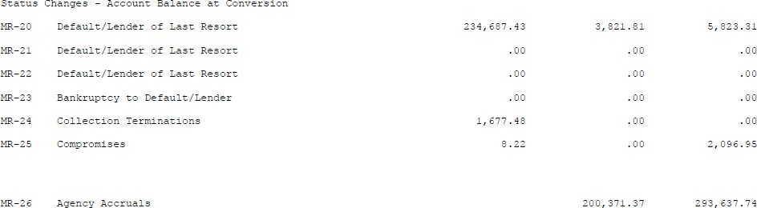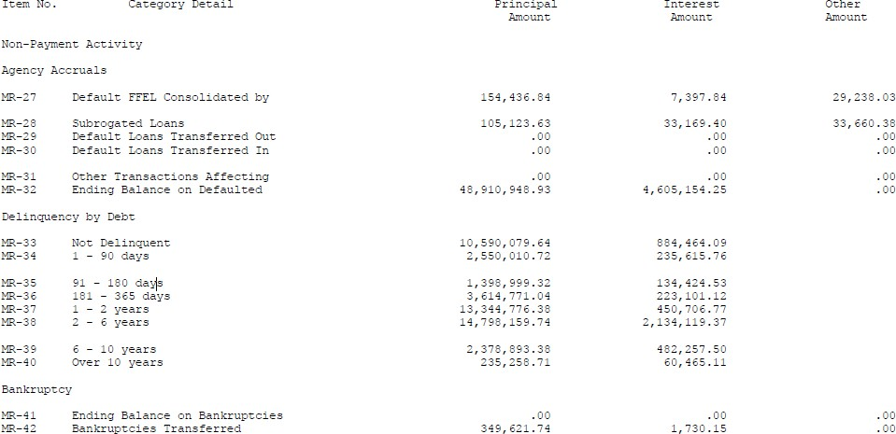

*[This page intentionally left blank.]*

## Appendix B – Presentation of MR-32 & MR-41 Loan Ending Balance Disposition Data Set in Microsoft Excel Format

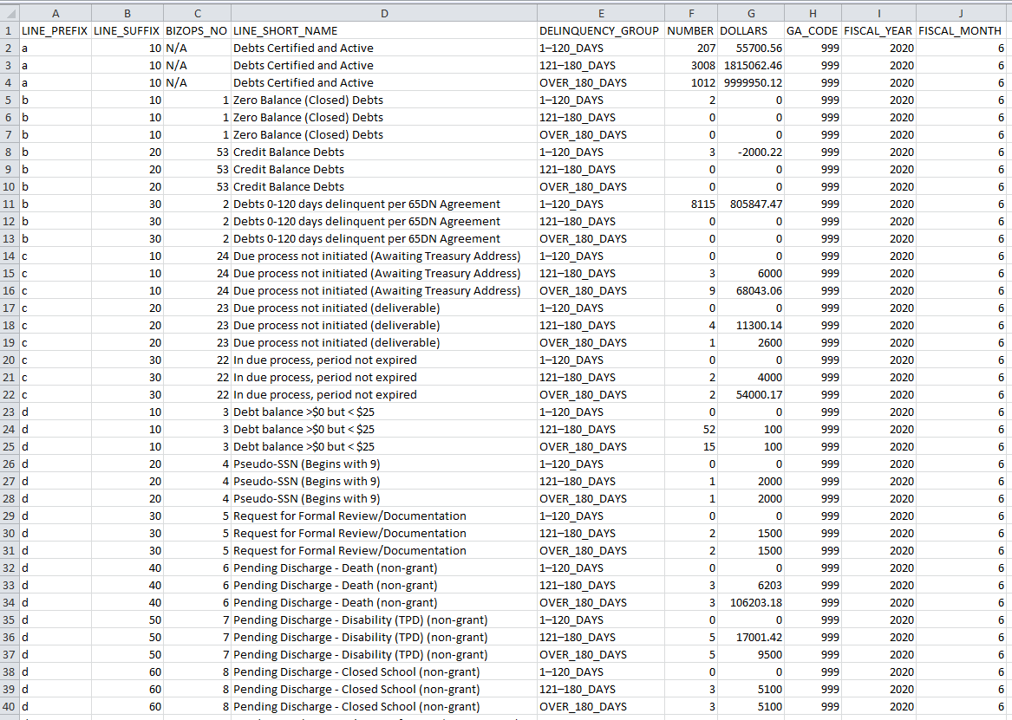**MR-32C & MR-41 Loan Ending Balance Disposition Data Set (Disposition Data)**

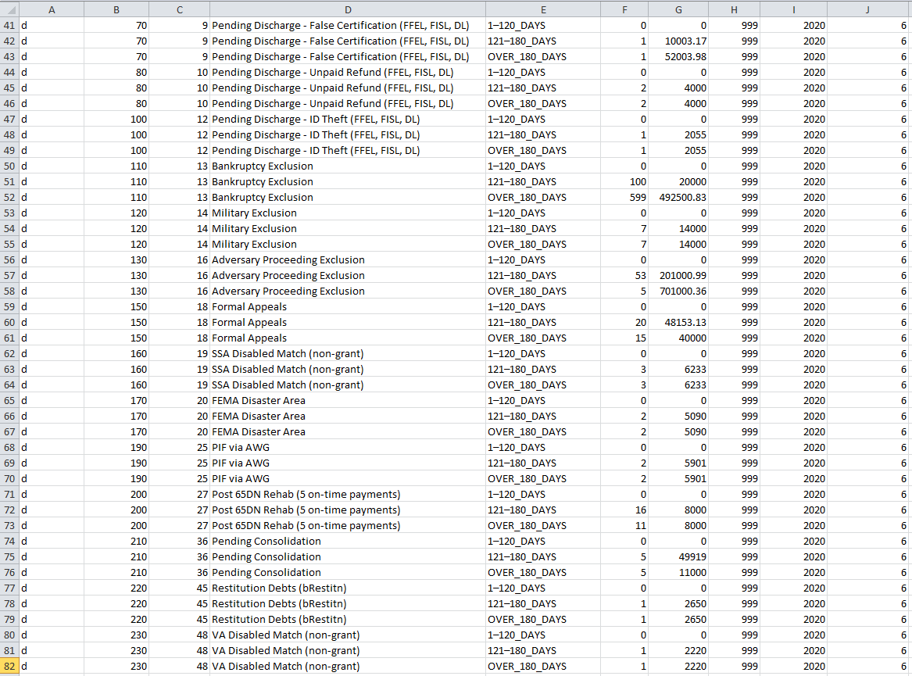

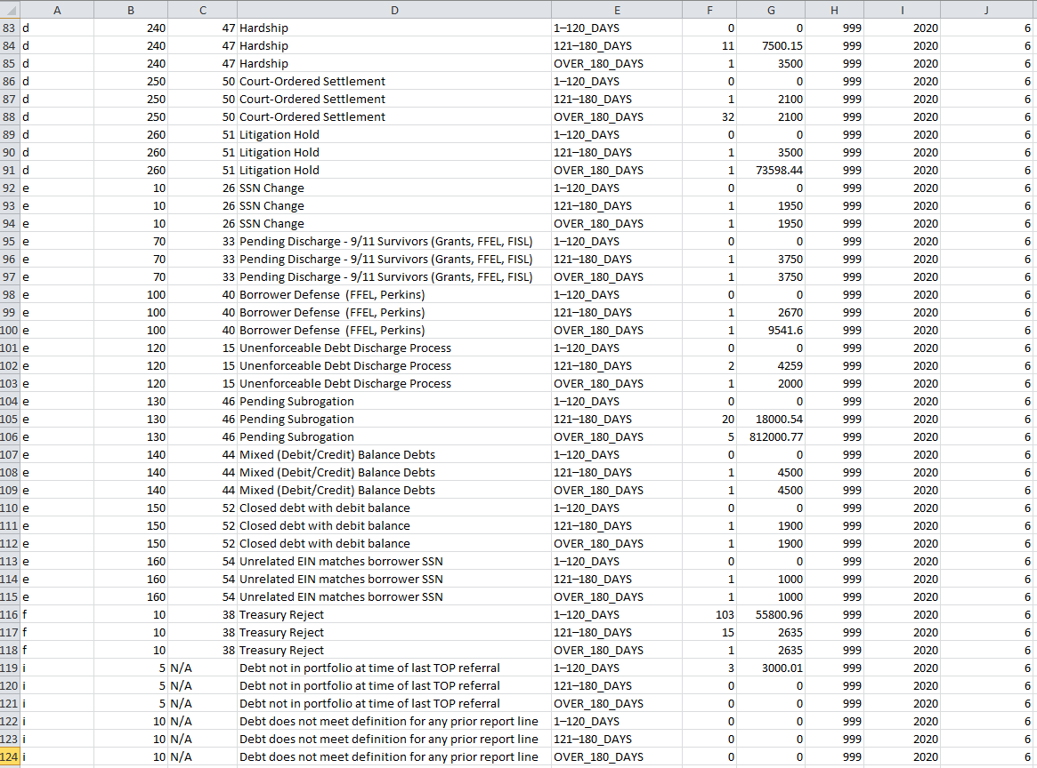

## Appendix C – Mapping GA TOP Referral Business Rules to MR-32 & MR-41 Loan Ending Balance Disposition Data Set Lines

### Mapping of FSA GA TOP Referral Business Rules to Disposition Data Line Numbers

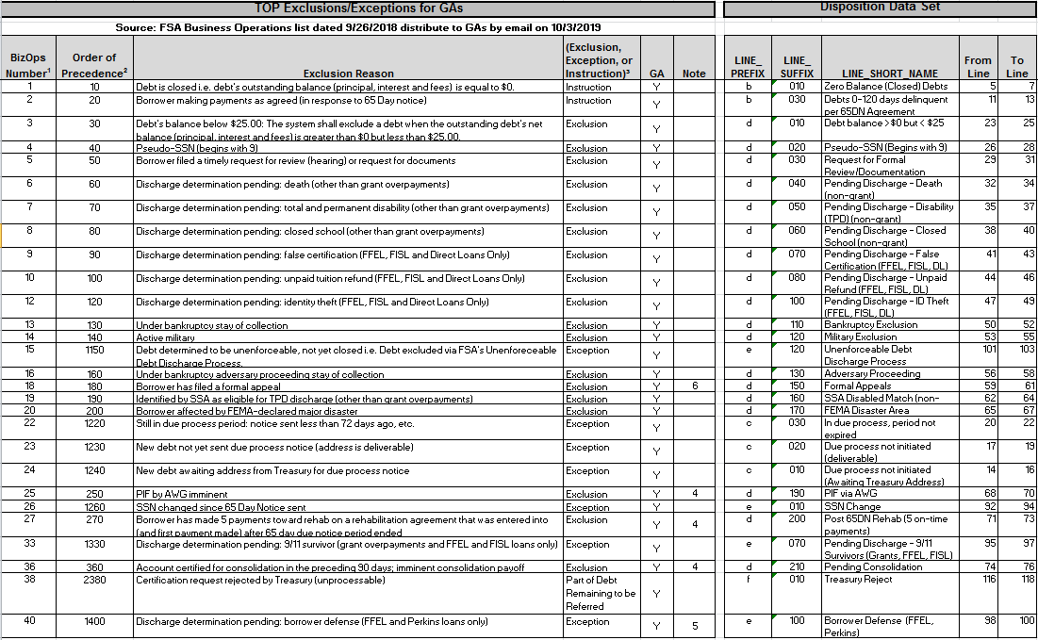

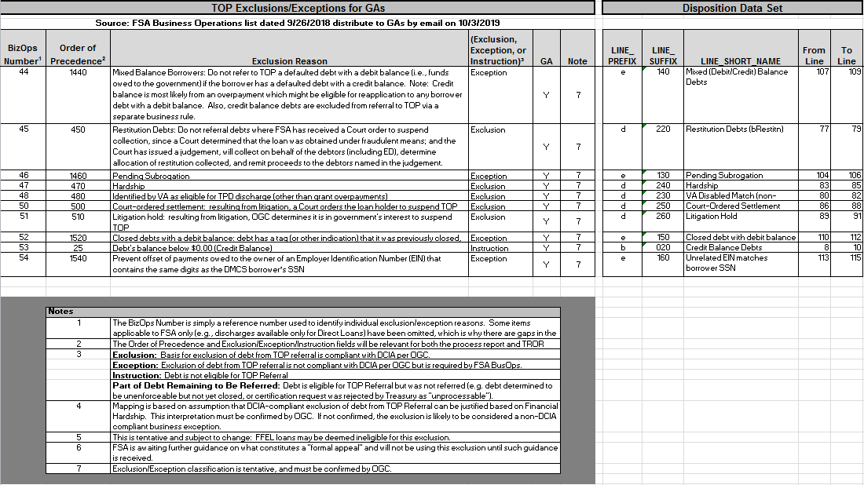

|  |
| --- |
| **Note About Top Exclusions/Exceptions for GAs** |
| The TOP Referral Exclusion/Exception Business Rules for GAs are the responsibility of Program Operations. Questions concerning the TOP referral business process are outside the scope of this document and should be addressed to Program Operations accordingly. |

*[This page intentionally left blank.]*

## Appendix D – Guaranty Agency List

**Appendix D – Guaranty Agency List**

|  |  |  |
| --- | --- | --- |
| **GA**  **Code** | **GA State** | **GA Name** |
| 708 | Colorado | Colorado Student Loan Program dba College Assist |
| 712 | Florida | Florida Department of Education, Office of Student Financial Assistance (OSFA) |
| 721 | Kentucky | Kentucky Higher Education Assistance Authority (KHEAA) |
| 722 | Louisiana | Louisiana Office of Student Financial Assistance (LOSFA) |
| 725 | Massachusetts | American Student Assistance dba Massachusetts Higher Education Assistance Corporation (MHEAC) |
| 726 | Michigan | Michigan Guaranty Agency (MGA) |
| 731 | Nebraska | Nebraska or National Student Loan Program (NSLP) |
| 733 | New Hampshire | New Hampshire Higher Education Assistance Foundation |
| 735 | New Mexico | New Mexico Student Loan Guarantee Corporation |
| 736 | New York | Higher Education Services Corporation (HESC) |
| 737 | North Carolina | North Carolina State Education Assistance Authority (NCSEAA) |
| 740 | Oklahoma | Oklahoma College Assistance Program (OCAP) |
| 742 | Pennsylvania | Pennsylvania Higher Education Assistance Agency (PHEAA) |
| 748 | Texas | Texas Guaranteed Student Loan Corporation |
| 749 | Utah | Utah Higher Education Assistance Authority (UHEAA) |
| 750 | Vermont | Vermont Student Assistance Corporation (VSAC) |
| 755 | Wisconsin | Ascendium Education Solutions |
| 927 | Minnesota | Educational Credit Management Corporation I |
| 951 | Minnesota | Educational Credit Management Corporation II |

## Appendix E – Glossary of Acronyms

**Appendix E – Glossary of Acronyms**

|  |  |
| --- | --- |
| **Acronym / Term** | **Description** |
| 65-Day Notice Period | Required period of notification to the borrower that delinquent *Title IV* debt will be sent to TOP for administrative offset unless the borrower enters into a Rehabilitation Agreement or Repayment Agreement prior to the end of the 65-day notice period or responds with a timely Request for Review or Request for Documents. The 65-Day Notice sent during this period satisfies the requirement to complete TOP due process before referring a debt to TOP. |
| Aging Data | MR-32 Loan Ending Balance Aging Data Set |
| CFOC | Chief Financial Officers’ Council |
| Claim Date | The date a Guaranty Agency pays a lender’s claim. |
| COB | Close of Business |
| Congress | The United States Congress |
| CSV | Comma-Separated Value (Comma Delimited) |
| CY | Calendar Year |
| DCIA | *Debt Collection Improvement Act of 1996,* as amended |
| DCIA Compliance Data Set | DCIA Aging and Compliance Data Set (i.e., the three Data Set requirements, collectively) |
| Department | United States Department of Education |
| Disposition Data | MR-32 & MR-41 Loan Ending Balance Disposition Data Set |
| Exception | A set of criteria, not authorized by DCIA, that when met FSA excludes a debt from referral to TOP or inactivates a debt already at TOP. This set of criteria is based upon FSA policy. An example of excepted debt is debt determined to be unenforceable but not yet closed out. |
| Exclusion | A set of criteria that is compliant with DCIA, that when met, FSA may exclude a debt from referral to TOP or inactivate a debt already at TOP as authorized by DCIA. Examples of excluded debt include debt less than $25 dollars, debt in bankruptcy, etc. |
| FFEL | Federal Family Education Loan Program |
| Form 1099-C | IRS Form 1099-C, Cancellation of Debt |
| FSA | Federal Student Aid |
| FY | Fiscal Year |
| GA | Guaranty Agency |

|  |  |
| --- | --- |
| **Acronym / Term** | **Description** |
| GAFR | Guaranty Agency Financial Report (ED Form 2000) |
| *HEA* | *Higher Education Act of 1965,* as amended |
| IRS | Internal Revenue Service |
| LLR | Lender-of-Last Resort |
| MR | Monthly Report |
| MR-24 | Collection Terminations (GAFR Line Reference) |
| MR-32 | Ending Balance of Defaulted Loans (GAFR Line Reference) |
| MR-41 | Ending Balance on Bankruptcies (GAFR Line Reference) |
| MS | Microsoft |
| OGC | Office of General Counsel |
| OMB | Office of Management and Budget |
| Rehabilitation Agreement | Default resolution agreement available to qualified defaulted *Title IV* borrowers under the terms of which if the borrower makes nine on-time payments (i.e., pays within 20 days of the due date) during a period of ten consecutive months, the debt will be considered “rehabilitated.” The rehabilitated loan is repurchased by a lender or assigned to FSA, clearing the default and resetting the delinquency age to zero (i.e., “current” ). |
| Reinsurance Date | The date the Department reimburses a GA for a previously paid claim. |
| Repayment Agreement | For the DCIA aging, the term Repayment Agreement is reserved to refer to any non-rehabilitation repayment agreement entered into by the borrower after the default of their *Title IV* debt. |
| *Title IV* | *Title IV* of *the Higher Education Act of 1965*, as amended |
| TOP | Treasury Offset Program |
| TPD | Total and Permanent Disability |
| Treasury | United States Department of Treasury |
| Write-Off Data | MR-24 Collection Terminations Write-Off Data Set |