Early Childhood Longitudinal Study, Kindergarten Class of 2023-24 (ECLS-K:2024)

Kindergarten and First-Grade National Data Collection and Transfer School Recruitment

OMB# 1850-0750 v.26

Attachment F
MyECLS Website Screens

National Center for Education Statistics
U.S. Department of Education

October 2022
revised January 2023

MyECLS Website Screens

Note: In this list, materials being translated into Spanish are denoted with an asterisk (“*”). The Spanish translations appear below the English text for each applicable website screen. This draft Spanish translation is under review; final Spanish translations will be provided in a future OMB revision request (e.g., translations of materials for fall 2023 will be submitted to OMB in April 2023).
STUDY HOME / LOG-IN SCREEN* 4
SCHOOL COORDINATOR PORTAL 54
SCHOOL ADMINISTRATOR PORTAL 93
TEACHER PORTAL 99
PARENT PORTAL* 106

STUDY HOME / LOG-IN SCREEN*

This publicly available website will be targeted to the following groups:
Fall 2023 (fall kindergarten data collection) (approximately August 2023 – January 2024) | School Coordinators, Teachers, and Parents (with credentials required to move beyond this home page into their targeted respondent portal)
Spring 2024 (spring kindergarten data collection) (approximately February 2024 – July 2024) | School Coordinators, School Administrators, Teachers, and Parents (with credentials required to move beyond this home page into their targeted respondent portal)
Fall 2024 (fall first-grade advance school contact) (approximately August 2024 – January 2025) | School Coordinators and Parents (with credentials required to move beyond this home page into their targeted respondent portal)
Spring 2025 (spring first-grade data collection) (approximately February 2025 – July 2025) | School Coordinators, School Administrators, Teachers, and Parents (with credentials required to move beyond this home page into their targeted respondent portal)

This document displays the text that will appear on each screen for the fall 2023 kindergarten round, as well as conditional text to display for later rounds. Note that most screenshots in this document will be replaced to reflect text edits once programming has been completed; therefore, those screenshots will be supplied in future OMB revision requests (e.g., fall 2023 screenshots will be provided in the April 2023 revision request). Also, draft Spanish translations are provided in this document. Final Spanish translations will be provided in a future OMB revision request.

While the current OMB request is for the national kindergarten and first-grade data collections and therefore those are the rounds described in this document, it is the current plan to keep the website active throughout the duration of the study. In future OMB requests, we will be proposing additional revisions in those out years to make the website applicable to those later rounds.

The study home/log-in screen (landing page) has four sections: Overview/log-in section (including the “Why Should I Participate?” section), Study Timeline section, Findings section, and More Information section. The landing page will be available in English and Spanish; a language toggle appears in the upper right.

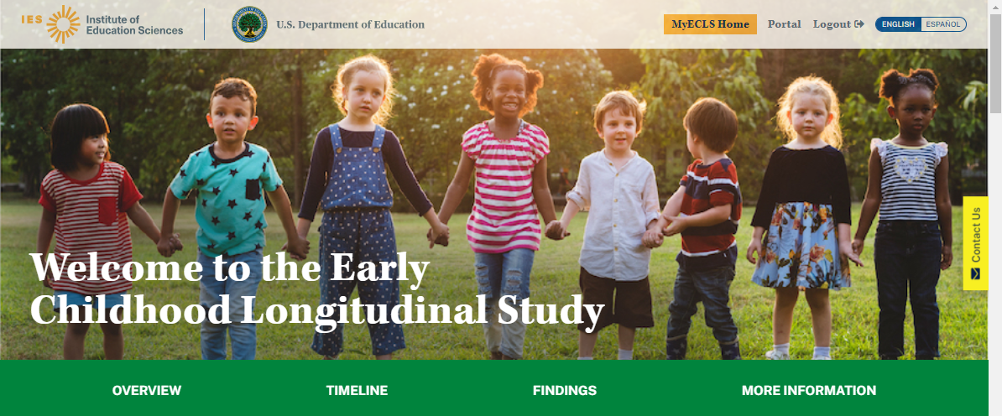

Top of the screen, when the participant is logged in:
- MyECLS Home
- Portal
- Logout

Spanish text:
- Página inicial de MyECLS
- Portal
- Cerrar sesión

Welcome to the Early Childhood Longitudinal Study, Kindergarten Class of 2023-24 (ECLS-K:2024)

The green banner displays buttons to navigate to different sections of the screen: Overview, Timeline, Findings, and More Information.
- “Overview” navigates to the overview section. This section includes the “What is the ECLS?,” the Log-in fields to access the participant’s portal page, and “Why Should I Participate?.”
- “Timeline” navigates to the “Study Timeline” section.
- “Findings” navigates to the “Study Findings” section.
- “More Information” navigates to general study information, the list of endorsements, and resources targeted to districts and schools.

Spanish text:
Bienvenido(a) al Estudio Longitudinal de la Primera Infancia, Clase de Kindergarten 2023-24 (ECLS-K:2024)

- Descripción general
- Calendario
- Resultados
- Más información

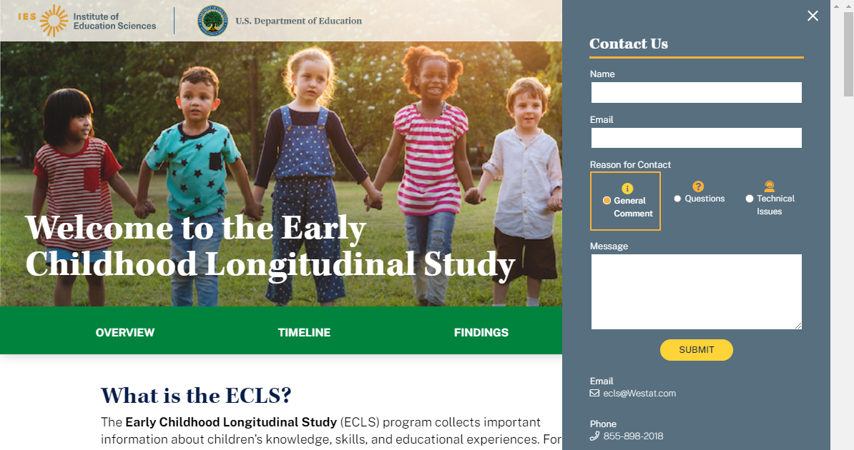

A tab to “Contact us” appears on the right-hand side of the screen. Selecting the “Contact Us” tab opens the “Contact Us” window. Completing the fields in the “Contact Us” window and selecting “Submit” sends a message to ECLS@westat.com.

English text: Spanish Text:
Contact Us Contáctenos
Name Nombre
Email Correo electrónico
Reason for Contact Motivo del contacto
General Comment Comentario general
Questions Preguntas
Technical Issues Problemas técnicos
Message Mensaje
SUBMIT ENVIAR
Email Correo electrónico
Phone Teléfono

The user may receive the following messages upon selecting “submit”:
- An error occurred, please try again. (Se produjo un error. Vuelva a intentarlo.)
- Thank you. Message sent successfully. (Gracias. El mensaje se ha enviado con éxito.)

1.1 Overview/Log-in Section

If still timely and relevant when the website goes live, display a banner at the top of the page regarding the coronavirus pandemic:
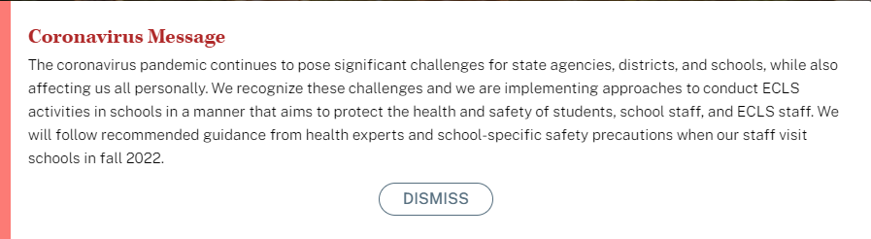
Coronavirus Message
The coronavirus pandemic continues to pose significant challenges for state agencies, districts, and schools, while also affecting us all personally. We recognize these challenges and we are implementing approaches to conduct ECLS-K:2024 activities in schools in a manner that aims to protect the health and safety of students, school staff, and ECLS-K:2024 staff. We will follow recommended guidance from health experts and school-specific safety precautions when our staff visit schools.
Dismiss
Spanish text:
Mensaje sobre coronavirus
La pandemia del coronavirus continúa presentando desafíos importantes a las agencias estatales, distritos y escuelas, mientras sigue afectándonos a todos a nivel individual. Reconocemos estos desafíos y estamos implementando cómo llevar adelante las actividades de ECLS-K:2024 en las escuelas de manera de proteger la salud y la seguridad de los estudiantes, del personal escolar y del personal de ECLS-K:2024. Cuando nuestro personal visite las escuelas, seguiremos las recomendaciones de los expertos en salud y las precauciones específicas de las escuelas.

Eliminar mensaje de error

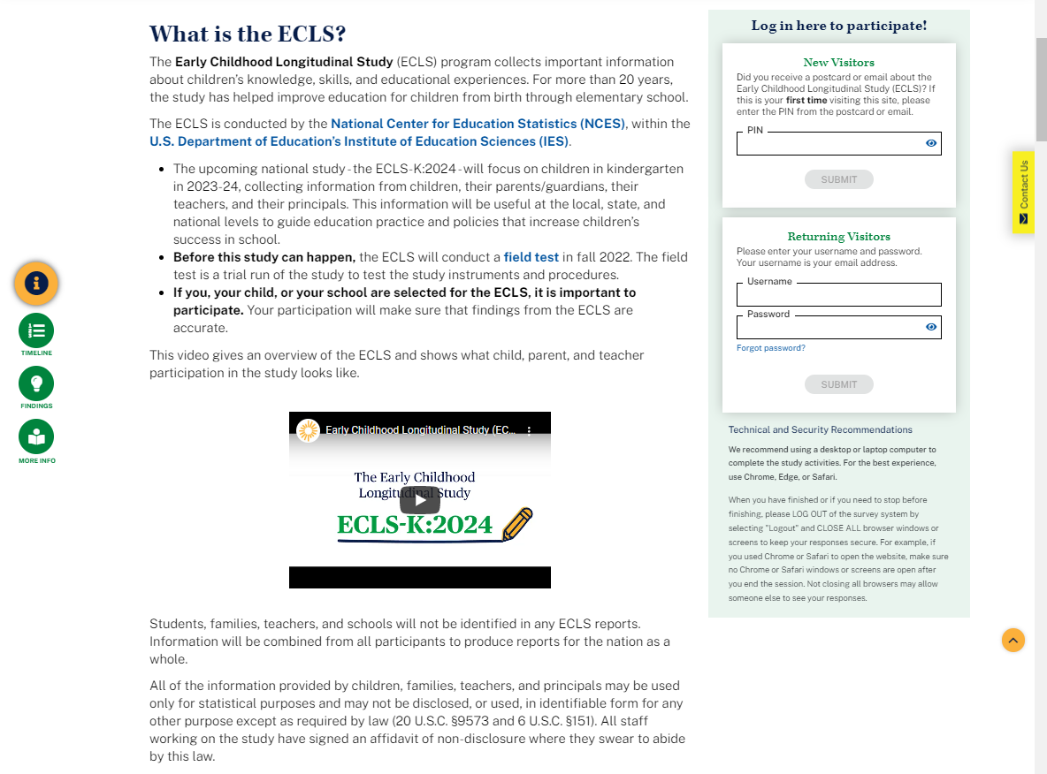

The left-hand side of the screen displays information about the ECLS. The navigation buttons on the left can be used to skip to each section: Overview, Timeline, Findings, and More Info.

What is the ECLS?
The Early Childhood Longitudinal Study (ECLS) program collects important information about children’s knowledge, skills, and educational experiences. For more than 20 years, the study has helped improve education for children from birth through elementary school.
The ECLS is conducted by the National Center for Education Statistics (NCES) [LINK TO NCES WEBSITE https://nces.ed.gov/ecls/], within the U.S. Department of Education’s [LINK TO DEPARTMENT OF EDUCATION SITE https://www.ed.gov/] Institute of Education Sciences (IES) [LINK TO IES SITE https://ies.ed.gov/].

- The current national study - the ECLS-K:2024 - focuses on children [BEGINNING IN FALL 2024: who were] in kindergarten in 2023-24, collecting information from children, their parents/guardians, their teachers, and their principals. This information will be useful at the local, state, and national levels to guide education practice and policies that increase children’s success in school. [FALL 2024: The study is currently contacting selected schools to prepare for the spring 2025 study activities, when most participating children will be in first grade.] [SPRING 2025: The study is currently conducting activities with participating children, most of whom are in first grade.]
- The ECLS-K:2024 will be particularly meaningful, as it will provide important information about the experiences of children whose early lives were shaped by the COVID-19 pandemic.
- If you, your child, or your school have been selected for the ECLS-K:2024, it is important to participate. Your participation will make sure that findings from the ECLS-K:2024 are accurate.

A thumbnail of the ECLS-K:2024 video displays below the text. This is a recruitment video that gives an overview of the ECLS program and ECLS-K:2024 study. See the video script in Attachment A-3.

This video gives an overview of the ECLS-K:2024 and shows what child, parent, and teacher participation in the study looks like.

DISPLAY OVERVIEW VIDEO THUMBNAIL

This video shows what the study activities look like for children.

DISPLAY CHILD EXPERIENCE VIDEO THUMBNAIL

Students, families, teachers, and schools will not be identified in any ECLS-K:2024 reports. Information will be combined from all participants to produce reports for the nation as a whole.

All of the information provided by children, families, teachers, and principals may be used only for statistical purposes and may not be disclosed, or used, in identifiable form for any other purpose except as required by law (20 U.S.C. §9573 and 6 U.S.C. §151). All staff working on the study have signed an affidavit of non-disclosure where they swear to abide by this law.

The right-hand side of the screen displays log-in fields for visitors with credentials.

Log in here to participate!

New Visitors
Did you receive a postcard or email about the Early Childhood Longitudinal Study, Kindergarten Class of 2023-24 (ECLS-K:2024)? If this is your first time visiting this site, please enter the PIN from the postcard or email.

Returning Visitors
Please enter your username and password. Your username is your email address.
Forgot Password? [LINK]

When the “forgot password” link is clicked, the user receives an email with a link. The email reads: “Click the link below to create a new password. Reset Password [LINK].”

Spanish text:

¿Qué es el ECLS?
El programa del Estudio Longitudinal de la Primera Infancia (ECLS por sus siglas en inglés) recopila información importante sobre los conocimientos, las habilidades y las experiencias educativas de los niños. Durante más de 20 años, el estudio ha ayudado a mejorar la educación de los niños desde su nacimiento y durante la escuela elemental.
El estudio ECLS es llevado a cabo por el Centro Nacional para Estadísticas de Educación (NCES por sus siglas en inglés) [LINK TO NCES WEBSITE https://nces.ed.gov/ecls/], dentro del Instituto de Ciencias de la Educación (IES por sus siglas en inglés) [LINK TO IES SITE https://ies.ed.gov/], del Departamento de Educación de los EE.UU. [LINK TO DEPARTMENT OF EDUCATION SITE https://www.ed.gov/].

- El estudio nacional actual - el ECLS-K:2024 – se enfoca en los niños [BEGINNING IN FALL 2024: que estaban] en kindergarten en 2023-24 y obtiene información de los niños, sus padres o madres/tutores o guardianes legales, sus maestros y los directores de escuelas. Esta información será útil a nivel local, estatal y nacional para guiar las prácticas y políticas educativas que permiten un mejor desempeño escolar en los niños. [FALL 2024: Actualmente el estudio está contactando a las escuelas seleccionadas para que se preparen para las actividades del estudio en la primavera de 2025, cuando la mayoría de los niños que participen estarán en primer grado.] [SPRING 2025: Actualmente el estudio está llevando a cabo actividades con los niños que participan, la mayor parte de los cuales están en primer grado.]

- El estudio ECLS-K:2024 será particularmente significativo ya que proporcionará importante información acerca de las experiencias de los niños cuyos primeros años de vida fueron moldeados por la pandemia del COVID-19.Si usted, su niño(a) o su escuela han sido seleccionados para el ECLS-K:2024, es importante que participen. Su participación asegurará que los resultados de ECLS-K:2024 sean precisos.

Este video presenta un resumen del ECLS-K:2024 y muestra en qué consiste la participación de los niños, sus padres/madres y maestros.

DISPLAY VIDEO THUMBNAIL

Los estudiantes, las familias, los maestros y las escuelas no se identificarán en ningún reporte de ECLS-K:2024. La información de todos los participantes se combinará para producir reportes sobre la nación en su conjunto.

Toda la información que proporcionen los niños, las familias, los maestros y los directores podrá usarse solamente para propósitos estadísticos y no podrá divulgarse ni usarse de manera que permita identificar a los participantes para ningún otro propósito, salvo que lo requiera la ley (20 U.S.C. §9573 y 6 U.S.C. §151). Todo el personal que trabaja en el estudio ha firmado una declaración de no divulgación, donde juran cumplir con esta ley.

¡Ingrese aquí para participar!

Visitantes Nuevos

¿Recibió una tarjeta postal o un correo electrónico sobre el Estudio Longitudinal de la Primera Infancia , Clase de Kindergarten 2023-24 (ECLS-K:2024)?Si es la primera vez que visita esta página de Internet, por favor ponga el PIN que está en la tarjeta postal o en su correo electrónico.

Visitantes Que Regresan
Por favor ponga su nombre de usuario y su contraseña. Su nombre de usuario es su dirección de correo electrónico.
¿Olvidó su contraseña? [LINK]

When the “¿Olvidó su contraseña?” link is clicked, the user receives an email with a link. The email reads: Haga clic en el siguiente enlace para crear una nueva contraseña. Crear nueva contraseña [LINK].

There is a PIN field for first-time visitors and there are username and password fields for returning visitors.
- First-time visitors will enter a PIN and then immediately will be prompted to create a username and password.
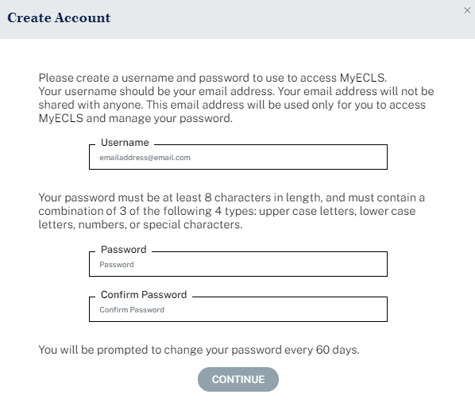
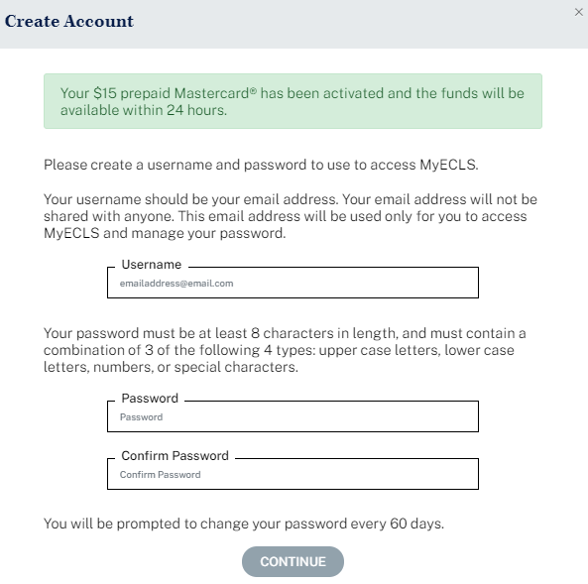
Create Account
Display for parents if a parent incentive is offered: Your $15 prepaid Mastercard® has been activated and the funds will be available within 24 hours.
Please create a username and password to use to access MyECLS. Your username should be your email address. Your email address will not be shared with anyone. This email address will be used only for you to access MyECLS and manage your password.
Username
Your password must be at least 8 characters in length and must contain a combination of 3 of the following 4 types: upper case letters, lower case letters, numbers, or special characters.
Password
Confirm Password
You will be prompted to change your password every 60 days.
Continue (BUTTON)
Spanish text:
Crear una cuenta
Display for parents if a parent incentive is offered: Su tarjeta prepagada Mastercard® de $15 ha sido activada y los fondos estarán disponibles en un plazo de 24 horas.

Por favor cree un nombre de usuario y una contraseña para ingresar a MyECLS. Su nombre de usuario debe ser su dirección de correo electrónico. No compartiremos con nadie su dirección de correo electrónico. Esta dirección de correo electrónico se usará solamente para ingresar a MyECLS y administrar su contraseña.

Nombre de usuario

Su contraseña deberá tener al menos 8 caracteres de longitud y deberá incluir una combinación de 3 de los siguientes 4 tipos: letras mayúsculas, letras minúsculas, números, o caracteres especiales.

Contraseña

Confirmar contraseña

Cada 60 días se le pedirá que cambie su contraseña.

Continuar (BUTTON)

- When the “Forgot Password?” link is selected, a temporary password will be sent to the user’s email address (username).
- Users will be prompted to reset passwords every 60 days.

The following messages will appear below the log-in fields on the Create Account modal (2-4; 6), or will appear in a new pop-up window (1; 5; 7-15).
- A message for invalid PIN entry (too few/many digits or not recognized):
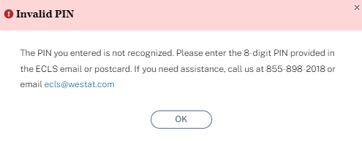

Invalid PIN
“The PIN you entered is not recognized. Please enter the 8-digit PIN provided in the ECLS-K:2024 email or postcard. If you need assistance, call us at 855-898-2018 or email ecls@westat.com.”

Spanish text:

PIN inválido
“El PIN que ingresó no se reconoce. Por favor, ingrese el PIN válido de 8 dígitos proporcionado en el correo electrónico o tarjeta postal de ECLS-K:2024. Si necesita ayuda, llámenos al 855-898-2018 o envíe un correo electrónico a ecls@westat.com."

- A message for invalid email address at account creation (no @ symbol, no .com/.org/etc. extension, contains a space or invalid characters):
“Please enter a valid email address.”

Spanish text:
“Por favor ponga una dirección de correo electrónico válida.”

- Messages for user account password requirements (depending on what is entered in the fields):
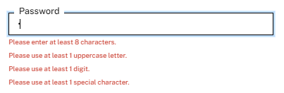

- “Please enter at least 8 characters.”
- “Please use at least 1 lowercase letter.”
- “Please use at least 1 uppercase letter.”
- “Please use at least 1 digit.”
- “Please use at least 1 special character.”
- “Password successfully updated.”
- “Reset MyECLS Password”
- “This field is required.”

Spanish text:
- “Por favor ingrese por lo menos 8 caracteres.”
- “Por favor use por lo menos 1 letra minúscula.”
- “Por favor use por lo menos 1 letra mayúscula.”
- “Por favor use por lo menos 1 dígito.”
- “Por favor use por lo menos 1 carácter especial.”
- “La contraseña se ha logrado cambiar.”
- “Cambiar mi contraseña de MyECLS”
- “Se debe rellenar este campo.”

- A message for non-matching passwords at password creation (either initially or upon reset):
“Please enter the same value again.”
Spanish text:
“Por favor ponga nuevamente el mismo valor.”

- A message if the user enters a PIN associated with an ID for which an account (username and password) has already been created:
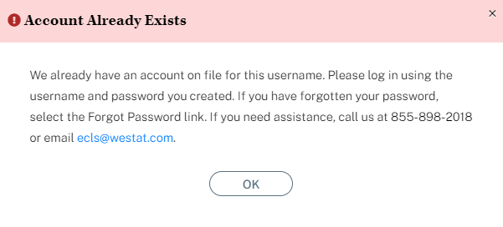
Account Already Exists
“We already have an account on file for this username. Please log in using the username and password you created. If you have forgotten your password, select the Forgot Password link. If you need assistance, call us at 855-898-2018 or email ecls@westat.com.”

Spanish text:
Esta cuenta ya existe
“Ya tenemos una cuenta en el sistema para este nombre de usuario. Por favor, inicie la sesión con el nombre de usuario y la contraseña que ha creado. Si ha olvidado su contraseña, haga clic en el enlace ¿Olvidó su contraseña? Si necesita ayuda, llámenos al 855-898-2018 o envíe un correo electrónico a ecls@westat.com."

- A message if the user attempts to use an existing username to create an account for a second PIN (red text on Create Account window):
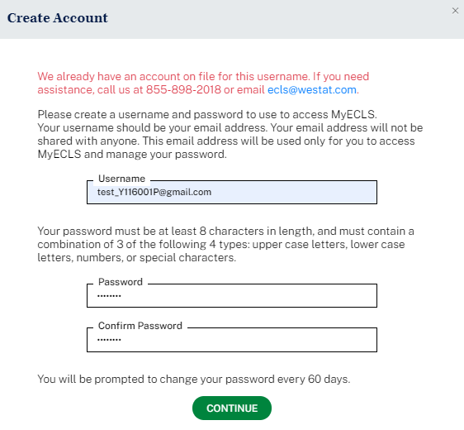
“We already have an account on file for this username. If you need assistance, call us at 855-898-2018 or email ecls@westat.com.”

Spanish text:
"Ya tenemos una cuenta en el sistema para este nombre de usuario. Si necesita ayuda, llámenos al 855-898-2018 o envíe un correo electrónico a ecls@westat.com."

- A message for unrecognized username:
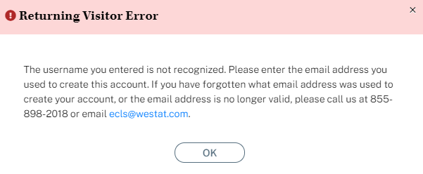
Returning Visitor Error
“The username you entered is not recognized. Please enter the email address you used to create this account. If you have forgotten what email address was used to create your account, or the email address is no longer valid, please call us at 855-898-2018 or email ecls@westat.com.”

Spanish text:
Error para visitantes que regresan
"El nombre de usuario que ha ingresado no se reconoce. Por favor, ingrese la dirección de correo electrónico que utilizó para crear esta cuenta. Si ha olvidado la dirección de correo electrónico que utilizó para crear su cuenta, o si esa dirección ya no es válida, por favor llámenos al 855-898-2018 o envíe un correo electrónico a ecls@westat.com."

- A message for unrecognized password:
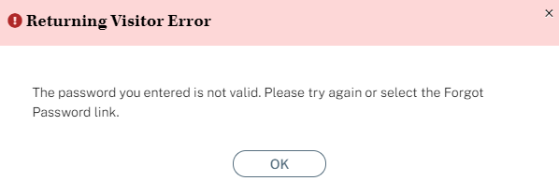
Returning Visitor Error
“The password you entered is not valid. Please try again or select the Forgot Password link.”

Spanish text:
Error para visitantes que regresan
"La contraseña que ha ingresado no es válida. Por favor, inténtelo de nuevo o haga clic en el enlace ¿Olvidó su contraseña?"

- Message pop-up box for when the user clicks the forgot password link:
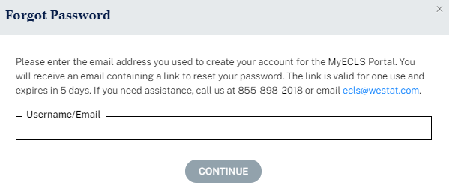
Forgot Password
“Please enter the email address you used to create your account for the MyECLS Portal. You will receive an email containing a link to reset your password. The link is valid for one use and expires in 5 days. If you need assistance, call us at 855-898-2018 or email ecls@westat.com.”

Username/Email [FIELD]

Continue [BUTTON]

Spanish text:
Olvidó su contraseña
"Por favor, ingrese la dirección de correo electrónico que utilizó para crear su cuenta en el portal MyECLS. Recibirá un correo electrónico con un enlace para cambiar su contraseña. El enlace es válido para un solo uso y expira en 5 días. Si necesita ayuda, llámenos al 855-898-2018 o envíe un correo electrónico a ecls@westat.com."
Nombre de usuario/correo electrónico [FIELD]
Continuar [BUTTON]

- Message box for log-in using the reset password link that the user received in an email after selecting the “forgot password” link:
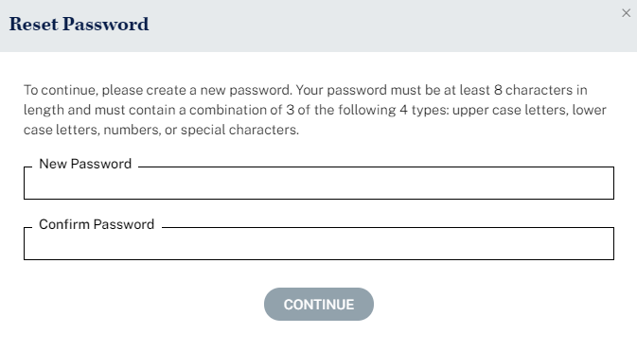
Reset Password
“To continue, please create a new password. Your password must be at least 8 characters in length and must contain a combination of 3 of the following 4 types: upper case letters, lower case letters, numbers, or special characters.”
New Password [FIELD]
Confirm Password [FIELD]
Continue [BUTTON]

Spanish text:
Cambiar de contraseña
"Para continuar, por favor cambie la contraseña. Su contraseña deberá tener al menos 8 caracteres de longitud y deberá incluir una combinación de 3 de los siguientes 4 tipos: letras mayúsculas, letras minúsculas, números, o caracteres especiales."
Nueva contraseña [FIELD]
Confirme la contraseña [FIELD]
Continuar [BUTTON]

Possible error messages associated with this screen (English and Spanish):

The password you entered does not meet the minimum requirements. Your password must be at least 8 characters in length and must contain a combination of 3 of the following 4 types: upper case letters, lower case letters, numbers, or special characters. It must not be identical to a previous password.

La contraseña que puso no cumple con los requisitos mínimos. Su contraseña deberá tener al menos 8 caracteres de longitud y deberá incluir una combinación de 3 de los siguientes 4 tipos: letras mayúsculas, letras minúsculas, números, o caracteres especiales. No debe ser idéntica a una contraseña que usó aquí antes.

The passwords you entered do not match. Please try again. Your password must be at least 8 characters in length and must contain a combination of 3 of the following 4 types: upper case letters, lower case letters, numbers, or special characters. It must not be identical to a previous password.
Las contraseñas que puso no concuerdan. Por favor, inténtelo de nuevo. Su contraseña deberá tener al menos 8 caracteres de longitud y deberá incluir una combinación de 3 de los siguientes 4 tipos: letras mayúsculas, letras minúsculas, números, o caracteres especiales. No debe ser idéntica a una contraseña que usó aquí antes.
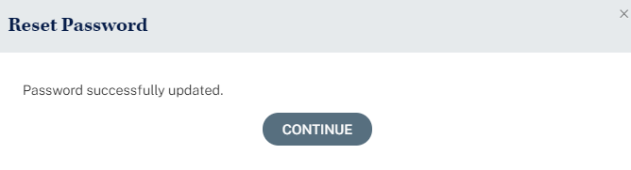
Reset Password
Password successfully updated.
Continue [BUTTON]

Spanish text:
Cambiar de contraseña
La contraseña se ha logrado cambiar.
Continuar [BUTTON]

- Message when user clicks a reset password link that has expired:
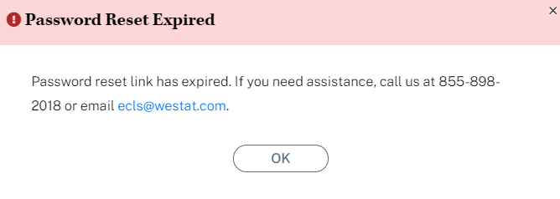
Password Reset Expired
“Password reset link has expired. If you need assistance, call us at 855-898-2018 or email ecls@westat.com.”

Spanish text:
El cambio de contraseña ha expirado
"El enlace para cambiar la contraseña ha expirado. Si necesita ayuda, llámenos al 855-898-2018 o envíe un correo electrónico a ecls@westat.com."

- An alert that the password will expire soon (passwords expire every 60 days). This message will display upon log-in within 7 days of the expiration date. The user can cancel, since he or she is not required to change passwords until the 60-day expiration. For the second message, only the red text is specified below the screenshot.
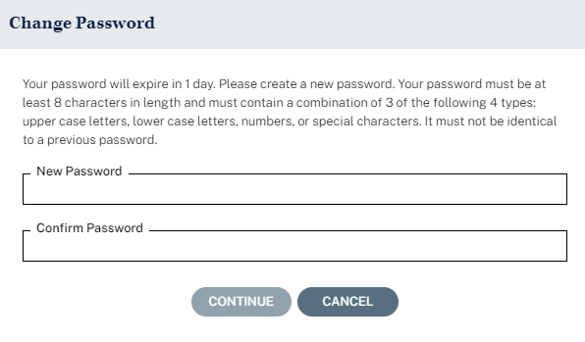
Change Password
“Your password will expire in X days. Please create a new password. Your password must be at least 8 characters in length and must contain a combination of 3 of the following 4 types: upper case letters, lower case letters, numbers, or special characters. It must not be identical to a previous password.”
New Password [FIELD]
Confirm Password [FIELD]
Continue [BUTTON]
Cancel [BUTTON]

Spanish text:
Cambiar contraseña
"Su contraseña expirará en X días. Por favor, cambie su nueva contraseña. Su contraseña deberá tener al menos 8 caracteres de longitud y deberá incluir una combinación de 3 de los siguientes 4 tipos: letras mayúsculas, letras minúsculas, números, o caracteres especiales. No debe ser idéntica a una contraseña que usó aquí antes."
Nueva contraseña [FIELD]
Confirme la contraseña [FIELD]
Cancelar [BUTTON]
Continuar [BUTTON]

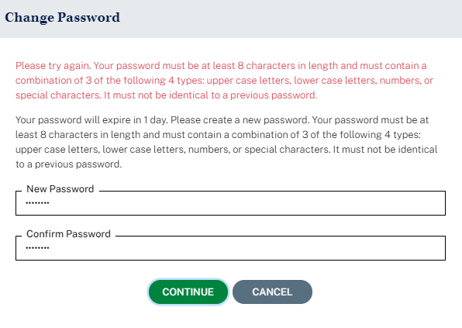
Change Password
“Please try again. Your password must be at least 8 characters in length and must contain a combination of 3 of the following 4 types: upper case letters, lower case letters, numbers, or special characters. It must not be identical to a previous password.

Your password will expire in X days. Please create a new password. Your password must be at least 8 characters in length and must contain a combination of 3 of the following 4 types: upper case letters, lower case letters, numbers, or special characters. It must not be identical to a previous password.”

New Password [FIELD]
Confirm Password [FIELD]
Continue [BUTTON]
Cancel [BUTTON]

Spanish text:
Cambiar contraseña
"Por favor, inténtelo de nuevo. Su contraseña deberá tener al menos 8 caracteres de longitud y deberá incluir una combinación de 3 de los siguientes 4 tipos: letras mayúsculas, letras minúsculas, números, o caracteres especiales. No debe ser idéntica a una contraseña que usó aquí antes.

Su contraseña expirará en X días. Por favor, cambie su nueva contraseña. Su contraseña deberá tener al menos 8 caracteres de longitud y deberá incluir una combinación de 3 de los siguientes 4 tipos: letras mayúsculas, letras minúsculas, números, o caracteres especiales. No debe ser idéntica a una contraseña que usó aquí antes."

Nueva contraseña [FIELD]
Confirme la contraseña [FIELD]
Continuar [BUTTON]
Cancelar [BUTTON]

Possible error messages associated with this screen (English and Spanish):

The password you entered does not meet the minimum requirements. Your password must be at least 8 characters in length and must contain a combination of 3 of the following 4 types: upper case letters, lower case letters, numbers, or special characters. It must not be identical to a previous password.

La contraseña que puso no cumple con los requisitos mínimos. Su contraseña deberá tener al menos 8 caracteres de longitud y deberá incluir una combinación de 3 de los siguientes 4 tipos: letras mayúsculas, letras minúsculas, números, o caracteres especiales. No debe ser idéntica a una contraseña que usó aquí antes.

The passwords you entered do not match. Please try again. Your password must be at least 8 characters in length and must contain a combination of 3 of the following 4 types: upper case letters, lower case letters, numbers, or special characters. It must not be identical to a previous password.
Las contraseñas que puso no concuerdan. Por favor, inténtelo de nuevo. Su contraseña deberá tener al menos 8 caracteres de longitud y deberá incluir una combinación de 3 de los siguientes 4 tipos: letras mayúsculas, letras minúsculas, números, o caracteres especiales. No debe ser idéntica a una contraseña que usó aquí antes.

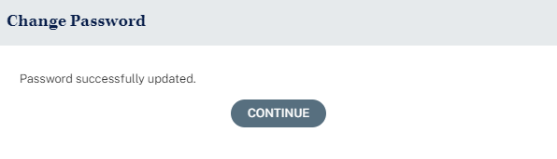
Change Password
Password Successfully updated.
Continue [BUTTON]

Spanish text:
Cambiar contraseña
La contraseña se ha logrado cambiar.
Continuar [BUTTON]

- An alert that the password has expired and the user must create a new one (passwords expire every 60 days):
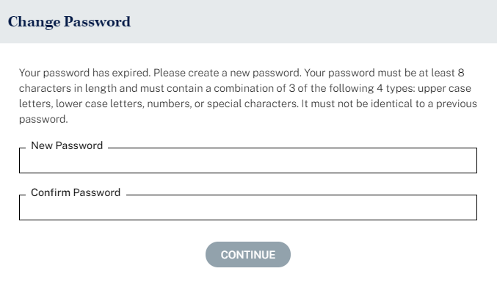
Change Password
“Your password has expired. Please create a new password. Your password must be at least 8 characters in length and must contain a combination of 3 of the following 4 types: upper case letters, lower case letters, numbers, or special characters. It must not be identical to a previous password.”
New Password [FIELD]
Confirm Password [FIELD]
Continue [BUTTON]

Spanish text:
Cambiar contraseña
"Su contraseña ha expirado. Por favor, cambie su contraseña. Su contraseña deberá tener al menos 8 caracteres de longitud y deberá incluir una combinación de 3 de los siguientes 4 tipos: letras mayúsculas, letras minúsculas, números, o caracteres especiales. No debe ser idéntica a una contraseña que usó aquí antes."
Nueva contraseña [FIELD]
Confirme la contraseña [FIELD]
Continuar [BUTTON]

Possible error messages associated with this screen (English and Spanish):

The password you entered does not meet the minimum requirements. Your password must be at least 8 characters in length and must contain a combination of 3 of the following 4 types: upper case letters, lower case letters, numbers, or special characters. It must not be identical to a previous password.

La contraseña que puso no cumple con los requisitos mínimos. Su contraseña deberá tener al menos 8 caracteres de longitud y deberá incluir una combinación de 3 de los siguientes 4 tipos: letras mayúsculas, letras minúsculas, números, o caracteres especiales. No debe ser idéntica a una contraseña que usó aquí antes.

The passwords you entered do not match. Please try again. Your password must be at least 8 characters in length and must contain a combination of 3 of the following 4 types: upper case letters, lower case letters, numbers, or special characters. It must not be identical to a previous password.
Las contraseñas que puso no concuerdan. Por favor, inténtelo de nuevo. Su contraseña deberá tener al menos 8 caracteres de longitud y deberá incluir una combinación de 3 de los siguientes 4 tipos: letras mayúsculas, letras minúsculas, números, o caracteres especiales. No debe ser idéntica a una contraseña que usó aquí antes.

- Message for a disabled account (e.g., parent assigned final refusal status code, parent of child who moved and was not followed, teacher no longer linked to study children, school administrator or school coordinator has changed).
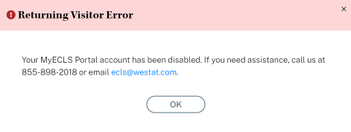
Returning Visitor Error
“Your MyECLS Portal account has been disabled. If you need assistance, call us at 855-898-2018 or email ecls@westat.com.”

Spanish text:
Error para visitantes que regresan
"Su cuenta del portal MyECLS ha sido desactivada. Si necesita ayuda, llámenos al 855-898-2018 o envíe un correo electrónico a ecls@westat.com."

- Message for when the user is inactive.
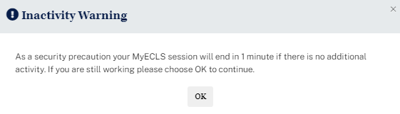
Inactivity Warning
“As a security precaution your MyECLS session will end in 1 minute if there is no additional activity. If you are still working please choose OK to continue.”
Advertencia de inactividad
“Como precaución de seguridad, su sesión de MyECLS va a terminar en 1 minuto si no hay ninguna actividad más. Si sigue trabajando, por favor seleccione OK para continuar.”
- Message for when MyECLS participant portals are inactive between rounds.
“The MyECLS website is currently unavailable. If you need assistance, call us at 855-898-2018 or email ecls@westat.com.”
Spanish text:
“El sitio MyECLS en Internet no está disponible actualmente. Si necesita ayuda, llámenos al 855-898-2018 o envíe un correo a ecls@westat.com.”

Below the log-in fields, display “Technical and Security Recommendations”:
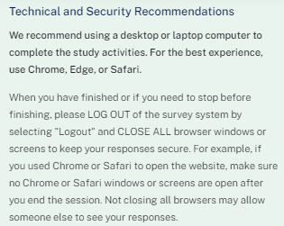
We recommend using a desktop or laptop computer to complete the study activities. For the best experience, use Chrome, Edge, or Safari.

When you have finished or if you need to stop before finishing, please LOG OUT of the survey system by selecting "Logout" and CLOSE ALL browser windows or screens to keep your responses secure. For example, if you used Chrome or Safari to open the website, make sure no Chrome or Safari windows or screens are open after you end the session. Not closing all browsers may allow someone else to see your responses.

Spanish text:

Le recomendamos usar una computadora de escritorio o una computadora portátil para completar las actividades del estudio. Para que tenga una mejor experiencia, use Chrome, Edge o Safari.

Cuando haya terminado, o si necesita hacer otra cosa antes de terminar, por favor CIERRE LA SESIÓN del sistema de la encuesta, haciendo clic en "Cerrar sesión" y CIERRE TODAS las ventanas o pantallas del navegador para mantener sus respuestas seguras. Por ejemplo, si usted usó Chrome o Safari para abrir la página de Internet, asegúrese de que no hay ventanas o pantallas abiertas en Chrome o Safari después de terminar la sesión. No cerrar todos los navegadores puede permitir que otra persona vea sus respuestas.

When the respondent logs in, “Technical and Security Recommendations” will appear:
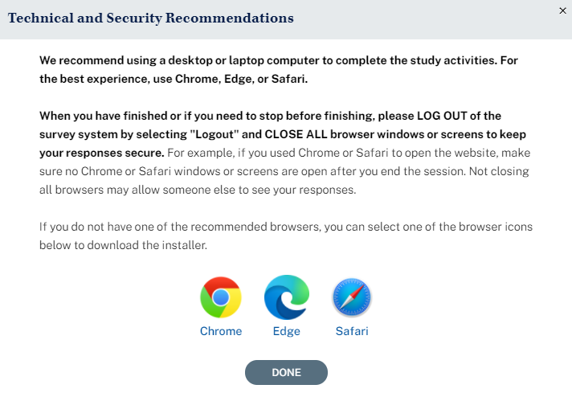

Technical and Security Recommendations

We recommend using a desktop or laptop computer to complete the study activities. For the best experience, use Chrome, Edge, or Safari.

When you have finished or if you need to stop before finishing, please LOG OUT of the survey system by selecting "Logout" and CLOSE ALL browser windows or screens to keep your responses secure. For example, if you used Chrome or Safari to open the website, make sure no Chrome or Safari windows or screens are open after you end the session. Not closing all browsers may allow someone else to see your responses.

If you do not have one of the recommended browsers, you can select one of the browser icons below to download the installer.

Chrome Edge Safari

DONE

Spanish text:
Recomendaciones técnicas y de seguridad
Le recomendamos usar una computadora de escritorio o una computadora portátil para completar las actividades del estudio. Para que tenga una mejor experiencia, use Chrome, Edge o Safari.

Cuando haya terminado, o si necesita hacer otra cosa antes de terminar, por favor CIERRE LA SESIÓN del sistema de la encuesta, haciendo clic en "Cerrar sesión" y CIERRE TODAS las ventanas o pantallas del navegador para mantener sus respuestas seguras. Por ejemplo, si usted usó Chrome o Safari para abrir la página de Internet, asegúrese de que no hay ventanas o pantallas abiertas en Chrome o Safari después de terminar la sesión. No cerrar todos los navegadores puede permitir que otra persona vea sus respuestas.

Si no tiene ninguno de los navegadores recomendados, puede seleccionar uno de los íconos de navegadores que están a continuación para descargar el instalador.

Chrome Edge Safari

LISTO

1.2 “Why Should I Participate?” Section

Below the overview and log-in section, the user can scroll down to “Why Should I Participate?”
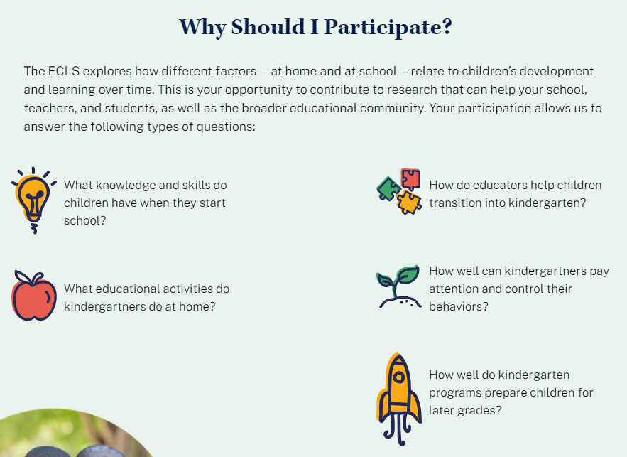

Why Should I Participate?

The ECLS-K:2024 explores how different factors—at home and at school—relate to children’s development and learning over time. This is your opportunity to contribute to research that can help your school, teachers, and students, as well as the broader educational community. Your participation allows us to answer the following types of questions:
[DISPLAY IN FALL AND SPRING KINDERGARTEN:
- What knowledge and skills do children have when they start school?
- What educational activities do kindergartners do at home?
- How do educators help children transition into kindergarten?
- How well can kindergartners pay attention and control their behaviors?
- How well do kindergarten programs prepare children for later grades?]

[DISPLAY IN FALL AND SPRING FIRST GRADE:
- How do children’s knowledge and skills at kindergarten entry relate to their development through elementary school?
- What educational activities do children in the first grade do at home?
- How do educators help children transition into later grades of elementary school?
- How well can children in the first grade pay attention and control their behaviors?
- How well did kindergarten programs prepare children for later grades?]

Spanish text:
¿Por qué debería yo participar?
El ECLS-K:2024 explora la manera en que distintos factores, en el hogar y en la escuela, se relacionan con el desarrollo y el aprendizaje de los niños a lo largo del tiempo. Esta es su oportunidad de contribuir a una serie de estudios que pueden ayudar a su escuela, a los maestros y a los estudiantes, así como a la comunidad educativa en general. Su participación nos permite responder a los siguientes tipos de preguntas:
[DISPLAY IN FALL AND SPRING KINDERGARTEN:
- ¿Qué conocimientos y habilidades tienen los niños cuando empiezan la escuela?
- ¿Qué actividades educativas hacen los niños de kindergarten en su hogar?
- ¿Cómo ayudan los educadores en la transición de los niños al kindergarten?
- ¿Qué tan bien pueden los niños de kindergarten poner atención y controlar sus comportamientos?
- ¿Qué tan bien preparan los programas de kindergarten a los niños para los grados que siguen?

[DISPLAY IN FALL AND SPRING FIRST GRADE:
- ¿Cómo se relacionan los conocimientos y habilidades de los niños al entrar al kindergarten con su desarrollo a lo largo de la escuela elemental?
- ¿Qué actividades educativas hacen los niños de primer grado en su hogar?
- ¿Cómo ayudan los educadores en la transición de los niños a los grados que siguen de la escuela elemental?
- ¿Qué tan bien pueden los niños de primer grado poner atención y controlar sus comportamientos?
- ¿Qué tan bien prepararon los programas de kindergarten a los niños para los grados que siguen?]

1.3 Study Timeline Section

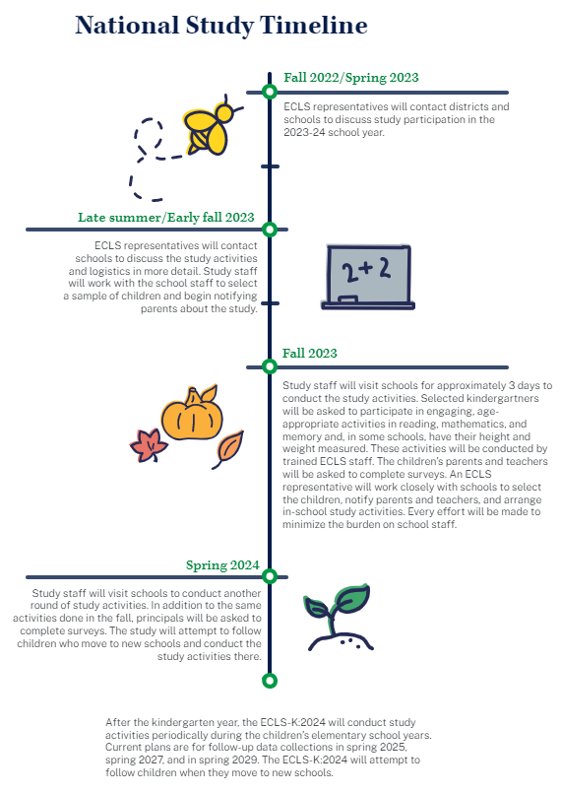

Study Timeline
National
Late summer/Early fall 2023: ECLS-K:2024 representatives will contact schools to discuss the study activities and logistics in more detail. Study staff will work with the school staff to select a sample of children and begin notifying parents about the study.

Fall 2023: Study staff will visit schools for approximately 3 days to conduct the study activities. Selected kindergartners will be asked to participate in engaging, age-appropriate activities in reading, mathematics, and memory and, in some schools, have their height and weight measured. These activities will be conducted by trained ECLS-K:2024 staff. The children’s parents and teachers will be asked to complete surveys. An ECLS-K:2024 representative will work closely with schools to select the children, notify parents and teachers, and arrange in-school study activities. Every effort will be made to minimize the burden on school staff.

Spring 2024: Study staff will visit schools to conduct another round of study activities. In addition to the same activities done in the fall, principals will be asked to complete surveys. The study will attempt to follow children who move to new schools and conduct the study activities there.

Fall 2024: Study staff will contact schools that participated in the spring 2024 to collect information on selected children, most of whom will be in first grade, and schedule the spring 2025 school visit. For children who have moved to new schools, study staff will contact their new schools to collect information and schedule the spring visits.

Spring 2025: Study staff will visit schools to conduct another round of study activities. [In addition to the same activities done in spring 2024, selected children will participate in vision evaluations during the spring 2025 school visits.] The study will attempt to follow children who move to new schools and conduct the study activities there.

The ECLS-K:2024 will conduct study activities periodically during the children’s elementary school years. Current plans are for follow-up data collections in spring 2027 and in spring 2029. The ECLS-K:2024 will attempt to follow children when they move to new schools.

Spanish text:
Calendario del estudio
Nacional
A finales del verano/principios del otoño 2023: Los representantes de ECLS-K:2024 se pondrán en contacto con las escuelas para hablar en más detalle sobre las actividades del estudio y la logística. El personal del estudio trabajará con el personal de la escuela para seleccionar una muestra de niños y comenzar a notificar a los padres sobre el estudio.

Otoño de 2023: El personal del estudio visitará escuelas durante aproximadamente 3 días para llevar a cabo las actividades de estudio. Se les pedirá a los niños de kindergarten seleccionados que participen en actividades interesantes y apropiadas para su edad lectura, matemáticas, y memoria y, en algunas escuelas, se les medirá la altura y el peso. Estas actividades serán llevadas a cabo por personal entrenado de ECLS-K:2024. A los padres o madres de los niños y a los maestros se les pedirá que completen encuestas. Un representante de ECLS-K:2024 trabajará muy de cerca con las escuelas para seleccionar los niños, notificar a los padres o madres y maestros, y organizar las actividades del estudio en la escuela. Se hará todo lo posible para minimizar la carga del personal de la escuela.

Primavera de 2024: El personal del estudio visitará las escuelas para llevar a cabo otra ronda de actividades del estudio. Además de las mismas actividades realizadas en el otoño, se les pedirá a los directores que completen encuestas. El estudio intentará seguir a sus nuevas escuelas a los niños que se muden, para llevar a cabo las actividades del estudio allí.

Otoño de 2024: El personal del estudio se pondrá en contacto con las escuelas que participaron en la primavera de 2024 para obtener información sobre algunos niños seleccionados, la mayoría de los cuales estarán en primer grado, y programar la visita escolar de la primavera de 2025. Para aquellos niños que hayan cambiado de escuela, el personal del estudio se pondrá en contacto con sus nuevas escuelas para obtener información y programar las visitas de primavera.

Primavera de 2025: El personal del estudio visitará las escuelas para realizar otra ronda de actividades del estudio. [Además de las mismas actividades realizadas en la primavera de 2024, algunos niños serán seleccionados para participar en evaluaciones de la visión durante las visitas escolares de la primavera de 2025]. El estudio intentará seguir a los niños que se transfieran a nuevas escuelas y realizar allí las actividades del estudio.

ECLS-K:2024 llevará a cabo actividades del estudio periódicamente durante los años de los niños en la escuela elemental. Según los planes actuales, se recopilarán datos de seguimiento en la primavera dede 2027 y en la primavera de 2029. ECLS-K:2024 intentará seguir a los niños cuando se muden a nuevas escuelas.

1.4 Findings Section

The infographics to be included in the “Findings” section include those on the following topics: social and academic skills, school supports for families, materials sent home from schools to parents/guardians, and children’s transition to school. The top of the page has the following text:

What we learned from ECLS students, parents, and schools

Spanish text:
Lo que aprendimos de los estudiantes, padres y madres, y escuelas de ECLS

The three sets of infographics display on three tabs: “Social & Academic Skills,” “Children Going to School,” and “School Support of Families.” The first tab displays the “Social and Academic Skills” infographic.
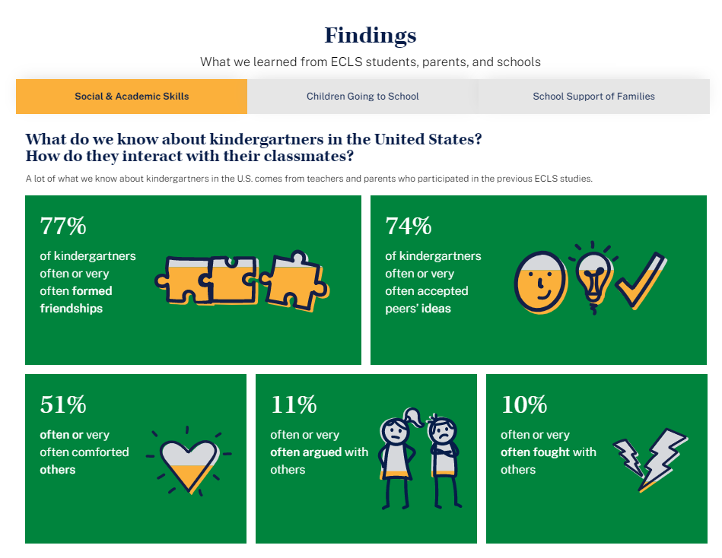
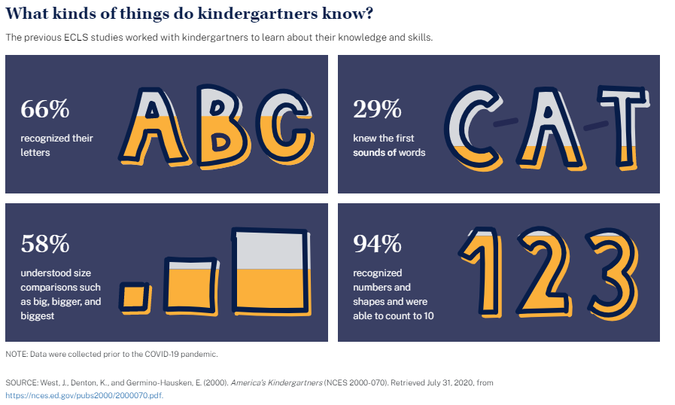

Findings
Social & Academic Skills

What do we know about kindergartners in the United States? How do they interact with their classmates?
A lot of what we know about kindergartners in the U.S. comes from teachers and parents who participated in the previous ECLS studies.
- 77% of kindergartners often or very often formed friendships
- 74% of kindergartners often or very often accepted peers’ ideas
- 51% often or very often comforted others
- 11% often or very often argued with others
- 10% often or very often fought with others

What kinds of things do kindergartners know?
The previous ECLS studies worked with kindergartners to learn about their knowledge and skills.
- 66% recognized their letters
- 29% knew the first sounds of words
- 58% understood size comparisons such as big, bigger, and biggest
- 94% recognized numbers and shapes and were able to count to 10

NOTE: Data were collected prior to the COVID-19 pandemic.
SOURCE: West, J., Denton, K., and Germino-Hausken, E. (2000). America’s Kindergartners (NCES 2000-070). Retrieved July 31, 2020, from https://nces.ed.gov/pubs2000/2000070.pdf.
Spanish text:
Resultados
Habilidades sociales y académicas

¿Qué sabemos de los niños de kindergarten en los Estados Unidos? ¿Cómo interactúan con sus compañeros de clase?
Mucho de lo que sabemos sobre los niños de kindergarten en los EE.UU. proviene de los maestros y de los padres y madres que participaron en los estudios de ECLS anteriores.
- 77% de los niños de kindergarten formaron amistades frecuentemente o muy frecuentemente
- 74% de los niños de kindergarten aceptaron las ideas de sus compañeros frecuentemente o muy frecuentemente
- 51% consolaron a otros frecuentemente o muy frecuentemente
- 11% discutieron con otros frecuentemente o muy frecuentemente
- 10% pelearon con otros frecuentemente o muy frecuentemente

¿Qué tipo de cosas saben los niños de kindergarten?
Los estudios de ECLS anteriores trabajaron con niños de kindergarten para conocer sobre sus conocimientos y habilidades.
- 66% reconoció las letras
- 29% sabía los primeros sonidos de palabras
- 58% entendía las comparaciones de tamaño, tales como grande, mayor y el más grande de todos
- 94% reconoció números y formas y pudo contar hasta 10

NOTA: Los datos fueron recopilados antes de la pandemia de COVID-19.
FUENTE: West, J., Denton, K., and Germino-Hausken, E. (2000). America’s Kindergartners (NCES 2000-070). Datos extraídos el 31 de julio de 2020, de https://nces.ed.gov/pubs2000/2000070.pdf.

The second tab displays the “Children Going to School” infographic.
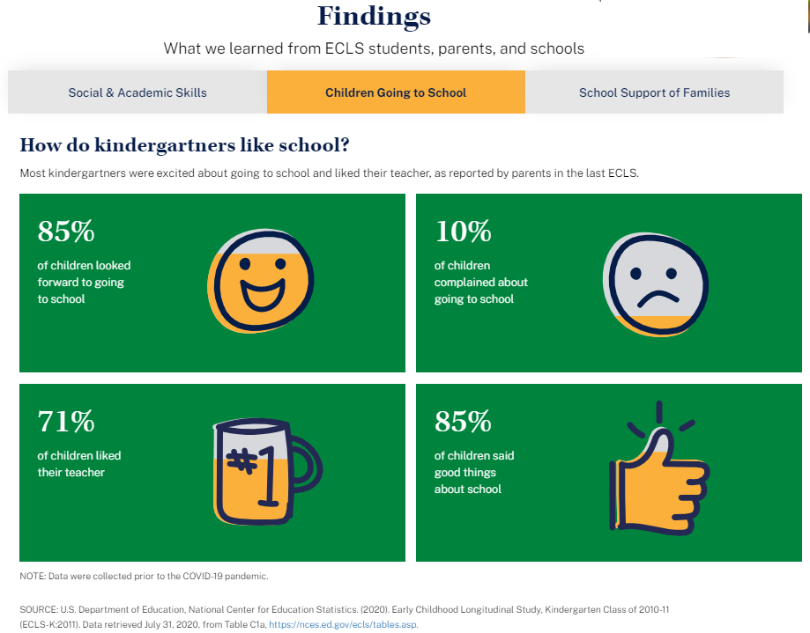
Children Going to School

How do kindergartners like school?
Most kindergartners were excited about going to school and liked their teacher, as reported by parents in the last ECLS.
- 85% of children looked forward to going to school
- 10% of children complained about going to school
- 71% of children liked their teacher
- 85% of children said good things about school
NOTE: Data were collected prior to the COVID-19 pandemic.
SOURCE: U.S. Department of Education, National Center for Education Statistics. (2020). Early Childhood Longitudinal Study, Kindergarten Class of 2010-11 (ECLS-K:2011). Data retrieved July 31, 2020, from Table C1a, https://nces.ed.gov/ecls/tables.asp.

Spanish text:
Los niños que van a la escuela

¿Qué tanto les gusta la escuela a los niños de kindergarten?
La mayoría de los niños de kindergarten estaban entusiasmados de ir a la escuela y les caía bien su maestro(a), de acuerdo a lo que reportaron los padres y madres en el último estudio ECLS.
- 85% de los niños estaban deseosos de ir a la escuela
- 10% de los niños se quejaban de ir a la escuela
- 71% de los niños les caía bien su maestro(a)
- 85% de los niños hablaron bien de su escuela

NOTA: Los datos fueron recopilados antes de la pandemia de COVID-19.
FUENTE: Departamento de Educación de los EE.UU., Centro Nacional para Estadísticas de Educación. (2020). Estudio Longitudinal de la Primera Infancia, Clase de Kindergarten 2010-11 (ECLS-K:2011). Datos extraídos el 31 de julio de 2020, de la tabla C1a, https://nces.ed.gov/ecls/tables.asp.

The third tab displays the “School Support of Families” and “Materials Sent Home” infographics.

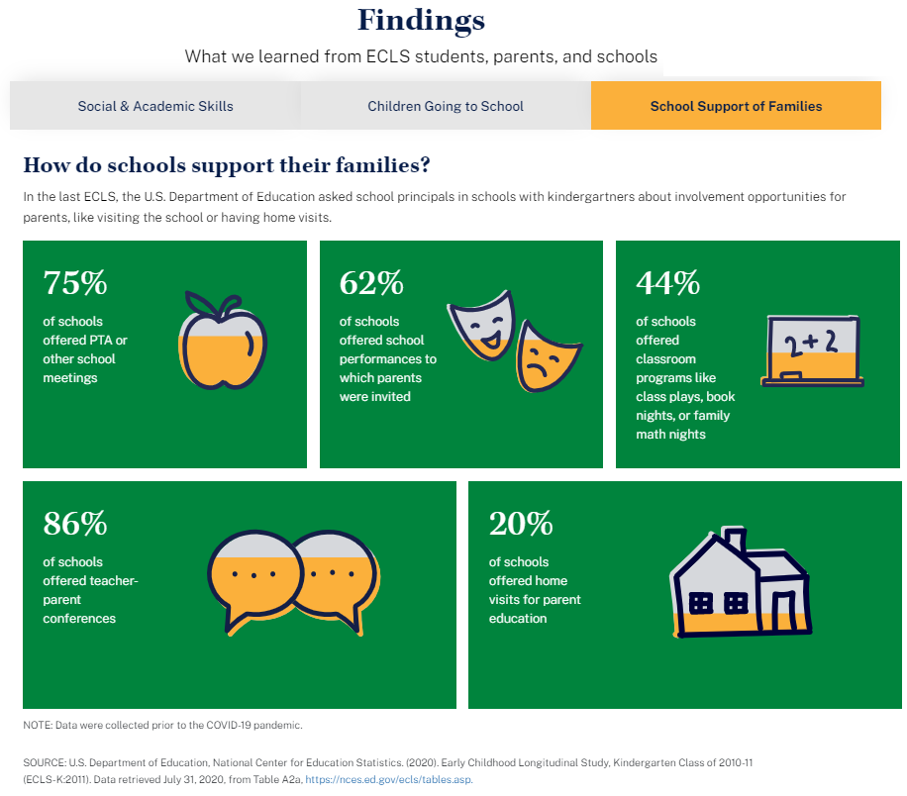
School Support of Families

How do schools support their families?
In the last ECLS, the U.S. Department of Education asked school principals in schools with kindergartners about involvement opportunities for parents, like visiting the school or having home visits.
- 75% of schools offered PTA or other school meetings
- 62% of schools offered school performances to which parents were invited
- 44% of schools offered classroom programs like class plays, book nights, or family math nights
- 86% of schools offered teacher-parent conferences
- 20% of schools offered home visits for parent education
NOTE: Data were collected prior to the COVID-19 pandemic.
SOURCE: U.S. Department of Education, National Center for Education Statistics. (2020). Early Childhood Longitudinal Study, Kindergarten Class of 2010-11 (ECLS-K:2011). Data retrieved July 31, 2020, from Table A2a, https://nces.ed.gov/ecls/tables.asp.

Spanish text:
Apoyo de las escuelas a las familias

¿Cómo apoyan las escuelas a las familias?
En el último estudio ECLS, el Departamento de Educación de los EE.UU. les preguntó a los directores de escuelas que tienen niños de kindergarten sobre las oportunidades de participación de los padres y madres, tales como visitar la escuela o ser visitados en el hogar.
- 75% de las escuelas ofrecían reuniones de la Asociación de padres/madres y maestros (PTA por sus siglas en inglés) u otras reuniones escolares
- 62% de las escuelas ofrecían representaciones o espectáculos escolares a los cuales los padres están invitados
- 44% de las escuelas ofrecían programas escolares, como obras de teatro en la clase, noches de libros o noches de matemáticas con la familia
- 86% de las escuelas ofrecían conferencias entre maestros y padres
- 20% de las escuelas ofrecían visitas al hogar para la educación de los padres y madres

NOTA: Los datos fueron recopilados antes de la pandemia de COVID-19.
FUENTE: Departamento de Educación de los EE.UU., Centro Nacional para Estadísticas de Educación. (2020). Estudio Longitudinal de la Primera Infancia, Clase de Kindergarten 2010-11 (ECLS-K:2011). Datos extraídos el 31 de julio de 2020, de la tabla A2a, https://nces.ed.gov/ecls/tables.asp.

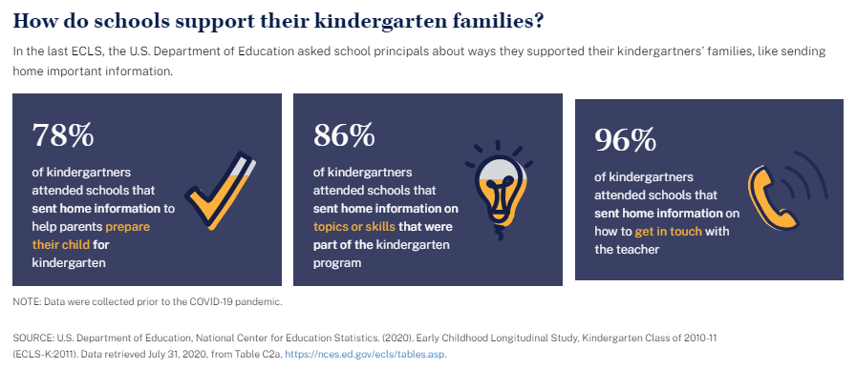
How do schools support their kindergarten families?
In the last ECLS, the U.S. Department of Education asked school principals about ways they support their kindergartners’ families, like sending home important information.
- 78% of kindergartners attended schools that sent home information to help parents prepare their child for kindergarten
- 86% of kindergartners attended schools that sent home information on topics or skills that were part of the kindergarten program
- 96% of kindergartners attended schools that sent home information on how to get in touch with the teacher
NOTE: Data were collected prior to the COVID-19 pandemic.
SOURCE: U.S. Department of Education, National Center for Education Statistics. (2020). Early Childhood Longitudinal Study, Kindergarten Class of 2010-11 (ECLS-K:2011). Data retrieved July 31, 2020, from Table C2a, https://nces.ed.gov/ecls/tables.asp.

Spanish text:
¿De qué manera apoyan las escuelas a sus familias de kindergarten?
En el último estudio ECLS, el Departamento de Educación de los EE.UU. les preguntó a los directores de las escuelas sobre las formas en que apoyaban a las familias de los niños de kindergarten, como por ejemplo, enviando información importante al hogar.
- 78% de los niños de kindergarten asistían a escuelas que enviaban información a sus hogares para ayudar a los padres y madres a preparar a su niño(a) para el kindergarten
- 86% de los niños de kindergarten asistían a escuelas que enviaban información a sus hogares sobre temas o habilidades que forman parte del programa de kindergarten
- 96% de los niños de kindergarten asistían a escuelas que enviaban información a sus hogares sobre cómo ponerse en contacto con el maestro/la maestra

NOTA: Los datos fueron recopilados antes de la pandemia de COVID-19.
FUENTE: Departamento de Educación de los EE.UU., Centro Nacional para Estadísticas de Educación. (2020). Estudio Longitudinal de la Primera Infancia, Clase de Kindergarten 2010-11 (ECLS-K:2011). Datos extraídos el 31 de julio de 2020, de la tabla C2a, https://nces.ed.gov/ecls/tables.asp.

For fall 2024 and spring 2025 (first grade), the infographics will be replaced as follows:
- Replace “Social and Academic Skills” with “Positive Learning Behaviors.”
- Replace “Children Going to School” with “Participation in Summer Activities.”
- Replace “School Support of Families” and “Materials Sent Home” with “School Programs and Services Available to Parents and Families.”
The first tab displays the “Positive Learning Behaviors” infographics.
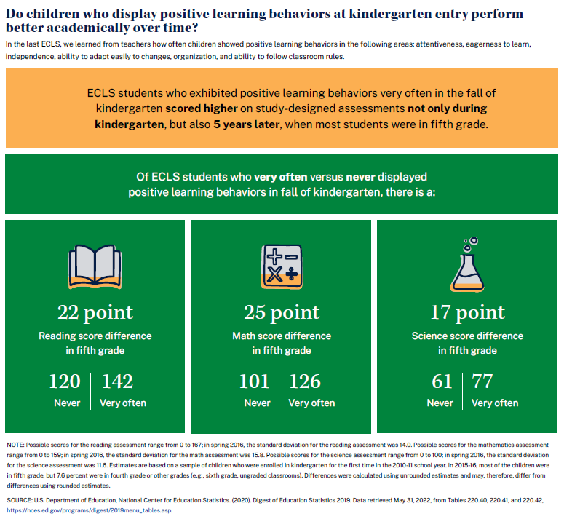
Do children who display positive learning behaviors at kindergarten entry perform better academically over time?
In the last ECLS, we learned from teachers how often children showed positive learning behaviors in the following areas: attentiveness, eagerness to learn, independence, ability to adapt easily to changes, organization, and ability to follow classroom rules.
ECLS students who exhibited positive learning behaviors very often in the fall of kindergarten scored higher on study-designed assessments not only during kindergarten, but also 5 years later, when most students were in fifth grade. Of ECLS students who very often versus never displayed positive learning behaviors in fall of kindergarten, there is a:
- 22 point Reading score difference in fifth grade
  - 120 Never
  - 142 Very often
- 25 point Math score difference in fifth grade
  - 101 Never
  - 126 Very often
- 17 point Science score difference in fifth grade
  - 61 Never
  - 77 Very often
NOTE: Possible scores for the reading assessment range from 0 to 167; in spring 2016, the standard deviation for the reading assessment was 14.0. Possible scores for the mathematics assessment range from 0 to 159; in spring 2016, the standard deviation for the math assessment was 15.8. Possible scores for the science assessment range from 0 to 100; in spring 2016, the standard deviation for the science assessment was 11.6. Estimates are based on a sample of children who were enrolled in kindergarten for the first time in the 2010-11 school year. In 2015-16, most of the children were in fifth grade, but 7.6 percent were in fourth grade or other grades (e.g., sixth grade, ungraded classrooms). Differences were calculated using unrounded estimates and may, therefore, differ from differences using rounded estimates.

NOTE: Data were collected prior to the COVID-19 pandemic.
SOURCE: U.S. Department of Education, National Center for Education Statistics. (2020). Digest of Education Statistics 2019. Data retrieved May 31, 2022, from Tables 220.40, 220.41, and 220.42, https://nces.ed.gov/programs/digest/2019menu_tables.asp.

Spanish Text
¿Los niños que exhiben conductas positivas de aprendizaje al entrar al Kindergarten tienen mejor desempeño académico a lo largo del tiempo?
En el último ECLS, los maestros nos informaron de la frecuencia con que los niños exhibían conductas positivas de aprendizaje en las siguientes áreas: atención, ansias de aprender, independencia, capacidad de adaptarse fácilmente a los cambios, organización y capacidad de seguir las reglas del aula.
Los alumnos del ECLS que exhibían conductas positivas de aprendizaje muy a menudo en el otoño de kindergarten obtuvieron puntuaciones más altas en las evaluaciones diseñadas para el estudio, no sólo durante el kindergarten, sino también 5 años después, cuando la mayoría de los alumnos estaban en quinto grado. Entre los estudiantes de ECLS que exhibían conductas positivas de aprendizaje muy a menudo en otoño de kindergarten y los que nunca las exhibían, hay una diferencia de 22 puntos en el puntaje de Lectura en quinto grado:
- 22 puntos de diferencia en el puntaje de Lectura en quinto grado
o 120 Nunca
o 142 Muy a menudo
- 25 puntos de diferencia en Matemáticas en quinto grado
o 101 Nunca
o 126 Muy a menudo
- 17 puntos de diferencia en Ciencias en 5º curso
o 61 Nunca
o 77 Muy a menudo
NOTA: El puntaje posible para la evaluación de lectura va de 0 a 167; en la primavera de 2016, la desviación estándar para la evaluación de lectura fue de 14.0. El puntaje posible para la evaluación de matemáticas van de 0 a 159; en la primavera de 2016, la desviación estándar para la evaluación de matemáticas fue de 15.8. El puntaje posible en la evaluación de ciencias va de 0 a 100; en la primavera de 2016, la desviación estándar de la evaluación de ciencias fue de 11.6. Estas estimaciones se basan en una muestra de niños que se matricularon en el kindergarten por primera vez en el año escolar 2010-11. En 2015-16, la mayoría de los niños estaban en quinto grado, pero el 7.6% estaba en cuarto grado o en otros grados (por ejemplo, sexto grado, salones sin nivel de grados). Las diferencias se calcularon utilizando estimaciones sin redondear y, por lo tanto, pueden ser distintas a las diferencias que se hacen utilizando estimaciones redondeadas.

NOTA: Los datos fueron recopilados antes de la pandemia de COVID-19.
FUENTE: Departamento de Educación de los EE.UU., Centro Nacional para Estadísticas de Educación. (2020). Compendio de Estadísticas de Educación 2019. Datos extraídos el 31 de mayo de 2022, de las Tablas 220.40, 220.41 y 220.42, https://nces.ed.gov/programs/digest/2019menu_tables.asp.

The second tab displays the “Participation in Summer Activities” infographics.

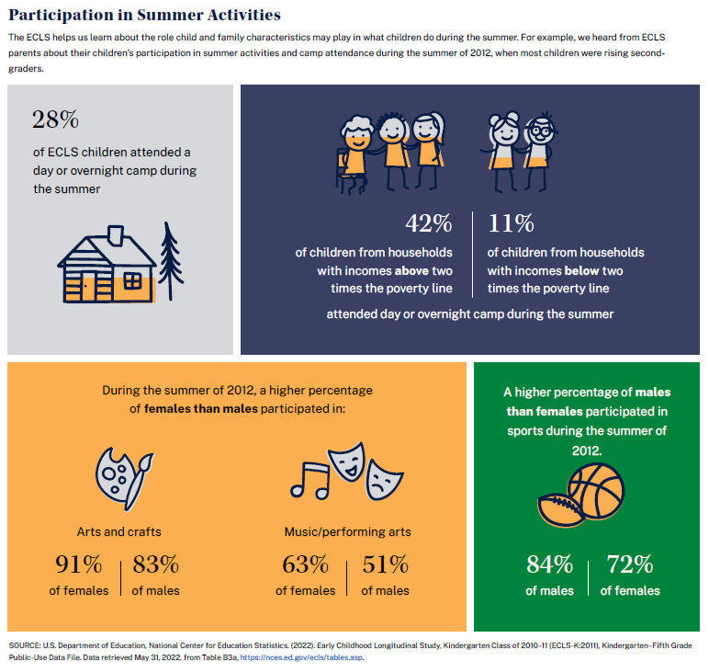
Participation in Summer Activities
The ECLS helps us learn about the role child and family characteristics may play in what children do during the summer. For example, we heard from ECLS parents about their children’s participation in summer activities and camp attendance during the summer of 2012, when most children were rising second-graders.
- 28% of ECLS children attended a day or overnight camp during the summer
- 42% of children from households with incomes above two times the poverty line
- 11% of children from households with incomes below two times the poverty line
  - Attended day or overnight camp during the summer
During the summer of 2012, a higher percentage of females than males participated in:
- Arts and crafts
  - 91% of females
  - 83% of males
- Music/performing arts
  - 63% of females
  - 51% of males
A higher percentage of males than females participated in sports during the summer of 2012.
- 84% of males
- 72% of females
- NOTE: Data were collected prior to the COVID-19 pandemic.
SOURCE: U.S. Department of Education, National Center for Education Statistics. (2022). Early Childhood Longitudinal Study, Kindergarten Class of 2010–11 (ECLS-K:2011), Kindergarten–Fifth Grade Public-Use Data File. Data retrieved May 31, 2022, from Table B3a, https://nces.ed.gov/ecls/tables.asp.

Spanish Text

Participación en actividades de verano

El estudio ECLS nos ayuda a conocer cómo las características del niño y de la familia pueden influir en lo que los niños hacen durante el verano. Por ejemplo, los padres de estudiantes del ECLS nos informaron sobre la participación de sus hijos en actividades de verano y la asistencia a campamentos durante el verano de 2012, cuando la mayoría de los niños estaban por comenzar segundo grado.

    - el 28% de los niños de ECLS asistieron a un campamento de día o de noche durante el verano
    - el 42% de los niños de hogares con ingresos superiores a dos veces el límite de pobreza
    - el 11% de los niños de hogares con ingresos inferiores a dos veces el límite de pobreza
- Asistieron a un campamento de día o de noche durante el verano

Durante el verano de 2012, un mayor porcentaje de mujeres que de hombres participaron en:

- Artes y manualidades
- 91% de las mujeres
- 83% de los hombres
- Música/artes escénicas
- 63% de mujeres
- 51% de los hombres

Un mayor porcentaje de hombres que de mujeres participó en deportes durante el verano de 2012.
- 84% de los hombres
- 72% de las mujeres
    - NOTA: Los datos fueron recopilados antes de la pandemia de COVID-19.

FUENTE: Departamento de Educación de los EE.UU., Centro Nacional para Estadísticas de Educación. (2022). Estudio Longitudinal de la Primera Infancia, Clase de Kindergarten de 2010-11 (ECLS-K:2011), Archivo de datos de uso público de Kindergarten a Quinto Grado. Datos extraídos el 31 de mayo de 2022, de la Tabla B3a, https://nces.ed.gov/ecls/tables.asp.
The third tab displays the “School Programs and Services Available to Parents and Families” infographics.

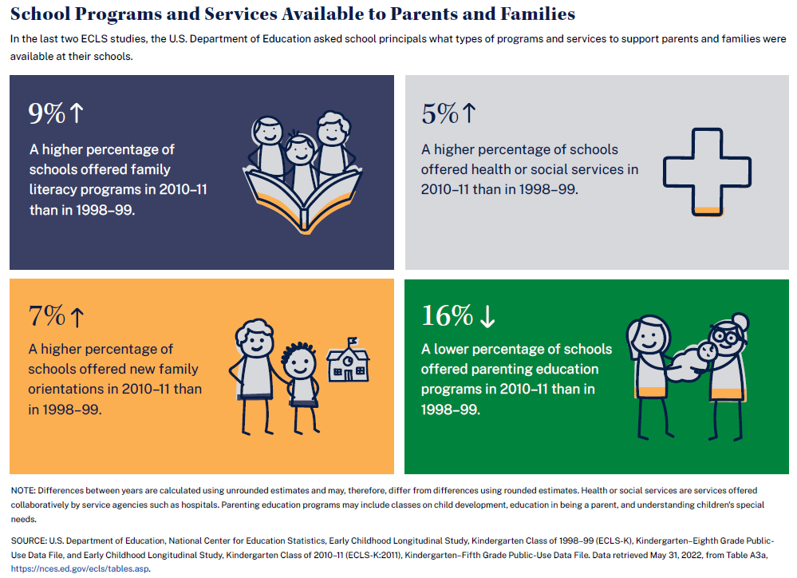
School Programs and Services Available to Parents and Families
In the last two ECLS studies, the U.S. Department of Education asked school principals what types of programs and services to support parents and families were available at their schools.
- 9% A higher percentage of schools offered family literacy programs in 2010-11 than in 1998-99.
- 5% A higher percentage of schools offered health or social services in 2010-11 than in 1998-99.
- 7% A higher percentage of schools offered new family orientations in 2010-11 than in 1998-99.
- 16% A lower percentage of schools offered parenting education programs in 2010-11 than in 1998-99.
NOTE: Differences between years are calculated using unrounded estimates and may, therefore, differ from differences using rounded estimates. Health or social services are services offered collaboratively by service agencies such as hospitals. Parenting education programs may include classes on child development, education in being a parent, and understanding children's special needs.

NOTE: Data were collected prior to the COVID-19 pandemic.
SOURCE: U.S. Department of Education, National Center for Education Statistics, Early Childhood Longitudinal Study, Kindergarten Class of 1998–99 (ECLS-K), Kindergarten–Eighth Grade Public-Use Data File, and Early Childhood Longitudinal Study, Kindergarten Class of 2010–11 (ECLS-K:2011), Kindergarten–Fifth Grade Public-Use Data File. Data retrieved May 31, 2022, from Table A3a, https://nces.ed.gov/ecls/tables.asp.

Spanish Text

Programas y servicios escolares disponibles para padres/madres y familias

En los últimos dos estudios de ECLS, el Departamento de Educación de los EE.UU. preguntó a los directores de los centros escolares de qué tupos de programas y servicios de apoyo a padres y familias disponían en sus escuelas.

    - 9% Un porcentaje mayor de escuelas ofrecían programas de alfabetización familiar en 2010-11 que en 1998-99.
    - 5% Un porcentaje mayor de escuelas ofrecía servicios de salud o servicios sociales en 2010-11 que en 1998-99.
    - 7% Un porcentaje mayor de escuelas ofrecieron orientación para familias nuevas en 2010-11 que en 1998-99.
    - 16% Un porcentaje menor de escuelas ofrecieron programas de educación para padres en 2010-11 que en 1998-99.

NOTA: Las diferencias entre los años se calcularon utilizando estimaciones sin redondear y, por lo tanto, pueden ser distintas a las diferencias que se calculan utilizando estimaciones redondeadas. Los servicios de salud o sociales son servicios ofrecidos de manera colaborativa por agencias que prestan servicios, tales como los hospitales. Los programas de educación para padres o madres pueden incluir clases sobre desarrollo infantil, educación para criar hijos y comprensión de las necesidades especiales de los niños.

NOTA: Los datos fueron recopilados antes de la pandemia de COVID-19.

FUENTE: Departamento de Educación de los EE.UU., Centro Nacional para Estadísticas de Educación, Estudio Longitudinal de la Primera Infancia, Clase de Kindergarten de 1998-99 (ECLS-K), Archivo de datos de uso público de Kindergarten- Octavo grado, y Estudio Longitudinal de la Primera Infancia, Clase de Kindergarten de 2010-11 (ECLS-K:2011), Archivo de datos de uso público de Kindergarten-quinto grado. Datos extraídos el 31 de mayo de 2022, de la Tabla A3a, https://nces.ed.gov/ecls/tables.asp.

1.5 More Information Section

This section will display a link to the NCES ECLS website, the ECLS-K:2024 Study Overview, and the ECLS-K:2024 video.

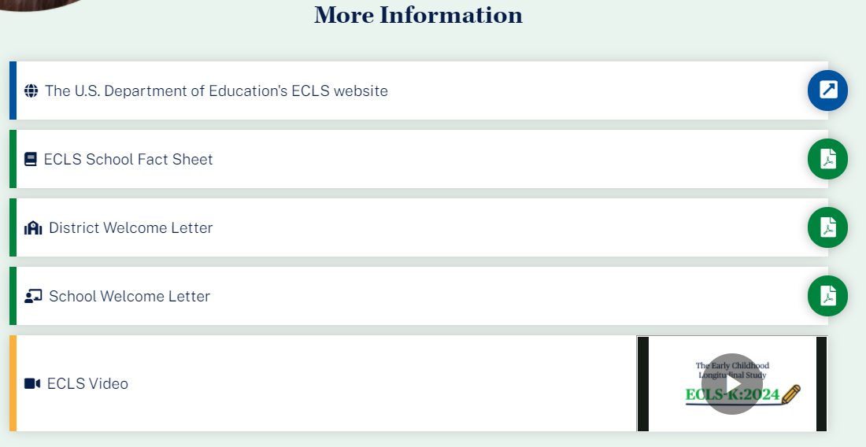

More Information
- The U.S. Department of Education’s ECLS website [https://nces.ed.gov/ecls]
- ECLS-K:2024 School Fact Sheet [LINK TO FACT SHEET]
- ECLS-K:2024 video [LINK TO VIDEO]

Spanish text:
Más información
- La página de Internet del estudio ECLS, del Departamento de Educación de los EE.UU. [https://nces.ed.gov/ecls]
- Hoja informativa escolar del estudio ECLS-K:2024 [LINK TO FACT SHEET]
- Video del estudio ECLS-K:2024 [LINK TO VIDEO]

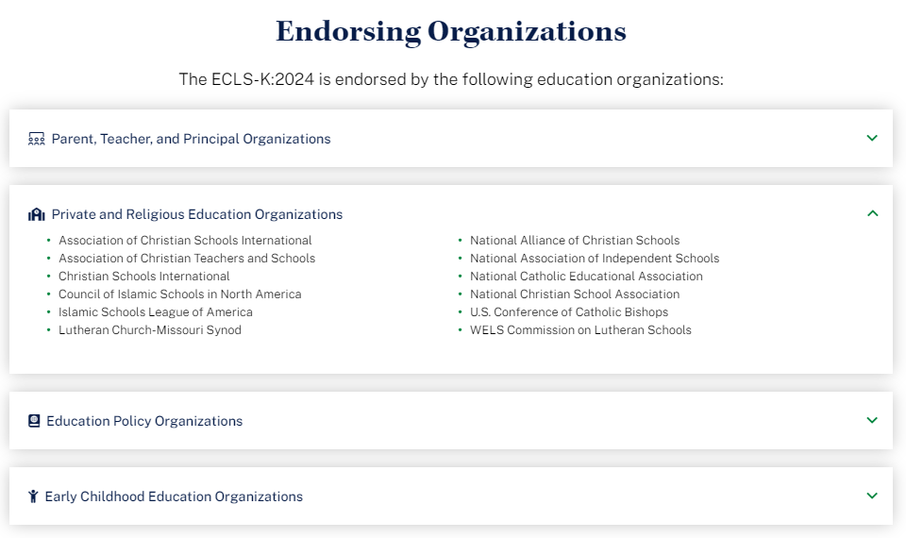

The list of endorsing organizations is divided by type. Each type category is expandable and collapsible.

Endorsing Organizations

The ECLS-K:2024 is endorsed by the following education organizations:

Parent, Teacher, and Principal Organizations
- American Federation of Teachers
- Association for Middle Level Education
- Council for Exceptional Children
- International Literacy Association
- National Association of Elementary School Principals
- National Council of Teachers of Mathematics
- National Parent Teacher Association
- National Science Teaching Association
- Texas State Teachers Association

Private and Religious Education Organizations
- Association of Christian Schools International
- Association of Christian Teachers and Schools
- Christian Schools International
- Council of Islamic Schools in North America
- Islamic Schools League of America
- Lutheran Church-Missouri Synod
- National Alliance of Christian Schools
- National Association of Independent Schools
- National Catholic Educational Association
- National Christian School Association
- U.S. Conference of Catholic Bishops
- WELS Commission on Lutheran Schools

Education Policy Organizations
- Alliance for Excellent Education
- Council of Chief State School Officers
- National Association of State Boards of Education
- National School Boards Association
- The School Superintendents Association

Early Childhood Education Organizations
- American Montessori Society
- Association Montessori International/USA
- National Institute for Early Education Research

Spanish text:

Organizaciones que respaldan al estudio
El ECLS-K:2024 está respaldado por las siguientes organizaciones educativas:

Organizaciones de padres/madres, maestros y directores
- American Federation of Teachers
- Association for Middle Level Education
- Council for Exceptional Children
- International Literacy Association
- National Association of Elementary School Principals
- National Council of Teachers of Mathematics
- National Parent Teacher Association
- National Science Teaching Association
- Texas State Teachers Association

Organizaciones de educación privada y/o religiosa
- Association of Christian Schools International
- Association of Christian Teachers and Schools
- Christian Schools International
- Council of Islamic Schools in North America
- Islamic Schools League of America
- Lutheran Church-Missouri Synod
- National Alliance of Christian Schools
- National Association of Independent Schools
- National Catholic Educational Association
- National Christian School Association
- U.S. Conference of Catholic Bishops
- WELS Commission on Lutheran Schools

Organizaciones de políticas educativas
- Alliance for Excellent Education
- Council of Chief State School Officers
- National Association of State Boards of Education
- National School Boards Association
- The School Superintendents Association

Organizaciones de educación de la primera infancia
- American Montessori Society
- Association Montessori International/USA
- National Institute for Early Education Research

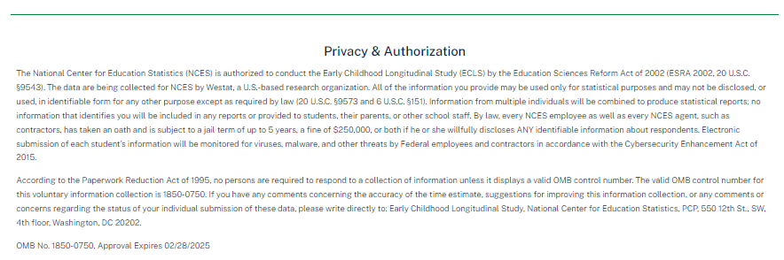

This language appears at the bottom of the log-in page, directly on the screen.
Privacy & Authorization
The National Center for Education Statistics (NCES) is authorized to conduct the Early Childhood Longitudinal Study (ECLS) by the Education Sciences Reform Act of 2002 (ESRA 2002, 20 U.S.C. §9543). The data are being collected for NCES by Westat, a U.S.-based research organization. All of the information you provide may be used only for statistical purposes and may not be disclosed, or used, in identifiable form for any other purpose except as required by law (20 U.S.C. §9573 and 6 U.S.C. §151). Information from multiple individuals will be combined to produce statistical reports; no information that identifies you will be included in any reports or provided to students, their parents, or other school staff. By law, every NCES employee as well as every NCES agent, such as contractors, has taken an oath and is subject to a jail term of up to 5 years, a fine of $250,000, or both if he or she willfully discloses ANY identifiable information about respondents. Electronic submission of each student’s information will be monitored for viruses, malware, and other threats by Federal employees and contractors in accordance with the Cybersecurity Enhancement Act of 2015.
According to the Paperwork Reduction Act of 1995, no persons are required to respond to a collection of information unless it displays a valid OMB control number. The valid OMB control number for this voluntary information collection is 1850-0750. If you have any comments concerning the accuracy of the time estimate, suggestions for improving this information collection, or any comments or concerns regarding the status of your individual submission of these data, please write directly to: Early Childhood Longitudinal Study, National Center for Education Statistics, PCP, 550 12th St., SW, 4th floor, Washington, DC 20202.
OMB No. 1850-0750, Approval Expires XX/XX/XXXX
Spanish text:

Privacidad y Autorización
El Centro Nacional para Estadísticas de Educación (NCES) está autorizado a hacer el Estudio Longitudinal de la Primera Infancia (ECLS por sus siglas en inglés) por el Acta de Reforma de las Ciencias de la Educación de 2002 (ESRA 2002, 20 U.S.C. §9543). La firma Westat, una organización que realiza estudios y está basada en los Estados Unidos, está recopilando los datos para NCES. Toda la información que usted proporcione podrá usarse solamente para propósitos estadísticos y no podrá divulgarse ni usarse de manera que permita identificar a los participantes para ningún otro propósito, salvo que lo requiera la ley (20 U.S.C. §9573 y 6 U.S.C. §151). La información recopilada de múltiples participantes se combinará para producir reportes estadísticos; ninguna información que pudiera identificarlo(a) será incluida en ningún reporte ni será proporcionada a los estudiantes, a sus padres o a otro personal de la escuela. Por ley, cada empleado de NCES, al igual que cada agente de NCES -- por ejemplo, los contratistas -- ha prestado un juramento y puede recibir una pena de cárcel de hasta 5 años, una multa de 250.000 dólares o ambas cosas, si revela deliberadamente CUALQUIER información que permita identificar a los participantes. En cumplimiento con la Ley de Mejora de la Ciberseguridad de 2015, habrá empleados y contratistas federales monitoreando el envío electrónico de la información de cada estudiante para detectar virus, malware y otras amenazas.
Según lo establece el Acta de Reducción del Papeleo de 1995, ninguna persona está obligada a responder a un pedido de información si la misma no contiene un número de control de OMB válido. El número de control de OMB válido para recolectar esta información que se proporciona voluntariamente es 1850-0750. Si usted tiene algún comentario con respecto a la precisión del cálculo de tiempo, sugerencias para mejorar esta recolección de información, o cualquier comentario o inquietud acerca del estatus del envío de sus datos individuales, por favor escriba directamente a: Early Childhood Longitudinal Study, National Center for Education Statistics, PCP, 550 12th St., SW, 4th floor, Washington, DC 20202.
Número OMB. 1850-0750. La aprobación vence el 02/28/2025

SCHOOL COORDINATOR PORTAL
The School Coordinator Portal has three sections: Overview, To Do (which contains links to other tabs), and More Information. Use the navigation icons on the left to skip to each section: Overview, To Do, and More Info.

2.1 Overview Section
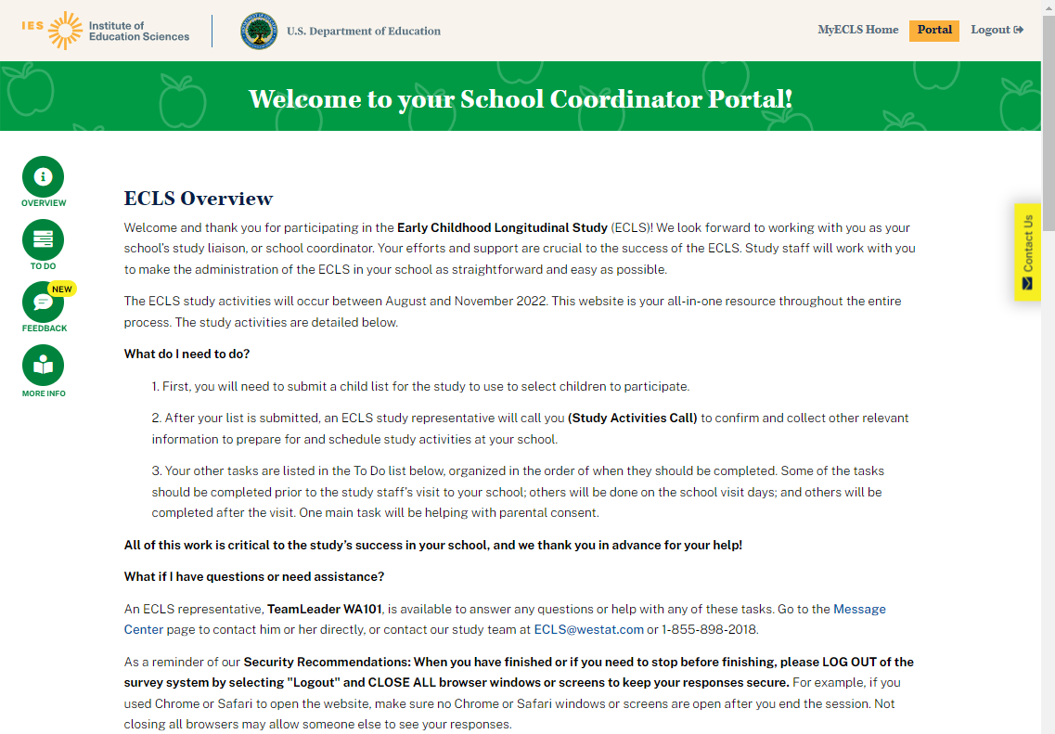
Welcome to your School Coordinator Portal!

ECLS-K:2024 Overview
Welcome and thank you for participating in the Early Childhood Longitudinal Study, Kindergarten Class of 2023-24 (ECLS-K:2024)! We look forward to working with you as your school’s study liaison, or school coordinator. Your efforts and support are crucial to the success of the ECLS-K:2024. Study staff will work with you to make the administration of the ECLS-K:2024 in your school as straightforward and easy as possible.

The ECLS-K:2024 kindergarten study activities will occur between August and December 2023 and again between February and June 2024. This website is your all-in-one resource throughout the entire process. The study activities are detailed below.

What do I need to do?
- First, you will need to submit a child list for the study to use to select children to participate.
- After your list is submitted, an ECLS-K:2024 study representative will call you (Study Activities Call) to confirm and collect other relevant information to prepare for and schedule study activities at your school.
- Your other tasks are listed in the To Do list below, organized in the order of when they should be completed. Some of the tasks should be completed prior to the study staff’s visit to your school; others will be done on the school visit days; and others will be completed after the visit. One main task will be helping with parental consent.

All of this work is critical to the study’s success in your school, and we thank you in advance for your help!

What if I have questions or need assistance?
An ECLS-K:2024 representative, [DISPLAY TEAM LEADER NAME], is available to answer any questions or help with any of these tasks. Go to the Message Center [DISPLAY LINK] page to contact your representative directly, or contact our study team at ECLS@westat.com or 1-855-898-2018.

As a reminder of our Security Recommendations: When you have finished or if you need to stop before finishing, please LOG OUT of the survey system by selecting "Logout" and CLOSE ALL browser windows or screens to keep your responses secure. For example, if you used Chrome or Safari to open the website, make sure no Chrome or Safari windows or screens are open after you end the session. Not closing all browsers may allow someone else to see your responses.
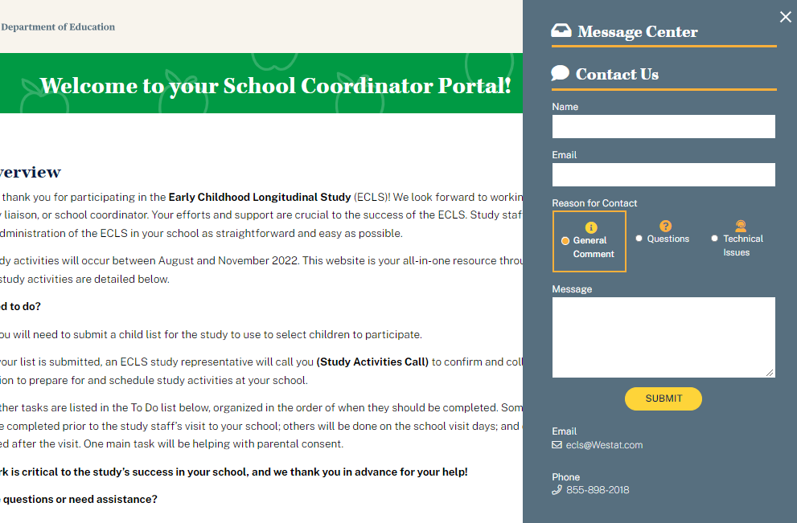
The Contact Us tab displays a link to the Message Center for the School Coordinator role.

2.2 To Do Section
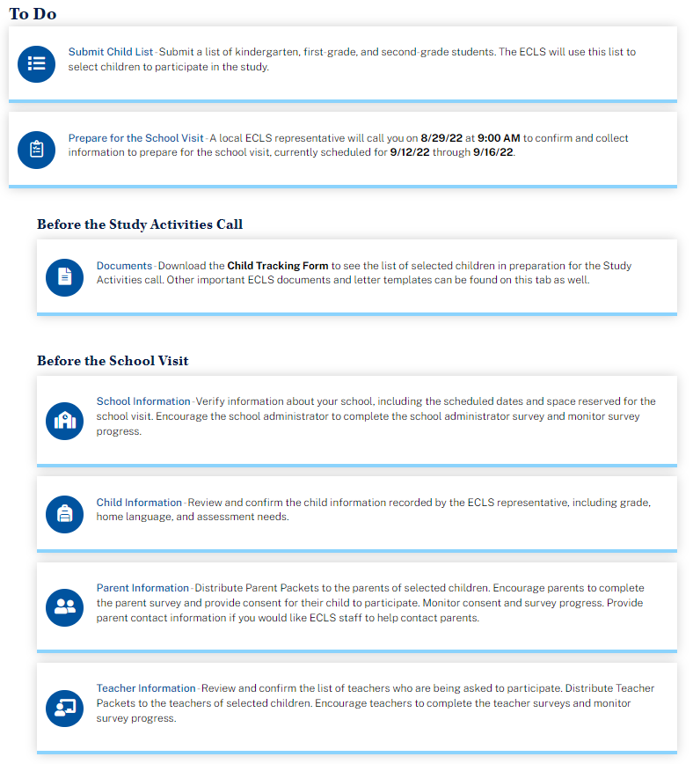

The To Do list displays as an accordion, allowing the user to expand and collapse the tasks. In the fall kindergarten round, only the School Information, Submit Child List, and Documents screens are available prior to the child list being submitted and finalized. Each of the items includes a link to a tab. The details of each tab are displayed on the following pages.

To Do

[DISPLAY IN FALL KINDERGARTEN FOR ALL SCHOOLS AND DISPLAY IN SPRING KINDERGARTEN FOR SCHOOLS THAT HAVE NOT YET COMPLETED CHILD SAMPLING: Submit Child List – Submit a list of kindergarten students, including students in transitional kindergarten and pre-first grade programs. The ECLS-K:2024 will use this list to select children to participate in the study.]

[DISPLAY IN FALL KINDERGARTEN, SPRING KINDERGARTEN, AND SPRING FIRST GRADE: Prepare for the School Visit – A local ECLS-K:2024 representative will call you [on [STUDY ACTIVITIES CALL DATE] at [STUDY ACTIVITIES CALL TIME]] to confirm and collect information to prepare for the school visit, currently scheduled for [SCHOOL VISIT START] through [SCHOOL VISIT END]].]

[DISPLAY IN FALL FIRST GRADE: Prepare for the Spring 2025 School Visit – A local ECLS-K:2024 representative will call you to confirm and collect information to prepare for the spring school visit.]

Before the Study Activities Call
- Documents – [DISPLAY IN FALL ROUNDSAND, IN SPRING KINDERGARTEN SCHOOLS THAT WERE NOT PREVIOUSLY SAMPLED: Download the Child Information Form to see the list of selected children in preparation for the Study Activities call.] Review important ECLS-K:2024 materials.
- [DISPLAY IN FALL KINDERGARTEN AND IN SPRING ROUNDS: School Information – Verify information about your school collected during our last contact, including the scheduled dates and space reserved for the school visit.]
- [DISPLAY IN FALL FIRST GRADE: School Information – Verify information about your school collected during our last contact.]
- [DISPLAY IN SPRING ROUNDS: Child Information – Review and confirm the child information collected during our last contact, including home language, teacher(s), and assessment needs.]
- [DISPLAY IN SPRING ROUNDS: Teacher Information – Review and confirm the teacher information collected during our last contact.]

Before the [Fall 2023/Spring 2024/Spring 2025] School Visit
- School Information – Verify information about your school, including the scheduled dates and space reserved for the school visit. [SPRING ROUNDS ONLY: Encourage the school administrator to complete the school administrator survey and monitor survey progress.]
- Child Information – Review and confirm the child information recorded by the ECLS-K:2024 representative, including home language, teacher(s), and assessment needs.
- Parent Information – Distribute Parent Packets to the parents of selected children. Encourage parents to complete the parent survey [FALL 2023/SPRING 2024 ONLY: and provide consent for their child to participate]. Monitor [FALL 2023/SPRING 2024 ONLY: consent and] survey progress. Provide parent contact information if you would like ECLS-K:2024 staff to help contact parents.
- Teacher Information – Review and confirm the list of teachers who are being asked to participate. Distribute Teacher Packets to the teachers of selected children. Encourage teachers to complete the teacher surveys and monitor survey progress.

Display “During the School Visit” and “After the School Visit” sections in fall kindergarten, spring kindergarten, and spring first-grade only (content not displayed during fall 2024 advance school contact).
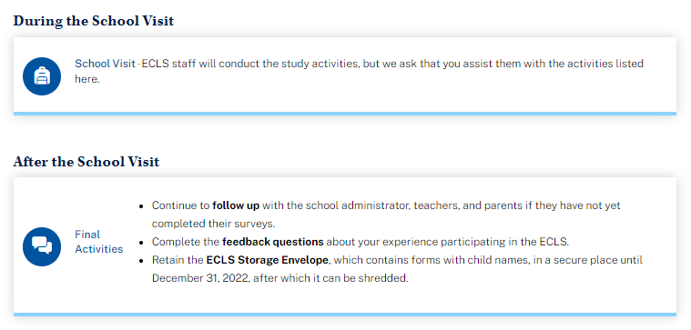
During the School Visit
School Visit – ECLS-K:2024 staff will conduct the study activities, but we ask that you assist them with the activities listed here.

SCHOOL VISIT MODAL
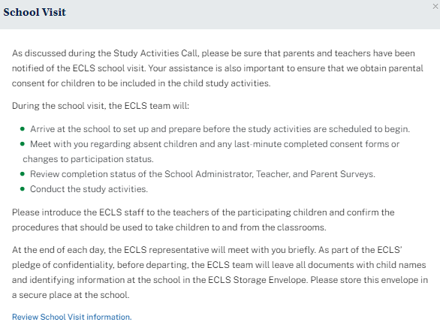
School Visit
As discussed during the Study Activities Call, please be sure that parents and teachers have been notified of the ECLS-K:2024 school visit. [KINDERGARTEN ROUNDS ONLY: Your assistance is also important to ensure that we obtain parental consent for children to be included in the child study activities.]
During the school visit, the ECLS-K:2024 team will:
- Arrive at the school to set up and prepare before the study activities are scheduled to begin.
- Meet with you regarding absent children and any last-minute completed consent forms or changes to participation status.
- Review completion status of the [SPRING ROUNDS ONLY: School Administrator,] Teacher[,] and Parent Surveys.
- Conduct the study activities.

Please introduce the ECLS-K:2024 staff to the teachers of the participating children and confirm the procedures that should be used to take children to and from the classrooms.
At the end of each day, the ECLS-K:2024 representative will meet with you briefly. As part of the ECLS-K:2024’s pledge of confidentiality, before departing, the ECLS-K:2024 team will leave all documents with child names and identifying information at the school in the ECLS-K:2024 Storage Envelope. Please store this envelope in a secure place at the school.
Review School Visit information [LINK TO SCHOOL INFO TAB].

After the School Visit
Final Activities –
- Continue to follow up with the [SPRING ROUNDS ONLY: school administrator,] teachers[,] and parents if they have not yet completed their surveys.
- Retain the ECLS-K:2024 Storage Envelope, which contains forms with child names, in a secure place until [December 31, 2023][ June 30, 2024][ June 30, 2025], after which it can be shredded.

2.3 More Information Section

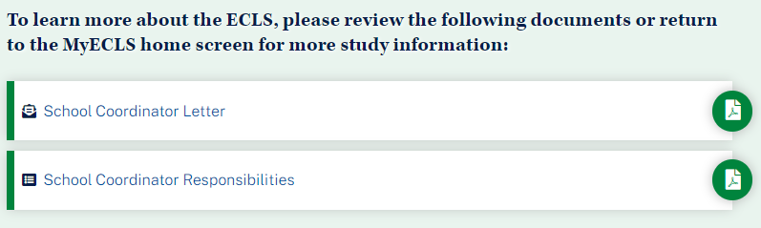

To learn more about the ECLS-K:2024, please review the following documents or return to the MyECLS home screen for more study information:
- School Coordinator Letter [LINK TO LETTER]
- School Coordinator Responsibilities [LINK TO RESPONSIBILITIES]

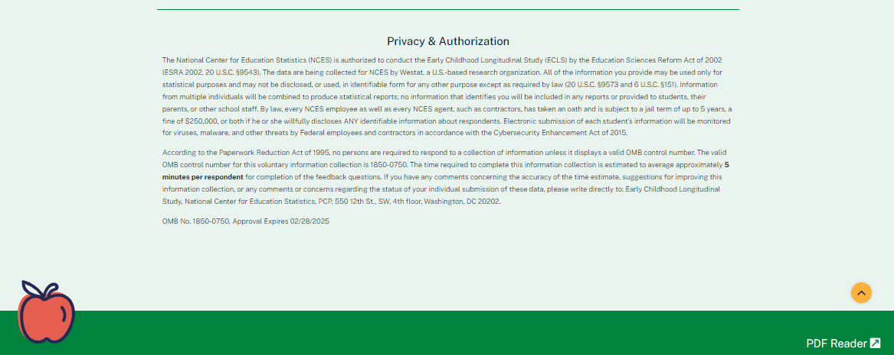

This language appears at the bottom of the School Coordinator Portal page, directly on the screen.
The National Center for Education Statistics (NCES) is authorized to conduct the Early Childhood Longitudinal Study (ECLS) by the Education Sciences Reform Act of 2002 (ESRA 2002, 20 U.S.C. §9543). The data are being collected for NCES by Westat, a U.S.-based research organization. All of the information you provide may be used only for statistical purposes and may not be disclosed, or used, in identifiable form for any other purpose except as required by law (20 U.S.C. §9573 and 6 U.S.C. §151).

Information from multiple individuals will be combined to produce statistical reports; no information that identifies you will be included in any reports or provided to students, their parents, or other school staff. According to the Paperwork Reduction Act of 1995, no persons are required to respond to a collection of information unless it displays a valid OMB control number. The valid OMB control number for this voluntary information collection is 1850-0750. If you have any comments concerning the accuracy of the time estimate, suggestions for improving this information collection, or any comments or concerns regarding the status of your individual submission of these data, please write directly to: Early Childhood Longitudinal Study, National Center for Education Statistics, PCP, 550 12th St., SW, 4th floor, Washington, DC 20202.
OMB No. 1850-0750, Approval Expires XX/XX/XXXX

2.4 To Do Tabs
When a user clicks on a tab in the To Do Section, a box with tabs that match the links in that section appears. Users can click on each tab to see detailed instructions. (They can also click on the links in the To Do section to display that particular tab.)

SUBMIT CHILD LIST TAB
The Submit Child List tab will display in fall kindergarten. It will display in spring kindergarten only for schools where children have not yet been sampled.
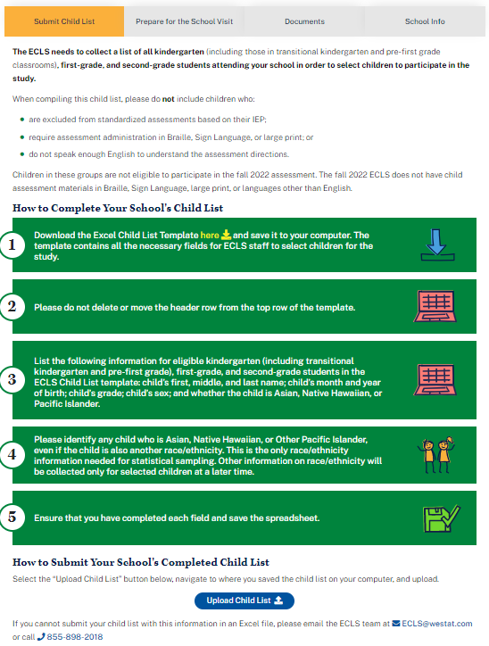

The ECLS-K:2024 needs to collect a list of all kindergarten students attending your school in order to select children to participate in the study. Please include students from all classes that make up the kindergarten grade (including those in transitional kindergarten and pre-first grade classrooms). Please include all kindergarten children on the list, regardless of what language they speak or if they have any learning differences or IEPs (or equivalents).
How to Complete Your School’s Child List
- Download the Excel Child List Template here [DISPLAY LINK] and save it to your computer. The template contains all the necessary fields for ECLS-K:2024 staff to select children for the study.
- Please do not delete or move the header row from the top row of the template.
- List the following information for eligible kindergarten (including transitional kindergarten and pre-first grade) students in the ECLS-K:2024 Child List template: child’s first, middle, and last name; child’s month and year of birth; child’s grade (kindergarten for all children, including those in transitional kindergarten and pre-first grade programs); child’s sex (male, female, or leave blank); and whether the child is Asian, Native Hawaiian, or Pacific Islander.
- Please identify any child who is Asian, Native Hawaiian, or Other Pacific Islander, even if the child is also another race/ethnicity. This is the only race/ethnicity information needed for statistical sampling. Other information on race/ethnicity will be collected only for selected children at a later time.
- Ensure that you have completed each field and save the spreadsheet.
How to Submit your School’s Completed Child List
Select the “Upload Child List” button below, navigate to where you saved the child list on your computer, and upload.
Display “Upload Child List” button. Selecting the “Upload Child List” button allows the user to browse his or her saved files and choose one to upload.
If you cannot submit your child list in an Excel file, please email the ECLS-K:2024 team at ECLS@westat.com or call 855-898-2018.
The Child List Template is a spreadsheet with a header row displaying labels for the following columns (required fields are indicated with an asterisk):
- Child First Name*
- Child Middle Name
- Child Last Name*
- Month of Birth
- Year of Birth
- Grade*
- Sex
- Asian, Native Hawaiian, or Other Pacific Islander?*

Child First Name | Child Middle Name | Child Last Name | Month of Birth | Year of Birth | Grade | Sex | Asian, Native Hawaiian, or Other Pacific Islander?
Ted | Brian | Brooks | 5 | 2018 | K | M | N

Validation Messages for Child List
Variable | Values / Messages
Initial Submission of Child List | - “The supplied file ({filename fill}) has less than the required number of columns. Please be sure your file has all of the required columns. Select Upload Child List to correct and upload your list again.”  - “The supplied file ({filename fill}) has no header row. Please be sure your file has a header row with a name for each column. Select Upload Child List to correct and upload your list again.”  - “The supplied file ({filename fill}) has no data rows. Please be sure your file contains data for all of the necessary fields. Select Upload Child List to correct and upload your list again.”
Child List is missing required columns | ”Your file may be missing some information. Please confirm that your file includes columns for child’s first middle, and last name; child’s month and year of birth; child’s sex; and whether the child is Asian, Native Hawaiian, or Pacific Islander. Select Start Over to correct and upload your list again.”
First Name | Hard Edit Check if Missing: "Please provide a first and last name or unique identifier in each name column for each child on the list. Select Start Over to correct and upload your list again."
Last Name | Hard Edit Check if Missing: "Please provide a first and last name or unique identifier in each name column for each child on the list. Select Start Over to correct and upload your list again."
Year of Birth | 2016 - 2019 (age 3 to 7);  Hard Edit Check if outside range: "Please provide a year of birth within the range 2016 to 2019 for each child on the list. Select Start Over to correct and upload your list again."
Month of Birth | 1-12;  Hard Edit Check if outside range: "One or more of the children's birth months is outside the expected range of 1 to 12. Select Start Over to correct and upload your list again."
Grade | Hard Edit Check if missing: "Please provide a grade for each child on the list. In 2023-24, each child should be listed as in kindergarten. Record students in transitional kindergarten and pre-first grade classrooms as in kindergarten. Select Start Over to correct and upload your list again."  Soft Edit Check if K count is over or under expected K enrollment (from School Masterfile) by 50%: "Please confirm that you have included all kindergarten children on the list, including children in transitional kindergarten and pre-first grade classrooms. If not, please select Start Over to update and upload your list again. If the list is correct, select Next to continue."
Asian, Native Hawaiian, or Other Pacific Islander | Hard Edit Check if Missing: "Please indicate whether each child is Asian, Native Hawaiian, or Other Pacific Islander. Type 'NA' if this information is not available. Select Start Over to update and upload your list again."  Note: If NA is recorded, the child will be considered non-API for sampling purposes.

The following text will display on the screen once the list is submitted successfully.
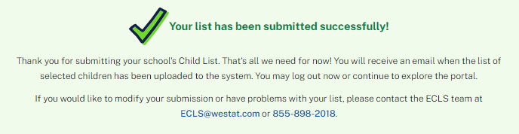
Your list has been submitted successfully!
Thank you for submitting your school’s Child List. That’s all we need for now! You will receive an email when the list of selected children has been uploaded to the system. You may log out now or continue to explore the portal.
If you would like to modify your submission or have problems with your list, please contact the ECLS-K:2024 team at ECLS@westat.com or 855-898-2018.

PREPARE FOR SCHOOL VISIT TAB
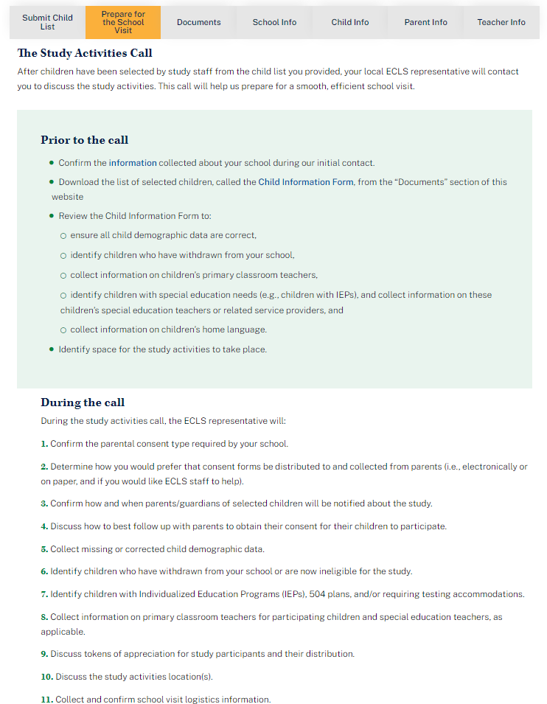

The Study Activities Call
[IN FALL KINDERGARTEN AND IN SPRING KINDERGARTEN SCHOOLS THAT DID NOT PREVIOUSLY HAVE CHILDREN SAMPLED, DISPLAY: After children have been selected by study staff from the child list you provided, your local ECLS-K:2024 representative will contact you to discuss the study activities. This call will help us prepare for a smooth, efficient school visit.]
[IN SPRING KINDERGARTEN SCHOOLS THAT HAD CHILDREN SAMPLED IN THE FALL, DISPLAY: Your local ECLS-K:2024 representative will contact you to discuss the spring kindergarten study activities.]
[IN FALL FIRST GRADE, DISPLAY: An ECLS-K:2024 representative will contact you to collect information on the participating children and discuss the study activities that will take place in the spring.]
[IN SPRING FIRST GRADE, DISPLAY: Your local ECLS-K:2024 representative will contact you to discuss the spring study activities.]
Prior to the call
[IN FALL KINDERGARTEN AND IN SPRING KINDERGARTEN SCHOOLS THAT DID NOT PREVIOUSLY HAVE CHILDREN SAMPLED, DISPLAY:
- Confirm the information [DISPLAY LINK TO SCHOOL INFO TAB] collected about your school during our initial contact.
- Download the list of selected children, called the Child Information Form [DISPLAY LINK TO CHILD INFORMATION FORM], from the “Documents” section of this website.
- Review the Child Information Form to:
  - ensure all child demographic data are correct,
  - identify children who have withdrawn from your school,
  - collect information on children’s primary classroom teachers,
  - identify children with special education needs (e.g., children with IEPs), and collect information on these children’s special education teachers or related service providers, and
  - collect information on children’s home language.
- Identify space for the study activities to take place.]

[IN SPRING KINDERGARTEN SCHOOLS THAT HAD CHILDREN SAMPLED IN THE FALL, DISPLAY:
- Confirm the information [DISPLAY LINK TO SCHOOL INFO TAB] collected about your school during our last contact, including the space for the study activities to take place.
- Review the Child Information [DISPLAY LINK TO CHILD INFO TAB] to:
  - ensure all child demographic data are correct,
  - identify children who have withdrawn from your school, and
  - confirm children’s special education needs (e.g., IEPs).
- Review the Teacher Information [DISPLAY LINK TO TEACHER INFO TAB] to confirm children’s primary classroom and, as appropriate, special education teachers or related services providers]

[IN FALL FIRST GRADE, DISPLAY:
- Confirm the information [DISPLAY LINK TO SCHOOL INFO TAB] collected about your school during our last contact.
- Download the list of participating children, called the Child Information Form [DISPLAY LINK TO CHILD INFORMATION FORM], from the “Documents” section of this website.
- Review the Child Information Form to:
  - ensure all child demographic data and home language are correct,
  - identify children who have withdrawn from your school,
  - collect information on children’s primary classroom teachers, and
  - identify children with special education needs (e.g., children with IEPs), and collect information on these children’s special education teachers or related service providers.
- Identify space for the study activities to take place.]

[IN SPRING FIRST GRADE, DISPLAY:
- Confirm the information [DISPLAY LINK TO SCHOOL INFO TAB] collected about your school during our last contact, including the space for the study activities to take place.
- Review the child information [DISPLAY LINK TO CHILD INFO TAB] to:
  - ensure all child demographic data are correct,
  - identify children who have withdrawn from your school, and
  - confirm children’s special education needs (e.g., IEPs).
- Review the teacher information [DISPLAY LINK TO TEACHER INFO TAB] to confirm children’s primary classroom and, as appropriate, special education teachers or related services providers]

During the call
[IN FALL KINDERGARTEN AND IN SPRING KINDERGARTEN SCHOOLS THAT DID NOT PREVIOUSLY HAVE CHILDREN SAMPLED, DISPLAY:
During the study activities call, the ECLS-K:2024 representative will:
- Confirm the parental consent type required by your school.
- Determine how you would prefer that consent forms be distributed to and collected from parents (i.e., electronically or on paper, and if you would like ECLS staff to help).
- Confirm how and when parents/guardians of selected children will be notified about the study.
- Discuss how to best follow up with parents to obtain their consent for their children to participate.
- Collect missing or corrected child demographic data.
- Identify children who have withdrawn from your school.
- Identify children with Individualized Education Programs (IEPs), 504 plans, and/or requiring testing accommodations.
- Collect information on primary classroom teachers for participating children and special education teachers, as applicable.
- Discuss tokens of appreciation for study participants and their distribution.
- Discuss the study activities location(s).
- Collect and confirm school visit logistics information.]

[IN SPRING KINDERGARTEN SCHOOLS THAT HAD CHILDREN SAMPLED IN THE FALL, DISPLAY:
During the study activities call, the ECLS-K:2024 representative will:
- Collect missing or corrected child demographic data.
- Identify children who have withdrawn from your school.
- Confirm children’s Individualized Education Programs (IEPs), 504 plans, and/or requiring testing accommodations.
- Confirm or collect information on primary classroom teachers for participating children and special education teachers, as applicable.
- Discuss tokens of appreciation for study participants and their distribution.
- Discuss the study activities location(s).
- Collect and confirm school visit logistics information.]

[IN FALL FIRST GRADE, DISPLAY:
During the study activities call, the ECLS-K:2024 representative will:
- Collect missing or corrected child demographic data.
- Identify children who have withdrawn from your school.
- Identify children with Individualized Education Programs (IEPs), 504 plans, and/or requiring testing accommodations.
- Collect information on primary classroom teachers for participating children and special education teachers, as applicable.
- Discuss logistics for the spring school visit, including the location for study activities.]

[IN SPRING FIRST GRADE, DISPLAY:
During the study activities call, the ECLS-K:2024 representative will:
- Collect missing or corrected child demographic data.
- Identify children who have withdrawn from your school.
- Confirm children’s Individualized Education Programs (IEPs), 504 plans, and/or requiring testing accommodations.
- Confirm or collect information on primary classroom teachers for participating children and special education teachers, as applicable.
- Discuss tokens of appreciation for study participants and their distribution.
- Discuss the study activities location(s).
- Collect and confirm school visit logistics information.]

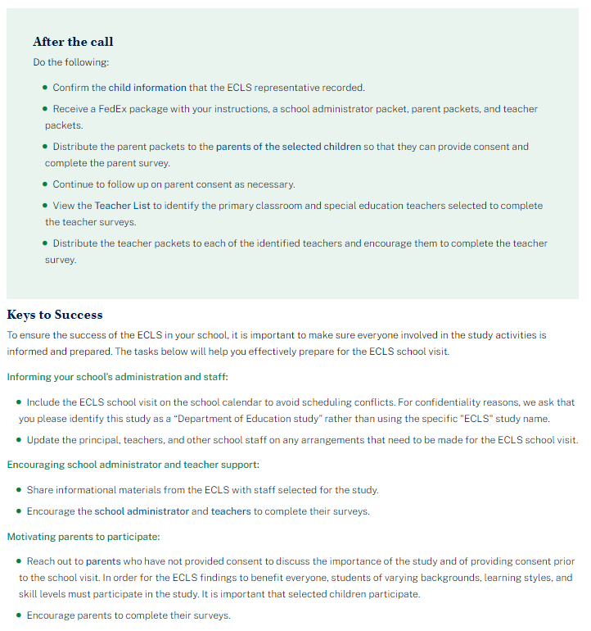
After the Call:
Do the following:
- Confirm the child information [DISPLAY LINK TO CHILD INFO TAB] that the ECLS-K:2024 representative recorded.
- Receive a FedEx package with your instructions, [SPRING ROUNDS ONLY; a school administrator packet,] parent packets, and teacher packets.
- Distribute the parent packets to the parents of the selected children [DISPLAY LINK TO PARENT INFO TAB] so that they can [FALL KINDERGARTEN AND SPRING KINDERGARTEN SCHOOLS THAT DID NOT HAVE CHILDREN SAMPLED PREVIOUSLY:] provide consent and] complete the parent survey.
- [FALL KINDERGARTEN AND SPRING KINDERGARTEN SCHOOLS THAT DID NOT HAVE CHILDREN SAMPLED PREVIOUSLY:] Continue to follow up on parent consent as necessary.
- View the Teacher List [DISPLAY LINK TO TEACHER INFO TAB] to identify the primary classroom [SPRING ROUNDS ONLY: and special education teachers] selected to complete the teacher surveys.
- [SPRING ROUNDS ONLY: Distribute a school administrator packet to the school administrator and encourage him or her to complete the survey.]
- Distribute the teacher packets to each of the identified teachers and encourage them to complete the teacher survey.

Keys to Success:
To ensure the success of the ECLS-K:2024 in your school, it is important to make sure everyone involved in the study activities is informed and prepared. The tasks below will help you effectively prepare for the ECLS-K:2024 school visit.
Informing your school’s administration and staff:
- Include the ECLS-K:2024 school visit on the school calendar to avoid scheduling conflicts. For confidentiality reasons, we ask that you please identify this study as a “U.S. Department of Education study” rather than using the specific “ECLS-K:2024” study name.
- Update the principal, teachers, and other school staff on any arrangements that need to be made for the ECLS-K:2024 school visit.

Encouraging [SPRING ROUNDS ONLY: school administrator and] teacher support:
- Share informational materials from the ECLS-K:2024 with staff selected for the study.
- Encourage the [SPRING ROUNDS ONLY: school administrator [DISPLAY LINK TO SCHOOL INFO TAB] and] teachers [DISPLAY LINK TO TEACHER INFO TAB] to complete their surveys.

Motivating parents to participate:
- [FALL KINDERGARTEN AND SPRING KINDERGARTEN UNSAMPLED SCHOOLS IF CONSENT TYPE = EXPLICIT, DISPLAY:] Reach out to parents [DISPLAY LINK TO PARENT INFO TAB] who have not provided consent] to discuss the importance of the study and of providing consent prior to the school visit. In order for the ECLS-K:2024 findings to benefit everyone, students of varying backgrounds, learning styles, and skill levels must participate in the study. It is important that selected children participate.
- Encourage parents to complete their surveys.

DOCUMENTS TAB
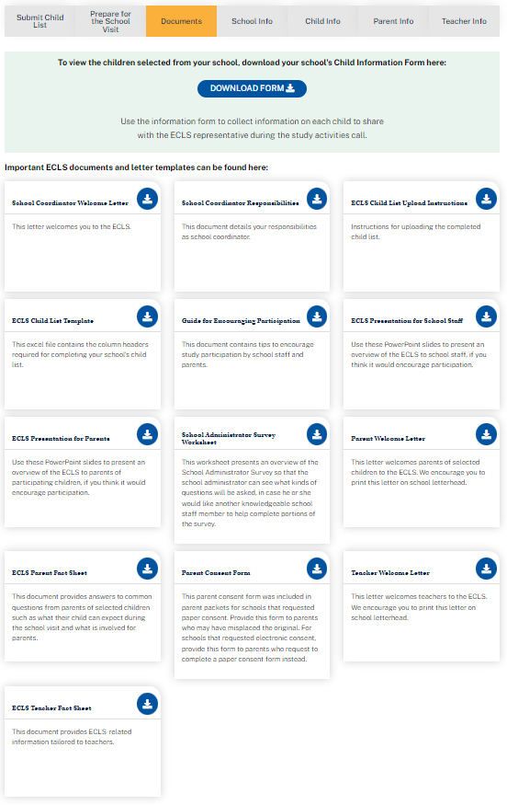
[FALL ROUNDS AND SPRING KINDERGARTEN SCHOOLS THAT DID NOT HAVE CHILDREN SAMPLED IN THE FALL: To view the children selected from your school, download your school's Child Information Form here: DISPLAY DOWNLOAD FORM BUTTON. Use the information form to collect information on each child to share with the ECLS-K:2024 representative during the study activities call.
The Child Information Form is a spreadsheet displaying a table with prefilled information on selected children from the uploaded child list, plus empty columns* in fall kindergarten and spring kindergarten schools that did not have children sampled in the fall for the school coordinator (SC) to collect additional information:
- Child name (last, first)
- Child ID
- Child month of birth
- Child year of birth
- Child sex
- Child grade
- Child ethnicity*
- Child race*
- Child’s home language*
- Primary classroom teacher name*
- Classroom*
- Teacher email address*
- Accommodations needed?*]

Important ECLS-K:2024 documents and letter templates can be found here:
File Name | Description
School Coordinator Welcome Letter | This letter welcomes you to the ECLS-K:2024.
School Coordinator Responsibilities | This document details your responsibilities as school coordinator.
ECLS-K:2024 Child List Upload Instructions | Instructions for uploading the completed child list.
ECLS-K:2024 Child List Template | This excel file contains the column headers required for completing your school’s child list.
Guide for Encouraging Participation | This document contains tips to encourage study participation by school staff and parents.
ECLS-K:2024 Presentation for School Staff | Use these PowerPoint slides to present an overview of the ECLS-K:2024 to school staff, if you think it would encourage participation.
ECLS-K:2024 Presentation for Parents | Use these PowerPoint slides to present an overview of the ECLS-K:2024 to parents of participating children, if you think it would encourage participation.
SPRING KINDERGARTEN AND SPRING FIRST GRADE ONLY: School Administrator Survey Worksheet | This worksheet presents an overview of the School Administrator Survey so that the school administrator can see what kinds of questions will be asked, in case he or she would like another knowledgeable school staff member to help complete portions of the survey.
FALL AND SPRING KINDERGARTEN ONLY: Parent Welcome Letter | This letter welcomes parents of selected children to the ECLS-K:2024. This letter is available in English and Spanish here. We can provide a letter in Mandarin upon request.
ECLS-K:2024 Parent Fact Sheet | This document provides answers to common questions from parents of selected children such as what their child can expect during the school visit and what is involved for parents. This fact sheet is available in English and Spanish.
FALL AND SPRING KINDERGARTEN ONLY: Parent Consent Form [EXPLICIT OR IMPLICIT DEPENDING ON THE SCHOOL’S CHOICE ON THE SCHOOL INFO SCREEN] | This parent consent form was included in parent packets for schools that requested paper consent. Provide this form to parents who may have misplaced the original. For schools that requested electronic consent, provide this form to parents who request to complete a paper consent form instead. This form is available in English and Spanish here. We can provide a form in Mandarin upon request.
Teacher Welcome Letter | This letter welcomes teachers to the ECLS-K:2024.
ECLS-K:2024 Teacher Fact Sheet | This document provides ECLS-K:2024-related information tailored to teachers.

SCHOOL INFORMATION TAB

The School Information (“School Info”) tab has three sections, which can be expanded and collapsed: School Information, School Administrator Survey Status, and School Visit Information.

SCHOOL INFORMATION SECTION

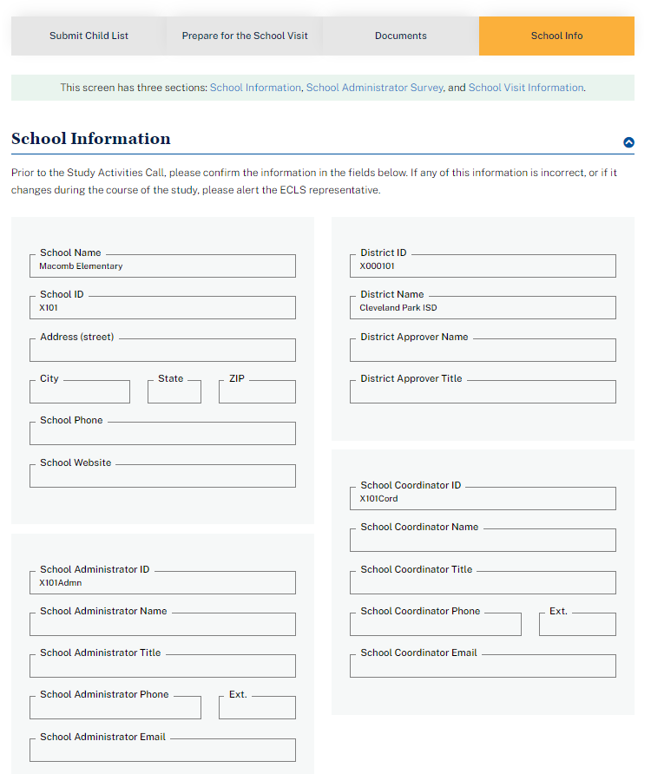

Display information prefilled from the previous round.

This screen has [two/three] sections: School Information[, SPRING ROUNDS ONLY: School Administrator Survey,] and School Visit Information.

School Information

Prior to the Study Activities Call, please confirm the information in the fields below. If any of this information is incorrect, or if it changes during the course of the study, please alert the ECLS-K:2024 representative.
- School Name
- School ID
- Address (street, city, state, ZIP)
- School Phone
- School Website
- District fields. Do not display if the school is private.
  - District ID
  - District Name
  - District Approver Name
  - District Approver Title
- School Administrator ID
- School Administrator Name
- School Administrator Title
- School Administrator Phone
- School Administrator Phone ext.
- School Administrator Email
- School Coordinator ID
- School Coordinator Name
- School Coordinator Title
- School Coordinator Phone
- School Coordinator Phone ext.
- School Coordinator Email

[DISPLAY IN SPRING ROUNDS ONLY: SCHOOL ADMINISTRATOR SURVEY STATUS SECTION (with example text):]

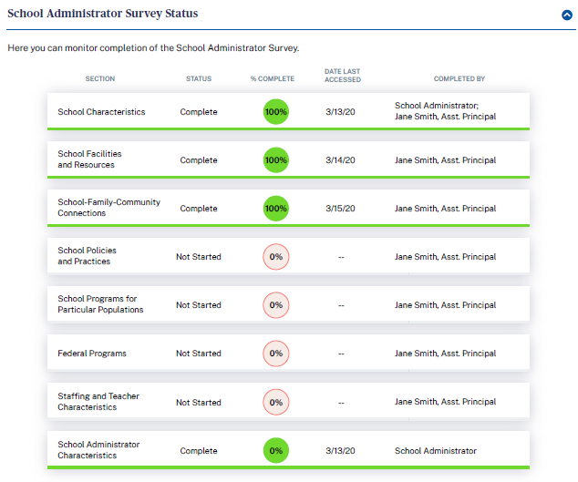

School Administrator Survey Status
Here you can monitor completion of the School Administrator Survey.

Section | Status | % Complete | Date Last Accessed | Completed by
- School Characteristics | Complete | 100% | 4/13/24 | School Administrator; Other School Staff: Jane Smith, Assistant Principal
- School Facilities and Resources | Complete | 100% | 4/14/24 | Other School Staff: Jane Smith, Assistant Principal
- School-Family-Community Connections | In-progress | 50% | 4/15/24
- School Policies and Practices | Not started | 0%
- School Programs for Particular Populations | Not started | 0%
- Federal Programs | Not started | 0%
- Staffing and Teacher Characteristics | Not started | 0%
- School Administrator Characteristics | Complete | 100% | 4/13/24 | School Administrator

SCHOOL VISIT INFORMATION SECTION (with example text):

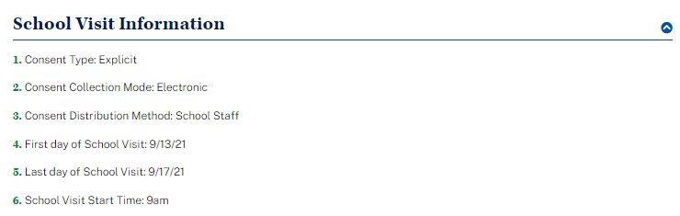

School Visit Information
Display information recorded by the ECLS-K:2024 representative.
- FALL KINDERGARTEN AND SPRING KINDERGARTEN SCHOOLS WITH CHILDREN NOT SAMPLED PREVIOUSLY: Consent Type: Explicit or Implicit
- FALL KINDERGARTEN AND SPRING KINDERGARTEN SCHOOLS WITH CHILDREN NOT SAMPLED PREVIOUSLY: Consent Collection Mode: Electronic or Paper
- FALL KINDERGARTEN AND SPRING KINDERGARTEN SCHOOLS WITH CHILDREN NOT SAMPLED PREVIOUSLY: Consent Distribution Method: ECLS-K:2024 Staff or School Staff
- First day of School Visit
- Last day of School Visit
- School Visit Arrival Time

CHILD INFORMATION TAB

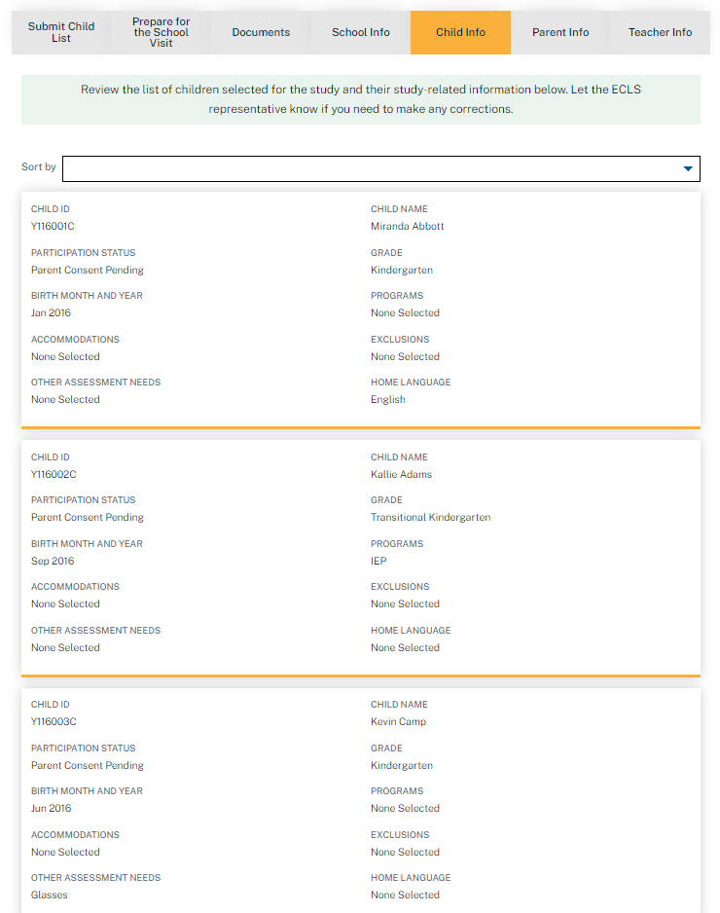

Review the list of children [FALL KINDERGARTEN AND SPRING KINDERGARTEN IN SCHOOLS THAT DID NOT HAVE CHILDREN SAMPLED PREVIOUSLY: selected for ][SPRING KINDERGARTEN IN SCHOOLS WITH CHILDREN SAMPLED PREVIOUSLY, FALL FIRST GRADE, AND SPRING FIRST GRADE: participating in] the study and their study-related information below. Let the ECLS-K:2024 representative know if you need to make any corrections.
Display a list of children in child ID order with the following information. Display the ECLS-K:2024 representative’s entries. The user can sort by child ID, child name, or grade.
- Child ID
- Child Name
- Participation Status
- Grade
- Birth Month and Year
- Program(s) (IEP, IFSP, or 504 Plan)
- Accommodations the ECLS-K:2024 will provide to help the child complete the study activities
- Exclusions (accommodations the ECLS-K:2024 is unable to provide)
- Other Assessment Needs
- Home Language

PARENT INFORMATION TAB

[FALL AND SPRING KINDERGARTEN, SPRING FIRST GRADE: Please use this screen to review and update Parent Consent and to review the status of Parent Surveys.]

[FALL FIRST GRADE: Please use this screen to review and update Parent Consent and Parent Contact Information.]

The Parent Information (“Parent Info”) tab has two sections: Parent Consent and Parent Information [and Survey Tracking]. “Parent Consent” and Parent [Surveys/Contact Information]” are links that navigate to the corresponding sections of the page. In fall first grade, the screen will not display survey information.

PARENT CONSENT SECTION
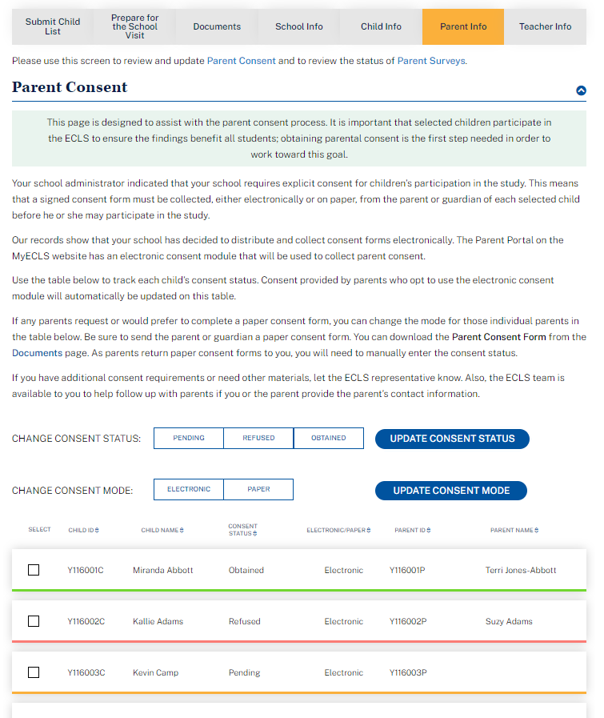
Parent Consent
[FALL KINDERGARTEN AND SPRING KINDERGARTEN SCHOOLS WITH CHILDREN NOT SAMPLED PREVIOUSLY:
This page is designed to assist with the parent consent process. It is important that selected children participate in the ECLS-K:2024 to ensure the findings benefit all students; obtaining parental consent is the first step needed in order to work toward this goal.
Your school administrator indicated that your school requires {EXPLICIT/IMPLICIT} consent for children’s participation in the study. [IF EXPLICIT, DISPLAY: This means that a signed consent form must be collected, either electronically or on paper, from the parent or guardian of each selected child before he or she may participate in the study.] [IF IMPLICIT, DISPLAY: This means that parents will be notified about their child’s selection for the study and they will be able to opt out if they would prefer that their child not participate.]
[IF PAPER CONSENT IS SELECTED, DISPLAY:] Our records show that your school has decided to distribute and collect consent forms on paper. The Parent Portal on the MyECLS website has an electronic consent module to collect and track parent consent. While you will be distributing paper forms, parents may still choose to use the electronic consent module.
[IF PAPER CONSENT IS SELECTED, DISPLAY:] Use the table below to track each child’s consent status. As you collect paper consent forms, please update the consent status manually for the associated children. (Consent provided by parents who opt to use the electronic consent module on MyECLS will automatically be updated on this table.) Please update and monitor consent statuses on a regular basis. It is important that every selected child participate to ensure the findings benefit all students.
[IF ELECTRONIC CONSENT IS SELECTED, DISPLAY:] Our records show that your school has decided to distribute and collect consent forms electronically. The Parent Portal on the MyECLS website has an electronic consent module that will be used to collect parent consent.
[IF ELECTRONIC CONSENT IS SELECTED, DISPLAY:] Use the table below to track each child’s consent status. Consent provided by parents who opt to use the electronic consent module will automatically be updated on this table.
[IF ELECTRONIC CONSENT SELECTED, DISPLAY:] If any parents request or would prefer to complete a paper consent form, you can change the mode for those individual parents in the table below. Be sure to send the parent or guardian a paper consent form. You can download the Parent Consent Form from the Documents [LINK TO DOCUMENTS PAGE] page. As parents return paper consent forms to you, you will need to manually enter the consent status.
If you have additional consent requirements or need other materials, let the ECLS-K:2024 representative know. Also, the ECLS-K:2024 team is available to you to help follow up with parents if you or the parent provide the parent’s contact information.
Display a list of children along with child ID, child name, consent status, consent delivery method, parent ID, parent name.

Consent delivery method is either electronic or paper, as recorded on the School Information Screen.
- If electronic, child consent status will update automatically as the electronic forms are signed.
- If paper, or for individual parents who prefer to provide paper, the school coordinator or ECLS-K:2024 representative will update child consent status as the forms are received.

The electronic or paper column is prefilled based on the school’s selection but can be updated manually for individual children.]

[SPRING KINDERGARTEN WITH CHILDREN SAMPLED PREVIOUSLY, FALL FIRST GRADE, AND SPRING FIRST GRADE:
Use the table below to track the consent status for each participating child. It is important that every selected child participate to ensure the findings benefit all students. However, if parents choose to opt their child out of future participation, you can change the consent status in the table below.
Display a list of children along with child ID, child name, consent status, parent ID, parent name.]

The checkbox in the far left column allows the user to select the row to update consent status or to print consent forms. The checkbox in the header row allows the user to select all rows.

Display a consent status update button above the table. The options include:
- Pending
- Obtained
- Refused

Apply the selection to selected children in the consent status column.

Display a “print consent forms” button above the table. Selecting the print button allows the user to print consent forms for selected children.

Child ID | Child Name | [Electronic or Paper] | Consent Status | Parent ID | Parent Name
9999001C | Child Name | [Electronic] | C_Consent | 9999001P | Parent Name

PARENT INFORMATION AND SURVEY TRACKING SECTION

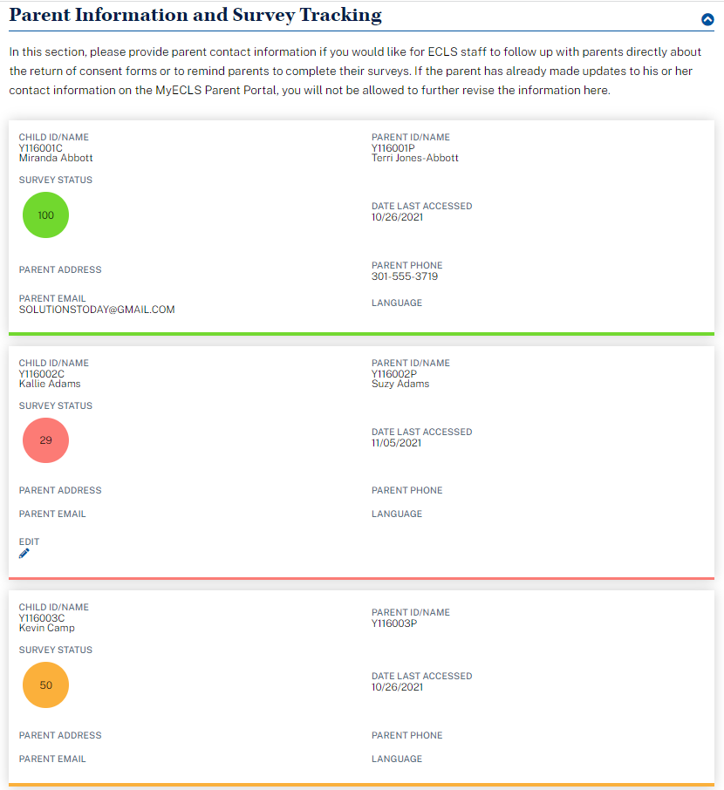

Parent Information [and Survey Tracking]

In this section, please provide parent contact information if you would like for ECLS-K:2024 staff to [follow up with parents directly about the return of consent forms or to] remind parents to complete their surveys. If the parent has already made updates to his or her contact information on the MyECLS Parent Portal, you will not be allowed to further revise the information here.

Display a tile for each child with the following information.
Fall kindergarten, spring kindergarten, and spring first grade:
Child ID/Name | Parent ID/Name | Parent Address | Parent Phone | Parent Email | Language | Survey Status | Date Last Accessed | Edit
9999  001C  Child Name | 9999001P  Parent Name | 123 Main St | 301-555-1212 | Parent  @gmail  .com | English | 75 | 9/15/23 | Edit icon

Fall first grade:
Child ID/Name | Parent ID/Name | Parent Address | Parent Phone | Parent Email | Language
9999  001C  Child Name | 9999001P  Parent Name | 123 Main St | 301-555-1212 | Parent  @gmail  .com | English

Fill parent information fields as parent information is recorded in the Parent Portal. Allow updates to the parent address/phone/email fields on this screen by the SC. If the parent has recorded information or made updates, do not allow updates by the SC. When the Edit icon is selected, a modal displays with fields to allow the user to update information: Parent First and Last Name, Address (street), City, State, ZIP, Parent Phone, and Parent Email.

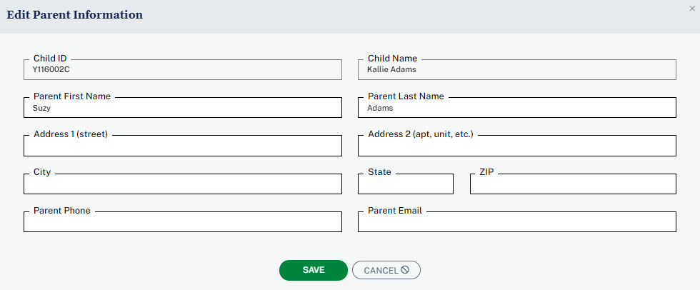

TEACHER INFORMATION TAB

Please use this screen to review the Teacher List, the list of Child-Teacher Links, and the status of Teacher Surveys.

The Teacher Information (“Teacher Info”) tab has three sections in fall kindergarten, spring kindergarten, and spring first grade: Teacher List, Child-Teacher Link, and Track Teacher Surveys. “Teacher List,” “Child-Teacher Links,” and “Teacher Surveys” are links that navigate to the corresponding sections of the page. The ”Track Teacher Surveys” section does not appear in fall first grade.

TEACHER LIST SECTION

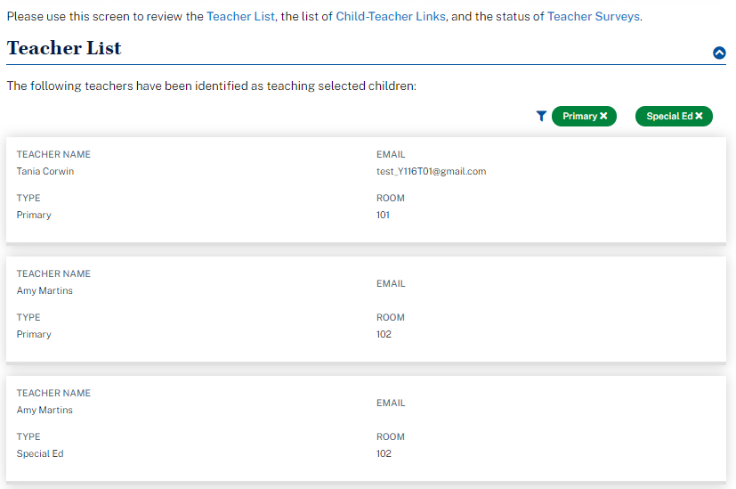

Teacher List

The following teachers have been identified as teaching selected children:

Display a list of teachers, as recorded by the ECLS-K:2024 representative.

Teacher Name | Email Address | Type | Room
Teacher Name | teacher@gmail.com | Primary or Special Ed | 123

CHILD-TEACHER LINK SECTION

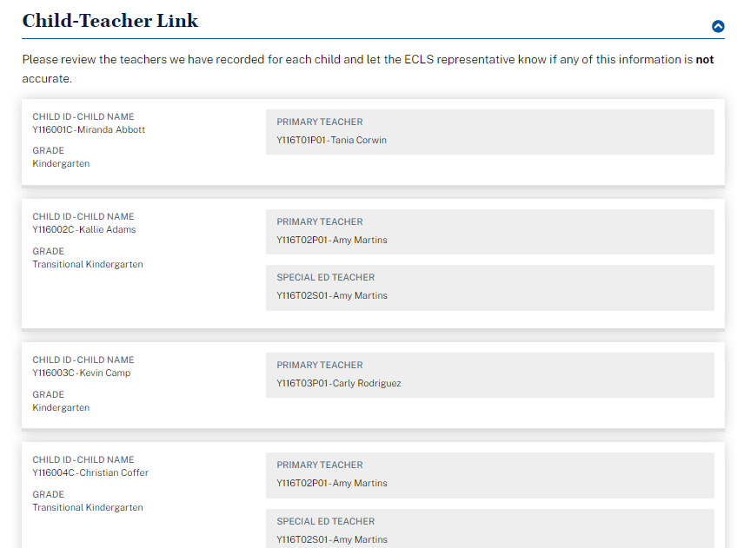

Display a list of children. For each child, display a primary classroom teacher, as recorded by the ECLS-K:2024 representative. For each child with an IEP or exclusion on file, also display the special education teacher, as recorded by the ECLS-K:2024 representative.

Child-Teacher Link

Please review the teachers we have recorded for each child and let the ECLS-K:2024 representative know if any of this information is not accurate.

Child  ID | Child Name | Grade | Primary Teacher ID | Primary Teacher Name | Special Ed Teacher ID | Special Ed Teacher Name
9999001C | Child One | K | 9999T01 – P01 | Teacher Name | 9999T01 – S01 | Teacher Name
9999002C | Child Two | K | 9999T01 – P01 | Teacher Name | N/A | N/A
9999003C | Child Three | TK | 9999T02 – P01 | Teacher Name | 9999T02 – S01 | Teacher Name

TEACHER SURVEY SECTION (FALL KINDERGARTEN, SPRING KINDERGARTEN, AND SPRING FIRST GRADE)
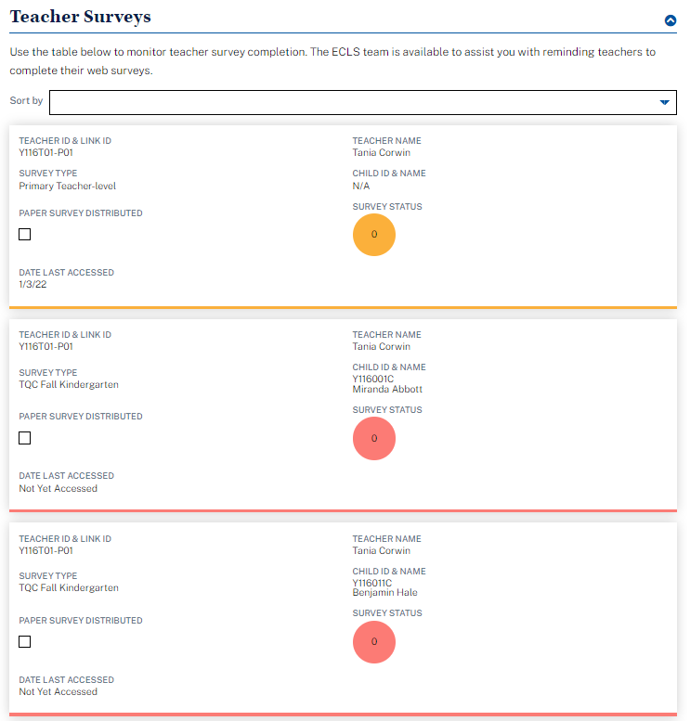
Teacher Surveys
Use the table below to monitor teacher survey completion. The ECLS-K:2024 team is available to assist you with reminding teachers to complete their web surveys.
- The user can sort by child name, grade, or teacher name.
- Teacher ID and link ID
- Teacher Name
- Survey type: Display primary teacher-level, primary child-level, and, in spring rounds only, special ed teacher-level, or special ed child-level.
- Child ID and name: For child-level surveys, display child ID and name, else display “n/a”.
- Paper survey distributed: Checked if the ECLS-K:2024 representative has distributed paper surveys
- Survey Status (% complete)
- Date Last Accessed

Teacher  ID & Link ID | Teacher Name | Survey Type | Child ID and Name | Paper Survey Distributed | Survey Status | Date Last Accessed
9999T01-P01/S01 | Teacher Name | primary teacher-level / primary child-level / special ed teacher-level / special ed child-level | 9999001C  Child Name | CHECK-BOX | 100% | 9/15/23

SCHOOL ADMINISTRATOR PORTAL

The screens appearing in this section (“3. SCHOOL ADMINISTRATOR PORTAL”) are for spring rounds only.

The School Administrator Portal has three sections: Overview, Survey, and More Information. Use the navigation icons on the left to skip to each section.

This portal is available to the school administrators, as well as other school personnel designated by a school administrator to complete sections of the School Administrator Survey. Some text on this screen is to be displayed only for the school administrator log-in, while some text may be displayed to both the school administrator and the secondary log-in (designee). Note that the secondary log-in protocol is being reviewed in the field test data collection and these procedures for use of a designee and secondary login may be revised in a future OMB revision request.

3.1 Overview Section
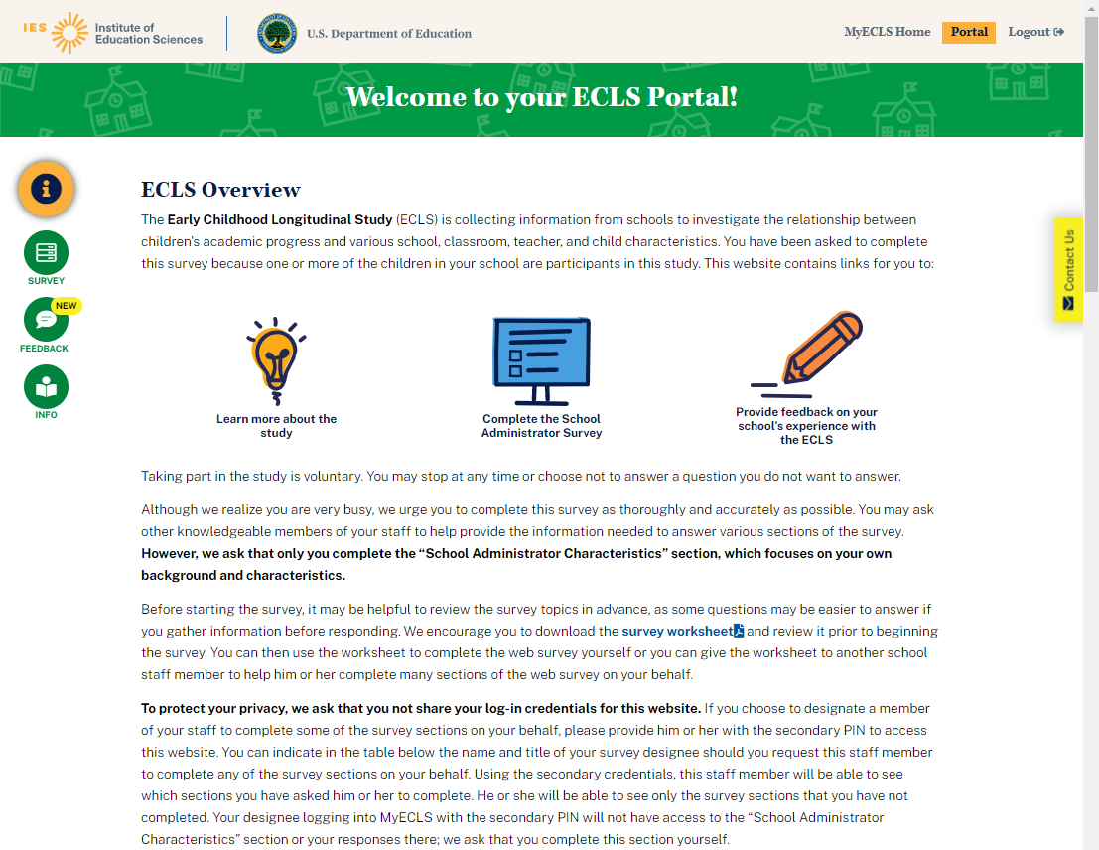

Welcome to your ECLS-K:2024 portal!

ECLS-K:2024 Overview

The Early Childhood Longitudinal Study, Kindergarten Class of 2023-24 (ECLS-K:2024) is collecting information from schools to investigate the relationship between children's academic progress and various school, classroom, teacher, and child characteristics. You have been asked to complete this survey because one or more of the children in your school are participants in this study. This website contains links for you to:
- Learn more about the study
- Complete the School Administrator Survey

Taking part in the study is voluntary. You may stop at any time or choose not to answer a question you do not want to answer.
[DISPLAY FOR SCHOOL ADMINISTRATOR ONLY:] Although we realize you are very busy, we urge you to complete this survey as thoroughly and accurately as possible. You may ask other knowledgeable members of your staff to help provide the information needed to answer various sections of the survey. However, we ask that only you complete the “School Administrator Characteristics” section, which focuses on your own background and characteristics.
[DISPLAY FOR SCHOOL ADMINISTRATOR ONLY:] Before starting the survey, it may be helpful to review the survey topics in advance, as some questions may be easier to answer if you gather information before responding. We encourage you to download the survey worksheet [DISPLAY LINK TO SAQ WORKSHEET] and review it prior to beginning the survey. You can then use the worksheet to complete the web survey yourself or you can give the worksheet to another school staff member to help your designee complete many sections of the web survey on your behalf.

The worksheet (see Attachment A-1) will display each section and a description of the types of items that appear in each section. There will also be a reminder that only the principal can and should respond to section H (the section about school administrator/principal background).

[DISPLAY FOR SCHOOL ADMINISTRATOR ONLY:] To protect your privacy, we ask that you not share your log-in credentials for this website. If you choose to designate a member of your staff to complete some of the survey sections on your behalf, please provide this designee with the secondary PIN to access this website. You can indicate in the table below the name and title of your survey designee should you request this staff member to complete any of the survey sections on your behalf. Using the secondary credentials, this staff member will be able to see which sections you have asked him or her to complete. He or she will be able to see only the survey sections that you have not completed. Your designee logging into MyECLS with the secondary PIN will not have access to the “School Administrator Characteristics” section or your responses there; we ask that you complete this section yourself.

3.2 Survey Section
Participants select the blue arrow to launch the survey section. When the survey section is complete, a green check mark displays and the section can no longer be opened.
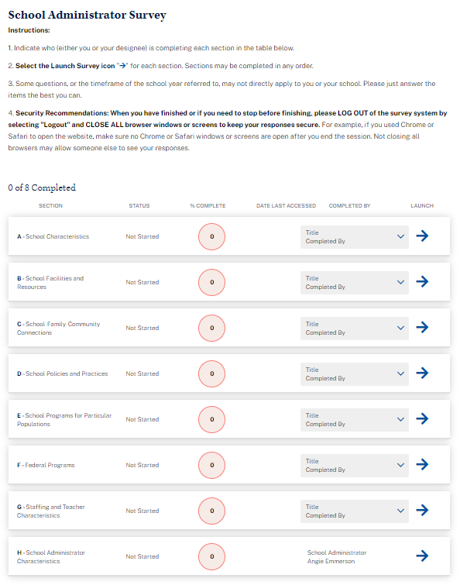
School Administrator Survey

Instructions:
      - Indicate who (either you or your designee) is completing each section in the table below.
      - Select the Launch Survey icon [DISPLAY ICON] for each section. Sections may be completed in any order.
      - Some questions may not directly apply to you or your school. Please just answer the items the best you can.
      - Security Recommendations: When you have finished or if you need to stop before finishing, please LOG OUT of the survey system by selecting "Logout" and CLOSE ALL browser windows or screens to keep your responses secure. For example, if you used Chrome or Safari to open the website, make sure no Chrome or Safari windows or screens are open after you end the session. Not closing all browsers may allow someone else to see your responses.

Fields to enter the other school staff name and title:
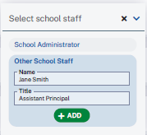

Display survey sections. Only the school administrator can see all 8 sections. The secondary (designee’s) log-in cannot see section H, as this section is to be completed only by the school administrator.

Survey Section table, with example text:
Section | Status | Percent Complete | Date Last Accessed | Completed by | Launch
- School Characteristics | Complete | 100 | 4/13/24 | School Administrator; Other School Staff: Jane Smith, Assistant Principal
- School Facilities and Resources | Complete | 100 | 4/13/24 | Other School Staff: Jane Smith, Assistant Principal
- School-Family-Community Connections | In-progress | 50 | 4/13/24 | Other School Staff: Jane Smith, Assistant Principal | Launch Survey
- School Policies and Practices | Not started | 0 |  | Other School Staff: Jane Smith, Assistant Principal | Launch Survey
- School Programs for Particular Populations | Not started | 0 |  | Other School Staff: Jane Smith, Assistant Principal | Launch Survey
- Federal Programs | Not started | 0 |  | Other School Staff: Jane Smith, Assistant Principal | Launch Survey
- Staffing and Teacher Characteristics | Not started | 0 |  | Other School Staff: Jane Smith, Assistant Principal | Launch Survey
- School Administrator Characteristics | Complete | 100 | 4/13/24 | School Administrator

3.3 More Information Section

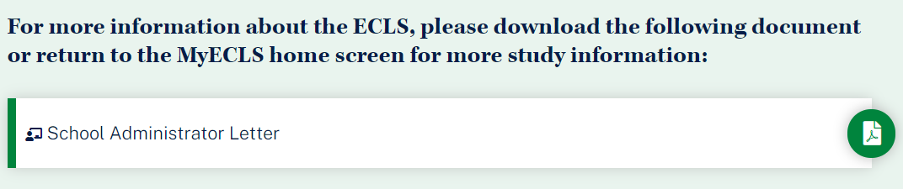
For more information about the ECLS-K:2024, please download the following document or return to the MyECLS home screen for more study information:
- School Administrator Letter [LINK TO LETTER]

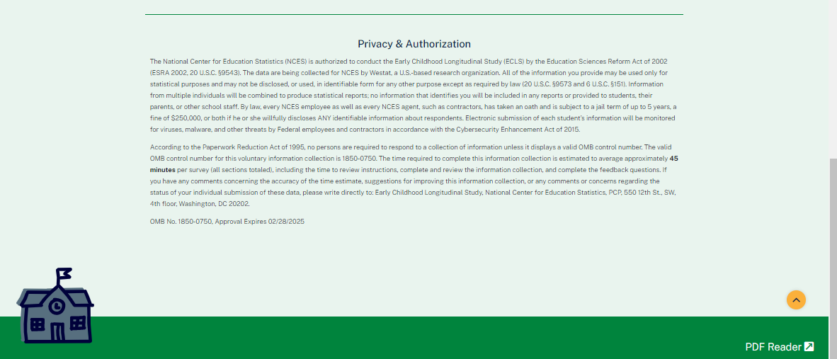
This language appears at the bottom of the School Administrator Portal page, directly on the screen.
The National Center for Education Statistics (NCES) is authorized to conduct the Early Childhood Longitudinal Study (ECLS) by the Education Sciences Reform Act of 2002 (ESRA 2002, 20 U.S.C. §9543). The data are being collected for NCES by Westat, a U.S.-based research organization. All of the information you provide may be used only for statistical purposes and may not be disclosed, or used, in identifiable form for any other purpose except as required by law (20 U.S.C. §9573 and 6 U.S.C. §151). Information from multiple individuals will be combined to produce statistical reports; no information that identifies you will be included in any reports or provided to students, their parents, or other school staff. By law, every NCES employee as well as every NCES agent, such as contractors, has taken an oath and is subject to a jail term of up to 5 years, a fine of $250,000, or both if he or she willfully discloses ANY identifiable information about respondents. Electronic submission of each student’s information will be monitored for viruses, malware, and other threats by Federal employees and contractors in accordance with the Cybersecurity Enhancement Act of 2015.

According to the Paperwork Reduction Act of 1995, no persons are required to respond to a collection of information unless it displays a valid OMB control number. The valid OMB control number for this voluntary information collection is 1850-0750. The time required to complete this information collection is estimated to average approximately 45 minutes per survey (all sections totaled), including the time to review instructions and to complete and review the information collection. If you have any comments concerning the accuracy of the time estimate, suggestions for improving this information collection, or any comments or concerns regarding the status of your individual submission of these data, please write directly to: Early Childhood Longitudinal Study, National Center for Education Statistics, PCP, 550 12th St., SW, 4th floor, Washington, DC 20202.

OMB No. 1850-0750, Approval Expires XX/XX/XXXX

TEACHER PORTAL

The Teacher Portal is available in the fall kindergarten, spring kindergarten, and spring first-grade rounds. Special education teachers will access the portal only in spring rounds. The special education fills in the text below will display only in spring rounds.

The Teacher Portal has three sections: Overview, Surveys, and More Information. Use the navigation icons on the left to skip to each section.

4.1 Overview Section

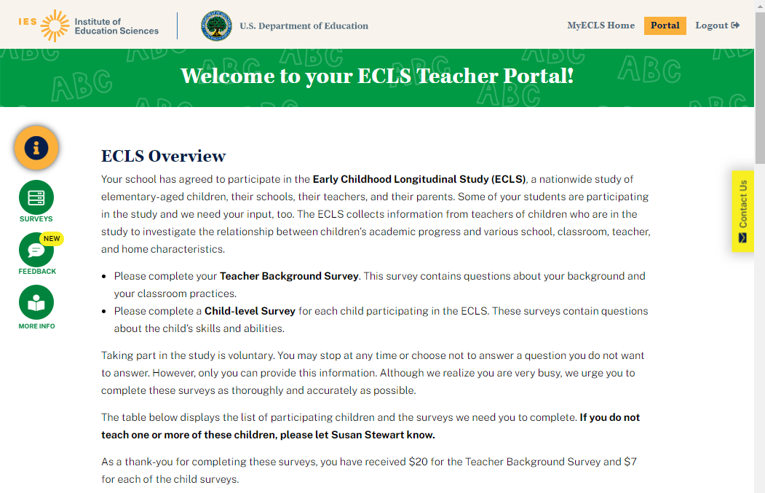
Welcome to your ECLS-K:2024 Teacher Portal!

ECLS-K:2024 Overview
Your school has agreed to participate in the Early Childhood Longitudinal Study, Kindergarten Class of 2023-24 (ECLS-K:2024), a nationwide study of elementary-aged children, their schools, their teachers, and their parents. Some of your students are participating in the study and we need your input, too. The ECLS-K:2024 collects information from teachers of children who are in the study to investigate the relationship between children’s academic progress and various school, classroom, teacher, and home characteristics.
- [IF TEACHER LINK ID = P (PRIMARY) OR C (CENSUS), OR IF TEACHER LINK ID = BOTH P AND S AND IT IS A FALL ROUND, DISPLAY: Please complete your Teacher Background Survey. This survey contains questions about your background and your classroom practices]. [IF TEACHER LINK ID = S (SPECIAL ED), AND IT IS A SPRING ROUND, DISPLAY: Please complete your Teacher Background Survey. This survey contains questions about your experiences teaching students with special education needs.] [IF TEACHER LINK ID = BOTH P AND S, AND IT IS A SPRING ROUND, DISPLAY: Please complete the two Teacher Background Surveys. One will focus on your background and classroom practices. The other is targeted to your experiences teaching students with special education needs.]
- If you teach any children selected to participate in the ECLS-K:2024, please complete a Child-level Survey for each child. [IF TEACHER LINK ID = P (PRIMARY), ), OR IF TEACHER LINK ID = BOTH P AND S AND IT IS A FALL ROUND, DISPLAY: These surveys contain questions about the child’s skills and abilities.] [IF TEACHER LINK ID = S (SPECIAL ED), AND IT IS A SPRING ROUND, DISPLAY: These surveys contain questions about services provided to the child. Please note that some of the information we are asking for may be found in the child’s IEP.] [IF TEACHER LINK ID = BOTH P AND S, AND IT IS A SPRING ROUND, DISPLAY: These surveys contain questions about the child’s skills and abilities and services provided. Please note that some of the information we are asking for may be found in the child’s IEP.]

Taking part in the study is voluntary. You may stop at any time or choose not to answer a question you do not want to answer. However, only you can provide this information. Although we realize you are very busy, we urge you to complete these surveys as thoroughly and accurately as possible.

The table below displays the list of participating children and the surveys we need you to complete. If you do not teach one or more of these children, please let [SCHOOL COORDINATOR] know.

[IF INCENTIVE RULE ON DISTRICT INFO AND SCHOOL INFO SCREENS = INCENTIVES ALLOWED, DISPLAY: As a thank-you, you have received $20 for the Teacher Background Survey [DISPLAY FOR TEACHERS WHO ARE LINKED TO CHILDREN: and $7 for each of the child surveys].]

4.2 Surveys Section
Participants select the blue arrow to launch the survey. When the survey is complete, a green check mark displays and the survey can no longer be opened.
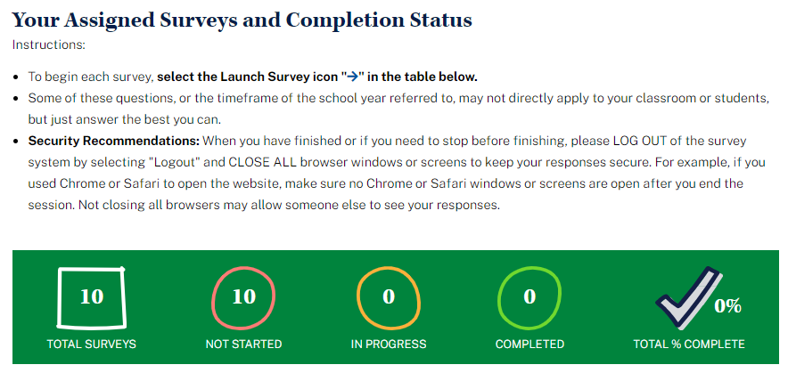

Your Assigned Surveys and Completion Status
Instructions:
- To begin each survey, select the Launch Survey icon [DISPLAY ICON] in the table below.
- Security Recommendations: When you have finished or if you need to stop before finishing, please LOG OUT of the survey system by selecting "Logout" and CLOSE ALL browser windows or screens to keep your responses secure. For example, if you used Chrome or Safari to open the website, make sure no Chrome or Safari windows or screens are open after you end the session. Not closing all browsers may allow someone else to see your responses.

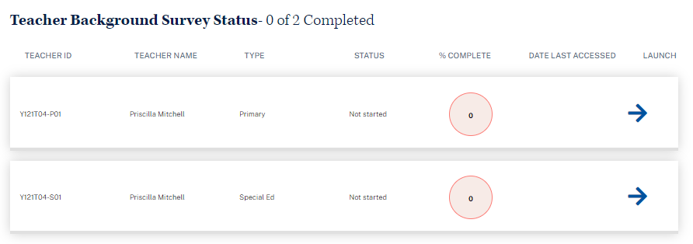

Teacher Background Survey Status (with example text):
Teacher ID | Teacher Name | Type | Status | % Complete | Date Last Accessed | Launch
9999T01 – P01 | Teacher Name | Primary | In-progress | 75 | 9/15/23 | Launch Survey
9999T01 – S01 | Teacher Name | Special Ed | Not Started | 0 |  | Launch Survey

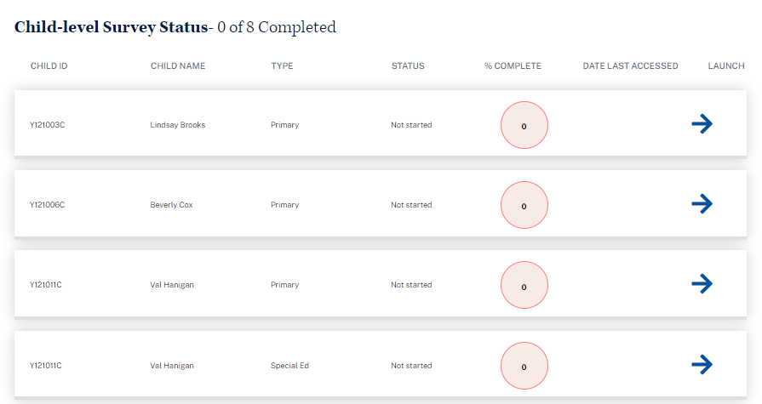

When the teacher is assigned more than 10 child-level surveys, filters appear to allow the teacher to filter the list by survey type (in spring rounds) and status.

Child-level Survey Status (with example text):
Child ID | Child Name | Type | Status | % Complete | Date Last Accessed | Launch
9999991C | Child 1 Name | Primary | Complete | 100 | 9/13/23
9999992C | Child 2 Name | Primary | In-progress | 50 | 9/16/23 | Launch Survey
9999993C | Child 3 Name | Primary | Not started | 0 | N/A | Launch Survey
9999993C | Child 3 Name | Special Ed | Not started | 0 | N/A | Launch Survey

4.3 More Information Section
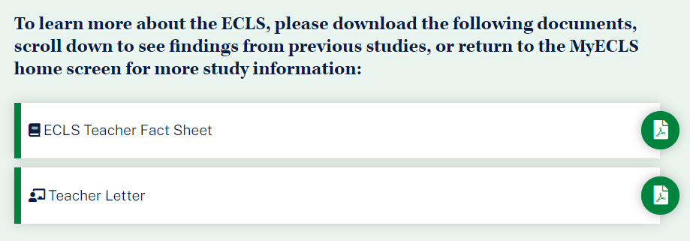
To learn more about the ECLS-K:2024, please download the following documents, scroll down to see findings from previous studies, or return to the MyECLS home screen for more study information:
- ECLS-K:2024 Teacher Fact Sheet [LINK TO TEACHER FACT SHEET]
- Teacher Letter [LINK TO LETTER]

Display “Barriers to Participation” infographic.
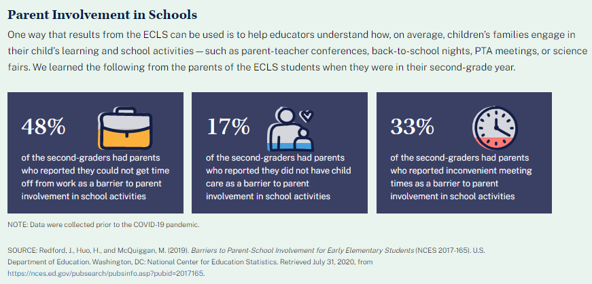
Parent Involvement in Schools
One way that results from the ECLS can be used is to help educators understand how, on average, children’s families engage in their child’s learning and school activities – such as parent-teacher conferences, back-to-school nights, PTA meetings, or science fairs. We learned the following from the parents of the ECLS students when they were in their second-grade year.
- 48% of the second-graders had parents who reported they could not get time off from work as a barrier to parent involvement in school activities
- 17% of the second-graders had parents who reported they did not have child care as a barrier to parent involvement in school activities
- 33% of the second-graders had parents who reported inconvenient meeting times as a barrier to parent involvement in school activities.
NOTE: Data were collected prior to the COVID-19 pandemic.
SOURCE: Redford, J., Huo, H., and McQuiggan, M. (2019). Barriers to Parent-School Involvement for Early Elementary Students (NCES 2017-165). U.S. Department of Education. Washington, DC: National Center for Education Statistics. Retrieved July 31, 2020, from https://nces.ed.gov/pubsearch/pubsinfo.asp?pubid=2017165.

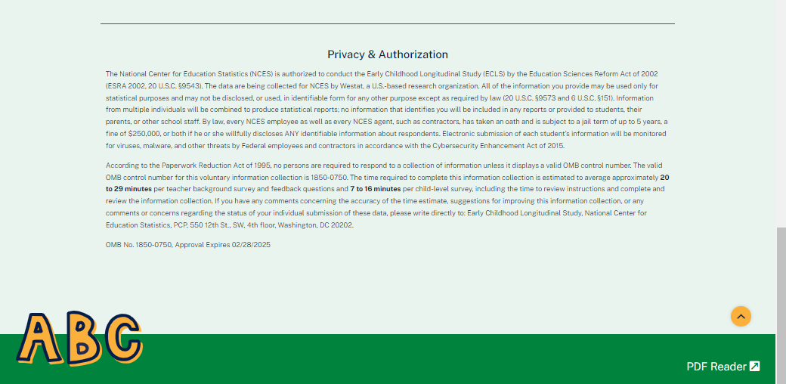

This language appears at the bottom of the Teacher Portal page, directly on the screen.

Privacy and Authorization

The National Center for Education Statistics (NCES) is authorized to conduct the Early Childhood Longitudinal Study (ECLS) by the Education Sciences Reform Act of 2002 (ESRA 2002, 20 U.S.C. §9543). The data are being collected for NCES by Westat, a U.S.-based research organization. All of the information you provide may be used only for statistical purposes and may not be disclosed, or used, in identifiable form for any other purpose except as required by law (20 U.S.C. §9573 and 6 U.S.C. §151). Information from multiple individuals will be combined to produce statistical reports; no information that identifies you will be included in any reports or provided to students, their parents, or other school staff. By law, every NCES employee as well as every NCES agent, such as contractors, has taken an oath and is subject to a jail term of up to 5 years, a fine of $250,000, or both if he or she willfully discloses ANY identifiable information about respondents. Electronic submission of each student’s information will be monitored for viruses, malware, and other threats by Federal employees and contractors in accordance with the Cybersecurity Enhancement Act of 2015.

According to the Paperwork Reduction Act of 1995, no persons are required to respond to a collection of information unless it displays a valid OMB control number. The valid OMB control number for this voluntary information collection is 1850-0750. The time required to complete this information collection is estimated to average approximately 20 to 29 minutes per teacher background survey and 7 to 16 minutes per child-level survey, including the time to review instructions and complete and review the information collection. If you have any comments concerning the accuracy of the time estimate, suggestions for improving this information collection, or any comments or concerns regarding the status of your individual submission of these data, please write directly to: Early Childhood Longitudinal Study, National Center for Education Statistics, PCP, 550 12th St., SW, 4th floor, Washington, DC 20202.

OMB No. 1850-0750, Approval Expires XX/XX/XXXX

PARENT PORTAL*

The Parent Portal is intended for the parents or guardians of selected children. It has five sections: Overview, Consent, Surveys, Contact Information, and More Information. Use the navigation icons on the left to skip to each section. Each section displays as an accordion, allowing the user to expand and collapse each section. Once consent is recorded, contact information is provided, and survey is completed, each section will be marked as complete. This portal is available in all rounds, but the consent section will appear only in fall kindergarten and, for parents in schools that did not have children sampled in the fall round, in spring kindergarten.

5.1 Overview Section
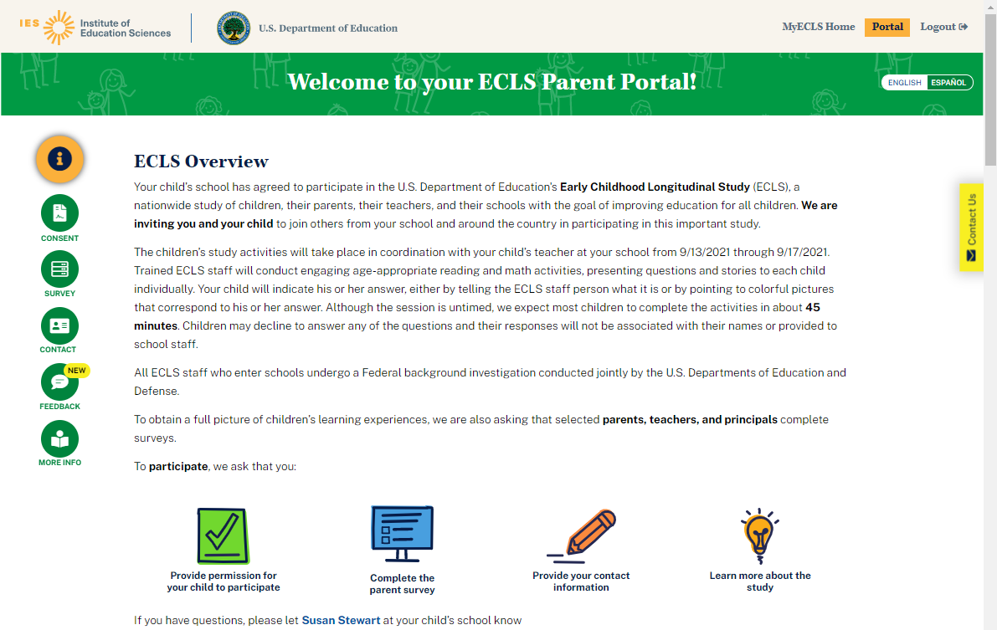

Welcome to your ECLS-K:2024 Parent Portal!
DISPLAY ENGLISH/SPANISH TOGGLE BUTTON.

Navigation icons:
Overview
Consent (fall kindergarten and spring kindergarten only)
Survey
Contact
More Info

Sections can be collapsed and expanded by clicking “Collapse” (Contraer) and “Expand” (Expandir).

ECLS-K:2024 Overview

[[DISPLAY FOR FALL KINDERGARTEN SCHOOLS AND SPRING KINDERGARTEN SCHOOLS FOR WHICH CHILDREN WERE NOT PREVIOUSLY SAMPLED: Your child’s school has agreed to participate in the U.S. Department of Education's Early Childhood Longitudinal Study, Kindergarten Class of 2023-24 (ECLS-K:2024), a nationwide study of children, their parents, their teachers, and their schools with the goal of improving education for all children. We are inviting you and your child to join others from your school and around the country in participating in this important study. ] / [DISPLAY FOR SPRING KINDERGARTEN SCHOOLS FOR WHICH CHILDREN WERE PREVIOUSLY SAMPLED AND SPRING FIRST GRADE: Your child’s school is participating in another round of study activities for the U.S. Department of Education's Early Childhood Longitudinal Study, Kindergarten Class of 2023-24 (ECLS-K:2024), a nationwide study of children, their parents, their teachers, and their schools with the goal of improving education for all children. We hope that you are your child will continue to participate in this important study.] / [DISPLAY FOR FALL FIRST GRADE: We are preparing for the spring study activities for the U.S. Department of Education's Early Childhood Longitudinal Study, Kindergarten Class of 2023-24 (ECLS-K:2024), a nationwide study of children, their parents, their teachers, and their schools with the goal of improving education for all children. Please take a few moments to update your contact information so that you and your child can continue to participate in this important study.]]

The children’s study activities will take place in coordination with your child’s teacher at your school [[from [ASSESSMENT DATE START] through [ASSESSMENT DATE END]] / [between March and June 2025]]. Trained ECLS-K:2024 staff will conduct engaging, age-appropriate reading, math, and memory activities, presenting questions and stories to each child individually. Your child will indicate answers orally to the ECLS-K:2024 staff person or by pointing to colorful pictures that correspond to the answers. Although the session is untimed, we expect most children to complete the activities in about 60 minutes. Children may decline to answer any of the questions and their responses will not be associated with their names or provided to school staff. [IN SCHOOLS FLAGGED FOR HEIGHT AND WEIGHT MEASUREMENTS, DISPLAY: To learn more about children’s physical development, in the spring rounds of the study, children will also have their height and weight measured.]

All ECLS-K:2024 staff who enter schools undergo a Federal background investigation conducted jointly by the U.S. Departments of Education and Defense.

To obtain a full picture of children’s learning experiences, we are also asking that selected parents, teachers, and principals complete surveys.

To participate, we ask that you: Display with icons:
- [DISPLAY FOR FALL KINDERGARTEN SCHOOLS AND SPRING KINDERGARTEN SCHOOLS FOR WHICH CHILDREN WERE NOT PREVIOUSLY SAMPLED: Provide permission for your child to participate]
- Complete the parent survey
- Provide your contact information

If you have questions [or have reconsidered your child’s participation], please let [SCHOOL COORDINATOR] at your child’s school know. When the user hovers over “school coordinator”, the SC phone number and email address recorded on the School Information Screen will display.
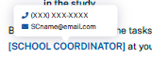
Spanish text:
¡Bienvenido(a) a su portal de padres y madres de ECLS-K:2024!

Descripción
Consentimiento
Encuesta
Contacto
Información

Descripción general de ECLS-K:2024

[[DISPLAY FOR FALL KINDERGARTEN SCHOOLS AND SPRING KINDERGARTEN SCHOOLS FOR WHICH CHILDREN WERE NOT PREVIOUSLY SAMPLED: La escuela de su niño(a) ha aceptado participar en el Estudio Longitudinal de la Primera Infancia, Clase de Kindergarten de 2023-24 (ECLS-K:2024), del Departamento de Educación de los Estados Unidos. Se trata de un estudio nacional sobre niños, sus padres y madres, sus maestros y sus escuelas con el propósito de mejorar la educación para todos los niños. Les estamos invitando a usted y a su niño(a) a unirse a otras personas de su escuela y de todo el país para participar en este importante estudio. ] / [DISPLAY FOR SPRING La escuela de su niño(a) está participando en una nueva ronda de actividades del Estudio Longitudinal de la Primera Infancia, Clase de Kindergarten de 2023-24 (ECLS-K:2024), del Departamento de Educación de los Estados Unidos. Se trata de un estudio nacional sobre niños, sus padres y madres, sus maestros y sus escuelas con el propósito de mejorar la educación para todos los niños. Esperamos que su niño(a) siga participando en este importante estudio.] / [DISPLAY FOR FALL FIRST GRADE: Estamos preparándonos para las actividades de primavera del Estudio Longitudinal de la Primera Infancia, Clase de Kindergarten de 2023-24 (ECLS-K:2024), del Departamento de Educación de los Estados Unidos. Se trata de un estudio nacional sobre niños, sus padres y madres, sus maestros y sus escuelas con el propósito de mejorar la educación para todos los niños. Por favor, dedique unos minutos a poner al día su información de contacto para que usted y su niño(a) puedan seguir participando en este importante estudio.]]

Las actividades del estudio para los niños se llevarán a cabo en coordinación con el maestro o la maestra de su niño(a) en su escuela [[desde el [ASSESSMENT DATE START] hasta el [ASSESSMENT DATE END]] / [entre marzo y junio de 2025]]. El personal entrenado de ECLS-K:2024 llevará a cabo actividades interesantes y apropiadas para la edad en lectura, matemáticas y memoria, presentando preguntas y cuentos a cada niño(a) individualmente. Su niño(a) indicará las respuestas de manera oral al personal de ECLS-K:2024 o señalando imágenes coloridas que correspondan a las respuestas. Aunque la sesión no tiene límite de tiempo, esperamos que la mayoría de los niños completen las actividades en unos 60 minutos. Los niños pueden negarse a responder cualquiera de las preguntas y sus respuestas no se asociarán con sus nombres ni tampoco se darán al personal de la escuela. [IN SCHOOLS FLAGGED FOR HEIGHT AND WEIGHT MEASUREMENTS, DISPLAY: Para saber más sobre el desarrollo físico de los niños, en las rondas de primavera del studio también se medirá la estatura y el peso de los niños.]

Todo el personal de ECLS-K:2024 que va a las escuelas debe pasar por una investigación federal de antecedentes penales, la cual es llevada a cabo de manera conjunta por el Departamento de Educación y el Departamento de Defensa de los EE.UU.

Para obtener una imagen completa de las experiencias de aprendizaje de los niños, también pedimos que los padres o madres, maestros(as) y directores seleccionados completen las encuestas.

Para participar, le pedimos que: Display with icons:
- [DISPLAY FOR FALL KINDERGARTEN SCHOOLS AND SPRING KINDERGARTEN SCHOOLS FOR WHICH CHILDREN WERE NOT PREVIOUSLY SAMPLED: Dé permiso para que su niño(a) participe
- Complete la encuesta para padres y madres
- Proporcione su información de contacto

Si tiene preguntas [o ha reconsiderado la participación de su niño(a)], por favor dígaselo a [SCHOOL COORDINATOR] de la escuela de su niño(a).

5.2 Consent Section

The consent section is available during fall kindergarten for all schools and in spring kindergarten for schools where children were not sampled in the fall round. The consent section will be expanded when the user first accesses the portal. It will collapse and be marked as complete once consent is provided. There are three screens for parents in schools with explicit consent and three screens for those with implicit consent. These consent screens may be revised for vision exams, if conducted, in spring 2025; if so, the revised screens will be provided in a future OMB revision request.

Explicit Consent screens 1-3:

SCREEN 1:
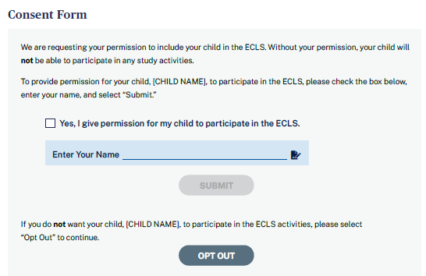

Consent Form
We are requesting your permission to include your child in the ECLS-K:2024. Without your permission, your child will not be able to participate in any study activities.
To provide permission for your child, [CHILD NAME], to participate in the ECLS-K:2024, please check the box below, enter your name, and select “Submit.”
[CHECK BOX] Yes, I give permission for my child to participate in the ECLS-K:2024.
Enter Your Name
SUBMIT [BUTTON]
If you do not want your child, [CHILD NAME], to participate in the ECLS-K:2024 activities, please select “Opt Out” to continue.
OPT OUT [BUTTON]
- When the user hovers over the checkbox, a tool tip appears: “Please check this box if you want to proceed.”
- If “submit” is selected, update child consent status to 2-obtained. The consent section will be marked as complete and the parent survey section will display.
- If “opt-out” is selected, go to screen 2.
Spanish text:
Formulario de Consentimiento
Solicitamos su permiso para incluir a su niño(a) en el ECLS-K:2024. Sin su permiso, su niño(a) no podrá participar en ninguna actividad del estudio.
Para dar permiso para que su niño(a) [CHILD NAME] participe en el ECLS-K:2024, por favor marque el cuadrito que está a continuación, ponga su nombre y seleccione “Enviar”.
[CHECK BOX] Sí, doy permiso para que mi niño(a) participe en el ECLS-K:2024.
Ponga su nombre
ENVIAR [BUTTON]
Si usted no desea que su niño(a) [CHILD NAME] participe en las actividades de ECLS-K:2024, por favor seleccione “No va a participar” para continuar.
NO VA A PARTICIPAR [BUTTON]
Tooltip text: “Por favor marque este cuadrito si quiere continuar.”
SCREEN 2:
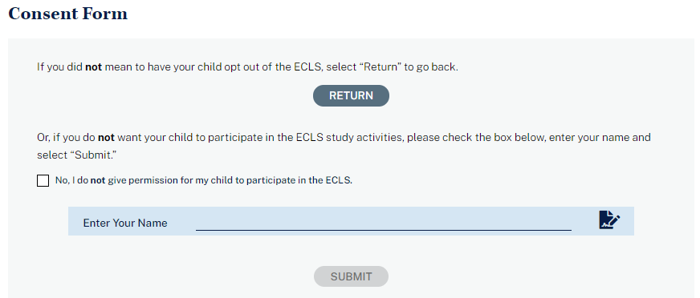

Consent Form

If you did not mean to have your child opt out of the ECLS-K:2024, select “Return” to go back.

RETURN [BUTTON]

Or, if you do not want your child to participate in the ECLS-K:2024 study activities, please check the box below, enter your name, and select “Submit.”

[CHECK BOX] No, I do not give permission for my child to participate in the ECLS-K:2024.

Enter Your Name

SUBMIT [BUTTON]
- If ‘’submit” is selected, update the child consent status to 3-refused and go to screen 3.
- If “return” is selected, return to screen 1.

Spanish text:
Formulario de Consentimiento

Si no deseaba dejar a su niño(a) fuera del estudio ECLS-K:2024, seleccione “Regresar” para volver.

REGRESAR [BUTTON]

O, si no desea que su niño(a) participe en las actividades del estudio ECLS-K:2024, por favor marque el cuadrito que está a continuación, ponga su nombre y seleccione “Enviar”.

[CHECK BOX] No, no doy mi permiso para que mi niño(a) participe en el ECLS-K:2024.

Ponga su nombre

ENVIAR [BUTTON]
SCREEN 3:
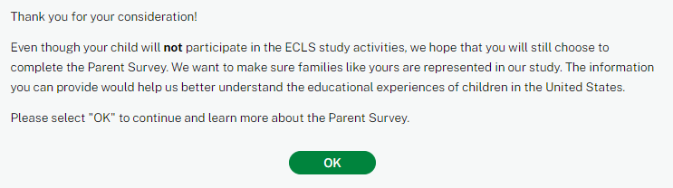

Consent Form
Thank you for your consideration!
Even though your child will not participate in the ECLS-K:2024 study activities, we hope that you will still choose to complete the Parent Survey. We want to make sure families like yours are represented in our study. The information you can provide would help us better understand the educational experiences of children in the United States.
Please select “OK” to continue and learn more about the Parent Survey.
OK [BUTTON]
- When the “OK” button is selected, the consent section will be marked as complete and the parent survey section will display.

Spanish text:

Formulario de Consentimiento
¡Gracias por considerarlo!
Aunque su niño(a) no participará en las actividades del estudio ECLS-K:2024, esperamos que usted decida completar la encuesta para padres y madres. Queremos asegurarnos de que las familias como la suya estén representadas en nuestro estudio. La información que usted puede proporcionar nos ayudaría a entender mejor las experiencias educativas de los niños en los Estados Unidos.
Por favor seleccione “OK” para continuar e informarse más sobre la encuesta para padres y madres.
OK [BUTTON]

Implicit Consent screens 4-6:

SCREEN 4
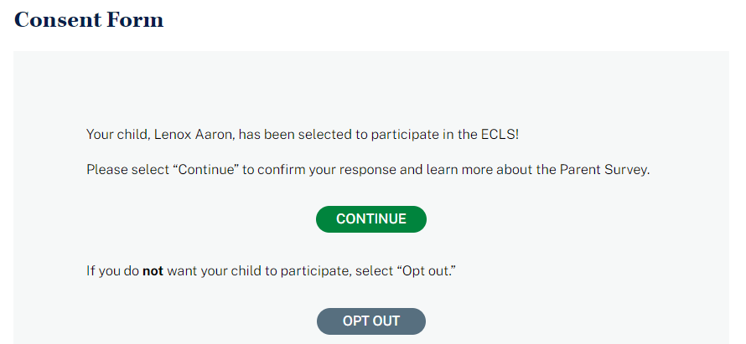

Consent Form
Your child, [CHILD NAME], has been selected to participate in the ECLS-K:2024!
Please select “Continue” to confirm participation and learn more about the Parent Survey.
CONTINUE [BUTTON]
If you do not want your child to participate, select “Opt out.”
OPT OUT [BUTTON]
- If the “continue” button is selected, the consent section will be collapsed and the parent survey section will display.
- If the “opt out” button is selected, go to screen 5.

Spanish text:
Formulario de Consentimiento
¡Su niño(a) [CHILD NAME] ha sido seleccionado(a) para participar en el estudio ECLS-K:2024!
Por favor seleccione “Continuar” para confirmar su participación e informarse más sobre la encuesta para padres y madres.
CONTINUAR [BUTTON]
Si usted no desea que su niño(a) participe, seleccione “No va a participar”.
NO VA A PARTICIPAR [BUTTON]

SCREEN 5
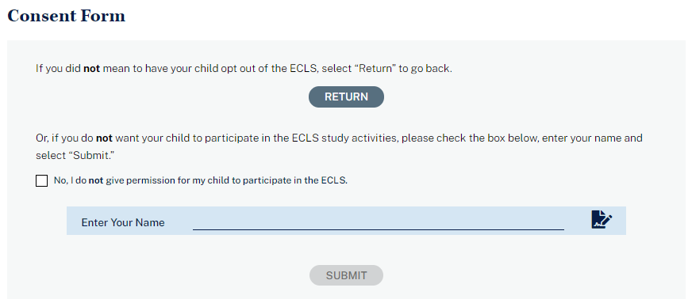

Consent Form

If you did not mean to have your child opt out of the ECLS-K:2024, select “Return” to go back.

RETURN BUTTON

Or, if you do not want your child to participate in the ECLS-K:2024 study activities, please check the box below, enter your name and select “Submit.”

[CHECK BOX] No, I do not give permission for my child to participate in the ECLS-K:2024.

Enter Your Name

SUBMIT [BUTTON]
- If ‘’submit” is selected, update the child consent status to 3-refused and go to screen 6.
- If “return” is selected, return to screen 4.

Spanish text:
Formulario de Consentimiento

Si no deseaba dejar a su niño(a) fuera de ECLS-K:2024, seleccione “Regresar” para volver.

REGRESAR [BUTTON]

O, si no desea que su niño(a) participe en las actividades del estudio ECLS-K:2024, por favor marque el cuadrito que está a continuación, ponga su nombre y seleccione “Enviar”.

[CHECK BOX] No, no doy mi permiso para que mi niño(a) participe en el ECLS-K:2024.

Ponga su nombre

ENVIAR [BUTTON]

SCREEN 6
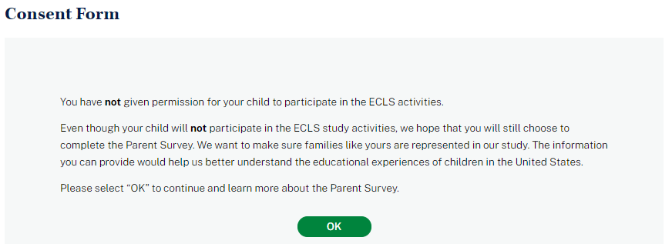

Consent Form
You have not given permission for your child to participate in the ECLS-K:2024 activities.
Even though your child will not participate in the ECLS-K:2024 study activities, we hope that you will still choose to complete the Parent Survey. We want to make sure families like yours are represented in our study. The information you can provide would help us better understand the educational experiences of children in the United States.
Please select “OK” to continue and learn more about the Parent Survey.
OK [BUTTON]
- When the “OK” button is selected, the consent section will be marked as complete (see screenshot below, with a check mark image and the text “Consent Given” or “Consent Not Provided”) and the parent survey section will display.

Spanish text:

Formulario de Consentimiento
Usted no ha dado permiso para que su niño(a) participe en las actividades del ECLS-K:2024.
Aunque su niño(a) no participará en las actividades del estudio ECLS-K:2024, esperamos que usted decida completar la encuesta para padres y madres. Queremos asegurarnos de que las familias como la suya estén representadas en nuestro estudio. La información que usted puede proporcionar nos ayudaría a entender mejor las experiencias educativas de los niños en los Estados Unidos.
Por favor seleccione “OK” para continuar e informarse más sobre la encuesta para padres y madres.
OK [BUTTON]
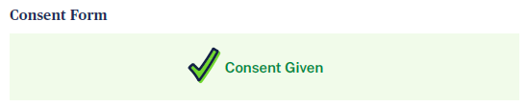

Consent Form
Consent Given

If you want to change your child’s consent status, contact the ECLS-K:2024 team at 1-855-898-2018 or ECLS@westat.com.

Spanish text:
Formulario de Consentimiento
Consentimiento otorgado

Si desea cambiar su respuesta al pedido de consentimiento para su niño(a), contacte al personal de ECLS-K:2024 en el teléfono 1-855-898-2018 o en ECLS@westat.com.

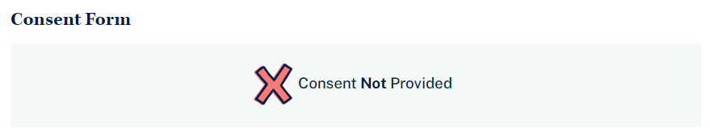
Consent Form
Consent Not Provided

If you want to change your child’s consent status, contact the ECLS-K:2024 team at 1-855-898-2018 or ECLS@westat.com.

Spanish text:
Formulario de Consentimiento
No se ha dado consentimiento

Si desea cambiar su respuesta al pedido de consentimiento para su niño(a), contacte al personal de ECLS-K:2024 en el teléfono 1-855-898-2018 o en ECLS@westat.com.

5.3 Parent Survey Section
The survey section appears during fall kindergarten, spring kindergarten, and spring first-grade. Participants select the blue arrow to launch the survey. When the survey is complete, a green check mark displays and the survey can no longer be opened.
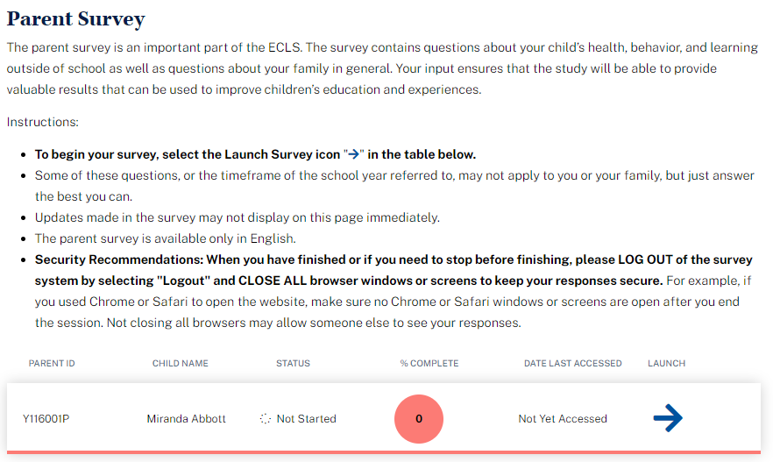
Parent Survey
The parent survey is an important part of the ECLS-K:2024. The survey contains questions about your child’s health, behavior, and learning outside of school as well as questions about your family in general. Your input ensures that the study will be able to provide valuable results that can be used to improve children’s education and experiences.

Instructions:
- To begin your survey, select the Launch Survey icon [DISPLAY ICON] in the table below.
- Updates made in the survey may not display on this page immediately.
- Security Recommendations: When you have finished or if you need to stop before finishing, please LOG OUT of the survey system by selecting "Logout" and CLOSE ALL browser windows or screens to keep your responses secure. For example, if you used Chrome or Safari to open the website, make sure no Chrome or Safari windows or screens are open after you end the session. Not closing all browsers may allow someone else to see your responses.

[IF THE PARENT SURVEY HAS BEEN ASSIGNED TO FIELD STAFF TO CONDUCT WITH THE PARENT OVER THE PHONE OR IN-PERSON, DISPLAY: Your survey is no longer available. An ECLS-K:2024 staff member will contact you shortly.]

Parent ID | Child Name | Status | % Complete | Date Last Accessed | Launch
9999001P | Child Name | In-progress | 75 | 9/15/23 | Launch Survey

Spanish text:
Encuesta para padres y madres
La encuesta para padres y madres es una parte importante del ECLS. La encuesta contiene preguntas acerca de la salud, el comportamiento y el aprendizaje de su niño(a) fuera de la escuela, así como preguntas generales acerca de su familia. Su participación garantiza que el estudio proporcionará resultados valiosos que podrán usarse para mejorar la educación y las experiencias de los niños.

Instrucciones:
- Para comenzar su encuesta, seleccione el ícono de iniciar la encuesta [DISPLAY ICON] en la siguiente tabla.
- Las actualizaciones hechas en la encuesta tal vez no aparezcan inmediatamente en esta página.
- Recomendaciones de seguridad: Cuando haya terminado, o si necesita hacer otra cosa antes de terminar, por favor CIERRE LA SESIÓN del sistema de la encuesta, haciendo clic en "Cerrar sesión" y CIERRE TODAS las ventanas o pantallas del navegador para mantener sus respuestas seguras. Por ejemplo, si usted usó Chrome o Safari para abrir la página de Internet, asegúrese de que no hay ventanas o pantallas abiertas en Chrome o Safari después de terminar la sesión. No cerrar todos los navegadores puede permitir que otra persona vea sus respuestas.

[IF THE PARENT SURVEY HAS BEEN ASSIGNED TO FIELD STAFF TO CONDUCT WITH THE PARENT OVER THE PHONE OR IN-PERSON, DISPLAY: Su encuesta ya no está disponible. Un miembro del personal de ECLS-K:2024 se pondrá en contacto con usted en breve.]

N° de ID del padre o madre | Nombre del niño(a) | Estado | % Completo | Última vez que ingresó a la encuesta | Iniciar
9999001P | Nombre del niño(a) | En progreso | 75 | 9/15/21 | Iniciar la encuesta

Survey statuses:
Not started = No Ha Comenzado
In-Progress = En progreso
Complete = Completado

5.4 Contact Information Screen
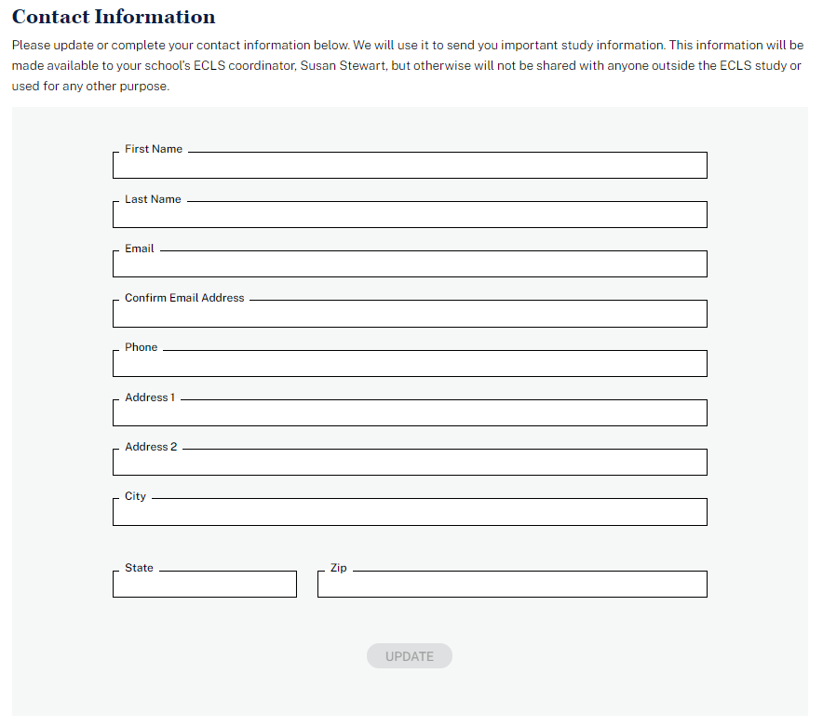
Contact Information
Please update or complete your contact information below. We will use it to send you important study information. This information will be made available to your school’s ECLS-K:2024 coordinator, [SC NAME], but otherwise will not be shared with anyone outside the ECLS-K:2024 study or used for any other purpose.

First Name
Last Name
Email Address
Confirm Email Address
Phone Number 1
Phone Number 1 Type (home landline, cell phone, work, other)
Phone Number 2
Phone Number 2 Type (home landline, cell phone, work, other)

Address 1
Address 2
City
State
ZIP
Confirm/Update button

Spanish text:

Información de Contacto
A continuación, por favor actualice o complete su información de contacto. La usaremos para enviarle información importante del estudio. Esta información estará disponible para el/la coordinador(a) de ECLS -K:2024 de su escuela, [SC NAME], pero fuera de eso no se compartirá con nadie fuera del estudio ECLS-K:2024 ni se usará para ningún otro propósito.

Primer nombre
Apellido(s)
Correo electrónico
Confirmar correo electrónico
Número de teléfono 1
Tipo de teléfono 1 (línea de la casa, teléfono celular, de trabajo, otro tipo)
Número de teléfono 2
Tipo de teléfono 2 (línea de la casa, teléfono celular, de trabajo, otro tipo)
Dirección 1
Dirección 2
Ciudad
Estado
CÓDIGO POSTAL
Confirmar/Actualizar button

The following error messages may display beneath the entry fields:
- Please enter a valid US zip code (use a hyphen if 9 digits).
  - Spanish text: Por favor ponga un código postal de Estados Unidos válido (use el guión si pone 9 dígitos).
- Please enter a valid email address.
  - Spanish text: Por favor ponga una dirección de correo electrónico válida.
- The email address you entered does not match.
  - Spanish text: La dirección de email que puso no concuerda.
- Please specify a valid state
  - Spanish text: Por favor especifique un estado válido.
- Please enter a valid phone number.
  - Spanish text: Por favor ponga un número de teléfono válido.

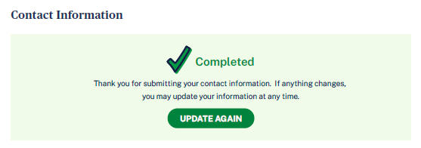
Contact Information
WHEN UPDATE BUTTON IS SELECTED, DISPLAY: Thank you for submitting your contact information. If anything changes, you may update your information at any time.
UPDATE AGAIN BUTTON

Spanish text:
Información de Contacto
WHEN UPDATE BUTTON IS SELECTED, DISPLAY: Gracias por enviar su información de contacto. Si algo cambia, usted puede actualizarlo en cualquier momento.
ACTUALIZAR NUEVAMENTE BUTTON

5.5 More Information Section

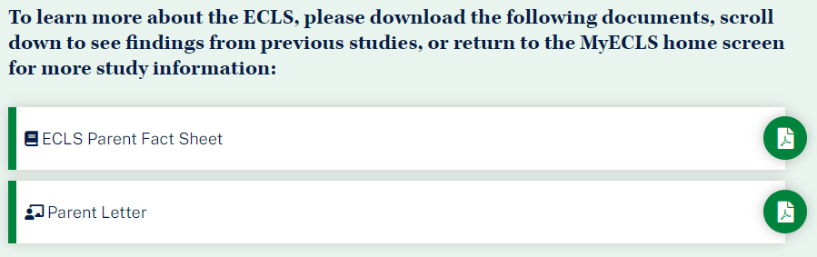
To learn more about the ECLS-K:2024, please download the following documents, scroll down to see findings from previous studies, or return to the MyECLS home screen for more study information:
- ECLS-K:2024 Parent Fact Sheet [LINK TO PARENT FACT SHEET]
- Parent Letter [LINK TO LETTER]

Para conocer más sobre el ECLS-K:2024, por favor descargue los siguientes documentos, avance para ver resultados de estudios anteriores o regrese a la página principal de MyECLS, para más información sobre el estudio:
- Hoja de información de ECLS-K:2024 para padres y madres [LINK TO PARENT FACT SHEET]
- Carta para los padres y madres [LINK TO LETTER]

Display “Common Activities for Families” infographic.
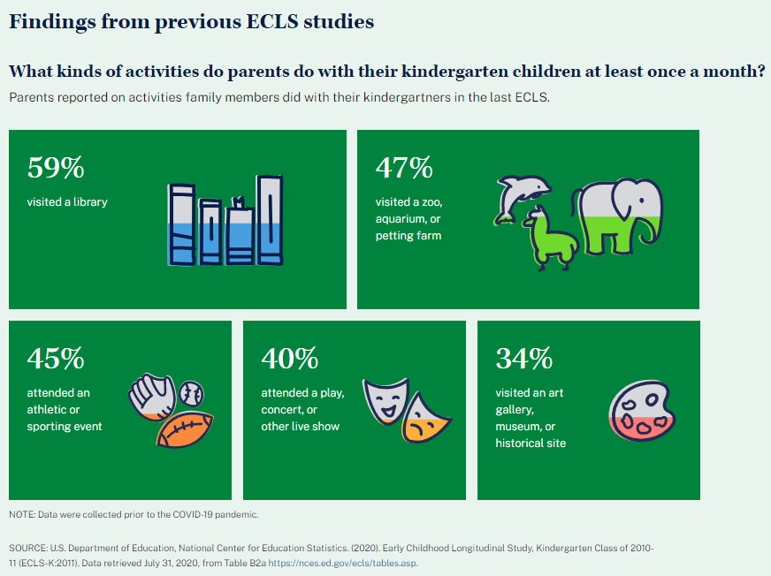
Findings from previous ECLS studies
What kinds of activities do parents do with their kindergarten children at least once a month?
Parents reported on activities family members did with their kindergartners in the last ECLS.
- 59% visited a library
- 47% visited a zoo, aquarium, or petting farm
- 45% attended an athletic or sporting event
- 40% attended a play, concert, or other live show
- 34% visited an art gallery, museum, or historical site

NOTE: Data were collected prior to the COVID-19 pandemic.
SOURCE: U.S. Department of Education, National Center for Education Statistics. (2020). Early Childhood Longitudinal Study, Kindergarten Class of 2010-11 (ECLS-K:2011). Data retrieved July 31, 2020, from Table B2a, https://nces.ed.gov/ecls/tables.asp.

Spanish text:
Resultados de estudios ECLS anteriores
¿Qué tipos de actividades realizan los padres y madres con sus niños de kindergarten, al menos una vez al mes?
Los padres o madres reportaron sobre las actividades que los miembros de la familia hicieron con sus niños de kindergarten en el último ECLS.
- 59% visitó una biblioteca
- 47% visitó un zoológico, un acuario o una granja de animales domésticos para niños
- 45% asistió a un evento atlético o deportivo
- 40% asistió a una obra de teatro, un concierto u otro show en vivo
- 34% visitó una galería de arte, un museo o un lugar histórico

NOTA: Los datos fueron recopilados antes de la pandemia de COVID-19.
FUENTE: Departamento de Educación de los EE.UU., Centro Nacional para Estadísticas de Educación. (2020). Estudio Longitudinal de la Primera Infancia, Clase de Kindergarten 2010-11 (ECLS-K:2011). Datos extraídos el 31 de julio de 2020, de la tabla B2a, https://nces.ed.gov/ecls/tables.asp.

Display “Barriers to Participation” infographic.
Parent Involvement in Schools
One way that results from the ECLS can be used is to help educators understand how, on average, children’s families engage in their child’s learning and school activities – such as parent-teacher conferences, back-to-school nights, PTA meetings, or science fairs. We learned the following from the parents of the ECLS students when they were in their second-grade year.
- 48% of the second-graders had parents who reported they could not get time off from work as a barrier to parent involvement in school activities
- 17% of the second-graders had parents who reported they did not have child care as a barrier to parent involvement in school activities
- 33% of the second-graders had parents who reported inconvenient meeting times as a barrier to parent involvement in school activities.
NOTE: Data were collected prior to the COVID-19 pandemic.
SOURCE: Redford, J., Huo, H., and McQuiggan, M. (2019). Barriers to Parent-School Involvement for Early Elementary Students (NCES 2017-165). U.S. Department of Education. Washington, DC: National Center for Education Statistics. Retrieved July 31, 2020, from https://nces.ed.gov/pubsearch/pubsinfo.asp?pubid=2017165.

Spanish text:

Participación de los padres y madres en las escuelas
Una forma en que los resultados del ECLS pueden usarse es ayudando a los educadores a entender de qué manera, en promedio, las familias de los niños participan en las actividades del aprendizaje y las actividades escolares de sus niños, tales como conferencias de padres y maestros, noches de regreso a la escuela, reuniones de la Asociación de padres/madres y maestros (PTA por sus siglas en inglés) o ferias de ciencias. Aprendimos lo siguiente de los padres y madres de estudiantes del ECLS cuando estaban en su segundo grado escolar.
- 48% de los estudiantes de segundo grado tenían padres o madres que reportaron que no tener permiso para ausentarse de sus trabajos era una barrera para su participación en las actividades escolares
- 17% de los estudiantes de segundo grado tenían padres o madres que reportaron que no tener cuidado de niños era una barrera para su participación en las actividades escolares
- 33% de los estudiantes de segundo grado tenían padres o madres que reportaron que organizar las reuniones en horarios inconvenientes era una barrera para su participación en las actividades escolares
NOTA: Los datos fueron recopilados antes de la pandemia de COVID-19.
FUENTE: Redford, J., Huo, H., and McQuiggan, M. (2019). Barriers to Parent-School Involvement for Early Elementary Students (NCES 2017-165). Departamento de Educación de los EE.UU. Washington, DC: Centro Nacional para Estadísticas de Educación. Datos extraídos el 31 de julio de 2020, de https://nces.ed.gov/pubsearch/pubsinfo.asp?pubid=2017165.
For the first grade rounds, replace “Common Activities for Families” infographic with “School Programs and Services Available to Parents and Families.”

Display the “School Programs and Services Available to Parents and Families” infographic.

School Programs and Services Available to Parents and Families
In the last two ECLS studies, the U.S. Department of Education asked school principals what types of programs and services to support parents and families were available at their schools.
- 9% A higher percentage of schools offered family literacy programs in 2010-11 than in 1998-99.
- 5% A higher percentage of schools offered health or social services in 2010-11 than in 1998-99.
- 7% A higher percentage of schools offered new family orientations in 2010-11 than in 1998-99.
- 16% A lower percentage of schools offered parenting education programs in 2010-11 than in 1998-99.
NOTE: Differences between years are calculated using unrounded estimates and may, therefore, differ from differences using rounded estimates. Health or social services are services offered collaboratively by service agencies such as hospitals. Parenting education programs may include classes on child development, education in being a parent, and understanding children's special needs.

NOTE: Data were collected prior to the COVID-19 pandemic.
SOURCE: U.S. Department of Education, National Center for Education Statistics, Early Childhood Longitudinal Study, Kindergarten Class of 1998–99 (ECLS-K), Kindergarten–Eighth Grade Public-Use Data File, and Early Childhood Longitudinal Study, Kindergarten Class of 2010–11 (ECLS-K:2011), Kindergarten–Fifth Grade Public-Use Data File. Data retrieved May 31, 2022, from Table A3a, https://nces.ed.gov/ecls/tables.asp.

Spanish Text

Programas y servicios escolares disponibles para padres/madres y familias

En los últimos dos estudios de ECLS, el Departamento de Educación de los EE.UU. preguntó a los directores de los centros escolares de qué tupos de programas y servicios de apoyo a padres y familias disponían en sus escuelas.

    - 9% Un porcentaje mayor de escuelas ofrecían programas de alfabetización familiar en 2010-11 que en 1998-99.
    - 5% Un porcentaje mayor de escuelas ofrecía servicios de salud o servicios sociales en 2010-11 que en 1998-99.
    - 7% Un porcentaje mayor de escuelas ofrecieron orientación para familias nuevas en 2010-11 que en 1998-99.
    - 16% Un porcentaje menor de escuelas ofrecieron programas de educación para padres en 2010-11 que en 1998-99.

NOTA: Las diferencias entre los años se calcularon utilizando estimaciones sin redondear y, por lo tanto, pueden ser distintas a las diferencias que se calculan utilizando estimaciones redondeadas. Los servicios de salud o sociales son servicios ofrecidos de manera colaborativa por agencias que prestan servicios, tales como los hospitales. Los programas de educación para padres o madres pueden incluir clases sobre desarrollo infantil, educación para criar hijos y comprensión de las necesidades especiales de los niños.

NOTA: Los datos fueron recopilados antes de la pandemia de COVID-19.

FUENTE: Departamento de Educación de los EE.UU., Centro Nacional para Estadísticas de Educación, Estudio Longitudinal de la Primera Infancia, Clase de Kindergarten de 1998-99 (ECLS-K), Archivo de datos de uso público de Kindergarten- Octavo grado, y Estudio Longitudinal de la Primera Infancia, Clase de Kindergarten de 2010-11 (ECLS-K:2011), Archivo de datos de uso público de Kindergarten-quinto grado. Datos extraídos el 31 de mayo de 2022, de la Tabla A3a, https://nces.ed.gov/ecls/tables.asp.

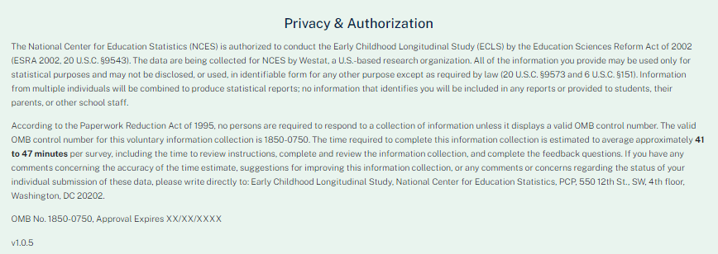

This language appears at the bottom of the Parent Portal page, directly on the screen.

Privacy and Authorization
The National Center for Education Statistics (NCES) is authorized to conduct the Early Childhood Longitudinal Study (ECLS) by the Education Sciences Reform Act of 2002 (ESRA 2002, 20 U.S.C. §9543). The data are being collected for NCES by Westat, a U.S.-based research organization. All of the information you provide may be used only for statistical purposes and may not be disclosed, or used, in identifiable form for any other purpose except as required by law (20 U.S.C. §9573 and 6 U.S.C. §151). Information from multiple individuals will be combined to produce statistical reports; no information that identifies you will be included in any reports or provided to students, their parents, or other school staff. By law, every NCES employee as well as every NCES agent, such as contractors, has taken an oath and is subject to a jail term of up to 5 years, a fine of $250,000, or both if he or she willfully discloses ANY identifiable information about respondents. Electronic submission of each student’s information will be monitored for viruses, malware, and other threats by Federal employees and contractors in accordance with the Cybersecurity Enhancement Act of 2015.

According to the Paperwork Reduction Act of 1995, no persons are required to respond to a collection of information unless it displays a valid OMB control number. The valid OMB control number for this voluntary information collection is 1850-0750. The time required to complete this information collection is estimated to average approximately 41 to 47 minutes per survey, including the time to review instructions and to complete and review the information collection. If you have any comments concerning the accuracy of the time estimate, suggestions for improving this information collection, or any comments or concerns regarding the status of your individual submission of these data, please write directly to: Early Childhood Longitudinal Study, National Center for Education Statistics, PCP, 550 12th St., SW, 4th floor, Washington, DC 20202.
OMB No. 1850-0750, Approval Expires XX/XX/XXXX

Spanish text:
Privacidad y Autorización
El Centro Nacional para Estadísticas de Educación (NCES) está autorizado a hacer el Estudio Longitudinal de la Primera Infancia (ECLS por sus siglas en inglés) por el Acta de Reforma de las Ciencias de la Educación de 2002 (ESRA 2002, 20 U.S.C. §9543). La firma Westat, una organización que realiza estudios y está basada en los Estados Unidos, está recopilando los datos para NCES. Toda la información que usted proporcione podrá usarse solamente para propósitos estadísticos y no podrá divulgarse ni usarse de manera que permita identificar a los participantes para ningún otro propósito, salvo que lo requiera la ley (20 U.S.C. §9573 y 6 U.S.C. §151). La información recopilada de múltiples participantes se combinará para producir reportes estadísticos; ninguna información que pudiera identificarlo(a) será incluida en ningún reporte ni será proporcionada a los estudiantes, a sus padres o a otro personal de la escuela. Por ley, cada empleado de NCES, al igual que cada agente de NCES -- por ejemplo, los contratistas -- ha prestado un juramento y puede recibir una pena de cárcel de hasta 5 años, una multa de 250.000 dólares o ambas cosas, si revela deliberadamente CUALQUIER información que permita identificar a los participantes. En cumplimiento con la Ley de Mejora de la Ciberseguridad de 2015, habrá empleados y contratistas federales monitoreando el envío electrónico de la información de cada estudiante para detectar virus, malware y otras amenazas.

Según lo establece el Acta de Reducción del Papeleo de 1995, ninguna persona está obligada a responder a un pedido de información si la misma no contiene un número de control de OMB válido. El número de control de OMB válido para recolectar esta información que se proporciona voluntariamente es 1850-0750. Se estima que el tiempo necesario para completar esta recolección de información es de aproximadamente 41 a 47 minutos por encuesta, incluido el tiempo para revisar las instrucciones, y para completar y revisar la recopilación de información. Si usted tiene algún comentario con respecto a la precisión del cálculo de tiempo, sugerencias para mejorar esta recolección de información, o cualquier comentario o inquietud acerca del estatus del envío de sus datos individuales, por favor escriba directamente a: Early Childhood Longitudinal Study, National Center for Education Statistics, PCP, 550 12th St., SW, 4th floor, Washington, DC 20202.
Número OMB. 1850-0750, La aprobación vence el XX/XX/XXXX

The MyECLS website will be live during the fall 2024 advance school contact round, during which time field data collectors contact participating schools to confirm school and child information from the spring kindergarten round, to collect new school information for children who are no longer enrolled in the school, to recruit new transfer schools to participate, and to arrange logistics and schedule the dates for the spring first-grade school visit.

