Thy United States Environmental Protection Agency | Office of Pollution Prevention and Toxics  Washington, DC 20460 | 740-B-22-004  October 2022

TOXICS RELEASE INVENTORY
Parent Company Definition for TRI Reporting

Section 313 of the Emergency Planning and Community Right-to-Know Act of 1986 (EPCRA) requires certain facilities manufacturing, processing, or otherwise using listed toxic chemicals to report the annual quantity of such chemicals entering each environmental medium. Such facilities must also report pollution prevention and recycling data for such chemicals, pursuant to section 6607 of the Pollution Prevention Act, 42 U.S.C. 13106. EPCRA section 313 is also known as the Toxics Release Inventory (TRI).

CONTENTS
Section 1.0 Introduction 1
Section 1.1 Background on Rule 1
Section 1.2 Purpose of Supporting Document 2
Section 2.0 Rule: Parent Company Definition (CFR Text) 3
Section 3.0 Reporting Examples 5
Section 3.1 Ownership by a Single, Standalone Entity 5
Section 3.2 Ownership by a Single, Subsidiary Entity 7
Section 3.3 Direct Ownership by Multiple Entities 8
Section 4.0 References 12

LIST OF TABLES

Table 3–1: Summary of Ownership Scenarios 5

LIST OF EXAMPLES
Example 1: Single Company Owning Single Facility 6
Example 2: Single Company Owning Multiple Facilities 6
Example 3: Ownership by a Single Foreign Company 6
Example 4: Ownership by a Federal Government Agency or Department 7
Example 5: Ownership by a State, Local, or Tribal Agency 7
Example 6: Ownership by U.S. Division of U.S. Corporation 7
Example 7: Ownership by U.S. Subsidiary of Foreign Corporation 8
Example 8: Multi-company Ownership by U.S. Companies 8
Example 9: Multi-company Ownership Including Foreign Entities 9
Example 10: Multi-company Ownership Including Foreign Entities 9
Example 11: Multi-company Ownership Including Foreign Entities 10
Example 12: U.S. 50-50 Joint Venture Ownership 10
Example 13: Foreign 50-50 Joint Venture Ownership 10
Example 14: U.S.-Foreign 50-50 Joint Venture Ownership, U.S. Legal Entity 11
Example 15: U.S.-Foreign 50-50 Joint Venture Ownership, Foreign Legal Entity 11

DISCLAIMER
This guidance document is intended to assist industry with parent company definitions for EPCRA section 313 reporting. These recommendations do not supersede any statutory or regulatory requirements, are subject to change, and are not independently binding on either EPA or covered facilities. Additionally, if a conflict exists between guidance on this site and the statutory or regulatory requirements, the conflict must be resolved in favor of the statute or regulation.
Although EPA encourages industry to consider these recommendations, in reviewing this document, industry should be aware that these recommendations were developed to address common circumstances at typical facilities. The circumstances at a specific facility may significantly differ from those contemplated in the development of this document. Thus, individual facilities may find that the recommendations provided in this document are inapplicable to their processes or circumstances, and that alternative approaches or information are more accurate and/or more appropriate for meeting the statutory and regulatory requirements of EPCRA section 313. To that end, industry should use facility specific information and process knowledge, where available, to meet the requirements of EPCRA section 313. EPCRA section 313 also provides that, in the absence of such readily available data, a reporting facility may make reasonable estimates to meet those EPCRA section 313 requirements. Facilities are encouraged to contact the Agency with any additional or clarifying questions about the recommendations in this document, or if the facility believes that EPA has incorrectly characterized a particular process or recommendation.
Additional guidance documents, including industry specific and chemical specific guidance documents, are also available on TRI’s GuideME website: https://ofmpub.epa.gov/apex/guideme_ext/f?p=guideme:gd-list
The contents of the guidance document do not have the force and effect of law and that the Agency does not bind the public in any way and intends only to provide clarity to the public regarding existing requirements under the law or Agency policies, except as authorized by law or as incorporated into a contract.

Introduction

Background on Rule
On September 28, 2021, EPA proposed to codify a definition of parent company and further clarify reporting requirements of facility parent company information to the Toxics Release Inventory (TRI). For years, TRI has required facilities to report their highest-level United States-based parent company information annually in Part I, Section 5, of the annual reporting forms. However, no regulatory definition existed in 40 CFR part 372 related to this important data field. Facilities relied on the following guidance in the TRI Reporting Forms and Instructions (U.S. EPA, 2021) when determining the appropriate parent company to report:
“Your parent company is the highest-level company, located in the United States, and that directly owns at least 50 percent of the voting stock of [the facility’s] company…. [A] facility that is a 50:50 joint venture is its own parent company. When a facility is owned by more than one company and none of the facility owners directly owns at least 50 percent of its voting stock, the facility should provide the name of the parent company of either the facility operator or the owner with the largest ownership interest in the facility.”
Each year, EPA standardizes parent company names submitted to TRI. This process involved aligning submissions to a set of business rules (e.g., “Corporation” is changed to “Corp”) to provide consistency in the TRI database. EPA also researches submitted company names to ensure proper reporting by using online sources and other public datasets. For several reporting years, EPA has needed to change at least 15 percent of the forms received to standardize parent company names. After identifying suggested changes to the submitted parent company name, EPA must contact these facilities to confirm the parent company name is appropriate.
Through the parent company name standardization and subsequent correspondence with facilities, EPA identified several causes for misreporting of parent company information to TRI including:
- Facilities with several levels of ownership misinterpret the use of the word “directly” in the parent company reporting guidance to mean the company that directly owns the facility, which may be the subsidiary of a higher-level company based in the United States.
- Facilities whose highest-level parent company is based outside of the United States report a foreign company as the highest-level company, often while not knowing the highest-level U.S.-based parent company.
- Facilities incorrectly report that no parent company exists.
In addition, there are several company ownership scenarios where prior guidance did not explicitly address how to report the parent company:
- Facilities with multiple owners and no owner with at least 50 percent of voting stock.
- Companies that own multiple facilities but have no higher-level parent company.
- Facilities that are publicly-owned (e.g., federal facilities, municipal power plants).
Therefore, EPA codified a clear definition of this reporting requirement under 40 CFR Part 372 to provide greater regulatory certainty to facilities under a variety of ownership structures and to add a foreign parent company data element for facilities to report if applicable.

Purpose of Supporting Document
The purpose of this document is to assist facilities in understanding the reporting requirements for facility parent company information. The objectives of this document are to:
- Provide explanation and assistance on EPCRA section 313 reporting requirements for parent company information
- Promote consistency in the reporting of parent company information
- Reduce the level of effort expended by facilities that prepare TRI reports
Below, this document provides the definition of parent company (Section 2.0) and several examples of how to report parent company information under various ownership scenarios (Section 3.0).

Rule: Parent Company Definition (CFR Text)
This section provides the definition of parent company for TRI. For the full regulatory text of the rule, please see the final rule in Docket EPA-HQ-OPPT-2018-0155.
Regulatory Text, 40 CFR Part 372:
§ 372.3 Definitions.
* * * * *
Parent company means the highest-level company (or companies) of the facility’s ownership hierarchy as of December 31 of the year for which data are being reported according to the following instructions. The U.S. parent company is located within the United States while the foreign parent company is located outside the United States:
(1) If the facility is entirely owned by a single U.S. company that is not owned by another company, that single company is the U.S. parent company.
(2) If the facility is entirely owned by a single U.S. company that is, itself, owned by another U.S.-based company (e.g., it is a division or subsidiary of a higher-level company), the highest-level company in the ownership hierarchy is the U.S. parent company. If there is a higher-level parent company that is outside of the United States, the highest-level foreign company in the ownership hierarchy is the foreign parent company.
(3) If the facility is owned by more than one company (e.g., company A owns 40 percent, company B owns 35 percent, and company C owns 25 percent), the highest-level U.S. company with the largest ownership interest in the facility is the U.S. parent company. If there is a higher-level foreign company in the ownership hierarchy, that company is the foreign parent company.
(4) If the facility is owned by a 50:50 joint venture or a cooperative, the joint venture or cooperative is its own parent company.
(5) If the facility is entirely owned by a foreign company (i.e., without a U.S.-based subsidiary within the facility’s ownership hierarchy), the highest-level foreign parent company is the facility’s foreign parent company.
(6) If the facility is federally owned, the highest-level federal agency or department operating the facility is the U.S. parent company.
(7) If the facility is owned by a non-federal public entity (e.g., a State, municipal, or tribal government), that entity is the U.S. parent company.
* * * * *
§ 372.85 Toxic chemical release reporting form and instructions.
* * * * *
(b) Form elements. Information elements reportable on EPA Form R and Form R Schedule 1 include the following:
* * * * *
(8) Name of the facility's parent company, including:
(i) Legal name of the facility’s highest-level U.S.-based parent company and its Dun and Bradstreet identification number, when applicable.
(ii) Beginning with the reporting year ending December 31, 2023, for which reporting forms are due July 1, 2024, and for each subsequent reporting year, the legal name of the facility’s highest-level foreign parent company and its Dun and Bradstreet identification number, when applicable.
(iii) The facility must report using the standardized conventions for the naming of a parent company as provided in the toxic chemical release inventory reporting instructions identified in paragraph (a) of this section.
* * * * *
§ 372.95 Alternate threshold certification and instructions.
* * * * *
(b) Alternate threshold certification statement elements. The following information must be reported on an alternate threshold certification statement pursuant to §372.27(b):
* * * * *
(12) Name of the facility’s parent company, including:
(i) Legal name of the facility’s highest-level U.S.-based parent company and its Dun and Bradstreet identification number, when applicable.
(ii) Beginning with the reporting year ending December 31, 2023, for which reporting forms are due July 1, 2024, and for each subsequent reporting year, the legal name of the facility’s highest-level foreign parent company and its Dun and Bradstreet identification number, when applicable.
(iii) The facility must report using the standardized conventions for the naming of a parent company as provided in the toxic chemical release inventory reporting instructions identified in paragraph (a) of this section.

Reporting Examples
In order to demonstrate how facilities are required to report parent companies to TRI, several example ownership scenarios are described below and accompanied by a description of the appropriate reporting of U.S. parent company and foreign parent company for each scenario. These examples are not intended to be a comprehensive description of all possible ownership scenarios, but rather provide some assistance to help facilities in their determination of the appropriate parent company(ies) to report.
Table 3–1: Summary of Ownership Scenarios
Ownership Scenario | U.S. Parent | Foreign Parent | Corresponding Sub-part in Parent Company Definition  (in 40 CFR 372.3) | Relevant Example(s)
U.S. Parent Whole Ownership | X |  | 1, 2 | 1, 2, 6
Foreign Parent, No U.S. Ownership |  | X | 5 | 3, 13
U.S. Federal Ownership | F |  | 6 | 4
U.S. State/Local/Tribe Owned | SLT |  | 7 | 5
U.S. Parent, Foreign Ultimate Ownership | X | X | 2 | 7
U.S. Parents, Split Ownership | XX |  | 3 | 8
U.S. and Foreign Parents, Split Ownership | XX | XX | 3 | 9, 10, 11
50/50 U.S. Parent Joint Venture | X |  | 4 | 12
50/50 Foreign Parent Joint Venture |  | X | 4 | 13
50/50 Foreign and U.S. Joint Venture | X | X | 4 | 14, 15
Note: X = single company/corporation; XX = multiple companies/corporations; F = federal government agency; SLT = other public legal entity (e.g., state, local, or tribe)

Examples are provided below for facility ownership by single standalone entities (‎Section 3.1); by single entities that are themselves owned by other entities (‎Section 3.2); and by multiple entities (‎Section 3.3). For each example, a scenario is described, the applicable sub-part in the parent company definition is indicated, and the reported data are provided for the following three reporting form data elements on the reporting form:
- Part I, Section 4.1: Facility or Establishment Name (Facility)
- Part I, Section 5.1: Name of U.S. Parent Company (U.S. Parent)
- Part I, Section 5.3: Name of Foreign Parent Company (Foreign Parent) (Beginning with Reporting Year 2023, for forms due by July 1, 2024)
In cases where there is no actual U.S. or foreign parent, the respondent will indicate not applicable (NA). In addition to the U.S. or foreign parent names, the facility must also report the corresponding Dun and Bradstreet number if applicable (not shown in the examples). Federally owned facilities, including government owned, contractor operated (GOCO) facilities, will also need to indicate their status through Part I, Section 4.2c (A Federal Facility) or Part I, Section 4.2d (GOCO).

Ownership by a Single, Standalone Entity
This section describes how to report parent company information for facilities that are owned by a single entity that is not owned by another entity. This includes scenarios in which the facility’s single owner is a U.S. company (Example 1 and Example 2), a foreign company (Example 3), the federal government (Example 4), or a state, local, or tribal entity (Example 5).
All facilities must report on ownership. Nearly all facilities will report a U.S. parent unless a facility has entirely foreign ownership (e.g., Example 3).

Example 1: Single Company Owning Single Facility
A facility is 100% owned directly by a U.S.-based company (Company X), which is not a subsidiary of any other entity.
Corresponding Subpart in Parent Company Definition: 1
Demonstration of appropriate reporting:
- Facility: Facility Name
- U.S. Parent: Company X
- Foreign Parent: NA

Example 2: Single Company Owning Multiple Facilities
Several facilities (Facility A, Facility B, and Facility C) are 100% owned directly by a large U.S.-based company (Company X), which is not a subsidiary of any other entity.
Corresponding Subpart in Parent Company Definition: 1
Demonstration of appropriate reporting:
- Facility: Facility A Name  - U.S. Parent: Company X  - Foreign Parent: NA | - Facility: Facility B Name  - U.S. Parent: Company X  - Foreign Parent: NA | - Facility: Facility C Name  - U.S. Parent: Company X  - Foreign Parent: NA

Example 3: Ownership by a Single Foreign Company
A facility is directly owned by a foreign company (Company X), without any of the foreign company’s U.S.-based subsidiaries within the ownership hierarchy of the facility. The foreign company is neither owned by nor a subsidiary of another entity.
Corresponding Subpart in Parent Company Definition: 5
Demonstration of appropriate reporting:
- Facility: Facility Name
- U.S. Parent: NA
- Foreign Parent: Company X
Example 4: Ownership by a Federal Government Agency or Department
A facility is owned by the federal government and directly operated by a federal government agency/department.
Corresponding Subpart in Parent Company Definition: 6
Also see the Federal Facility Reporting Information guidance document. Per this guidance, federal facilities should report their facility name as the federal agency or department acronym and the facility name, prefaced by “US”. Federal facilities should report their parent company name by reporting their complete Department or Agency name, prefaced by “US”. The facility would also indicate “Federal Facility” in Part I, Section 4.2.
Demonstration of appropriate reporting:
- Facility: US Federal Agency/Department Acronym Facility Name
- U.S. Parent: US Agency or Department Name
- Foreign Parent: NA
- Part I, Section 4.2c: A Federal Facility

Note that the parent company standardization (see 5.1 Name of Parent Company in the Reporting Forms and Instructions) eliminates all periods and replaces UNITED STATES with US.
Example 5: Ownership by a State, Local, or Tribal Agency
A facility is owned and operated by a State, Local, or Tribal agency.
Corresponding Subpart in Parent Company Definition: 7
Demonstration of appropriate reporting:
- Facility Name: Facility Name
- U.S. Parent: State, Local, or Tribal Agency
- Foreign Parent: NA

Ownership by a Single, Subsidiary Entity
This section describes how to report parent company information for facilities that are owned by a single entity, which are in turn owned by another entity, and/or may have more complicated ownership structures. Below, examples are provided, including scenarios in which the single owner is a U.S. company owned by another U.S. corporation (Example 6), or the single owner is a U.S. company owned by a foreign corporation (i.e., a U.S. subsidiary of a foreign corporation) (Example 7).
Example 6: Ownership by U.S. Division of U.S. Corporation
A facility is 100% owned directly by a company (Company X) within the U.S., which is itself owned by a larger U.S. company (Company Y), which is not a subsidiary of any other entity.
Corresponding Subpart in Parent Company Definition: 2
Demonstration of appropriate reporting:
- Facility: Facility Name
- U.S. Parent: Company Y
- Foreign Parent: NA
Example 7: Ownership by U.S. Subsidiary of Foreign Corporation
A facility is 100% owned directly by a company (Company X) within the U.S., which is itself owned by a larger U.S. company (Company Y). This larger U.S.-based company is a subsidiary of a large foreign corporation (Corporation Z), which is not a subsidiary of any other entity.
Corresponding Subpart in Parent Company Definition: 2
Demonstration of appropriate reporting:
- Facility: Facility Name
- U.S. Parent: Company Y
- Foreign Parent: Corporation Z

Direct Ownership by Multiple Entities
This section describes how to report parent company information for facilities that are directly owned by multiple entities, which in turn can have multilevel ownership structures including both U.S. and foreign entities. Schematic illustrations of multilevel ownership structures are also included.
Example 8: Multi-company Ownership by U.S. Companies
A facility is partially owned by three U.S.-based companies: Company A owns 40%, Company B owns 35%, and Company C owns 25%. Company A is a subsidiary of a large U.S.-based corporation, Corporation D. None of the companies are owned by a foreign company.  Corresponding Subpart in Parent Company Definition: 3  Demonstration of appropriate reporting:  - Facility: Facility Name  - U.S. Parent: Corporation D  - Foreign Parent: NA | 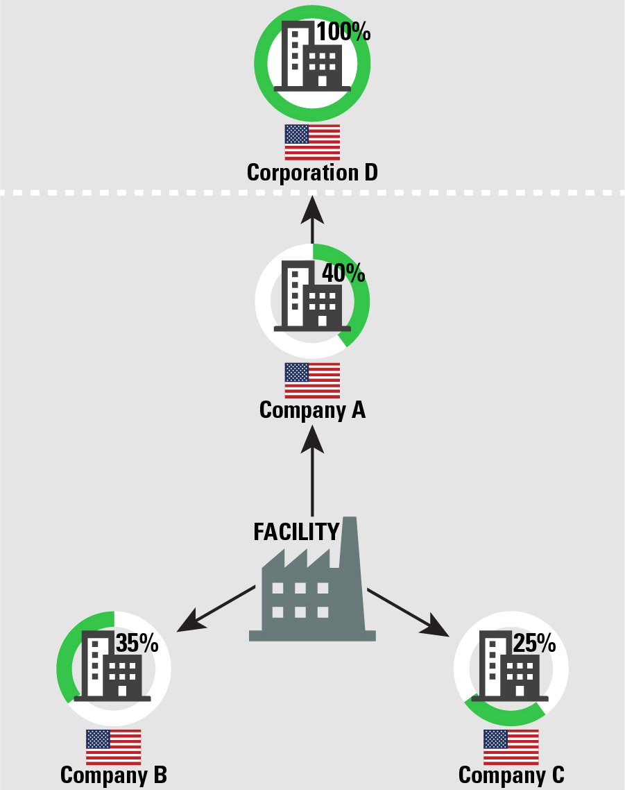

Example 9: Multi-company Ownership Including Foreign Entities
A facility is partially owned by two companies: Company A owns 60%, and Company B owns 40%. Both Company A and Company B are based in the U.S. Company B is a 100% subsidiary of a foreign company, Corporation D.  Corresponding Subpart in Parent Company Definition: 3  Demonstration of appropriate reporting:  - Facility: Facility Name  - U.S. Parent: Company A  - Foreign Parent: Corporation D | 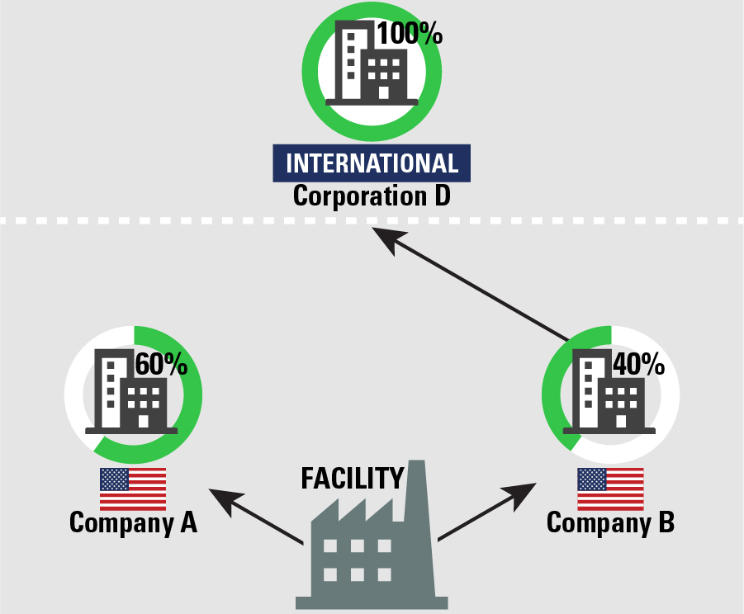

Example 10: Multi-company Ownership Including Foreign Entities
A facility is partially owned by three companies: Company A owns 40%, Company B owns 35%, and Company C owns 25%. Company A is a foreign corporation, and Companies B and C are based in the U.S. Company B is a 100% subsidiary of a foreign company, Corporation D. Companies A and C are not owned by any other entity.  Corresponding Subpart in Parent Company Definition: 3  Demonstration of appropriate reporting:  - Facility: Facility Name  - U.S. Parent: Company B  - Foreign Parent: Company A  Note that Company A holds the largest percentage share of ownership in the facility itself and is a foreign company, thus it should be reported as the foreign parent. Company B has the largest percentage of U.S.-based ownership, and thus should be reported as the U.S. parent. | 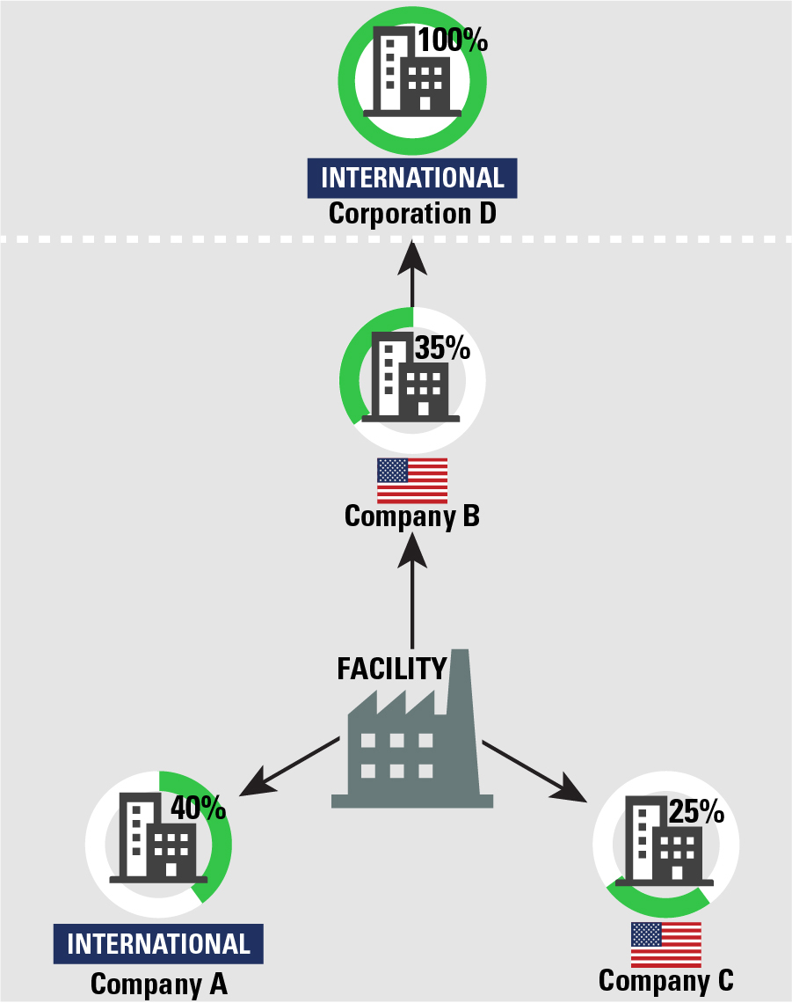

Example 11: Multi-company Ownership Including Foreign Entities
A facility is partially owned by three companies: Company A owns 40%, Company B owns 35%, and Company C owns 25%. Company A is a U.S.-based company, which is a 100% subsidiary of a foreign company, Corporation D. Companies B and C are both foreign companies, neither of which are owned by any other entity.  Corresponding Subpart in Parent Company Definition: 3  Demonstration of appropriate reporting:  - Facility: Facility Name  - U.S. Parent: Company A  - Foreign Parent: Corporation D  Note that Corporation D, through its ownership of Company A, holds the largest percentage share of foreign ownership in the facility. Corporation D should be reported as the foreign parent. | 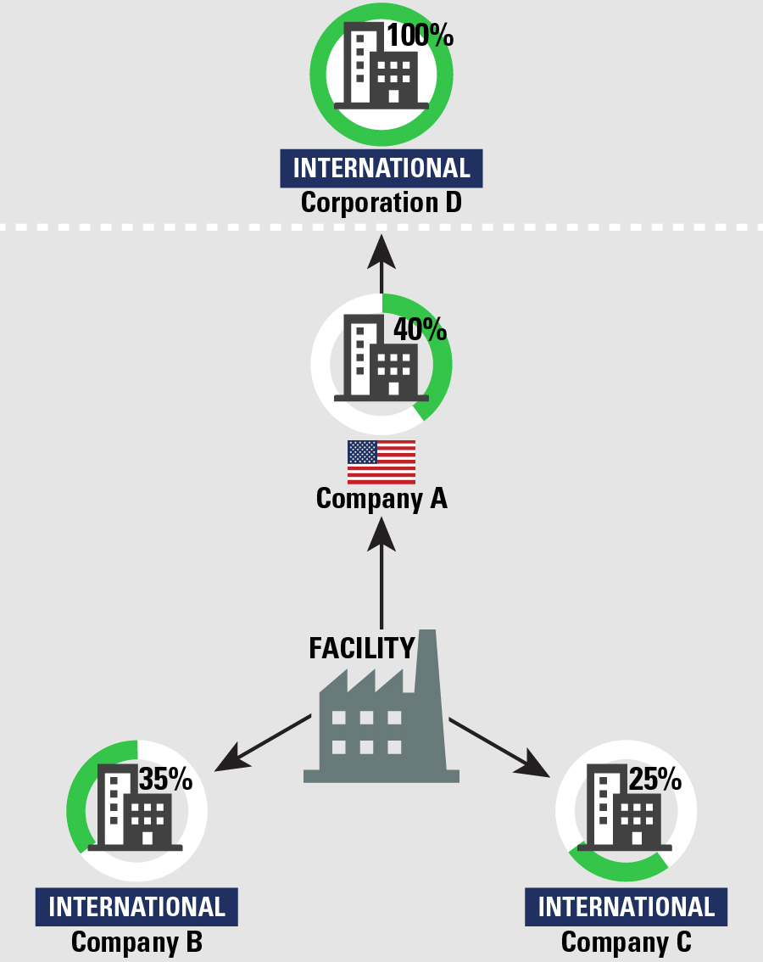

Example 12: U.S. 50-50 Joint Venture Ownership
A facility is owned by a joint venture between two U.S. companies, Company A and Company B, both of which own exactly half of the facility.
Corresponding Subpart in Parent Company Definition: 4
Demonstration of appropriate reporting:
- Facility: Facility Name
- U.S. Parent: Name of joint venture
- Foreign Parent: NA
Example 13: Foreign 50-50 Joint Venture Ownership
A facility is owned by a joint venture between two foreign companies, Company A and Company B, both of which own exactly half of the facility. This joint venture is also based outside the U.S.
Corresponding Subpart in Parent Company Definition: 4
Demonstration of appropriate reporting:
- Facility: Facility Name
- U.S. Parent Company: NA
- Foreign Parent: Name of foreign-based joint venture

This joint venture is based outside of the U.S.; it does not need to report a U.S. parent company under the TRI definition of parent company, but it must report the name of the foreign-based joint venture.
Example 14: U.S.-Foreign 50-50 Joint Venture Ownership, U.S. Legal Entity
A facility is owned by a joint venture between a U.S. company, Company A, and a foreign company, Company B, both of which own exactly half of the facility. This joint venture is a U.S. legal entity.
Corresponding Subpart in Parent Company Definition: 4
Demonstration of appropriate reporting:
- Facility: Facility Name
- U.S. Parent Company: Name of joint venture
- Foreign Parent: NA

This joint venture is based in the U.S.; it does not need to report a foreign parent company under the TRI definition of parent company, but it must report the name of the joint venture as the U.S. parent company.

Example 15: U.S.-Foreign 50-50 Joint Venture Ownership, Foreign Legal Entity
- A facility is owned by a joint venture between a U.S. company, Company A, and a foreign company, Company B, both of which own exactly half of the facility. This joint venture is a foreign legal entity.

Corresponding Subpart in Parent Company Definition: 4
Demonstration of appropriate reporting:
- Facility: Facility Name
- U.S. Parent Company: NA
- Foreign Parent: Name of foreign-based joint venture

This joint venture is based outside of the U.S.; it does not need to report a U.S. parent company under the TRI definition of parent company, but it must report the name of the foreign-based joint venture.

References
- U.S. Environmental Protection Agency (2021). Toxic Chemical Release Inventory Reporting Forms and Instructions: Revised 2021 Version. Available at: https://ordspub.epa.gov/ords/guideme_ext/guideme_ext/guideme/file/ry_2021_rfi.pdf

