**Supporting Statement**

This information collection will be added to OMB Number: 2120-0810.

Audience:

New entrants including Unmanned Aircraft Systems (UAS) accessing the National Airspace System (NAS).

Overall Description:

This IC will create a feedback loop which will allow the FAA to receive UAS stakeholder input to help improve FAA processes, guidance, and procedures. It will enhance user experience by applying lessons learned from previous projects to streamline and provide clarity for future projects.

Feedback should be structured in a way that summarizes insights gleaned from past experiences, aimed at informing, and improving future endeavors. It should relate to emerging entrant activities and provide actionable insights around guidance, processes, or procedures to enhance decision-making and problem-solving efforts going forward.

FAA’s experience with feedback shows that stakeholders will provide the feedback, so this change will provide them with a specific place to provide that feedback so it is not mixed in with other stakeholder inquiries.

1. Preferred Method of Contact (required – phone or e-mail)
2. First Name (required)
3. Last Name (required)
4. E-mail (required)
5. Phone (optional)
6. Phone Extension (optional)
7. Demographic (optional)
8. FAA Program (optional – BEYOND, IPA, TA, NTAP, “other” write-in option)
9. Main Category (required - drop-down, with an “other” write-in option)
10. Secondary Category (optional - Identical list as category)

Then the 3 free text boxes (all required fields) for:

* Practice (i.e. procedure or way of doing of something)
* Result (i.e. positive or negative outcome of the practice)
* Lesson learned (i.e. recommendations for future behavior based on past experience)

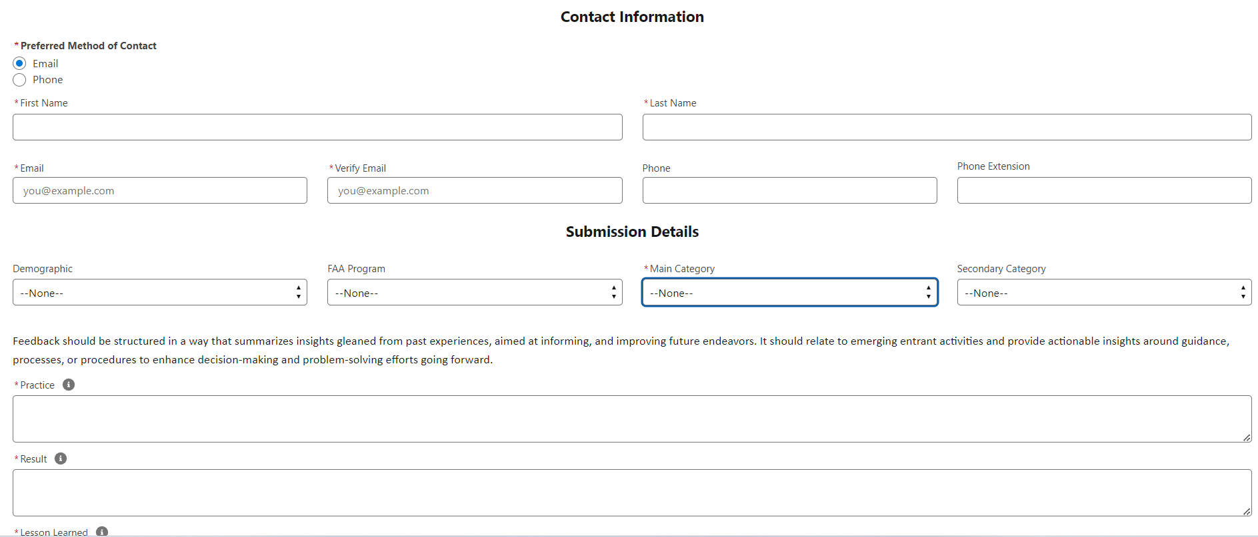

Calculations:

Stakeholders have provided feedback through other means in the past, allowing FAA to estimate the volume of feedback that this collection will yield.

BEYOND has 8 Lead Participants who report 2 times a year on Lessons Learned. We're estimating based on the history of BEYOND to receive approximately 10 lessons learned a year from each Lead Participant. We're adding an additional buffer of 20 submissions for any future BEYOND Lead Participants who may be added to the program.

Part 107 Waivers: We took the past 3 years’ worth of total submitted Part 107 waivers. FY24 (estimated based on first 3 quarters of the year submissions) - 2693, FY23 - 2761, FY22 - 2534, and averaged them to get an average of 2662 waiver submissions per year. We then determined that approximately 15% of part 107 waiver applicants may choose to provide the FAA with feedback on lessons learned resulting in 399.3 (rounded up to the nearest whole number, 400).

To find a median hourly wage for drone operators we used the Standard Occupational Classification (SOC) code 17-3024 Electro-Mechanical and Mechatronics Technologists and Technicians. We added 30% to the wage to reflect benefits so that the wage is fully loaded. This resulted in a mean hourly wage of $45.27. Then multiplied by 66.7 hours a year resulted in a yearly cost of $3,019.51 for the external stakeholders.

