Form HUD-9910, “Office of Housing Counseling- Agency Performance Review”

LOCATION | CURRENT TEXT | REVISED TEXT
Top of Page – Public Reporting Burden | Public reporting burden for this collection of information is estimated to average 1 hours per initial response, including the time for reviewing instructions, searching existing data sources, gathering, and maintaining the data needed, and completing and reviewing the collection of information. | Public reporting burden for this collection of information is estimated to average 9.5 hours per initial response, including the time for reviewing instructions, searching existing data sources, gathering and maintaining the data needed, and completing and reviewing the collection of information.
Page 1, instructions section | TO SUPPORT ANSWERS, PROVIDE DETAILED COMMENTS AND DOCUMENTATION, IF APPLICABLE. Housing Counseling Agencies are responsible for the requirements outlined in Parts A and B, and C, if applicable. Housing Counseling Agencies and HUD Reviewers are recommended to review Handbook 7610.1 REV 5,24 CFR Part 214, and information on HUD's Website at:  http://portal.hud.gov/hudportal/HUD?src=/program_offices/housing/sfh/hcc/hcc_home in support of the most current legislative and programmatic requirements for the Department's Housing Counseling Program. | TO SUPPORT ANSWERS, PROVIDE DETAILED COMMENTS AND DOCUMENTATION, IF APPLICABLE. Housing Counseling Agencies are responsible for the requirements outlined in Parts A and B, and C, if applicable. Housing Counseling Agencies and HUD Reviewers are recommended to review Handbook 7610.1 REV 5,24 CFR Part 214, and information on HUD's Website at: https://www.hud.gov/program_offices/housing/sfh/hcc/hcc_home in support of the most current legislative and programmatic requirements for the Department's Housing Counseling Program.
Page 1, Part A, between #8 and #10 | The current text does not include item #9 | 9 Does the agency maintain policies to screen for ineligible participants, including the agency’s directors, partners, officers, principals, or employees?
Chart between questions 61 and 62 | 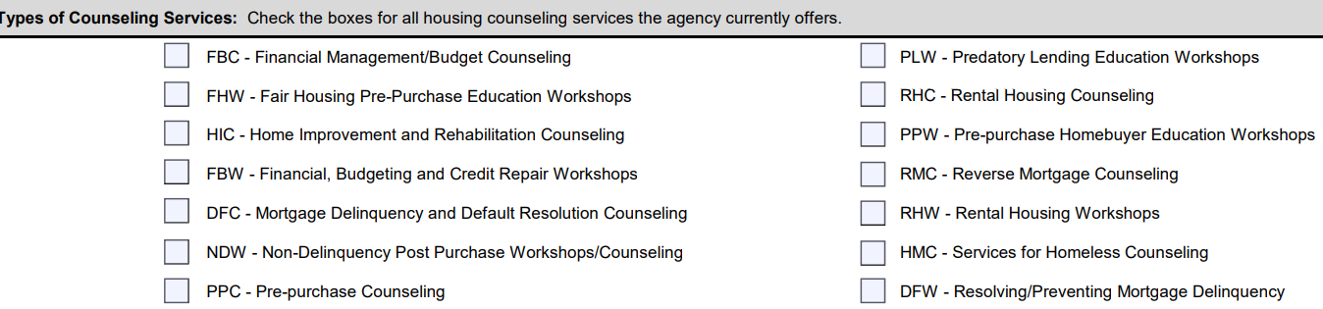 | 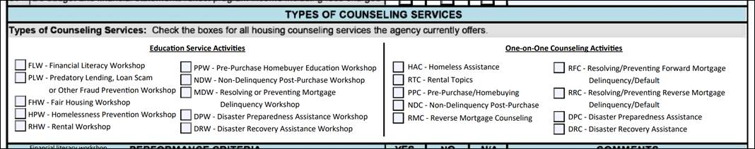
Question 66a. | The current text does not include item #66a | Are all staff providing housing counseling HUD certified housing counselors?
Last Page, Findings status | There are no findings or concerns that need to be addresses.  There are findings or concerns that need to be addresses. | There are no findings or concerns that need to be addressed.  There are findings or concerns that need to be addressed
Last Page, first signature block | Signature of Reviewer | Signature of Representative
Question 55f | Does the agreement state the agency will provide information on | Does the agreement state the agency will provide information on comparable products from at least 3 different lenders.
Public Reporting Burden, Page 1 | Public reporting burden for this collection of information is estimated to average 9.5 hours per initial response, including the time for reviewing instructions, searching existing data sources, gathering and maintaining the data needed, and completing and reviewing the collection of information. This agency may not conduct or sponsor, and a person is not required to respond to, a collection of information unless that collection displays a valid OMB control number.  The following information is used to assist HUD in evaluating the managerial and financial capacity of organizations to sustain operations sufficient to implement HUD approved housing counseling programs. The collection of information assists HUD to reduce its own risk from fraudulent activities or supporting inefficient or ineffective housing counseling programs. HUD publishes a web list of HUD approved Housing Counseling Agencies and maintains a toll free housing counseling hotline. Performance reviews help HUD ensure that individuals seeking assistance from these participating agencies can have confidence in the quality of services that they will receive. This information is collected in connection with HUD Housing Counseling Program and will be used by HUD to evaluate participating agencies' compliance with programmatic requirements. The information is considered sensitive and is protected by the Privacy Act of 197 4, which required the records to be maintained with appropriate administrative, technical and physical safeguards to ensure their security and confidentiality. NOTE: Part A will be completed by the HUD Reviewer, based on housing counseling agency performance, and Part B and C (if applicable) will be completed by the housing counseling agency. The agency will self-certify the responses and are subject to verification. HUD may, at its discretion, request clarification or additional information from an agency. The agency may consult with HUD to determine the specific actions needed to complete the form. | Public reporting burden for this collection of information is estimated to average 9.5 hours per initial response, including the time for reviewing instructions, searching existing data sources, gathering and maintaining the data needed, and completing and reviewing the collection of information. Send comments regarding this burden estimate or any other aspect of this collection of information, including suggestions to reduce this burden, to the Reports Management Officer, Paperwork Reduction Project, to the Office of Information Technology, US. Department of Housing and Urban Development, Washington, DC 20410-3600. When providing comments, please refer to OMB Approval No. 2502-0574. This agency may not conduct or sponsor, and a person is not required to respond to, a collection of information unless that collection displays a valid OMB control number.  The following information is used to assist HUD in evaluating the managerial and financial capacity of organizations to sustain operations sufficient to implement HUD approved housing counseling programs. The information is required under 24 CFR 214 subpart D. The collection of information assists HUD to reduce its own risk from fraudulent activities or supporting inefficient or ineffective housing counseling programs. HUD publishes a web list of HUD approved Housing Counseling Agencies and maintains a toll-free housing counseling hotline. Performance reviews help HUD ensure that individuals seeking assistance from these participating agencies can have confidence in the quality of services that they will receive. This information is collected in connection with the HUD Housing Counseling Program and will be used by HUD to evaluate participating agencies' compliance with programmatic requirements. The information will not be held confidential. NOTE: Part A will be completed by the HUD Reviewer, based on housing counseling agency performance, and Part B and C (if applicable) will be completed by the housing counseling agency. The agency will self-certify the responses and are subject to verification. HUD may, at its discretion, request clarification or additional information from an agency. The agency may consult with HUD to determine the specific actions needed to complete the form.
Entire Document | There are different size and type fonts on the form | Fonts to be standardized to all be the same style
Question 1 | Did the agency receive HUD Housing Counseling grants or sub-grants since the last performance review? If yes, answer the remaining questions in this section. | Did the agency receive HUD Housing Counseling grants or sub-grants since the last performance review? If yes, answer the remaining questions in this section. If no, proceed to question number 7.
Question 5 | Do CMS client notes or other client documentation support counselor hours billed and/or reported to the HUD Housing Counseling grant? | Do the agency’s client notes and/or other documentation in the agency’s HUD-Approved Client Management System (CMS) support counselor hours billed and/or reported to the HUD Housing Counseling grant?
Question 17 | Does the agency maintain a separate confidential file; use a unique number for each client; documenting each unique, distinct provision of housing counseling services provided to the client? | Does the agency maintain a separate confidential file, use a unique number for each client, and document each unique, distinct provision of housing counseling services provided to the client?
Question 21a | Does the agency establish an action plan for each client except HECM clients?  a. Do the action plans clearly identify the clients' need or problem? | Does the agency establish an action plan for each client except HECM clients?  a. Do the action plans clearly identify the clients' needs or problems?
Question 21b | b. Do the action plans outline what the agency and clients will do in order to meet clients' housing goal(s)? | b. Do the action plans outline what the agency and clients will do in order to meet clients' housing goals?
Question 24 | For pre-purchase clients, does the agency document client and homebuyer education files distribution of HUD publications on Home Inspection, if applicable? | For pre-purchase clients, does the agency document that clients are provided with HUD publications on Home Inspection, if applicable?
Question 38 | Do the facilities have accessibility features in accordance with ADA requirements or does the agency offer alternative accommodations for person with disabilities? | Is the facility accessible for those with mobility impairments and does the facility meet federal accessibility requirements? Does the agency offer any other accommodations for person with disabilities?
Question 39 | Other (specify in box at right) | Other (explain below)
Question 40 | Does the agency counsel clients whose native language is not English? | Does the agency take reasonable steps to ensure meaningful access for individuals with limited English proficiency, including by providing translation and interpretation services and written materials in other languages?
Question 44 | Does the agency comply with all applicable fair housing and civil rights requirements in 24 CFR 5.105a? | Does the agency comply with all applicable fair housing and civil rights requirements in 24 CFR 5.105(a), including the obligations to ensure meaningful access for individuals with limited English proficiency and effective communication with individuals with disabilities?
Question 45(a) | Has the agency:  Been charged with an ongoing systemic violation of the Fair Housing Act? | Has the agency:  Been charged with an ongoing systemic violation of the Fair Housing Act? See 42 USC 3601 et seq.
Question 46 | Does the agency provide outreach to persons least likely to apply for housing counseling services? | Does the agency provide outreach to persons least likely to apply for housing counseling services, as per the requirements of the HUD Handbook 7610.1 REV 5?
Question 47 | Does the agency maintain records of its activities to affirmatively further fair housing? | Does the agency maintain records of its activities to affirmatively further fair housing? See 24 CFR § 5.150. (AFFH). If "Yes," do these records:
Question 49 | If the agency is an intermediary, affiliate, or sub-grantee, does the contract or agreement between the intermediary and its affiliate(s) or sub-grantee(s) address non-discrimination and equality opportunity responsibility per Handbook 7610.1 REV.? | If the agency is an intermediary, affiliate, or sub-grantee, does the contract or agreement between the intermediary and its affiliate(s) or sub-grantee(s) address non-discrimination and equal opportunity responsibilities per Handbook 7610.1 REV.?
Question 54 | Does the agency safeguard and maintain the confidentiality paper and/or electronic files, including credit cards, etc.? | Does the agency safeguard and maintain the confidentiality of paper and/or electronic files, including credit reports, etc.?
Question 55f | Does the agreement state the agency will provide information on comparable products from at least 3 different lenders. | Does the agreement state the agency will provide information on comparable products from at least 3 different lenders?
Question 56 | Does the agency charge fees for its counseling, education or debt management services? If yes, answer the following questions. | Does the agency charge fees for its counseling, education and/or debt management services? If yes, answer the following questions.
Question 57 | Did the agency/grant recipient/sub-grant recipient expend $750,000 or more in federal funds a year? | Did the agency/grant recipient/sub-grant recipient expend $750,000 or more in federal funds a year? See 2 CFR 200.501 (Audit requirements).
Question 60 | Does the agency's budget and financial statements demonstrate the necessary level of funds that enables the agency to perform the minimum workload required by HUD for the next year? | Does the agency's budget and financial statements demonstrate the necessary level of funds that enables the agency to perform the minimum workload required by HUD for the next year? See 24 CFR 214.303 (Performance criteria).
Question 61 | Do budget and financial statements reflect program income including fees charged | Do budget and financial statements reflect program income including fees charged?
Question 66(a) | Do at least half of the counselors have at least six months experience in the job they are performing? Provide a current list of counseling staff.  - Are all staff providing housing counseling HUD certified housing counselors? | Do at least half of the counselors have at least six months experience in the job they are performing? Provide a current list of counseling staff.  - Are all staff providing housing counseling HUD certified housing counselors? See 24 CFR § 214.3 (Definitions).
Question 74 | Did the agency notify HUD of conflicts of interest no later than 15 days after the conflict was discovered and report to HUD on the corrective action taken to cure the immediate conflict and avoid future conflicts? | Did the agency notify HUD of conflicts of interest no later than 15 days after the conflict was discovered and report to HUD on the corrective action taken to cure the immediate conflict and avoid future conflicts? See 24 CFR § 214.303(f)(5).
Question 75(b) | If applicable, did the agency notify HUD of its policy or changes to policy regarding the following:  b. Business practices and/or partnerships that would constitute a conflict of interest pursuant to HUD regulations? | If applicable, did the agency notify HUD of its policy or changes to policy regarding the following:  b. Business practices and/or partnerships that would constitute a conflict of interest pursuant to HUD regulations per 24 CFR § 214.303(f)
Question 75(e) | If applicable, did the agency notify HUD of its policy or changes to policy regarding the following:  e. Agency's quality control plan for identifying, addressing or mitigating any conflicts of interest and complying with HUD requirements? | If applicable, did the agency notify HUD of its policy or changes to policy regarding the following:  e. Agency's quality control plan for identifying, addressing, or mitigating any conflicts of interest and complying with HUD requirements? See 24 CFR § 214.303.
Question 76 |  | Insert black bar over question response area across from “does the agency disclosure meet the following HUD requirements:”
Question 77(d) | Did the agency experience any of the following changes?  d. Changes to any other aspect of the agency's purpose or functions that may impair its ability to comply with the programmatic requirements, applicable regulations or applicable grant agreement(s) (e.g., lack of qualified housing counselors). | Did the agency experience any of the following changes?  d. Changes to any other aspect of the agency's purpose or functions that may impair its ability to comply with the programmatic requirements, applicable regulations or applicable grant agreement(s) (e.g., lack of qualified housing counselors). See 24 CFR § 214.303
Question 79 | Does the client intake process collect all the required information per the HECM protocol? | Does the client intake process collect all the required information per the HECM protocol? See HUD Handbook 7610.1 REV-5.
Question 84 |  | Insert black bar over question response area across from “Do the files contain the required information noted below (if applicable)?”
Question 88 |  | Insert black bar over question response area across from “Do counselor(s) perform the required client follow-up to include:”
Question 82 | Is the agency in compliance with clients lacking legal competence? | Is the agency in compliance with HUD guidance regarding clients lacking legal competence? See HUD Handbook 7610.1 REV-5, Chapter 4.
Page 4 | Font is blurry and non-compliant with Section 508 | Clear non-blurry copy is being provided

