memorandum
to: | VBA Publications Control Officer
from: | DANIEL G ELLIS, VA Life Insurance Center
subject: | Non-Sub Change for Designatin of Beneficiary AND SUPPLEMENTAL DESIGNATIN OF BENEFICIARY – GOVERNMENT LIFE INSURANCE FORMS
date: | OCTOBER 6, 2022
The VA 29-336 Designation of Beneficiary – Government Life Insurance Form, is used for veterans to update their beneficiary information. The VA Insurance Center needs to update the Beneficiary Designation forms (VA Form 29-336 and 29-336a) based on a recent decision made to no longer allow multiple beneficiaries on multiple policies. We also added a note differentiating between VALife and non VALife regulations to cover us in case a B&O is accidently received by a VALife policyholder. This is to also includes information about ambiguous designations.
- On page 1, the NOTE at the top of the page should read “NOTE: Before completing the form, please note we highly recommend updating your beneficiary designation directly online at https://www.insurance.va.gov/home. It is safe, secure and instant.”
- On page 1, on the IMPORTANT note below item 7, please remove “UNLESS YOU INDICATE OTHERWISE BY CHECKING THE BOX BELOW” from the end of the sentence so the note reads “IMPORTANT - IF YOU DO NOT NAME A SPECIFIC BENEFICIARY, YOUR INSURANCE WILL BE PAID AS NOTED UNDER SECTION V BELOW. THIS DESIGNATION WILL APPLY TO ALL POLICIES.”
- On page 1, Please remove box 8 in its entirety.
- On page 1 under INSTRUCTIONS FOR COMPLETING THIS FORM, please add a 4th bullet that reads “Federal regulations pertaining to designating beneficiaries of Government life insurance require that the designation be valid. If any part of the designation in either the principal or contingent beneficiary section is unclear, ambiguous, or not legally acceptable, then the previous beneficiary designation will remain effective, or the Veteran's estate will become the beneficiary if no previous, valid designation exists.”
  - To create space, move the INSTRUCTIONS FOR COMPLETING THE FORM up utilizing the extra space from removing item 8, making the box bigger. See attached for reference.
- On page 5, under SECTION IV - ADDITIONAL INSTRUCTIONS, please remove the last sentence “ALSO, LIST THE POLICY NUMBER OF ANY POLICY ON WHICH THE BENEFICIARY IS NOT TO BE CHANGED.” From the end of the sentence so the language reads “YOUR INSURANCE PROCEEDS WILL BE AUTOMATICALLY PAID ACCORDING TO THE AUTOMATIC SURVIVORSHIP CLAUSE DETAILED IN SECTION V BELOW. IF YOU DO NOT WANT YOUR INSURANCE PAID THIS WAY, PLEASE EXPLAIN BELOW HOW YOU WANT IT PAID.”

- On page 5, the entire box under SECTION V – CERTIFICATION AND SIGNATURE should read like the pic below. (Number 1 and the first 2 bullets under number 1 stay the same, everything else changes) Also see attached for reference.
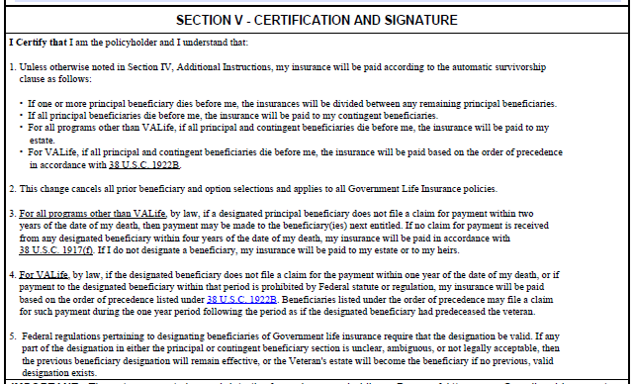
  - To create space, move everything from the IMPORTANT note down to the bottom of the page. The mail and online instructions should sit at the bottom of the page. See attached for reference.
  - I added a Word document with the text you need so wouldn’t have to retype everything. You can also use the attached 29-336 for reference and copy and paste.

________________________________________________________________________

The VA 29-336a Supplemental Designation of Beneficiary – Government Life Insurance Form, is used for veterans to add additional beneficiary’s and beneficiary information to their policy. The VA Insurance Center needs to update the Beneficiary Designation forms (VA Form 29-336 and 29-336a) based on a recent decision made to no longer allow multiple beneficiaries on multiple policies. We also added a note differentiating between VALife and non VALife regulations to cover us in case a B&O is accidently received by a VALife policyholder. This is to also includes information about ambiguous designations.
- On page 1, the NOTE at the top of the page should read “NOTE: Before completing the form, please note we highly recommend updating your beneficiary designation directly online at https://www.insurance.va.gov/home. It is safe, secure and instant. You may either complete the form online or by hand. If completed by hand, print the information requested in ink, neatly, and legibly and using capital letters to expedite processing of the form.”
- On page 1, after VETERANS SOCIAL SECURITY NUMBER, please remove the box below in its entirety.
- At the bottom of page 3 under SECTION III – ADDITIONAL INSTRUCTIONS, please remove the last sentence so the text should read – “YOUR INSURANCE PROCEEDS WILL BE AUTOMATICALLY PAID ACCORDING TO THE AUTOMATIC SURVIVORSHIP CLAUSE DETAILED IN SECTION IV BELOW. IF YOU DO NOT WANT YOUR INSURANCE PAID THIS WAY, PLEASE EXPLAIN BELOW HOW YOU WANT IT PAID.”
- On page 5, under SECTION IV - ADDITIONAL INSTRUCTIONS, please remove the last sentence “ALSO, LIST THE POLICY NUMBER OF ANY POLICY ON WHICH THE BENEFICIARY IS NOT TO BE CHANGED.” So the language reads “YOUR INSURANCE PROCEEDS WILL BE AUTOMATICALLY PAID ACCORDING TO THE AUTOMATIC SURVIVORSHIP CLAUSE DETAILED IN SECTION V BELOW. IF YOU DO NOT WANT YOUR INSURANCE PAID THIS WAY, PLEASE EXPLAIN BELOW HOW YOU WANT IT PAID.”

- On page 4, the entire box under SECTION IV – CERTIFICATION AND SIGNATURE should read like the pic below. See attached for reference.
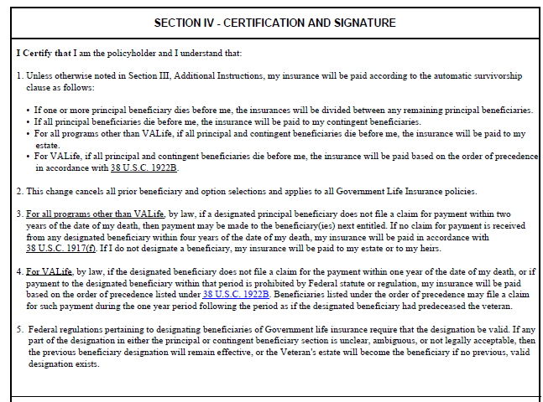
  - If you need to create space, move everything from the IMPORTANT note down to the bottom of the page. The mail and online instructions should sit at the bottom of the page. See attached for reference.
  - I added a Word document with the text you need so wouldn’t have to retype everything. You can also use the attached 29-336a for reference and copy and paste. This is the same language as 29-336 except the second line should state section III not IV.

These modifications will not change any previous calculations for either form. Therefore, this in a non-substantial change on both forms.

Thank you

