Use the following steps to upload State Plans to SFPD State Plans Site:
- From the left menu, select the Program you would like to upload a final State Plan for.
Note: The SPFD State Plans PartnerWeb Site is located at the following web address (url): SFPD State Plans PartnerWeb Site 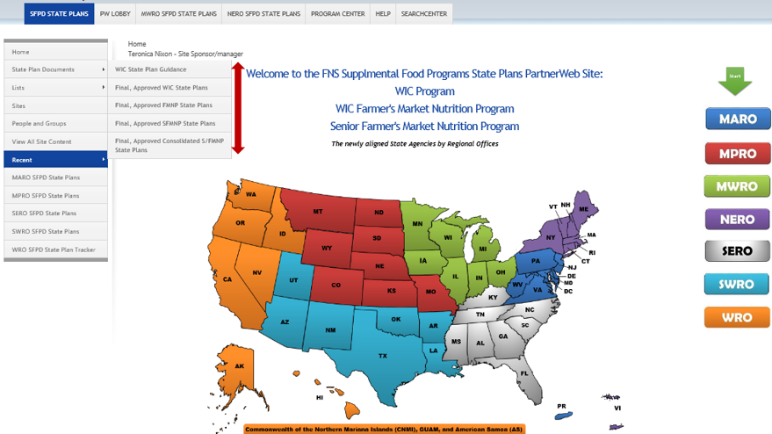

- Select “Upload”
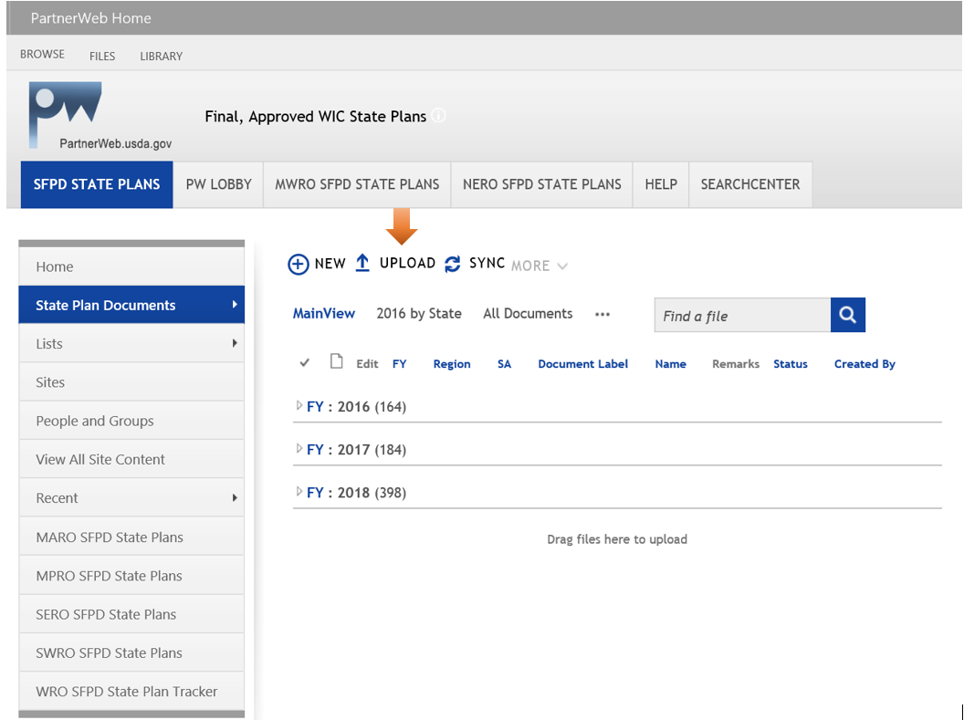

- Select “Choose File” to find and select your document and click “OK”.
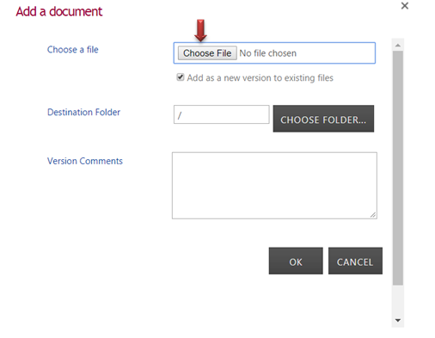
- Fill in all pertinent information and click “Check In”. An (*) means information is required. Functional areas should be uploaded separately.
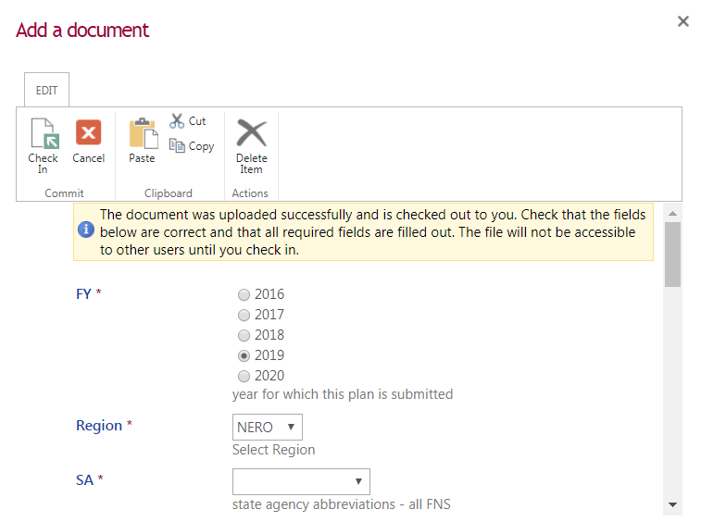
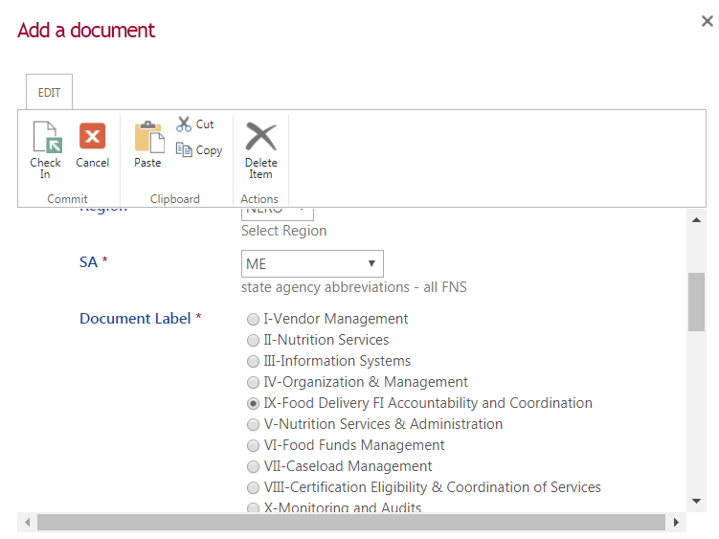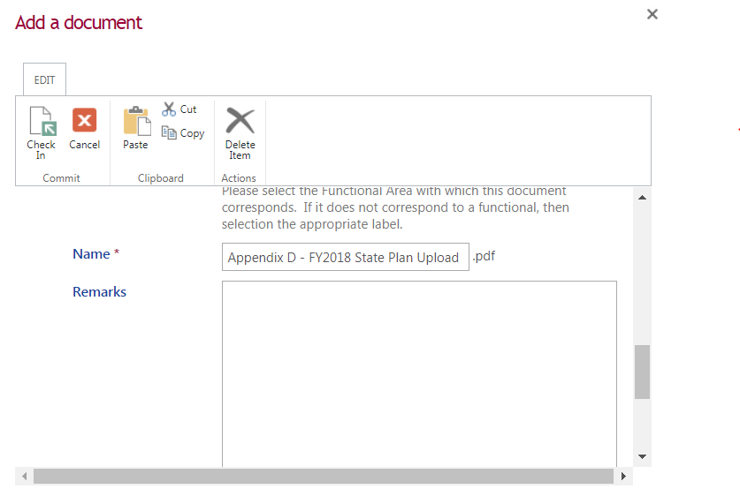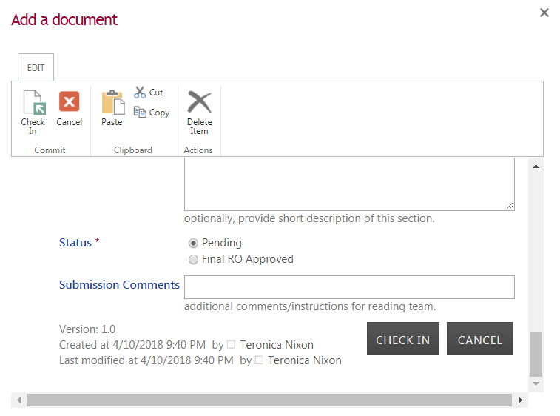
- Document upload is successful.

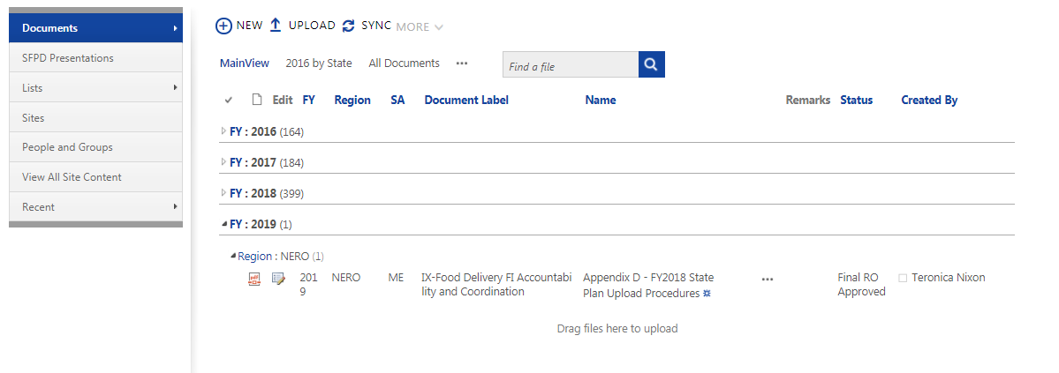

6. Repeat Steps 1 through 5 for additional uploads.

