**Appendix F1. First Survey Reminder Letter (English)**

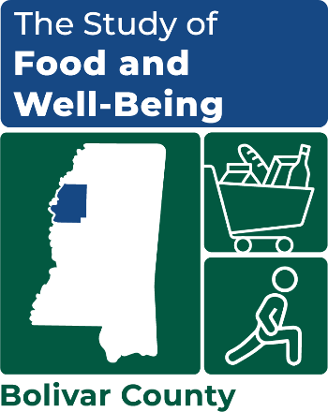

OMB Number: 0584-XXXX

Expiration Date: XX/XX/20XX

Dear [[COUNTY] County Resident/SNAP NAME]:

Recently, we sent you a letter about an important study called the Study of Food and Well-Being. **Your participation will help improve supports for households across [COUNTY] County!** This study, sponsored by the U.S. Department of Agriculture, asks important questions about food access and well-being.

Your responses will be used to better align resources with your community’s needs. **We need your input to design programs that are more effective at reducing hunger and benefiting all households in [COUNTY] County.**

To participate in the study, you can:

|  |  |  |
| --- | --- | --- |
| **Participate NOW Online**  **Scan this QR Code with your phone** | **Participate NOW by Phone** | **Participate Later – with Community Worker** |
| [**www.surveylink.com**](http://www.surveylink.com)  **Username:** [USERNAME]  **Password:** [PASSWORD] | **Call toll-free at:**  **1-XXX-XXX-XXXX** | **A representative from**  **Mathematica will visit you** |

The survey takes about 35 minutes to complete and eligible households will **receive a $35 gift card**. It should be completed by the adult who does most of the planning or preparing of meals or most of the food shopping.

Taking part in this study is your choice. We will only use your information for research. If you have questions, need assistance with accessing the web survey, or would prefer to complete the survey over the phone, please call us toll-free at 1-XXX-XXX-XXXX or email us at [XXX@mathematica-mpr.com](mailto:XXX@mathematica-mpr.com).

Thanks in advance for your cooperation and support of the Study of Food and Well-Being!

Sincerely,

*---insert signature image here---*

Kim McDonald

*Survey Director*