**Appendix E1. Endorsement Letter (English)**

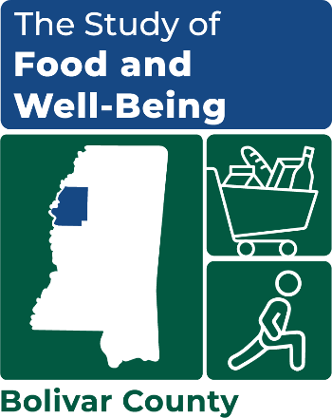Dear Community Member,

OMB Number: XXXX-XXXX

Expiration Date: XX/XX/20XX

PLACEHOLDER FOR LOCAL COUNTY ORGANIZATION’S LOGO

I’m writing to let you know that our community has been selected for an important study by the U.S. Department of Agriculture’s Food and Nutrition Service (FNS). It is called the **Study of Food and Well-Being**. FNS is the agency that oversees [Food Stamp / LOCAL SNAP NAME] benefits and the national school breakfast and lunch programs.

The goal of this study is to understand how to better help families access affordable food and to improve programs that aim to reduce hunger. The [SNAP agency/community organization] supports this effort.

**We believe this study could have a positive impact on programs and food access in our community. We fully encourage your household to participate.**

To conduct the study, FNS is working with a company called Mathematica. Mathematica is reaching out to households like yours to complete a survey online or over the phone. [Mathematica will send a letter and brochure with more details about the survey and the types of questions they will ask.] **You will receive a $35 gift card after you complete the survey.**

Participation in the study is voluntary and your responses are confidential. Your participation will not affect any nutrition assistance or other services that you or your household may receive. This study gives us all a chance to help these programs best serve the needs of households in our community.

Let your voice be heard.

If you have any questions about the study, please contact the study team directly at (XXX) XXX-XXXX or XXXXX@mathematica-mpr.com.

Sincerely,

NAME

ORGANIZATION