**Appendix G1. Second Survey Reminder Letter (English)**

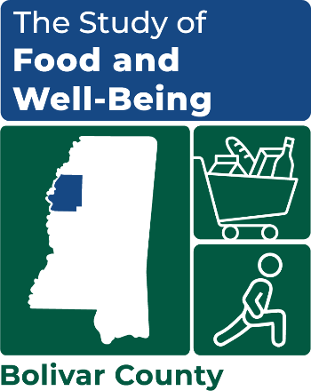

OMB Number: 0584-XXXX

Expiration Date: XX/XX/20XX

Resident of [COUNTY] County

[IF AVAILABLE, SNAP Name]

[ADDRESS 1 / ADDRESS 2]

[CITY, STATE ZIP]

Dear [resident/SNAP NAME]:

We have been trying to reach you about the Study of Food and Well-Being! **This study is ending soon – we want to make sure you have all the details you need to participate before it’s too late.**

* **If eligible, you’ll get a $35 gift card for completing the survey.** The survey will take about 35 minutes to complete. The survey should be completed by the adult who does most of the planning or preparing of meals or most of the food shopping.
* **You can take the survey online or over the phone.** You may start the survey at any time and finish it later at your convenience. The survey will ask you questions about your food-related experiences, benefits you may receive, and your overall health and well-being.
* **If we don’t hear from you, a representative from Mathematica will visit you at your home to assist you in completing the survey.** Prefer to complete the survey on your own? Use the link below or call us toll-free to participate now.

Please see the enclosed brochure for more information. Your participation is voluntary, but very important. Your decision to participate will not affect any benefits that you or your household receives.

|  |  |  |
| --- | --- | --- |
| **Participate NOW Online**  **Scan this QR Code with your phone** | **Participate NOW by Phone** | **Participate Later – with Community Worker** |
| [**www.surveylink.com**](http://www.surveylink.com)  **Username:** [USERNAME]  **Password:** [PASSWORD] | **Call toll-free at:**  **1-XXX-XXX-XXXX** | **A representative from**  **Mathematica will visit you** |

Sincerely,

*---insert signature image here---*

Kim McDonald

Survey Director