**Appendix J1. Survey Refusal Letter (English)**

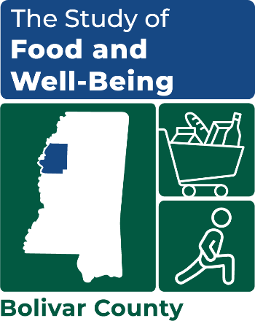

OMB Number: 0584-XXXX

Expiration Date: XX/XX/20XX

DATE

ADDRESS 1

ADDRESS 2

CITY, STATE ZIP

Dear [COUNTY] County resident:

We recently reached out to invite your household to participate in the **Study of Food and Well-Being**. If you have already completed, thank you for your participation!

You probably receive a lot of telephone calls from telemarketers and other sales representatives, and we want to assure you, this was not one of those calls. **We want to hear your perspective on food access and well-being in your community. Your household was selected to represent [COUNTY] County – we cannot replace you!**

We understand you are busy, and your time is valuable. If eligible, you will **receive a $35 gift card for completing the survey**, and you can choose the method and time that’s best for you.

* It should be completed by the adult who does most of the planning or preparing of meals or most of the food shopping.
* Complete the survey all at once, or over multiple sessions. Skip any questions that you do not want to answer.

Participating in the survey is your choice. Your participation will not affect any benefits you or your household receives. Your responses are private and secure.

**Please call us at XXX-XXX-XXXX (toll free) to complete the survey now, make an appointment to complete it, or to ask any questions about the study.**

You can also complete the survey online anytime:

[**www.surveylink.com**](http://www.surveylink.com)

**Username: [USERNAME]**

**Password: [PASSWORD]**

We look forward to hearing from you soon!

Sincerely,

*---insert signature image here---*

Kim McDonald

Survey Director

This information is being collected to assist the Food and Nutrition Service (FNS) in understanding the interrelated factors that affect food insecurity and poverty. This is a voluntary collection and FNS will use the information to aid in the administration of the Supplemental Nutrition Assistance Program. This collection does request personally identifiable information under the Privacy Act of 1974. According to the Paperwork Reduction Act of 1995, an agency may not conduct or sponsor, and a person is not required to respond to, a collection of information unless it displays a valid OMB control number. The valid OMB control number for this information collection is 0584-[xxxx]. The time required to complete this information collection is estimated to average 2 minutes (0.0334 hours) per response, including the time for reviewing instructions, searching existing data sources, gathering and maintaining the data needed, and completing and reviewing the collection of information. Send comments regarding this burden estimate or any other aspect of this collection of information, including suggestions for reducing this burden, to: U.S. Department of Agriculture, Food and Nutrition Service, Office of Policy Support, 1320 Braddock Place, 5th Floor, Alexandria, VA 22306 ATTN: PRA (0584-xxxx). Do not return the completed form to this address.