**Appendix O1. IDI Consent Form (English)**

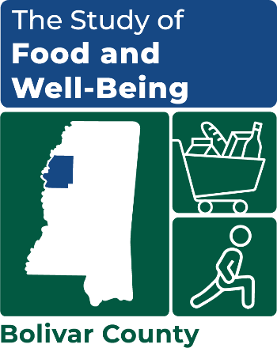

OMB Number: 0584-XXXX

Expiration Date: XX/XX/20XX

**STUDY OF FOOD AND WELL-BEING**

**Consent to Participate in Interview**

By signing this form, you are agreeing to participate in an interview for a study that Mathematica is conducting for the U.S. Department of Agriculture, Food and Nutrition Services. This study is examining how poverty affects food insecurity and well-being in six counties throughout the United States.

As part of this study, we are talking to individuals like yourself to better understand your experiences living in [COUNTY NAME], and the different aspects of your life that affect your wellbeing, including access to affordable food. You will also be asked to talk about important events, your community and food access at different points in your life, and how these have affected your well-being or the well-being of your family. There is a risk that some topics may be uncomfortable for you to talk about. You may choose to not answer any question you do not want to answer. The goal of the study is to improve the programs and supports that aim to eliminate hunger, and understanding your views and experiences may help us know how to do that.

The interview will last approximately two hours. It is your decision whether or not to participate in the study. If you choose to participate, you may stop at any time or refuse to answer any question in the interview without penalty. All of the information you provide will be kept private to the extent allowed by law. Some examples are laws that require reporting if you tell the interviewers anything that suggests you are very likely to harm yourself, that you are planning to hurt another person, or that someone is likely to harm you.

The information is being collected for research purposes only. After the research study is completed, the information you provide will be destroyed. Your name will never be used in any reports, and the information will never be reported in any way that can identify you. Nothing you say will affect your eligibility for the services and benefits you receive through any programs.

In appreciation for your participation in this interview, you will receive a $50 cash card. You will receive the cash card even if you decide not to answer certain questions.

If you have any questions, complaints, or concerns about this study, you may contact:

Andrew Weiss, Project Director

(734) 794-8025

[AWeiss@Mathematica-Mpr.com](mailto:AWeiss@Mathematica-Mpr.com)

**I agree to take part in this interview. I have read the above interview description. Anything I did not understand was explained to me by the interviewer and my questions were answered to my satisfaction.**

**______________________________________________________________________**

Participant Printed Name

**______________________________________________________________________**

Participant Signature Date

This information is being collected to assist the Food and Nutrition Service (FNS) in understanding the interrelated factors that affect food insecurity and poverty. This is a voluntary collection and FNS will use the information to aid in the administration of the Supplemental Nutrition Assistance Program. This collection does request personally identifiable information under the Privacy Act of 1974. According to the Paperwork Reduction Act of 1995, an agency may not conduct or sponsor, and a person is not required to respond to, a collection of information unless it displays a valid OMB control number. The valid OMB control number for this information collection is 0584-[xxxx]. The time required to complete this information collection is estimated to average 2 minutes (0.0334 hours) per response, including the time for reviewing instructions, searching existing data sources, gathering and maintaining the data needed, and completing and reviewing the collection of information. Send comments regarding this burden estimate or any other aspect of this collection of information, including suggestions for reducing this burden, to: U.S. Department of Agriculture, Food and Nutrition Service, Office of Policy Support, 1320 Braddock Place, 5th Floor, Alexandria, VA 22306 ATTN: PRA (0584-xxxx). Do not return the completed form to this address.

**Privacy Act Statement**

**Authority:** This information is being collected under the authority of Section 9 of the Food and Nutrition Act of 2008, as amended, (7 U.S.C. 2018). Disclosure of the information is voluntary.

**Purpose:** Information is collected primarily for use by the Food and Nutrition Service in the administration of the Supplemental Nutrition Assistance Program.

**Routine Use:** The information may be shared with SNAP contract researchers and USDA SNAP research and administrative staff.

**Disclosure:** Furnishing the information on this form is voluntary, and there are no consequences to you for not providing the information.