Appendix Q1. Focus Group Consent Form

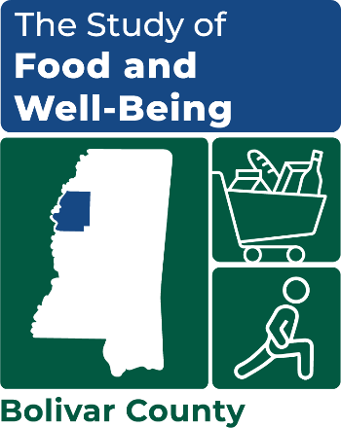

STUDY OF FOOD AND WELL-BEING
OMB Number: 0584-XXXX
Expiration Date: XX/XX/20XX

focus group consent form
By signing this form, you are agreeing to participate in a group discussion about food and well-being. The discussion is part of a larger study being conducted by Mathematica for the US Department of Agriculture Food and Nutrition Service to look at how poverty affects well-being and food insecurity. The group will discuss your experiences working with families in [COUNTY NAME], and your thoughts about what contributes to the well-being, food insecurity, and poverty of community members. The group discussion will last approximately 90 minutes.
Your participation in this group discussion is voluntary. The information is being collected for research purposes only. Please do not share what you hear during this session with others outside the group. While the study team cannot guarantee confidentiality, all of the information you provide will be kept private to the extent allowed by law. After the research study is completed, the information you provide during this discussion will be destroyed. Your name will never be used in any reports and no information will be reported in any way that can identify you.
If you have any questions about the study, please feel free to call the study director, Andy Weiss at (734) 794-8025. If you have any questions about your rights as a research study volunteer, please call the HML Institutional Review Board. Its toll-free number is 1-800-232-9570.
 I agree to take part in this discussion group. I have read the above group discussion description. Anything I did not understand was explained to me by the group discussion facilitator and my questions were answered to my satisfaction.

________________________________________________________________________
Participant Printed Name

________________________________________________________________________
Participant Signature Date

This information is being collected to assist the Food and Nutrition Service (FNS) in understanding the interrelated factors that affect food insecurity and poverty. This is a voluntary collection and FNS will use the information to aid in the administration of the Supplemental Nutrition Assistance Program. This collection does request personally identifiable information under the Privacy Act of 1974. According to the Paperwork Reduction Act of 1995, an agency may not conduct or sponsor, and a person is not required to respond to, a collection of information unless it displays a valid OMB control number. The valid OMB control number for this information collection is 0584-[xxxx]. The time required to complete this information collection is estimated to average 2 minutes (0.0334 hours) per response, including the time for reviewing instructions, searching existing data sources, gathering and maintaining the data needed, and completing and reviewing the collection of information. Send comments regarding this burden estimate or any other aspect of this collection of information, including suggestions for reducing this burden, to: U.S. Department of Agriculture, Food and Nutrition Service, Office of Policy Support, 1320 Braddock Place, 5th Floor, Alexandria, VA 22306 ATTN: PRA (0584-xxxx). Do not return the completed form to this address.

Public Burden Statement
According to the Paperwork Reduction Act of 1995, an agency may not conduct or sponsor, and a person is not required to respond to, a collection of information unless it displays a valid OMB control number. The valid OMB control number for this information collection is xxxxx. The time required to complete this information collection is estimated to average 90 minutes including the time for reviewing instructions, searching existing data sources, gathering and maintaining the data needed, and completing and reviewing the collection of information. Send comments regarding this burden estimate or any other aspect of this collection of information, including suggestions for reducing this burden, to: U.S. Department of Agriculture, Food and Nutrition Service, Office of Policy Support, 1320 Braddock Place, 5th Floor, Alexandria, VA 22314, ATTN: PRA (XXXX-XXXX). Do not return the completed form to this address.

