Appendix R. Study Description
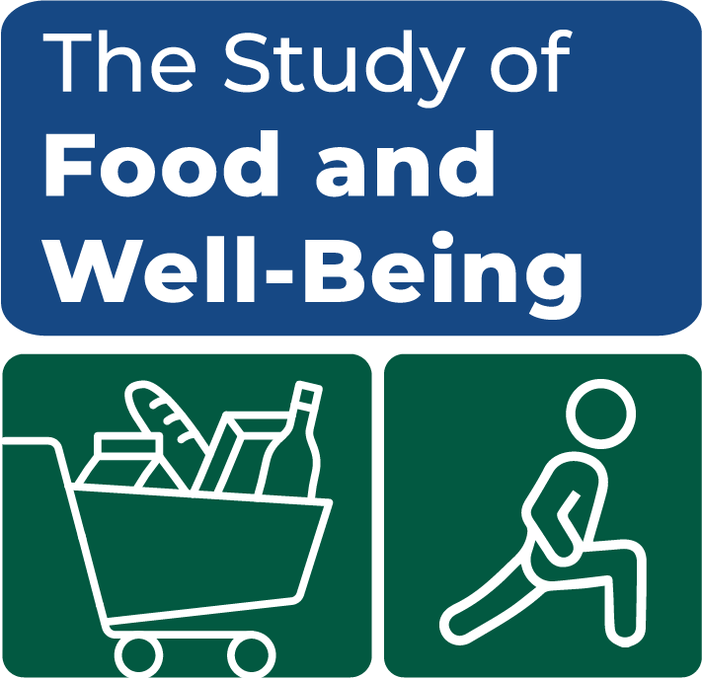

OMB Number: 0584-XXXX
Expiration Date: XX/XX/20XX
The Study of Food and Well-Being
Overview | The U.S. Department of Agriculture (USDA) is conducting this study to gain a deeper understanding of the interrelated factors that affect food insecurity and poverty. This data collection effort will help the USDA better understand the association between SNAP, other USDA-administered programs, and community-based assistance with well-being and the food environment. The USDA has contracted with Mathematica to conduct this study in six counties experiencing persistent poverty.
Research goals | The study team will conduct a survey of a representative sample of low-income households in each study county, some who participate in SNAP and some who do not. These households will provide the basis for understanding food insecurity and poverty in environments experiencing high and persistent levels of poverty.  Key study goals are to:  - Produce descriptive statistics in each study county on key social, financial, and geographic variables related to well-being and economic strain.  - Characterize the social context and the life course of individuals, especially within multigenerational family units, as they define their overall life experiences and history with food insecurity.
Study activities | To achieve its research objectives, the team is conducting:  - Household Surveys: will collect information to better understand county residents’ sociodemographic and economic backgrounds that affect food security.  - In-depth Interviews: will be conducted with multigenerational SNAP and SNAP-eligible households to provide a richer and more nuanced understanding of factors that affect individuals’ well-being and to provide context to survey findings.  - Focus Groups: will be conducted with community stakeholders that work closely with low-income populations to enhance understanding of the community, including service needs and gaps.
Findings | Data collection on this 5-year study will begin in 2024. Final data files and documentation will be available to the public. A final report on the research findings is expected in 2026.
To find out more | Contact Mathematica’s project director, [NAME], by phone at (XXX) XXX-XXXX) or by email at [EMAIL], or the FNS project officer, Michael Burke, by phone at (703) 305-4369 or by email at michael.burke@usda.gov. You can also learn more about the study by visiting the study website: www.mathematica.org/STUDYWEBSITE
This information is being collected to assist the Food and Nutrition Service (FNS) in understanding the interrelated factors that affect food insecurity and poverty. This is a voluntary collection and FNS will use the information to aid in the administration of the Supplemental Nutrition Assistance Program. This collection does request personally identifiable information under the Privacy Act of 1974. According to the Paperwork Reduction Act of 1995, an agency may not conduct or sponsor, and a person is not required to respond to, a collection of information unless it displays a valid OMB control number. The valid OMB control number for this information collection is 0584-[xxxx]. The time required to complete this information collection is estimated to average 2 minutes (.0334 hours) per response, including the time for reviewing instructions, searching existing data sources, gathering and maintaining the data needed, and completing and reviewing the collection of information. Send comments regarding this burden estimate or any other aspect of this collection of information, including suggestions for reducing this burden, to: U.S. Department of Agriculture, Food and Nutrition Service, Office of Policy Support, 1320 Braddock Place, 5th Floor, Alexandria, VA 22306 ATTN: PRA (0584-xxxx). Do not return the completed form to this address.

