**Appendix Q3. Focus Group Invitation**

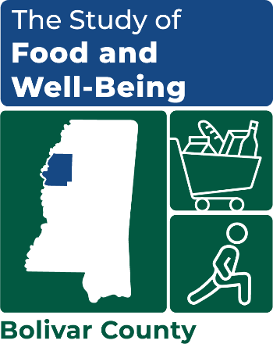

OMB Number: 0584-XXXX

Expiration Date: XX/XX/20XX

[DATE]

[FIRSTNAME] [MIDDLEINITIAL] [LASTNAME]

[TITLE]

[ORGANIZATION]

[ADDRESS 1 / ADDRESS 2]

[CITY, STATE ZIP]

Dear [FIRST NAME] [LAST NAME]:

We would like to invite you to participate in an important study sponsored by the United States Department of Agriculture’s Food and Nutrition Service (FNS), called the **Study of Food and Well-Being**. This study focuses on six counties in the United States that have experienced persistent or long-term poverty and where families often experience poverty for multiple generations. A one-page summary and a brochure about the study is attached.

As part of this study, we are holding a meeting with representatives from approximately eight key service organizations in [NAME OF COUNTY] that provide assistance or services to families experiencing poverty, food insecurity, or hunger. Our study will greatly benefit from your organization’s deep, first-hand knowledge of the economic and social conditions of your community, the challenges and strengths of the families you serve, and issues surrounding the availability of and access to services in this community.

This meeting will take place for 90 minutes. The meeting will be designed to facilitate a robust discussion and thoughtful exchange of ideas and opinions. You will be asked to share your knowledge and insights about conditions in the community that contribute to persistent poverty and food insecurity in [NAME OF COUNTY], availability of services for families in need, barriers to accessing services, and gaps in services and resources. This information will help us better understand your community and the experiences of the families you serve, which will help FNS improve programs and services related to food assistance.

We would like to hold this meeting during the week of [MONTH/WEEK] when members of the study team will be in [NAME OF COUNTY]. Below are three different times that our team will be available to conduct the focus group.

* **Option 1.** [DAY, DATE, x:xx – x:xx am/pm TIMEZONE]
* **Option 2.** [DAY, DATE, x:xx – x:xx am/pm TIMEZONE]
* **Option 3.** [DAY, DATE, x:xx – x:xx am/pm TIMEZONE]

Kindly respond if you would be interested in participating in this study by emailing [STUDY TEAM MEMBER] at [XXXX@mathematica-mpr.com]. Please include in your email which time options (1-3) would work well for you. We will pick the time that works best for the most people and follow up with you by [TIMEFRAME] about your participation and to share the final date, time, and location of the meeting. Thank you in advance for your cooperation and support of this important study.

Sincerely,

Pamela Holcomb

Principal Researcher

This information is being collected to assist the Food and Nutrition Service (FNS) in understanding the interrelated factors that affect food insecurity and poverty. This is a voluntary collection and FNS will use the information to aid in the administration of the Supplemental Nutrition Assistance Program. This collection does request personally identifiable information under the Privacy Act of 1974. According to the Paperwork Reduction Act of 1995, an agency may not conduct or sponsor, and a person is not required to respond to, a collection of information unless it displays a valid OMB control number. The valid OMB control number for this information collection is 0584-[xxxx]. The time required to complete this information collection is estimated to average 1 minute (0.0167 hours) per response, including the time for reviewing instructions, searching existing data sources, gathering and maintaining the data needed, and completing and reviewing the collection of information. Send comments regarding this burden estimate or any other aspect of this collection of information, including suggestions for reducing this burden, to: U.S. Department of Agriculture, Food and Nutrition Service, Office of Policy Support, 1320 Braddock Place, 5th Floor, Alexandria, VA 22306 ATTN: PRA (0584-xxxx). Do not return the completed form to this address.