**Appendix C1. Survey Invitation (English)**

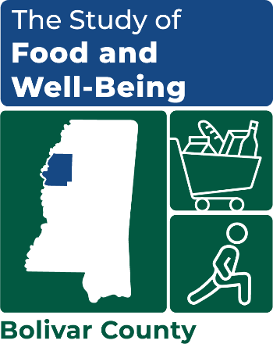

OMB Number: 0584-XXXX

Expiration Date: XX/XX/20XX

NOTE TO OMB REVIEWERS: Survey recruitment materials will display county-specific graphical art. Bolivar County is included on materials for illustrative purposes.

Dear [resident/SNAP Name],

We need your help! Your household was randomly selected to participate in an important study in [COUNTY] County for the U.S. Department of Agriculture, **the Study of Food and Well-Being.** [COUNTY] County is one of only six counties in the whole country invited to participate in this study. **We cannot replace you—your viewpoint matters!**If you agree to share your perspective, you will be asked to complete a survey about your household’s food-related experiences, benefits you may receive, and your overall health and well-being.

* **The survey should be completed by the adult who does most of the planning or preparing of meals for your household.**
* **If eligible, you will receive a $35 Visa gift card after you complete the** **35 minute survey.**

Please do one of three things to make your voice heard:

|  |  |  |
| --- | --- | --- |
| **Participate NOW Online**  **Scan this QR Code with your phone** | **Participate NOW by Phone** | **Participate Later – with Community Worker** |
| [**www.surveylink.com**](http://www.surveylink.com)  **Username:** [USERNAME]  **Password:** [PASSWORD] | **Call toll-free at:**  **1-XXX-XXX-XXXX** | **A representative from the**  **Mathematica research**  **team will visit you**  [www.mathematica.org/studywebsite](http://www.mathematica.org/studywebsite) |

Your participation is voluntary, but very important. We are required by law to protect and keep your data private[1]. Your decision to participate will not affect any benefits that you or your household may receive.

A study brochure and **$5 cash** are included with this letter. If you have any questions or need assistance with accessing the web survey, please call us toll-free at 1-XXX-XXX-XXXX.

Sincerely,

*---insert signature image here---*

Kim McDonald

Survey Director

This information is being collected to assist the Food and Nutrition Service (FNS) in understanding the interrelated factors that affect food insecurity and poverty. This is a voluntary collection and FNS will use the information to aid in the administration of the Supplemental Nutrition Assistance Program. This collection does request personally identifiable information under the Privacy Act of 1974. According to the Paperwork Reduction Act of 1995, an agency may not conduct or sponsor, and a person is not required to respond to, a collection of information unless it displays a valid OMB control number. The valid OMB control number for this information collection is 0584-[xxxx]. The time required to complete this information collection is estimated to average 2 minutes (0.0334 hours) per response, including the time for reviewing instructions, searching existing data sources, gathering and maintaining the data needed, and completing and reviewing the collection of information. Send comments regarding this burden estimate or any other aspect of this collection of information, including suggestions for reducing this burden, to: U.S. Department of Agriculture, Food and Nutrition Service, Office of Policy Support, 1320 Braddock Place, 5th Floor, Alexandria, VA 22306 ATTN: PRA (0584-xxxx). Do not return the completed form to this address.

1. As described in the system of records notice (SORN) titled FNS 8 USDA/FNS Studies and Reports (published in the Federal Register on April 25, 1991, volume 56, pages 19078 – 19080), FNS and contractors working on their behalf may collect and analyze this survey information for research purposes and are required to have safeguards in place to keep data private.