**Appendix M1. IDI Confirmation Letter/Email (English)**

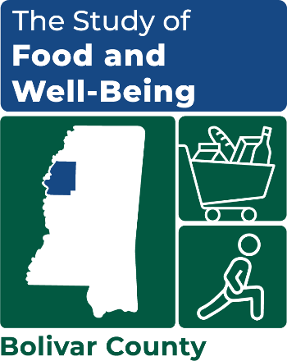

OMB Number: 0584-XXXX

Expiration Date: XX/XX/20XX

[DATE]

[FIRSTNAME] [MIDDLEINITIAL] [LASTNAME]

[TITLE]

[ORGANIZATION]

[ADDRESS 1 / ADDRESS 2]

[CITY, STATE ZIP]

Dear [FIRST NAME],

Thank you again for agreeing to participate in an [in-person] discussion for the Study of Food and Well-Being. We greatly appreciate your interest in this important study and are looking forward to hearing more about your experiences.

Your [in-person] discussion is scheduled for [MM/DD @ HH:MM – HH:MM]. [You will meet our interviewer at the [LOCATION], located at [ADDRESS].] Your interviewer will give you a call 1-2 days before the scheduled interview to introduce themselves and confirm the interview time and location. [On the day of the discussion, an interviewer will be waiting to greet you at [LOCATION] a few minutes before [INTERVIEW START TIME].]

The discussion will take up to 2 hours. As a reminder, your participation in this study is completely voluntary and we will provide you with a $50 gift card as a token of our appreciation for your participation.

If your schedule changes or you have any questions, please call me at [PHONE NUMBER] or email me at [EMAIL]. If no one answers when you call, you can leave a message with you name and reason for calling and we’ll call you back on the number you provided. Thank you again and we look forward to speaking with you on [MM/DD]

Sincerely,

Pamela Holcomb

Principal Researcher

This information is being collected to assist the Food and Nutrition Service (FNS) in understanding the interrelated factors that affect food insecurity and poverty. This is a voluntary collection and FNS will use the information to aid in the administration of the Supplemental Nutrition Assistance Program. This collection does request personally identifiable information under the Privacy Act of 1974. According to the Paperwork Reduction Act of 1995, an agency may not conduct or sponsor, and a person is not required to respond to, a collection of information unless it displays a valid OMB control number. The valid OMB control number for this information collection is 0584-[xxxx]. The time required to complete this information collection is estimated to average 1 minute (0.0167 hours) per response, including the time for reviewing instructions, searching existing data sources, gathering and maintaining the data needed, and completing and reviewing the collection of information. Send comments regarding this burden estimate or any other aspect of this collection of information, including suggestions for reducing this burden, to: U.S. Department of Agriculture, Food and Nutrition Service, Office of Policy Support, 1320 Braddock Place, 5th Floor, Alexandria, VA 22306 ATTN: PRA (0584-xxxx). Do not return the completed form to this address.