Appendix I.6. Study Announcement for Local Community Partners in Spanish
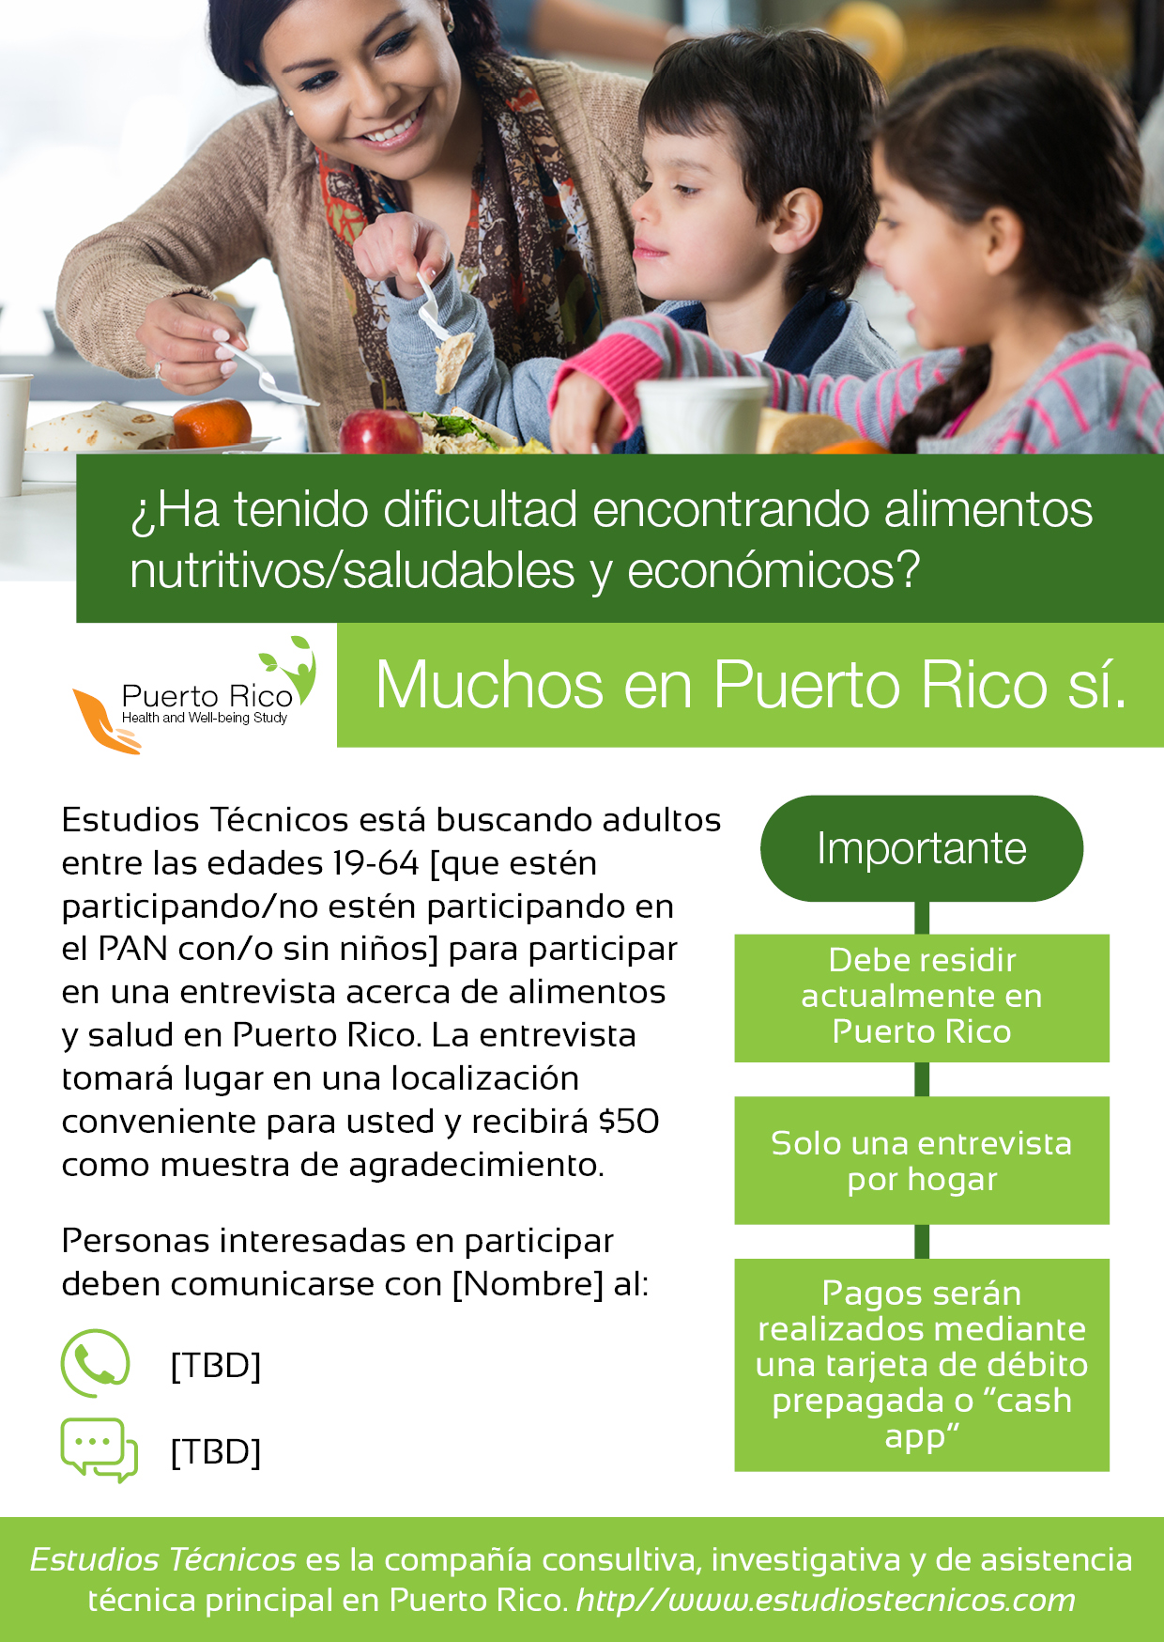

Declaración de Carga Pública
Esta información está siendo recopilada para asistir al Servicio de Alimentos y Nutrición (FNS, por sus siglas en inglés) en comprender el estado de seguridad alimentaria y el bienestar económico entre los residentes de Puerto Rico. Esta es una recopilación voluntaria. FNS utilizará la información como base para futuras evaluaciones de seguridad alimentaria y el Programa de Asistencia Nutricional, particularmente en el contexto de desastres naturales. Esta recopilación no solicita información de identificación personal bajo la Ley de Privacidad de 1974 (Privacy Act of 1974). De acuerdo con la Ley de Reducción de Trámites de 1995 (Paperwork Reduction Act of 1995), una agencia no puede realizar o patrocinar, y una persona no está obligada a responder a una recopilación de información a menos que demuestre un numero de control válido de la OMB. El número de control válido de la OMB para esta recopilación de información es 0584-XXXX. El tiempo requerido para leer esta información se estima en un promedio de 1 minuto. Envíe sus comentarios con respecto a este estimado de carga o cualquier otro aspecto de esta recopilación de información, incluyendo sugerencias para reducir esta carga a: U.S. Department of Agriculture, Food and Nutrition Service, Office of Policy Support, 1320 Braddock Place, Alexandria, VA 22314. ATTN: PRA (0584-XXXX). No devuelva el formulario completado a esta dirección.

