Focus Group Confirmation Letter
OMB # 0596-0078
Expiration date: to be updated

Paperwork Reduction Act Notice
A Federal agency may not conduct or sponsor, and a person is not required to respond to, nor shall a person be subject to a penalty for failure to comply with an information collection subject to the requirements of the Paperwork Reduction Act of 1995 unless the information collection has a currently valid OMB Control Number. The approved OMB Control Number for this information collection is 0596-0078. Without this approval, we could not conduct this survey. Public reporting for this information collection is estimated to be approximately 2 minutes per response, including the time for reviewing instructions, searching existing data sources, gathering and maintaining the data needed, and completing and reviewing the information collection. All responses to this information collection are voluntary. Send comments regarding this burden estimate or any other aspect of this information collection, including suggestions for reducing this burden to the U.S.D.A. Forest Service email address SM.FS.InfoCollect@usda.gov and include the OMB Control Number in the subject line.

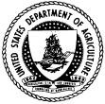
Forest

Service

United States

Department of Agriculture

Dear Landowner:
This letter is confirming your participation in the focus group on <DATE> at <TIME> at the <PLACE> to discuss your [public land/tribal land]. You will be asked to share your opinions and ideas with others like yourself. The discussion will last approximately two hours and you would be paid $75 for your time and cooperation. Light food (sandwich platters) and refreshments will be provided.
We greatly appreciate your valuable assistance. If you have any questions please call us toll-free at 1-855-233-3372, visit our website at www.fia.fs.usda.gov/nwos/, or write us at USDA Forest Service, National Woodland Owner Survey, 160 Holdsworth Way, Amherst MA 01003.
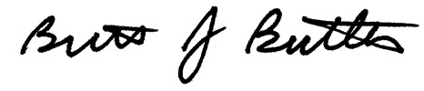
Brett J. Butler, Survey Director

