2020 CQR-E-01
OMB Control No. 0679-0879

<Entity Name>
<Entity ID>

<Subject: Announcing the 2020 Census Count Question Resolution operation (CQR)>

FROM THE ASSOCIATE DIRECTOR FOR
DECENNIAL CENSUS PROGRAMS

The U.S. Census Bureau is conducting the 2020 Census Count Question Resolution operation (CQR) between January 3, 2022 and June 30, 2023. The 2020 Census CQR provides tribal, state, and local officials, or their designated representatives in the United States and Puerto Rico, an opportunity to request a review of their 2020 Census housing counts.

Please refer to the attached 2020 Census CQR flyer for a summary of this voluntary operation. For details on the operation, refer to the Federal Register Notice on the CQR website at <www.census.gov/programs-surveys/decennial-census/decade/2020/planning-management/evaluate/cqr.html>. The website also includes other helpful information about the 2020 Census CQR.

If you have any questions about this email, please contact the CQR Help Desk by phone at
1-(888) 369-3617 or by email at <dcmd.2020.cqr.submissions@census.gov>.

Sincerely,

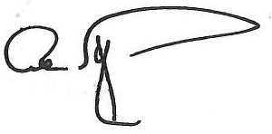

Albert E. Fontenot, Jr.
Associate Director for
Decennial Census Programs

Attachment

