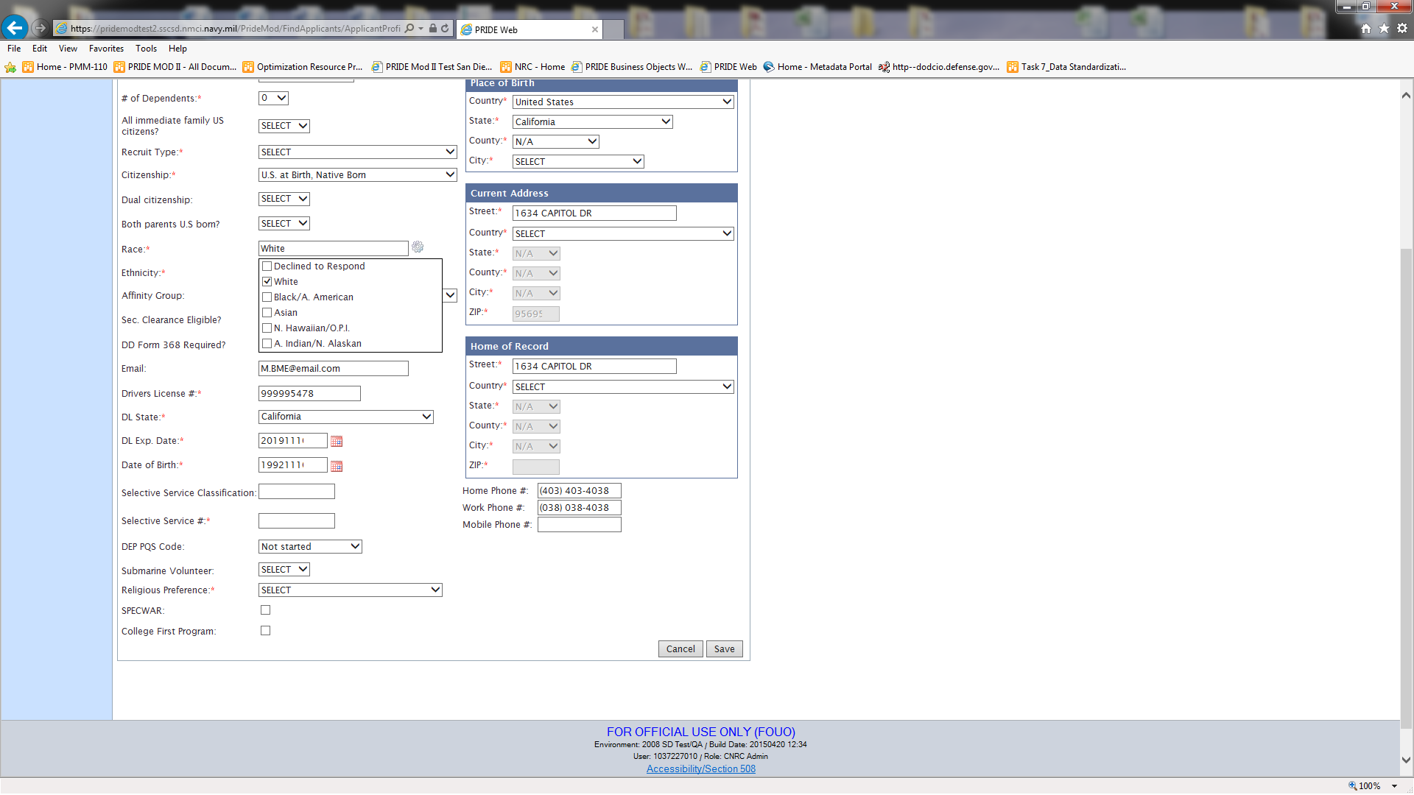
Here is the Race drop down expanded. These can be one or many which then translates to the 32 Race Code table.
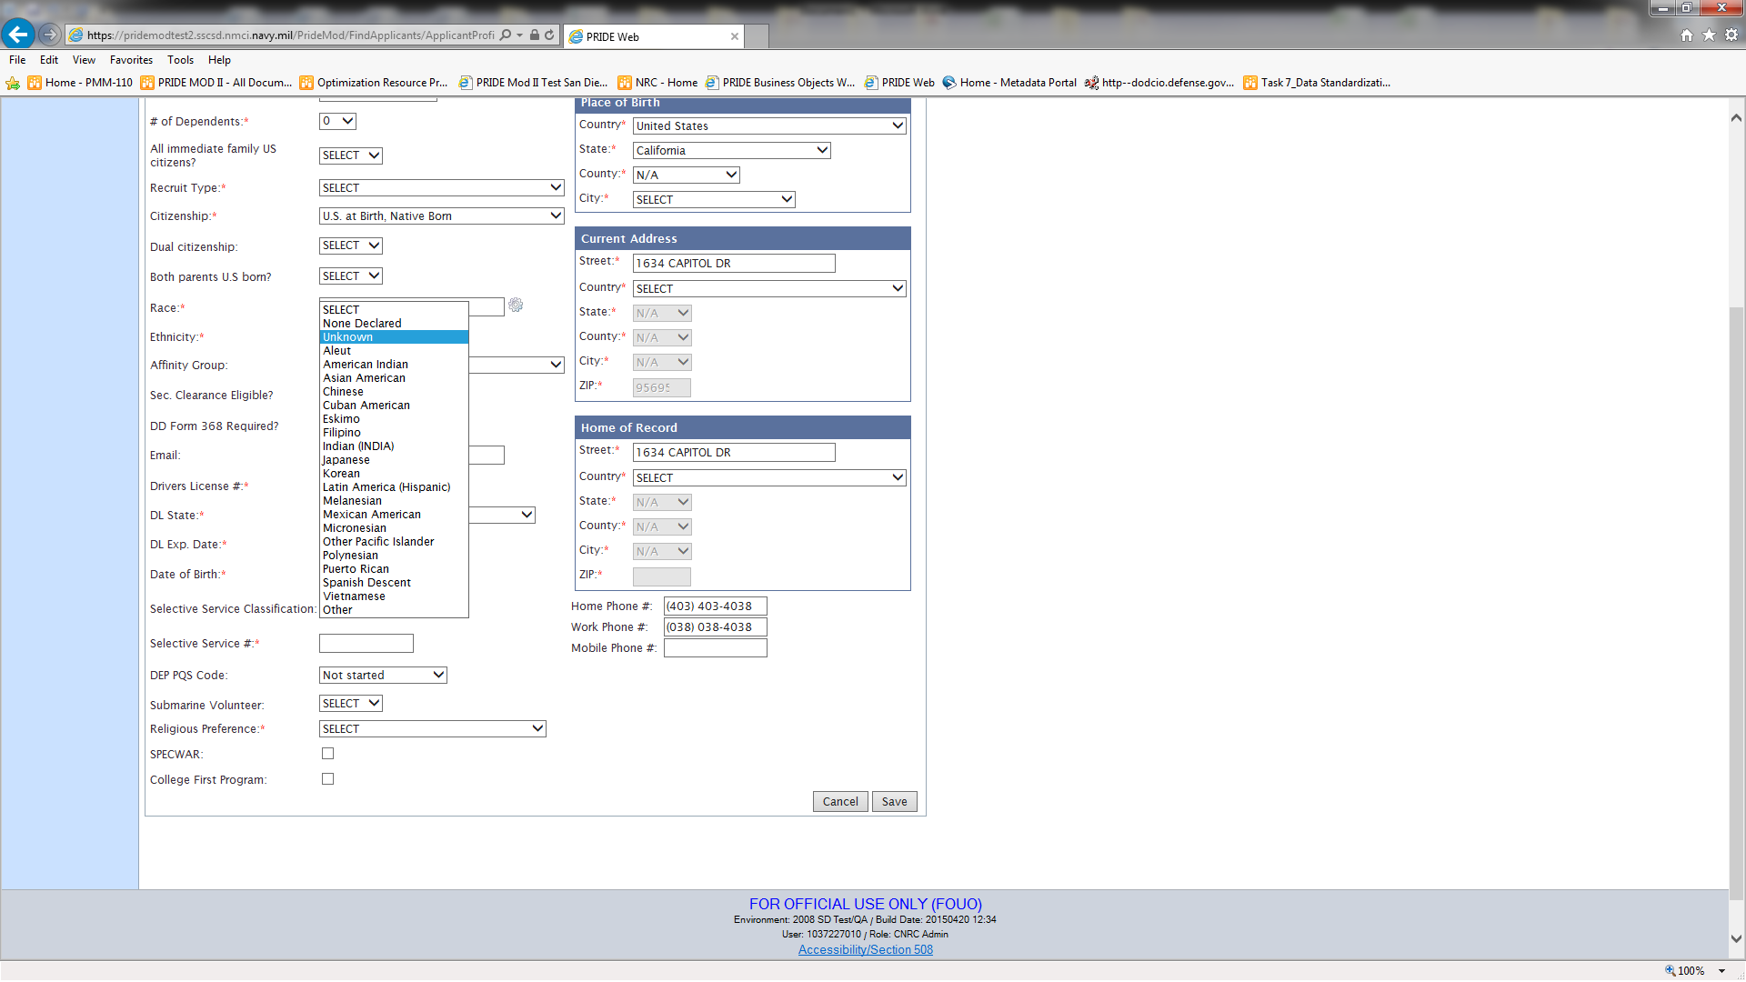
Here is the Ethnicity drop down with the 22 choices. If you choose: Hispanic, Puerto Rican, Mexican, Cuban or Latin American Hispanic then that answers whether or not an applicant is of Hispanic or Latin American decent.
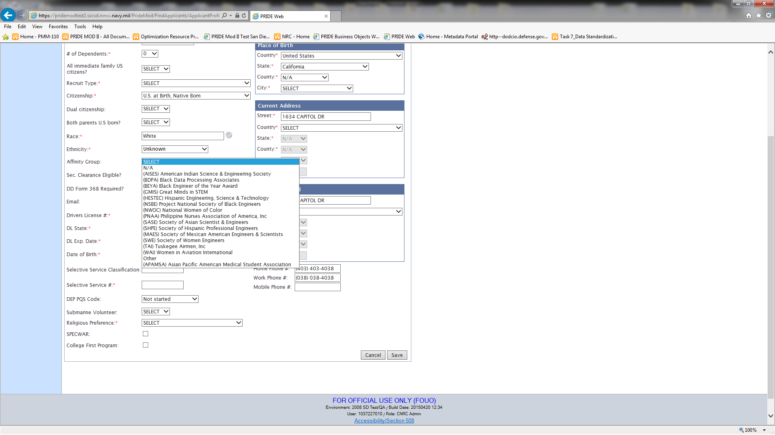
This is the drop down of the Affinity Group choices. These are only used for our Diversity department in order to see if any applicants are affiliated with any of these selected affinity groups.

