U.S. Food and Drug Administration
Center for Tobacco Products

[Text within brackets will not show to participants]

[Appendix E:
In-Depth Interview Questionnaire]
Menthol User Audience Research
Introductory Questionnaire

[Upon joining the Zoom line for interviews, participants will be asked to complete a short questionnaire about their history of menthol cigarette use. Participants will be directed to let the moderator know when they have finished this questionnaire and will continue with the interview.]

Thank you for your participation in this brief survey. We would like to ask you a few questions about tobacco use and demographics.

[Current Smoking]
[CURR_SMK] During the past 30 days, on how many days did you smoke cigarettes?

__days [RANGE = 0-30]

[ASK IF CURR_SMK = 1-30]
[CPD_ALL] On average, on those [FILL IN NUMBER OF DAYS] days, how many cigarettes did you usually smoke each day? A pack usually has 20 cigarettes in it. [Source: PATH W6 Adult]

__ Cigarettes per day

[Age of Initiation]
[ASK ALL]
[SMK_AGE] How old were you when you first tried cigarette smoking, even one or two puffs?
__ years old [NUMERIC, WHOLE NUMBERS ONLY]

[Nicotine Dependence]
[ASK IF CURR_SMK = 1-30]
[SMK_WAKE] On the days that you smoke, how soon after you wake up do you have your first cigarette?

- Within 5 minutes
- 6-30 minutes
- 31-60 minutes
- After 60 minutes

[Other Tobacco Product Use]
[PROGRAMMER NOTE: RANDOMIZE ORDER OF ITEMS IN THIS SECTION]
[ASK ALL]
For each of the following tobacco products, please indicate how often you have used the product in the past 30 days.

[Response options: every day, most days, some days, rarely, or not at all.]

[CURR_CIGAR] Large or premium cigars. Some common brands include Macanudo, Romeo y Julieta, and Arturo Fuente, but there are many others.

[Show images of large cigars]

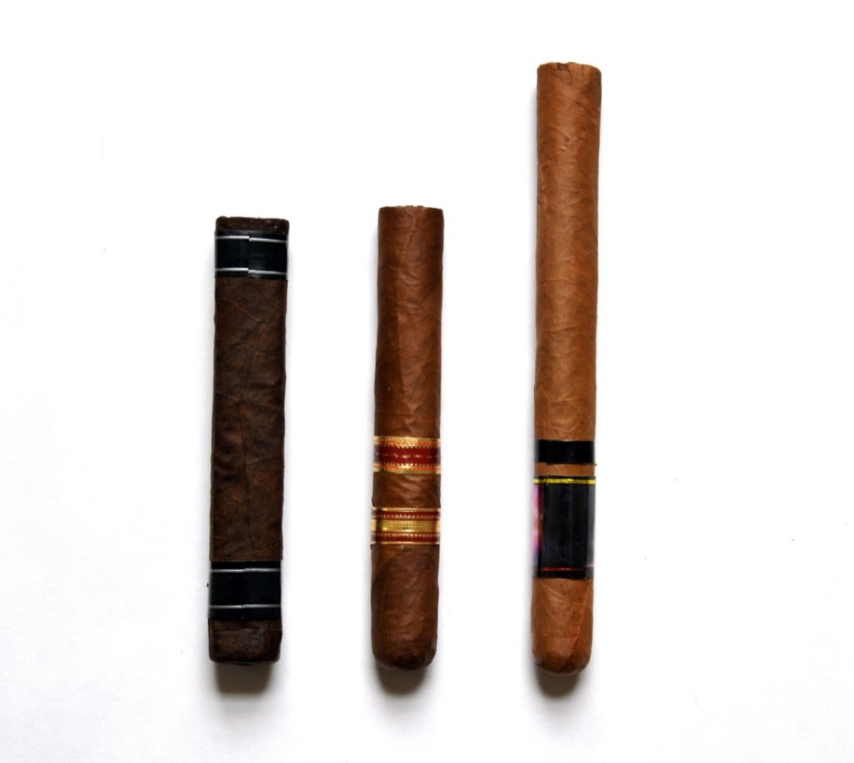

- Every day
- Most days
- Some days
- Rarely
- Not at all

[CURR_CIGARILLO] Cigarillos or little cigars without marijuana. Some common brands of cigarillos are Black and Mild, Swisher Sweets, Backwoods, Dutch Masters, White Owl, and Game Cigars. Some common brands of filtered little cigars are Cheyenne, Djarum, Talon, and 305s.

[Show images of cigarillos and little cigars]

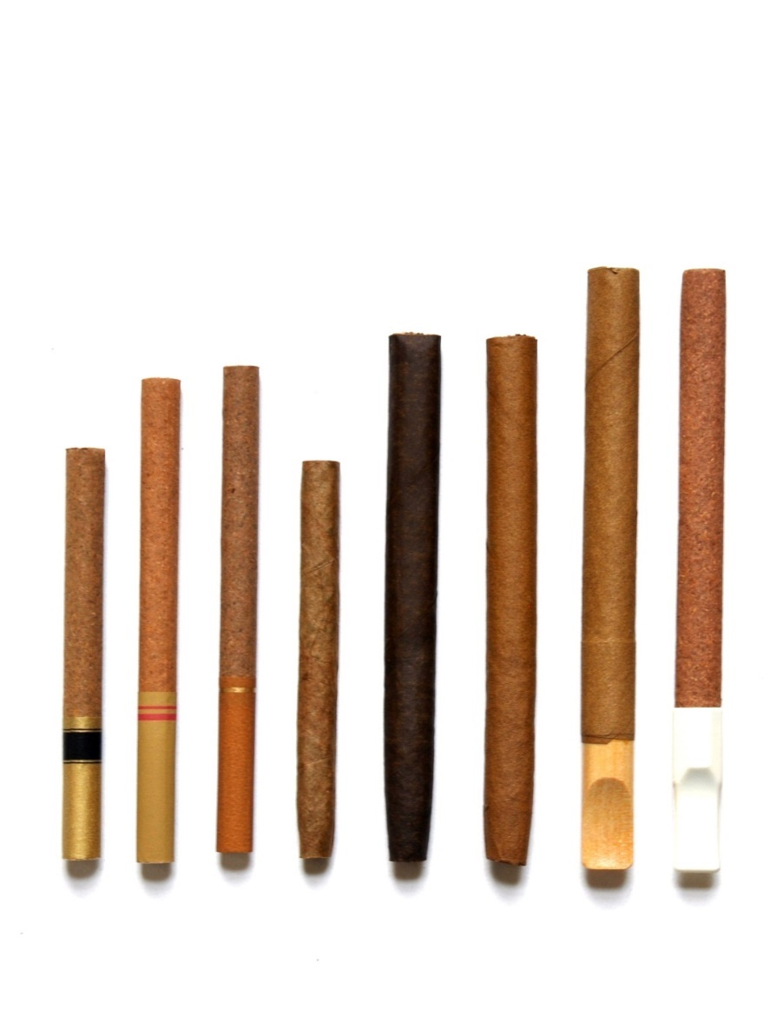

- Every day
- Most days
- Some days
- Rarely
- Not at all

[CURR_BLUNT] Cigarillos or little cigars with marijuana. These may also be known as blunts. Some common brands of cigarillos are Black and Mild, Swisher Sweets, Backwoods, Dutch Masters, White Owl, and Game Cigars. Some common brands of filtered little cigars are Cheyenne, Djarum, Talon, and 305s.

[Show images of cigarillos and little cigars]
- Every day
- Most days
- Some days
- Rarely
- Not at all

[CURR_SLT] Smokeless tobacco, such as chewing tobacco, snuff, snus or dip. Common brands include Copenhagen, Grizzly, Skoal, Camel Snus, Kodiak, and Longhorn.

[Show images of smokeless tobacco]

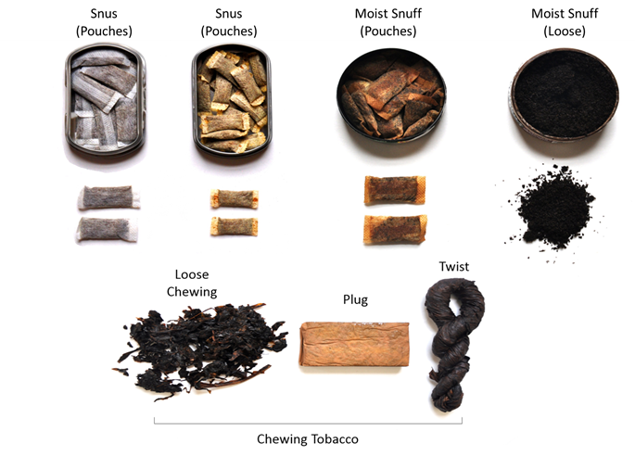

- Every day
- Most days
- Some days
- Rarely
- Not at all

[CURR_ECIG] Vaping products or vapes. You may also know them as e-cigarettes. Some common brans are JUUL, Suorin, and Puff Bar.

[Show images of e-cigarettes]

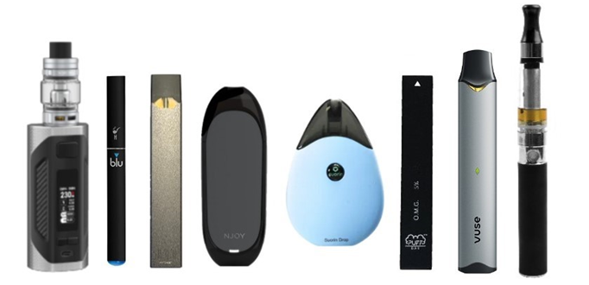

- Every day
- Most days
- Some days
- Rarely
- Not at all

[CURR_HOOK] Water pipe or hookah.

[Show images of water pipe or hookah]
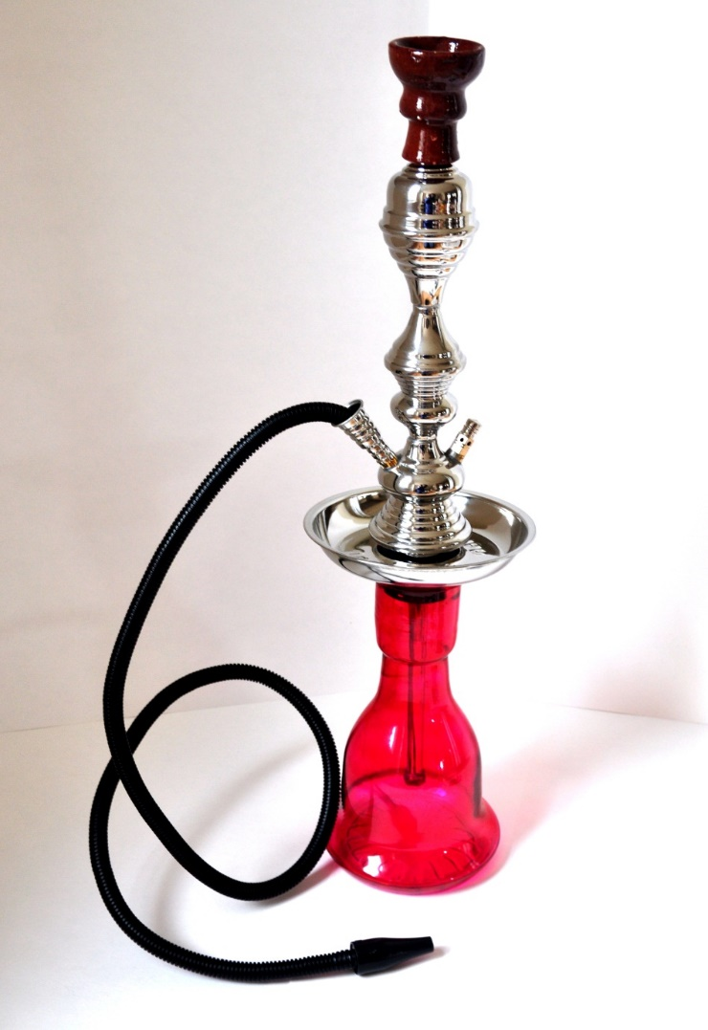

- Every day
- Most days
- Some days
- Rarely
- Not at all

[Household Tobacco Use]
[ASK ALL]
[HTU] Other than you, has anyone who lives with you used any of the following during the past 30 days? Select all that apply.

- Cigarettes
- Large or premium cigars
- Cigarillos or little cigars without marijuana
- Cigarillos or little cigars with marijuana
- Smokeless tobacco, such as chewing tobacco, snuff, snus or dip
- Vaping products or vapes. Also called e-cigarettes.
- Water pipe or hookah
- Any other form of tobacco
- No, no one who lives with me has used any form of tobacco during the past

[Final Screen]

Thank you for responding to these questions. Please let the moderator know that you have finished the questionnaire and are ready to move into the interview.

If you have any questions about this study, you may call Matthew Eggers of RTI at 919-990-8380, or at 1800-334-8571, extension 28380. You may also send an email to meggers@rti.org. If you have any questions about your rights as a study participant, you may call RTI’s Office of Research Protection at 1-866-214-2043.

[Include the statement below in smaller grey font at the bottom of the end of the survey]
Paperwork Reduction Act Statement: According to the Paperwork Reduction Act of 1995, an agency may not conduct or sponsor, and a person is not required to respond to a collection of information unless it displays a valid OMB control number. The valid OMB control number for this information collection is 0910-0796. The time required to complete this information collection is estimated to average 90 minutes per response, including the time for reviewing instructions, searching existing data sources, gathering and maintaining the data needed, and completing and reviewing the collection of information.
Send comments regarding this burden estimate or any other aspects of this collection of information, including suggestions for reducing burden to PRASTAFF@fda.hhs.gov.

