ATTACHMENT 4: PROMISING THEMES LCC SURVEY

Promising THemes LCC SCREENER

NOTE FOR INVESTIGATORS: The Promising Themes Study is designed to identify beliefs or belief categories (themes) that can be used to prevent initiation or progression to established use, or promote quitting, among youth and young adults in relation to four product types: little cigars and cigarillos, vapes, smokeless tobacco, and cigarettes. This work is based on similar studies conducted by Bob Hornik and colleagues. To conduct the data analyses needed to inform future campaigns, surveys must include individuals with a range of substance use behaviors, including 1) current users, 2) non-current users who are susceptible or open to future use, and 3) non-current users who are closed to future use. This screener reflects that need. This screener may be tailored to focus on one, or a subset, of the product types included here.

PROGRAMMER NOTE: FORCE RESPONSES TO ALL SCREENER QUESTIONS.

[SCNR_INTRO]

Welcome to the Unique Minds Survey!

The U.S. Food and Drug Administration (FDA) is developing education programs that will improve the health of youth and young adults.
​
To inform these education programs, the FDA is conducting a survey in partnership with RTI International, a non-profit research organization.
- You are being asked to answer a few questions to see if you are eligible for a study of approximately 1,700 youth and young adults in the United States.
- You may only complete this questionnaire one time.
- It will only take about 3 minutes to see if you are eligible.
- You may only take that survey one time and you will only receive one $5 electronic gift card if you complete it. If we find that you have completed the survey more than once, you may not receive a gift card. Once we complete this check, we will send you a $5 electronic gift card to the email address you provide. The gift card will be sent within 1-2 weeks.
- Your answers to the questions will be kept private to the fullest extent allowable by law and your participation is voluntary. Please read our privacy policy before continuing.

- If you have any questions about the survey, you can contact us at uniqueminds@rti.org

ASK: All respondents

[SCNR_ASSENT]
Do you agree to participate in this survey?
- Yes, I agree to participate in this survey
- No, I do not agree to participate in this survey

ASK: All respondents

[EXIT_1] [IF SCNR_ASSENT = 2]
Thank you for your time.

ASK: Ask respondents who do not provide assent

[LAND] [IF R IS ON MOBILE DEVICE]

It looks like you are viewing this survey on a mobile device. This survey works best in landscape mode. Taking the survey on a mobile device might take longer.

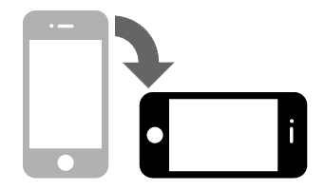

NEXT

ASK: All respondents who access the survey via a mobile device.

[PRIV]
Please make sure that you can answer the questions in private where no one can see your answers.
- Next

ASK: All respondents

[DRIV]
Do not answer the questions while driving.
- Next

ASK: All respondents

[SCNR_INTRO2] [IF FB_AUTH = 1]
The first part of the survey asks a couple general questions about yourself.

ASK: All Respondents

[AGE]
How old are you?

_____________years old [RANGE: 5-100]
99.

ASK: All respondents

[HISPANIC]
Are you Hispanic, Latino/a, or of Spanish origin?
- Yes
- No

ASK: All Respondents
[RACE]
What race or races do you consider yourself to be? (Select all that apply.)

- American Indian or Alaska Native
- Asian
- Black or African American
- Native Hawaiian or Other Pacific Islander
- White

ASK: All Respondents

[RECENT_MEDIA_V2]
Thinking only about yesterday, about how much time did you spend…

 | None | At least one minute, but less than 1 hour | 1 hour or more, but less than 2 hours | 2 hours or more, but less than 3 hours | 3 hours or more
a. Watching TV shows or movies on a TV, desktop or laptop computer, tablet, or smartphone? | 1 | 2 | 3 | 4 | 5
b. Using social media such as Instagram, TikTok, Snapchat, Twitter, or Facebook? | 1 | 2 | 3 | 4 | 5
c. Gaming? | 1 | 2 | 3 | 4 | 5

ASK: All respondents

[CIGARETTE] [IF AGE > 14]
Have you ever tried cigarette smoking, even one or two puffs?
- Yes
- No

ASK: All respondents ages 15+

[VAPE_EVER] [IF AGE >14]
The next question is about vaping products or vapes. You may also know them as e-cigarettes. They can contain nicotine and/or flavors. Some common brands are JUUL, Vuse, Sourin, Puff Bar, Njoy, and blu.

Please do NOT include vaping marijuana/THC/CBD when answering this question.
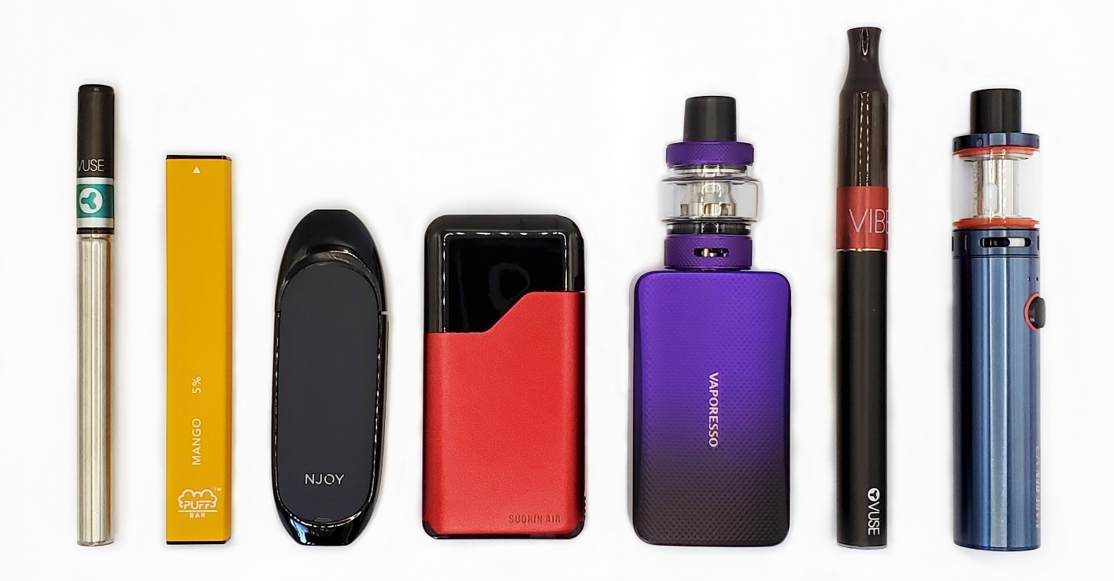
Have you ever tried vaping, even one time?
- Yes
- No

ASK: All respondents ages 15 +.

Blunt ever and current use

[IF AGE >14] The next questions are about the products pictured below. Some common brands are Black & Mild, Swisher Sweets, Backwoods, Dutch Masters, White Owl, and Game, but there are others.

[SHOW IMAGES OF CIGARILLOS]
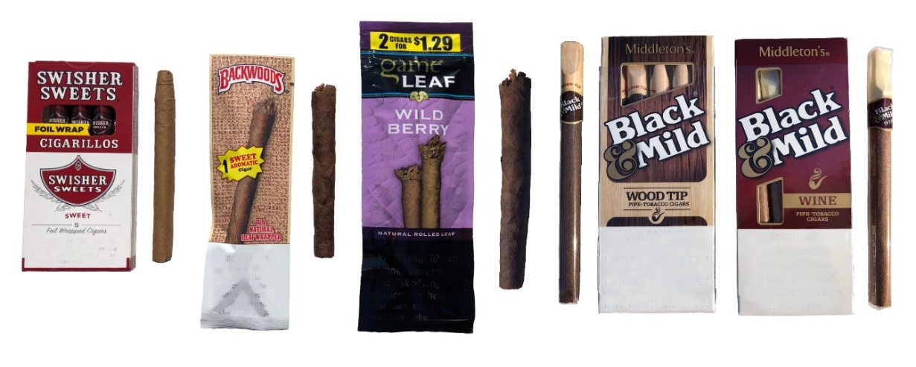

[BLUNT_EV] [IF AGE >14]
Have you ever smoked products like the ones pictured below, even one or two puffs?

The brands pictured are just examples, but there are others such as White Owl and Dutch Masters.
[show picture of tipped and untipped cigarillos]
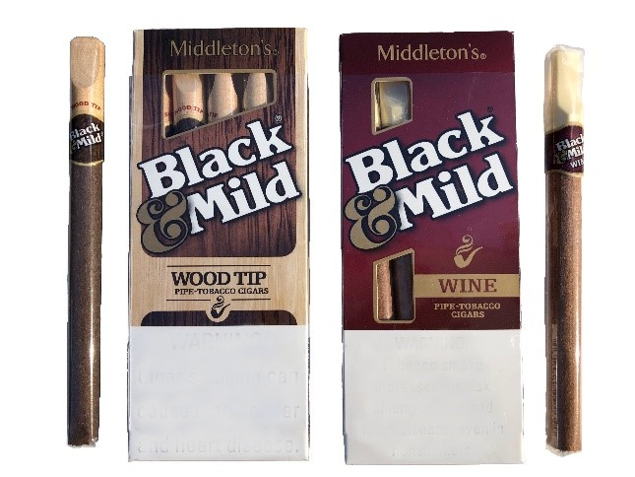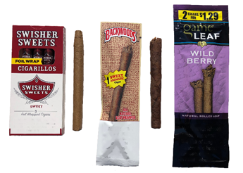
1. Yes
2. No
98. Don’t know
99.

ASK: All respondents ages 15+

[BLUNT_CURR] [IF BLUNT_EV =1 or 99]
During the past 30 days, on how many days did you smoke products like the ones pictured below, even one or two puffs?

The brands pictured are just examples, but there are others, such as White Owl and Dutch Masters.
[INSERT PICTURE OF TIPPED AND UNTIPPED CIGARILLOS]
__________ [0-30 Days]
- Don’t know

ASK: Respondents who ever smoked cigarillos

[TYPE_CURR] [IF AGE>14 AND BLUNT_CURR >0]
When you smoked products like the ones pictured, did you smoke them with marijuana inside?
[INSERT PICTURE OF TIPPED AND UNTIPPED CIGARILLOS]

- Yes, I smoked them with marijuana
- No, I smoked them without marijuana
- I smoked them both ways—sometimes with and sometimes without marijuana
- Don’t know
- Prefer not to answer

ASK: Respondents who currently smoke cigarillos

Susceptibility

[BLUNT_SUSCEPT] [PROGRAMMER: ASK IF AGE > 14]

Please refer to the photo below when answering the following questions. Thinking about the future…

 |  | Definitely Yes | Probably Yes | Probably Not | Definitely Not
a. | Do you think that you will smoke a product like this soon? | ₁ | ₂ | ₃ | ₄
b. | Do you think you will smoke a product like this at any time in the next year? | ₁ | ₂ | ₃ | ₄
c. | If one of your best friends were to offer you a product like this would you use it? | ₁ | ₂ | ₃ | ₄

ASK: Respondents 15+ who have never smoked cigarillos/blunts

[GENDER]
What is your gender identity? [Select all that apply]
- Woman/girl
- Man/boy
- Transgender woman/girl
- Transgender man/boy
- Nonbinary or gender non-conforming
- Another gender identity

ASK: All Respondents

[STATE]
What state do you live in?

[PROGRAMMER note: INCLUDE DROP DOWN LIST OF 50 STATES & WASHINGTON DC. INCLUDE AN OPTION for ‘I don’t live in the United States’. SHOULD APPEAR FIRST IN DROP DOWN. INCLUDE AN OPTION FOR 99. Prefer not to answer. SHOULD APPEAR LAST IN DROP DOWN.]

ASK: All respondents

[ZIP]
What is your zip code?
[OPEN TEXT ALLOW 5 NUMBERS]

ASK: All respondents

[DOB]
What is your date of birth?

Please use the following format (MM/DD/YYYY)
____/______/_______

ASK: All respondents

[EMAIL]
Please enter your email address: _____________________ [OPEN TEXT]

The email address you provide is used only for the purposes of sending you a digital gift card if you qualify and complete the survey in full and will not be sold or shared with anyone outside of the survey team.

ASK: All respondents

[EMAIL_VER] [IF EMAIL ≠ 99]
[PROGRAMMER NOTE: VERIFY EMAIL FORMAT AND THAT BOTH EMAIL ADDRESSES MATCH. Verify that this email was not used IN THE PAST 6 MONTHS.]
Please verify your email address: _____________________

ASK: Respondents who provide an email address in EMAIL

[CHECKPOINT, INCLUDE IF:
- 15-24 years old based on age provided
- 15-24 years old BASED ON DOB
- STATE ≠ I DON’T LIVE IN THE US AND ≠ 99
- Age provided and age calculated by DOB must match
- Provided a valid email address (EMAIL ≠ 99 AND EMAIL_VER = 1)]

[THANK_YOU] [IF FAIL CHECKPOINT CRITERIA]
Thank you for taking the time to take our eligibility screener. Unfortunately, based on your responses, you do not qualify to participate in our survey.

[EXIT]

OMB No: 0910-0810 Expiration Date: 12/31/2024
Paperwork Reduction Act Statement: According to the Paperwork Reduction Act of 1995, an agency may not conduct or sponsor, and a person is not required to respond to a collection of information unless it displays a valid OMB control number. The valid OMB control number for this information collection is 0910-0810. The time required to complete this information collection is estimated to average 3 minutes per response, including the time for reviewing instructions, searching existing data sources, gathering and maintaining the data needed, and completing and reviewing the collection of information. Send comments regarding this burden estimate or any other aspects of this collection of information, including suggestions for reducing burden to PRASTAFF@fda.hhs.gov.

ASK: Participants who fail the inclusion criteria

[CONTINUE] [IF PASS CHECKPOINT CRITERIA]
You are invited to complete our web survey for a $5 electronic gift card. The survey will take about 20 minutes. Please click the “Next” button to continue and take the survey now.
- Next

OMB No: 0910-0810 Expiration Date: 12/31/2024
Paperwork Reduction Act Statement: According to the Paperwork Reduction Act of 1995, an agency may not conduct or sponsor, and a person is not required to respond to a collection of information unless it displays a valid OMB control number. The valid OMB control number for this information collection is 0910-0810. The time required to complete this information collection is estimated to average 3 minutes per response, including the time for reviewing instructions, searching existing data sources, gathering and maintaining the data needed, and completing and reviewing the collection of information. Send comments regarding this burden estimate or any other aspects of this collection of information, including suggestions for reducing burden to PRASTAFF@fda.hhs.gov.

ASK: Respondents who pass the inclusion criteria

PROMISING THEMES STUDY YOUTH AND YOUNG ADULT SURVEY

[CONSENT] [IF SCREENER AGE ≥ 18 OR (STATE = NE/AL & AGE ≥ 19]]
[ATTACHMENT X. PROMISING THEMES STUDY CONSENT FORM]

ASK: All respondents who are 18 years old or older (≥ 19 in NE/AL)

[ASSENT] [IF SCREENER AGE < 18 OR (STATE = NE/AL & AGE < 19)]
[ATTACHMENT X. PROMISING THEMES STUDY ASSENT FORM]

ASK: All respondents who are 15 to 17 years old (<19 in NE/AL)

[CONSENTREF] [IF CONSENT = 2 OR ASSENT = 2]
[PROGRAMMER: CODE AS REFUSAL]
Thank you for your time.

ASK: Respondents who refuse to provide consent or assent.

SECTION A: BELIEFS

[LCC BELIEFS]

[PROGRAM AT THE TOP OF EACH SCREEN]
Our questions are about blunts. We want to hear what you think. There are no right or wrong answers.

[RANDOMIZE ALL QUESTIONS]

Programming note: All items in this section will have the following response options:
- Strongly Disagree
- Disagree
- Neither agree nor disagree
- Agree
- Strongly Agree
- Don’t know
9 Prefer not to answer

If I smoke blunts…

Short term health effects
- I will have headaches.
- I will get a bad cough.
- I will have a hard time breathing.
- I will be more likely to get sick.
- I will have a weakened immune system.

Long term negative health consequences
- I will get heart disease.
- I will get lung cancer or other lung illness.
- I will get cancers like pancreatic, stomach, or bladder cancer.
- I will get throat or mouth cancer.
- I will get gum disease.
- I will develop mouth cancer, even if I don’t inhale.
- It will affect how my brain develops.

[ADD LANGUAGE SHIFTING TO SECTION WITHOUT COMMON STEM]

Self-Efficacy
- I could say no to blunts at a party where most people are smoking them.
- I could say no to blunts if a very close friend offers me one.
- I could say no to blunts when feeling stressed or lonely.

Harms of Wrap
- Blunt wraps are made from tobacco.
- Blunt wraps have nicotine in them.
- Blunt wraps that are made of whole leaf tobacco are harmful.
- If I smoke blunts, I can get addicted to nicotine from the wrap, even if the tobacco filling is removed.
- If I smoke blunts, I will be exposed to toxic chemicals from the wrap even if the tobacco filling is removed.

[SHIFT BACK TO COMMON STEM]
If I smoke blunts…

Secondary effects from anxiety
- I will have trouble sleeping.
- I will have trouble concentrating.
- I will feel irritable.

Self-discrepancy
- I will not live up to my potential.
- I will fall behind on my goals
- I will be letting myself down.

Addiction
- I will not be able to stop even if I want to.
- I will be controlled by nicotine.
- I will become addicted to nicotine.

Nicotine exposure
- I will be exposed to nicotine.
- I will inhale nicotine.
- I will absorb nicotine through my fingers and lips.

Short-term physical fitness effects
- It will hurt my physical fitness.
- It will make exercising much more difficult.
- It will make me get out of breath more easily.

Anxiety from Withdrawal
- I will feel anxious if I go too long without smoking one.
- I will feel stressed if I go too long without smoking one.
- I will feel anxious if I cannot smoke when I want one.

Noxious chemical exposure
- I will be exposed to dangerous ingredients.
- I will have toxic chemicals in my body.
- I will inhale chemicals that can cause serious health problems.

Negative Cosmetic Effects
- I will get wrinkles.
- I will lose my teeth.
- I will get stains on my fingers.
- I will smell bad.

Harm to others
- It will harm others around me.
- It will expose my friends to harmful smoke.
- It will expose my family to harmful smoke.

Gateway and polyuse
- I will be more likely to smoke cigarettes
- I will be more likely to vape nicotine, such as Juul, Vuse, or Puff Bar
- I will be more likely to smoke blunts without marijuana in them. [ASK ONLY AMONG PEOPLE WHO USE BLUNTS WITH MARIJUANA]

Negative family outcomes
- I will be a bad influence on my younger family members.
- I will let my family down.
- It will harm my relationship with my family.

Add negative friend outcomes
- I might let my teammates down. [Programming note: include option “I am not on a team.”]
- I will not fit in with my friends.
- I will be a bad influence on my friends.
- It will harm my relationship with my friends.

[PROGRAMMING NOTE: END OF SECTION WITH COMMON STEM]

Comparison to cigarettes
- Blunts have many of the same harmful chemicals as cigarettes.
- Blunts can be as addictive as cigarettes.
- Blunts contain as much as or more nicotine than cigarettes.

Comparison to vapes
- Blunts have many of the same harmful chemicals as vapes.
- Blunts can be as addictive as vapes.
- Blunts contain as much as or more nicotine than vapes.

Injunctive norms
- Most people who are important to me think that I should not smoke blunts.
- Most of my close friends think it is not OK for me to smoke blunts.
- My family is not OK with me smoking blunts.

Descriptive norms
- Out of every 10 people your age, how many do you think smoke blunts?
Slider bar 0 – 10
- Prefer not to answer

[START OF SECTION WITH ALTERNATIVE CIGARILLO TERM]

If I smoke cigarillos…

Short term health effects
- I will have a hard time breathing
- I will be more likely to get sick
- I will have a weakened immune system

Long term negative health consequences
- I will get lung cancer or other lung illness.
- I will get cancers like pancreatic, stomach, or bladder cancer.
- I will get throat or mouth cancer.
- It will affect how my brain develops.

Addiction
- I will become addicted to nicotine.

Short-term physical fitness effects
- It will make me get out of breath more easily.

Anxiety from Withdrawal
- I will feel anxious if I go too long without smoking.

Noxious chemical exposure
- I will have toxic chemicals in my body.

Negative Cosmetic Effects
- I will get wrinkles

Harm to others
- It will expose my family to harmful smoke

Gateway and polyuse
- I will be more likely to smoke cigarettes

Negative family outcomes
- I will be a bad influence on my younger family members

[END OF COMMON STEM]

Comparison to cigarettes
- Cigarillos have many of the same harmful chemicals as cigarettes.

- Out of every 10 people your age, how many do you think smoke cigarillos?
Slider bar 0 – 10
- Prefer not to answer

[AFTER THE ALTERNATE STEM ITEMS HAVE BEEN ANSWERED, DISPLAY THESE QUESTIONS:]

- When you were answering these questions about blunts, what were you thinking about?

- I was thinking about blunts filled with just tobacco
- I was thinking about blunts with marijuana added
- I was thinking about both: blunts with just tobacco and blunts with marijuana added
- Something else: _________
- Don’t Know
- Prefer not to answer

- When you were answering these questions about cigarillos, what were you thinking about?
- I was thinking about cigarillos filled with just tobacco
- I was thinking about cigarillos with marijuana added
- I was thinking about both cigarillos with just tobacco and cigarillos with marijuana added
- Something else: __________
- Don’t Know
- Prefer not to answer

[IF ANY ITEM IS LEFT UNANSWERED, THE ERROR MESSAGE SHOULD SAY “PLEASE PROVIDE AN ANSWER TO THIS QUESTION. IF YOU WOULD PREFER NOT TO ANSWER, PLEASE SELECT THE OPTION ‘PREFER NOT TO ANSWER.’” IN LOWERCASE LETTERS.]

ASK: All respondents.

SECTION B: other substance use

[A_INTRO]
This section asks about your experiences with cigarettes, vapes, and marijuana.
- Next

ASK: All respondents

Cigarettes
[A1] [IF CIGARETTE=1 OR 99]
During the past 30 days, on how many days did you smoke cigarettes?
- 0 days
- 1 or 2 days
- 3 to 5 days
- 6 to 9 days
- 10 to 19 days
- 20 to 29 days
- All 30 days
- Prefer not to answer

ASK: Ever cigarette users

Vapes
[IF VAPE_USE = 1 OR 99]
The next question is about vaping products or vapes. You may also know them as e-cigarettes. They can contain nicotine and/or flavors. Some common brands are JUUL, Vuse, Sourin, Puff Bar, Njoy, and Blu.
[A2]
During the past 30 days, on how many days did you vape?
- __________ [0-30 Days]
- Prefer not to answer

ASK: Ever vape users

[MJ] How have you used marijuana in the past 30 days? (Select all that apply)
- I have not used marijuana in the past 30 days [EXCLUSIVE]
- Smoked marijuana in a blunt
- Smoked marijuana in a joint, spliff, pipe, bong, or waterpipe
- Vaped marijuana (like hash oil, marijuana concentrates, or dried marijuana flower)
- Used marijuana another way (please specify: __________________)
- Prefer not to answer
ASK: All respondents

SECTION C: ENVIRONMENT

[ENV_1]
Other than you, has anyone who lives with you used any of the following during the past 30 days?

Select all that apply.

- Blunts or cigarillos filled with just tobacco
- Blunts or cigarillos with marijuana added
- Marijuana in any form other than blunts
- Vapes
- Smokeless tobacco (chewing tobacco, snuff, or dip)
- Cigarettes
- Tobacco out of a water pipe (also called “hookah”)
- Any other form of tobacco
- No, no one who lives with me has used any of these during the past 30 days
- Don’t know
- Prefer not to answer

ASK: All respondents

[ENV_2] [IF AGE = 15 – 17]
To keep my friends, I’d even do things I don’t want to do.
- Strongly disagree
- Disagree
- Neither agree nor disagree
- Agree
- Strongly agree
- Prefer not to answer

ASK: All respondents

[ENV_3]
Thinking about your mental health, which includes stress, depression, and anxiety, for how many days during the past 30 days was your mental health not good?
_____ Number of days [RANGE: 0-30]
98. Don’t know
99. Prefer not to answer

ASK: All respondents

[MH_INFO] IF ENV_3 ≥1
If you feel that you're in a crisis, whether or not you're thinking about hurting yourself, the National Suicide Prevention Lifeline can help. Call 800-273-TALK (8255) to reach a skilled, trained counselor anytime, 24/7. They can help with substance abuse, relationship and family problems, sexual orientation, money worries, recovering from abuse, depression, mental and physical illness, and even loneliness.

ASK: Respondents with one or more bad mental health days

SECTION D: DEMOGRAPHICS AND CLOSING

[EDUCATION]

D_1.
[IF AGE = 15-18:] What grade are you currently in? If school is not in session, what grade are you going into?
- Grade 7 or lower
- Grade 8
- Grade 9
- Grade 10
- Grade 11
- Grade 12
- In college or technical school
- Out of school
- Prefer not to answer
ASK: Ages 15-18

D_2. [IF AGE = 19-24:] What is the highest level of education you have completed?
1. Grade/elementary school
2. Middle school
3. High school/GED
4. College or technical school
5. Graduate school
- Prefer not to answer

ASK: Ages 19-24

D_3. [IF AGE 19-24]: Are you currently a student, either full or part time?
      - Yes
      - No
- Prefer not to answer
ASK: Ages 19-24

EMPLOYMENT
D_4.
Do you currently have a job, either full or part time?
- Yes
- No
- Prefer not to answer

ASK: All respondents

[VERIFY]
D_5.
Including this one, how many surveys about tobacco have you taken in the past six months?

__________ [RANGE: 1-10]
- Prefer not to answer

ASK: All respondents

[COMMNT]
Thank you for completing the survey. Please enter any comments that you have about the survey.

______________________ PROGRAMMER: PROGRAM OPEN ENDED ITEM WITH 2000 CHARACTER LIMIT. MAKE ITEM OPTIONAL.
- Next

ASK: All respondents

[THANKS]
To thank you for completing the survey, you will receive an electronic gift card for $5 to the email address you provided earlier. If you would like to decline receiving this payment, you can select “No” to continue to the next screen.

Would you like to receive this gift card?
- Yes
- No

ASK: All respondents

[CARD] [IF THANKS=1]
We will send you a $5 electronic gift card to the email address you provided within 1-2 weeks.

ASK: Participants who indicate they would like to receive a gift card.

[CLOSE]
Thank you again for your participation. You may now close your browser or navigate away from this page.

OMB No: 0910-0810 Expiration Date: 12/31/2024
Paperwork Reduction Act Statement: According to the Paperwork Reduction Act of 1995, an agency may not conduct or sponsor, and a person is not required to respond to a collection of information unless it displays a valid OMB control number. The valid OMB control number for this information collection is 0910-0810. The time required to complete this information collection is estimated to average 20 minutes per response, including the time for reviewing instructions, searching existing data sources, gathering and maintaining the data needed, and completing and reviewing the collection of information. Send comments regarding this burden estimate or any other aspects of this collection of information, including suggestions for reducing burden to PRASTAFF@fda.hhs.gov.

ASK: All respondents

