Little Cigar, Cigarillo, and Blunt Use Audience Insights Study
Survey Instrument

SURVEY

Cigarillo use

[FIL_EV]

The next questions are about little cigars. Little cigars contain tobacco, are the same size and shape as cigarettes, and often include a filter. The brand pictured below — Djarum — is just an example, but there are others, like Cheyenne, Talon, and 305s.

Have you ever smoked little cigars, even one or two puffs?

[INSERT PICTURE OF LITTLE CIGARS]
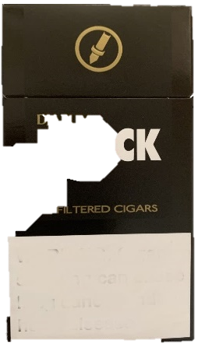

1. Yes
2. No
99. Prefer not to answer

ASK: All respondents

[FIL_CURR] [IF FIL_EV=1 or 99]
During the past 30 days, on how many days did you smoke little cigars, even one or two puffs?

The brand pictured below — Djarum — is just an example, but there are others, like Cheyenne, Talon, and 305s.

[INSERT PICTURE OF LITTLE CIGARS]
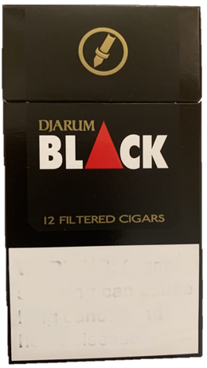

__________days [RANGE 0-30]
- Prefer not to answer

ASK: Respondents who ever smoked filtered cigars or PNTA

[FIL_SUSCEPT] [PROGRAMMER: ASK IF (FIL_EV=2) OR (FIL_EV=1 AND FI_CURR=0)]
Thinking about the future…
 |  | Definitely Yes | Probably Yes | Probably Not | Definitely Not | PNTA
a. | Do you think that you will smoke a little cigar soon? | ☐₁ | ☐₂ | ☐₃ | ☐₄ | ☐₉₉
b. | Do you think you will smoke a little cigar at any time in the next year? | ☐₁ | ☐₂ | ☐₃ | ☐₄ | ☐₉₉
c. | If one of your best friends were to offer you a little cigar, would you use it? | ☐₁ | ☐₂ | ☐₃ | ☐₄ | ☐₉₉

ASK: Never filtered cigar users and ever/non-current users

[TIP_EV]

The next few questions are about tipped cigarillos that come with a plastic or wooden tip. The brand pictured below—Black & Mild—is just an example, but there are others.

Please do not include marijuana or blunt use when answering this question.

Have you ever smoked tipped cigarillos, even one or two puffs?

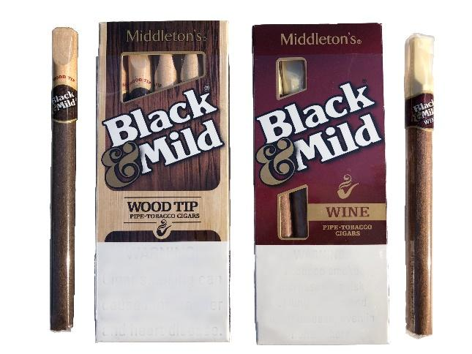
[INSERT PICTURE OF TIPPED CIGARILLOS]

1. Yes
2. No
99. Prefer not to answer

ASK: All respondents

[TIP_CURR] [IF TIP_EV =1 or 99]
During the past 30 days, on how many days did you smoke tipped cigarillos, even one or two puffs?

The brand pictured—Black & Mild—is just an example, but there are others.

Please do not include marijuana or blunt use when answering this question.

[INSERT PICTURE OF TIPPED CIGARILLOS]

__________ days [RANGE 0-30]
- Prefer not to answer

ASK: Respondents who ever smoked tipped cigarillos or PNTA

[TIP_FIRST_USE] [IF TIP_CURR = 1-30]
How old were you when you first tried a tipped cigarillo, even one or two puffs?
Please do not include marijuana or blunt use when answering this question.

_____________years old [RESPONSE =< AGE]
- Prefer not to answer

ASK: Current tipped cigarillo users

[TIP_SUSCEPT] [IF (TIP_EV=2) OR (TIP_EV=1) AND TIP_CURR=0)]

Please do not include marijuana or blunt use when answering these questions.

Thinking about the future…
 |  | Definitely Yes | Probably Yes | Probably Not | Definitely Not | PNTA
a. | Do you think that you will smoke a tipped cigarillo soon? | ☐₁ | ☐₂ | ☐₃ | ☐₄ | ☐₉₉
b. | Do you think you will smoke a tipped cigarillo at any time in the next year? | ☐₁ | ☐₂ | ☐₃ | ☐₄ | ☐₉₉
c. | If one of your best friends were to offer you a tipped cigarillo, would you use it? | ☐₁ | ☐₂ | ☐₃ | ☐₄ | ☐₉₉

ASK: Never tipped cigarillo users and ever/non-current users

[UNTIP_EV]

The next few questions are about cigarillos without a tip or untipped cigarillos. The brands pictured below — Backwoods, Swisher Sweets, and Dutch Masters — are just examples, but there are others, such as White Owl and Game.

When answering this question, please think about your use without marijuana – that is, an untipped cigarillo with the tobacco still in it.

Have you ever smoked untipped cigarillos, even one or two puffs?

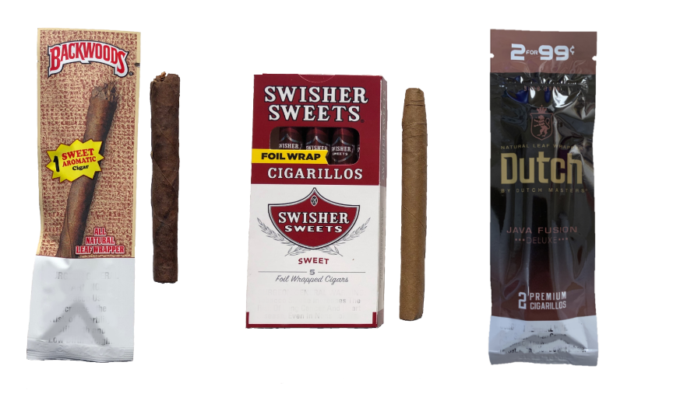
[INSERT PICTURE OF UNTIPPED CIGARILLOS]

1. Yes
2. No
99. Prefer not to answer

ASK: All respondents
[UNTIP_CURR] [IF UNTIP_EV=1 or 99]
During the past 30 days, on how many days did you smoke untipped cigarillos, even one or two puffs?

The brands pictured — Backwoods, Swisher Sweets, and Dutch Masters — are just examples, but there are others, like White Owl and Game.

When answering this question, please think about your use without marijuana – that is, an untipped cigarillo with the tobacco still in it.

[INSERT PICTURES OF UNTIPPED CIGARILLOS]
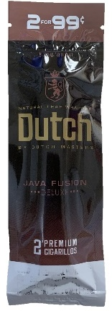
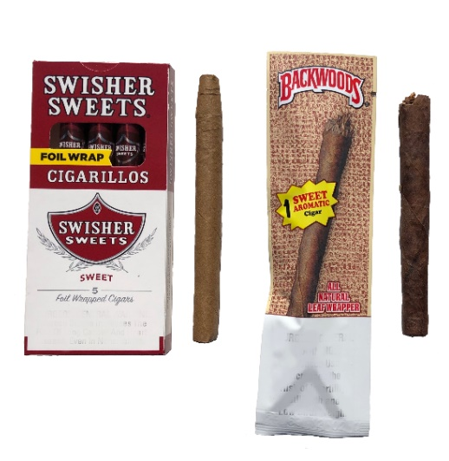

__________ days [0-30 Days]
99. Prefer not to answer

ASK: Respondents who have ever smoked untipped cigarillos or PNTA

[UNTIP_FIRST_USE] [IF TIP_CURR OR UNTIP_CURR = 1-30]
How old were you when you first tried an untipped cigarillo, even one or two puffs?

When answering this question, please think about your use without marijuana – that is, an untipped cigarillo with the tobacco still in it.

_____________years old [RESPONSE =< AGE]
- Prefer not to answer

ASK: Current untipped cigarillo users

[UNTIP_SUSCEPT] [IF (UNTIP_EV=2) OR (UNTIP_EV=1 AND UNTIP_ CURR=0)]

When answering this question, please think about your use without marijuana – that is, an untipped cigarillo with the tobacco still in it.

Thinking about the future…
 |  | Definitely Yes | Probably Yes | Probably Not | Definitely Not | PNTA
a. | Do you think that you will smoke an untipped cigarillo soon? | ☐₁ | ☐₂ | ☐₃ | ☐₄ | ☐₉₉
b. | Do you think you will smoke an untipped cigarillo at any time in the next year? | ☐₁ | ☐₂ | ☐₃ | ☐₄ | ☐₉₉
c. | If one of your best friends were to offer you an untipped cigarillo, would you use it? | ☐₁ | ☐₂ | ☐₃ | ☐₄ | ☐₉₉

ASK: Never untipped cigarillo users and ever/non-current users

Thanks for your responses so far! Now we want to ask you about your use of other tobacco products.

Other tobacco use

[CIG_EV]
Have you ever tried cigarette smoking, even one or two puffs?
- Yes
- No
- Prefer not to answer

ASK: All respondents

[CIG_CURR] [IF CIG_EV=1 OR 99]
During the past 30 days, on how many days did you smoke cigarettes?
__________days [RANGE 0-30]
- Prefer not to answer

ASK: Respondents who have ever tried smoking cigarettes or PNTA

[CIG_FIRST_USE] [IF CIG_CURR = 1-30]
How old were you when you first tried smoking cigarettes, even one or two puffs?

_____________years old [RESPONSE =< AGE]
- Prefer not to answer

ASK: Current cigarette users

[VAPE_INTRO_V2] [IF VAPE_EV = 1]

The next questions are about vapes. You may also know them as e-cigarettes.

Some can be bought as one-time, disposable products, while others can be bought as re-usable kits that are rechargeable. Some common brands include JUUL, Vuse, Puff Bar, NJOY, and blu.

Please do not include vaping marijuana/THC/CBD/Delta 8 with these products when answering these questions.

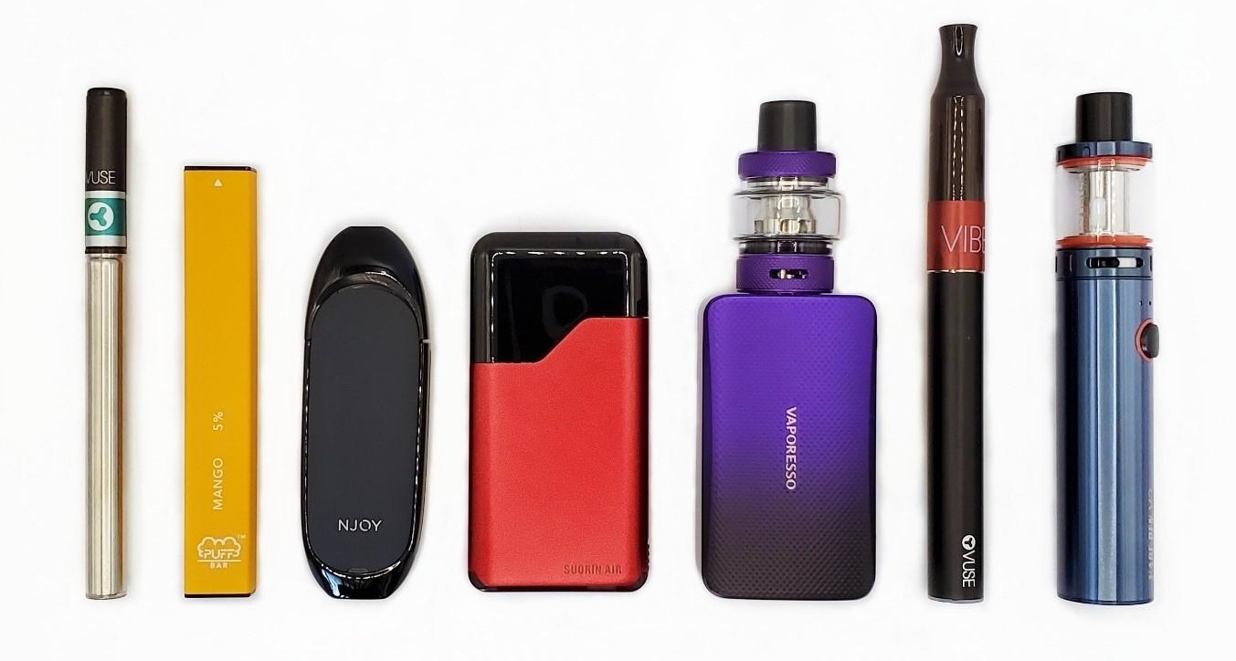
[INSERT PICTURES OF VAPES]

[VAPE_CURR] [IF VAPE_EV = 1]
During the past 30 days, on how many days did you vape nicotine?
__________ days [RANGE 0-30]
- Prefer not to answer

ASK: Respondents who have ever tried vaping nicotine

[VAPE_FIRST_USE] [IF VAPE_CURR = 1-30]
How old were you when you first tried vaping nicotine, even one or two puffs?

Please do not include vaping marijuana/THC/CBD/Delta 8 with these products when answering this question.

_____________years old [RESPONSE =< AGE]
- Prefer not to answer

ASK: Current vape users

[HOOKAH_INTRO]

The next questions are about smoking tobacco in a hookah, which is a type of water pipe. It is sometimes also called a "narghile" pipe. People smoke shisha or hookah tobacco in a hookah.

Please do not include smoking marijuana/THC/CBD/Delta 8 when answering these questions.

SOURCE: Adapted from PATH

[INSERT PICTURES OF HOOKAH]

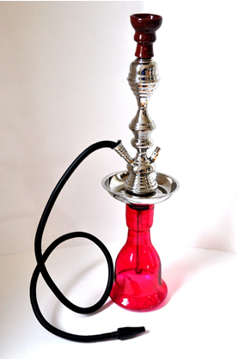

[HOOKAH_EV]
Have you ever tried smoking tobacco out of a hookah, even one time?

Please do not include smoking marijuana/THC/CBD/Delta 8 when answering this question.
- Yes
- No
- Prefer not to answer

ASK: All respondents

[HOOKAH_CUR] [IF HOOKAH_EV=1 OR 99]
During the past 30 days, on how many days did you smoke tobacco out of a hookah?
Please do not include smoking marijuana/THC/CBD/Delta 8 when answering this question.
________ days [RANGE 0-30]
- Prefer not to answer

ASK: Respondents who have ever tried smoking tobacco out of a hookah or PNTA

Detailed Blunt Items

[BLUNT_INTRO2] [IF (BLUNT_CURR = 1-30) OR (BLUNT_3M = 1) OR (BLUNT_EV = 1)]
You’re doing great! We now want to ask you more questions about your use of blunts. As a reminder, sometimes people take the tobacco out of a cigarillo (for example a Backwoods, Swisher Sweets, or Dutch Masters) and replace it with marijuana, or they may put marijuana into a cigar or tobacco leaf wrap. This is what we mean by “blunt” in the next questions.

ASK: Current blunt users, past 3-month blunt users, or ever blunt users

[BLUNT_FIRST_USE] [IF (BLUNT_CURR = 1-30) OR (BLUNT_3M = 1) OR (BLUNT_EV = 1)]
How old were you when you first tried smoking blunts, even one or two puffs?

_____________years old [RESPONSE =< AGE]
- Prefer not to answer

ASK: Current blunt users, past 3-month blunt users, or ever blunt users

[BLUNT_FIRST_WHERE] [IF (BLUNT_CURR = 1-30) OR (BLUNT_3M = 1) OR (BLUNT_EV = 1)]

Where were you when you smoked a blunt for the first time?
- Indoors
- Outdoors
- In the car
- Other (please specify) _________ [OPEN TEXT]
- Prefer not to answer

SOURCE: ENDS MMS, adapted from PATH

ASK: Ever blunt users

[BLUNT_FIRST_IN] [IF BLUNT_FIRST_WHERE = 1]
Where indoors were you the first time you smoked a blunt?
- At my home
- At a friend’s house
- At school
- At work
- Public place, not including school or work (e.g., store, restaurants, sports arenas)
- Other (please specify) _________ [OPEN TEXT]
- Prefer not to answer [EXCLUSIVE]

SOURCE: ENDS MMS, adapted from PATH

ASK: Ever blunt user who first smoked indoors

[BLUNT_FIRT_OUT] [IF BLUNT_FIRST_WHERE = 2]
Where outdoors were you the first time you smoked a blunt?
- At my home
- At a friend’s house
- At school
- At work
- Public place, not including school or work (e.g., parking lot, stadium, park)
- Other (please specify) _________ [OPEN TEXT]
- Prefer not to answer [EXCLUSIVE]

SOURCE: ENDS MMS, adapted from PATH

ASK: Ever blunt user who usually smoked outdoors

[BLUNT_FIRST_WHO] [IF (BLUNT_CURR = 1-30) OR (BLUNT_3M = 1) OR (BLUNT_EV = 1)]
Who were you with the first time you smoked a blunt?
            - Friend(s)
            - A family member who is older than you
            - A family member who is younger than you or the same age
            - Co-worker(s)
            - No one, I was alone
            - Other (please specify)__________ [OPEN TEXT]
            - Prefer not to answer

ASK: Ever blunt users

[OTHER_MJ1] [IF BLUNT_CURR = 1-30]
Other than smoking blunts, how else have you used marijuana during the past 30 days? Select all that apply.
- I have not used marijuana other than blunts in the past 30 days [EXCLUSIVE]
- Smoked marijuana (like a joint, pipe, bong or waterpipe)
- Vaped marijuana (like hash oil, marijuana concentrates, or dried marijuana leaves, buds, or flowers)
- Ate marijuana (like in a brownie, cookie, or candy)
- Used marijuana another way (please specify:___________________)
99. Prefer not to answer [EXCLUSIVE]

ASK: Current blunt users

[OTHER_MJ2] [IF (BLUNT_EV=2) OR (BLUNT_CURR = 0 AND BLUNT_EV = 1) OR (BLUNT_3M=1)]
How have you used marijuana during the past 30 days? Select all that apply.
- I have not used marijuana in the past 30 days [EXCLUSIVE]
- Smoked marijuana (like a joint, pipe, bong, or waterpipe)
- Vaped marijuana (like hash oil, marijuana concentrates, or dried marijuana leaves, buds, or flowers)
- Ate marijuana (like in a brownie, cookie, or candy)
- Used marijuana another way (please specify:___________________)
99. Prefer not to answer [EXCLUSIVE]

ASK: Never blunt users and ever/non-current blunt users and past 3-month blunt users

[SEQ] [IF (TIP_CURR OR UNTIP_CURR = 1-30 OR FIL_CURR = 1-30) OR (CIG_CURR = 1-30) OR (VAPE_CURR = 1-30) OR (HOOKAH_CUR = 1-30)] AND
[(BLUNT_CURR = 1-30) OR (OTHER_MJ = 2-5) OR (BLUNT_3M=1)] AND
[MORE THAN ONE PRODUCT TYPE WAS SELECTED]

Which product did you try first? [PROGRAMMING NOTE: RESTRICT RESPONSE OPTIONS TO THOSE SELECTED FOR EVER USE]
[RANDOMIZE LIST]

- Blunt (with marijuana)
- E-cigarette or vape device with nicotine
- Marijuana in some other form (like a joint, pipe, vape, bong, waterpipe, or edible)
- Tipped cigarillo (like Black and Mild)
- Untipped cigarillo (like Backwoods or Swisher Sweets without marijuana)
- Little cigar (like Cheyenne, Djarum, Talon, and 305s)
- Cigarette
- Hookah
99. Prefer not to answer [ANCHOR]

SOURCE: LCC MMS W1

ASK: Current users of 1+ product

[SIMUL] [IF (BLUNT_CURR = 1-30) OR (BLUNT_3M = 1)]
Do you ever use tobacco products (like cigarettes, cigarillos, or vapes with nicotine) immediately after smoking a blunt?
      - Yes
      - No
99. Prefer not to answer

SOURCE: LCC MMS W1

ASK: Current blunt users and past 3-month blunt users

[SIMUL_PROD] [IF SIMUL = 1]
What do you use? Select all that apply.
[RANDOMIZE LIST]

- Cigarettes
- Tipped cigarillo (like Black and Mild)
- Untipped cigarillo (without marijuana, like Backwoods or Swisher Sweets)
- Little cigars (like Cheyenne, Djarum, Talon, and 305s)
- E-cigarette or vape device with nicotine
- Other (please specify:_______________) [ANCHOR]
- Prefer not to answer [ANCHOR]

SOURCE: LCC MMS W1

ASK: Simultaneous users of tobacco and blunts

[SIMUL_R] [IF SIMUL = 1]
Why did you use another tobacco product immediately after smoking blunts? Select all that apply.
[RANDOMIZE LIST]

- To enhance or extend the high from marijuana
- To enhance or extend the effect of nicotine
- Because marijuana makes me crave nicotine
- To cover the taste of marijuana
- Other (please specify:____________) [ANCHOR]
- Don’t know [ANCHOR]
- Prefer not to answer [ANCHOR]

SOURCE: LCC MMS W1

ASK: Simultaneous users of tobacco and blunts

[SIMUL_T] [IF SIMUL = 1 AND SIMUL_PROD=1-5. IF SELECT MORE THAN 1 RESPONSE, THEN REPEAT SIMUL_T FOR EACH RESPONSE]
You said you’ve used [INSERT SHORTENED ANSWER FROM SIMUL_PROD] immediately after smoking blunts. What name/term do you use to describe this behavior?
- I don’t have a term
- Chasing
- Boosting
- Other (please specify:____________) [OPEN ENDED]
- Don’t know
- Prefer not to answer

ASK: Simultaneous users of tobacco and blunts

[SUB] [IF [BLUNT_EV = 1] and [TIP_EV OR UNTIP_EV = 1]]
Have you ever smoked a cigarillo (like Backwoods, Swisher Sweets, or Black and Mild) without marijuana instead of smoking a blunt?
- Yes
- No
99. Prefer not to answer

SOURCE: LCC MMS W1

ASK: Ever blunt users who have also smoked unmodified LCCs

[SUB_R] [If SUB = 1]
Why did you smoke a cigarillo (like Backwoods, Swisher Sweets, or Black and Mild) without marijuana instead of smoking a blunt? Select all that apply.
Because…
[RANDOMIZE LIST]
- I didn’t have any marijuana
- I wanted nicotine
- I was concerned about being tested for drug use
- I was trying to cut back on smoking marijuana
- I needed to be alert and clear-headed
- Some other reason (please specify: _______) [ANCHOR]
99. Prefer not to answer [ANCHOR]

SOURCE: LCC MMS W1

ASK: Respondents who have substituted a cigar product for a blunt

[MIX_30D] [IF BLUNT_CURR = 1-30]
Thinking about the blunts you smoked during the past 30 days, how often did you mix the tobacco that comes in the cigarillo with the marijuana (sometimes called a “spliff”)?
1. Always mixed in tobacco
2. Sometimes mixed in tobacco
3. Never mixed in tobacco
99.Prefer not to answer

SOURCE: LCC MMS W1

ASK: Current blunt users

[MIX_3M] [IF BLUNT_3M = 1]
Thinking about the blunts you’ve smoked, how often did you mix the tobacco that comes in the cigarillo with the marijuana (sometimes called a “spliff”)?
1. Always mixed in tobacco
2. Sometimes mixed in tobacco
3. Never mixed in tobacco
99.Prefer not to answer

SOURCE: LCC MMS W1

ASK: Past 3-month blunt users

[BLUNT_PROD] [IF (BLUNT_CURR = 1-30) OR (BLUNT_3M = 1)]
What do you usually use to make a blunt? Select all that apply.
- Untipped cigarillo (like Swisher Sweets, Backwoods, or Dutch Masters)
- Tipped cigarillo (like Black & Mild)
- Tobacco or cigar wrap (like ZigZag, Grabba Leaf, or Royal Blunts cigar wraps)
99. Prefer not to answer

SOURCE: LCC MMS W1

ASK: Current blunt users and past 3-month blunt users

[BLUNTBRAND_30D] [IF BLUNT_CURR = 1-30]
During the past 30 days, which brand of cigarillos or cigar wraps did you use most often to smoke blunts?
[RANDOMIZE LIST]
[DISPLAY 1, 16, 98, 99 FOR ALL RESPONDENTS WHO RECEIVE THIS QUESTION. ONLY SHOW 2 – 10 IF BLUNT_PROD = 1, 2, OR 99; ONLY SHOW 11-14 IF BLUNT_PROD = 3 OR 99]:
- I do not have a usual brand. [ANCHOR]
- Black & Mild
- Swisher Sweets
- Dutch Masters
- Backwoods
- Phillies Blunts
- Optimo
- Jackpot
- Game
- White Owl
- Grabba Leaf
- Zig Zag
- Royal Blunts
- Good Times
- Al Capone
- Some other brand not listed here (please specify:___________) [ANCHOR]
- Don’t know [ANCHOR]
99. Prefer not to answer [ANCHOR]

SOURCE: LCC MMS W1

ASK: Current blunt users

[BLUNTBRAND_3M] [IF BLUNT_3M = 1]
During the past 3 months, which brand of cigarillos or cigar wraps did you use most often to smoke blunts?
[RANDOMIZE LIST]
[ONLY SHOW 1 – 9 IF BLUNT_PROD = 1, 2, OR 99; ONLY SHOW 10-14 IF BLUNT_PROD = 3 OR 99]:
- I do not have a usual brand. [ANCHOR]
- Black & Mild
- Swisher Sweets
- Dutch Masters
- Backwoods
- Phillies Blunts
- Optimo
- Jackpot
- Game
- White Owl
- Grabba Leaf
- Zig Zag
- Royal Blunts
- Good Times
- Al Capone
- Some other brand not listed here (please specify:___________) [ANCHOR]
- Don’t know [ANCHOR]
99. Prefer not to answer [ANCHOR]

SOURCE: LCC MMS W1

ASK: Past 3-month blunt users

[BLUNT_FLAVOR_30D] [IF BLUNT_CURR = 1-30]
During the past 30 days, how often were the blunts you smoked flavored? For example, flavored to taste like menthol, mint, clove or spice, chocolate, candy, fruit, desserts or other sweets, alcoholic or non-alcoholic drinks such as wine, margarita, soda, or coffee?

- Never
- Sometimes
- Always
- Prefer not to answer

SOURCE: Adapted from PATH

ASK: Current blunt user

[BLUNT_FLAVOR_3M] [IF BLUNT_3M = 1]
During the past 3 months, how often were the blunts you smoked flavored? For example, flavored to taste like menthol, mint, clove or spice, chocolate, candy, fruit, desserts or other sweets, alcoholic or non-alcoholic drinks such as wine, margarita, soda, or coffee?

- Never
- Sometimes
- Always
- Prefer not to answer

SOURCE: Adapted from PATH

ASK: Past 3-month blunt users

[BLUNT__FLAVOR2_30D] [IF BLUNT_FLAVOR_30D = 2 OR 3]
During the past 30 days, what flavors were the blunts you smoked? Select all that apply.
[RANDOMIZE LIST]

- Menthol
- Mint
- Clove or spice
- Fruit
- Chocolate
- An alcoholic drink such as wine, cognac, margarita, or other cocktails
- A non-alcoholic drink such as soda or coffee
- Candy or other sweets
- Some other flavor (please specify:______________) [ANCHOR]
- Prefer not to answer [ANCHOR]

SOURCE: Adapted from PATH

ASK: Current blunt users who use flavors at least sometimes

[BLUNT__FLAVOR2_3M] [IF BLUNT_FLAVOR_3M = 2 OR 3]
During the past 3 months, what flavors were the blunts you smoked? Select all that apply.
[RANDOMIZE LIST]

- Menthol
- Mint
- Clove or spice
- Fruit
- Chocolate
- An alcoholic drink such as wine, cognac, margarita, or other cocktails
- A non-alcoholic drink such as soda or coffee
- Candy or other sweets
- Some other flavor (please specify:______________) [ANCHOR]
- Prefer not to answer [ANCHOR]

SOURCE: Adapted from PATH

ASK: Past 3-month blunt users who use flavors at least sometimes

[BLUNT_GROUP_30D] [IF BLUNT_CURR = 1-30]
During the past 30 days, how often did you smoke blunts with other people (for example, take a hit then pass it along to others in the group)?

- Never
- Sometimes
- Always
99. Prefer not to answer

SOURCE: LCC MMS W1

ASK: Current blunt users

[BLUNT_GROUP_3M] [IF BLUNT_3M = 1]
During the past 3 months, how often did you smoke blunts with other people (for example, take a hit then pass it along to others in the group)?
- Never
- Sometimes
- Always
99. Prefer not to answer

SOURCE: LCC MMS W1

ASK: Past 3-month blunt users

[BLUNT_LOC_30D] [IF BLUNT_CURR = 1-30]
During the past 30 days, where did you smoke blunts most often? Select all that apply.
- Indoors
- Outdoors
- In the car
- Other (please specify) _________ [OPEN TEXT]
- Prefer not to answer [EXCLUSIVE]

SOURCE: ENDS MMS, adapted from PATH

ASK: Current blunt users

[BLUNT_LOCIN_30D] [IF BLUNT_LOC_30D = 1]
During the past 30 days, where did you smoke blunts indoors most often? Select all that apply.
- At my home
- At a friend’s house
- At school
- At work
- Public place, not including school or work (e.g., store, restaurants, sports arenas)
- Other (please specify) _________ [OPEN TEXT]
- Prefer not to answer [EXCLUSIVE]

SOURCE: ENDS MMS, adapted from PATH

ASK: Current blunt user who usually smoke indoors

[BLUNT_LOCOUT_30D] [IF BLUNT_LOC_30D = 2]
During the past 30 days, where did you smoke blunts outdoors most often? Select all that apply.
- At my home
- At a friend’s house
- At school
- At work
- Public place, not including school or work (e.g., parking lot, stadium, park)
- Other (please specify) _________ [OPEN TEXT]
- Prefer not to answer [EXCLUSIVE]

SOURCE: ENDS MMS, adapted from PATH

ASK: Current blunt user who usually smoke outdoors

[BLUNT_LOC_3M] [IF BLUNT_3M = 1]
During the past 3 months, where did you smoke blunts most often? Select all that apply.
- Indoors
- Outdoors
- In the car
- Other (please specify) _________ [OPEN TEXT]
- Prefer not to answer [EXCLUSIVE]

SOURCE: ENDS MMS, adapted from PATH

ASK: Past 3-month blunt users

[BLUNT_LOCIN_3M] [IF BLUNT_LOC_3M = 1]
During the past 3 months, where did you smoke blunts indoors most often? Select all that apply.
- At my home
- At a friend’s house
- At school
- At work
- Public place, not including school or work (e.g., store, restaurants, sports arenas)
- Other (please specify) _________ [OPEN TEXT]
- Prefer not to answer [EXCLUSIVE]

SOURCE: ENDS MMS, adapted from PATH

ASK: Past 3-month blunt user who usually smoke indoors

[BLUNT_LOCOUT_3M] [IF BLUNT_LOC_3M = 2]
During the past 3 months, where did you smoke blunts outdoors most often? Select all that apply.
- At my home
- At a friend’s house
- At school
- At work
- Public place, not including school or work (e.g., parking lot, stadium, park)
- Other (please specify) _________ [OPEN TEXT]
- Prefer not to answer [EXCLUSIVE]

SOURCE: ENDS MMS, adapted from PATH

ASK: Past 3-month blunt user who usually smoke outdoors

[BLUNT_EVBUY] [IF BLUNT_CURR = 1-30 OR BLUNT_3M = 1]
When you smoke blunts, how do you usually get the blunt or the materials to make a blunt?
    - I give someone else money to buy them for me
    - I buy them myself from a store
    - I ask someone to give me one
    - I buy them from another person
    - I take them from a store or another person
    - I get them some other way (Please specify:_____) [OPEN TEXT]
    - Don’t know
    - Prefer not to answer

ASK: Current blunt users and past 3-month blunt users

[BLUNT_BUY] [IF BLUNT_CURR = 1-30 OR BLUNT_3M = 1]
When you get or buy a blunt, do you usually…
      - Buy/get pre-rolled blunts
      - Buy/get cigarillos such as Backwoods, Swisher Sweets or Dutch masters to make my own blunts
      - Buy/get cigar or tobacco wrap to roll my own blunts
    - Prefer not to answer

ASK: Current blunt users and past 3-month blunt users

[BLUNT_REASON] [IF BLUNT_EV = 1]
What are the main reasons you smoke or have tried smoking blunts? Select up to three.
[RANDOMIZE LIST]

- Come in flavors I like
- Help me feel relaxed/relieve stress
- Give me a good high that I enjoy
- They are natural
- They are not addictive
- Masks the taste of marijuana
- Masks the smell of marijuana
- My friends use them
- A way to spend time with friends
- They are cheap
- Easy to use
- Easy to get
- People I admire use them, like influencers and celebrities
- My family uses them (like siblings, cousins)
- Some other reason (please specify:______) [ANCHOR]
- Don’t know [ANCHOR]
- Prefer not to answer [ANCHOR]

SOURCE: Adapted from PATH

ASK: Ever blunt users

Thanks for all your answers so far! The next few questions are about your opinions about blunts. As a reminder, sometimes people take the tobacco out of a cigarillo and replace it with marijuana, or they may put marijuana into a cigar/tobacco leaf wrap. This is what we mean by “blunt” in the next questions.

[BLUNT_SUSCEPT_d] [PROGRAMMER: ASK IF (BLUNT_EV=2) OR (BLUNT_EV=1 AND BLUNT_CURR=0)]
Are you curious about smoking a blunt?
- Definitely yes
- Probably yes
- Probably not
- Definitely not

ASK: Never blunt users

[BLUNT_REASON_CUR] [IF BLUNT_EV = 2 and BLUNT_SUSCEPT_d = 1 or 2]
What are the main reasons you are curious about smoking blunts? Select up to three.
[RANDOMIZE LIST]

- They come in flavors I like
- They would help me feel relaxed/relieve stress
- They would give me a good high that I enjoy
- They are natural
- They are not addictive
- They mask the taste of marijuana
- They mask the smell of marijuana
- My friends use them
- They are a way to spend time with friends
- They are cheap
- They are easy to use
- They are easy to get
- People I admire use them, like influencers and celebrities
- My family uses them (like siblings, cousins)
- Some other reason (please specify:______) [ANCHOR]
- Don’t know [ANCHOR]
- Prefer not to answer [ANCHOR]

SOURCE: Adapted from PATH

ASK: Respondents who have not tried blunts but are curious about blunts

Beliefs

[BLUNT_RHARM1]
Is smoking blunts more harmful, less harmful, or just as harmful as smoking cigarettes?
- More harmful than cigarettes
- Less harmful than cigarettes
- As harmful as cigarettes
- Don’t know
- Prefer not to answer

SOURCE: Adapted from PATH

ASK: All respondents

[BLUNT_RHARM2]
Is smoking blunts more harmful, less harmful, or just as harmful as vaping nicotine?
- More harmful than vaping nicotine
- Less harmful than vaping nicotine
- As harmful as vaping nicotine
- Don’t know
- Prefer not to answer

SOURCE: Adapted from PATH

ASK: All respondents

[BLUNT_ADD1]
Are blunts more addictive, less addictive, or just as addictive as cigarettes?
- More addictive than cigarettes
- Less addictive than cigarettes
- As addictive as cigarettes
- Don’t know
- Prefer not to answer

SOURCE: Adapted from PATH

ASK: All respondents

[BLUNT_ADD2]
Are blunts more addictive, less addictive, or just as addictive as vaping nicotine?
- More addictive than vaping nicotine
- Less addictive than vaping nicotine
- As addictive as vaping nicotine
- Don’t know
- Prefer not to answer

SOURCE: Adapted from PATH

ASK: All respondents

[BLUNT_AHARM1]
How harmful is smoking blunts every day?
  - Not at all harmful
  - A little harmful
  - Somewhat harmful
  - Very harmful
- Don’t know
- Prefer not to answer

SOURCE: Adapted from PATH

ASK: All respondents

[BLUNT_AHARM2]
How harmful is smoking blunts occasionally (a few days per month)?
- Not at all harmful
- A little harmful
- Somewhat harmful
- Very harmful
- Don’t know
- Prefer not to answer

SOURCE: Adapted from PATH

ASK: All respondents

[BLUNT_AHARM3]
How harmful is smoking just a few puffs of a blunt (not a whole blunt)?
- Not at all harmful
- A little harmful
- Somewhat harmful
- Very harmful
- Don’t know
- Prefer not to answer

SOURCE: Adapted from PATH

ASK: All respondents

[BLUNT_STMTS] [RANDOMIZE ORDER OF BLUNT_STMTS_1-4]
How true or false do you think the following statements are?

[1] The blunt wrap or wrapper contains nicotine.
- Definitely true
- Probably true
- Probably false
- Definitely false
- Prefer not to answer

[2] The blunt wrap or wrapper contains tobacco.
- Definitely true
- Probably true
- Probably false
- Definitely false
- Prefer not to answer

[3] Smoking blunts is addictive.
- Definitely true
- Probably true
- Probably false
- Definitely false
- Prefer not to answer

[4] Taking the loose tobacco out of the blunt wrap makes it less harmful.
- Definitely true
- Probably true
- Probably false
- Definitely false
- Prefer not to answer

ASK: All respondent

[BELIEFS]

Please indicate how much you agree or disagree with the following statements.

If I smoke blunts occasionally…
[RANDOMIZE ORDER]

[OSD1] … my family will be disappointed.
[OSD2] … my family relationships will be harmed.
[OSD3] … my family will feel like I’m breaking their trust.
[OSD4] … I will not live up to my family’s expectations.
[OSD5] … I will be a bad influence on my family members.
[ISD1] … I will never become the person I want to be.
[ISD2] … I will never become my best self.
[ISD3] … I will never be able to live up to my potential.
[ISD4] … I will never be able to achieve my goals.

- Strongly disagree
- Disagree
- Neutral
- Agree
- Strongly agree
- Prefer not to answer

If you were to smoke blunts occasionally, how likely is it that you would….
[RANDOMIZE ORDER]

[AS1] …want to smoke blunts more often to get the same effect
[AS2] …crave blunts all the time
[AS3] …find it difficult to stop smoking blunts, even if you wanted to
[AS4] …feel like you need to smoke blunts just to feel normal
[AS5] …feel anxious if you can’t smoke a blunt whenever you want to
[AS6] …easily get hooked on blunts
[AS7] …become addicted to nicotine
[AS8] …become addicted to marijuana
[AS9] …become addicted to tobacco
[OE1] …get in trouble with your parents
[OE2] …get in trouble with your boss
[OE3] …get in trouble with the police
[OE4] …see yourself as a tobacco smoker
[OE5] …be seen as a tobacco smoker by others
[OE6] …look cool
[OE7] …feel less stressed
[OE8] …feel less anxious
[OE9] …feel more connected to/fit in with your friends
[OE10] …feel more connect to/fit in with your family

- Not at all likely
- A little likely
- Somewhat likely
- Very likely
- Extremely likely
99. Prefer not to answer

ASK: All respondents

[BLUNT_APPEAL]
Please indicate the number that best describes how you feel about smoking blunts.

Smoking blunts is…
A | Unattractive | 1 | 2 | 3 | 4 | 5 | Attractive
B | Not Cool |  |  |  |  |  | Cool
C | Boring |  |  |  |  |  | Fun
D | Not meant for someone like me |  |  |  |  |  | Meant for someone like me
E | Childish |  |  |  |  |  | Grown-up

- Prefer not to answer

SOURCE: Adapted from Ford A, MacKintosh AM, Moodie C, et al. Cigarette pack design and adolescent smoking susceptibility: a cross-sectional survey. BMJ Open 2013;3:e003282

ASK: All respondents

[BLUNT_VIEWS] Think about the people who are important to you. How would you describe their views on smoking blunts? Their views on smoking blunts are…
- Very positive
- Positive
- Neither positive nor negative
- Negative
- Very negative
  - Prefer not to answer

SOURCE: Adapted from PATH

ASK: All respondents

[PAR_REACT] [IF AGE < 18]
If your parents or other adult caregiver found you smoking a blunt, how do you think they would react? Would they…
    - Be very upset
    - Not be too upset
    - Have no reaction
    - Don’t know
    - Prefer not to answer

ASK: Respondents who are < 18 years old

[PERC_PREV]
Out of every 10 people your age, how many do you think…
 | Slider bar 0 - 10 | 98. Don’t know | 99. Prefer not to answer
A. Smoke cigarillos without marijuana (like Backwoods, Swisher Sweets, or Black and Mild)?
B. Smoke blunts with marijuana?
C. Vape marijuana?
D. Vape nicotine?

ASK: All respondents

[PEER_USE] How many of your 4 closest friends…
 | Slider bar 0 - 4 | 98. Don’t know | 99. Prefer not to answer
A. Smoke cigarillos without marijuana (like Backwoods, Swisher Sweets, or Black and Mild)?
B. Smoke blunts with marijuana?
C. Vape marijuana?
D. Vape nicotine?

ASK: All respondents

[HH_USE]
Other than you, has anyone who lives with you used any of the following during the past 30 days? Select all that apply.
- Cigarettes
- Smokeless tobacco, such as chewing tobacco, snuff, snus or dip (like [NAME TOP BRANDS])
- Untipped cigarillos without marijuana (like Backwoods, Swisher Sweets, or Dutch Masters)
- Tipped cigarillos (like Black and Mild)
- Little Cigars (like Cheyenne, Djarum, Talon, and 305s)
- Blunts with marijuana
- Hookah with tobacco
- E-cigarettes or vape devices with nicotine (like JUUL, Puff Bar, NJOY, or blu)
- Nicotine pouches (like ZYN, Velo or On!)
- Any other form of tobacco
- No, no one who lives with me has used any form of tobacco during the past 30 days [EXCLUSIVE]
- Prefer not to answer [EXCLUSIVE]

ASK: All respondents

[PARENT_TALK] [IF CURRENT_AGE<18]
Has a parent or other adult in your life ever talked to you about reasons for not smoking blunts?
  - Yes
  - No
  - Prefer not to answer

ASK: All respondents ages <18

[BLUNT_RULES]
Which statement best describes the rules about smoking blunts in your home? Would you say…
  - I am never allowed to smoke blunts
  - I can smoke blunts anywhere in or outside of my home
  - I can smoke blunts as long as I smoke at home and/or with an older member of the family
  - I can smoke blunts as long as it’s not at home
  - Something else (please specify)_____________
  - Prefer not to answer

ASK: All respondents

[BLUNT_ACCESS]
How easy do you think it is for people your age to get blunts?

- Very easy
- Somewhat easy
- Somewhat difficult
- Very difficult
- Prefer not to answer

SOURCE: Adapted from PATH

ASK: All respondents

[BLUNT_CONVO]
Where have you seen or heard conversations about blunts during the past week? Select all that apply.
[RANDOMIZE LIST]
    - I have not seen or heard anything about blunts in the past week [EXCLUSIVE, ANCHOR]
    - On social media
    - On television or streaming
    - On the radio or music streaming
    - At home/among family members
    - At school/among classmates
    - At parties or kickbacks
    - At work/my job
    - Somewhere else (please specify:_______________) [OPEN ENDED, ANCHOR]
    - Don’t know [EXCLUSIVE, ANCHOR]
    - Prefer not to answer [EXCLUSIVE, ANCHOR]

ASK: All respondents

[BLUNT_SM] [IF BLUNT_CONVO=1]
Who posted the content about blunts you saw or heard on social media during the past week?
- Friend or family member
- Someone I don’t personally know (like a celebrity or influencer)
- A company trying to sell a product
- Someone else (please specify) [OPEN ENDED]
    - Don’t know
    - Prefer not to answer

SOURCE: ENDS MMS

ASK: Respondents who saw/heard conversations about blunts on social media
We now want to ask you about some slogans or logos that might or might not have appeared in the media around here, as part of ads about tobacco.

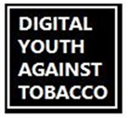
[CAMP1]
In the past 3 months, that is since [FILL DATE], have you seen or heard the following slogan or logo?
Digital Youth Against Tobacco (DYAT)
- Yes
- No
9. Not sure
99. Prefer not to answer

ASK: All respondents

DISPLAY: FILL DATE IS THE FIRST DAY OF THE RECALL PERIOD. FILL DATE = DATE THAT IS 3 MONTHS BEFORE CURRENT DATE.

[CAMP2]
In the past 3 months, that is since [FILL DATE], have you seen or heard the following slogan or logo?
The Real Cost
- Yes
- No
9. Not sure
99. Prefer not to answer

ASK: All respondents

DISPLAY: FILL DATE IS THE FIRST DAY OF THE RECALL PERIOD. FILL DATE = DATE THAT IS 3 MONTHS BEFORE CURRENT DATE.

[CAMP3]
In the past 3 months, that is since [FILL DATE], have you seen or heard the following slogan or logo?
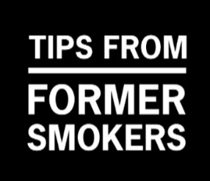
Tips from Former Smokers (Tips)
- Yes
- No
9. Not sure
99. Prefer not to answer

ASK: All respondents

DISPLAY: FILL DATE IS THE FIRST DAY OF THE RECALL PERIOD. FILL DATE = DATE THAT IS 3 MONTHS BEFORE CURRENT DATE.

[CAMP4]
In the past 3 months, that is since [FILL DATE], have you seen or heard the following slogan or logo?
- Yes
- No
9. Not sure
99. Prefer not to answer

ASK: All respondents

DISPLAY: FILL DATE IS THE FIRST DAY OF THE RECALL PERIOD. FILL DATE = DATE THAT IS 3 MONTHS BEFORE CURRENT DATE.

You’re doing great! We just have a few more questions for you.

Intrapersonal characteristics

[SS]
Please tell us how much you agree with the following statements.

[SS_1]
I would like to explore strange new places.
- Strongly disagree
- Disagree
- Neutral
- Agree
- Strongly agree
- Prefer not to answer

[SS_2]
I like to do frightening things.
- Strongly disagree
- Disagree
- Neutral
- Agree
- Strongly agree
- Prefer not to answer

[SS_3]
I like new and exciting experiences, even if I have to break the rules.
- Strongly disagree
- Disagree
- Neutral
- Agree
- Strongly agree
- Prefer not to answer

[SS_4]
I prefer friends who are exciting and unpredictable. Would you say you…
- Strongly disagree
- Disagree
- Neutral
- Agree
- Strongly agree
- Prefer not to answer

SOURCE: BSSS-4

ASK: All respondents

[MH]
The next questions will ask about your mental or emotional health. As a reminder, you can skip any question you are not comfortable answering.

If you experience any distress while taking this survey, you may contact the (1) Substance Abuse and Mental Health Services Administration (SAMHSA) Disaster Distress Helpline (1-800-985-5990) or the (2) Suicide Prevention Lifeline (1-800-273-8255), which both offer free 24/7 support services.

Over the last 2 weeks, how often have you been bothered by the following problems?

 |  | Not at all | Several days | More than half the days | Nearly every day | Prefer Not to Answer
MH_1. | Feeling nervous, anxious or on edge. | ₁ | ₂ | ₃ | ₄ | ₉₉
MH_2. | Not being able to stop or control worrying. | ₁ | ₂ | ₃ | ₄ | ₉₉
MH_3. | Little interest or pleasures in doing things. | ₁ | ₂ | ₃ | ₄ | ₉₉
MH_4. | Feeling down, depressed, or hopeless. | ₁ | ₂ | ₃ | ₄ | ₉₉

SOURCE: PHQ-4

ASK: All respondents

[DISCRIM] In your day-to-day life, how often do any of the following things happen to you?

 | Almost every day | At least once a week | A few times a month | A few times a year | Less than once a year | Never
- You are treated with less courtesy or respect than other people are.
- You receive poorer service than other people at restaurants or stores.
- People act as if they think you are not smart.
- People act as if they are afraid of you.
- You are threatened or harassed.

SOURCE: Adapted From: Everyday Discrimination Scale -Short Version
https://scholar.harvard.edu/davidrwilliams/node/32397

ASK: All respondents

Black Identity

[IDENTITY] [IF RACE_ETH = 3]

Earlier in the survey you said that Black or African American best describes your racial or ethnic background.

The next questions are about how closely connected you feel to others in your community who are Black or African American. As a reminder, you can skip any question you don’t feel comfortable answering.

How much do you agree or disagree with the following statements?

[ID1] I feel part of a community of people who share my Black or African American identity.
[ID2] I feel connected to other people who share my Black or African American identity.
[ID3] When interacting with members of the community who share my Black or African American identity, I feel like I belong.
[ID4] I’m not like other people who share my Black or African American identity.
[ID5] I feel isolated and separate from other people who share my Black or African American identity.

- Strongly disagree
- Disagree
- Neutral
- Agree
- Strongly agree
- Prefer not to answer

SOURCE: Testa, R. J., Habarth, J., Peta, J., Balsam, K., & Bockting, W. (2015). Development of the Gender Minority Stress and Resilience Measure. Psychology of Sexual Orientation and Gender Diversity, 2(1), 65.

ASK: Respondents who identify as Black/AA

Demographics

[SEX_OR]
Which of the following best represents how you think of yourself? Select all that apply.
- Straight or heterosexual
- Bisexual
- Gay or lesbian
- Something else ___________[OPEN TEXT]
- I have not figured out or am in the process of figuring out my sexuality
- Prefer not to answer [EXLUSIVE]

ASK: All respondents

[INCOME_YOUTH] [IF AGE = 15-17]
How much money does your family have?
- Not enough to get by
- Just enough to get by
- Only have to worry about money for fun or extras
- Never have to worry about money
- Prefer not to answer

ASK: All respondents ages 15-17

[INCOME_ADULT] [IF AGE = 18-24]
Considering your own income and the income from any other people who help you, how much money do you have?
- Not enough to get by
- Just enough to get by
- Only have to worry about money for fun or extras
- Never have to worry about money
- Prefer not to answer

ASK: All respondents ages 18-24

Closing

[COMMNT]
Thank you for completing the survey. Please enter any comments that you have about the survey or about blunt use.

______________________ PROGRAMMER: PROGRAM OPEN ENDED ITEM WITH 2000 CHARACTER LIMIT. MAKE ITEM OPTIONAL.
- Next

ASK: All respondents

[THANKS]
To thank you for completing the survey, you will receive an electronic gift card for $5. If you would like to decline receiving this payment, you can select “No” to continue to the next screen.

Would you like to receive this gift card?
- Yes
- No

ASK: All respondents

[CARD] [IF THANKS = 1]
We will send you a $5 electronic gift card to the email address you provided within 1-2 weeks.
- Next

ASK: Respondents who would like to receive a gift card.

[CLOSE]
Thank you for your participation. If you have questions about this study, please contact the principal investigator, Jennifer Duke, at (919) 541-1249. If you want to quit using tobacco, call your state’s Quitline at 1-800-QUIT-NOW (1-800-784-8669) or try the tools and tips at https://smokefree.gov.

You may now close your browser or navigate away from this page.

OMB No: 0910-0810 Expiration Date: 12/31/2024

Paperwork Reduction Act Statement: According to the Paperwork Reduction Act of 1995, an agency may not conduct or sponsor, and a person is not required to respond to a collection of information unless it displays a valid OMB control number. The valid OMB control number for this information collection is 0910-0810. The time required to complete this information collection is estimated to average 15 minutes per response, including the time for reviewing instructions, searching existing data sources, gathering and maintaining the data needed, and completing and reviewing the collection of information.

Send comments regarding this burden estimate or any other aspects of this collection of information, including suggestions for reducing burden to PRASTAFF@fda.hhs.gov.

ASK: All respondents

