Little Cigar, Cigarillo, and Blunt Use Audience Insights Study
Screener

Form Approved
OMB No. 0910-0810
Exp. Date 12/31/24

PROGRAMMER NOTE: FORCE RESPONSES TO ALL SCREENER QUESTIONS. IF RESPONDENTS TRY TO SKIP A QUESTION IN THE SCREENER THAT DOES NOT INCLUDE PNTA, DISPLAY THE FOLLOWING ERROR MESSAGE: “THIS QUESTION IS REQUIRED TO DETERMINE IF YOU ARE ELIGIBLE FOR THIS STUDY. PLEASE ANSWER THE QUESTION OR CLOSE YOUR BROWSER WINDOW TO EXIT THE ELIGIBILITY QUESTIONNAIR.”

[SCNR_INTRO]

Welcome to the Your Voice Now Survey!

The U.S. Food and Drug Administration (FDA) is developing education programs that aim to improve the health of youth and young adults.
​
To inform these education programs, the FDA is conducting a survey in partnership with RTI International, a non-profit research organization.
- You are being asked to answer a few questions to see if you are eligible for a study of approximately 1,500 youth and young adults in the United States.
- You may only complete this questionnaire one time.
- It will only take about 2.5 minutes to see if you are eligible.
- If we determine you are eligible, you will have the opportunity to continue and complete an additional online survey for a $5 electronic gift card.

- The survey will take approximately 15 minutes to complete.
- You may only take that survey one time and you will only receive one $5 electronic gift card if you complete it. If we find that you have completed the survey more than once, you may not receive a gift card. Once we complete this check, we will send you a $5 electronic gift card to the email address you provide. The gift card will be sent within 1-2 weeks.
- Your answers to the questions will be kept private to the fullest extent allowable by law and your participation is voluntary.

ASK: All respondents

[SCNR_ASSENT]
Do you agree to participate in this short survey?
- Yes, I agree to participate in this short survey
- No, I do not want to participate in this short survey
ASK: All respondents

[EXIT_1] [IF SCNR_ASSENT = 2]
Thank you for your time.

ASK: Ask respondents who do not provide assent

[LAND] [IF R IS ON MOBILE DEVICE]

It looks like you are viewing this survey on a mobile device. This survey works best in landscape mode. Taking the survey on a mobile device might take longer.

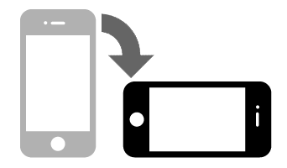

NEXT

ASK: All respondents who access the survey via a mobile device.

[PRIV]
Please make sure that you can answer the questions in private where no one can see your answers.
- Next

ASK: All respondents

[DRIV]
Do not answer the questions while driving.
- Next

ASK: All respondents

SCREENER

[SCNR_INTRO2] [IF FB_AUTH = 1 OR IG_AUTH = 1]
The first part of the survey asks a couple general questions about yourself.

ASK: All respondents

[AGE]
How old are you?

_____________years old [RANGE: 5-100]

ASK: All respondents

[SOCIAL_MED]
About how often do you visit social media sites, such as Instagram, TikTok, Snapchat, Facebook, or Twitter?
- Every hour or more
- More than once a day
- About once a day
- 3-5 days a week
- 1-2 days a week
- Every few weeks or less
- I do not have a social media account
99. Prefer not to answer

ASK: All respondents

[VAPE_INTRO_V1]

The next question is about vapes. You may also know them as e-cigarettes.

These products are battery-powered and produce vapor or aerosol instead of smoke. They contain nicotine liquid, sometimes called "e-liquid" or "e-juice," although the amount of nicotine can vary and some may not contain any nicotine at all.

Some can be bought as one-time, disposable products, while others can be bought as re-usable kits that are rechargeable. Some common brands include JUUL, Vuse, Puff Bar, NJOY, and blu.

Please do not include vaping marijuana/THC/CBD/Delta 8 with these products when answering this question.
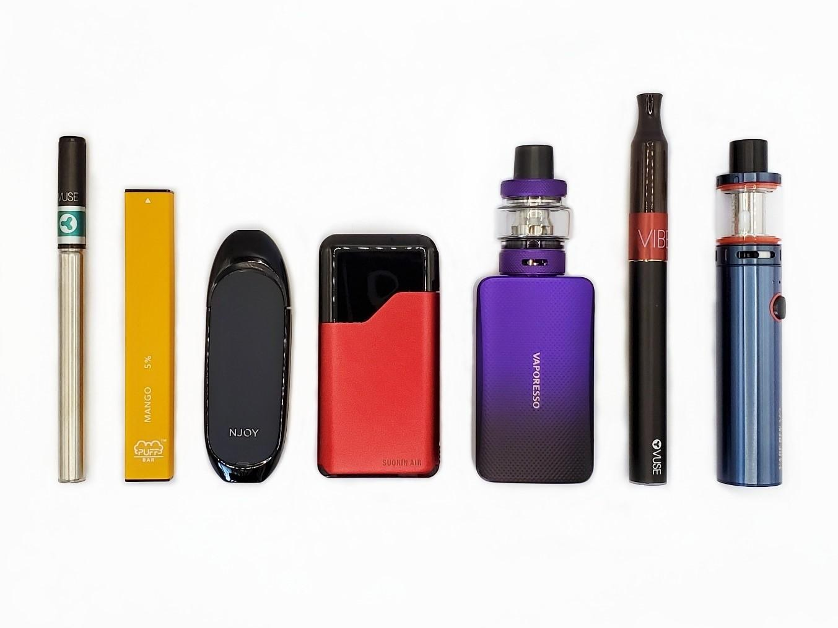

SOURCE: Adapted from PATH

[VAPE_EV]
Have you ever tried vaping nicotine, even one time?
- Yes
- No

ASK: All respondents

[BLUNT_INTRO1]

The next questions are about blunts. This refers to taking the tobacco out of a cigarillo (such as Backwoods, Black & Mild, Swisher Sweets, or Dutch Masters) and replacing some or all of it with marijuana. Blunts can also be made by putting marijuana into a cigar or tobacco leaf wrap.

[BLUNT_EV]
Have you ever smoked a blunt, even one or two puffs?
- Yes
- No

ASK: All respondents

[BLUNT_CURR] [IF BLUNT_EV=1]
During the past 30 days, on how many days did you smoke a blunt, even one or two puffs?
____________days [RANGE 0-30]

ASK: Ever blunt users

[BLUNT_3M] [IF BLUNT_EV=1 AND BLUNT_CURR=0]
Have you smoked a blunt, even one or two puffs, during the past 3 months? That is, since [FILL DATE]?
- Yes
- No

ASK: Ever blunt users, but no use in past 30 days

[BLUNT_SUSCEPT] [IF (BLUNT_EV=2) OR (BLUNT_EV=1 AND BLUNT_CURR=0)]
Thinking about the future…
 |  | Definitely Yes | Probably Yes | Probably Not | Definitely Not
a. | Do you think that you will smoke a blunt soon? | ☐₁ | ☐₂ | ☐₃ | ☐₄
b. | Do you think you will smoke a blunt at any time in the next year? | ☐₁ | ☐₂ | ☐₃ | ☐₄
c. | If one of your best friends were to offer you a blunt, would you use it? | ☐₁ | ☐₂ | ☐₃ | ☐₄

ASK: Never blunt users and ever/not current users

[RACE_ETH]
Which of these best describes your racial and/or ethnic background? Select all that apply.
- American Indian or Alaska Native
- Asian
- Black or African American
- Hispanic, Latino/a, Latinx
- Native Hawaiian or Other Pacific Islander
- White

ASK: All respondents

[GENDER]
What is your gender identity? Select all that apply.
- Woman/girl
- Man/boy
- Non-binary or gender non-conforming
- Transgender woman/girl
- Transgender man/boy
- Another gender identity

ASK: All respondents

[STATE]
What state do you live in?

[PROGRAMMER note: INCLUDE DROP DOWN LIST OF 50 STATES & WASHINGTON DC. INCLUDE AN OPTION for ‘I don’t live in the United States’. SHOULD APPEAR FIRST IN DROP DOWN.]

ASK: All respondents

[ZIP]
What is your zip code?
[OPEN TEXT ALLOW 5 NUMBERS]

ASK: All respondents

[DOB]
What is your date of birth?

Please use the following format (MM/DD/YYYY)
____/______/_______

ASK: All respondents

[EMAIL]
Please enter your email address: _____________________ [OPEN TEXT]

The email address you provide is used only for the purposes of sending you a digital gift card if you qualify and complete the survey in full and will not be sold or shared with anyone outside of the survey team.

Please make sure your email address is correct.

ASK: All respondents
[EMAIL_VER]
[PROGRAMMER NOTE: VERIFY EMAIL FORMAT AND THAT BOTH EMAIL ADDRESSES MATCH. VERIFY THAT THIS EMAIL WAS NOT USED IN THE PAST 6 MONTHS.]
Please verify your email address: _____________________

ASK: Respondents who provide an email address in EMAIL

CHECKPOINT, INCLUDE IF:
- 15-24 YEARS OLD BASED ON AGE PROVIDED
- 15-24 YEARS OLD BASED ON DOB
- STATE ≠ I DON’T LIVE IN THE US
- AGE PROVIDED AND AGE CALCULATED BY DOB MUST MATCH
- PROVIDED A VALID EMAIL ADDRESS AND EMAIL ADDRESSES MATCH
- [BLUNT_EV = 1] OR [BLUNT_SUSCEPT A, B, OR C = 1, 2, OR 3]
- RACE =4 (UNLESSED RELAXED TO INCREASE SAMPLE)

[QUOTAS (1,500 TOTAL)
- CIGARILLO/BLUNT CATEGORY
  - 300 CURRENT USERS [BLUNT_CURR > 0]
  - 300 RECENT USERS ([BLUNT_EV = 1] & [BLUNT_CURR = 0] & [BLUNT_3M = 1])
  - 300 EVER (NOT CURRENT OR RECENT) USERS ([BLUNT_EV = 1] & [BLUNT_CURR = 0] & [BLUNT_3M = 0])
  - 300 SUSCEPTIBLE (NEVER USERS THAT ARE SUSCEPTIBLE) ([BLUNT_EV = 2] & [BLUNT_SUSCEPT A, B, OR C = 1, 2, OR 3]
- RACE/ETHNICITY:
  - ALL BLACK (CAN ALSO SELECT OTHER RACE/ETHNICITIES)
- GENDER: ~50% FEMALE/50% MALE
- AGE: 50% 15-17 / 50% 18-24

[THANK_YOU] [IF FAIL CHECKPOINT CRITERIA]
Thank you for taking the time to take our eligibility screener. Unfortunately, based on your responses, you do not qualify to participate in our survey.

[EXIT]

OMB No: 0910-0810 Expiration Date: 12/31/2024
Paperwork Reduction Act Statement: The public reporting burden for this collection of information has been estimated to average 2.5 minutes per response. Send comments regarding this burden estimate or any other aspects of this collection of information, including suggestions for reducing burden to PRAStaff@fda.hhs.gov.

ASK: Participants who fail the inclusion criteria

[CONTINUE] [IF PASS CHECKPOINT CRITERIA]
You are invited to complete our web survey for a $5 electronic gift card. The survey will take about 15 minutes. Please click the “Next” button to continue and take the survey now.
- Next

OMB No: 0910-0810 Expiration Date: 12/31/2024
Paperwork Reduction Act Statement: According to the Paperwork Reduction Act of 1995, an agency may not conduct or sponsor, and a person is not required to respond to a collection of information unless it displays a valid OMB control number. The valid OMB control number for this information collection is 0910-0810. The time required to complete this information collection is estimated to average 2.5 minutes per response, including the time for reviewing instructions, searching existing data sources, gathering and maintaining the data needed, and completing and reviewing the collection of information.

Send comments regarding this burden estimate or any other aspects of this collection of information, including suggestions for reducing burden to PRASTAFF@fda.hhs.gov.

ASK: Respondents who pass the inclusion criteria

