Protocol and Questions for Unmoderated User Testing of a Proposed New CMS.gov Website Structure

Pre-Test Questions

Participants will be asked to respond to the following two questions when they first land on the testing web page:

How often do you visit CMS.gov? (select one)

* + - Multiple times a day
    - Multiple times a week
    - A few times each month
    - A few times each year

Which of the following best describes your role? (select one)

* + - Health Care Providers (Clinicians/Physicians)
    - Health Care Providers (Practice Administrators)
    - Health Care Providers (Consultants)
    - Health Care Providers (Coders and Billers)
    - Health Insurance Brokers/Agents
    - Health Insurance Assisters/Counselors
    - Other [please describe]

Site Structure Tree Testing

We will enter the new site structure (the names of each page in a hierarchical arrangement) into an unmoderated testing platform called Treejack (from a company called Optimal Workshop). Treejack automatically makes our hierarchical site structure navigable online. That is, participants will be able to click on each node of the site structure in succession in order to find specific pages.

We will ask participants to complete the following seven tasks, which are common reasons that people visit the CMS.gov website:

* Look up a specific National or Local Coverage Determination
* Find a physician fee schedule
* Download a spreadsheet of Medically Unlikely Edits (MUEs)
* Get resources that would enable you to provide guidance to a beneficiary who is looking to purchase private insurance
* Learn about the Nursing Home Quality Initiative
* Review drug pricing for Medicare Part B
* Get training

For each task, participants navigate the clickable site hierarchy in the Treejack tool in order to find the page on which they believe they can complete the task. Each task is expected to take 2-3 minutes.

Here are the tree testing instructions that will appear to participants

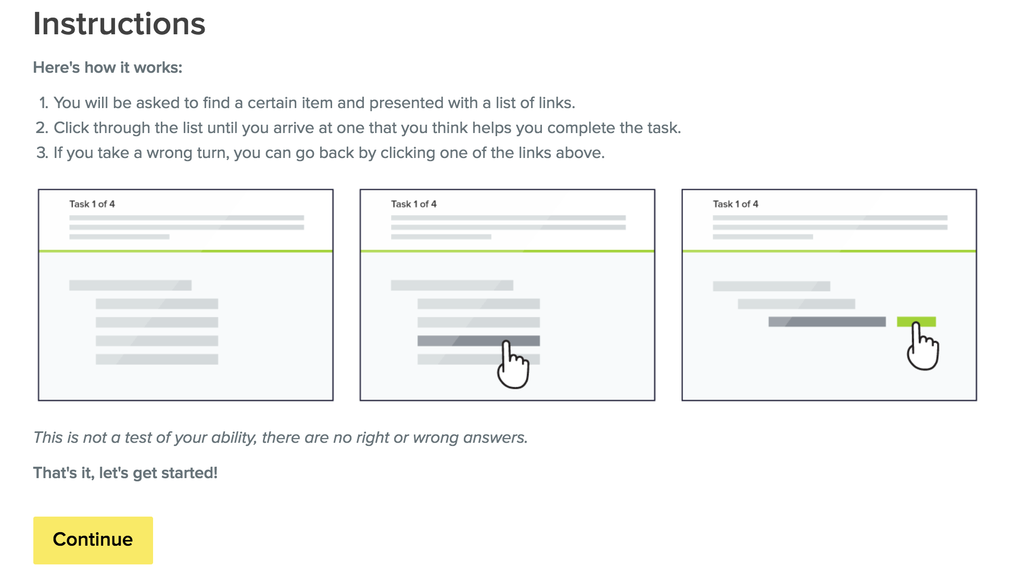

Post-Test Questions

Participants will be given the opportunity to write responses of any length they choose to one or more of the following questions. These questions are optional and a participants can complete the test without providing any responses to them.

* Describe your experience completing these tasks.
* What is your general opinion of the new CMS.gov site structure and navigation?
* What do you like best about it? Least?
* What would you like to see improved on the proposed site structure?
* Are there certain things that need to be added or changed?

**PRA Disclosure Statement**

According to the Paperwork Reduction Act of 1995, no persons are required to respond to a collection of information unless it displays a valid OMB control number.  The valid OMB control number for this information collection is **0938-XXXX (Expires XX/XX/XXXX)**.  The time required to complete this information collection is estimated to average **15 minutes** per response, including the time to review instructions, search existing data resources, gather the data needed, and complete and review the information collection.  If you have comments concerning the accuracy of the time estimate(s) or suggestions for improving this form, please write to: CMS, 7500 Security Boulevard, Attn: PRA Reports ClearanceOfficer, Mail Stop C4-26-05, Baltimore, Maryland 21244-1850. **\*\*\*\*CMS Disclosure\*\*\*\***  **Please do not send applications, claims, payments, medical records or any documents containing sensitive information to the PRA Reports Clearance Office. Please note that any correspondence not pertaining to the information collection burden approved under the associated OMB control number listed on this form will not be reviewed, forwarded, or retained. If you have questions or concerns regarding where to submit your documents, please contact Michael McCann.**