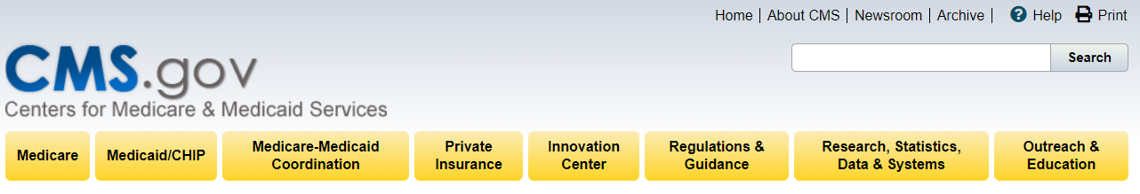
CMS Outreach Engagement Feedback Evaluation
Thank you for attending this session with CMS. We appreciate your time. We are always trying to improve our level of service to our customers and stakeholders. You can help us do that by providing your feedback on Today’s session. Please take a few moments to complete this brief evaluation. Just click on the link below to go to the evaluation.
Thank you very much.

PRA Disclosure Statement This collection of information request is directly related to the President’s Management Agenda (PMA), specifically Priority Areas for Transformation, CAP Goal 4, Improving Customer Experience with Federal Services. The collection consists of a voluntary evaluation that is associated with the PMA objective of providing a modern, streamlined, and responsive customer experience across Government. Under the Privacy Act of 1974 any personally identifying information obtained will be kept private to the extent of the law.

According to the Paperwork Reduction Act of 1995, no persons are required to respond to a collection of information unless it displays a valid OMB control number. The valid OMB control number for this information collection is 0938-1185 (CMS-10732). The time required to complete this information collection is estimated to average 3 minutes per response, including the time to review instructions, search existing data resources, gather the data needed, and complete and review the information collection. If you have comments concerning the accuracy of the time estimate(s) or suggestions for improving this form, please write to: CMS, 7500 Security Boulevard, Attn: PRA Reports Clearance Officer, Mail Stop C4-26-05, Baltimore, Maryland 21244-1850.

Please let us know the name of the CMS Activity you attended:
TEXT BOX

Please let us know the date of the CMS Activity you attended:
TEXT BOX

Please select from the list below, to let us know which audience most accurately describes you.
I am a:
DROP-DOWN LIST

The session I attended was relevant to me.
DROP-DOWN LIST

The CMS presenter(s) was/were knowledgeable about the subject matter.
DROP-DOWN LIST

If your session covered more than one topic, which topic(s) was/were of greatest interest or importance to you?
TEXT BOX

How much have your skills or knowledge of this/these topic(s) improved because of this session?
DROP-DOWN LIST

What topic(s) do you wish CMS had covered (but didn’t)? We’ll try to address them next time.

TEXT BOX

BASED ON SELECTION FOR AUDIENCE TYPE, ONE OF THESE FOUR QUESTIONS WILL APPEAR

[If a Medicare beneficiary] How do you plan to use the information you gathered from this CMS session? Select all that apply.
DROP-DOWN LIST

[If a marketplace consumer] How do you plan to use the information you gathered from this CMS session? Select all that apply.
DROP-DOWN LIST

[If a provider/supplier] How do you plan to use the information you gathered from this CMS session? Select all that apply.
DROP-DOWN LIST

[If a SHIP or other assister or partner] How many others do you estimate you can reach and educate with the information you learned today from CMS?

TEXT BOX

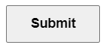
Are there any additional comments or suggestions you have to improve this session for the future? Thank you for your feedback!
TEXT BOX

