Medicare Ground Ambulance Data Collection System (GADCS) User Guide

Centers for Medicare and Medicaid Services (CMS)
2022

Table of Contents

Acronyms and Definitions………………………………………………………………………………………………………………3
Introduction and User Roles definition 5
Important Information 7
Logging In 8
Linking Your Organization’s NPI 11
1. General Instructions 13
2. Organizational Characteristics 16
3. Service Area 22
4. Emergency Response Time 26
5. Ground Ambulance Service Volume 30
6. Service Mix 36
7. Labor Cost 38
8. Facilities Cost 42
9. Vehicle Costs 46
10. Equipment, Consumable, and Supply Costs 51
11 Other Costs 54
12 Total Costs 57
13 Revenues 58
Certifier Landing Page 64

Acronyms and Definitions
ALS1 | Advanced Life Support, Level 1
ALS2 | Advanced Life Support, Level 2
BBA | Bipartisan Budget Act
BLS | Basic Life Support
CMS | Centers for Medicare & Medicaid Services
EMR | Emergency Medical Responder
EUA | Enterprise User Administration
GAAP | Generally Accepted Accounting Principles
GADCS | Ground Ambulance Data Collection System
HCPCS | Healthcare Common Procedure Coding System
HHS | Department of Health and Human Services
MAC | Medicare Administrative Contractor
MFA | Multi-Factor Authentication
NPI | National Provider Identifier
PI | Paramedic Intercept
Primary service area | The area in which you are exclusively or primary responsible for providing service at one or more levels and where it is highly likely that the majority of your transport pickups occur.
QRV | Quick response vehicle
PDF | Portable Document Format
SCT | Specialty Care Transport
Secondary service area | Other areas that are outside of your primary service area but one where you regularly provide services through mutual or auto-aid agreements.
SUV | Sport-utility vehicle

duction and User Roles definition
Medicare Ground Ambulance Data Collection System (GADCS) User Guide
Introduction
This document provides an overview of the Medicare Ground Ambulance Data Collection System (GADCS) and lists the specific information that sampled ground ambulance organizations must collect and report through the GADCS.

The Medicare Ground Ambulance Data Collection Instrument is the set of questions that sampled ground ambulance organizations will answer when they report information to the GADCS. The Instrument contains questions relating to your organization’s characteristics, service area, emergency response time (if applicable), mix of ground ambulance services (e.g., basic life support versus advanced life support and emergency versus non-emergency transports), costs (including those related to labor, facilities, vehicle, equipment, consumables, supplies, and other), and revenues (e.g., payments from health insurers) and provides instructions on how to report this information.

A printable version of the Medicare Ground Ambulance Data Collection Instrument is available on CMS’ Ambulances Services Center website at https://www.cms.gov/Center/Provider-Type/Ambulances-Services-Center.html. The Ambulances Services Center website lists other resources, including prior presentations and a Frequently Asked Questions (FAQ) document (https://www.cms.gov/Medicare/Medicare-Fee-for-Service-Payment/AmbulanceFeeSchedule/Downloads/Medicare-Ground-Ambulance-FAQs.pdf), that may be helpful to ground ambulance organizations preparing to collect and report information to the GADCS. Please email AmbulanceDataCollection@cms.hhs.gov if you have questions regarding this document or the GADCS.

Timeline and Process Overview
CMS developed the GADCS to meet the requirements described in paragraph (17) of section 1834 (l) of the Social Security Act. CMS is required by law to collect information on costs, revenue, utilization, and other information from representative samples of ground ambulance organizations. This information will be analyzed by the Medicare Payment Advisory Commission (MedPAC), a government body independent from CMS, to develop a report to Congress on the adequacy of Medicare payment rates for ground ambulance services and geographic variations in the cost of furnishing such services.

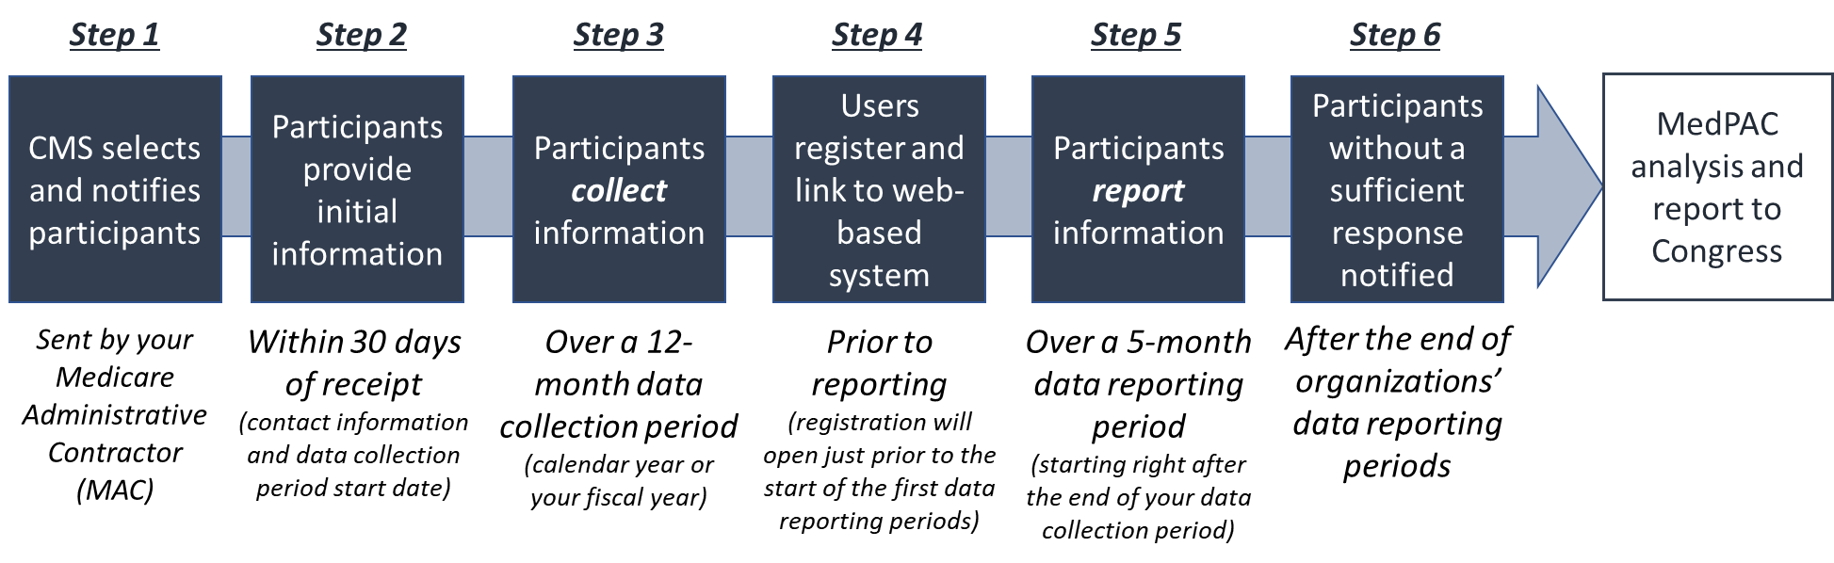
The figure above provides a high-level overview of the timeline for the data collection and data reporting requirements under the GADCS. In brief, CMS first selects and notifies participants in each of four representative samples of ground ambulance organizations (Step 1). Selected organizations have 30 days following receipt of notification to submit important initial information, including contact information and the start of the organization’s data collection period, to CMS (Step 2).

After reporting this initial information, organizations will collect data over a continuous 12-month data collection period (Step 3). Organizations can choose to use a calendar year as their reporting period or, if different than a calendar year, their fiscal year.

Two types of users, data submitters and certifiers, will need to create accounts and link to the sampled NPI via a web-based GADCS portal currently under development by CMS (Step 4). Submitters are responsible for entering information into the web-based instrument (i.e., questions organized by section). Certifiers will review complete responses and certify the information is complete and accurate before submitting the response to CMS.

Organizations must report and certify their response in the GADCS before the end of their data reporting period, a 5-month period starting immediately after the end of the organization’s data collection period (Step 5). CMS will notify organizations that do not sufficiently report information and may apply a 10 percent payment reduction on Medicare Part B Ambulance Fee Schedule services during the next calendar year to organizations that do not sufficiently report (Step 6). Ultimately, MedPAC will analyze the data reported to CMS to determine the adequacy of Medicare payments for ground ambulance services and geographic variations in the cost of furnishing such services. MedPAC will submit a report including its recommendations to Congress.

General Data Collection and Reporting Principles

Collecting information over a continuous, 12-month data collection period. Selected organizations will collect information over a continuous, 12-month data collection period. Organizations will not report any information to CMS until after the end of the data collection period. The information that you report to CMS must reflect the entire continuous, 12-month data collection period. Your answers to questions about the characteristics of your organization should reflect how your organization operated during its data collection period, even if there were subsequent changes in characteristics or operations. Similarly, reported expenses, revenue, and hours worked must reflect the entire continuous, 12-monthd data collection period, even if your situation changed after the end of your data collection period. Please see detailed instructions in the printable version of the Medicare Ground Ambulance Data Collection Instrument for more detail.

Collecting and reporting required information that you may not currently track. Some ground ambulance organizations may need to reach out to individuals outside their organization to gather information that is not currently tracked. As an example, if your organization is part of a local government or broader parent entity that paid for certain aspects of your ground ambulance costs (e.g., if your municipality paid facility rent or benefits for staff), you will need to collect and report that information in order for CMS to get a full picture of the costs of operating your ground ambulance organization. As another example, you may need to reach out to your billing company for information on your volume of billed ground ambulance transports and the breakdown by level during your organization’s data collection period.

Avoiding double counting. It is important that the staff hours, costs, and revenues contributing to the totals you report in the Medicare Ground Ambulance Data Collection Instrument are counted only once. As an example, following the instructions in the instrument, staff with both emergency medical technician (EMT) and administrative responsibilities must contribute only to reported EMT hours and compensation and not to reported administrative staff hours and compensation. The data collection instrument includes instructions on how to assign staff, costs, and revenue to only one category for the purposes of reporting.

Reporting information for sampled National Provider Identifiers (NPIs) only. CMS selects ground ambulance organizations to participate in the GADCS using NPIs. In some cases, an individual selected NPI will be part of a larger company or parent organization operating multiple ground ambulance NPIs. In other cases, a single ground ambulance organization may bill under multiple NPIs, for example when providing ambulance services in different jurisdictions. In these cases, you must collect and report data separately for each NPI, and you must report only for selected NPIs.

General Layout of Information
The bullet lists below summarizes the information in the Medicare GADCS across its 13 sections. Ground ambulance organizations selected to participate in the GADCS must collect and report all information below that is applicable to their organization. The grey boxes below list information applicable only to certain types of ground ambulance organizations based on organizational characteristics and the services that are provided. Unless otherwise specified, all questions ask for information collected over your organization’s continuous, 12-month data collection period.

A. Organizational Characteristics and Service Area (Instrument Sections 2 & 3)

- How you categorize your ground ambulance organization among several organization types.
- Whether your organization provides services other than ground ambulance services.
- Whether your organization operates land and/or water ambulances.
- Whether your organization provides certain types and levels of services (e.g., responses to emergency calls for service).
- Your organization’s overall staffing model.
- Whether your organization uses any volunteer labor.
- The ZIP codes which you consider to comprise your service area.

B. Services Volume and Mix (Instrument Sections 4, 5, & 6)

- Your organization’s approximate average trip time (in minutes).
- Number of total responses for all calls for service.
- Number of total ground ambulance responses involving a fully equipped and staffed ground ambulance, regardless of whether the response resulted in a transport.
- Whether your ground ambulance organization responds to calls with another non-transporting agency (such as a local fire department) that is not part of your organization, and the types of staff involved.
- Your organization’s number of ground ambulance responses that did not result in a transport and, of these, the share where the patient received medical treatment on site.
- Your organization’s number of ground ambulance responses that did result in a transport.
- Your organization’s number of ground ambulance transports during the data collection period that were paid in part or in full by any health insurer or patient by the time you report data.
- Whether your organization participates in standby events (paid or unpaid).
- The number of paramedic intercepts for which your organization provided an Advanced Life Support (ALS) level of service for which another organization provides an ambulance transport.
- Excluding paramedic intercepts meeting Medicare’s definition, the number of responses for which your organization provided ALS intervention as a joint response to meet a Basic Life Support (BLS) ambulance from another organization.
- The share of ground ambulance transports by level of service by billing code.
- The share of ground ambulance services that were interfacility.

Box 1: Services Provided Information Applicable to Certain Organization Types
Organizations that use more than one NPI to bill Medicare:
- Your parent organization’s number of ground ambulance transports, including the number of transports across all ground ambulance organizations and NPIs owned or operated by the parent organization.

Organizations Responding to Emergency Calls for Service:
- How your organization currently tracks response times.
- Average response time.
- The share of emergency responses with response times more than twice your organization’s average response time.
- Whether your organization is required or incentivized to meet response time targets.
- The share of ground ambulance responses that were emergency and non-emergency.

Organizations Operating Water Ambulances:
- The share of ground ambulance responses involving a water ambulance.

C. Information on Costs (Instrument Sections 7 through 12)

Staffing and Labor Costs (Instrument Section 7)
- Whether your organization uses paid and/or volunteer staff in specific categories of emergency medical technician (EMT) and other response staff categories.
- Whether your organization uses paid and/or volunteer medical director staff and staff in specific administration/facility categories.
- Total annual hours worked, hours worked related to ground ambulance responsibilities, and hours worked related to all other responsibilities by staff category.
- Total compensation for paid staff by staff category.
- Whether your organization has staff performing specific roles such as billing, data analysis, training, and medical quality assurance more than half-time.

Box 2: Staffing and Labor Cost Information Applicable to Certain Organization Types
Organizations using volunteer labor:
- The total number of EMT/response and of administrative/facilities volunteers. Total annual hours worked by volunteer staff by staff category.
- Total costs associated with volunteer staff.

Fire, Police, and/or Public Safety-Based Organizations:
- Hours worked related to fire, police, or other public safety activities by category for individuals with both ground ambulance and fire/police/public safety roles.

Facility Costs (Instrument Section 8)
- Information on each facility used by your organization related to ground ambulance services such as whether your organization pays mortgage or lease payments for each facility, whether the facility is owned outright or donated, the square footage of the facility, and the share of the facility related to ground ambulance services.
- Annual costs associated with each facility due to mortgage interest, lease payments, and depreciation (if applicable).
- Combined, facilities-related insurance costs, maintenance and improvements costs, utility costs, and facility taxes.

Vehicle Costs (Instrument Section 9)
- Information on each ambulance used by your organization related to ground ambulance services such as whether the ambulance was used to transport patients, whether the ambulance was donated, the annual depreciated value of the ambulance if owned (if applicable), payment amount if leased, and whether the ambulance was remounted and at what cost if owned.
- Information on each non-ambulance vehicle used by your organization related to ground ambulance services such as the vehicle type, whether the vehicle was donated, annual depreciation expense if owned (if applicable), and the payment amount if leased.
- The total miles traveled by ambulance and non-ambulance vehicles.
- Combined vehicle-related registration, license, insurance, maintenance, and fuel costs as well as estimates of the breakdown of maintenance and fuel costs across different types of vehicles.

Equipment, Consumable, and Supply Costs (Instrument Section 10)
- Total annual depreciation expense (if applicable), acquisition costs (if applicable), and total annual maintenance, certification, and service costs for capital medical equipment.
- Total annual costs associated with medications. If your organization does not have any costs related to medications, you will be asked to indicate a reason why.
- Total annual costs for medical supplies and consumables. This amount excludes costs related to capital medical equipment and medication reported elsewhere.
- Total annual depreciation expense (if applicable), acquisition cost (if applicable), and total annual maintenance, certification, and service costs for capital non-medical equipment.
- Total annual costs associated with uniforms.
- Total annual costs for non-medical supplies. This amount excludes costs associated with medical supplies, all capital equipment, and uniforms, all of which are reported elsewhere.

Other Costs (Instrument Section 11)
- Whether your organization contracts for billing, accounting, vehicle maintenance/repair, dispatch and call center, facilities maintenance, or information technology services and, if so, the annual cost for the service and the share of the costs associated with ground ambulance services. You will report a single cost for contracted services in each category.
- Whether your organization has any other costs related to ground ambulance services not reported elsewhere. While the instrument lists many categories, you may also enter your own categories if necessary to ensure all costs are reported.

Total Costs (Instrument Section 12)
- Your organization’s total costs, including costs unrelated to ground ambulance services. Note: We are asking for your organization’s total costs in one separate question at the end of the cost section in the Medicare Ground Ambulance Data Collection Instrument. You are being asked a series of more detailed cost questions to help CMS understand the components of your total costs.

D. Information on Revenue (Instrument Section 13)

- Your organization’s total revenue, including revenue unrelated to ground ambulance services.
- Transport revenue from different types of health care payers. Specific categories include fee-for-service (FFS) Medicare, Medicare Advantage (i.e., Medicare managed care), FFS Medicaid, Medicaid managed care, TRICARE, Veteran’s Health Administration, commercial insurance, workers’ compensation, and patient self-pay. You will be asked whether patient cost sharing is included in the amount you report for each payer category or in the patient self-pay category.
- Whether you routinely bill for transports of patients with different sources of coverage. The specific categories are the same as those listed above.
- Whether your organization realized revenue from any other sources (e.g., from contracts, earmarked taxes, donations, grants, etc.)
- Percent of revenue attributable to ground ambulance services across different categories.

Getting Help

If you have questions about the GADCS, please email (insert helpdesk info). If you have policy questions, please email the CMS’s ambulance data collection mailbox (AmbulanceDataCollection@cms.hhs.gov). For a list of supplemental documents, webinars, and other resources, please see CMS’s Ambulances Services Center website at https://www.cms.gov/Center/Provider-Type/Ambulances-Services-Center.html.

User Roles
The Medicare Ground Ambulance Data Collection System is a role-based system. This means that certain system functions are linked to specific “user role profiles.” When a new user is given access to the Medicare Ground Ambulance Data Collection System, a role is approved that provides access to the specific functions they need.
Data Submitter: this role is the person who submits all the required information. Once this person has completed the online form and submitted the form, the Certifier will be notified.
Certifier: this role will review the information reported by the Data Submitter to ensure it is correct and complete. The Certifier will then certify the submission of the reported data. If the Certifier would like changes to be made to the data that was reported in the system, the certifier must notify the Submitter to submit the revised data.

Important Information
Browser Compatibility
The GADCS instrument is only compatible in Chrome, Firefox, Edge.
Progress Bar
As you move through the instrument, you will notice a progress bar above the questions. While you’re working in a section, it will say In Progress. When you’ve completed a section, it will say Complete. If a question was skipped or requires more information, it will say Review.
Question Formatting
As you input data, some responses will generate follow-up questions. Be sure to answer all prompts and questions before moving to the next page or section. Certain questions will have explanations, definitions, or warnings. Be sure you are reading all the information provided on the page before entering your data.
Warning Messages
Depending on your responses, you may see “warning” messages as you input data. These messages will appear with this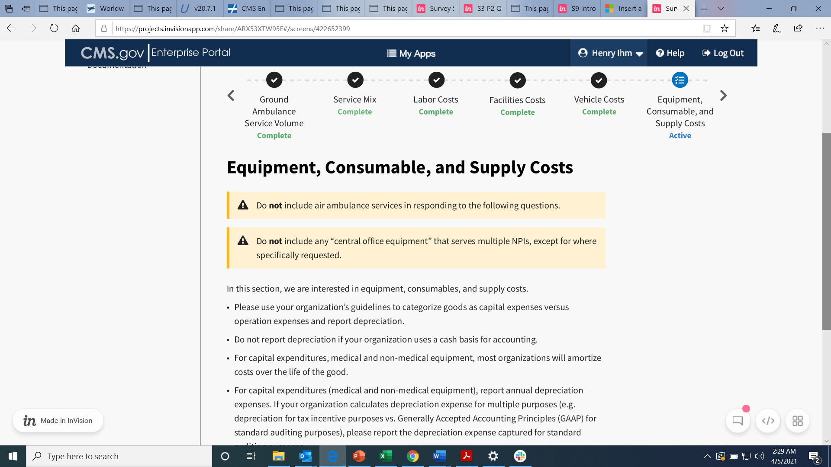 symbol with a yellow or orange background. These do not mean you have done something incorrectly, but instead will highlight information that requires extra attention. Here is a list of the potential messages you will see.
- Do not include any “central office staff” that serve multiple NPIs, except for where specifically requested.
- Do not include any “central office facilities” that serve multiple NPIs, except for where specifically requested.
- Do not include any “central office vehicles” that serve multiple NPIs, except for where specifically requested.
- Do not include any “central office equipment” that serves multiple NPIs, except for where specifically requested.
- Do not include any other “central office” costs that apply to multiple NPIs, except where specifically requested.
- Do not include individuals who had only air ambulance responsibilities.
- Do not include air ambulance services in responding to the following questions.

Logging In
Before you can log in, you must create a new user account.
CMS IDM User Guide (PDF) section 4 on page 4 will show you the steps for creating a new user account.
Once you have completed creating your new user account, you can login to the portal.
To log in, click this link: https://portalval.cms.gov/
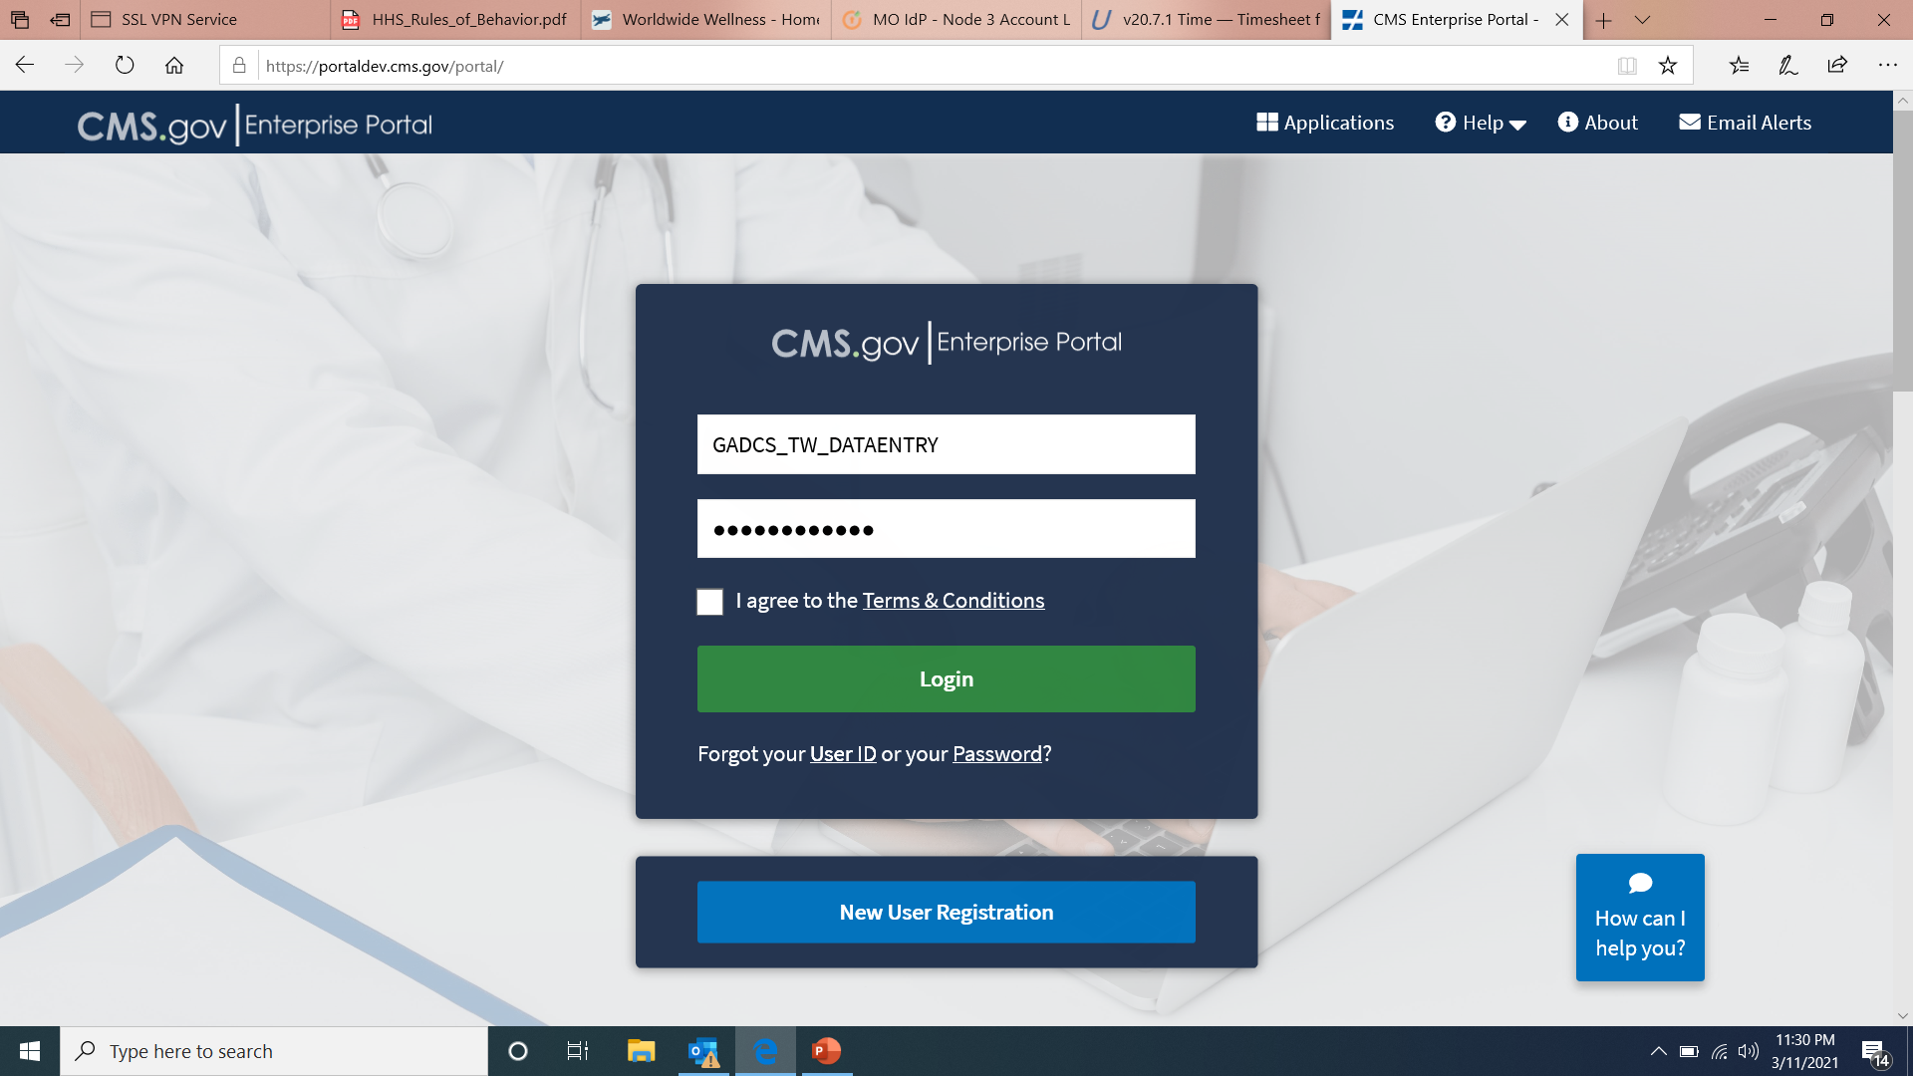
Enter your log-in credentials provided in the email sent to you when you created your new user account.
Once you agree to the Terms & Conditions and click Login, you will be prompted to enter in a multi-factor identification (MFA) code.

Click Send MFA Code and then enter the six-digit code sent to the email address you used to register your account.
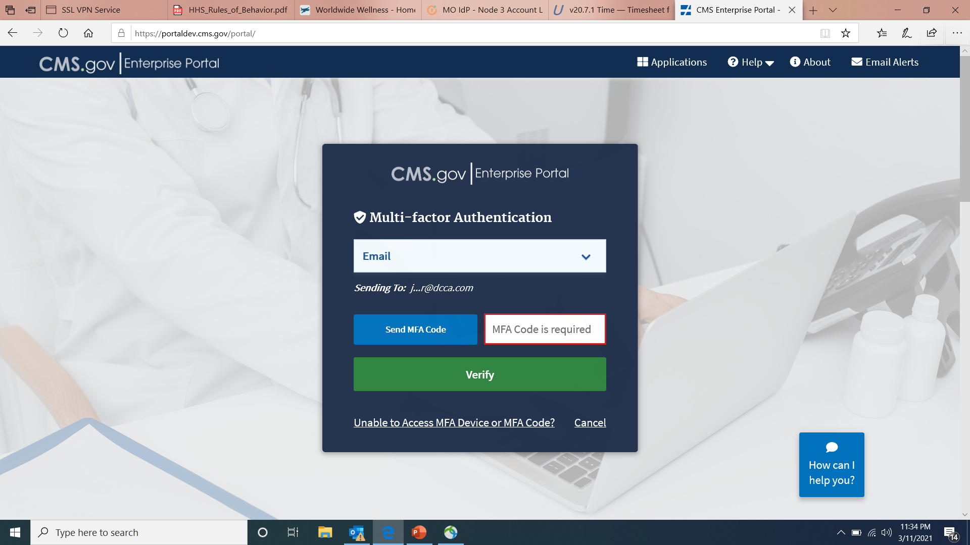
Click the Verify button.
After verifying your MFA code, you will see your My Portal page.
Click on the Fee For Service Data Collection System icon to show the selections.
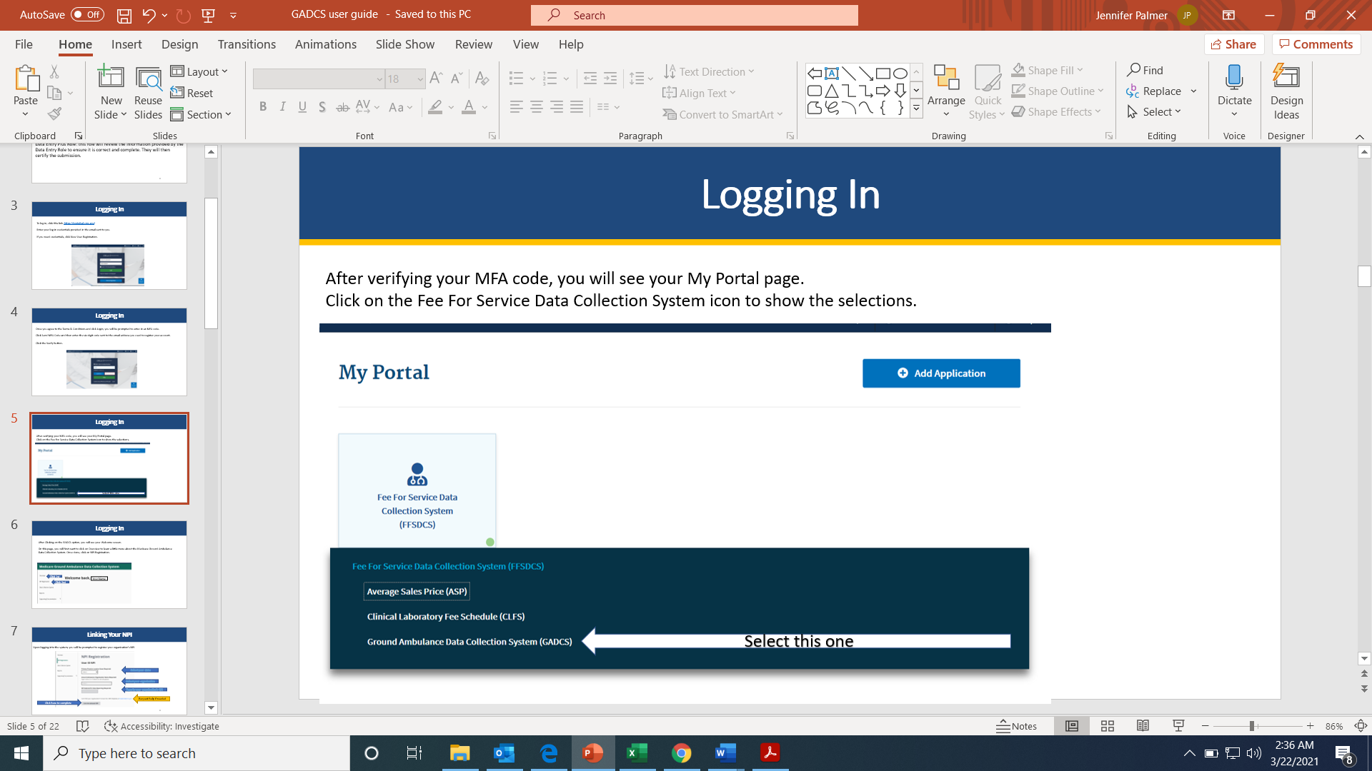

After Clicking on the GADCS option, you will see your Welcome screen.
On this page, you will first want to read Overview to learn a little more about the Medicare Ground Ambulance Data Collection System. Then when you have completed reading the Overview page, click on Start, and begin on NPI Registration.
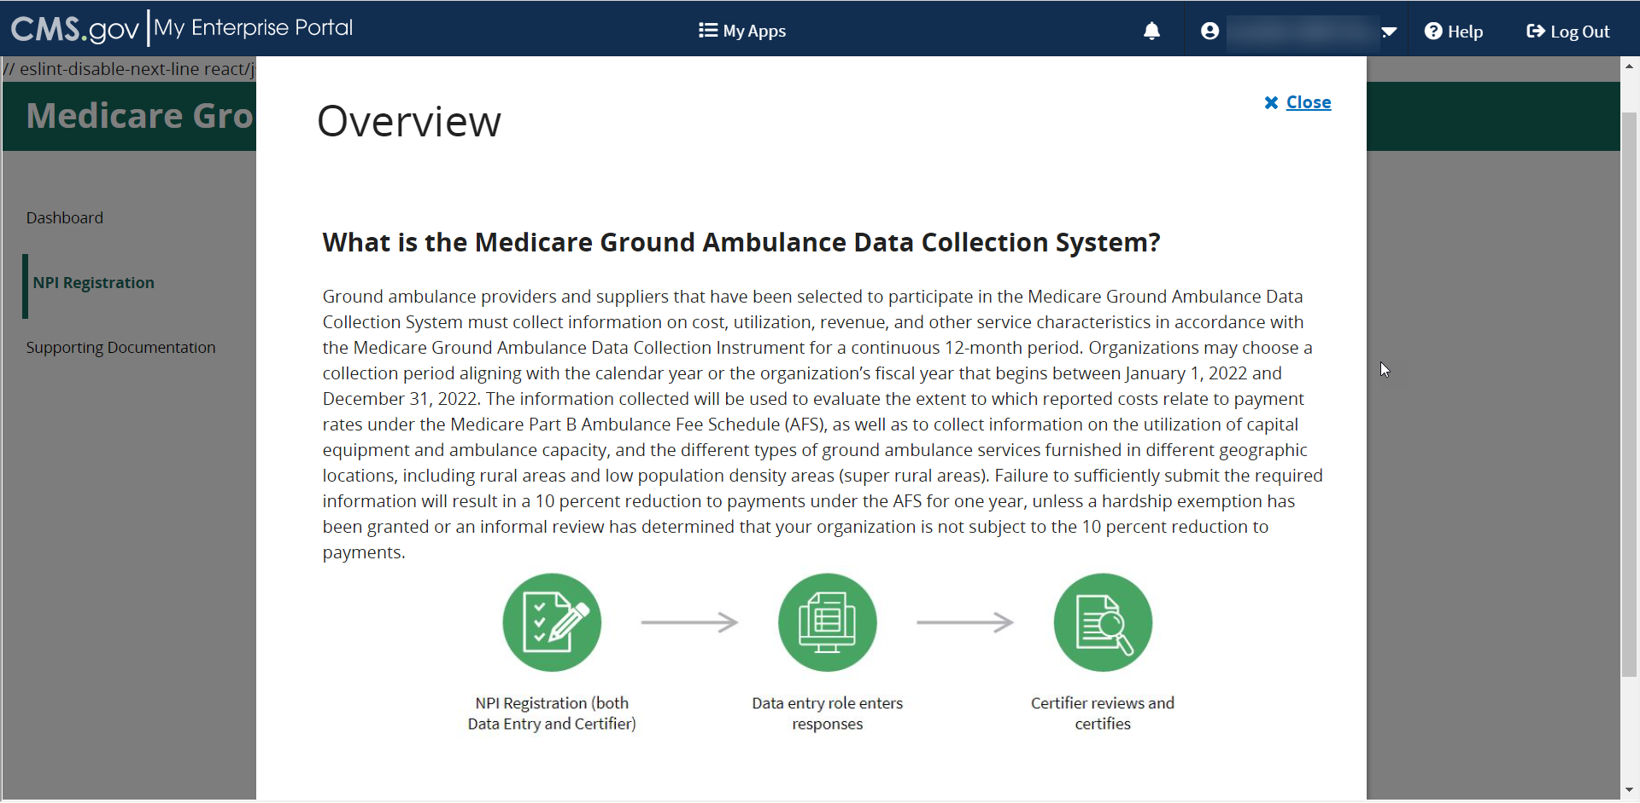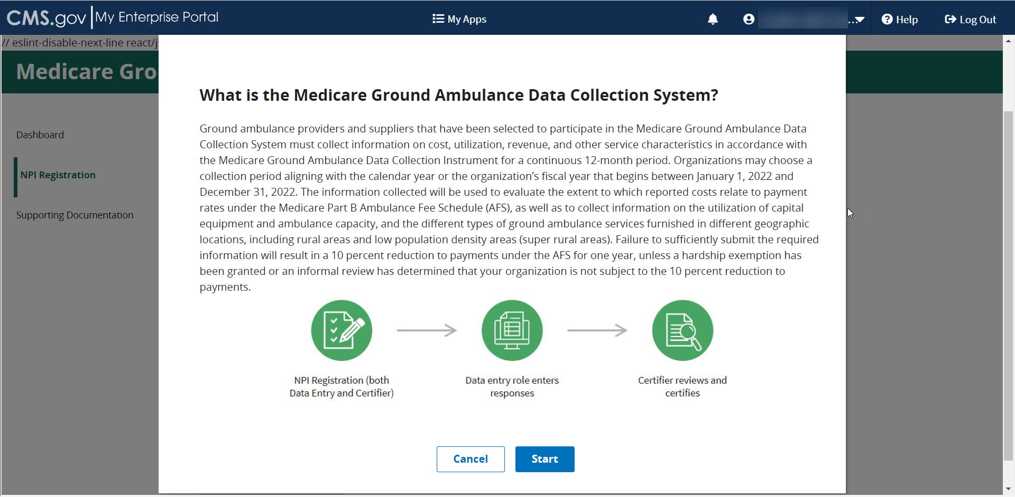

Linking Your Organization’s NPI
Upon logging into the system, you will be prompted to register your organization’s NPI
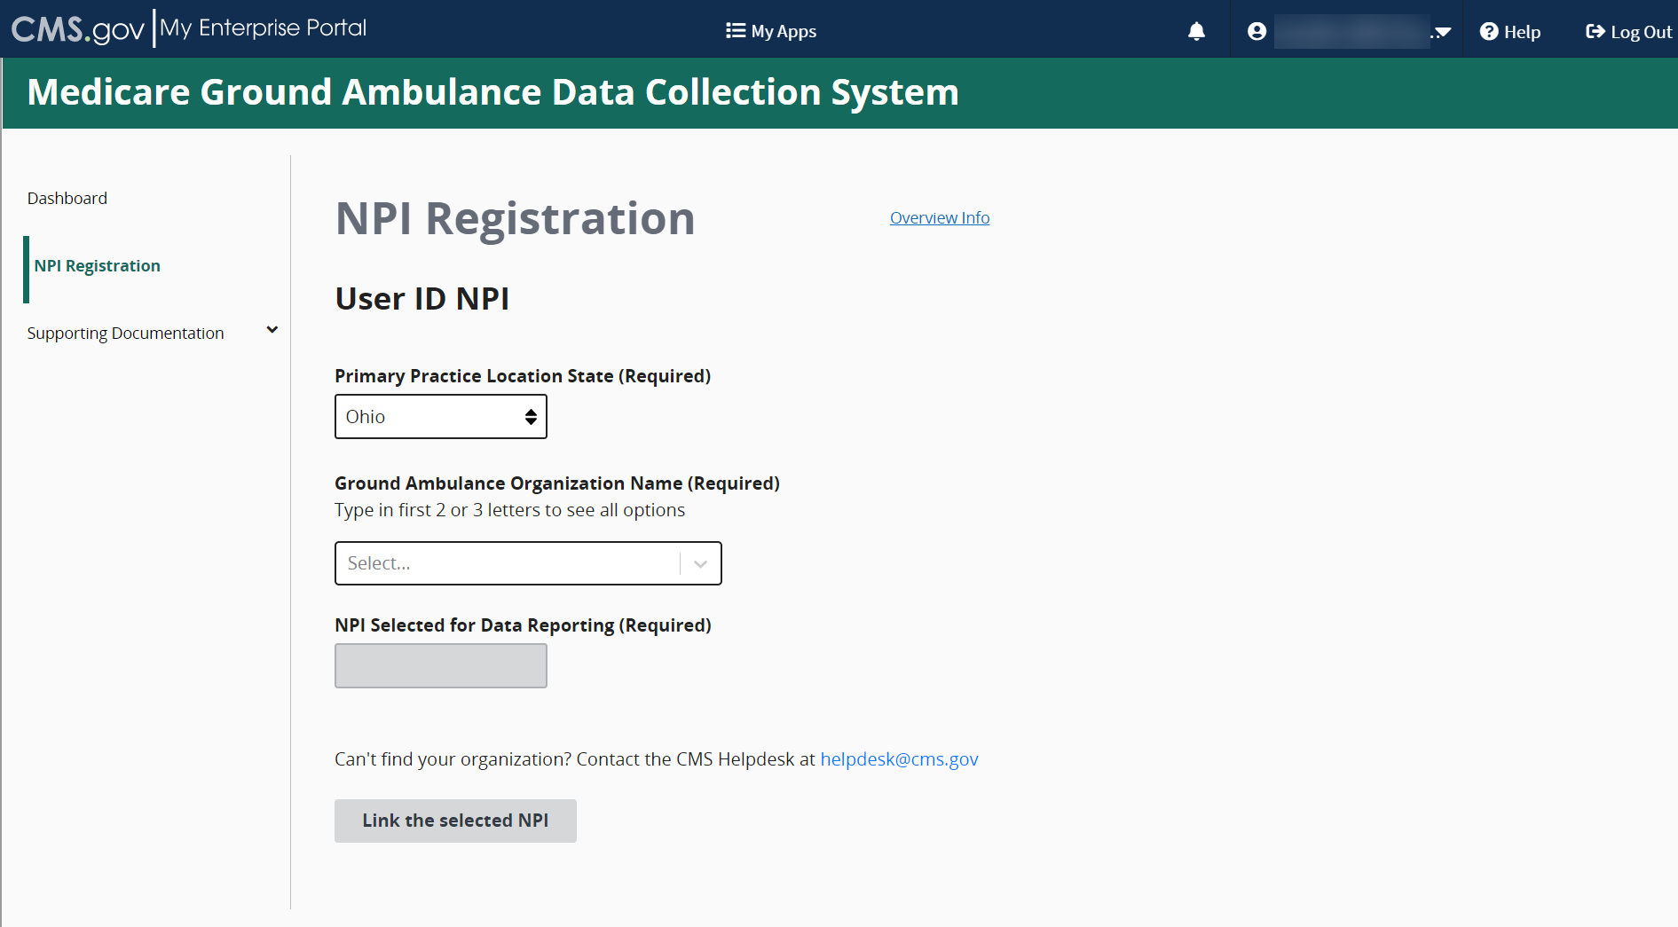
Click to complete
Request help if needed
Type in your organization’s NPI
Select your organization
Select your state

If the NPI you are trying to link to is already in use, you will see an error message that will prompt you to send an email to the help desk to resolve the issue.
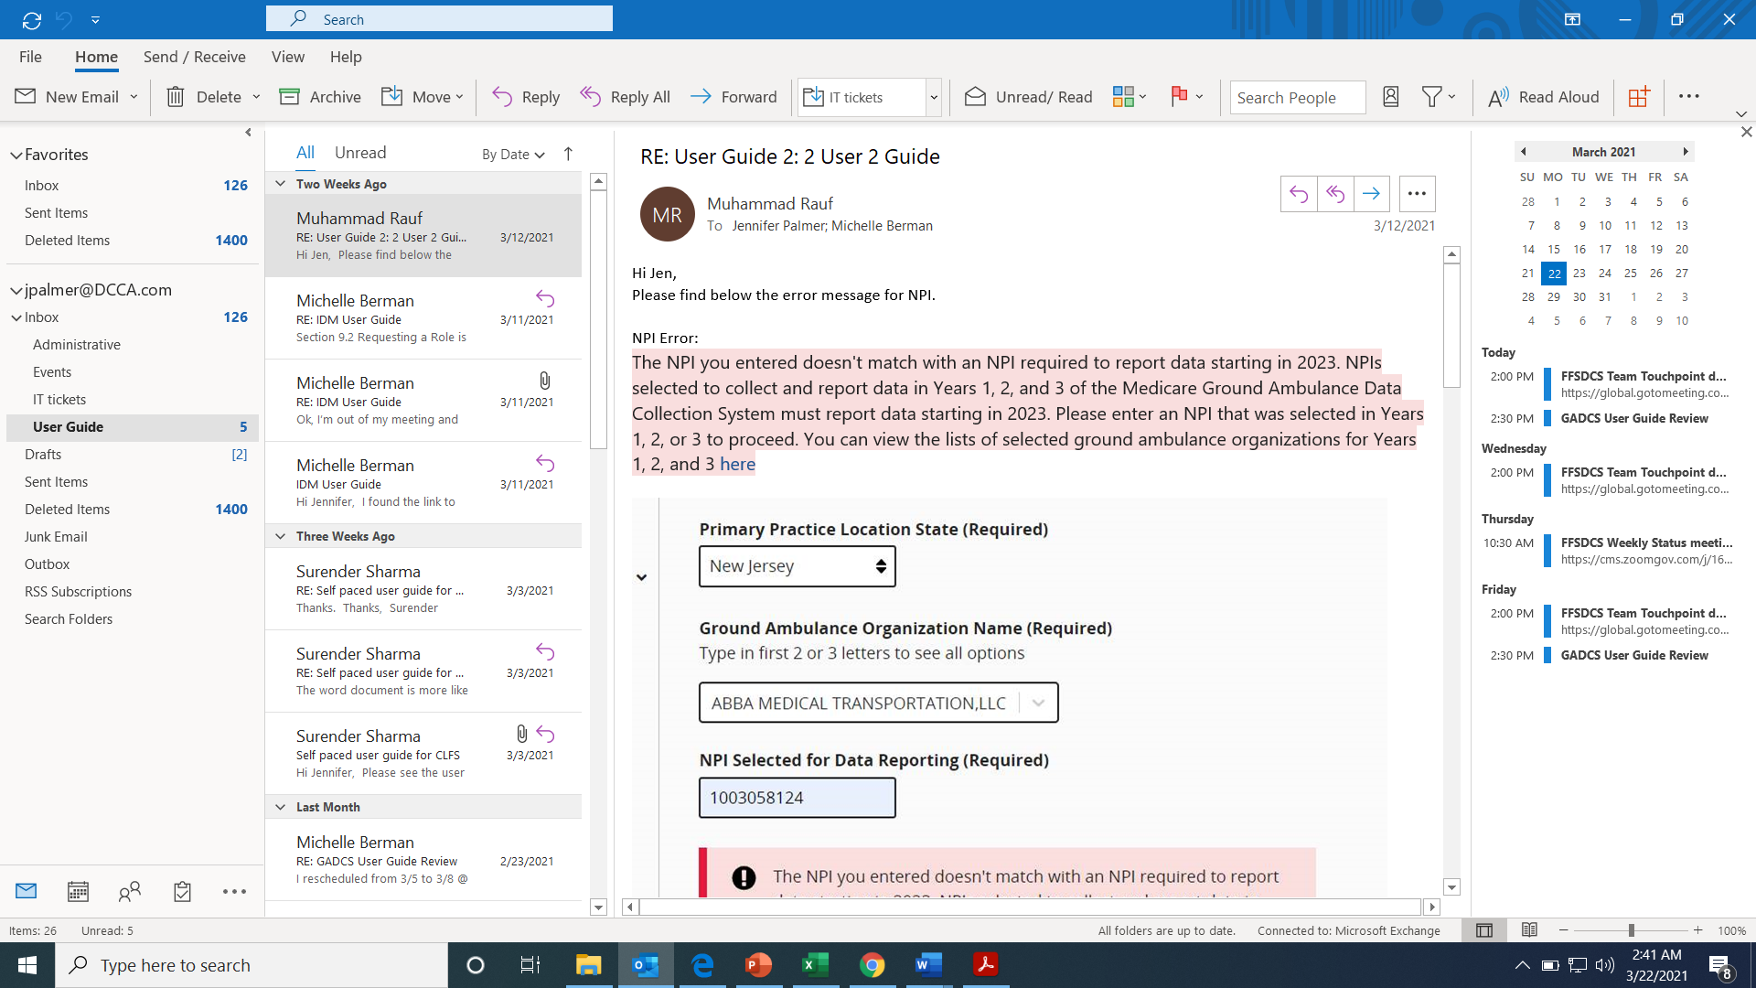
If you see an error message, please check your information and try again. If the error message persists, please contact the CMS Helpdesk at helpdesk@cms.gov.

You may register more than one NPI if you are responsible for entering data for more than one organization.
Select Yes to add another NPI, and then enter the information for the second number. Repeat for as many NPIs as you need.
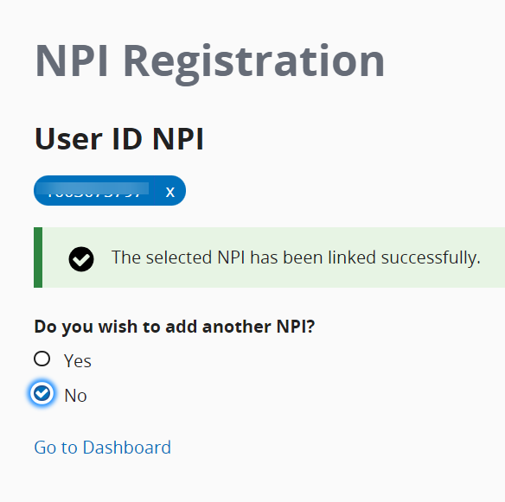
If you register more than one NPI, you will need to select the NPI you are entering data for from the drop down menu at the top of the page as you move through the instrument.
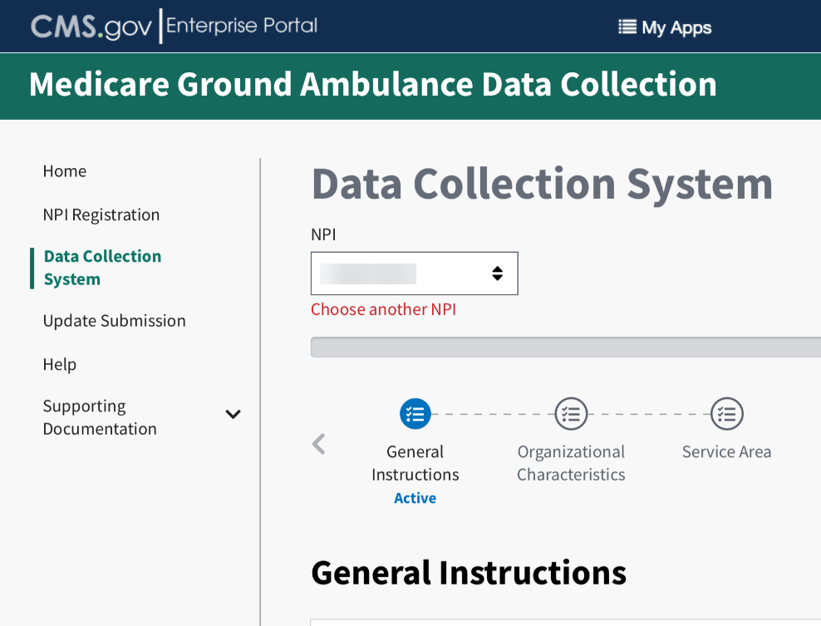

General Instructions
Welcome to the Medicare Ground Ambulance Data Collection System!
You must read the General Instructions (see below) and verify that you have read and understand them by clicking the box that says “I verify that I’ve read the instructions above.”
There are two pages of general instructions and you must verify each one.
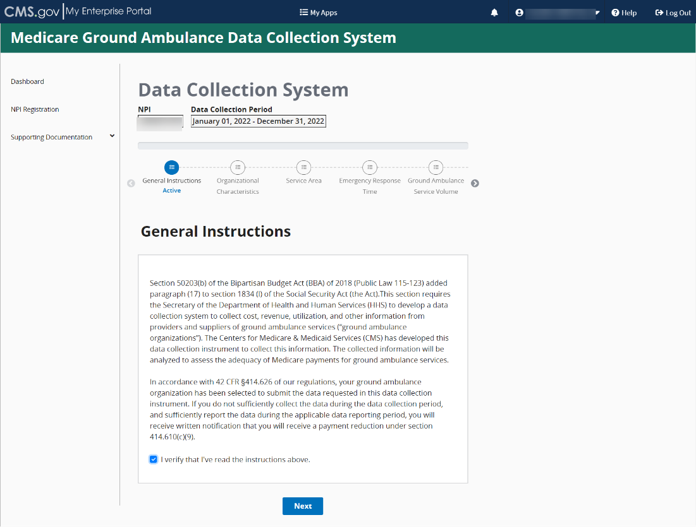
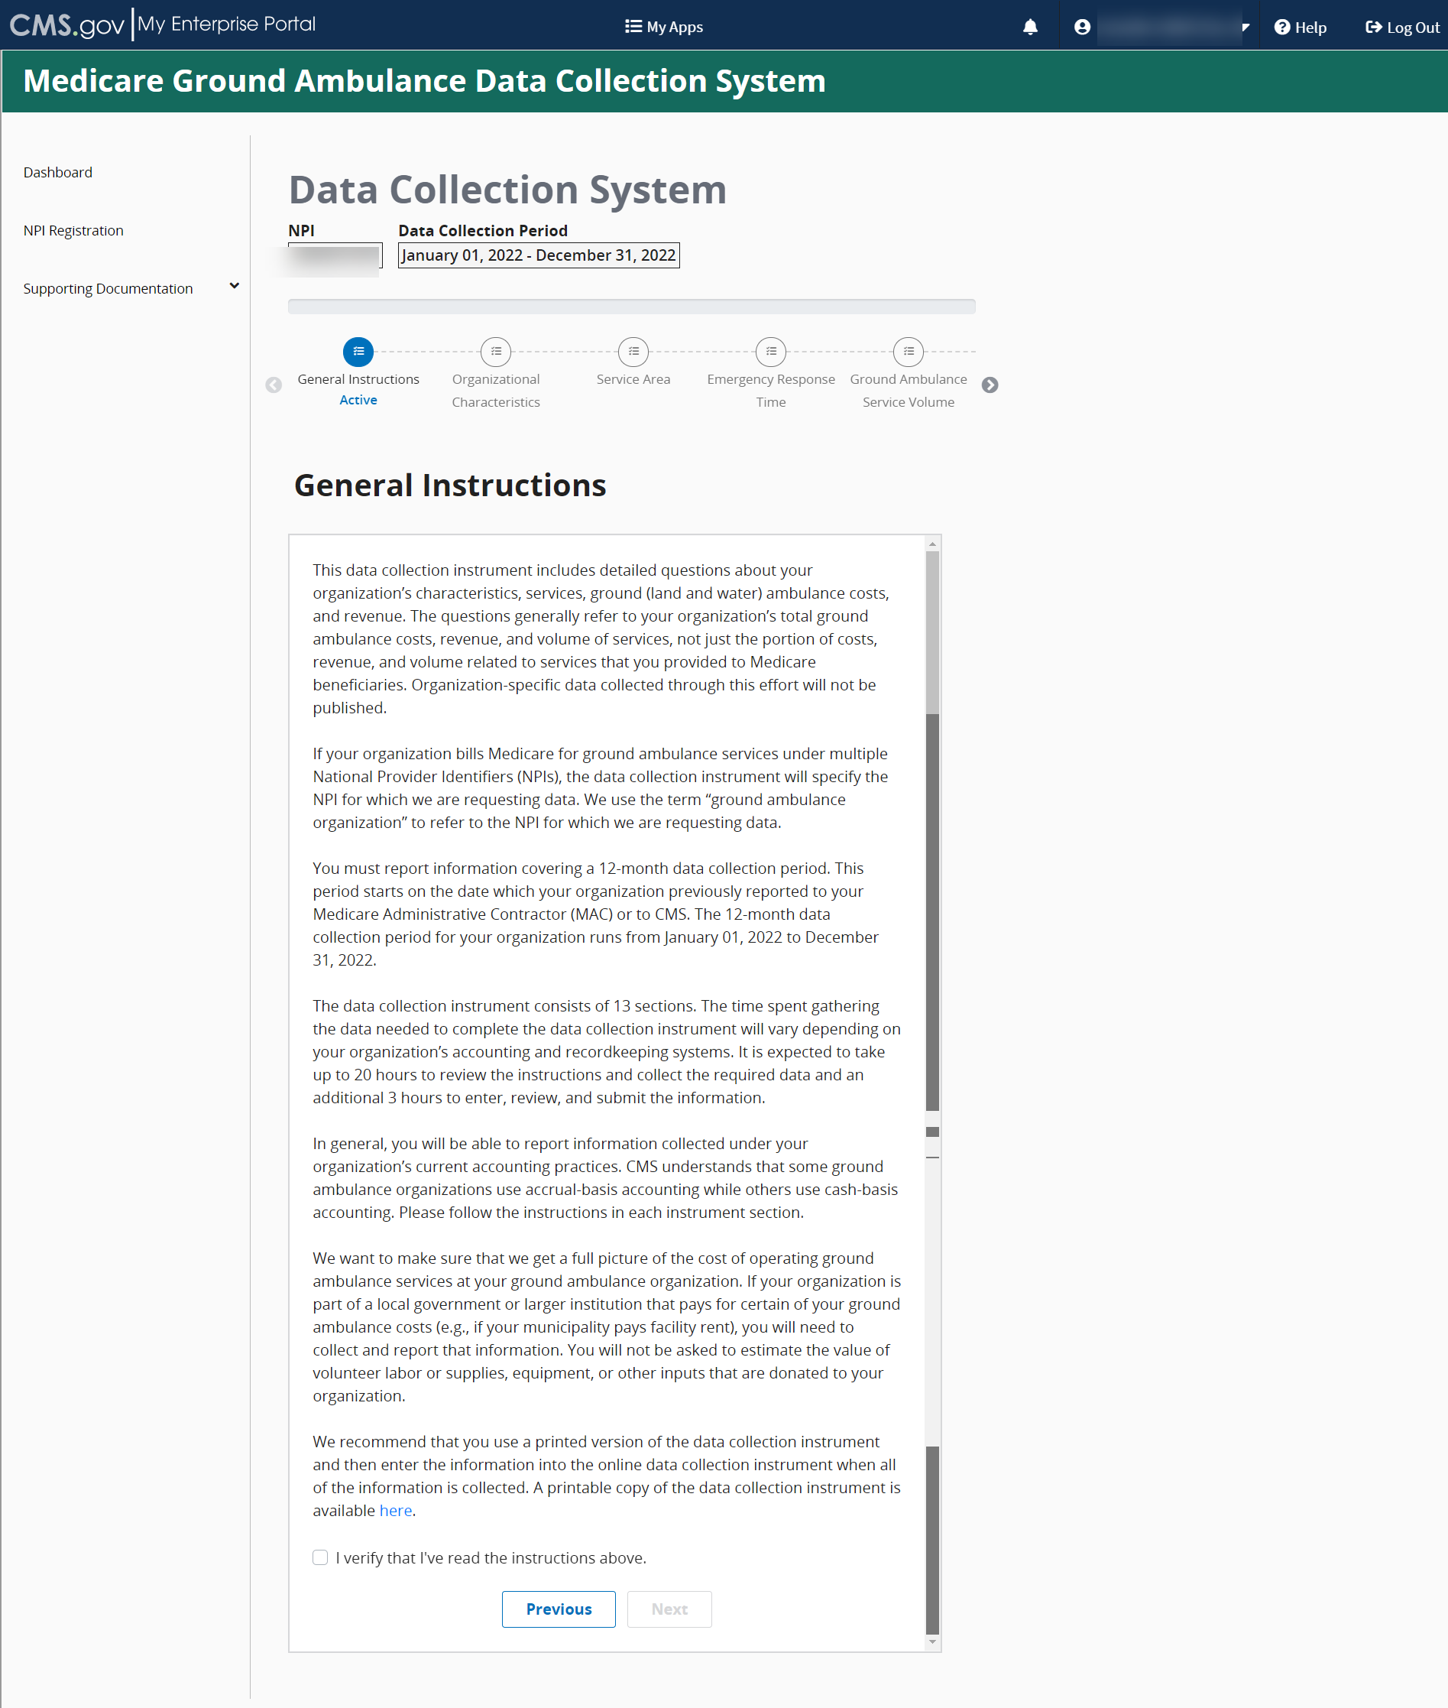
Review the instructions and then click Next, then click on Next Section to begin reporting Organizational Characteristics.
Please note that the system does not automatically save your progress, so it is important for you to click Save before moving on to the next page or section. You can proceed through the instrument without saving, but if you exit the system without saving, your progress will be lost.
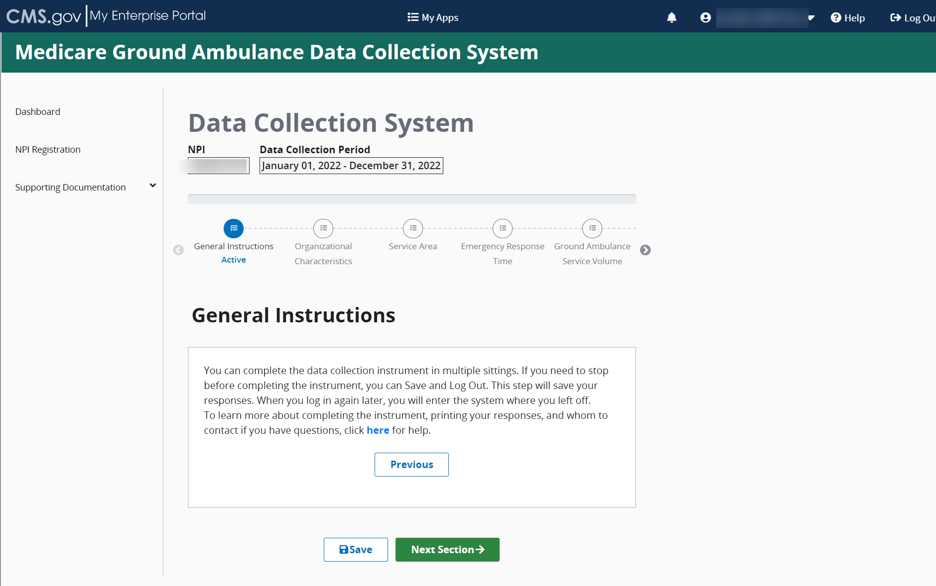

Organizational Characteristics
Once you complete the General Instructions section, you will complete the Organizational Characteristics section.
You must complete this section before moving on to any other sections, as your responses in this section will determine the questions you see later.
If you need to stop at any time, you can save your progress by clicking the Save Icon at the bottom of your screen and resume entering data from where you left off.
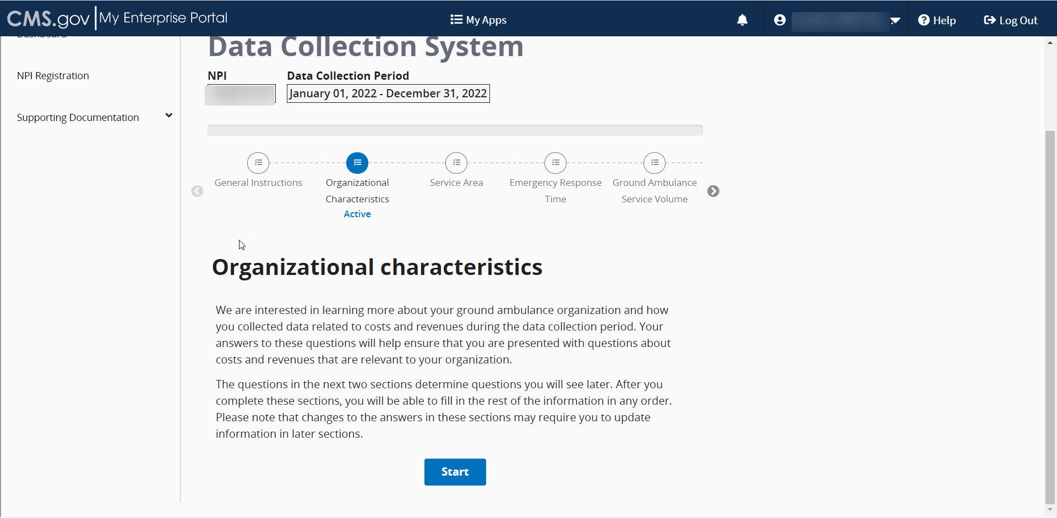
You will be answering a series of questions some of which you will select the answer from options provided, and some you will have to fill in a blank field.
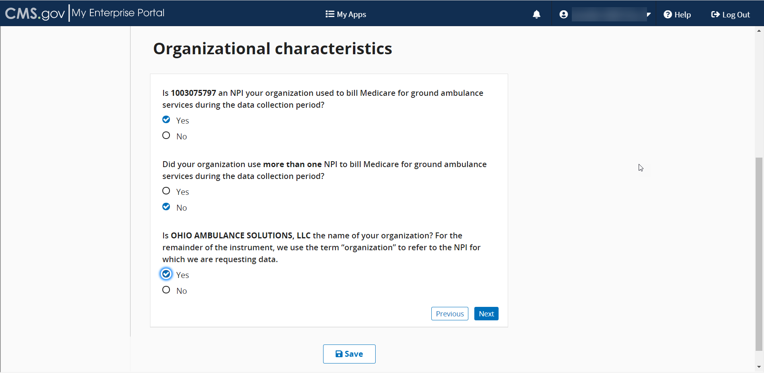
Once you begin answering these questions, more questions will appear. Answer all questions before clicking Save and then Next to move onto the next screen.
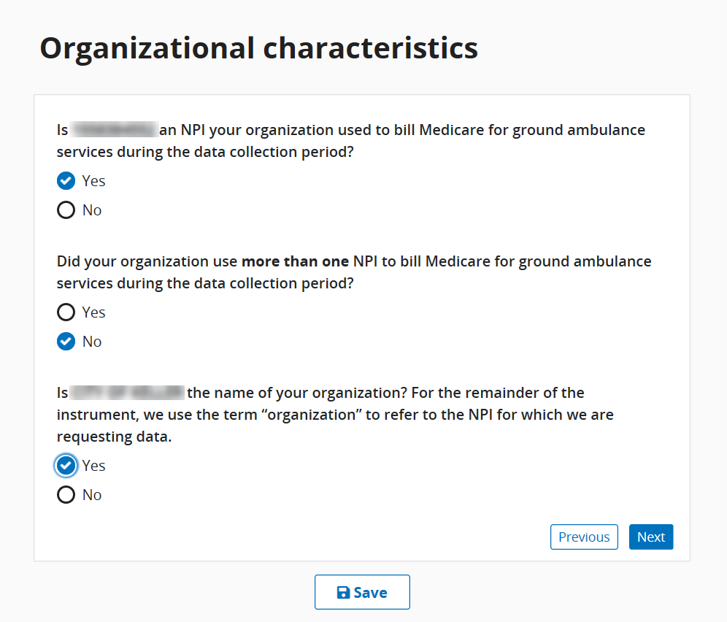
Click Save and then click Next to move to the next series of questions.

- The Job Title field is where you put your current title. There is a maximum of 200 characters.
- Enter your work email address in this format: Words@Emailaddress.com.
- Enter your 10-digit work phone number, area code first in the XXX-XXX-XXXX format.
Before moving onto a new page, be sure to click the Save button to save your progress.
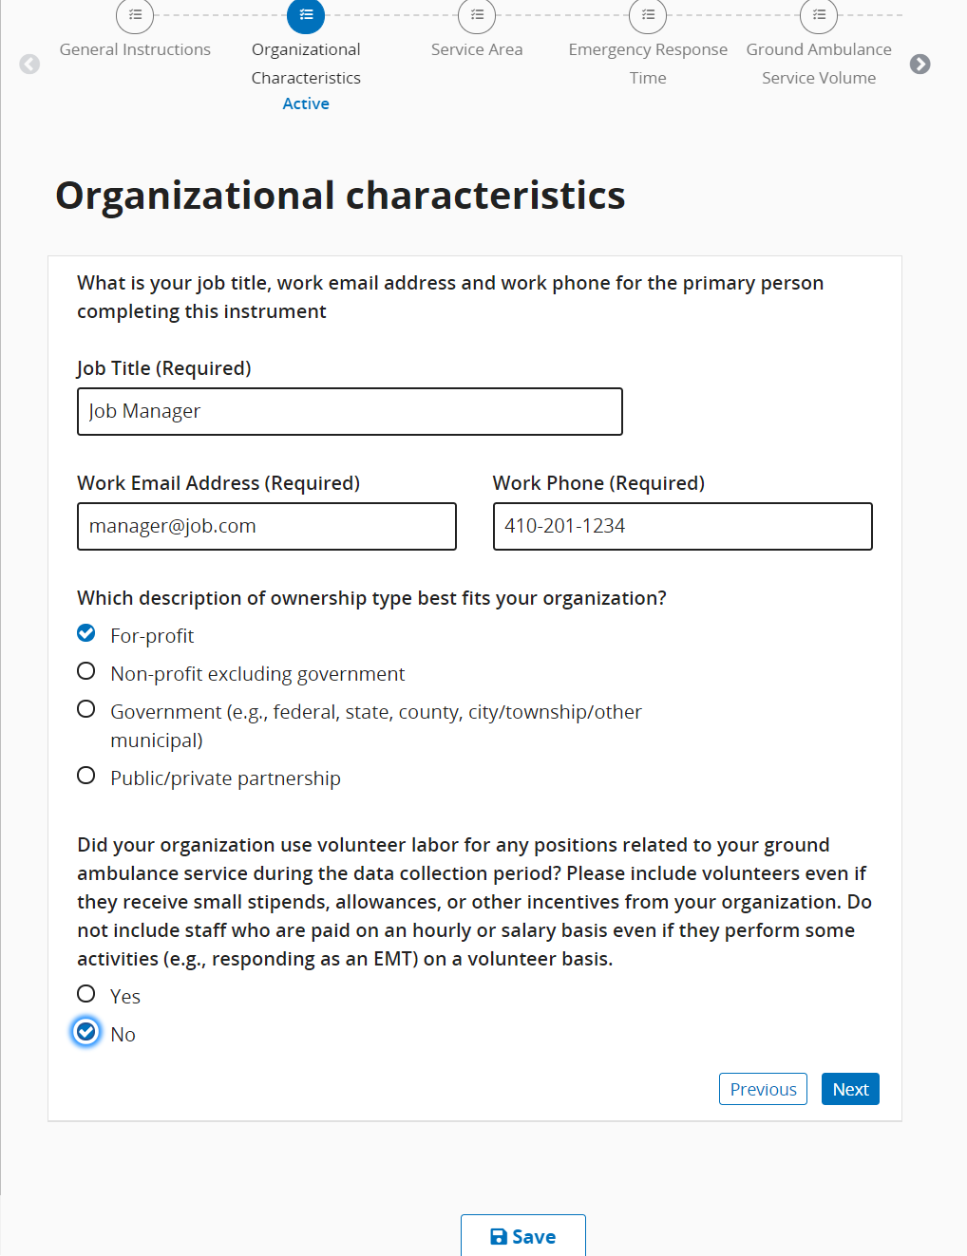

For this question, if you select Costs are not shared, you will be unable to report on any shared costs later in the instrument.
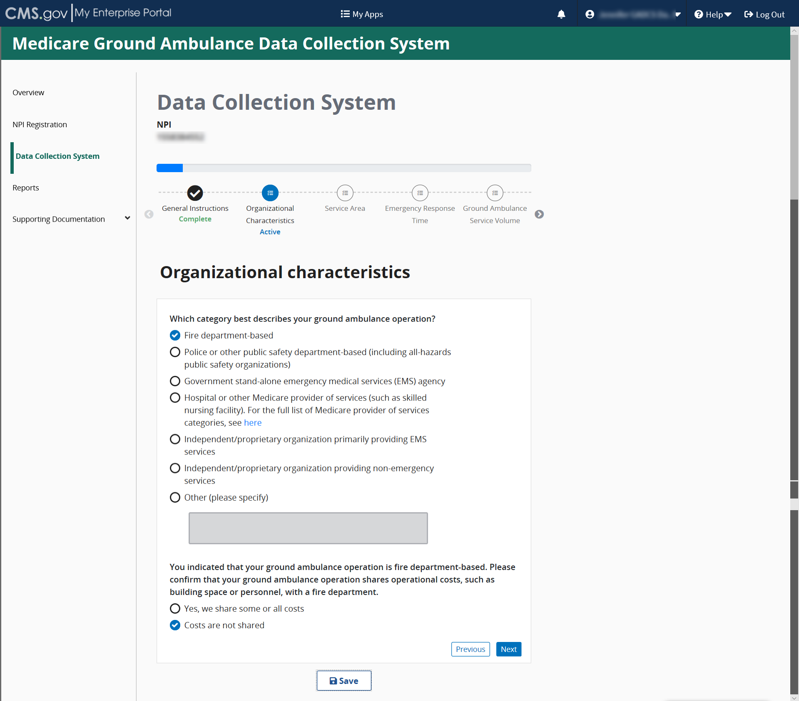

If you select “Other” you must specify what operational costs you share using the space provided.
Proceed answering the questions by selecting “Yes” or “No” as the example shows below.
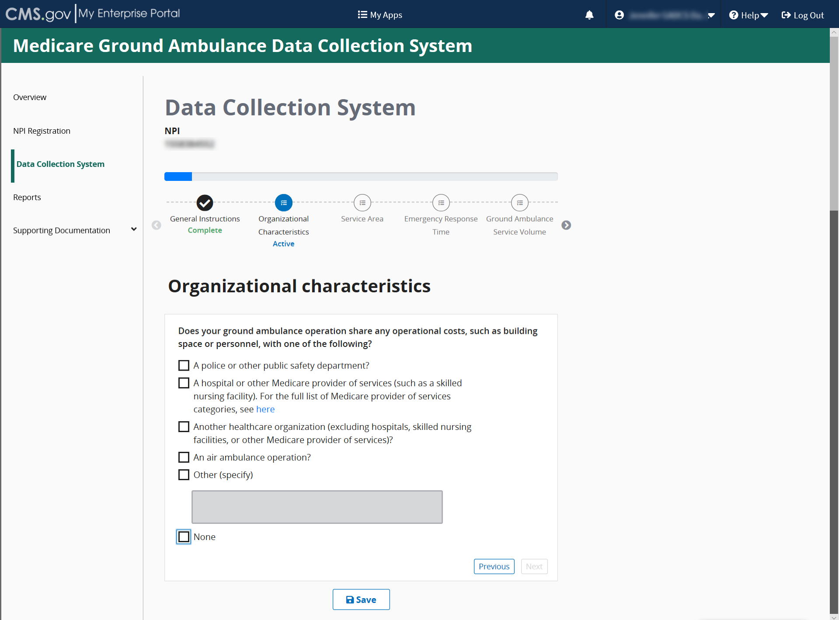

Continue answering the questions until you reach the end of this section where you will see this screen:
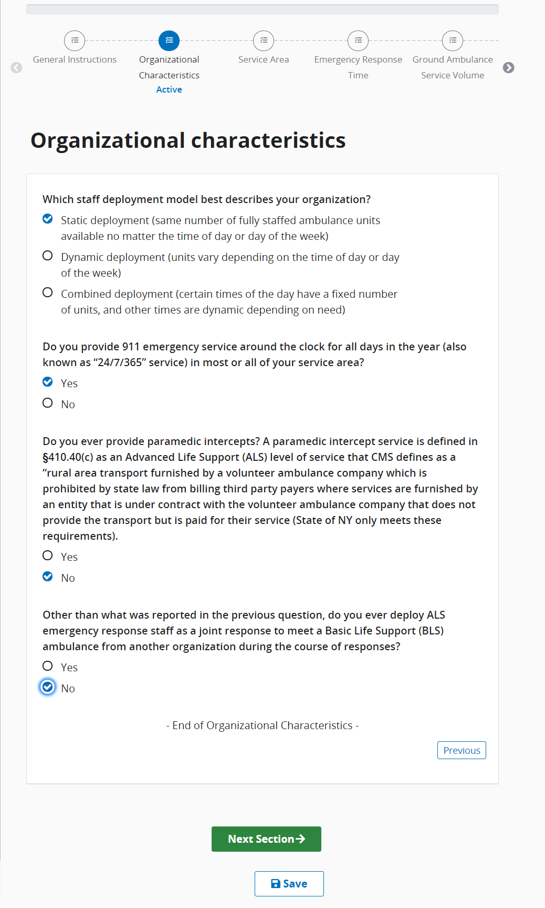
Click Save and then click Next Section.

Service Area
Please read the information at the beginning of this section carefully before clicking Start to begin.
You must complete this section before moving on to any other sections, as your responses in this section will determine the questions you see later.
Once this section is complete, you may fill in the other sections in any order you choose, or you may continue reporting data in the order the sections are presented.
Click start to begin this section.
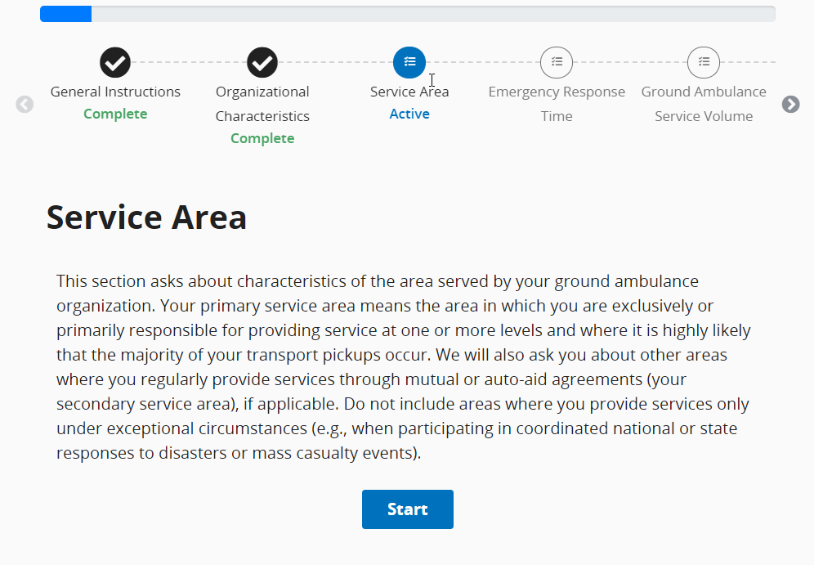
The first question in the Service Area section gives you the option to enter in the ZIP codes of your service area manually or to choose from a prepopulated list.
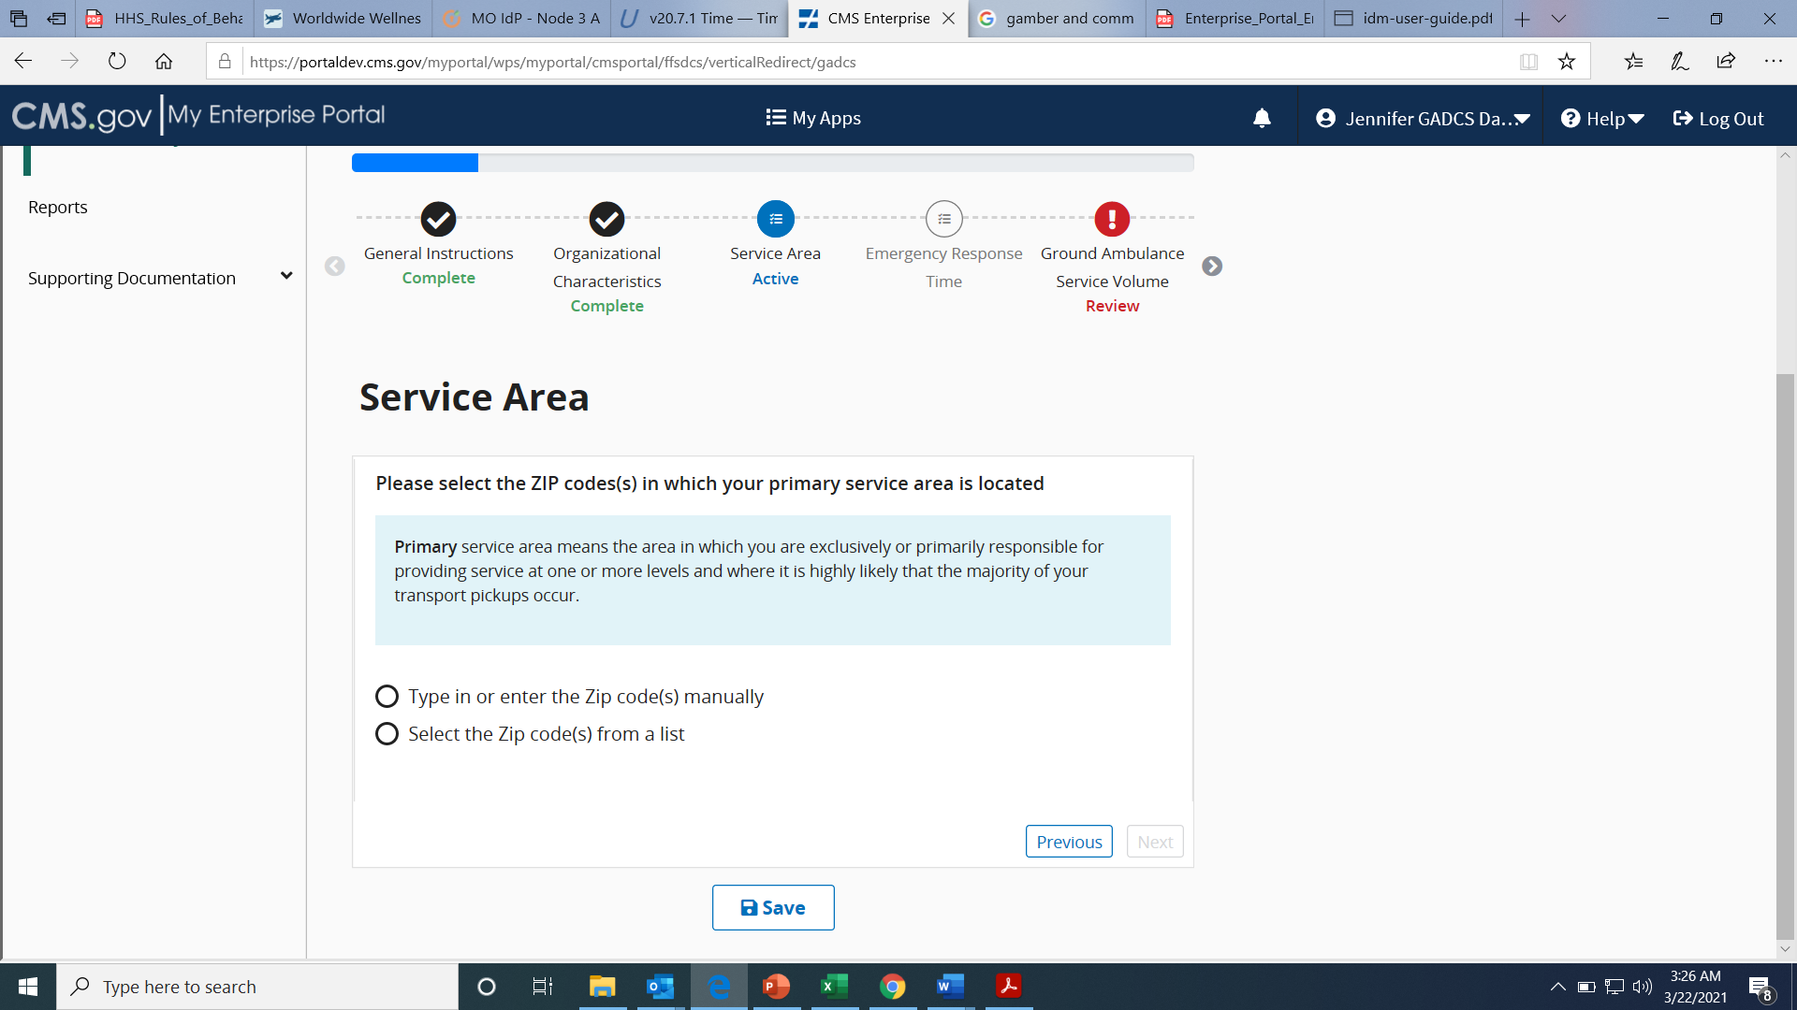

If you choose the prepopulated list, enter in the State and County, and then select all ZIP codes that apply. You can choose Check All. You can also choose multiple counties within a state or add ZIP codes from another state after you input ZIP codes from your primary state.
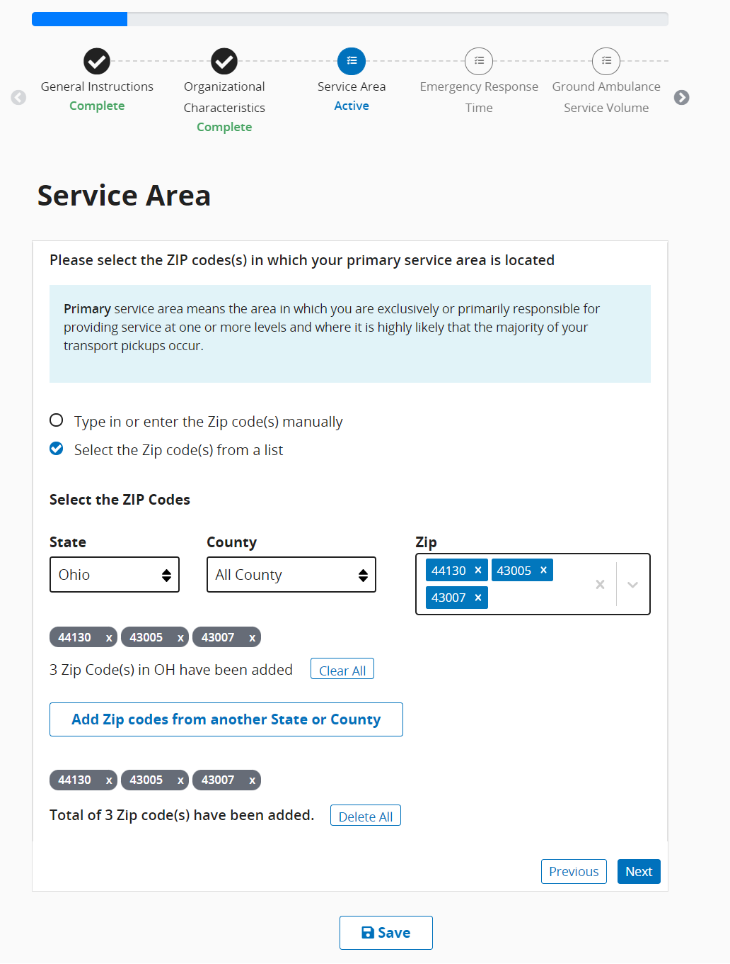

OR
You may copy and paste your list of ZIP codes. If you choose this option, each ZIP code must be separated by a comma, space, or semi colon.
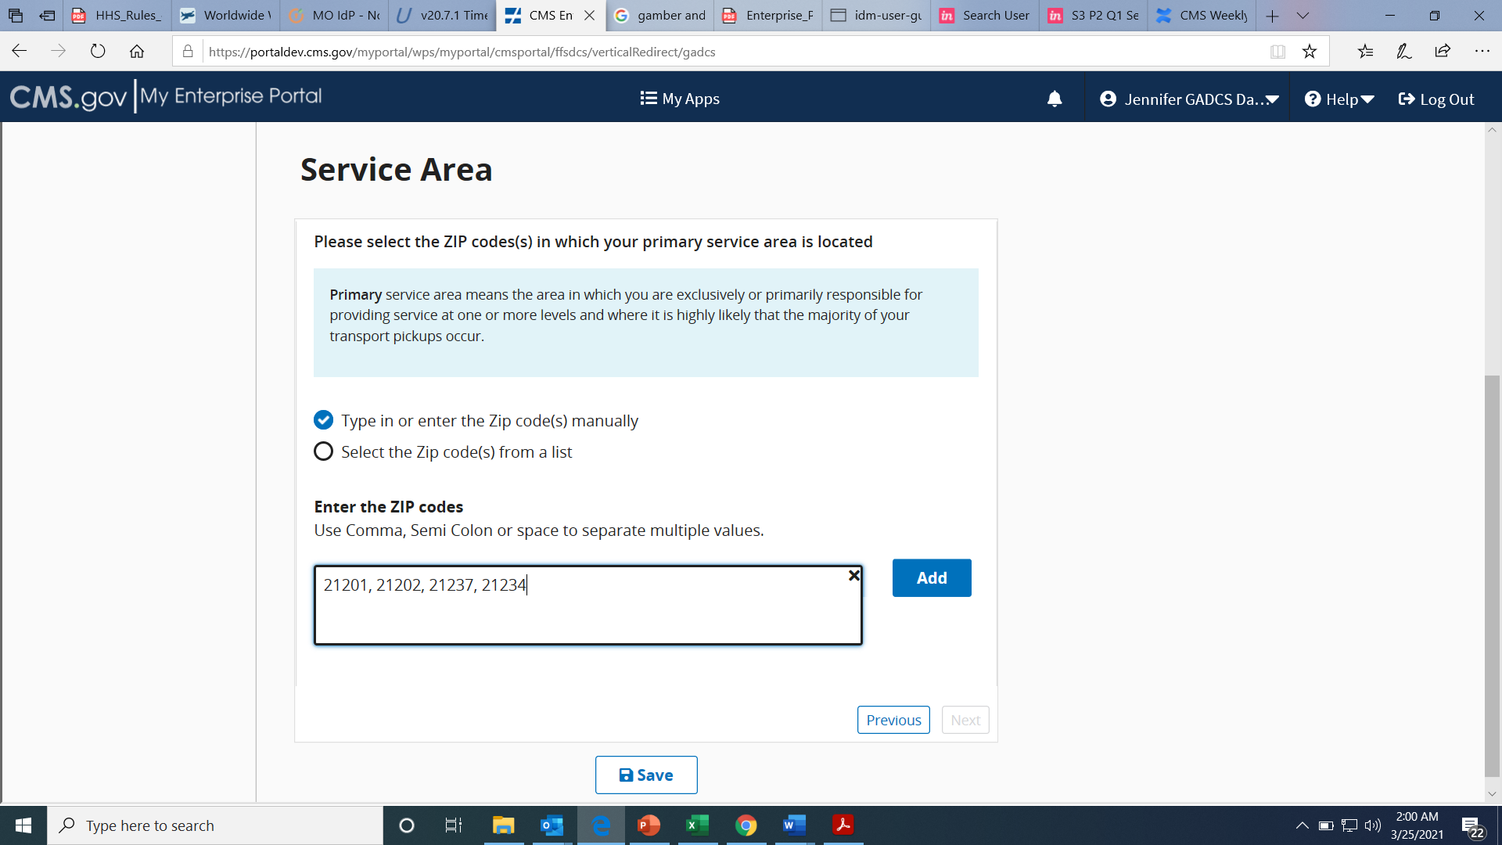
Once all zip codes have been entered or copied, click the Add button.
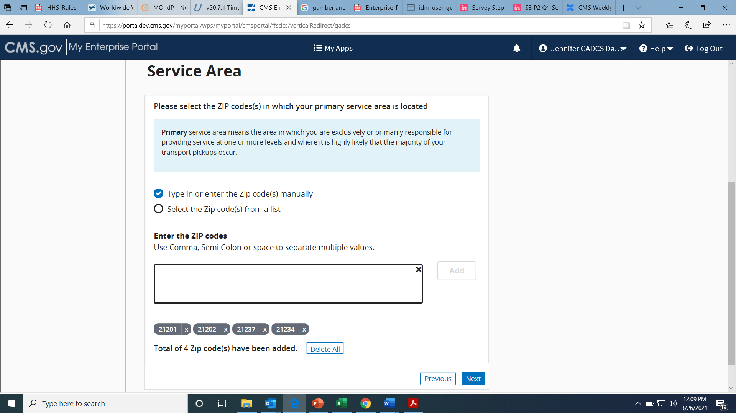
Individual ZIP codes can be removed if needed by clicking the “x” next to each ZIP code.

Continuing answering the questions as prompted until you see the End of Service Area section message, then click Save and click Next Section.
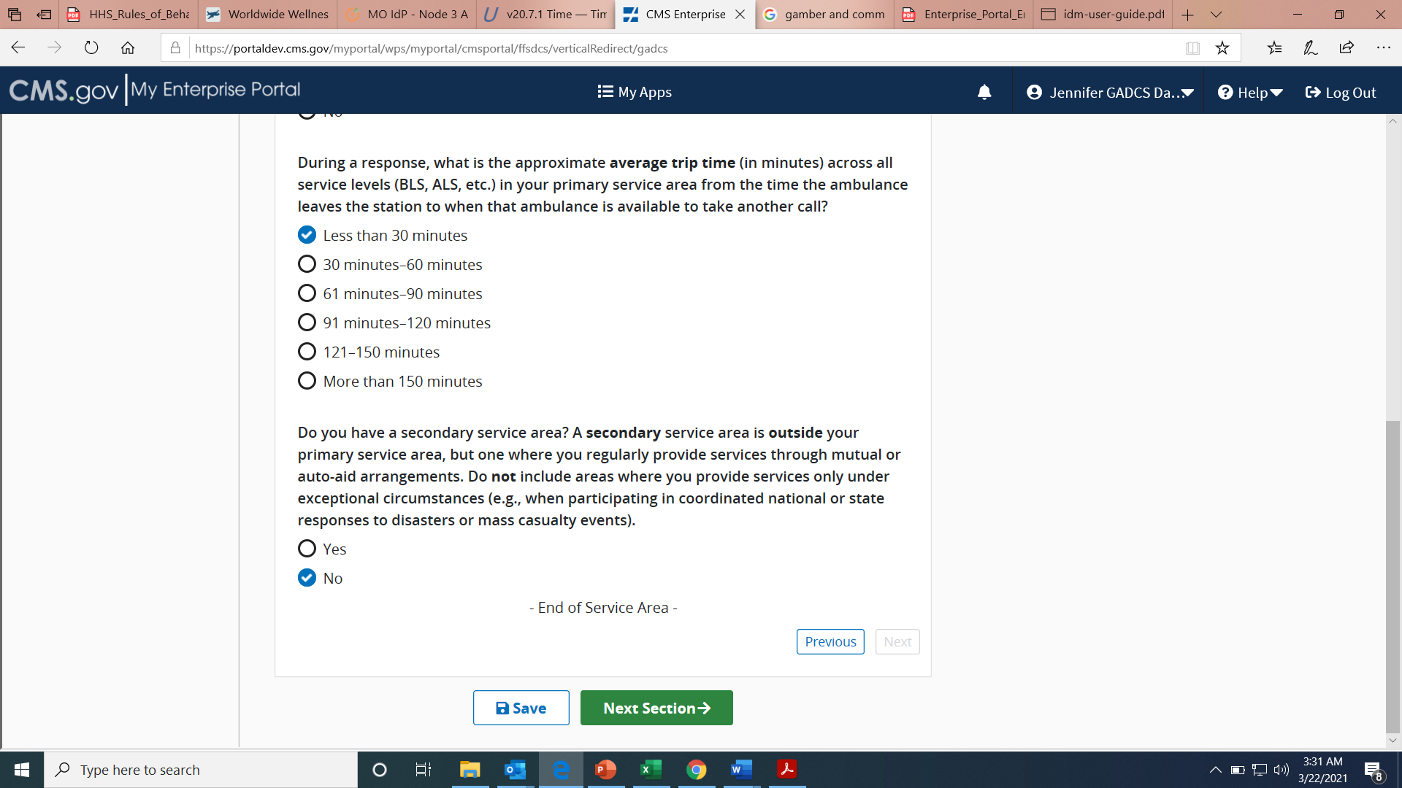

Emergency Response Time
Please answer all questions in this section using your most accurate data.
Click start to begin this section.
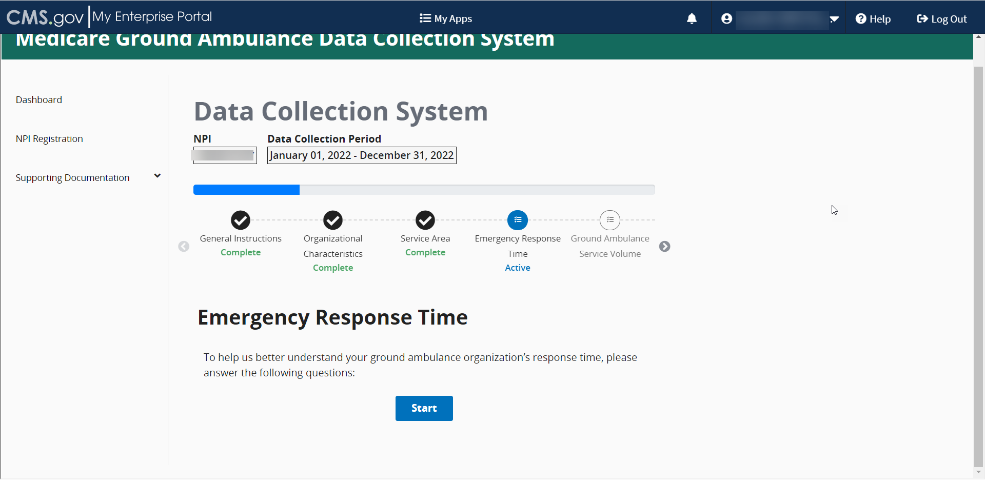
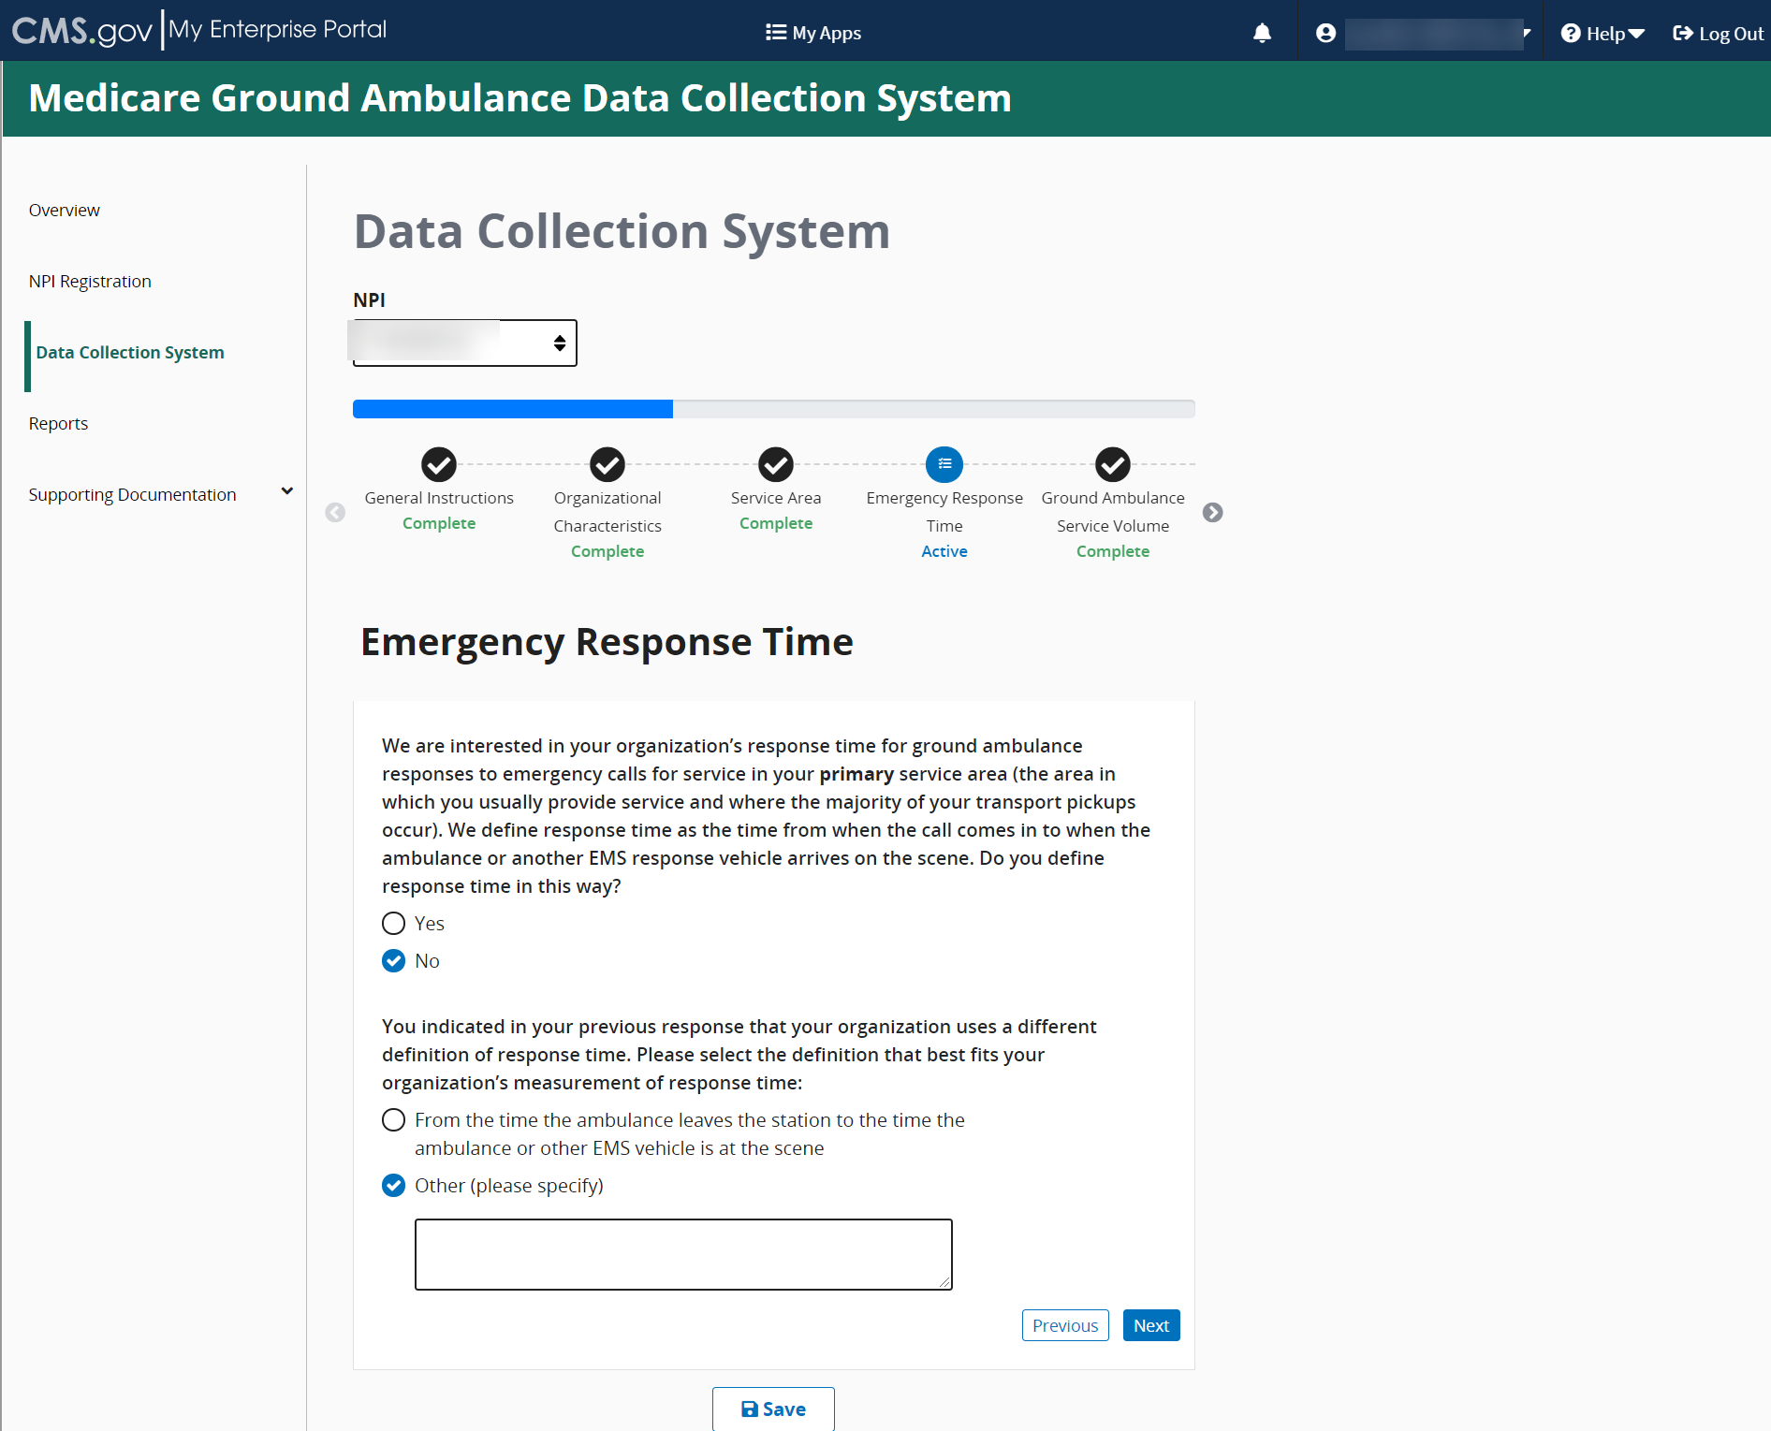

The second question asks if you are able to report statistics related to response times as measured by your organization. If you select no, you will be prompted to provide your best estimate for response time.
When entering this information, you are required to report time in MINUTES.
If you select no, you will be prompted to report your best estimate of the average response time in MINUTES (see below).
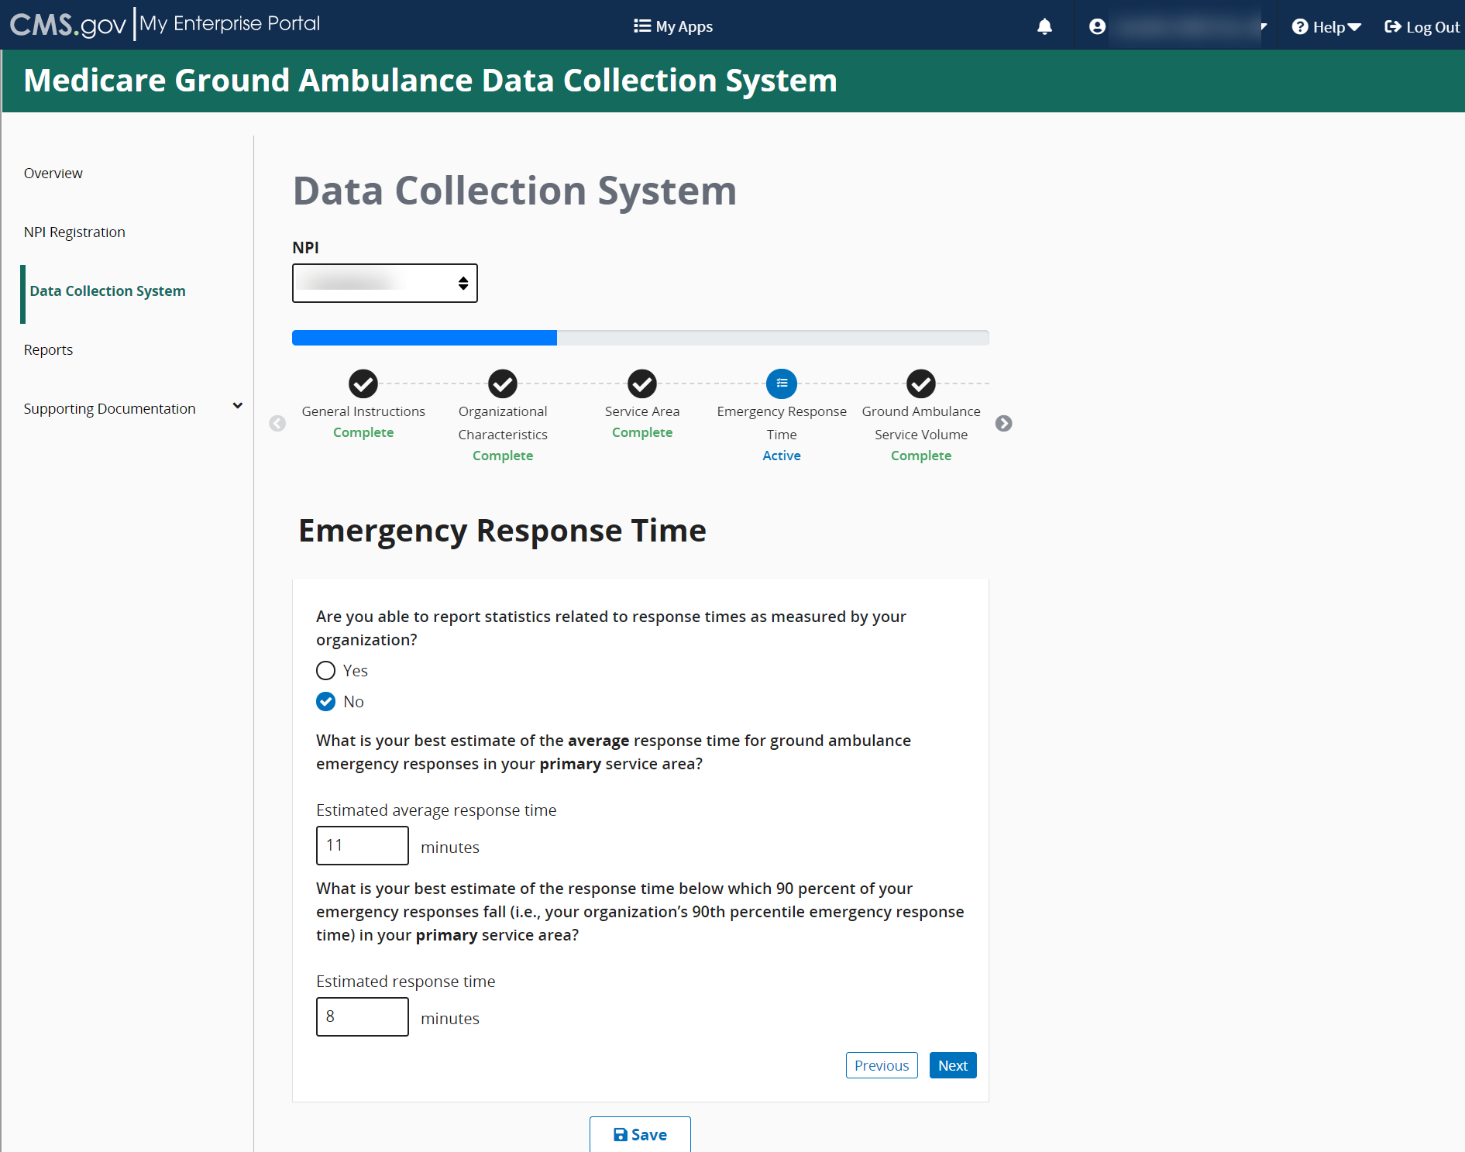
This is an example of the questions if you select Yes where you will be asked to record the average response time in MINUTES for your primary service area.
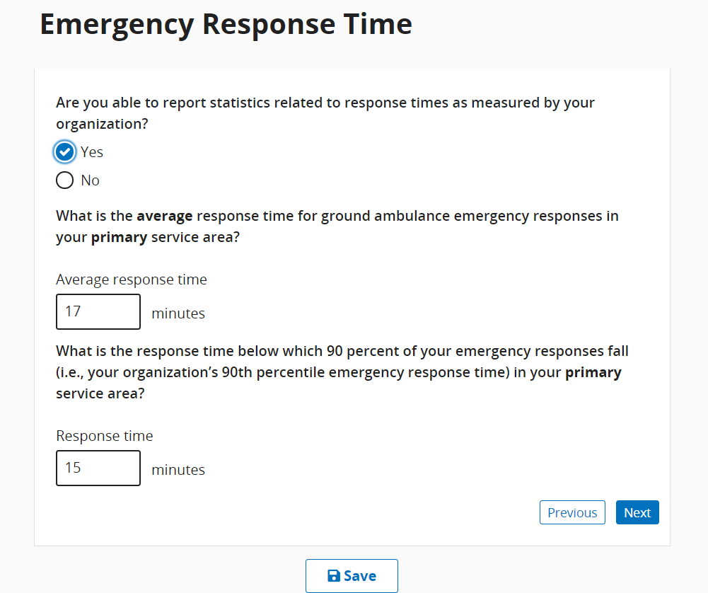

Based on some responses, follow-up questions may appear.
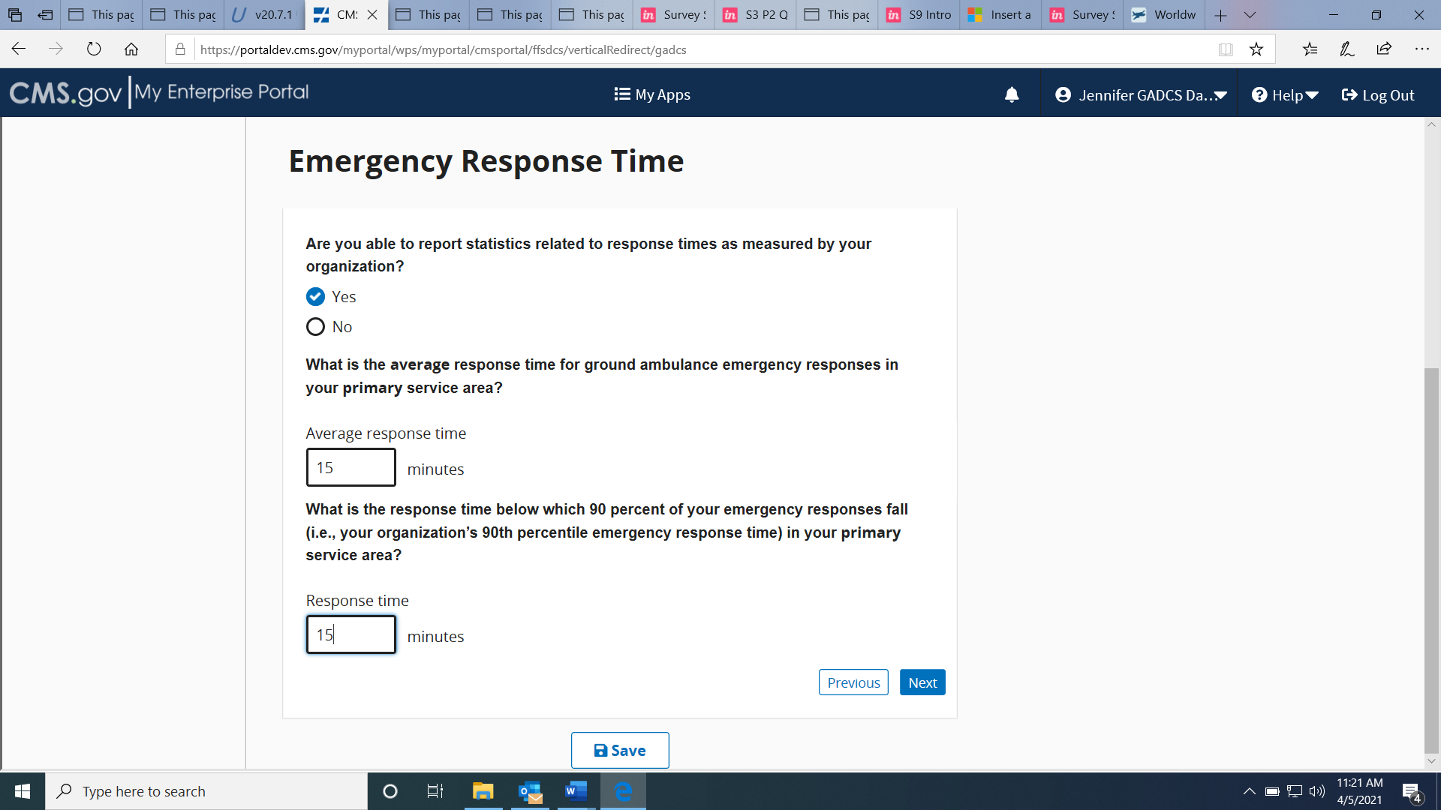

When you reach the end of this section, click Save and then click Next Section.
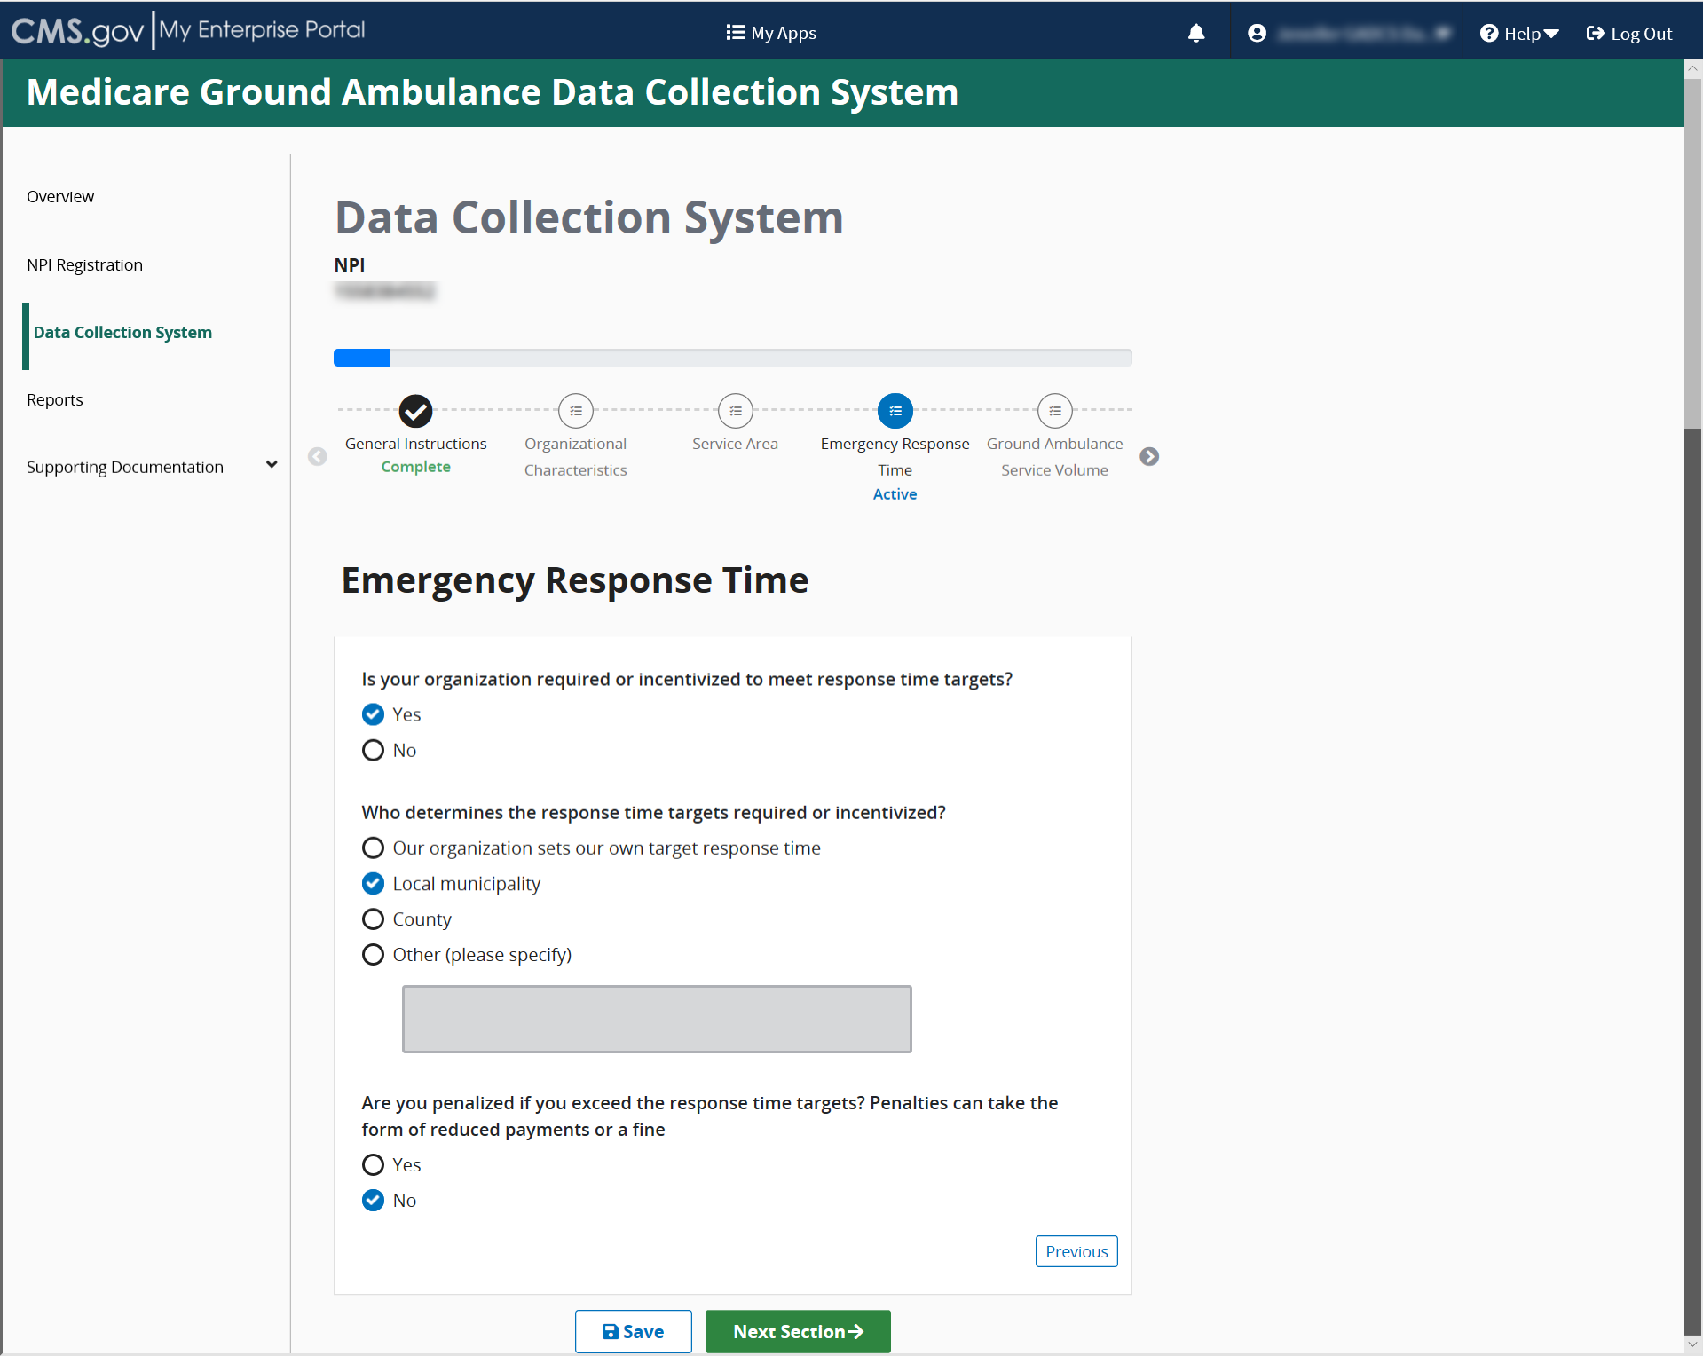

Ground Ambulance Service Volume
Click start to begin this section.
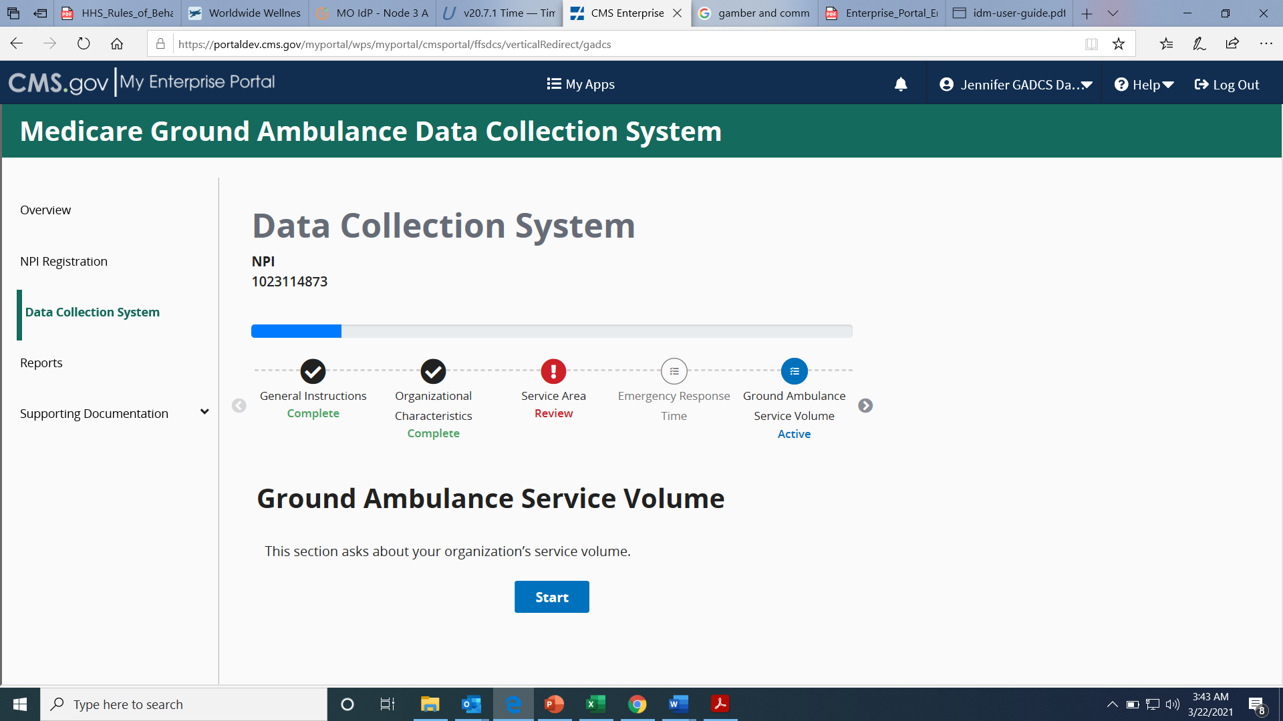
Be sure to read the descriptions that accompany the questions.
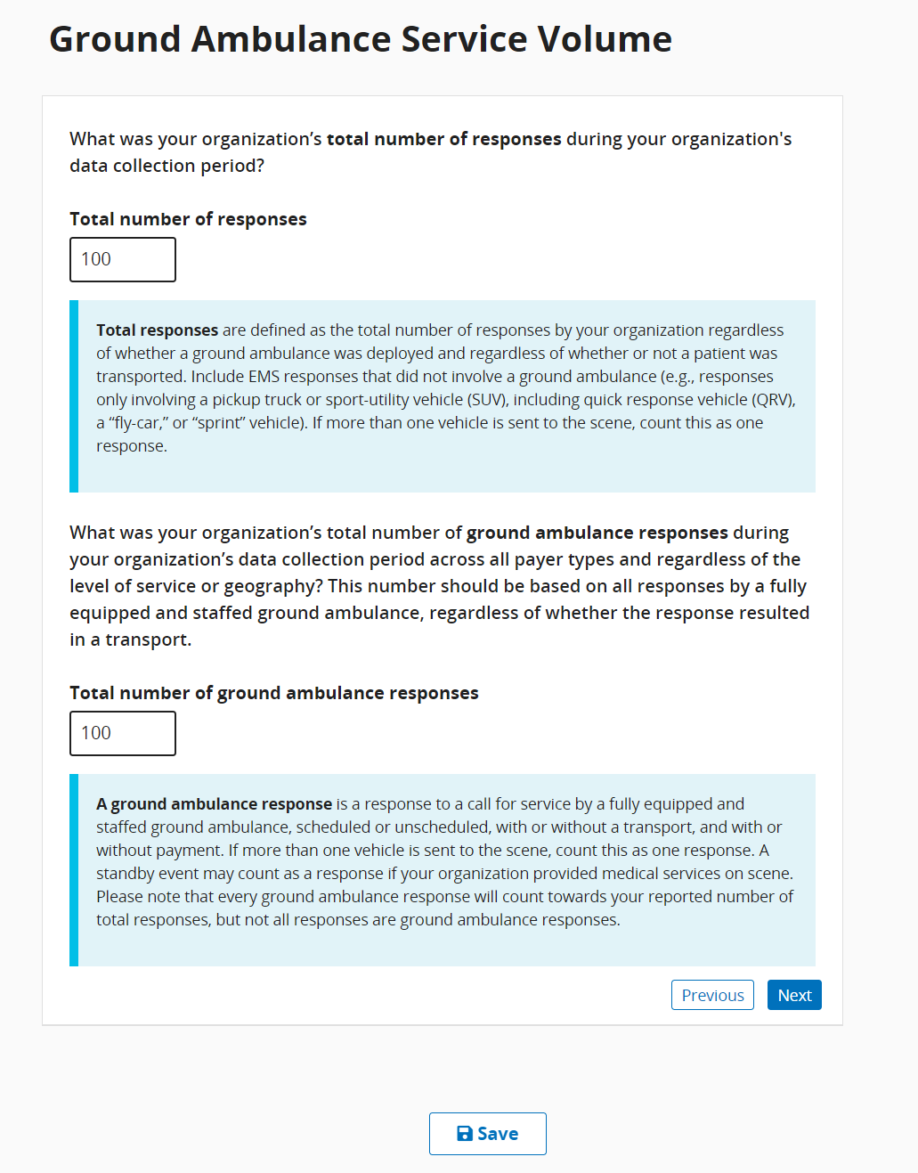

If you enter a larger or equal number for the 2nd response, a warning popup will appear to ask you if you’re sure the responses you gave are correct. For most organizations, the number of responses across all payer types will be greater than the number of ground ambulance responses.
Be sure to use whole percentages on this question, if zero, input 0. Do not leave blank.
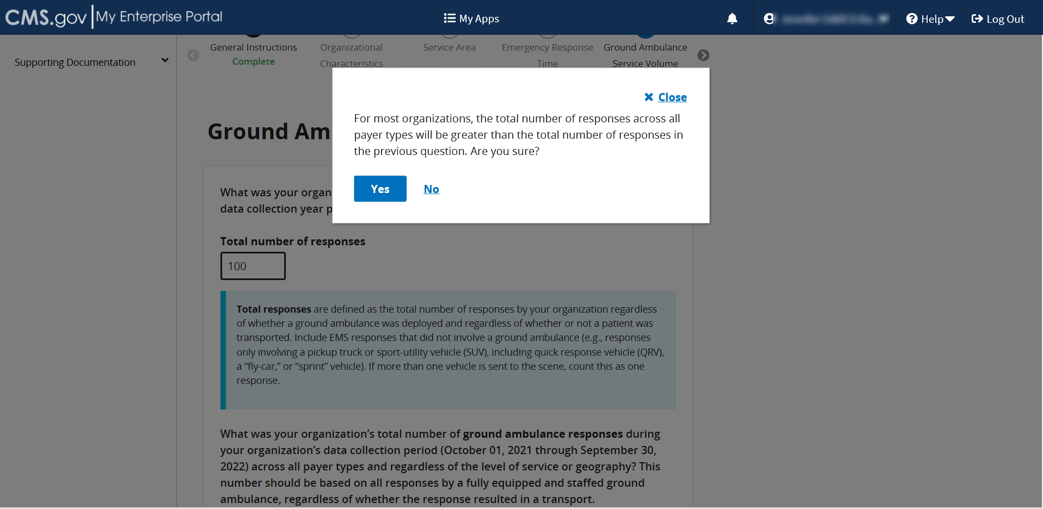

This question only appears if you previously indicated in the Service Area section that your organization has a secondary service area.
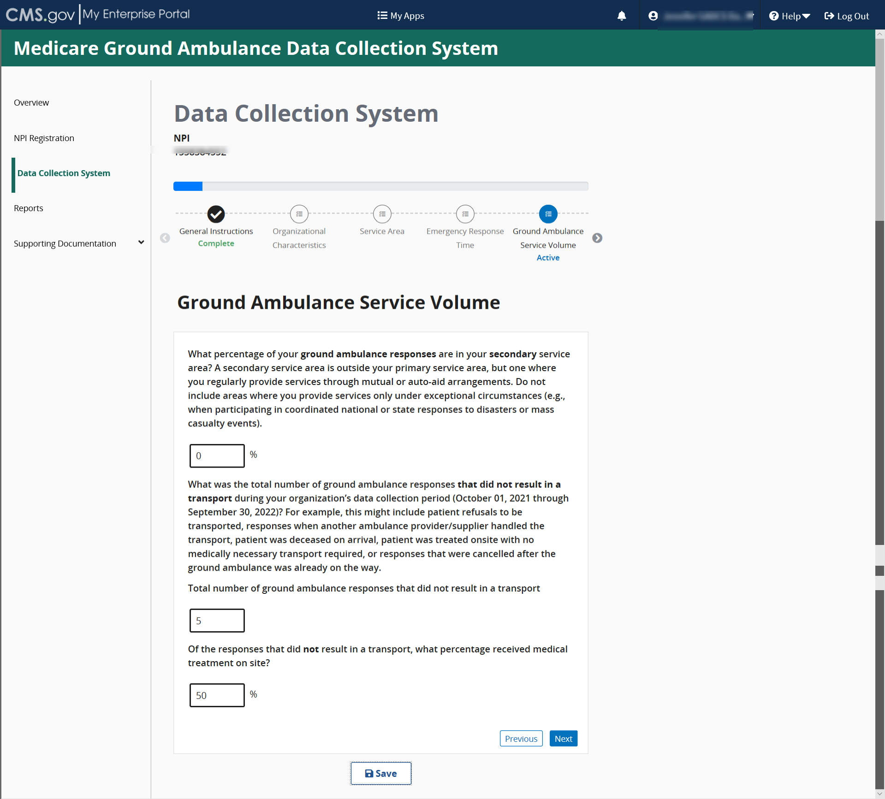
Depending on your entries, more questions may appear requiring your response.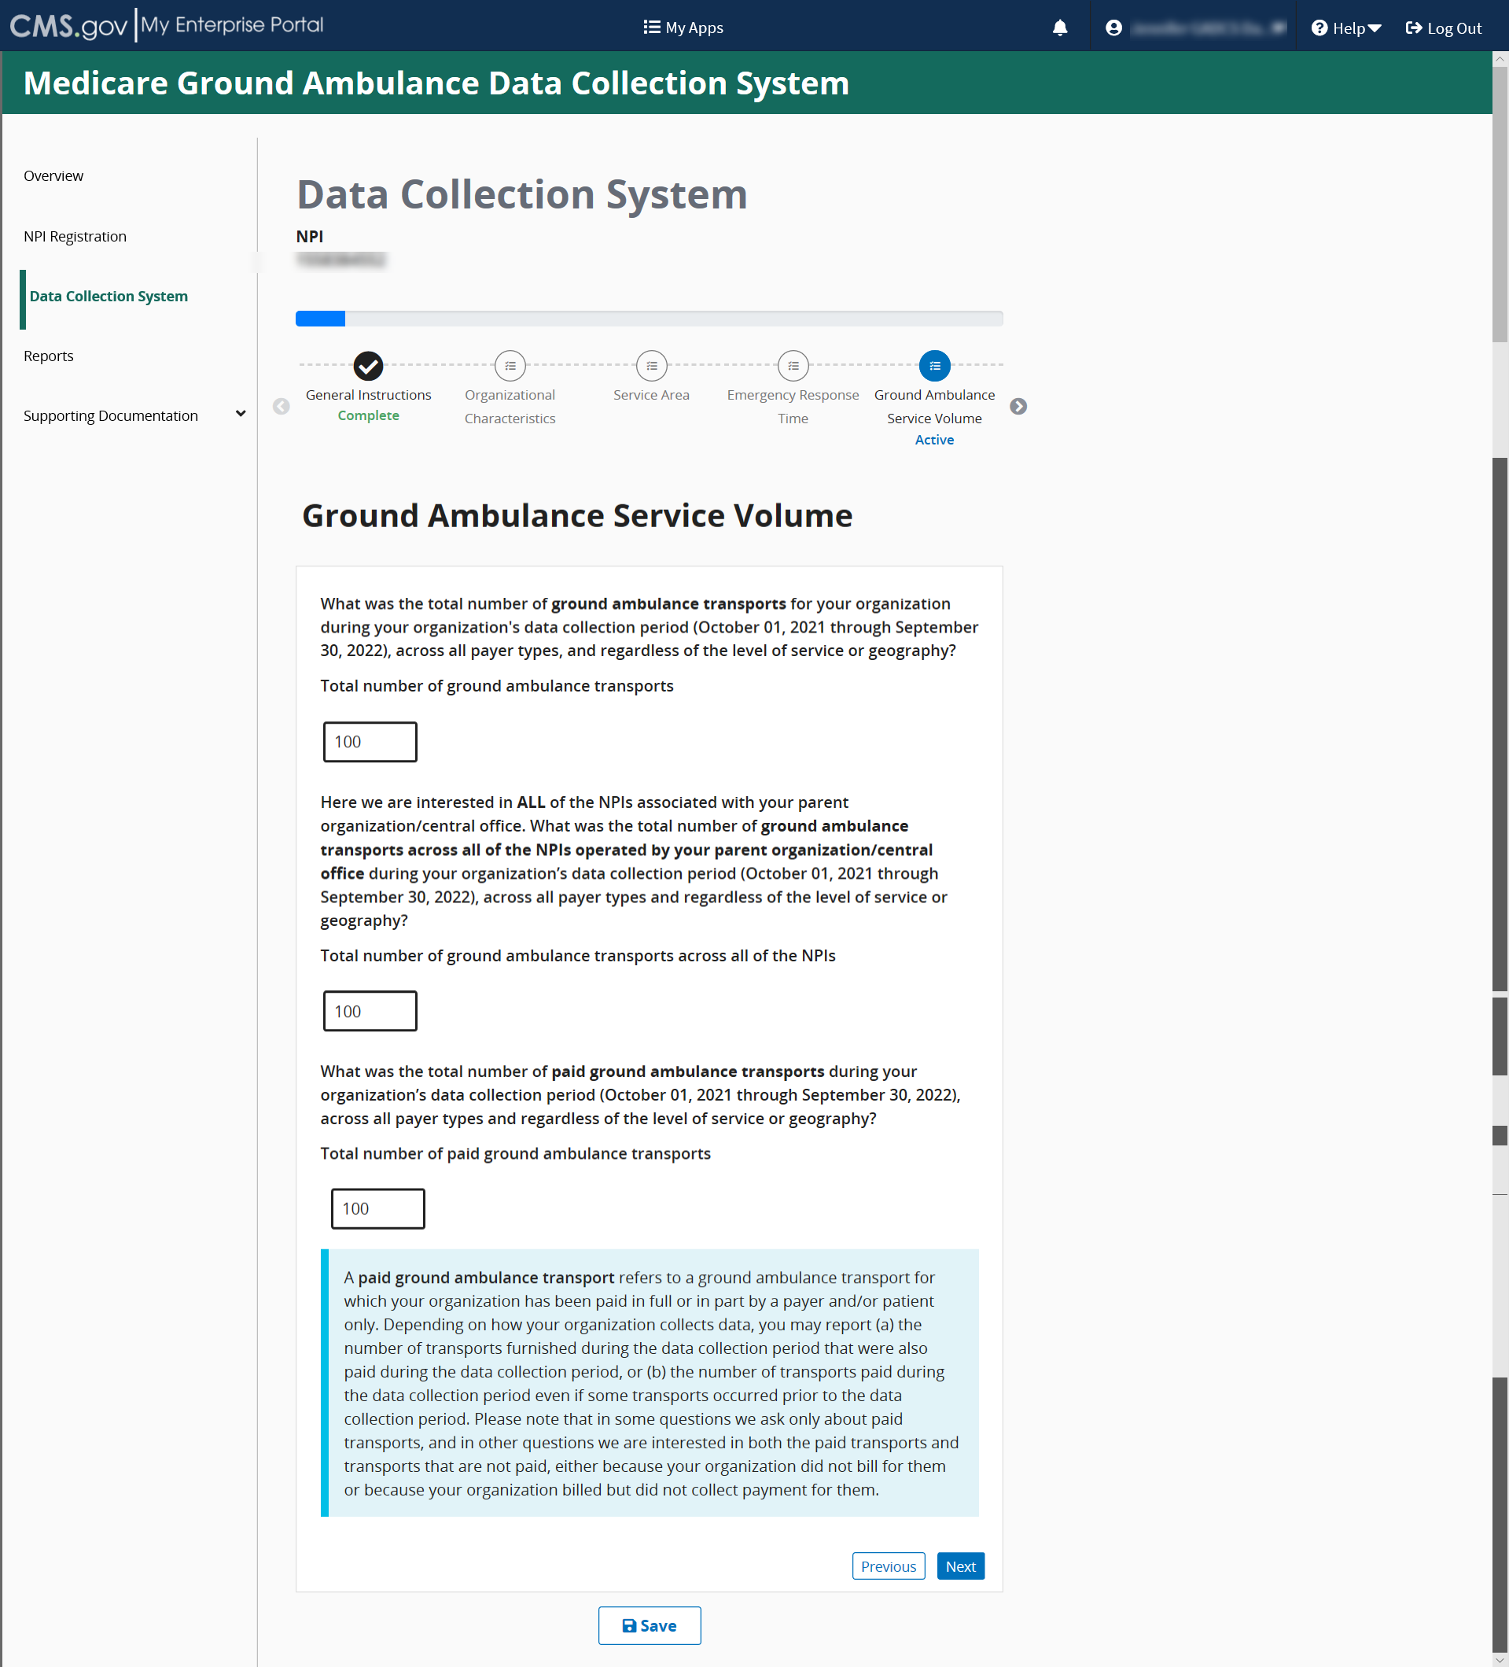

As a reminder, some of the questions you see are dependent on the responses you gave in previous responses. You may not see this as the last question in this section.
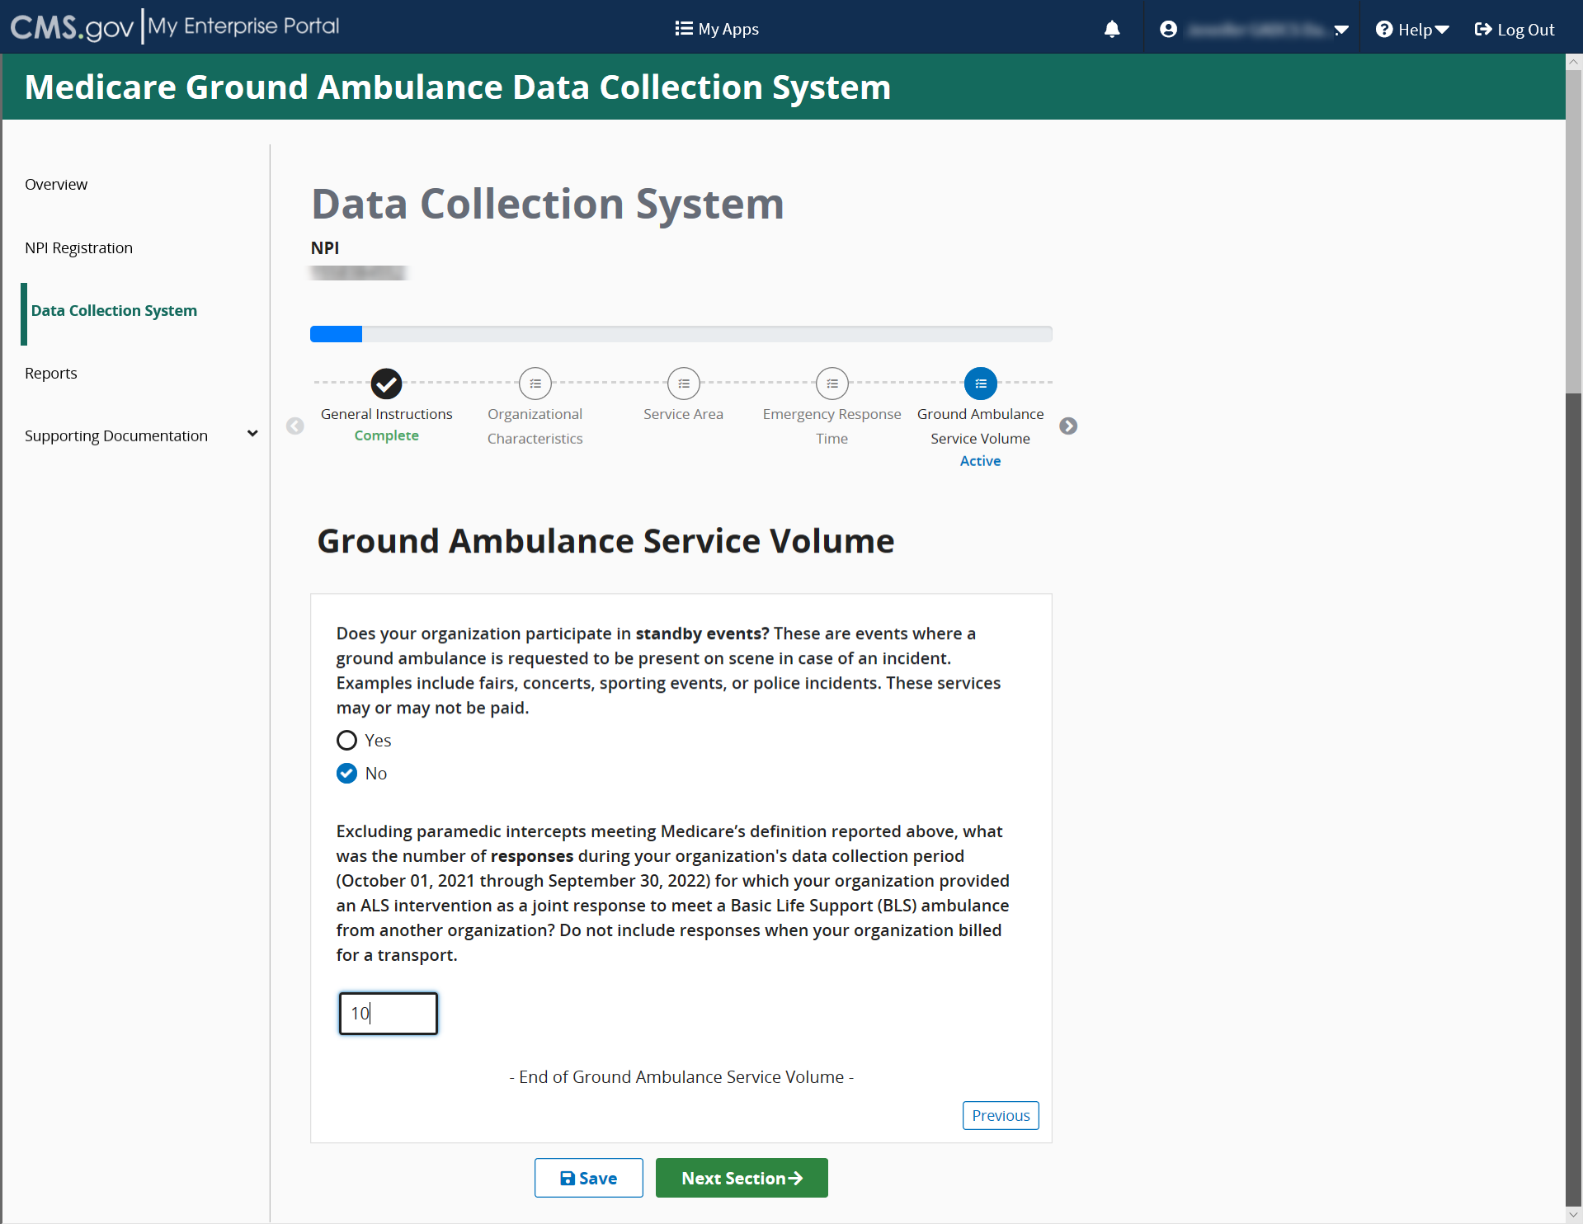
When you reach the end of the section, click Save and then click Next Section.

Service Mix
Please read the instructions and then click Start to begin.
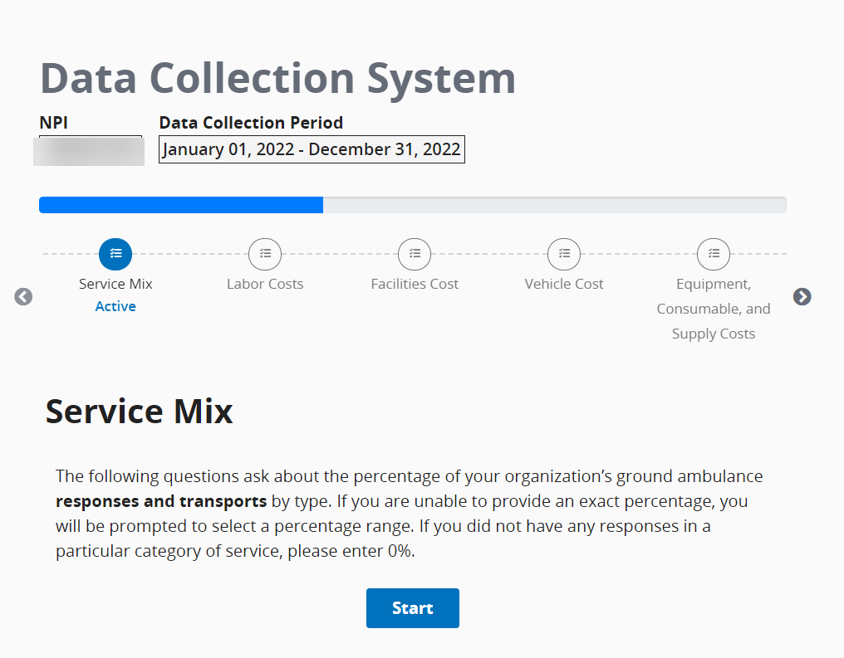
Please be sure to read the descriptions carefully for each question. You may not leave fields blank. If your response is zero, enter 0.
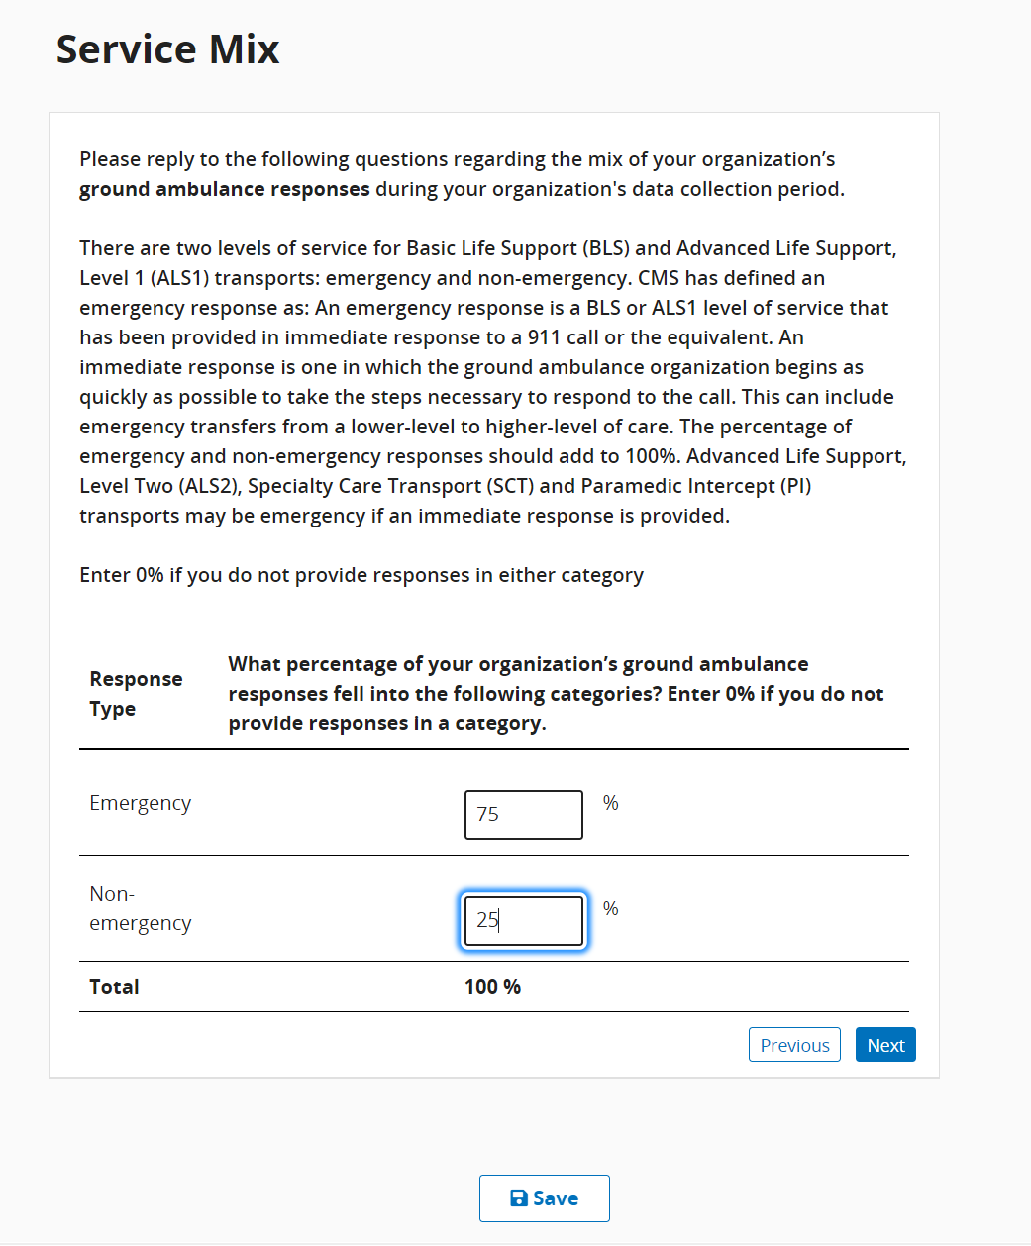
Be sure to click the Save button before moving on to the next questions or sections.

You can hover your cursor over the blue text to see definitions. Your totals cannot exceed 100%.
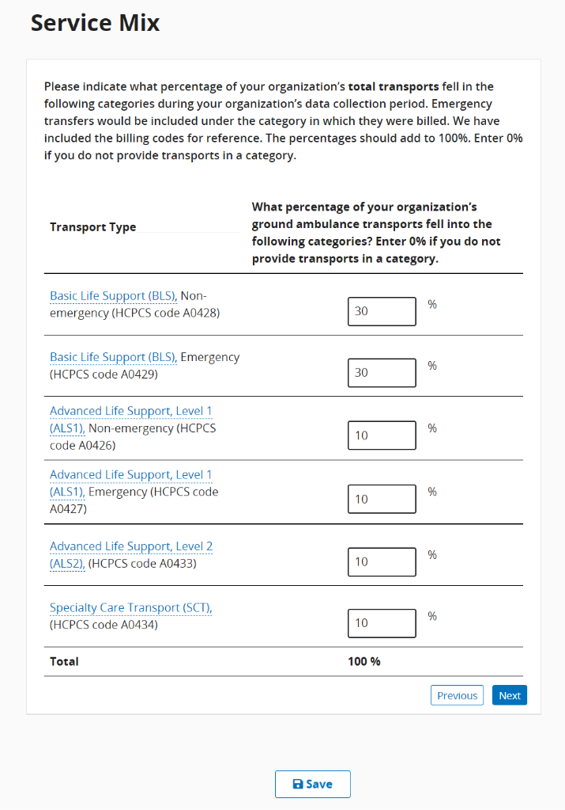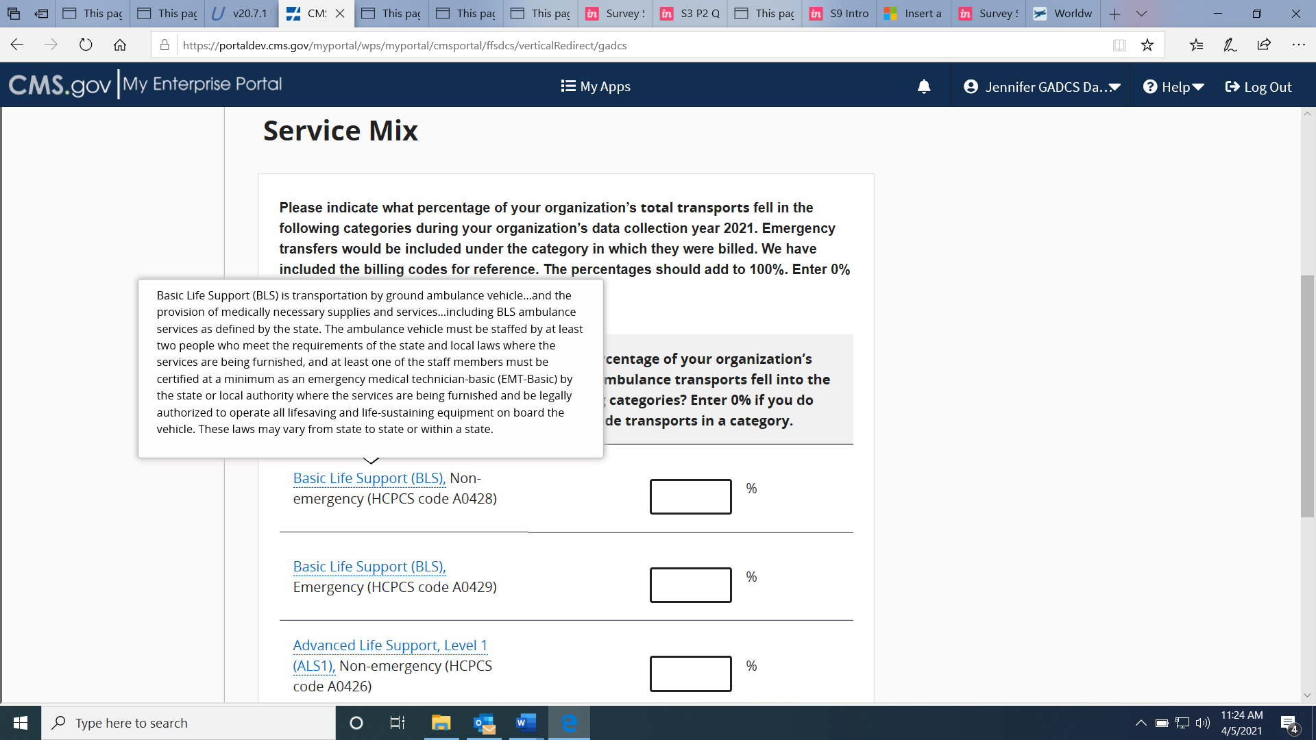
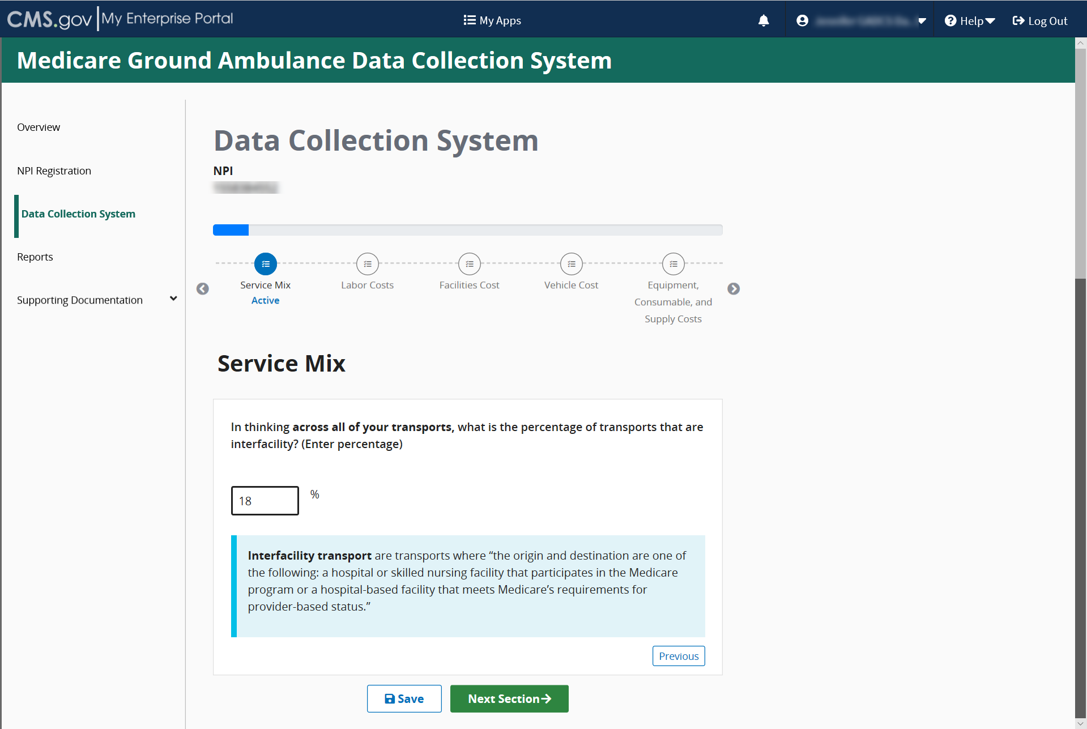

Labor Cost
Please read the introduction description carefully before answering any questions.
Acknowledge the instructions, then click Start to begin.
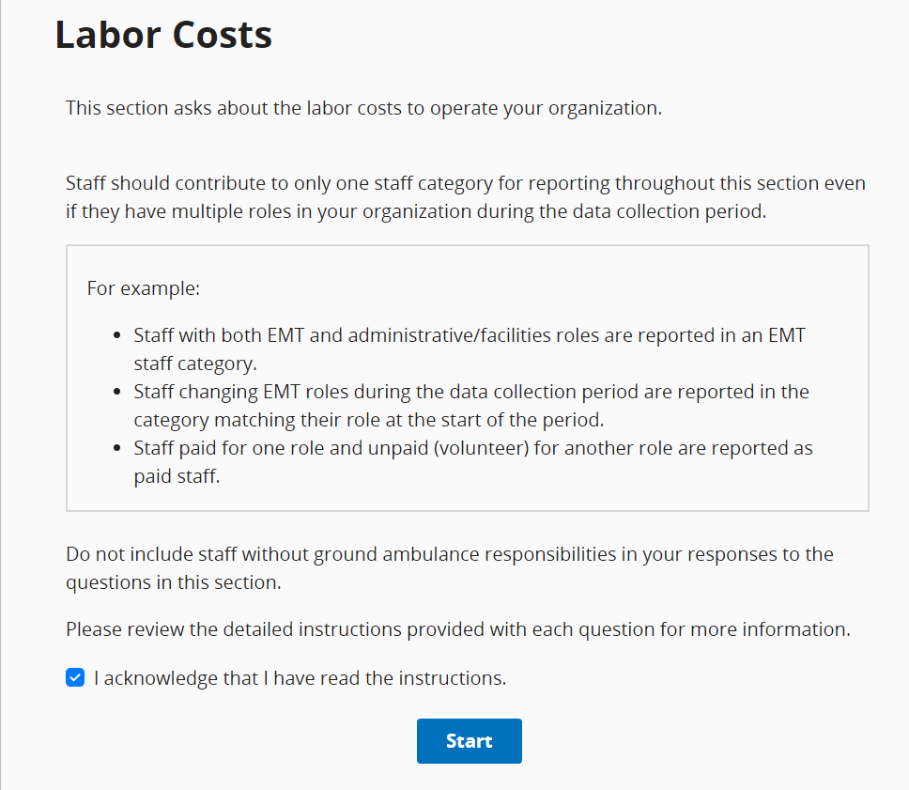
You will need to review the instructions by clicking Review Instructions at the beginning of the first question in this section. Read the instructions completely before you begin.
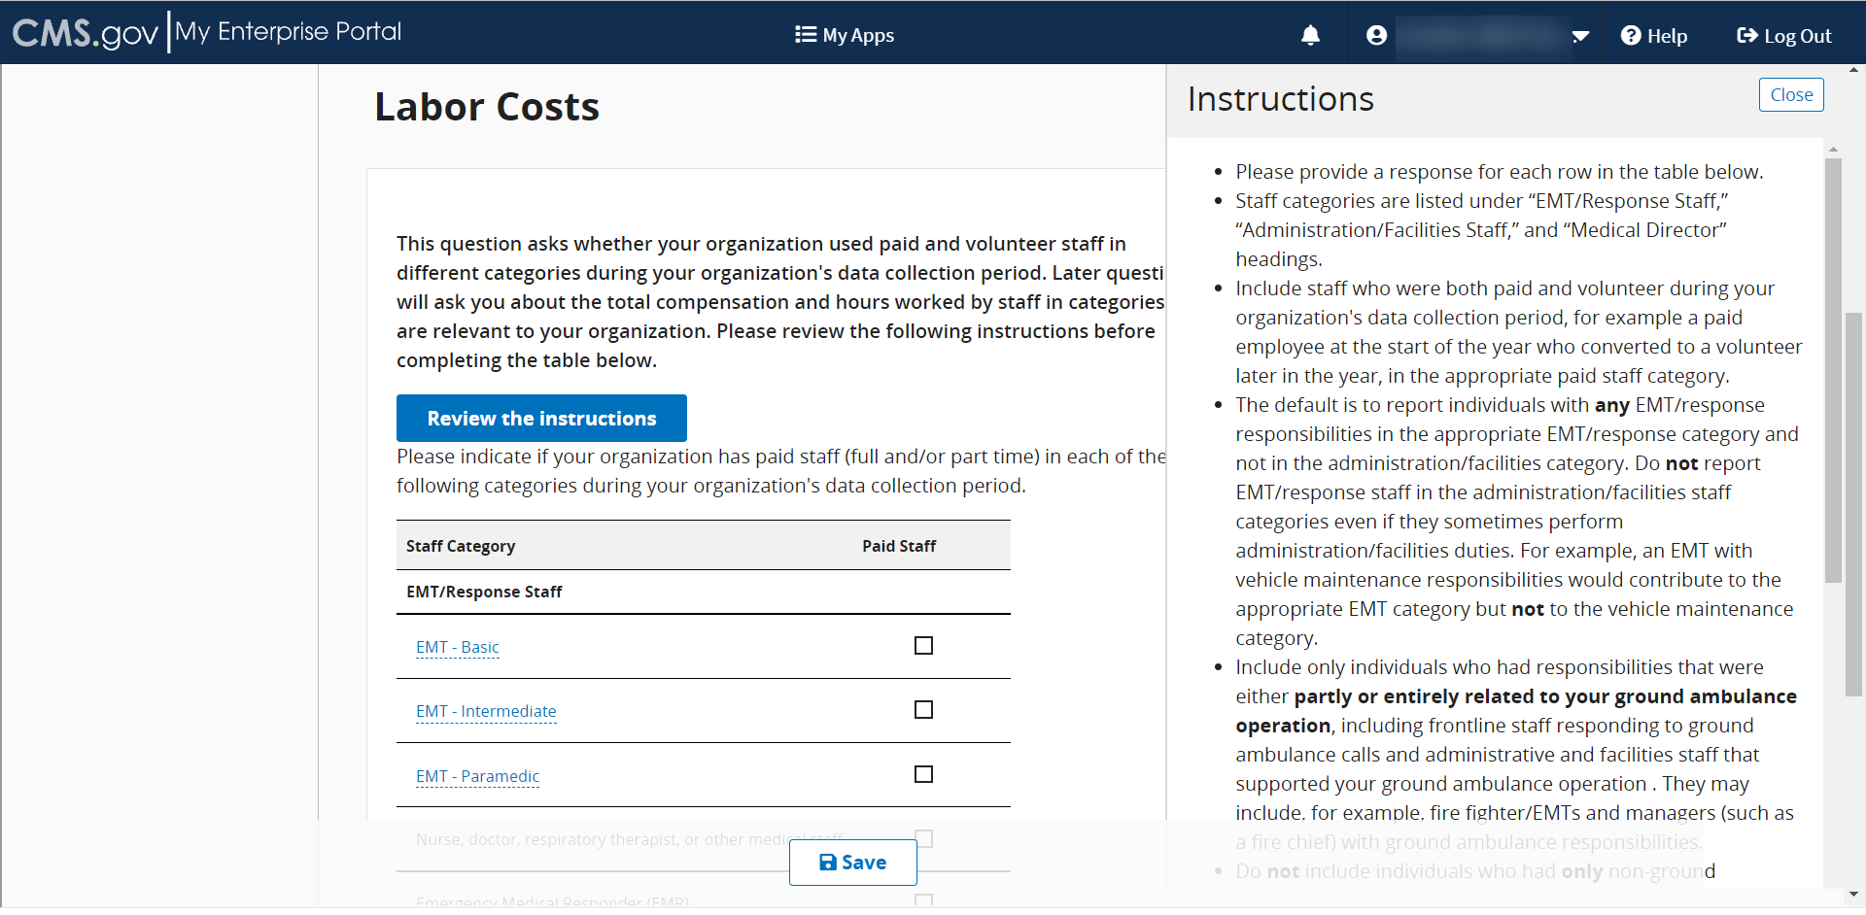

You can also click to see a brief definition of staff.
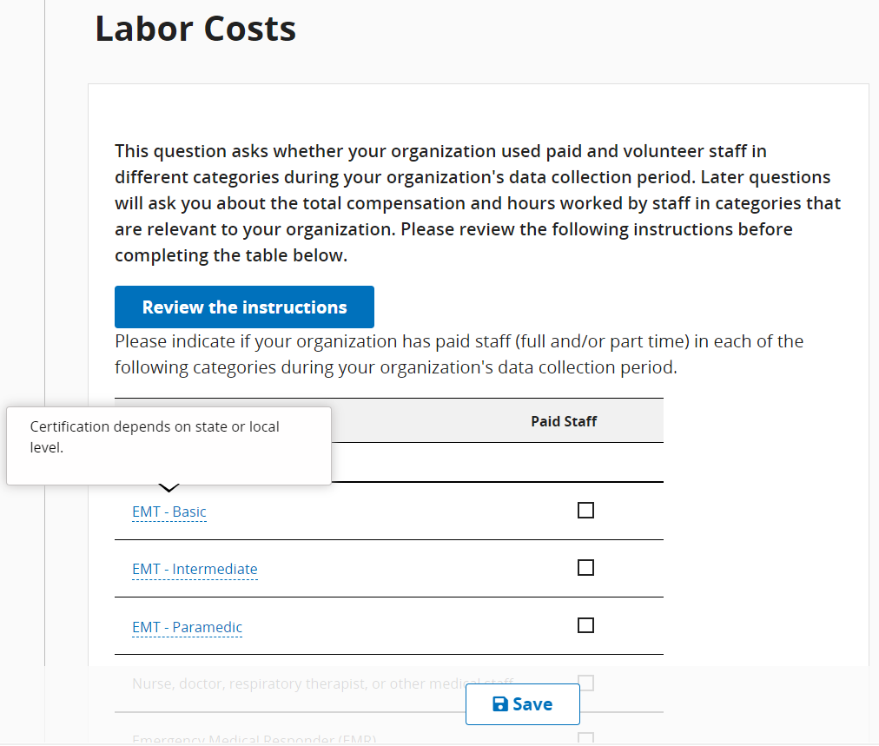
If your organization employs a staff choice not listed, you may use the Other field to type in a staff type name. If you select Other, you cannot leave it blank.
Before you input any data related to Paid EMT/Response Staff compensation, be sure to click Review Instructions and read them carefully.
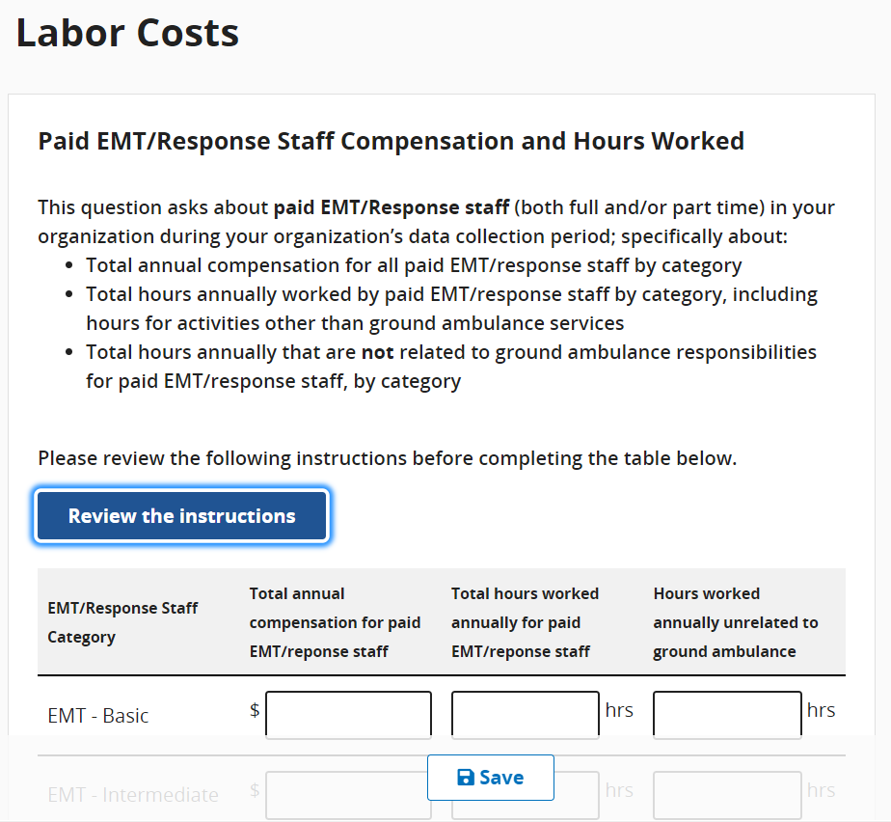

Be sure to click Review Instructions and read them carefully. For this question, the hours must be entered in whole numbers only
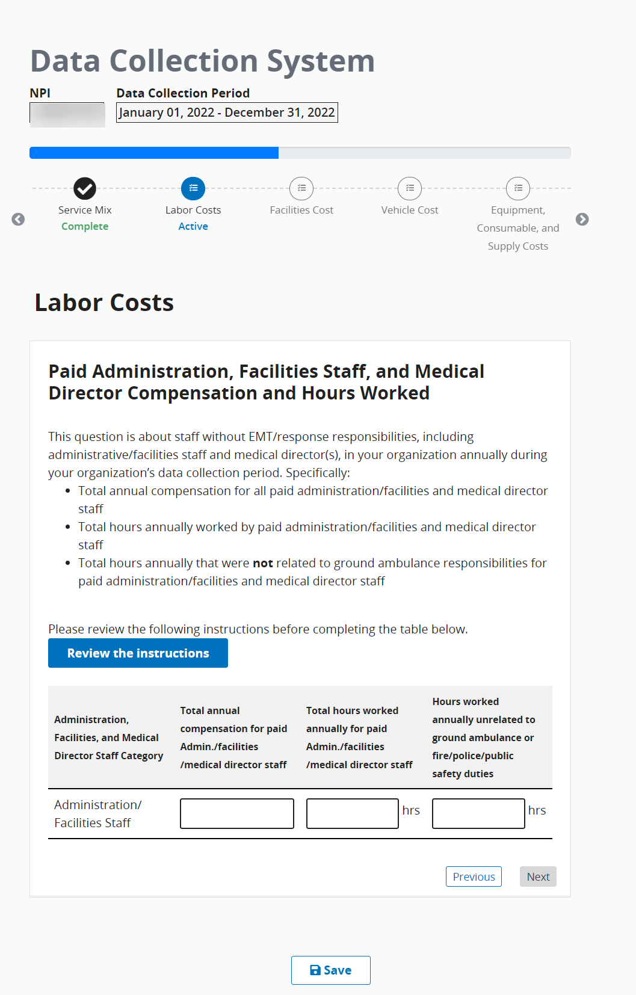

You will input data about volunteer labor.
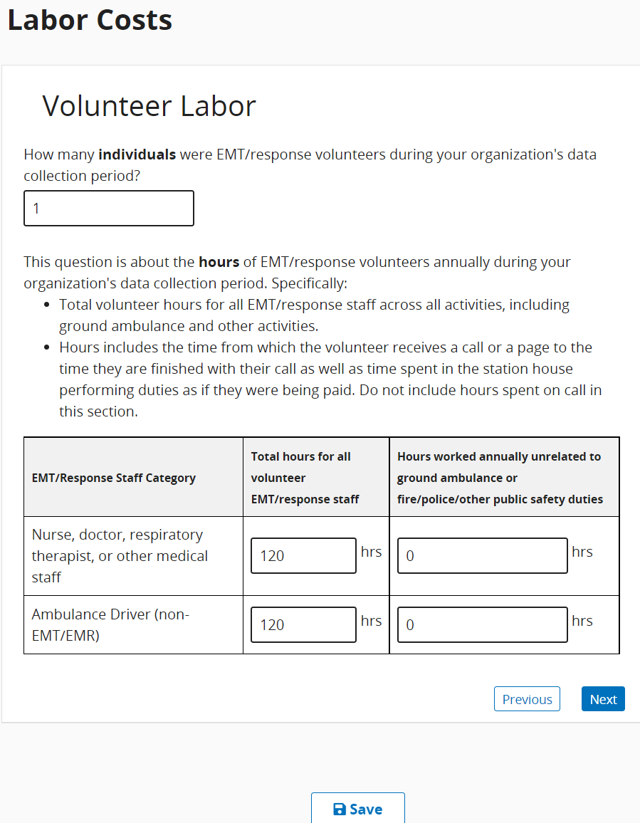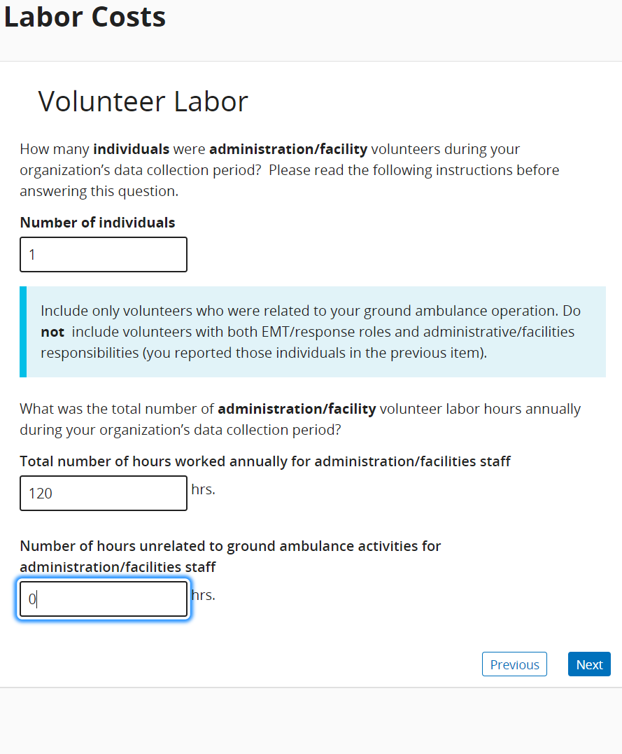

When you reach the end of this section, click Save and then click Next Section.

Facilities Cost
In this section, you will be asked about all the facilities associated with your organization’s ground ambulance services including the function of the facility, square footage, lease and/or mortgage costs, insurance and maintenance costs, and more.
Please enter only whole numbers for each question.
You will also have the option of downloading an Excel form, filling in the required information, and uploading it. The file must remain in Excel format.
Click Start to begin answering questions in this section.
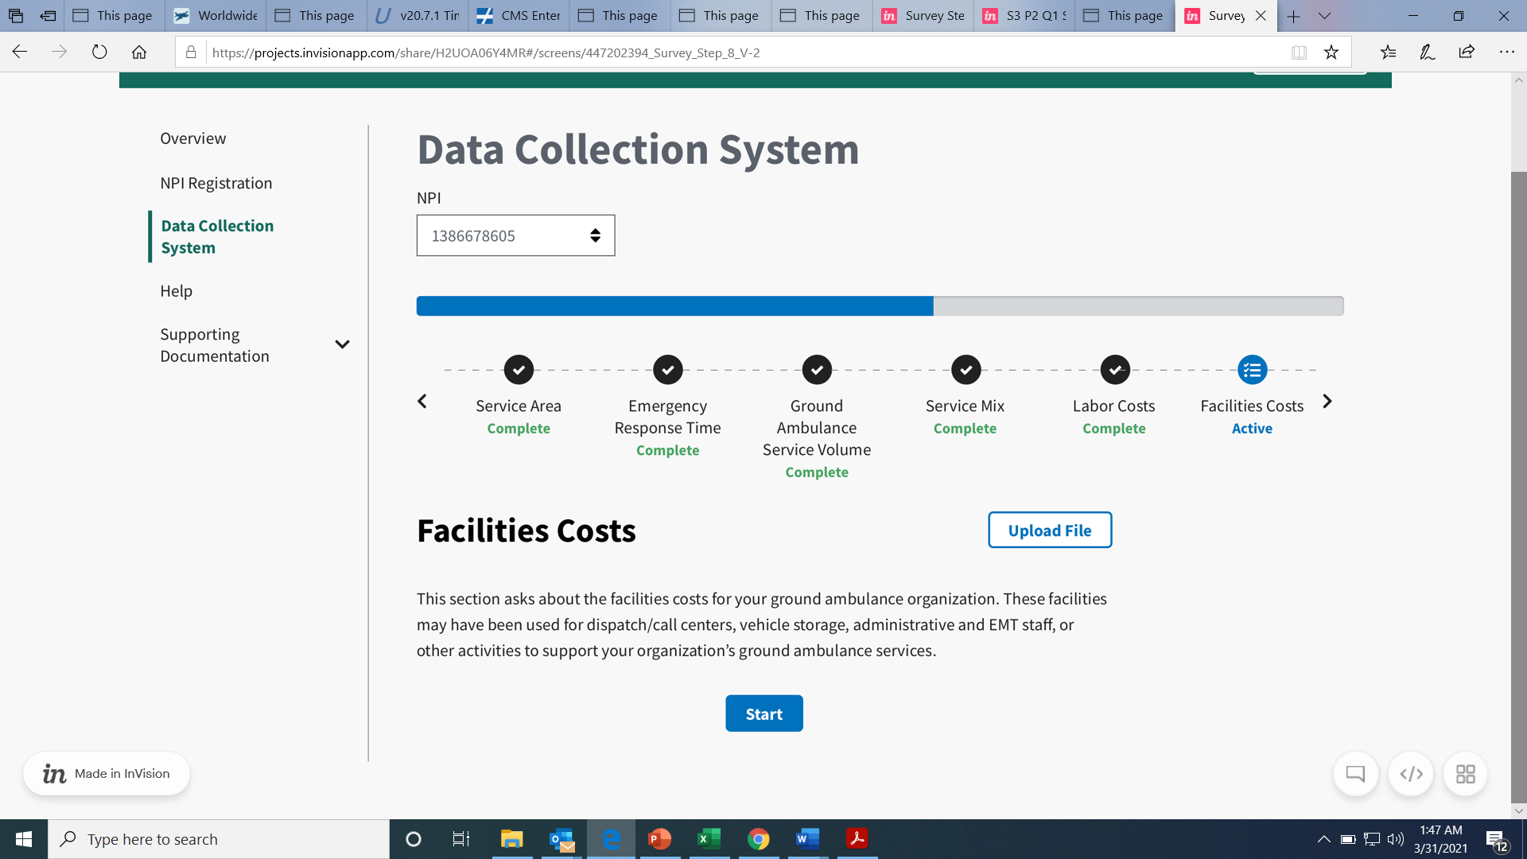
If you chose to download the form and fill it in, click Upload File.
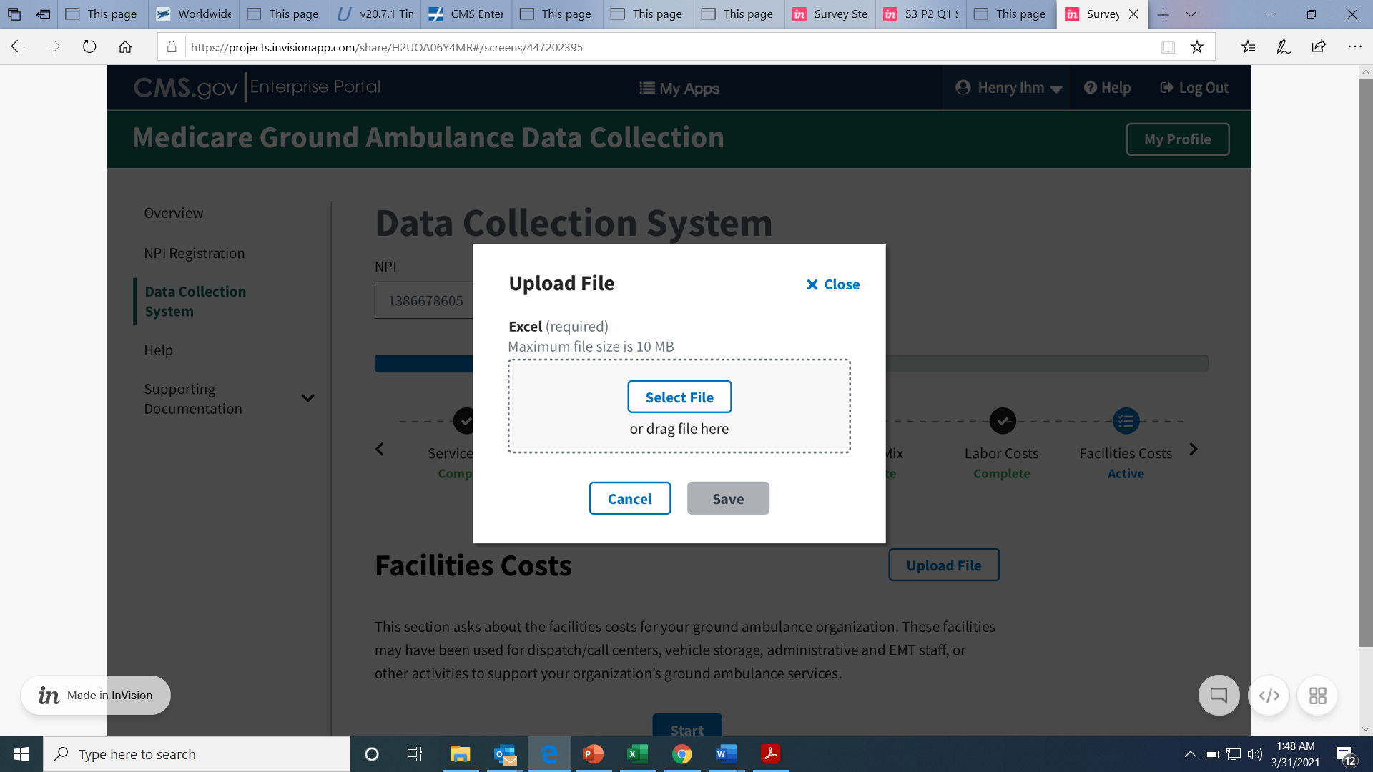
The file must be Excel. Select the file, then click save.
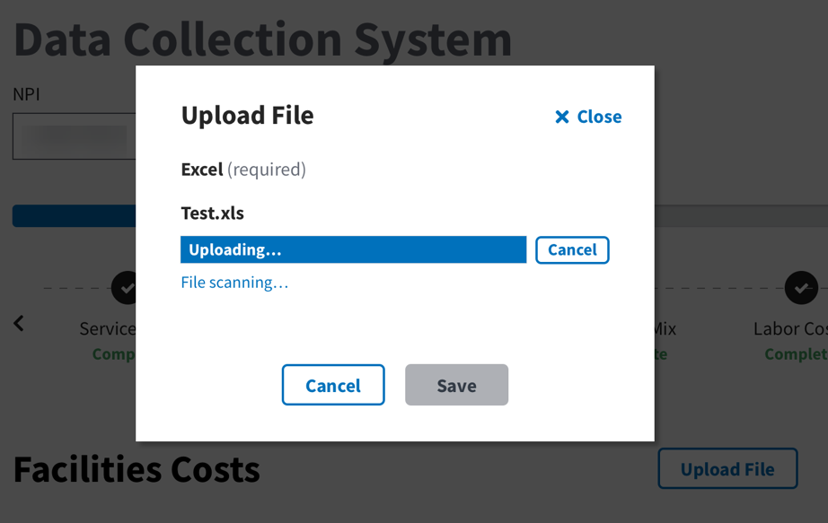
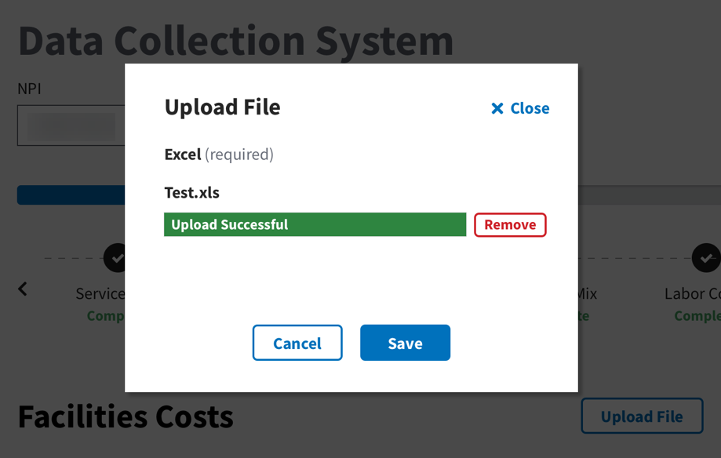
If you choose to enter in the numbers using the instrument, click start and then enter in the total number of facilities.
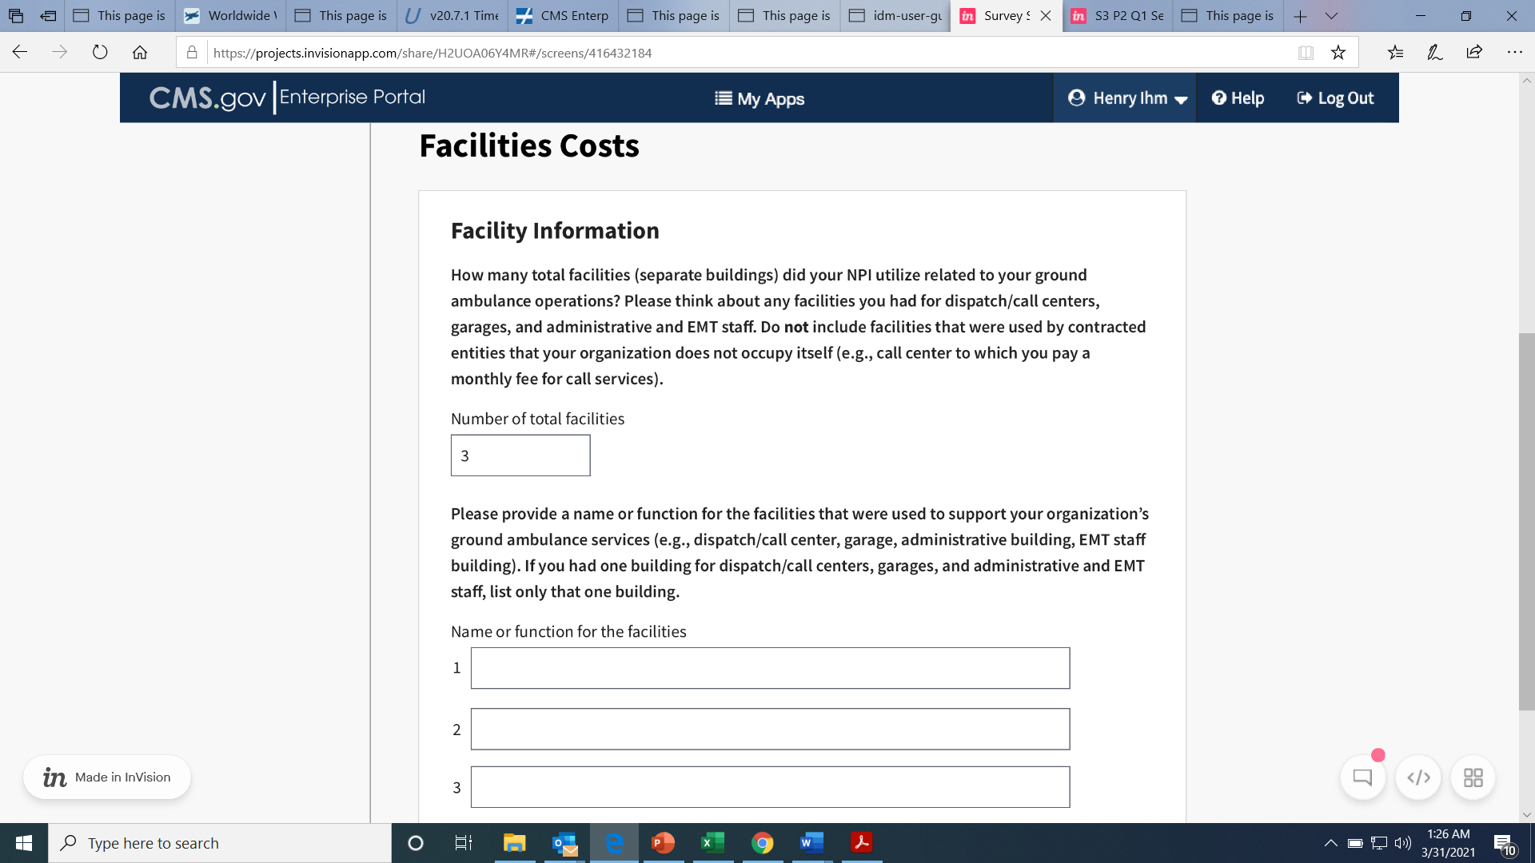
The number you enter in this first box will determine the number of boxes that appear below
You will then fill out additional information about the facilities you name. Enter numbers in only whole numbers.
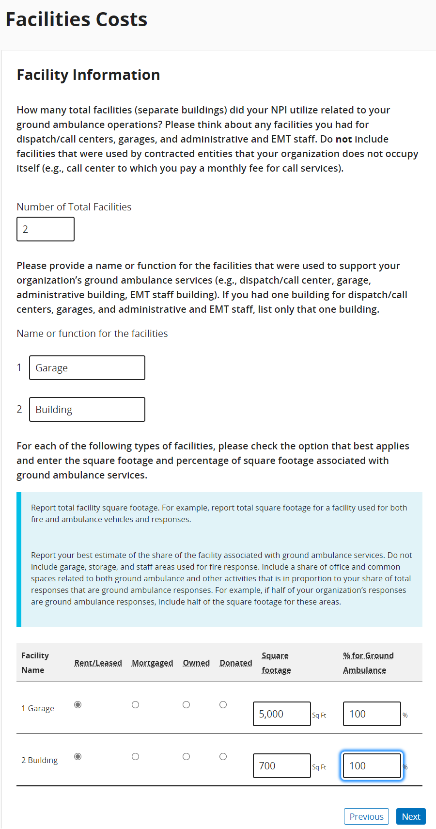
For this question regarding mortgage or lease costs, round the numbers to the nearest whole number.
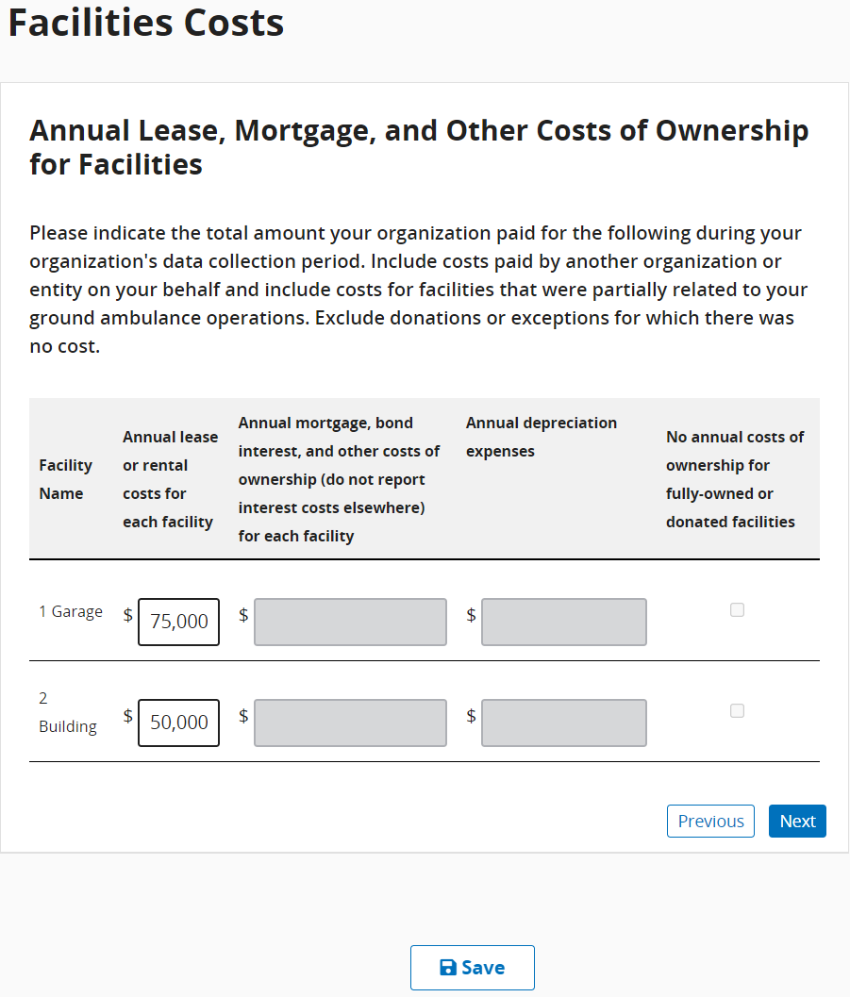
Again, you will enter whole numbers for the question about Insurance, Maintenance, Utilities, and Taxes
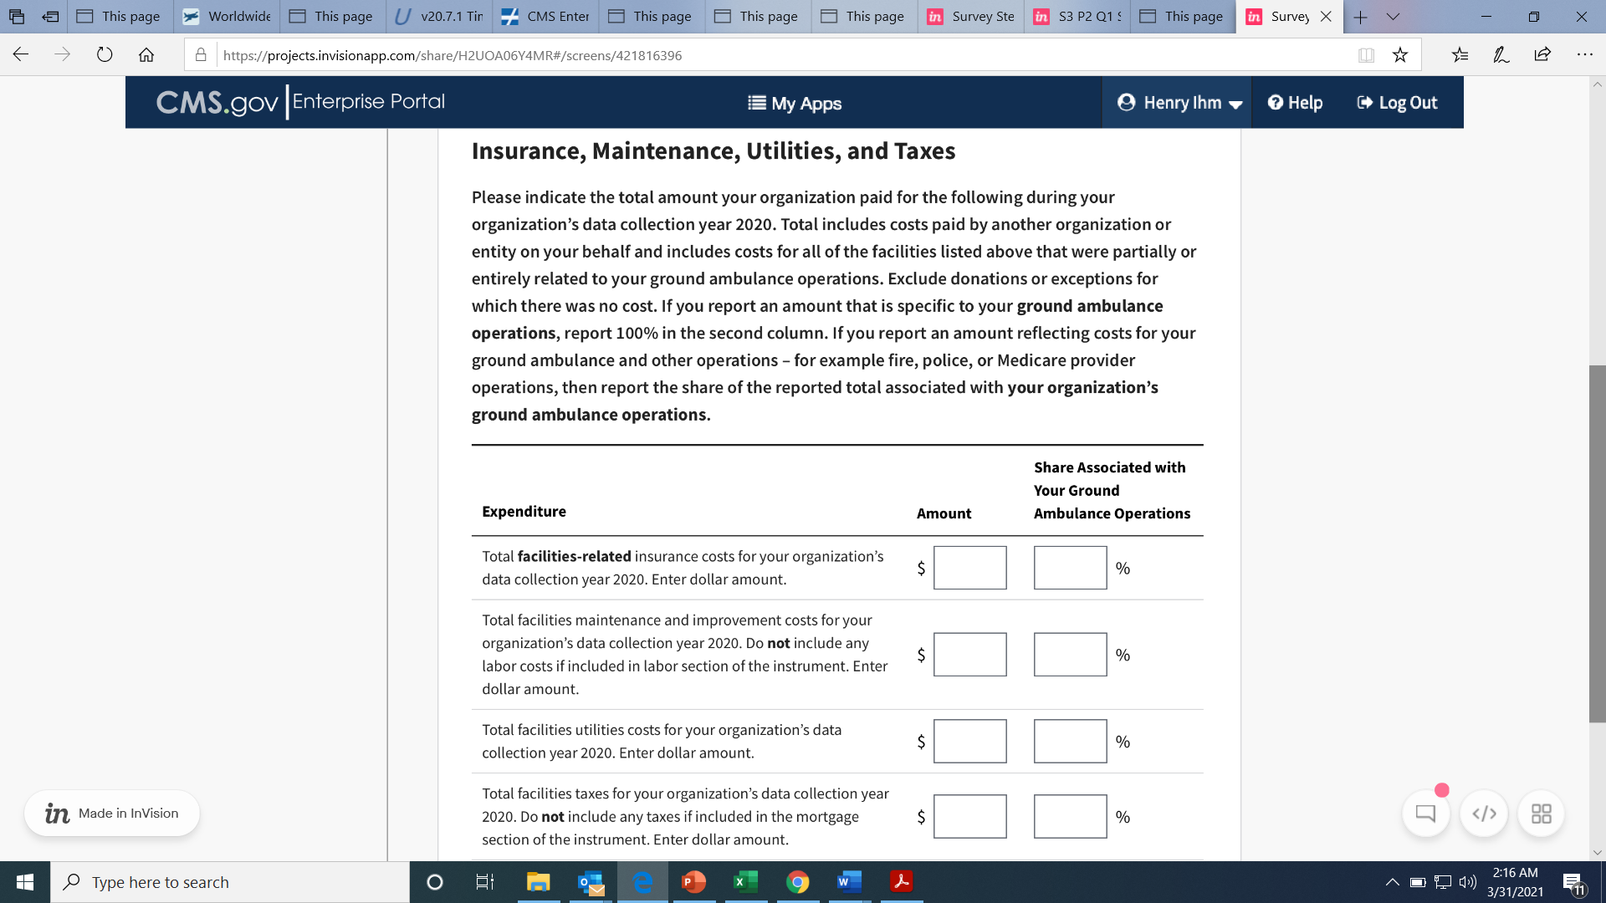

Vehicle Costs
This section will ask you about the vehicles your organization uses, starting with ground ambulances.
Click Start to begin.
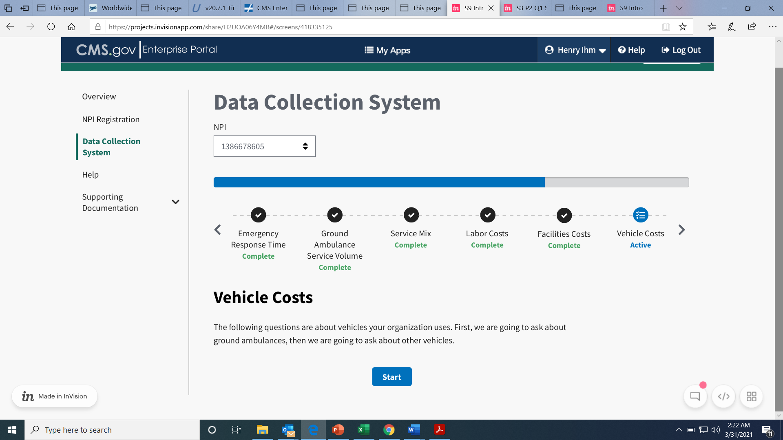
You will begin by entering information about ground ambulances your organization owns.
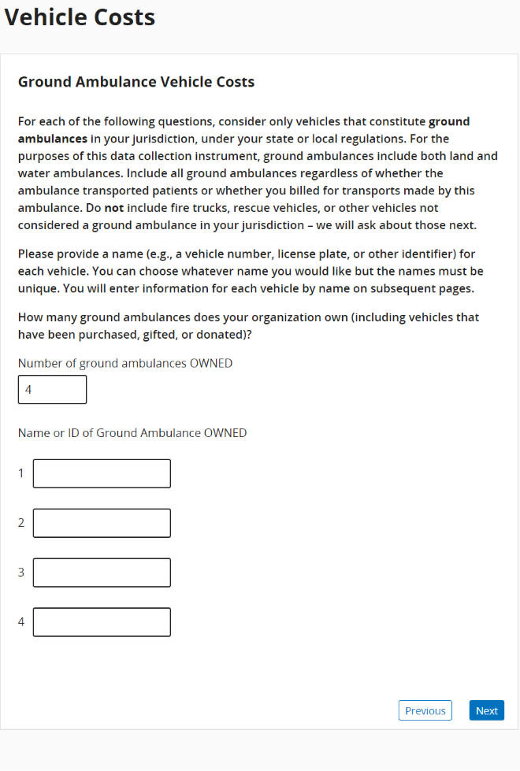

Next, you will enter information about ground ambulances your organization leases or rents. Just as before, the number you enter will populate the number of entries for Names or IDs. If you indicated your organization operates air ambulances, do not include air ambulance services in responding to the following questions.
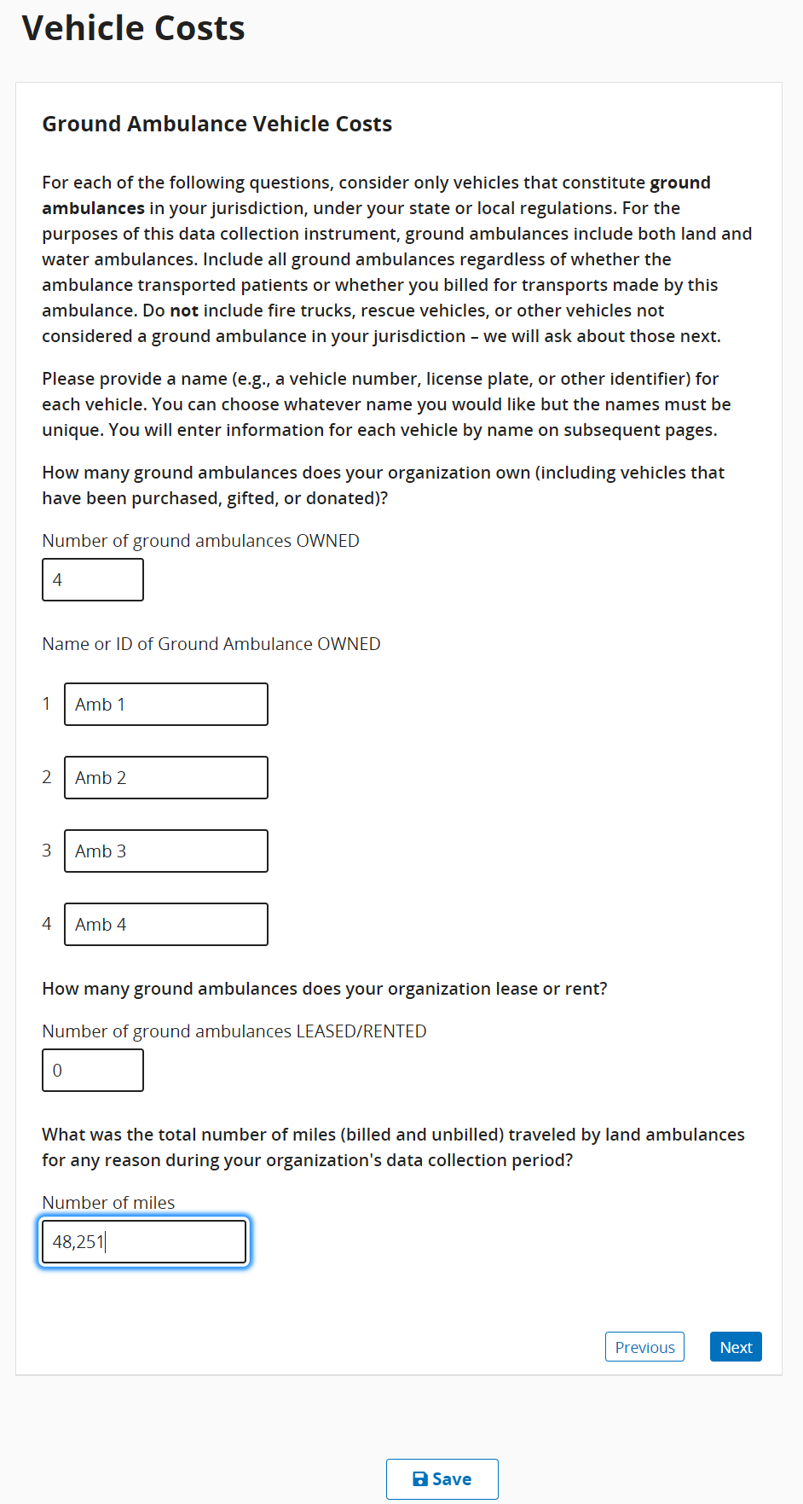
You will be asked to fill out financial information for your ground ambulance vehicles. Use only whole numbers.
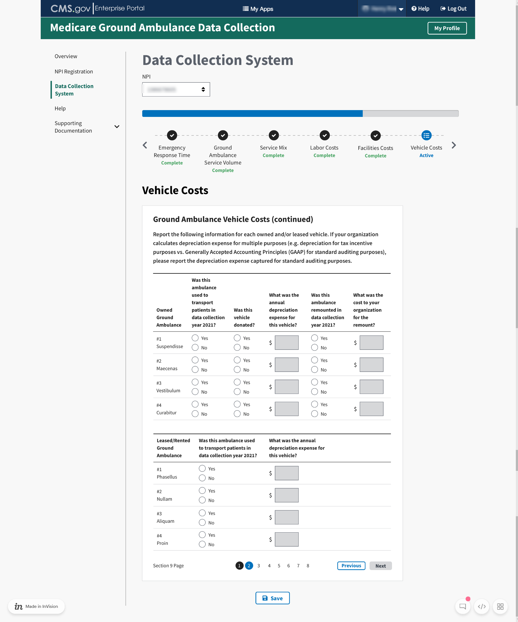

Once you’ve completed entering information about ground ambulance vehicle costs, you will be asked about your organization’s non-ambulance vehicles.
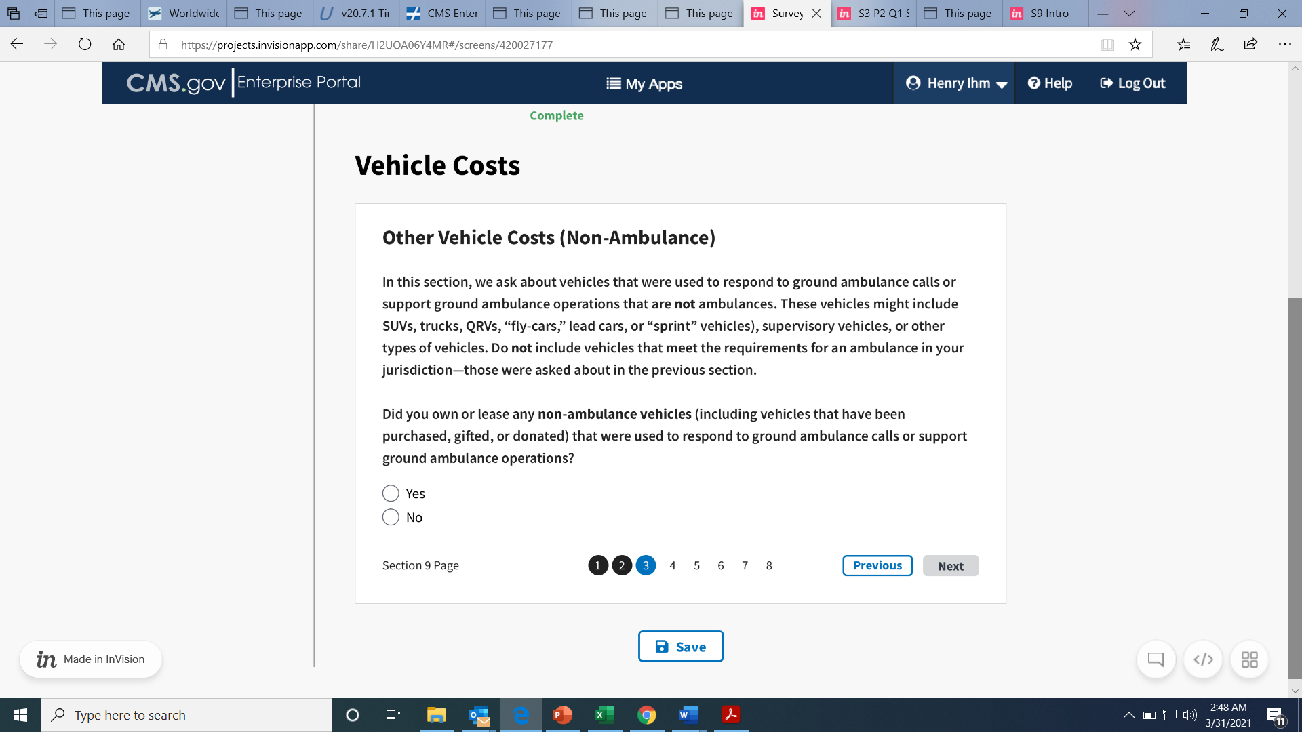
If you do not have any other vehicle costs, click No to move on to the next set of questions. Otherwise, you will enter information the same way you did for the ground ambulance vehicle costs.
Next, calculate the total cost of registration for all your organization’s vehicles. You will do the same for license and insurance costs. When totaling the Other Costs, please enter only whole numbers.
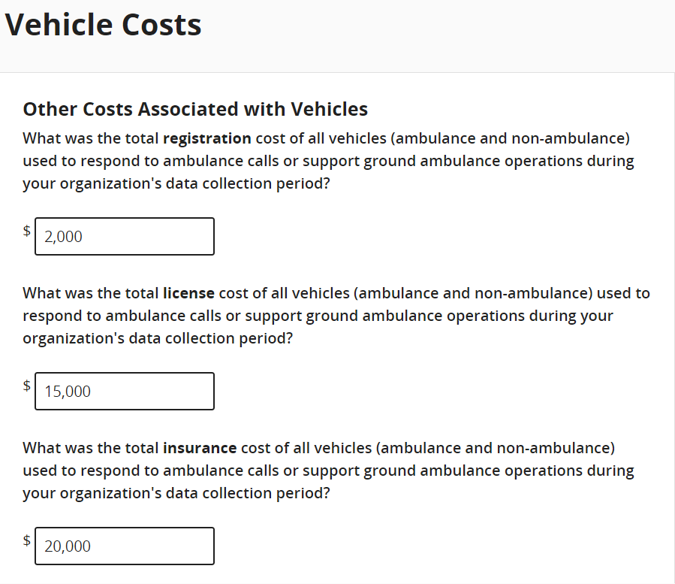
You will only see this question if you indicated your organization has more than one NPI to bill Medicare for ground ambulance Services. Enter in the whole dollar amount.
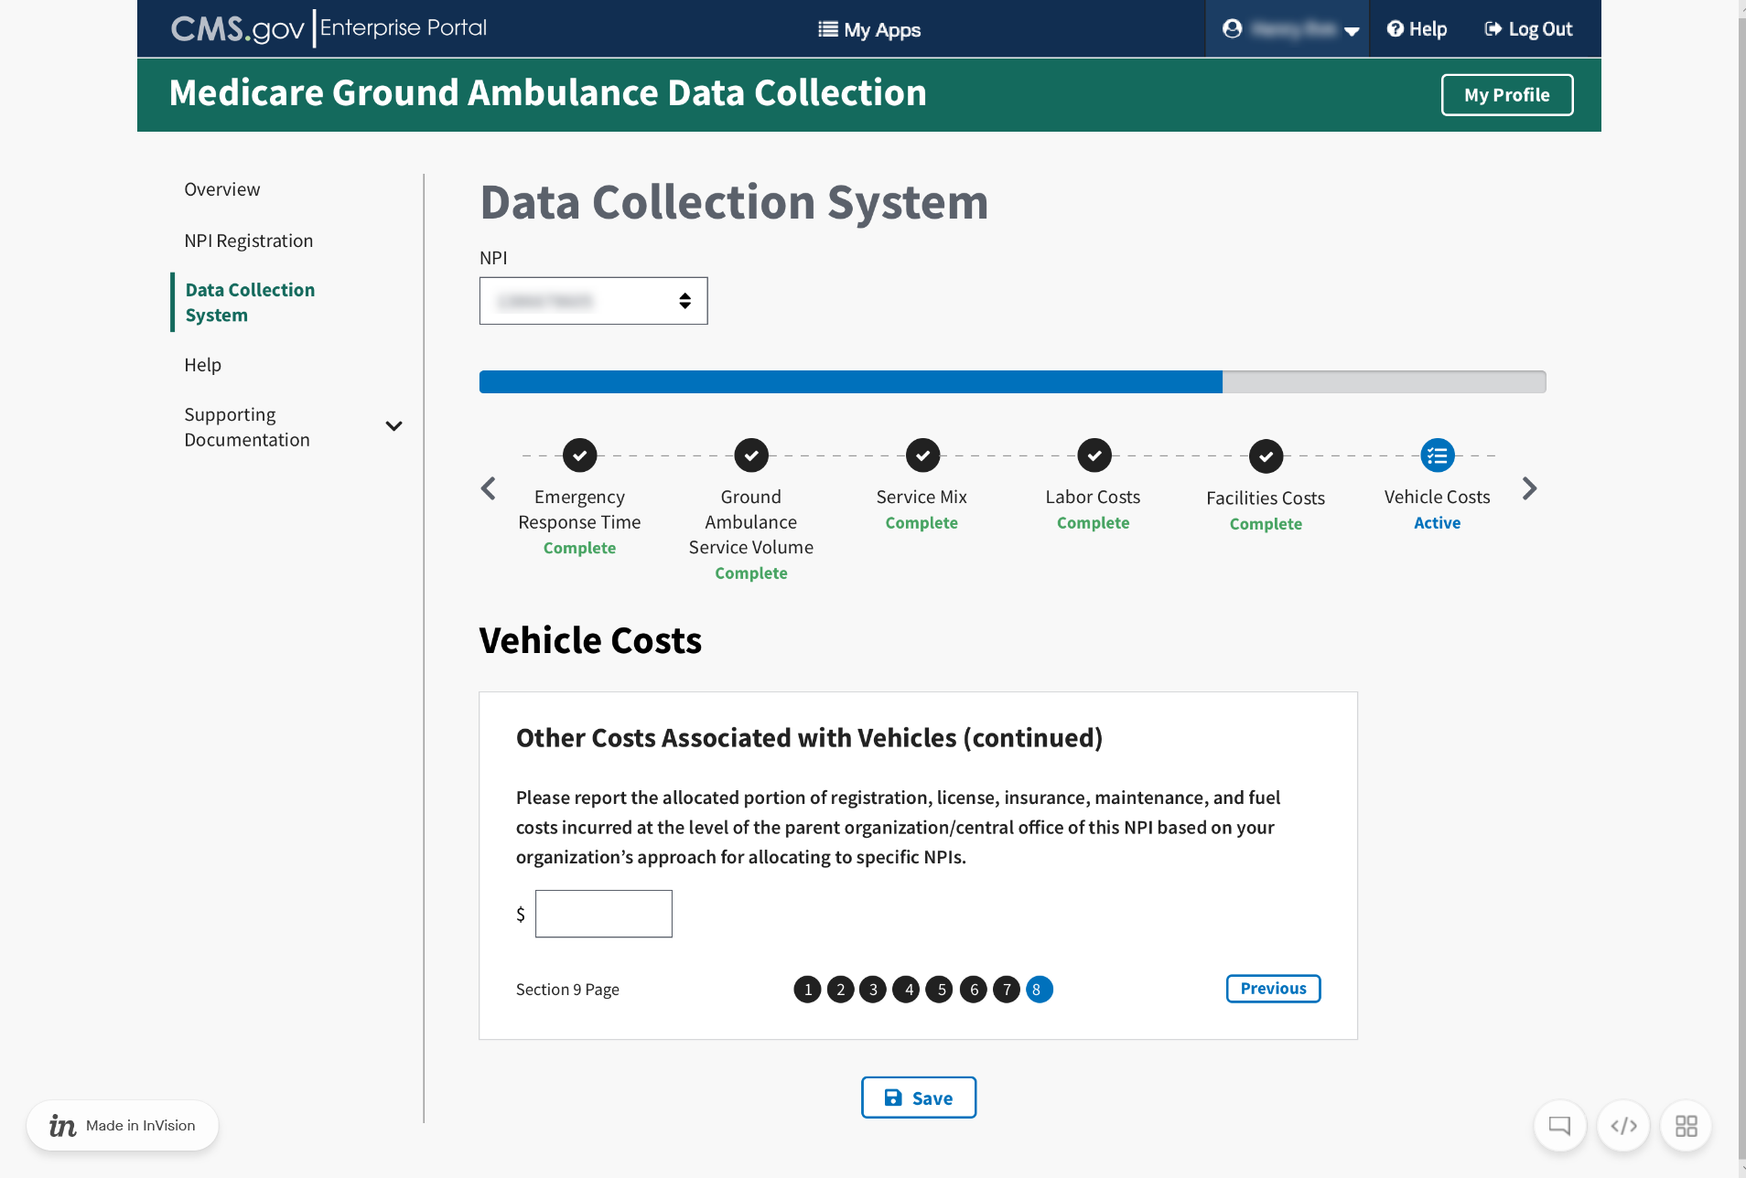

Equipment, Consumable, and Supply Costs
Please read the information before clicking Start to begin.
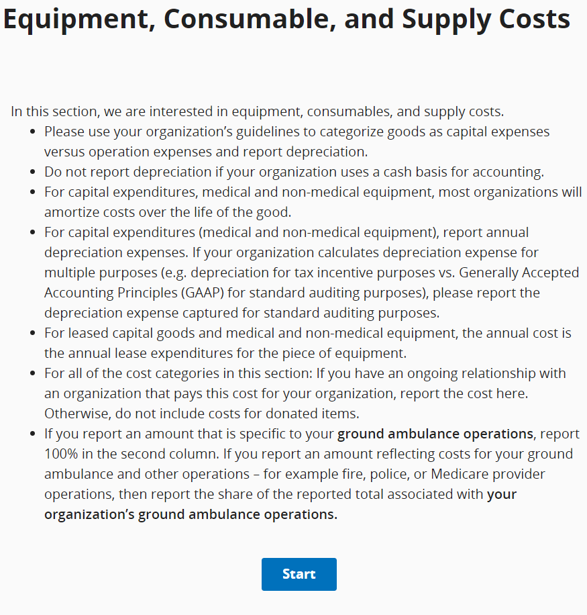
Proceed to answer the questions using whole numbers.
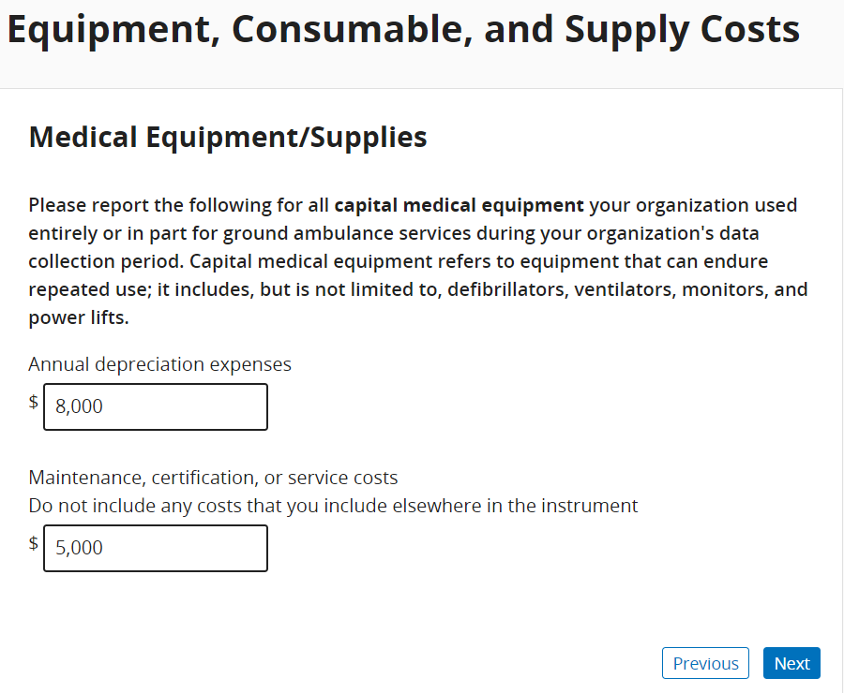
For this question, be sure to select ALL the statements that apply.
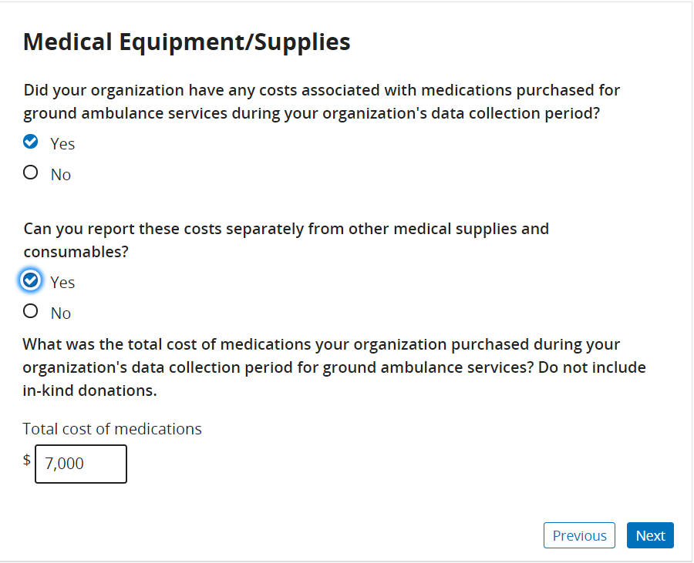
Continuing answering the questions until you complete this section.
For this question, you will only see the second part if you indicate your organization has shared services.
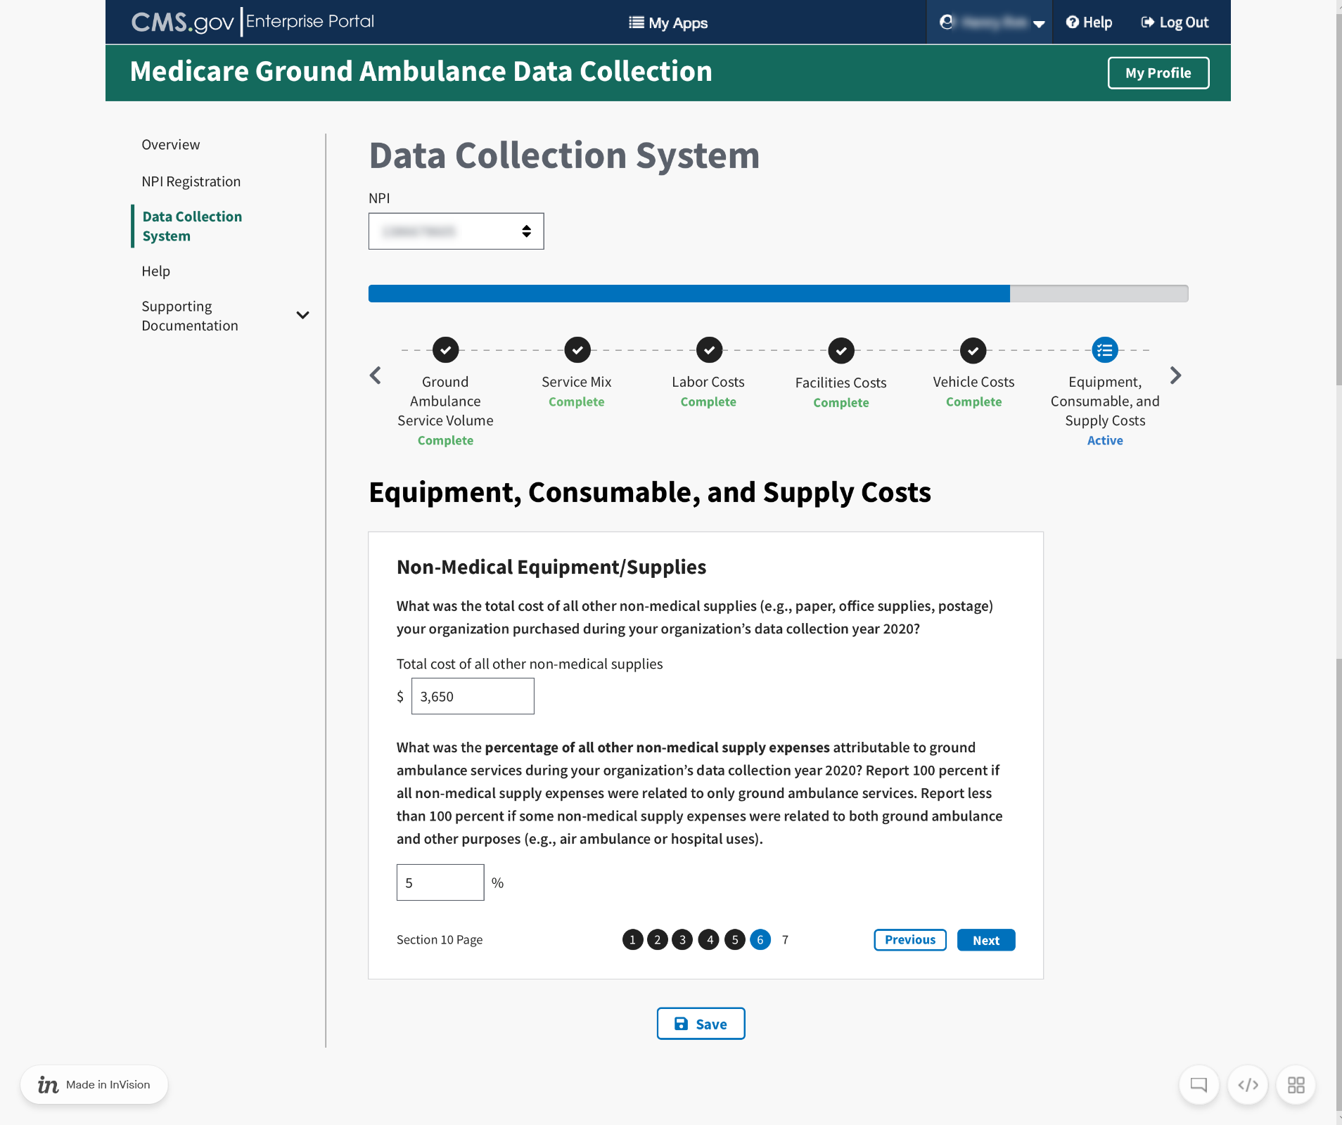

You will see this question if you indicate your organization has more than one NPI to bill Medicare for ground ambulance services.
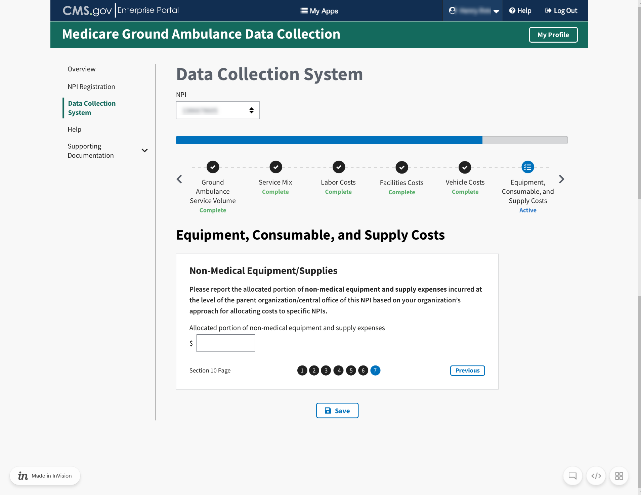
When you reach the end of this section, click Save and then click Next Section.

11 Other Costs
The beginning of this section has instructions on how to answer the questions for additional costs.
Once you have finished reading, click Start to begin.
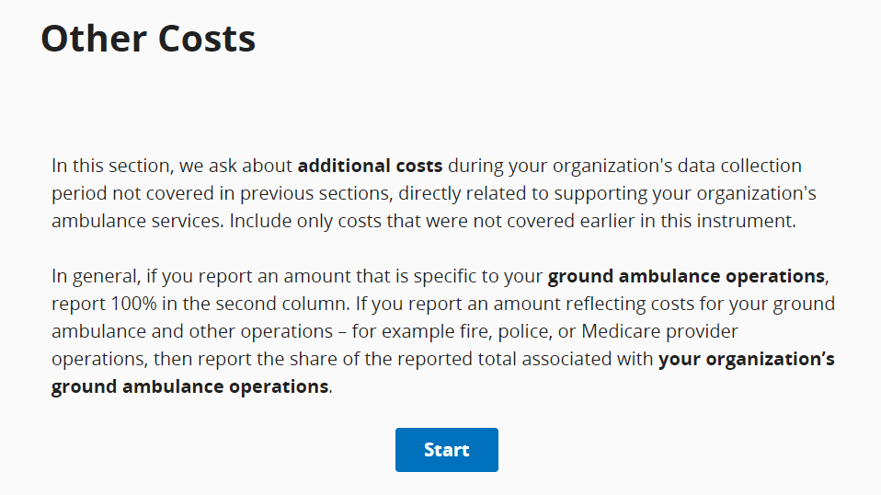
For the first question, you must check the box for all that apply, and only then will you be able to fill in the dollar amount and percentages.
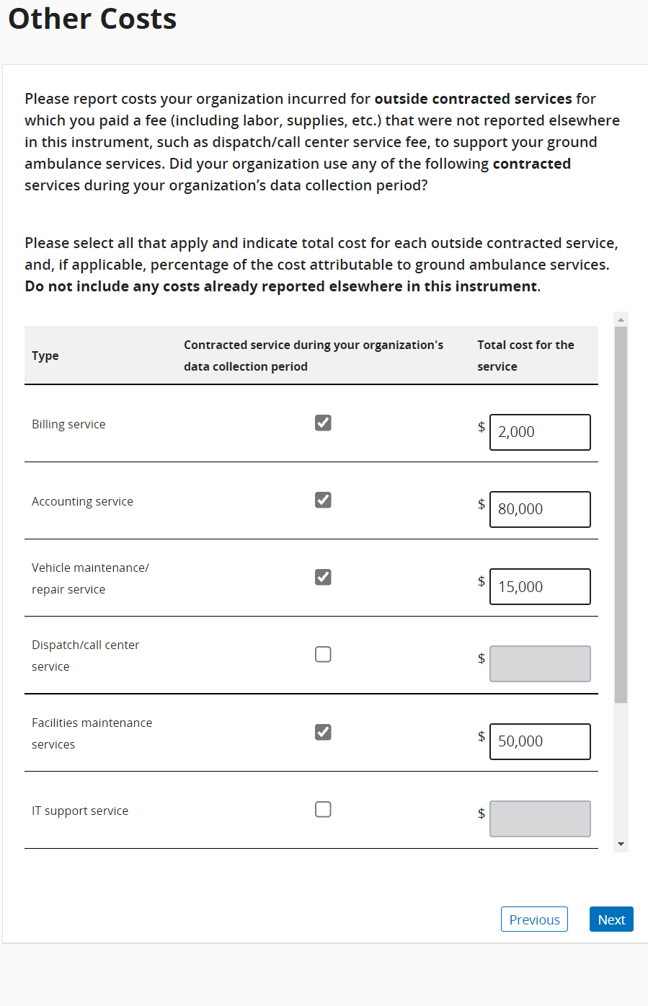
If you select “Other” you must write in a description.
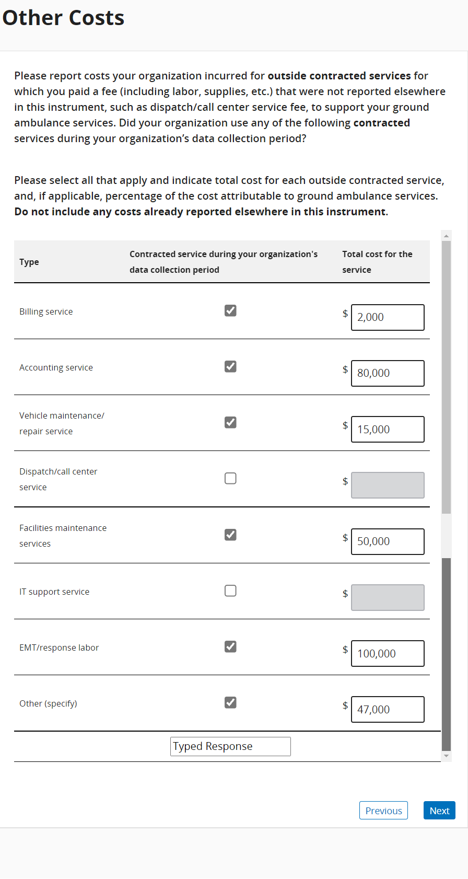

For this question, be sure to check all statements that apply to your organization.
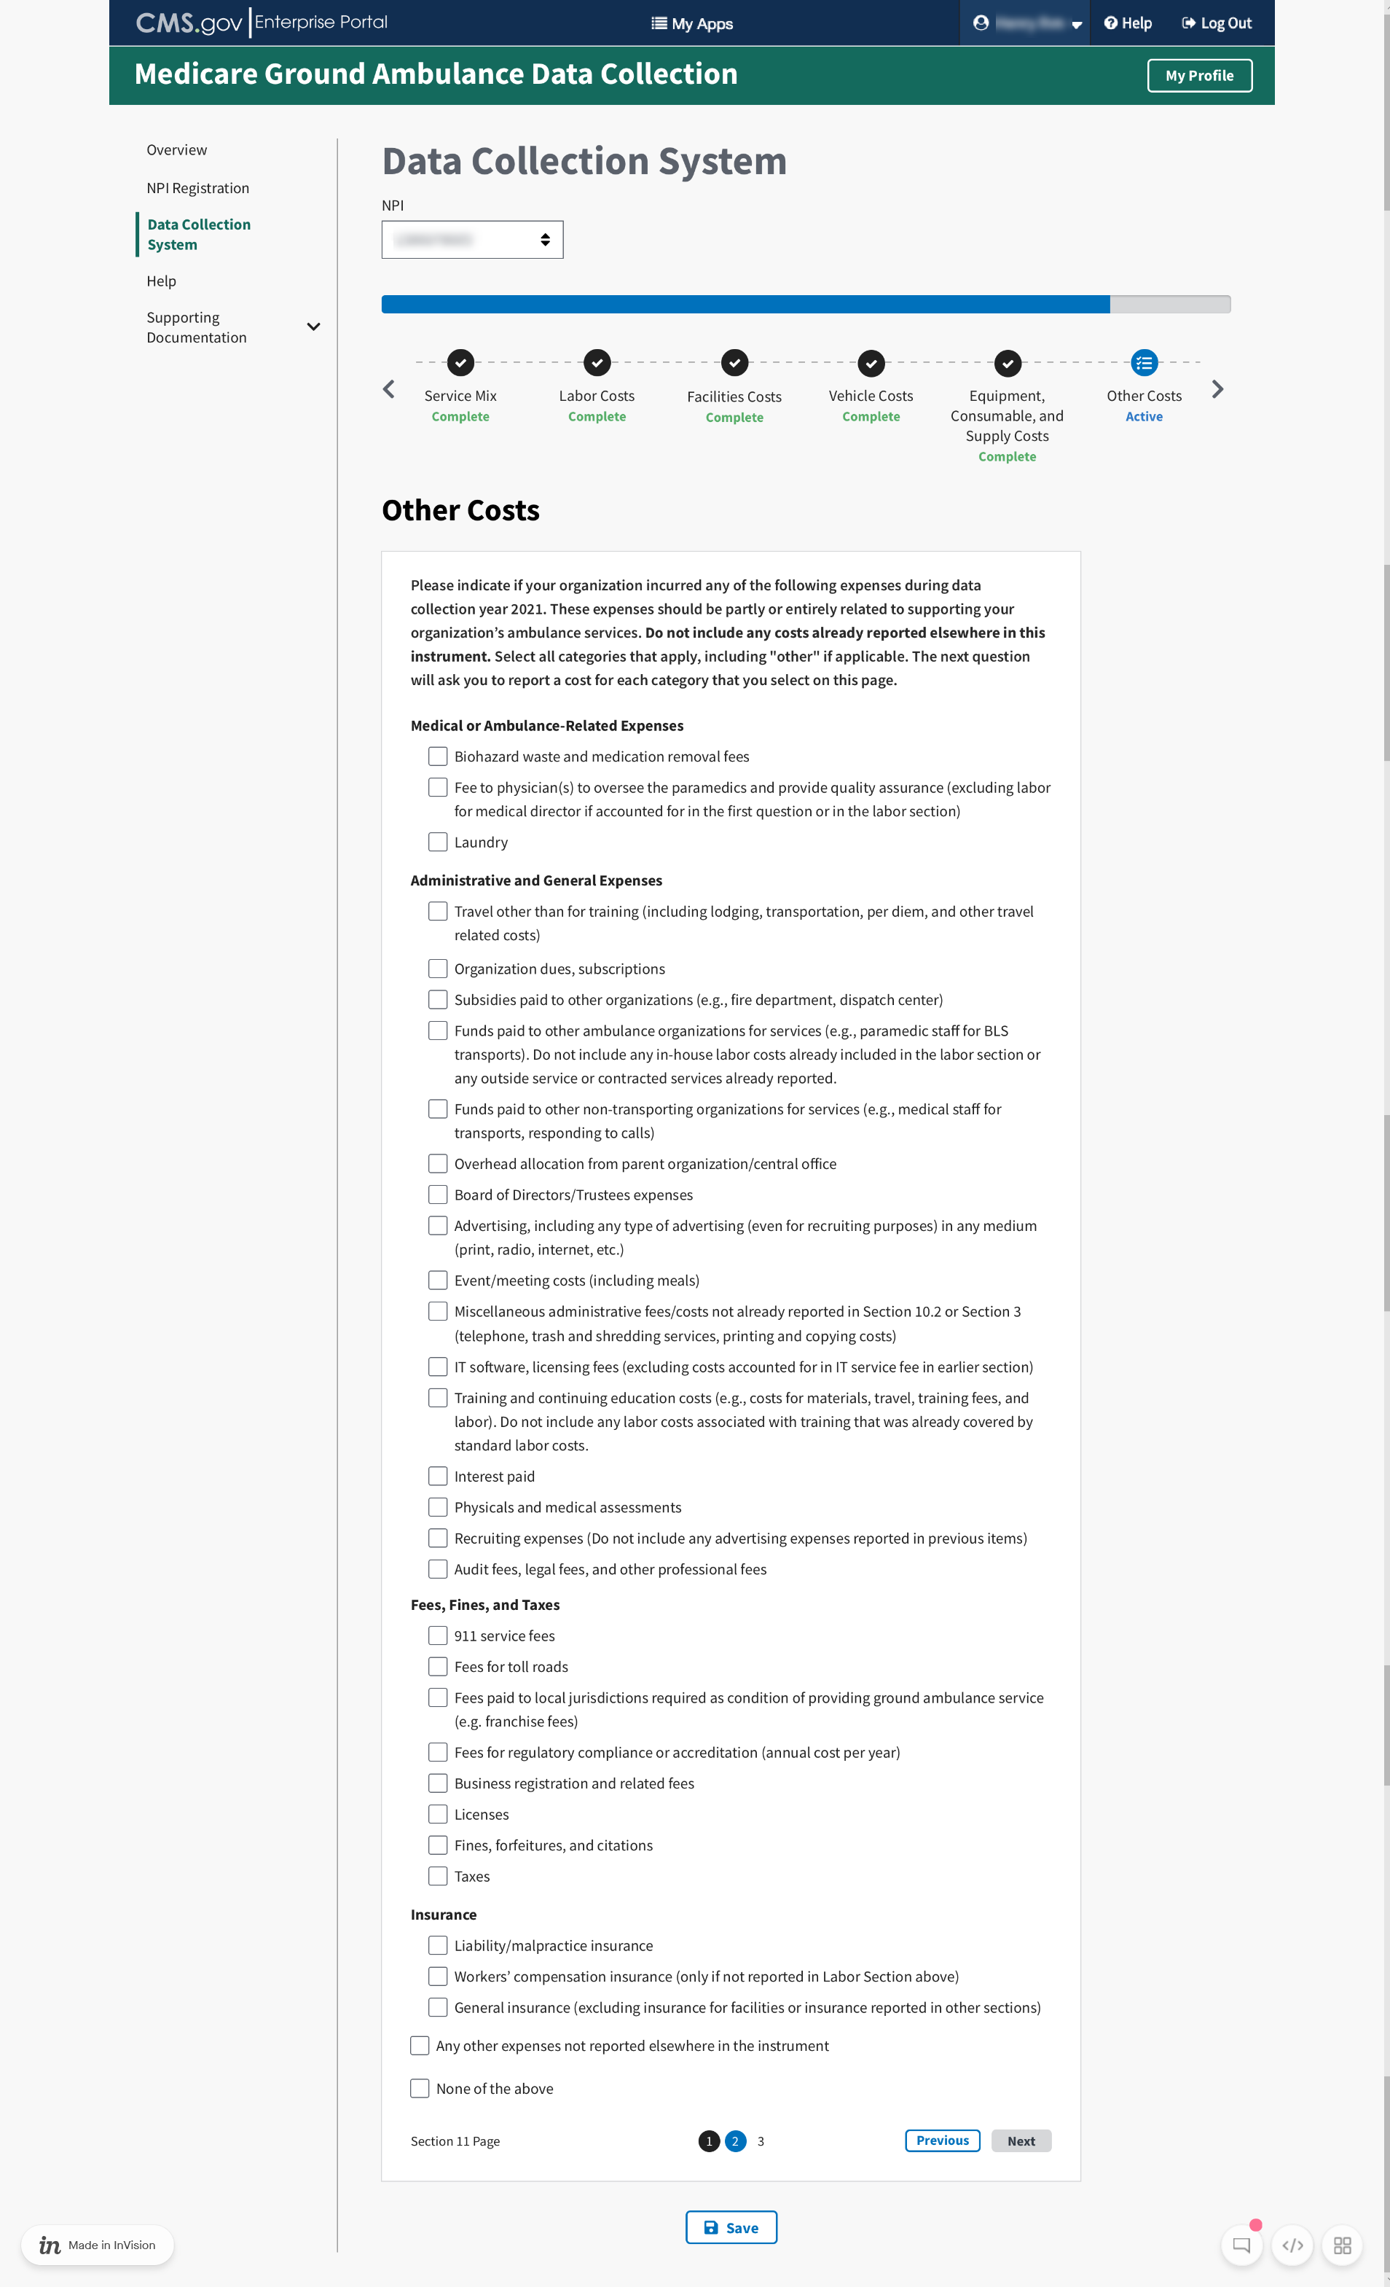

12 Total Costs
Enter in the total of your organization’s costs.
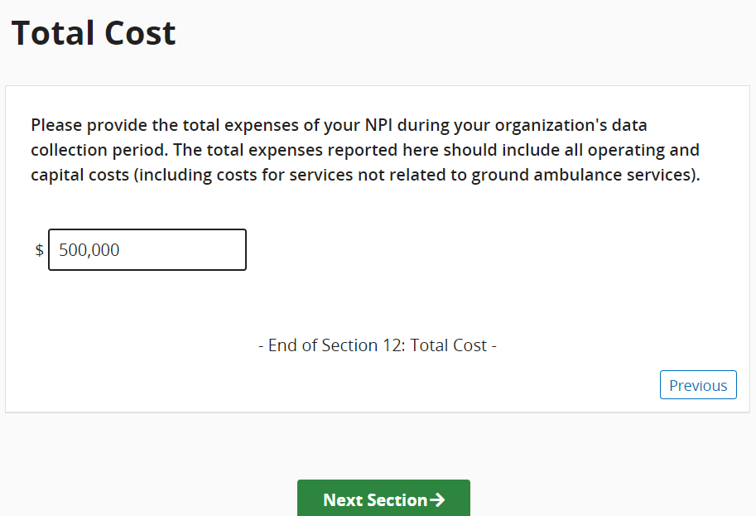
This is the only question for this section.

13 Revenues
This section asks about your organization’s sources of ground ambulance revenue. Click start to begin.
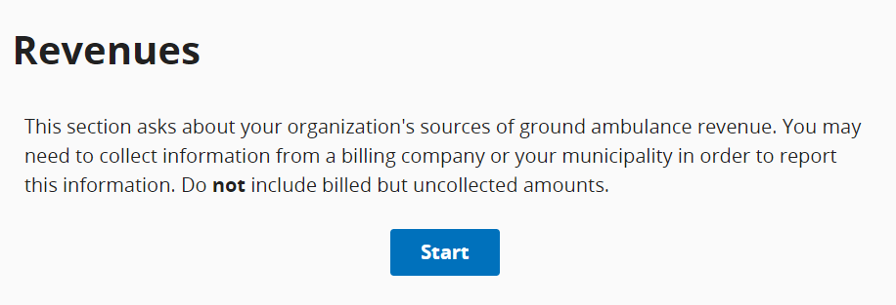
You will report your total revenue from all sources your organization received during your data collection period.
Choose the response that best applies to the payers that your organization billed during your data collection period.
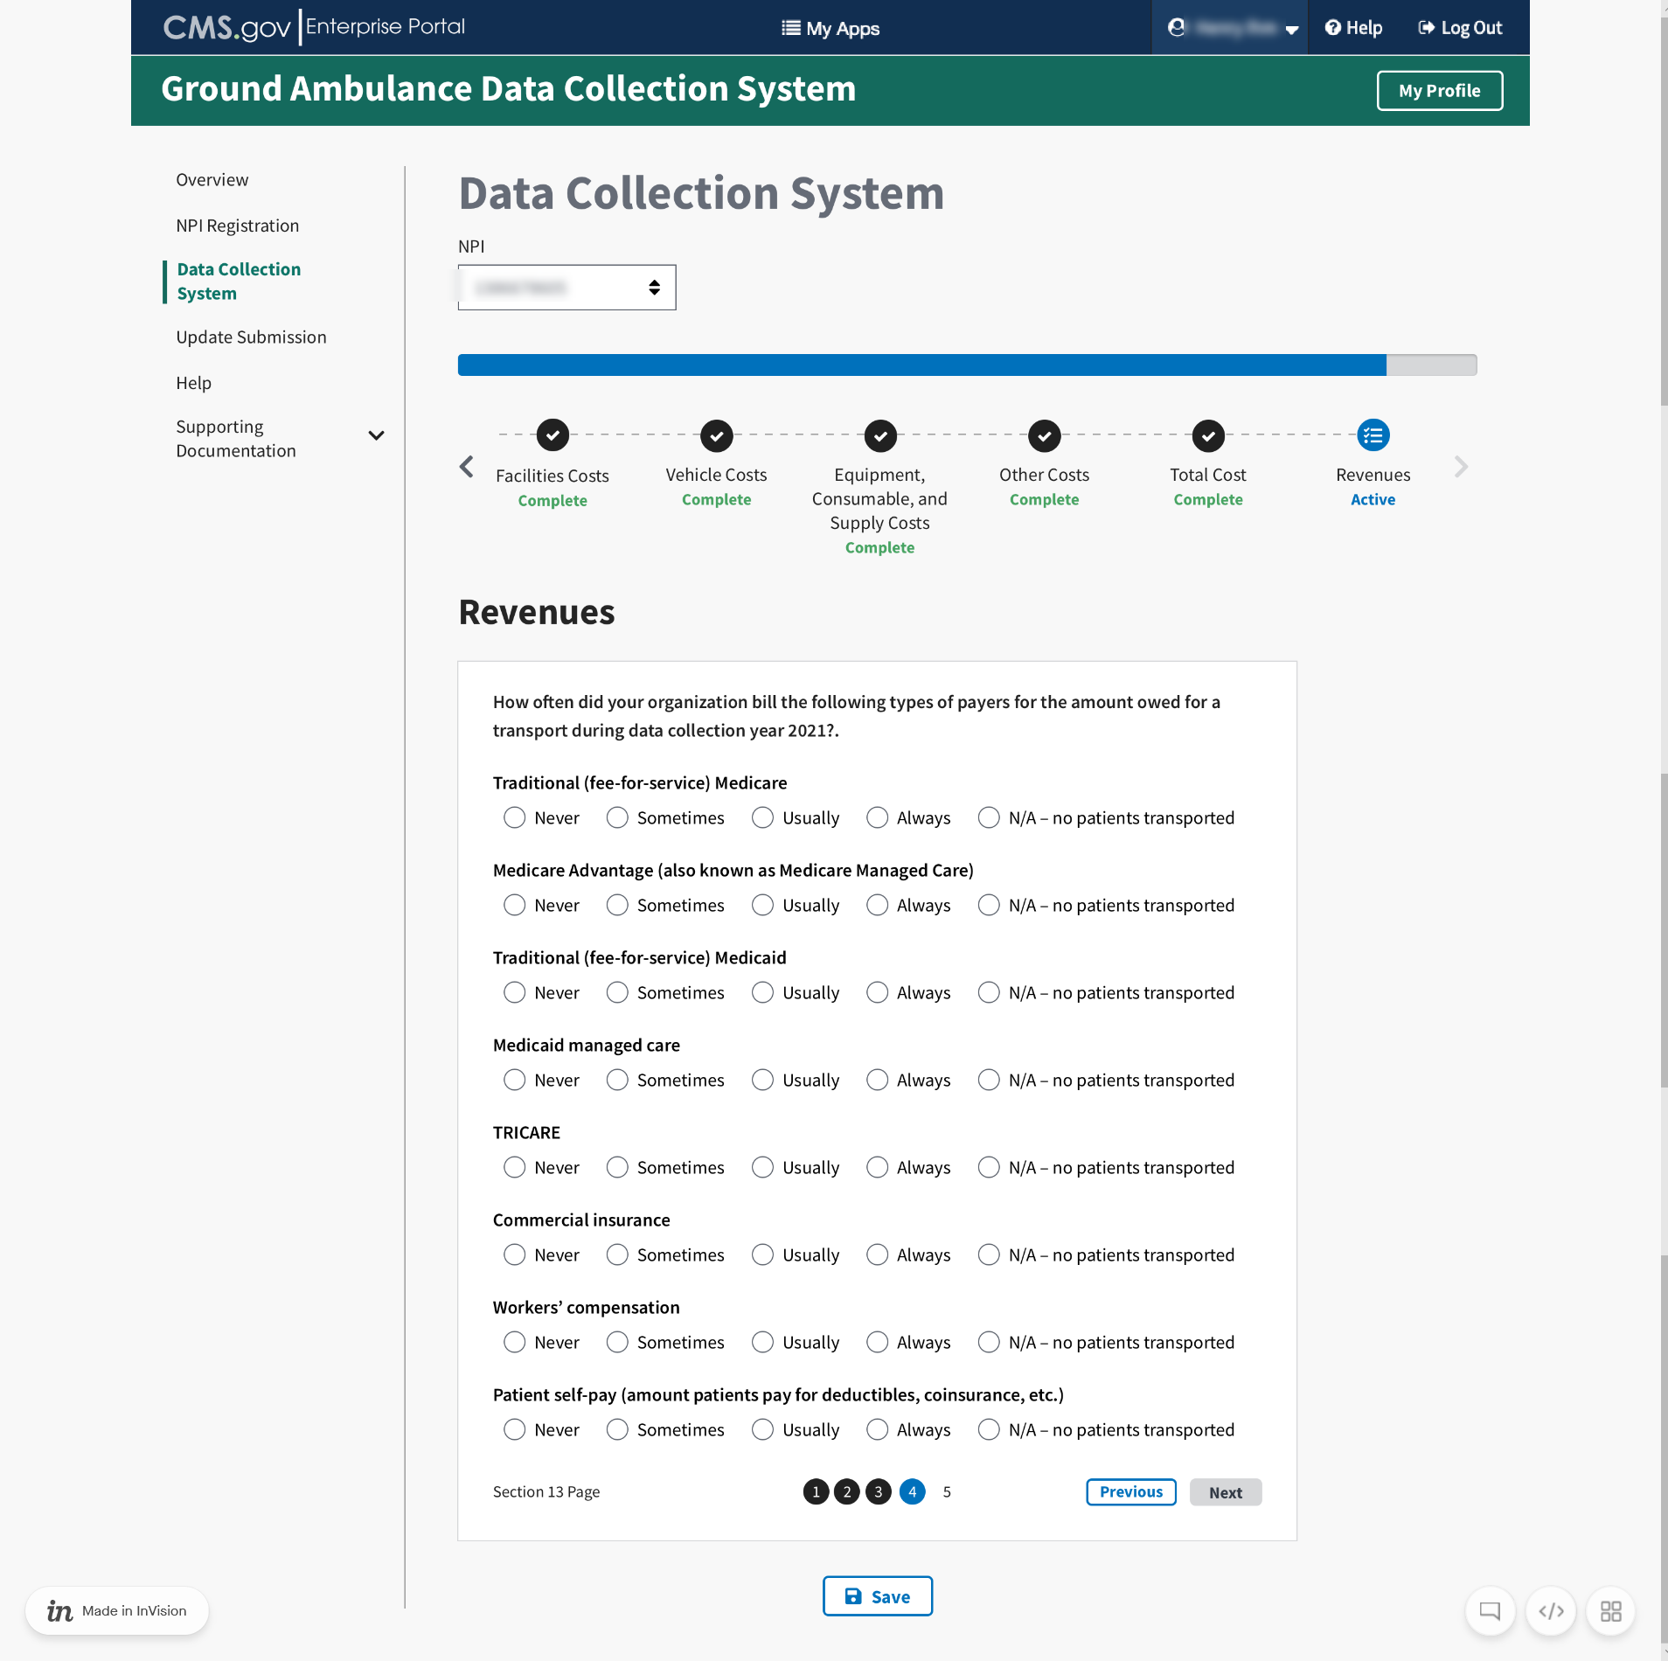

For this question, you will check the boxes for all the sources of revenue that your organization received during your data collection period. You will only be allowed to enter data for the sources where you check the box.
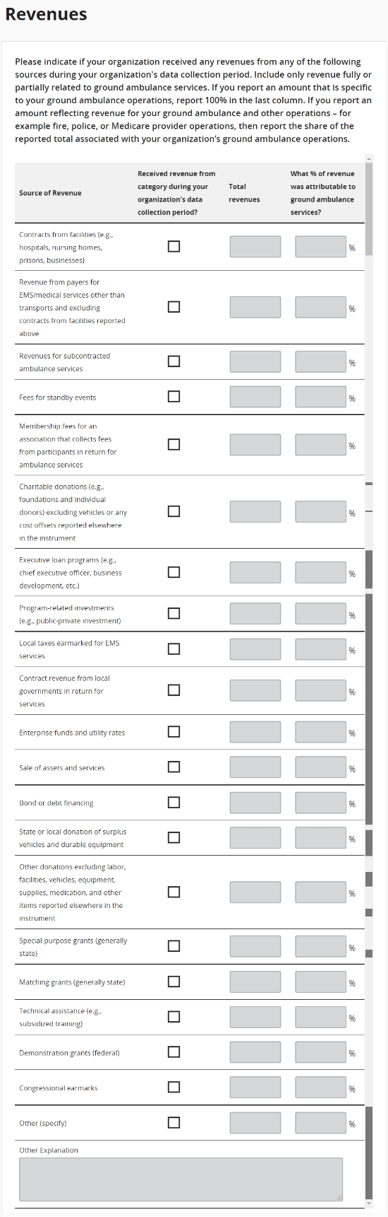
This is the final section of the instrument. If the submitter has completed all the other sections, you can choose to review or submit your responses.
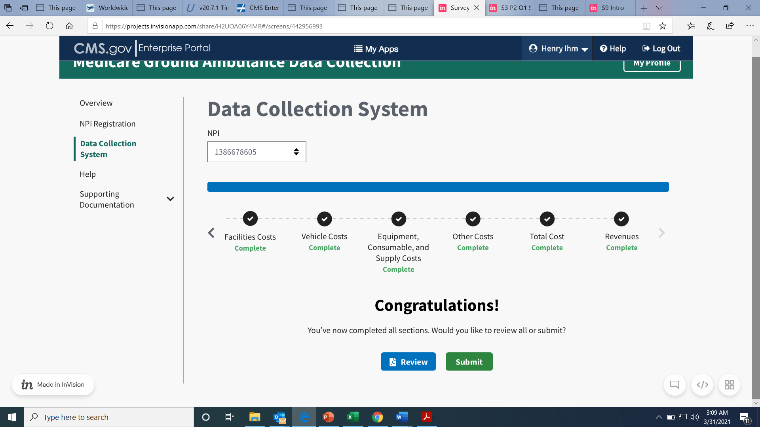
Once you are ready, click the Submit button.
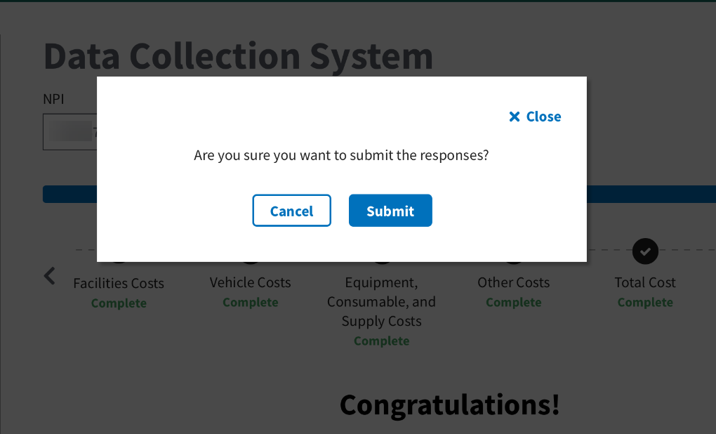

Once the Submitter have reported all of the data and saved the entries, the Submitter will be prompted to email a notification to the Certifier that it is ready to review.
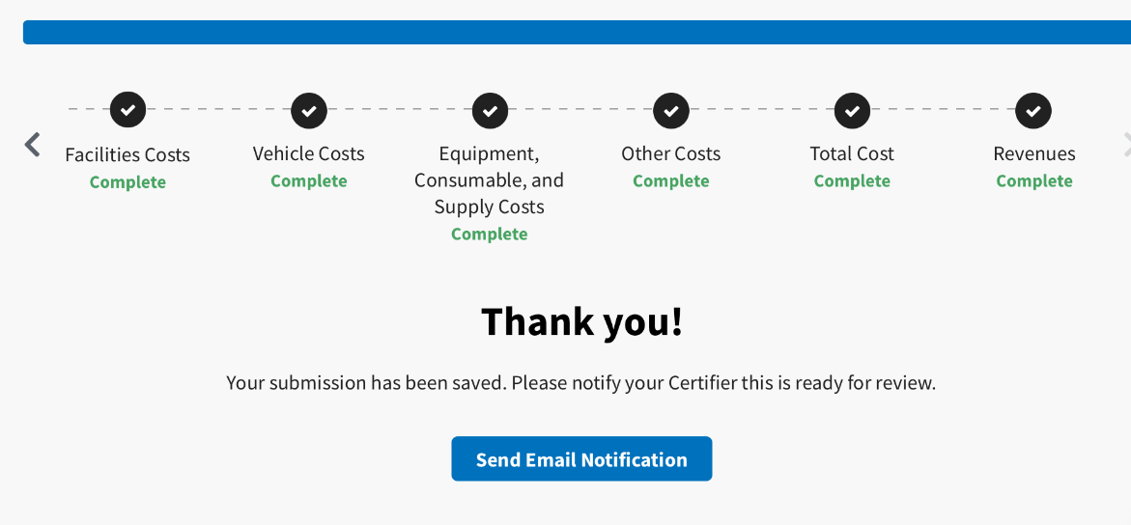
The From, Subject, and Message fields will be auto populated. You must enter the certifier’s email address.
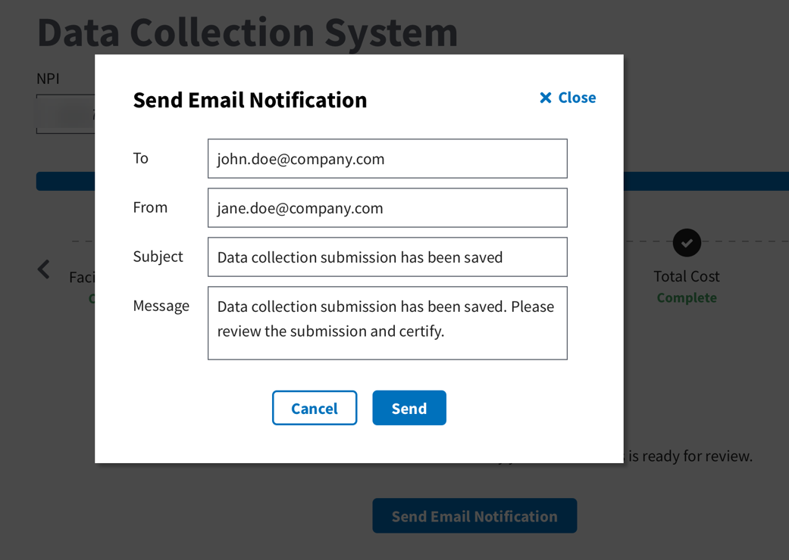

Click send to notify the Certifier the data is ready for their review.
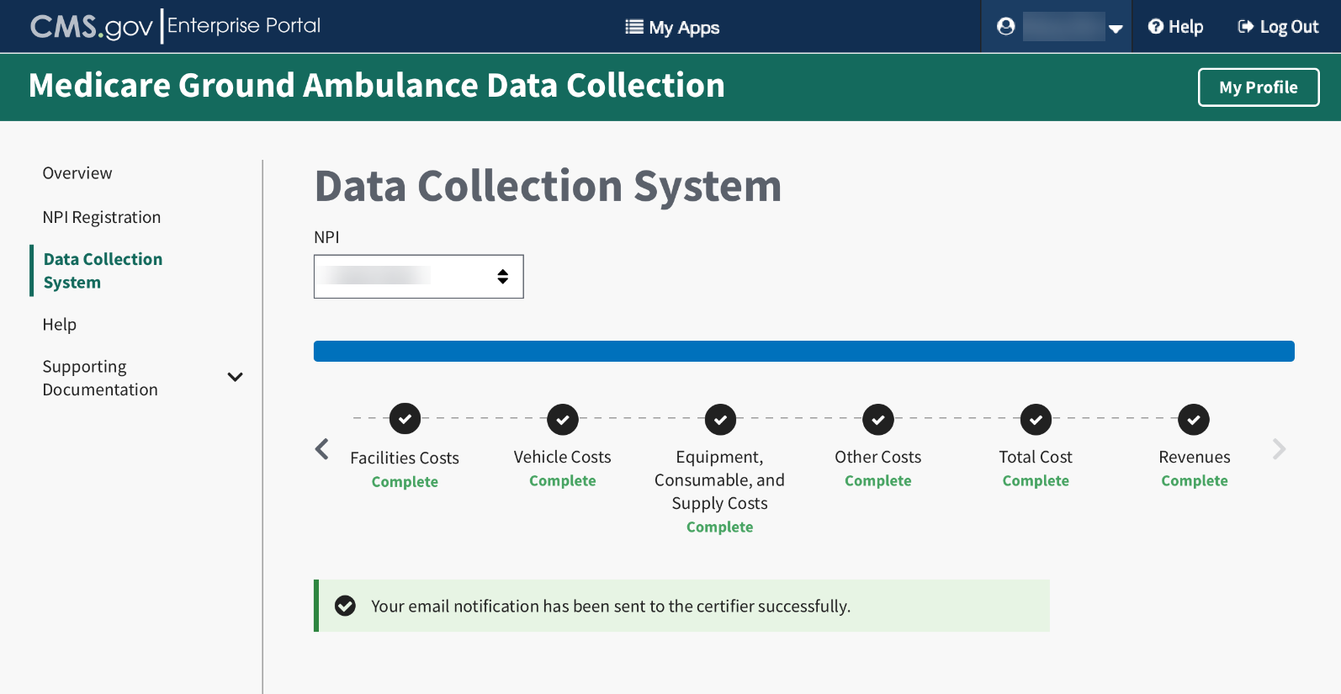

Certifier Landing Page
Once the Certifier receives the email notification that the data is ready to be reviewed, they will log in and see this page.
Click Review Submission to review the data.
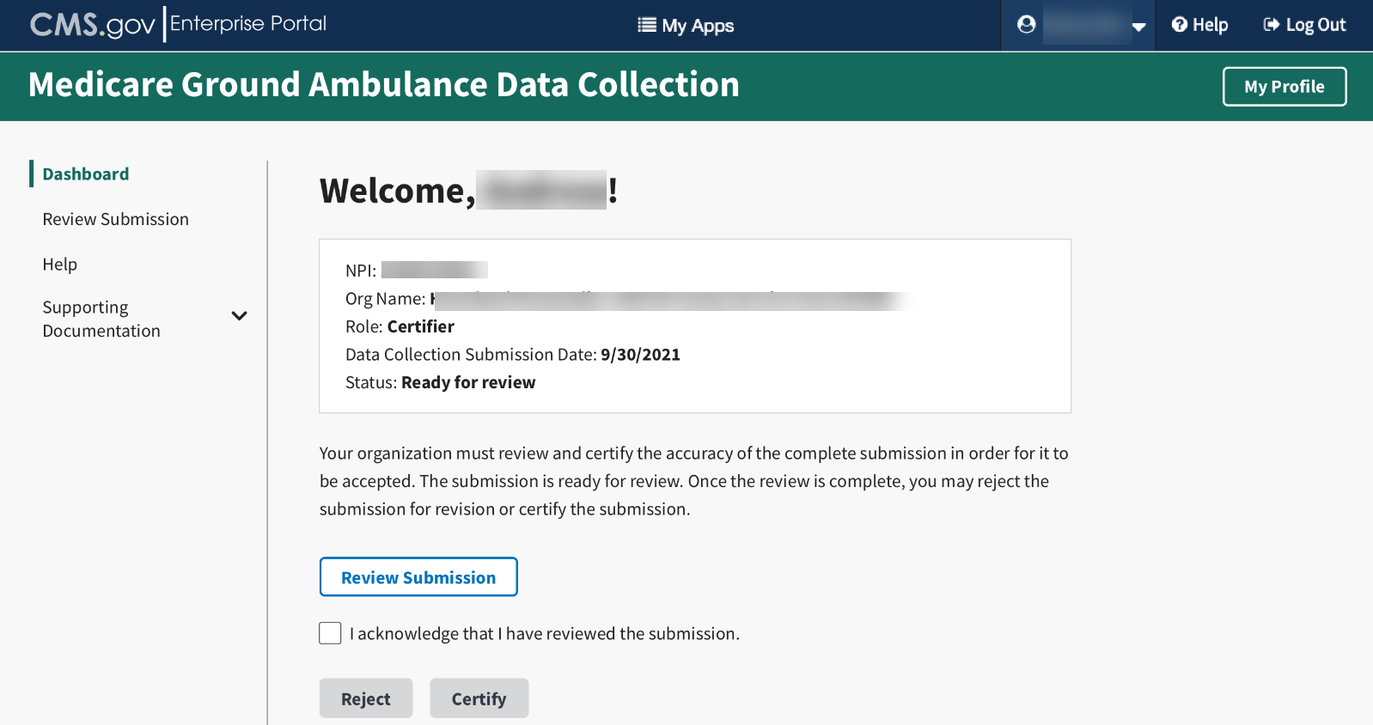
The Certifier must then review the data.
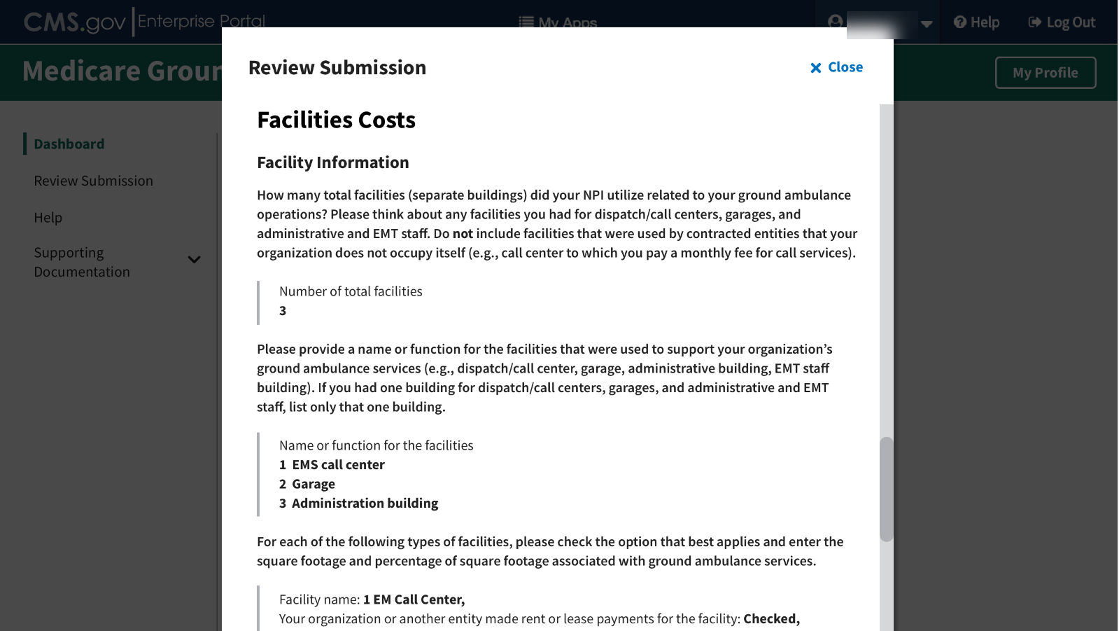

If the data is correct, the certifier will then click the box to acknowledge they have reviewed the data, and then click the Certify button.
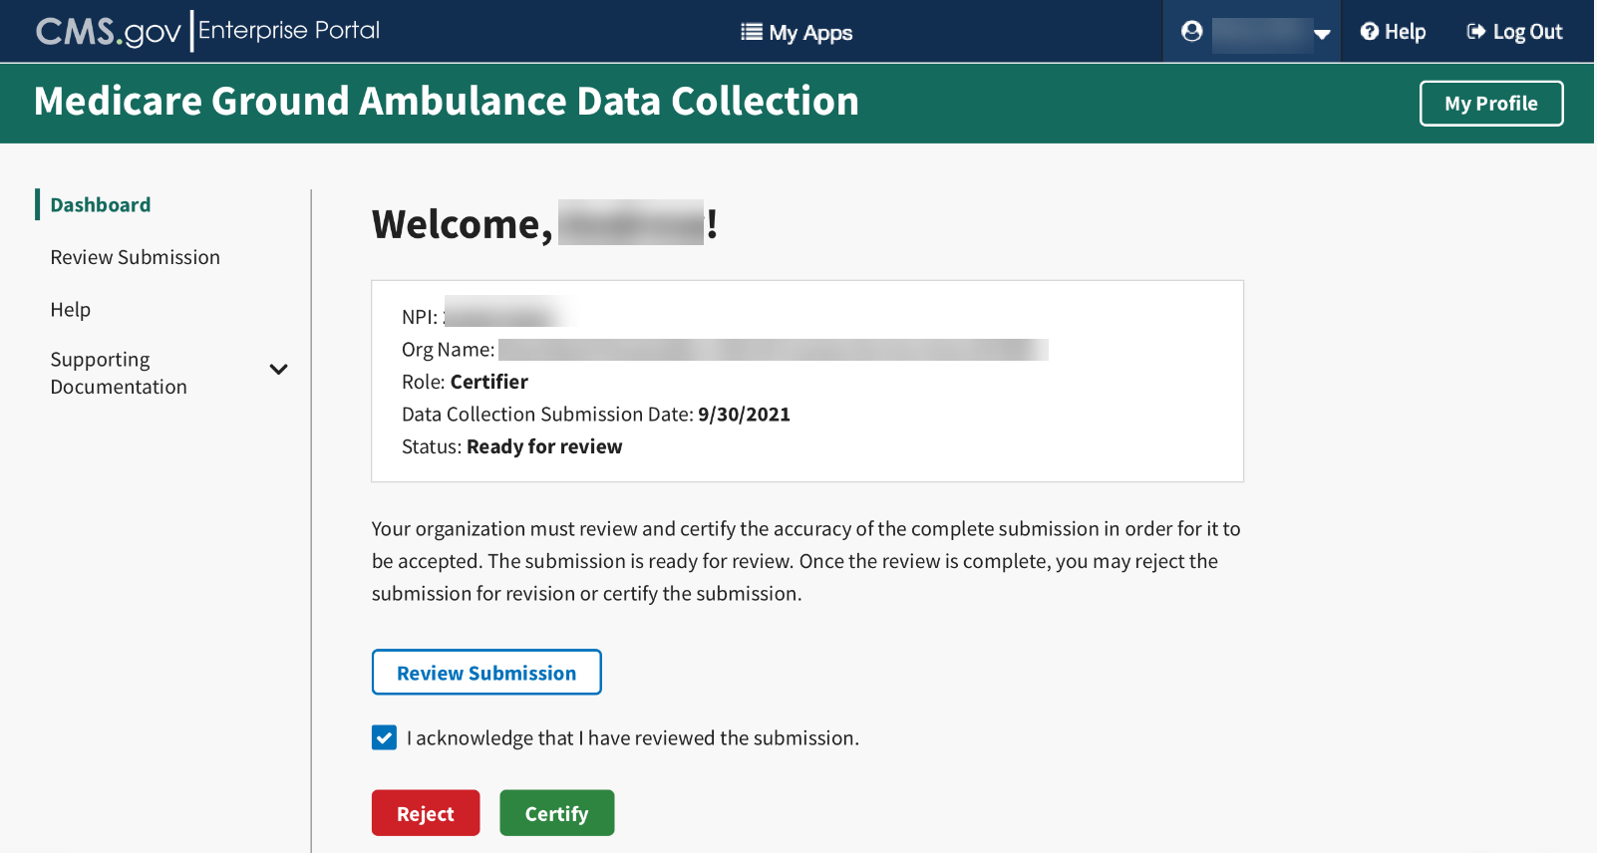
After you review the submission, if you must reject it for any reason, click on the Reject button. You will be prompted to check off any sections that require further review and space to provide information to the Submitter on what data needs to be reviewed.
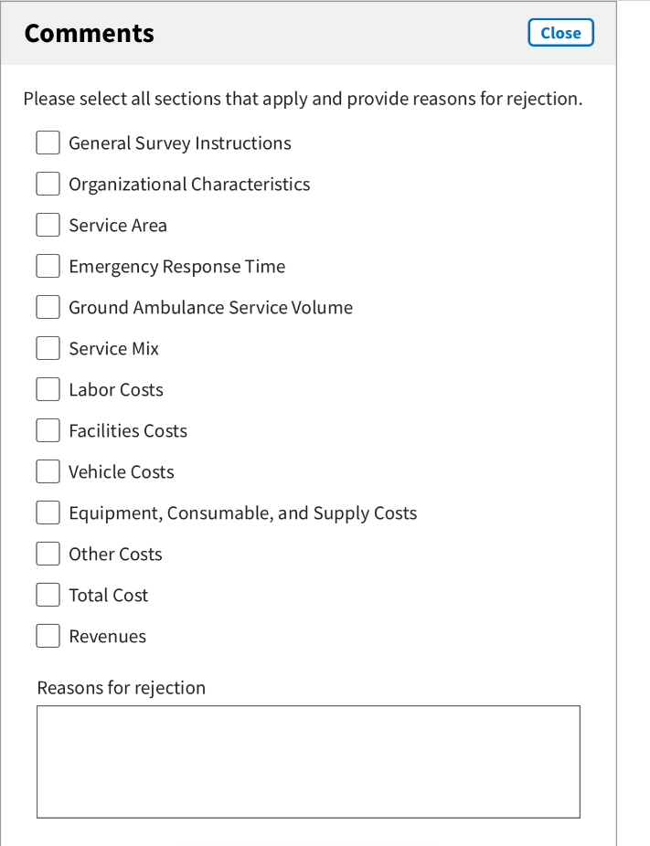

If the data is accurate and the submission is complete, The Certifier will click the Certify button.
The Certifier will see a pop-up screen asking for their certification.
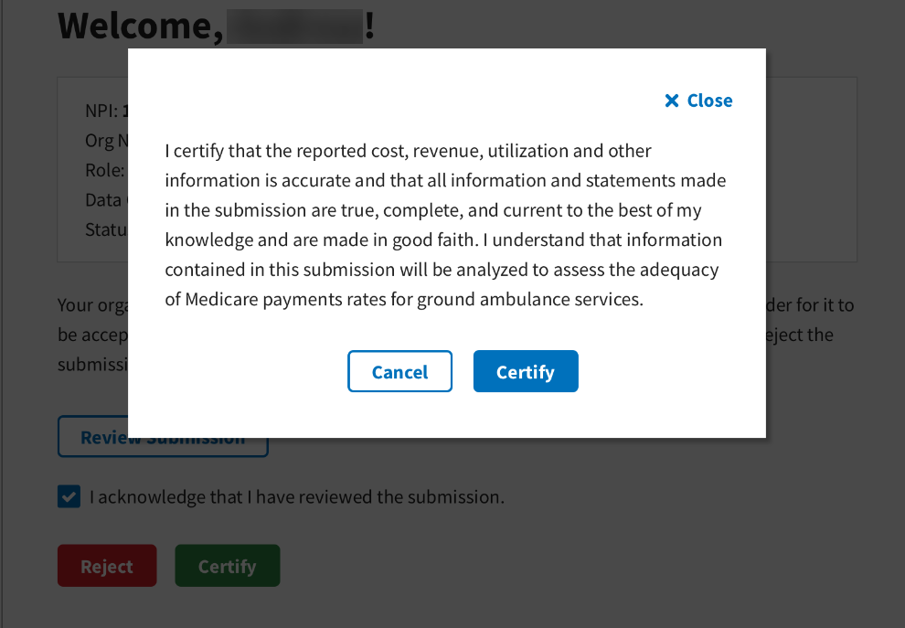
Once you click the Certify button, you will see this screen.
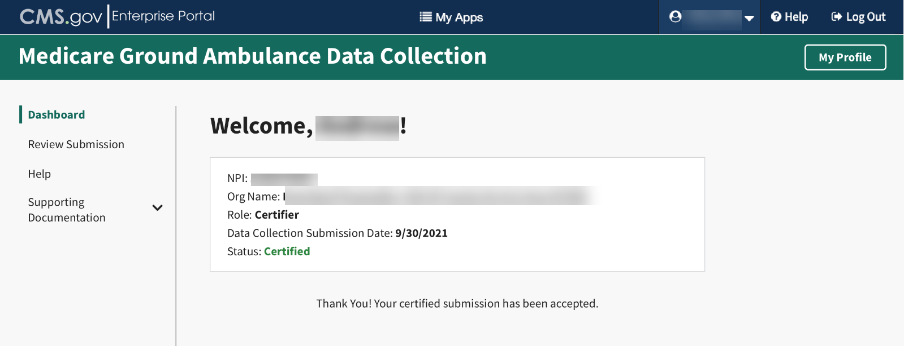
Congratulations!

