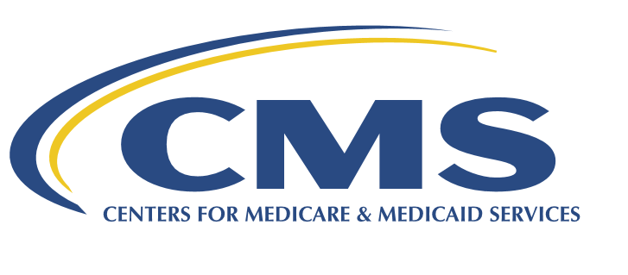
Medicare Ground Ambulance Data Collection System (GADCS) User Guide

2021

Table of Contents

Acronyms and Definitions………………………………………………………………………………………………………………………….3
Medicare Ground Ambulance Data Collection System (GADCS) User Guide 4
Important Information 5
Logging In 7
Linking Your Organization’s NPI 10
General Instructions 12
Organizational Characteristics 15
Service Area 21
Emergency Response Time 24
Ground Ambulance Service Volume 28
Service Mix 33
Labor Cost 35
Facilities Cost 40
Vehicle Costs 44
Equipment, Consumable, and Supply Costs 52
Other Costs 56
Total Costs 60
Revenues 61
Certifier Landing Page 68

Acronyms and Definitions
ALS1 | Advanced Life Support, Level One
ALS2 | Advanced Life Support, Level Two
BBA | Bipartisan Budget Act
BLS | Basic Life Support
CMS | Centers for Medicare & Medicaid Services
Data collection period | Continuous 12-month data collection period that reflects the ground ambulance’s annual accounting period
Data reporting period | The 5-month period that begins the day after the last day of the ground ambulance organization’s data collection period
EMR | Emergency Medical Responder
EUA | Enterprise User Administration
GAAP | Generally Accepted Accounting Principles
GADCS | Ground Ambulance Data Collection System
HCPCS | Healthcare Common Procedure Coding System
HHS | Department of Health and Human Services
MAC | Medicare Administrative Contractor
MFA | Multi-Factor Authentication
NPI | National Provider Identifier
PI | Paramedic Intercept
Primary service area | The area in which you are exclusively or primary responsible for providing service at one or more levels and where it is highly likely that the majority of your transport pickups occur.
QRV | Quick response vehicle
PDF | Portable Document Format
SCT | Specialty Care Transport
Secondary service area | Other areas that are outside of your primary service area but one where you regularly provide services through mutual or auto-aid agreements.
SUV | Sport-utility vehicle

Medicare Ground Ambulance Data Collection System (GADCS) User Guide
Background on the Medicare Ground Ambulance Data Collection System:
Section 50203(b) of the Bipartisan Budget Act (BBA) of 2018 (Public Law 115-123) added paragraph (17) to section 1834 (l) of the Social Security Act (the Act). This section requires the Secretary of the Department of Health and Human Services (HHS) to develop a data collection system by December 31, 2019 to collect cost, revenue, utilization, and other information from providers and suppliers of ground ambulance services (“ground ambulance organizations”). The Centers for Medicare & Medicaid Services (CMS) has developed a data collection system (84 FR 62863) that collects detailed information on ground ambulance provider and supplier characteristics including service areas, service volume, costs and revenue through a survey, commonly referred to as the Medicare Ground Ambulance Data Collection Instrument via a web-based system.
Effective January 1, 2020 and continuing through 2024, ground ambulance organizations that have been selected to participate in the Medicare Ground Ambulance Data Collection System must collect information on cost, utilization, revenue, and other service characteristics in accordance with the Medicare Ground Ambulance Data Collection Instrument for a continuous 12-month data collection period. The ground ambulance organizations that has have been selected have 5 months after their data collection period has ended to report their data collection in the Medicare Ground Ambulance Data Collection System. The information collected will be used to evaluate the extent to which reported costs relate to payment rates under the Medicare Part B Ambulance Fee Schedule (AFS), as well as to collect information on the utilization of capital equipment and ambulance capacity, and the different types of ground ambulance services furnished in different geographic locations, including rural areas and low population density areas (super rural areas). Failure to sufficiently submit the required information will result in a 10 percent reduction to payments under the AFS for one year, unless a hardship exemption has been granted or an informal review has determined that your organization is not subject to the 10 percent reduction to payments.
CMS has provided several documents on its Ambulances Services Center website: https://www.cms.gov/Center/Provider-Type/Ambulances-Services-Center.html that may be helpful to selected ground ambulance organizations that are required to report under the Medicare Ground Ambulance Data Collection System. The documents include: a printable version of the Medicare Ground Ambulance Data Collection Instrument, Frequently Asked Questions (FAQs), Quick Reference Guide, and education webinars.

This user guide will show you how to properly report the information requested by CMS for ground ambulance services during a continuous 12-month data collection period into the Medicare Ground Ambulance Data Collection System
User Roles
The Medicare Ground Ambulance Data Collection System is a role-based system. This means that certain system functions are linked to specific “user role profiles.” When a new user is given access to the Medicare Ground Ambulance Data Collection System, a role is approved that provides access to the specific functions they need.
Data Entry Role (Submitter): this role is the person who submits all the required information. Once this person has completed the online form and submitted the form, the Certifier will be notified.
Certifier: this role will review the information reported by the Data Entry Role(Submitter) to ensure it is correct and complete. The Certifier will then certify the submission of the reported data. If the Certifier would like changes to be made to the data that was reported in the system, the certifier must notify the Submitter to submit the revised data.

Important Information
Browser Compatibility
The GADCS instrument is only compatible in Chrome, Firefox, Edge.
Progress Bar
As you move through the instrument, you will notice a progress bar above the questions. While you’re working in a section, it will say In Progress. When you’ve completed a section, it will say Complete. If a question was skipped or requires more information, it will say Review.
Question Formatting
As you input data, some responses will generate follow-up questions. Be sure to answer all prompts and questions before moving to the next page or section. Certain questions will have explanations, definitions, or warnings. Be sure you are reading all the information provided on the page before entering your data.
Warning Messages
Depending on your responses, you may see “warning” messages as you input data. These messages will appear with this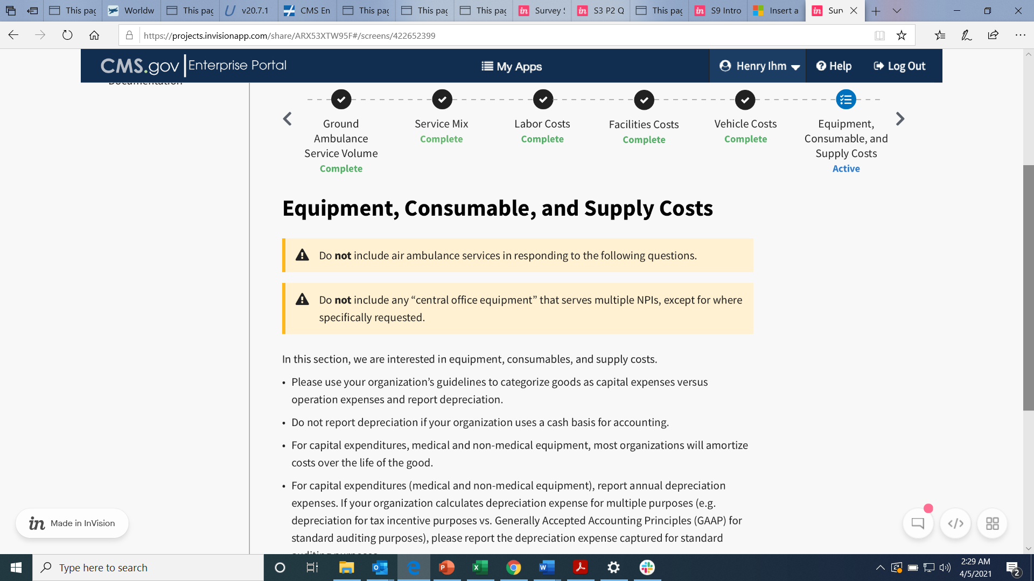 symbol with a yellow or orange background. These do not mean you have done something incorrectly, but instead will highlight information that requires extra attention. Here is a list of the potential messages you will see.
- Do not include any “central office staff” that serve multiple NPIs, except for where specifically requested.
- Do not include any “central office facilities” that serve multiple NPIs, except for where specifically requested.
- Do not include any “central office vehicles” that serve multiple NPIs, except for where specifically requested.
- Do not include any “central office equipment” that serves multiple NPIs, except for where specifically requested.
- Do not include any other “central office” costs that apply to multiple NPIs, except where specifically requested.
- Do not include individuals who had only air ambulance responsibilities.
- Do not include air ambulance services in responding to the following questions.

Logging In
Before you can log in, you must create a new user account.
CMS IDM User Guide (PDF) section 4 on page 4 will show you the steps for creating a new user account.
Once you have completed creating your new user account, you can login to the portal.
To log in, click this link: https://portalval.cms.gov/
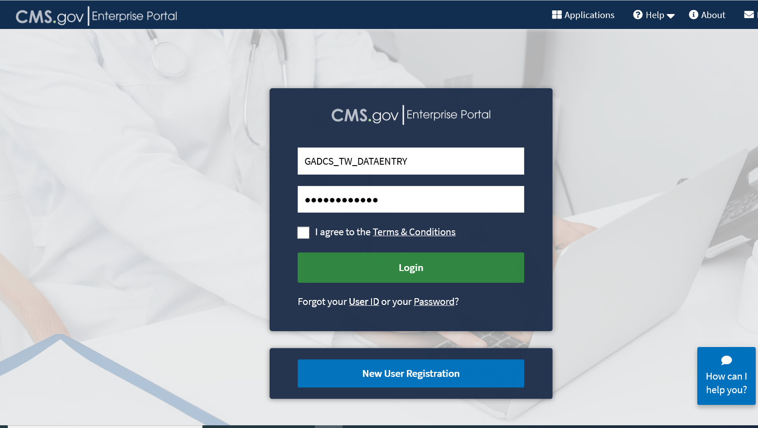
Enter your log-in credentials provided in the email sent to you when you created your new user account.
Once you agree to the Terms & Conditions and click Login, you will be prompted to enter in a multi-factor identification (MFA) code.

Click Send MFA Code and then enter the six-digit code sent to the email address you used to register your account.
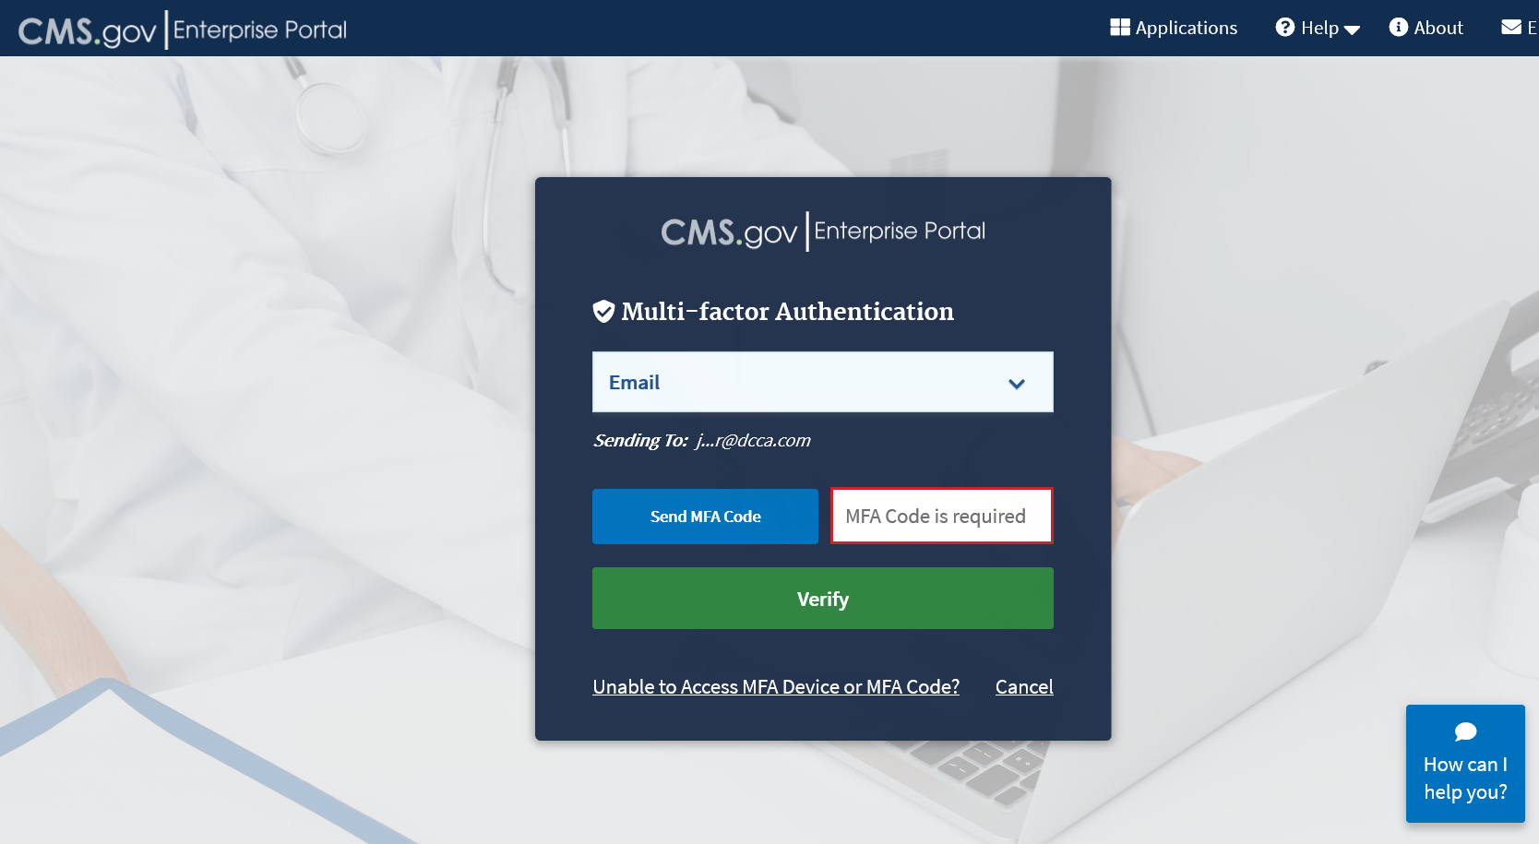
Click the Verify button.
After verifying your MFA code, you will see your My Portal page.
Click on the Fee For Service Data Collection System icon to show the selections.
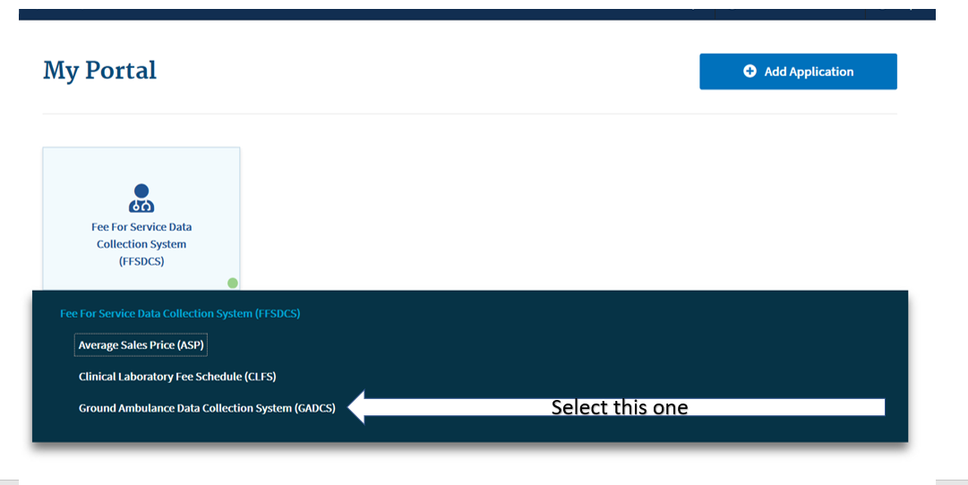

After Clicking on the GADCS option, you will see your Welcome screen.
On this page, you will first want to click on Overview to learn a little more about the Medicare Ground Ambulance Data Collection System. Then when you have completed reading the Overview page, click on NPI Registration.
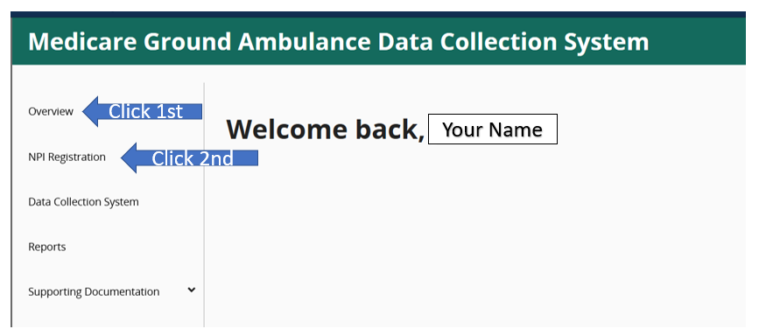

Linking Your Organization’s NPI
Upon logging into the system, you will be prompted to register your organization’s NPI
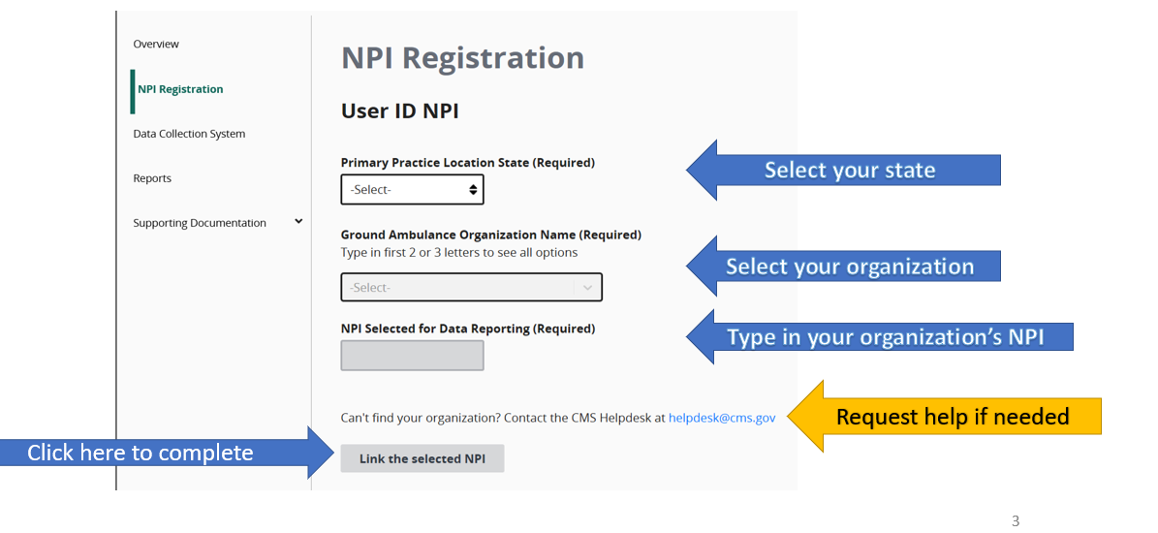
If the NPI you are trying to link to is already in use, you will see an error message that will prompt you to send an email to the help desk to resolve the issue.
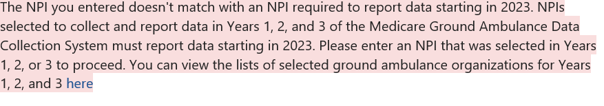
If you see an error message, please check your information and try again. If the error message persists, please contact the CMS Helpdesk at helpdesk@cms.gov.

You may register more than one NPI if you are responsible for entering data for more than one organization.
After the page refreshes when you register the first NPI, you can fill out the fields again to register the second NPI. Repeat for as many NPIs as you need.
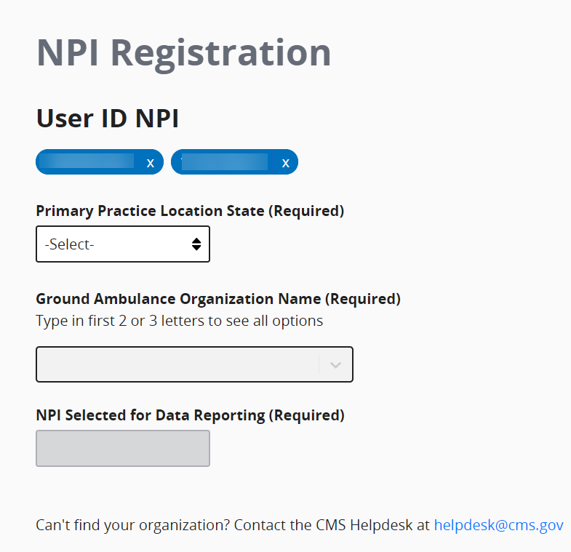
If you register more than one NPI, you will need to select the NPI you are entering data for from the drop down menu at the top of the page as you move through the instrument.
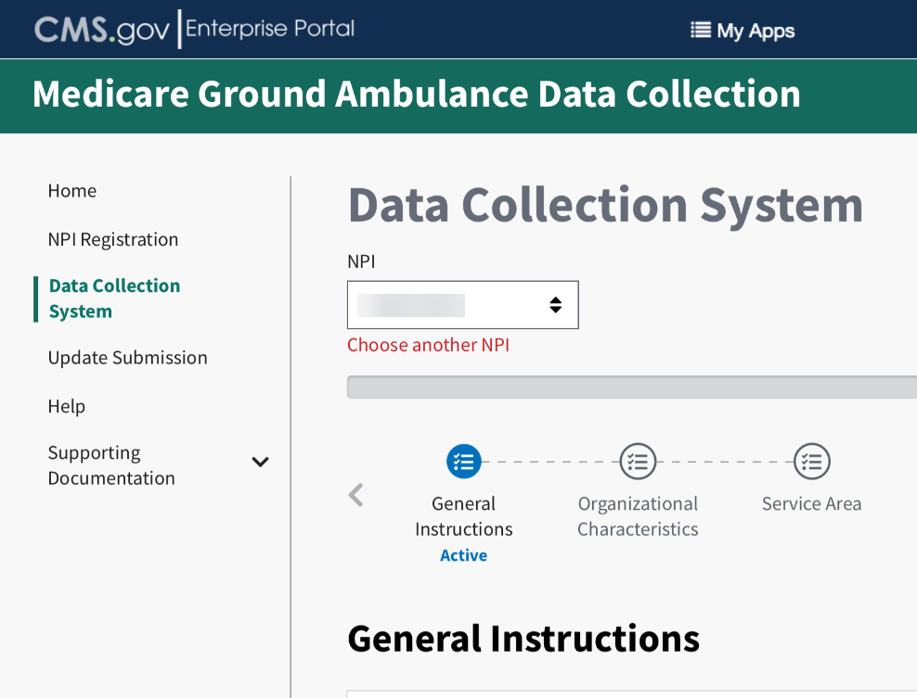

General Instructions
Welcome to the Medicare Ground Ambulance Data System!
You must read the General Instructions (see below) and verify that you have read and understand them by clicking the box that says “I verify that I’ve read the instructions above.”
There are two pages of general instructions and you must verify each one.
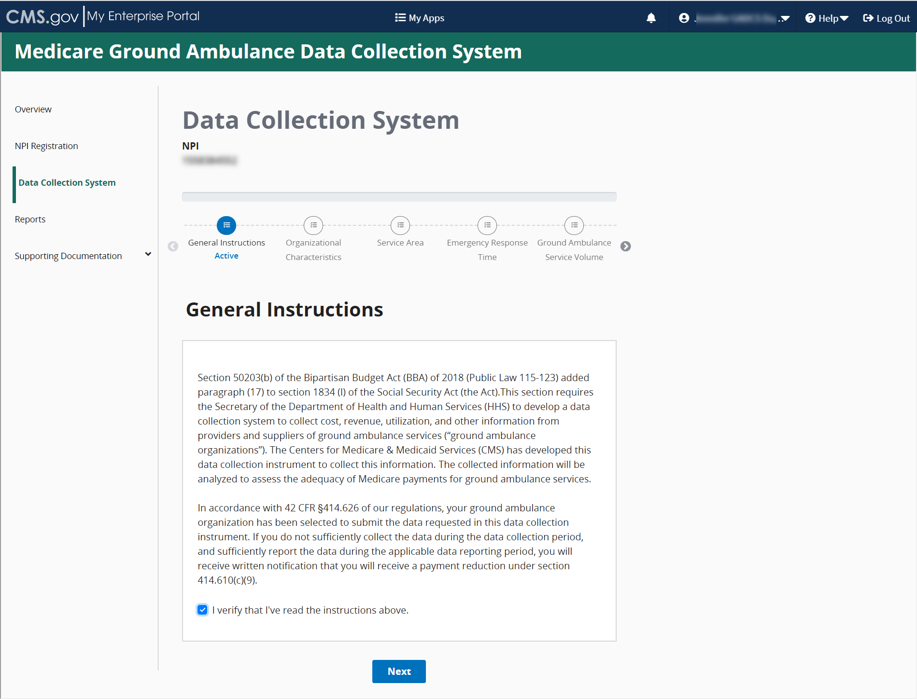
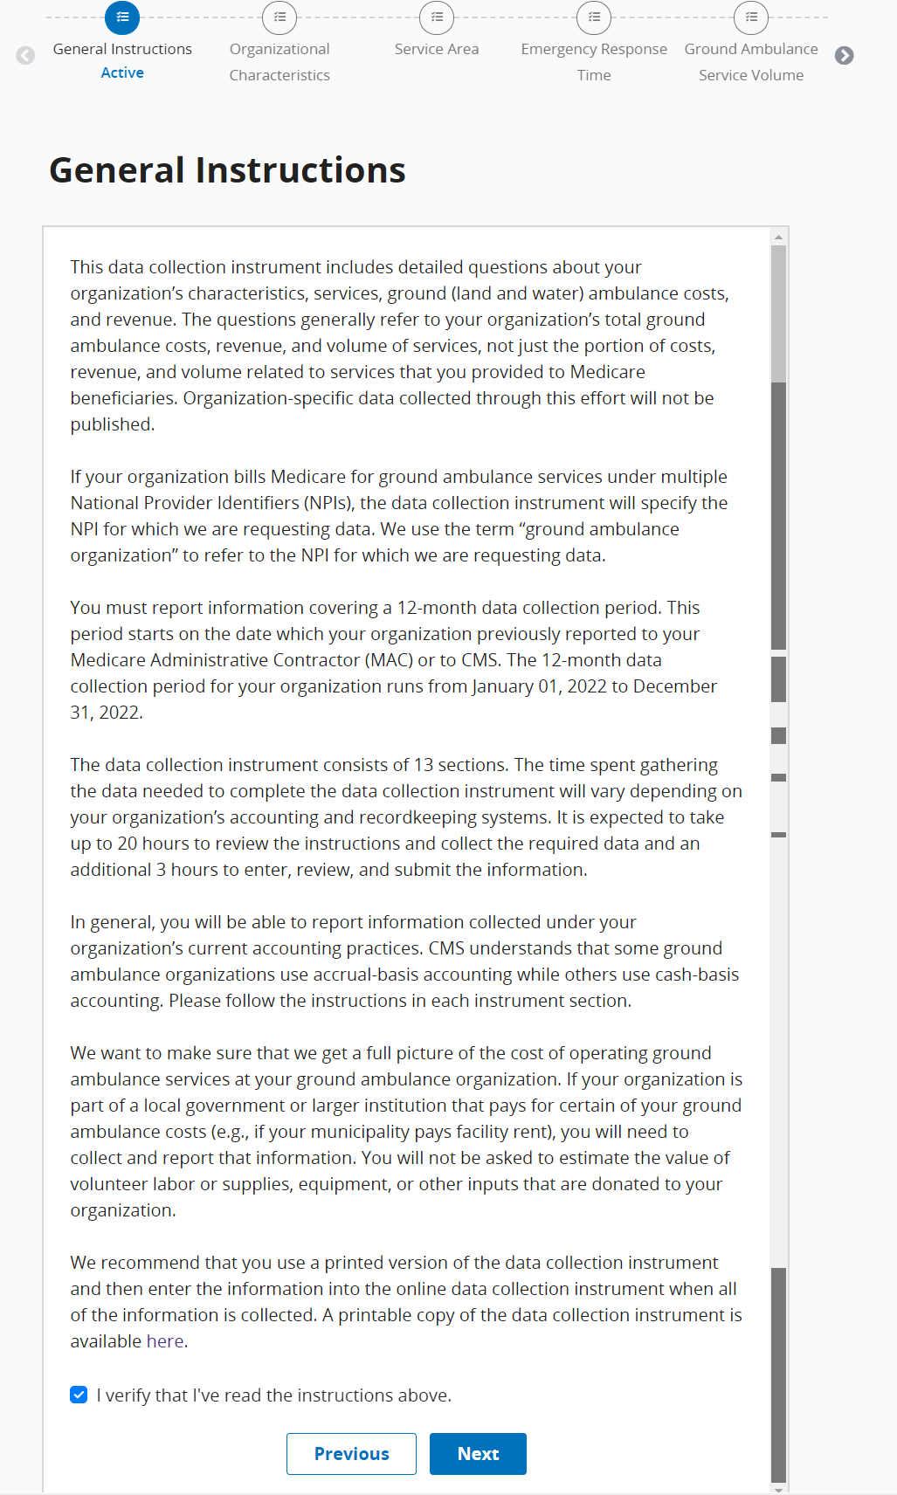
Review the instructions and then click Save, then click on Next Section to begin reporting Organizational Characteristics.

Please note that the system does not automatically save your progress, so it is important for you to click Save before moving on to the next page or section. You can proceed through the instrument without saving, but if you exit the system without saving, your progress will be lost.
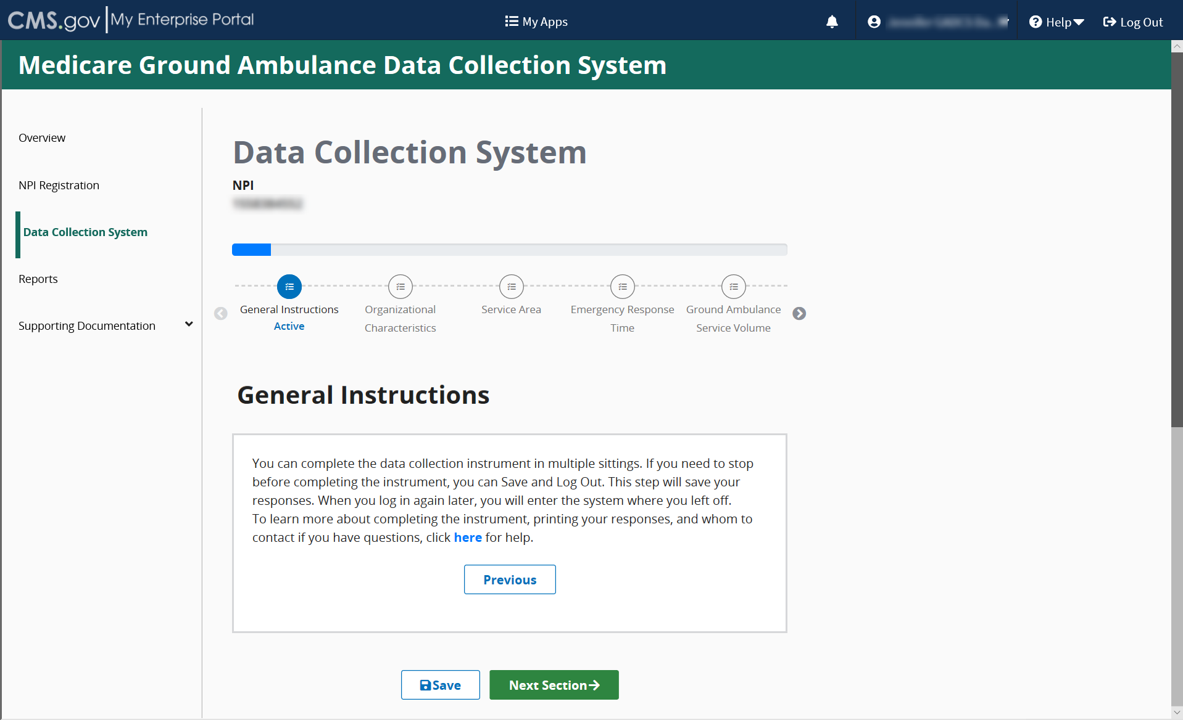

Organizational Characteristics
Once you complete the General Instructions section, you will complete the Organizational Characteristics section.
You must complete this section before moving on to any other sections, as your responses in this section will determine the questions you see later.
If you need to stop at any time, you can save your progress by clicking the Save Icon at the bottom of your screen and resume entering data from where you left off.
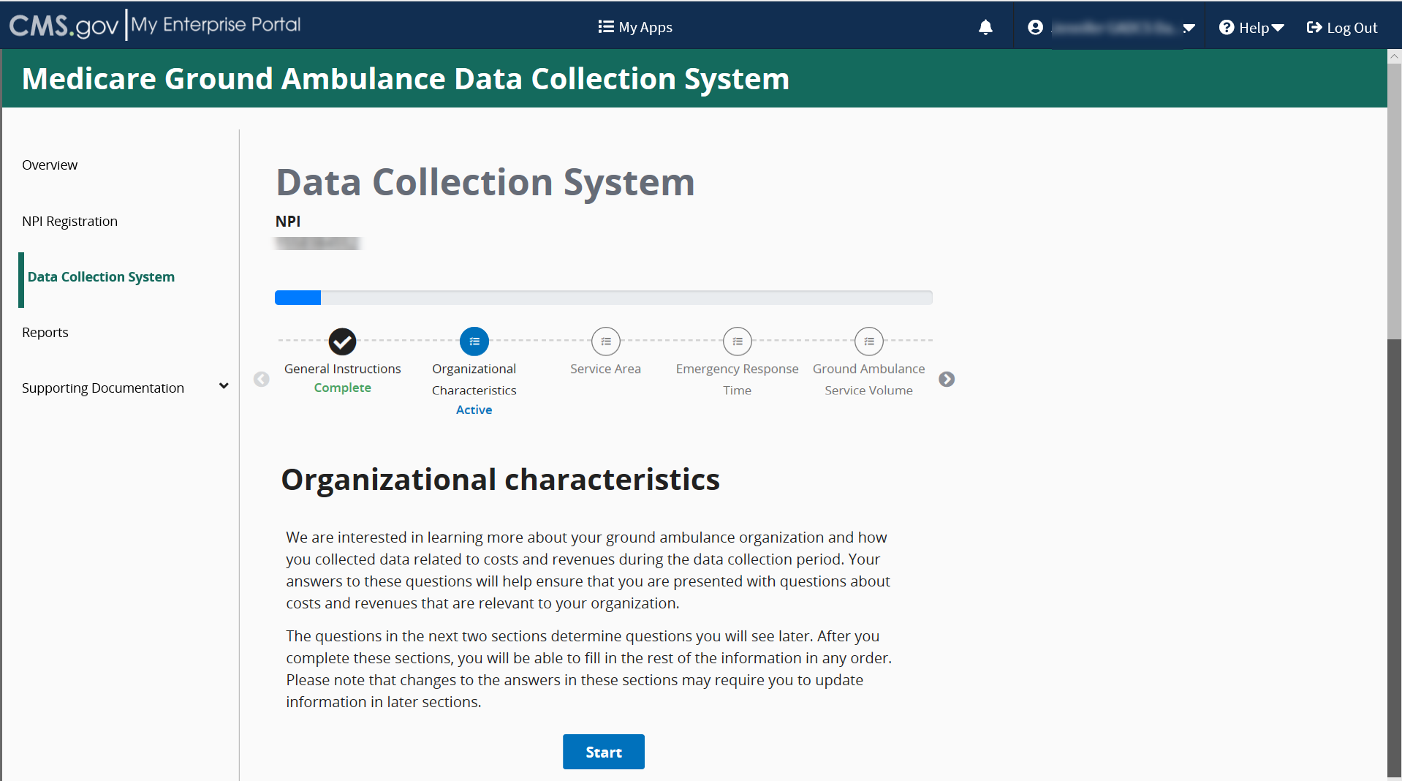
You will be answering a series of questions some of which you will select the answer from options provided, and some you will have to fill in a blank field.
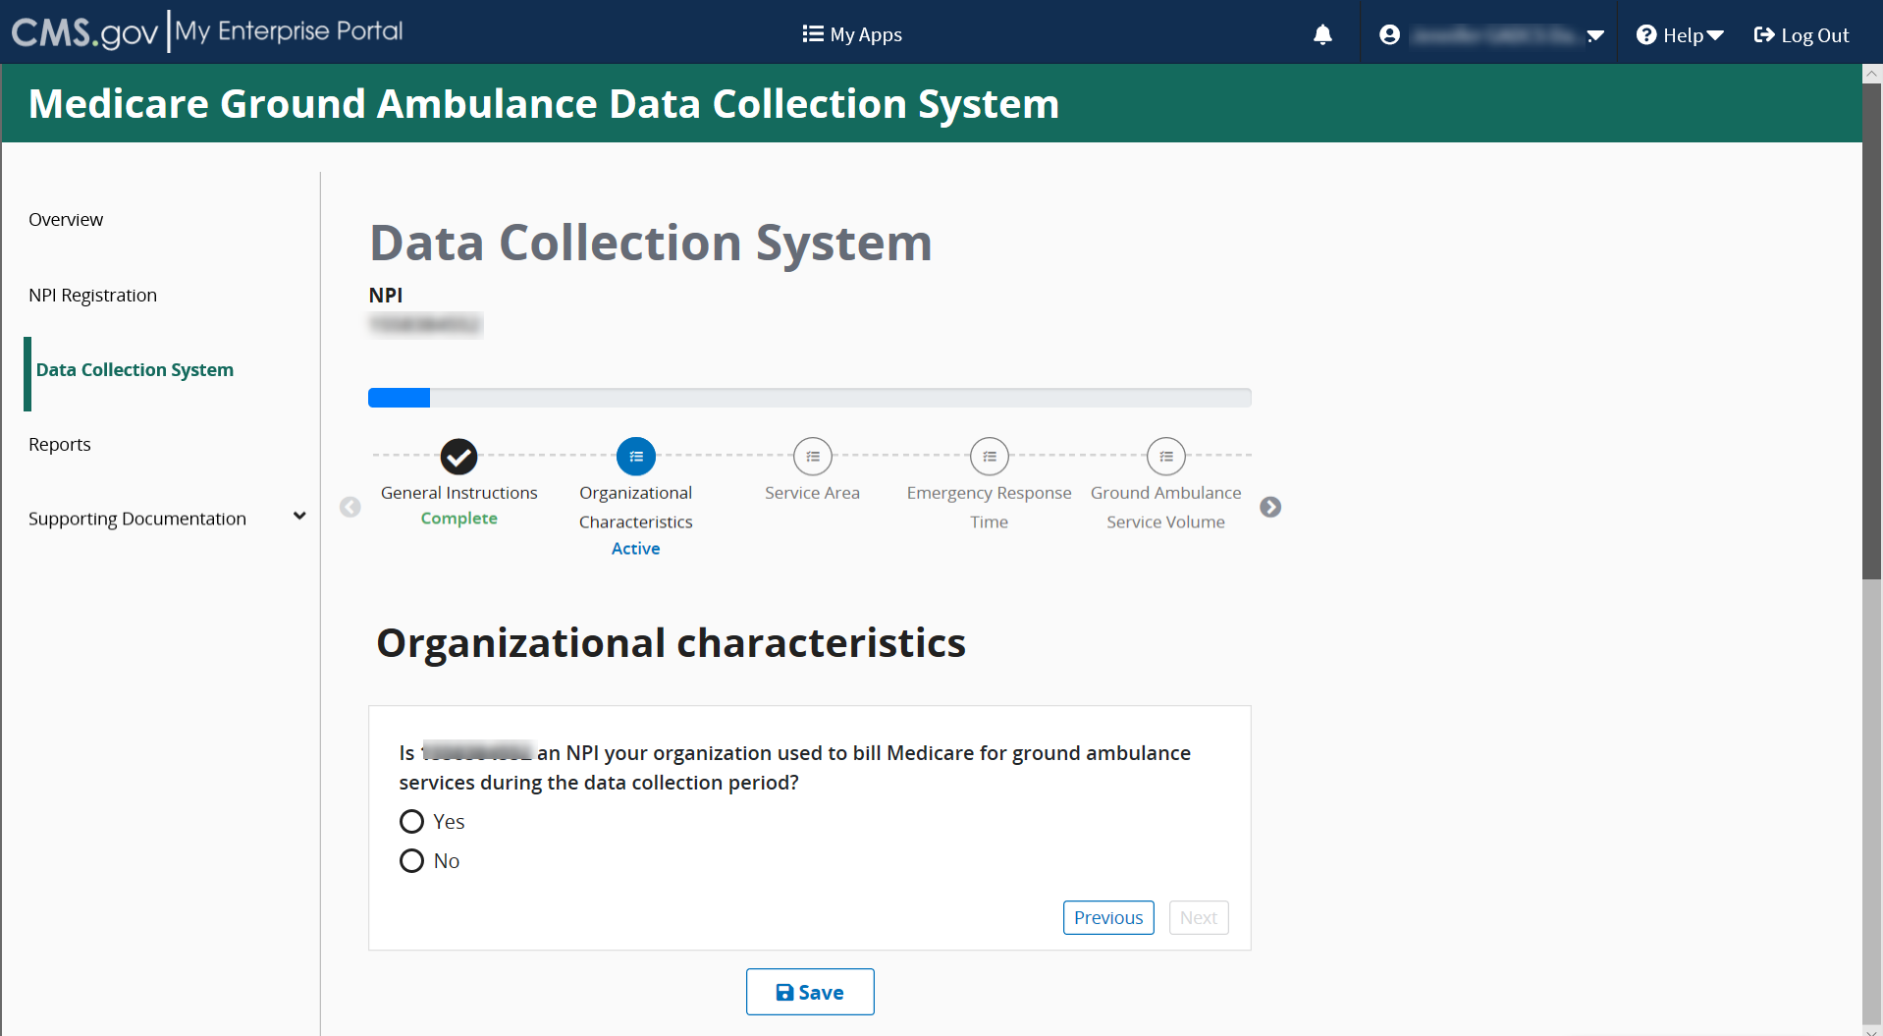

Once you begin answering these questions, more questions will appear. Answer all questions before clicking Save and then Next to move onto the next screen.
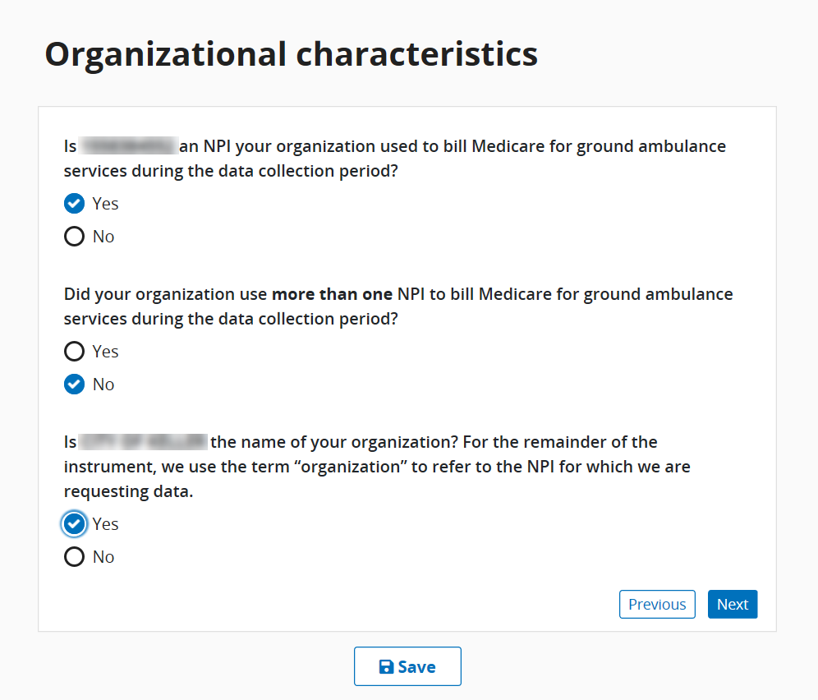
Click Save and then click Next to move to the next series of questions.

- The Job Title field is where you put your current title. There is a maximum of 200 characters.
- Enter your work email address in this format: Words@Emailaddress.com.
- Enter your 10-digit work phone number, area code first in the XXX-XXX-XXXX format.
Before moving onto a new page, be sure to click the Save button to save your progress.
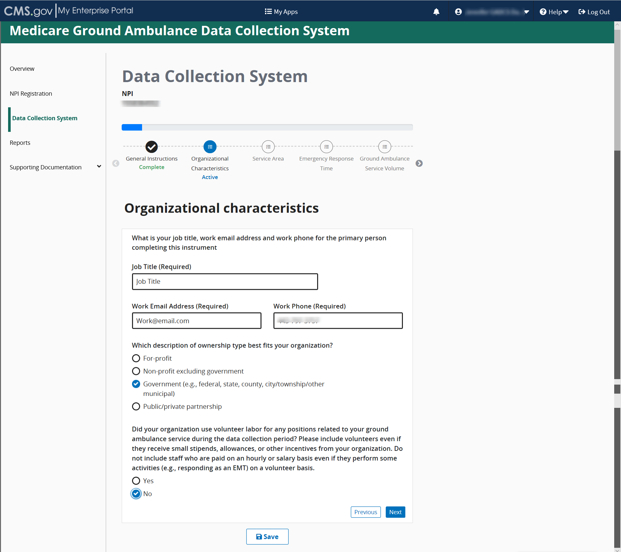

For this question, if you select Costs are not shared, you will be unable to report on any shared costs later in the instrument.
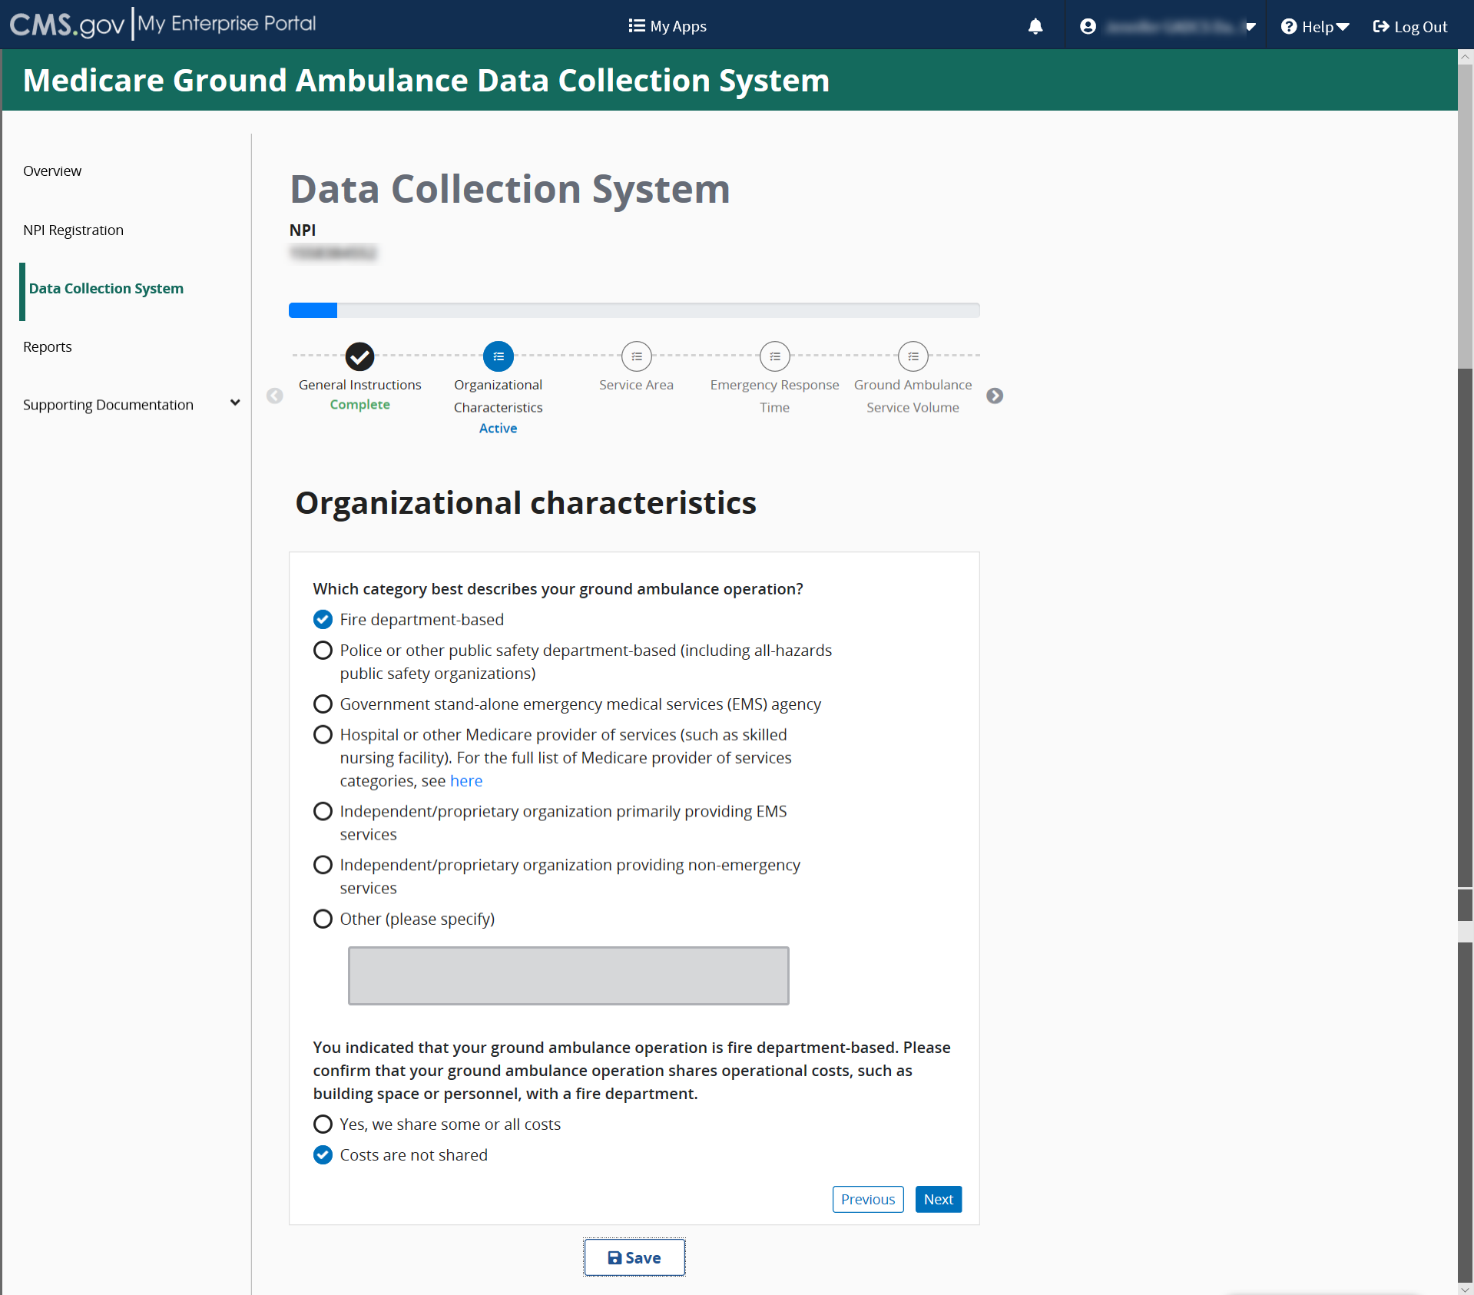

If you select “Other” you must specify what operational costs you share using the space provided.
Proceed answering the questions by selecting “Yes” or “No” as the example shows below.
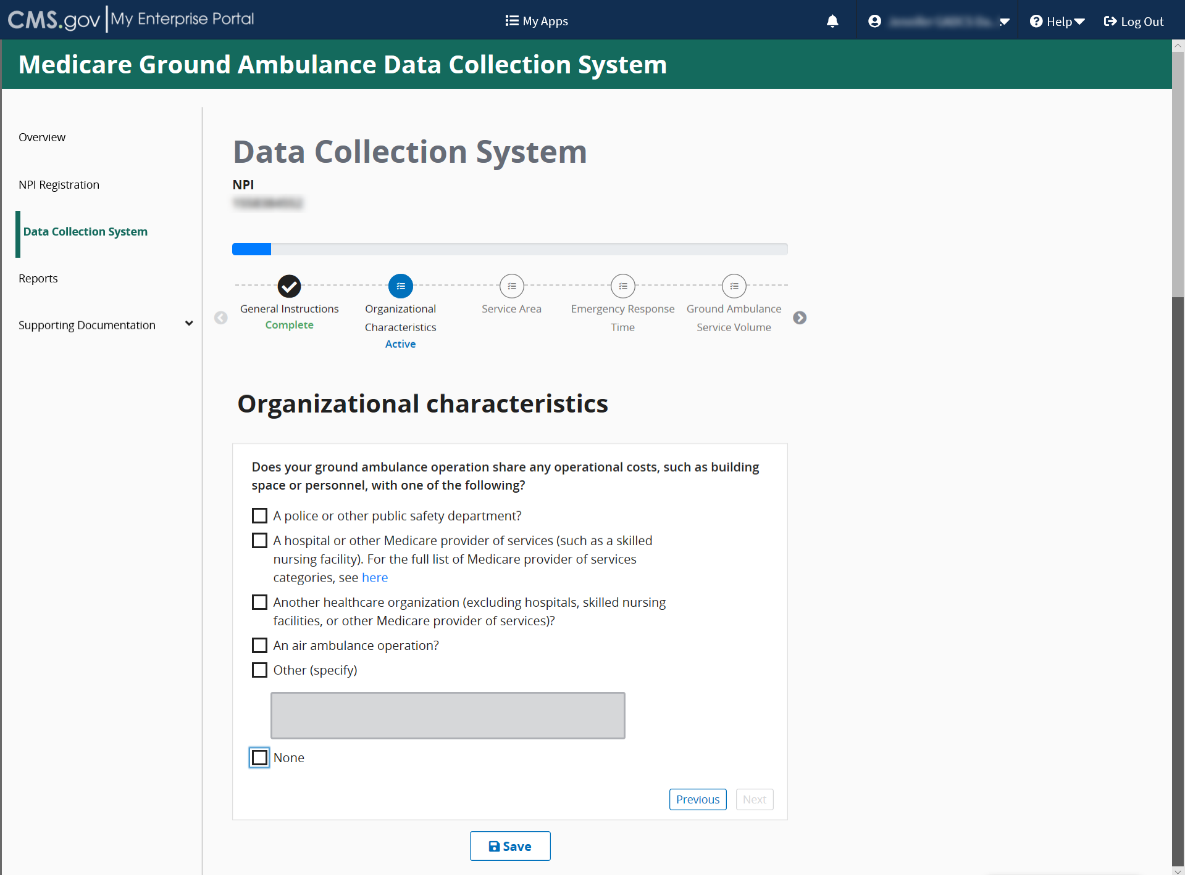

Continue answering the questions until you reach the end of this section where you will see this screen:
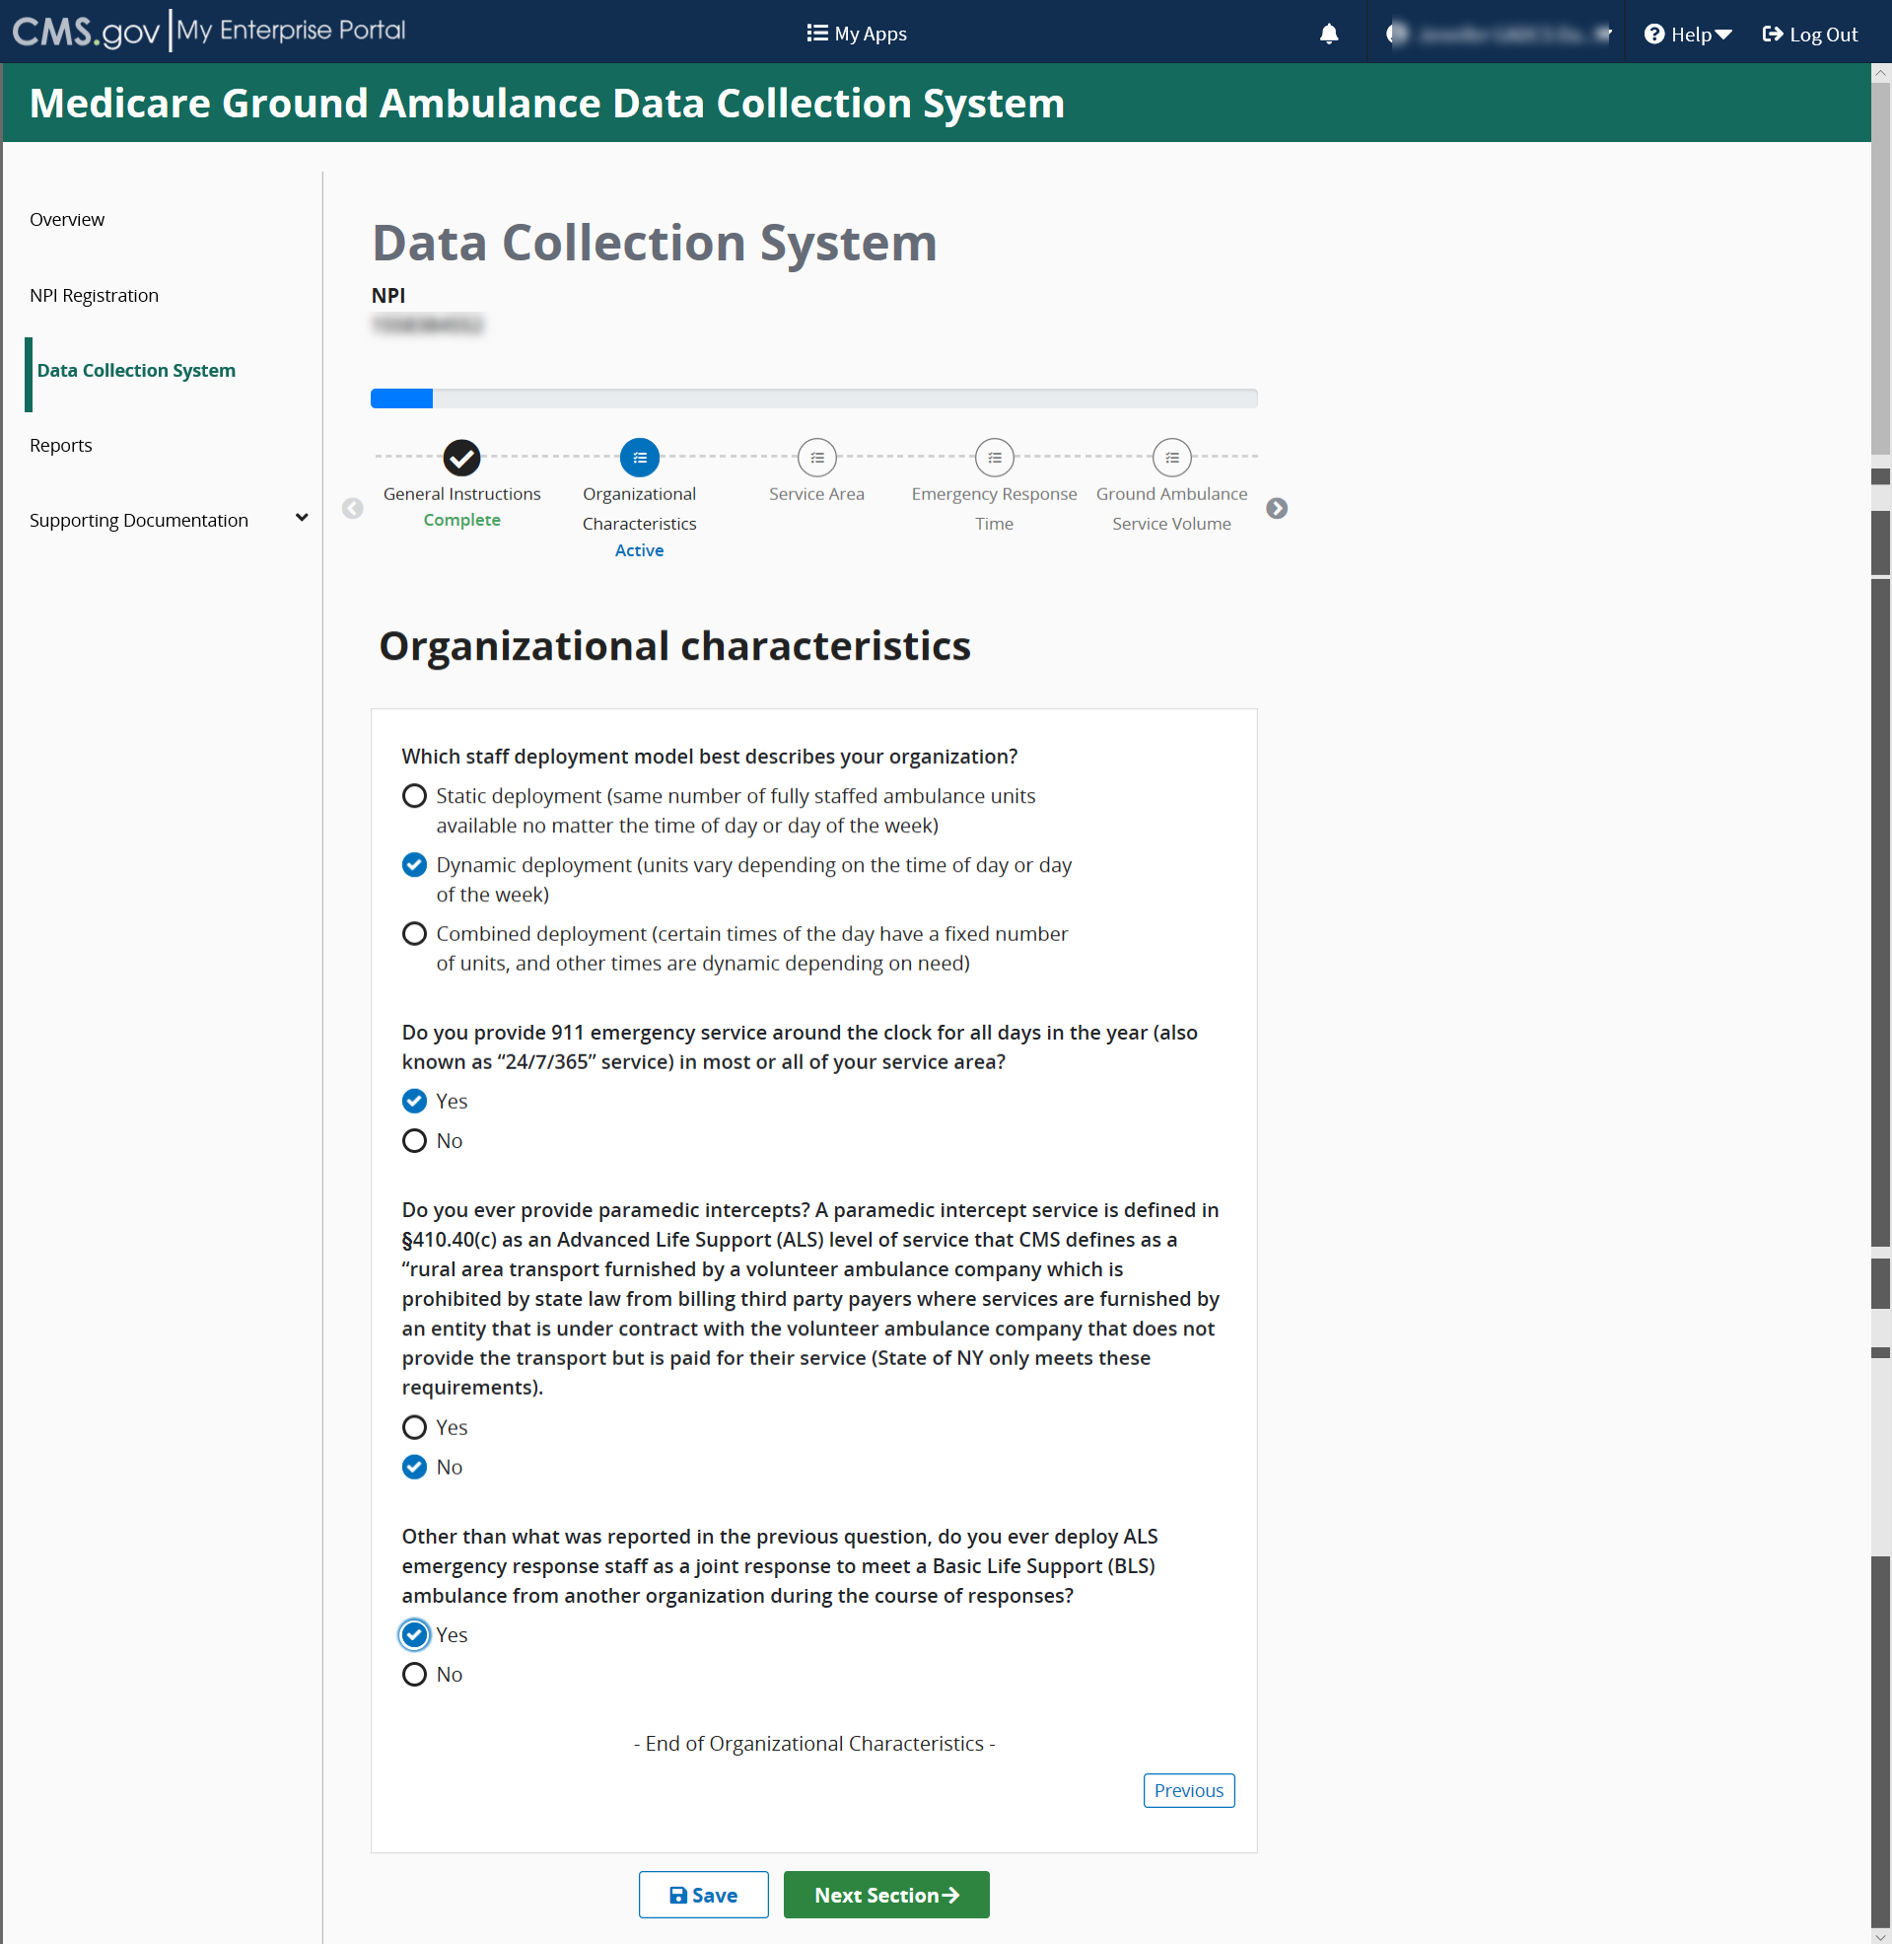
Click Save and then click Next Section.

Service Area
Please read the information at the beginning of this section carefully before clicking Start to begin.
You must complete this section before moving on to any other sections, as your responses in this section will determine the questions you see later.
Once this section is complete, you may fill in the other sections in any order you choose, or you may continue reporting data in the order the sections are presented.
Click start to begin this section.
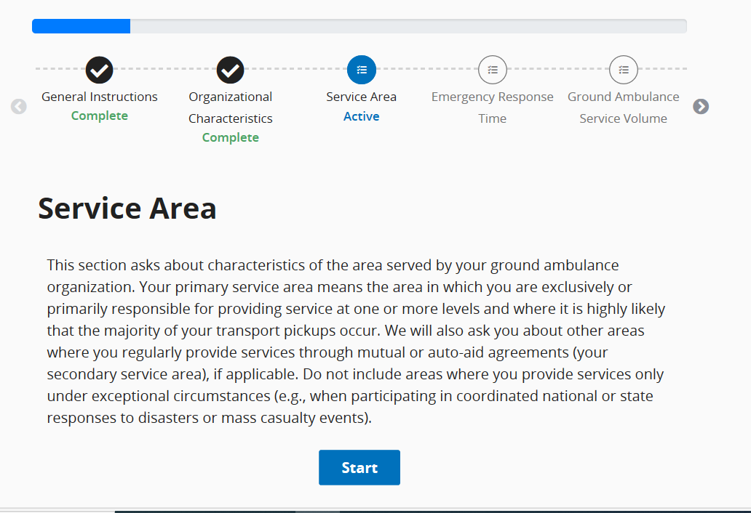
The first question in the Service Area section gives you the option to enter in the ZIP codes of your service area manually or to choose from a prepopulated list.
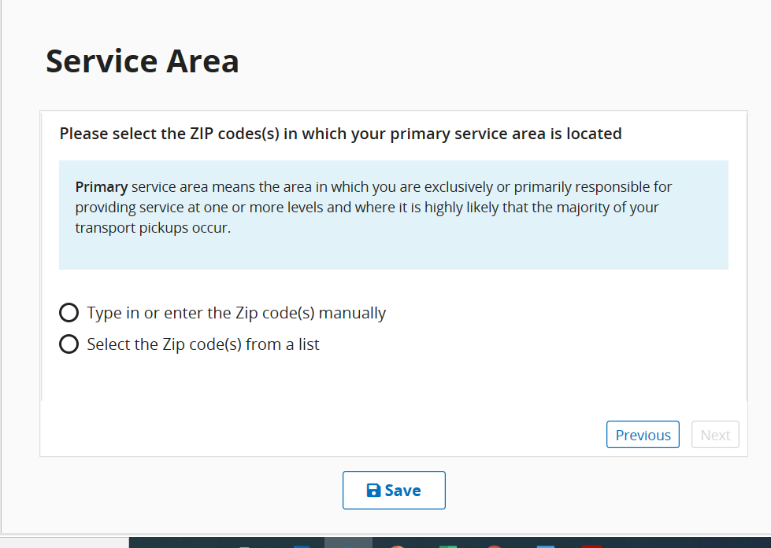

If you choose the prepopulated list, enter in the State and County, and then select all ZIP codes that apply. You can choose Check All. You can also choose multiple counties within a state or add ZIP codes from another state after you input ZIP codes from your primary state.
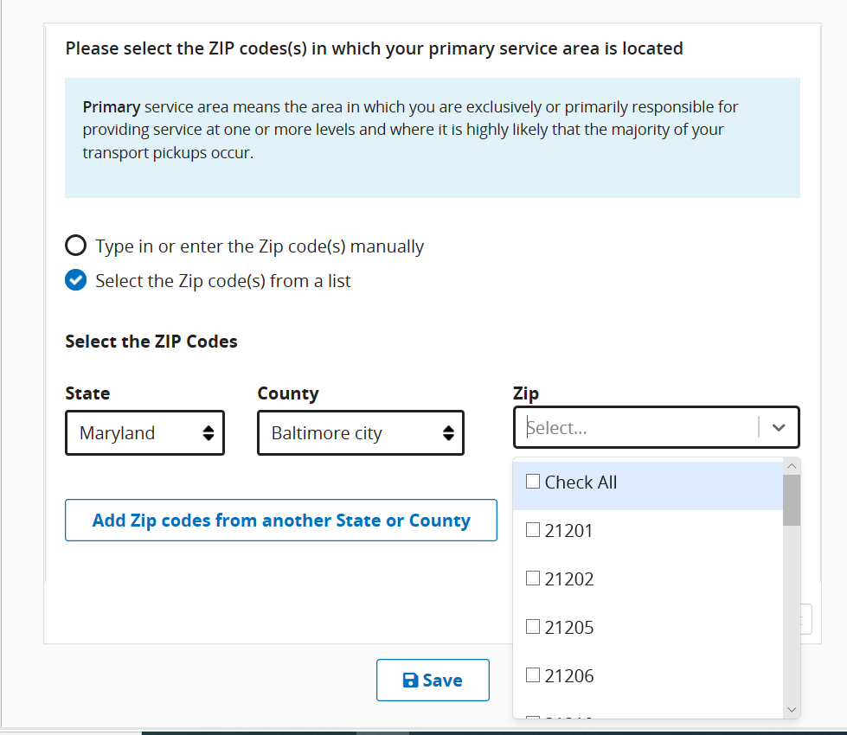
OR
You may copy and paste your list of ZIP codes. If you choose this option, each ZIP code must be separated by a comma, space, or semi colon.
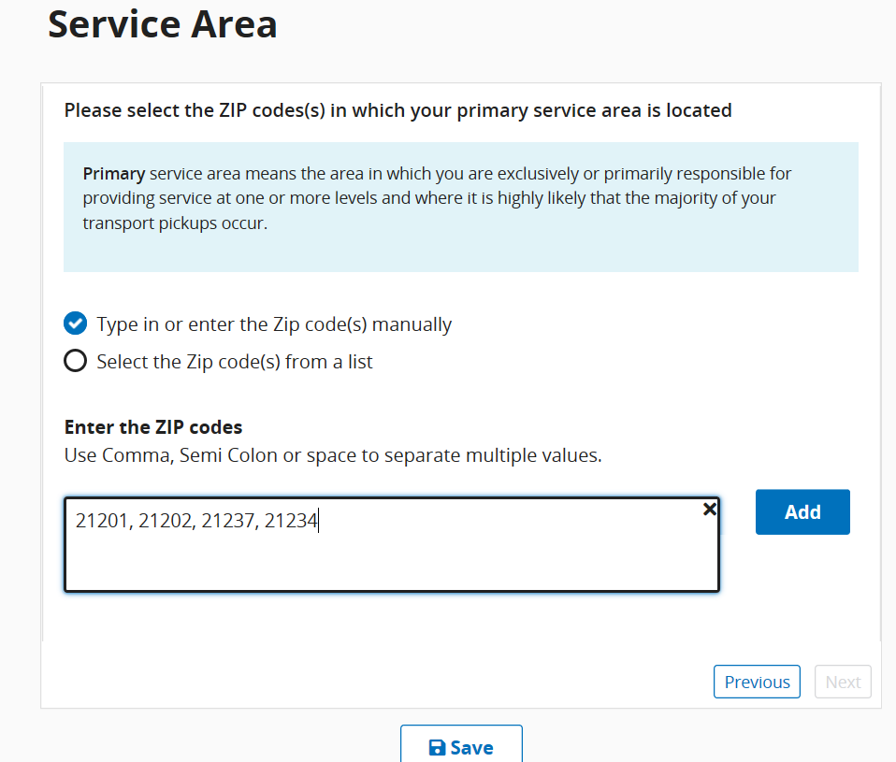

Once all zip codes have been entered or copied, click the Add button.
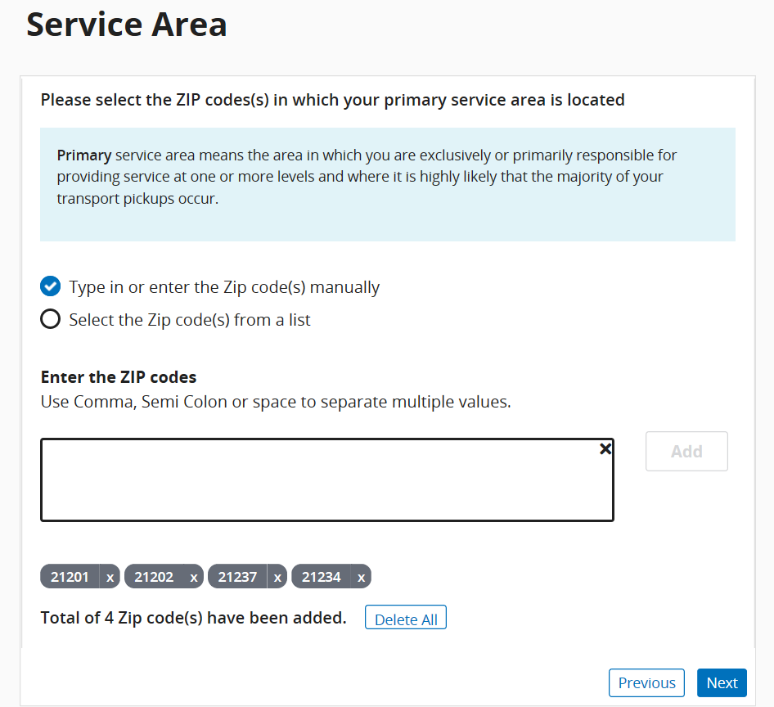
Individual ZIP codes can be removed if needed by clicking the “x” next to each ZIP code.
Continuing answering the questions as prompted until you see the End of Service Area section message, then click Save and click Next Section.
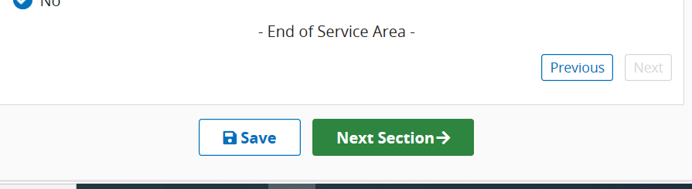

Emergency Response Time
Please answer all questions in this section using your most accurate data.
Click start to begin this section.
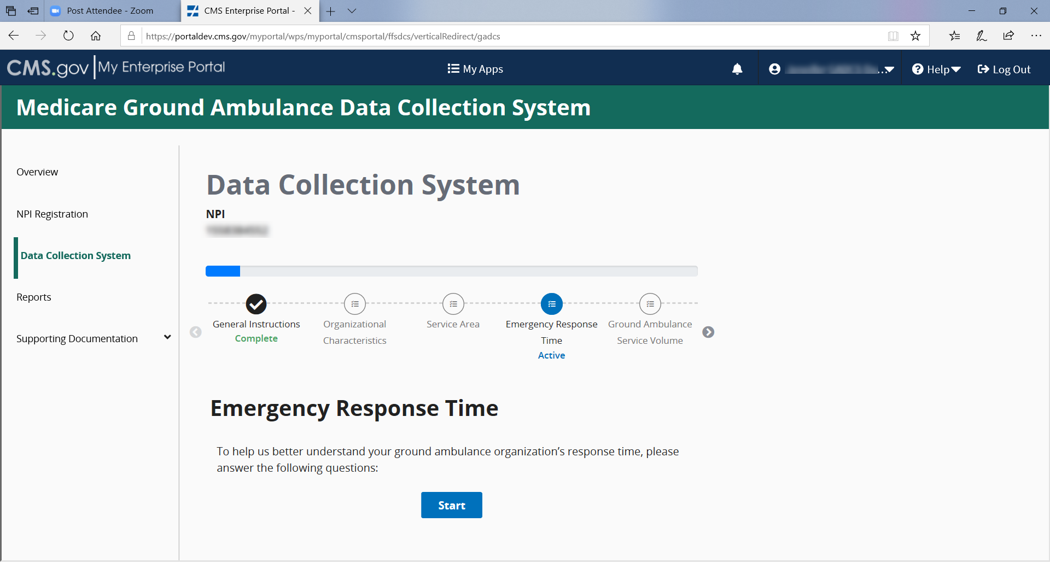
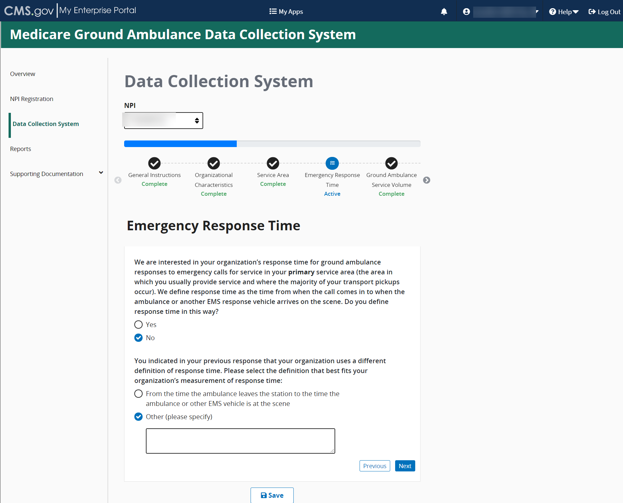

The second question asks if you are able to report statistics related to response times as measured by your organization. If you select no, you will be prompted to provide your best estimate for response time.
When entering this information, you are required to report time in MINUTES.
If you select no, you will be prompted to report your best estimate of the average response time in MINUTES (see below).
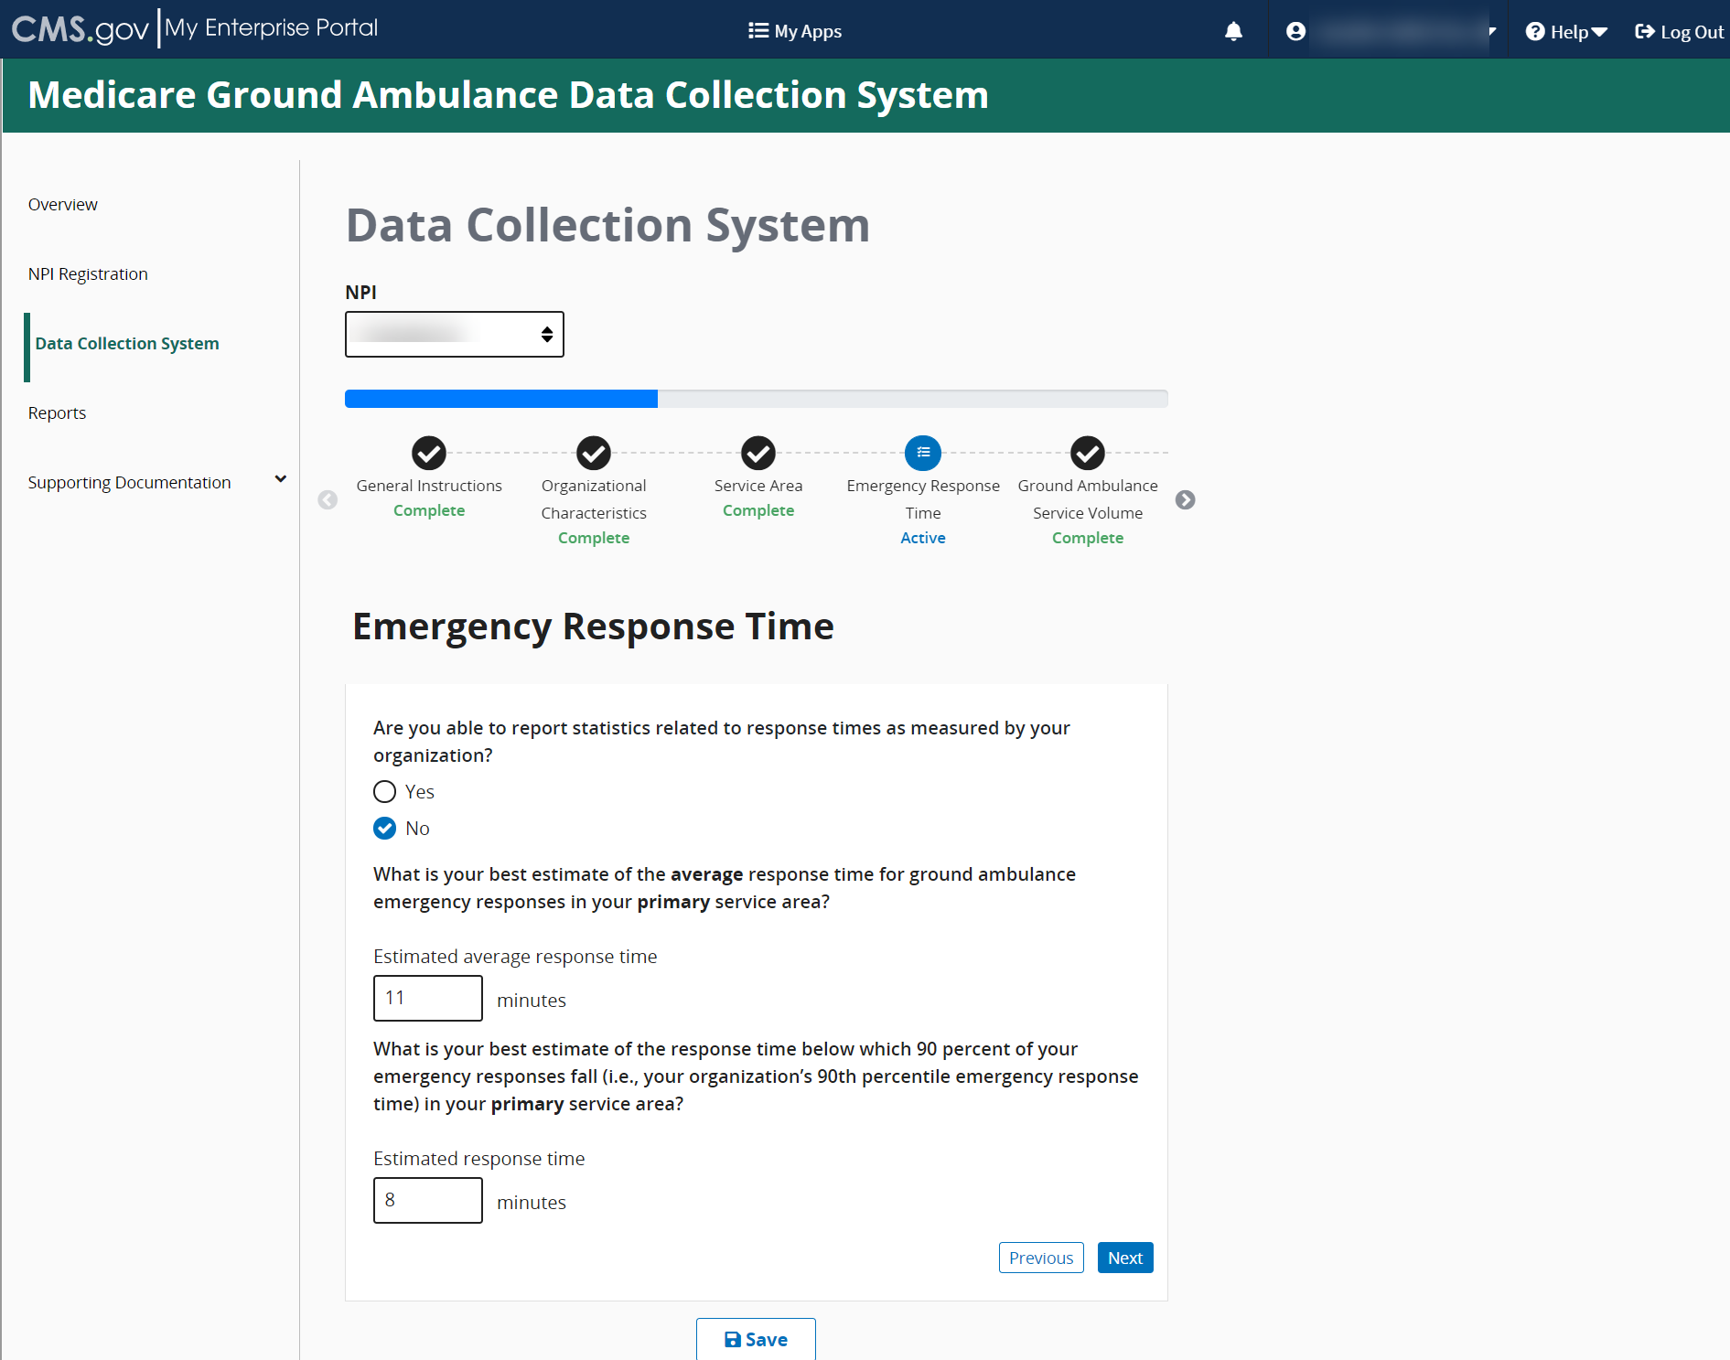
This is an example of the questions if you select Yes where you will be asked to record the average response time in MINUTES for your primary service area.
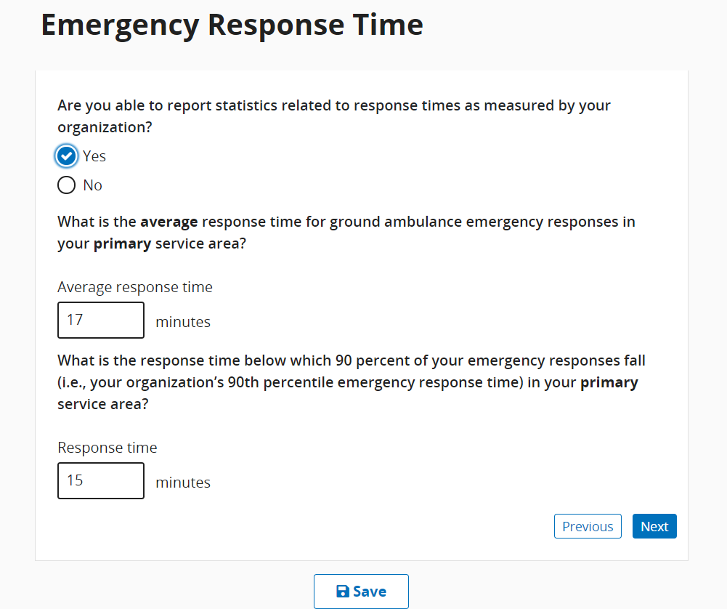

Based on some responses, follow-up questions may appear.
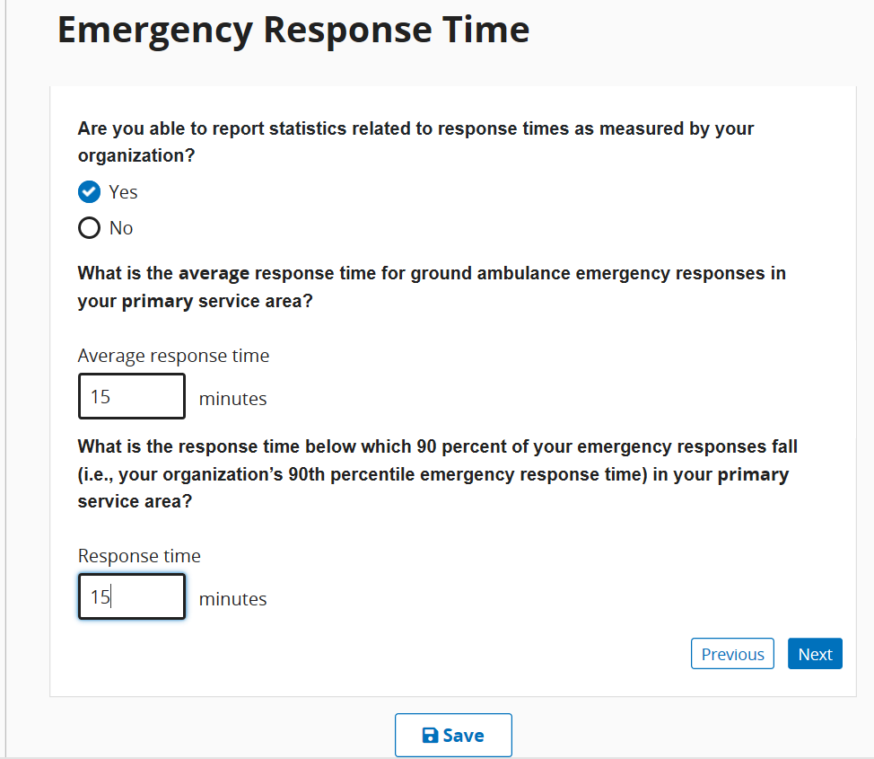

When you reach the end of this section, click Save and then click Next Section.
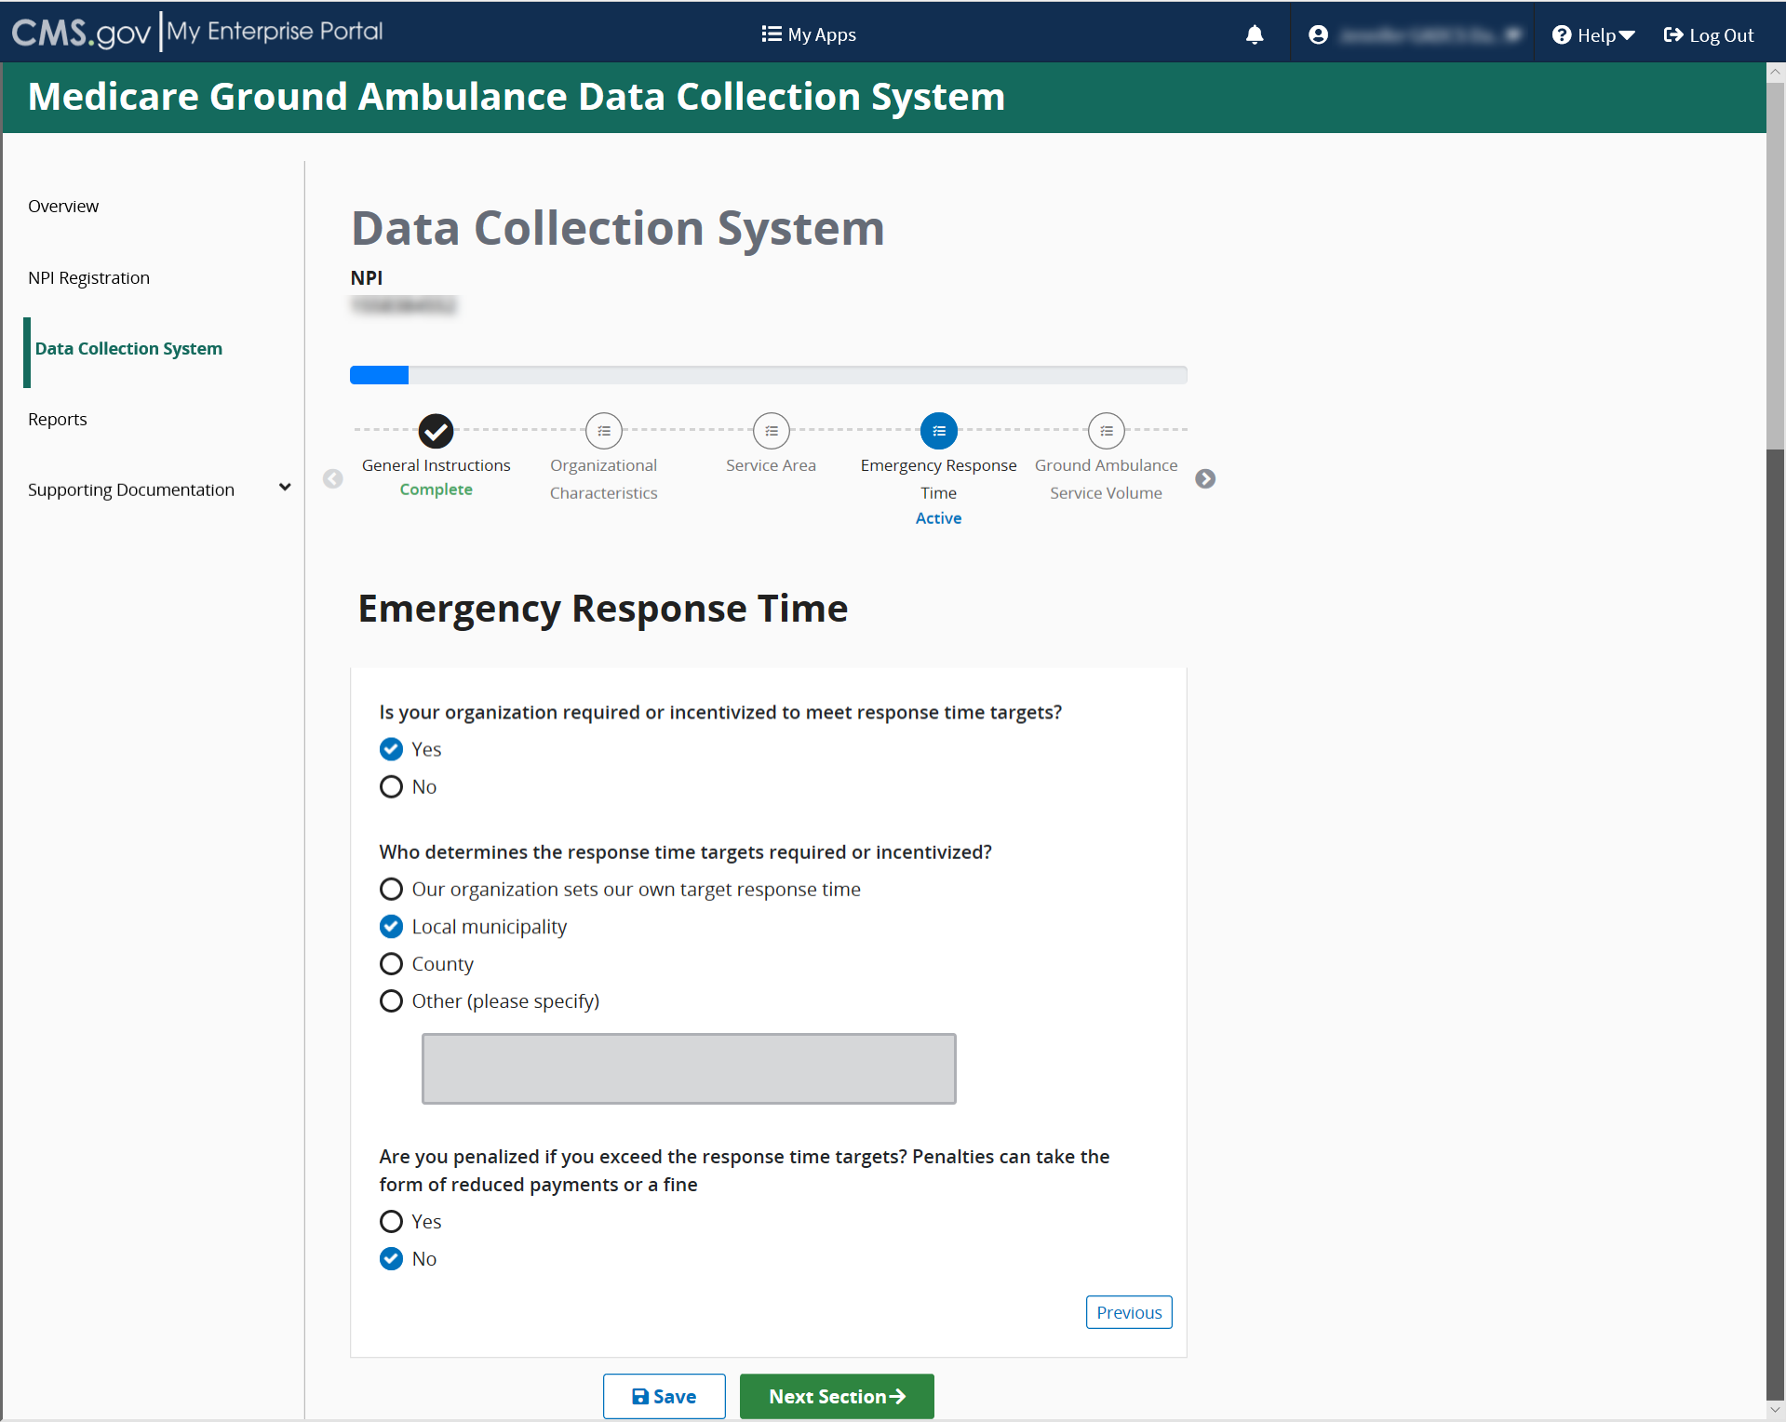

Ground Ambulance Service Volume
Click start to begin this section.
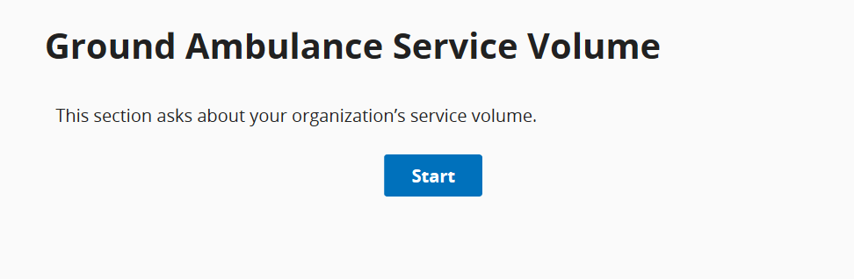
Be sure to read the descriptions that accompany the questions.
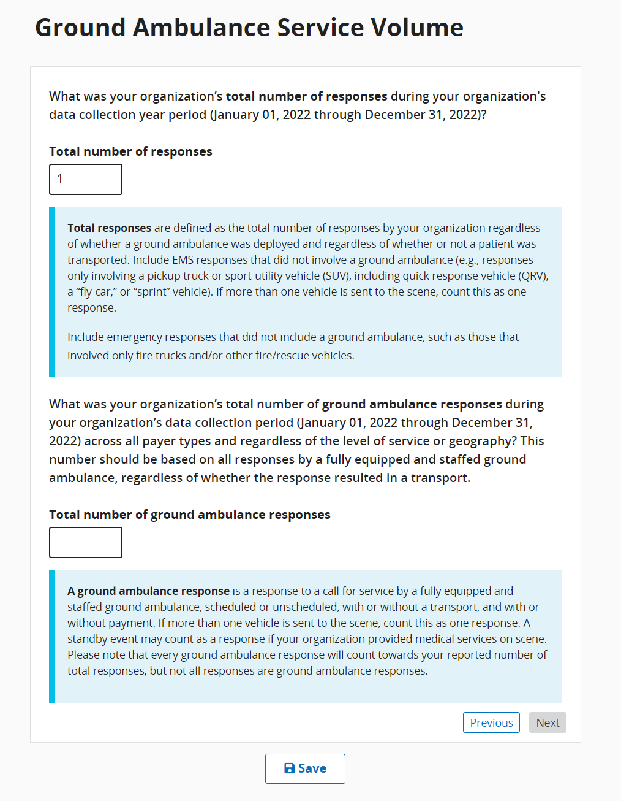
If you enter a larger or equal number for the 2nd response, a warning popup will appear to ask you if you’re sure the responses you gave are correct. For most organizations, the number of responses across all payer types will be greater than the number of ground ambulance responses.
Be sure to use whole percentages on this question, if zero, input 0. Do not leave blank.
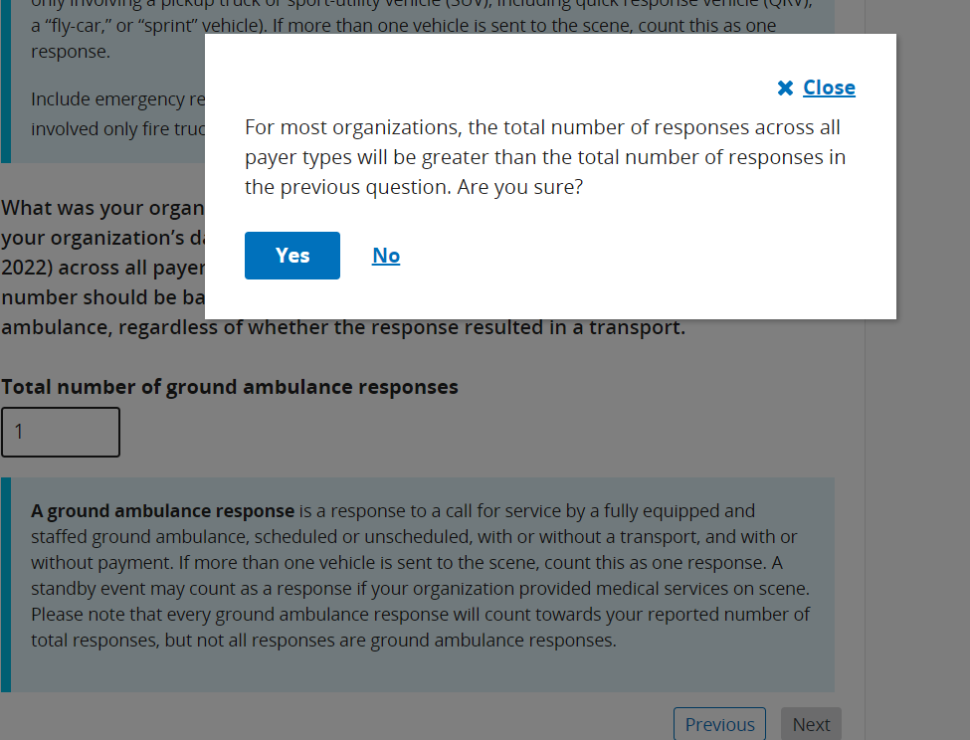

This question only appears if you previously indicated in the Service Area section that your organization has a secondary service area.
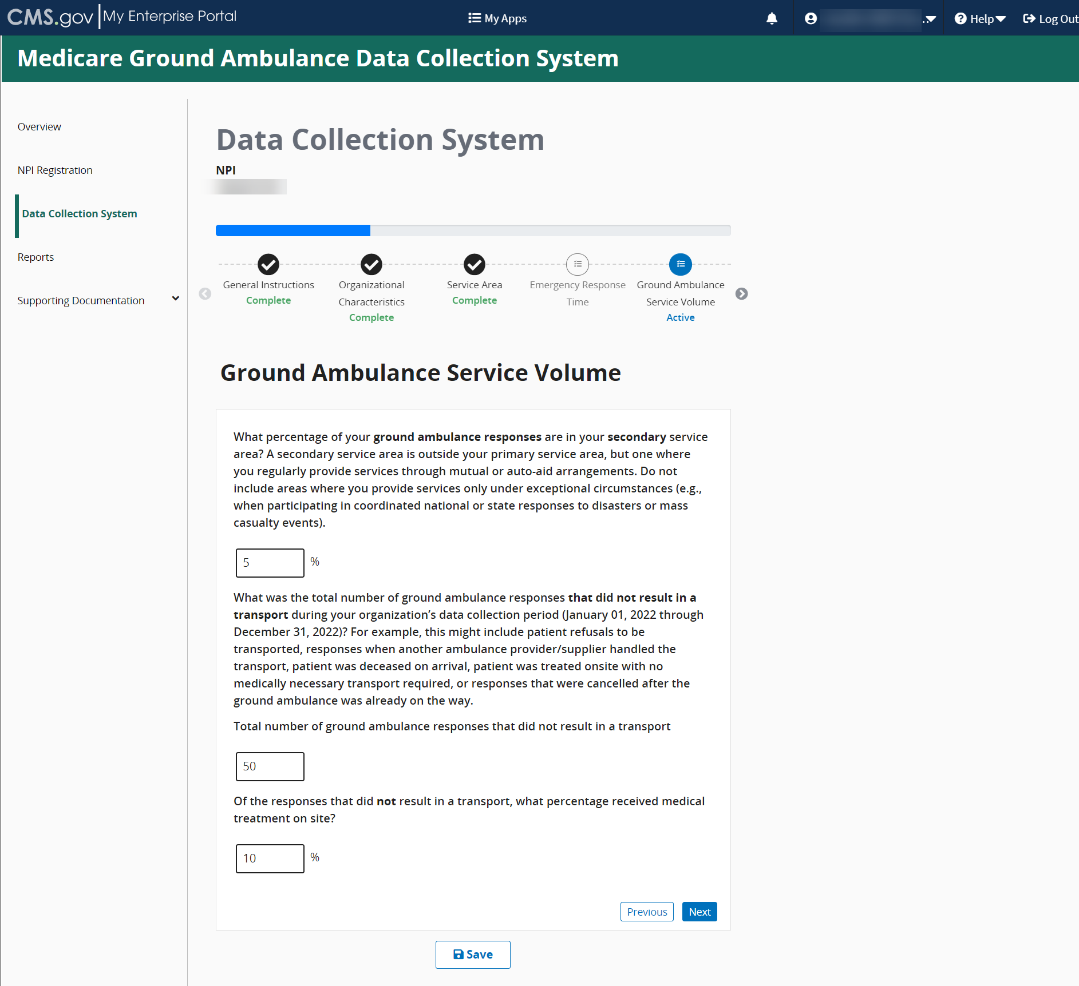
Depending on your entries, more questions may appear requiring your response. 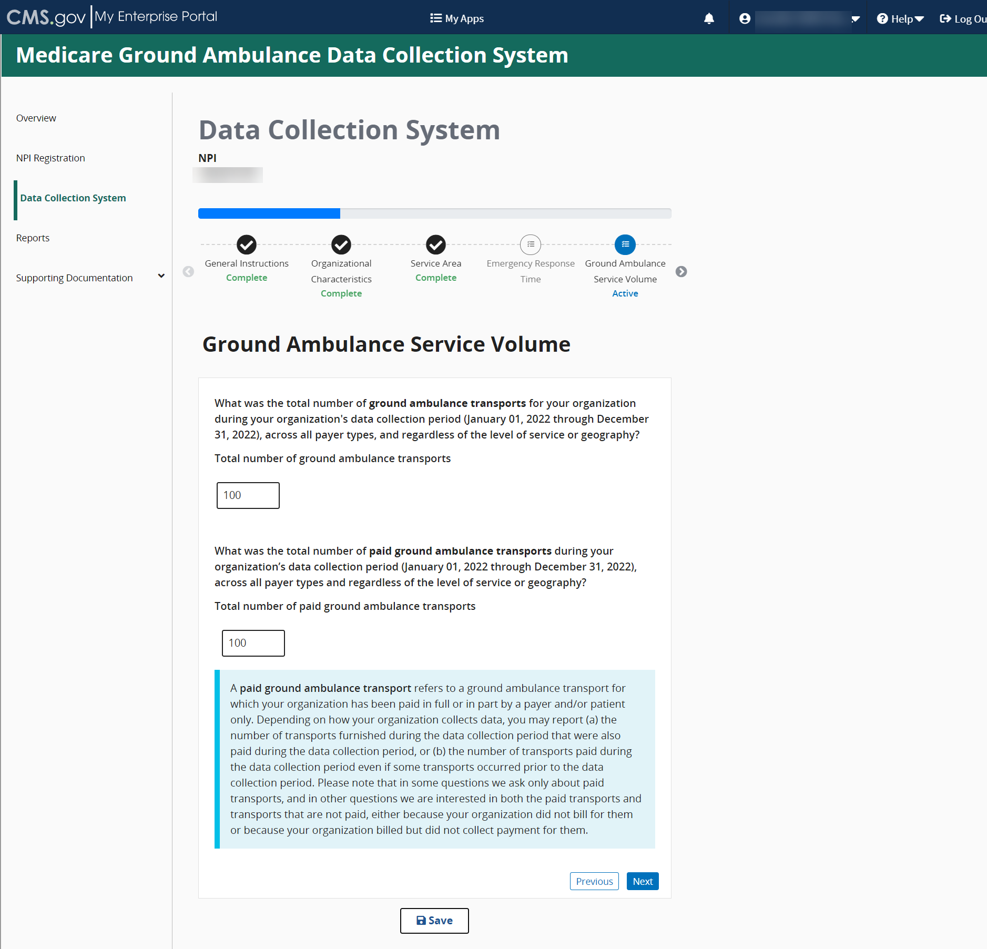

As a reminder, some of the questions you see are dependent on the responses you gave in previous responses. You may not see this as the last question in this section.
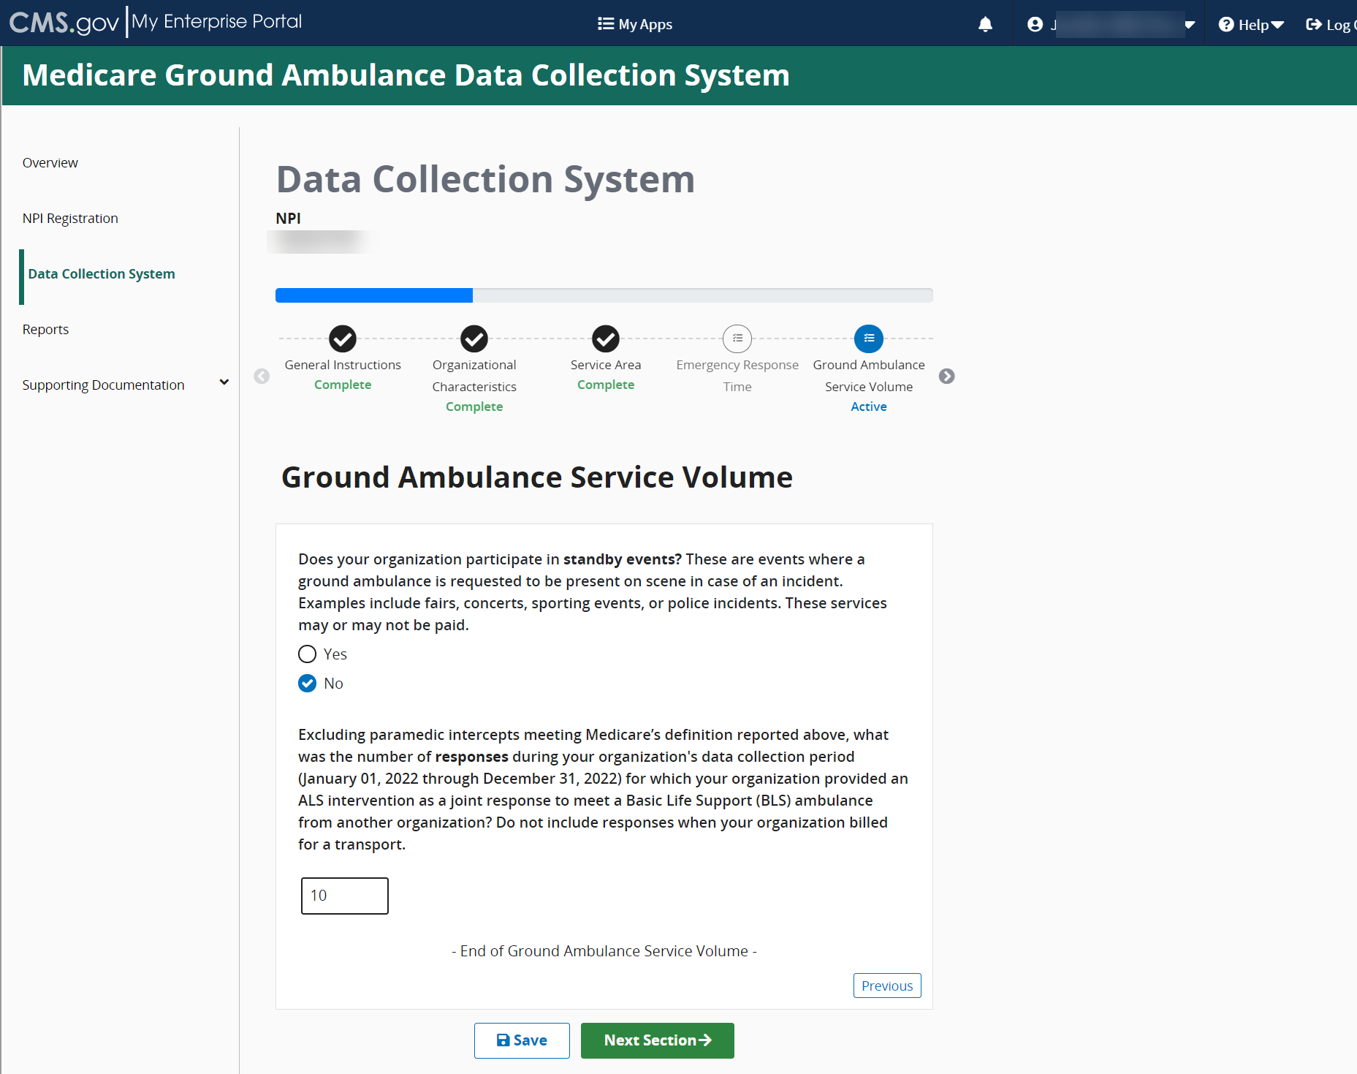
When you reach the end of the section, click Save and then click Next Section.

Service Mix
Please read the instructions and then click Start to begin.
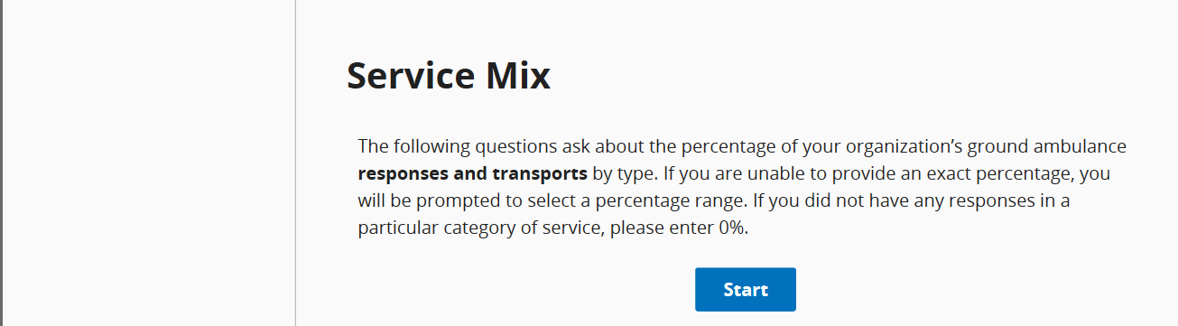

Please be sure to read the descriptions carefully for each question. You may not leave fields blank. If your response is zero, enter 0.
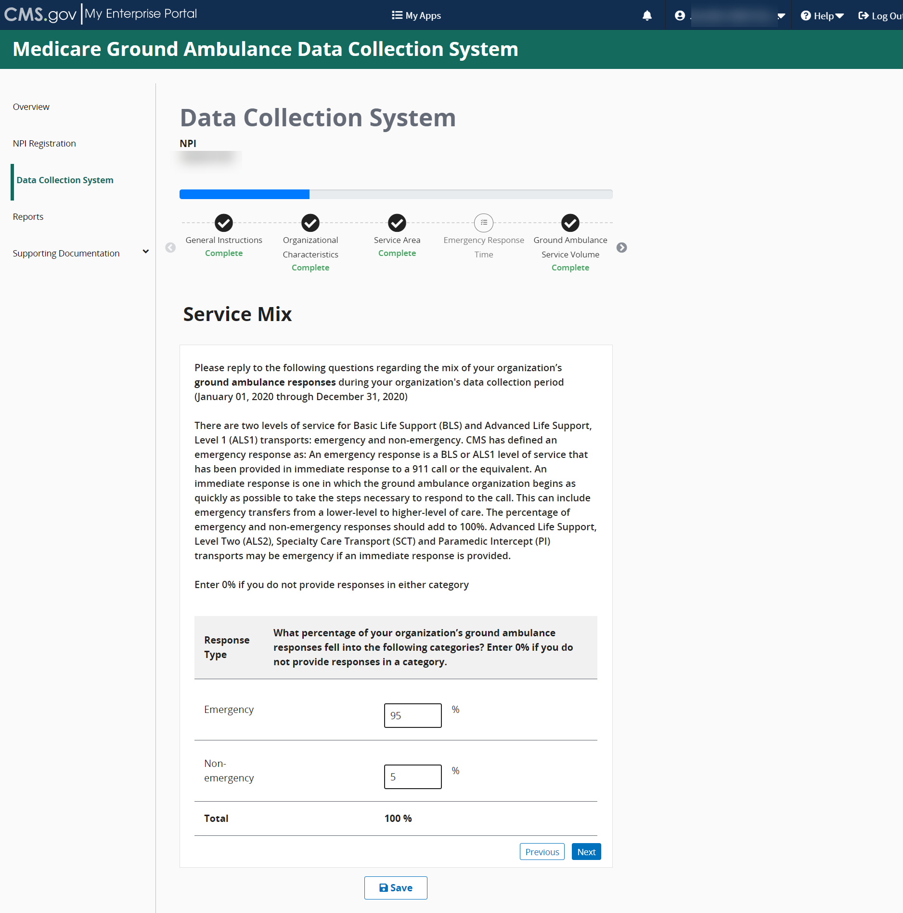
Be sure to click the Save button before moving on to the next questions or sections.

You can hover your cursor over the blue text to see definitions. Your totals cannot exceed 100%.
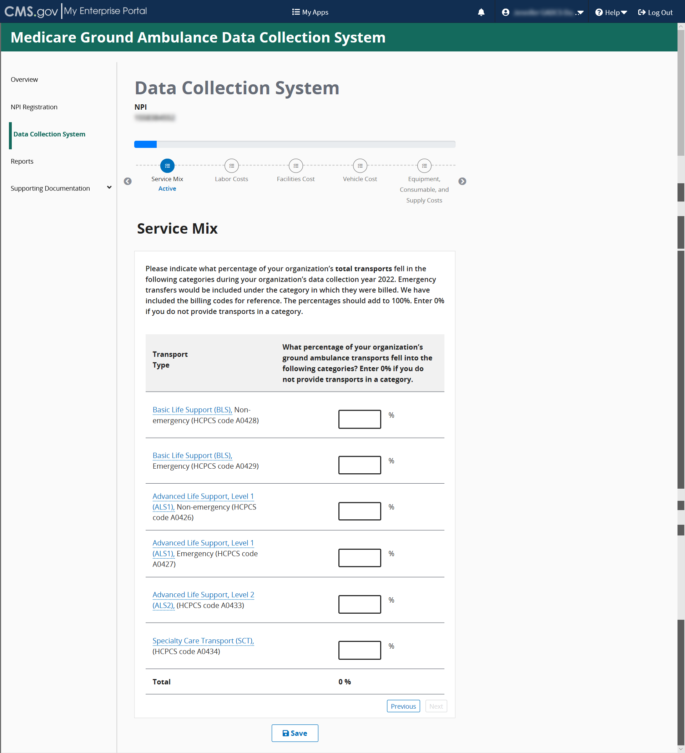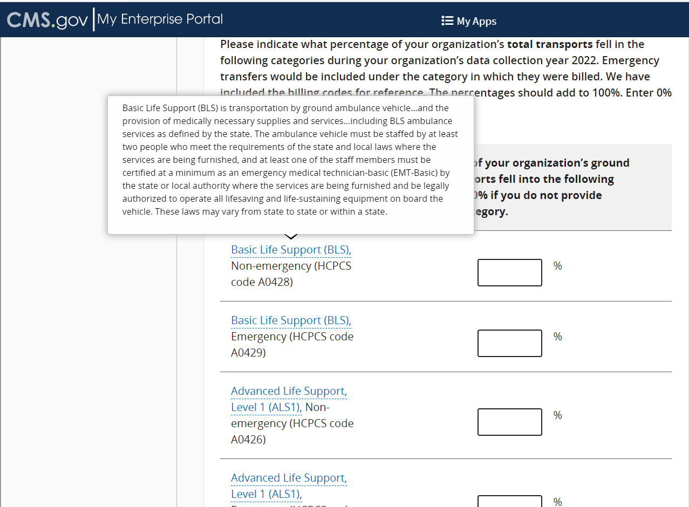
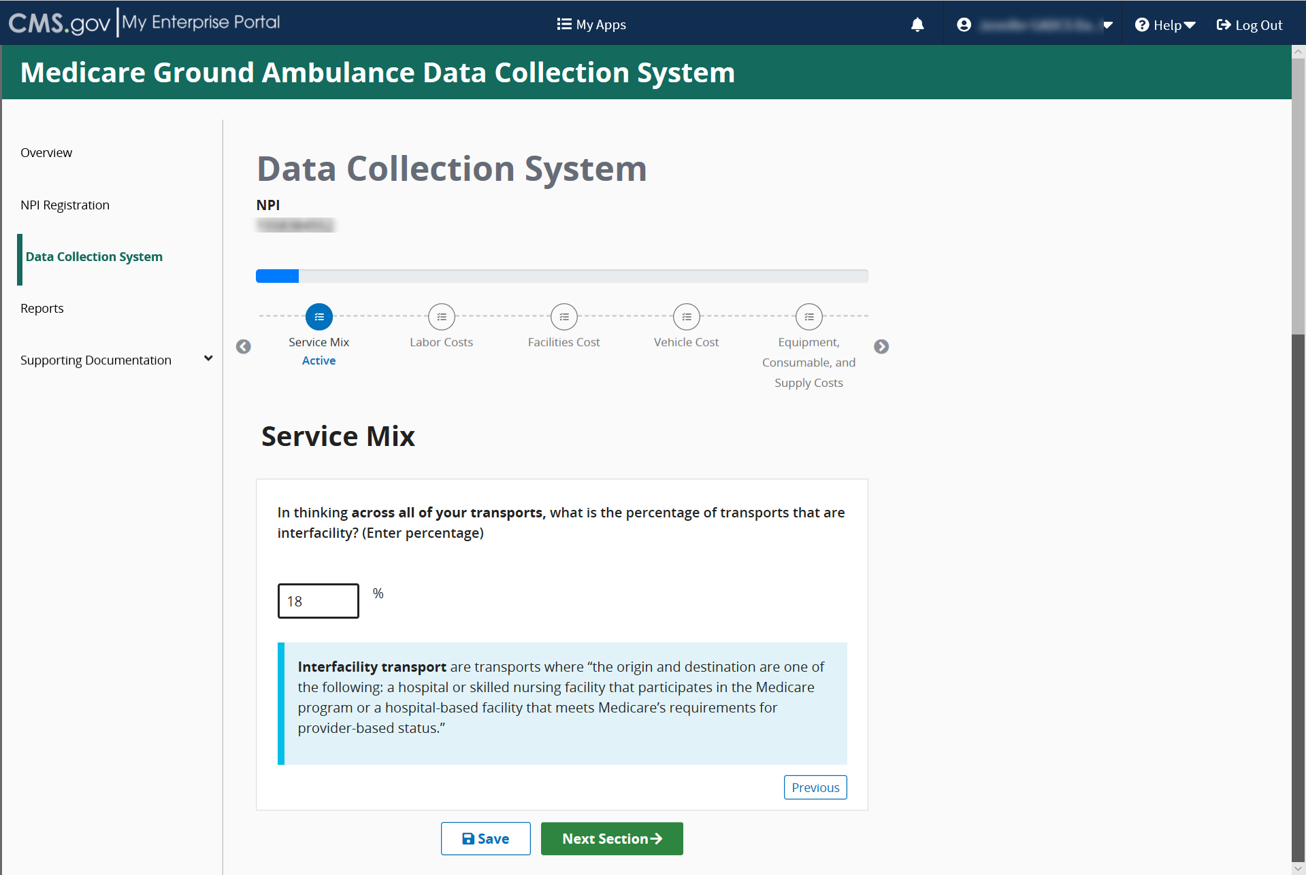

Labor Cost
Please read the introduction description carefully before answering any questions.
Acknowledge the instructions, then click Start to begin.
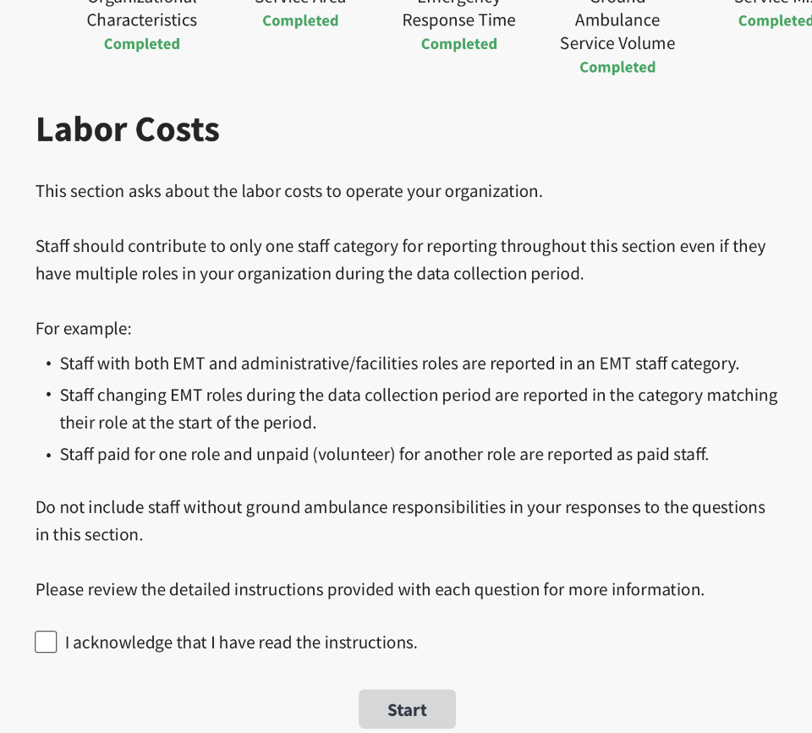
You will need to review the instructions by clicking Review Instructions at the beginning of the first question in this section. Read the instructions completely before you begin.
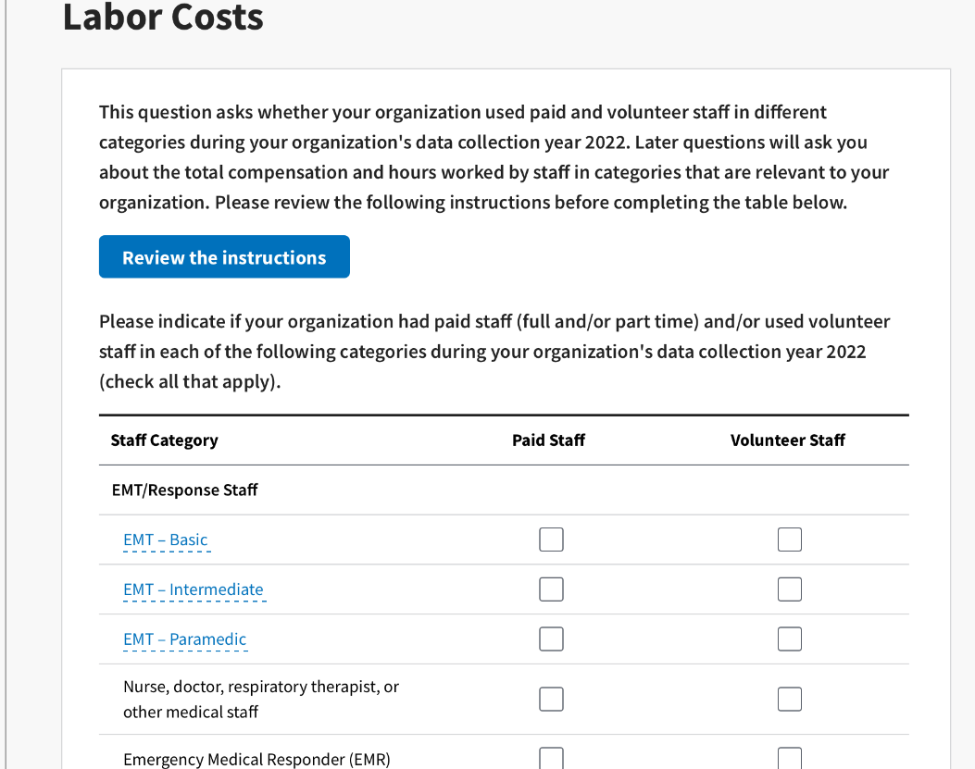

You can also click to see a brief definition of staff.
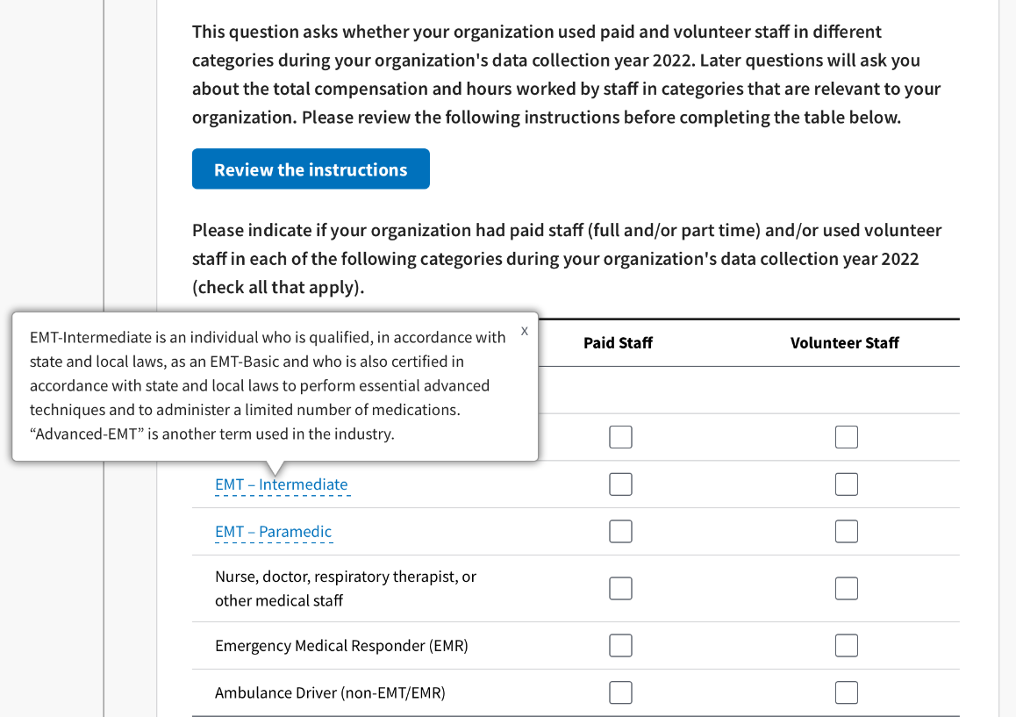
If your organization employs a staff choice not listed, you may use the Other field to type in a staff type name. If you select Other, you cannot leave it blank.
Before you input any data related to Paid EMT/Response Staff compensation, be sure to click Review Instructions and read them carefully.
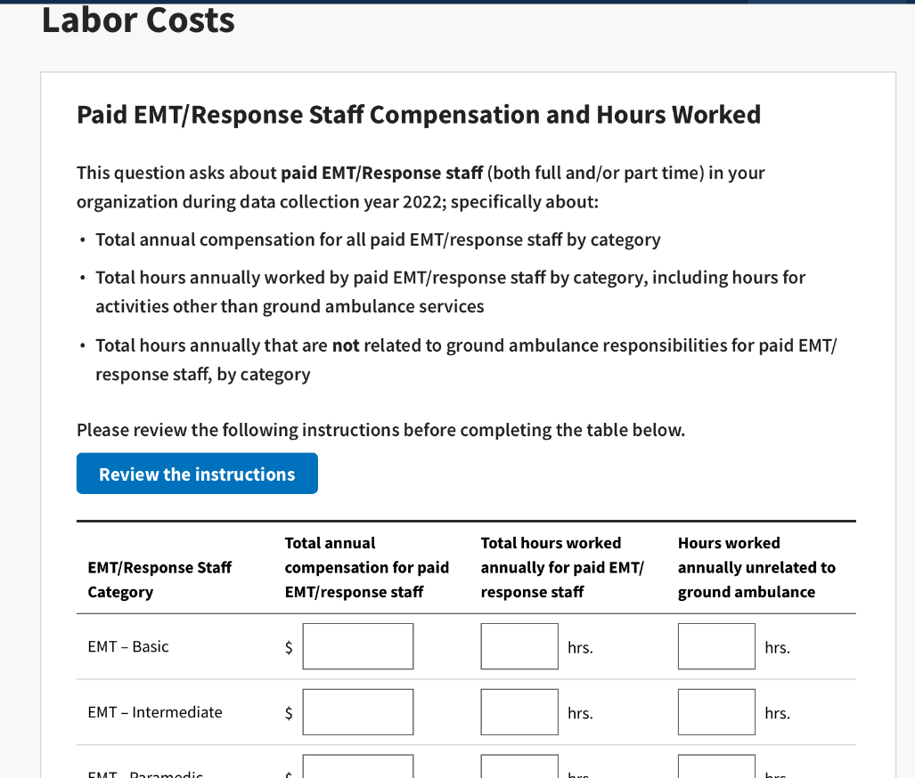

Be sure to click Review Instructions and read them carefully.
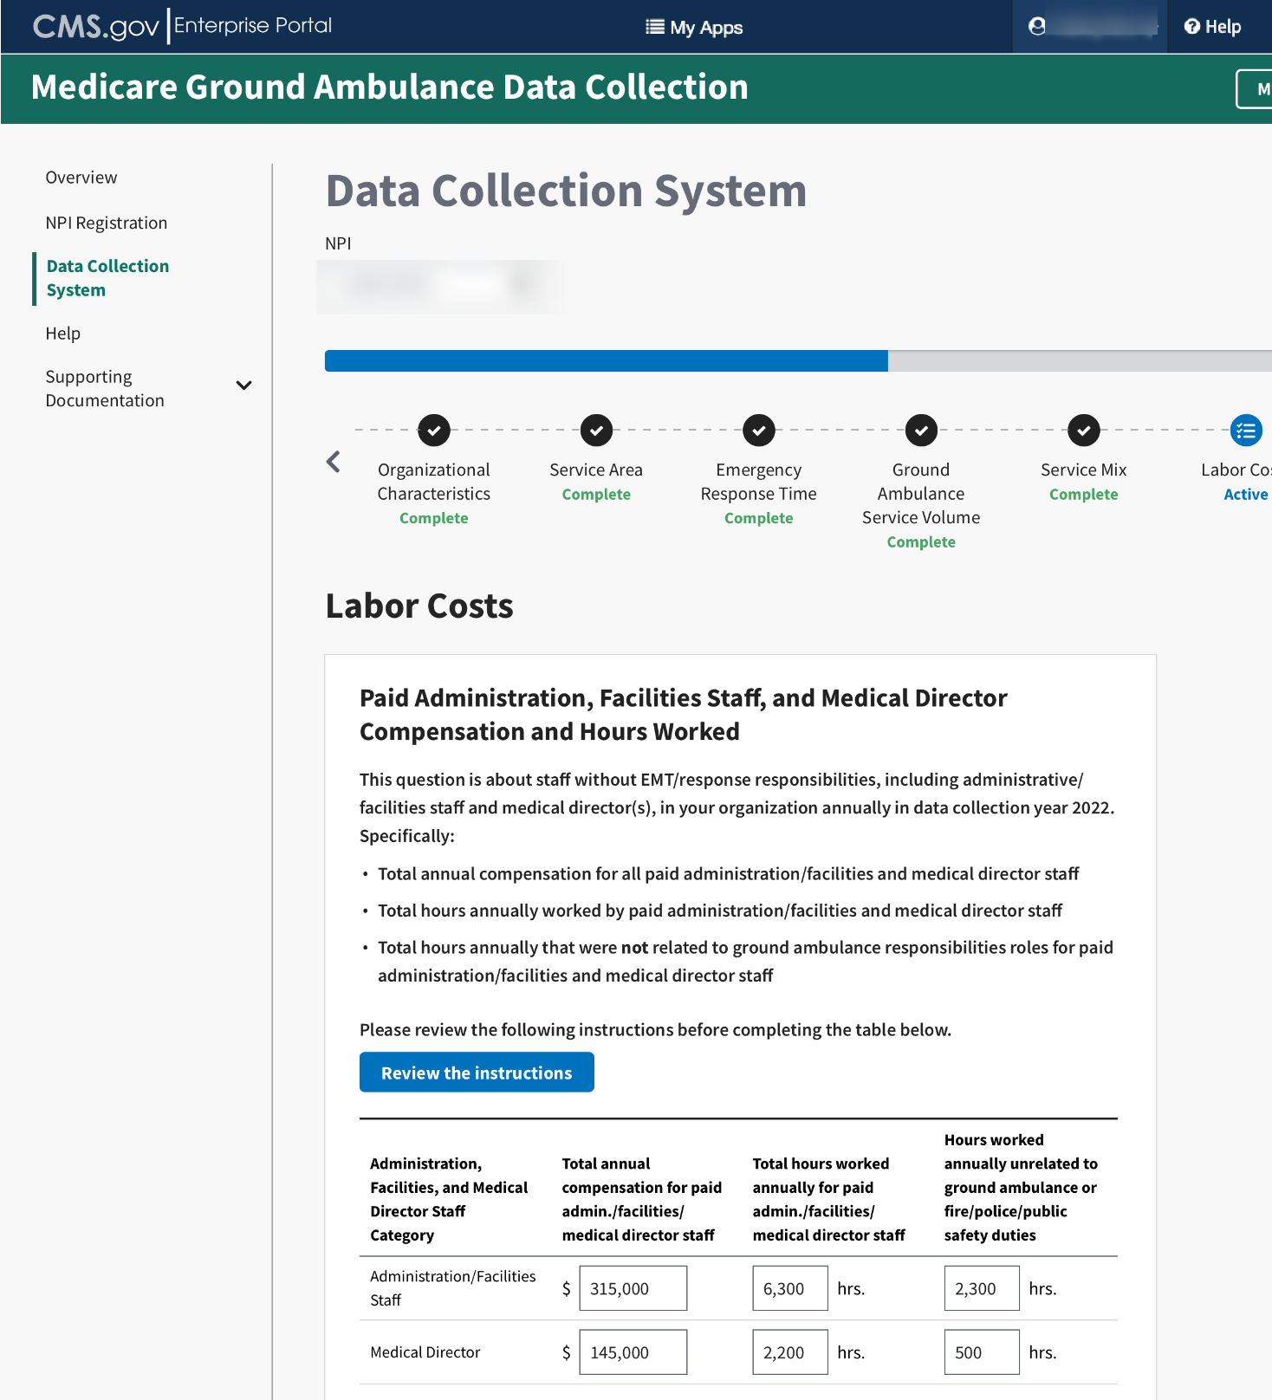

For the second question, the hours must be entered in whole numbers only.
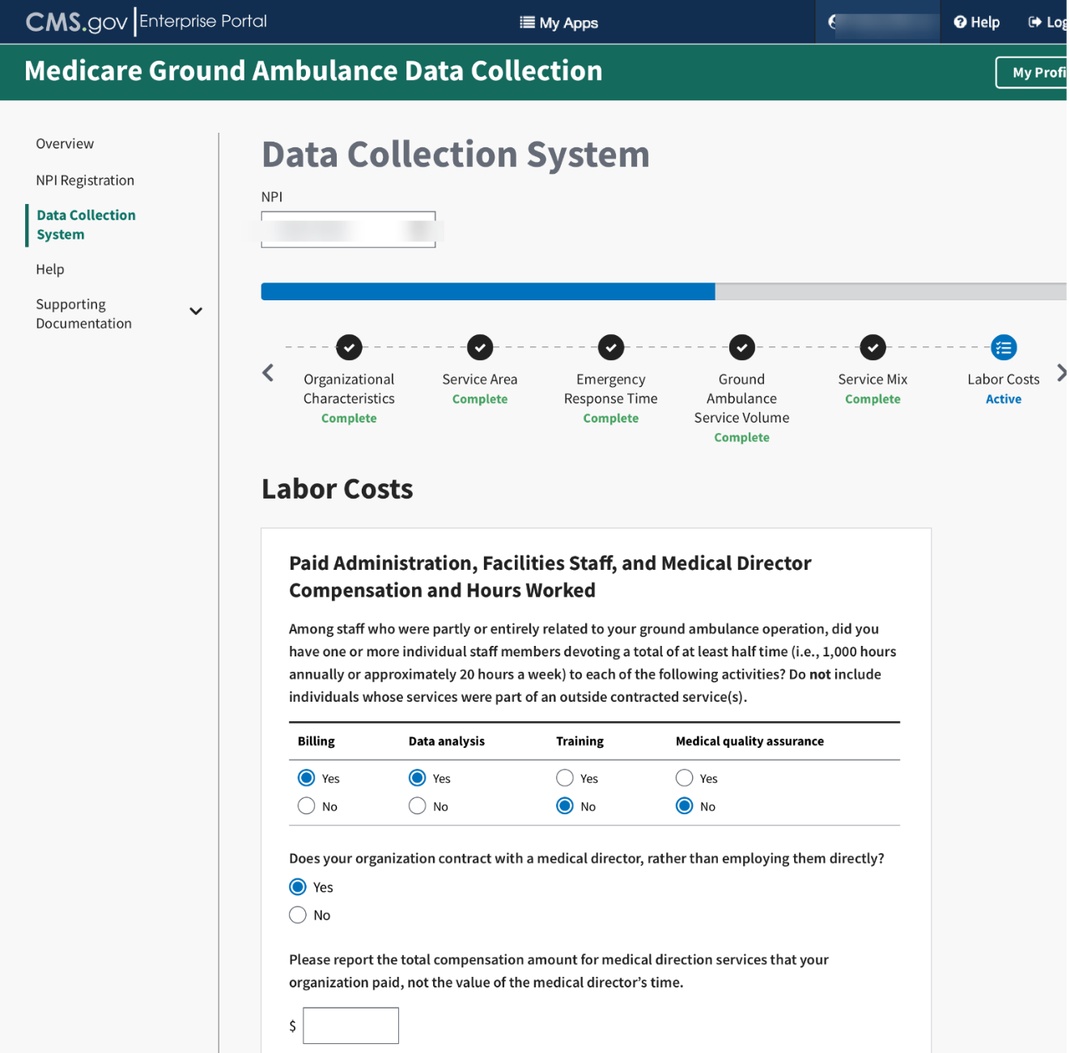

You will input data about volunteer labor.
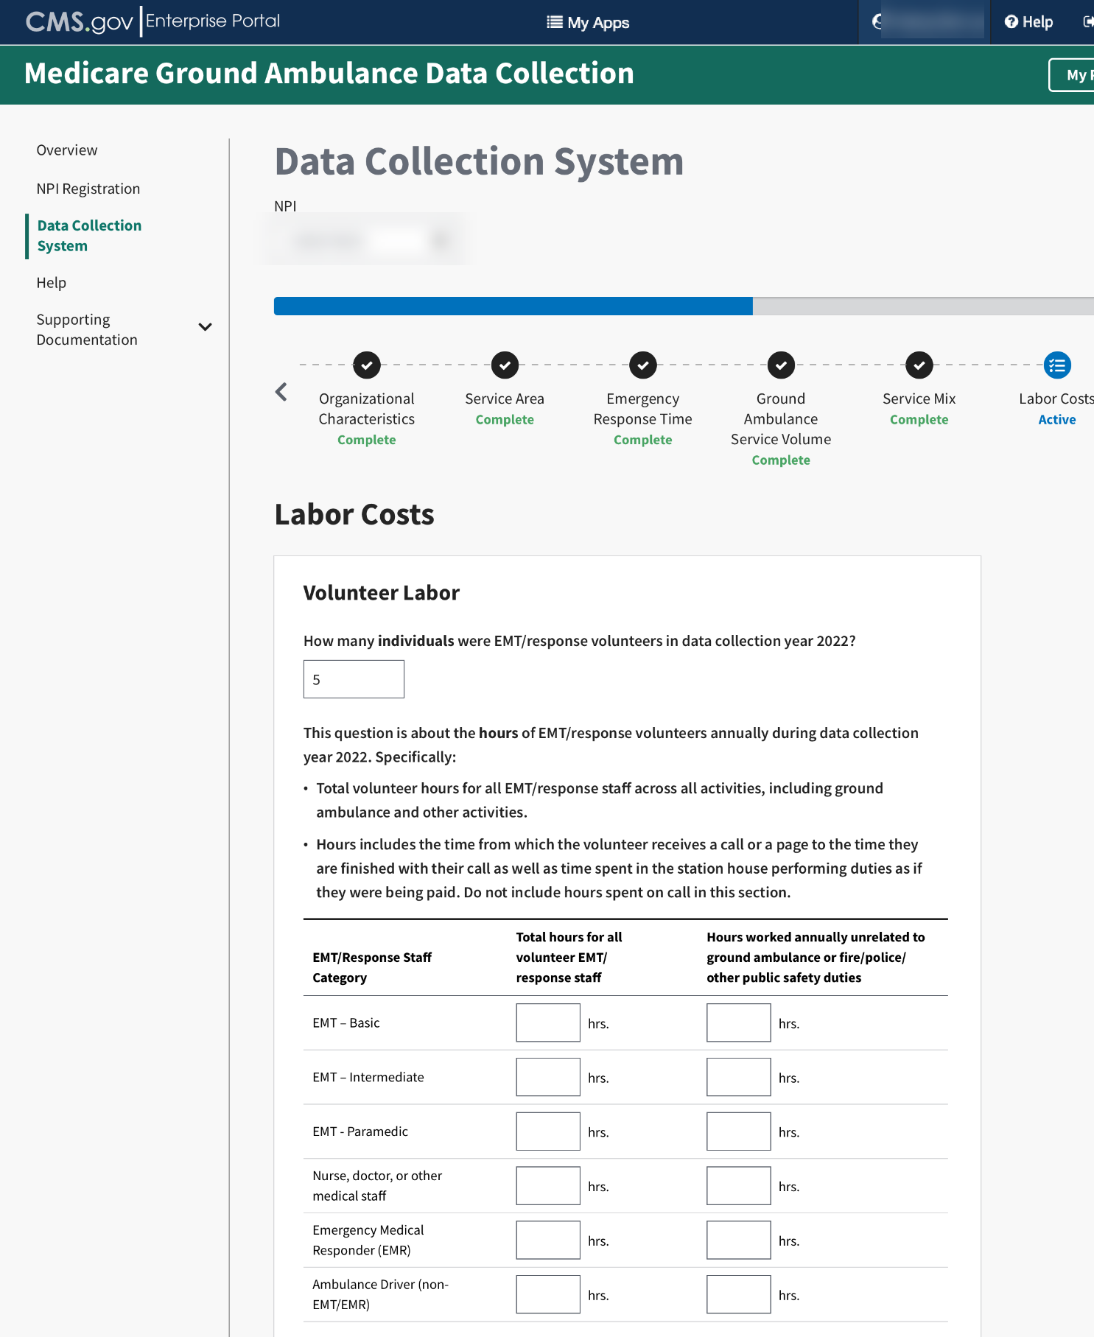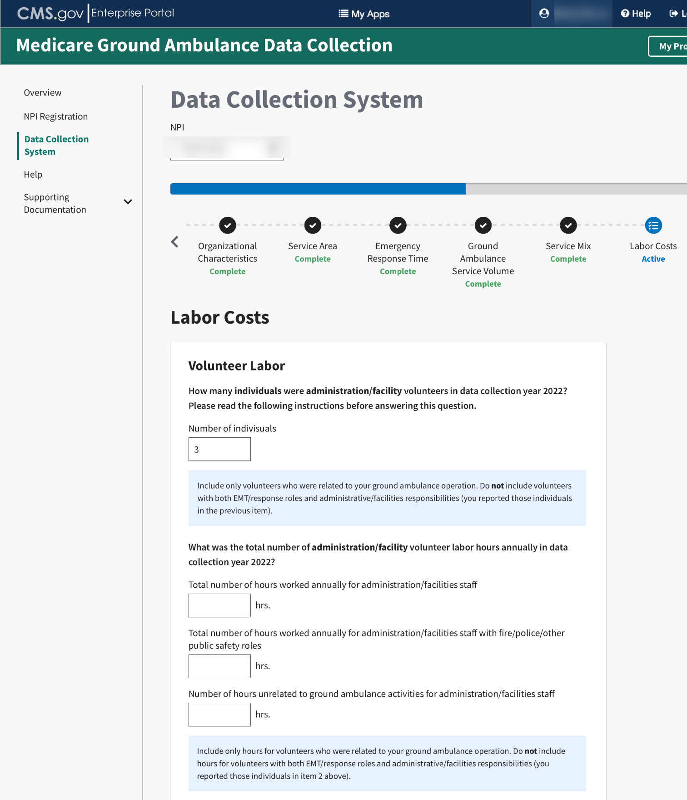

When you reach the end of this section, click Save and then click Next Section.

Facilities Cost
In this section, you will be asked about all the facilities associated with your organization’s ground ambulance services including the function of the facility, square footage, lease and/or mortgage costs, insurance and maintenance costs, and more.
Please enter only whole numbers for each question.
You will also have the option of downloading an Excel form, filling in the required information, and uploading it. The file must remain in Excel format.
Click Start to begin answering questions in this section.
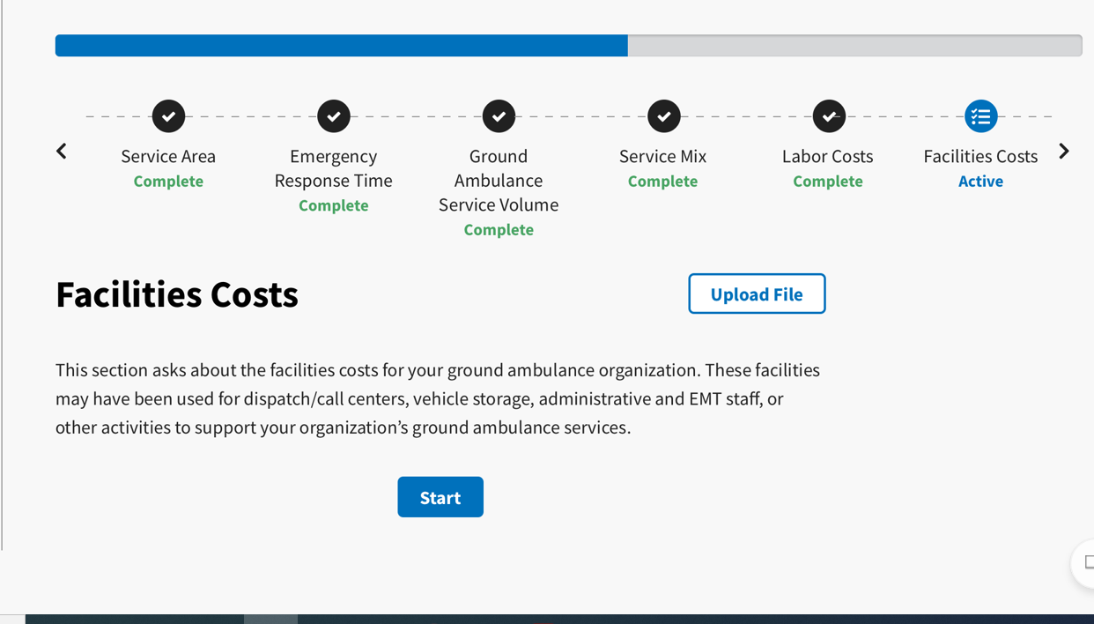
If you chose to download the form and fill it in, click Upload File.
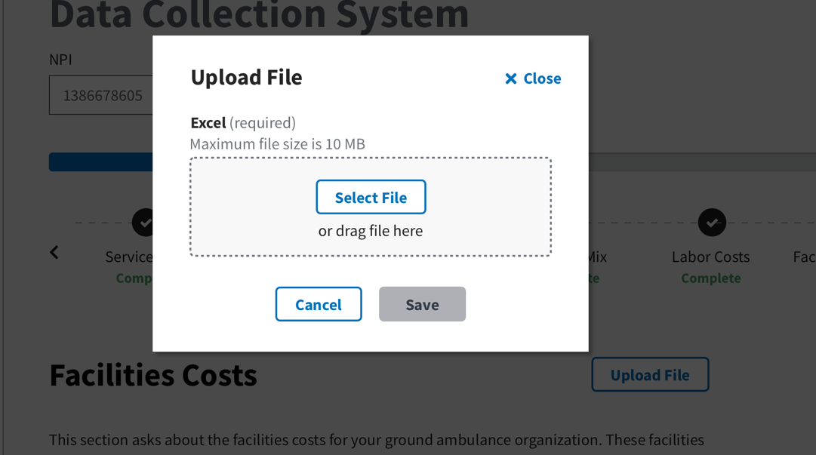

The file must be Excel. Select the file, then click save.
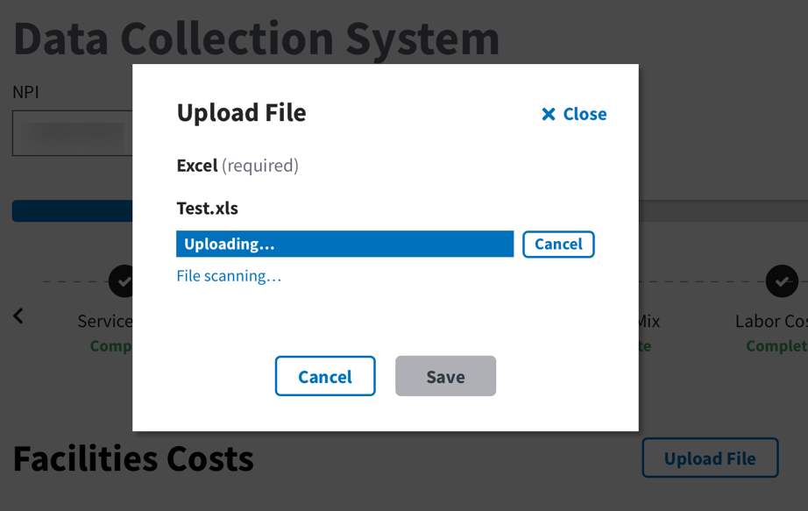
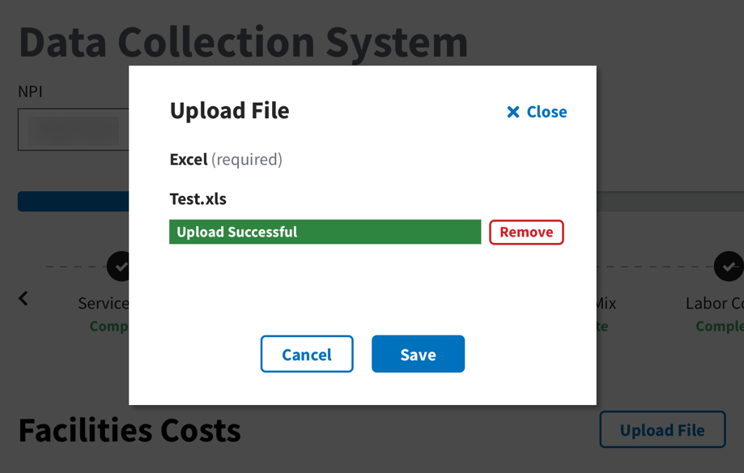
If you choose to enter in the numbers using the instrument, click start and then enter in the total number of facilities.
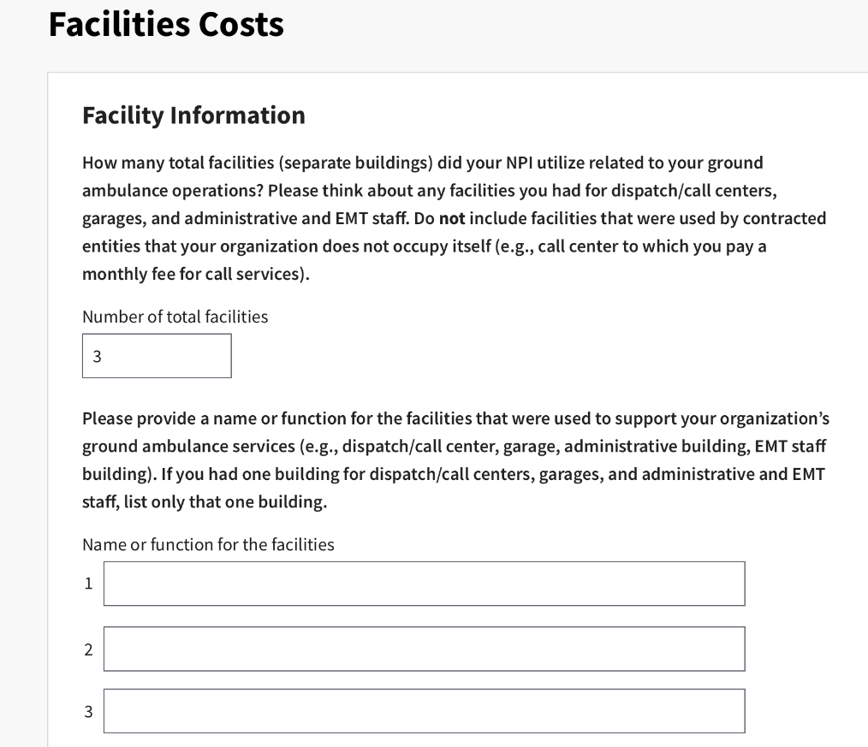
The number you enter in this first box will determine the number of boxes that appear below
You will then fill out additional information about the facilities you name. Enter numbers in only whole numbers.
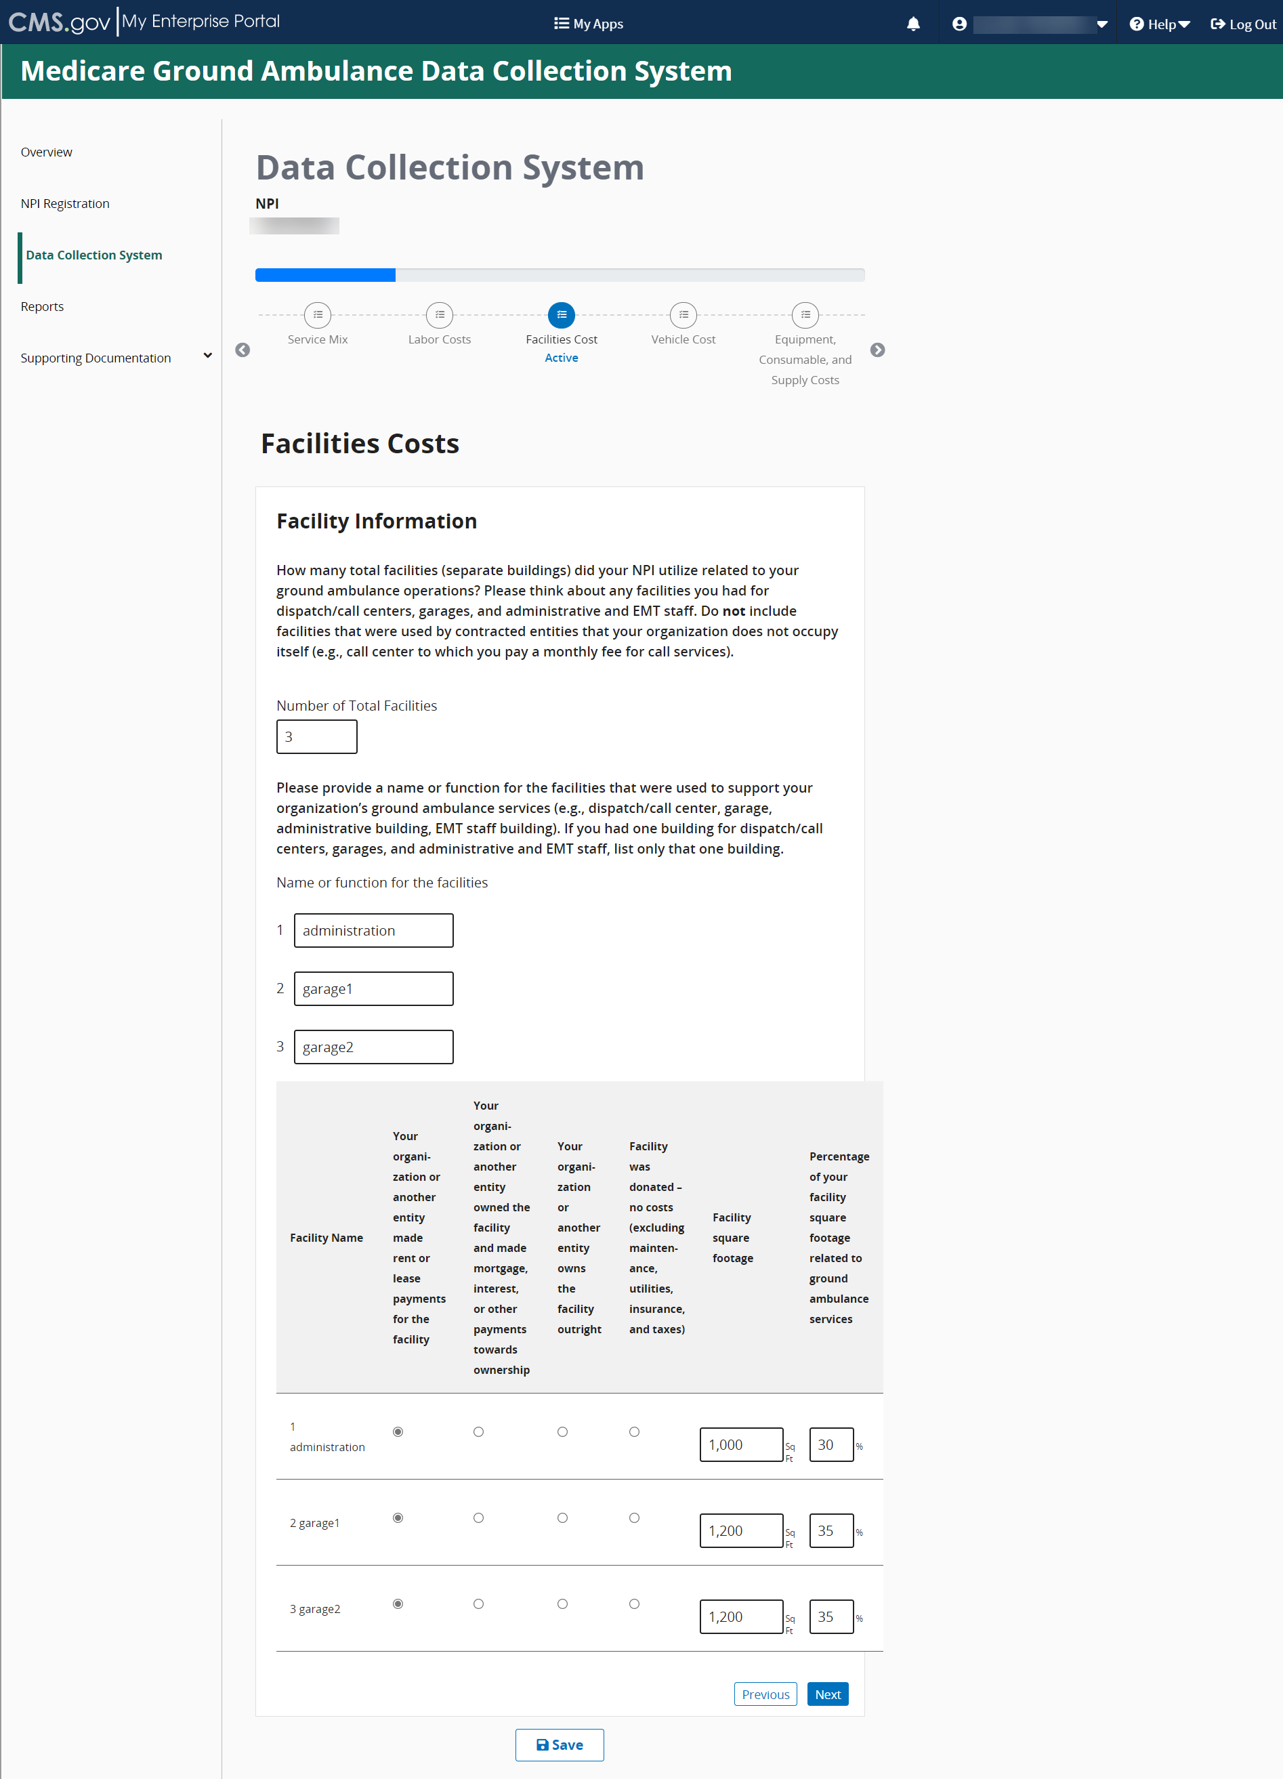

For this question regarding mortgage or lease costs, round the numbers to the nearest whole number.
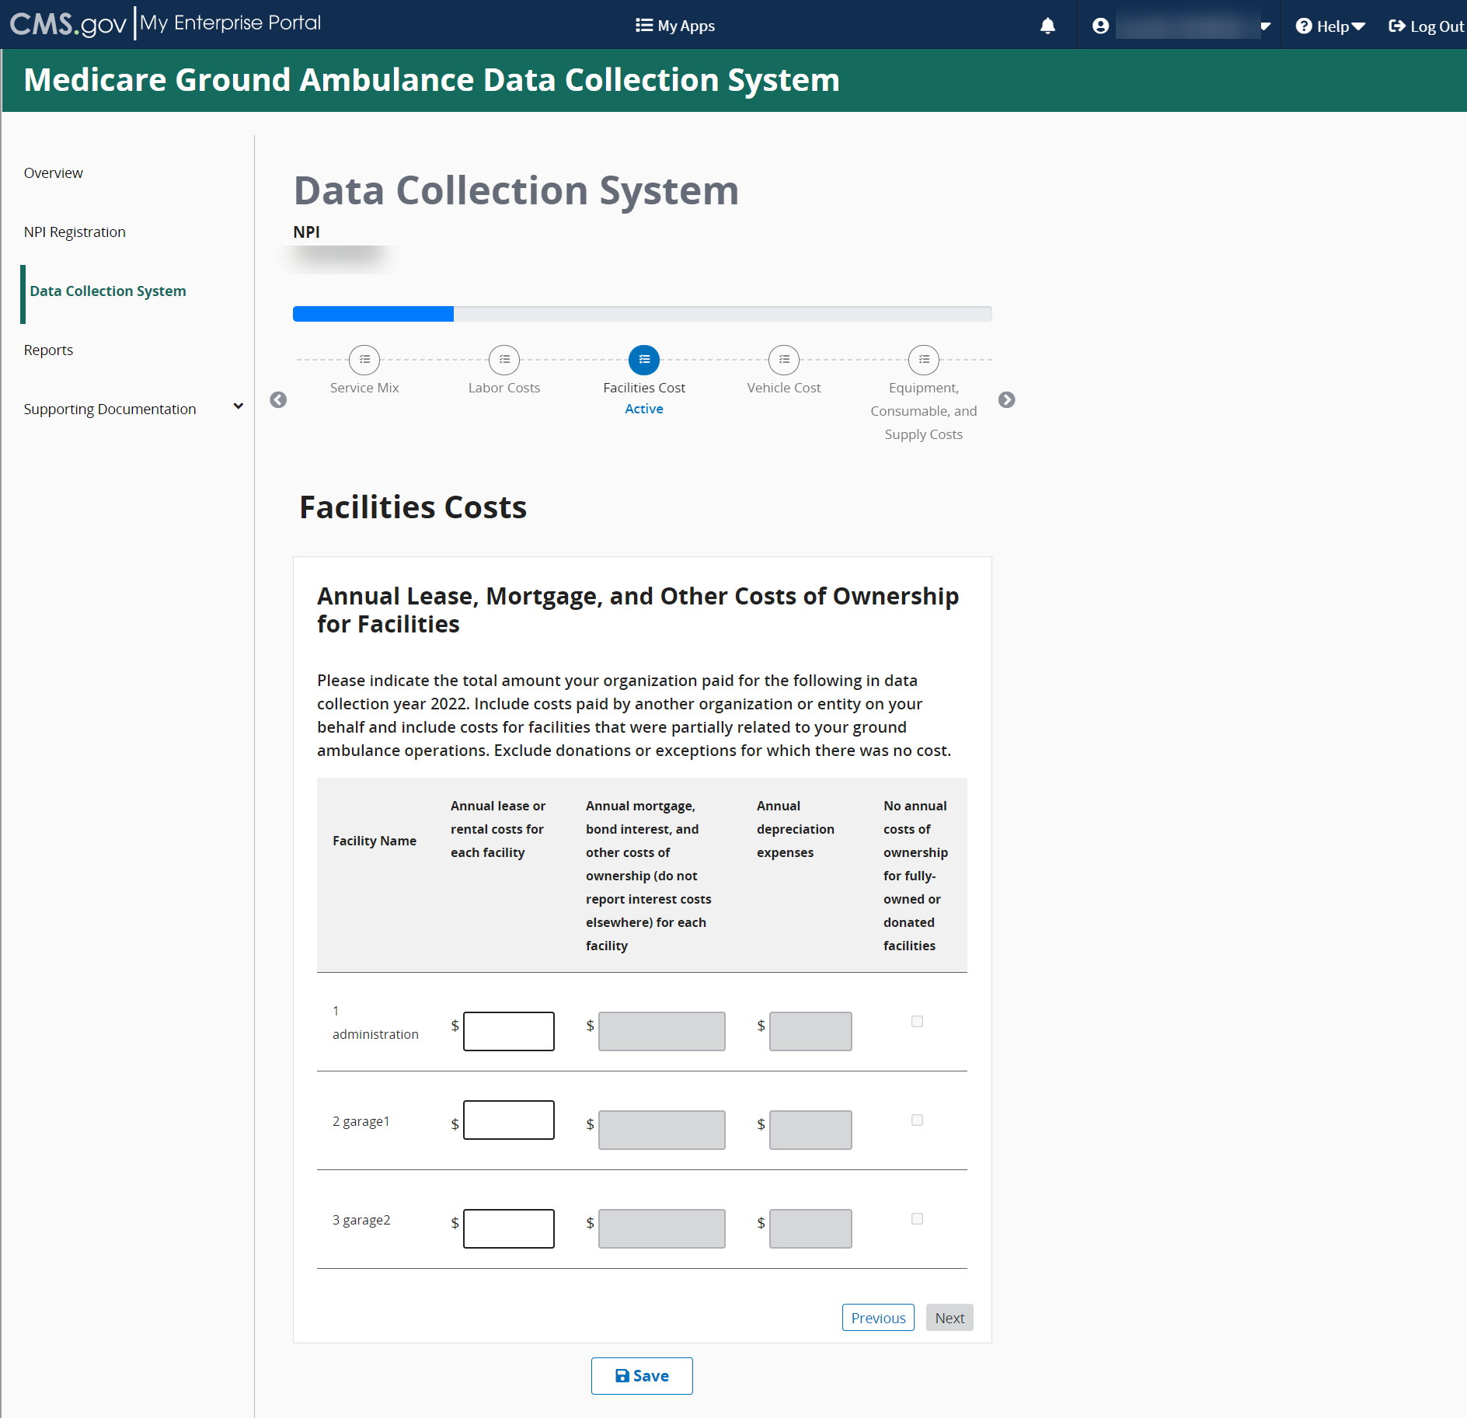

Again, you will enter whole numbers for the question about Insurance, Maintenance, Utilities, and Taxes
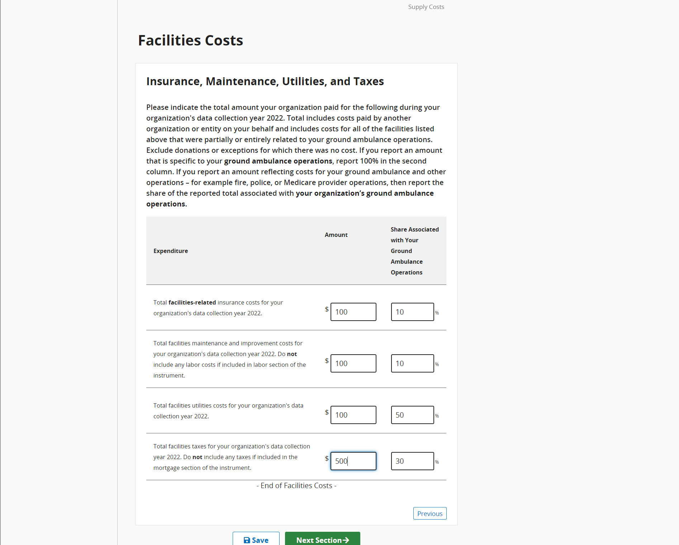

Vehicle Costs
This section will ask you about the vehicles your organization uses, starting with ground ambulances.
Click Start to begin.
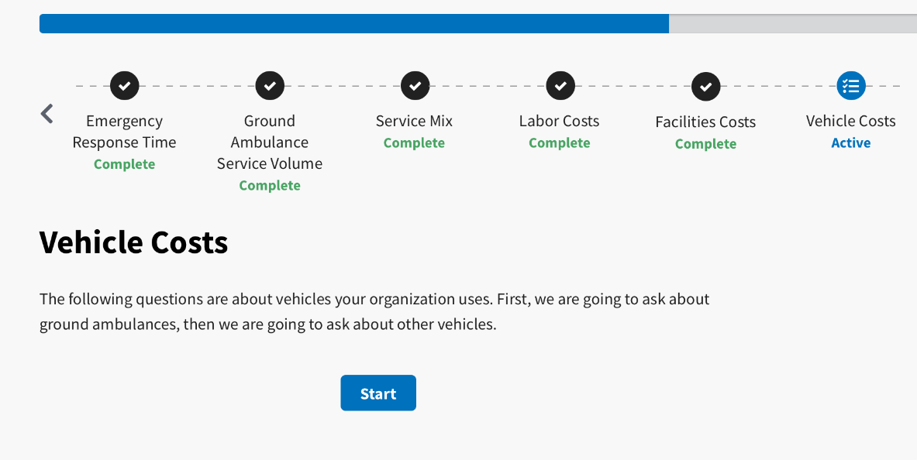
You will begin by entering information about ground ambulances your organization owns.
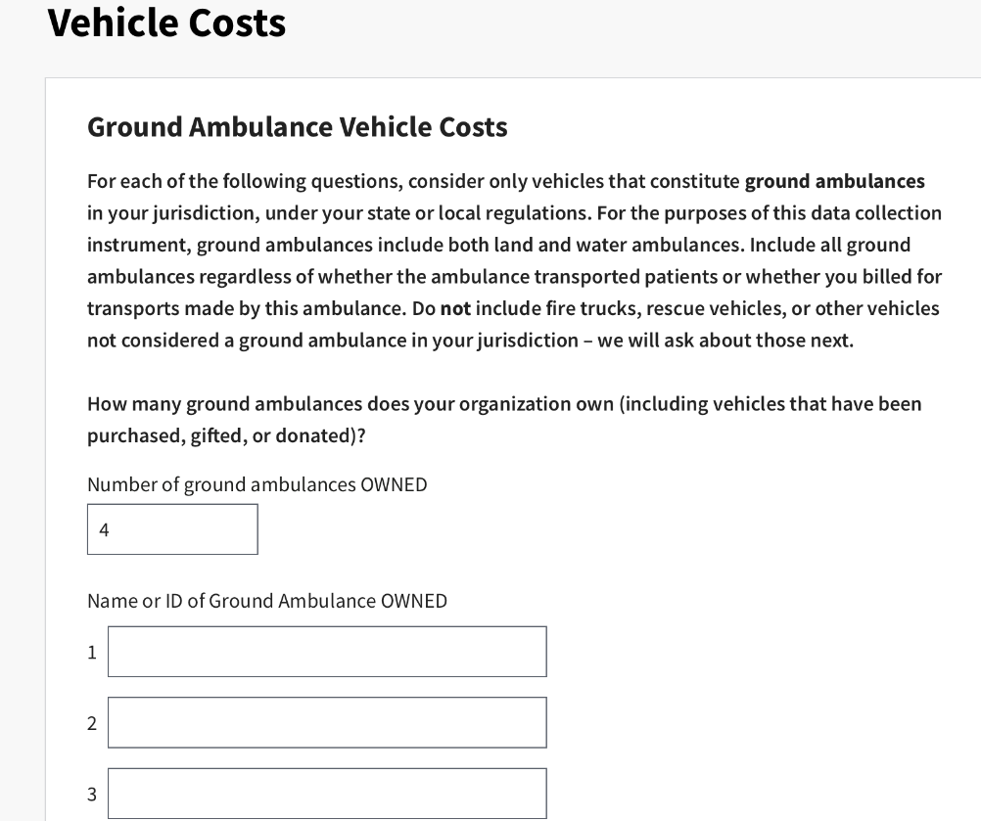

Next, you will enter information about ground ambulances your organization leases or rents. Just as before, the number you enter will populate the number of entries for Names or IDs. If you indicated your organization operates air ambulances, do not include air ambulance services in responding to the following questions.
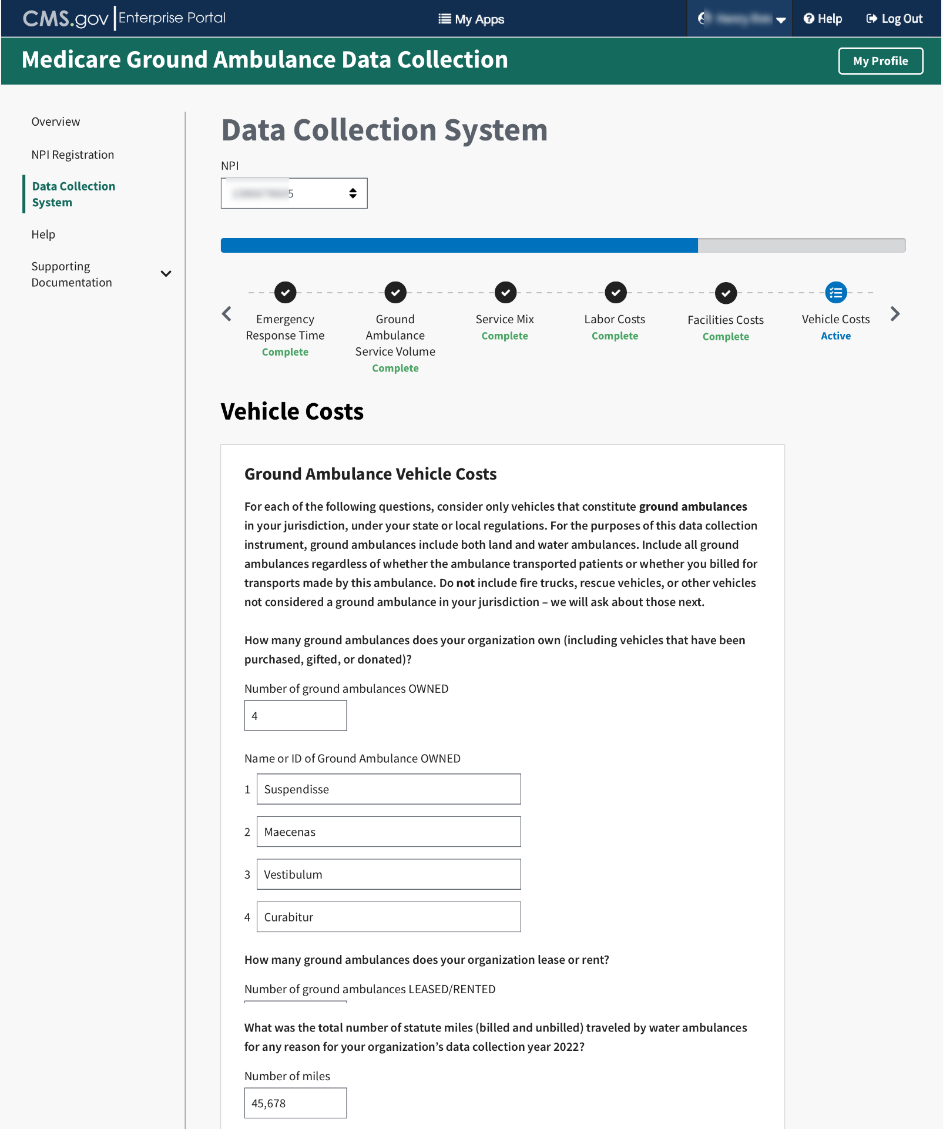

You will be asked to fill out financial information for your ground ambulance vehicles. Use only whole numbers.
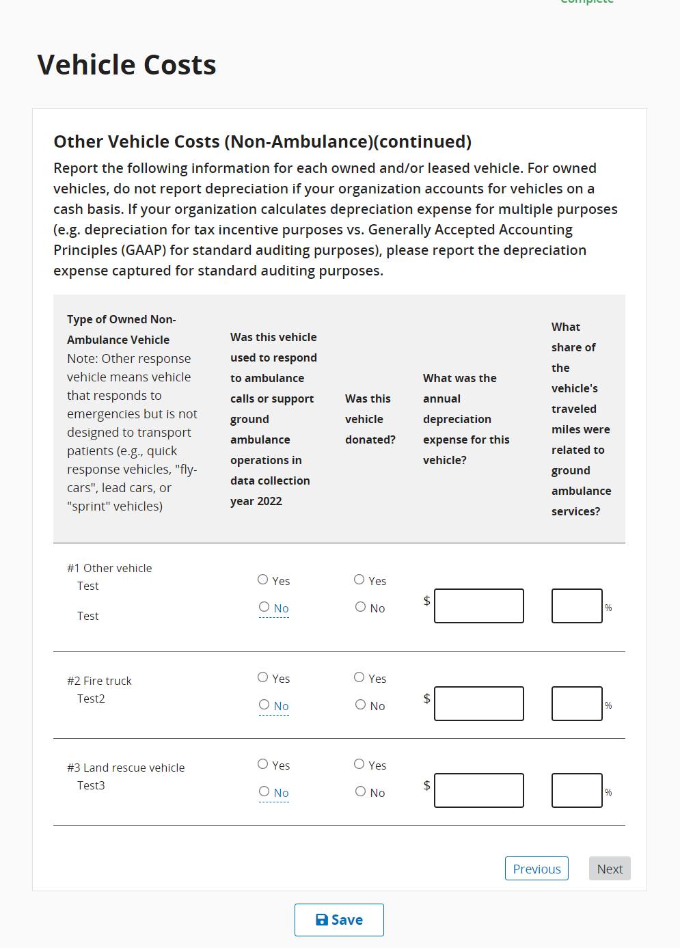

Once you’ve completed entering information about ground ambulance vehicle costs, you will be asked about your organization’s non-ambulance vehicles.
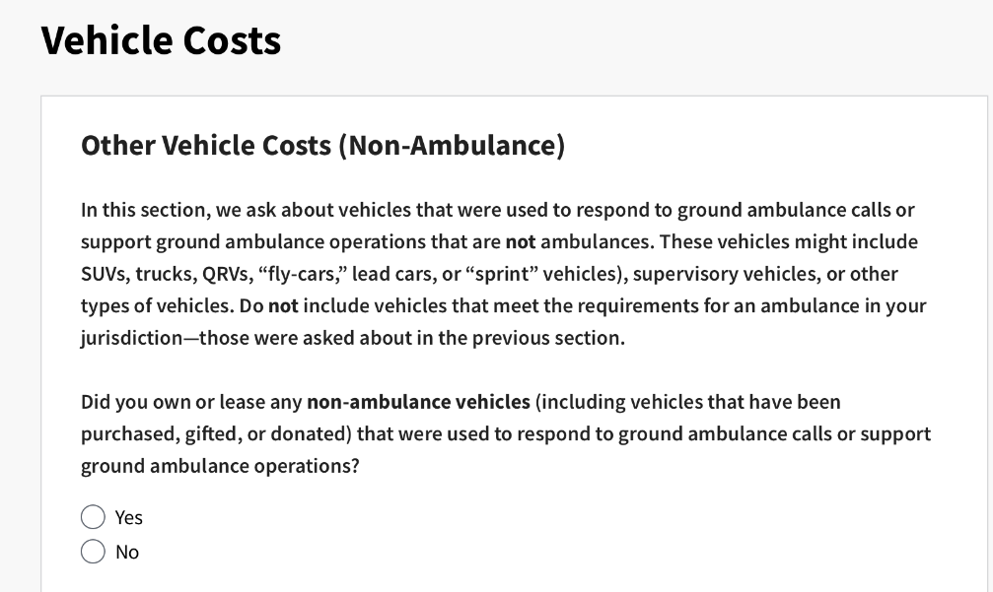
If you do not have any other vehicle costs, click No to move on to the next set of questions. Otherwise, you will enter information the same way you did for the ground ambulance vehicle costs.
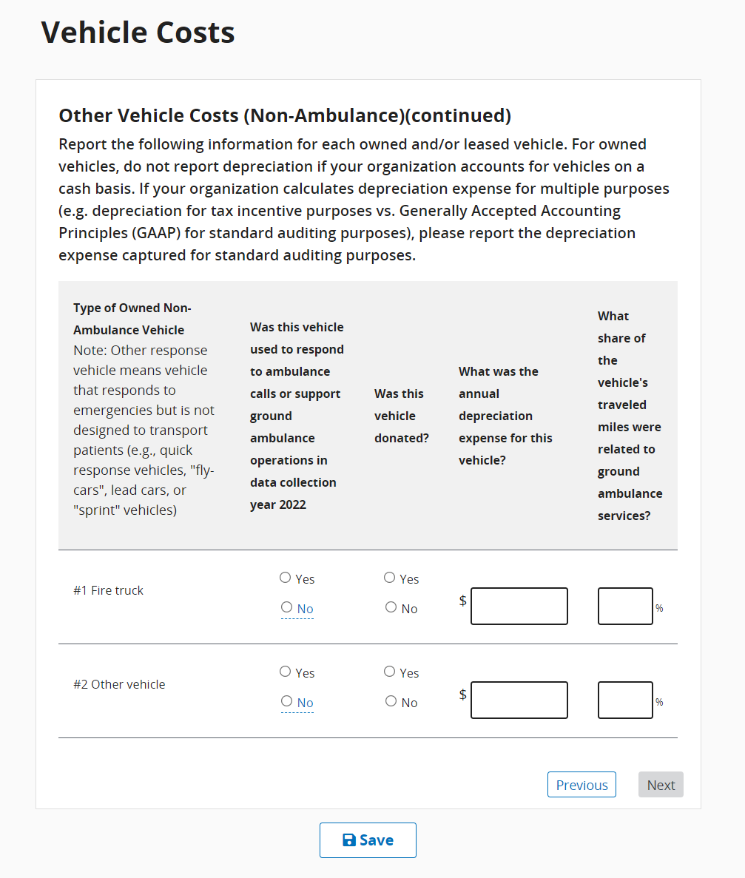
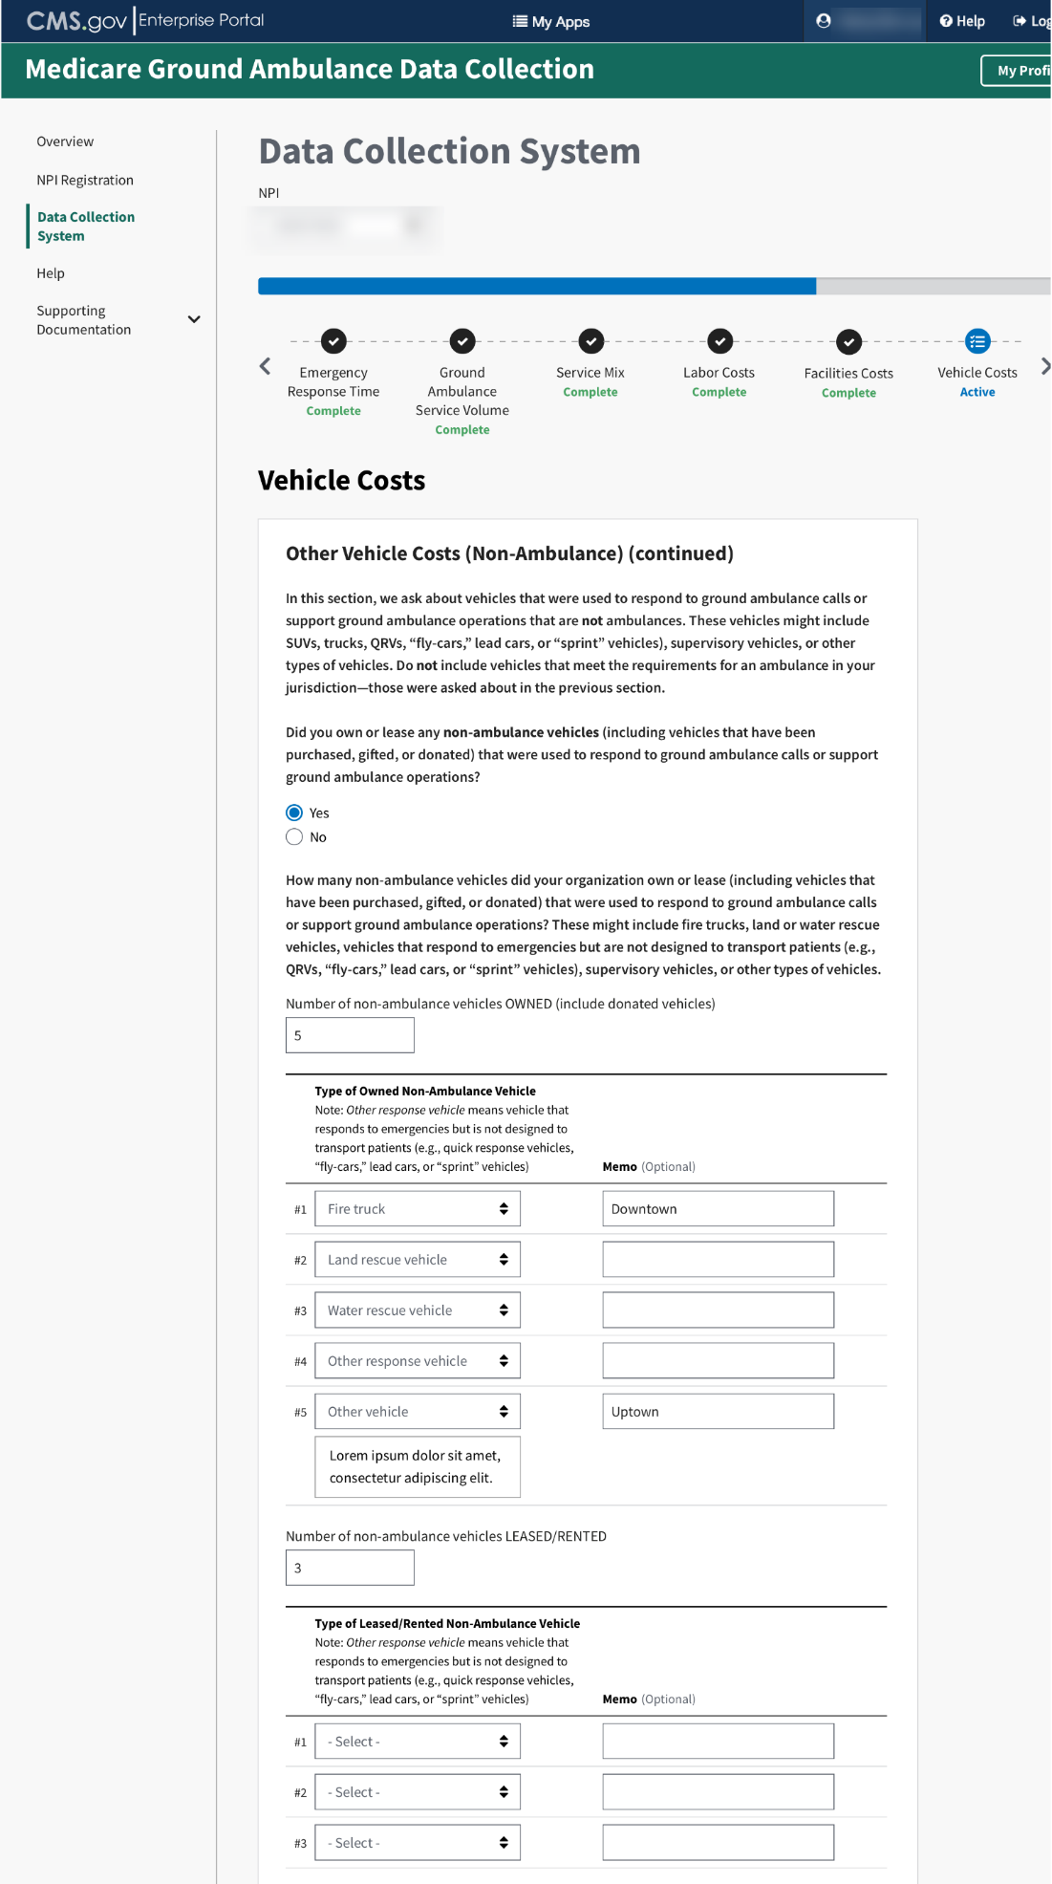
Once complete, calculate the total cost of registration for all of your organization’s vehicles. You will do the same for license and insurance costs.
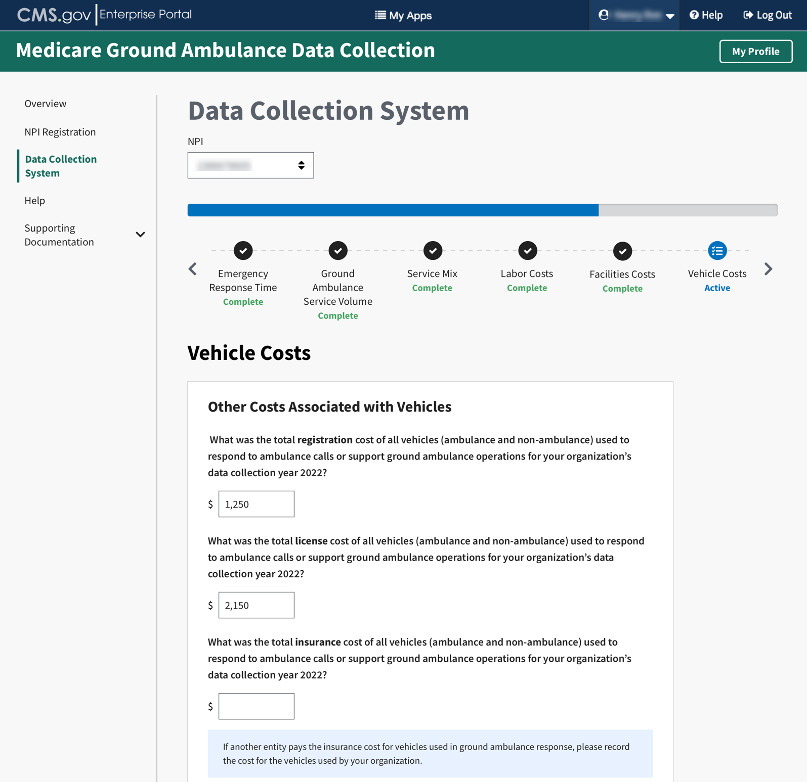

When totaling the Other Costs, please enter only whole numbers. Enter 0 if the percentage is 0. Your totals cannot exceed 100%.
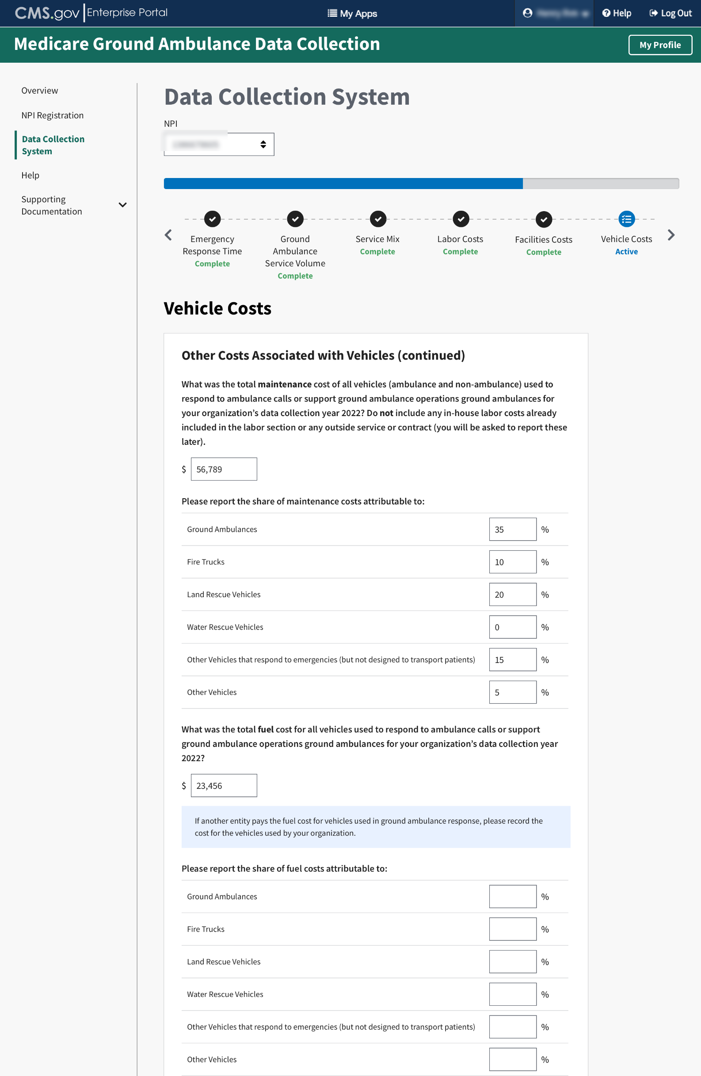
You will only see this question if you indicated your organization has more than one NPI to bill Medicare for ground ambulance Services. Enter in the whole dollar amount.
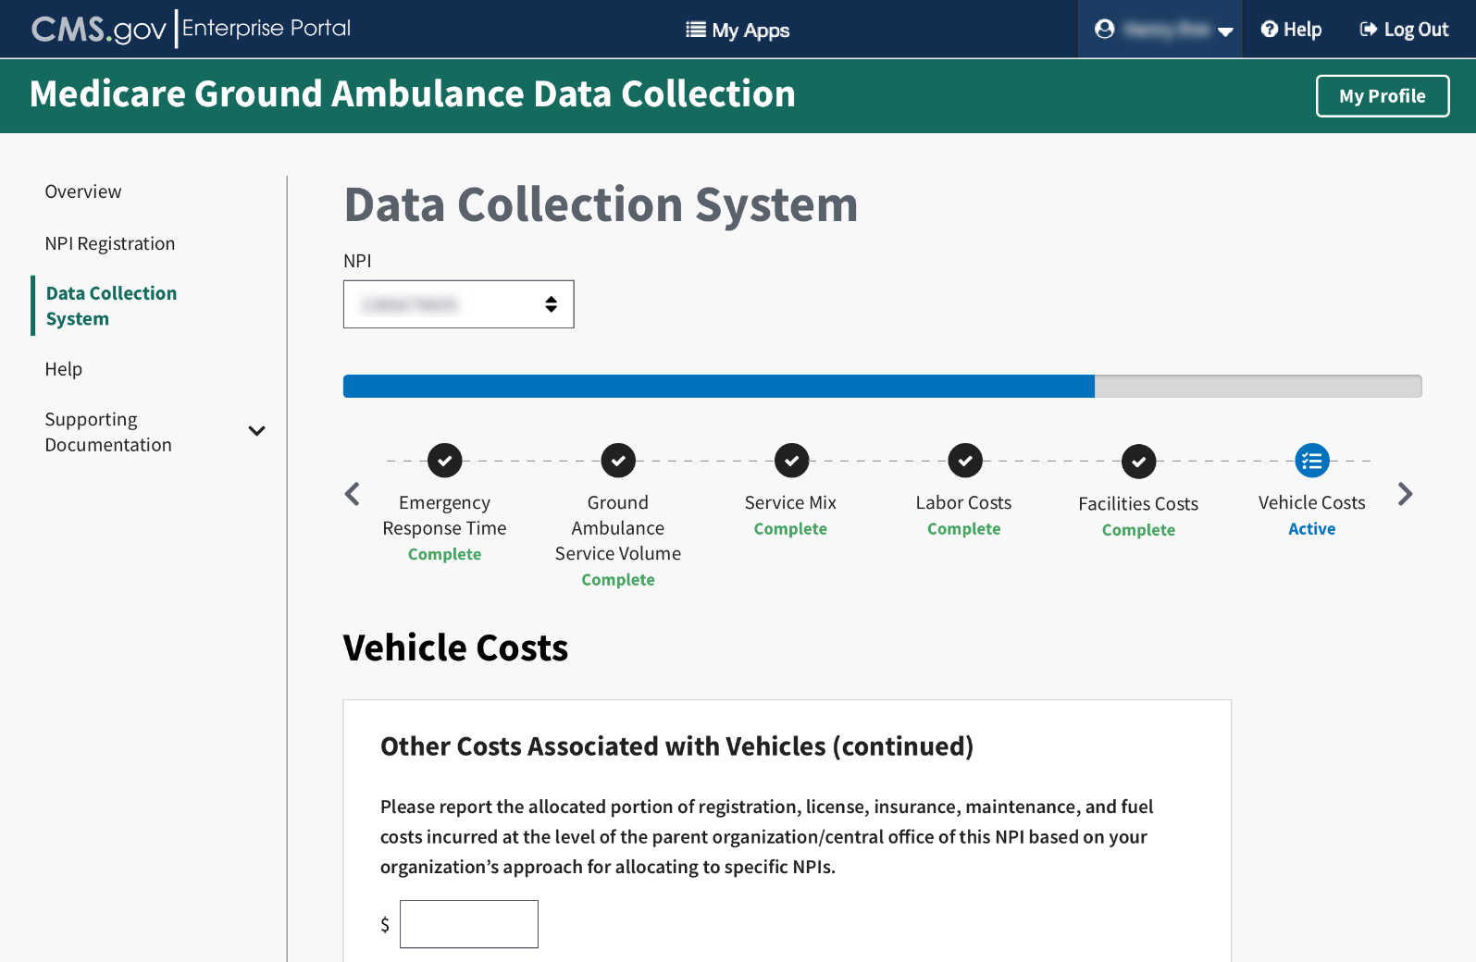

Equipment, Consumable, and Supply Costs
There may be two notes at the beginning of the section to read, depending on your previous responses.
Proceed to answer the questions using whole numbers.
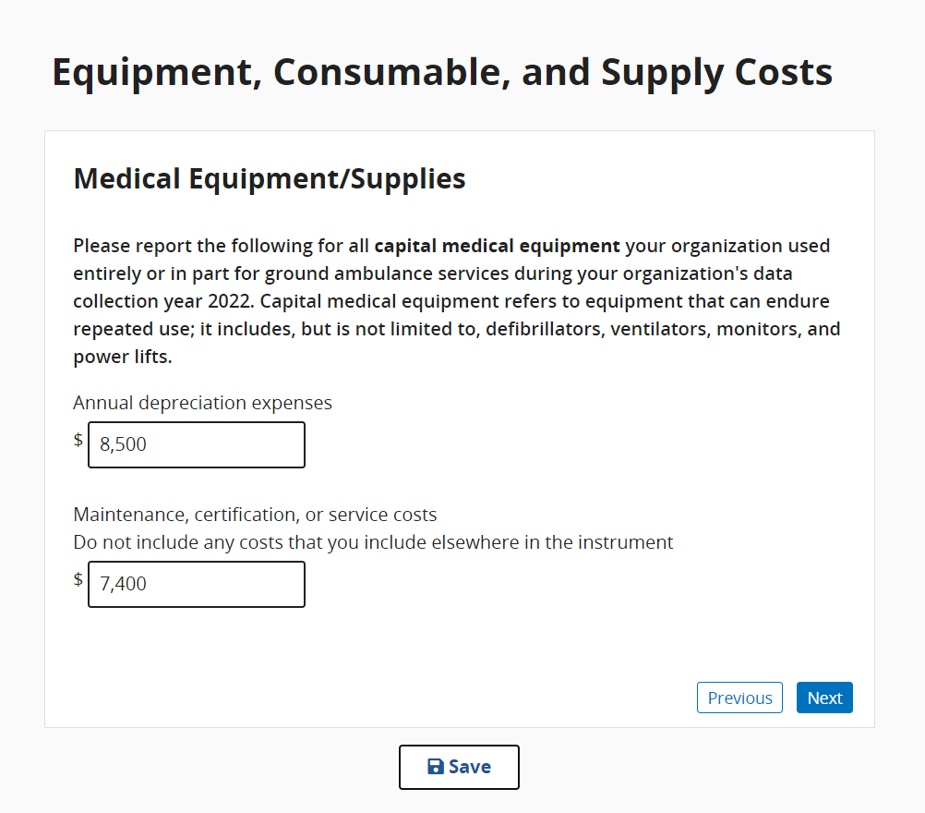

For this question, be sure to select ALL the statements that apply.
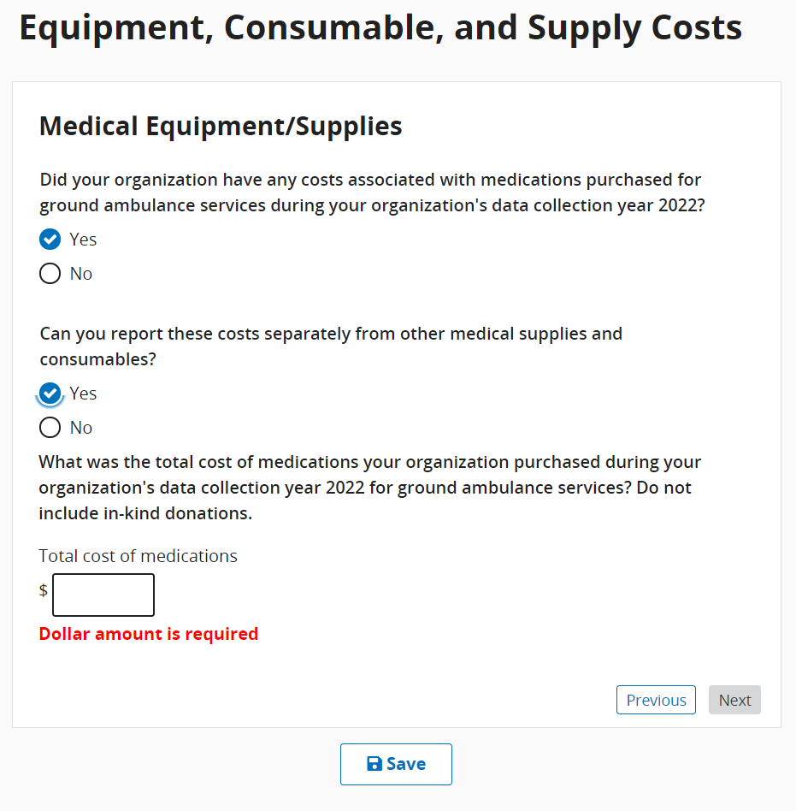

Continuing answering the questions until you complete this section.
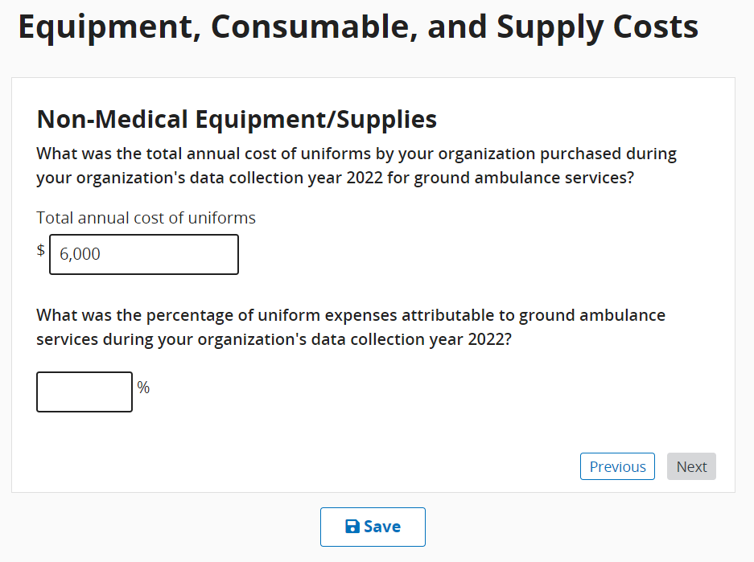
For this question, you will only see the second part if you indicate your organization has shared services.
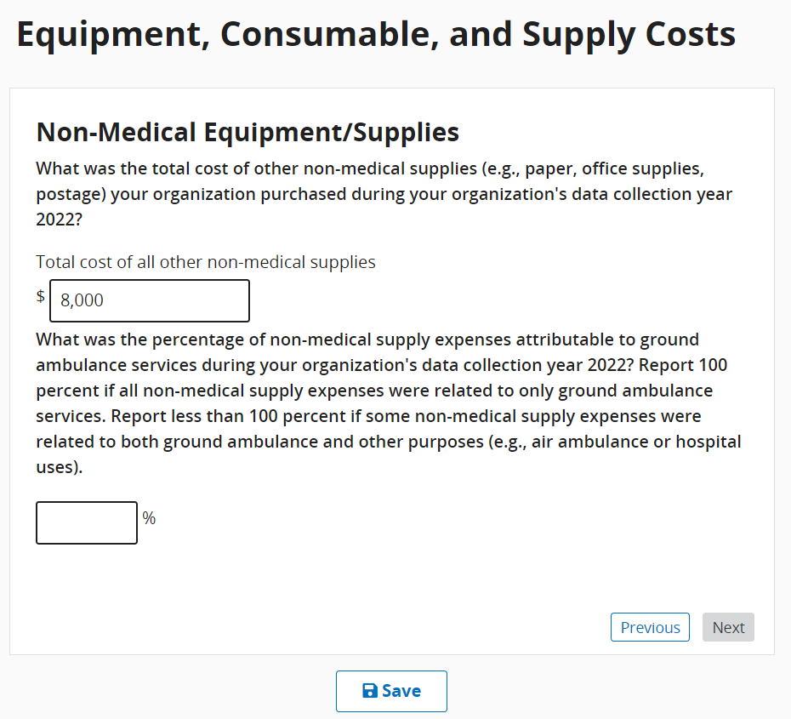
You will see this question if you indicate your organization has more than one NPI to bill Medicare for ground ambulance services.
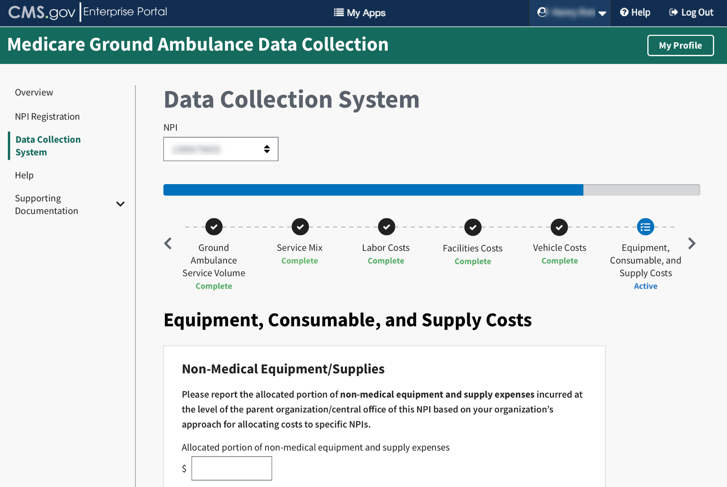

When you reach the end of this section, click Save and then click Next Section.

Other Costs
The beginning of this section has instructions on how to answer the questions for additional costs.
Once you have finished reading, click Start to begin.
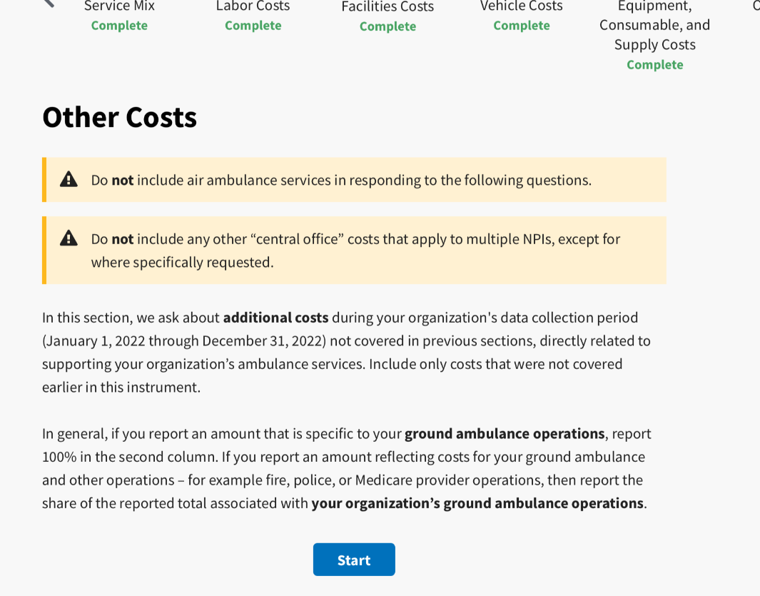
For the first question, you must check the box for all that apply, and only then will you be able to fill in the dollar amount and percentages.
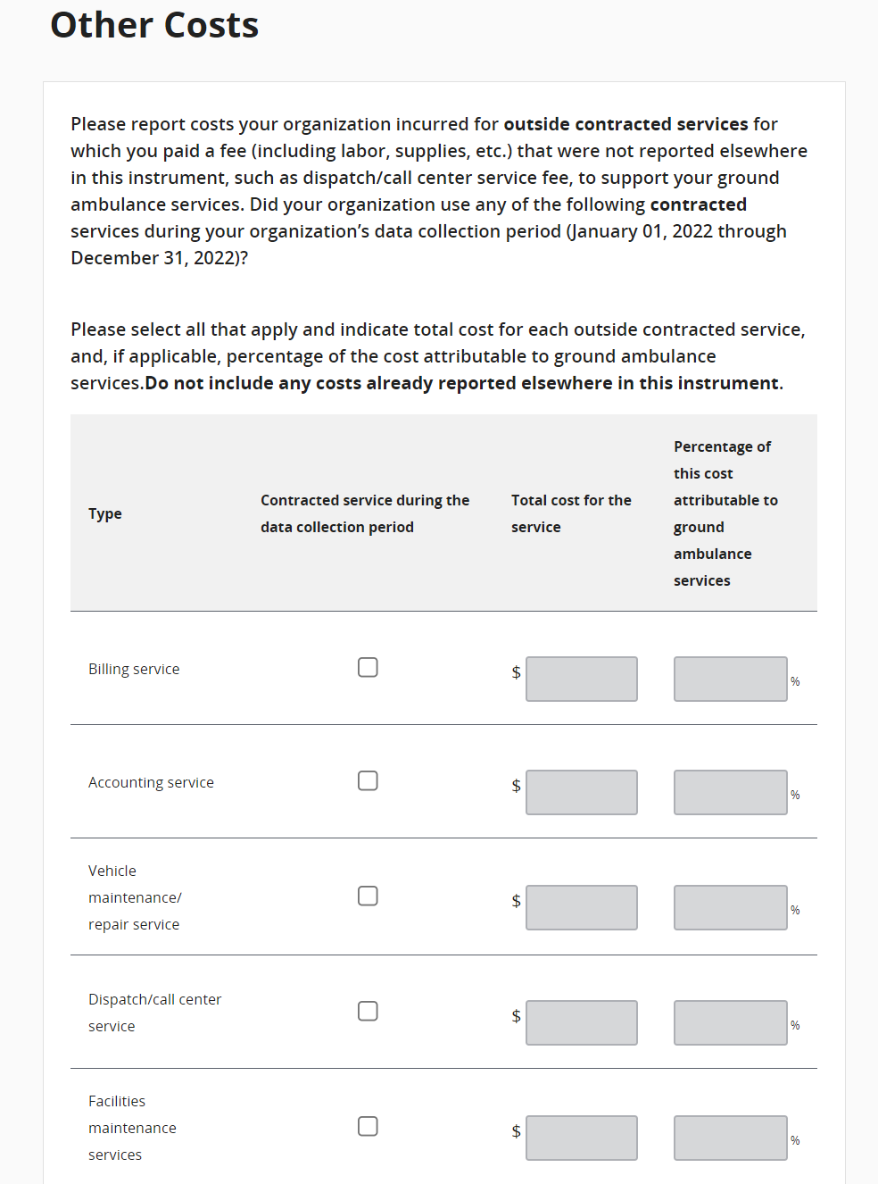
If you select “Other” you must write in a description.
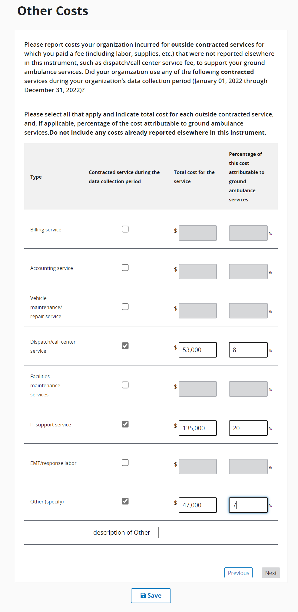

For this question, be sure to check all statements that apply to your organization.
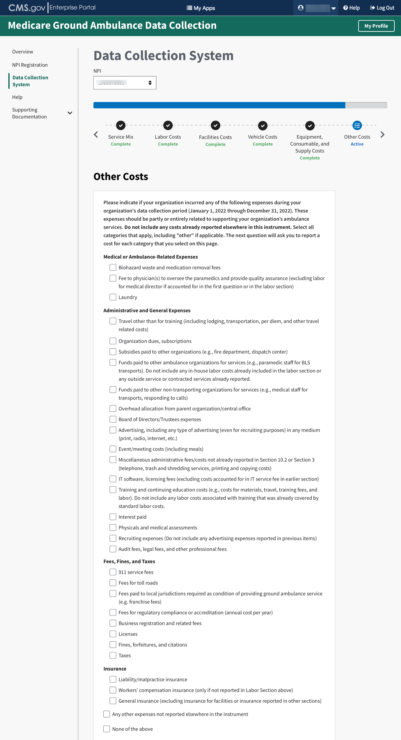
Continue answering questions until you complete the section. The sources you will see listed are based on the categories you selected previously. The percentage total does need to equal 100%.
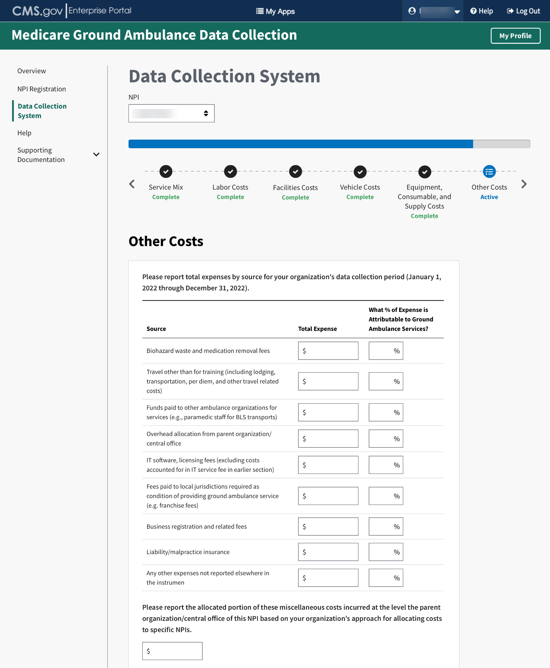

Total Costs
Enter in the total of your organization’s costs.
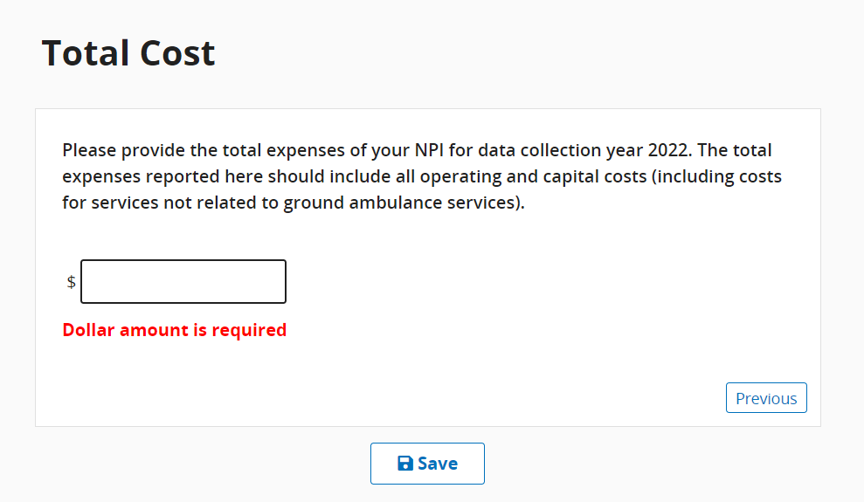

Revenues
This section asks about your organization’s sources of ground ground ambulance revenue. Click start to begin.
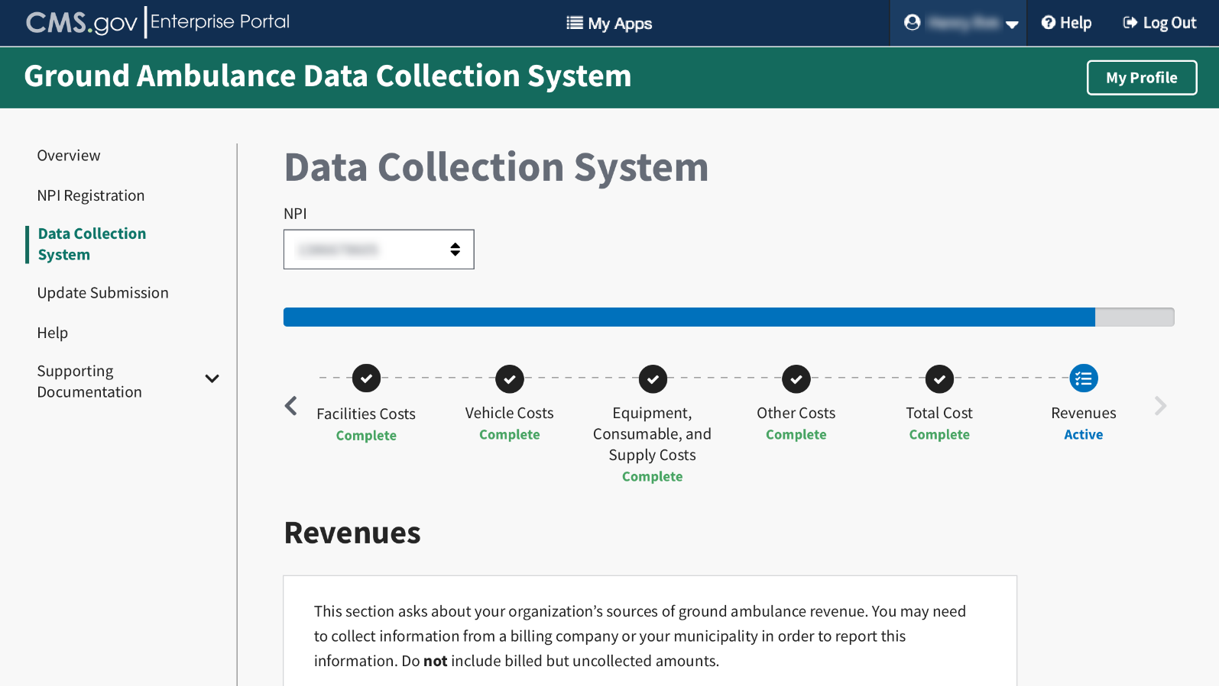
You will report your total revenue from all sources your organization received during your data collection period.
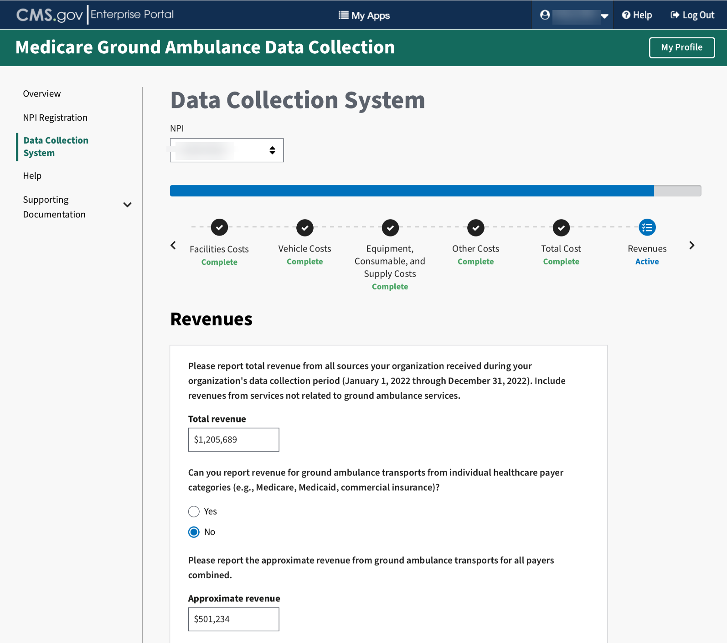
For this question, you will check the boxes for all the sources of revenue that your organization received during your data collection period. You will only be allowed to enter data for the sources where you check the box.
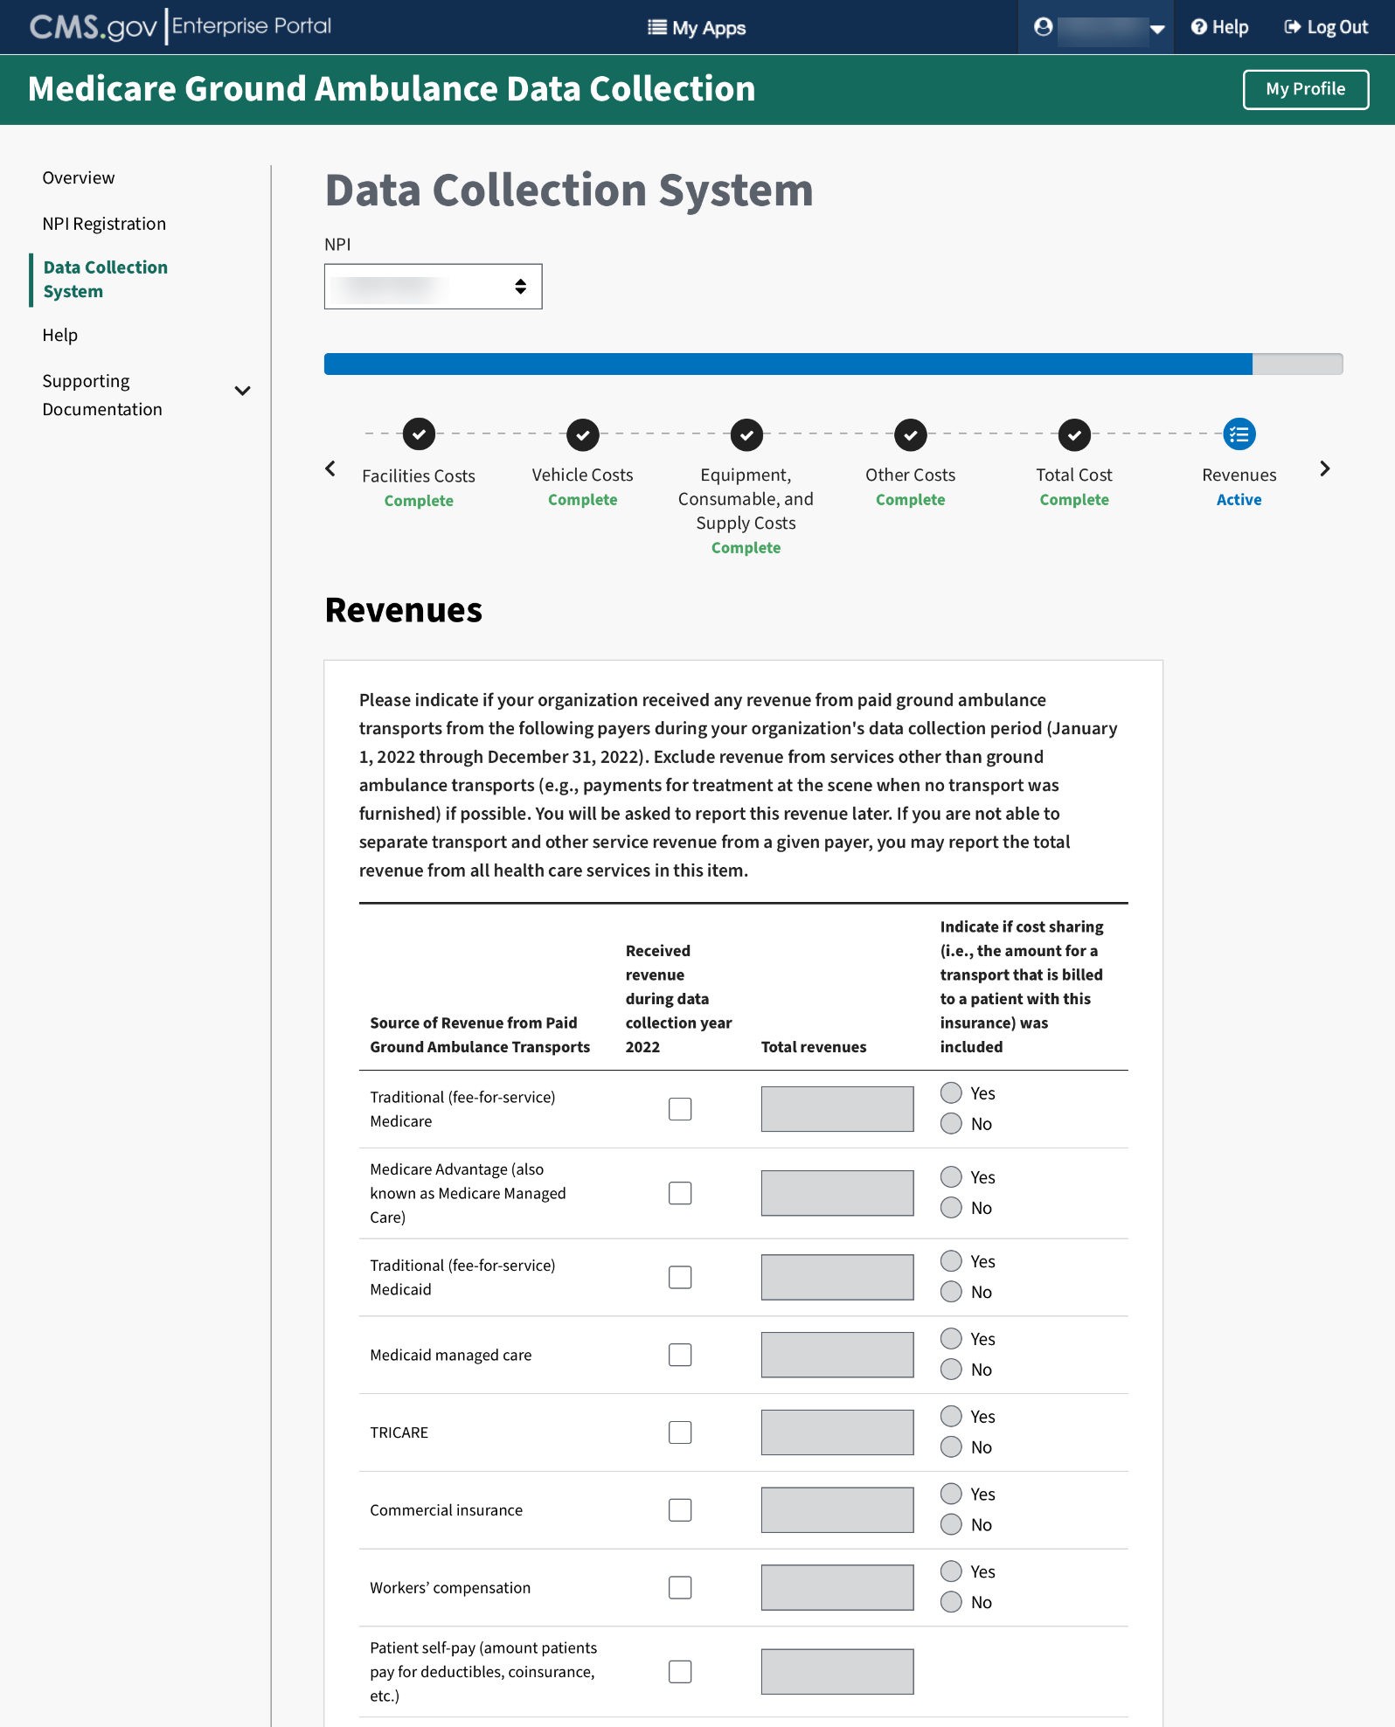

Choose the response that best applies to the payers that your organization billed during your data collection period..
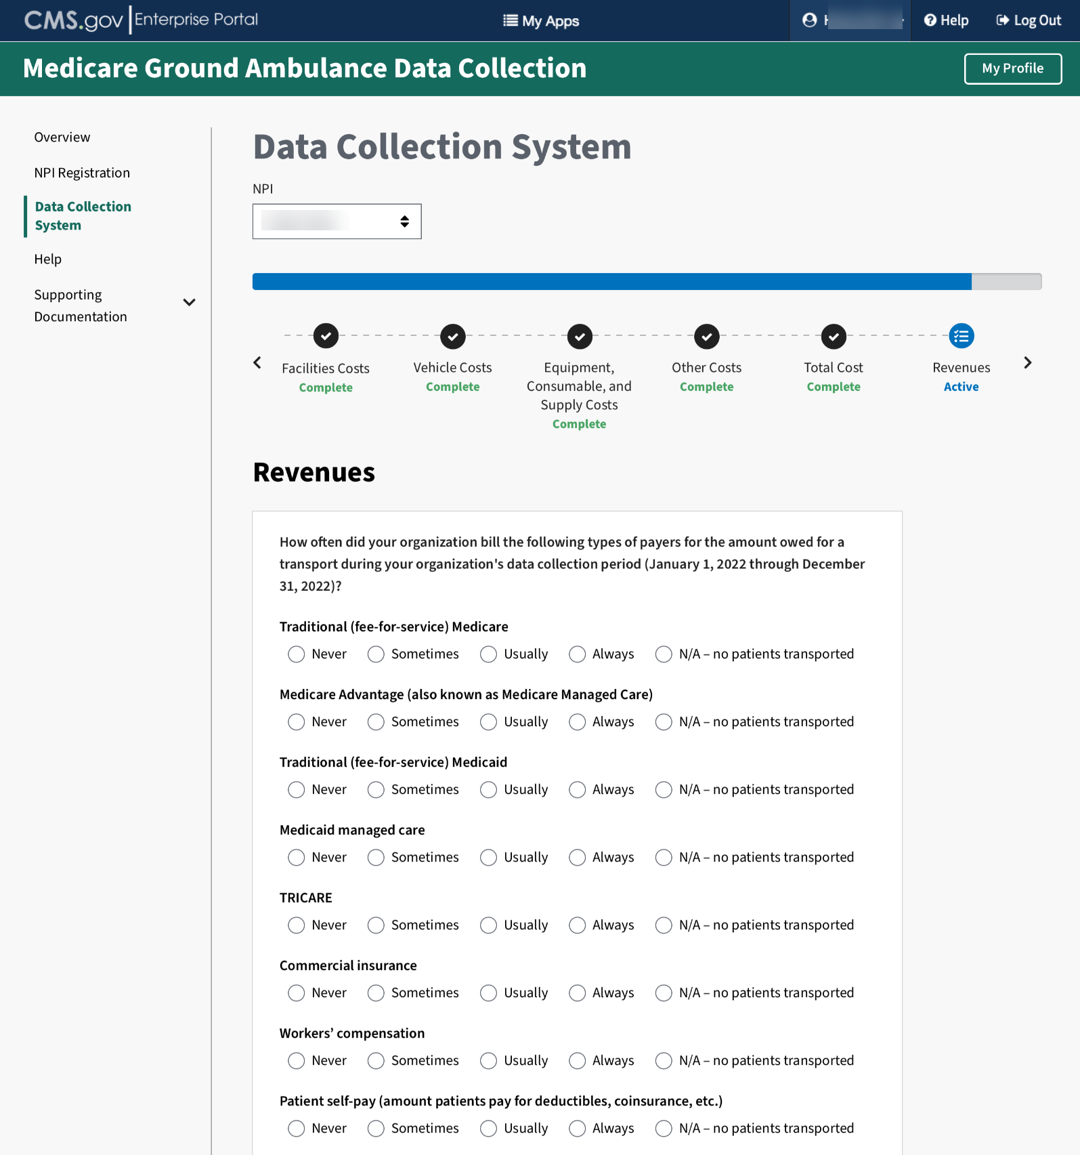

Check all that apply regarding the sources of revenue. You will only be able to enter amounts in the fields you select.
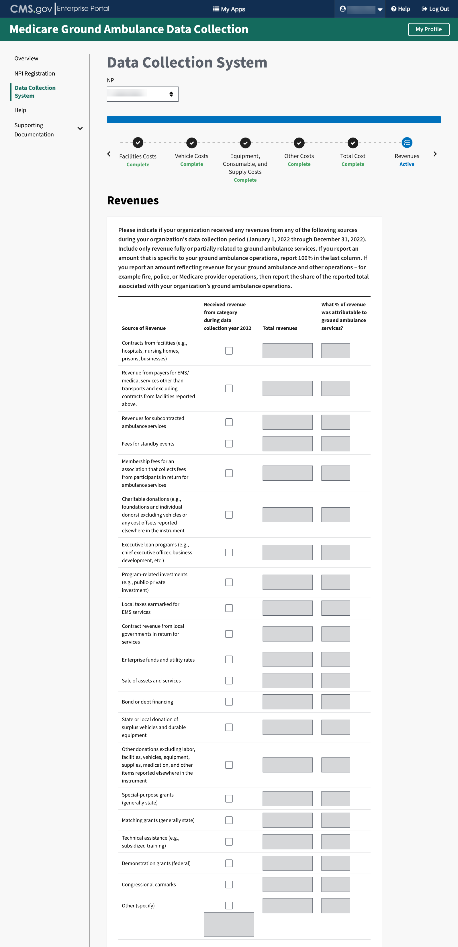
This is the final section of the instrument. If the submitter has completed all the other sections, you can choose to review or submit your responses.
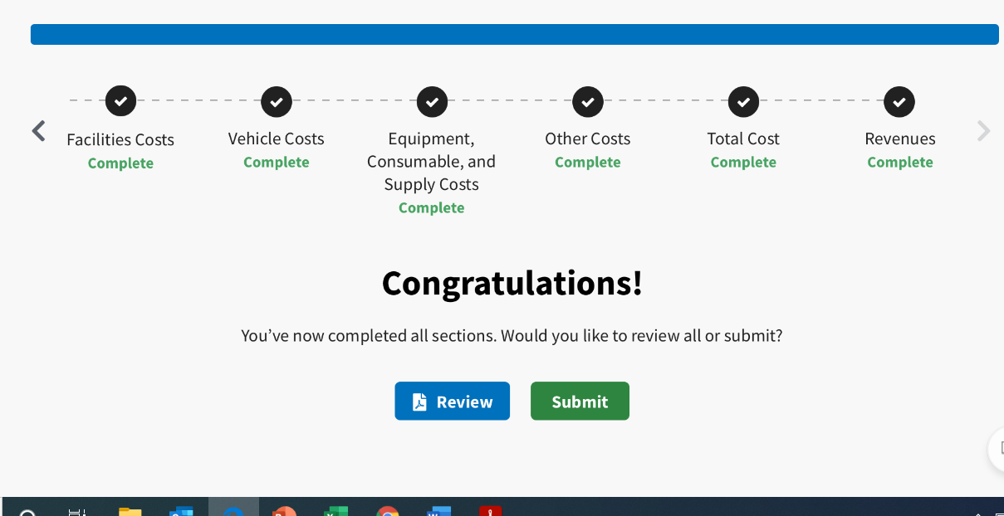
Once you are ready, click the Submit button.
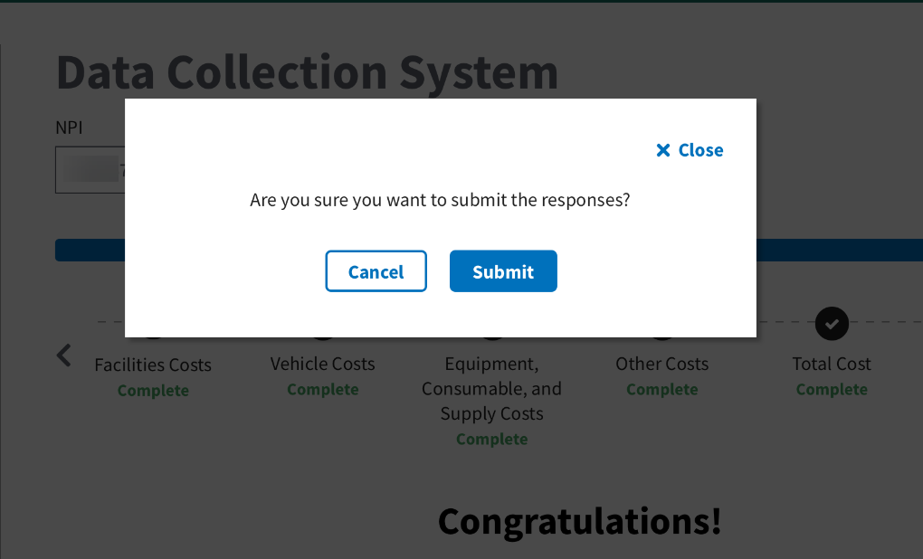

Once the Submitter have reported all of the data and saved the entries, the Submitter will be prompted to email a notification to the Certifier that it is ready to review.
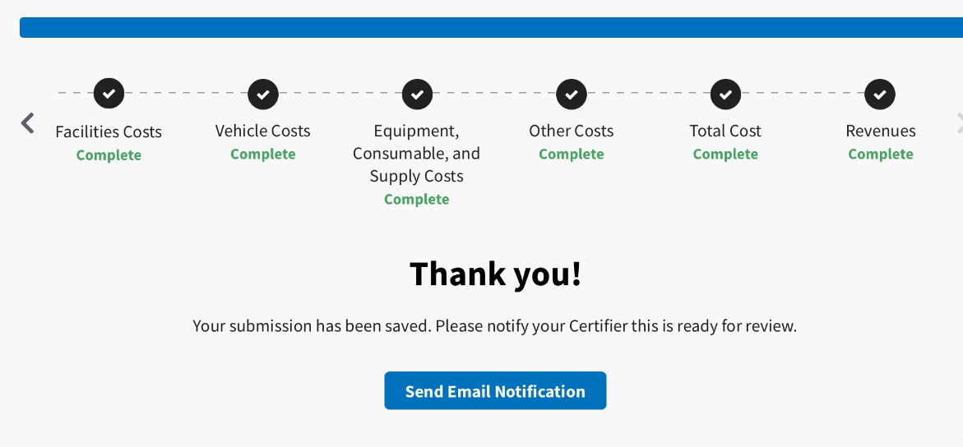
The From, Subject, and Message fields will be auto populated. You must enter the certifier’s email address.
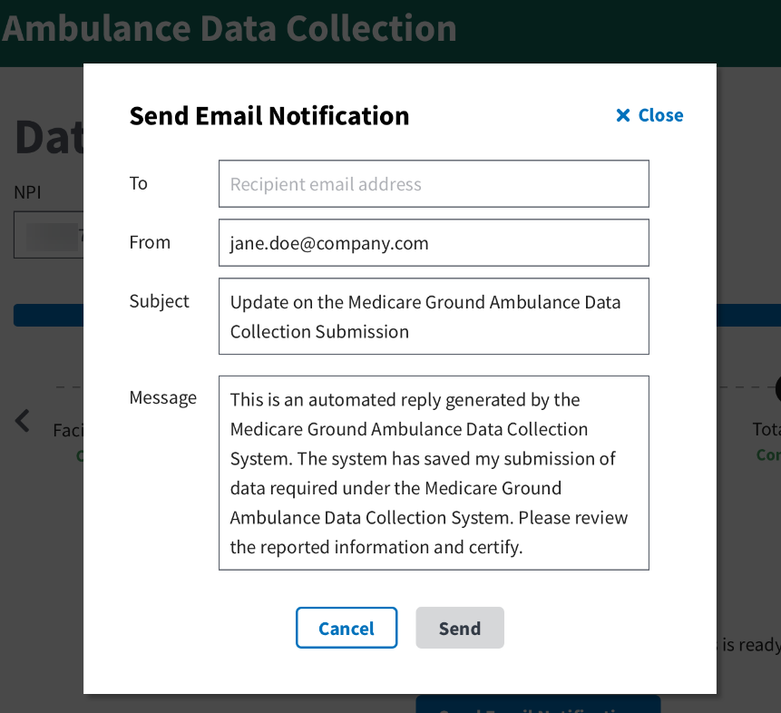

Click send to notify the Certifier the data is ready for their review.
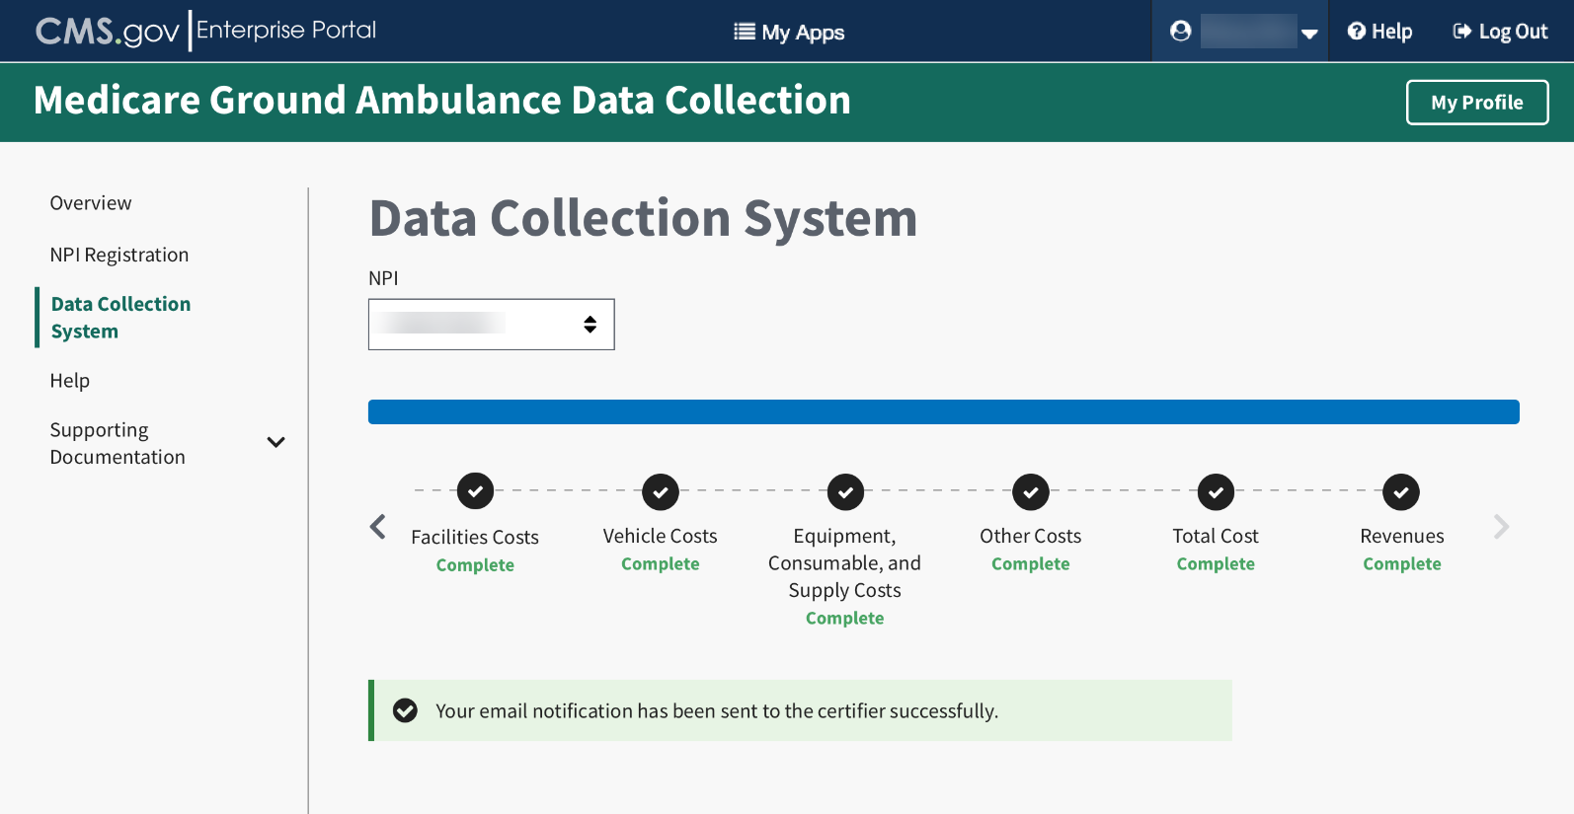

Certifier Landing Page
Once the Certifier receives the email notification that the data is ready to be reviewed, they will log in and see this page.
Click Review Submission to review the data.
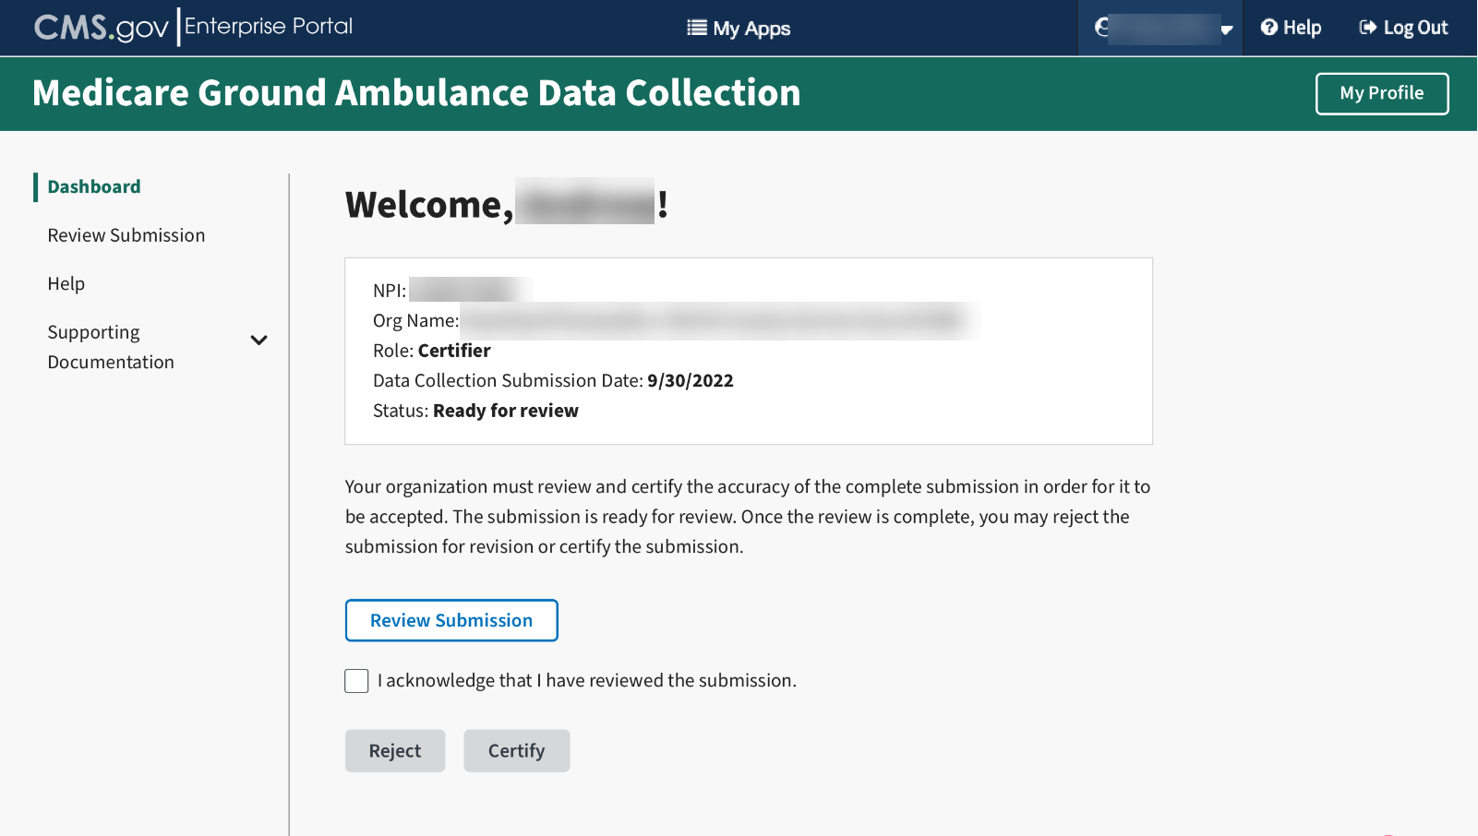
The Certifier must then review the data.
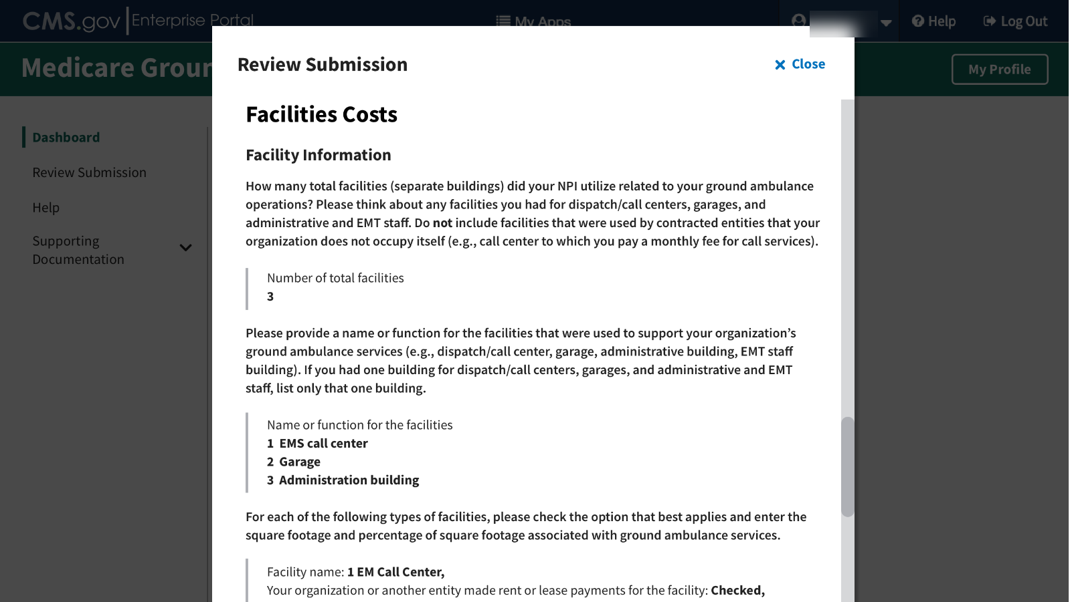

If the data is correct, the certifier will then click the box to acknowledge they have reviewed the data, and then click the Certify button.
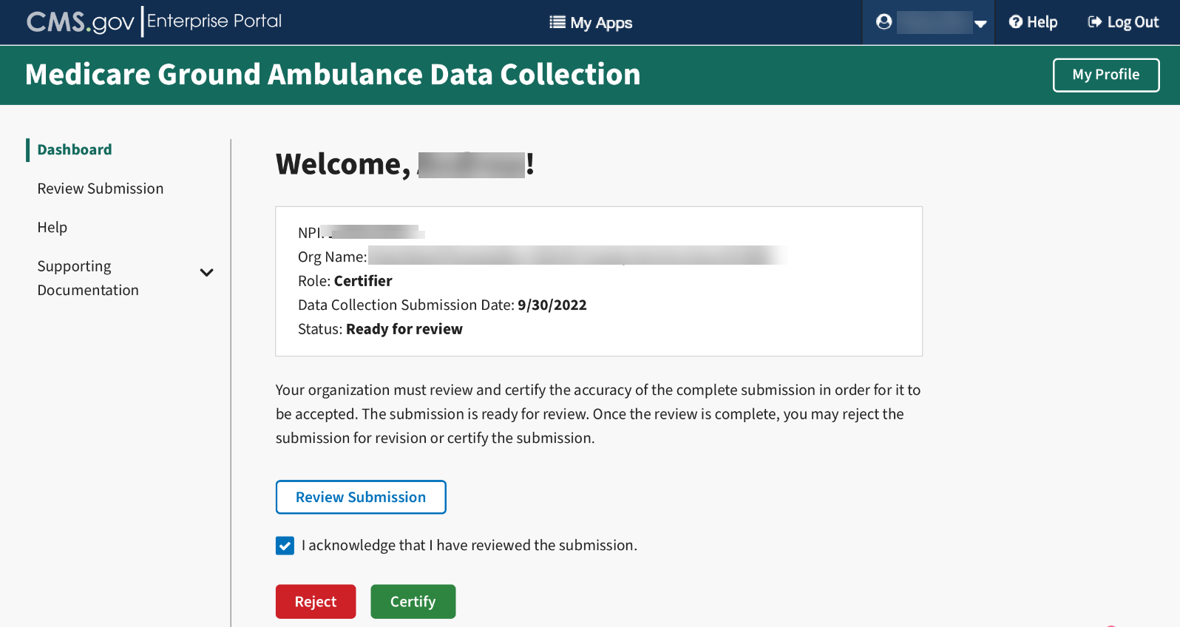
After you review the submission, if you must reject it for any reason, click on the Reject button. You will be prompted to check off any sections that require further review and space to provide information to the Submitter on what data needs to be reviewed. The submitter will receive an email with this information.
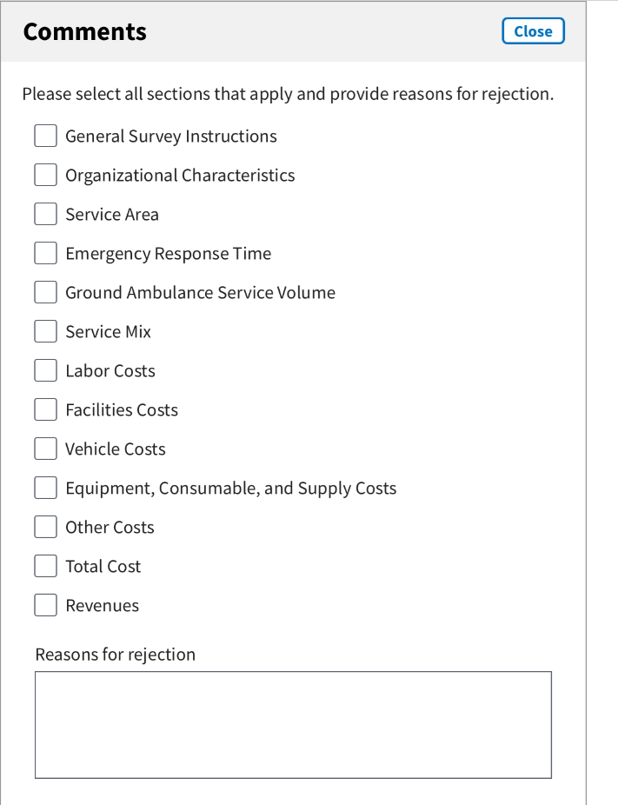

If the data is accurate and the submission is complete, The Certifier will click the Certify button.
The Certifier will see a pop-up screen asking for their certification.
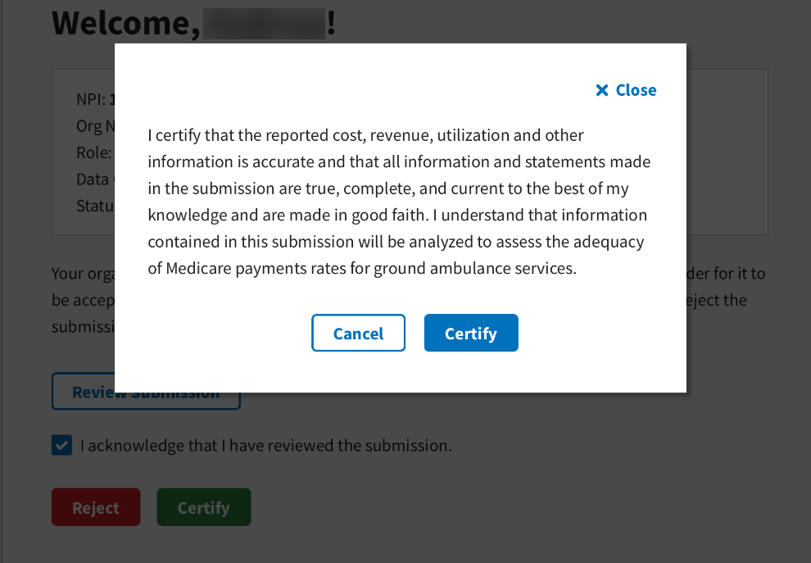
Once you click the Certify button, you will see this screen.
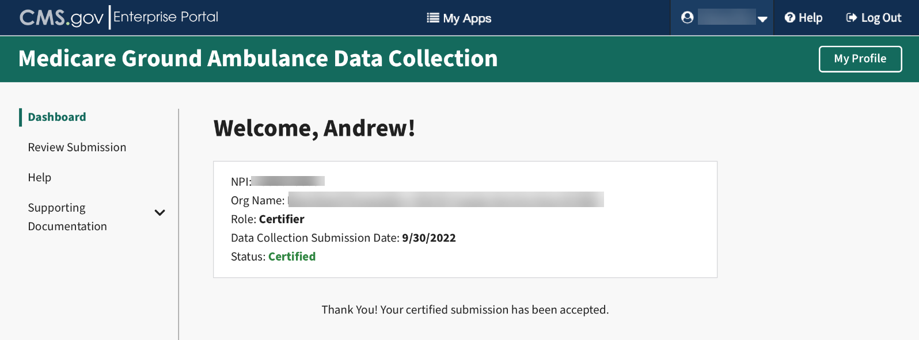
Congratulations!

