Justification of Non-Material Change
For Regulations Pertaining to Certain Investments in the United States by Foreign Persons and Regulations Pertaining to Certain Transactions by Foreign Persons Involving Real Estate in the United States
1505-0121

The Department of Treasury is submitting a request for non-material change to OMB Control Number 1505-0121 in order to streamline applications through the Committee on Foreign Investment in the United States (CFIUS) Case Management System in which parties submit their notices and declarations through an online portal.
The information collected by CFIUS is not changing, just the format in which certain responses are collected. There are five proposed field changes.
The first (see screenshot 6) would change one of our fields from required to optional. This would bring the form more in line with our regulations, which do not state that such information is necessary in order to file.
The second (see screenshots 4 and 5) would split information currently entered in one box into two boxes. Parties currently provide the case numbers for all of their prior CFIUS filings under one textbox. The proposed change would create a separate designated box in the notice forms for the case number of a declaration regarding the same transaction that is the subject of the notice, if the transaction was previously filed as a declaration. This information is helpful to have highlighted for reviewers and will allow us to begin processing the application more efficiently. It will also allow the system to automatically link the current filing with the information the parties previously provided.
The third (see screenshot 2) would also split information currently collected in one box into two boxes. We currently ask parties whether they have received or have placed DO orders in a single textbox on the portal. However, whether DO orders have been “received” or “placed” are separate prompts in our regulations and print as two questions on the official form printout. Currently, when viewing the printout, it is not possible to tell which question parties are responding to. Separating responses to these questions into two boxes will prevent us from having to email the parties after their submission to clarify.
The fourth and fifth proposed changes (see screenshots 1 and 3) will each add an optional freeform textbox to the structured input we currently allow for two of our questions. Currently, when parties are providing information on their facilities manufacturing products or producing services for the United States Government (USG) or their contracts with the USG, the form only allows for responses in the form of a structured table listing such contracts or facilities and a yes/no dropdown. If the parties need to provide additional relevant information, such as the fact that they are in the process of renewing one of the listed contracts or applying for a facility clearance on one of the listed facilities, there is no place to provide such details under that prompt. Instead they provide that information by including it in the summary section at the top of the form or in the “additional information” section at the end of the form. These optional textboxes would provide parties a place to enter such information in a more relevant location on the form, facilitating both the entry and review of such information.
These changes will not affect the currently approved burden under 1505-0121.

Part 800 Notice Form (30, 44, 45, 49, 110)
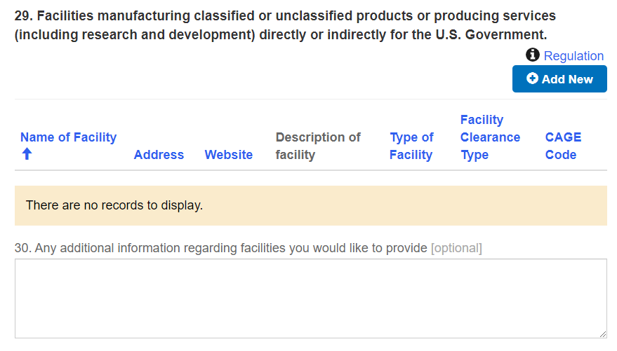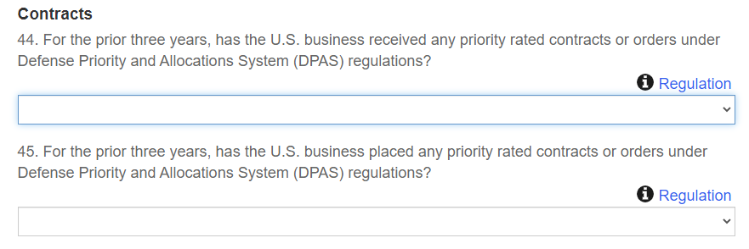
2.
1.

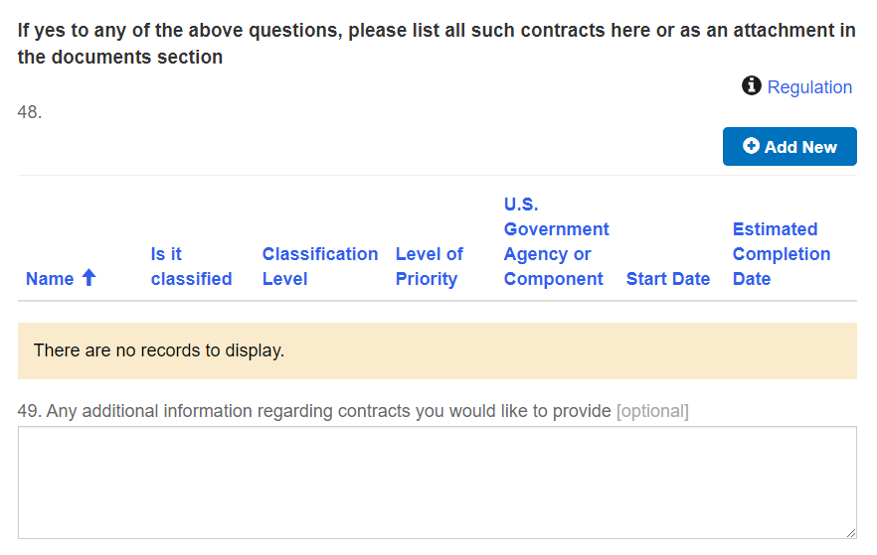
3.
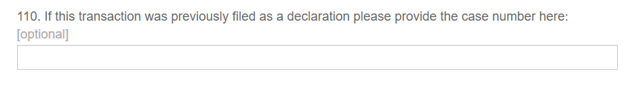
4.

Part 802 Notice Form
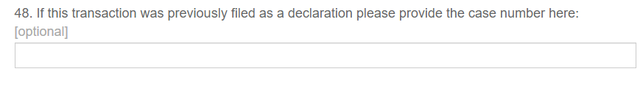
5.

Part 800 Declaration Form
6.


