Community Assistance Visit (CAV) Community Visit Report Screens in the NFIP Community Information System (CIS)
https://sso.fema.net/cis/homepage.action

PAPERWORK BURDEN DISCLOSURE NOTICE O.M.B. No. 1660-0023 Expires 4/30/2017
Public reporting burden for this data collection is estimated to average 60 hours per response. The burden estimate includes the time for preparing for the CAV field tour and meeting, conducting the field tour, conducting the meeting, searching existing data sources, writing the report, gathering and maintaining the data needed, and completing and submitting this form. This collection of information is required to obtain or retain benefits. You are not required to respond to this collection of information unless it displays a valid OMB control number. Send comments regarding the accuracy of the burden estimate and any suggestions for reducing the burden to: Information Collections Management, Department of Homeland Security, Federal Emergency Management Agency, 500 C Street, SW, Washington, DC 20472, Paperwork Reduction Project (1660-0023)

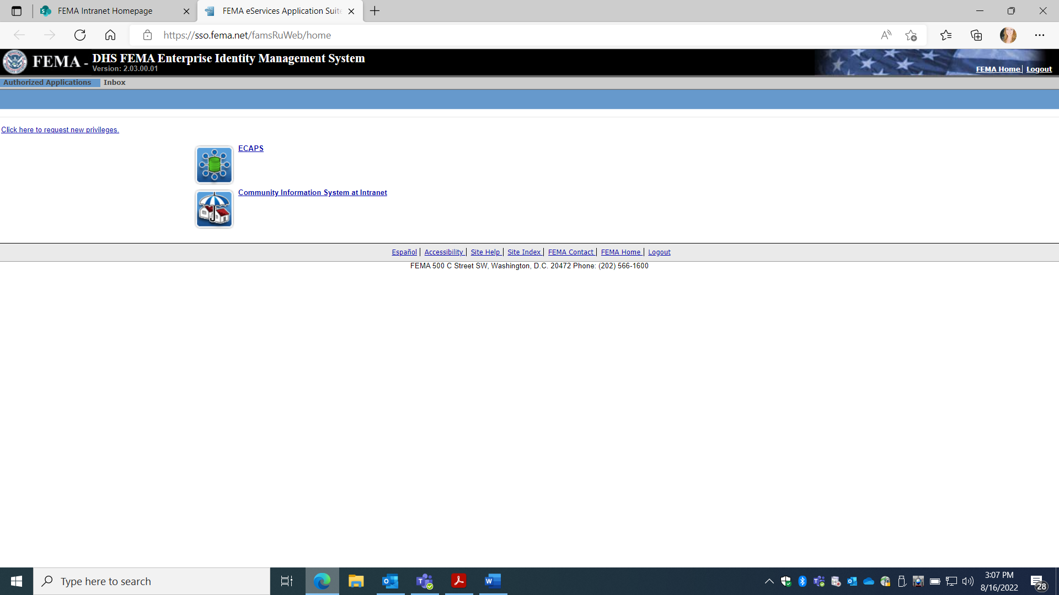
Account must be requested from NFIP CIS Administrator where Read, Add, Edit Rights provided based on Need. Once approved, the user automatically signs in with PIV card. Select Community Information System.
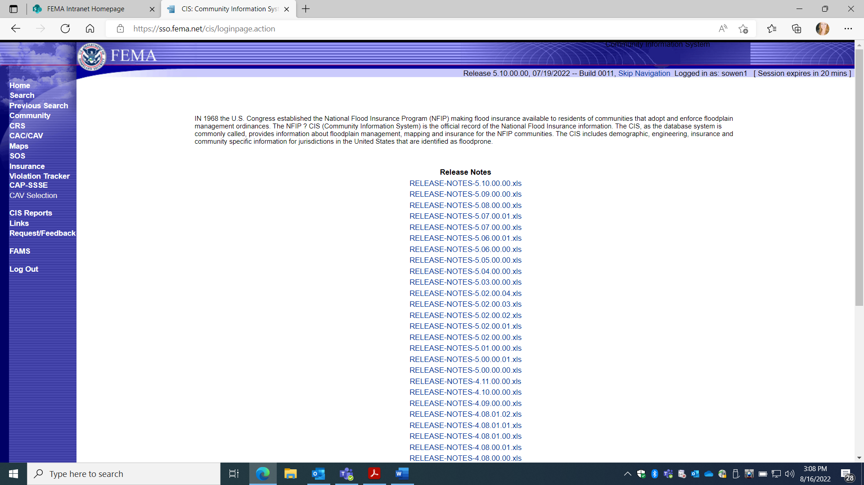
Select “Search”
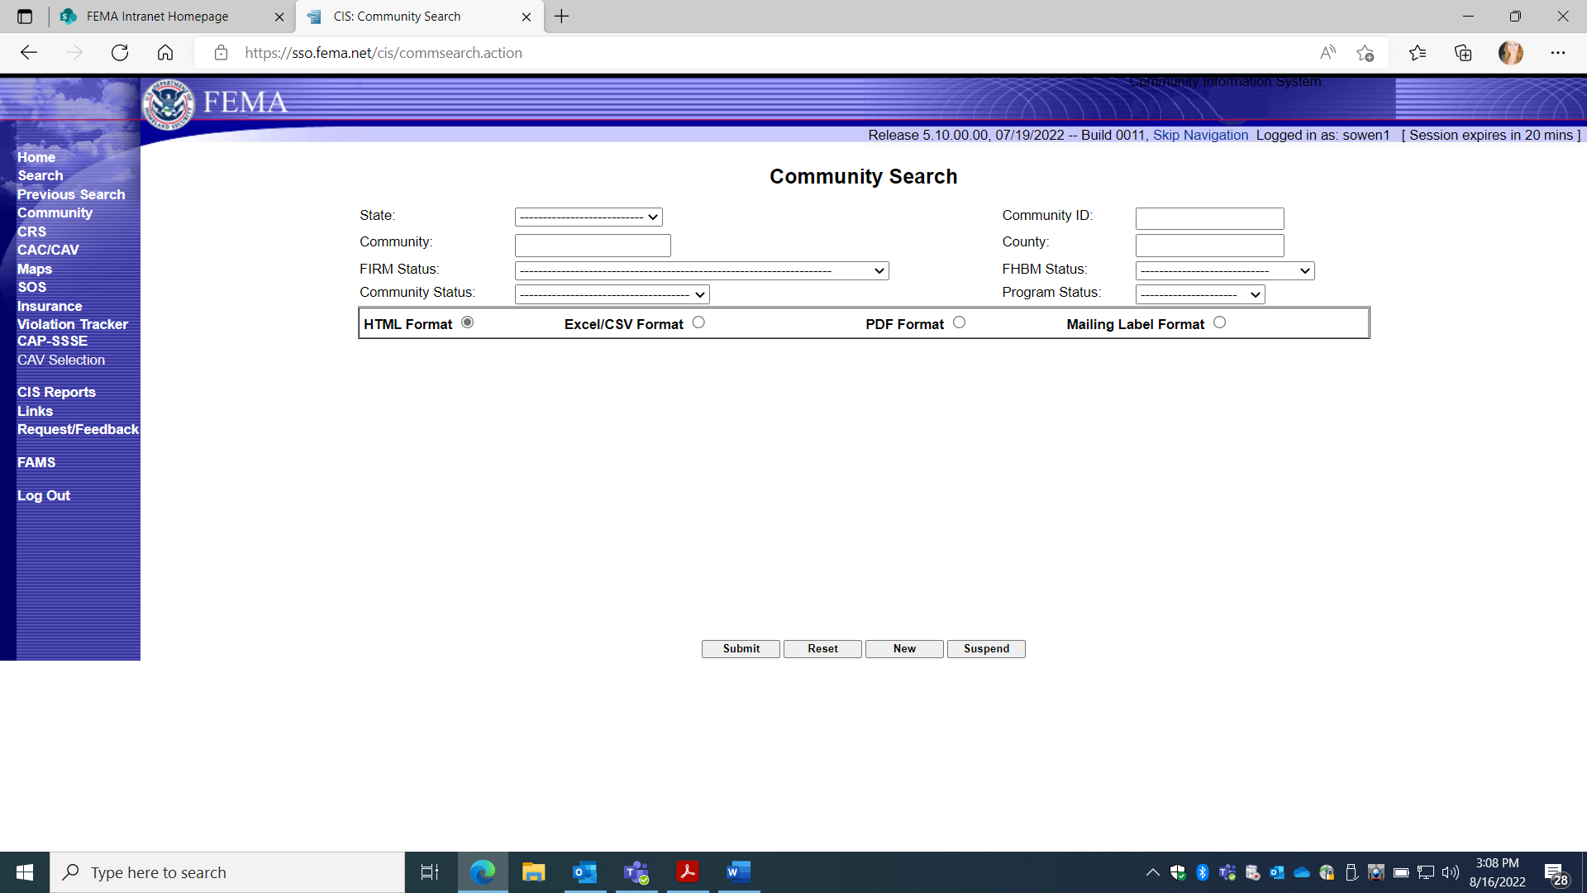
Enter Community name and State to search or unique Community ID number

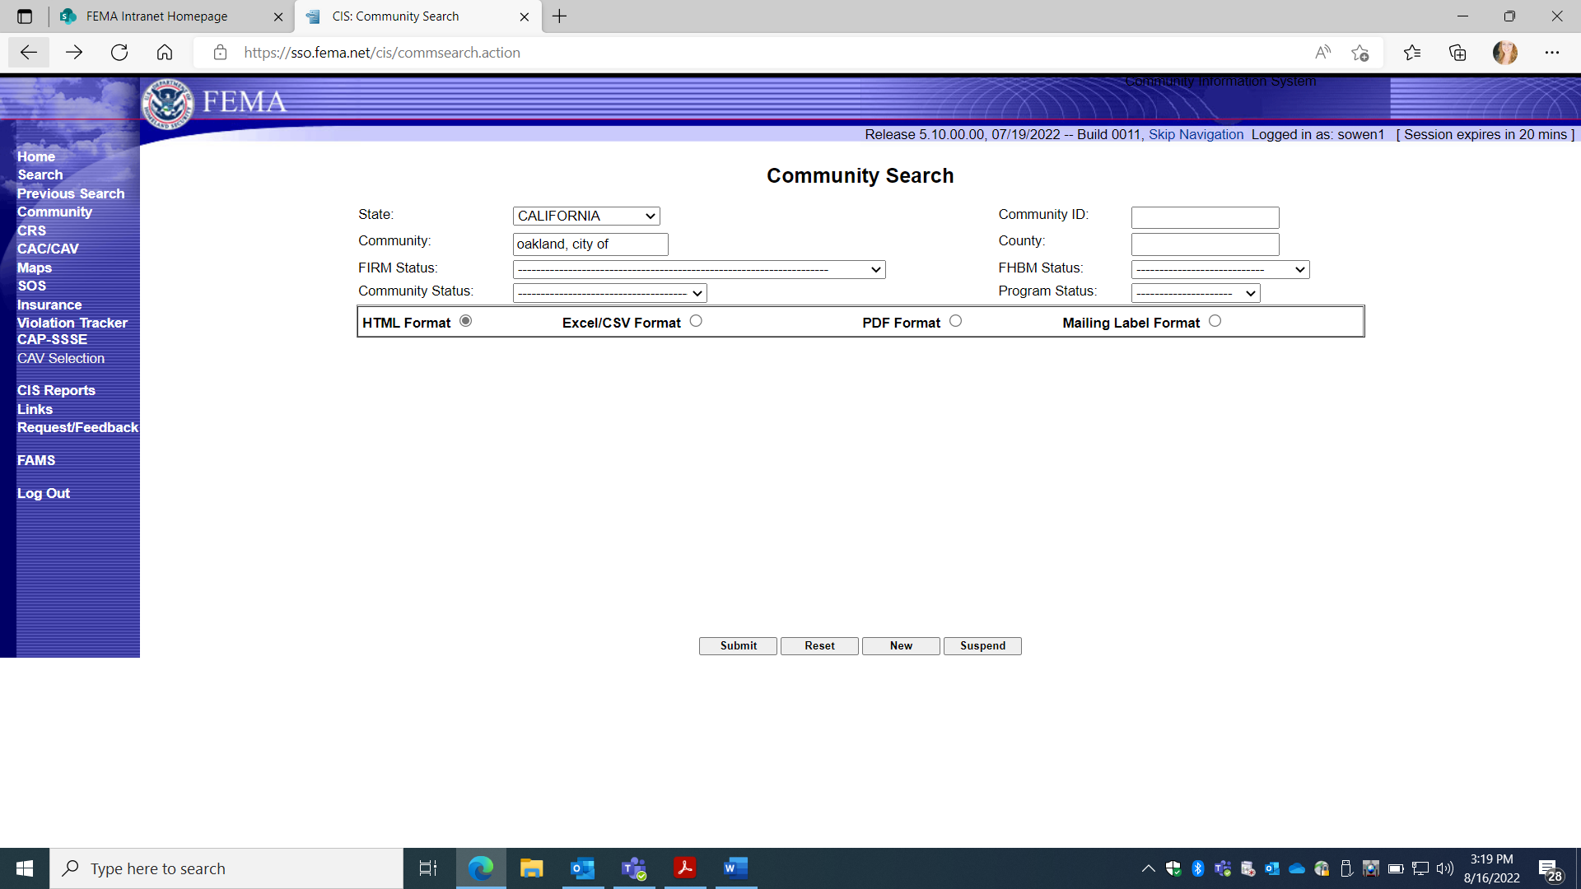
Click “submit”
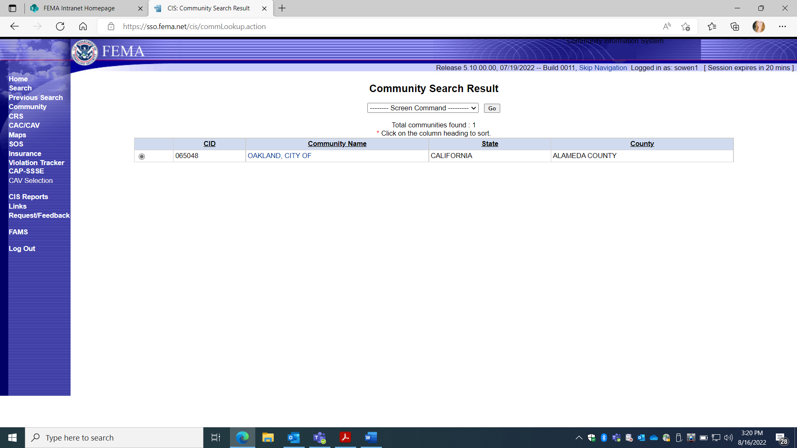
Click on Community name.

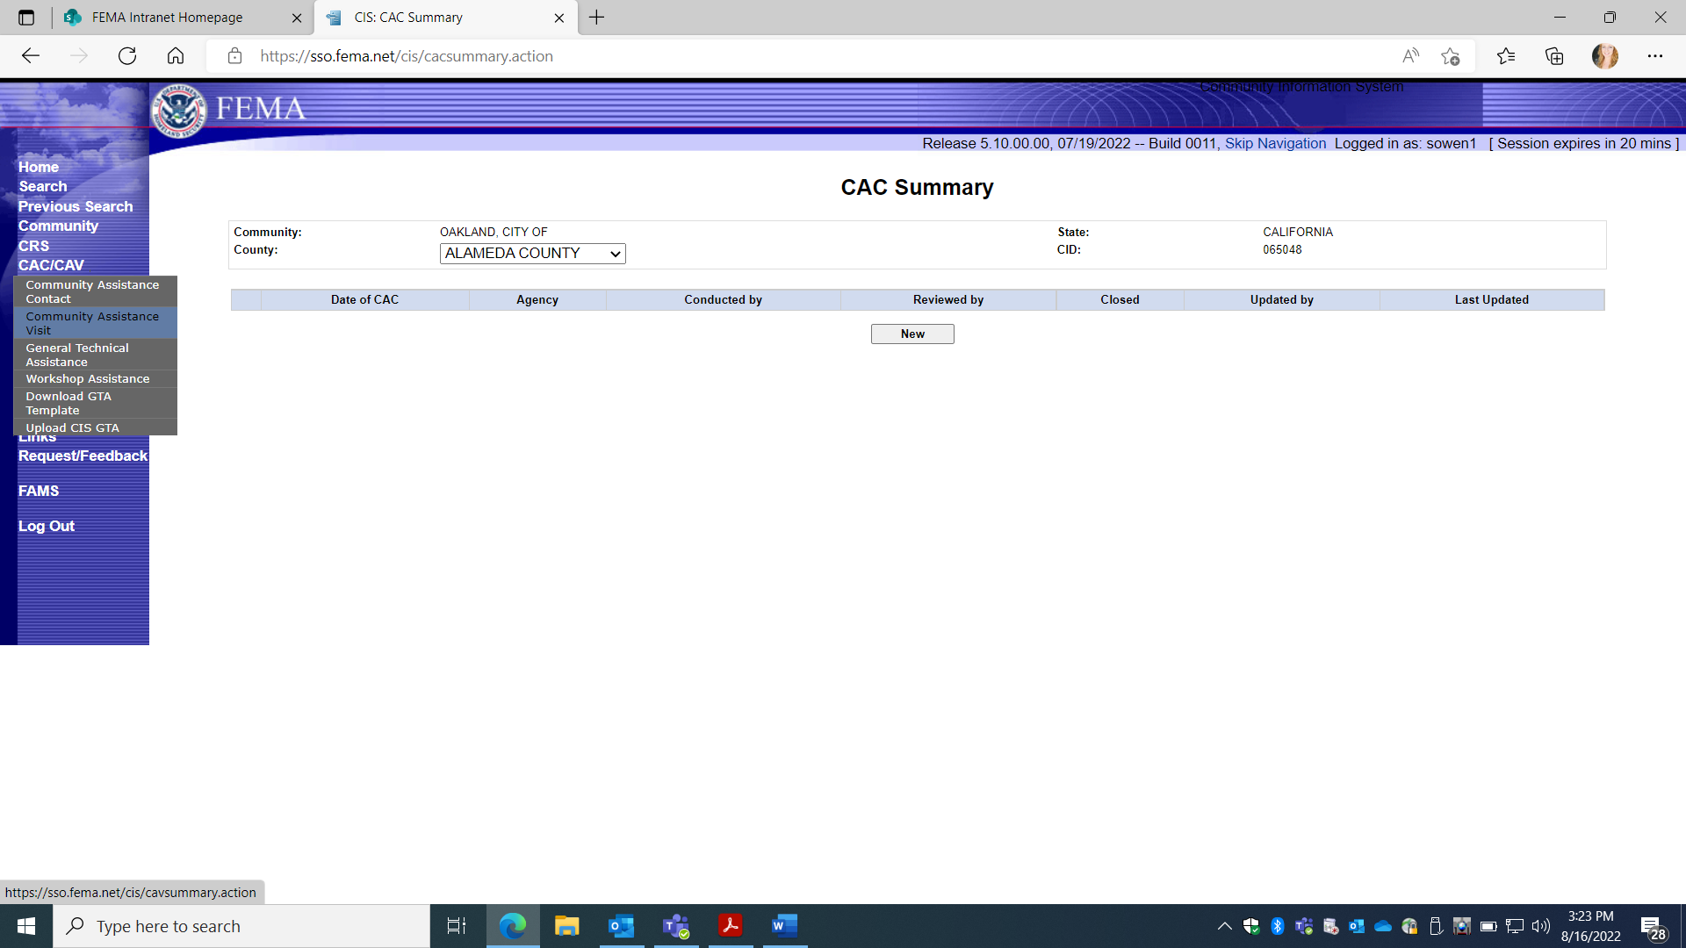
Select CAV on the left.

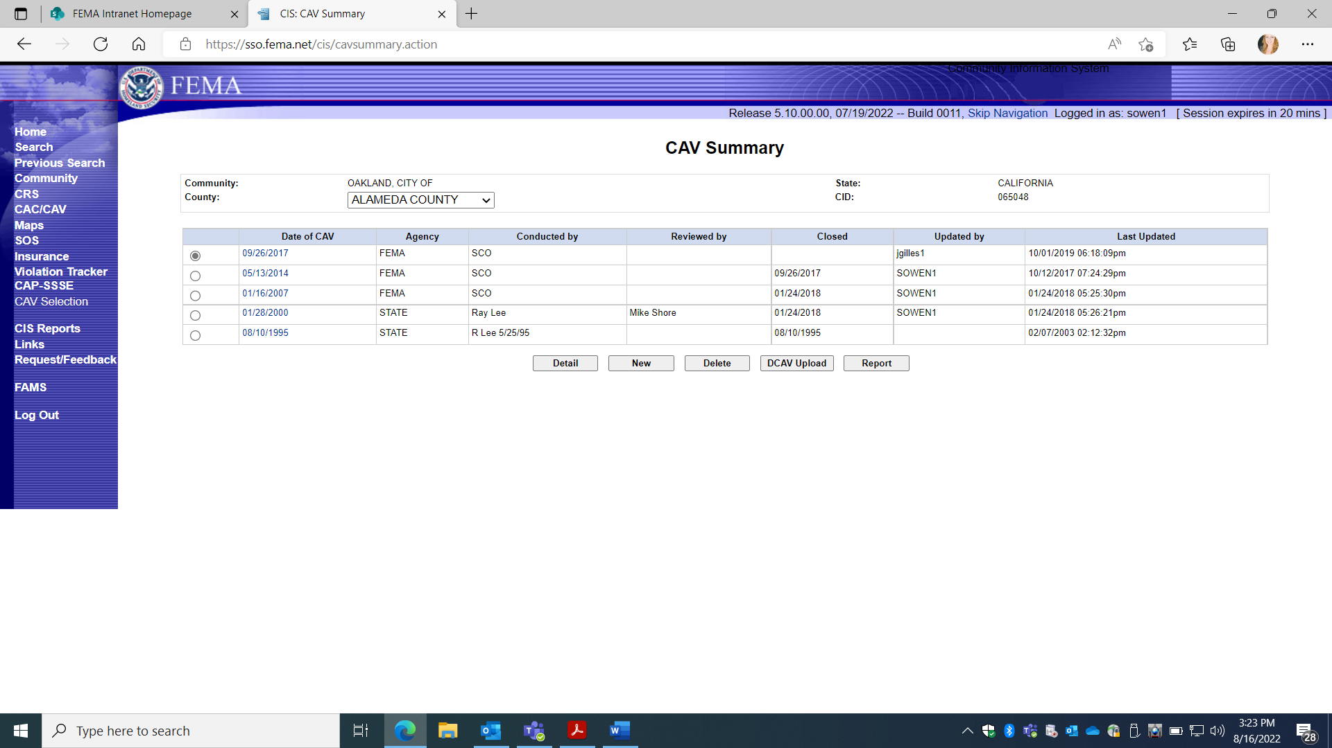
This screen reflects PRA collection Entry Information for 1660-0023, Community Assistance Visit.
Five Choices (Gray Boxes):
1. DETAIL: Loads Previous CAV Information.
2. NEW: Adds new CAV collection information.
3. DELETE: Allows an option to delete a previous CAV entry.
4. DCAV UPLOAD: Provides option for digital upload of collected data.
5. REPORT: This option Prints a report for all CAV entry fields.

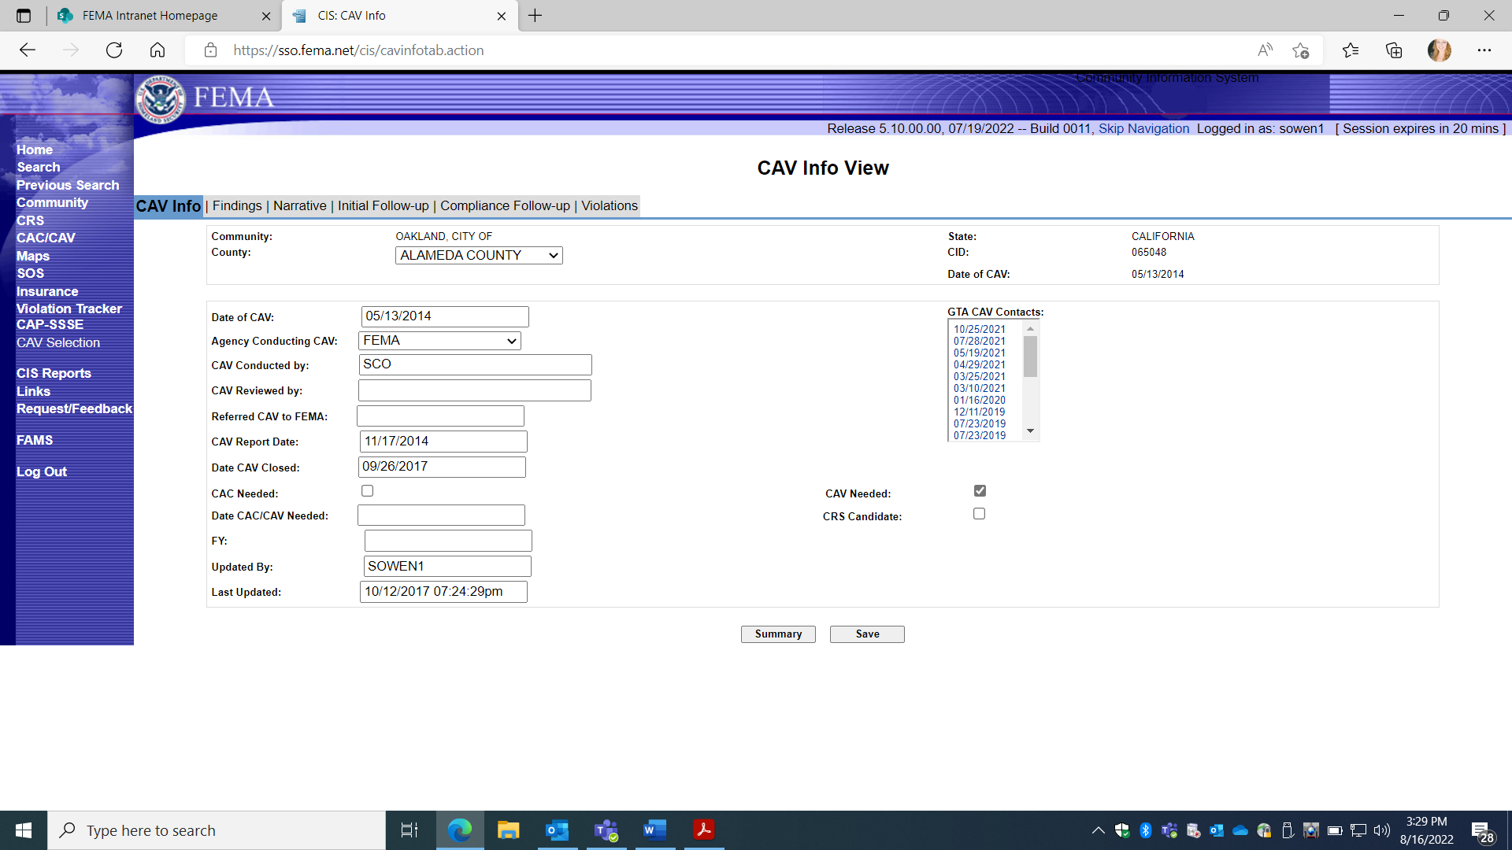

- DETAILS selection displays previously entered collection information on specific CAV, under 5 Screen TABS:
a. CAV Info; Findings; Narrative; Initial Follow-up; Compliance Follow-up

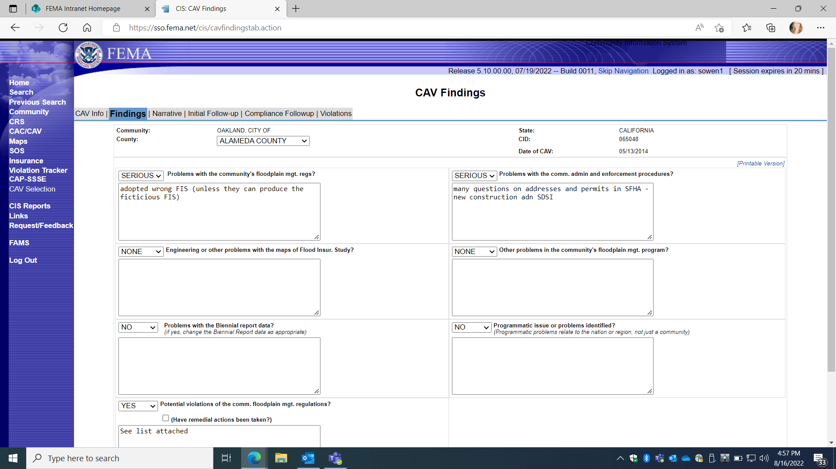
1. CAV Details:
b. FINDINGS Screen TAB

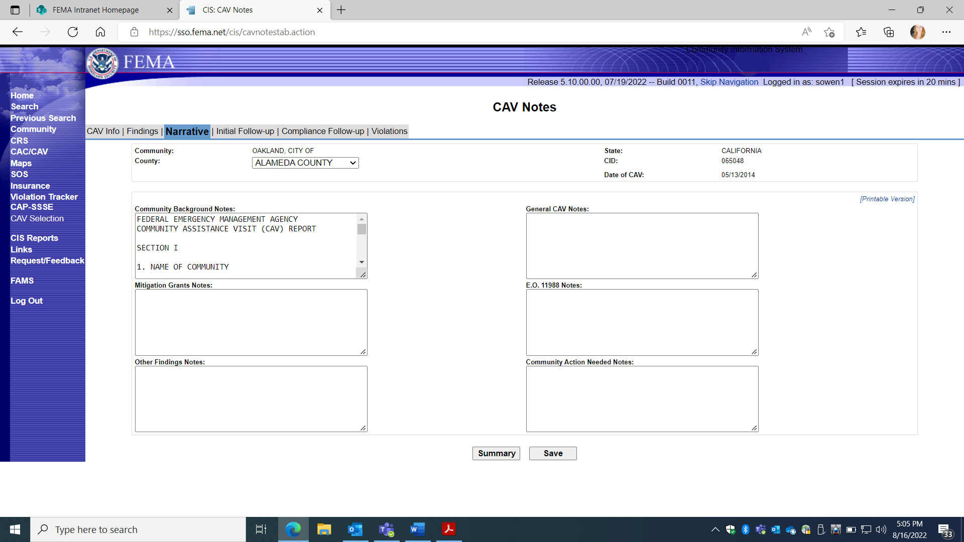

1. CAV Details:
c. NARRATIVE “CAV Notes” Screen TAB

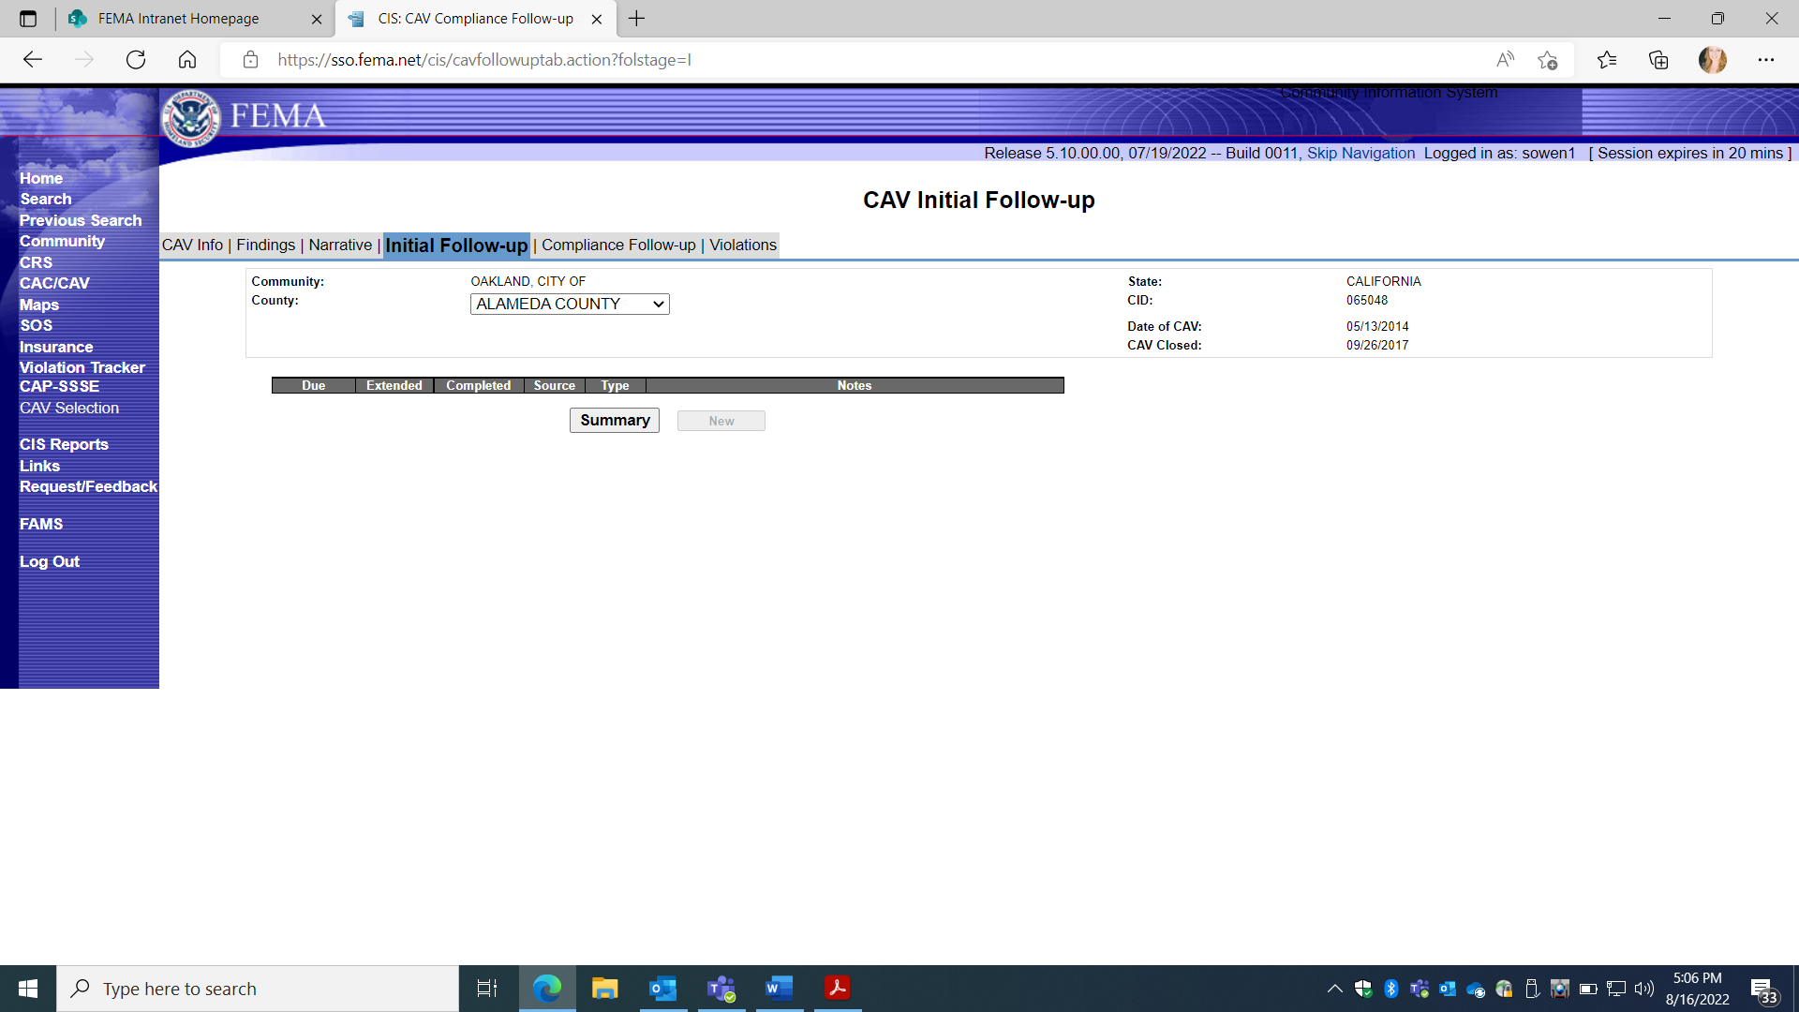

1. CAV Details:
d. CAV Initial Follow-up Screen TAB

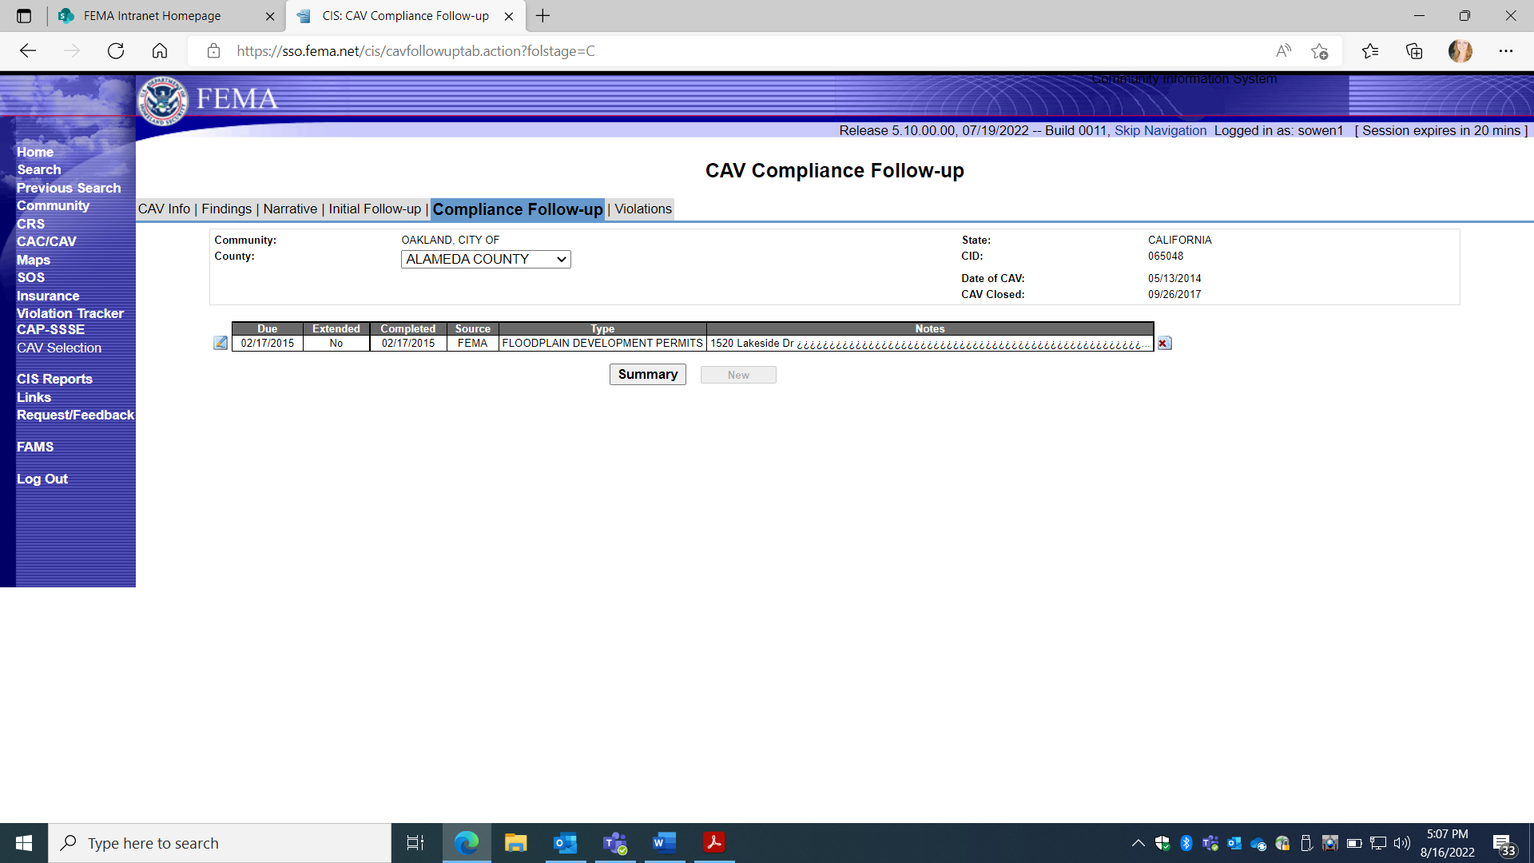

1. CAV Details:

e. CAV Compliance Follow-up Screen TAB
This TAB also displays optional additional tracking information dates if entered under sub TABs: Due; Extended; Completed; Source; Type; Notes.

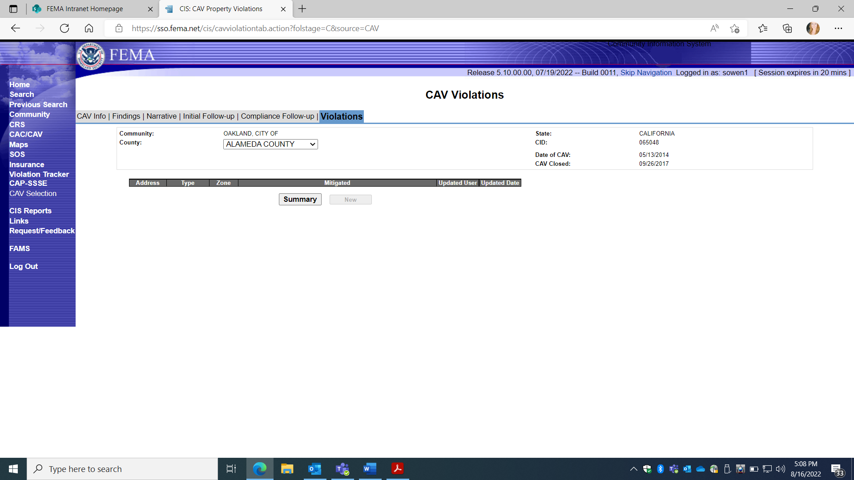
1. CAV Details:

f. Violations Screen TAB
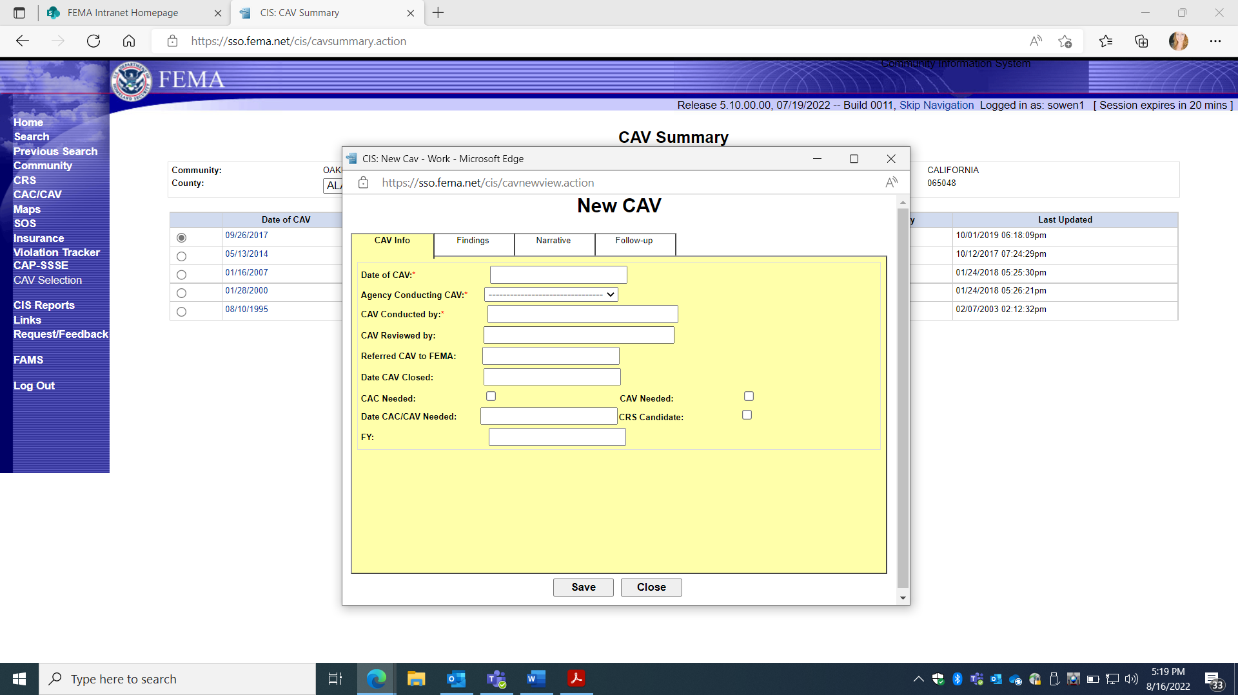
2. NEW CAV Screen TAB - 4 Data TABs to Enter:

a. CAV Info
b. Findings
c. Narrative
d. Follow-up

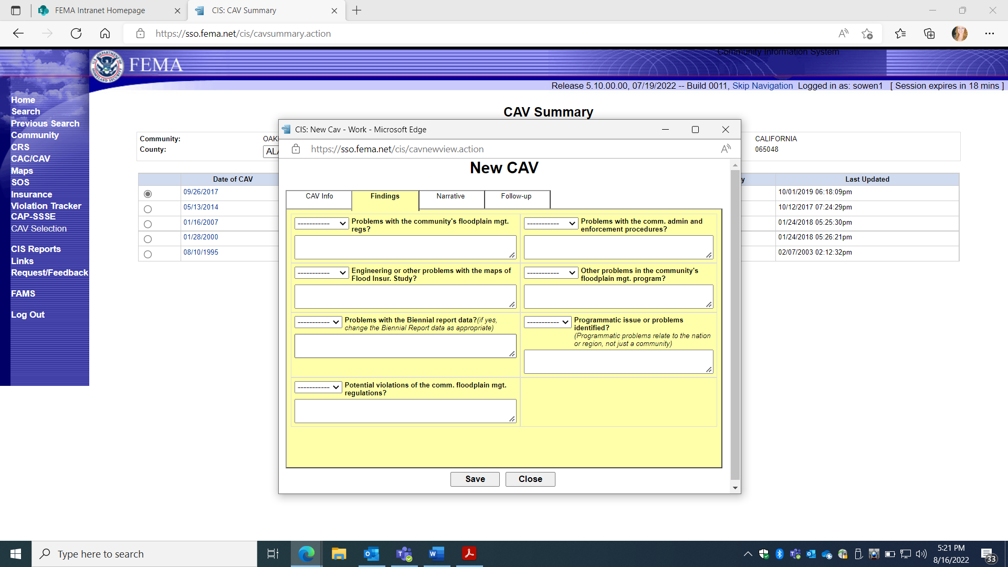
FEMA Form 086-0-28(E), Community Visit Report
2. NEW CAV Screen TAB

b. Findings TAB
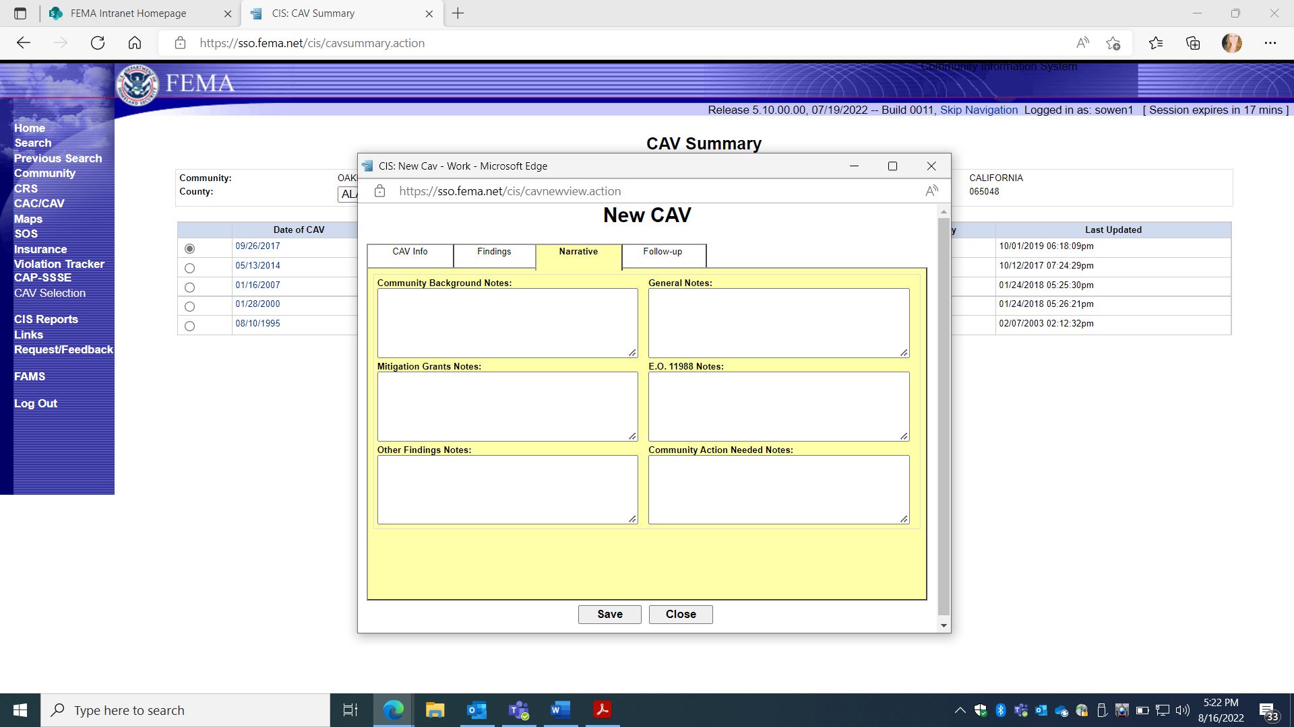
2.NEW CAV Screen TAB
c. Narrative TAB

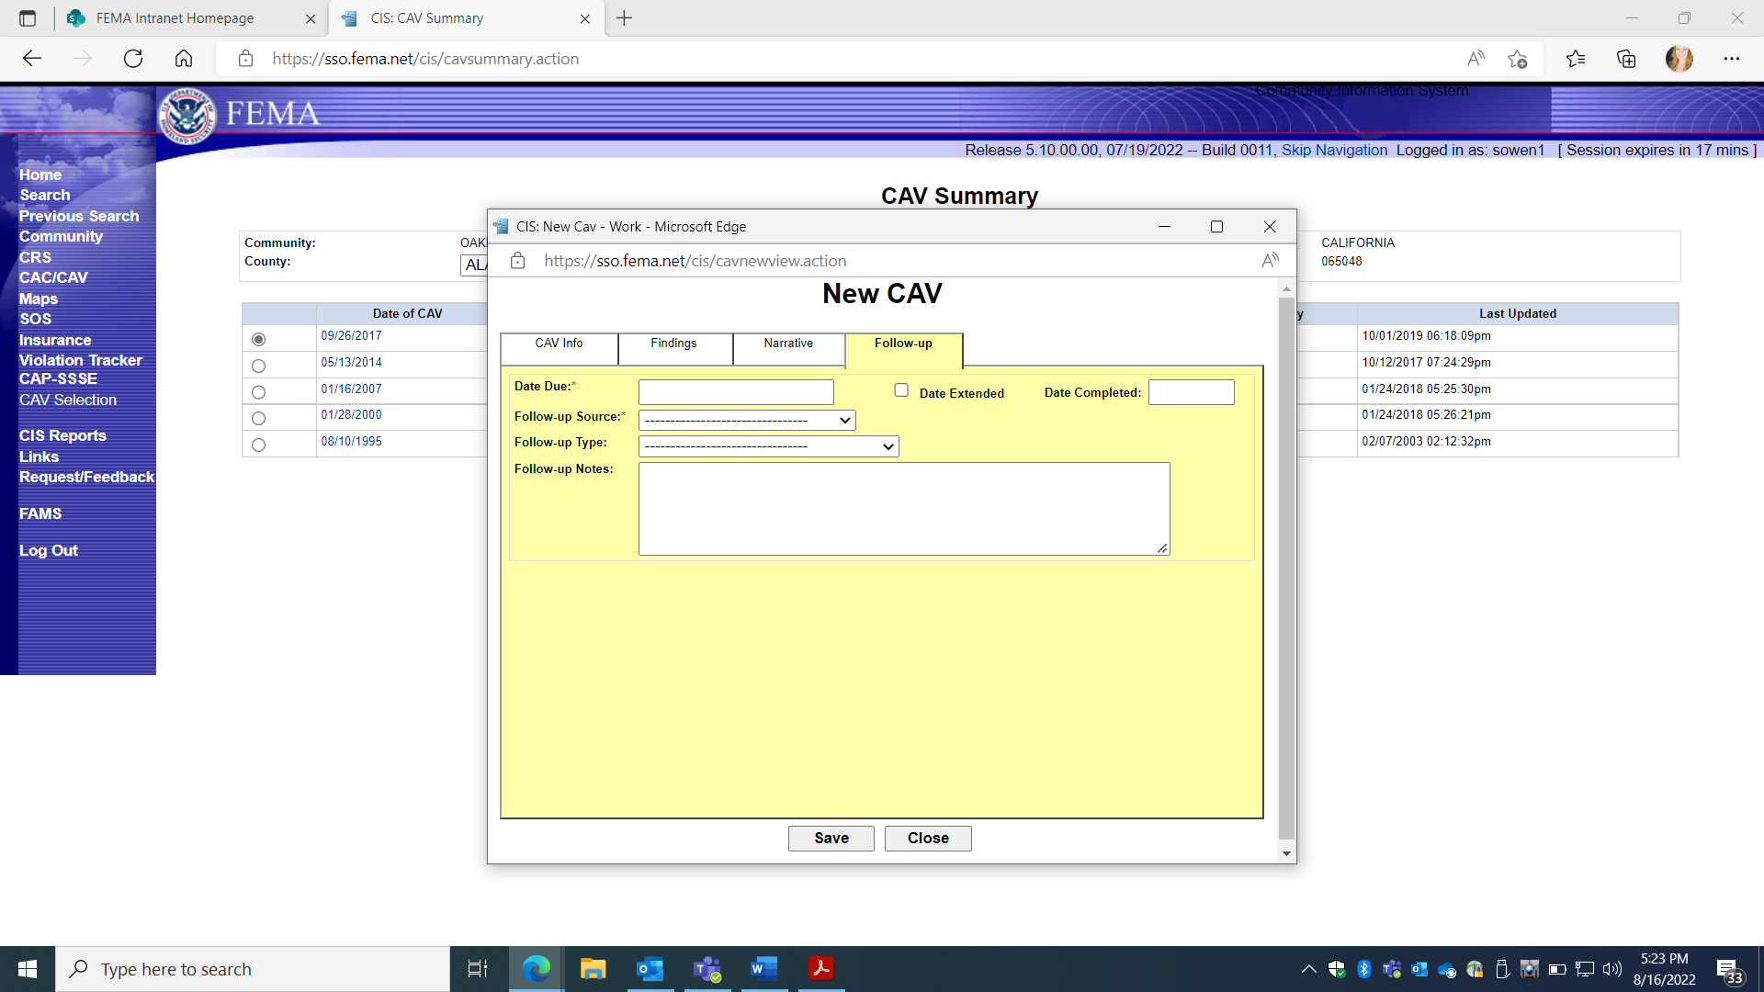
2.New CAV screen TAB
d. Follow-up TAB

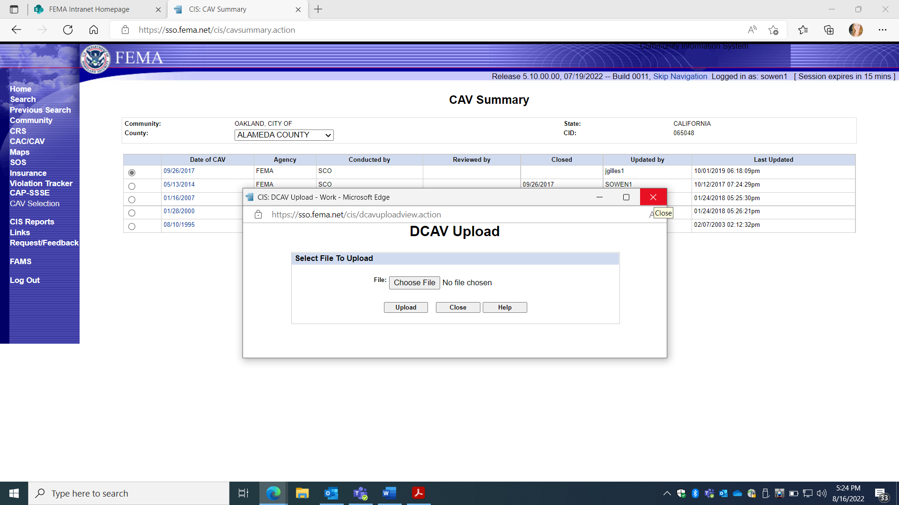

3. DCAV Upload Screen TAB

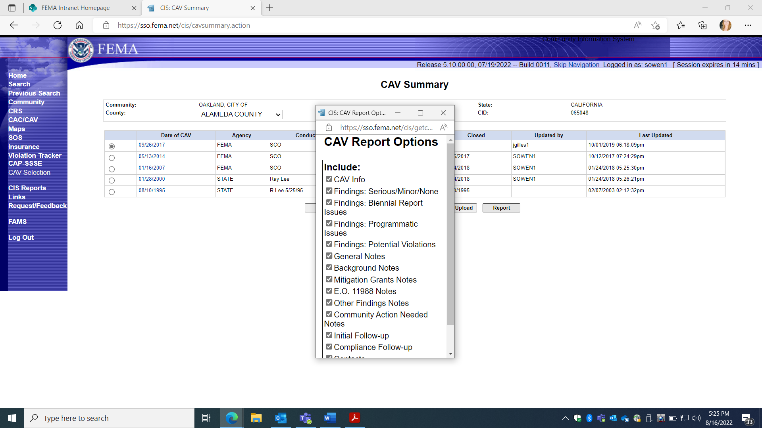
4. CAV REPORT Screen TAB

