NATIONAL CENTER FOR EDUCATION STATISTICS NATIONAL ASSESSMENT OF EDUCATIONAL PROGRESS

National Assessment of Educational Progress (NAEP) 2024

Appendix F

Item Library for NAEP 2024 Survey Questionnaires

OMB# 1850-0928 v.28



October 2022

This Appendix F provides the library of previously cleared items that may be used in the NAEP 2024 questionnaires. Non-substantive wording changes to the questionnaire items (based on ongoing and future cognitive and pilot testing results), if any will be made, along with the final selection of which items will be used in the final versions of the NAEP 2024 questionnaires, will be provided as outlined below. The number of items selected for each type of respondent will be appropriate to the allocated time (as indicated in the Supporting Statement Part A section A.12).
Appendix F includes the core and subject specific survey questionnaires for students, teachers, and school administrators, which were approved in October 2021 (OMB# 1850-0928 v.25). The final survey questionnaires for 2024 will be included in Appendices J1, J2, J3 and J-S. System login screens and paper booklet covers will be updated in upcoming Amendments to the Clearance Package.

Login Screens for Survey Questionnaires

Student Login Screen:
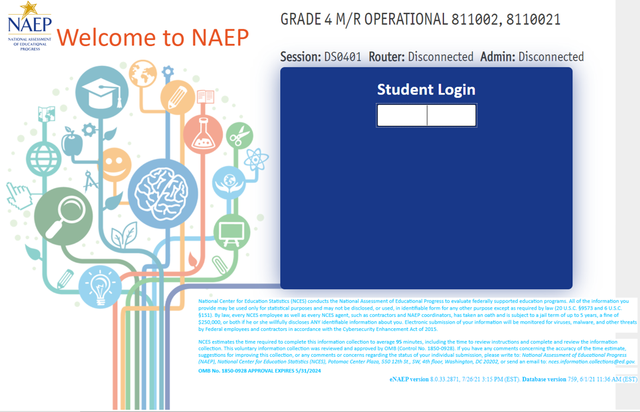

Teacher/School Administrator Login Screens:
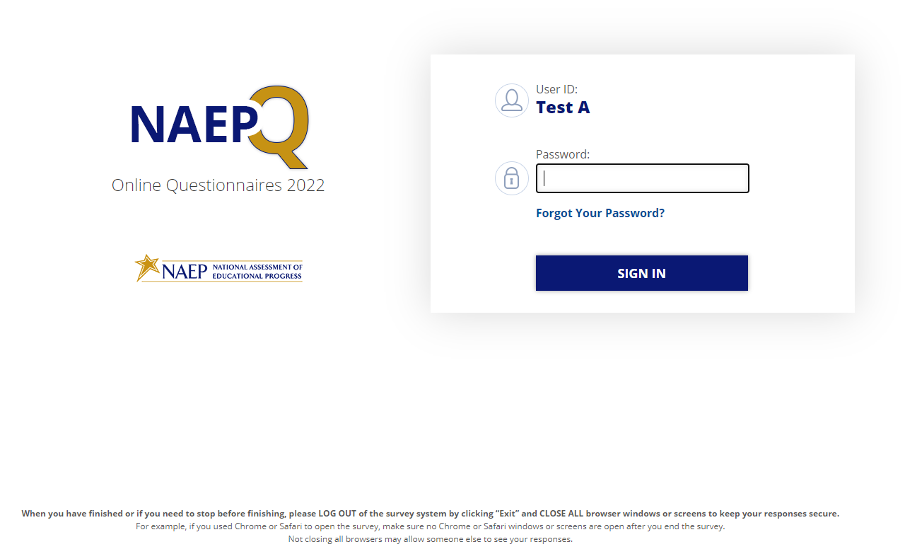
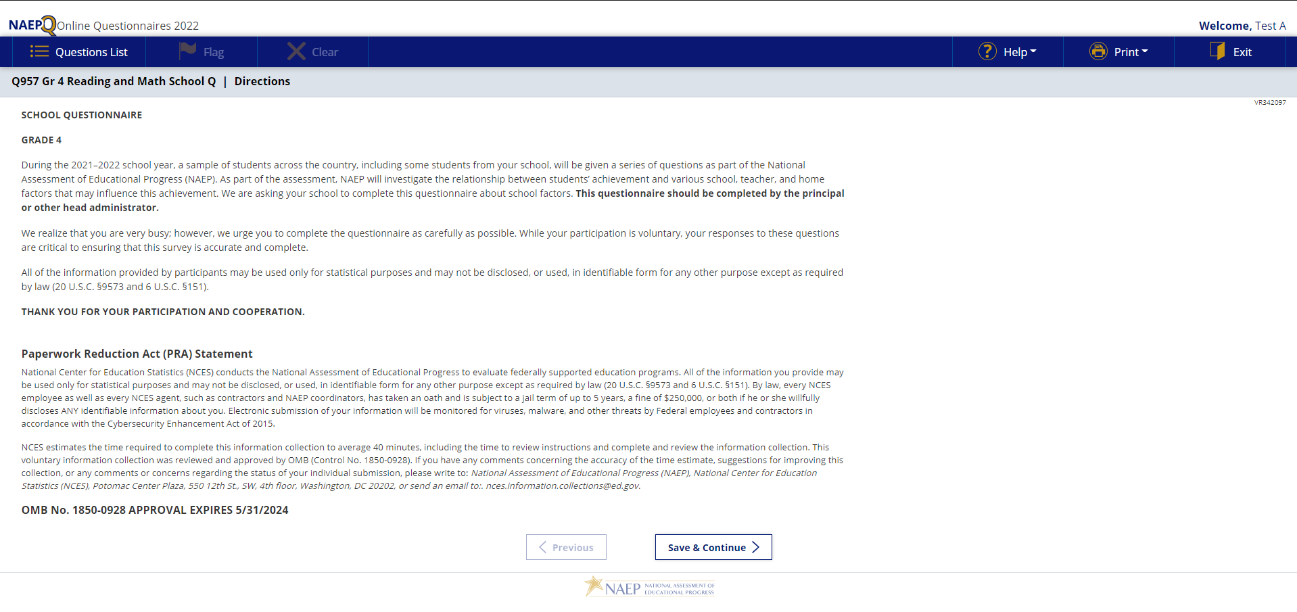

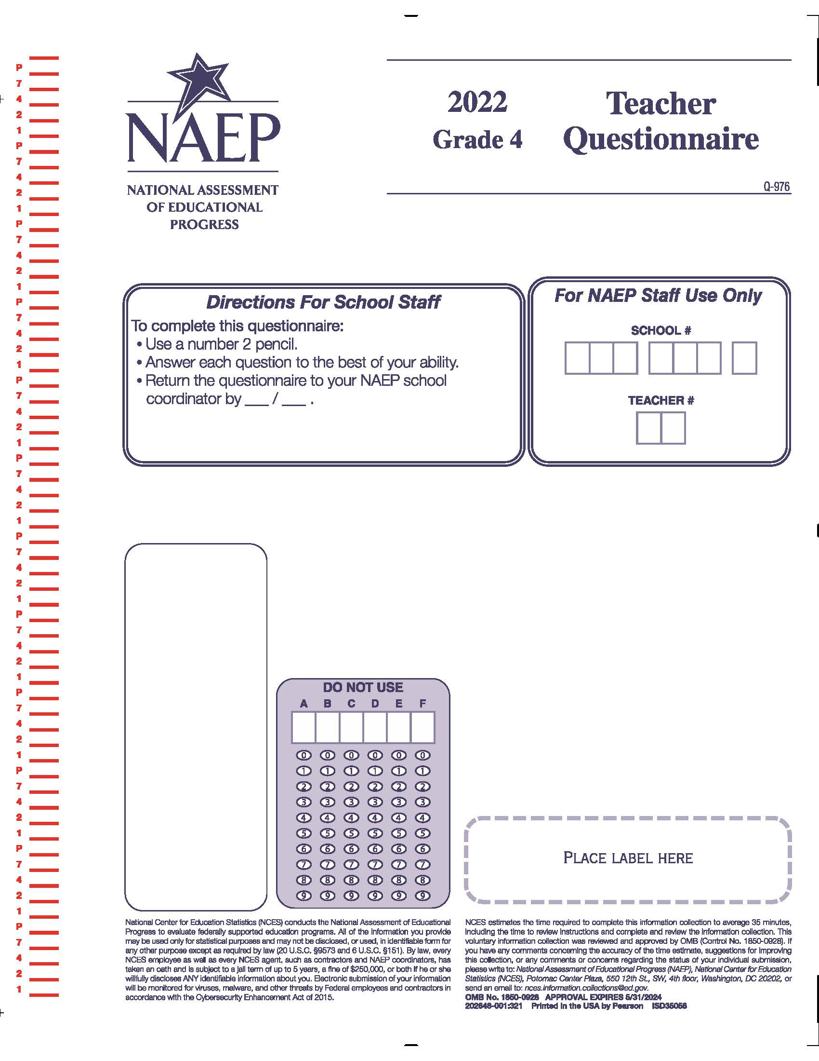
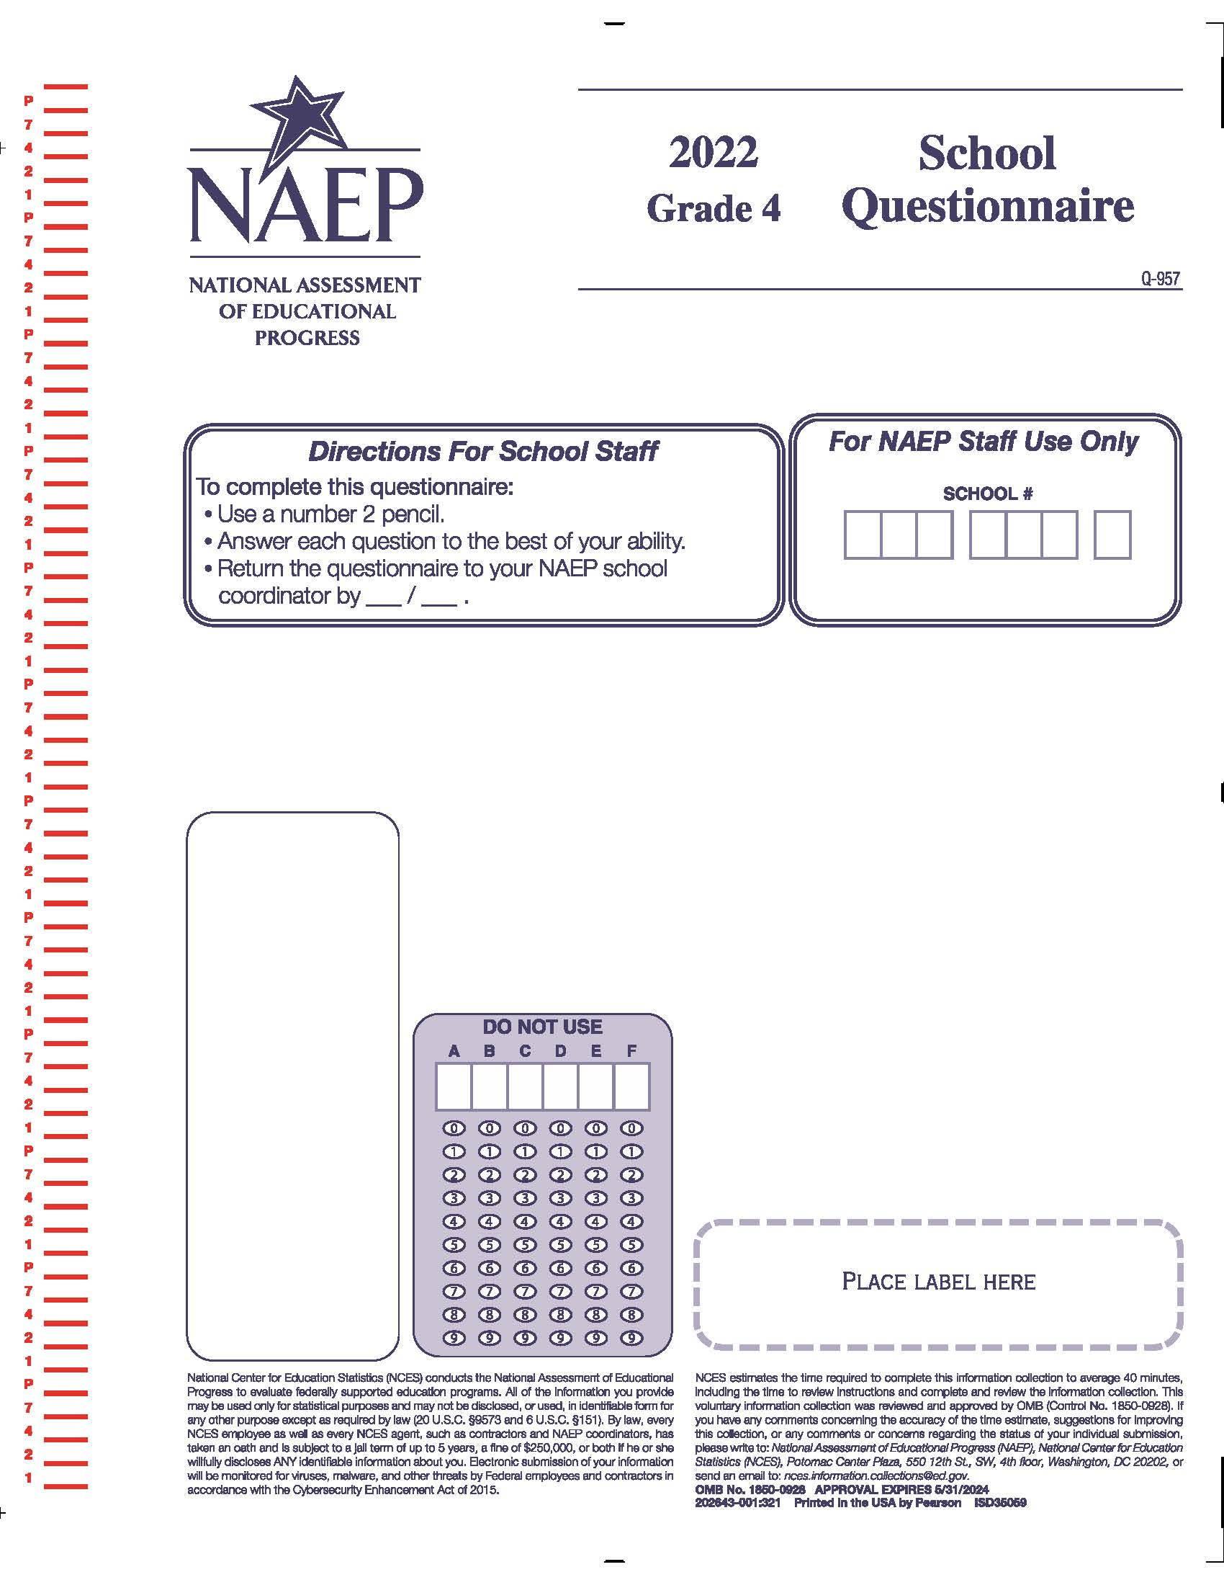

Table of Contents
Login Screens for Survey Questionnaires 3
Student Login Screen: 3
Teacher/School Administrator Login Screens: 4
Appendix F-1: 2021 Student Questionnaire 9
Appendix F-1a: Operational Grade 4 Debrief 10
Appendix F-1b: Operational Grade 8 Debrief 11
Appendix F-1c: Operational Grade 4 (CORE) 12
Appendix F-1d: Operational Grade 8 (CORE) 16
Appendix F-1e: Operational Grade 4 (Mathematics) 23
Appendix F-1f: Operational Grade 8 (Mathematics) 27
Appendix F-1g: Operational Grade 4 (Reading) 33
Appendix F-1h: Operational Grade 8 (Reading) 38
Appendix F-1i: Operational Grade 8 (Civics) 44
Appendix F-1j: Operational Grade 8 (U.S. History) 51
Appendix F-1k: Operational Grade 4 COVID-19 Student Items (ELA) 58
Appendix F-1l: Operational Grade 8 COVID-19 Student Items (ELA) 61
Appendix F-1m: Operational Grade 4 COVID-19 Student Items (Math) 65
Appendix F-1n: Operational Grade 8 COVID-19 Student Items (Math) 68
Appendix F-1: 2022 Student Questionnaire 72
Appendix F-1a-22: Operational Grade 4 (CORE) 73
Appendix F-1b-22: Operational Grade 8 (CORE) 77
Appendix F-1c-22: Operational Grade 4 (Mathematics) 84
Appendix F-1d-22: Operational Grade 8 (Mathematics) 88
Appendix F-1e-22: Operational Grade 4 (Reading) 94
Appendix F-1f-22: Operational Grade 8 (Reading) 99
Appendix F-1g-22: Operational Grade 8 Civics 105
Appendix J1-16: Operational Grade 8 U.S. History 112
Appendix F-1h-22: Operational Grade 4 Debrief 117
Appendix F-1i-22: Operational Grade 8 Debrief 118
Appendix F-1j-22: Operational Grade 4 COVID-19 Student Items (ELA) 119
Appendix F-1k-22: Operational Grade 8 COVID-19 Student Items (ELA) 122
Appendix F-1l-22: Operational Grade 4 COVID-19 Student Items (Math) 126
Appendix F-1m-22: Operational Grade 8 COVID-19 Student Items (Math) 129
Appendix F-1n-22: Operational Grade 8 COVID-19 Student Items (Civics) 133
Appendix F-1o-22: Operational Grade 8 COVID-19 Student Items (U.S. History) 137
Appendix F-2: 2021 Teacher Questionnaire 141
Appendix F-2a: Operational Grade 4 CORE 142
Appendix F-2b: Operational Grade 8 CORE 151
Appendix F-2c: Operational Grade 4 Mathematics 162
Appendix F-2d: Operational Grade 8 Mathematics 169
Appendix F-2e: Operational Grade 4 Reading 177
Appendix F-2f: Operational Grade 8 Reading 182
Appendix F-2g: Operational Grade 8 Social Studies 188
Appendix F-2h: Operational Grade 4 COVID-19 Teacher Items 197
Appendix F-2i: Operational Grade 8 COVID-19 Teacher Items 201
Appendix F-2: 2022 Teacher Questionnaire 205
Appendix F-2a-22: Operational Grade 4 CORE 206
Appendix F-2b-22: Operational Grade 8 CORE 215
Appendix F-2c-22: Operational Grade 4 Mathematics 225
Appendix F-2d-22: Operational Grade 8 Mathematics 232
Appendix F-2e-22: Operational Grade 4 Reading 240
Appendix F-2f-22: Operational Grade 8 Reading 245
Appendix F-2g-22: Operational Grade 8 Social Studies 251
Appendix F-2h-22: Operational Grade 4 COVID-19 260
Appendix F-2i-22: Operational Grade 8 COVID-19 264
Appendix F-3: 2021 School Questionnaires 268
Appendix F-3a: Operational Grade 4 CORE 269
Appendix F-3b: Operational Grade 8 CORE 279
Appendix F-3c: Operational Grade 4 and 8 Charter School 289
Appendix F-3d: Operational Grade 4 Mathematics 291
Appendix F-3e: Operational Grade 8 Mathematics 294
Appendix F-3f: Operational Grade 4 Reading 298
Appendix F-3g: Operational Grade 8 Reading 302
Appendix F-3h: Operational Grade 8 Social Studies 306
Appendix F-3i: Operational Grade 4 COVID-19 School Items 309
Appendix F-3j: Operational Grade 8 COVID-19 School Items 317
Appendix F-3: 2022 School Questionnaires 325
Appendix F-3a-22: Operational Grade 4 CORE 326
Appendix F-3b-22: Operational Grade 8 CORE 335
Appendix F-3c-22: Operational Grade 4 and 8 Charter School 344
Appendix F-3d-22: Operational Grade 4 Mathematics 346
Appendix F-3e-22: Operational Grade 8 Mathematics 349
Appendix F-3f-12: Operational Grade 4 Reading 353
Appendix F-3f-22: Operational Grade 8 Reading 357
Appendix F-3g-22: Operational Grade 8 Social Studies School Items 361
Appendix F-3h-22: Operational Grade 4 COVID-19 School Items 364
Appendix F-2i-22: Operational Grade 8 COVID-19 School Items 373

Appendix F-1: 2021 Student Questionnaire

Appendix F-1a: Operational Grade 4 Debrief

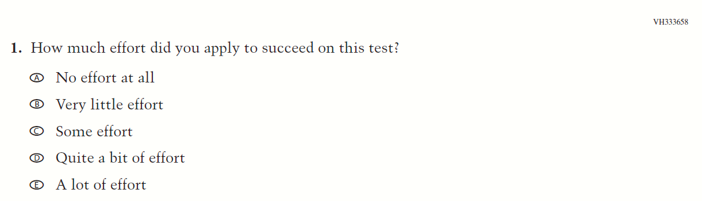

Appendix F-1b: Operational Grade 8 Debrief
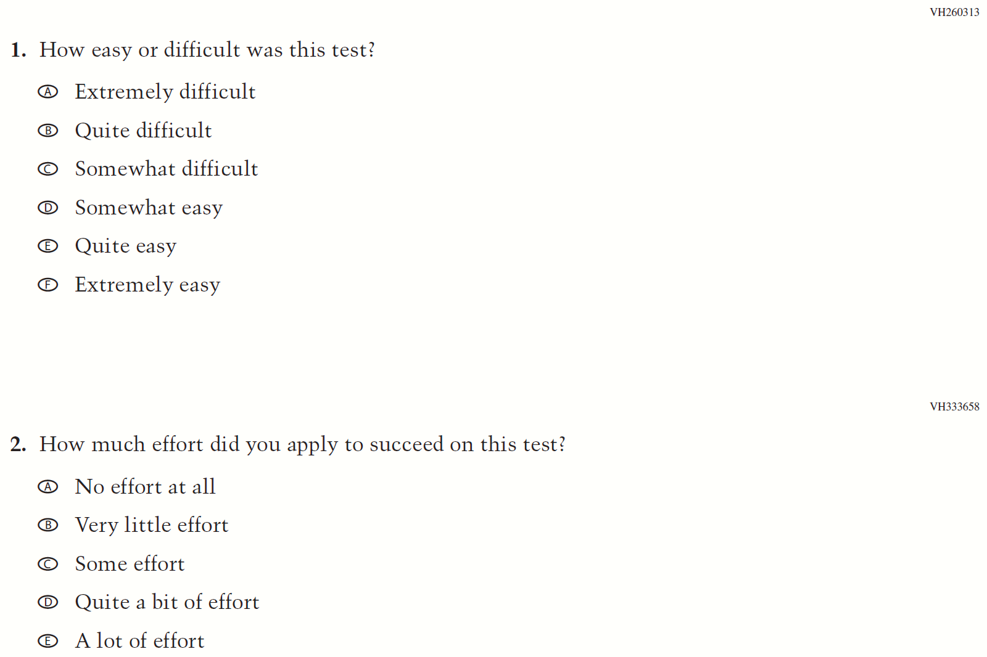

Appendix F-1c: Operational Grade 4 (CORE)
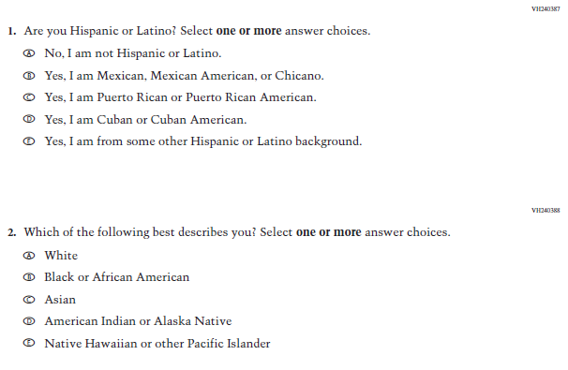
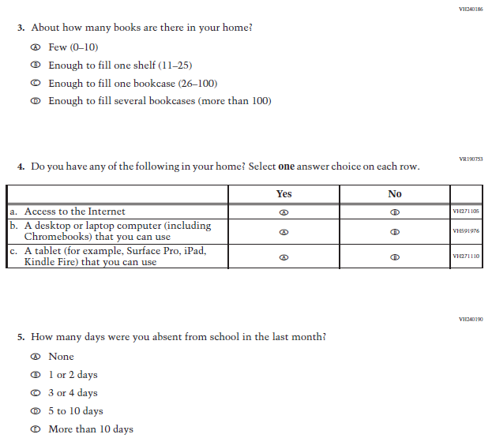

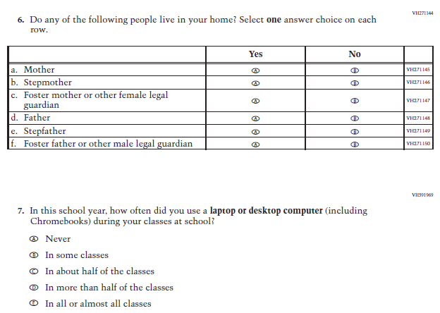

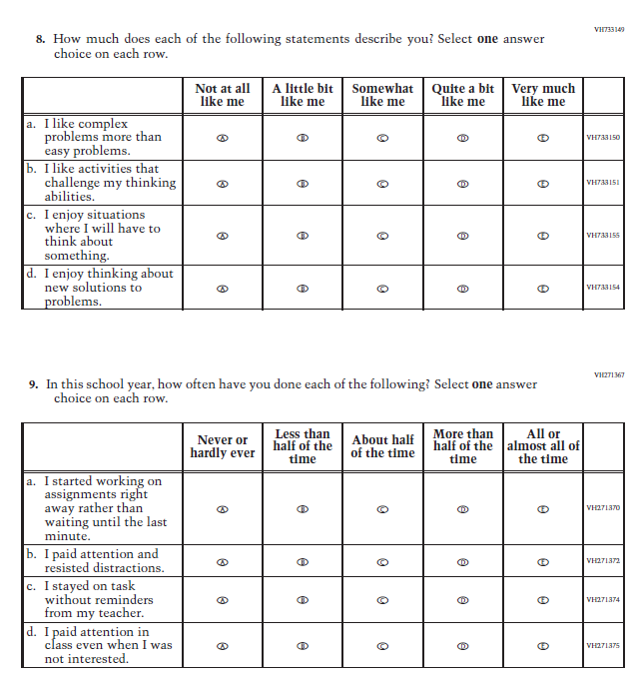

Appendix F-1d: Operational Grade 8 (CORE)

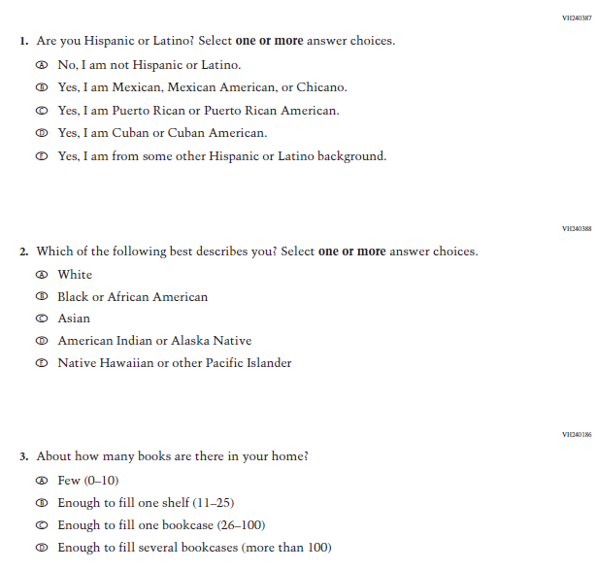

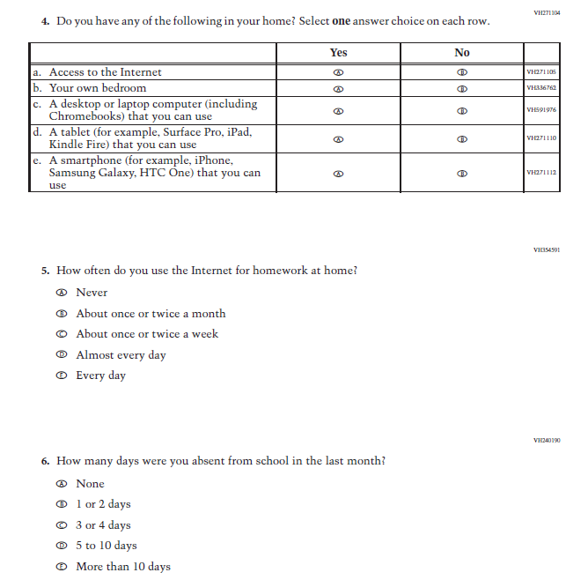

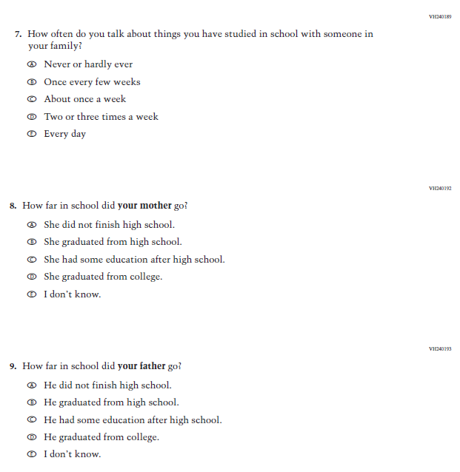

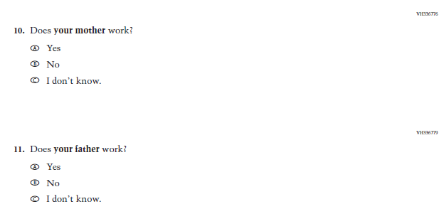
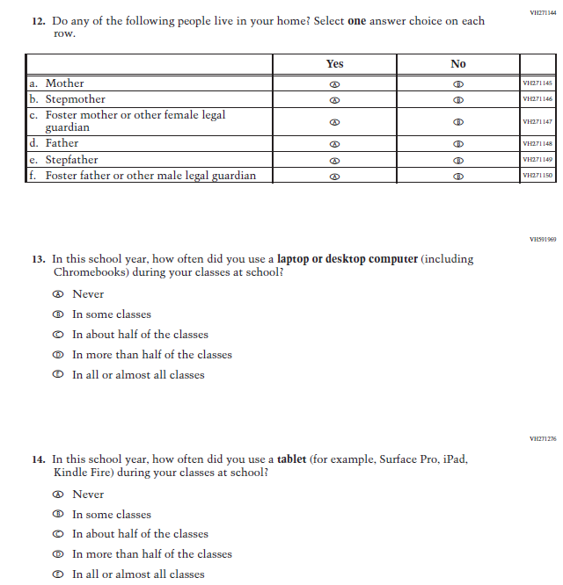
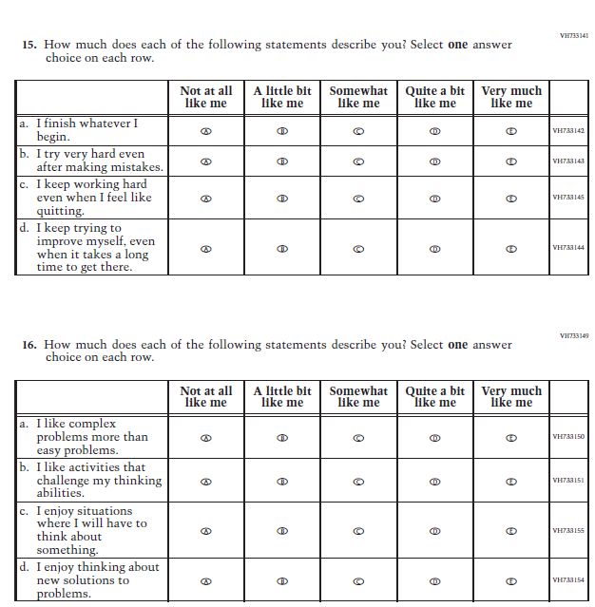

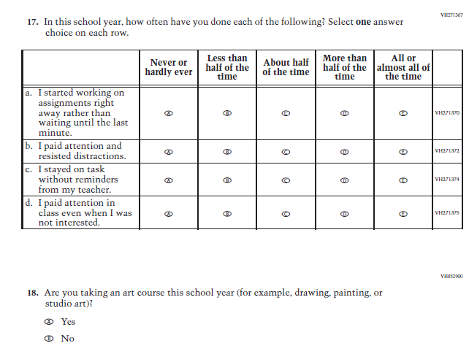

Appendix F-1e: Operational Grade 4 (Mathematics)

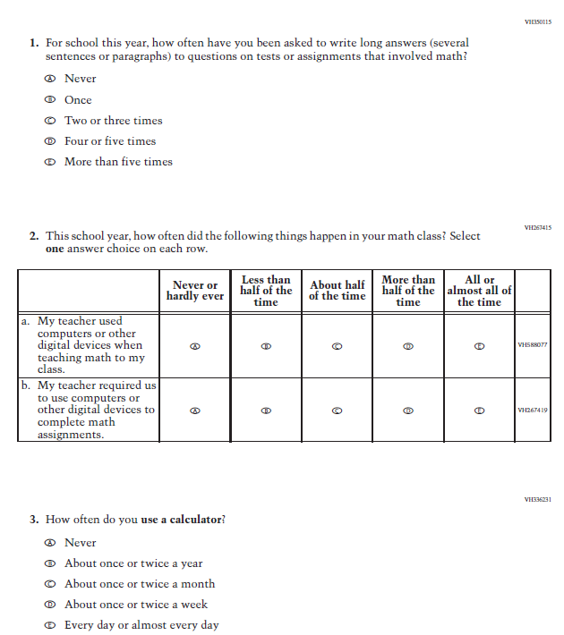

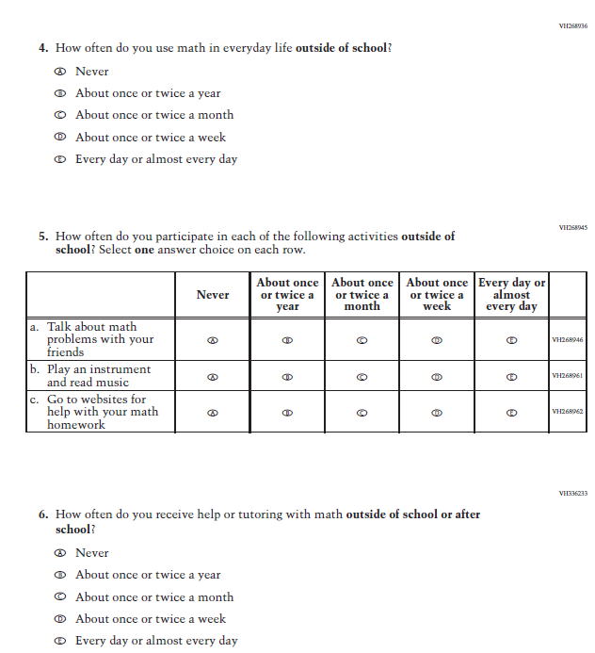
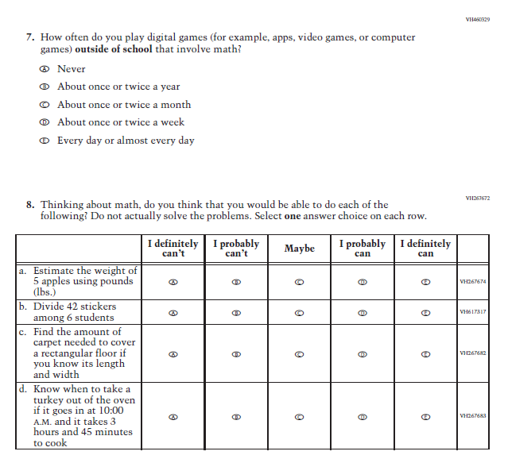

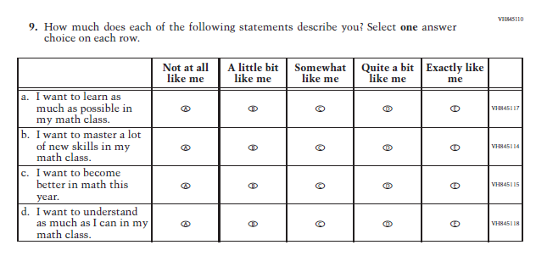

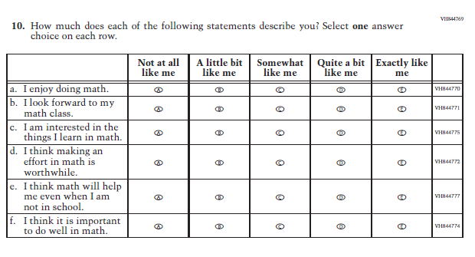

Appendix F-1f: Operational Grade 8 (Mathematics)

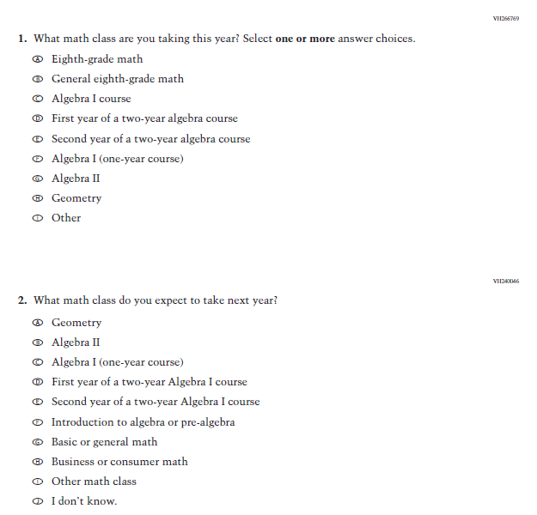
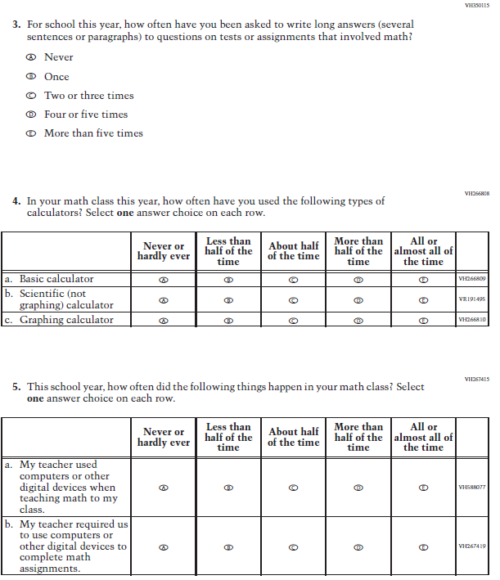

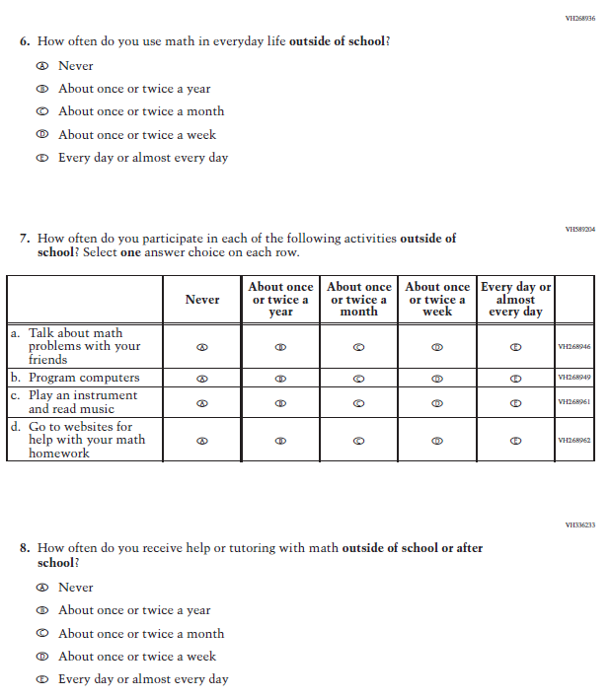

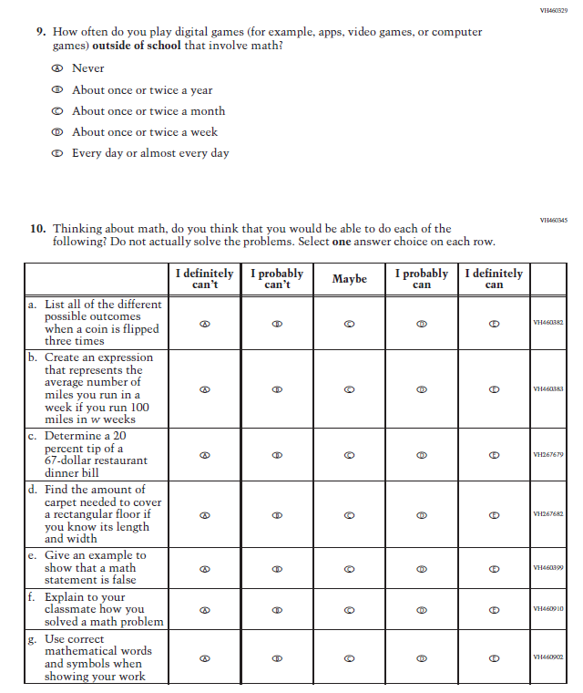
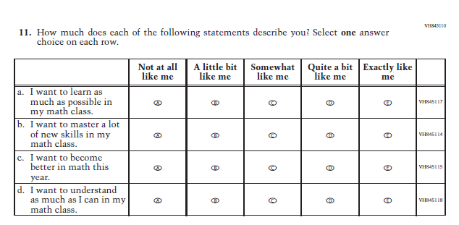
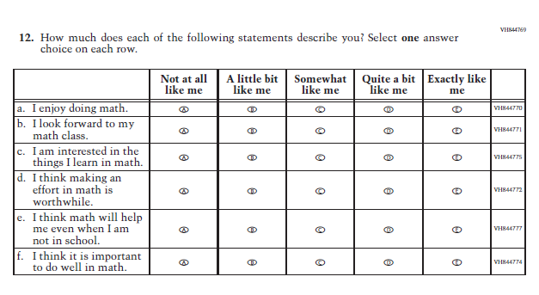
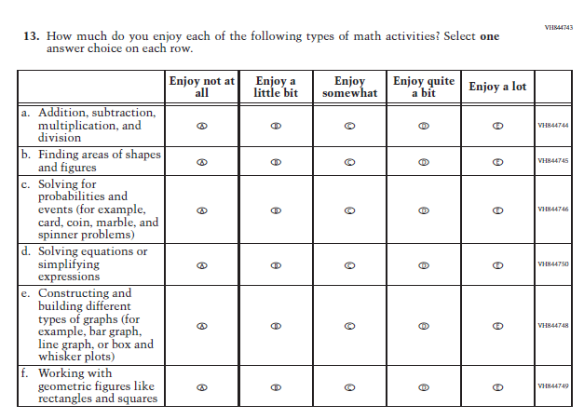

Appendix F-1g: Operational Grade 4 (Reading)
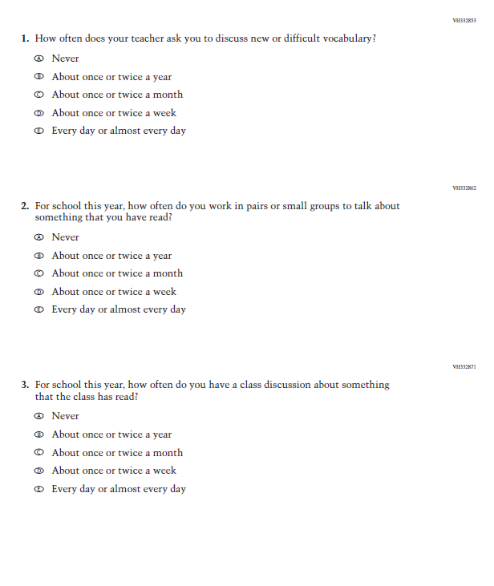

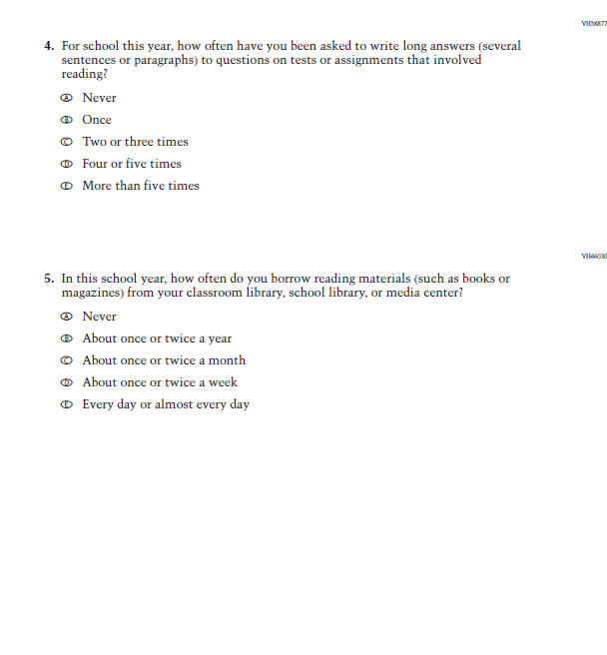

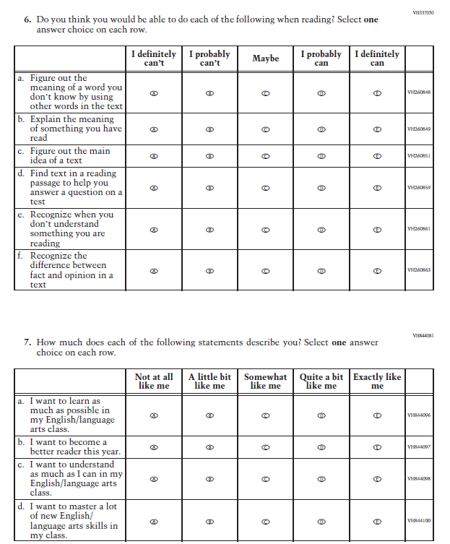
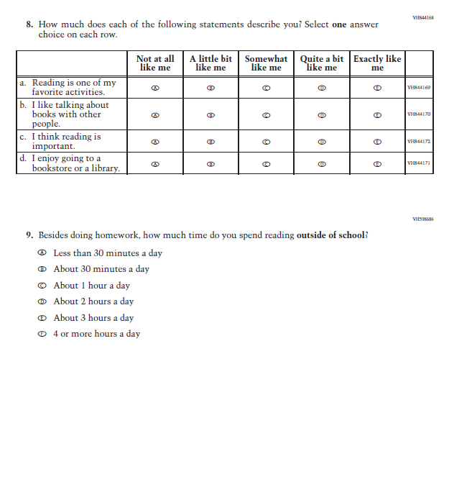

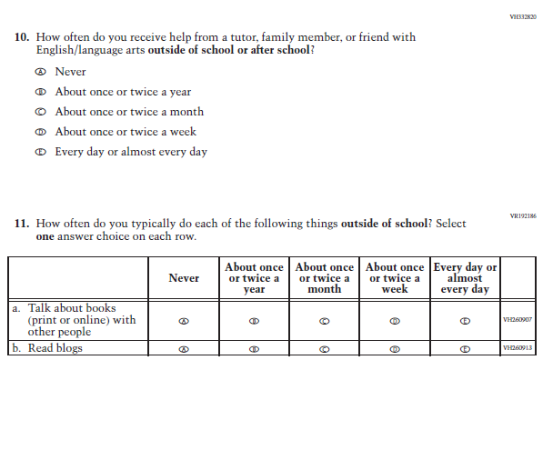

Appendix F-1h: Operational Grade 8 (Reading)
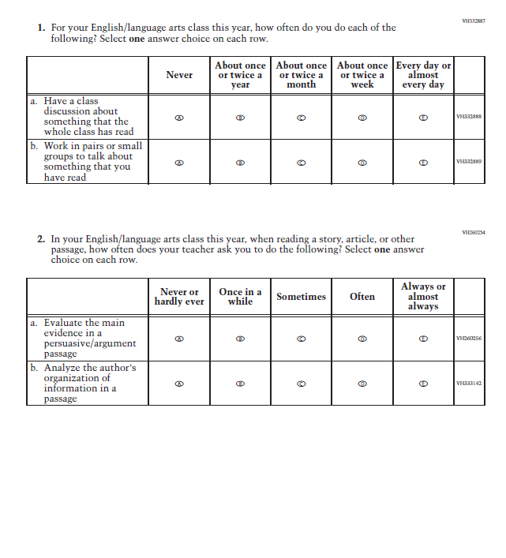

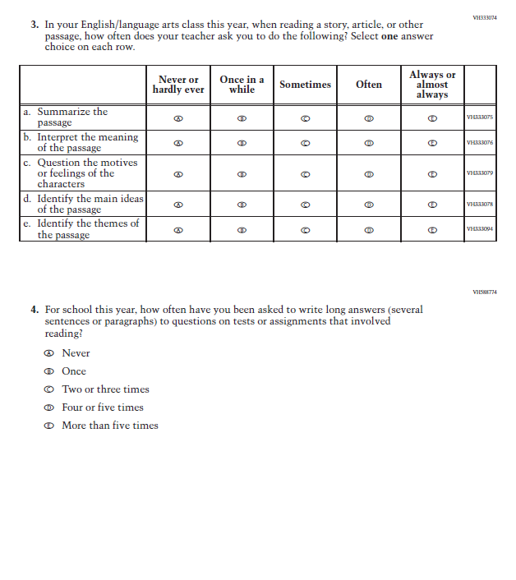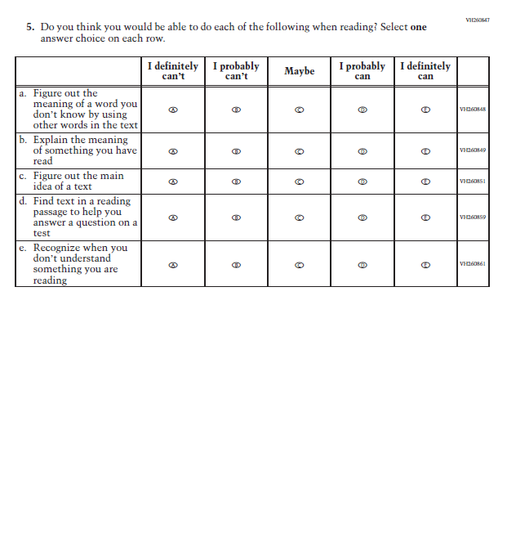

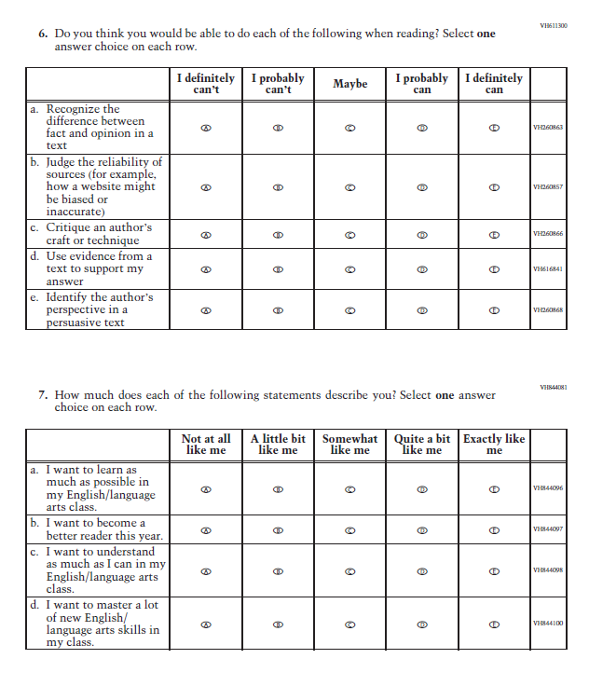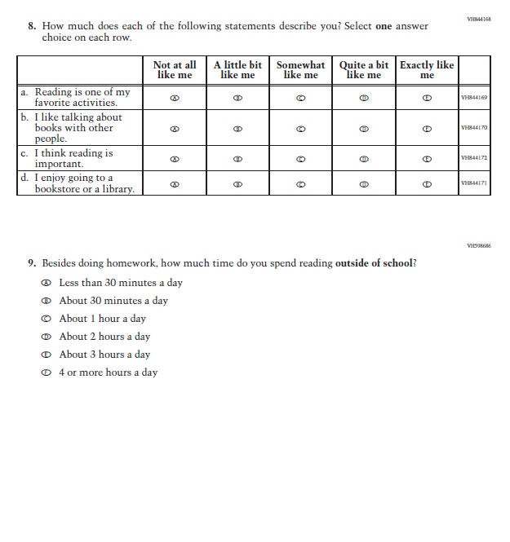

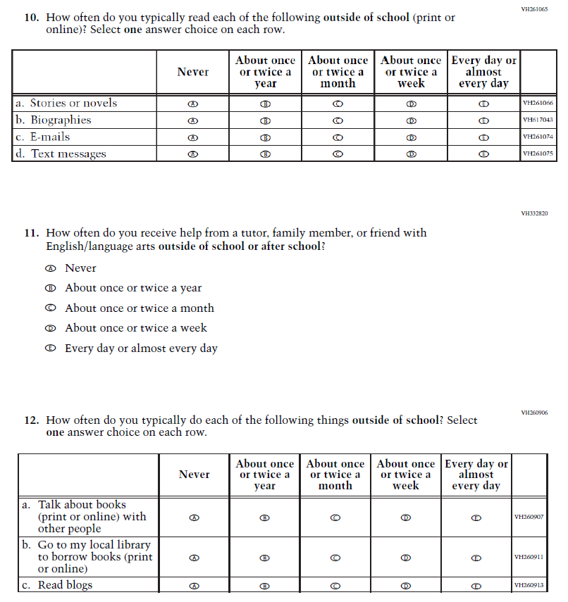

Appendix F-1i: Operational Grade 8 (Civics)

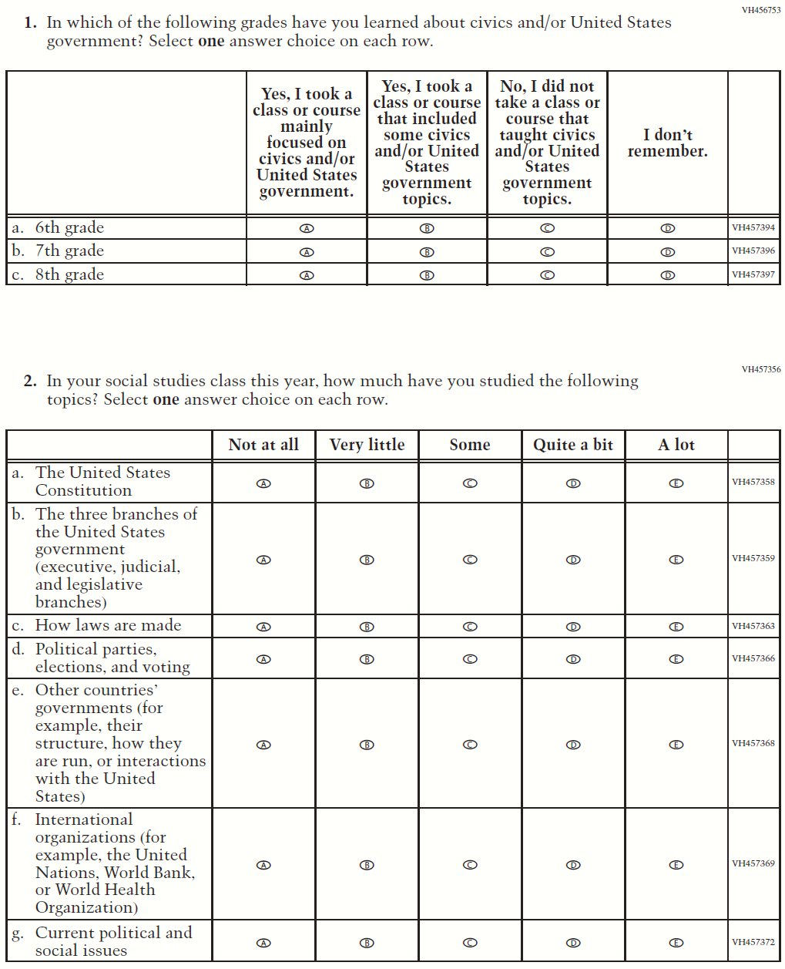

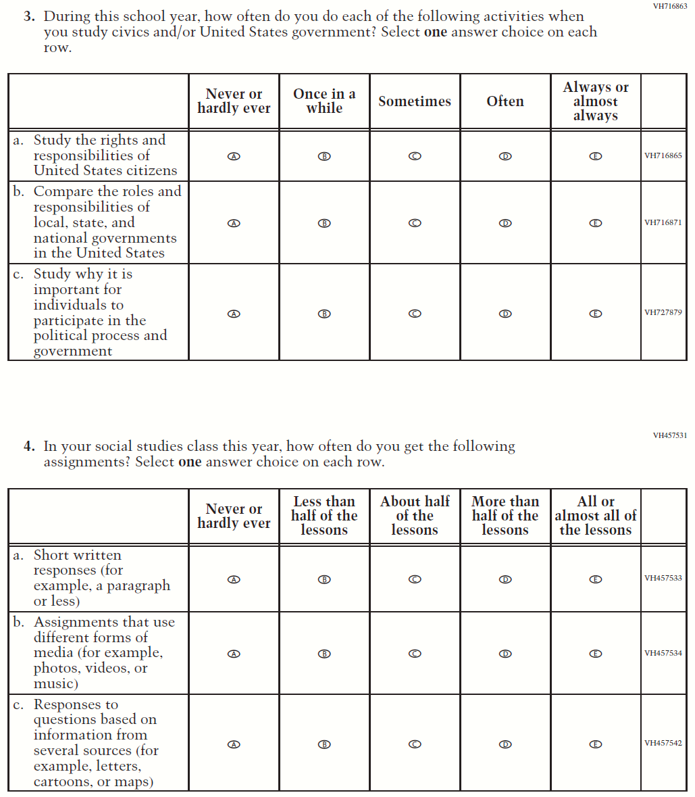

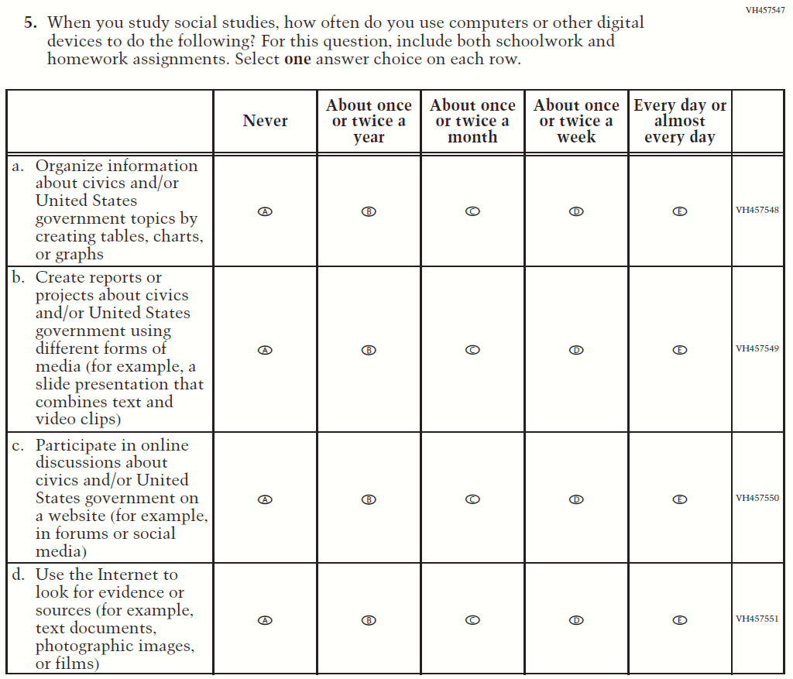

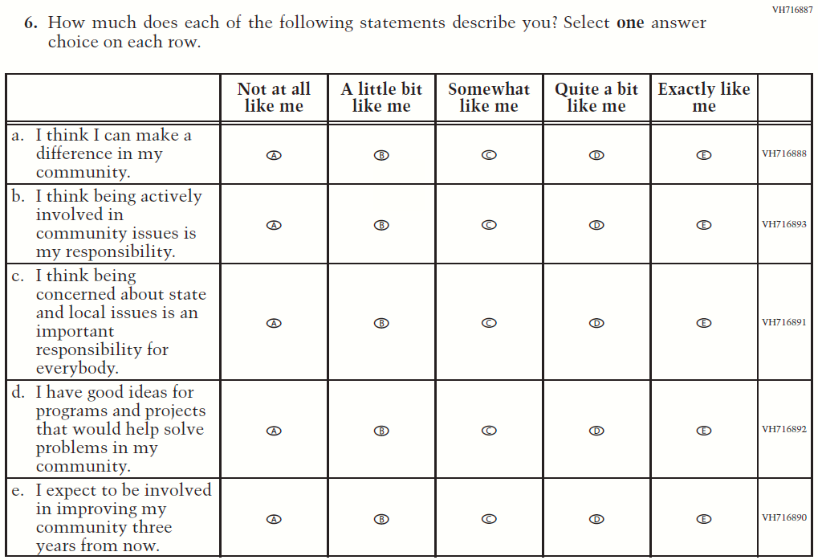

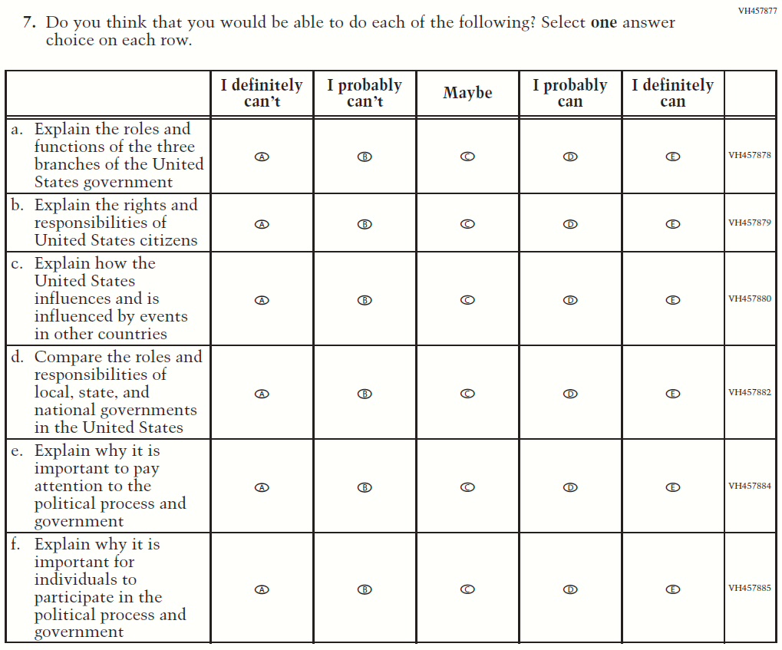

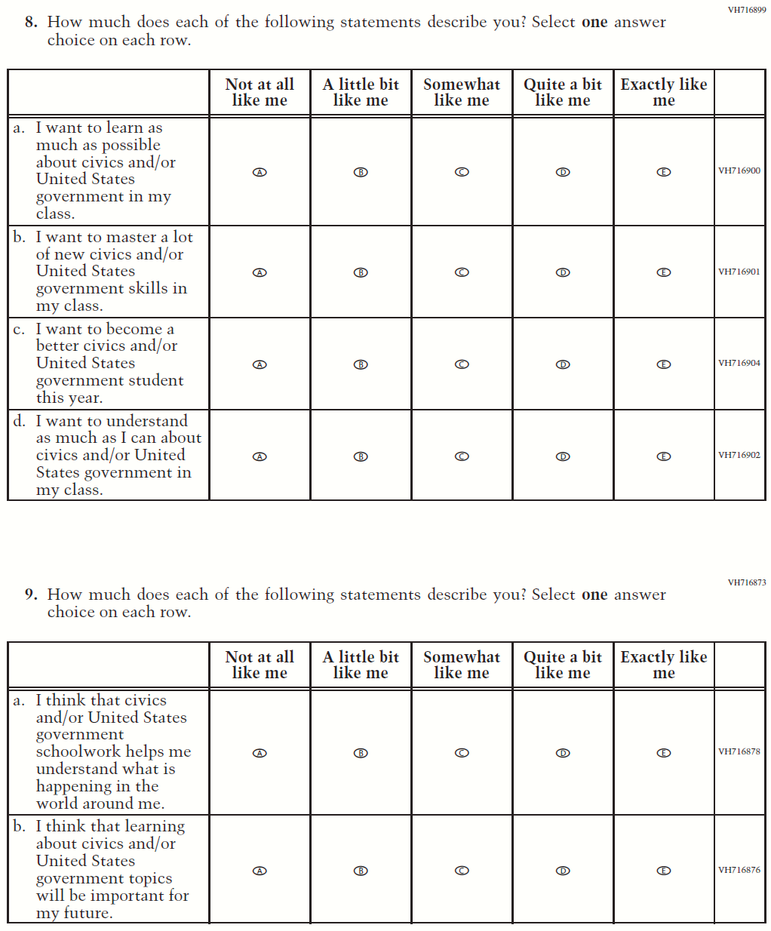

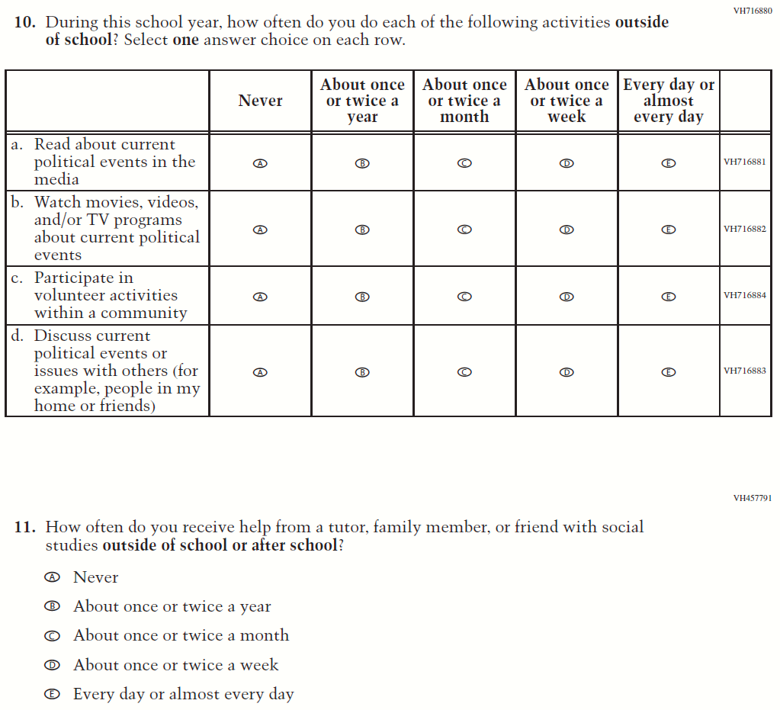

Appendix F-1j: Operational Grade 8 (U.S. History)

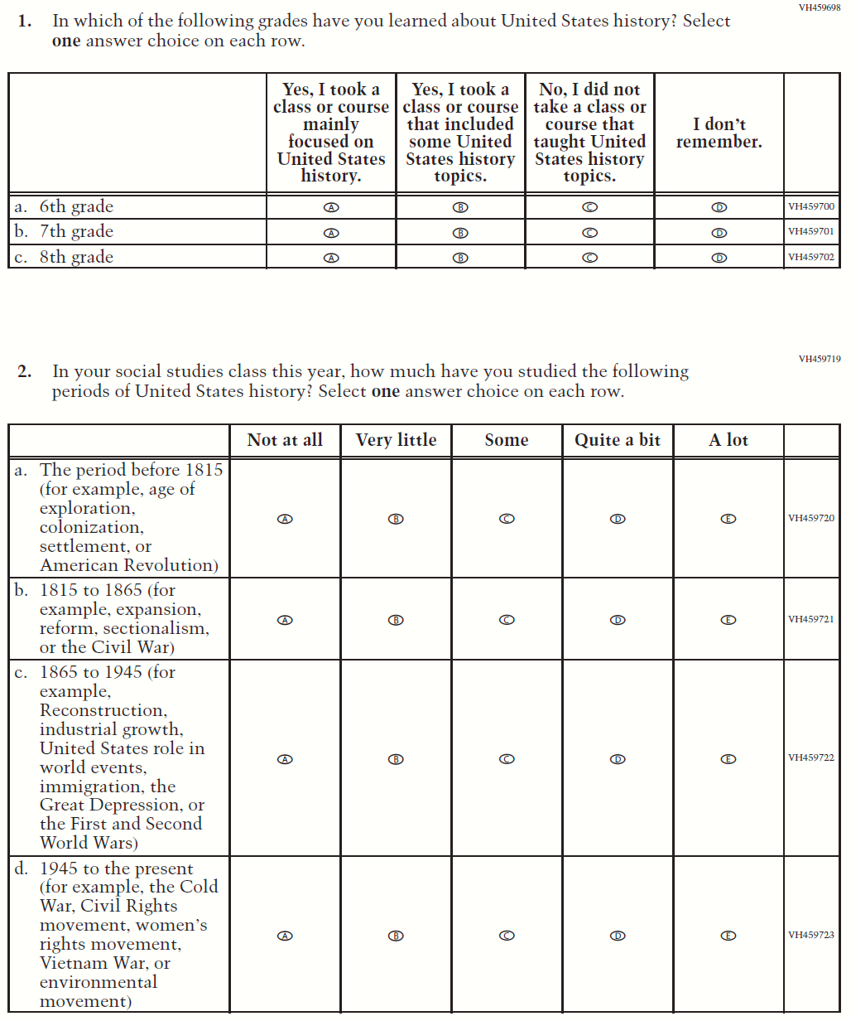

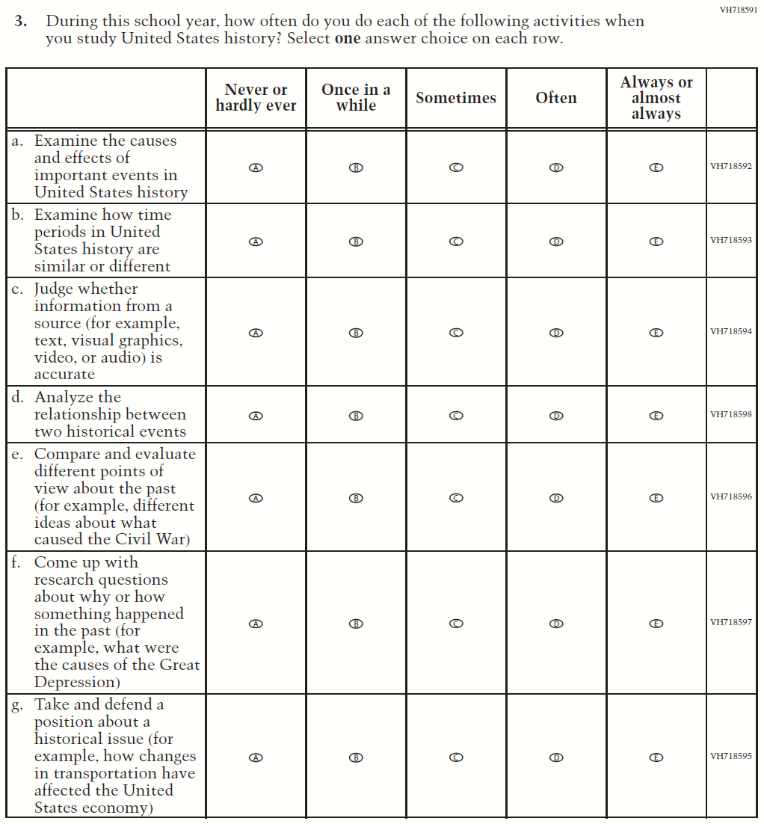

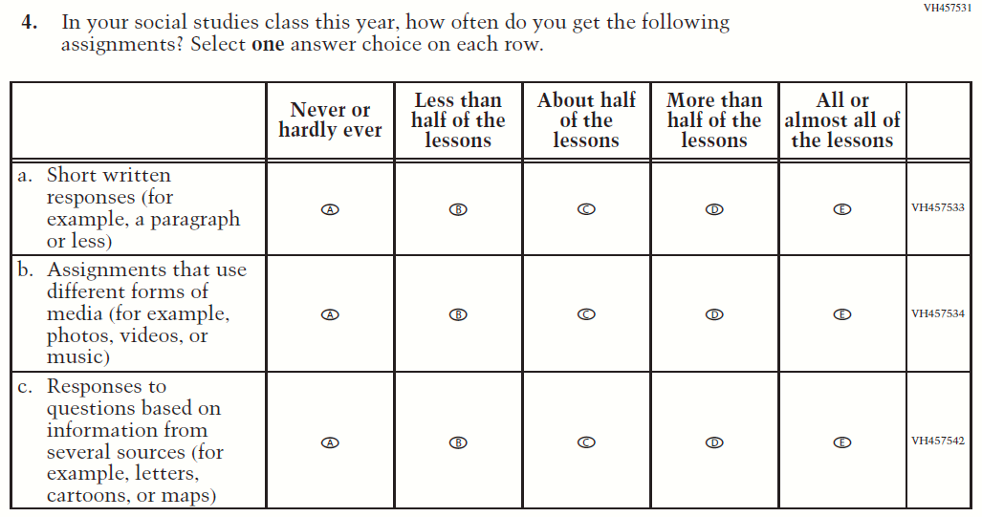

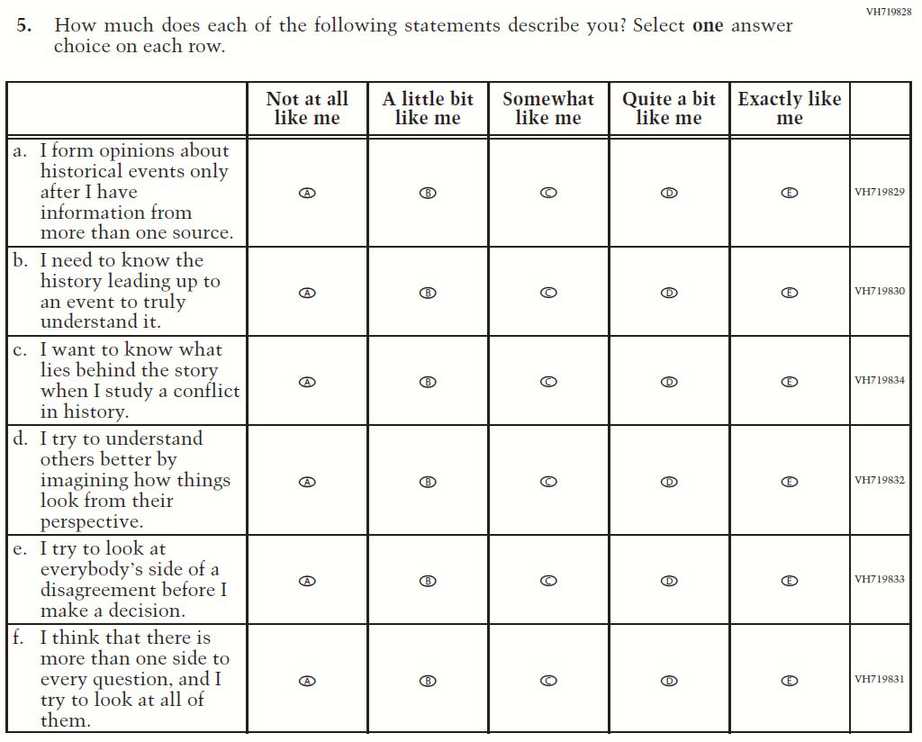

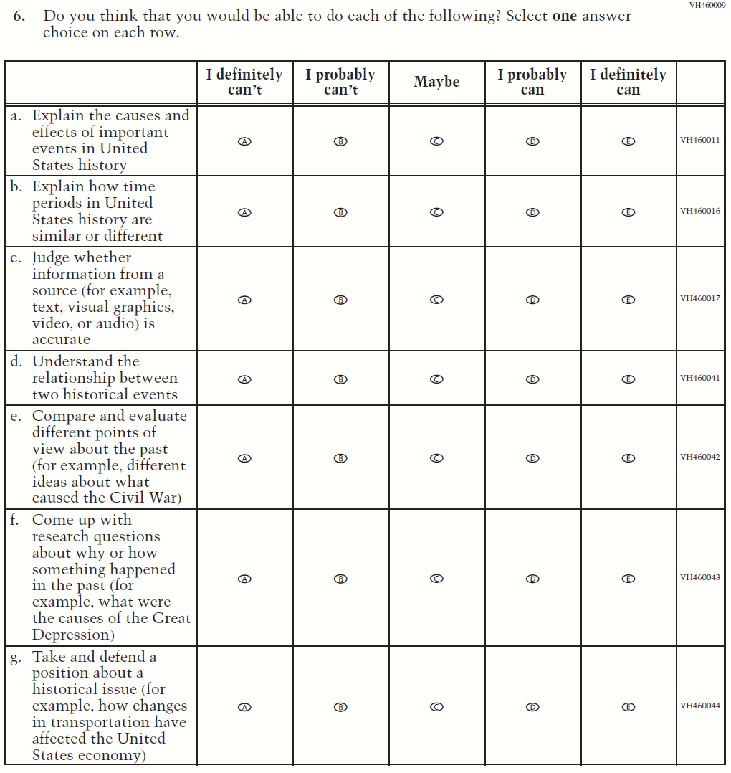

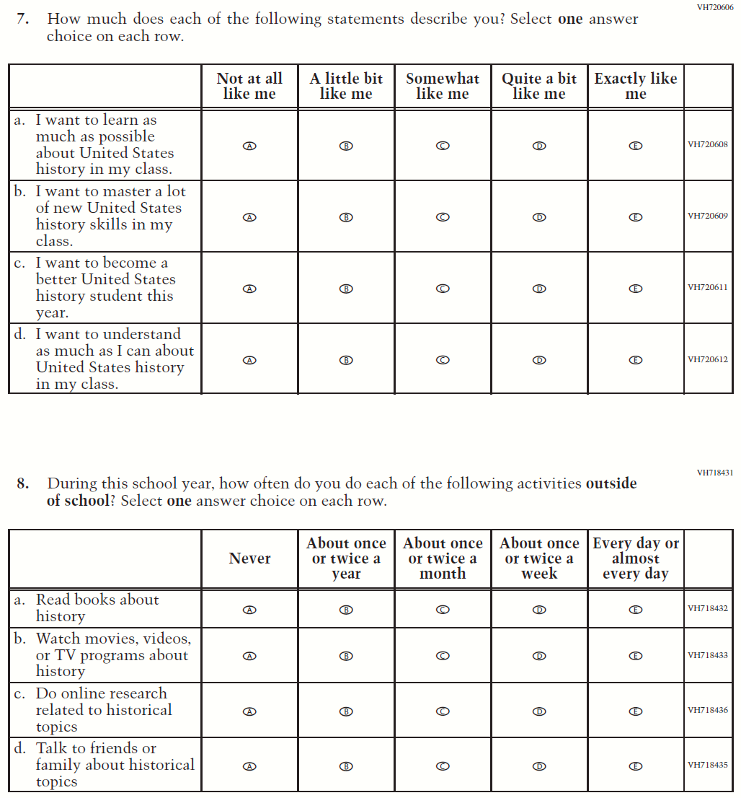

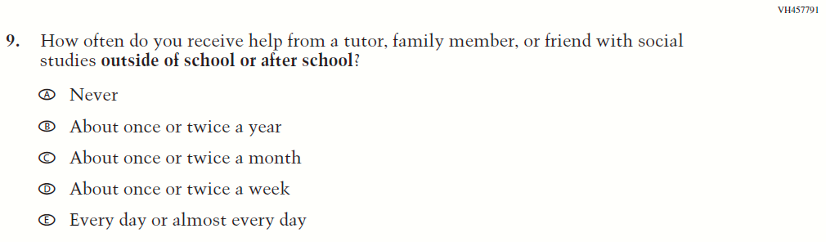

Appendix F-1k: Operational Grade 4 COVID-19 Student Items (ELA)

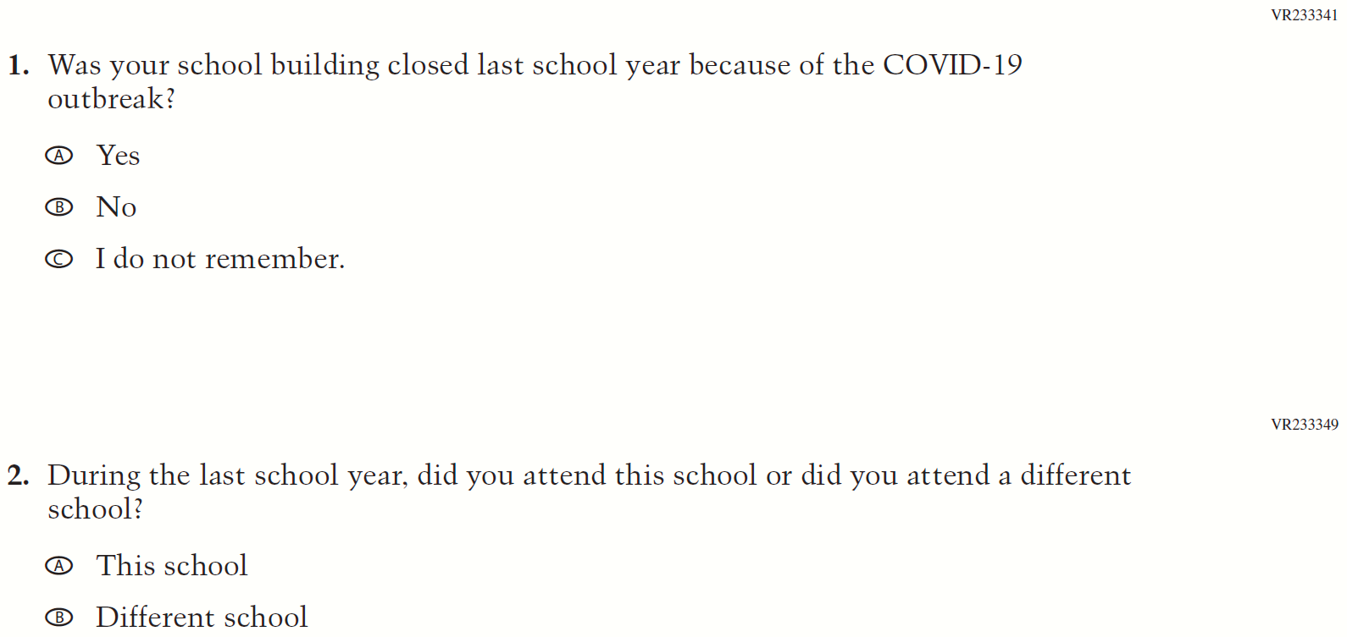

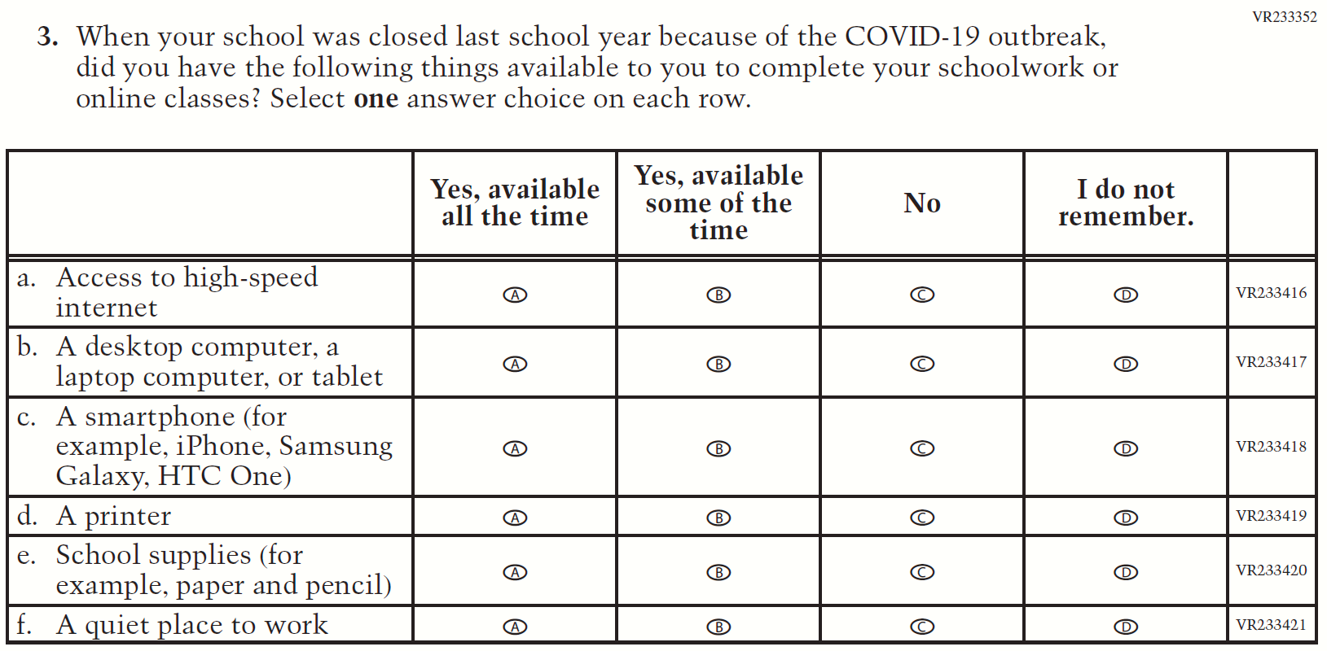

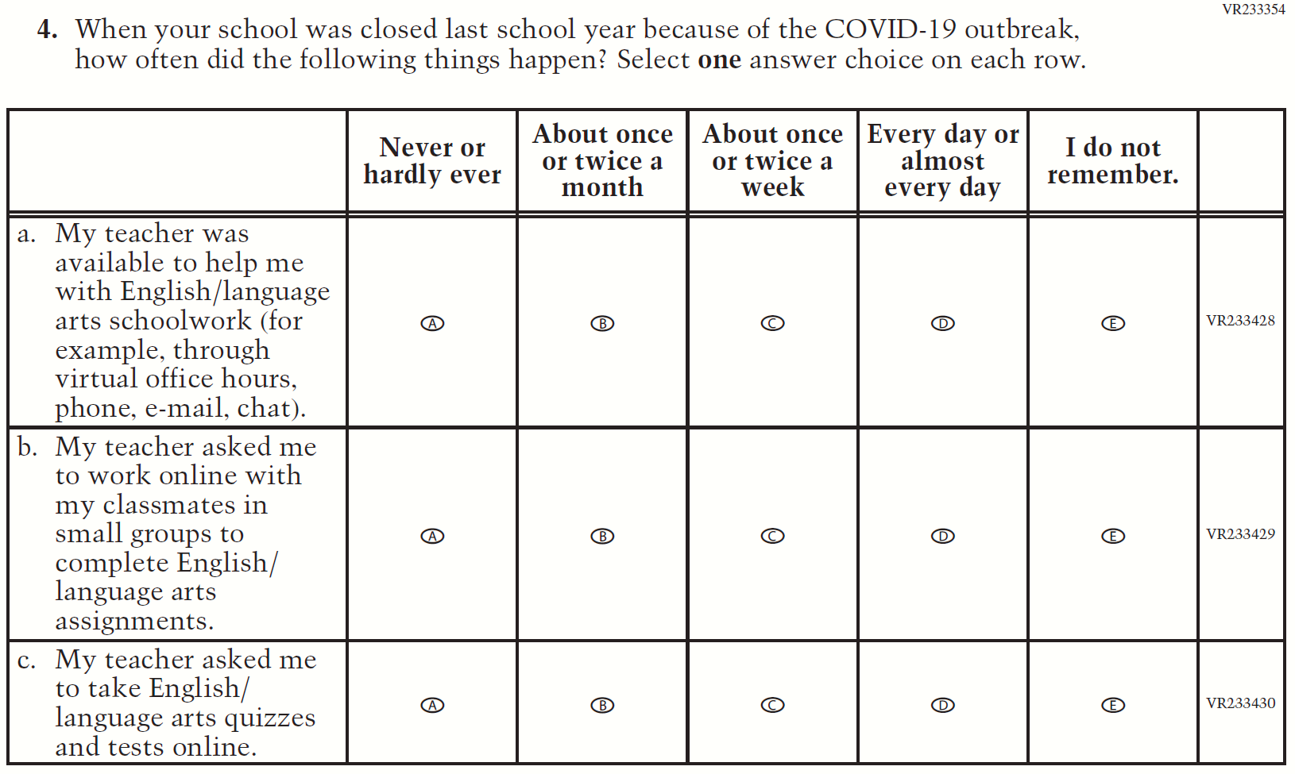
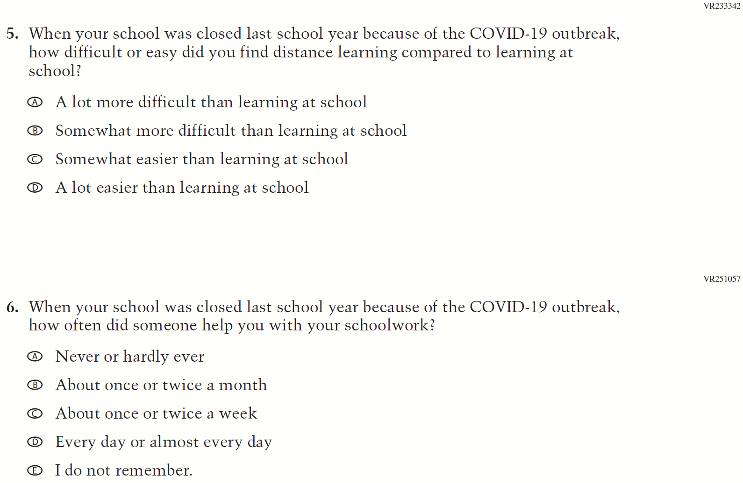

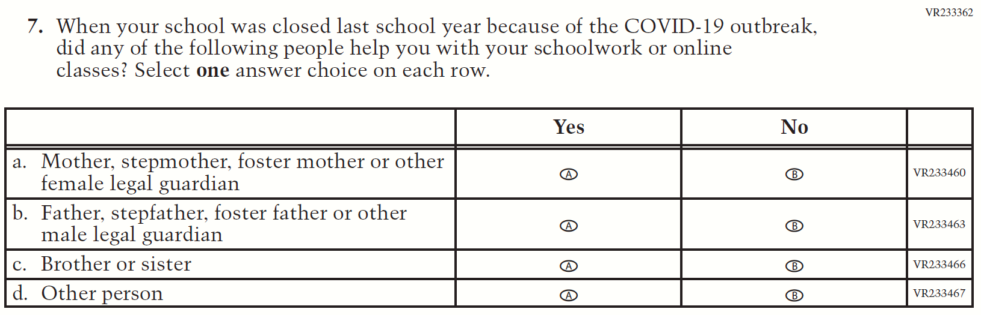

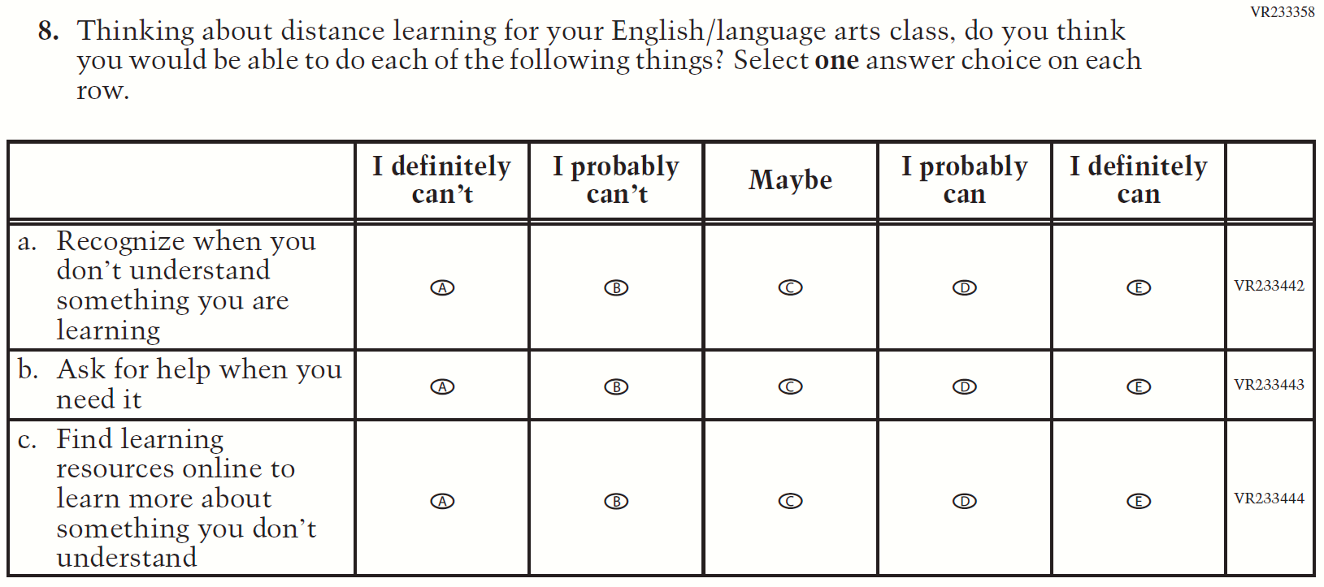

Appendix F-1l: Operational Grade 8 COVID-19 Student Items (ELA)

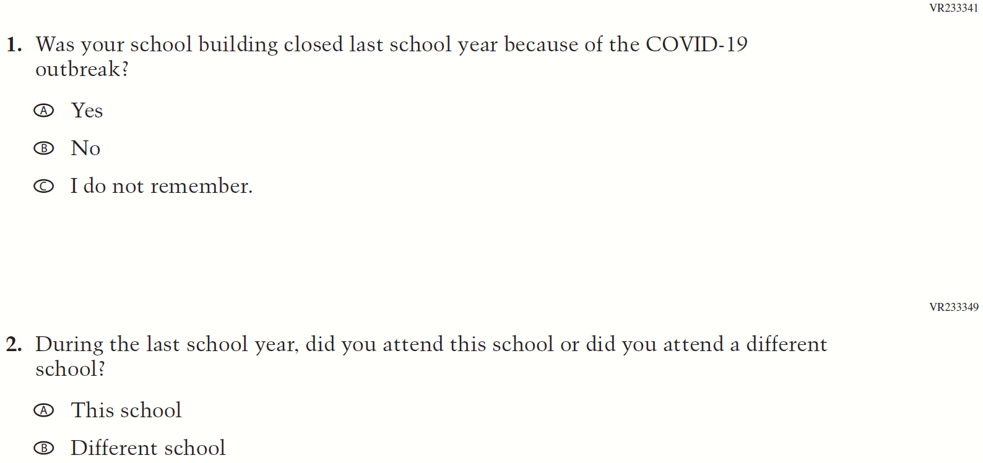

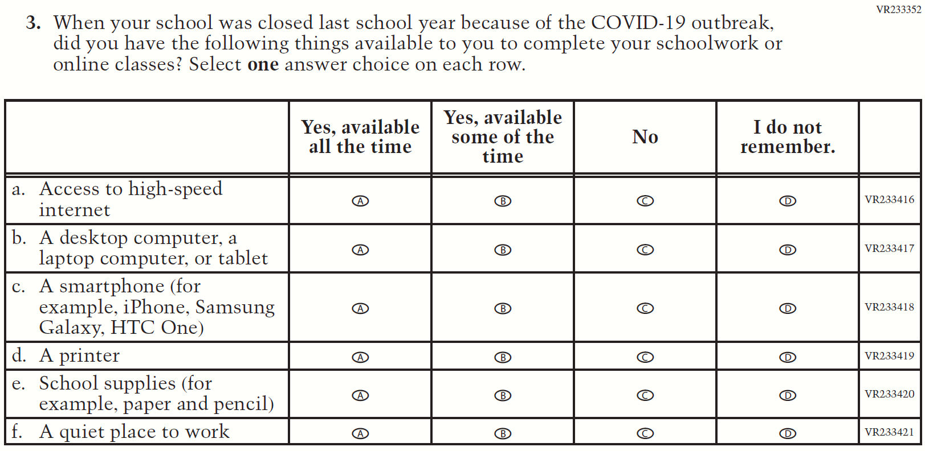

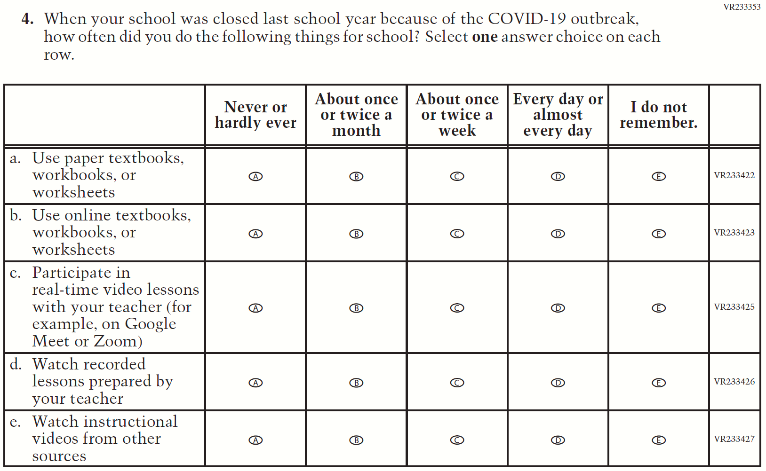

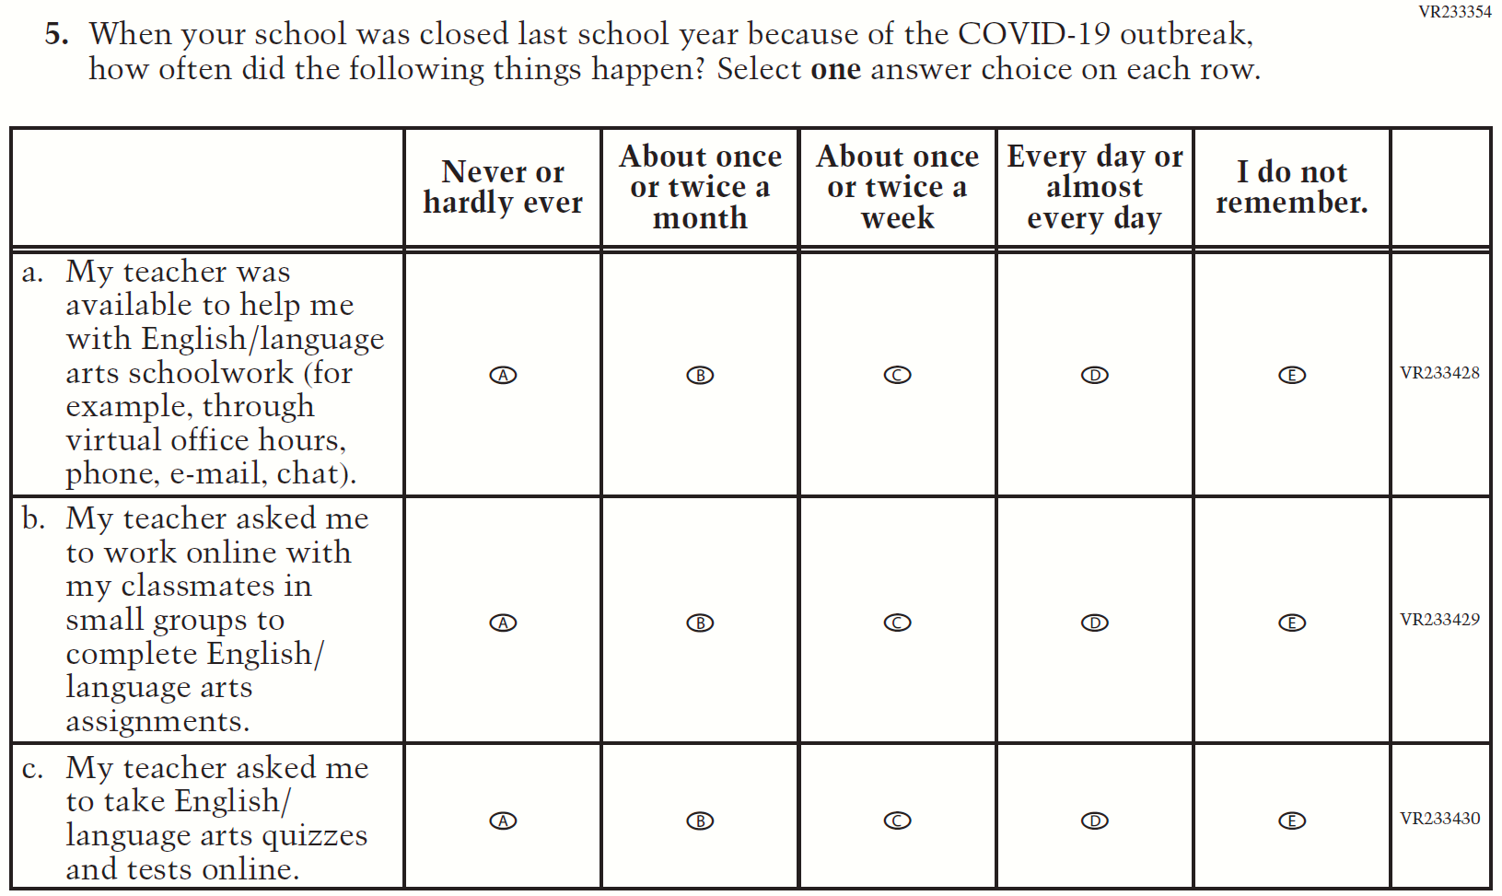
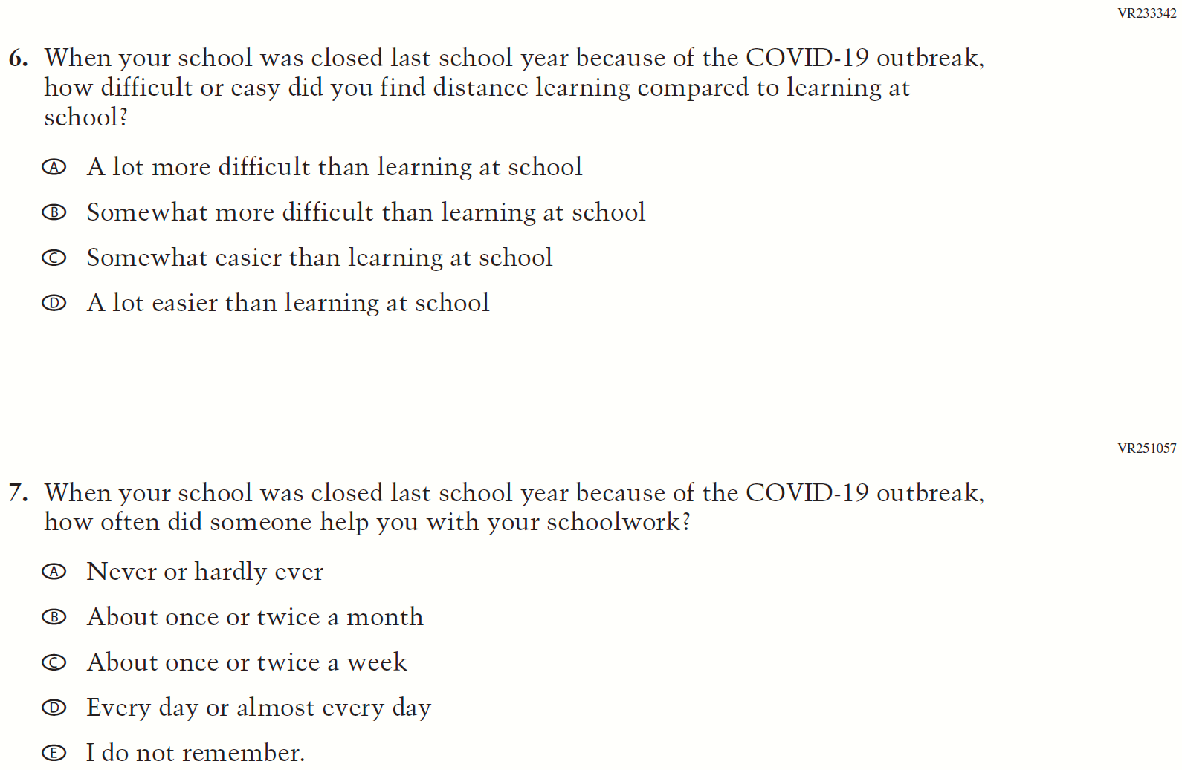
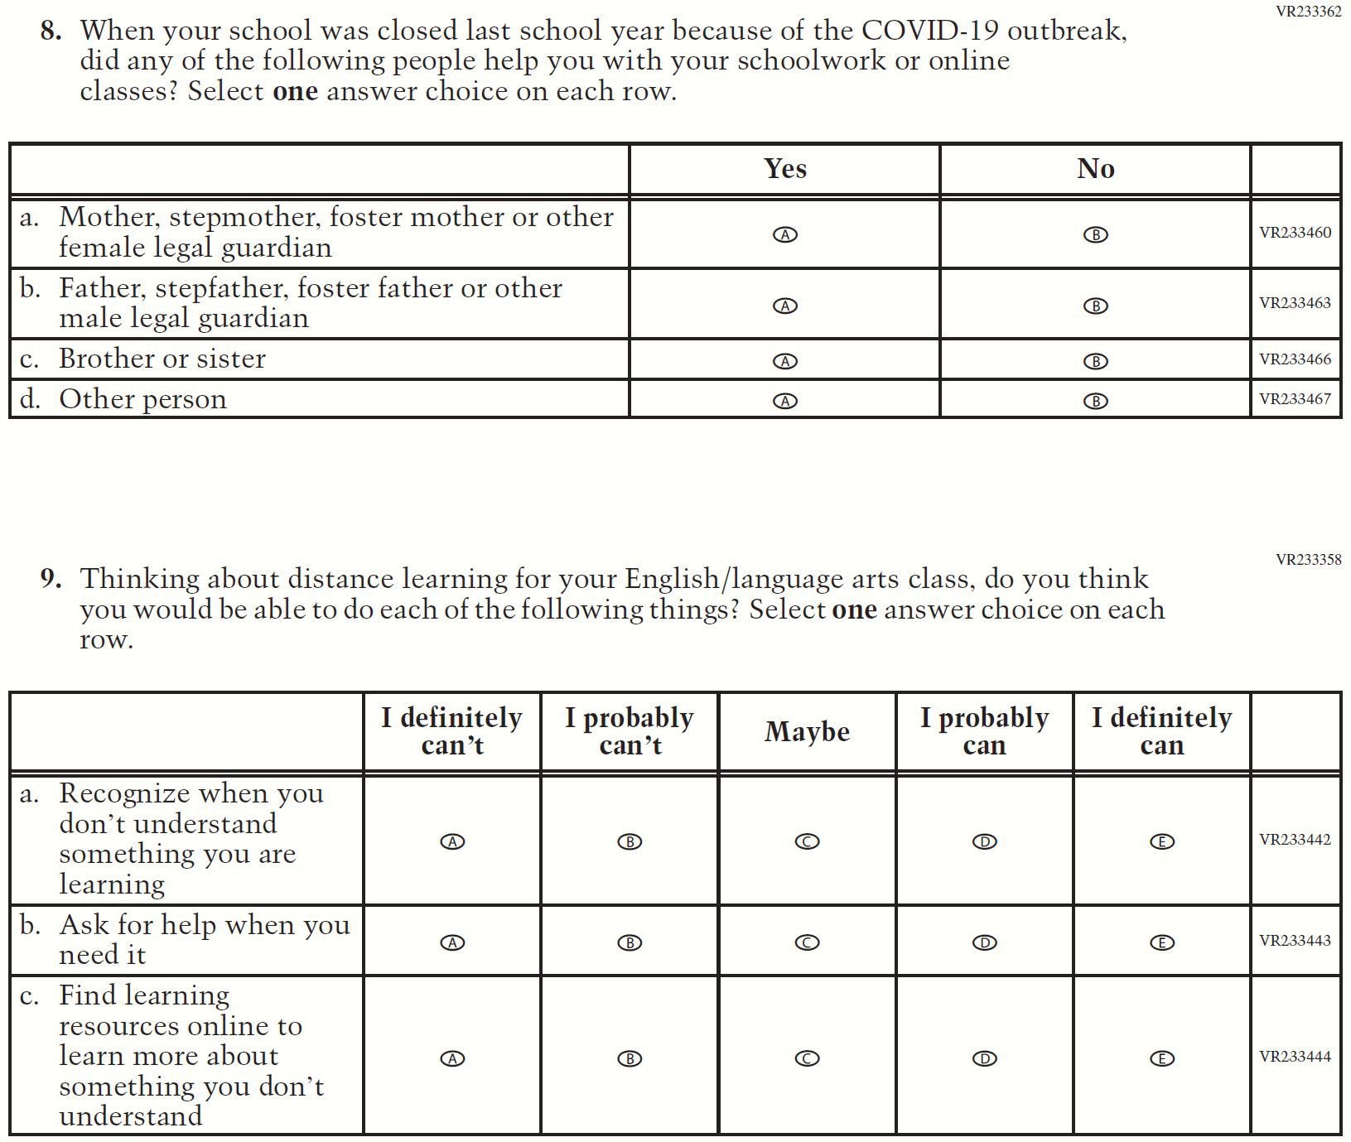

Appendix F-1m: Operational Grade 4 COVID-19 Student Items (Math)

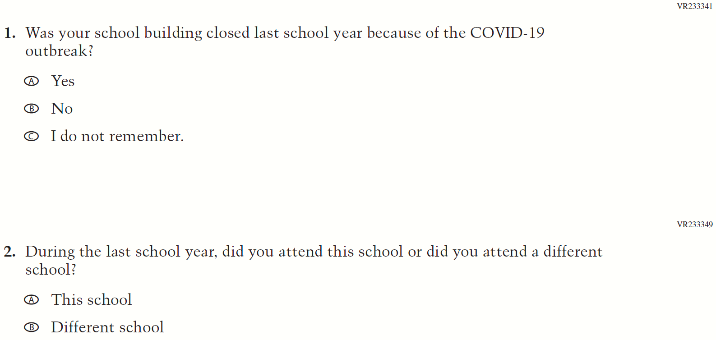

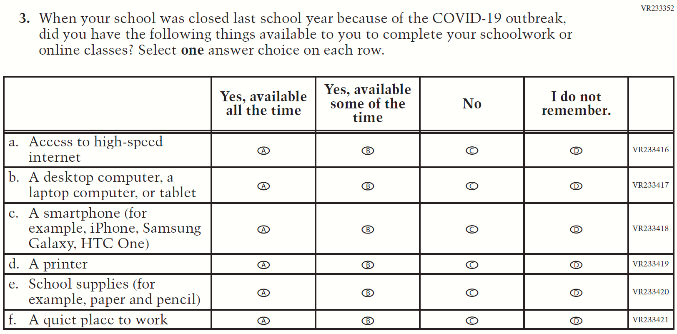
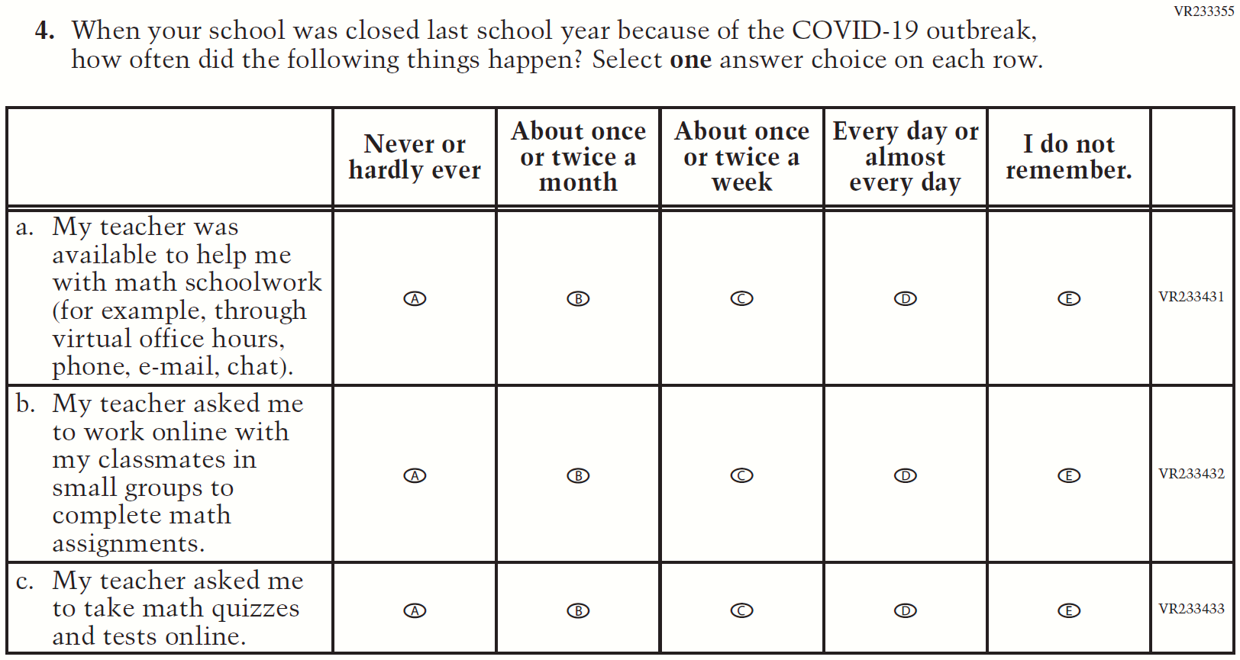
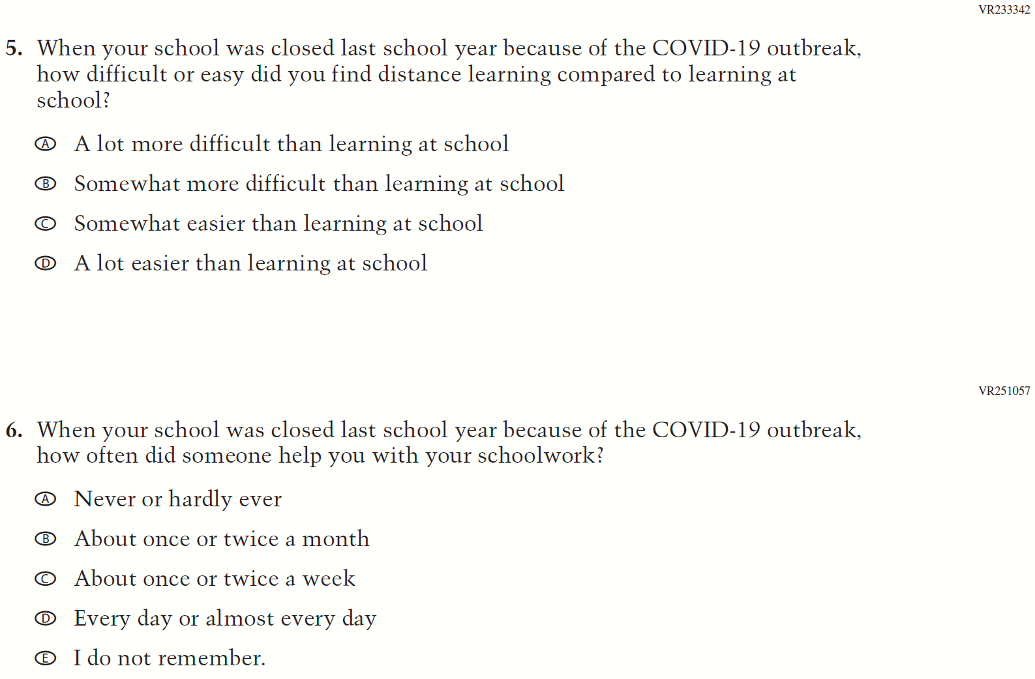
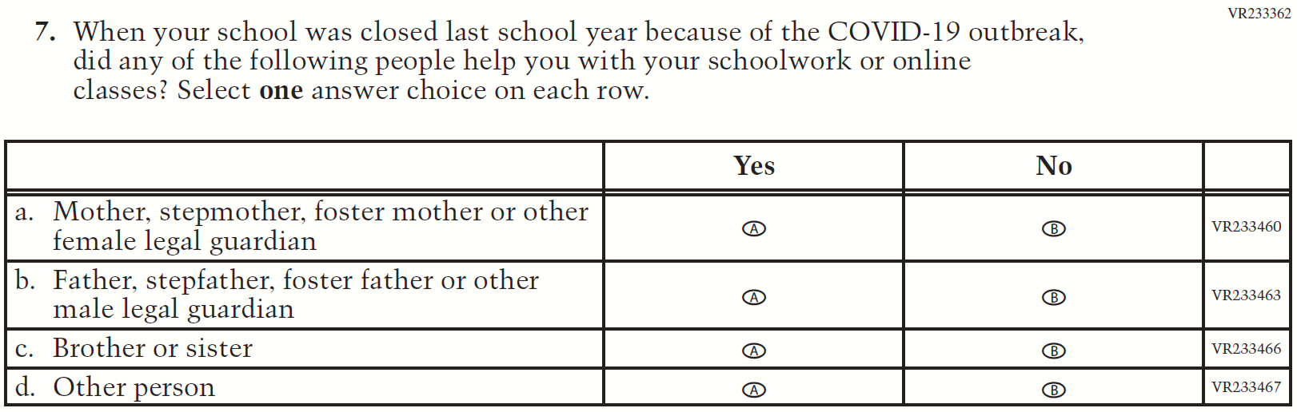
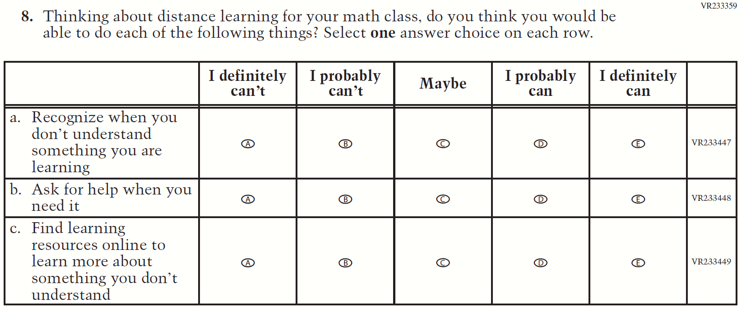

Appendix F-1n: Operational Grade 8 COVID-19 Student Items (Math)

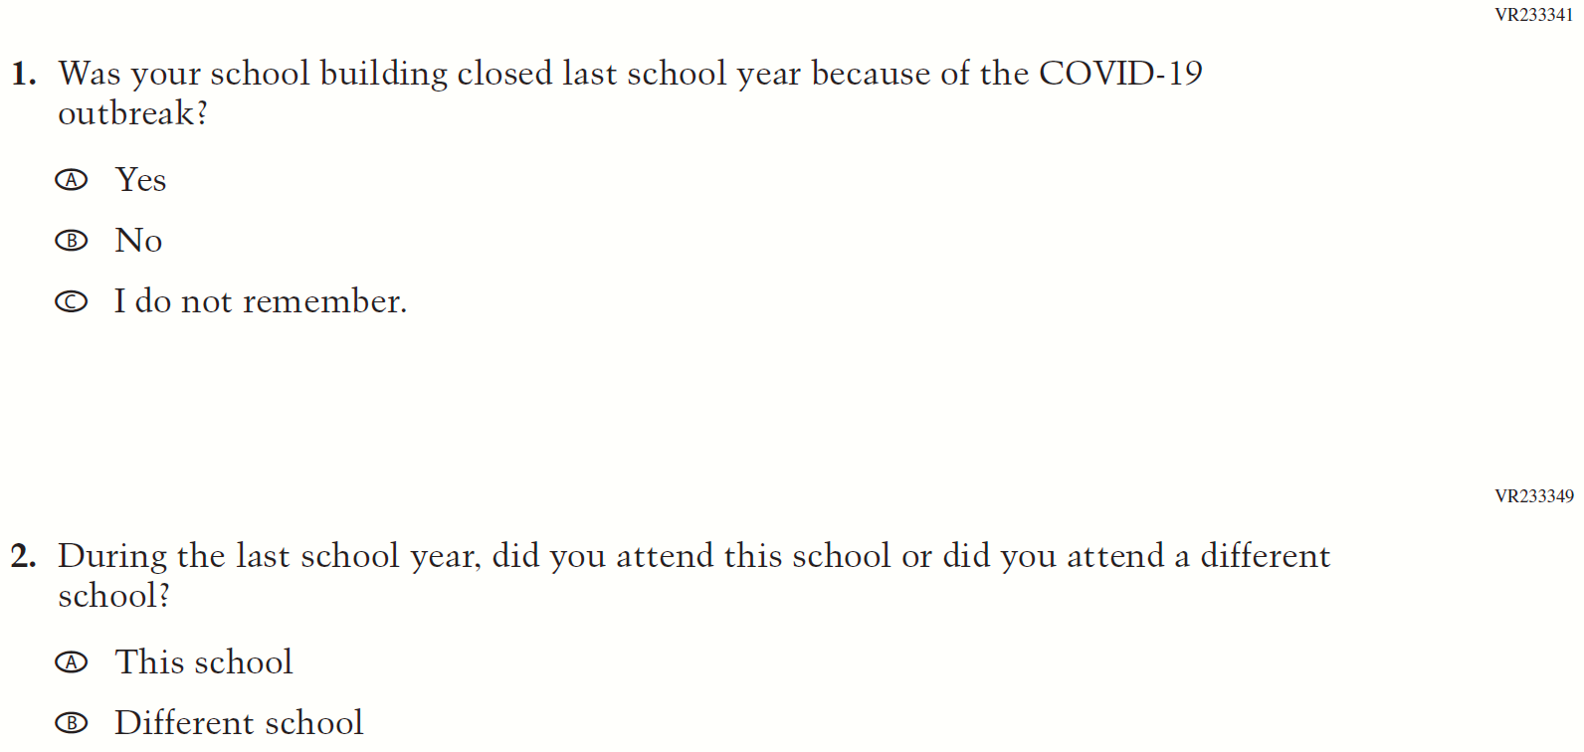

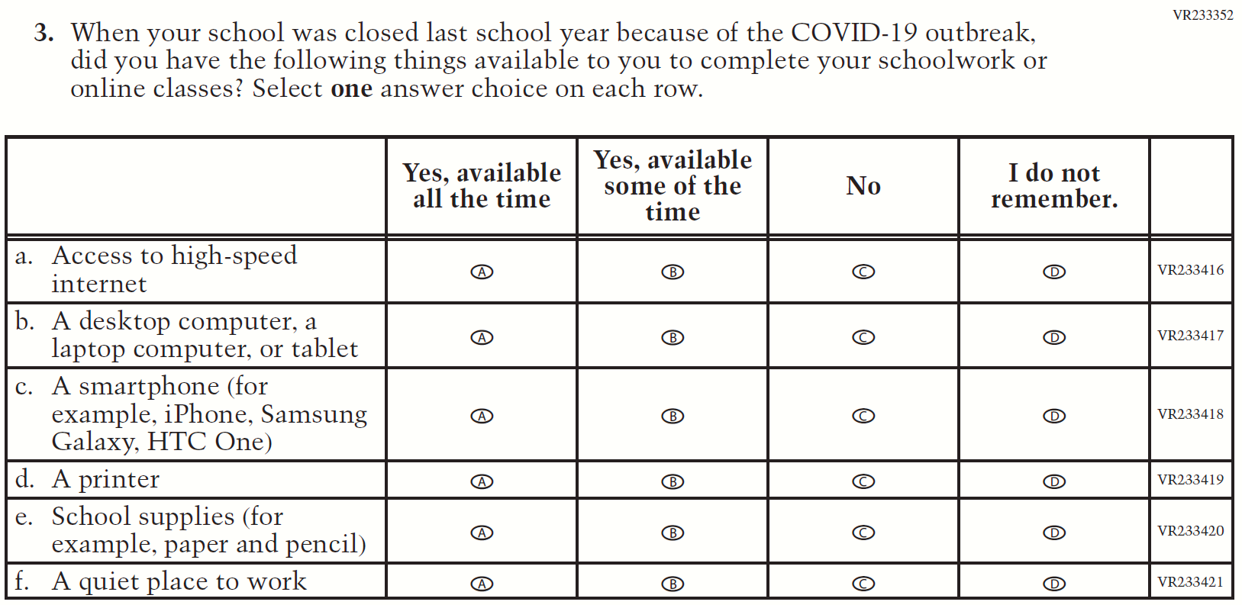
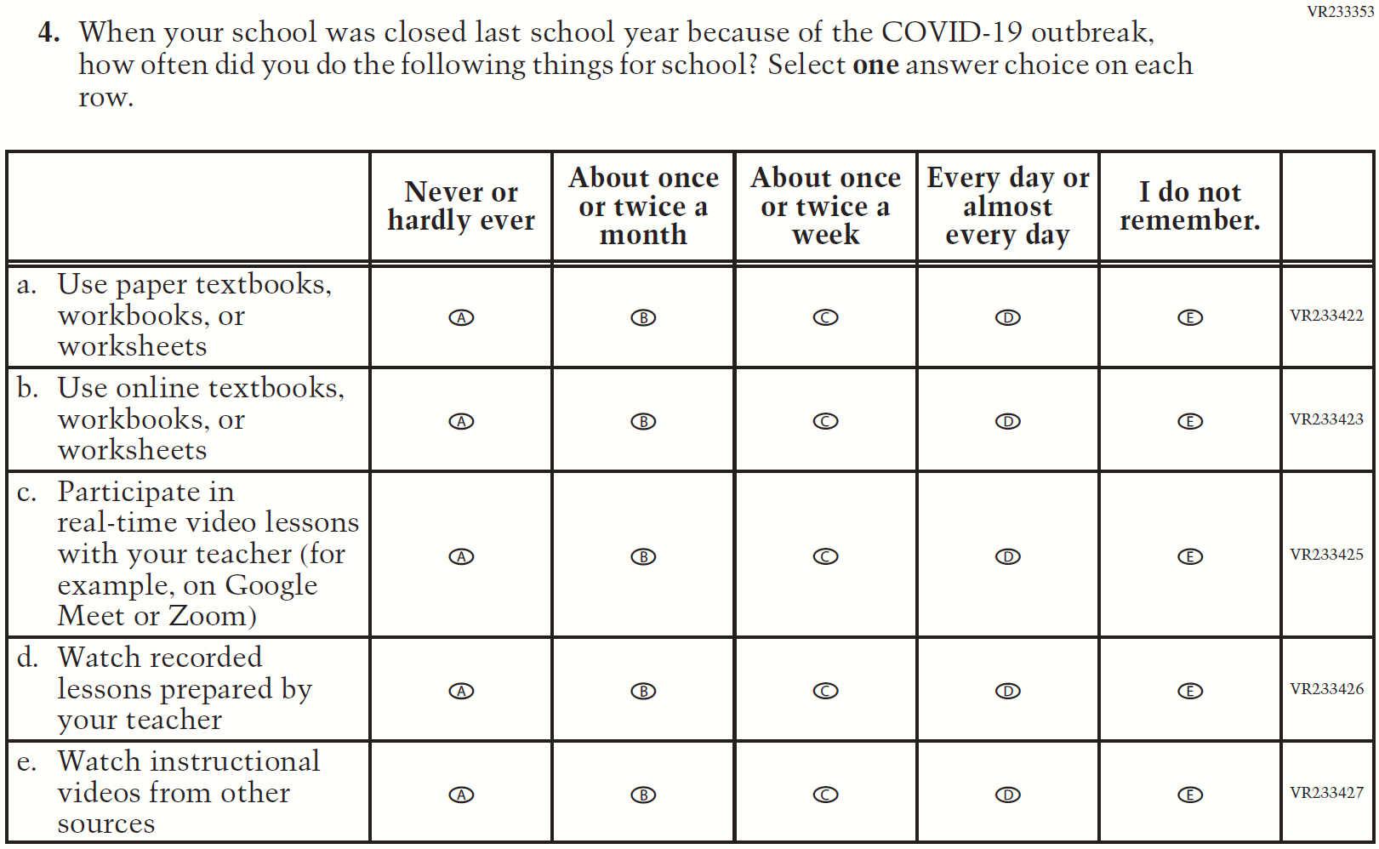
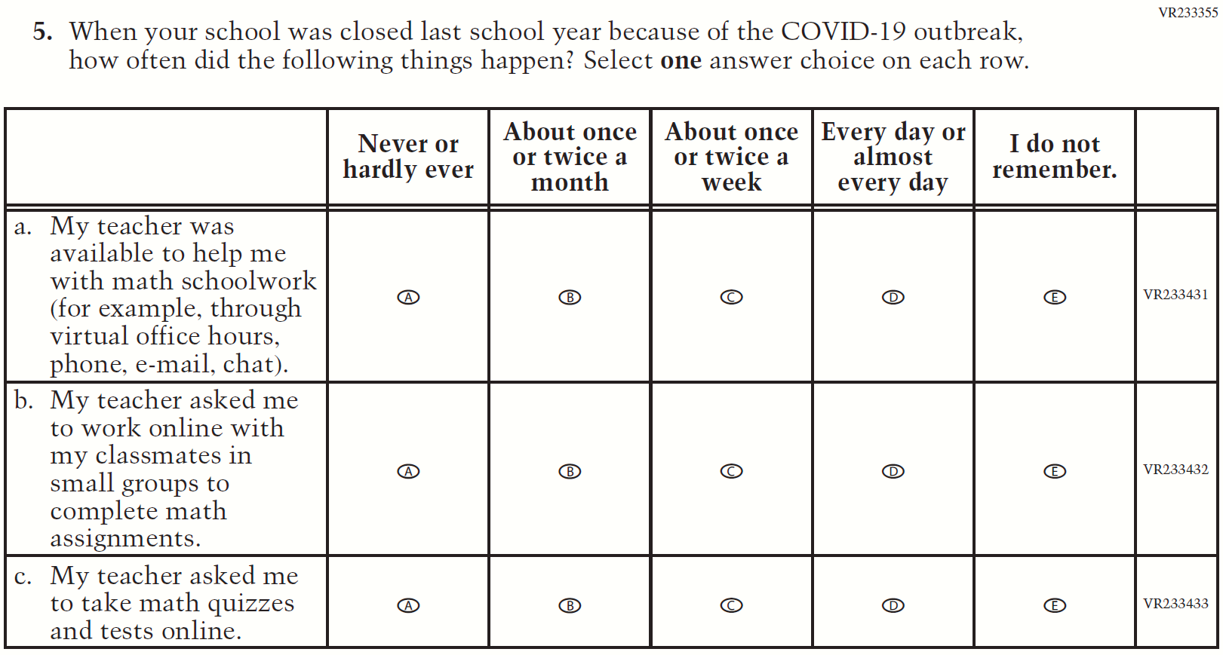
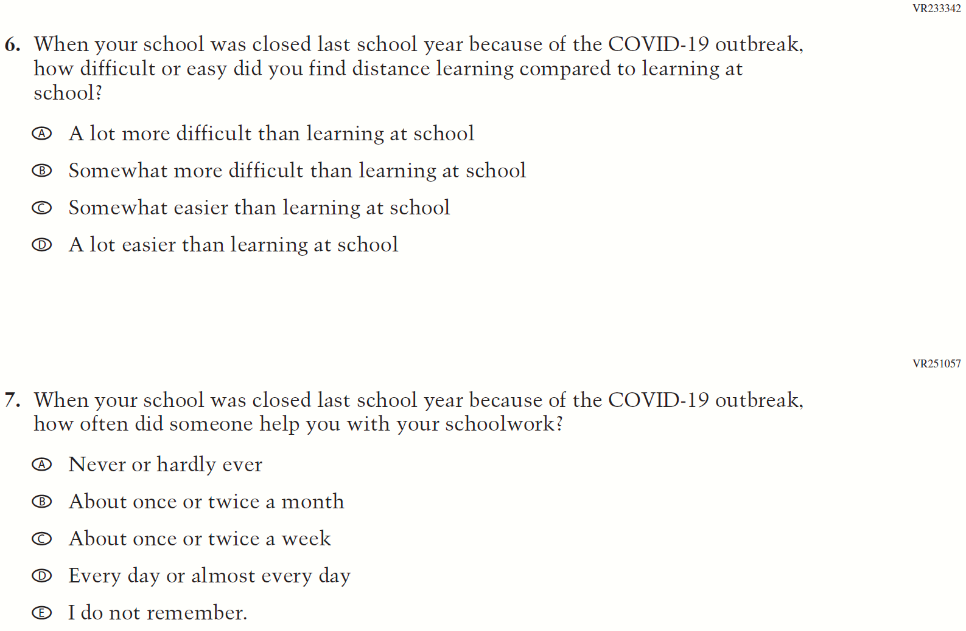
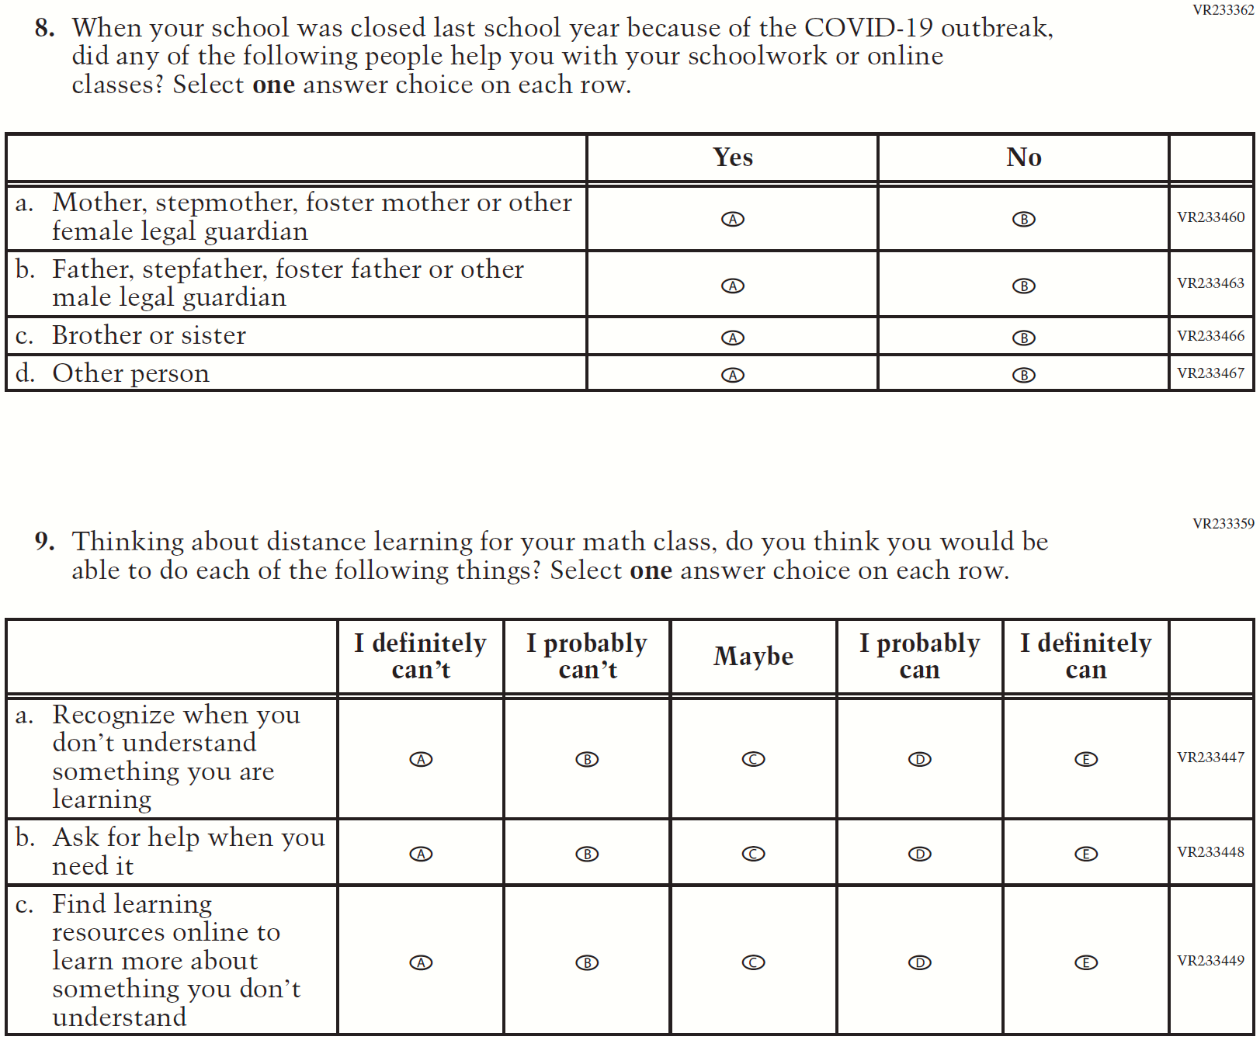

Appendix F-1: 2022 Student Questionnaire

Appendix F-1a-22: Operational Grade 4 (CORE)

Appendix F-1b-22: Operational Grade 8 (CORE)

Appendix F-1c-22: Operational Grade 4 (Mathematics)

Appendix F-1d-22: Operational Grade 8 (Mathematics)

Appendix F-1e-22: Operational Grade 4 (Reading)

Appendix F-1f-22: Operational Grade 8 (Reading)

Appendix F-1g-22: Operational Grade 8 Civics

Appendix J1-16: Operational Grade 8 U.S. History

Appendix F-1h-22: Operational Grade 4 Debrief

Appendix F-1i-22: Operational Grade 8 Debrief

Appendix F-1j-22: Operational Grade 4 COVID-19 Student Items (ELA)

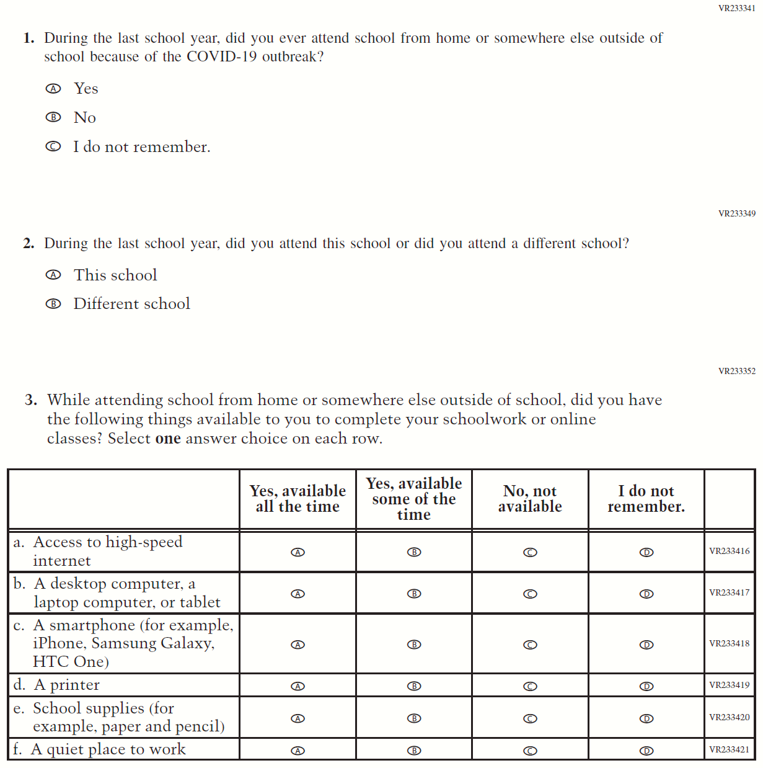

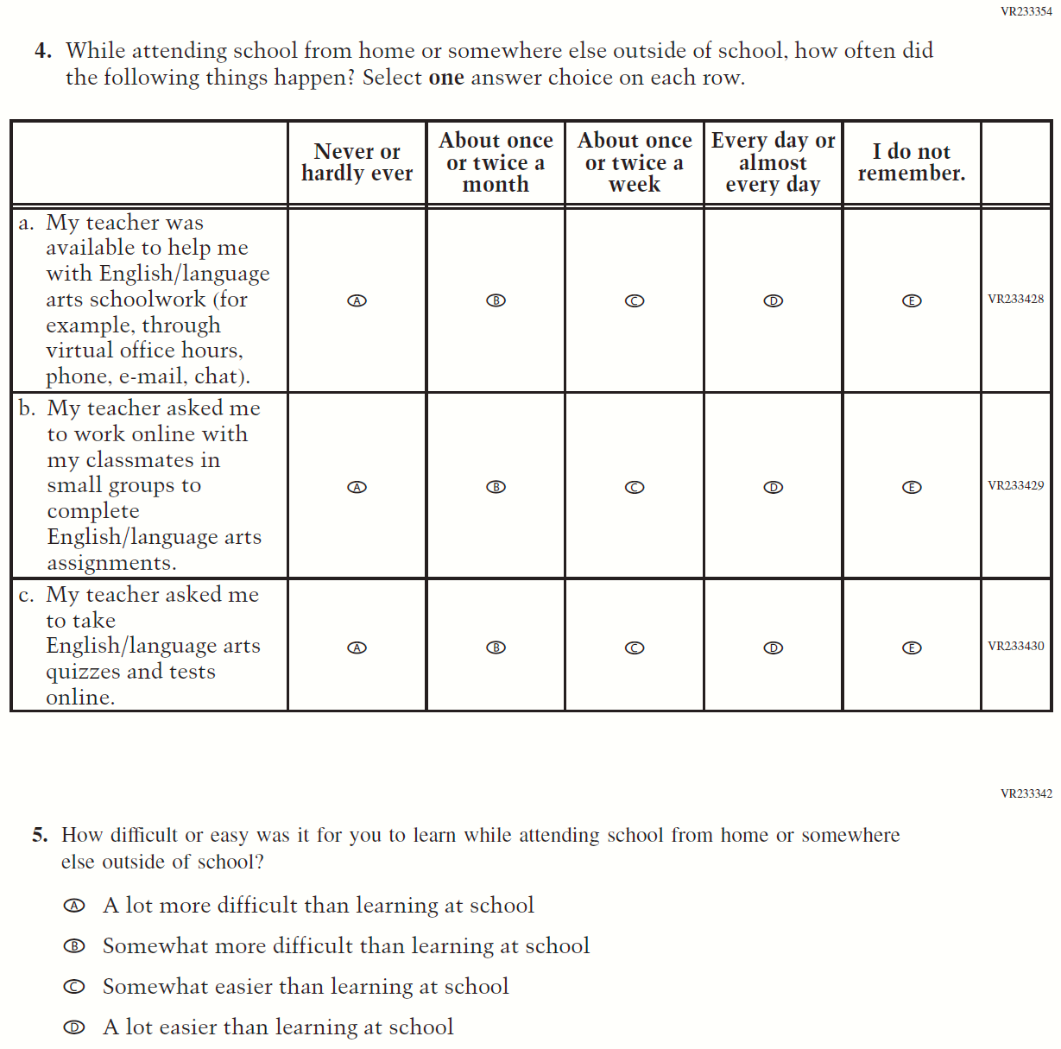

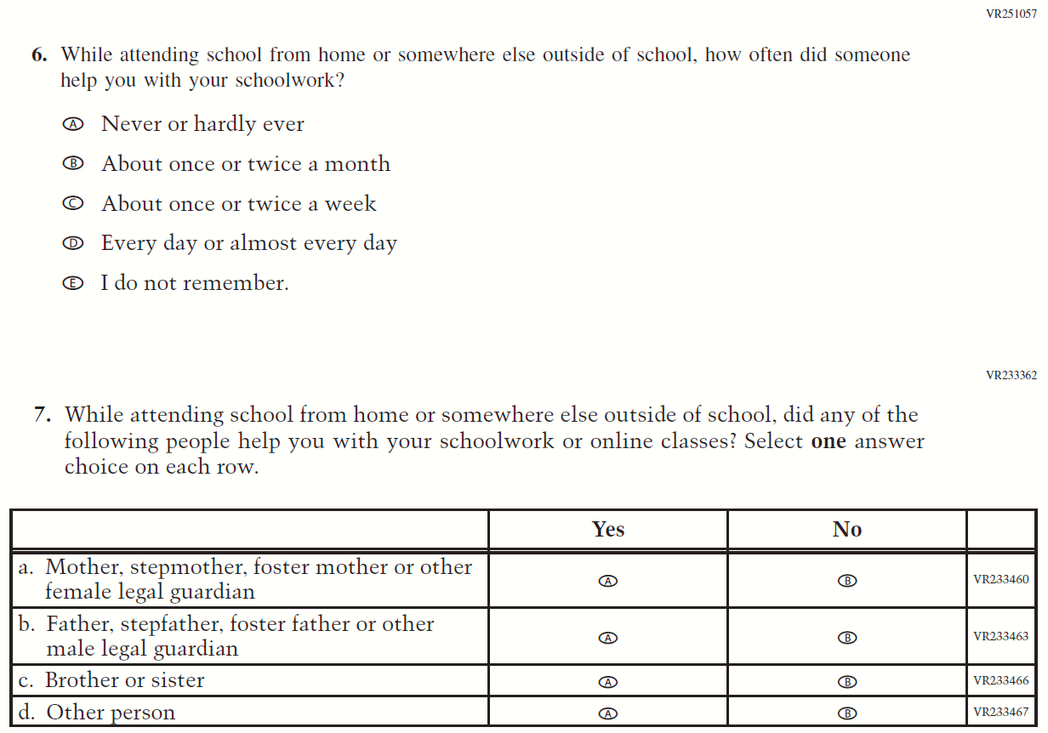
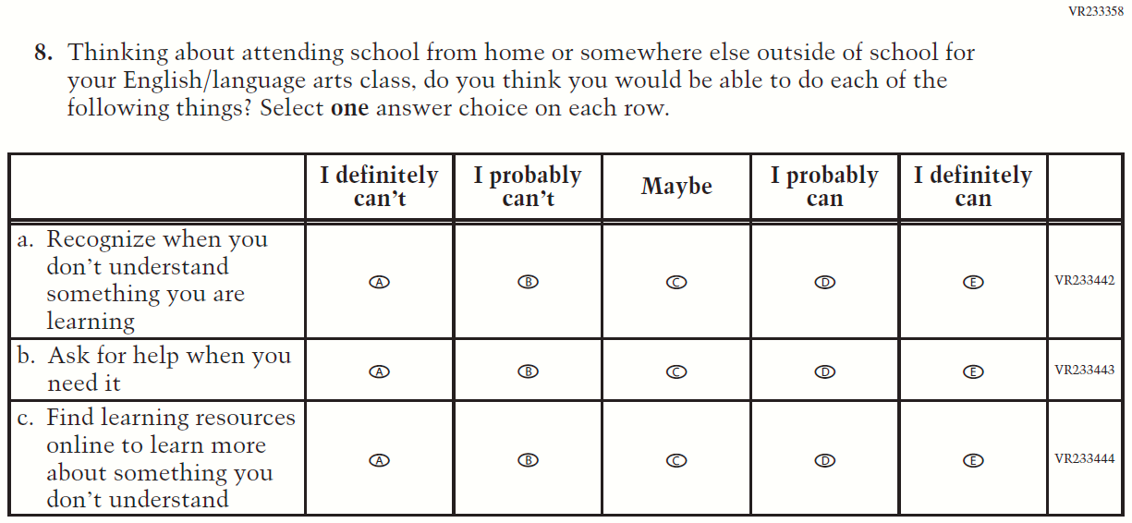

Appendix F-1k-22: Operational Grade 8 COVID-19 Student Items (ELA)

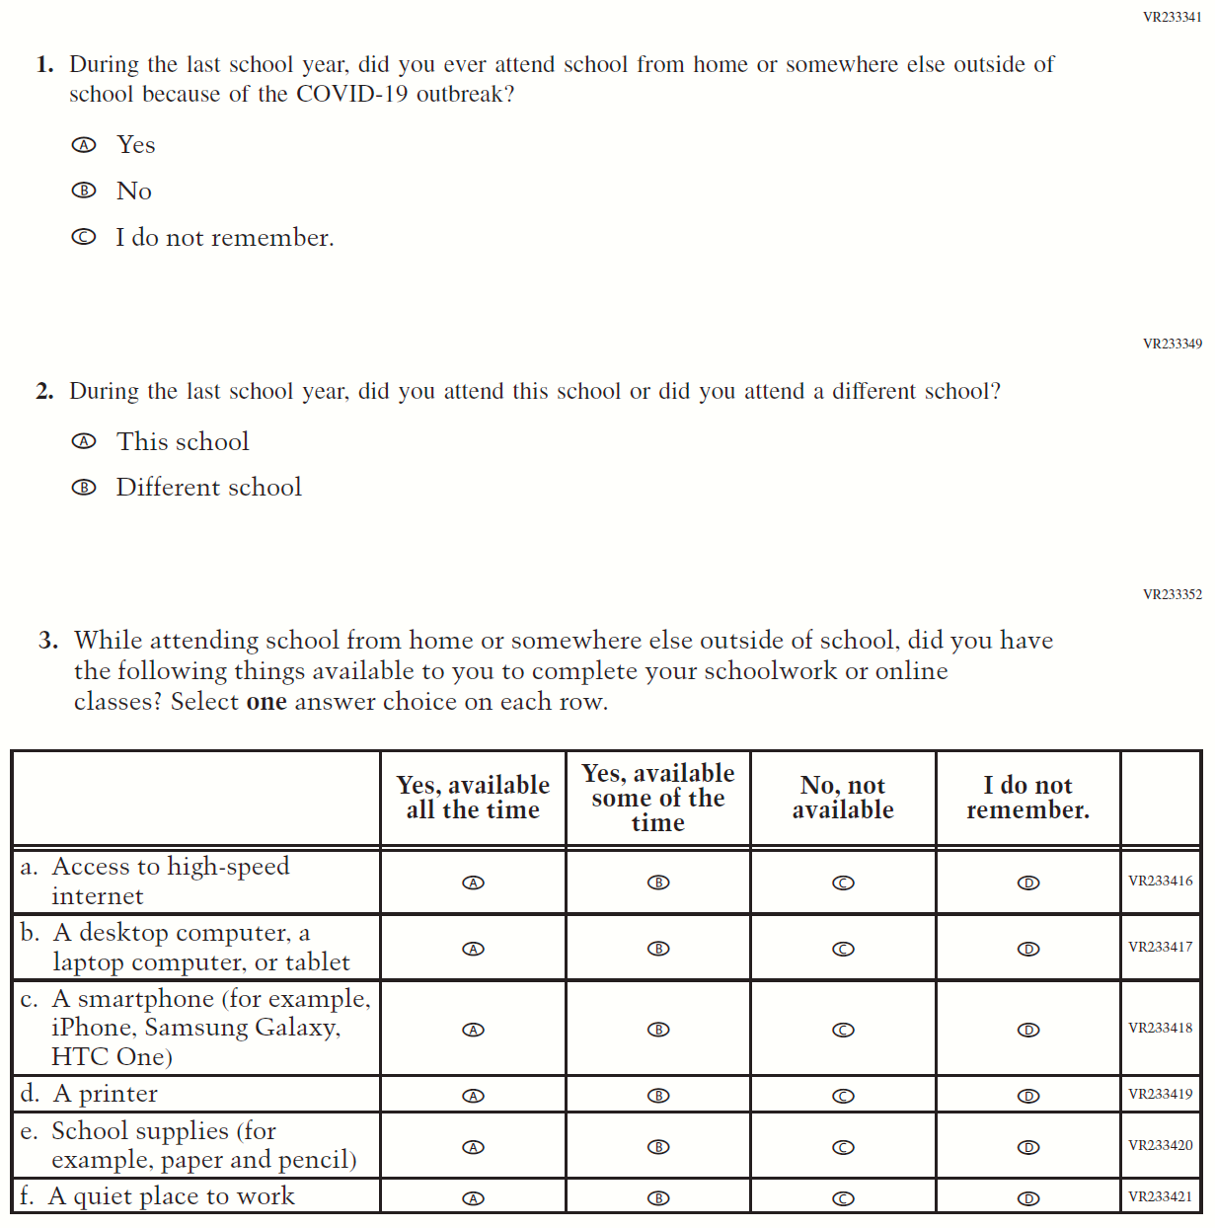

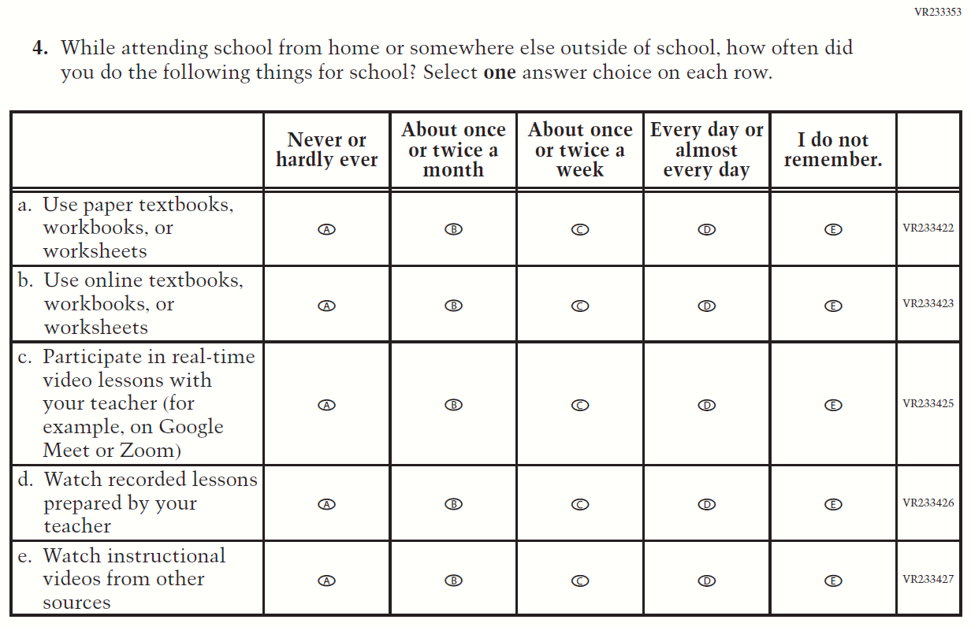

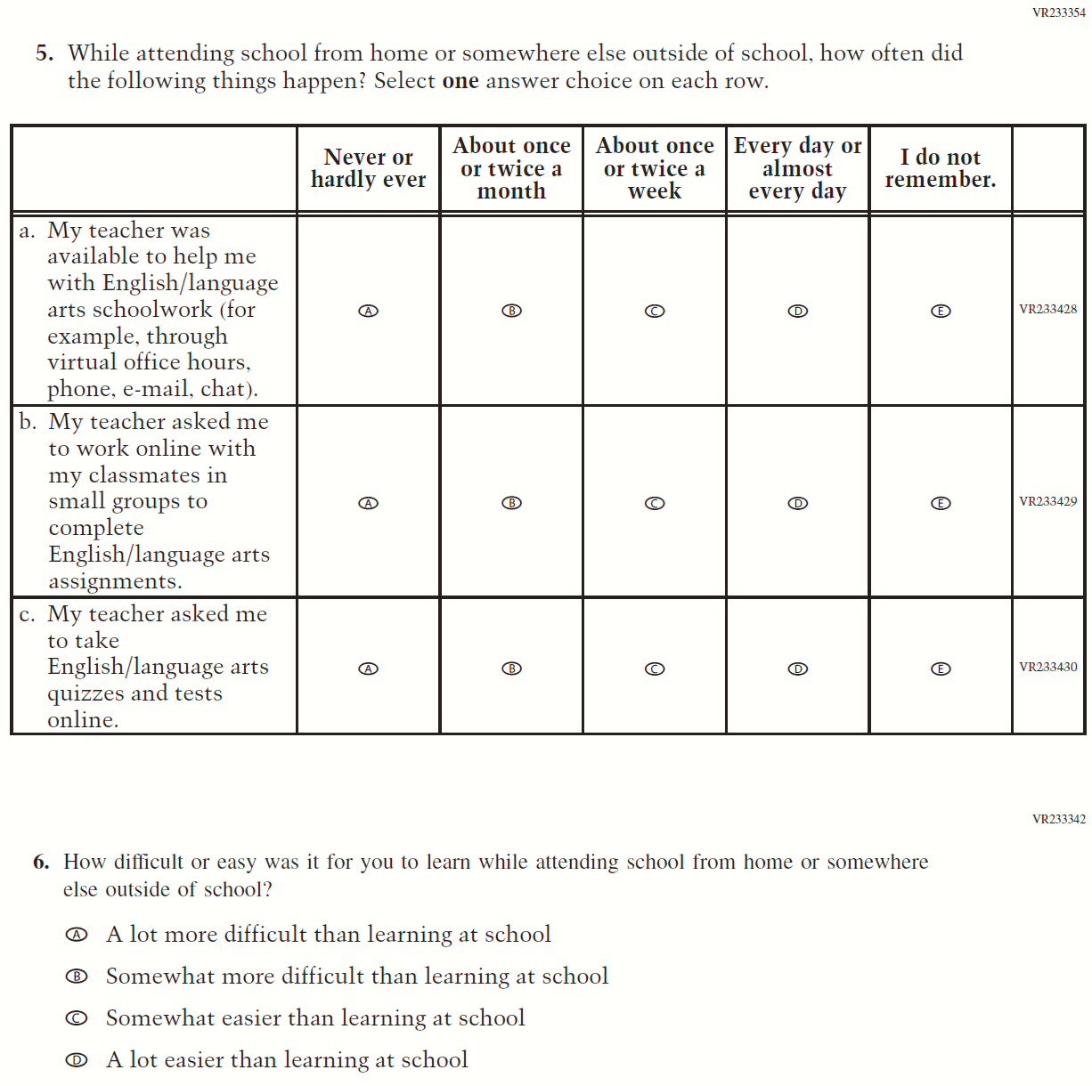

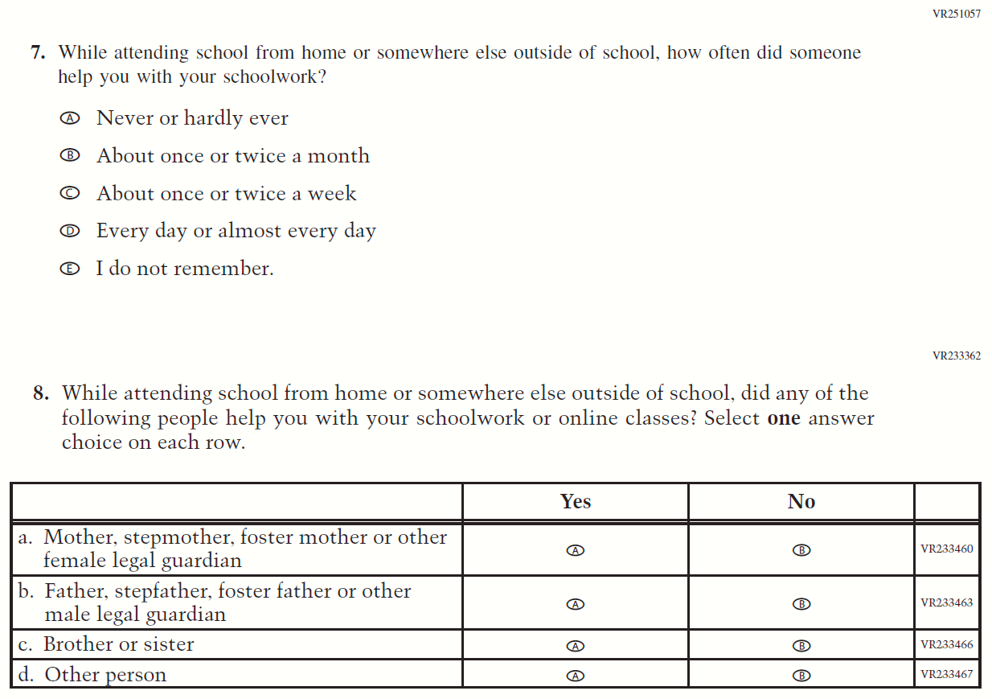
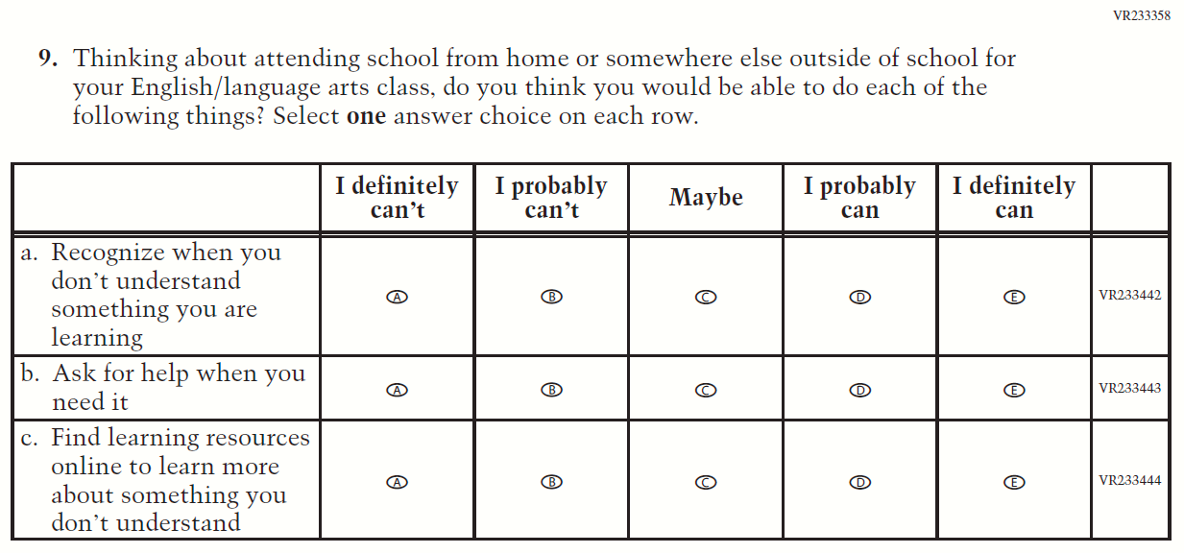

Appendix F-1l-22: Operational Grade 4 COVID-19 Student Items (Math)
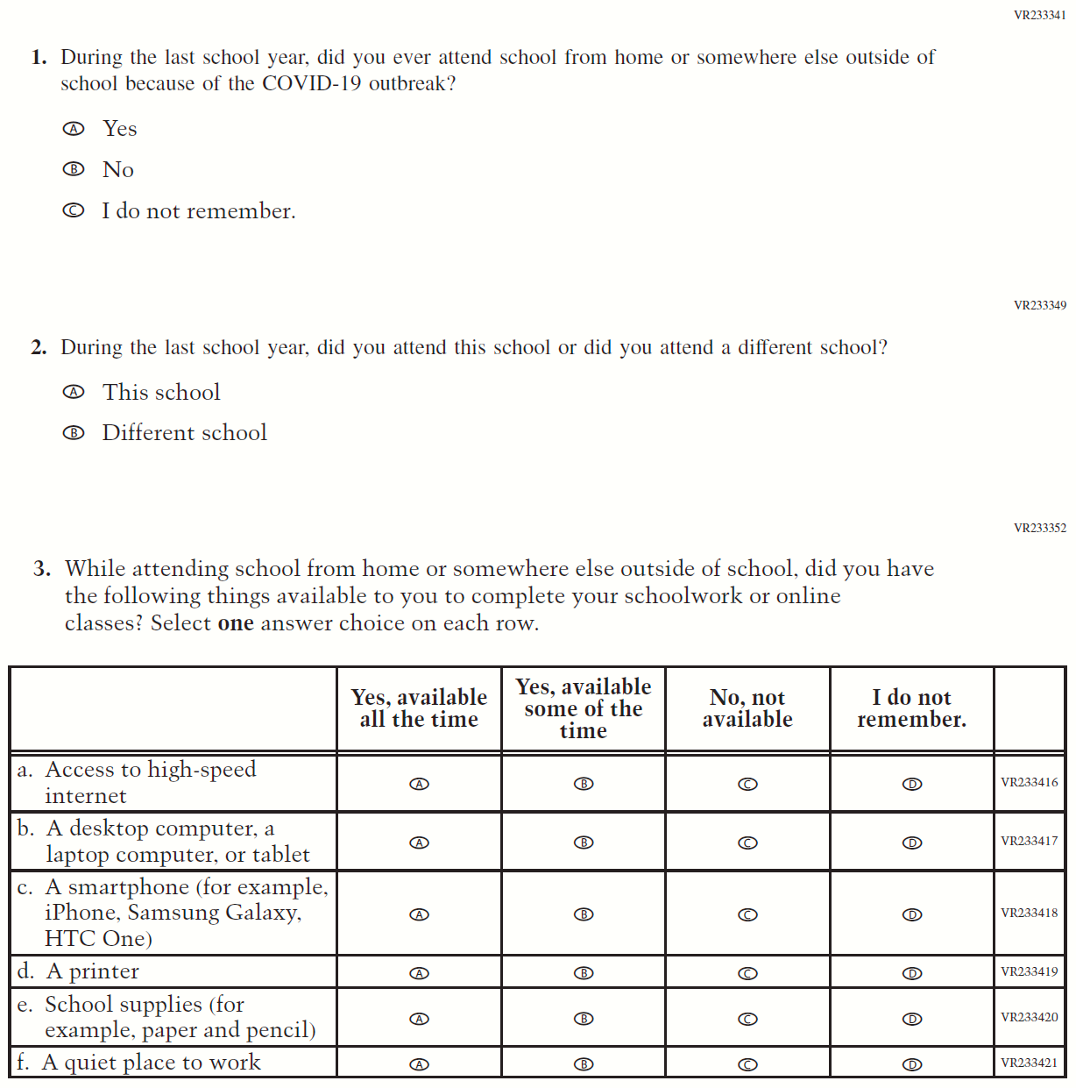

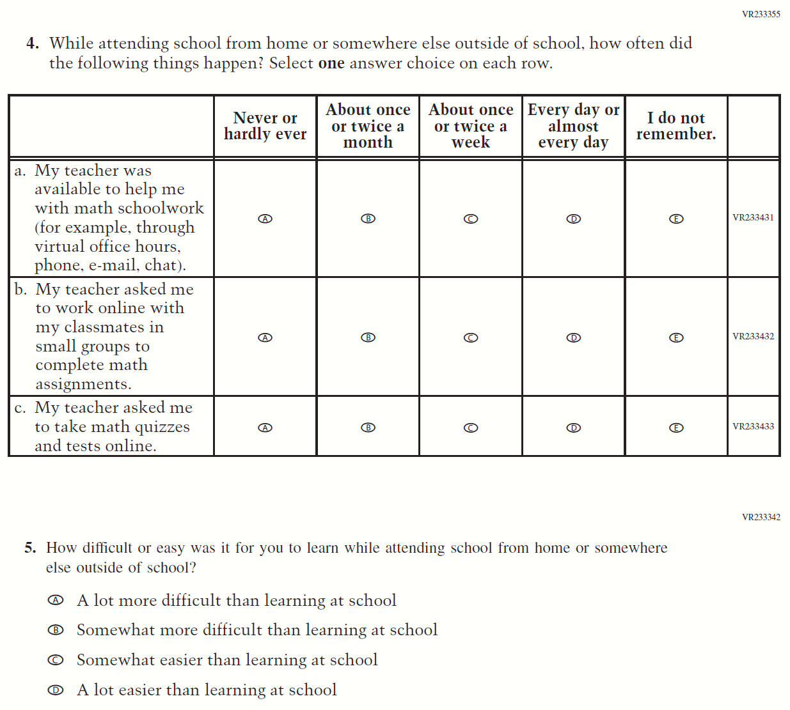

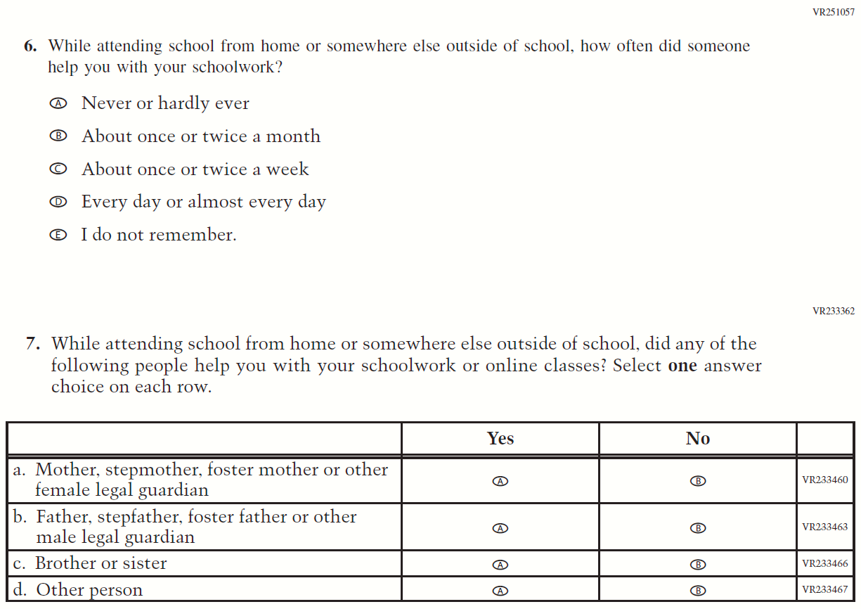

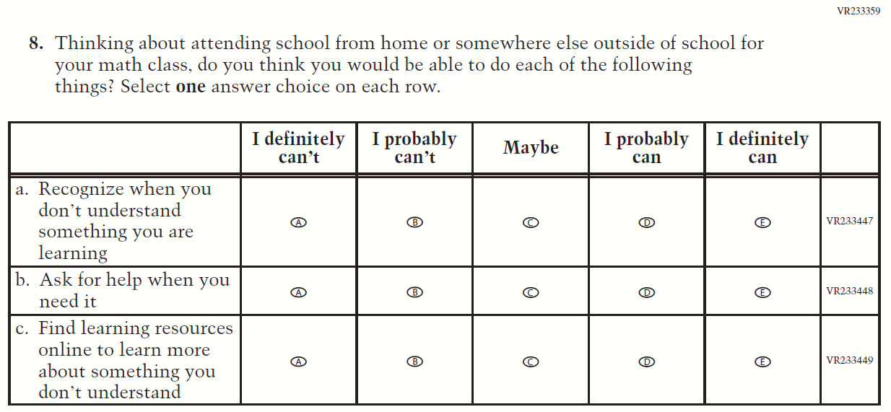

Appendix F-1m-22: Operational Grade 8 COVID-19 Student Items (Math)
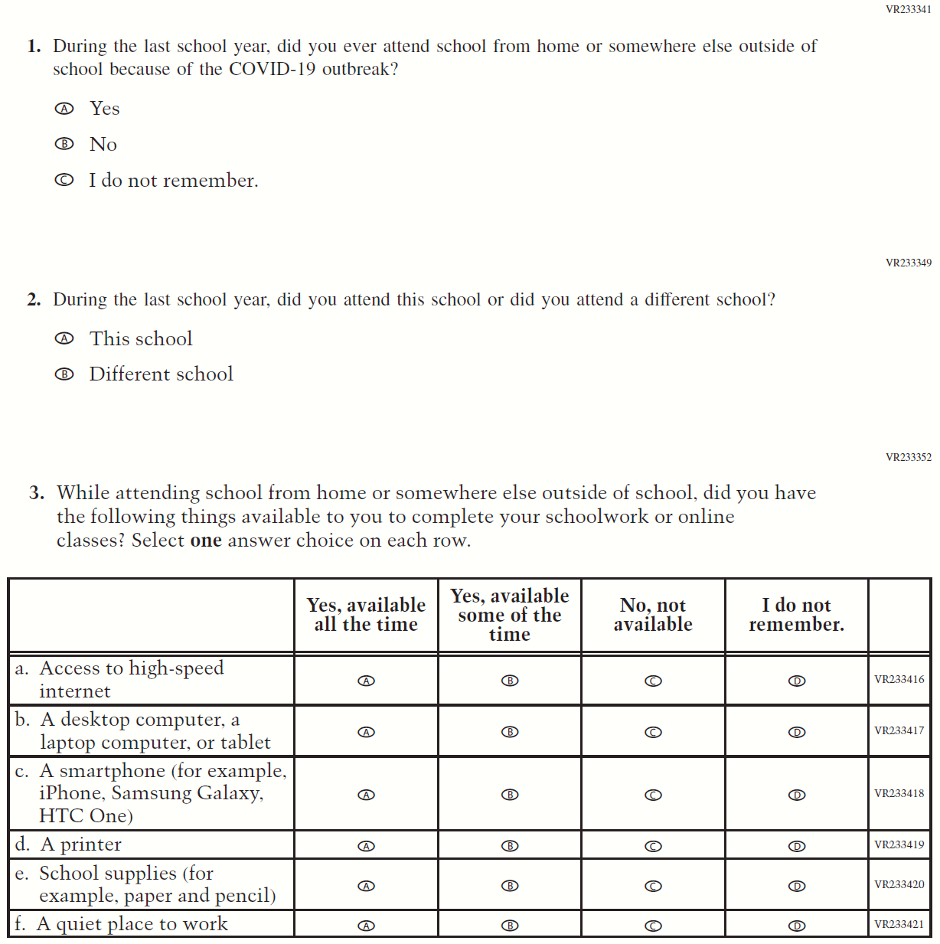

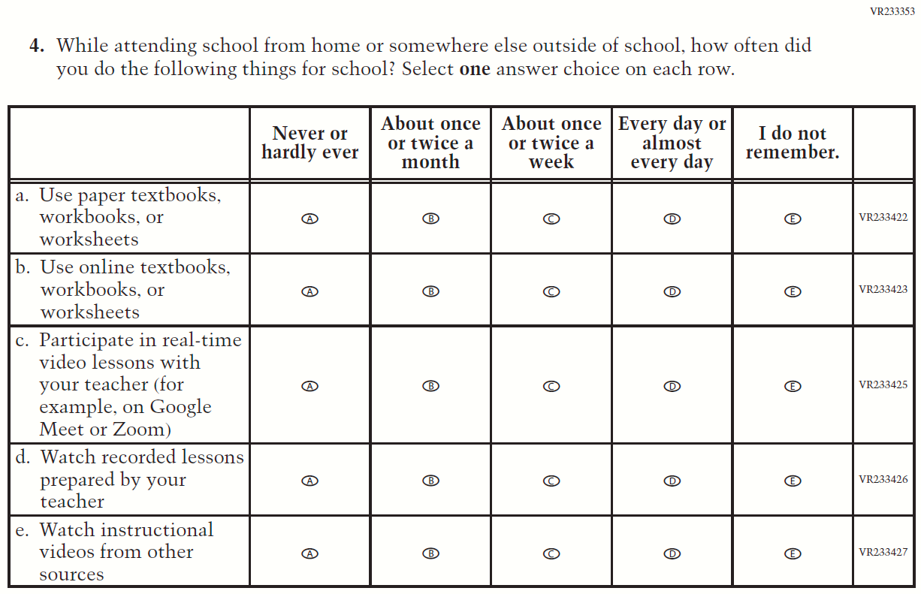

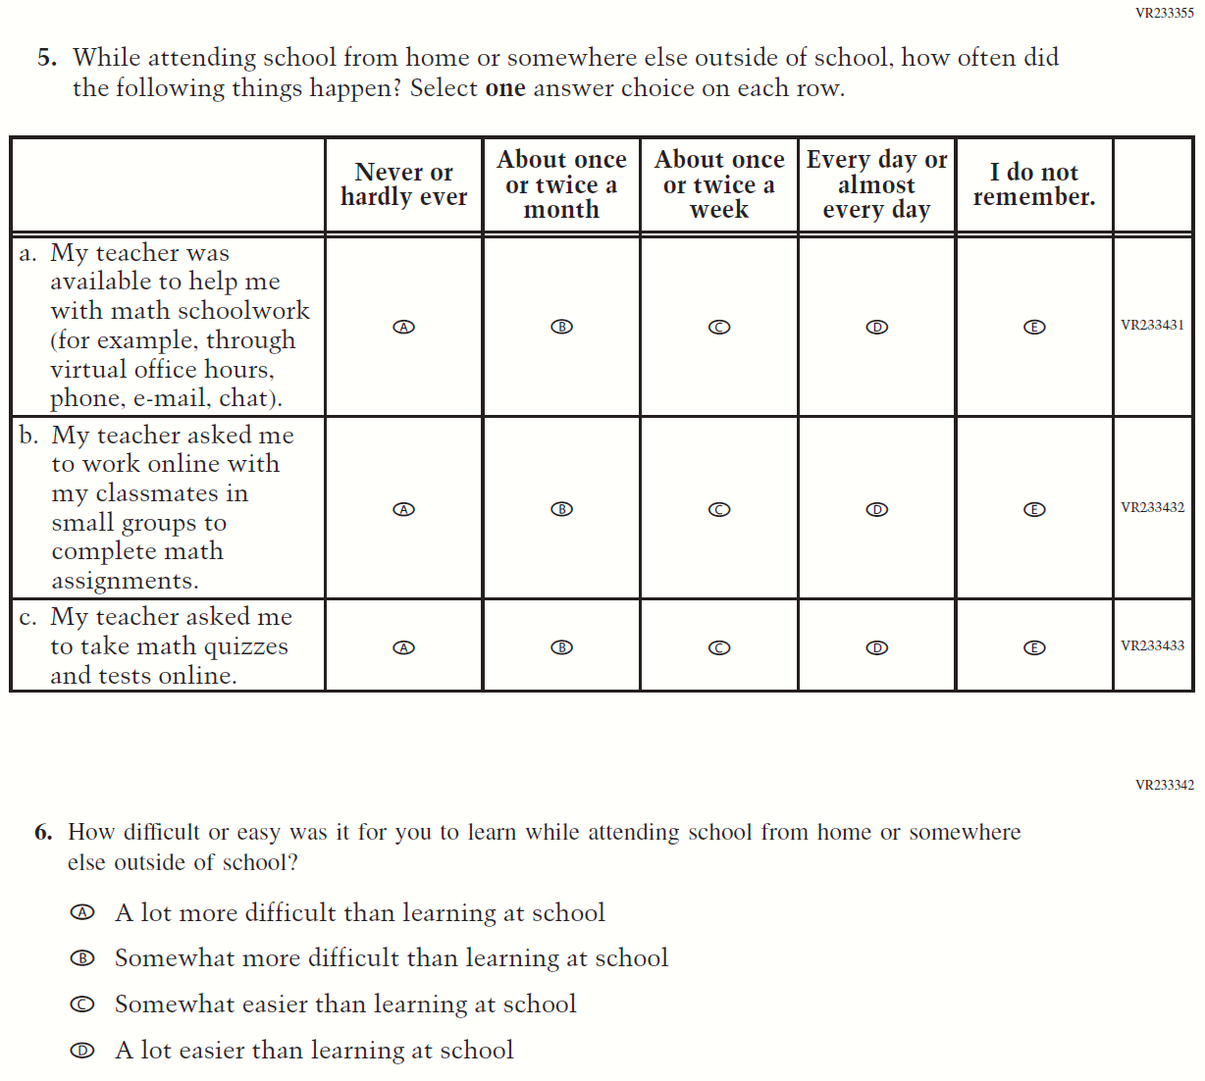

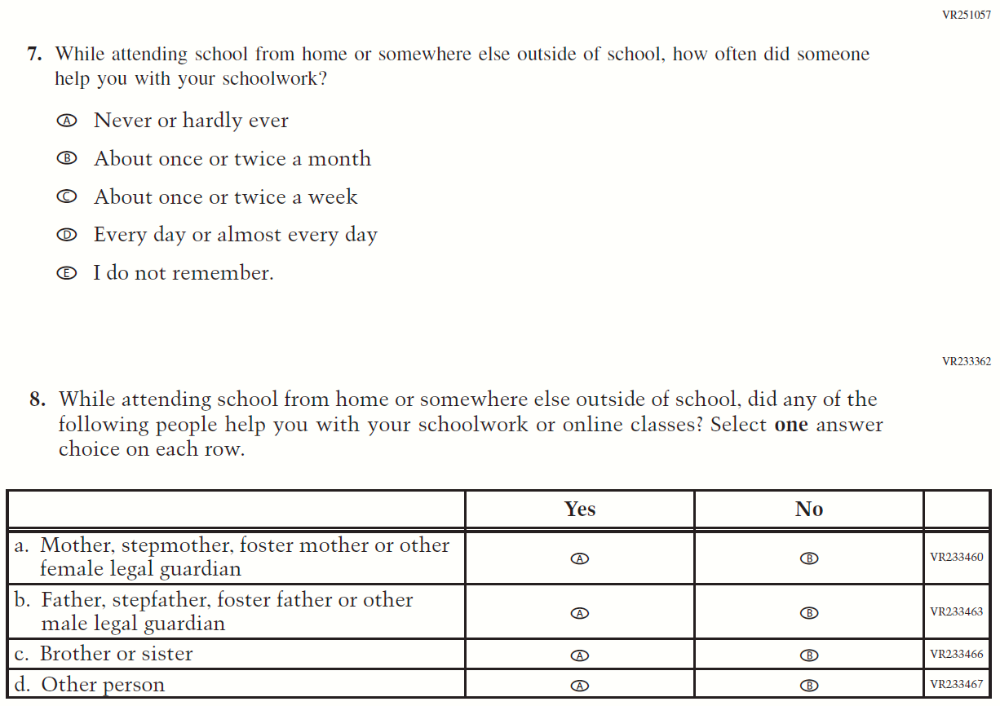
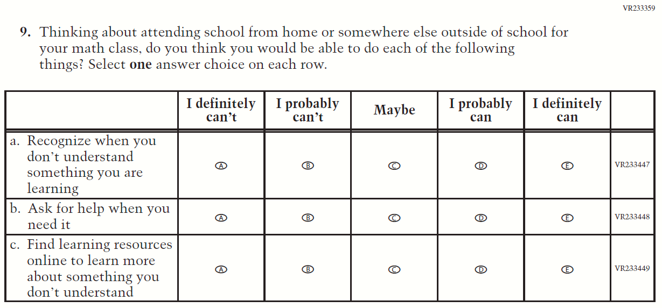

Appendix F-1n-22: Operational Grade 8 COVID-19 Student Items (Civics)

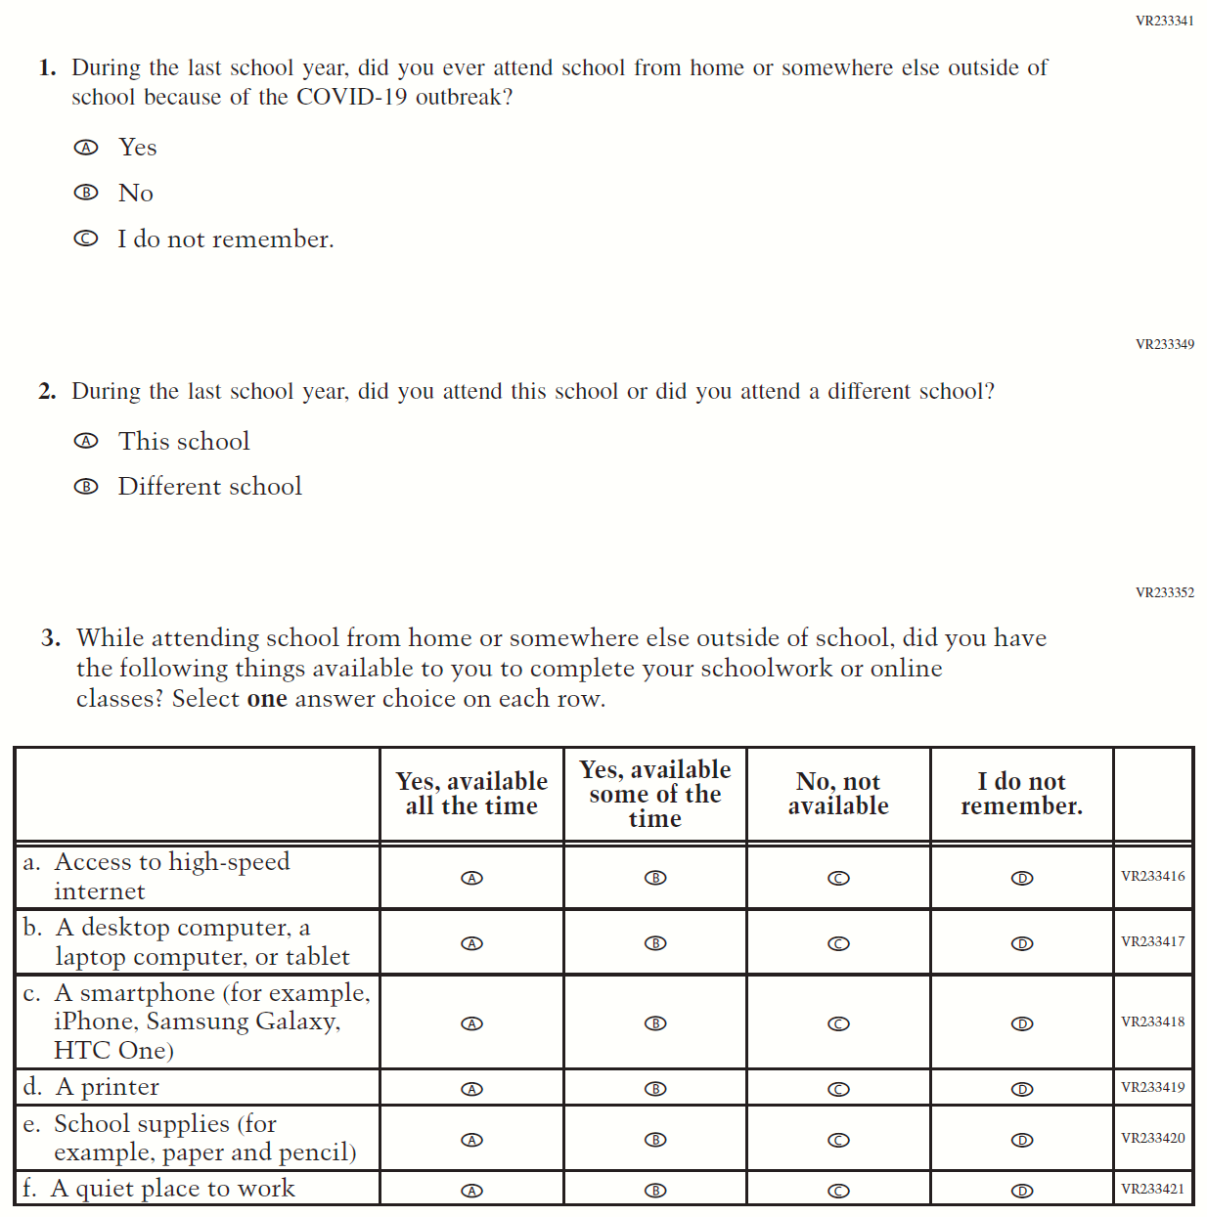

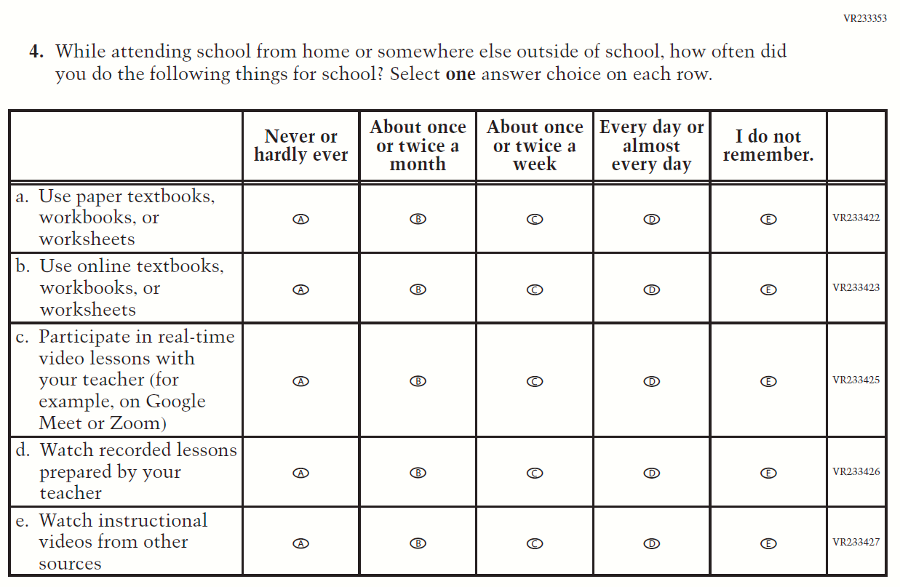

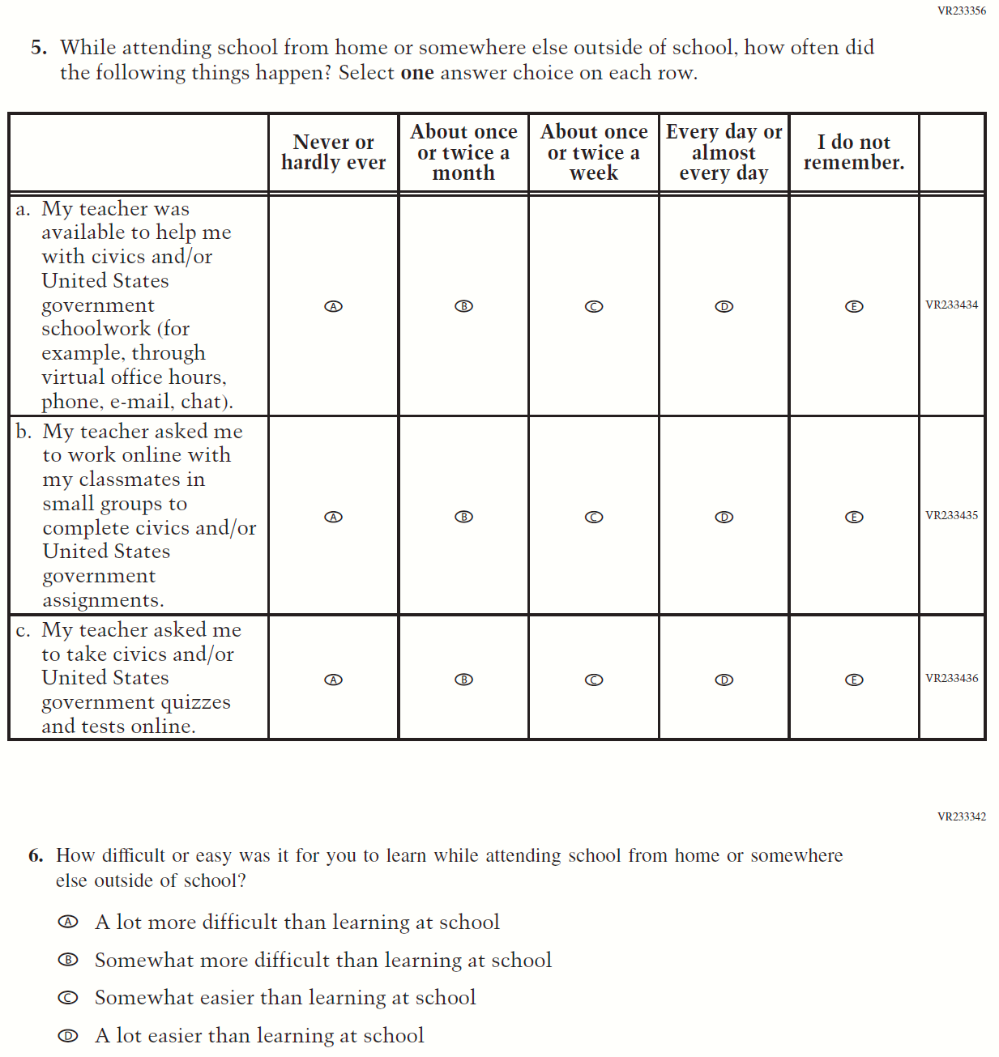

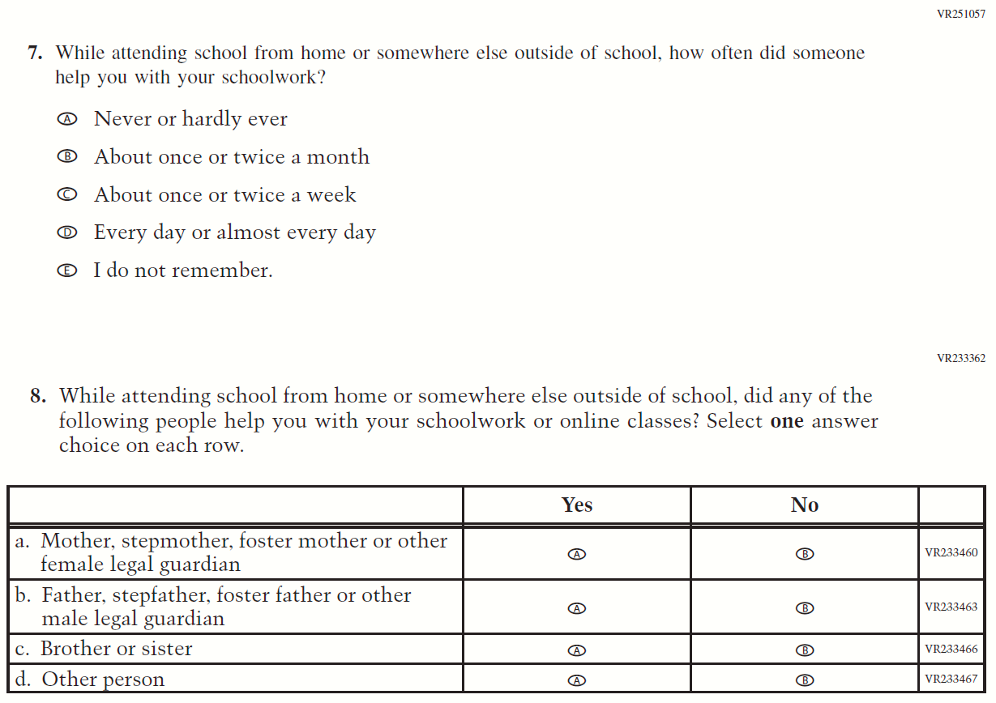
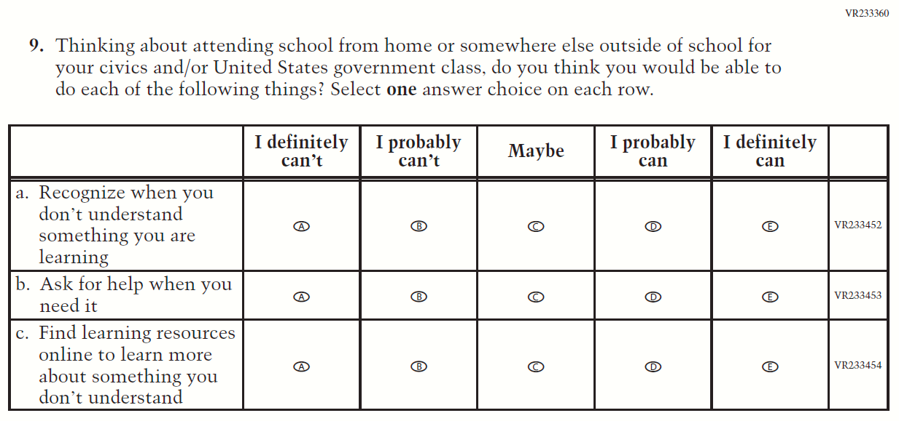

Appendix F-1o-22: Operational Grade 8 COVID-19 Student Items (U.S. History)
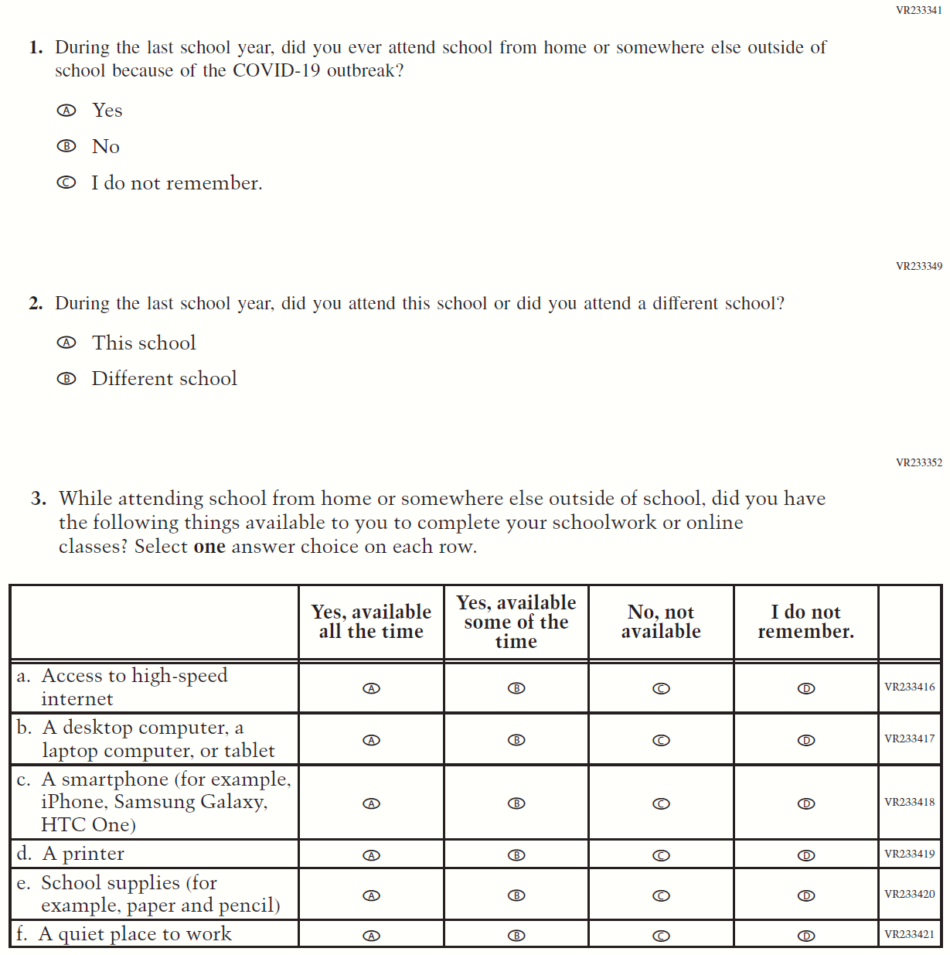

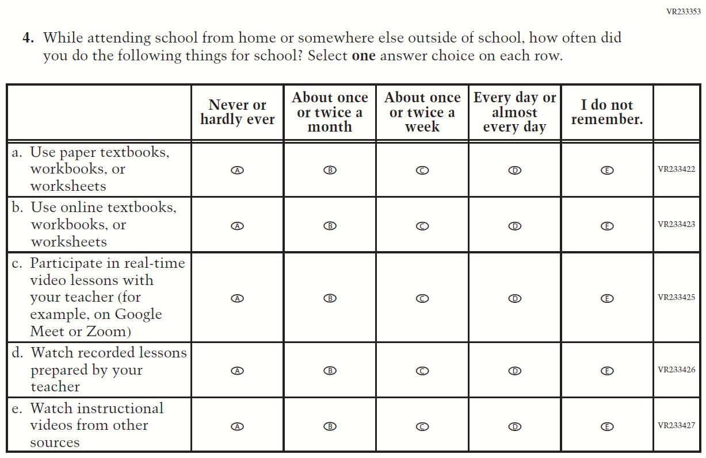

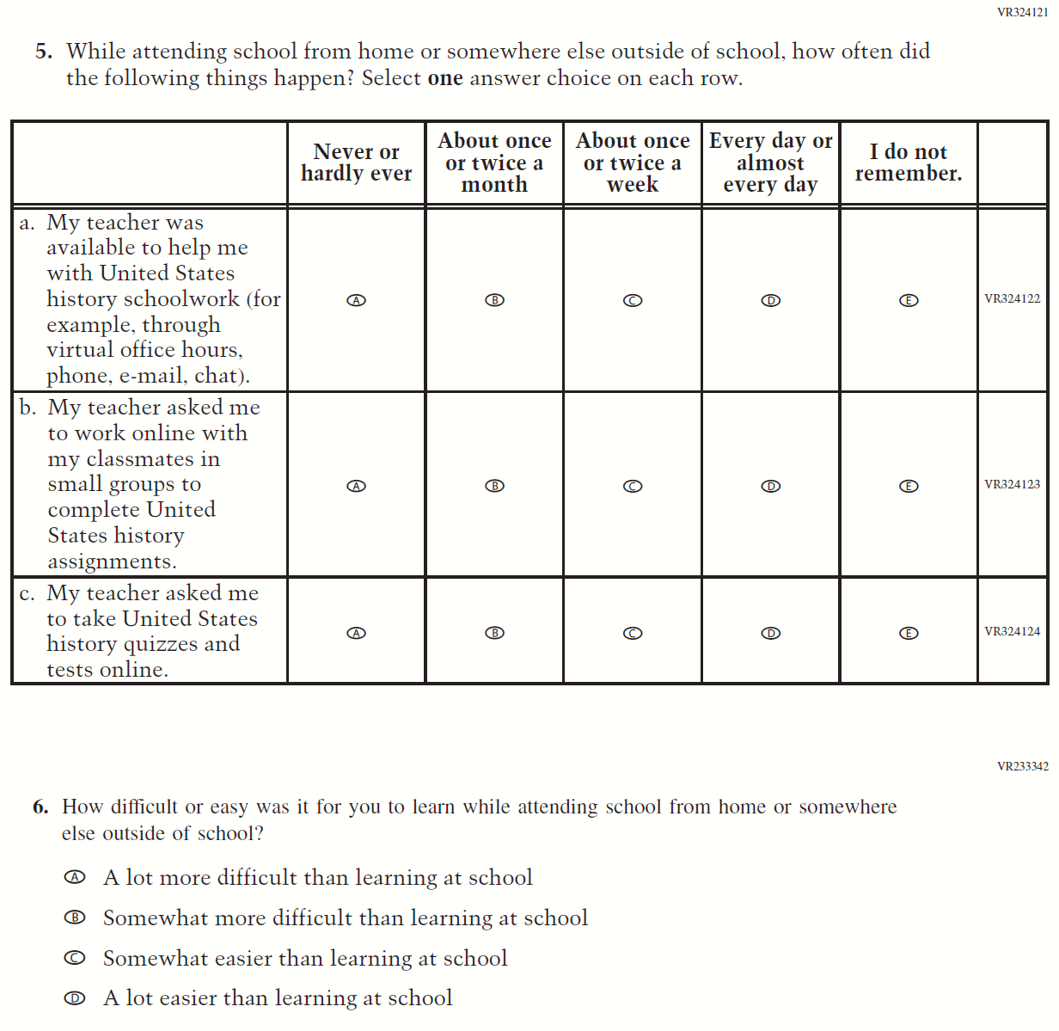

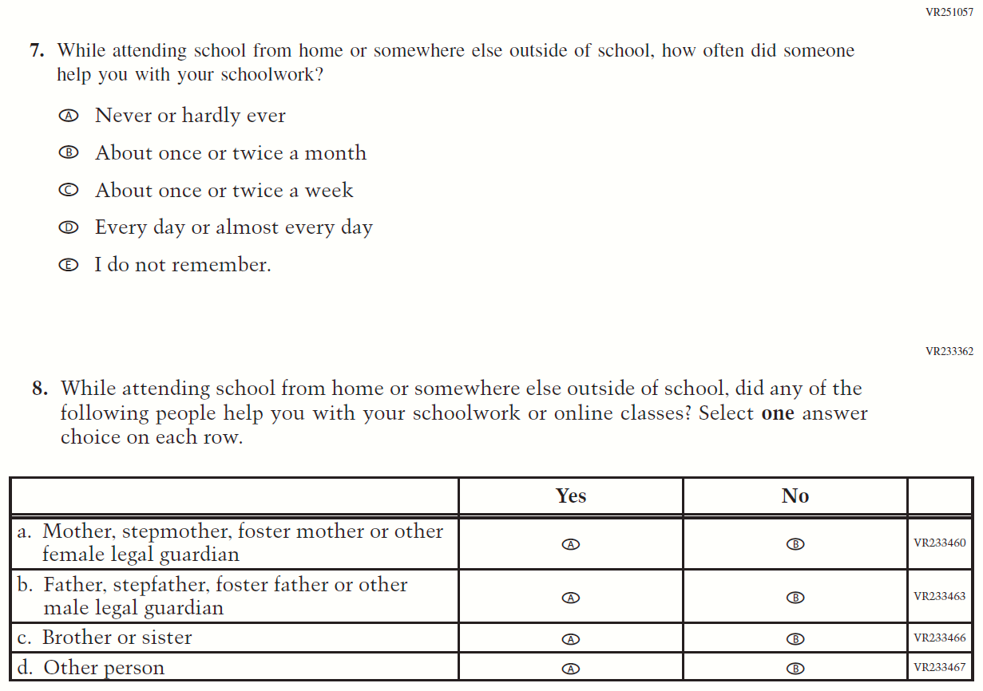
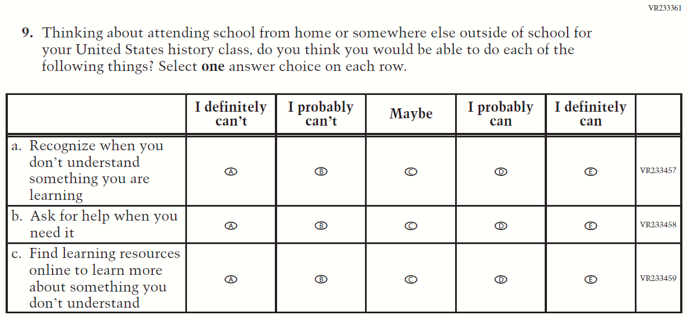

Appendix F-2: 2021 Teacher Questionnaire

Appendix F-2a: Operational Grade 4 CORE

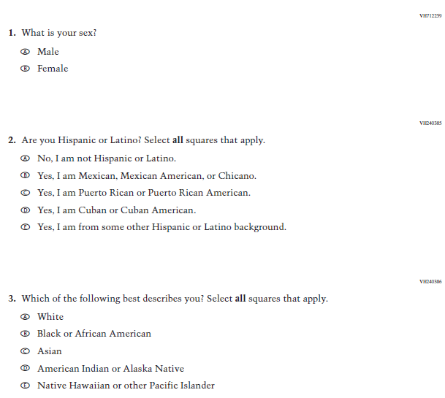

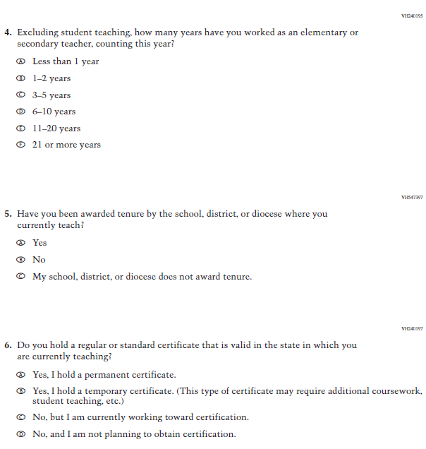
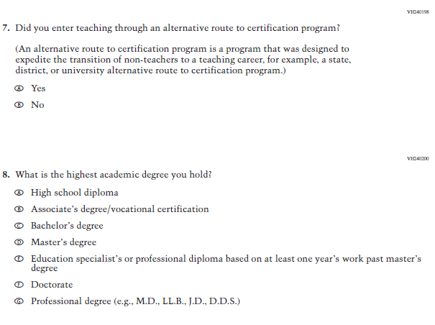
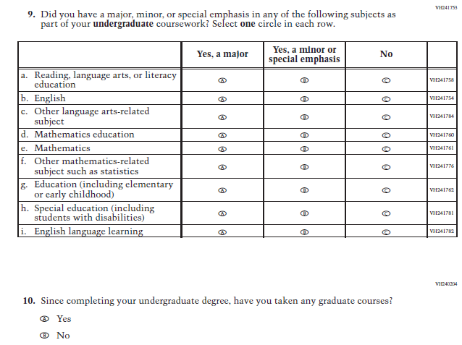
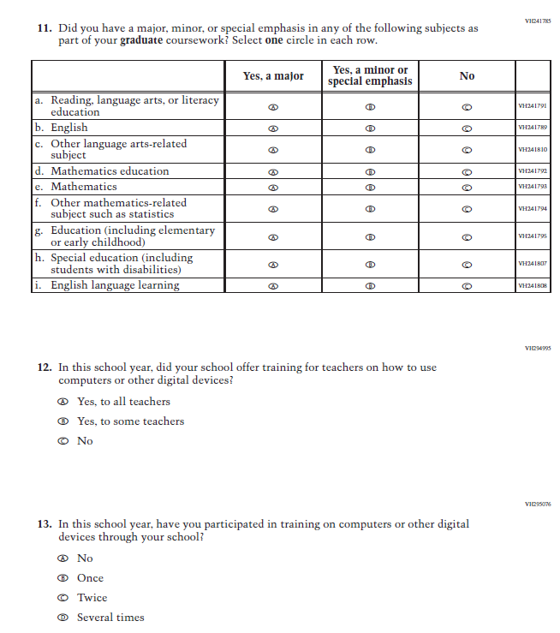

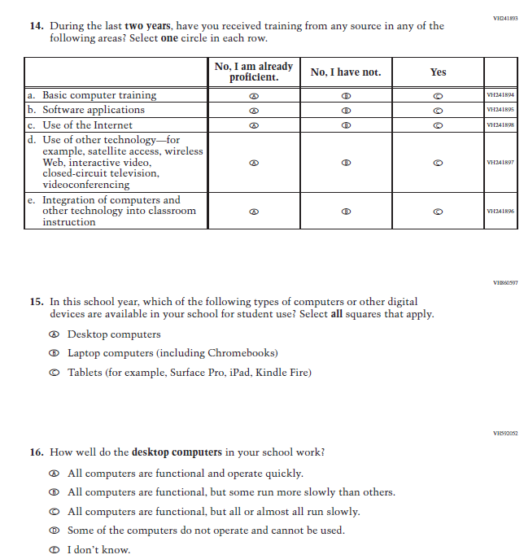

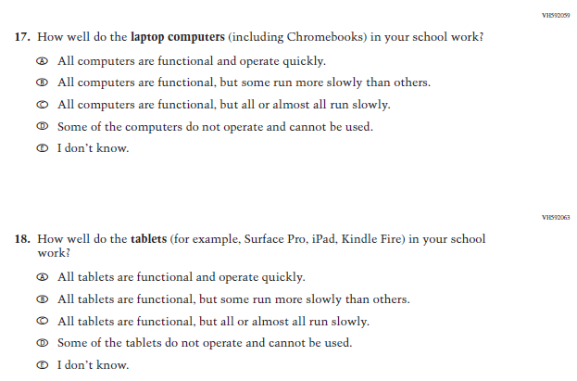

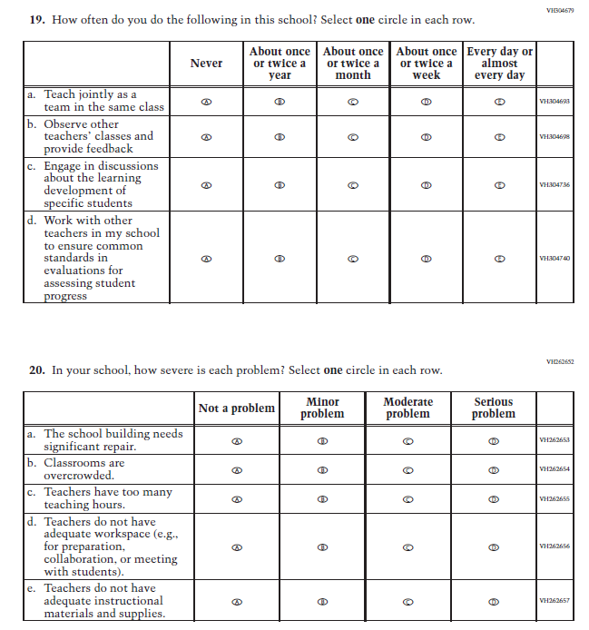

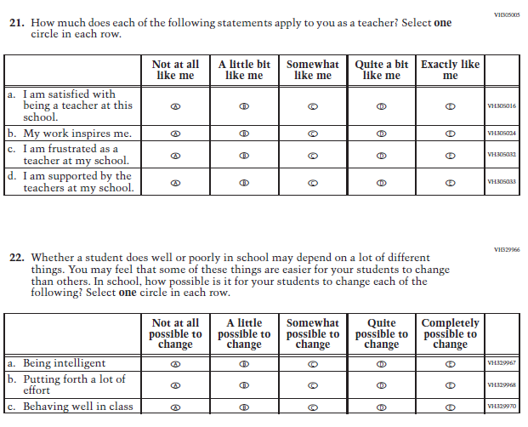

Appendix F-2b: Operational Grade 8 CORE

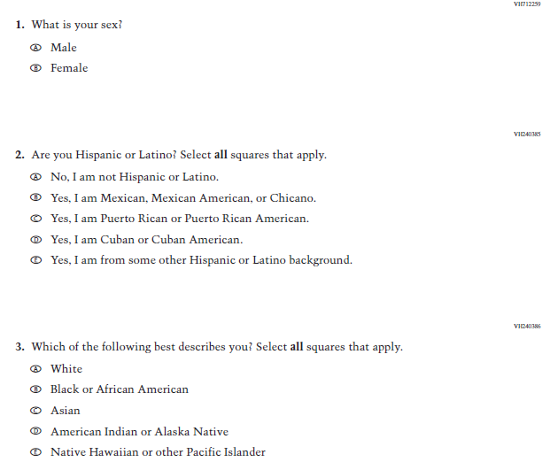

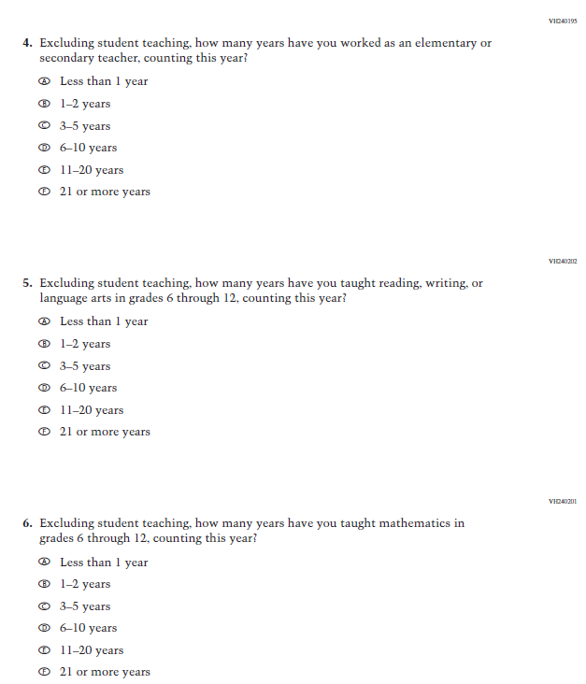
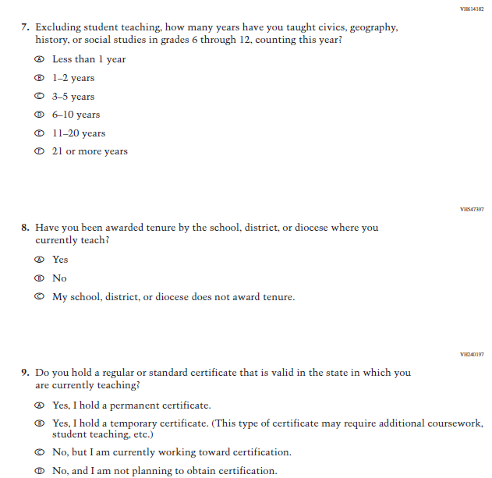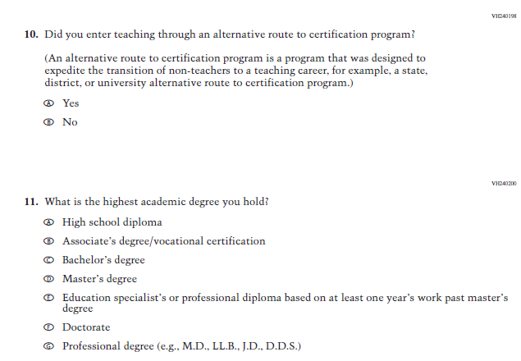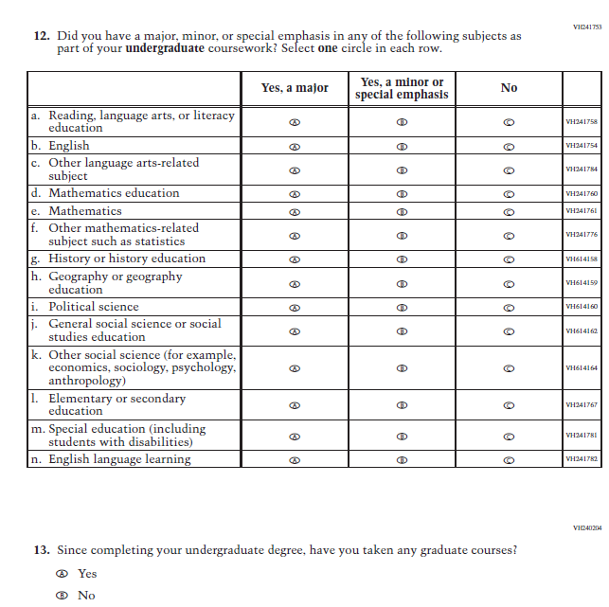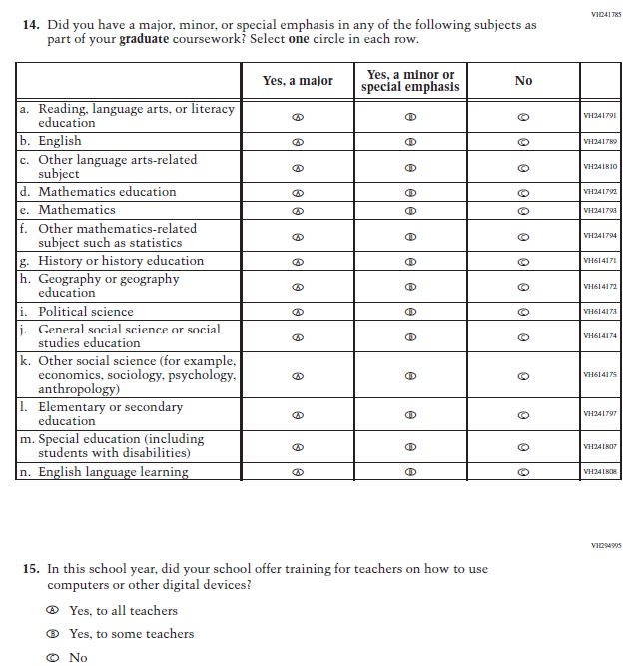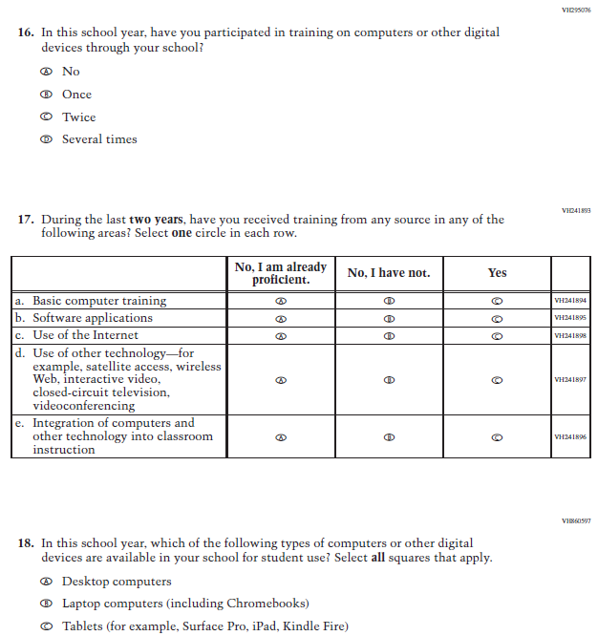
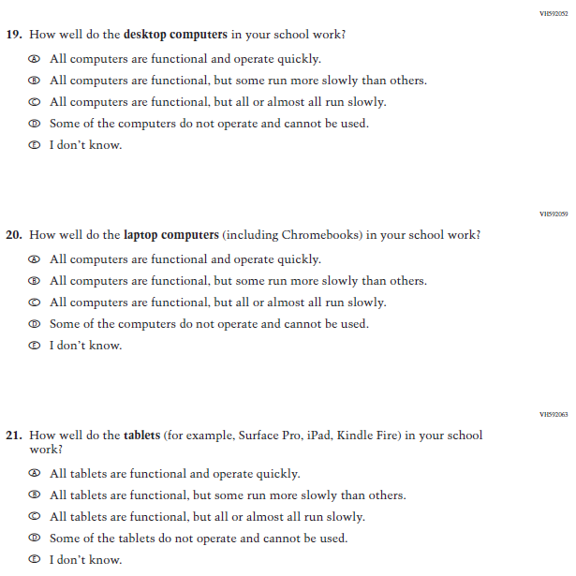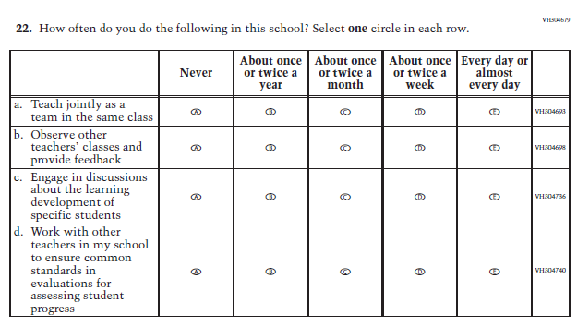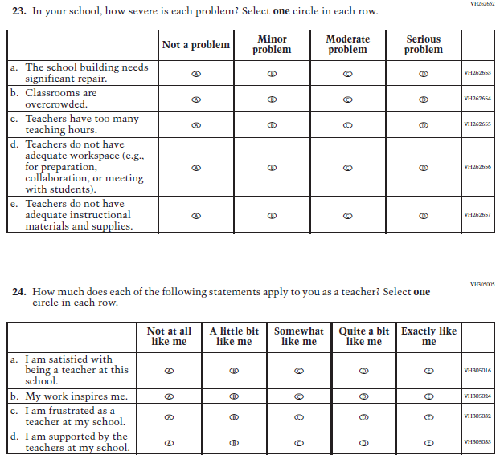
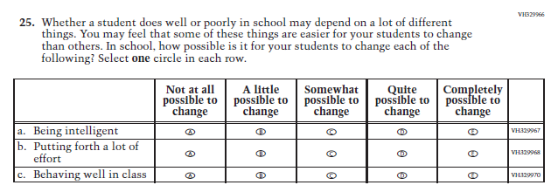

Appendix F-2c: Operational Grade 4 Mathematics

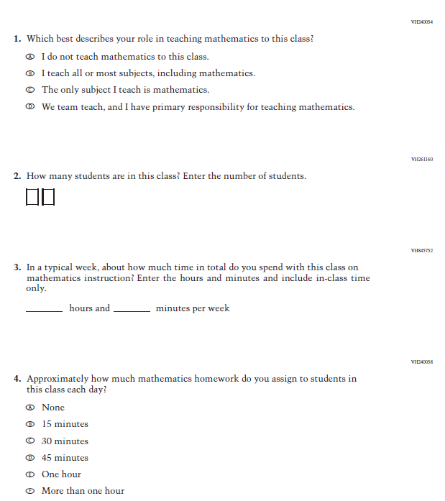

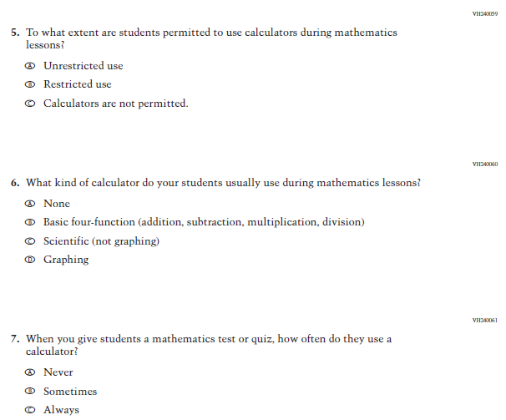

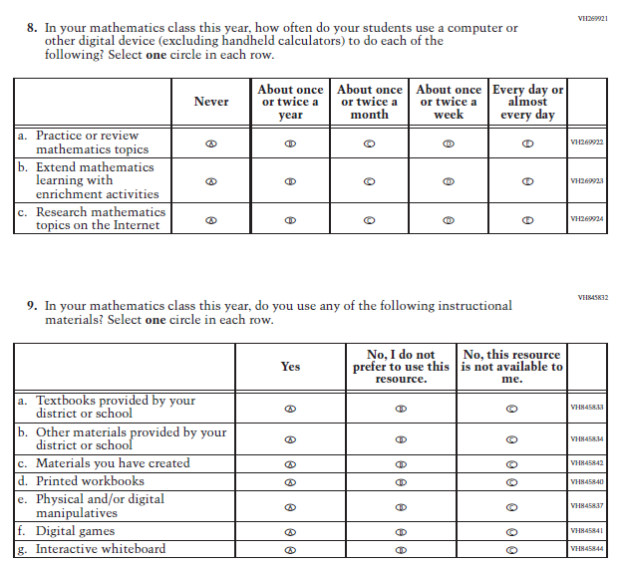

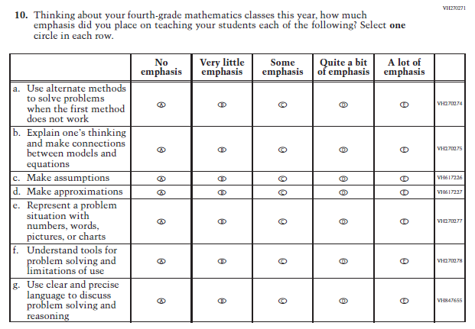
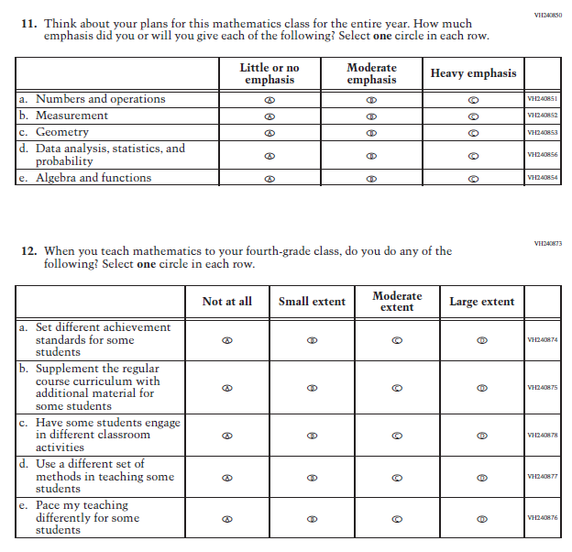
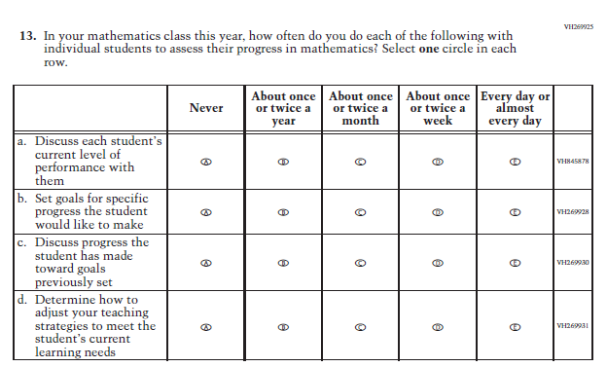

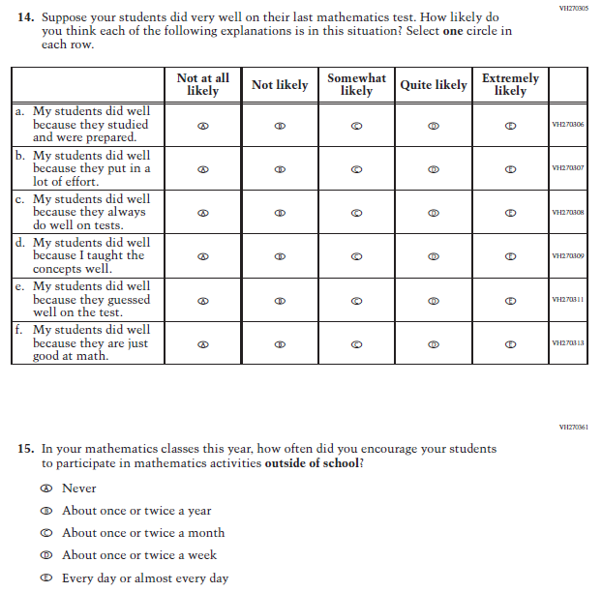
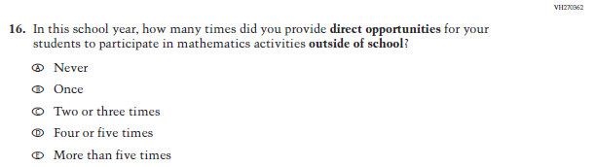

Appendix F-2d: Operational Grade 8 Mathematics

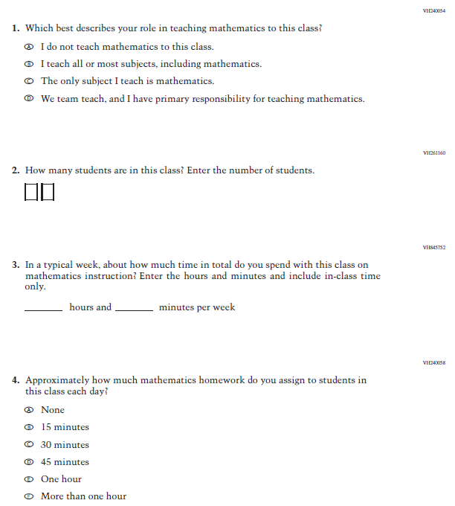

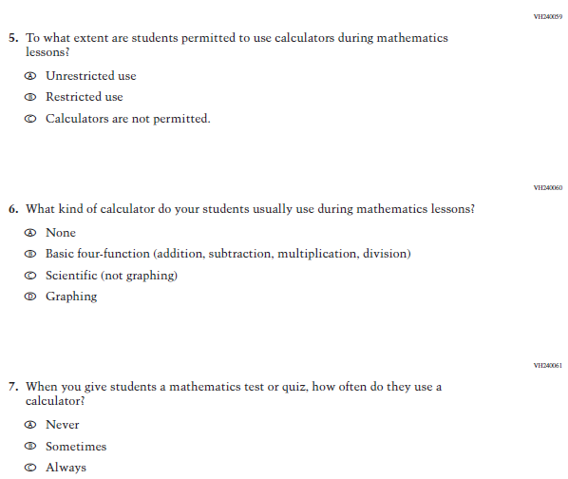
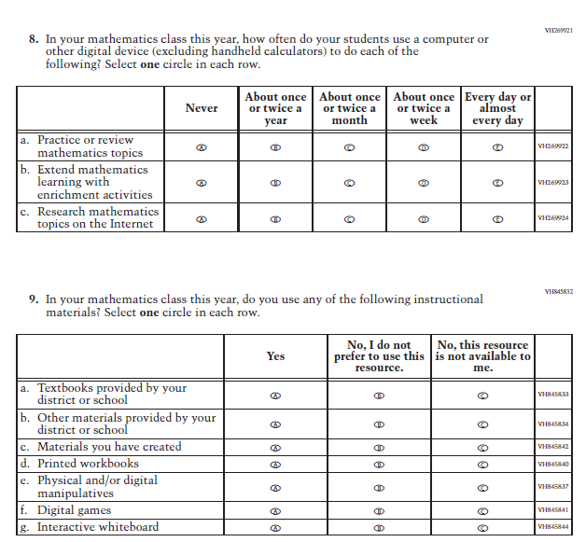

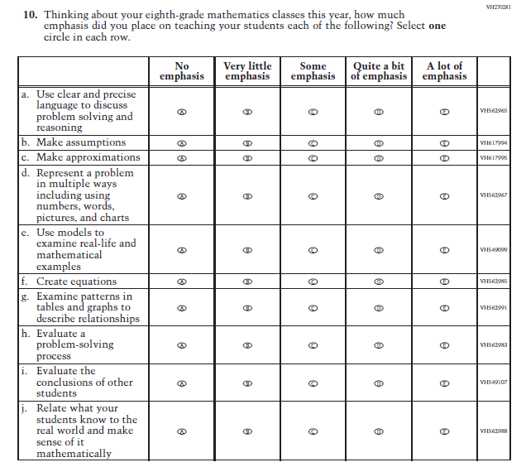
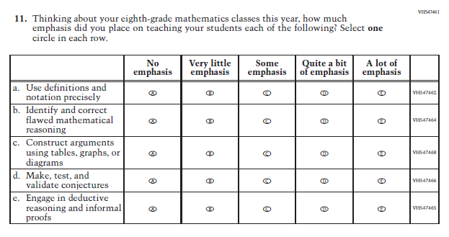
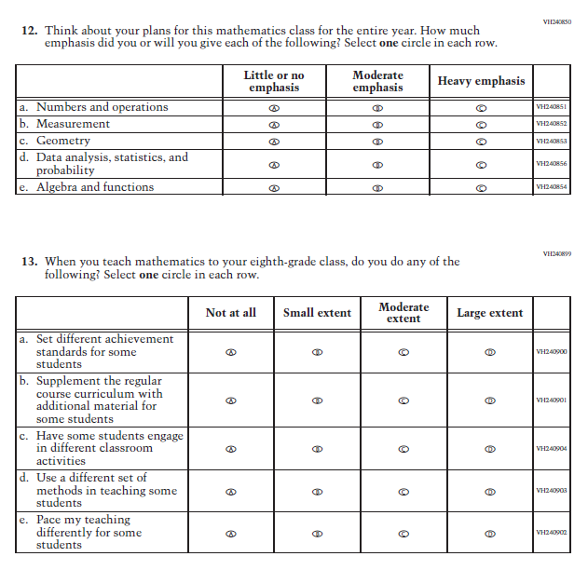
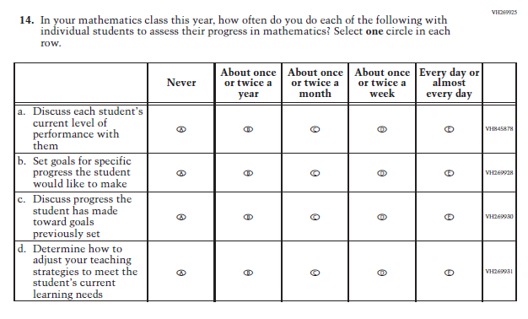
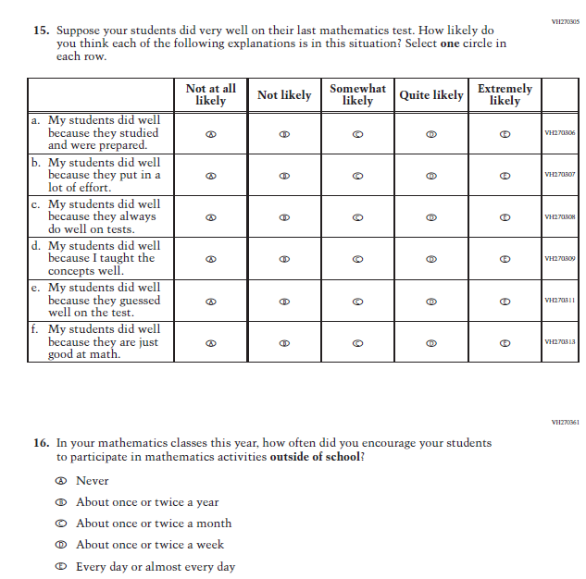
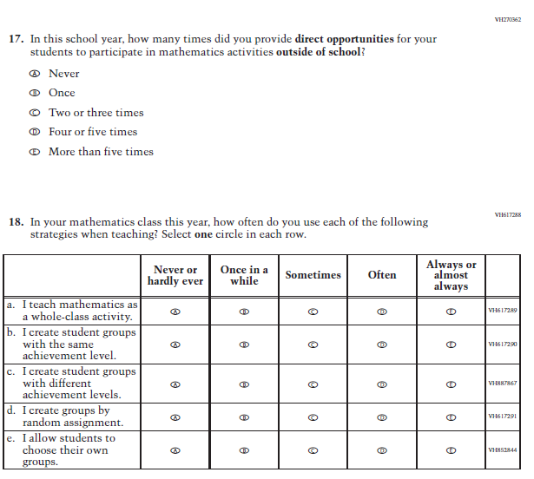

Appendix F-2e: Operational Grade 4 Reading

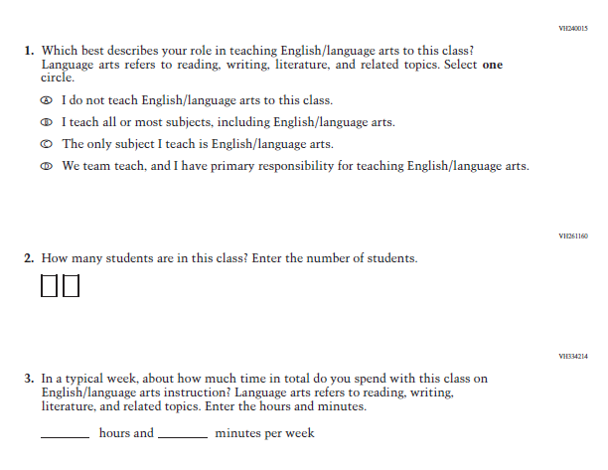

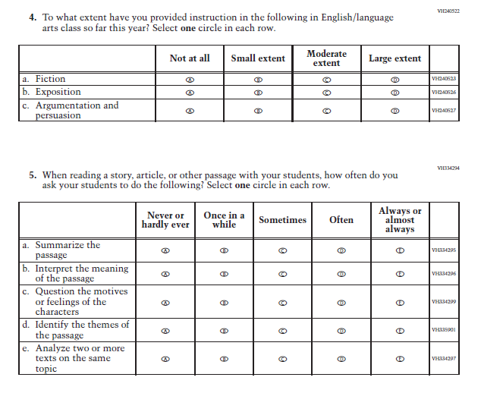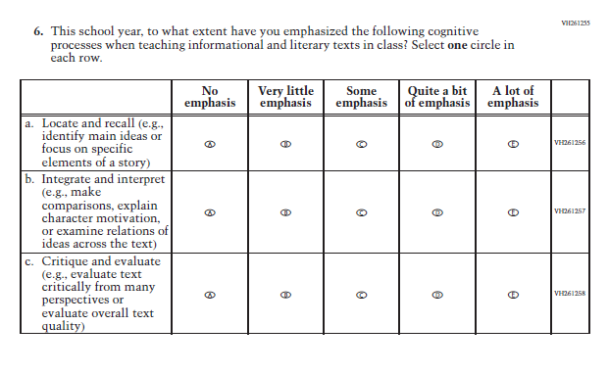
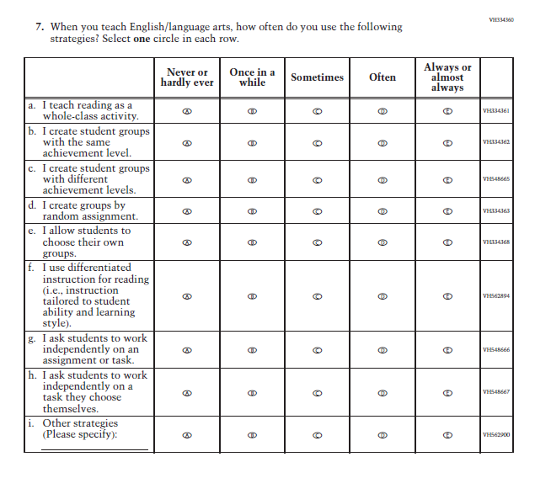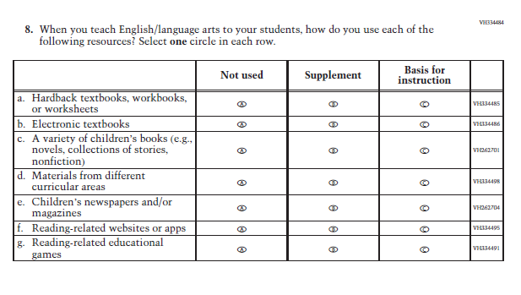
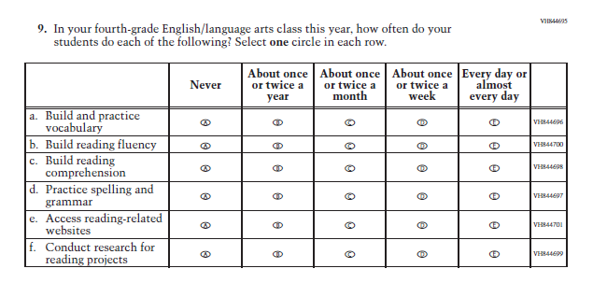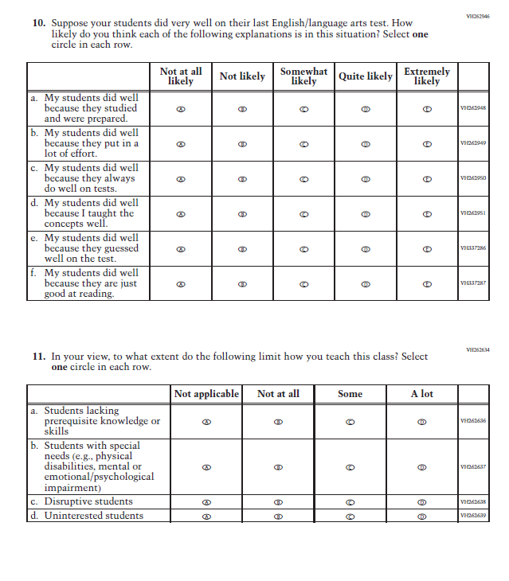

Appendix F-2f: Operational Grade 8 Reading

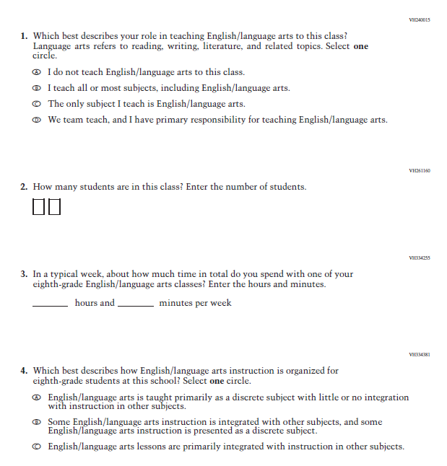

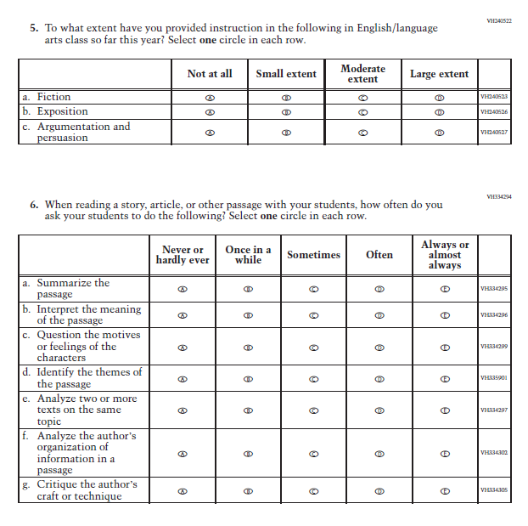

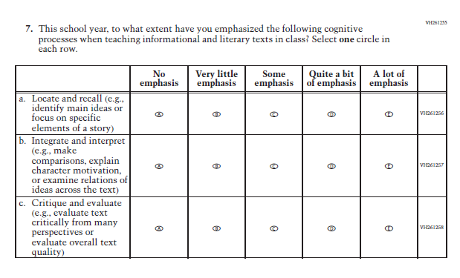

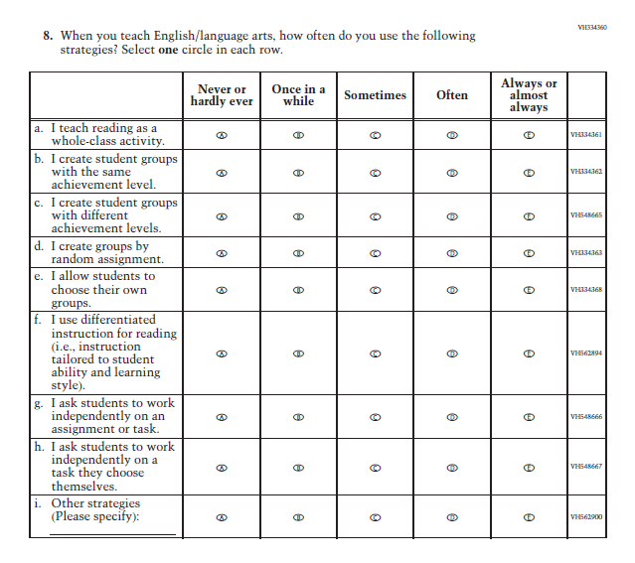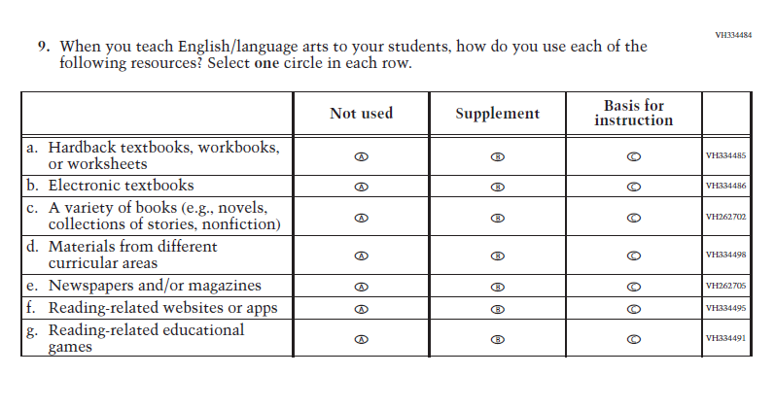

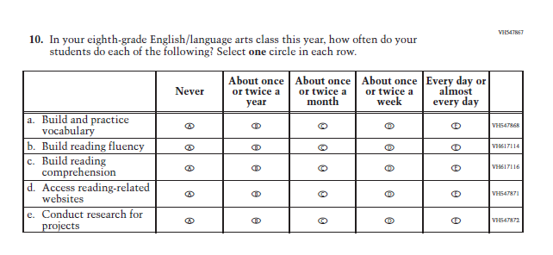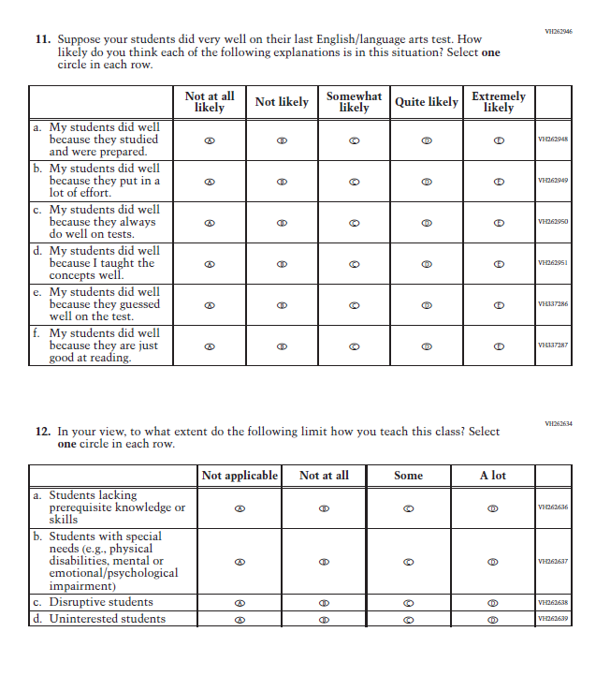

Appendix F-2g: Operational Grade 8 Social Studies

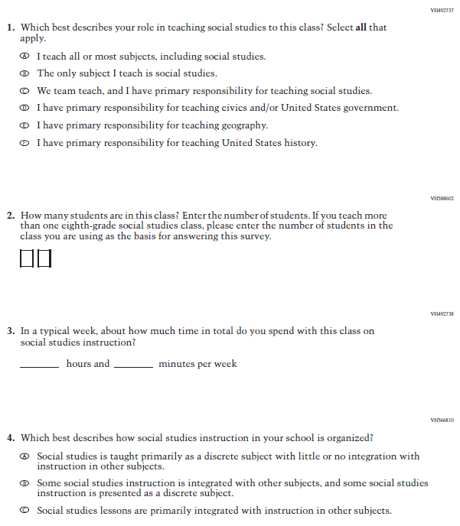

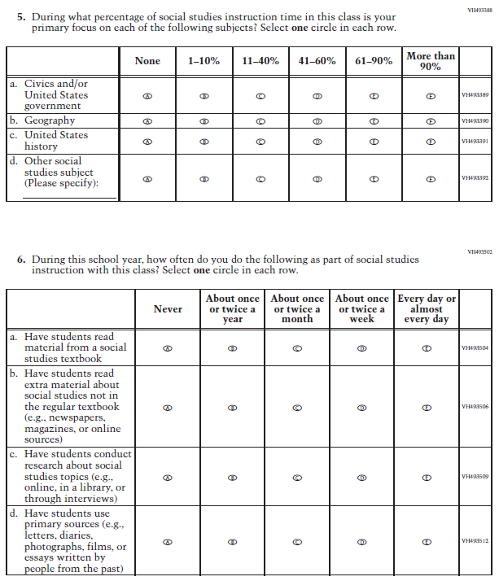

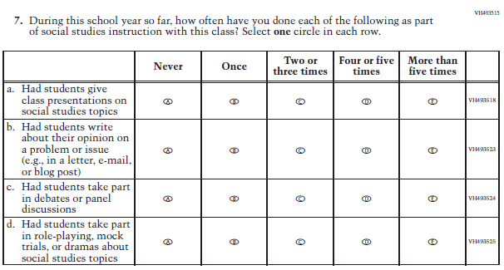
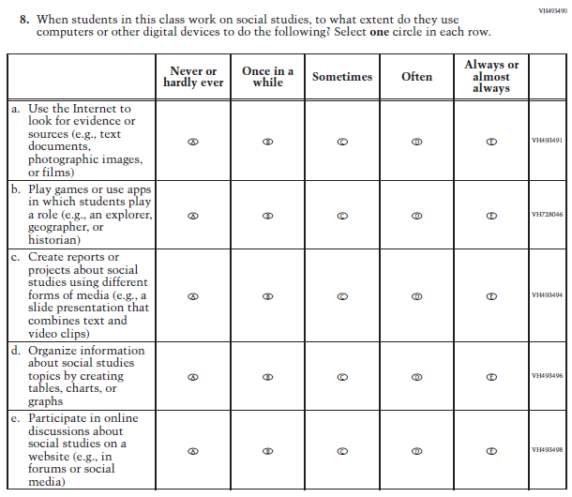
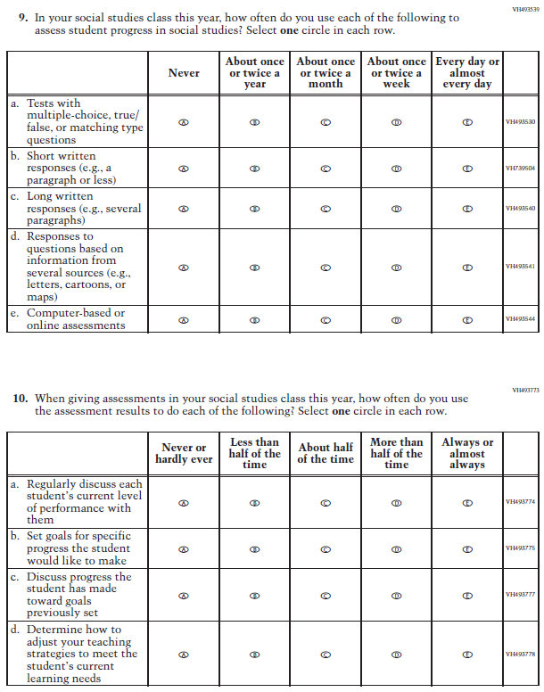

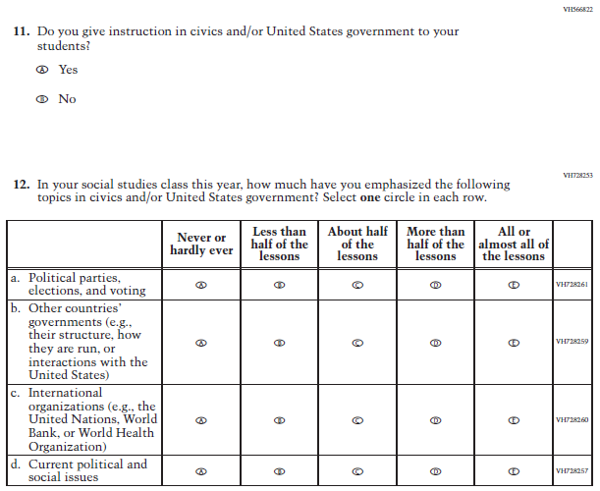

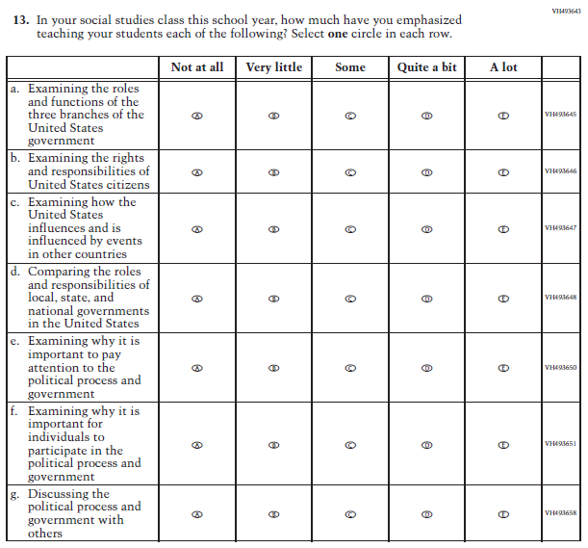

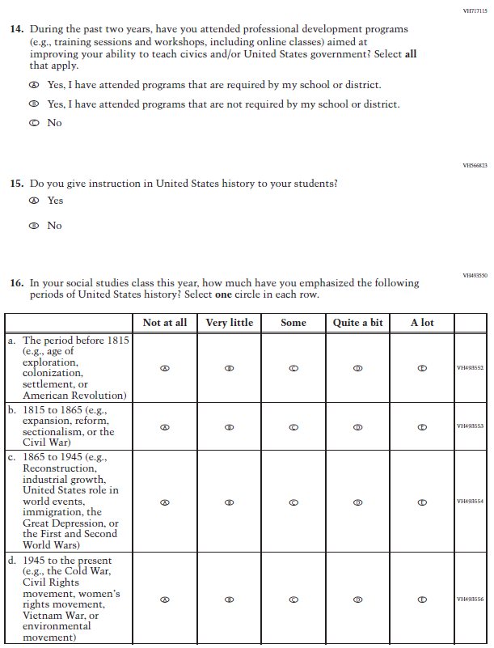

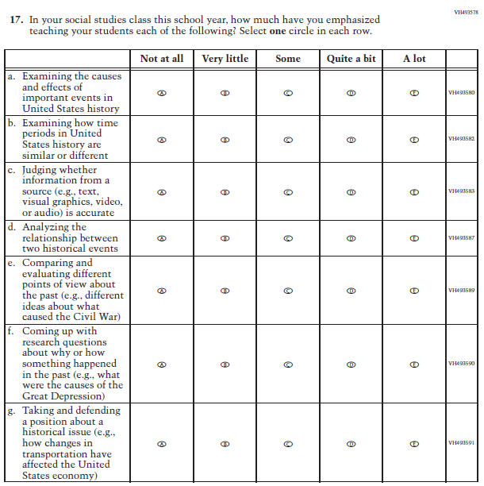

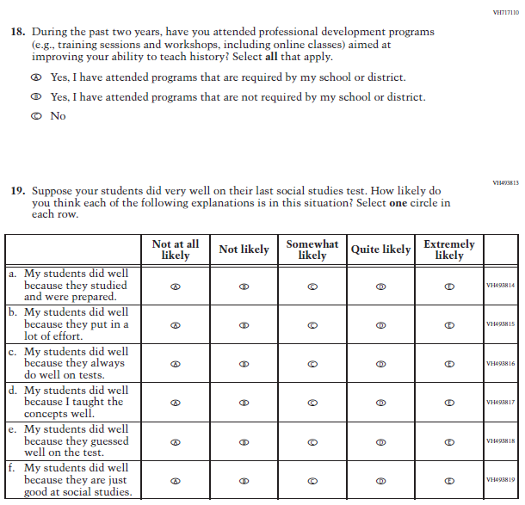

Appendix F-2h: Operational Grade 4 COVID-19 Teacher Items

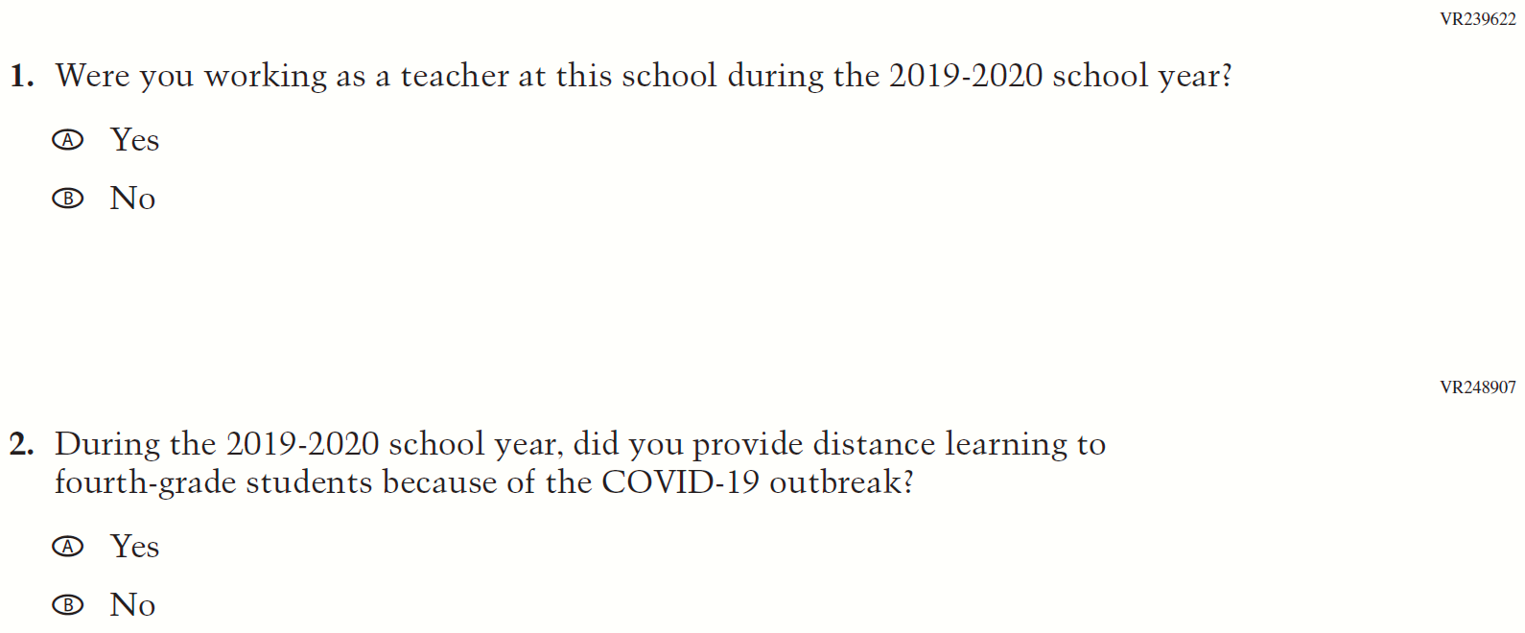
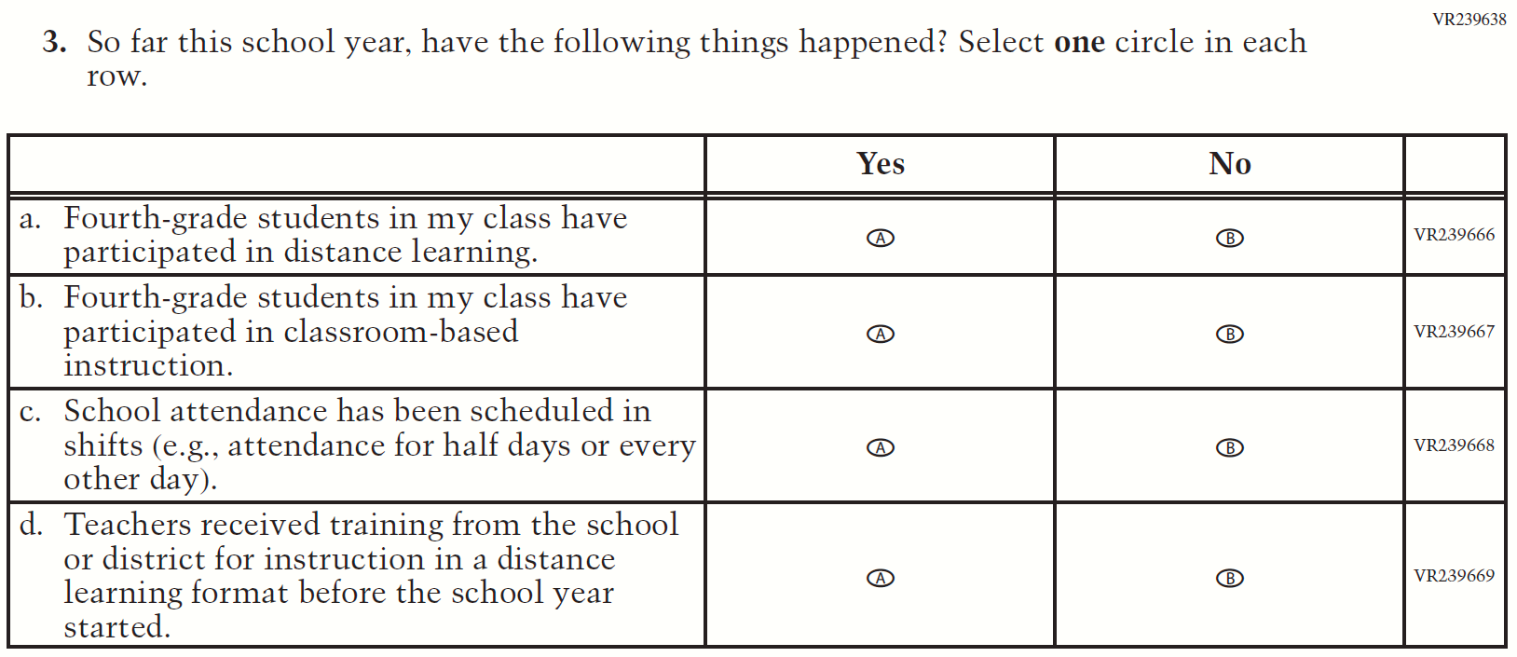
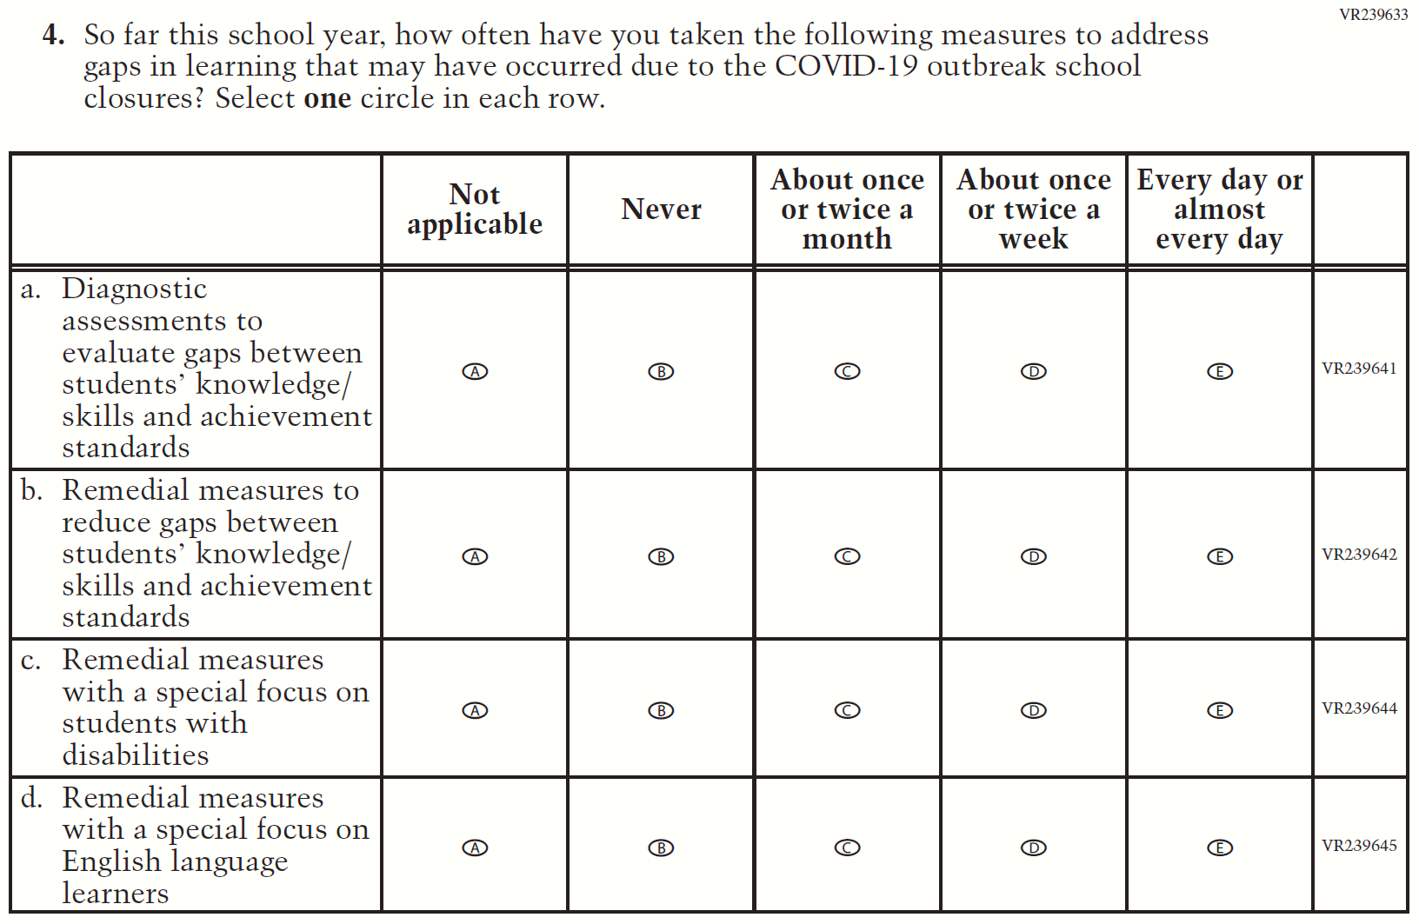
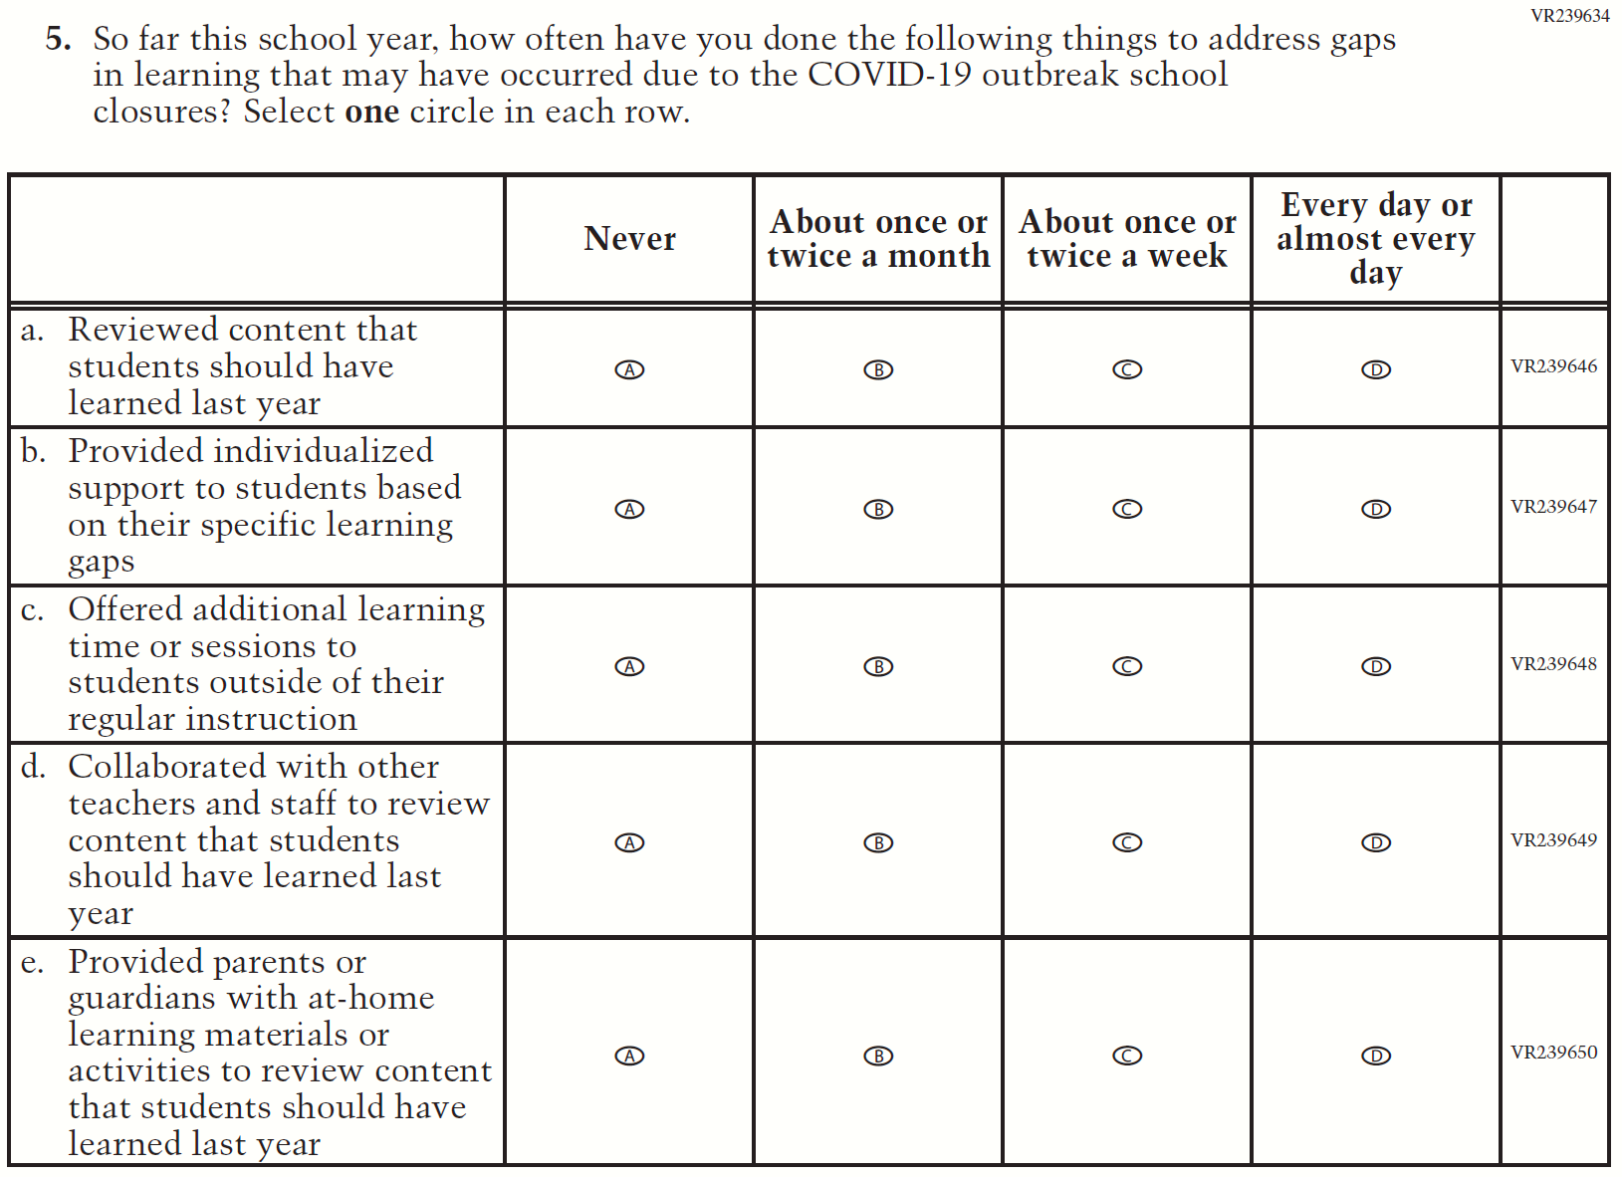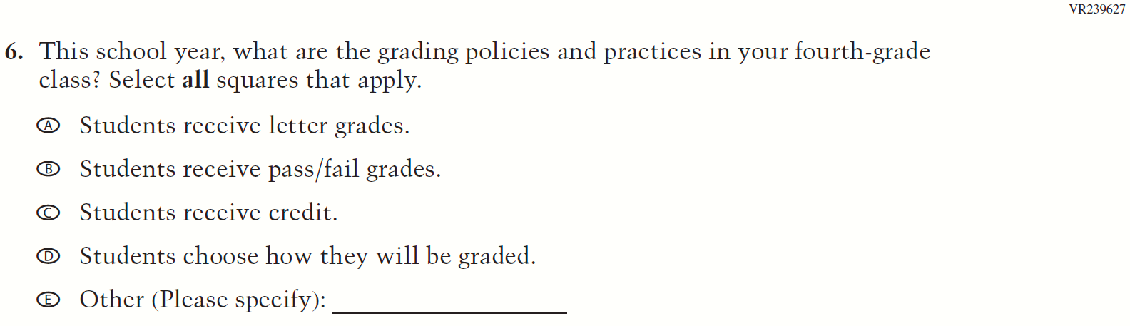
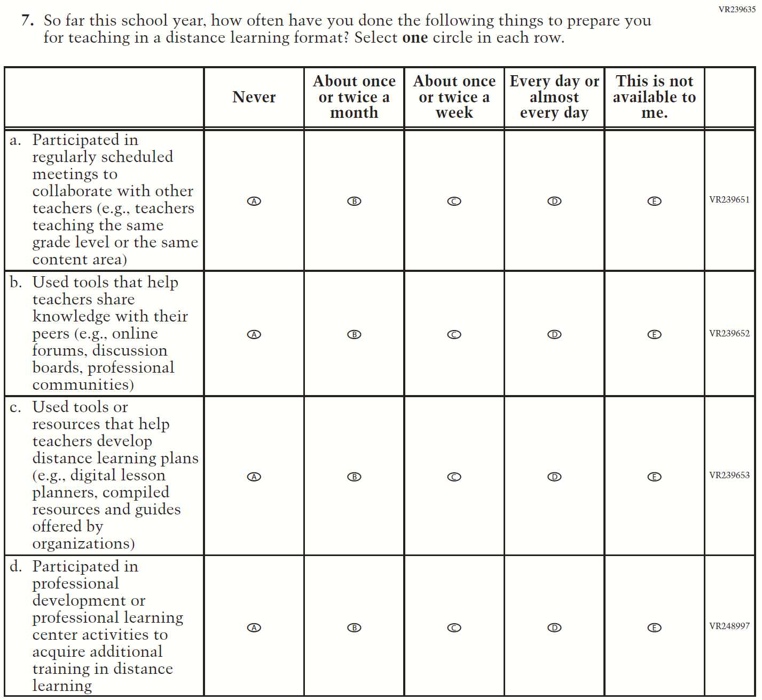
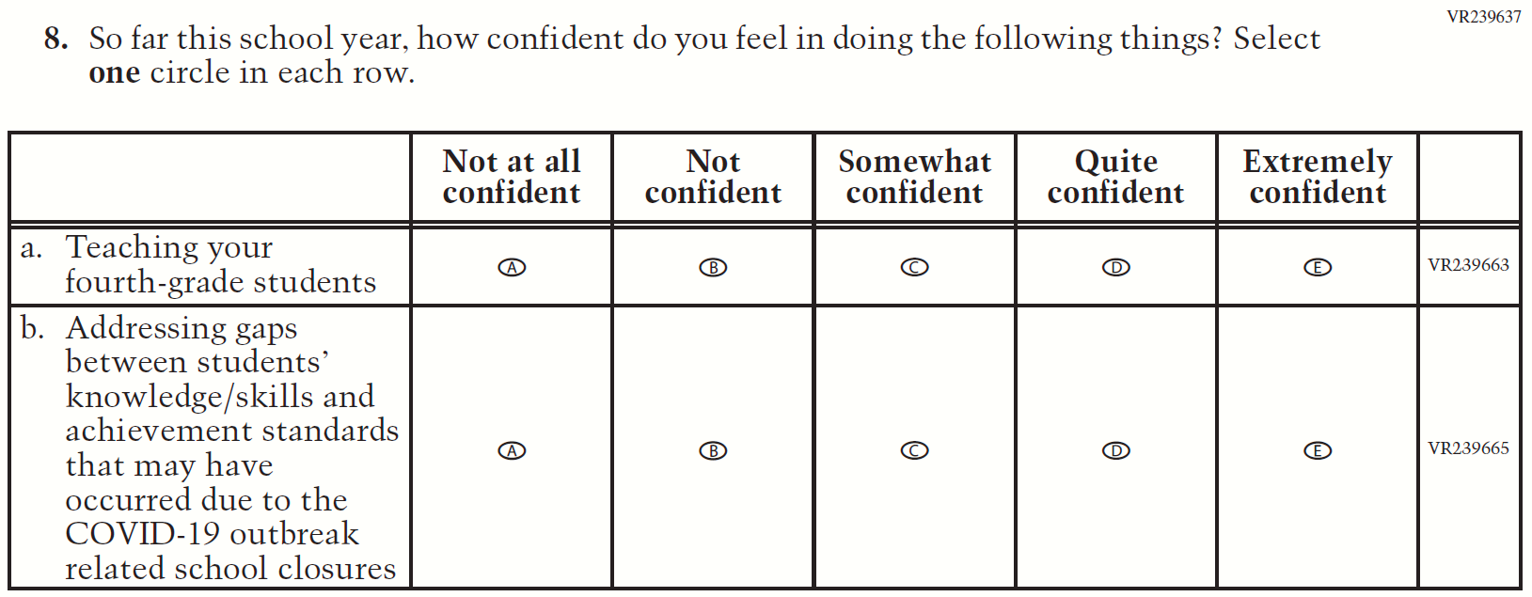
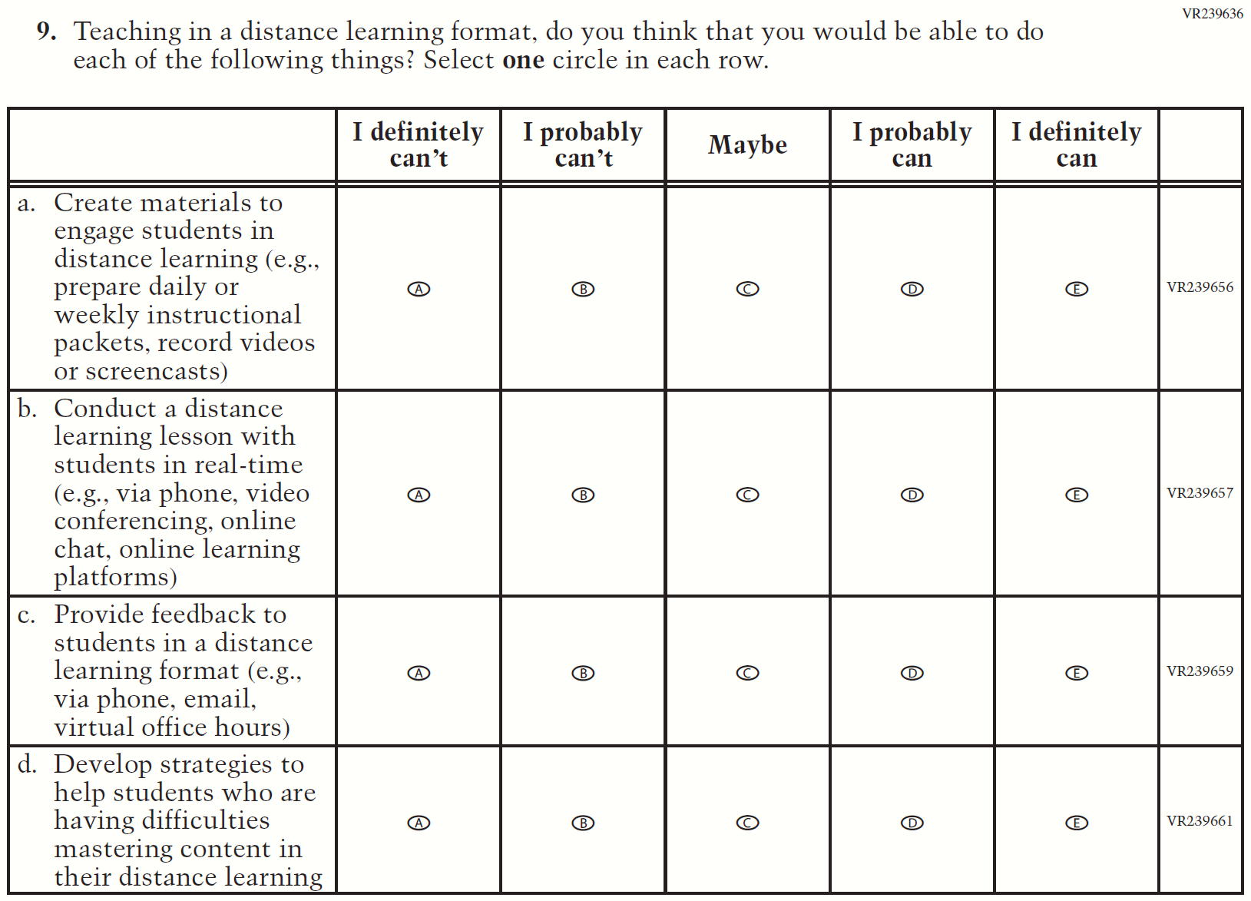

Appendix F-2i: Operational Grade 8 COVID-19 Teacher Items

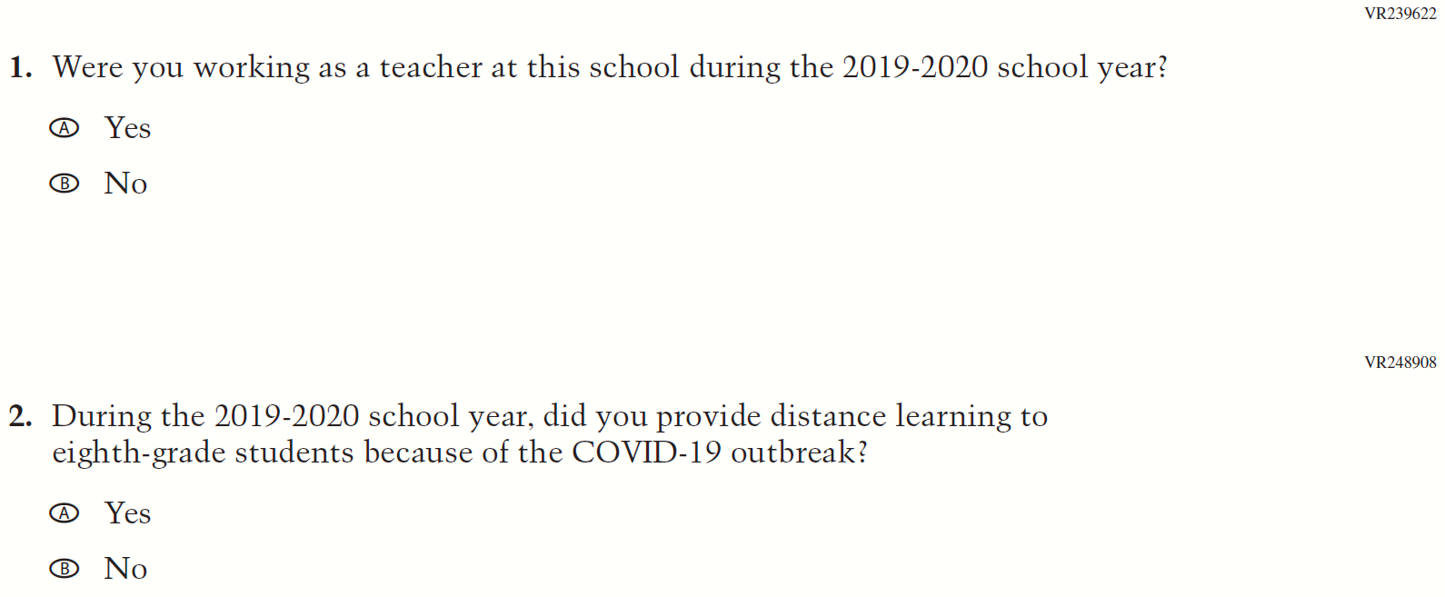

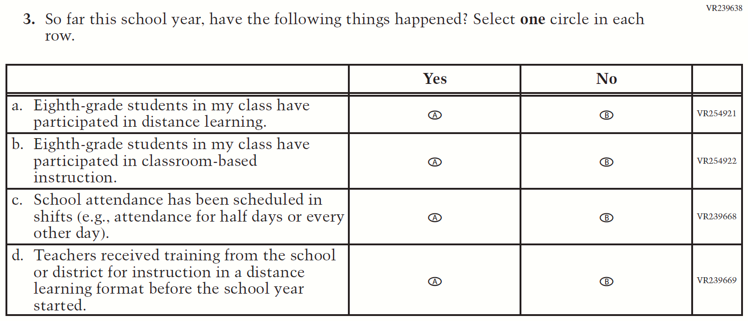
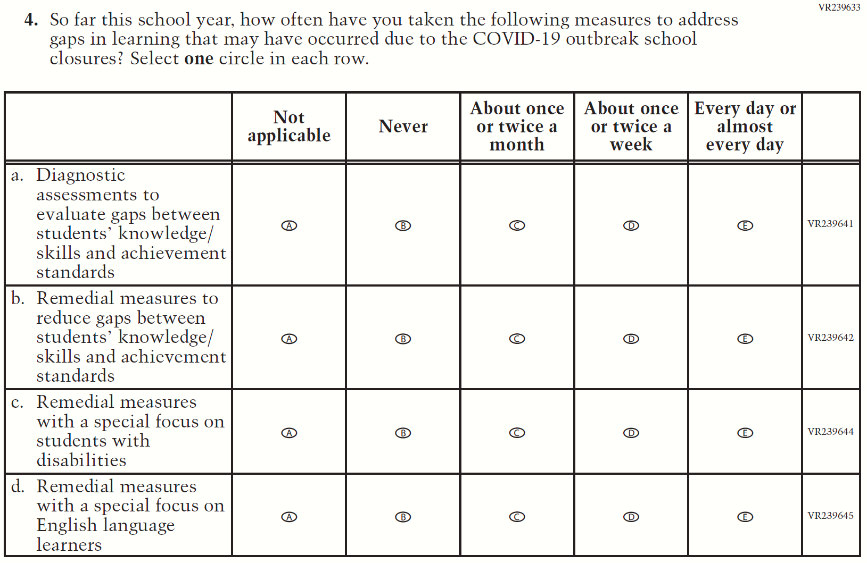
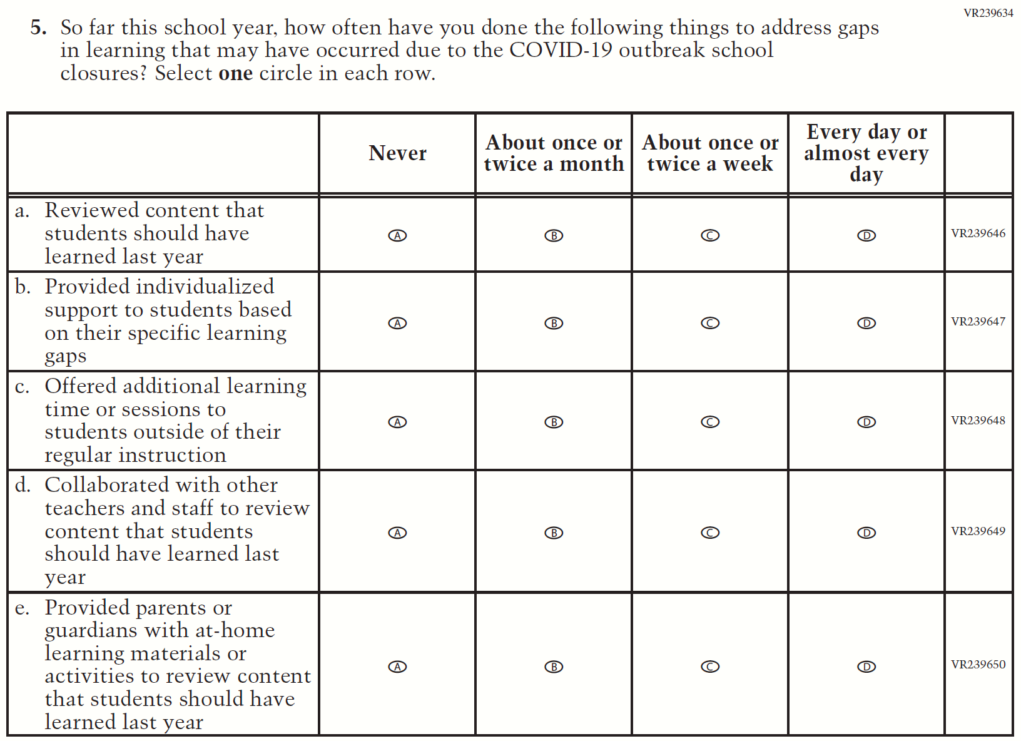
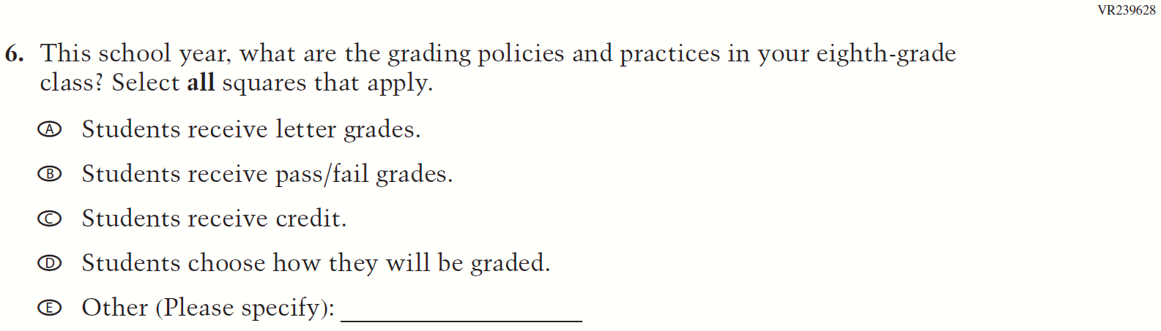
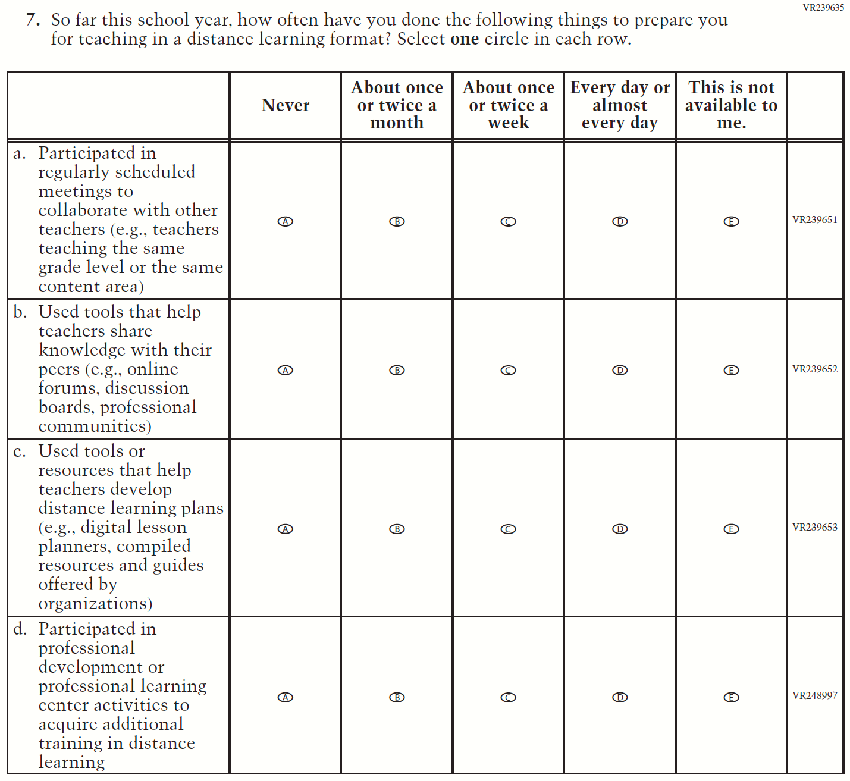
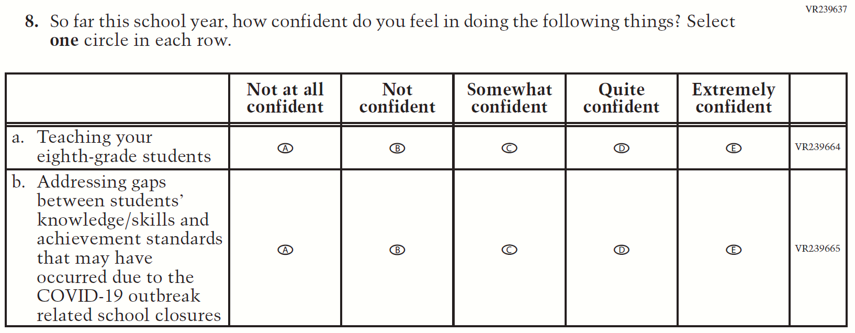
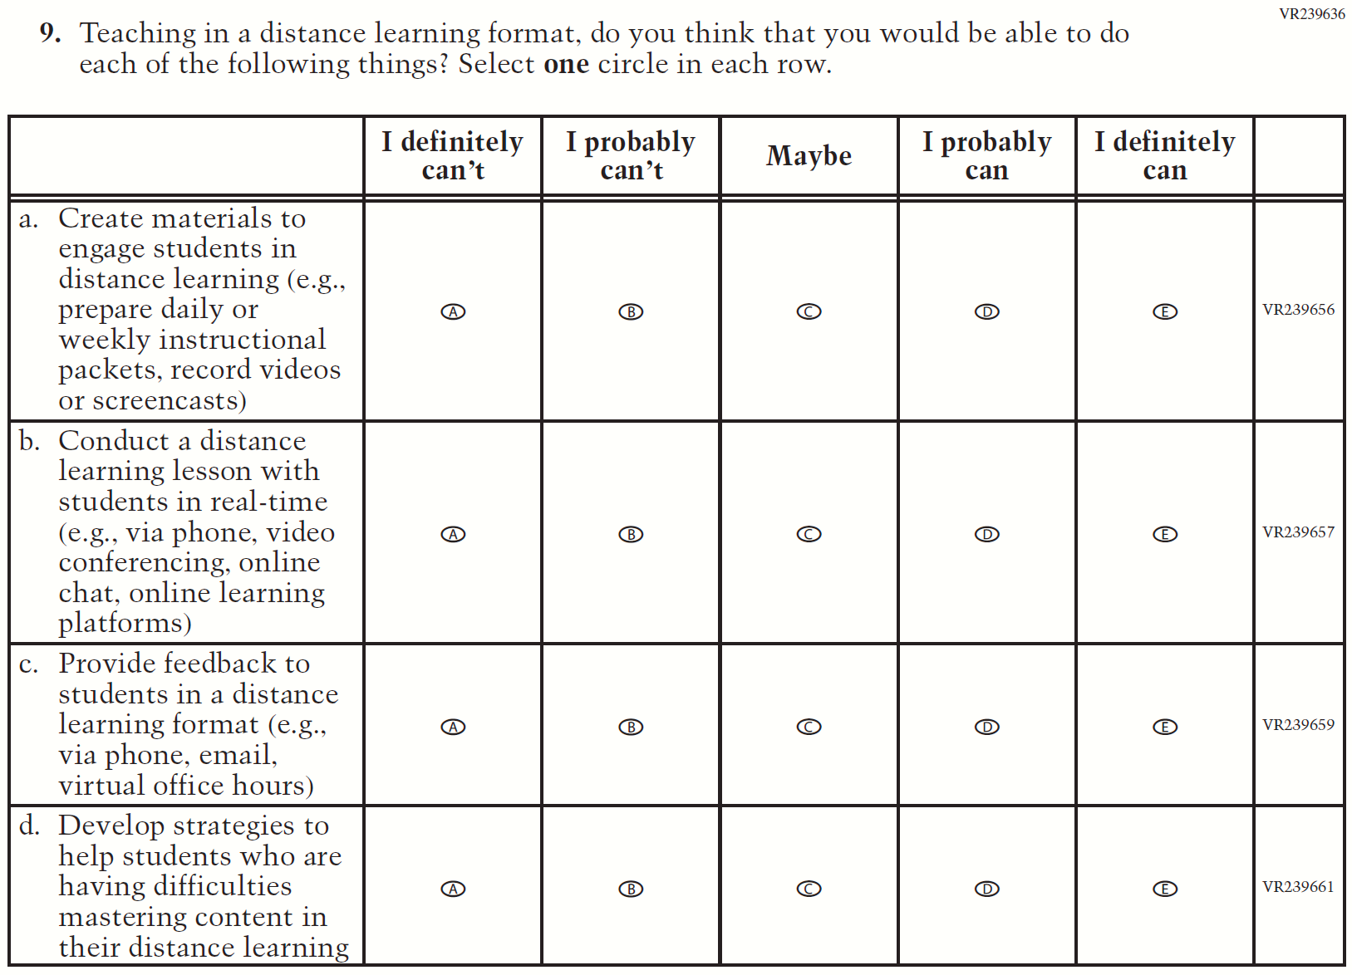

Appendix F-2: 2022 Teacher Questionnaire

Appendix F-2a-22: Operational Grade 4 CORE

Appendix F-2b-22: Operational Grade 8 CORE

Appendix F-2c-22: Operational Grade 4 Mathematics

Appendix F-2d-22: Operational Grade 8 Mathematics

Appendix F-2e-22: Operational Grade 4 Reading

Appendix F-2f-22: Operational Grade 8 Reading

Appendix F-2g-22: Operational Grade 8 Social Studies

Appendix F-2h-22: Operational Grade 4 COVID-19
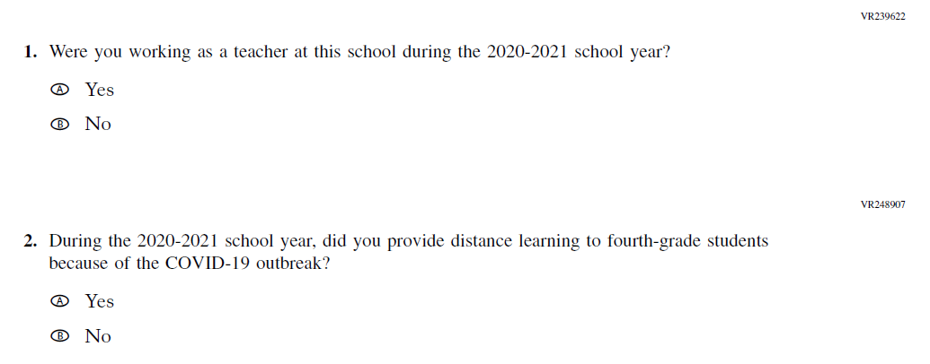

Appendix F-2i-22: Operational Grade 8 COVID-19
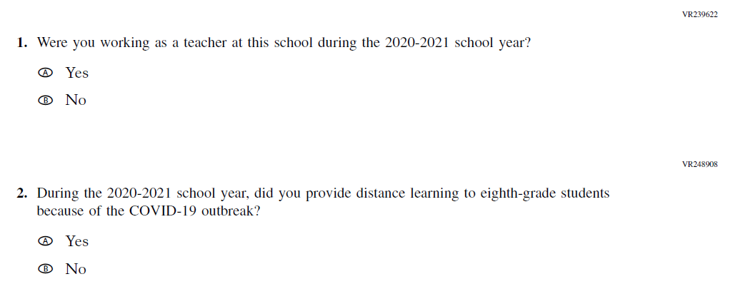

Appendix F-3: 2021 School Questionnaires

Appendix F-3a: Operational Grade 4 CORE
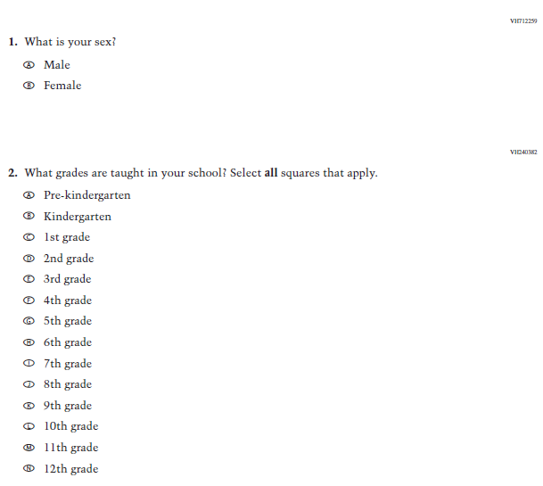
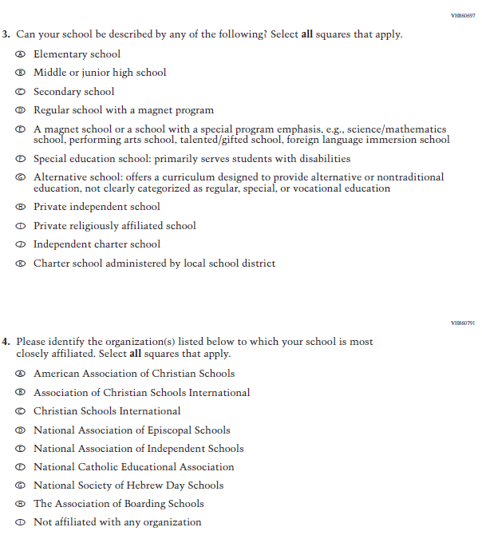

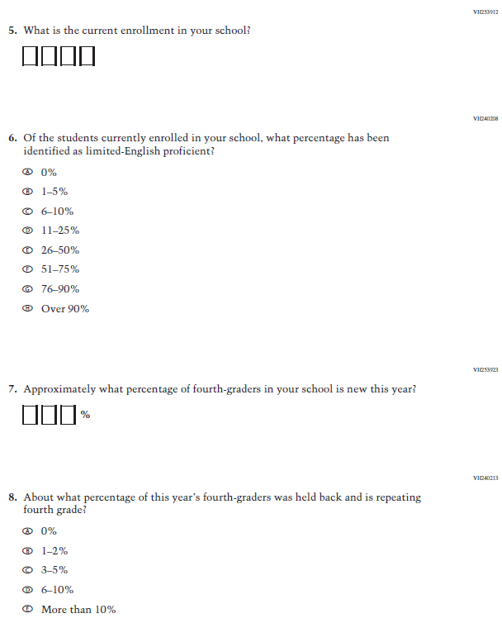

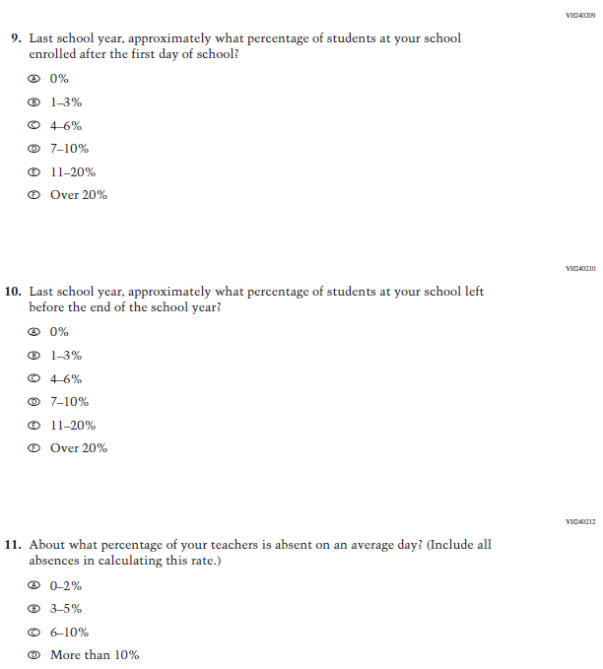

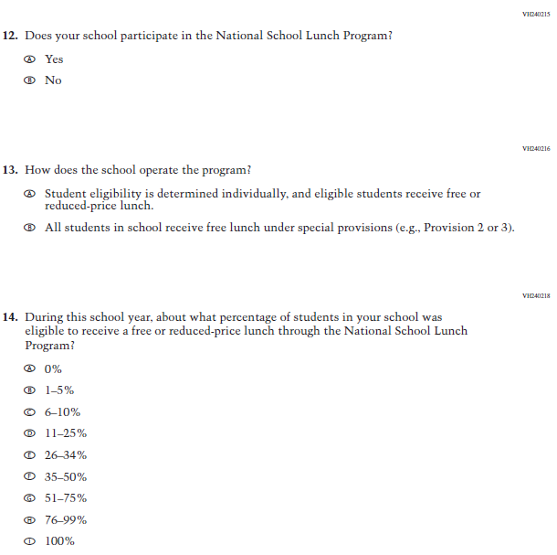

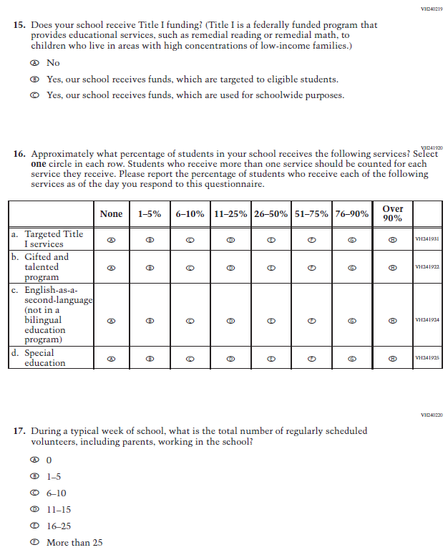

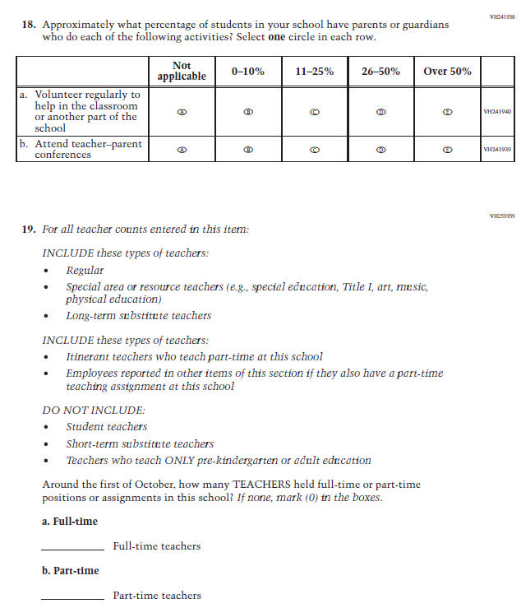

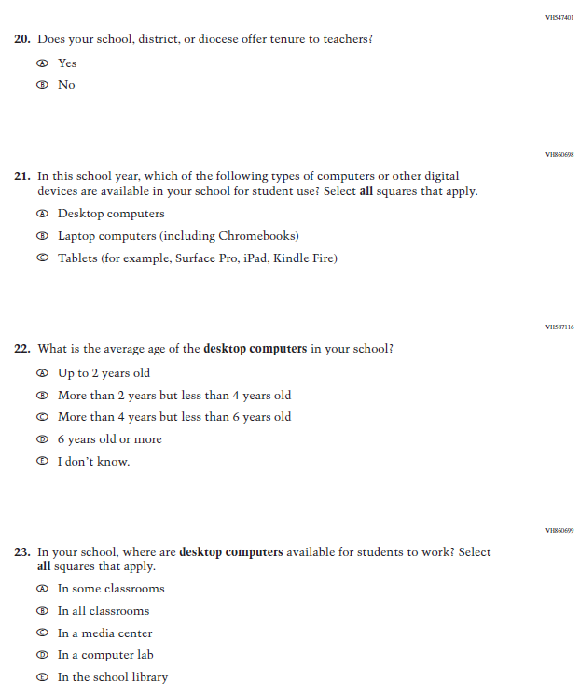

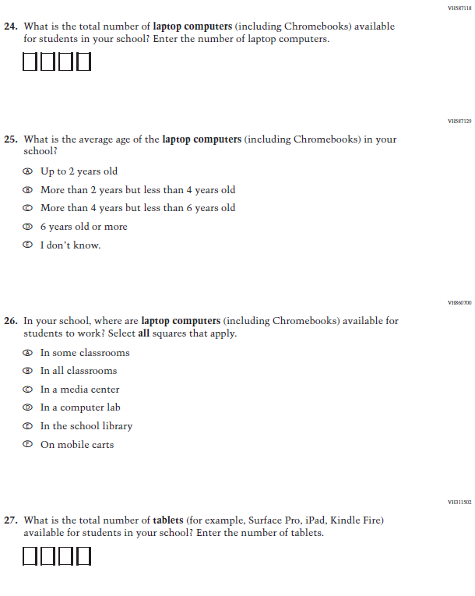

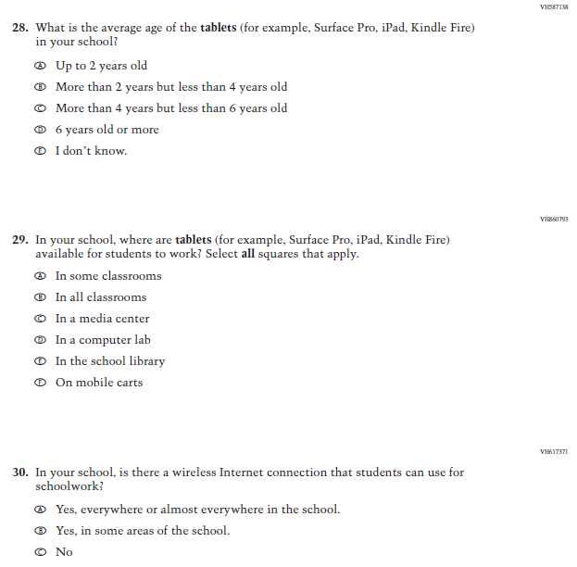

Appendix F-3b: Operational Grade 8 CORE

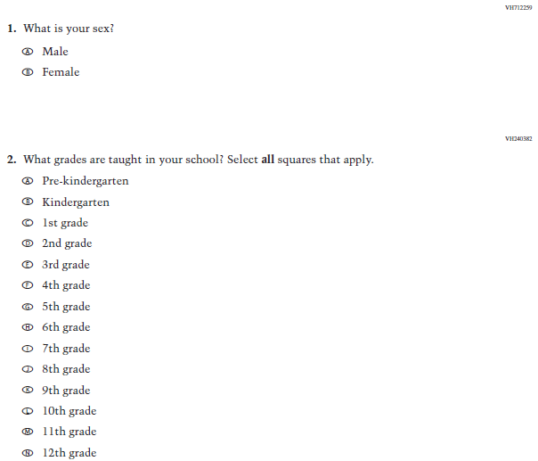

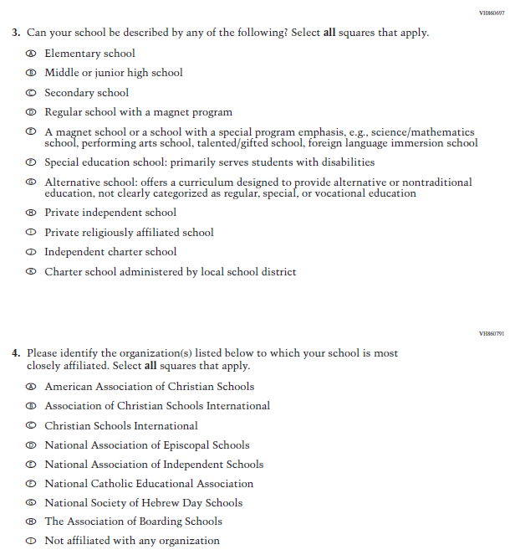

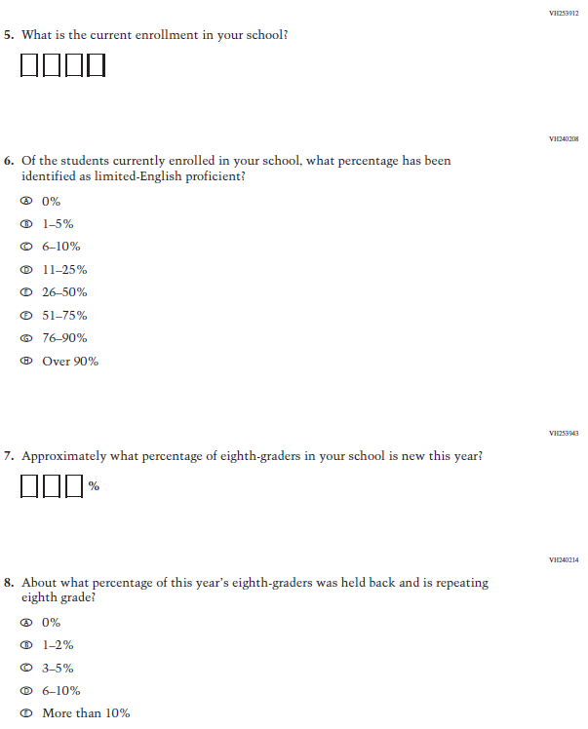

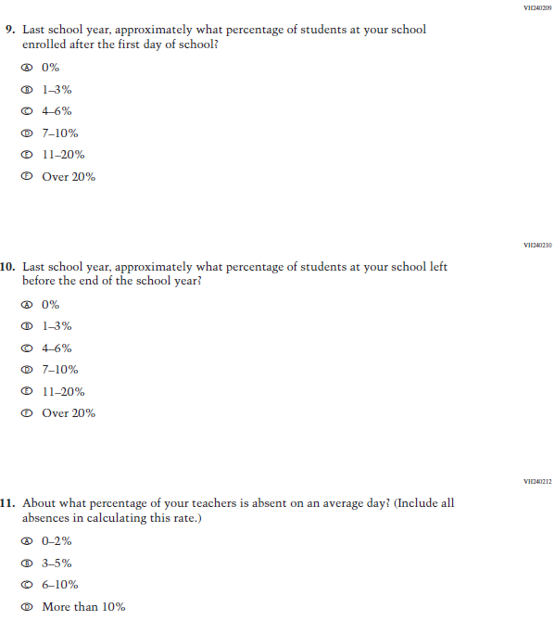

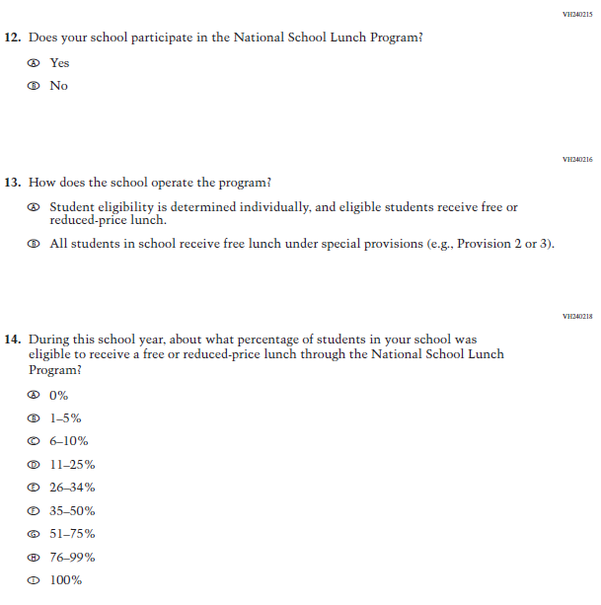

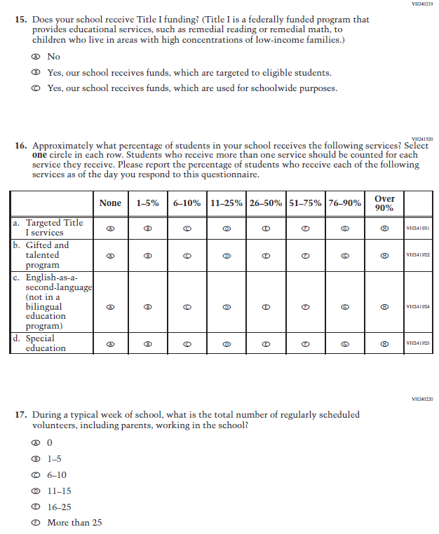

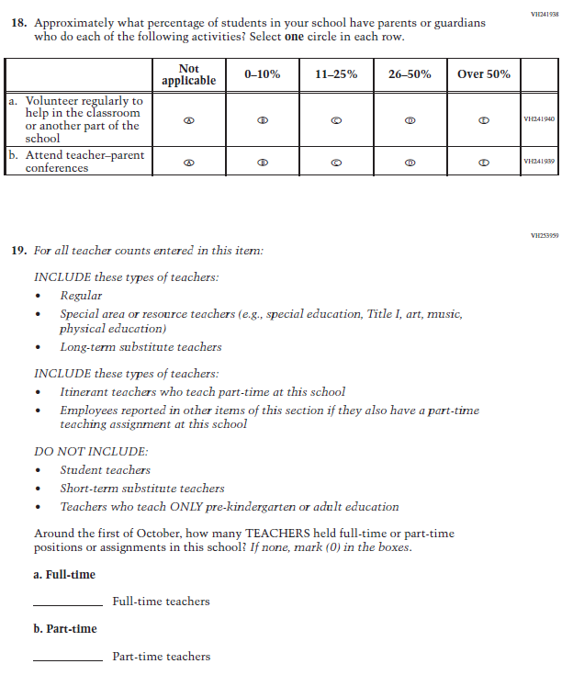

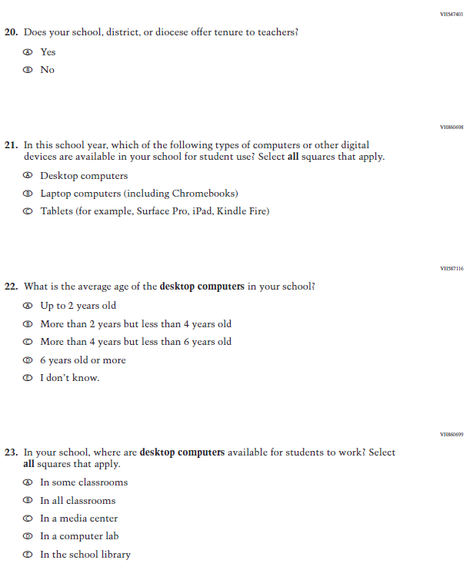
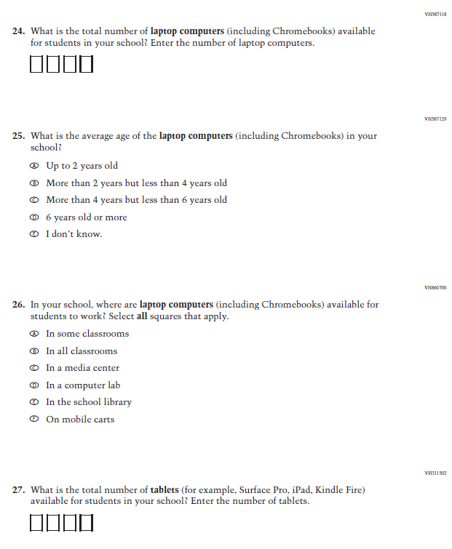

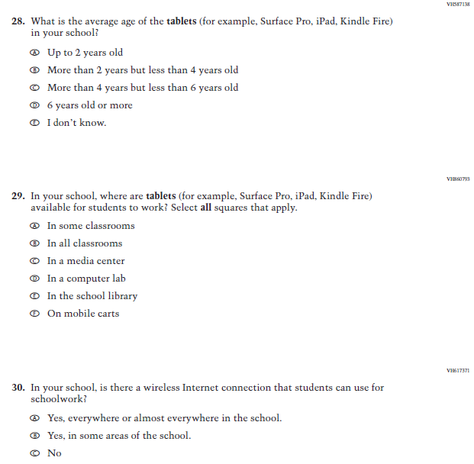

Appendix F-3c: Operational Grade 4 and 8 Charter School

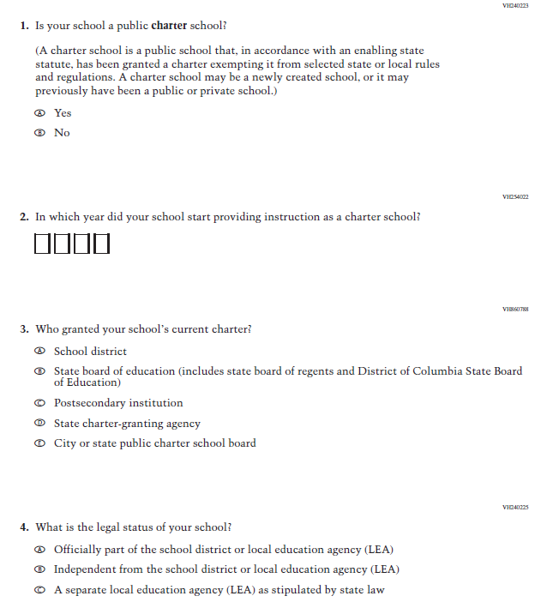

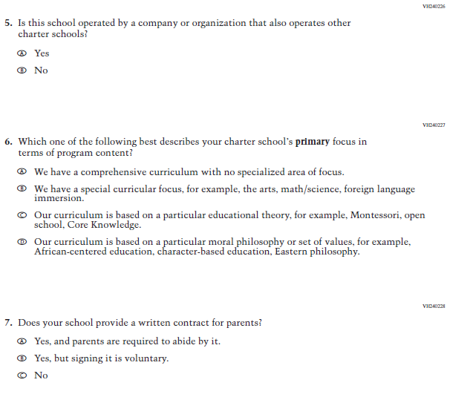

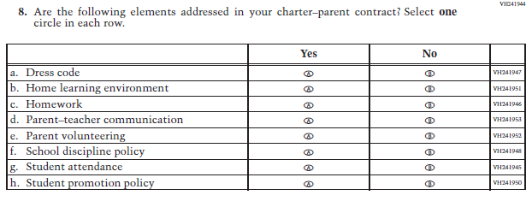

Appendix F-3d: Operational Grade 4 Mathematics
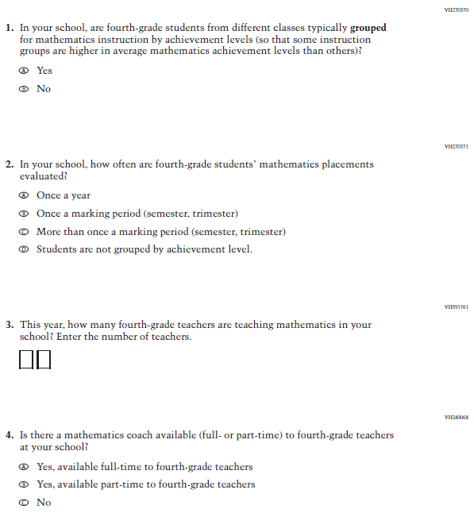

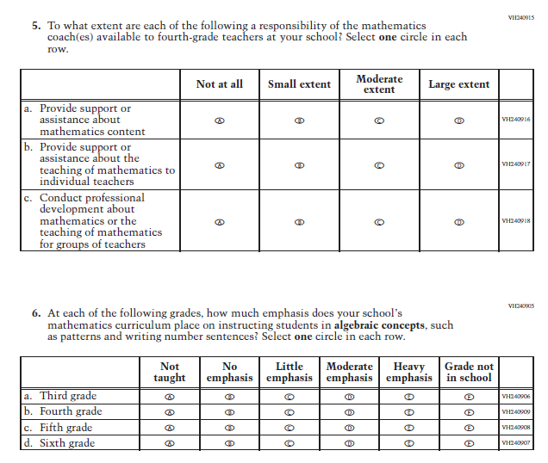

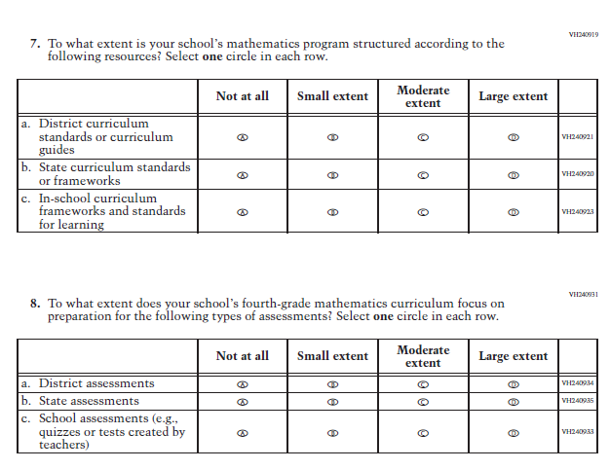

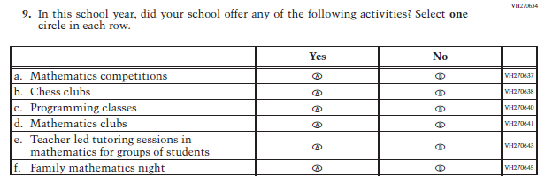

Appendix F-3e: Operational Grade 8 Mathematics
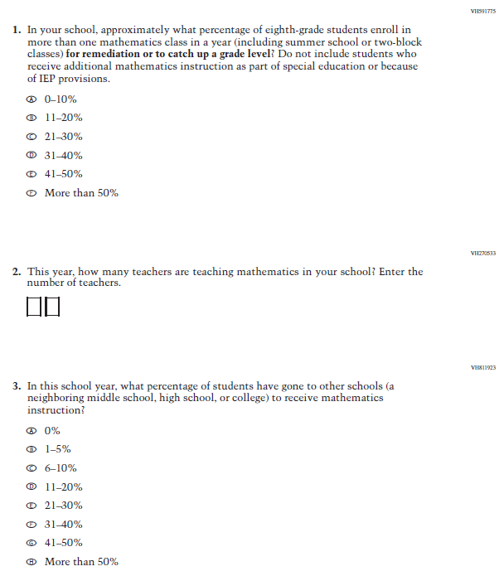

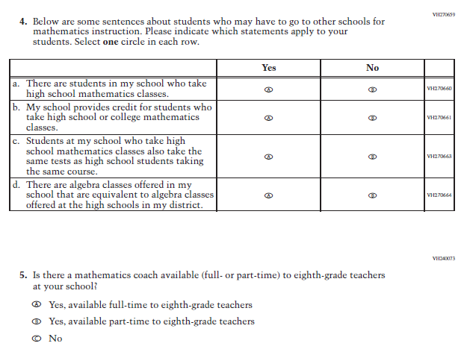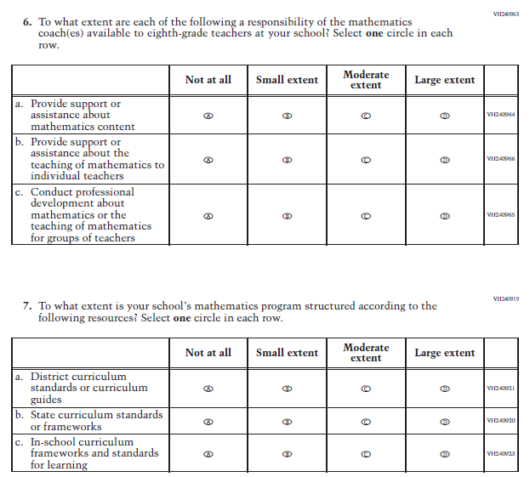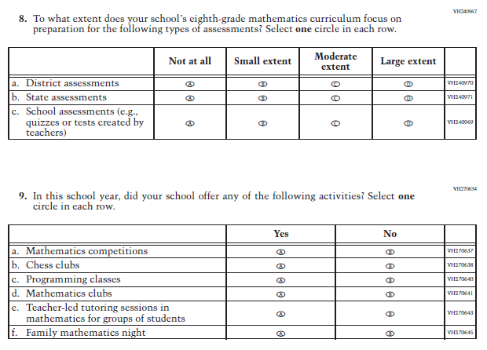

Appendix F-3f: Operational Grade 4 Reading
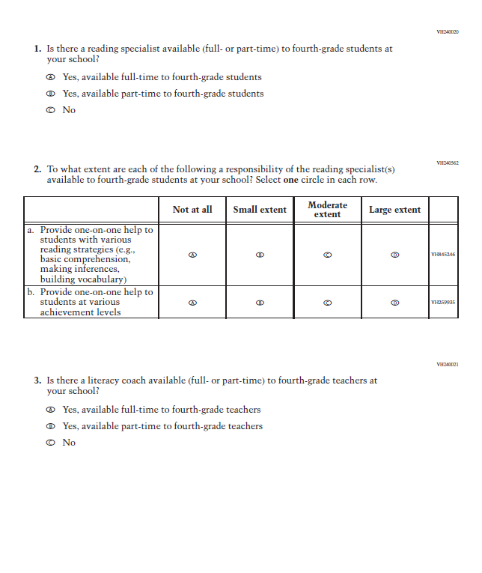

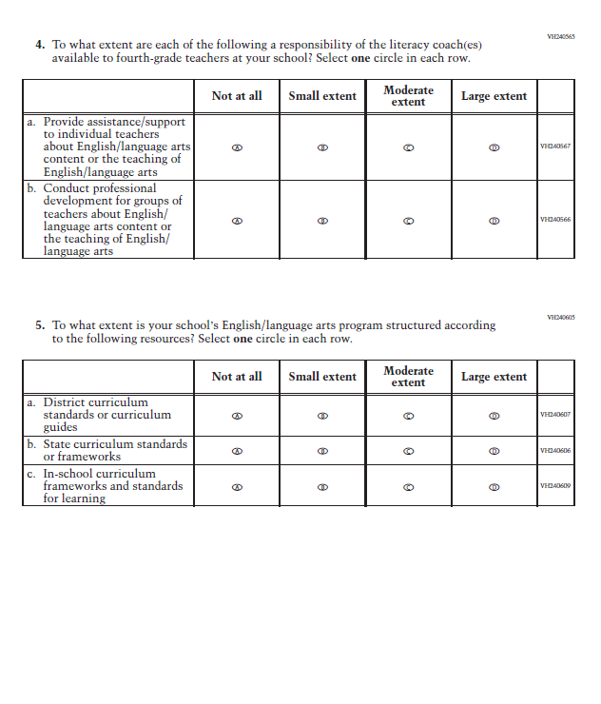

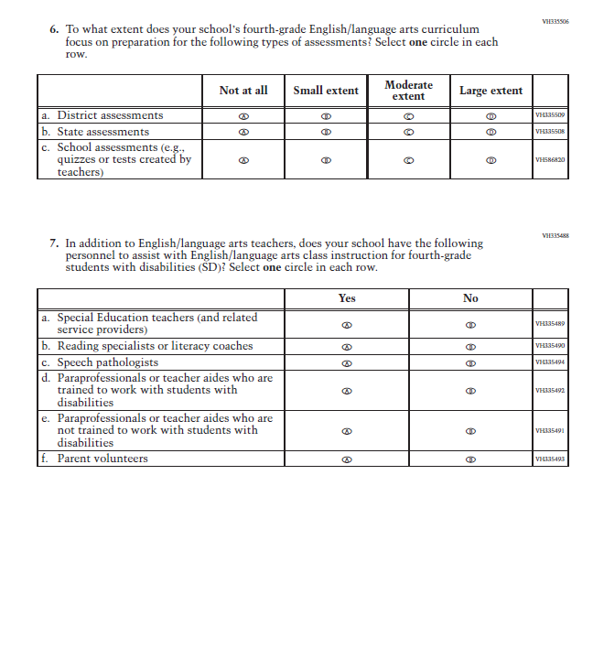
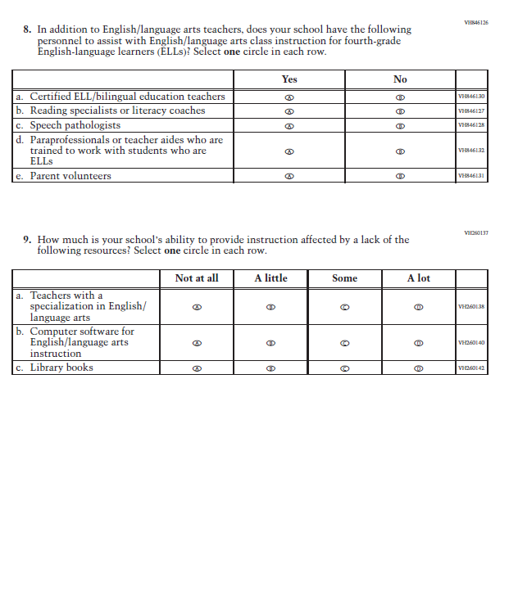

Appendix F-3g: Operational Grade 8 Reading
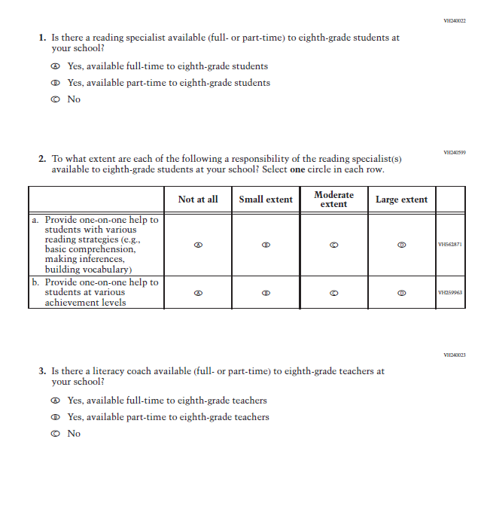
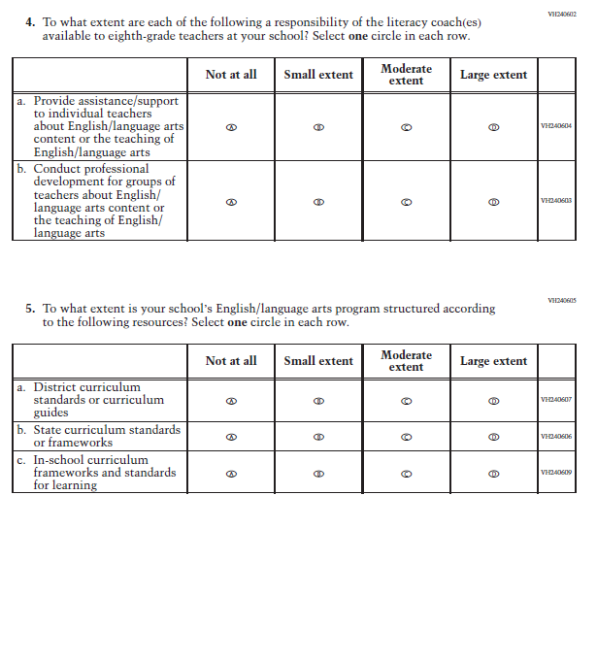
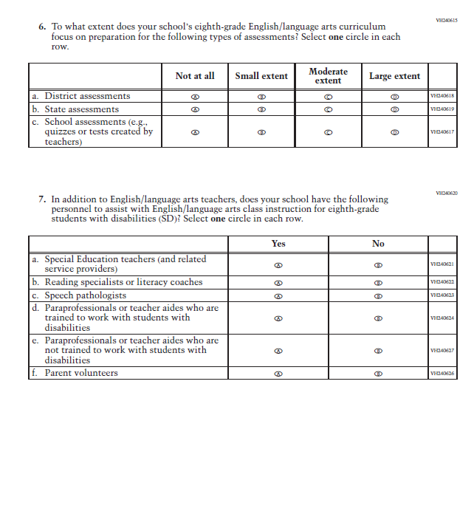
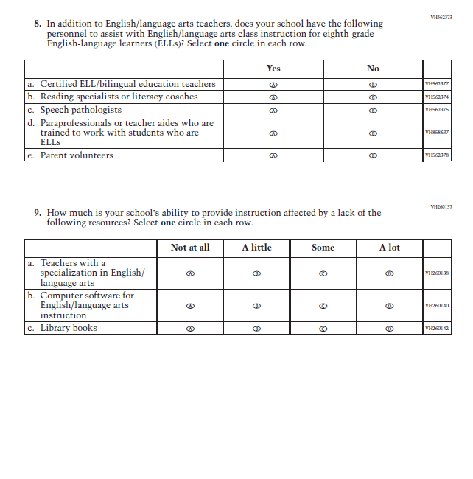

Appendix F-3h: Operational Grade 8 Social Studies
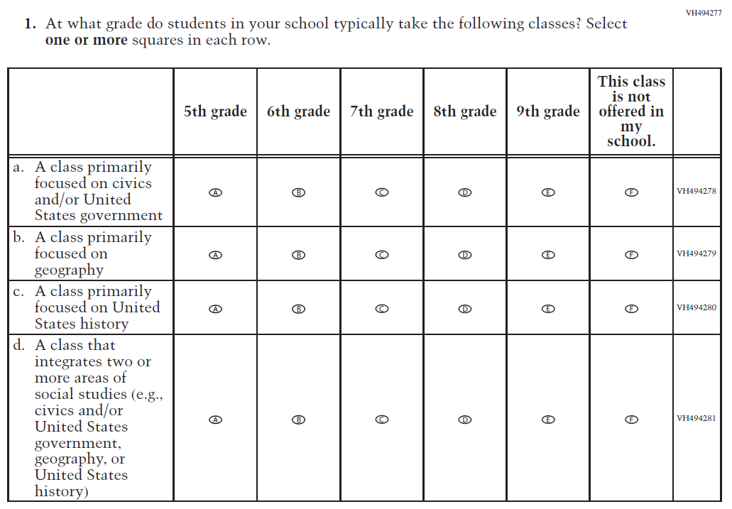

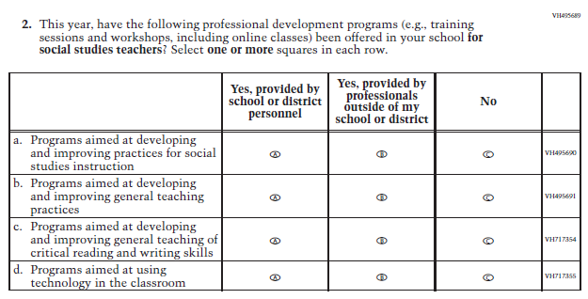

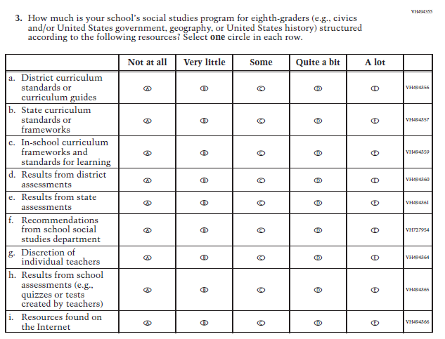

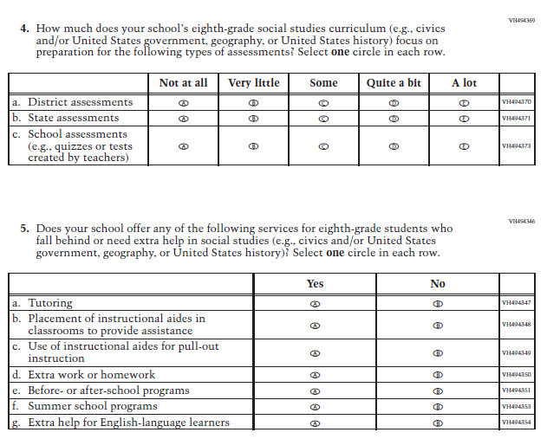

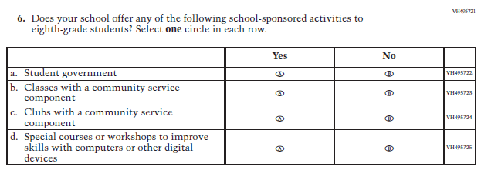

Appendix F-3i: Operational Grade 4 COVID-19 School Items

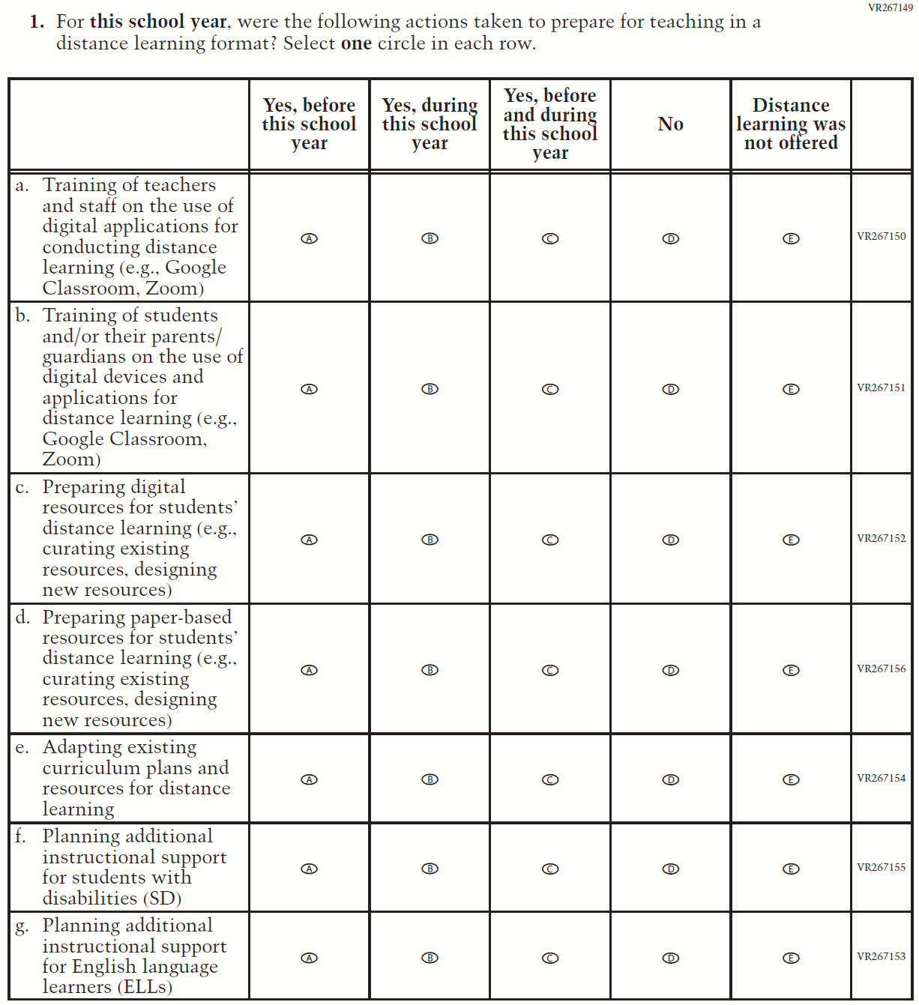

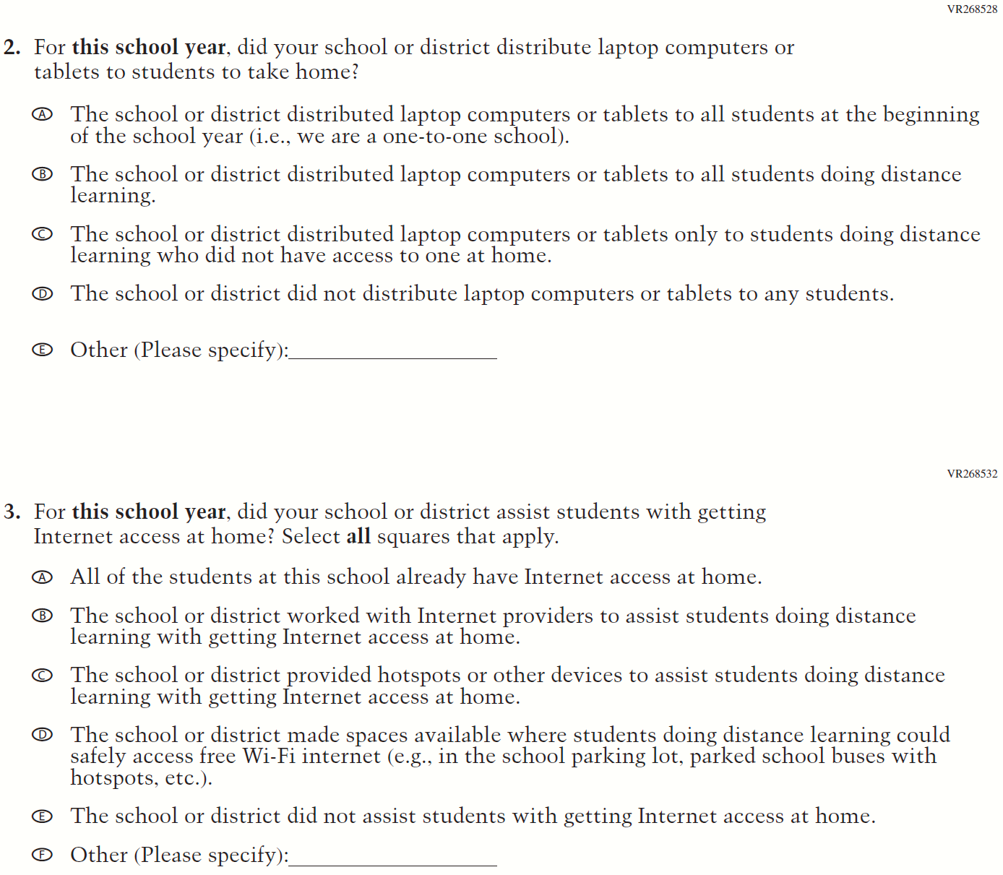

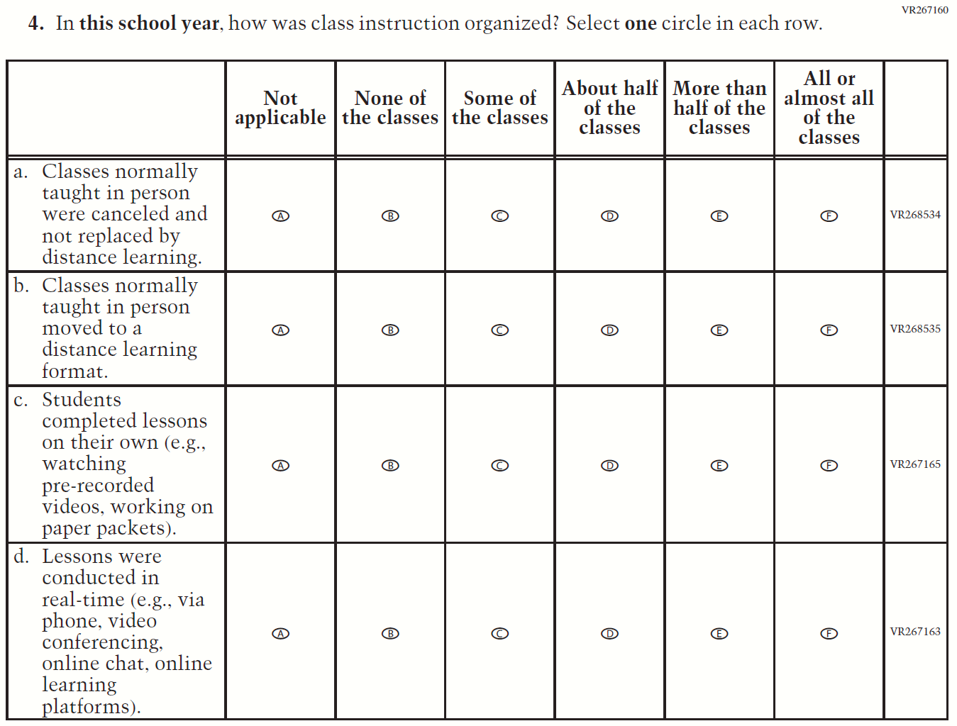
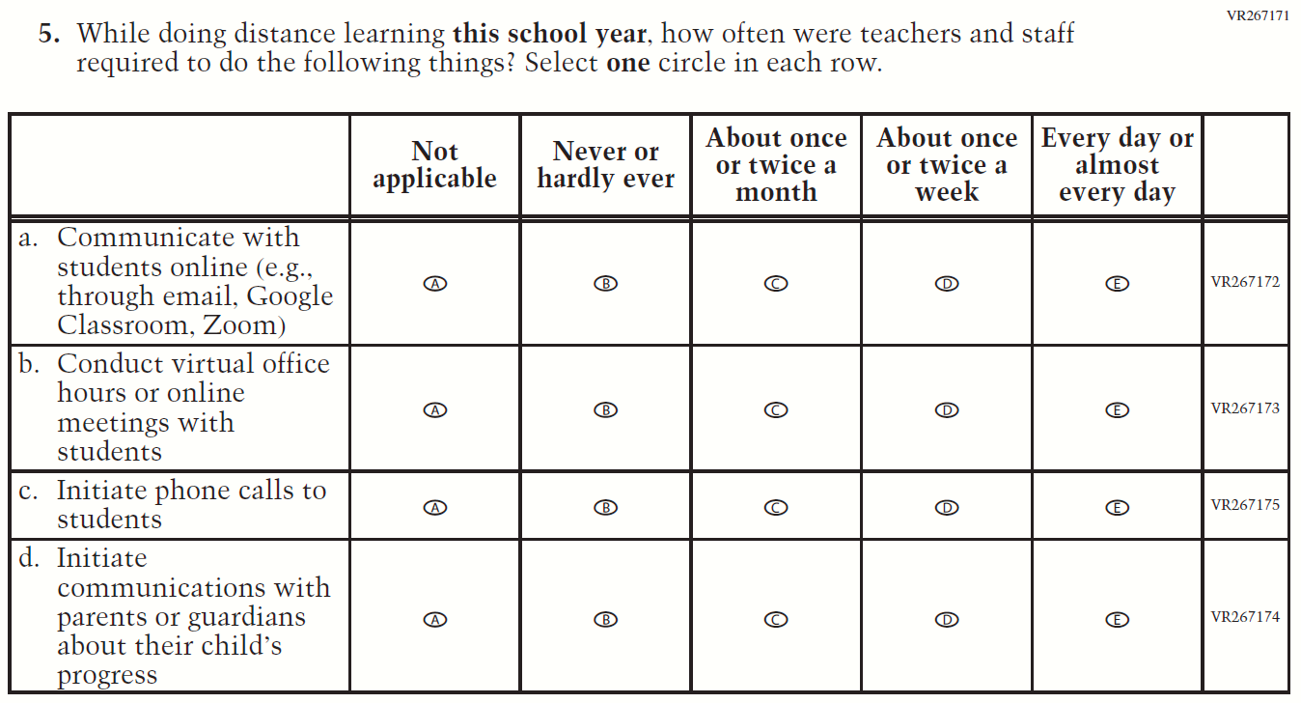

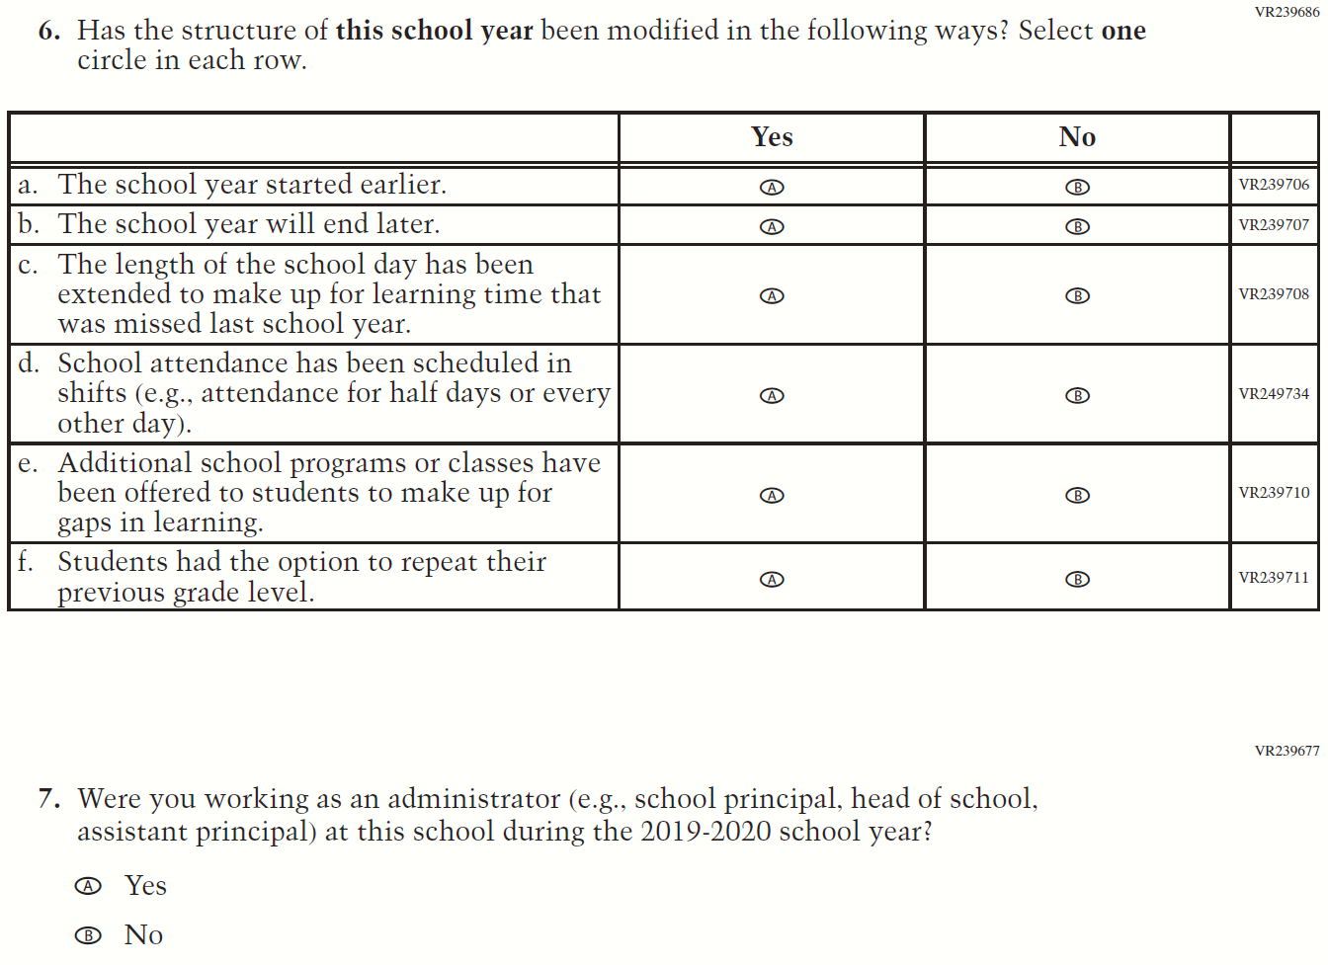

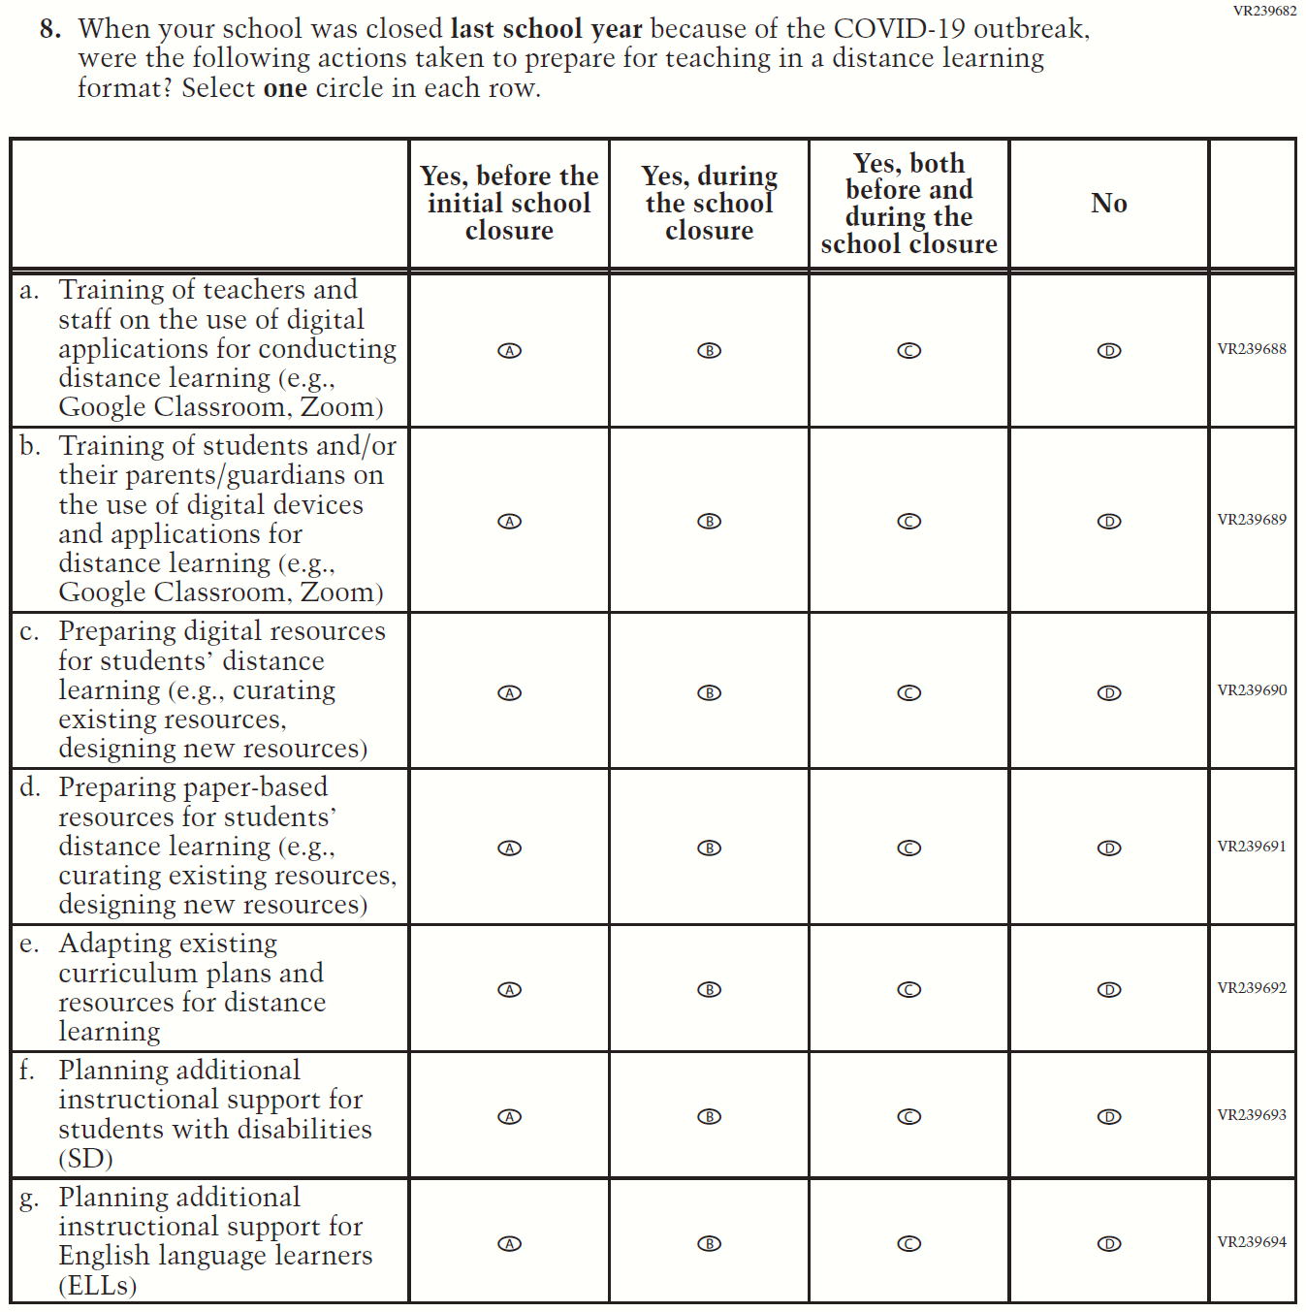

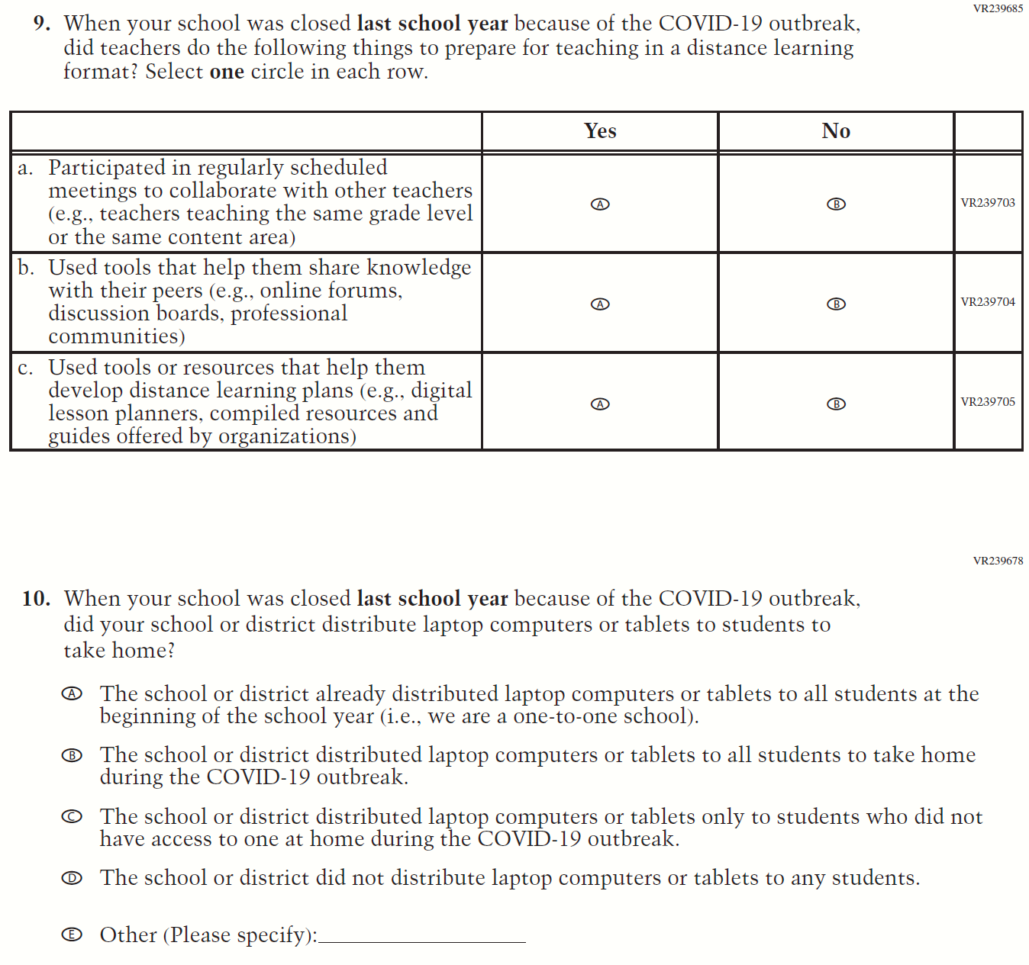

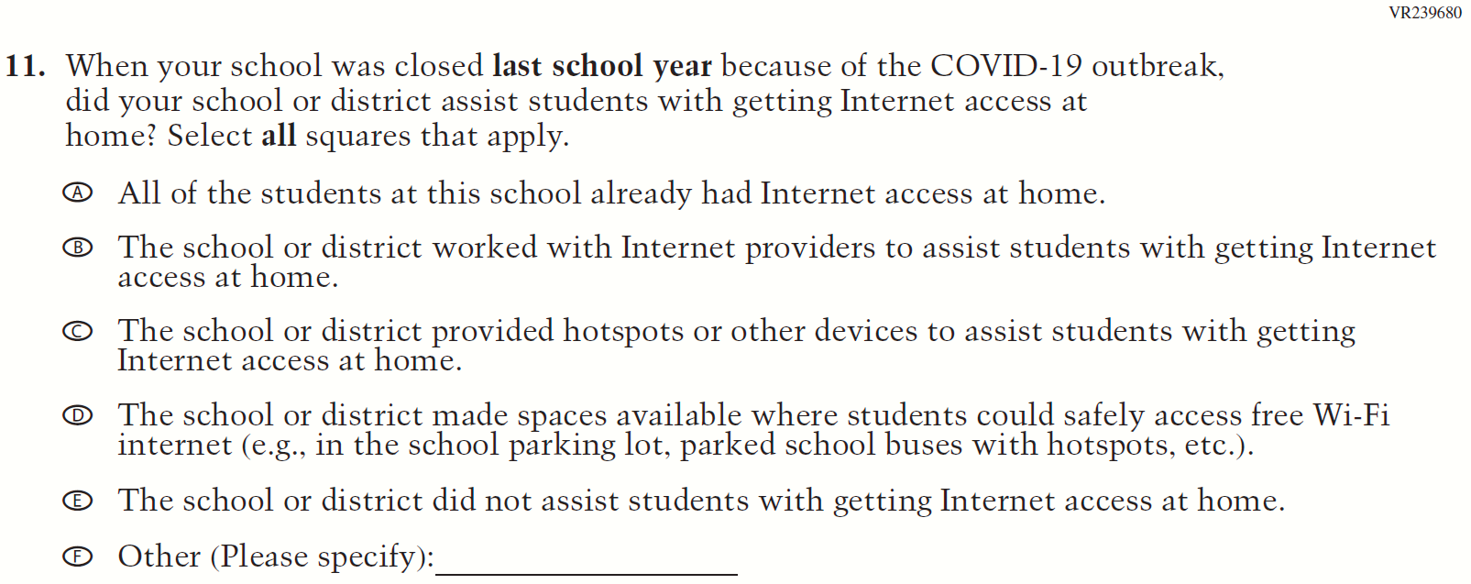

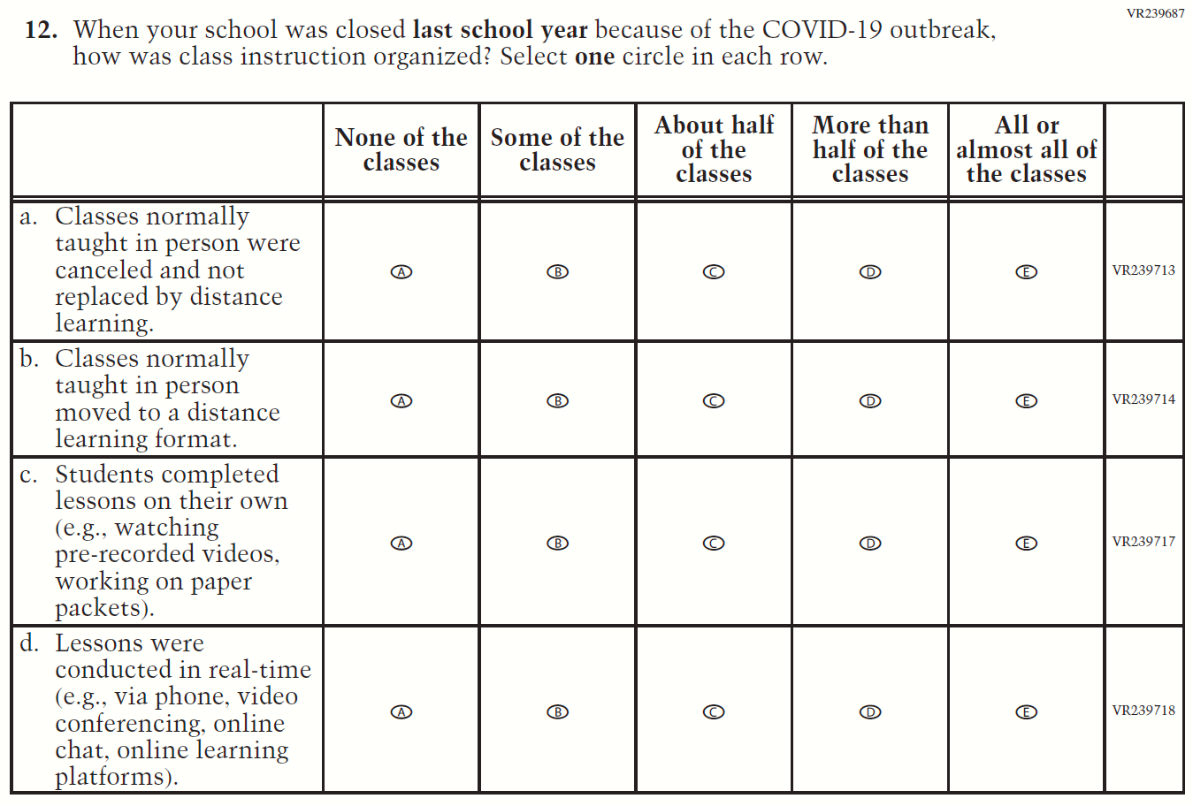

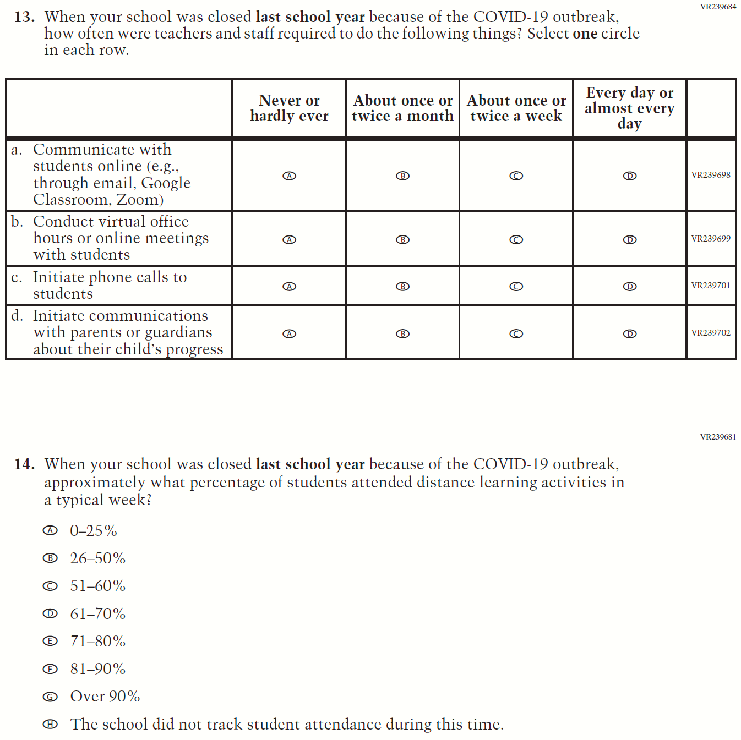

Appendix F-3j: Operational Grade 8 COVID-19 School Items
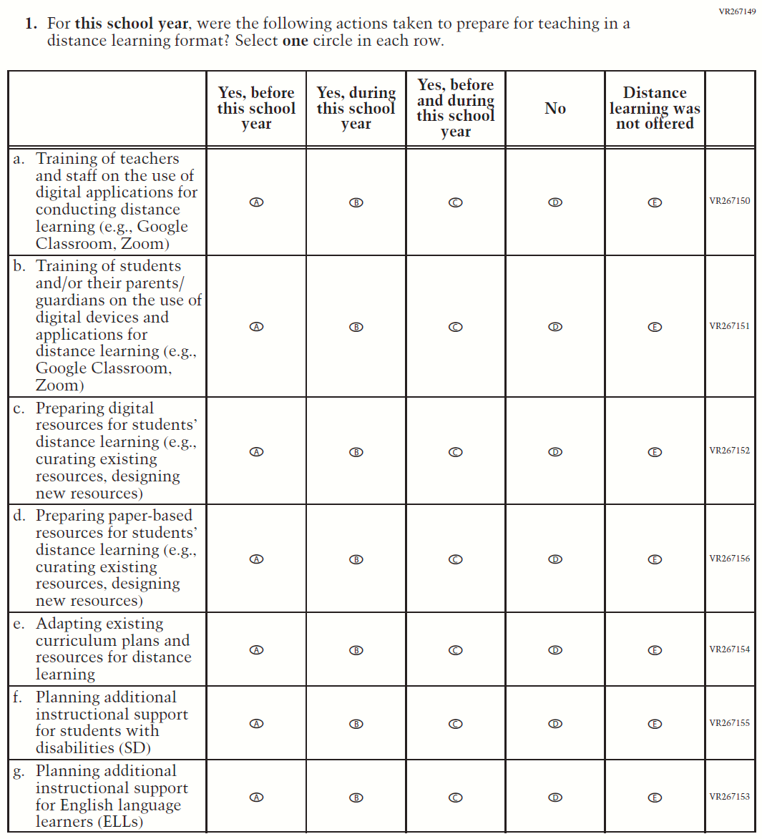

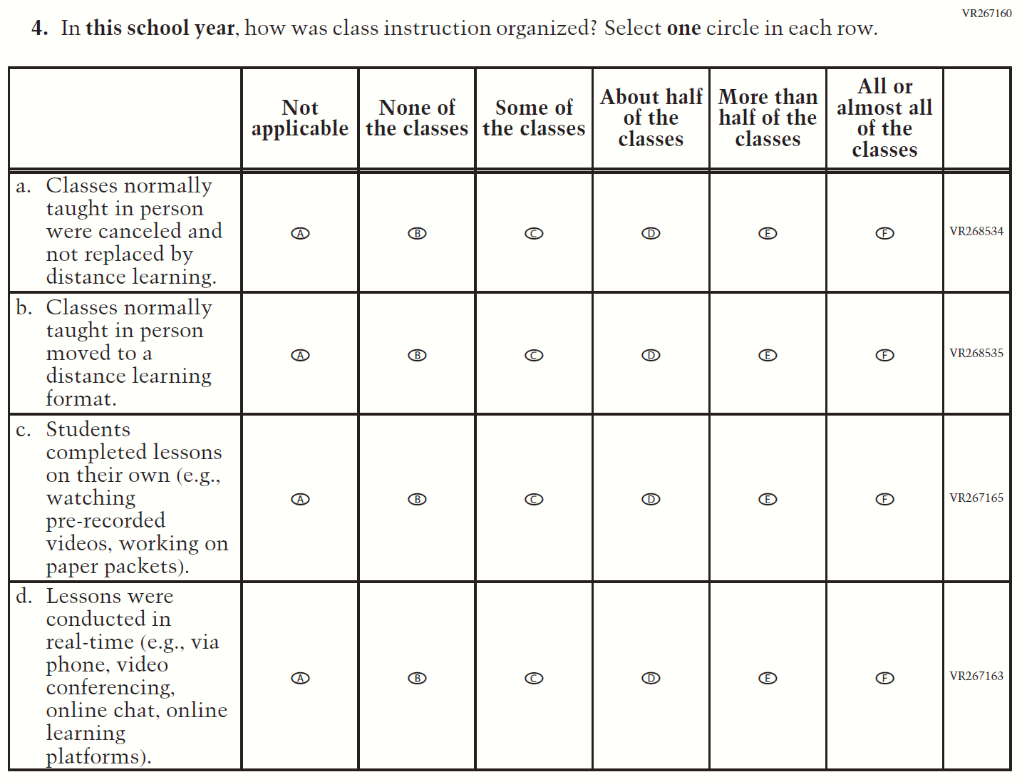
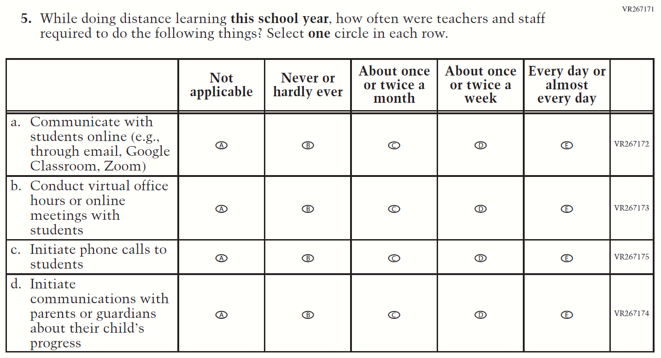

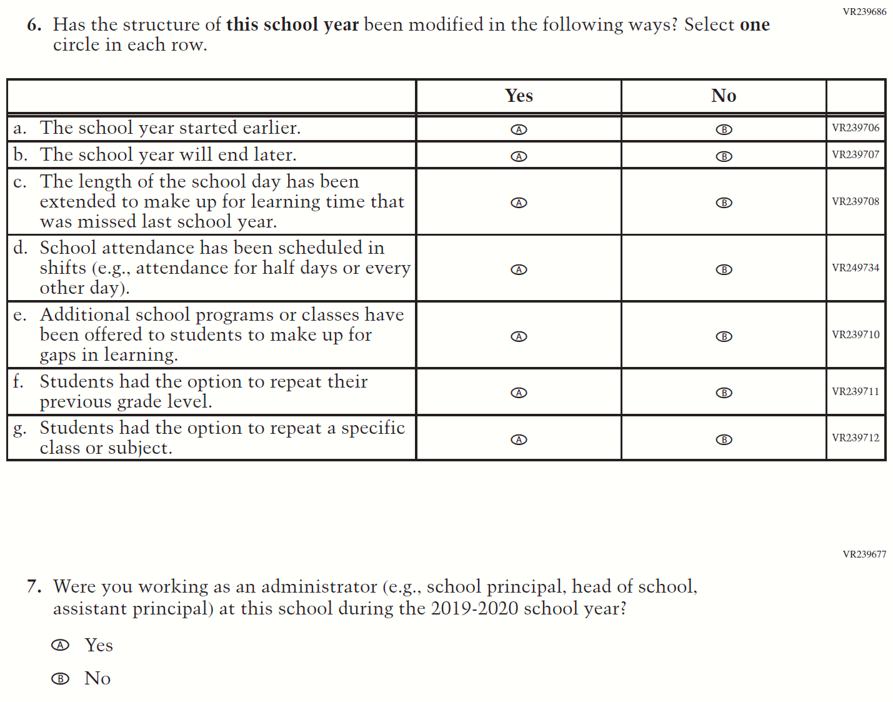

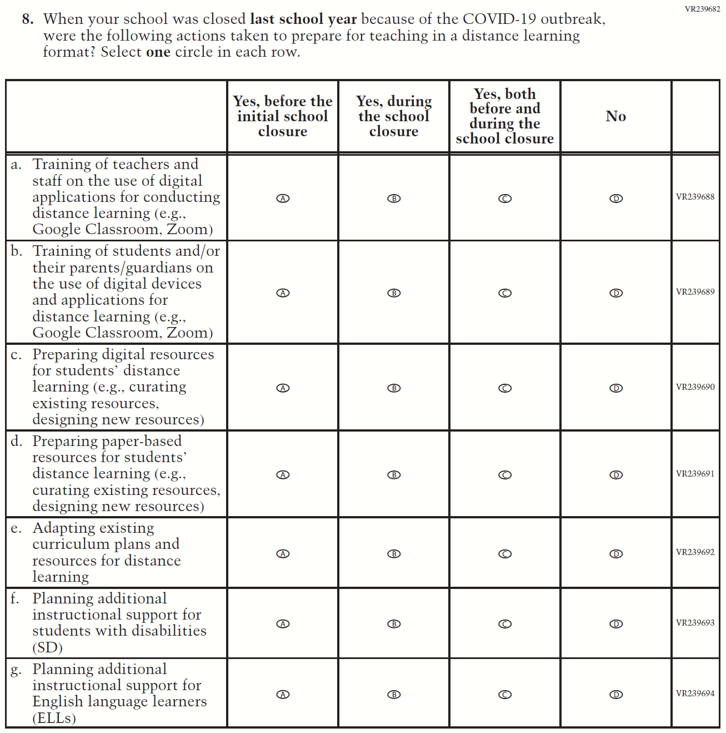

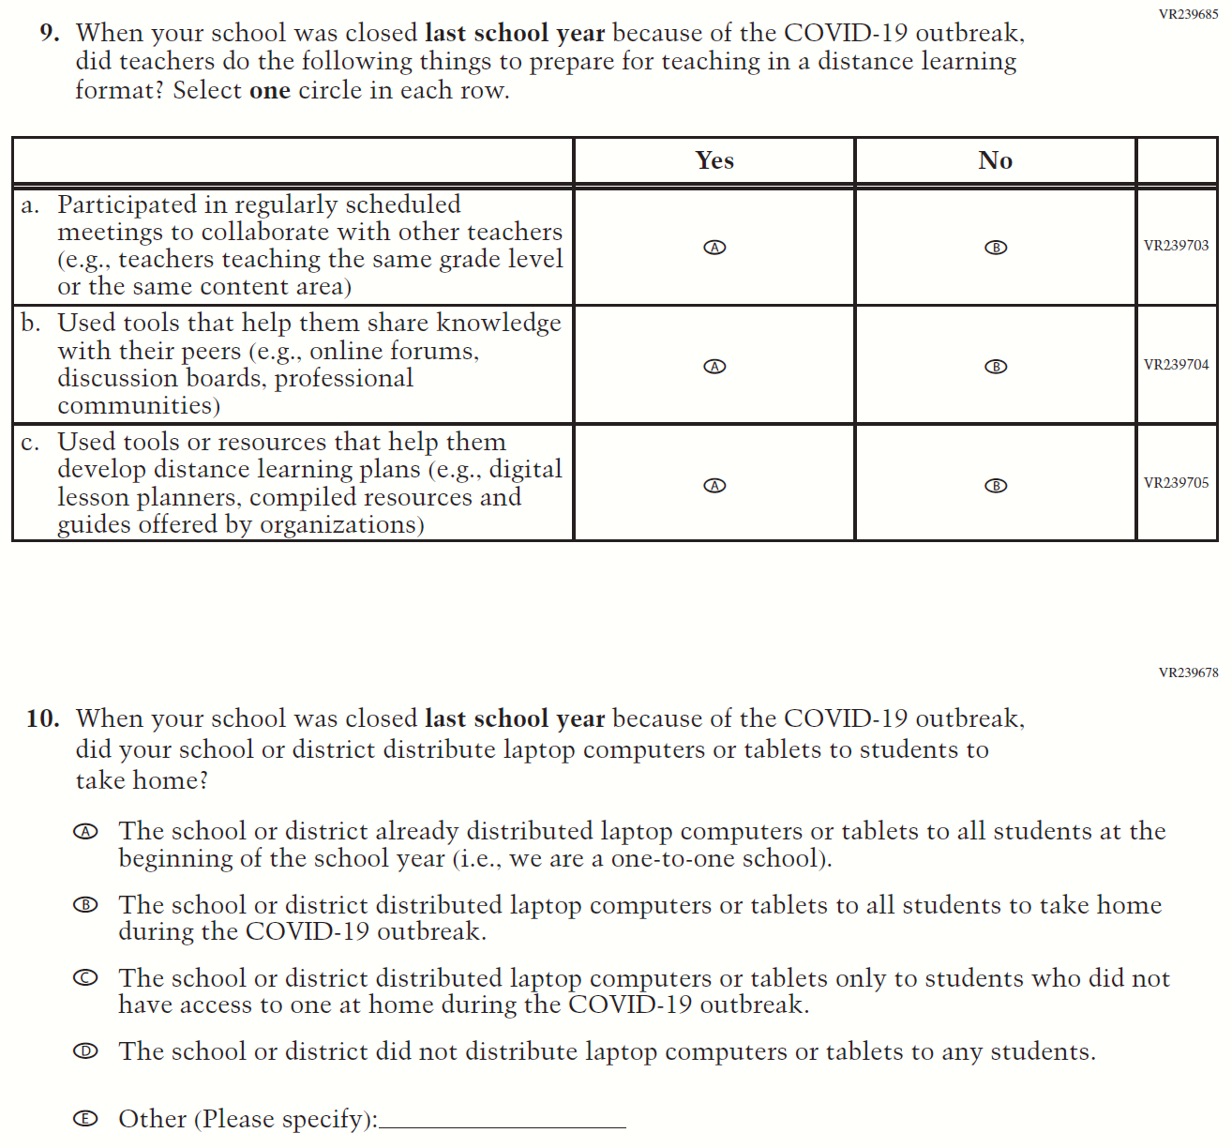

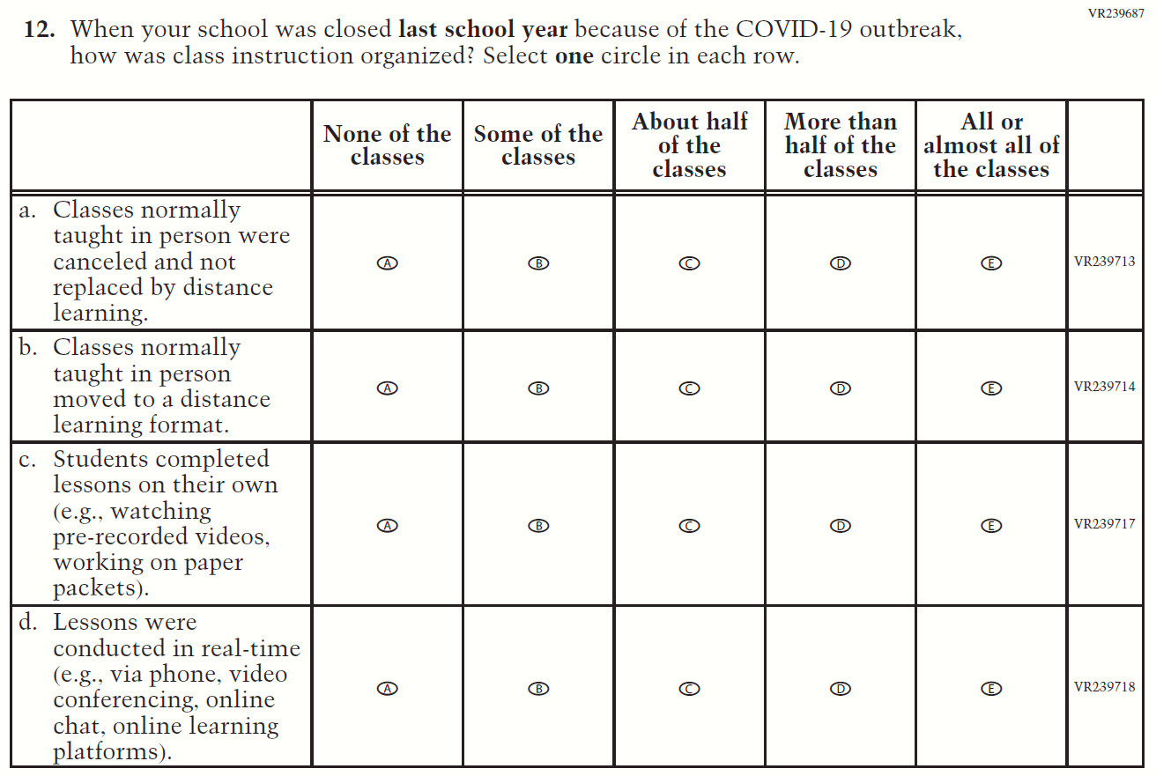

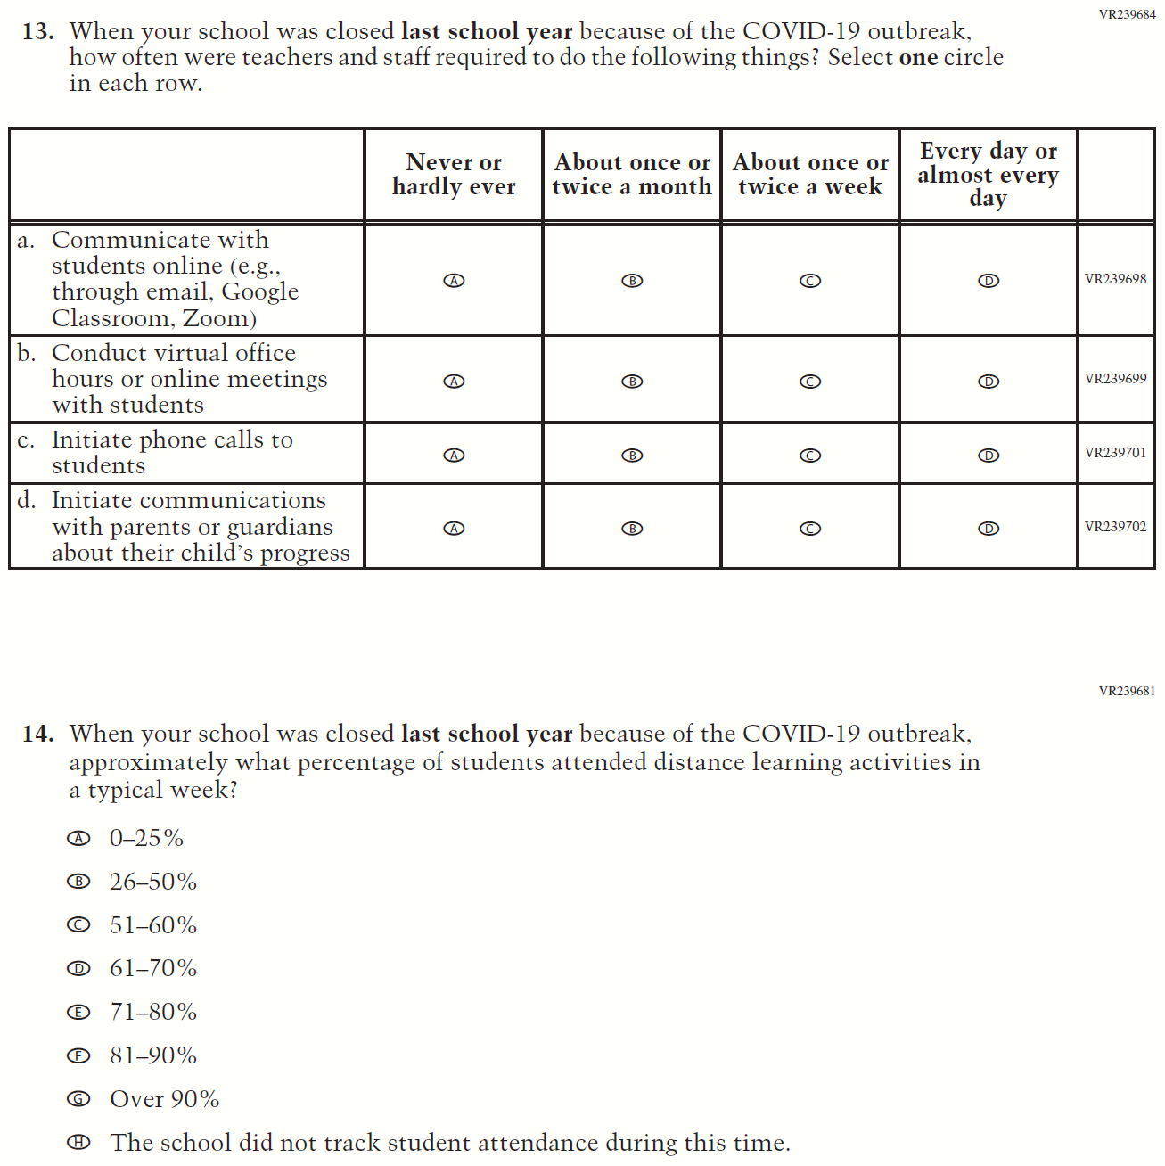

Appendix F-3: 2022 School Questionnaires

Appendix F-3a-22: Operational Grade 4 CORE
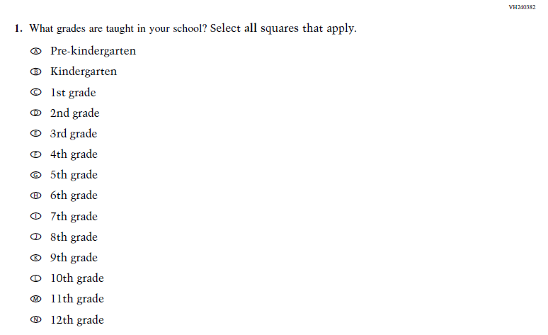
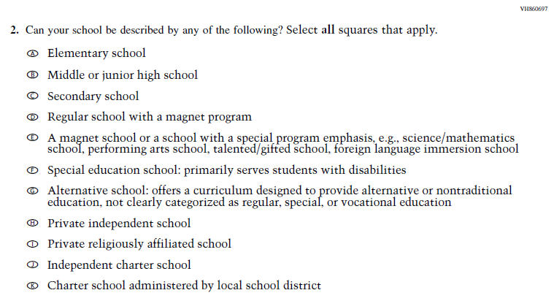

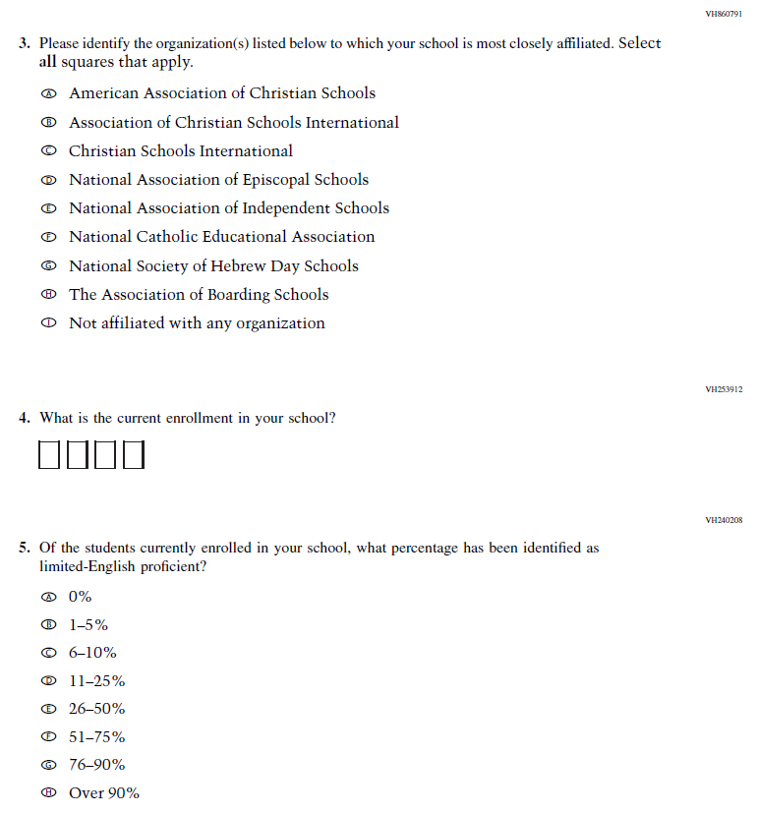
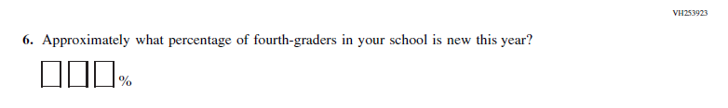

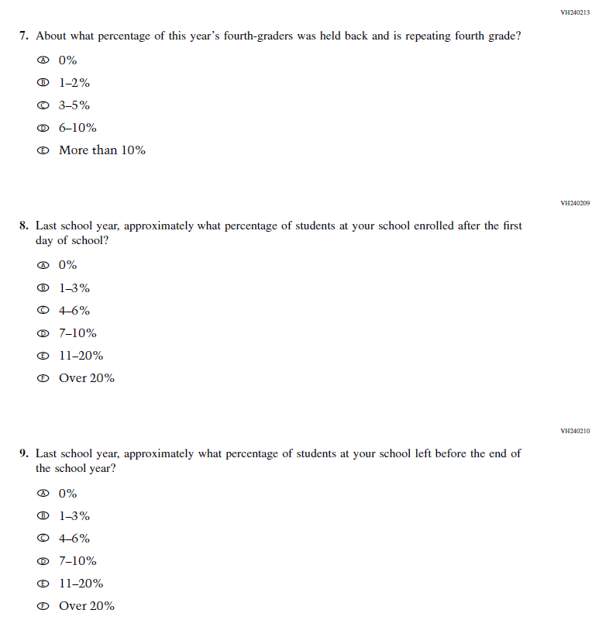
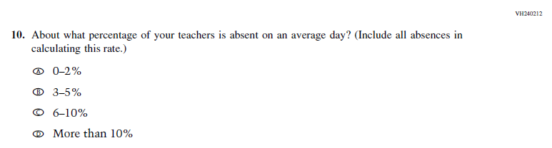

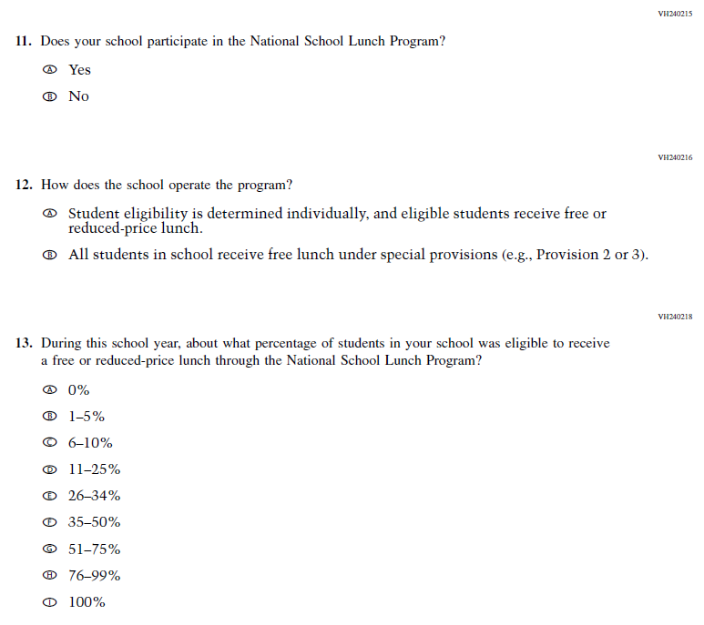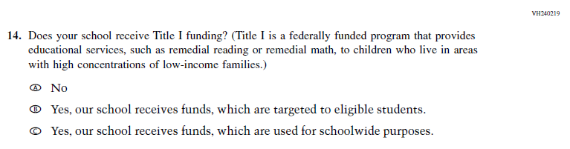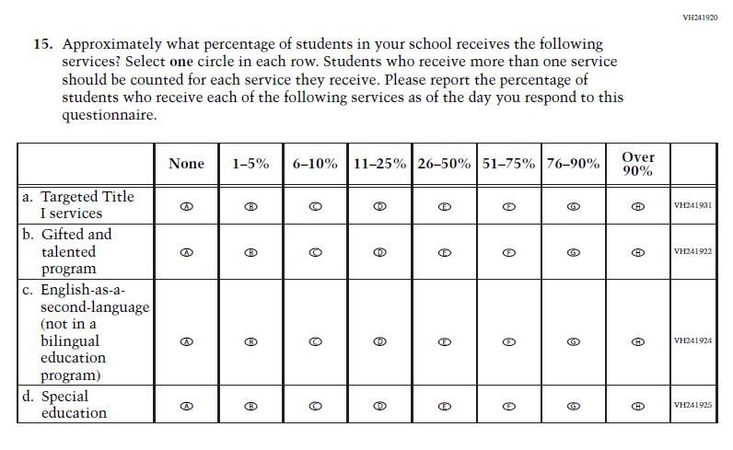
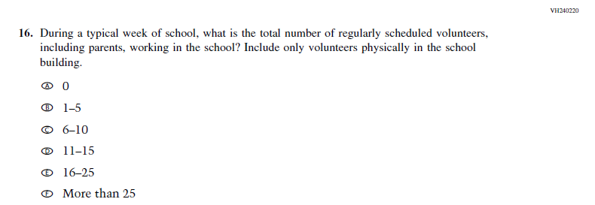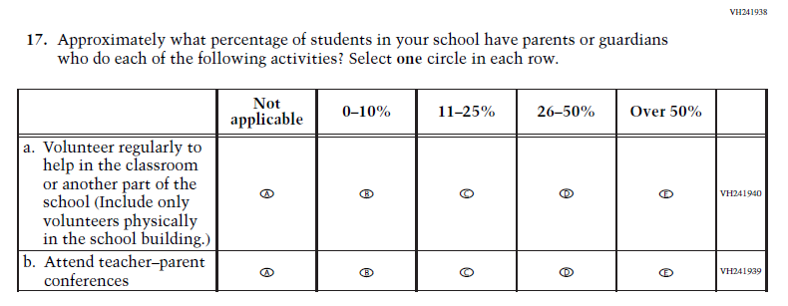
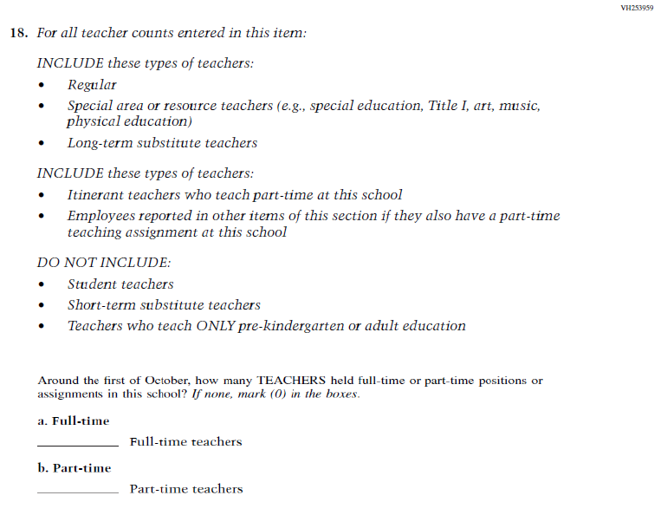
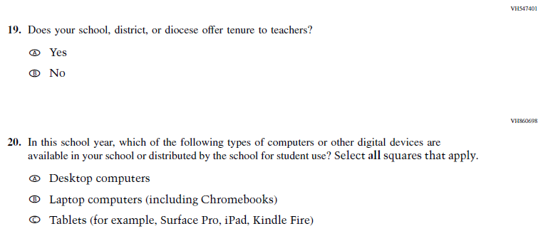

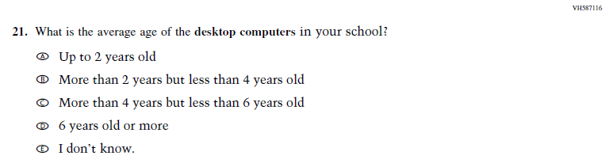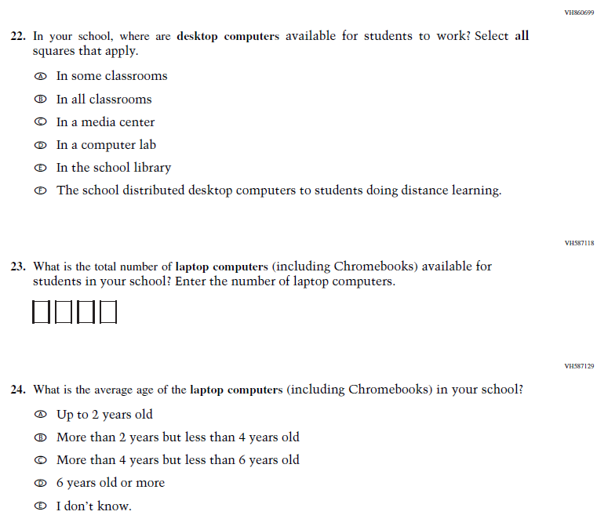

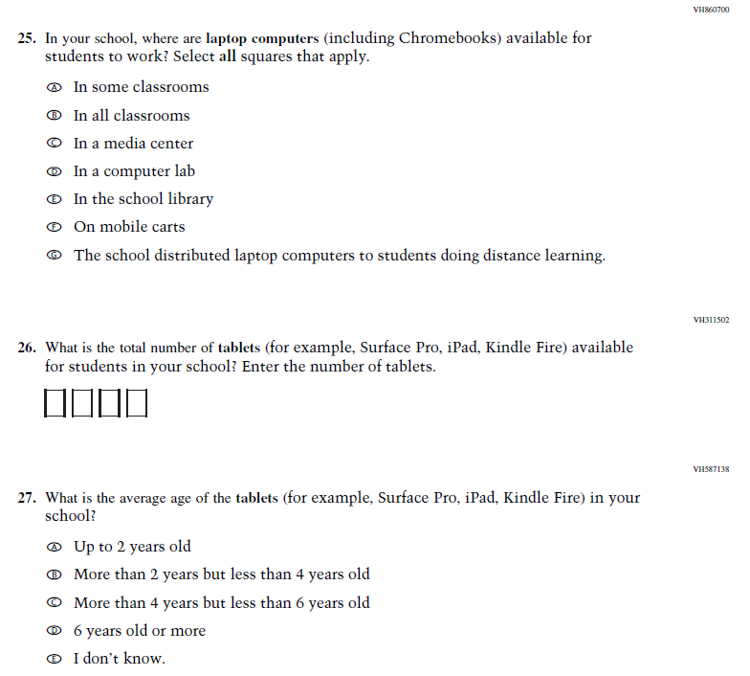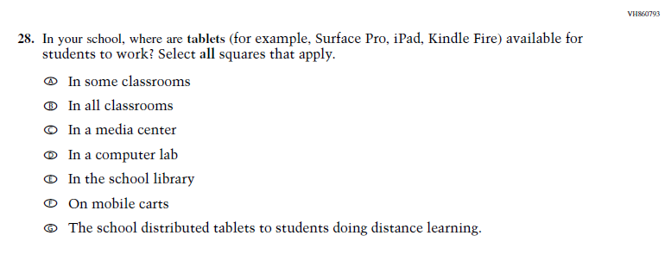

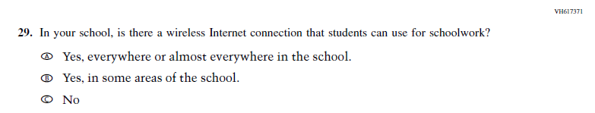

Appendix F-3b-22: Operational Grade 8 CORE

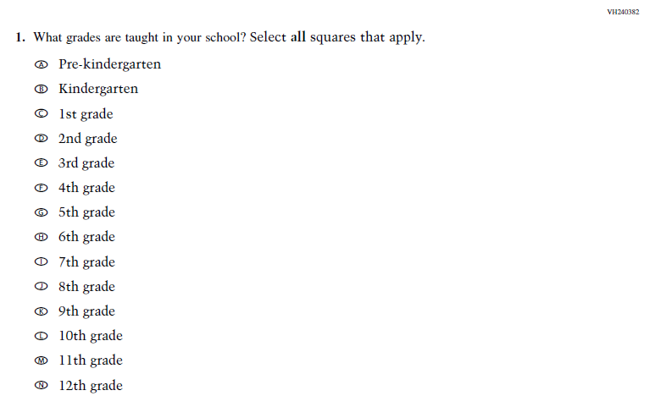
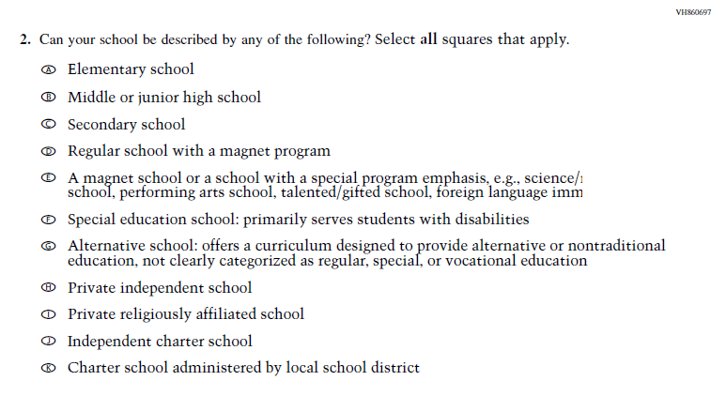

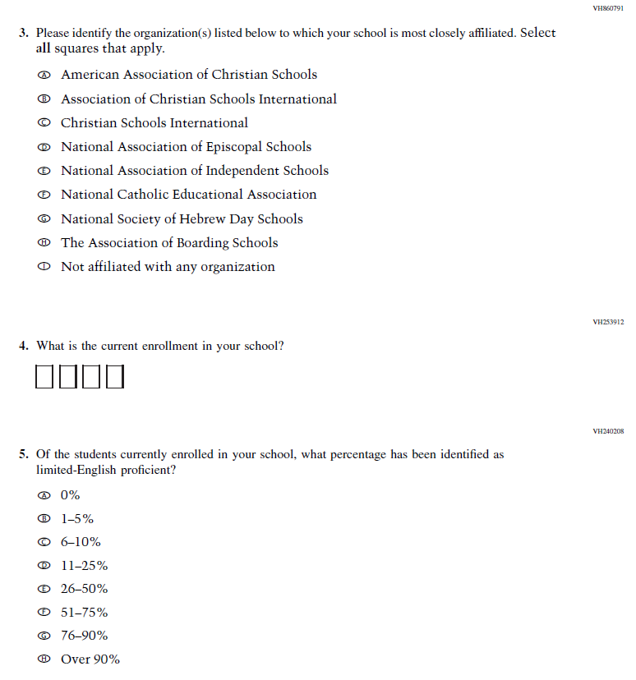
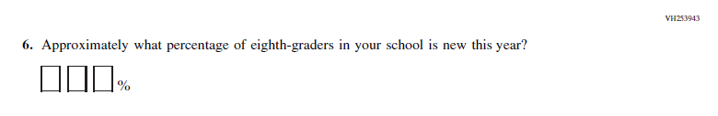
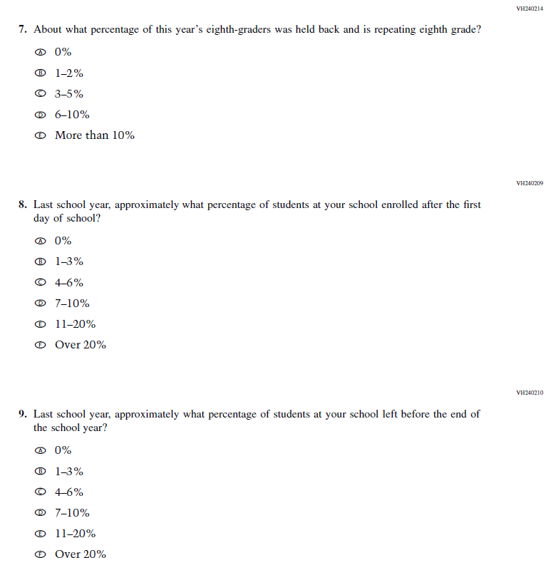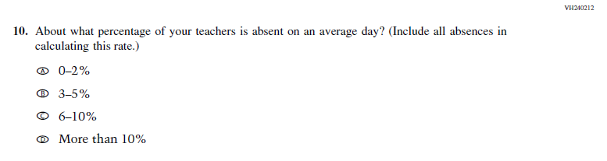

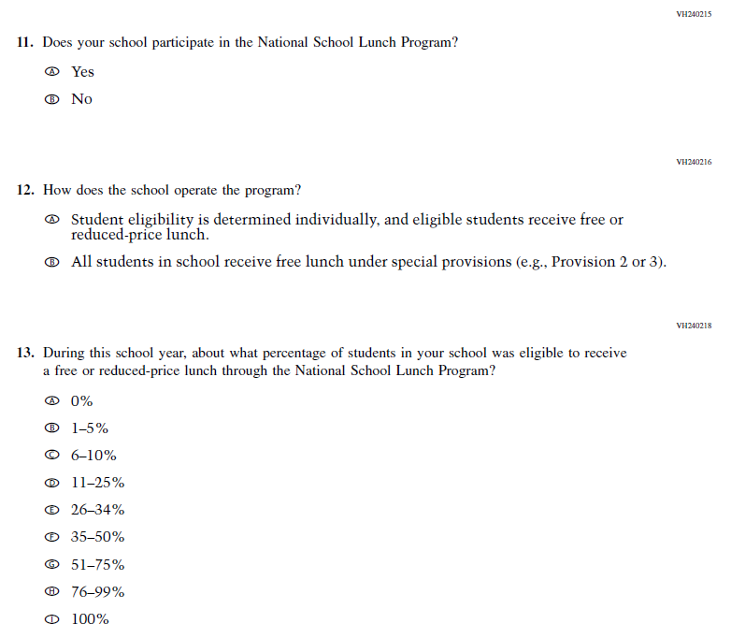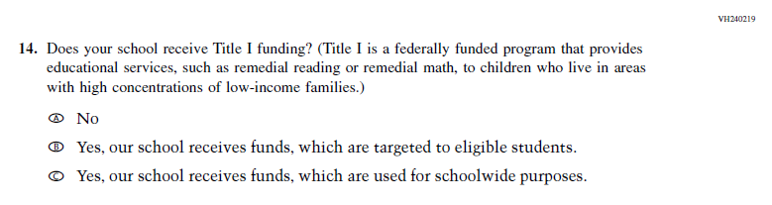

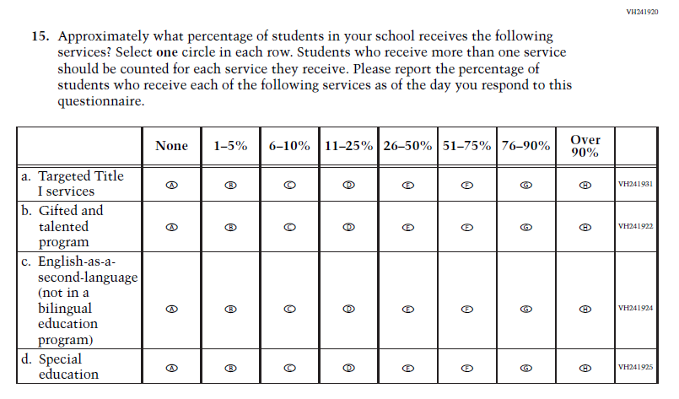
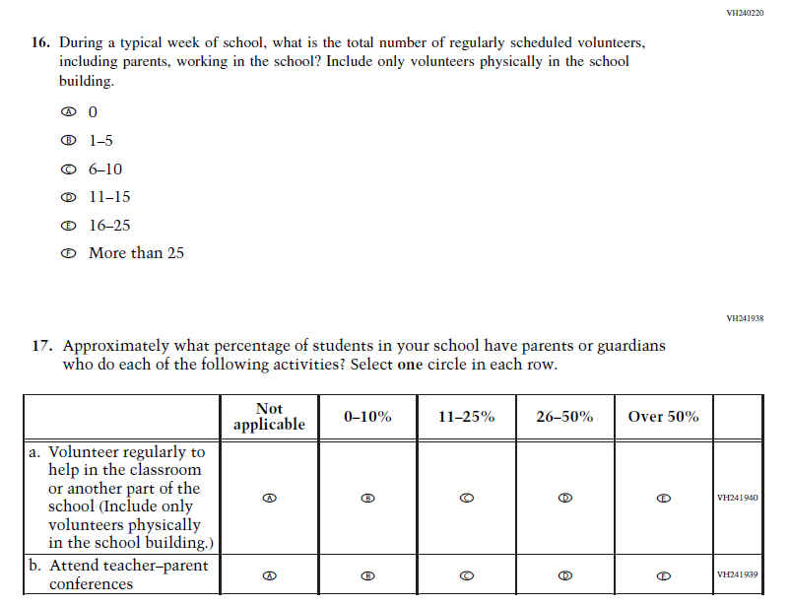
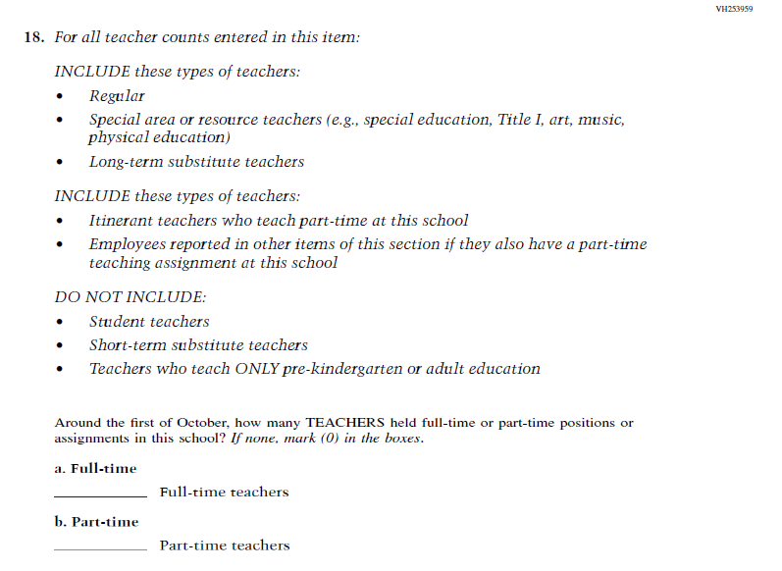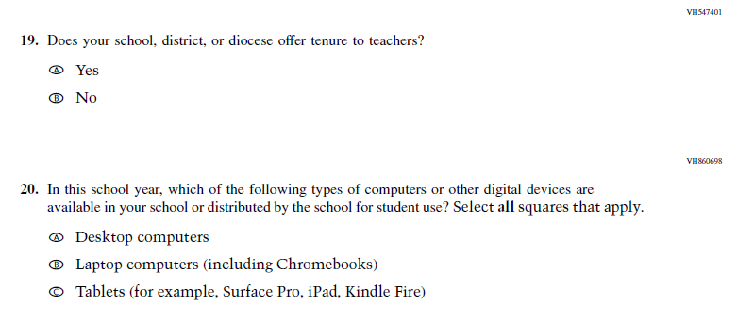
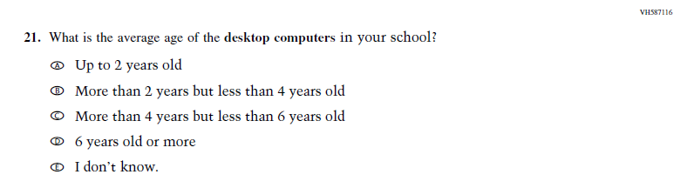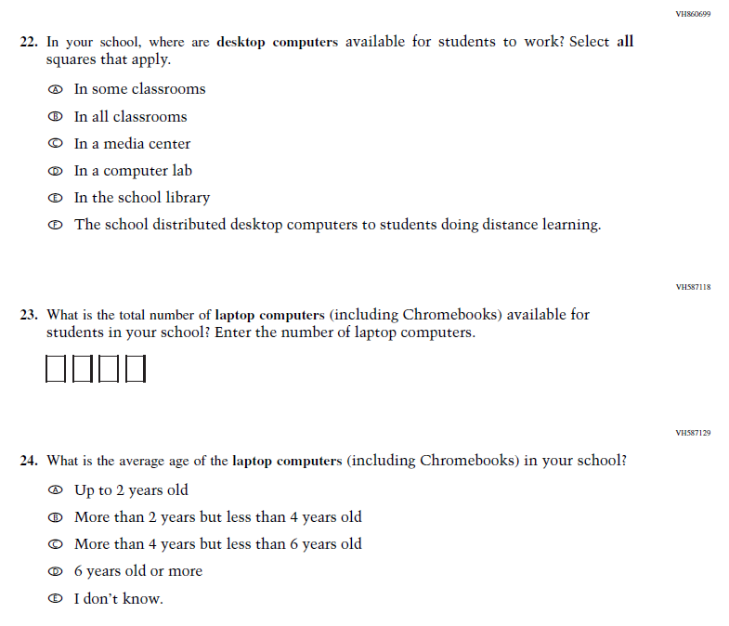

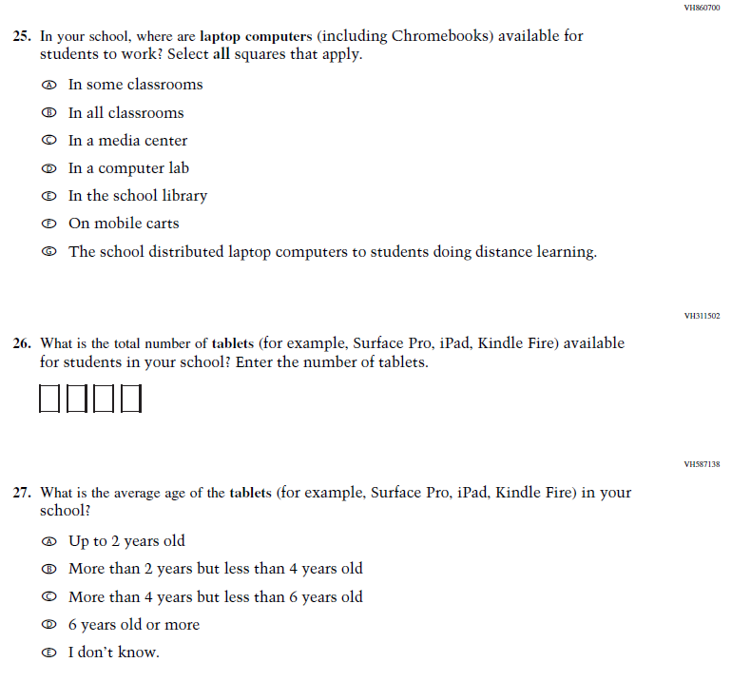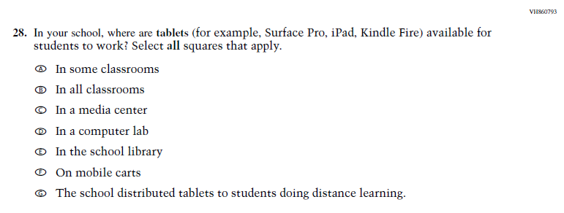

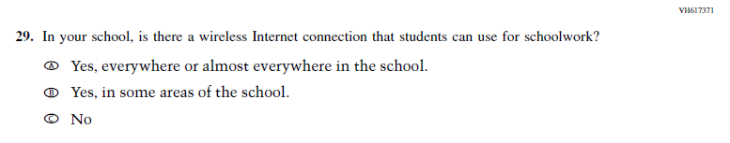

Appendix F-3c-22: Operational Grade 4 and 8 Charter School

Appendix F-3d-22: Operational Grade 4 Mathematics

Appendix F-3e-22: Operational Grade 8 Mathematics

Appendix F-3f-12: Operational Grade 4 Reading

Appendix F-3f-22: Operational Grade 8 Reading

Appendix F-3g-22: Operational Grade 8 Social Studies School Items

Appendix F-3h-22: Operational Grade 4 COVID-19 School Items
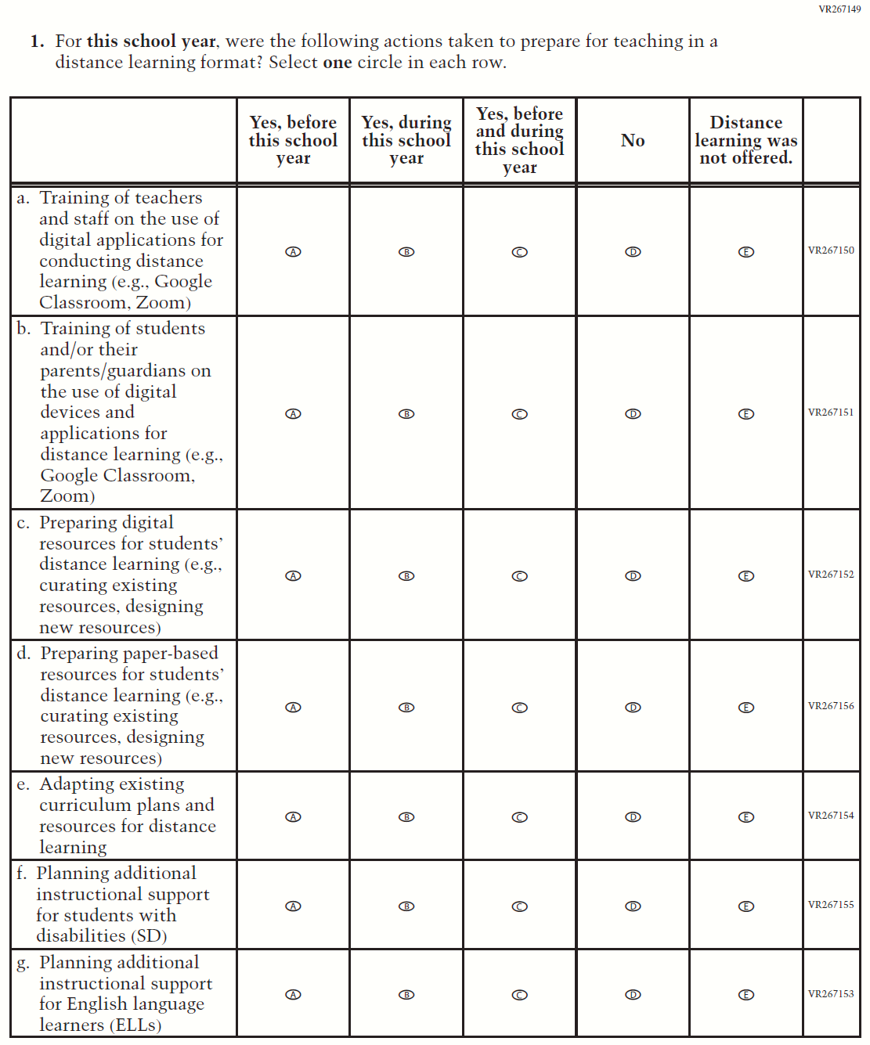

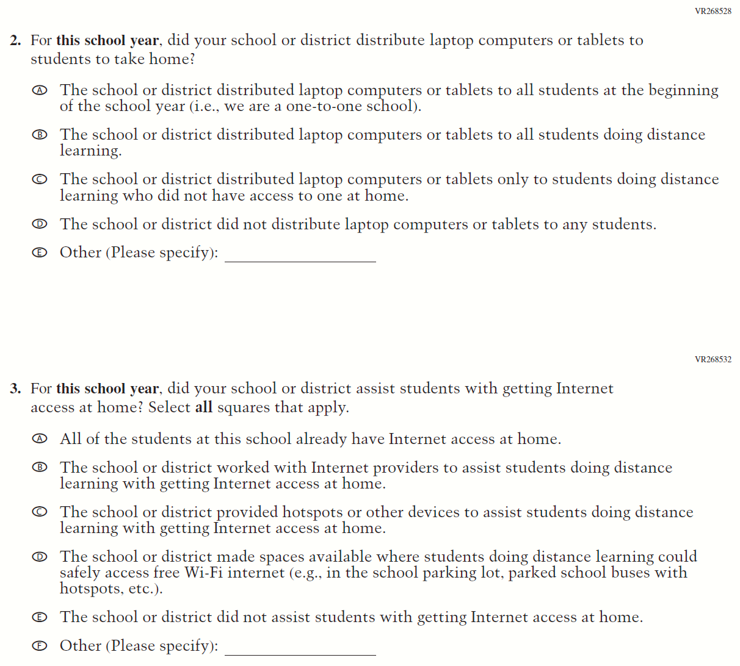

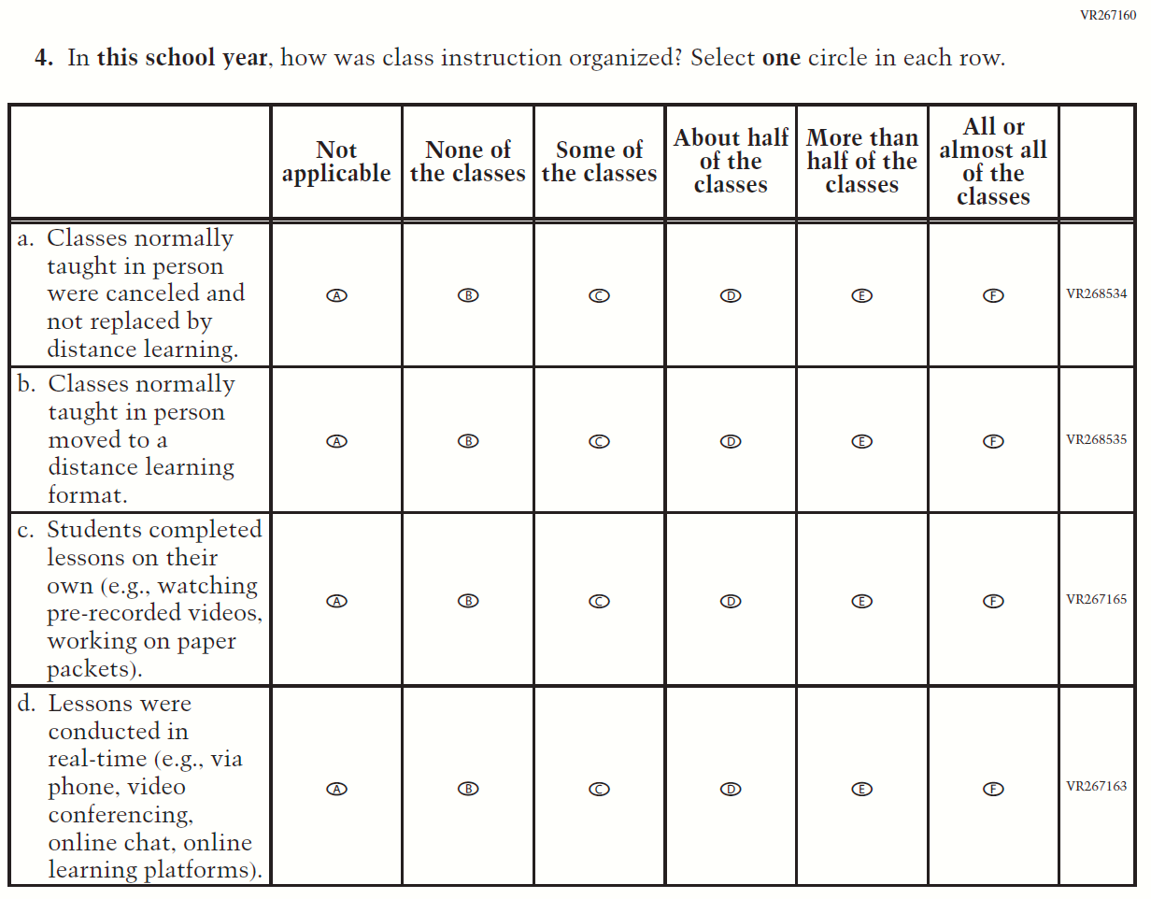

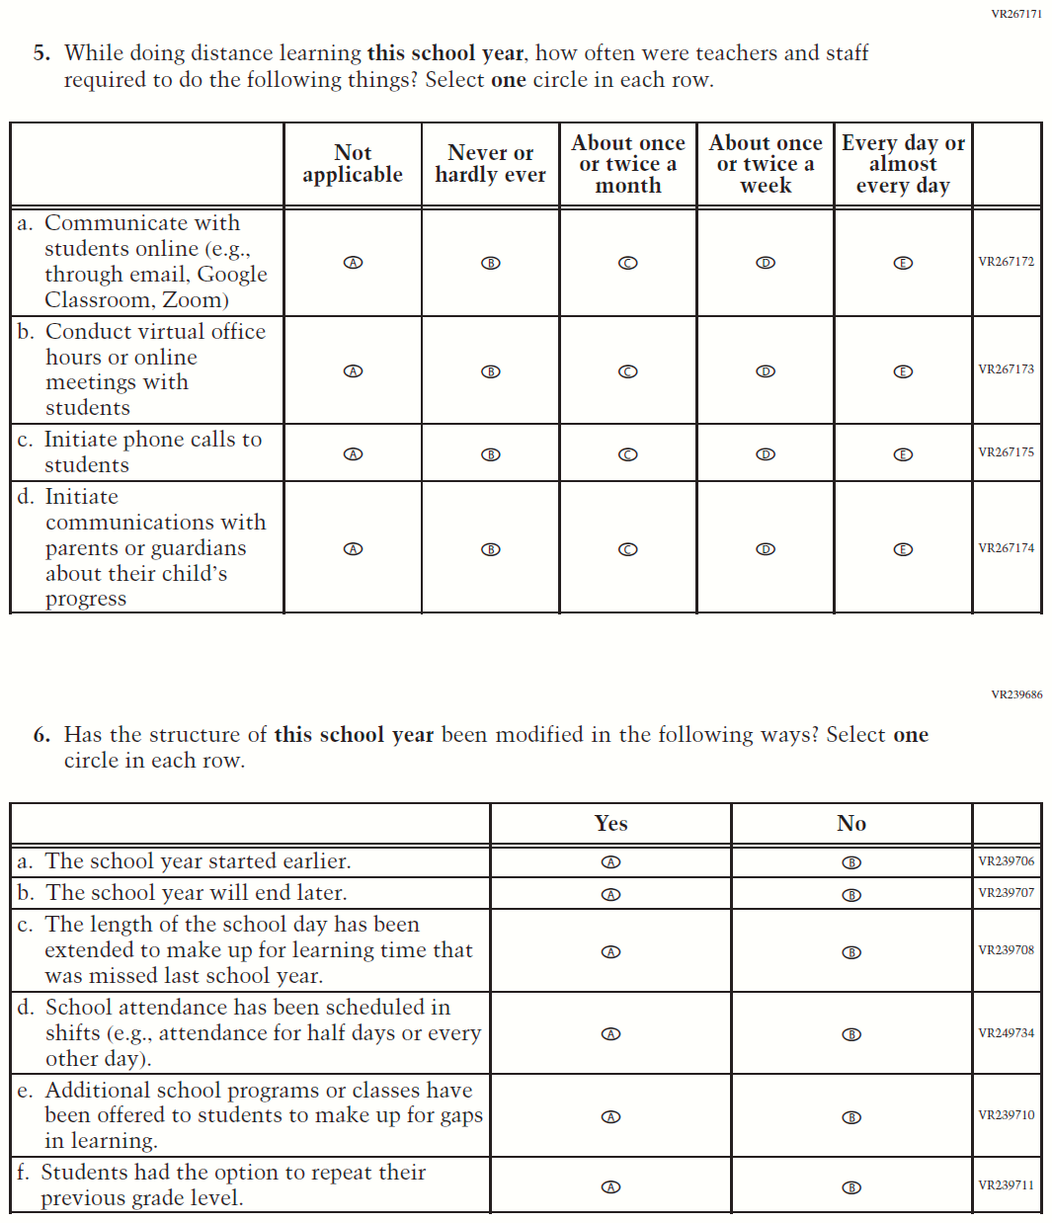

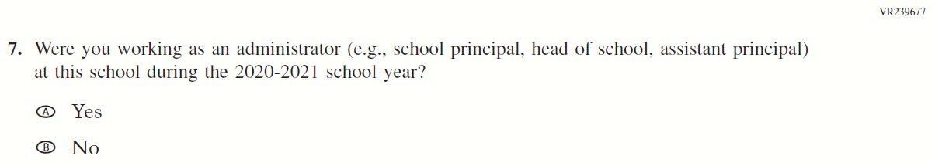

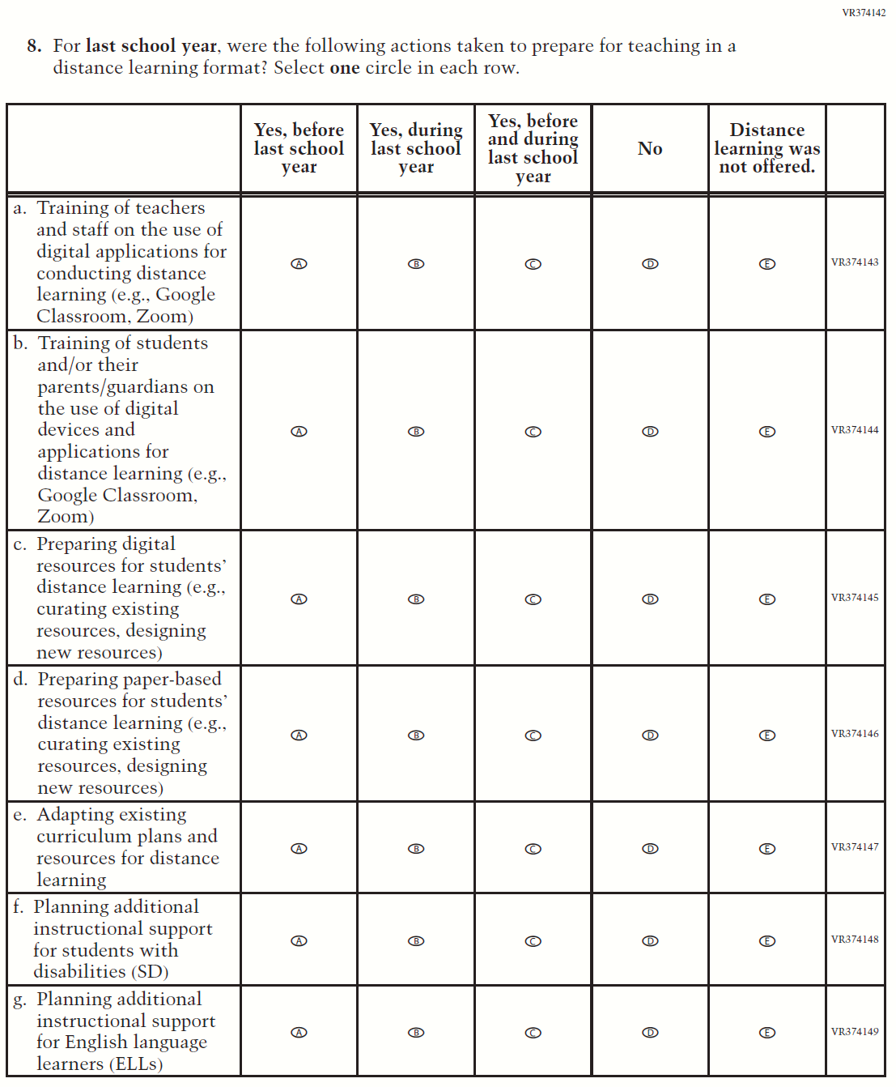

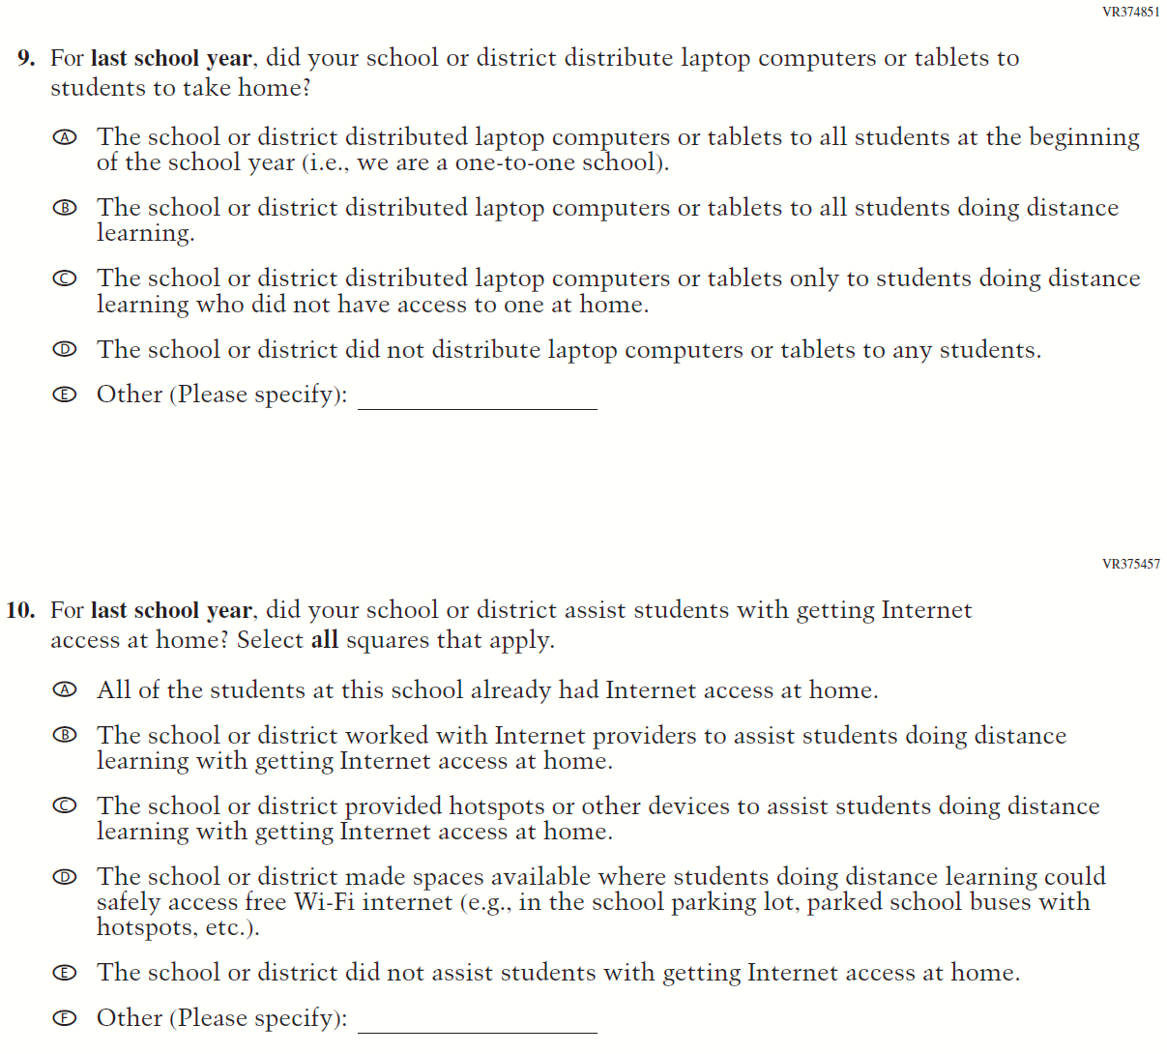

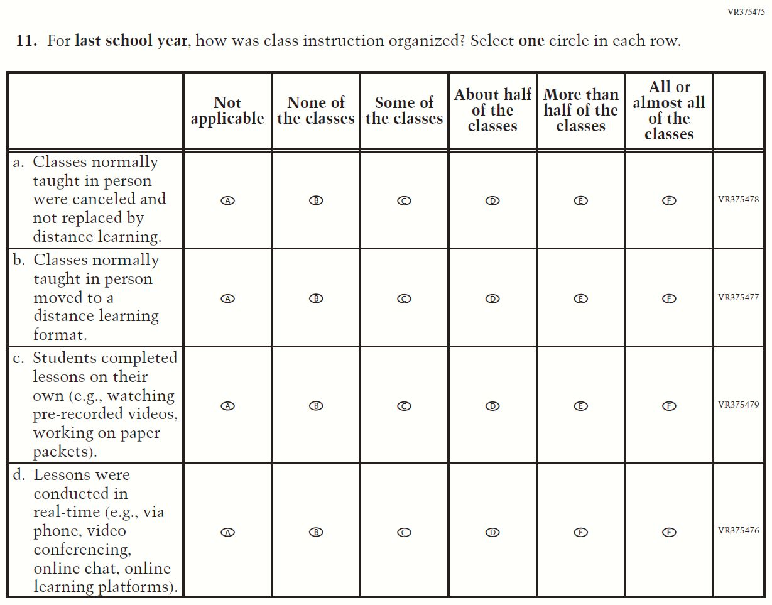

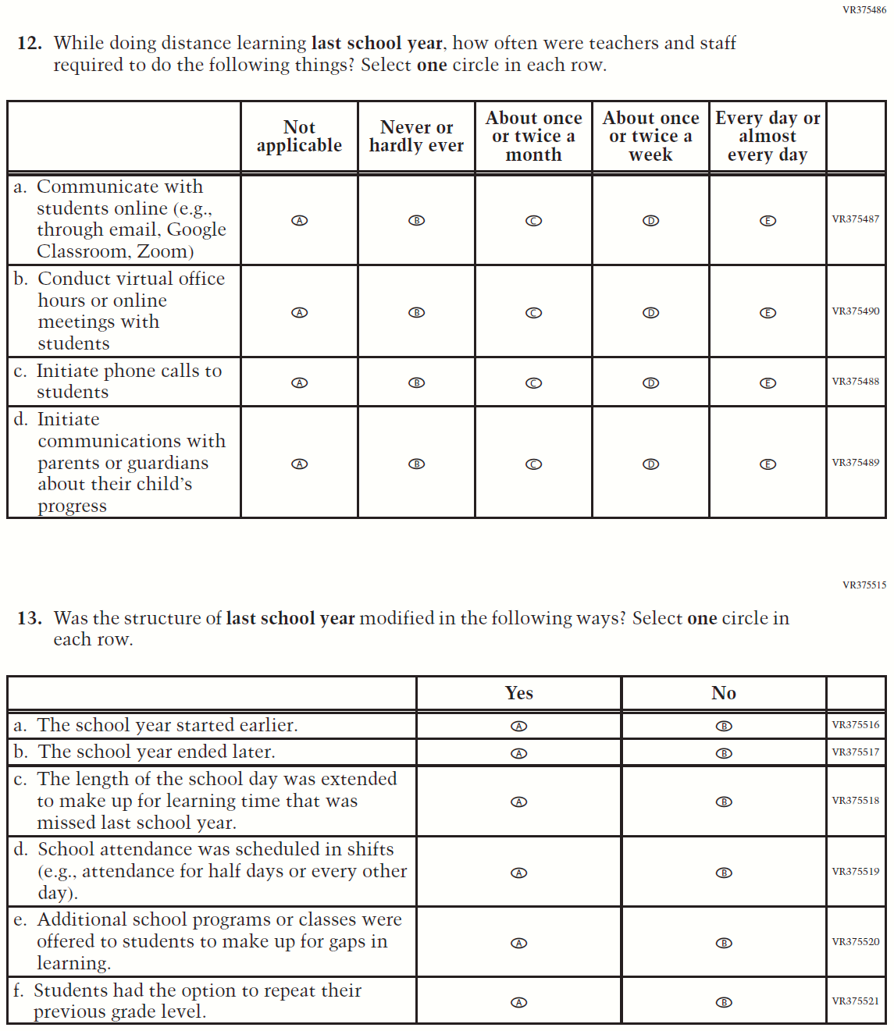

Appendix F-2i-22: Operational Grade 8 COVID-19 School Items
