NATIONAL CENTER FOR EDUCATION STATISTICS NATIONAL ASSESSMENT OF EDUCATIONAL PROGRESS

National Assessment of Educational Progress (NAEP) 2024

Appendix J1

Student Questionnaires

OMB# 1850-0928 v.28



October 2022
No changes since October 2021

This document provides a sample from 2022 (OMB# 1850-0928 v.25). Updates to the student survey questionnaires will be available in this document for Amendment #1 by February 2023 and finalized in Amendment #2 (by April 2023).

Table of Contents
Student Questionnaires
Student Login Screen 3
Appendix J1-1: Summary of Changes Operational Grade 4 (CORE) 4
Appendix J1-2: Operational Grade 4 (CORE) 9
Appendix J1-3: Summary of Changes Operational Grade 8 (CORE) 13
Appendix J1-4: Operational Grade 8 (CORE) 19
Appendix J1-5: Summary of Changes Operational Grade 4 (Mathematics) 26
Appendix J1-6: Operational Grade 4 (Mathematics) 31
Appendix J1-7: Summary of Changes Operational Grade 8 (Mathematics) 35
Appendix J1-8: Operational Grade 8 (Mathematics) 41
Appendix J1-9: Summary of Changes Operational Grade 4 (Reading) 47
Appendix J1-10: Operational Grade 4 (Reading) 51
Appendix J1-11: Summary of Changes Operational Grade 8 (Reading) 56
Appendix J1-12: Operational Grade 8 (Reading) 61
Appendix J1-13: Summary of Operational Grade 8 Civics 67
Appendix J1-14: Operational Grade 8 Civics 74
Appendix J1-15: Summary of Operational Grade 8 U.S. History 80
Appendix J1-16: Operational Grade 8 U.S. History 87
Appendix J1-17: Summary of Operational Grade 4 Debrief 92
Appendix J1-18: Operational Grade 4 Debrief 93
Appendix J1-19: Summary of Operational Grade 8 Debrief 94
Appendix J1-20: Operational Grade 8 Debrief 95
Appendix J1-21: Operational Grade 4 COVID-19 Student Items (ELA) 96
Appendix J1-22: Operational Grade 8 COVID-19 Student Items (ELA) 99
Appendix J1-23: Operational Grade 4 COVID-19 Student Items (Math) 102
Appendix J1-24: Operational Grade 8 COVID-19 Student Items (Math) 105
Appendix J1-25: Operational Grade 8 COVID-19 Student Items (Civics) 108
Appendix J1-26: Operational Grade 8 COVID-19 Student Items (U.S. History) 111

Student Login Screen

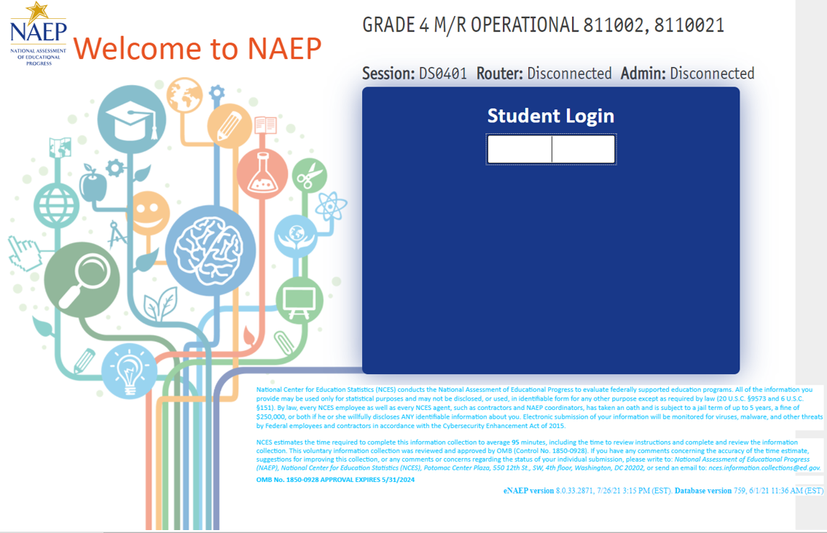

Appendix J1-1: Summary of Changes Operational Grade 4 (CORE)
2022 Operational Grade 4 Core Student

Previous item | 2022 item | D/A/ R/NC+ | Rationale
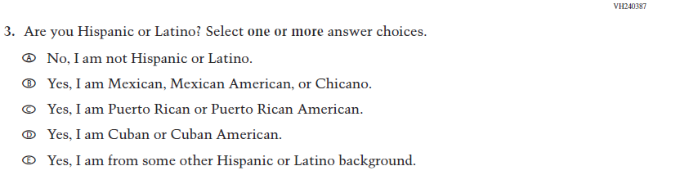  (2019 Grade 4) | 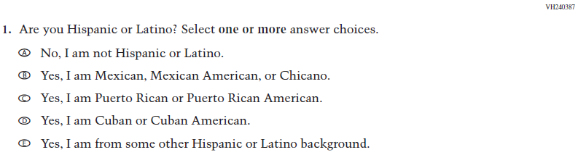  Issue: Race/Ethnicity | NC | N/A
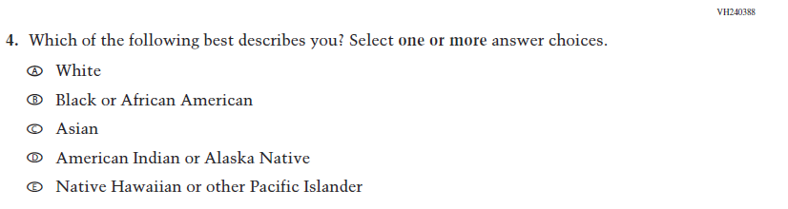  (2019 Grade 4) | 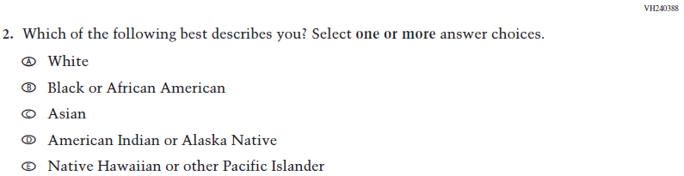  Issue: Race/Ethnicity | NC | N/A
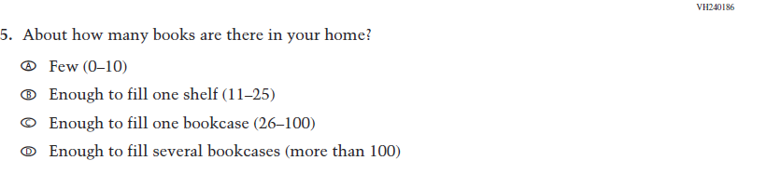  (2019 Grade 4) | 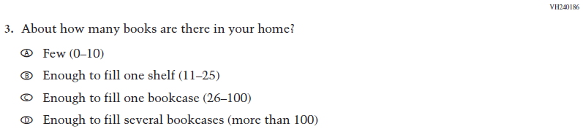  Issue: Socioeconomic Status | NC | N/A

2022 Operational Grade 4 Core Student
Previous item | 2022 item | D/A/ R/NC+ | Rationale
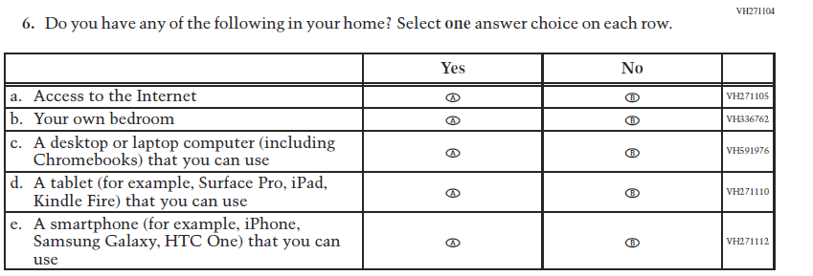  (2019 Grade 4) | 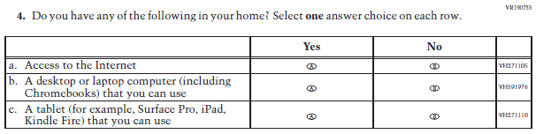  Issue: Socioeconomic Status | R | To keep student burden low, sub-items b and e were dropped.
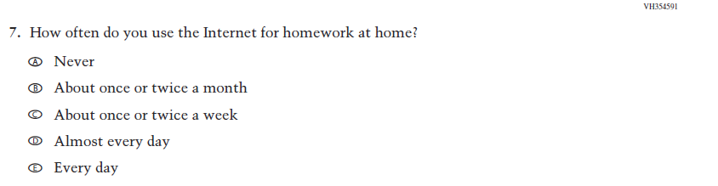  (2019 Grade 4) | N/A | D | To keep student burden low, this item was dropped.
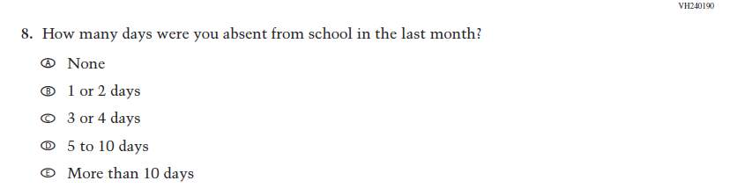  (2019 Grade 4) | 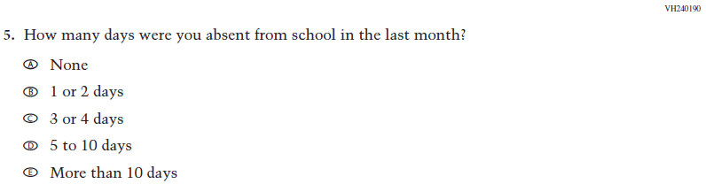  Issue: School Climate | NC | N/A
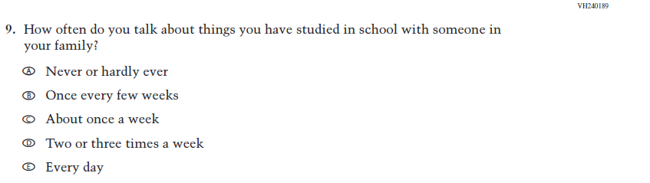  (2019 Grade 4) | N/A | D | To keep student burden low, this item was dropped.

2022 Operational Grade 4 Core Student

Previous item | 2022 item | D/A/ R/NC+ | Rationale
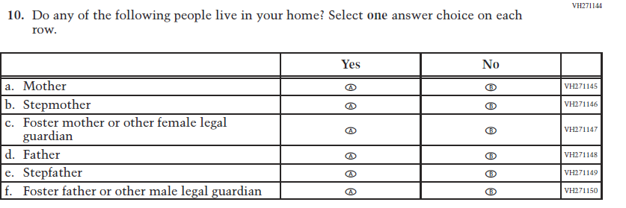  (2019 Grade 4) | 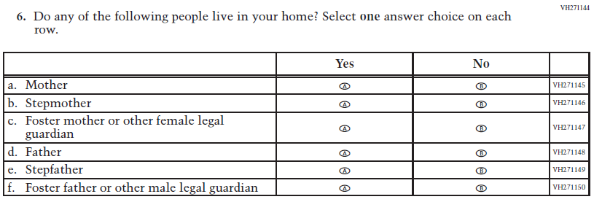  Issue: Socioeconomic Status | NC | N/A
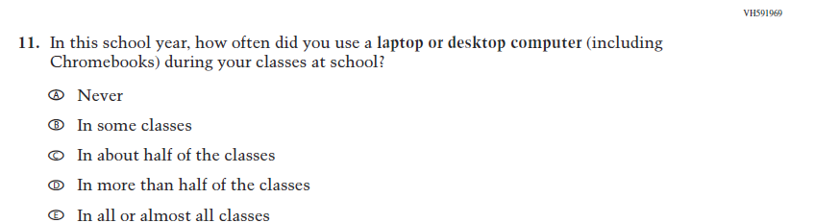  (2019 Grade 4) | 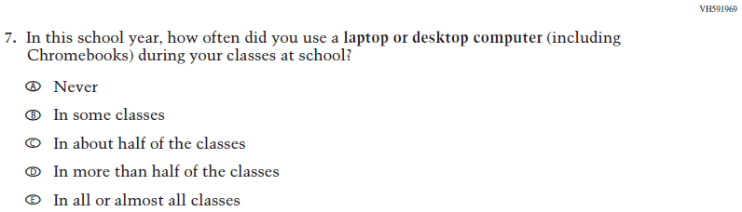  Issue: Technology Use | NC | N/A
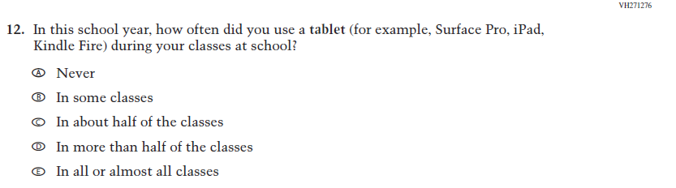  (2019 Grade 4) | N/A | D | To keep student burden low, this item was dropped.

2022 Operational Grade 4 Core Student

Previous item | 2022 item | D/A/ R/NC+ | Rationale
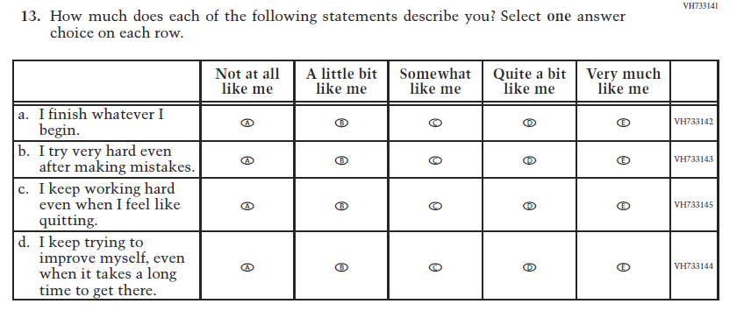  (2019 Grade 4) | N/A | D | To keep student burden low, this item was dropped.
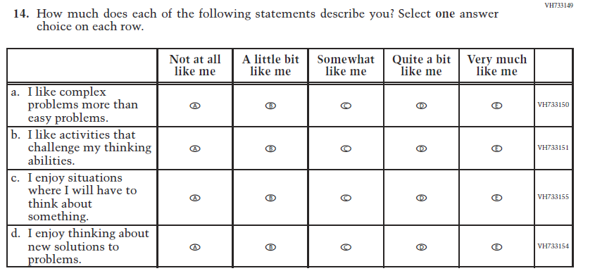  (2019 Grade 4) | 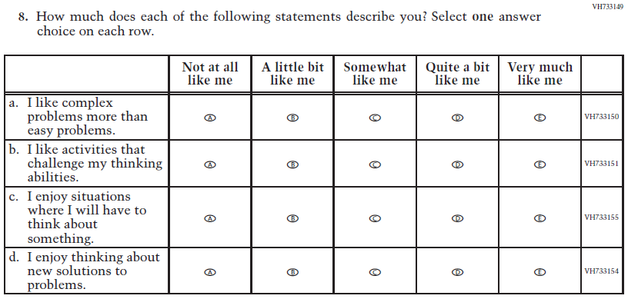  Issue: Desire for Learning | NC | N/A
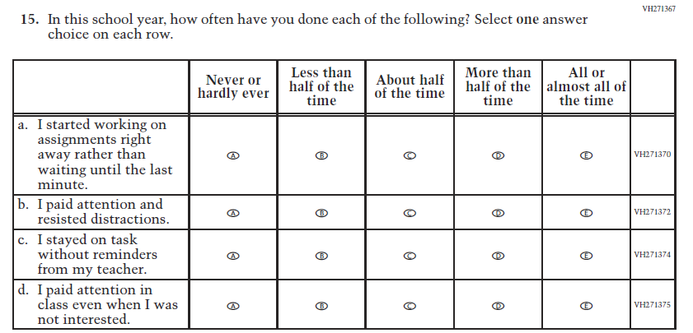  (2019 Grade 4) | 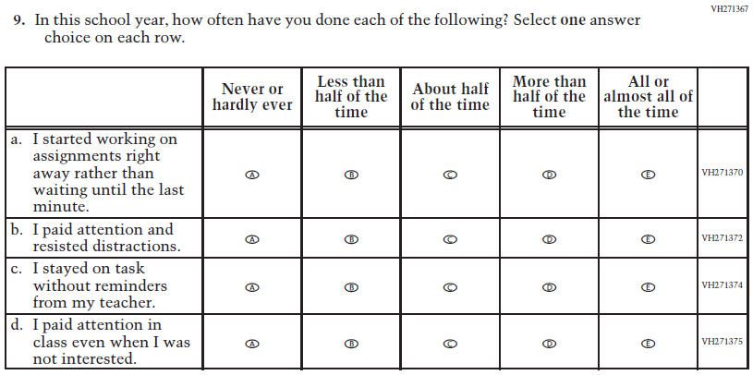  Issue: Grit | NC | N/A
2022 Operational Grade 4 Core Student
Previous item | 2022 item | D/A/ R/NC+ | Rationale
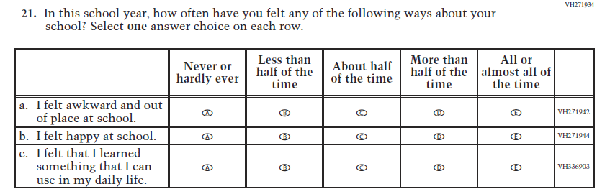  (2019 Grade 4) | N/A | D | To keep student burden low, this item was dropped.

Appendix J1-2: Operational Grade 4 (CORE)
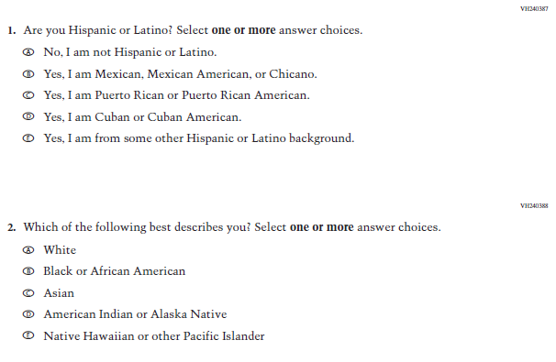
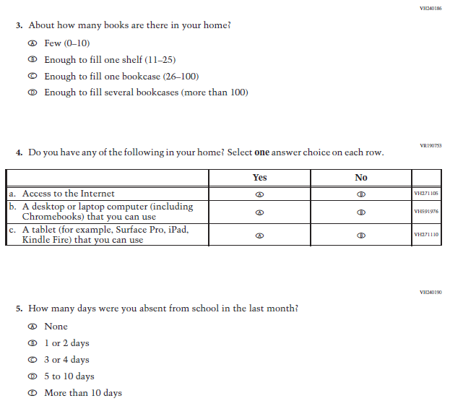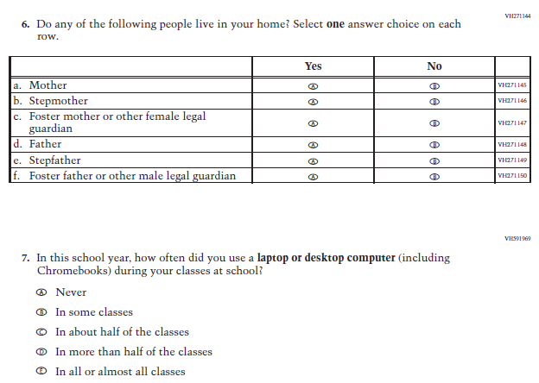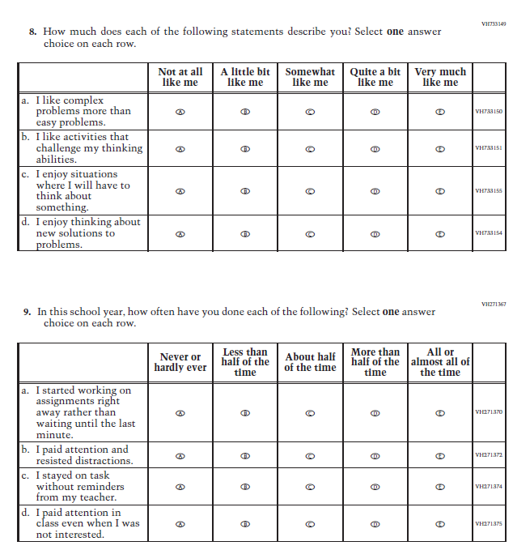

Appendix J1-3: Summary of Changes Operational Grade 8 (CORE)
2022 Operational Grade 8 Core Student

Previous item | 2022 item | D/A/ R/NC+ | Rationale
(2019 Grade 8) | 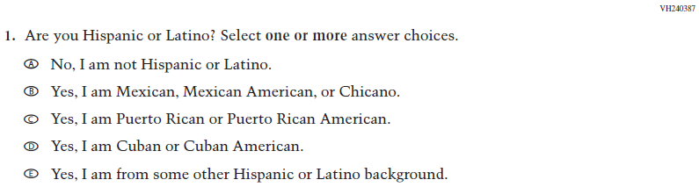  Issue: Race/Ethnicity | NC | N/A
(2019 Grade 8) | 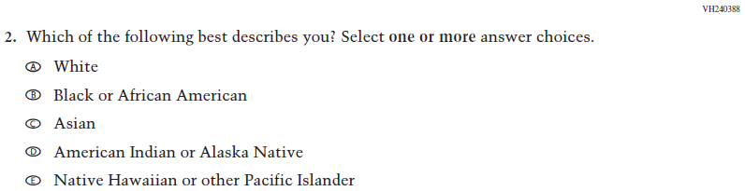  Issue: Race/Ethnicity | NC | N/A
(2019 Grade 8) | 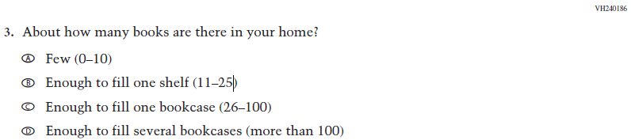  Issue: Socioeconomic Status | NC | N/A

2022 Operational Grade 8 Core Student

Previous item | 2022 item | D/A/ R/NC+ | Rationale
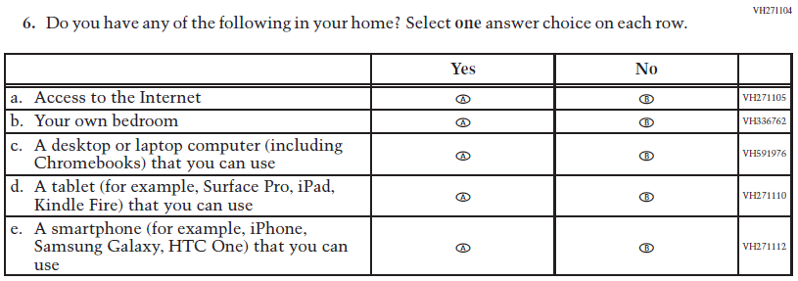  (2019 Grade 8) | 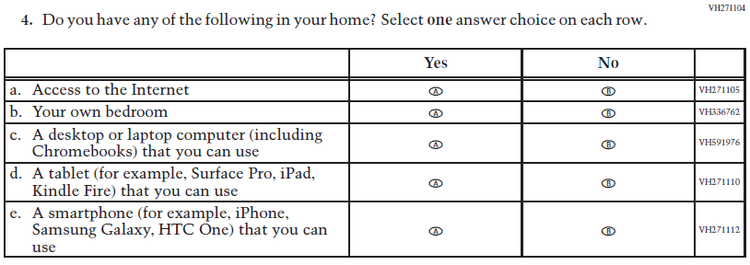  Issue: Socioeconomic Status | NC | N/A
(2019 Grade 8) | 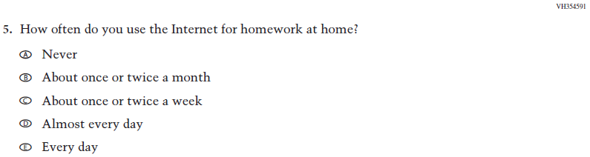  Issue: Technology Use | NC | N/A
(2019 Grade 8) | 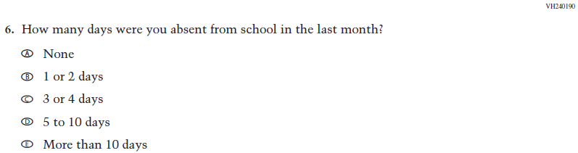  Issue: School Climate | NC | N/A
(2019 Grade 8) | 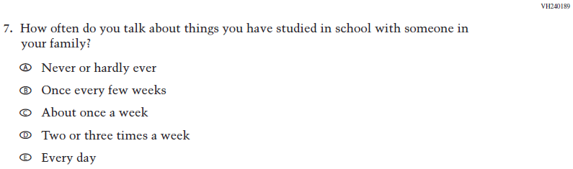  Issue: Socioeconomic Status | NC | N/A

2022 Operational Grade 8 Core Student

Previous item | 2022 item | D/A/ R/NC+ | Rationale
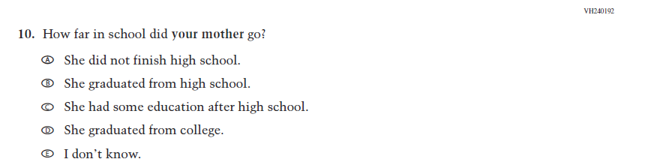  (2019 Grade 8) | 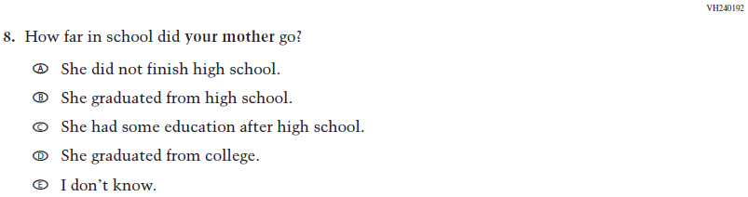  Issue: Socioeconomic Status | NC | N/A
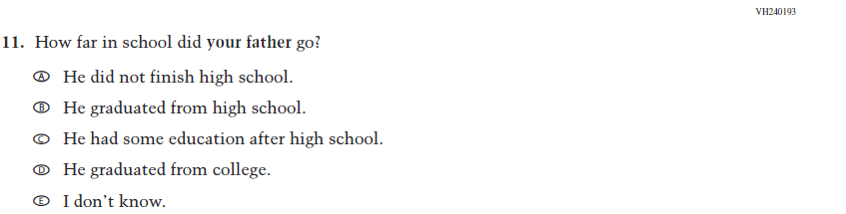  (2019 Grade 8) | 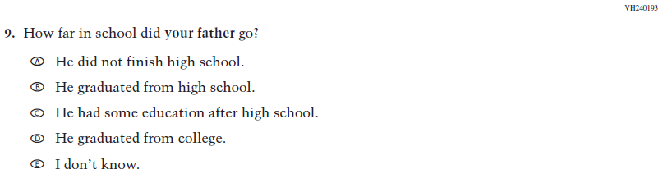  Issue: Socioeconomic Status | NC | N/A
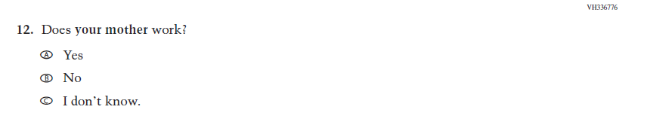  (2019 Grade 8) | 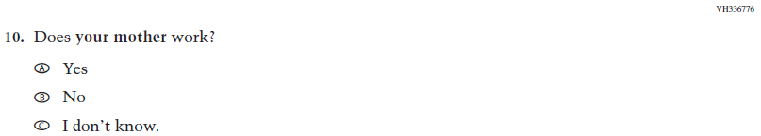  Issue: Socioeconomic Status | NC | N/A
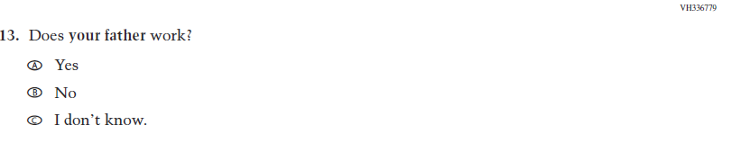  (2019 Grade 8) | 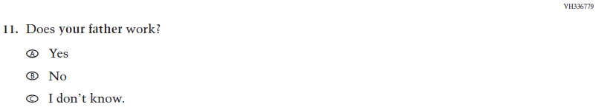  Issue: Socioeconomic Status | NC | N/A

2022 Operational Grade 8 Core Student

Previous item | 2022 item | D/A/ R/NC+ | Rationale
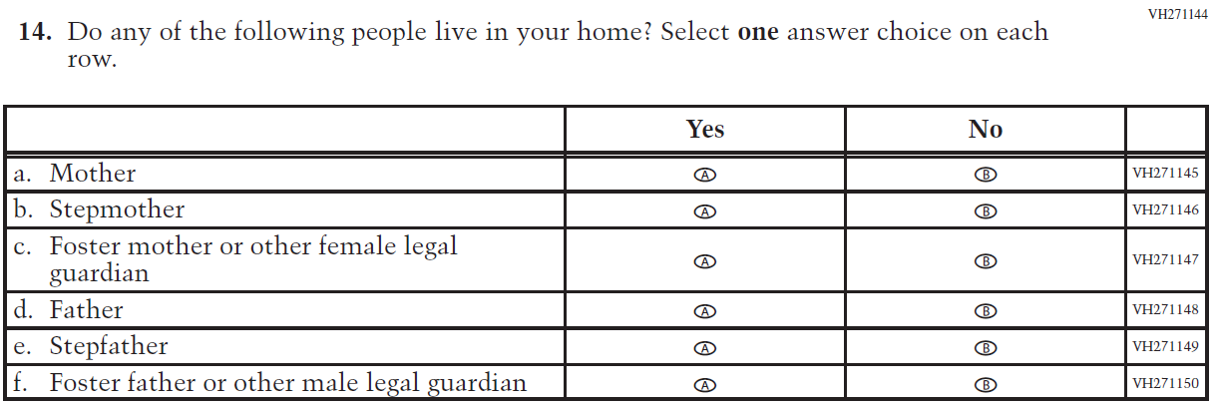  (2019 Grade 8) | 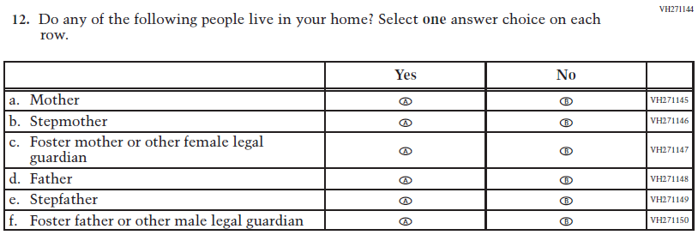  Issue: Socioeconomic Status | NC | N/A
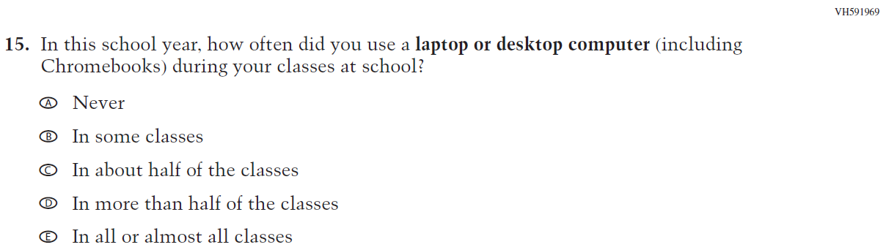  (2019 Grade 8) | 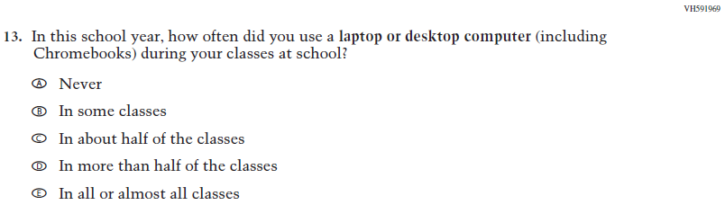  Issue: Technology Use | NC | N/A
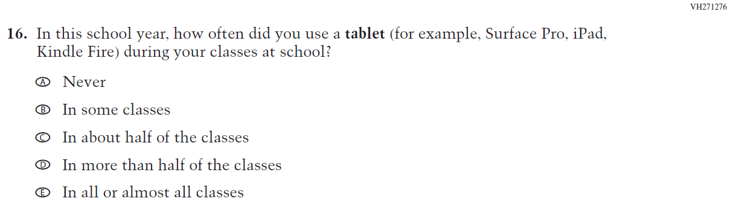  (2019 Grade 8) | 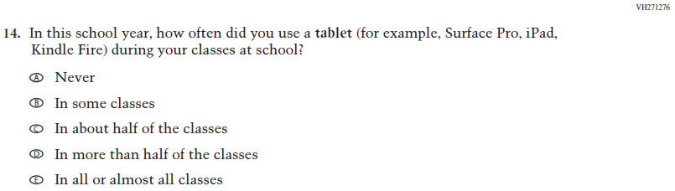  Issue: Technology Use | NC | N/A
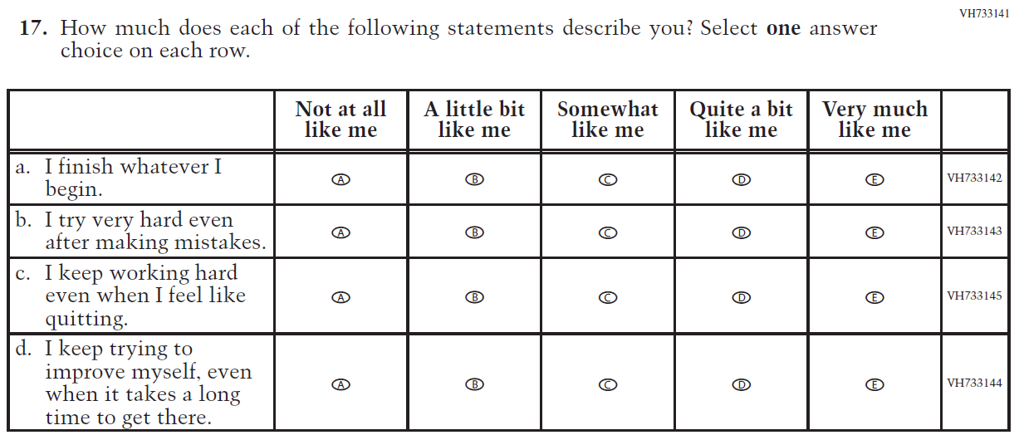  (2019 Grade 8) | 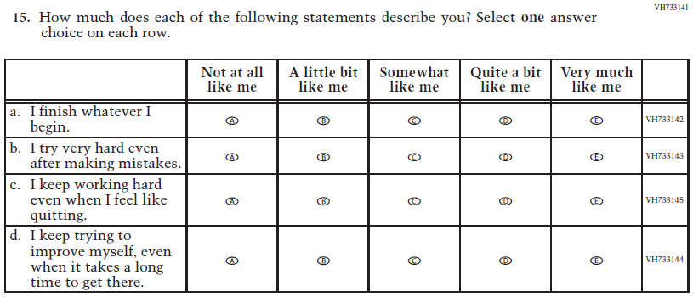  Issue: Grit | NC | N/A
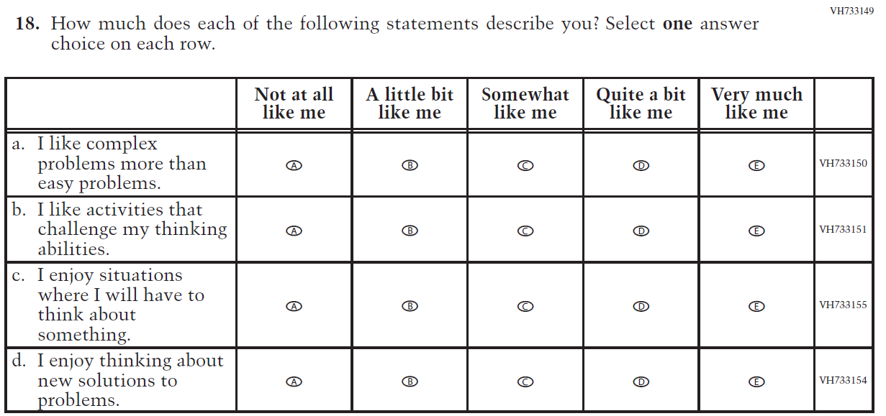  (2019 Grade 8) | 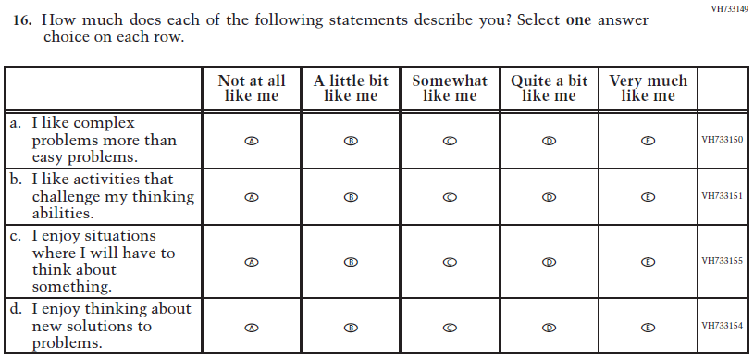  Issue: Desire for Learning | NC | N/A
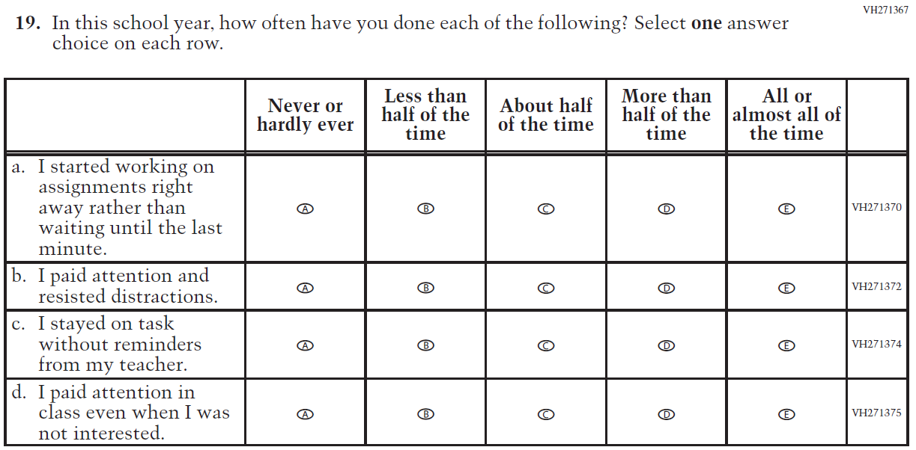  (2019 Grade 8) | 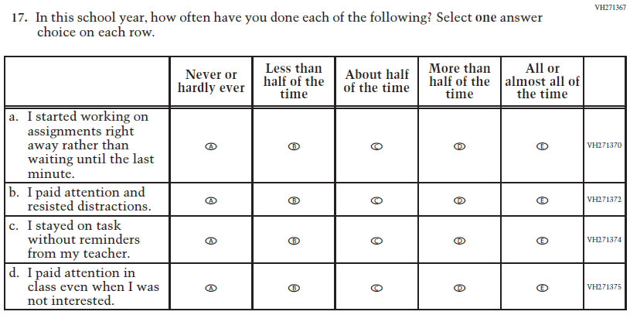  Issue: Grit | NC | N/A
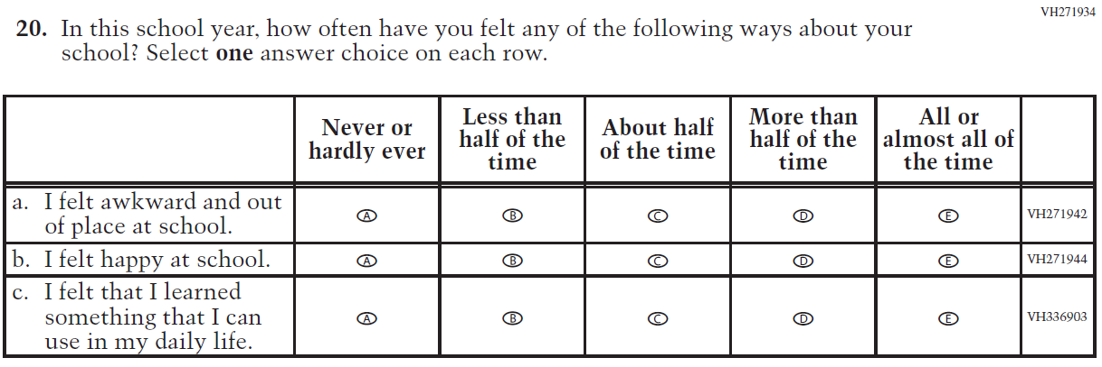  (2019 Grade 8) | N/A | D | To keep student burden low, this item was dropped.
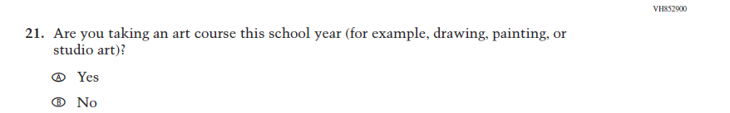  (2019 Grade 8) | 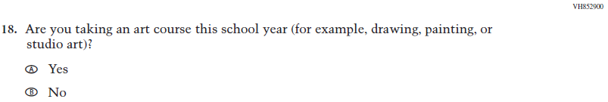  Issue: Educational Experiences | NC | N/A

Appendix J1-4: Operational Grade 8 (CORE)
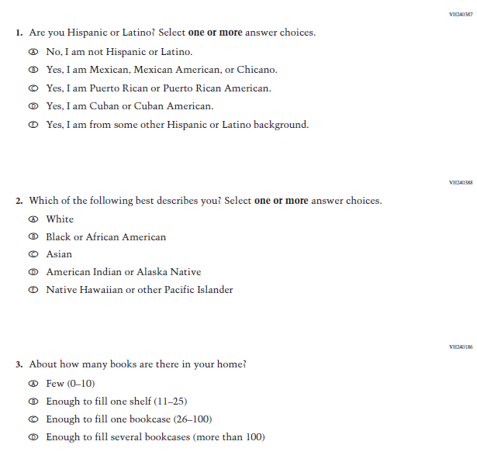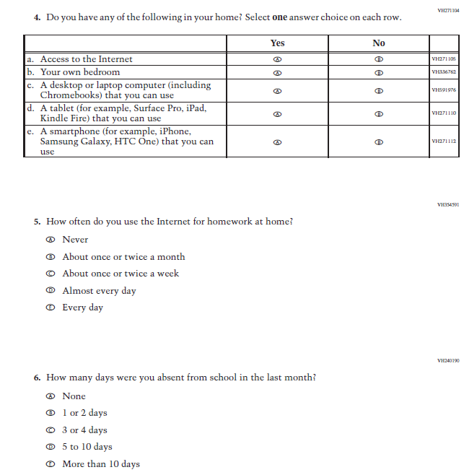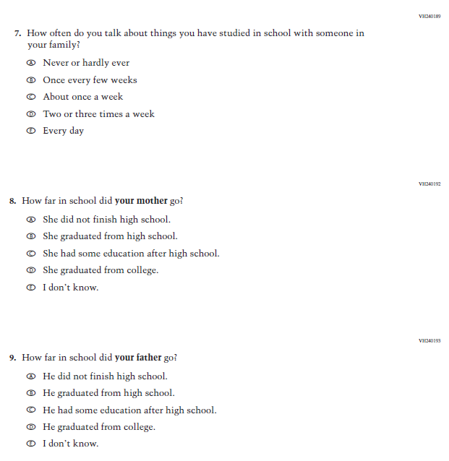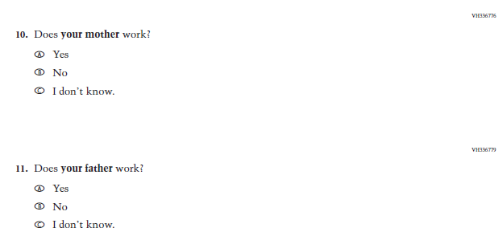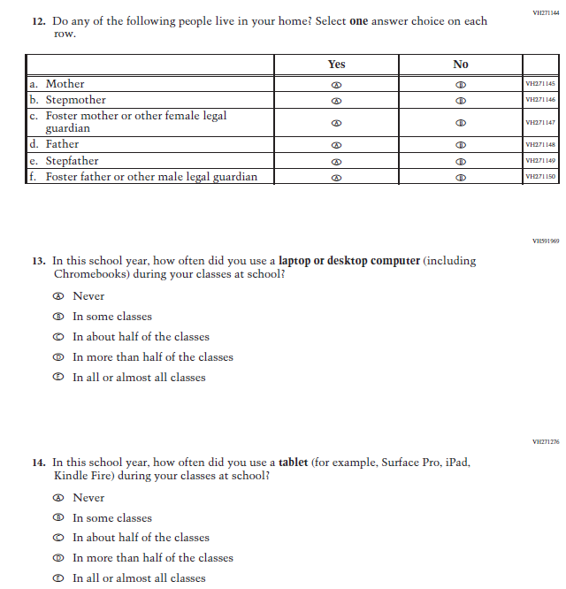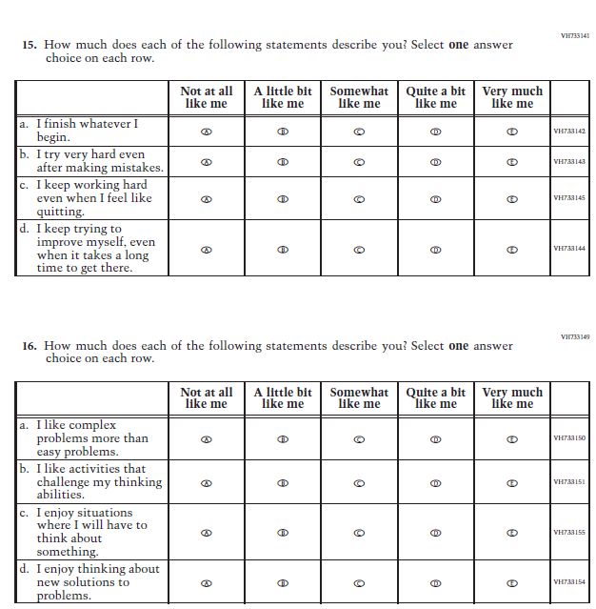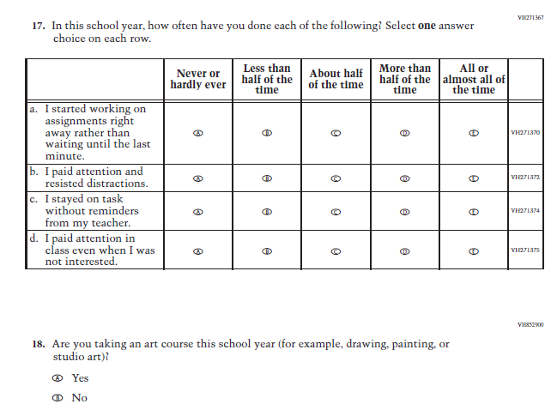

Appendix J1-5: Summary of Changes Operational Grade 4 (Mathematics)
2022 Operational Grade 4 Mathematics Student

Previous item | 2022 item | D/A/ R/NC+ | Rationale
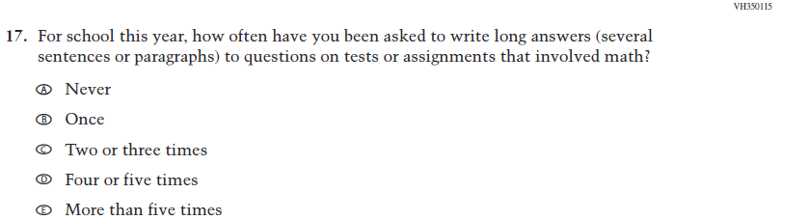  (2019 Grade 4) | 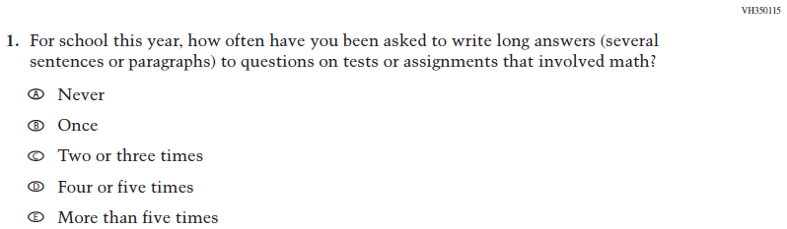  Issue: Organization of Instruction | NC | N/A
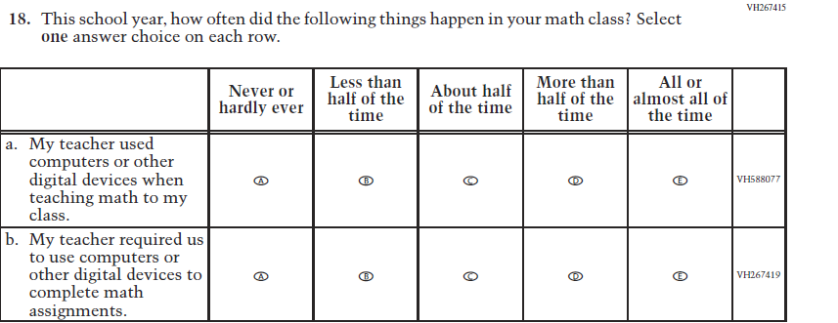  (2019 Grade 4) | 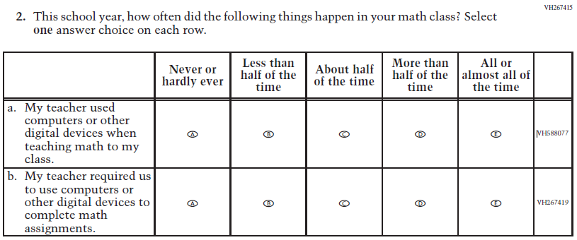  Issue: Resources for Learning and Instruction | NC | N/A
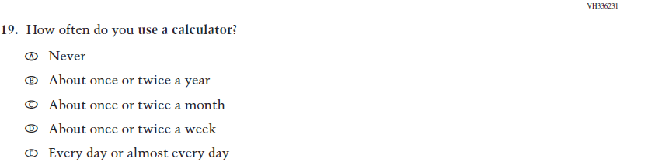  (2019 Grade 4) | 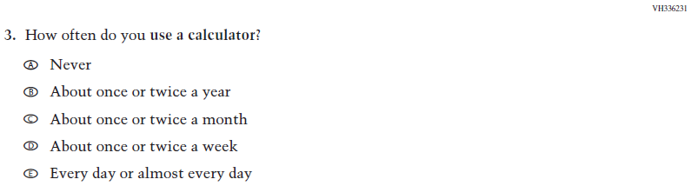  Issue: Resources for Learning and Instruction | NC | N/A
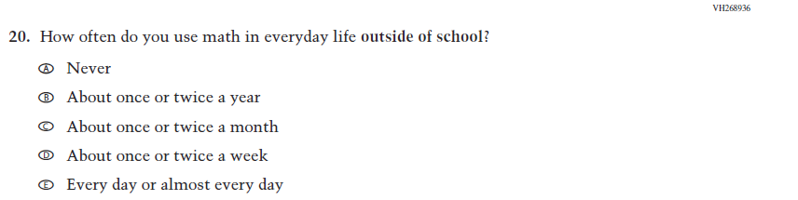  (2019 Grade 4) | 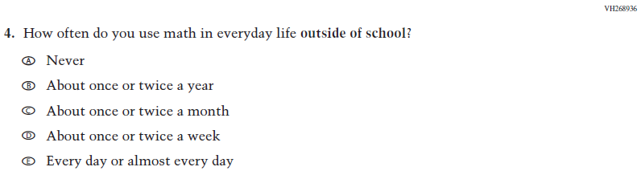  Issue: Resources for Learning and Instruction | NC | N/A
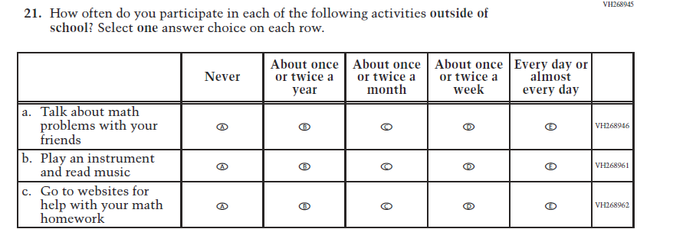  (2019 Grade 4) | 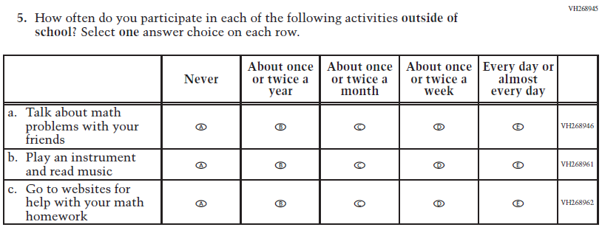  Issue: Resources for Learning and Instruction | NC | N/A
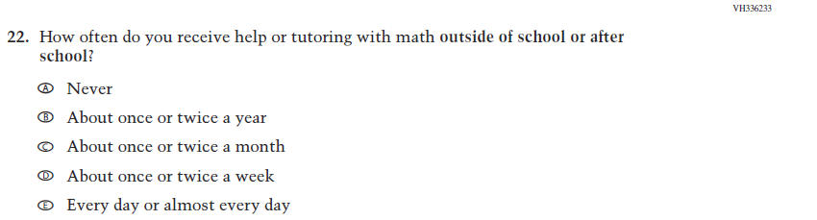  (2019 Grade 4) | 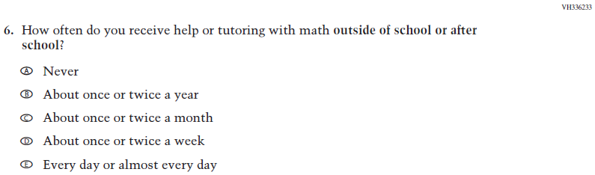  Issue: Resources for Learning and Instruction | NC | N/A
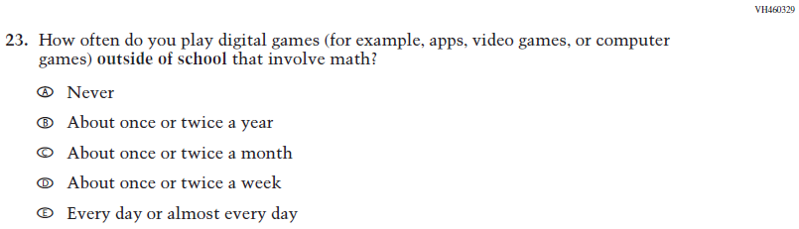  (2019 Grade 4) | 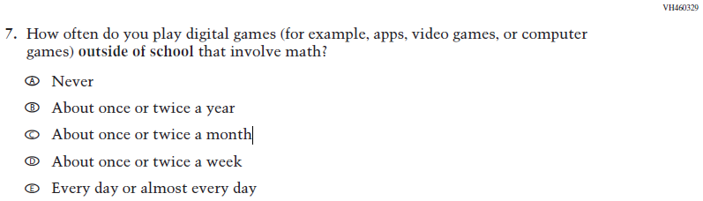  Issue: Resources for Learning and Instruction | NC | N/A

2022 Operational Grade 4 Mathematics Student

Previous item | 2022 item | D/A/ R/NC+ | Rationale
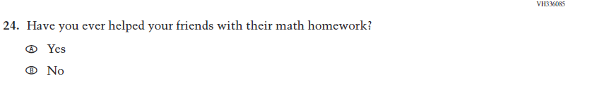  (2019 Grade 4) | N/A | D | To keep student burden low, this item was dropped.
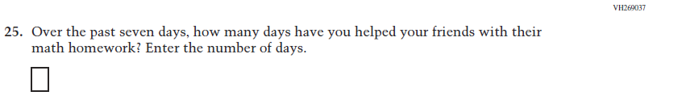  (2019 Grade 4) | N/A | D | To keep student burden low, this item was dropped.
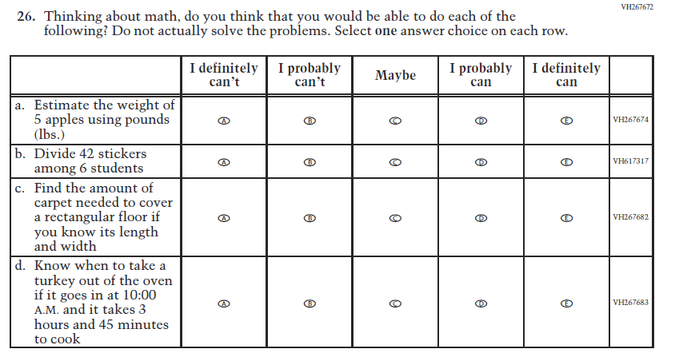  (2019 Grade 4) | 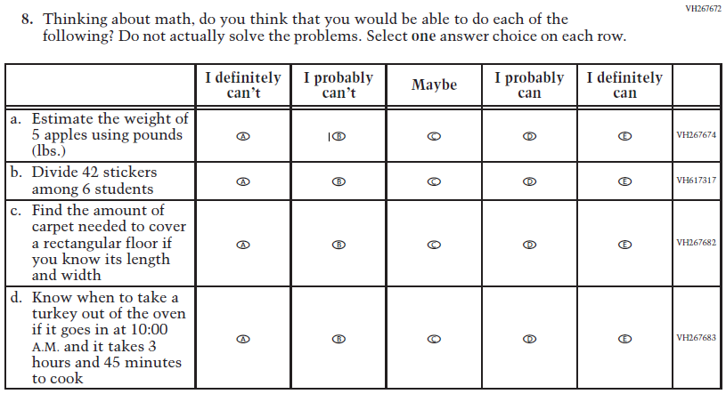  Issue: Student Factors | NC | N/A

2022 Operational Grade 4 Mathematics Student

Previous item | 2022 item | D/A/ R/NC+ | Rationale
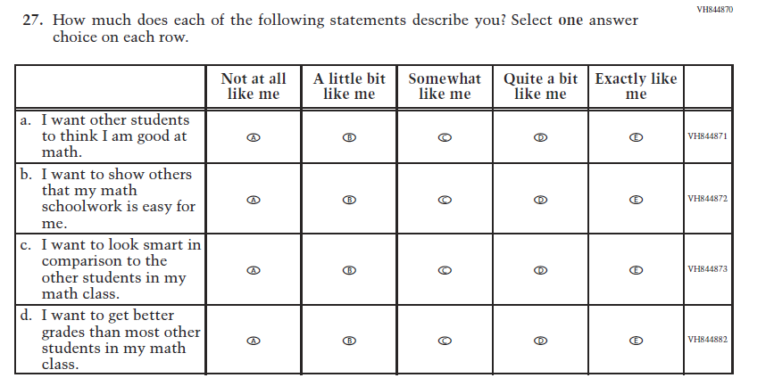  (2019 Grade 4) | N/A | D | To keep student burden low, this item was dropped.
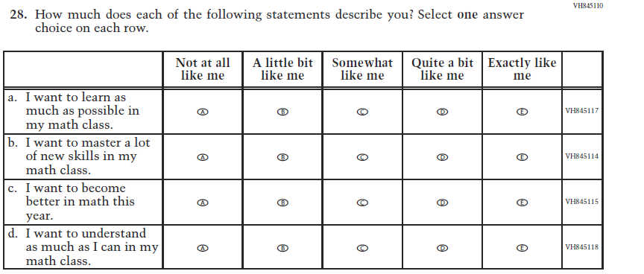  (2019 Grade 4) | 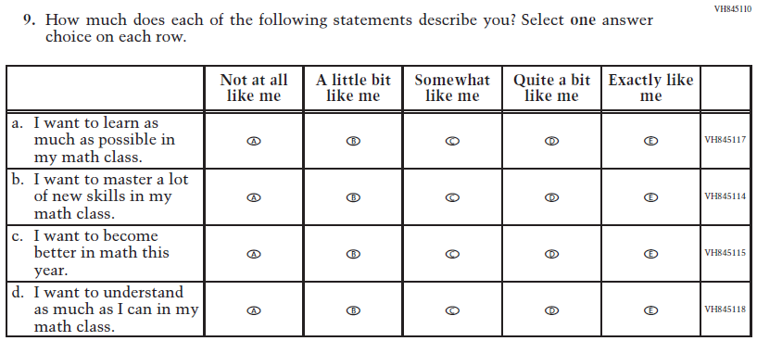  Issue: Student Factors | NC | N/A

2022 Operational Grade 4 Mathematics Student

Previous item | 2022 item | D/A/ R/NC+ | Rationale
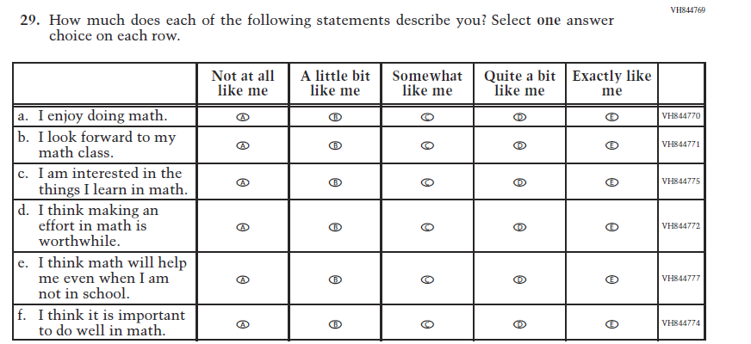  (2019 Grade 4) | 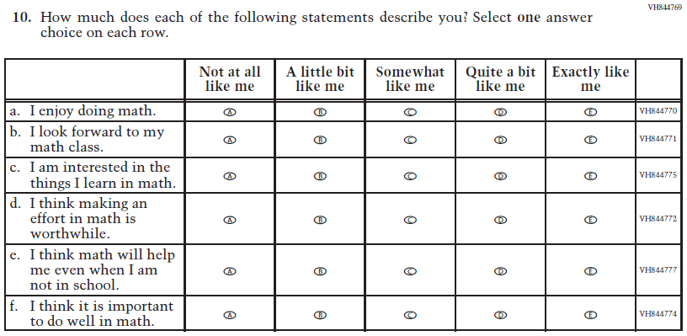  Issue: Student Factors | NC | N/A

Appendix J1-6: Operational Grade 4 (Mathematics)
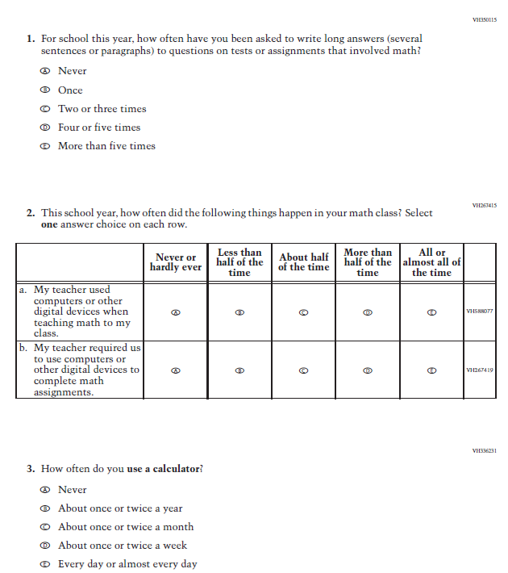

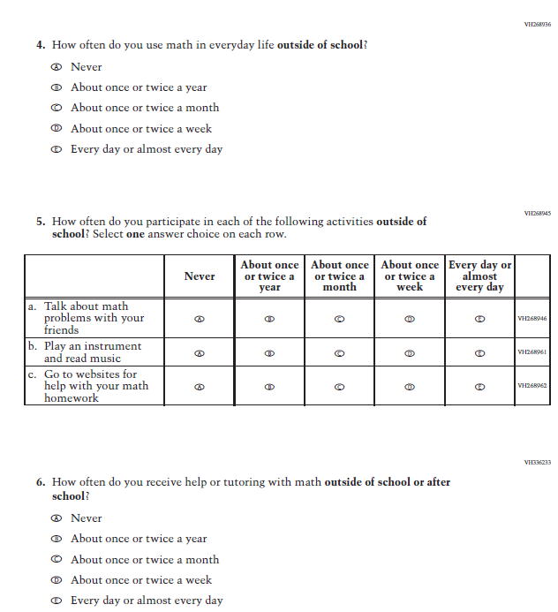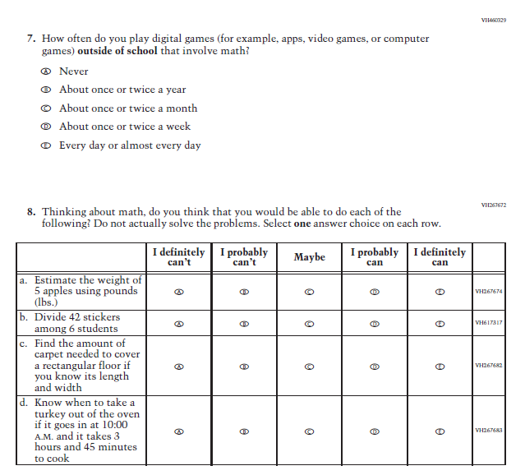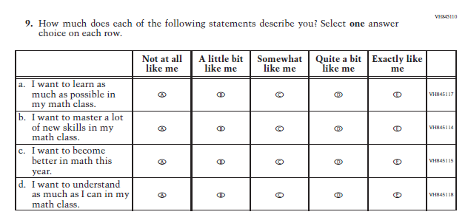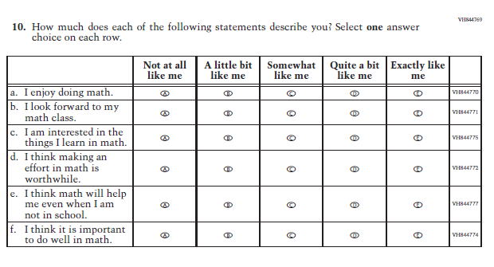

Appendix J1-7: Summary of Changes Operational Grade 8 (Mathematics)
2022 Operational Grade 8 Mathematics Student

Previous item | 2022 item | D/A/ R/NC+ | Rationale
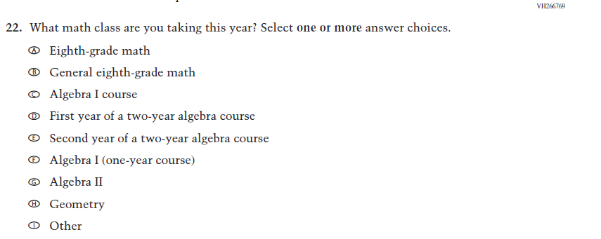  (2019 Grade 8) | 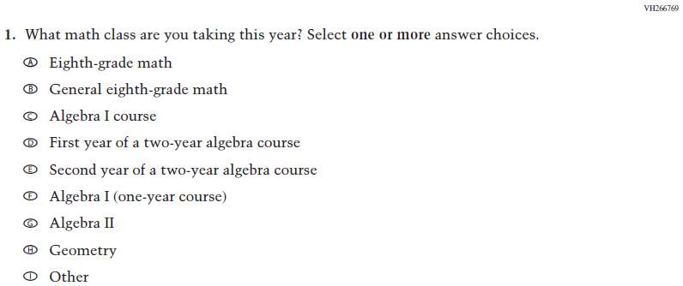  Issue: Organization of Instruction | NC | N/A
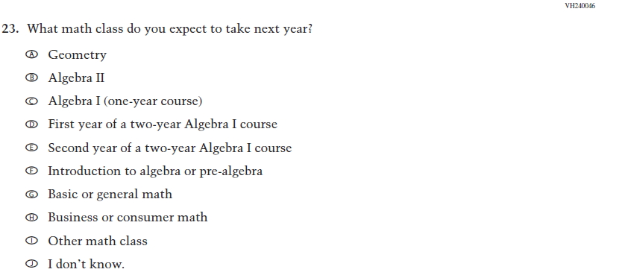  (2019 Grade 8) | 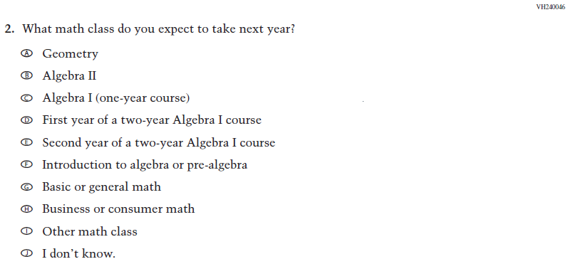  Issue: Organization of Instruction | NC | N/A
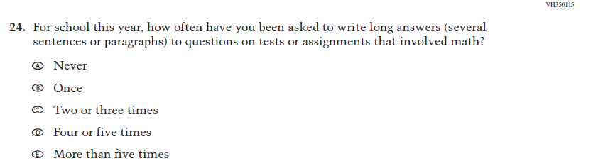  (2019 Grade 8) | 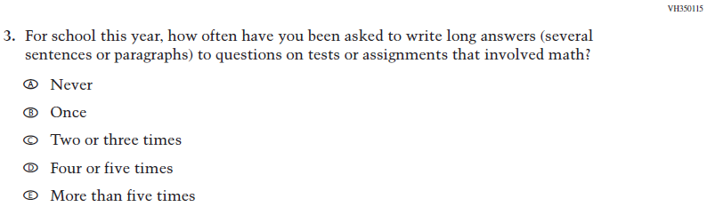  Issue: Organization of Instruction | NC | N/A

2022 Operational Grade 8 Mathematics Student
Previous item | 2022 item | D/A/ R/NC+ | Rationale
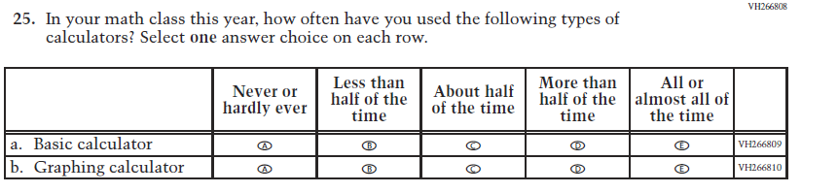  (2019 Grade 8) | 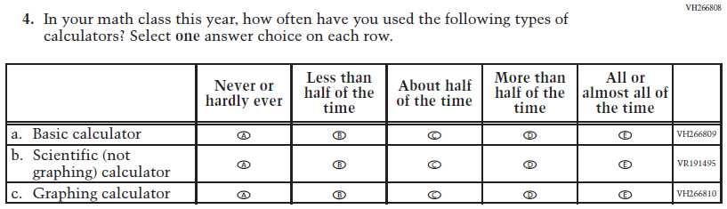  Issue: Resources for Learning and Instruction | A: sub-item “b”  NC for SL and sub-items “a” and “c” | The “Scientific (not graphing) calculator” sub-item was dropped previously due to an oversight and is being reinstated to capture calculator features in mathematics as students progress from K to 12.
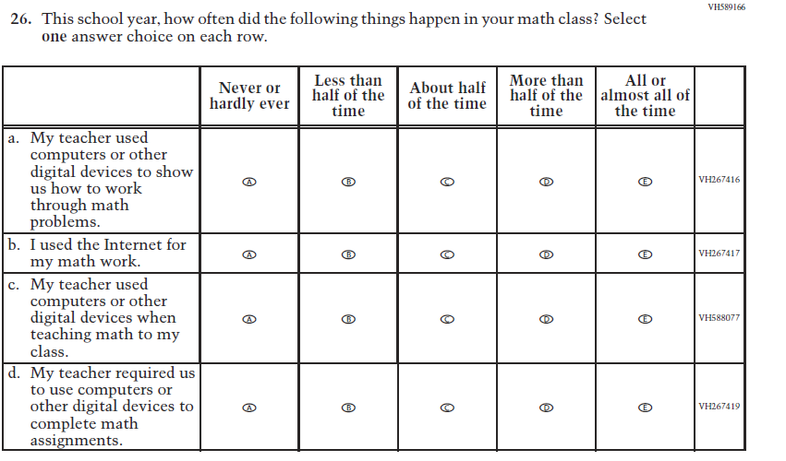  (2019 Grade 8) | 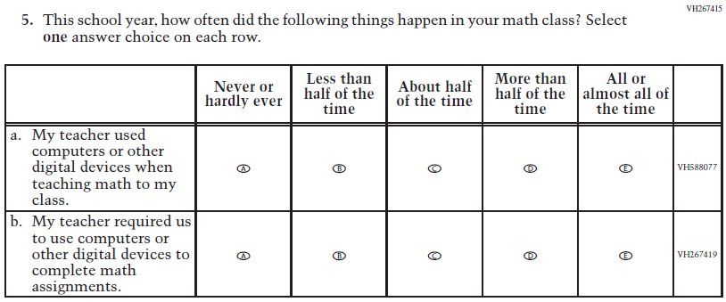  Issue: Resources for Learning and Instruction | R | To keep student burden low, sub-items a and b were dropped.

2022 Operational Grade 8 Mathematics Student
Previous item | 2022 item | D/A/ R/NC+ | Rationale
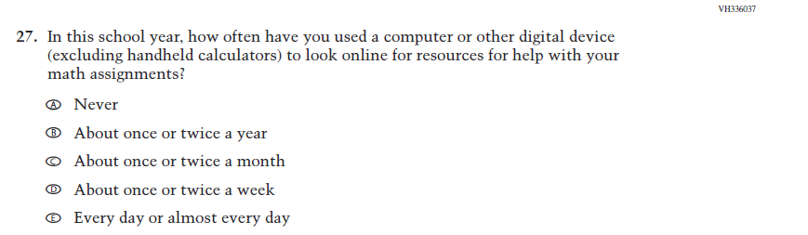  (2019 Grade 8) | N/A | D | To keep student burden low, this item has been dropped.
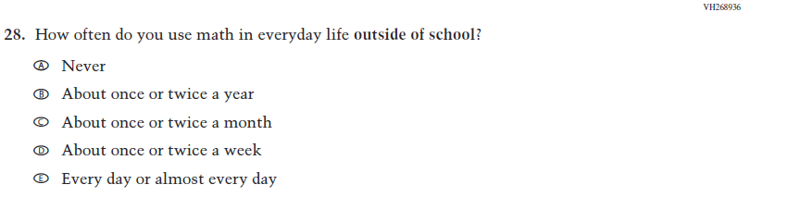  (2019 Grade 8) | 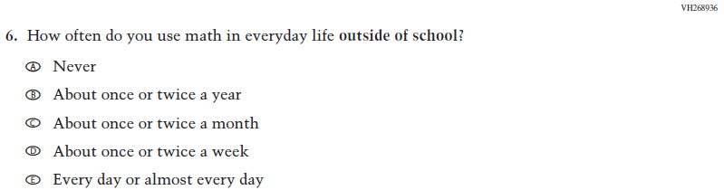  Issue: Resources for Learning and Instruction | NC | N/A
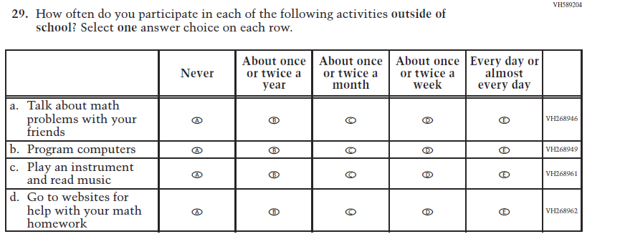  (2019 Grade 8) | 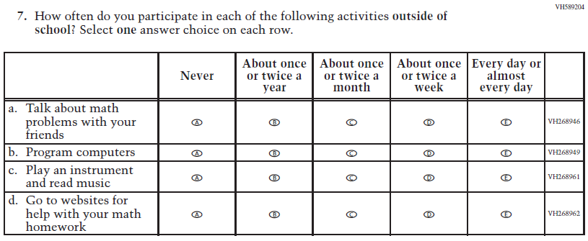  Issue: Resources for Learning and Instruction | NC | N/A
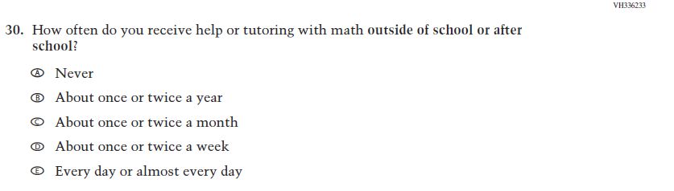  (2019 Grade 8) | 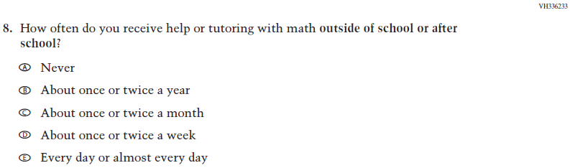  Issue: Resources for Learning and Instruction | NC | N/A

2022 Operational Grade 8 Mathematics Student
Previous item | 2022 item | D/A/ R/NC+ | Rationale
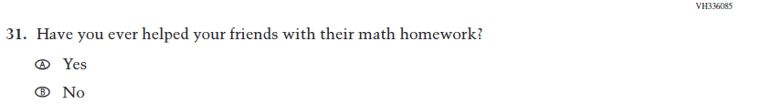  (2019 Grade 8) | N/A | D | To keep student burden low, this item was dropped.
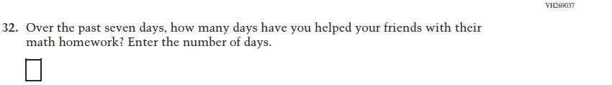  (2019 Grade 8) | N/A | D | To keep student burden low, this item was dropped.
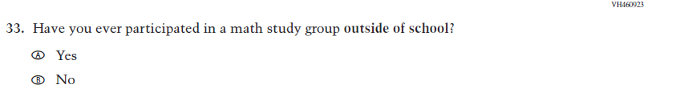  (2019 Grade 8) | N/A | D | To keep student burden low, this item was dropped.
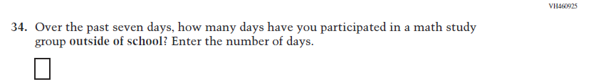  (2019 Grade 8) | N/A | D | To keep student burden low, this item was dropped.
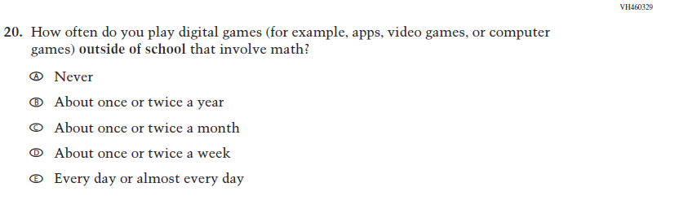  (2019 Grade 8) | 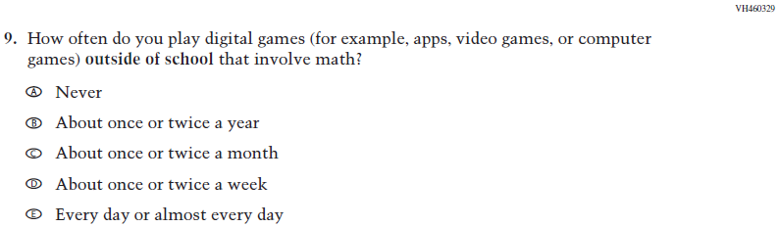  Issue: Resources for Learning and Instruction | NC | N/A
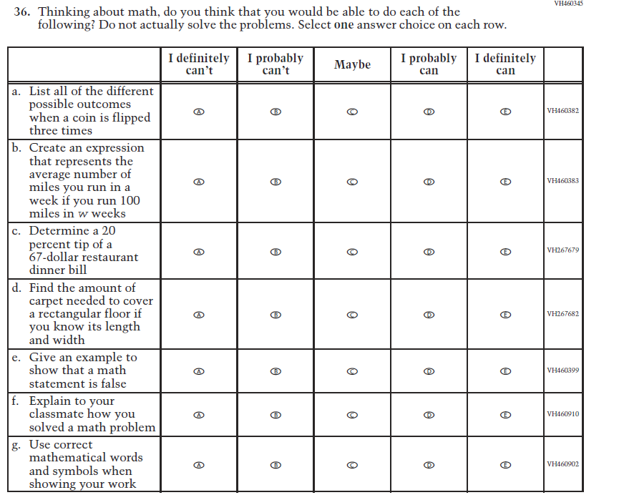  (2019 Grade 8) | 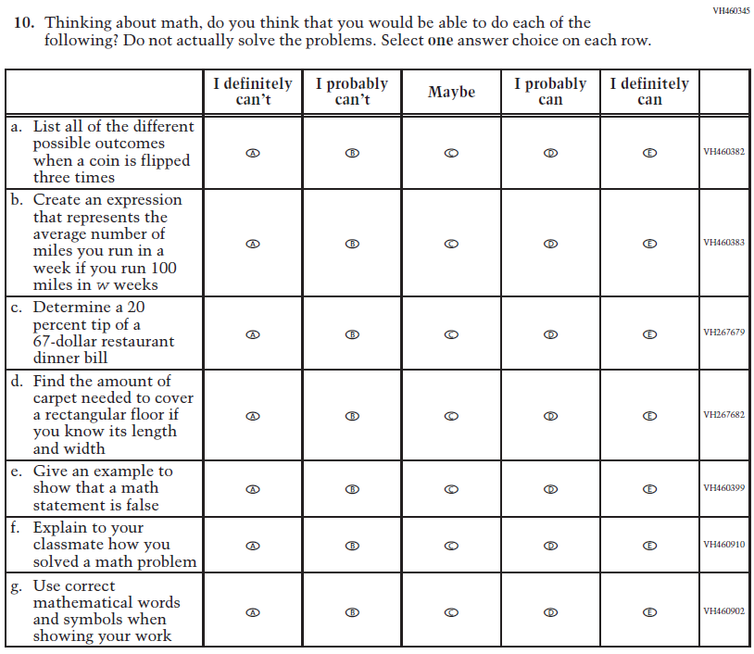  Issue: Student factors | NC | N/A
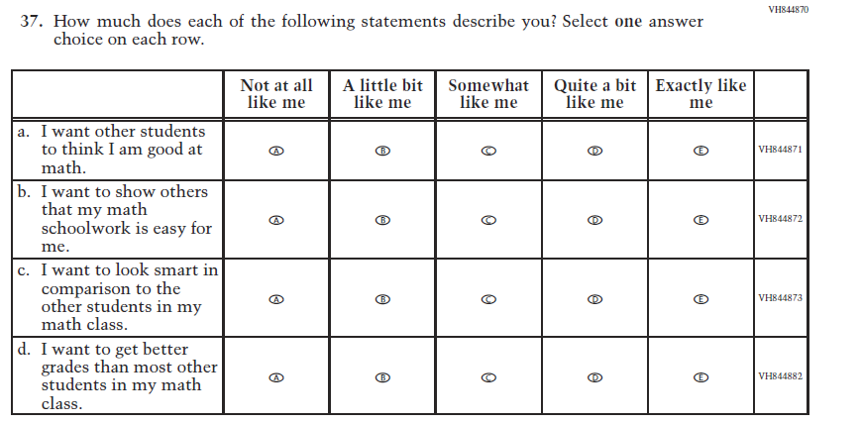  (2019 Grade 8) | N/A | D | To keep student burden low, this item was dropped.
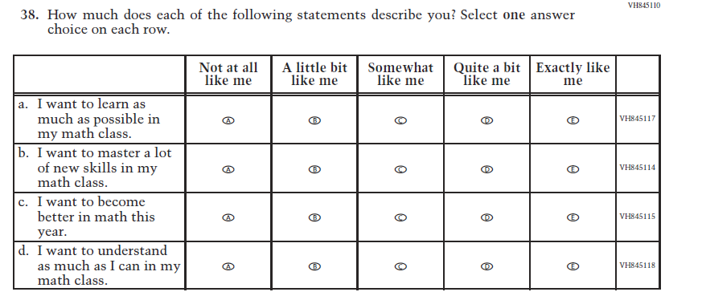  (2019 Grade 8) | 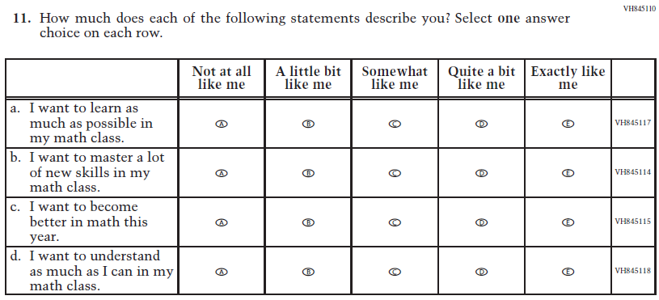  Issue: Student factors | NC | N/A
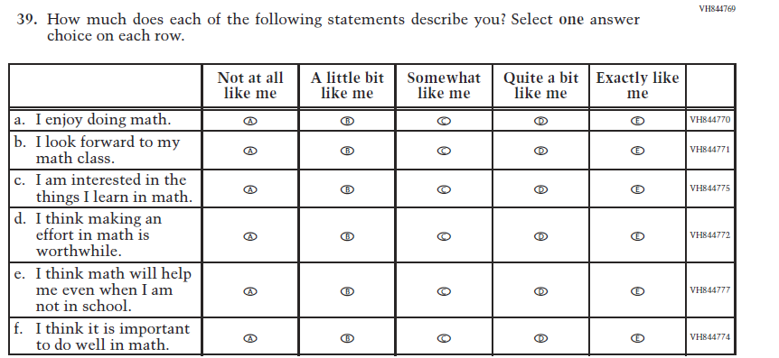  (2019 Grade 8) | 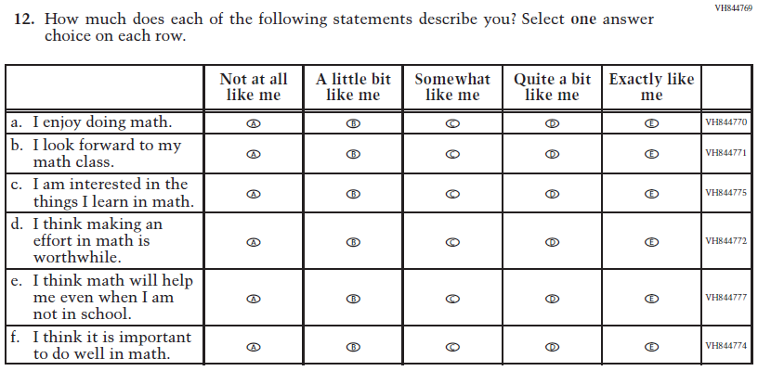  Issue: Student Factors | NC | N/A
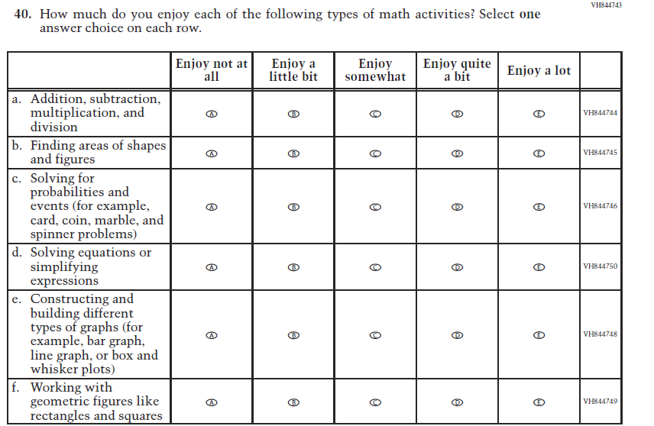  (2019 Grade 8) | 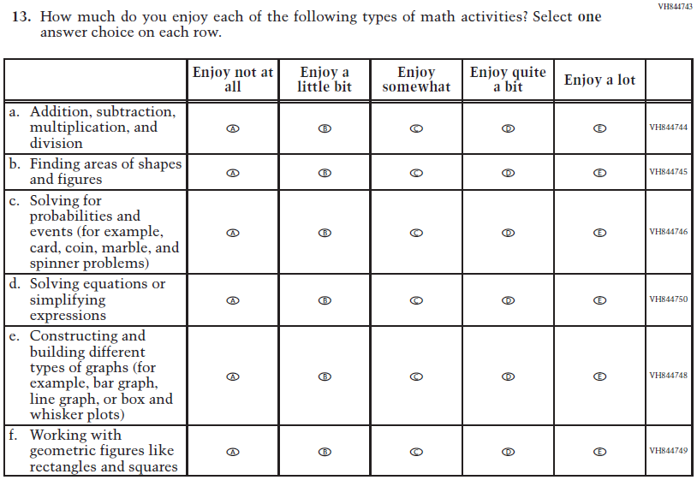  Issue: Student Factors | NC | N/A

Appendix J1-8: Operational Grade 8 (Mathematics)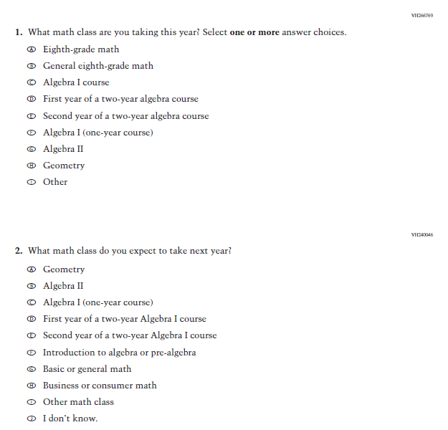
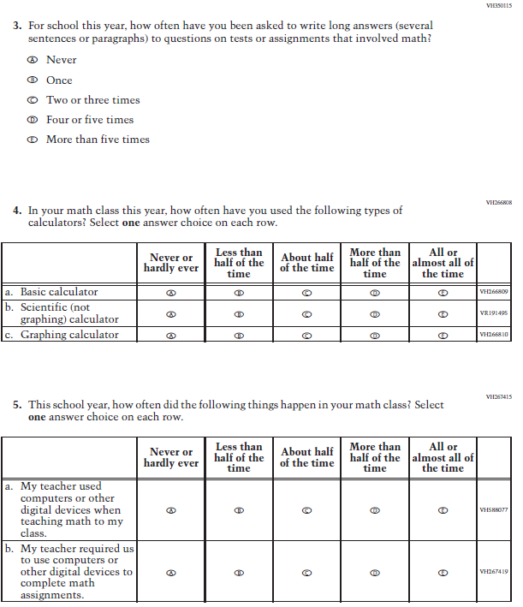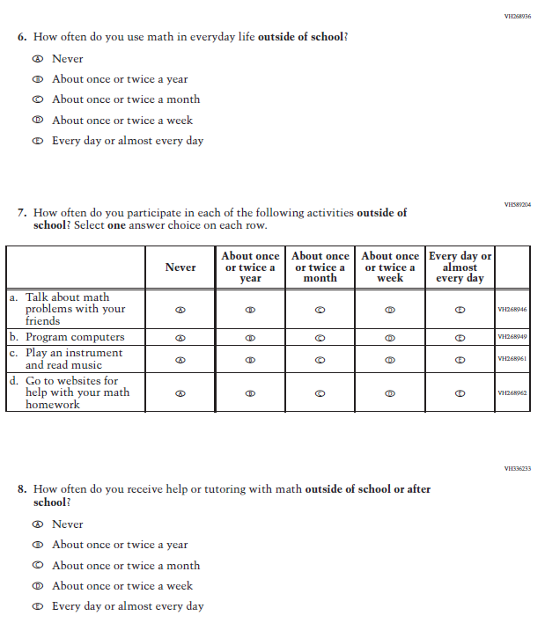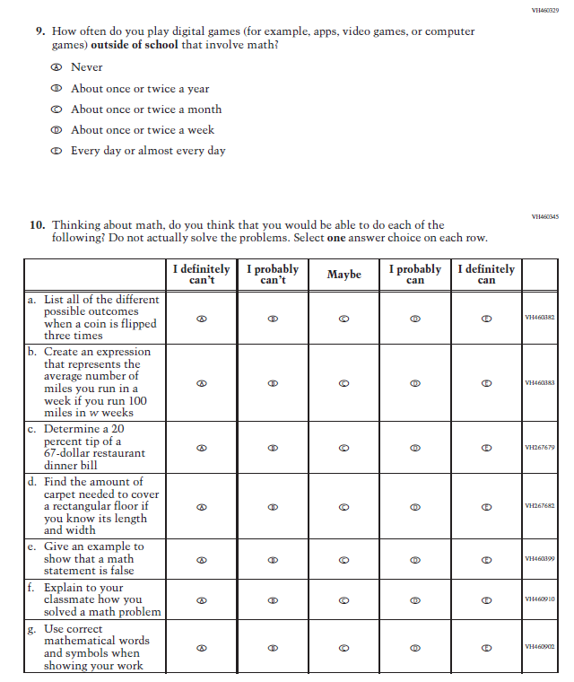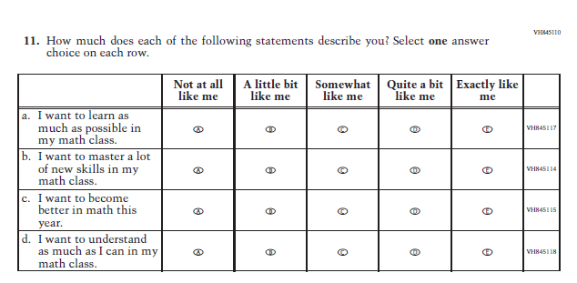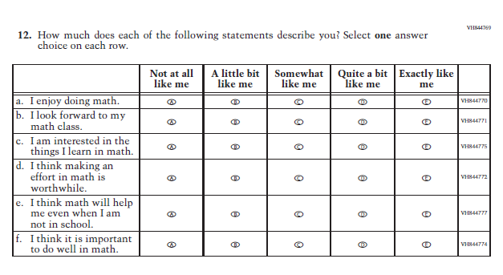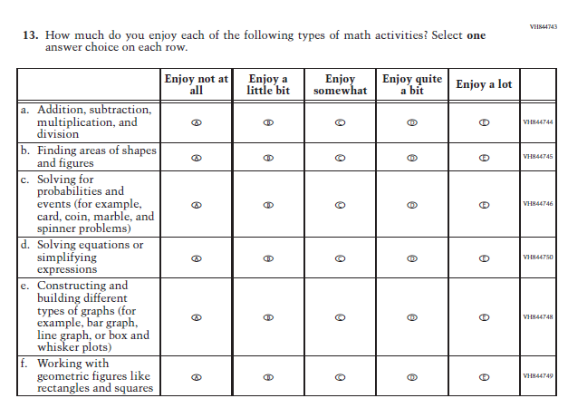

Appendix J1-9: Summary of Changes Operational Grade 4 (Reading)
2022 Operational Grade 4 Reading Student

Previous item | 2022 item | D/A/ R/NC+ | Rationale
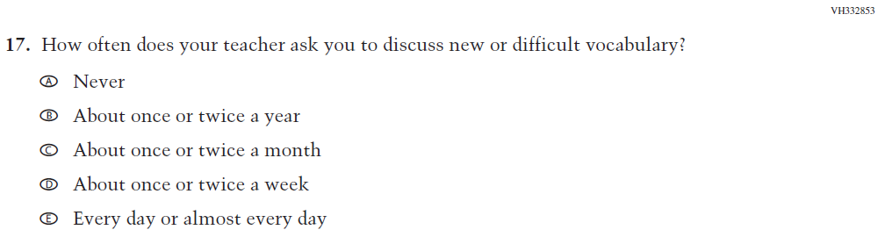  (2019 Grade 4) | 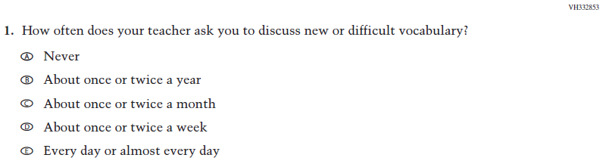  Issue: Organization of Instruction | NC | N/A
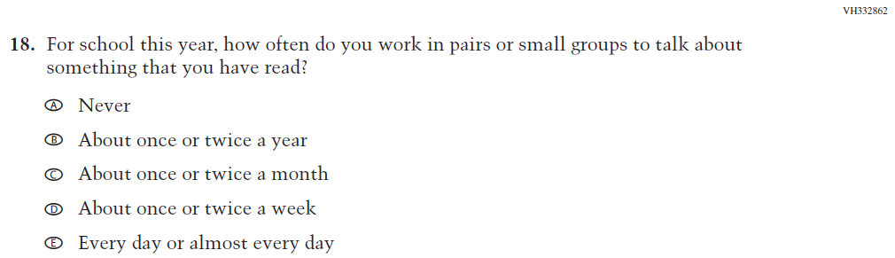  (2019 Grade 4) | 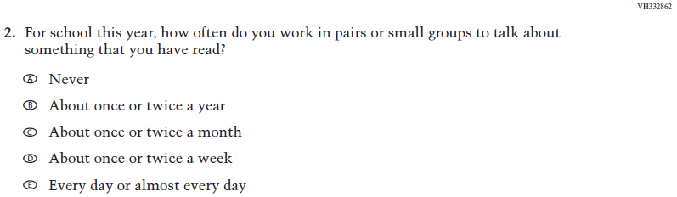  Issue: Organization of Instruction | NC | N/A
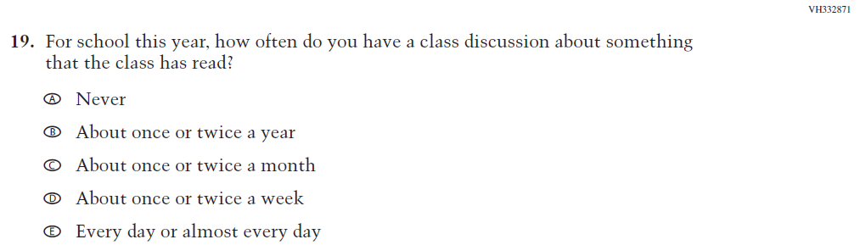  (2019 Grade 4) | 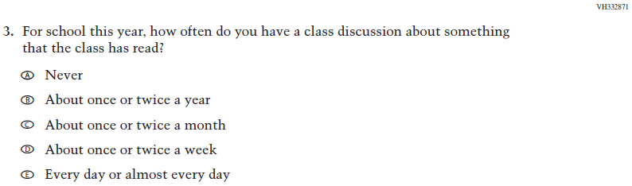  Issue: Organization of Instruction | NC | N/A
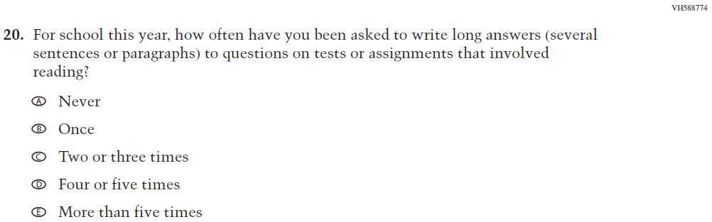  (2019 Grade 4) | 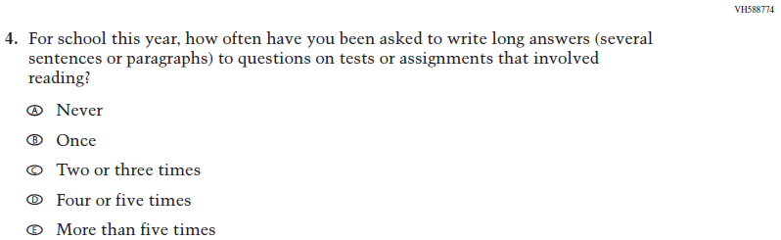  Issue: Organization of Instruction | NC | N/A
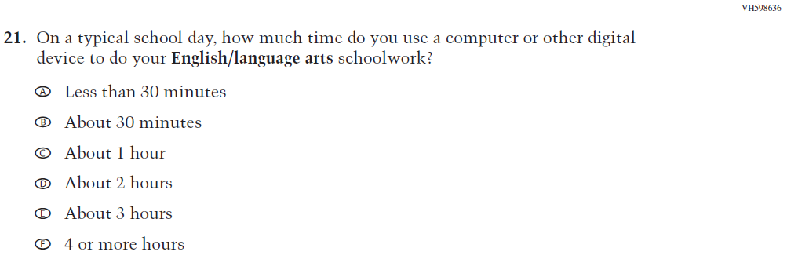  (2019 Grade 4) | N/A | D | To keep student burden low, this item was dropped.
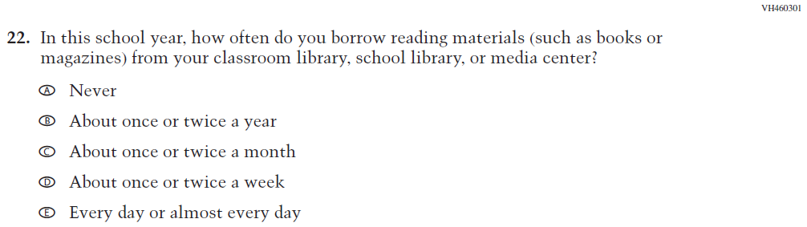  (2019 Grade 4) | 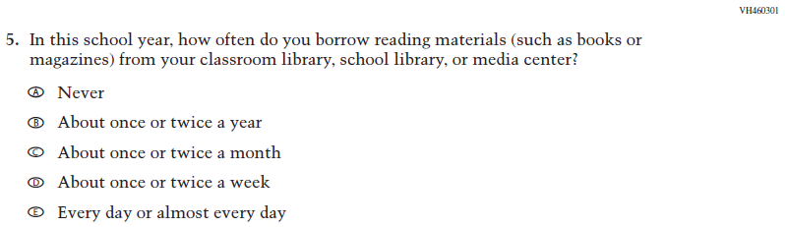  Issue: Resources for Learning and Instruction | NC | N/A
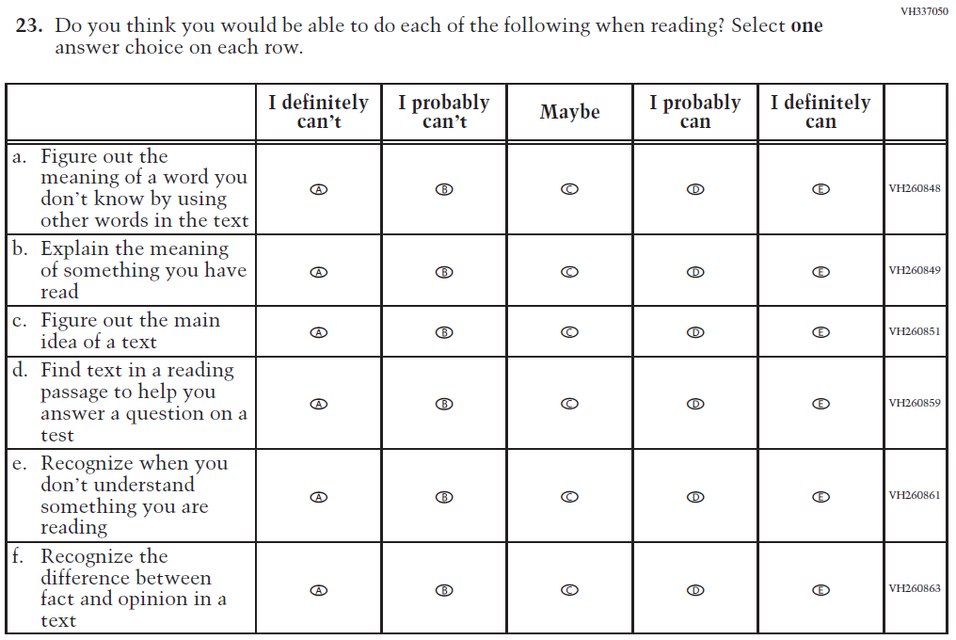  (2019 Grade 4) | 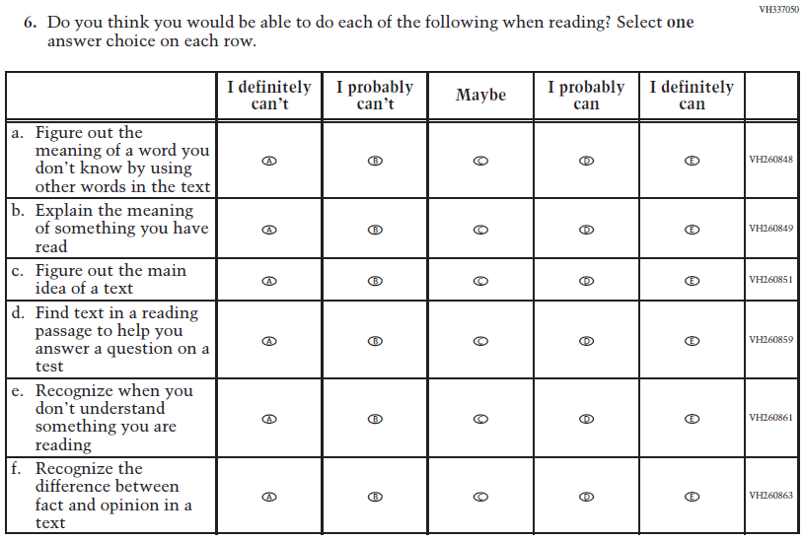  Issue: Student Factors | NC | N/A
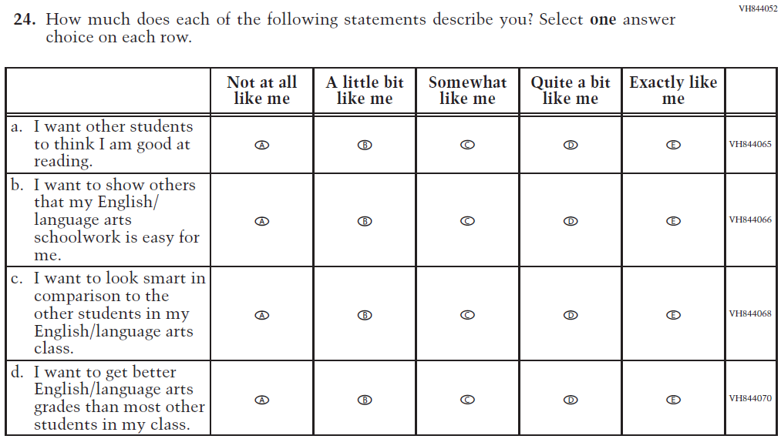  (2019 Grade 4) | N/A | D | To keep student burden low, this item was dropped.
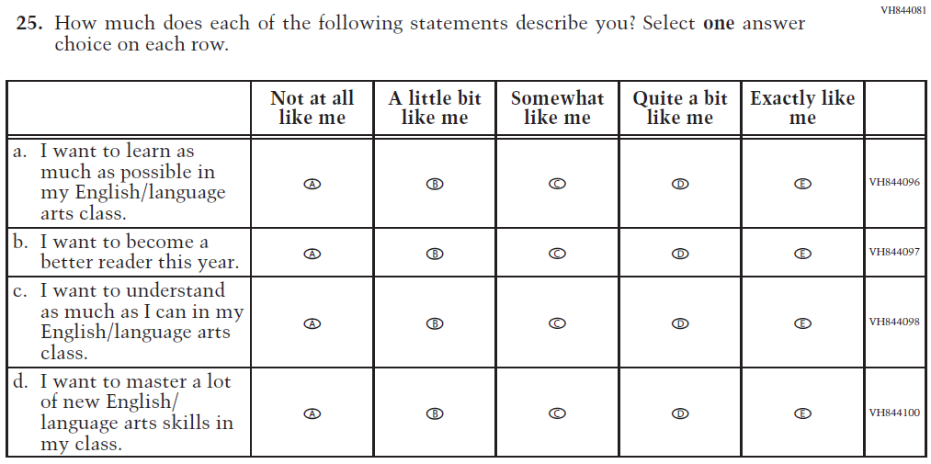  (2019 Grade 4) | 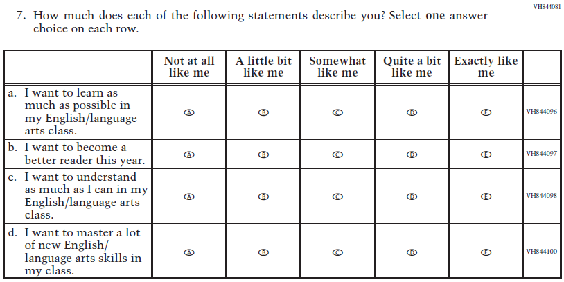  Issue: Student Factors | NC | N/A
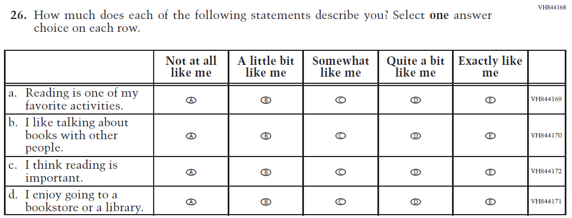(2019 Grade 4) | 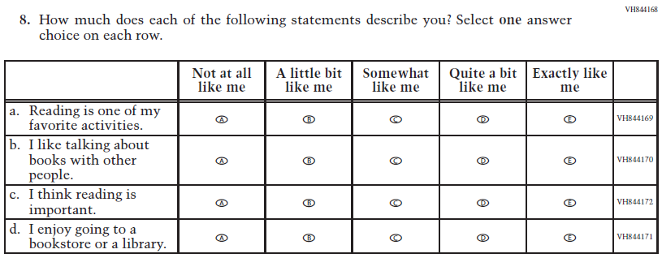Issue: Student Factors | NC | N/A
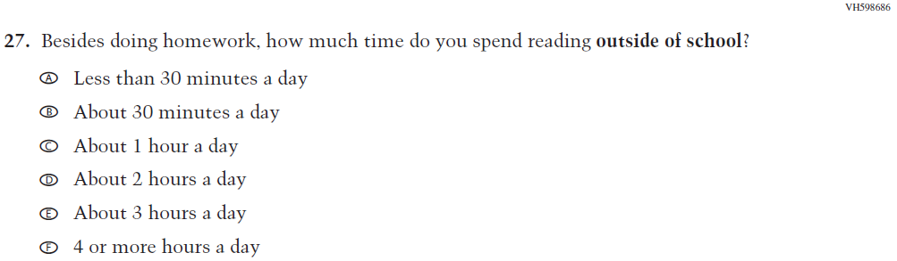  (2019 Grade 4) | 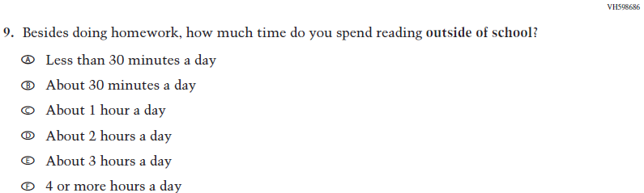  Issue: Student Factors | NC | N/A
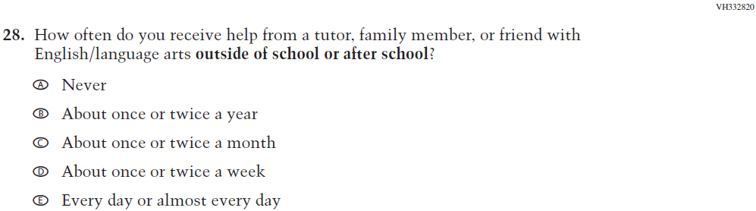  (2019 Grade 4) | 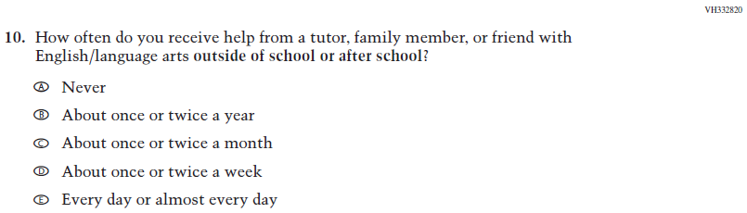  Issue: Resources for Learning and Instruction | NC | N/A
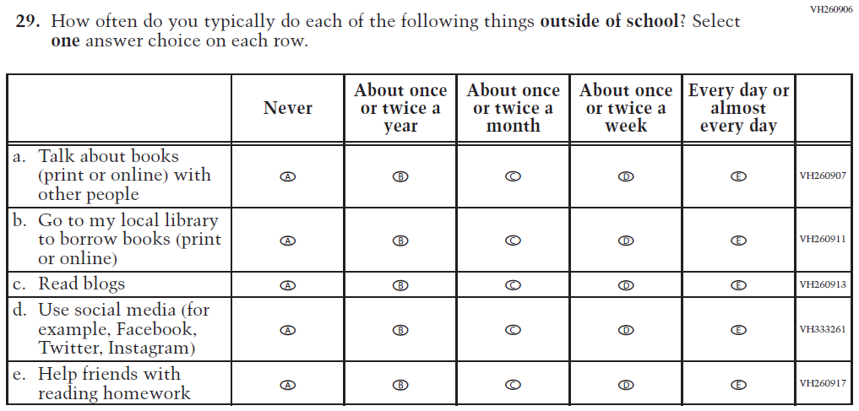  (2019 Grade 4) | 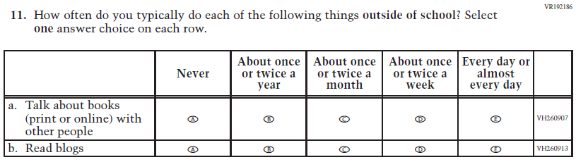  Issue: Student Factors | R | To keep student burden low, sub-items b, d, and e were dropped.

Appendix J1-10: Operational Grade 4 (Reading)
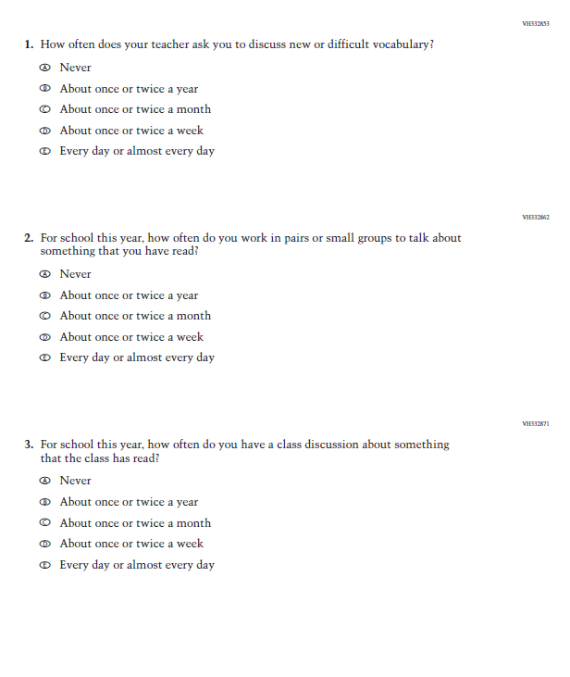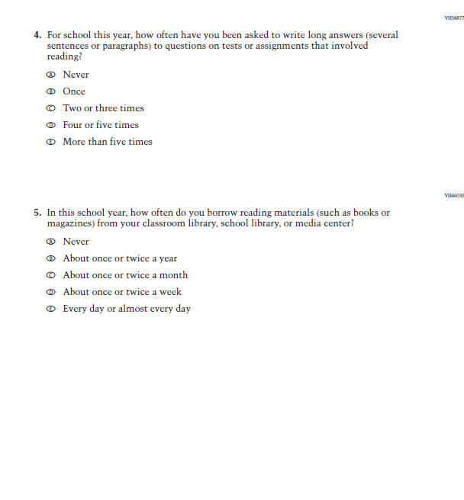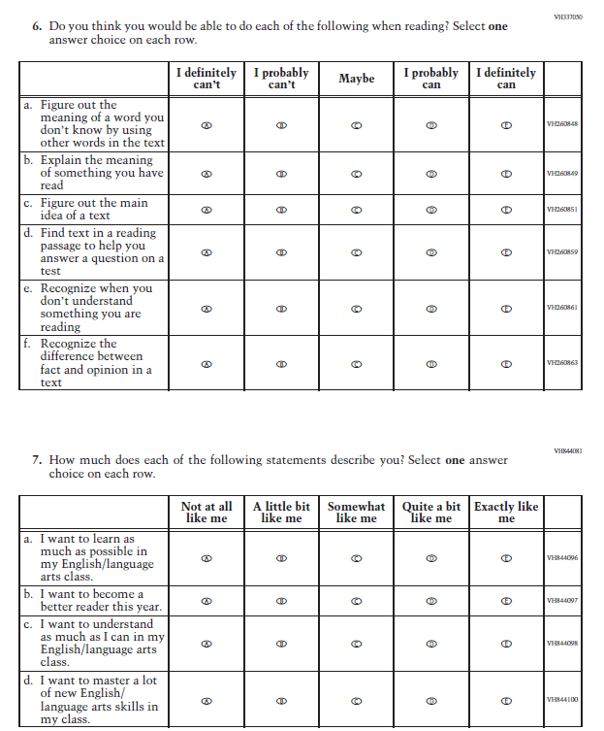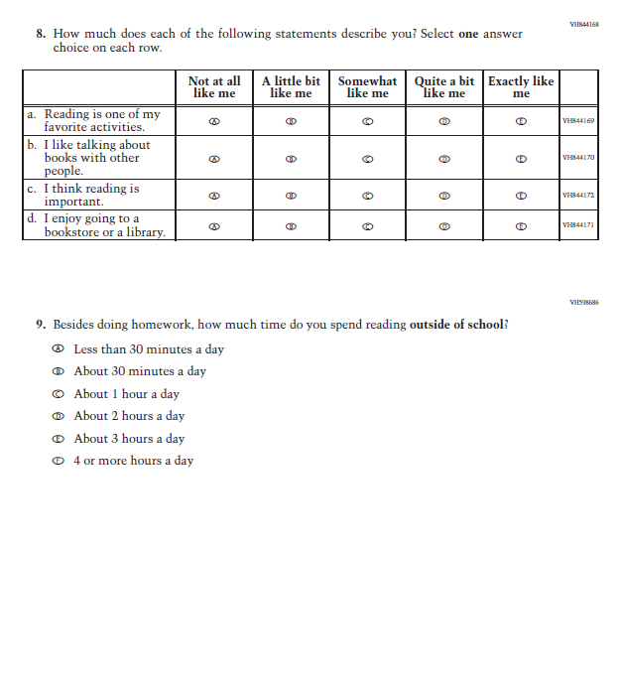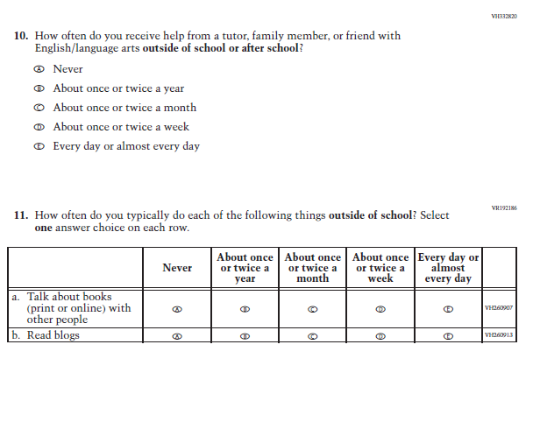

Appendix J1-11: Summary of Changes Operational Grade 8 (Reading)
2022 Operational Grade 8 Reading Student

Previous item | 2022 item | D/A/ R/NC+ | Rationale
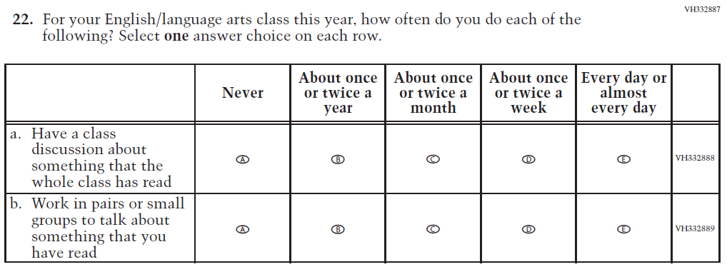  (2019 Grade 8) | 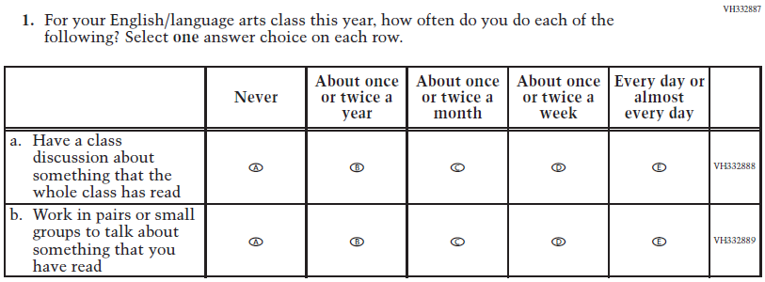  Issue: Organization of Instruction | NC | N/A
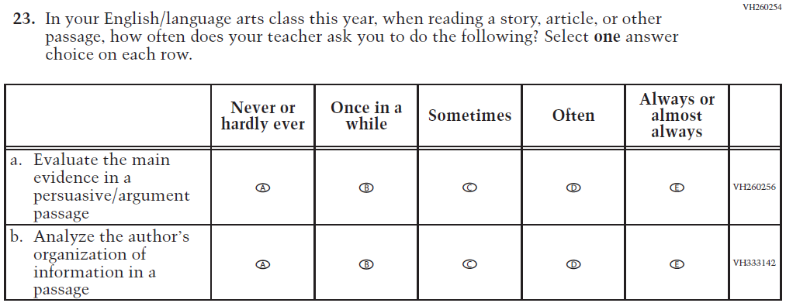  (2019 Grade 8) | 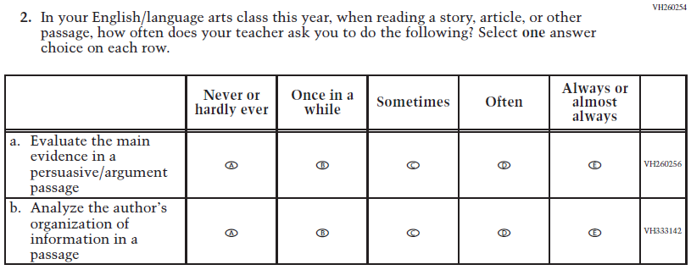  Issue: Organization of Instruction | NC | N/A
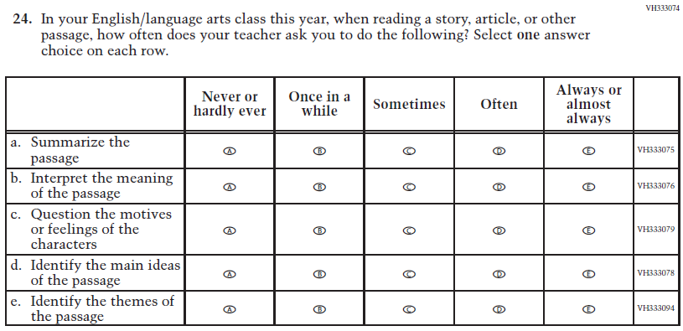  (2019 Grade 8) | 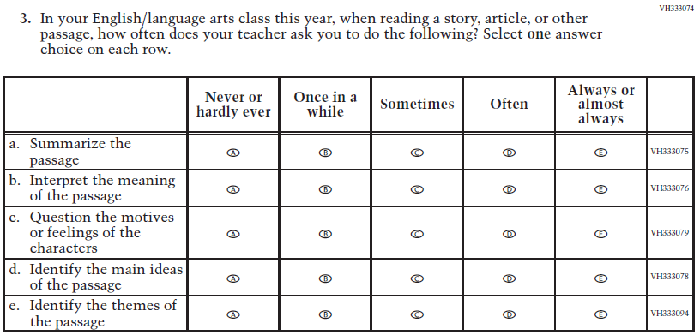  Issue: Organization of Instruction | NC | N/A
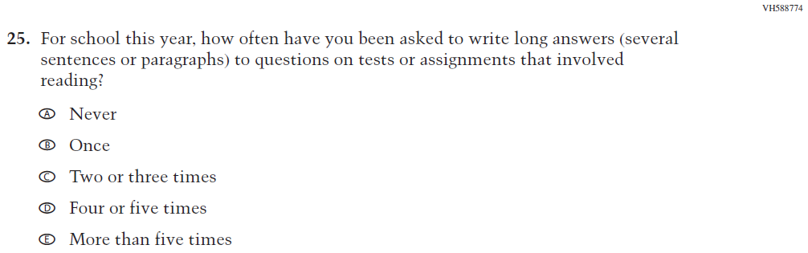  (2019 Grade 8) | 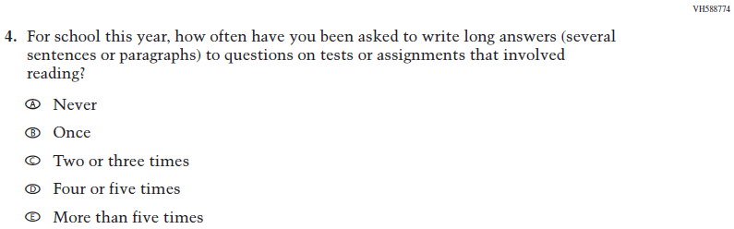  Issue: Organization of Instruction | NC | N/A
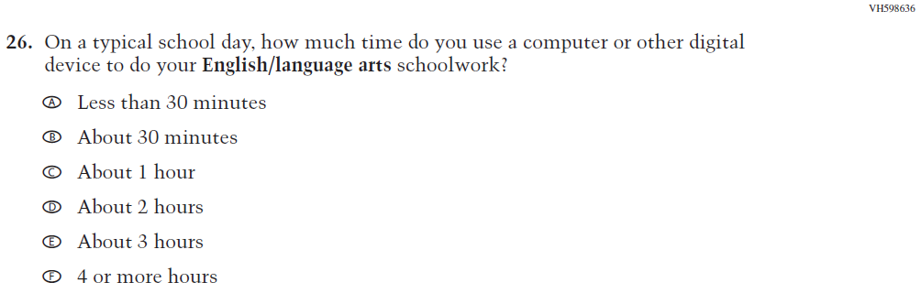  (2019 Grade 8) | N/A | D | To keep student burden low, this item was dropped.
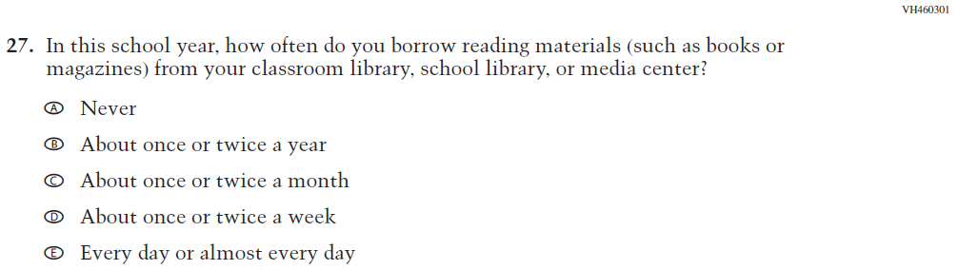  (2019 Grade 8) | N/A | D | To keep student burden low, this item was dropped.
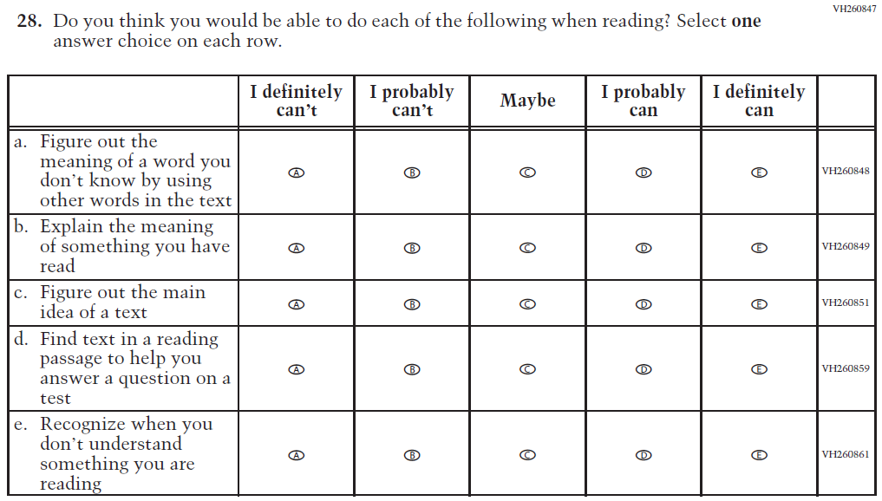  (2019 Grade 8) | 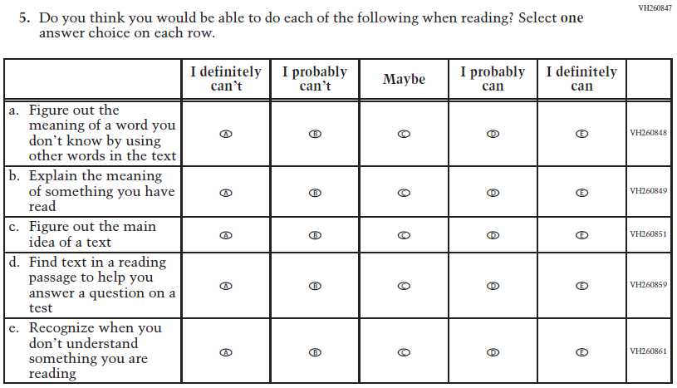  Issue: Student Factors | NC | N/A
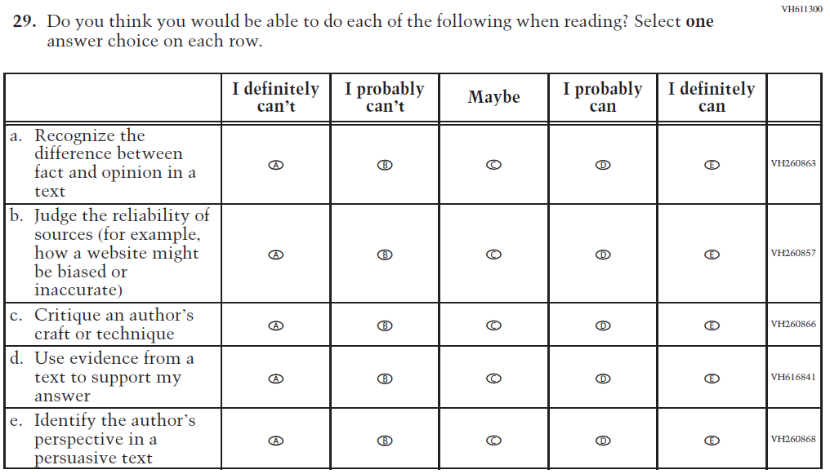  (2019 Grade 8) | 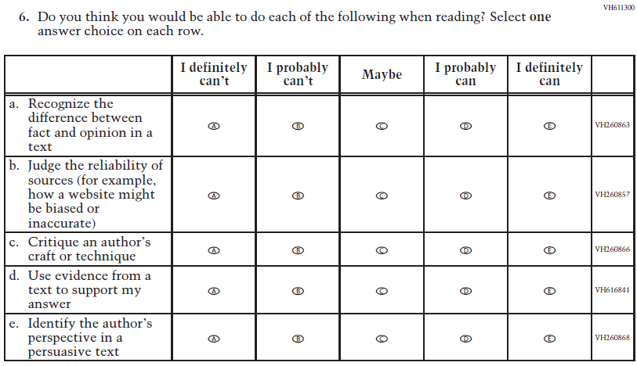  Issue: Student Factors | NC | N/A
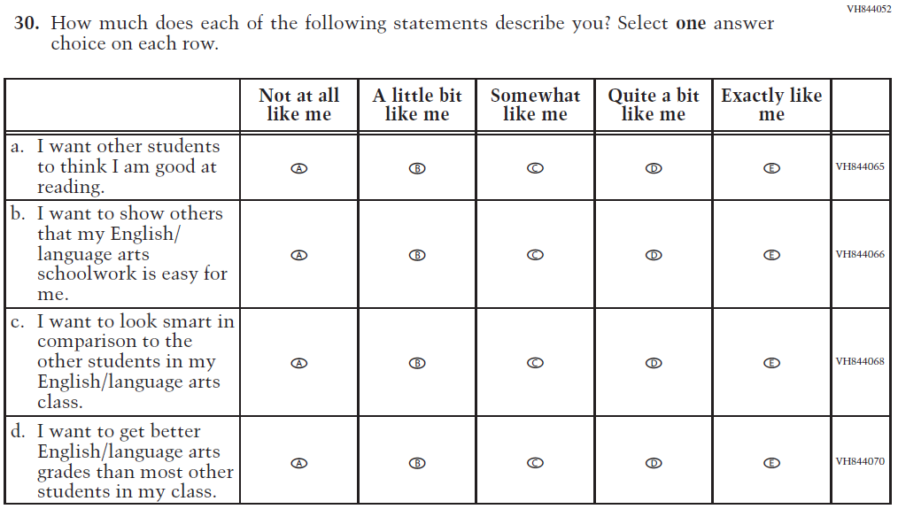  (2019 Grade 8) | N/A | D | To keep student burden low, this item was dropped.
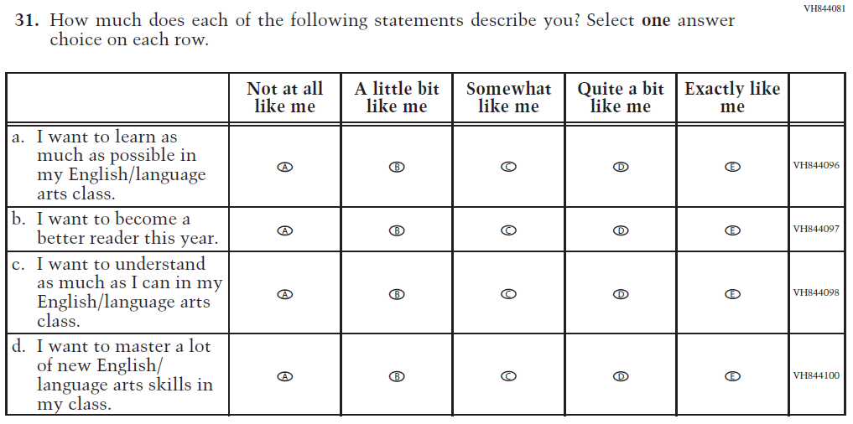  (2019 Grade 8) | 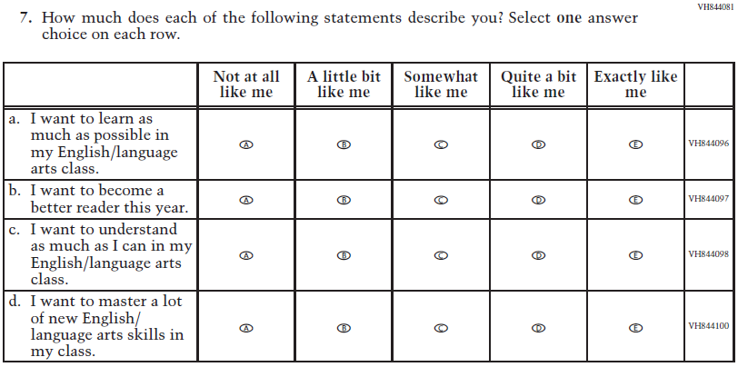  Issue: Student Factors | NC | N/A
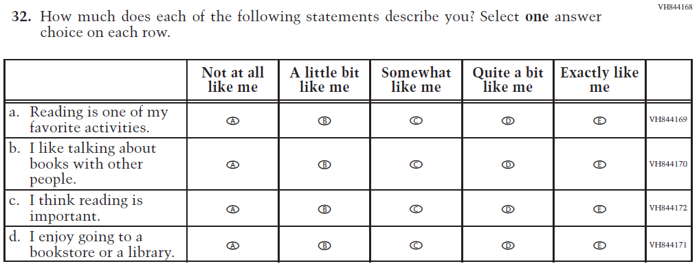(2019 Grade 8) | 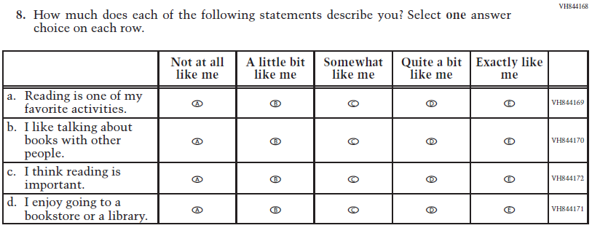  Issue: Student Factors | NC | N/A
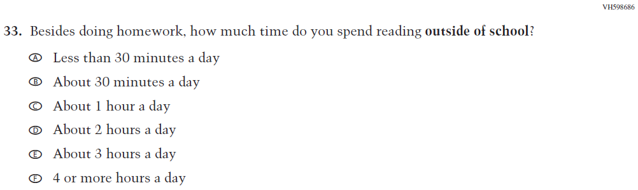  (2019 Grade 8) | 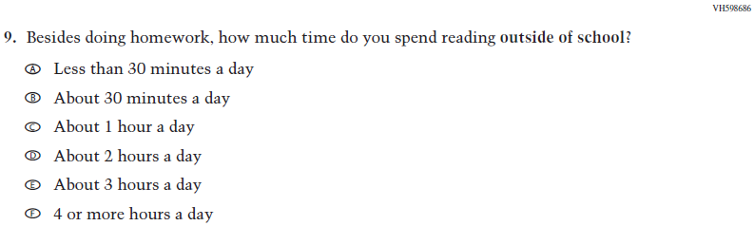  Issue: Student Factors | NC | N/A
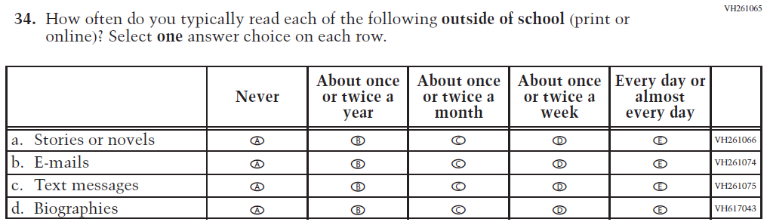  (2019 Grade 8) | 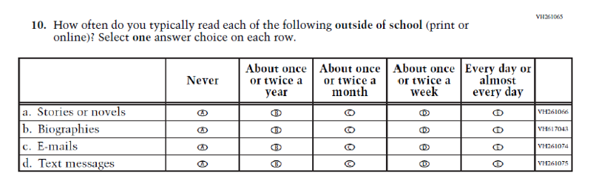  Issue: Student Factors | R | The order of sub-items b, c, and d was revised.
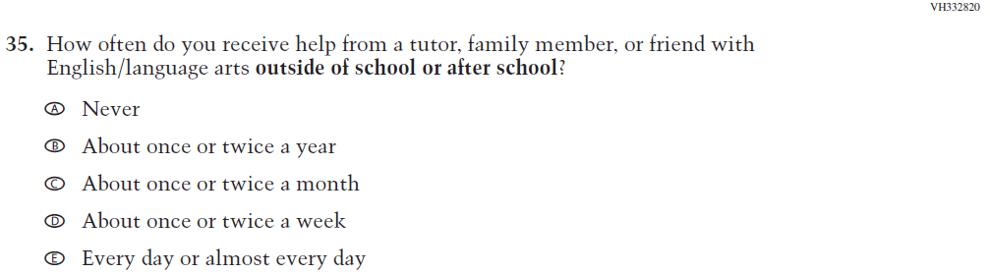  (2019 Grade 8) | 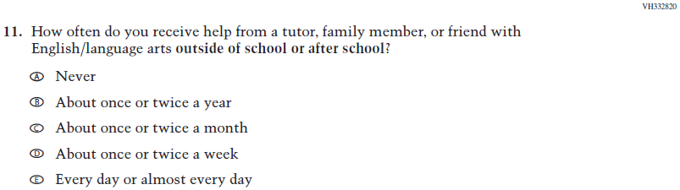  Issue: Resources for Learning and Instruction | NC | N/A
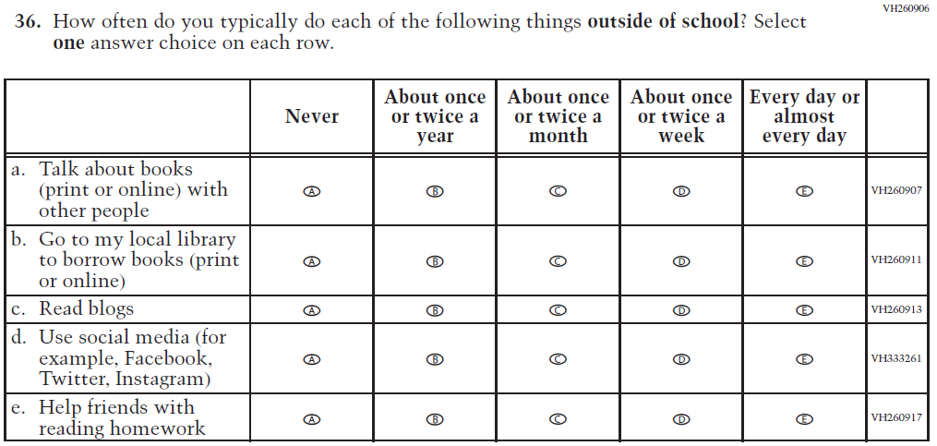  (2019 Grade 8) | 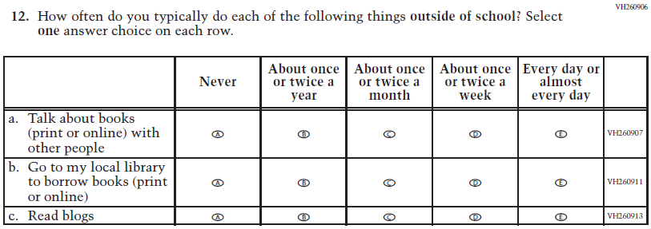  Issue: Student Factors | R | To keep student burden low, sub-items d and e were dropped.

Appendix J1-12: Operational Grade 8 (Reading)
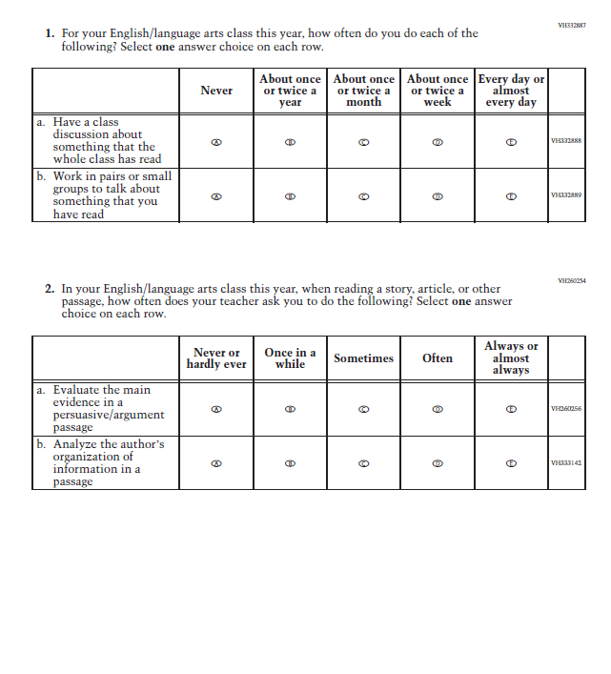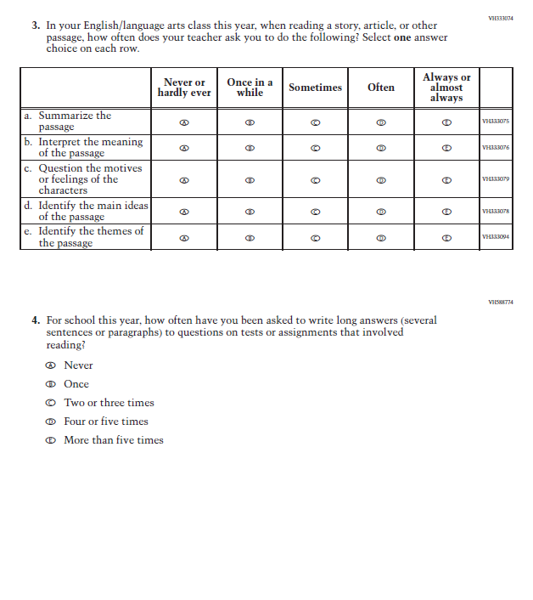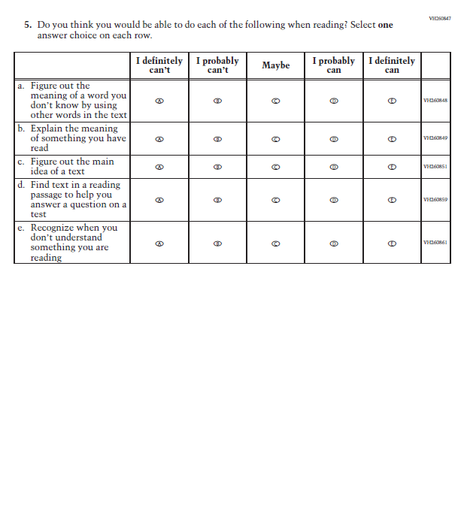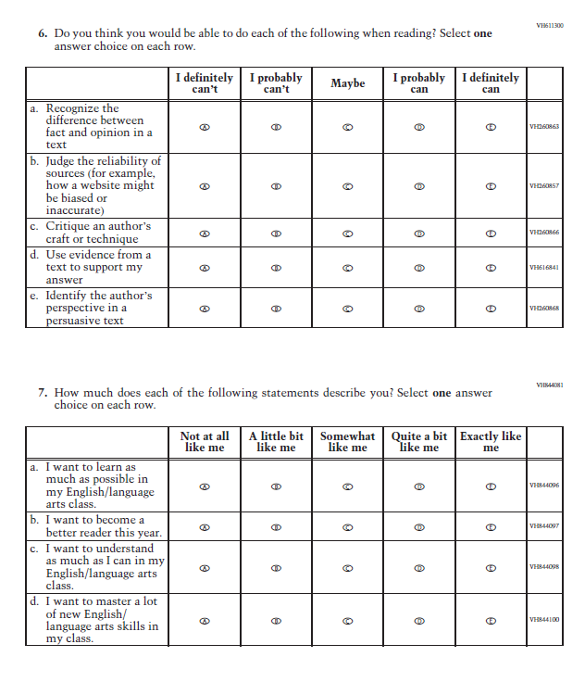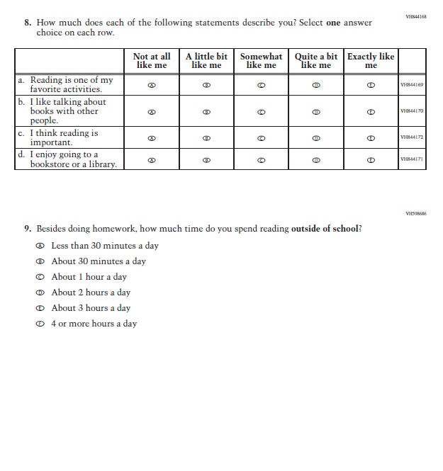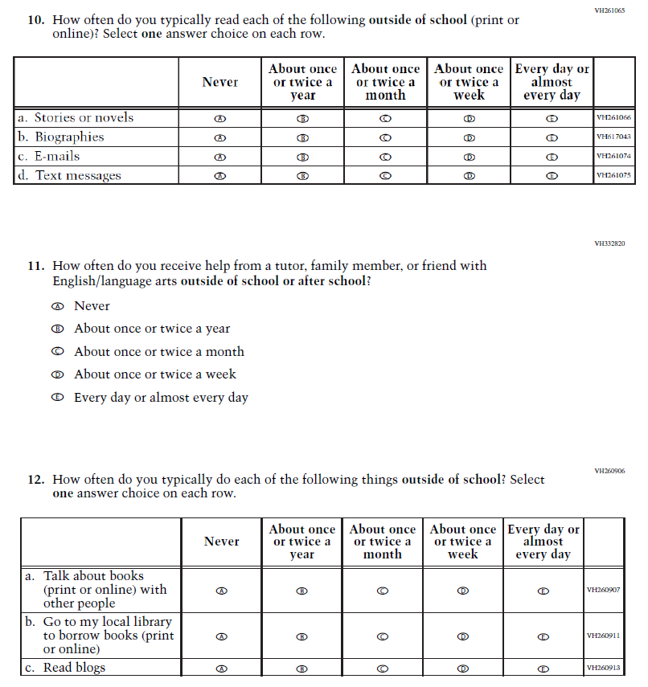

Appendix J1-13: Summary of Operational Grade 8 Civics
2022 Operational Grade 8 Civics Student
Previous item | 2022 item | D/A/ R/NC+ | Rationale
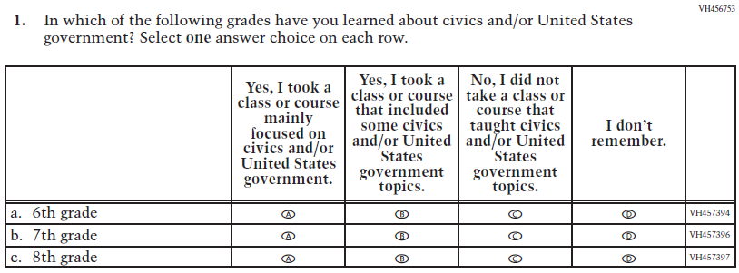  (2018 Grade 8) | 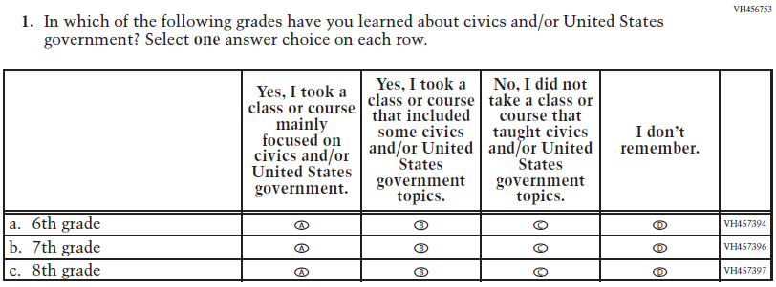  Issue: Organization of Instruction | NC | N/A
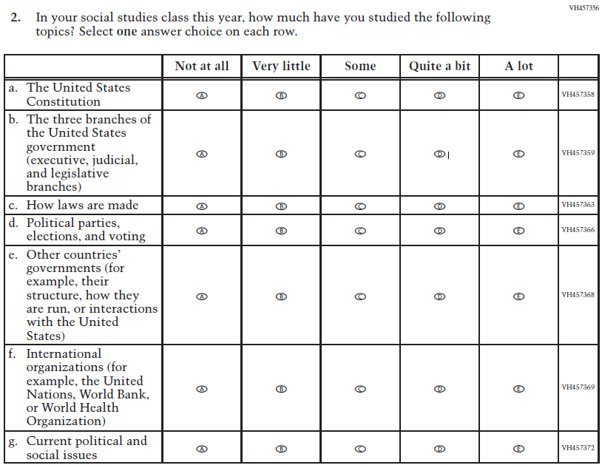  (2018 Grade 8) | 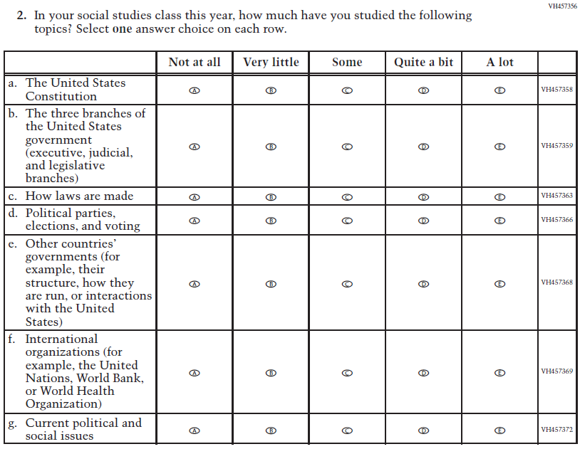  Issue: Organization of Instruction | NC | N/A
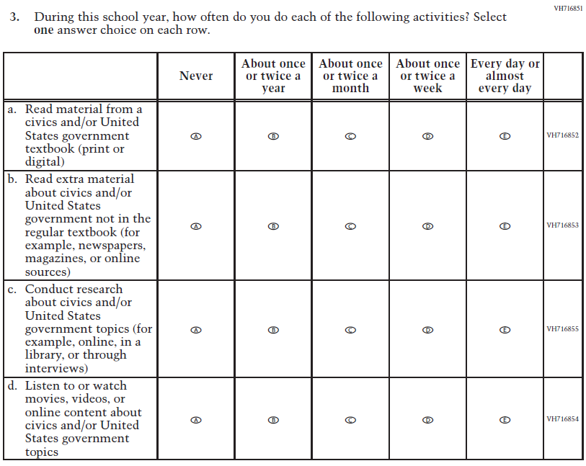  (2018 Grade 8) | N/A | D | To keep student burden low, this item was dropped.
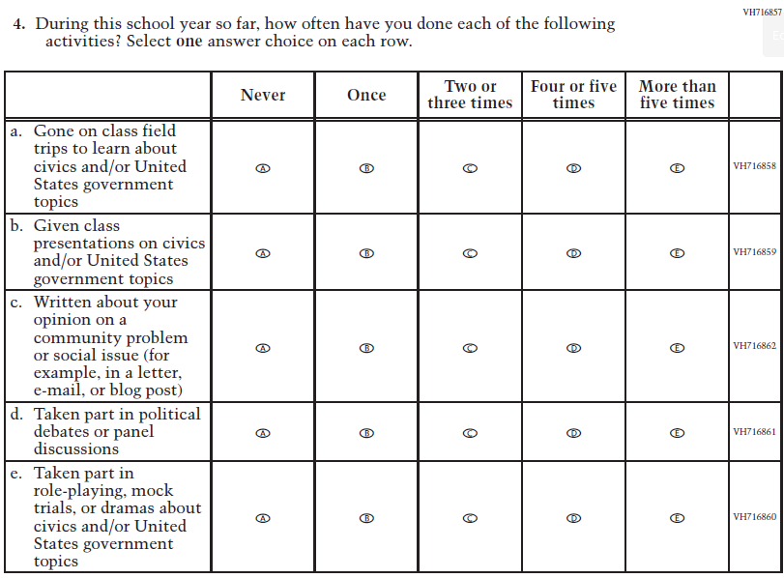  (2018 Grade 8) | N/A | D | To keep student burden low, this item was dropped.
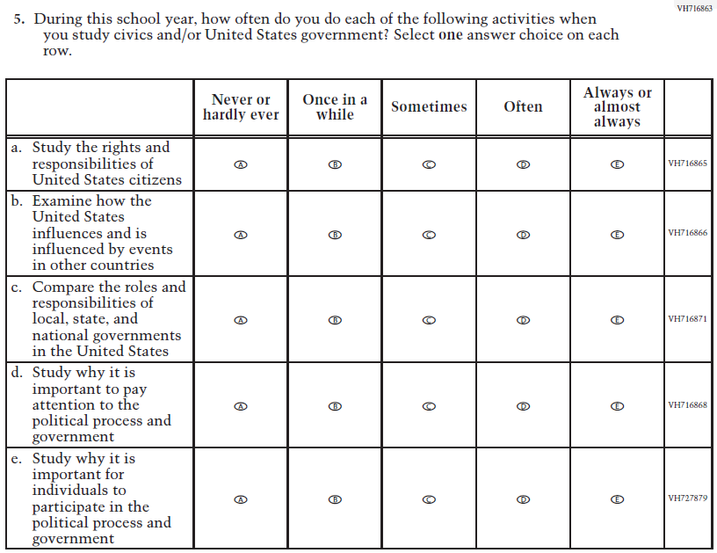  (2018 Grade 8) | 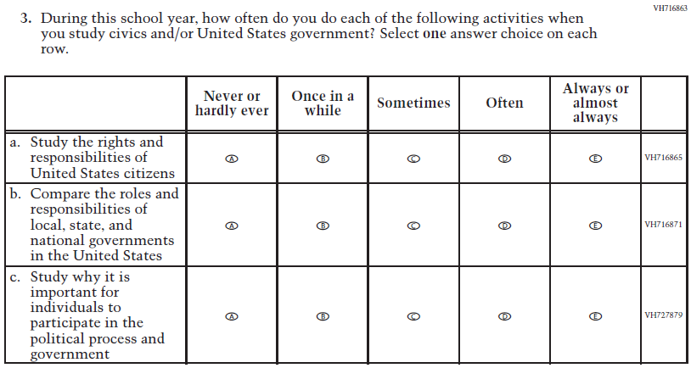  Issue: Organization of Instruction | R | To keep student burden low, sub-items b and d were dropped.
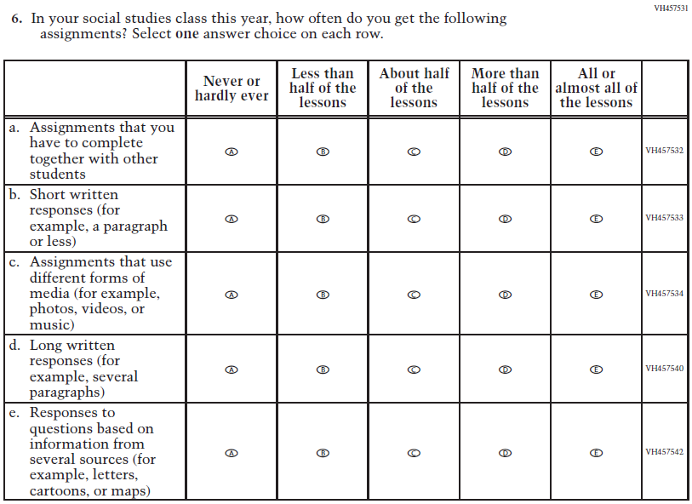  (2018 Grade 8) | 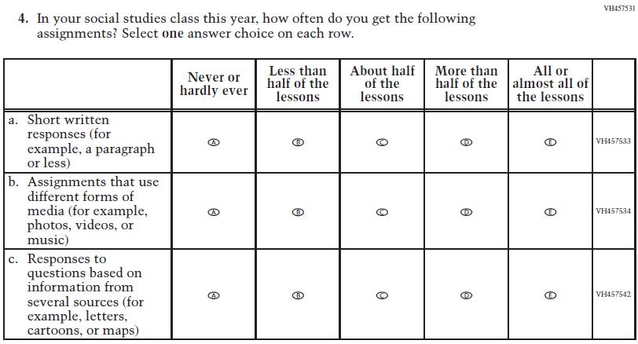  Issue: Organization of Instruction | R | To keep student burden low, sub-items a and d were dropped.
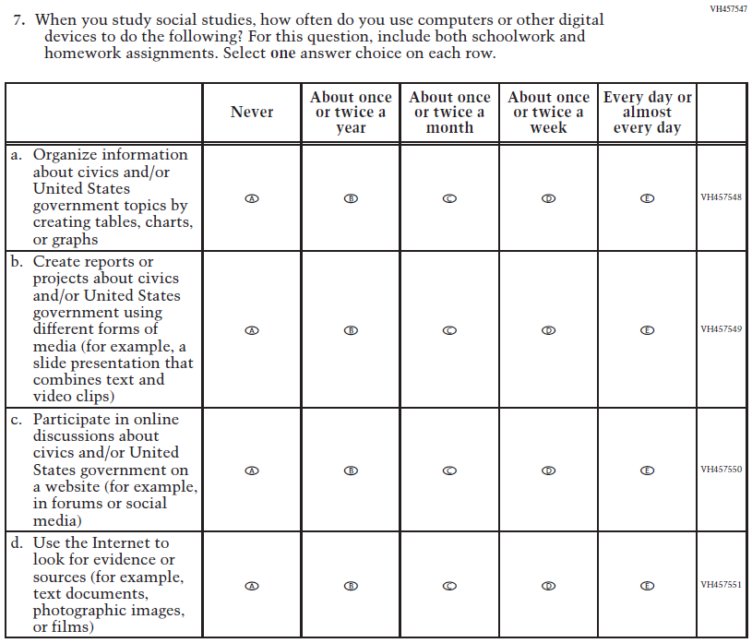  (2018 Grade 8) | 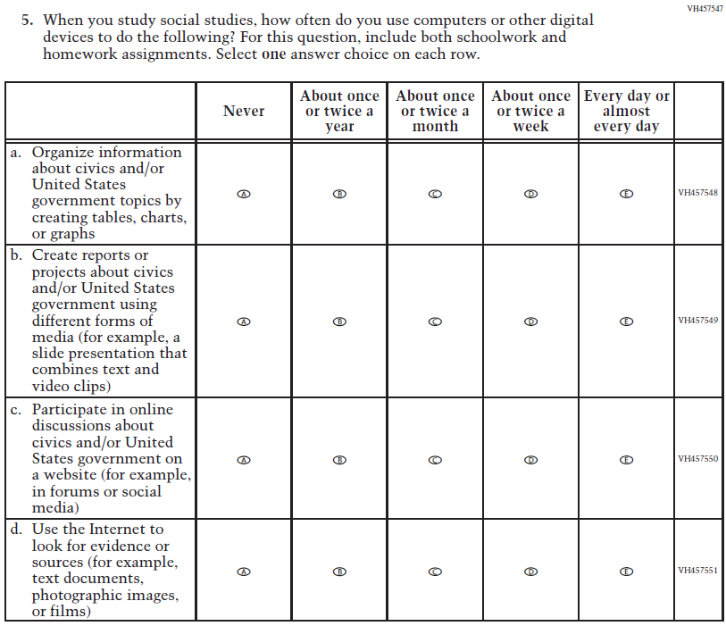  Issue: Organization of Instruction | NC | N/A
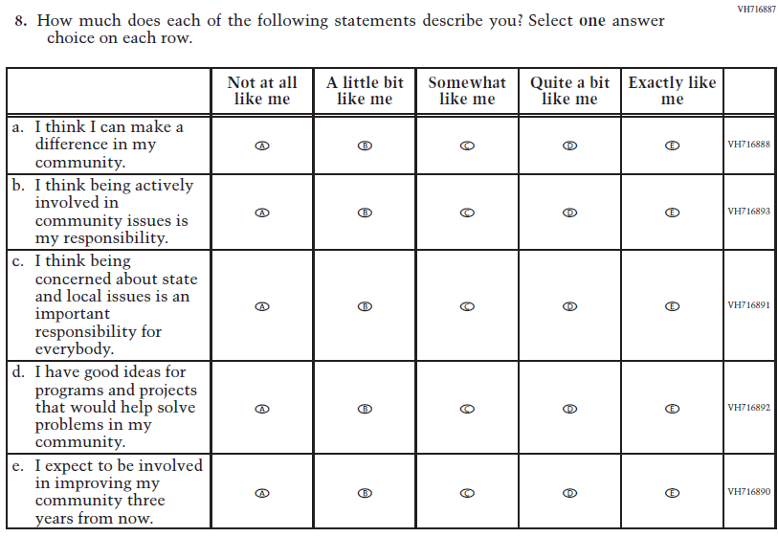  (2018 Grade 8) | 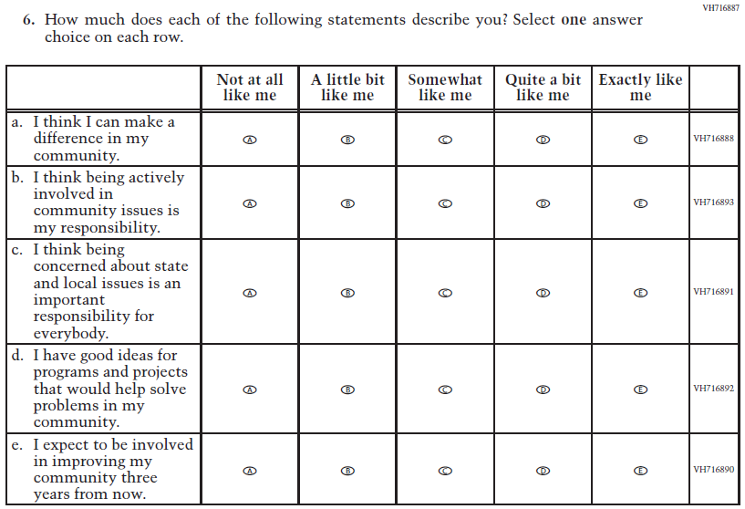  Issue: Student Factors | NC | N/A
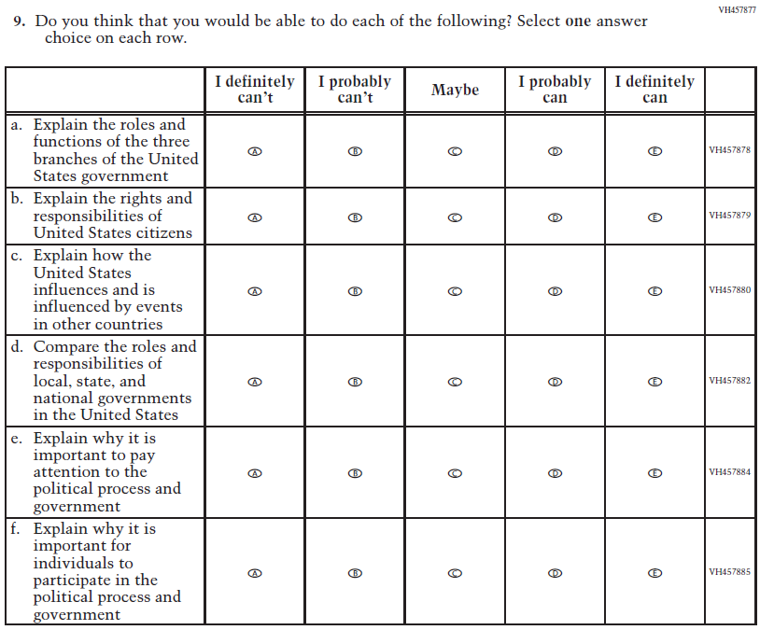  (2018 Grade 8) | 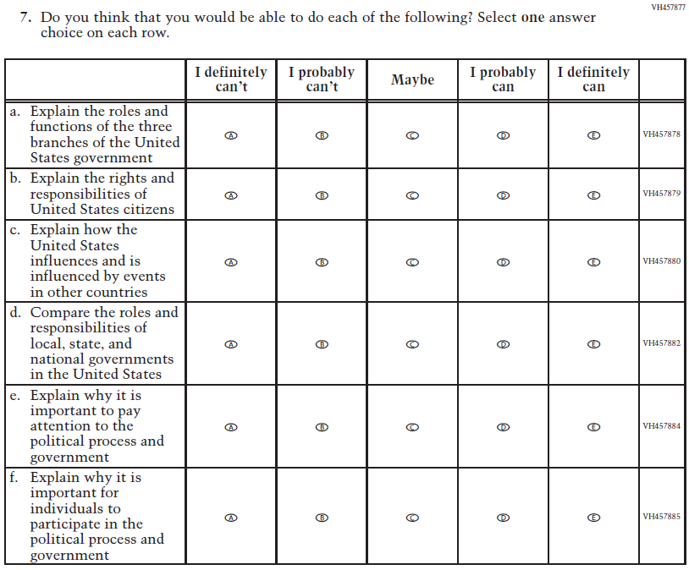  Issue: Student Factors | NC | N/A
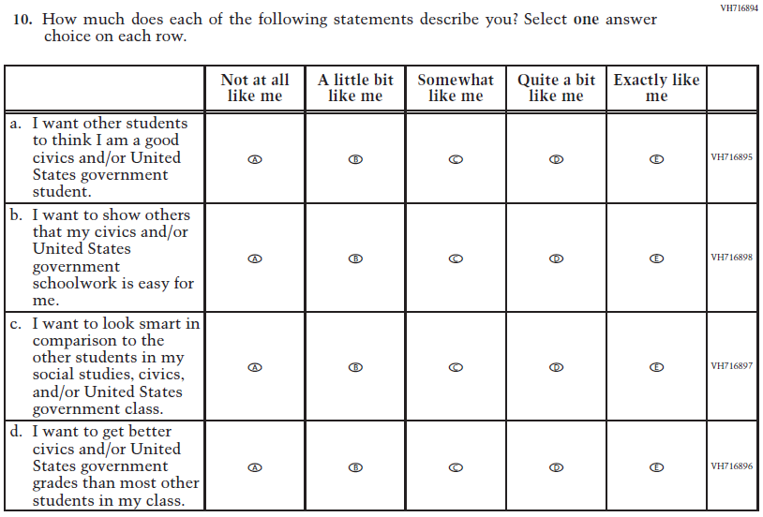  (2018 Grade 8) | N/A | D | To keep student burden low, this item was dropped.
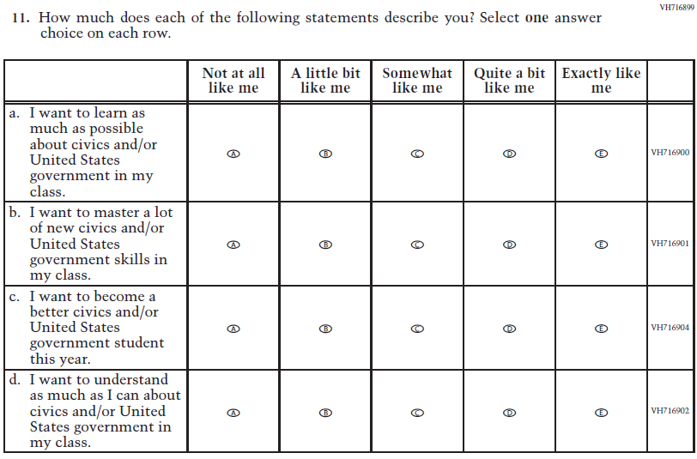  (2018 Grade 8) | 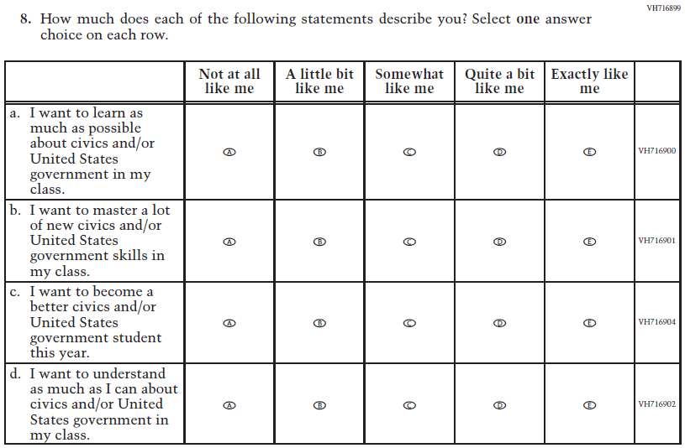  Issue: Student Factors | NC | N/A
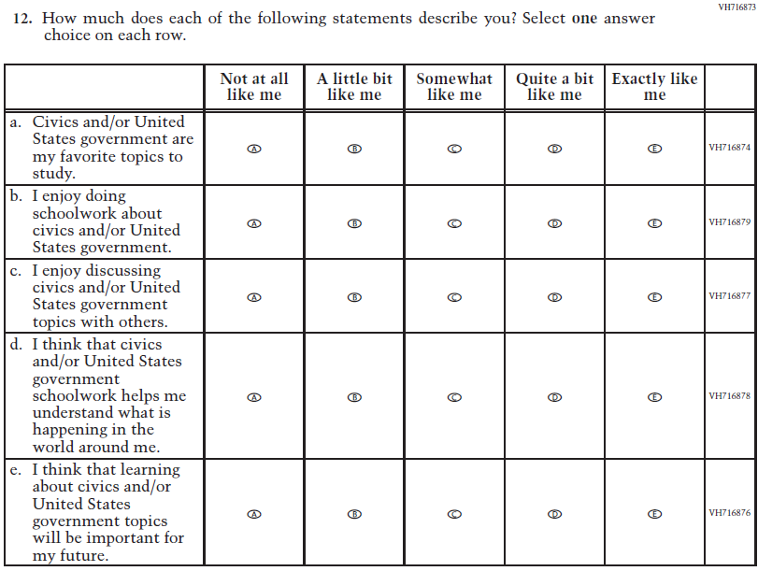  (2018 Grade 8) | 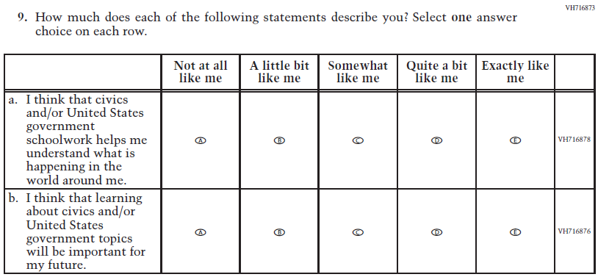  Issue: Student Factors | R | To keep student burden low, sub-items a, b, and c were dropped.
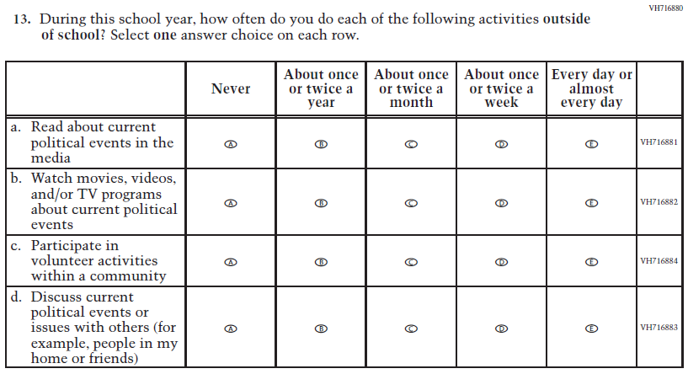  (2018 Grade 8) | 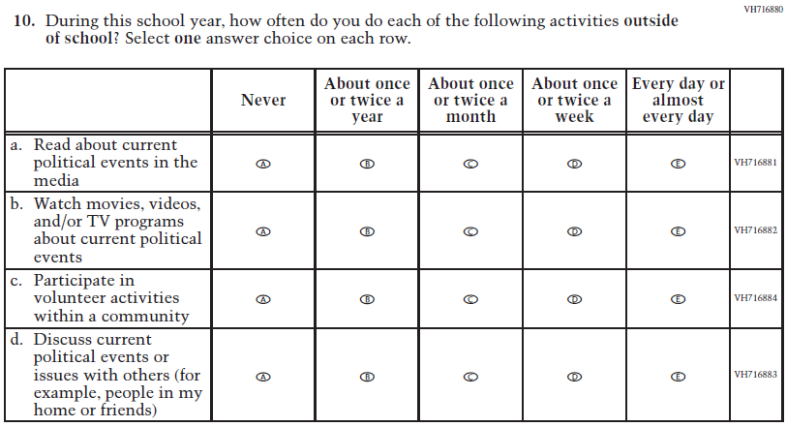  Issue: Student Factors | NC | N/A
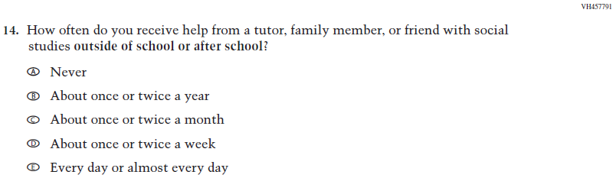  (2018 Grade 8) | 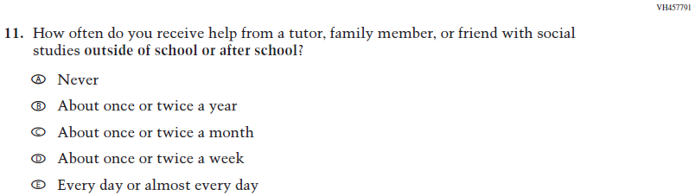  Issue: Resources for Learning and Instruction | NC | N/A
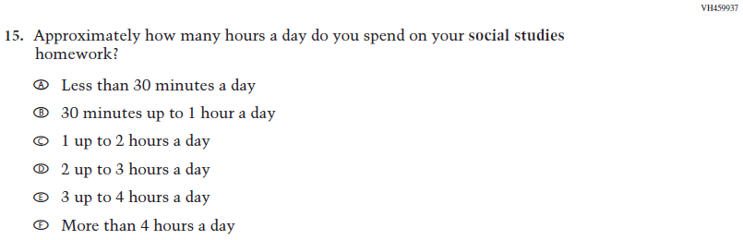  (2018 Grade 8) | N/A | D | To keep student burden low, this item was dropped.

Appendix J1-14: Operational Grade 8 Civics
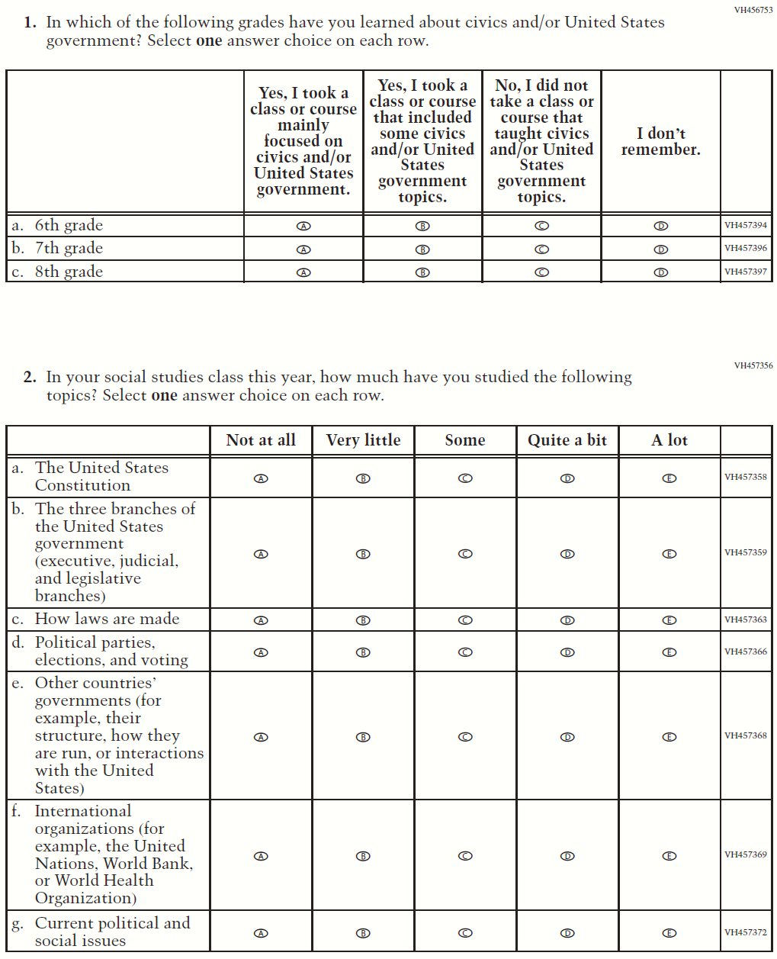
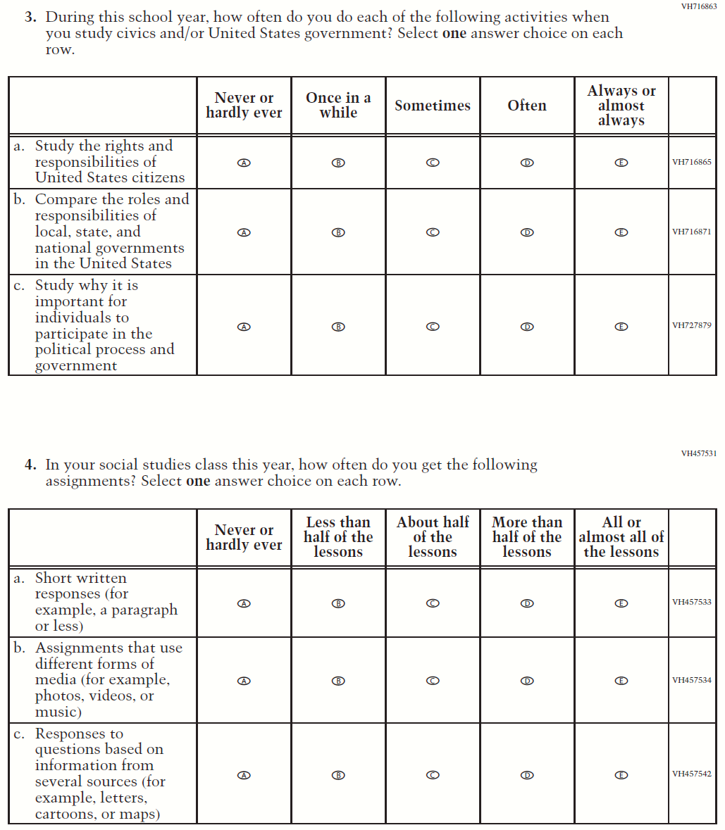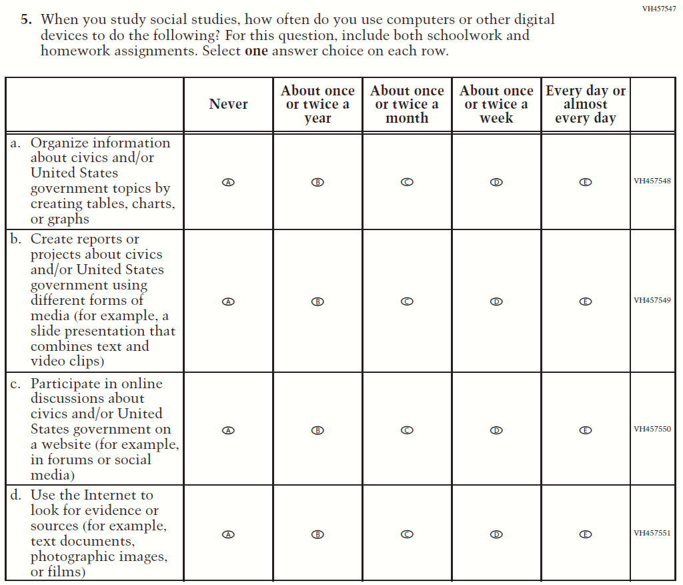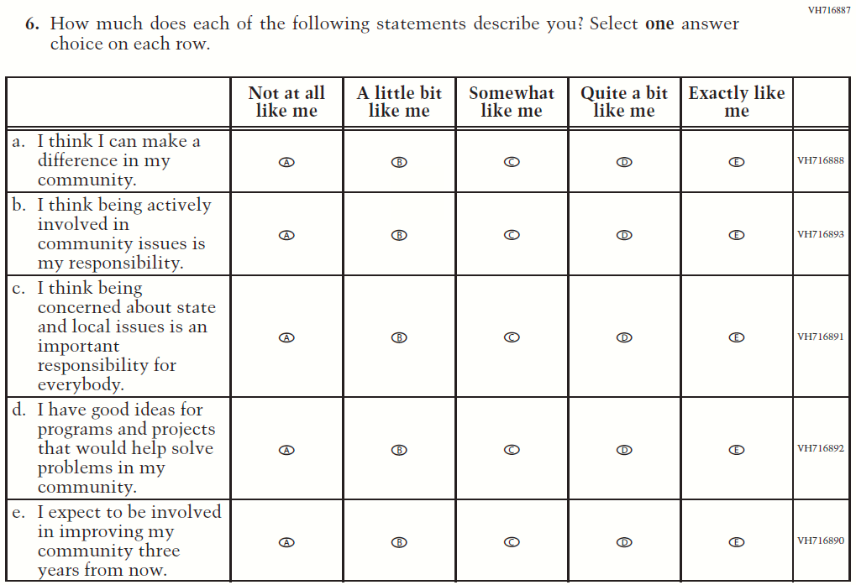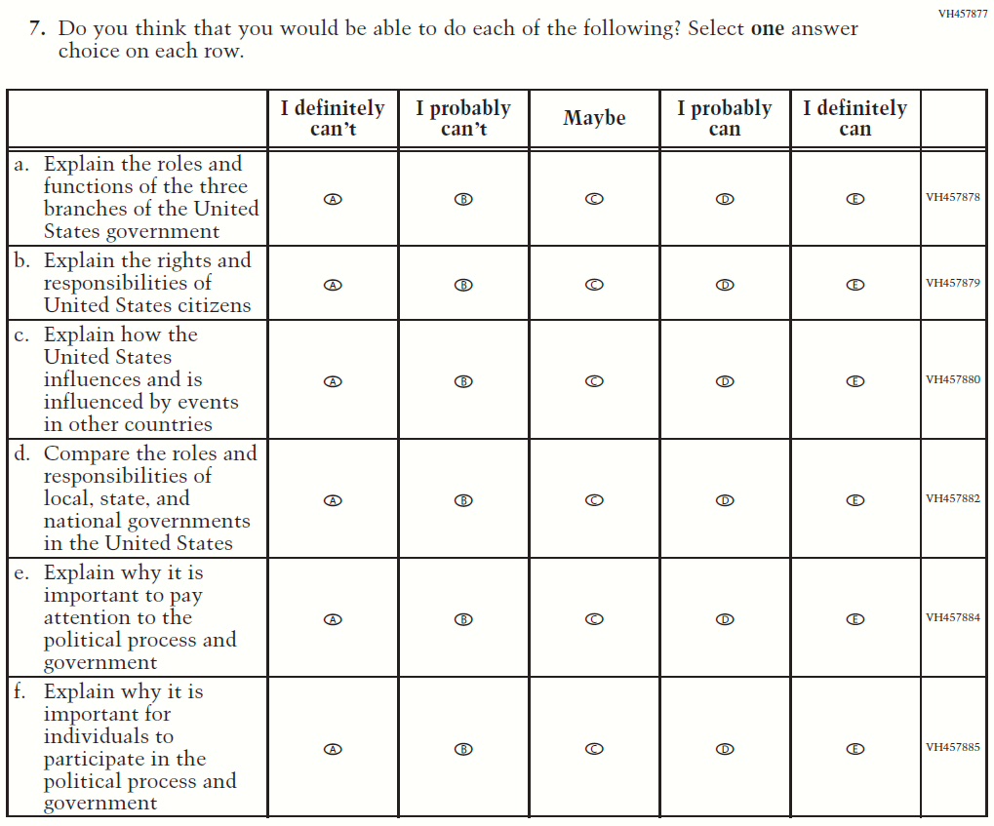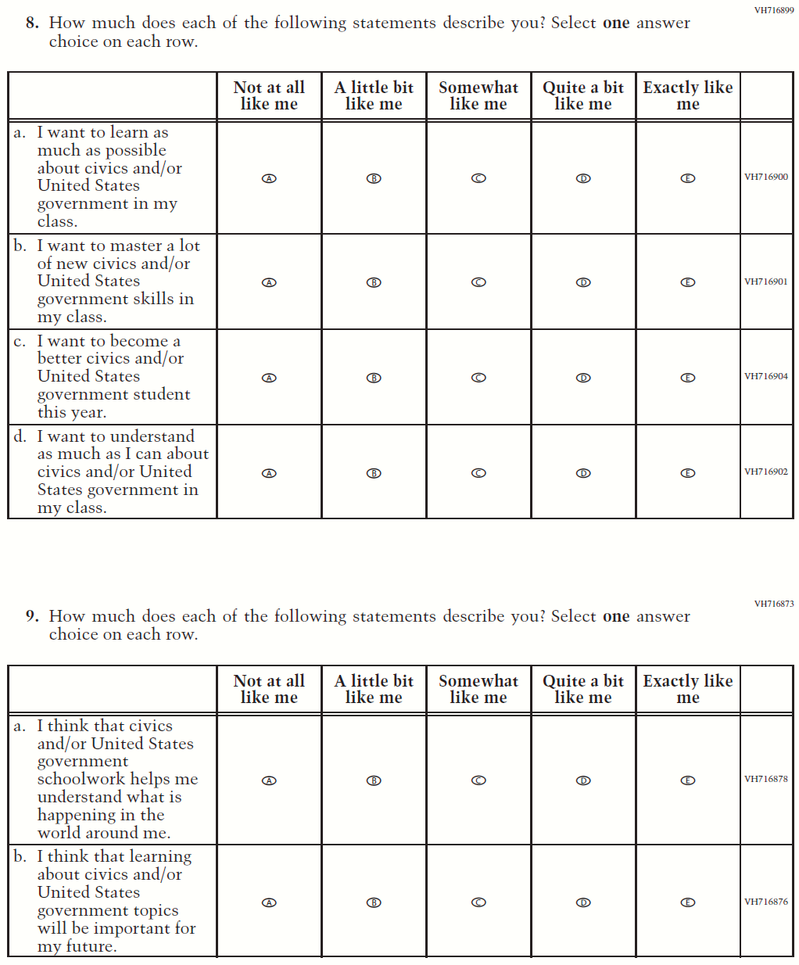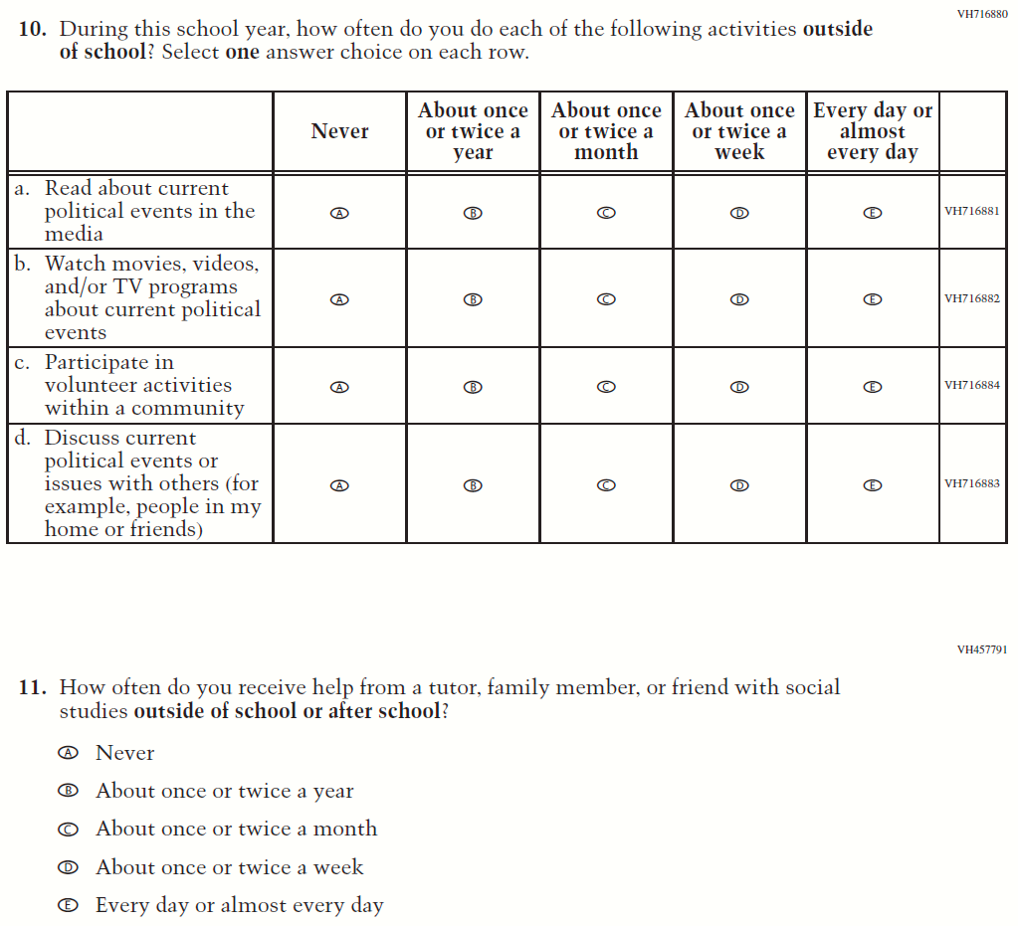

Appendix J1-15: Summary of Operational Grade 8 U.S. History
2022 Operational Grade 8 U.S. History Student
Previous item | 2022 item | D/A/ R/NC+ | Rationale
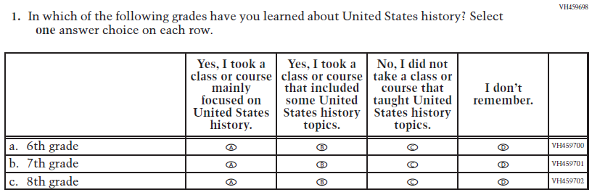  (2018 Grade 8) | 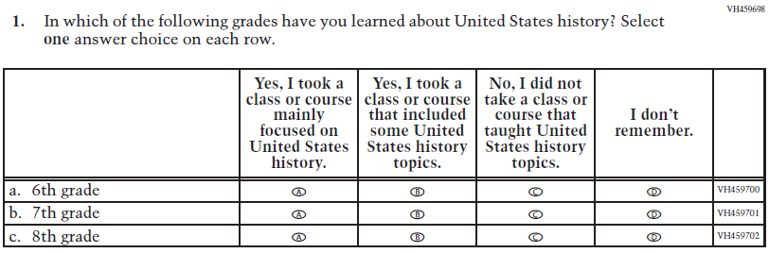  Issue: Organization of Instruction | NC | N/A
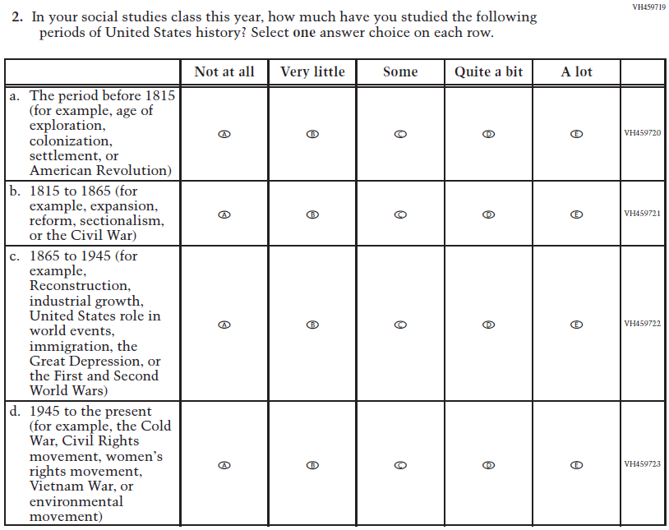  (2018 Grade 8) | 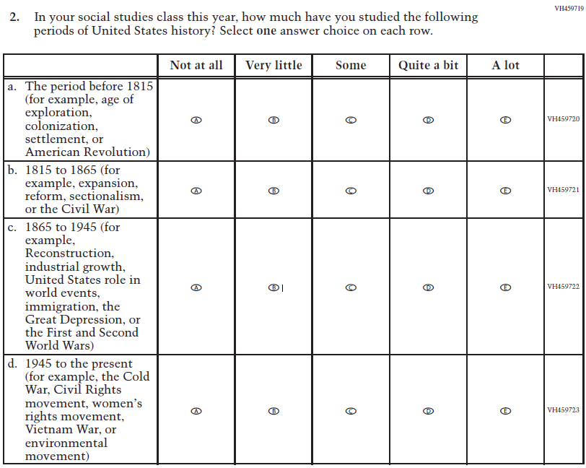  Issue: Organization of Instruction | NC | N/A
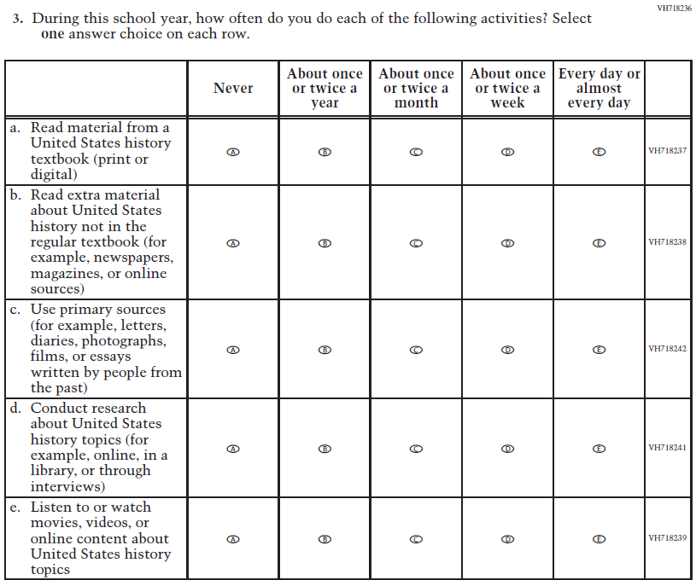  (2018 Grade 8) | N/A | D | To keep student burden low, this item was dropped.
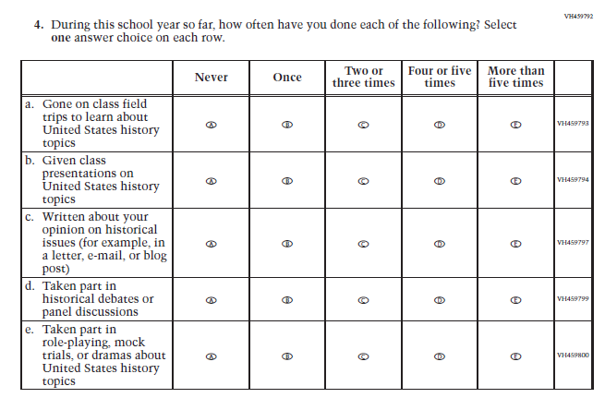  (2018 Grade 8) | N/A | D | To keep student burden low, this item was dropped.
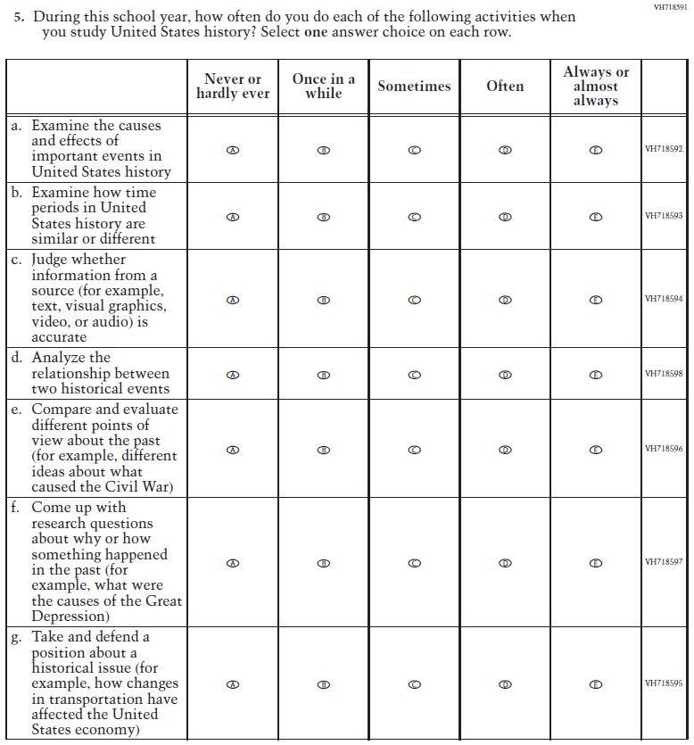  (2018 Grade 8) | 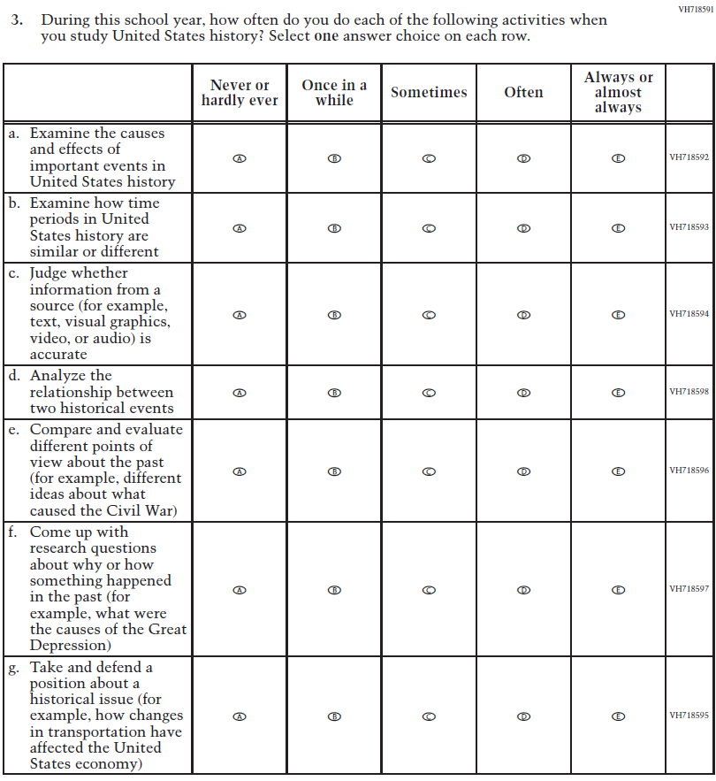  Issue: Organization of Instruction | NC | N/A
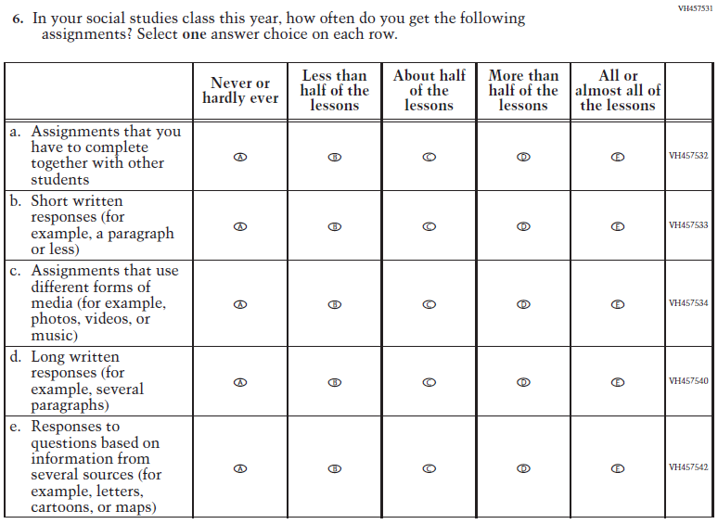  (2018 Grade 8) | 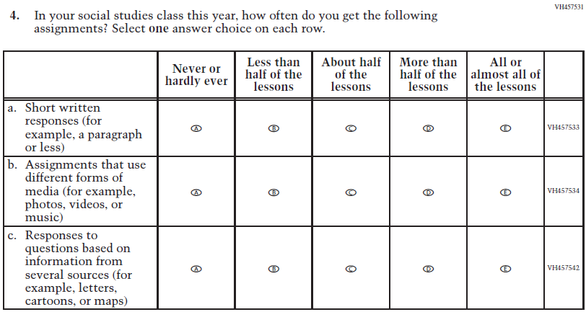  Issue: Organization of Instruction | R | To keep student burden low, sub-items a and d were dropped.
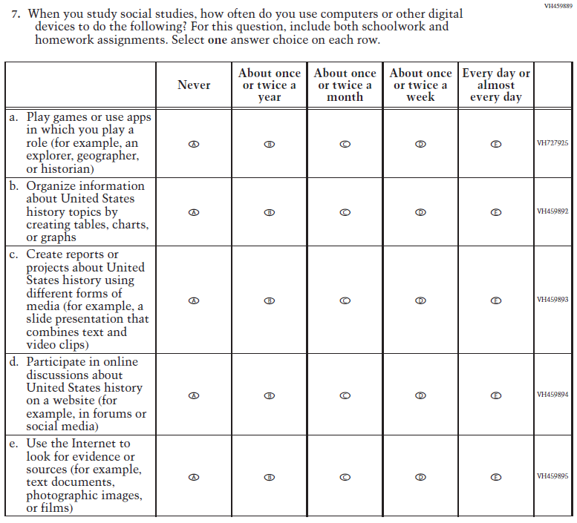(2018 Grade 8) | N/A | D | To keep student burden low, this item was dropped.
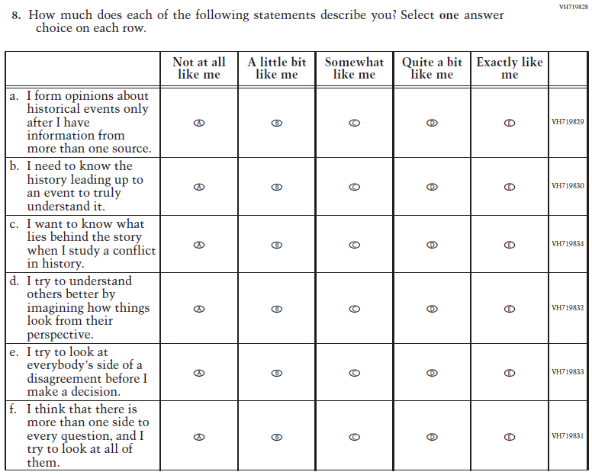  (2018 Grade 8) | 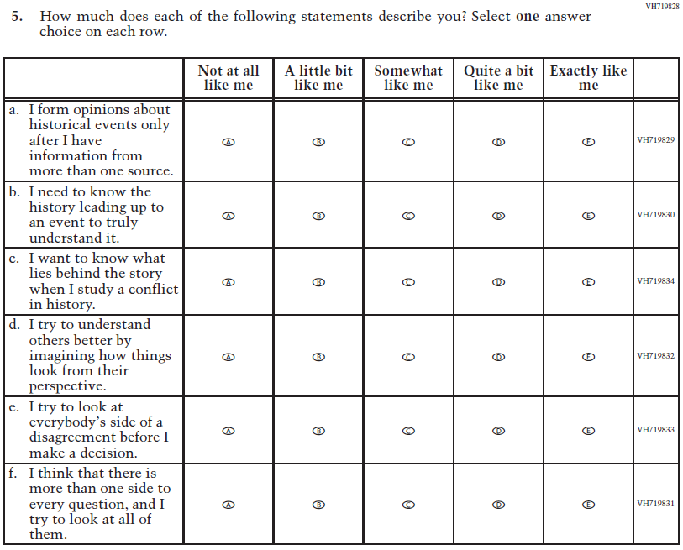  Issue: Student Factors | NC | N/A
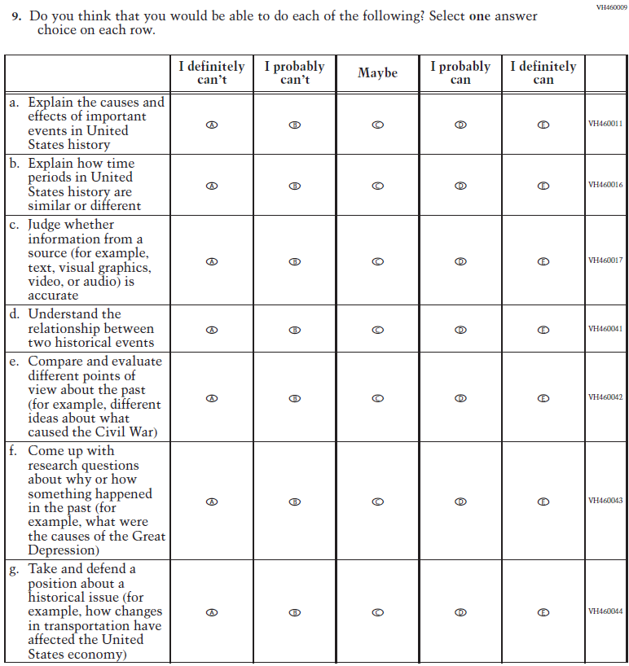  (2018 Grade 8) | 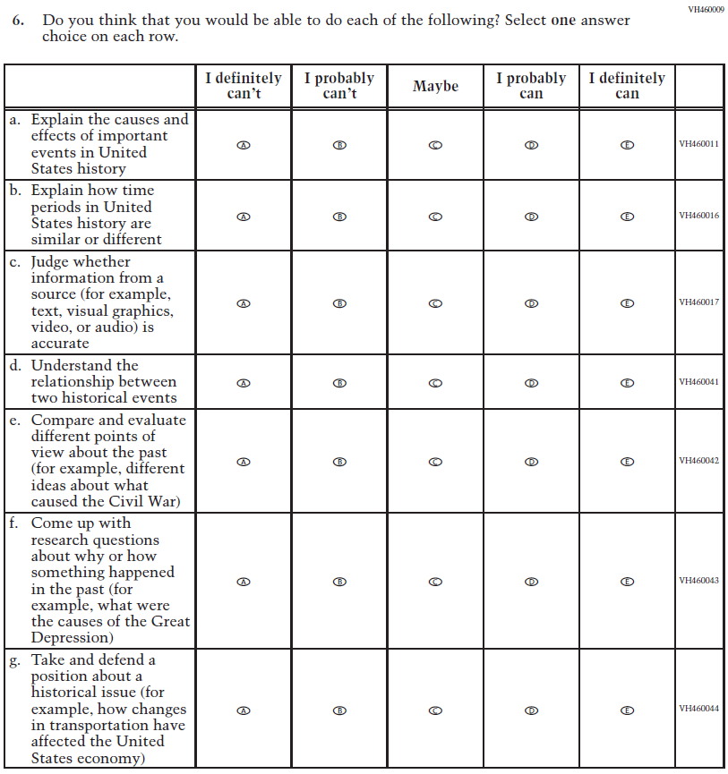  Issue: Student Factors | NC | N/A
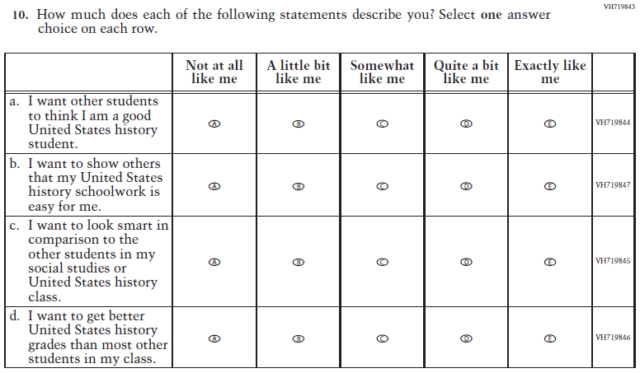  (2018 Grade 8) | N/A | D | To keep student burden low, this item was dropped.
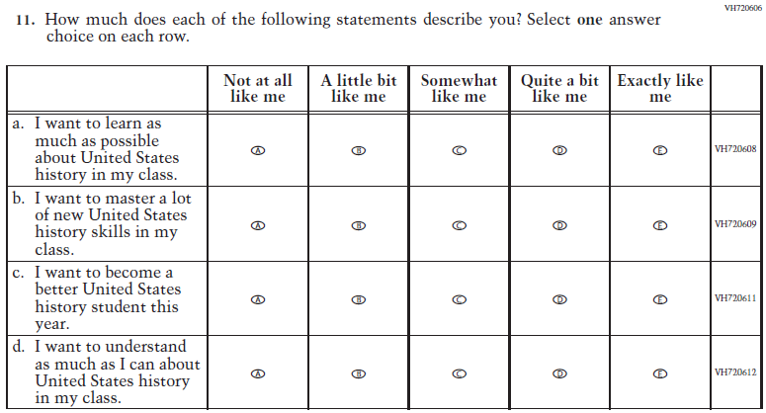  (2018 Grade 8) | 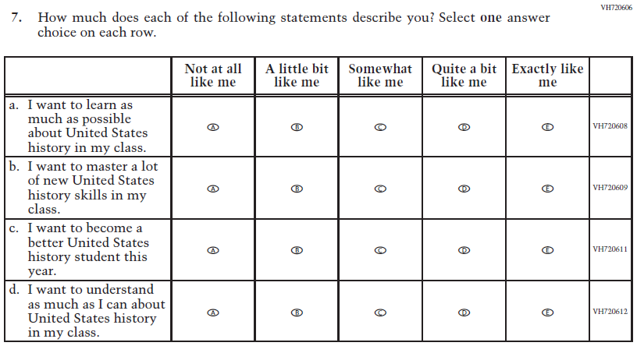  Issue: Student Factors | NC | N/A
(2018 Grade 8) | N/A | D | To keep student burden low, this item was dropped.
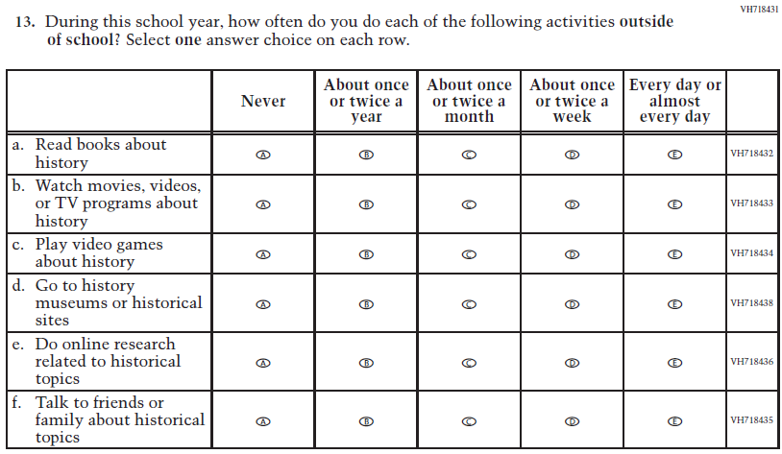  (2018 Grade 8) | 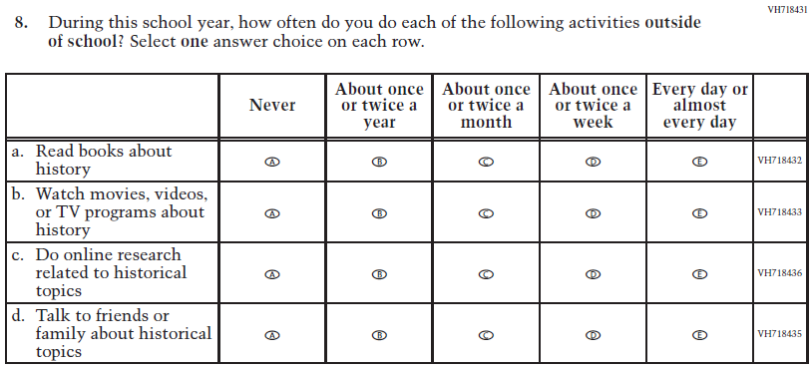  Issue: Student Factors | R | To keep student burden low, sub-items c and d were dropped.
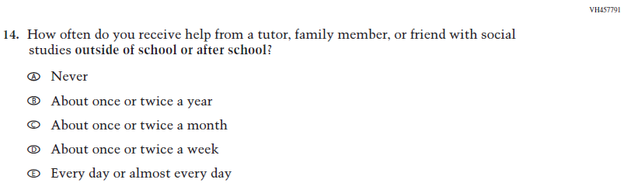  (2018 Grade 8) | 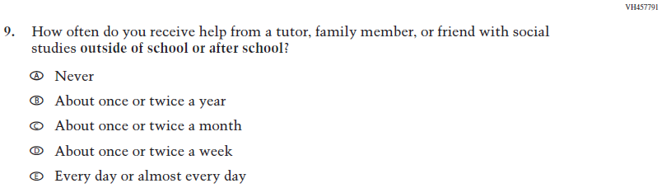  Issue: Resources for Learning and Instruction | NC | N/A
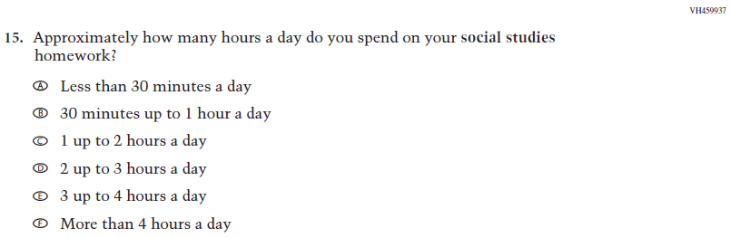  (2018 Grade 8) | N/A | D | To keep student burden low, this item was dropped.

Appendix J1-16: Operational Grade 8 U.S. History
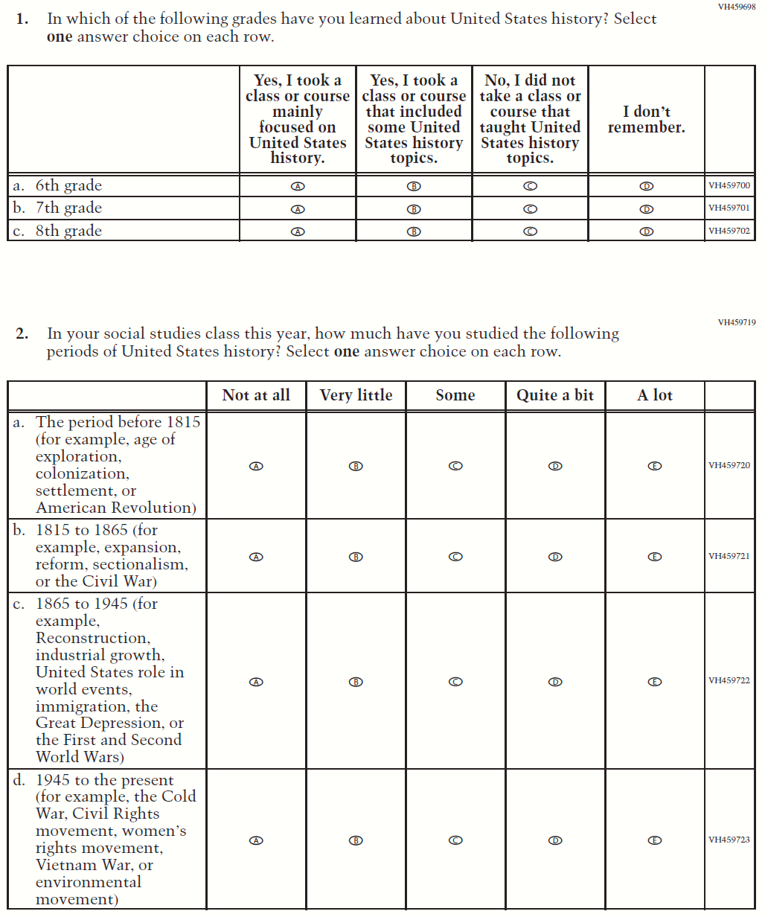
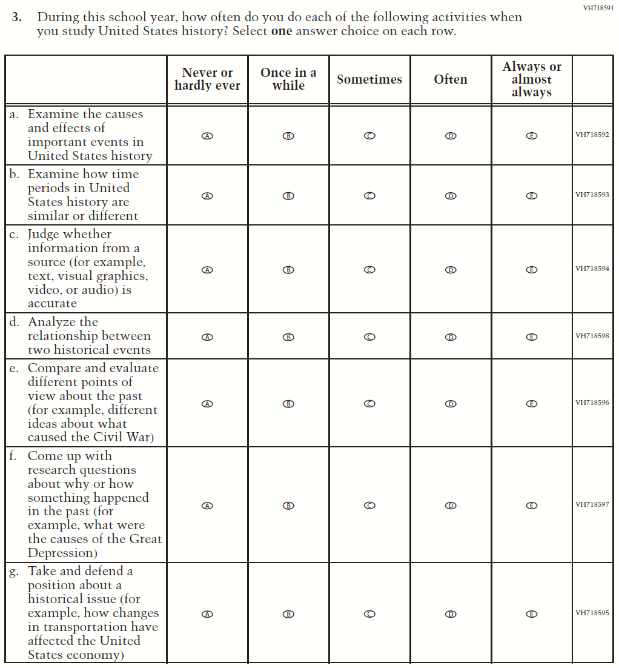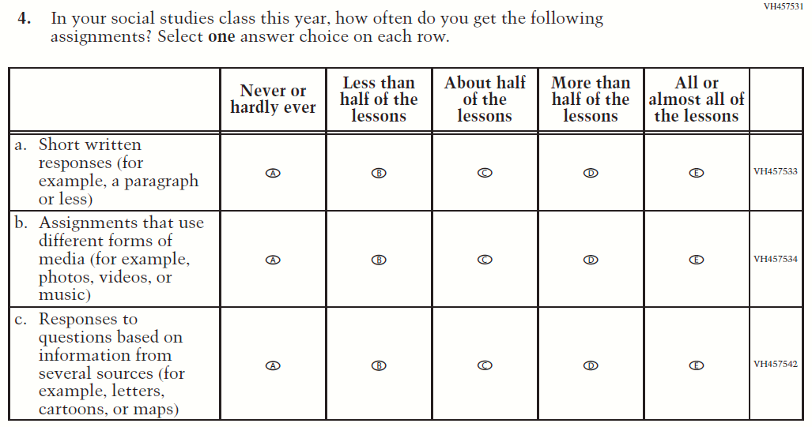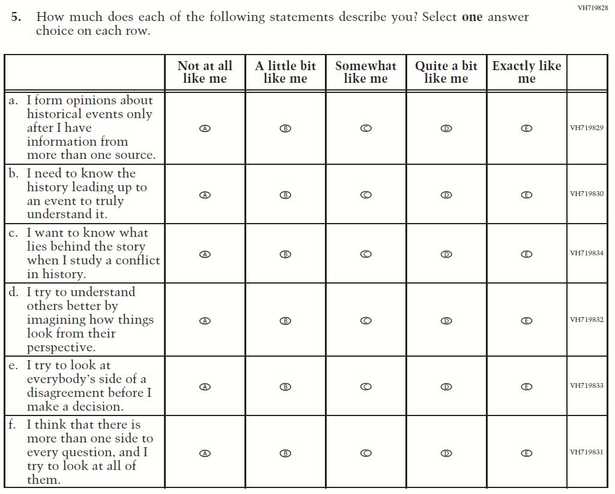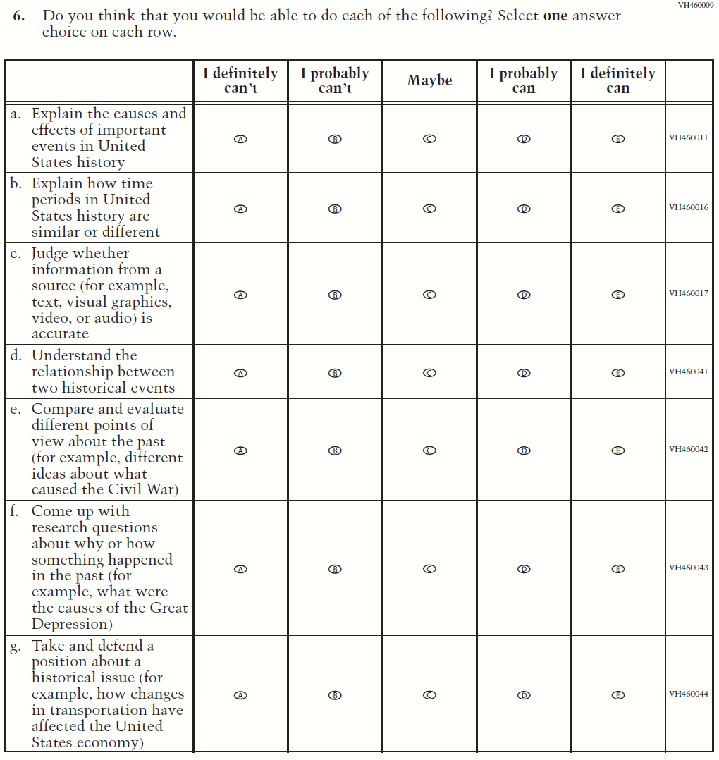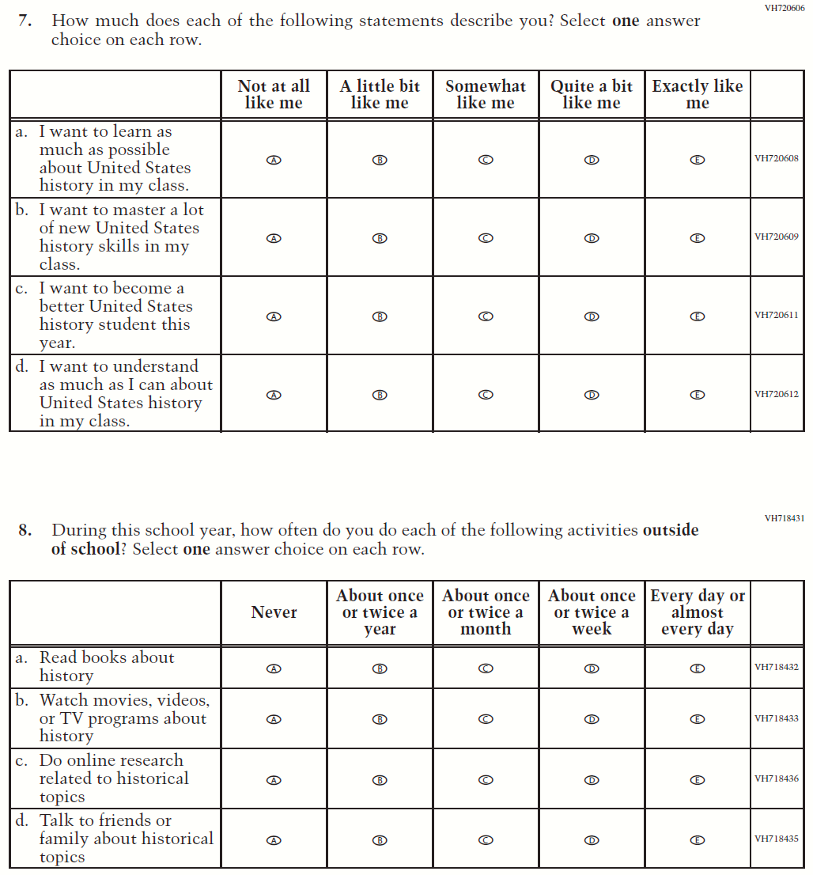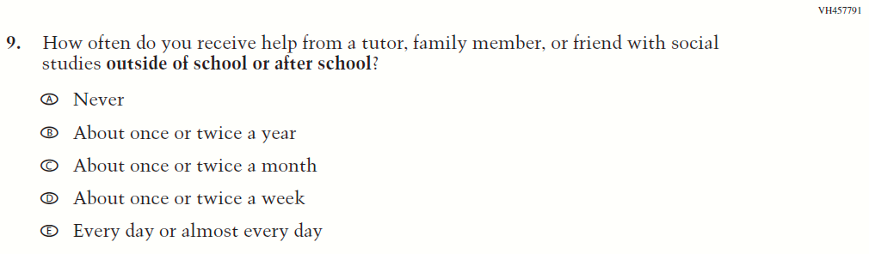

Appendix J1-17: Summary of Operational Grade 4 Debrief

2022 Operational Grade 4 Debrief Student

Previous item | 2022 item | D/A/ R/NC+ | Rationale
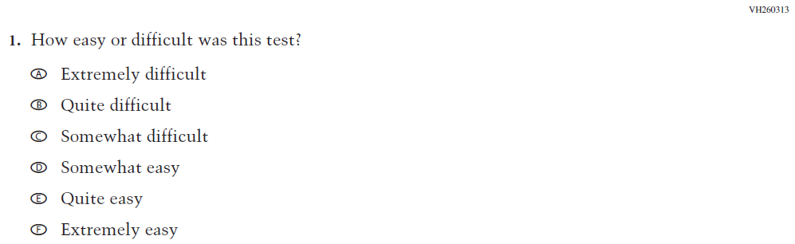  (2019 Grade 4, 8, and 12) | N/A | D | To keep student burden low, this item was dropped.
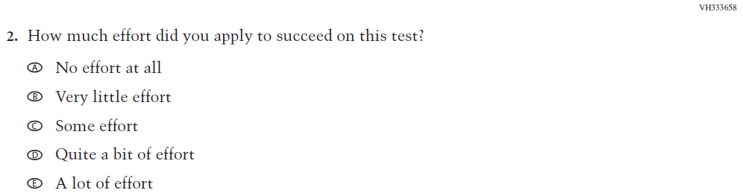  (2019 Grade 4, 8, and 12) | 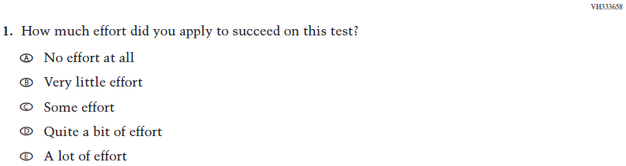  Issue: Debrief | NC | N/A

Appendix J1-18: Operational Grade 4 Debrief
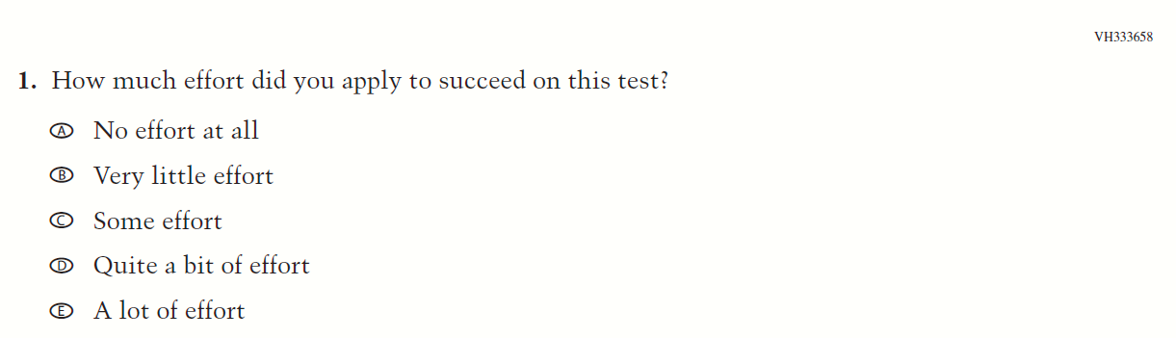

Appendix J1-19: Summary of Operational Grade 8 Debrief
2022 Operational Grade 8 Debrief Student

Previous item | 2022 item | D/A/ R/NC+ | Rationale
(2019 Grade 4, 8, and 12) | Issue: Debrief | NC | N/A
(2019 Grade 4, 8, and 12) | Issue: Debrief | NC | N/A

Appendix J1-20: Operational Grade 8 Debrief
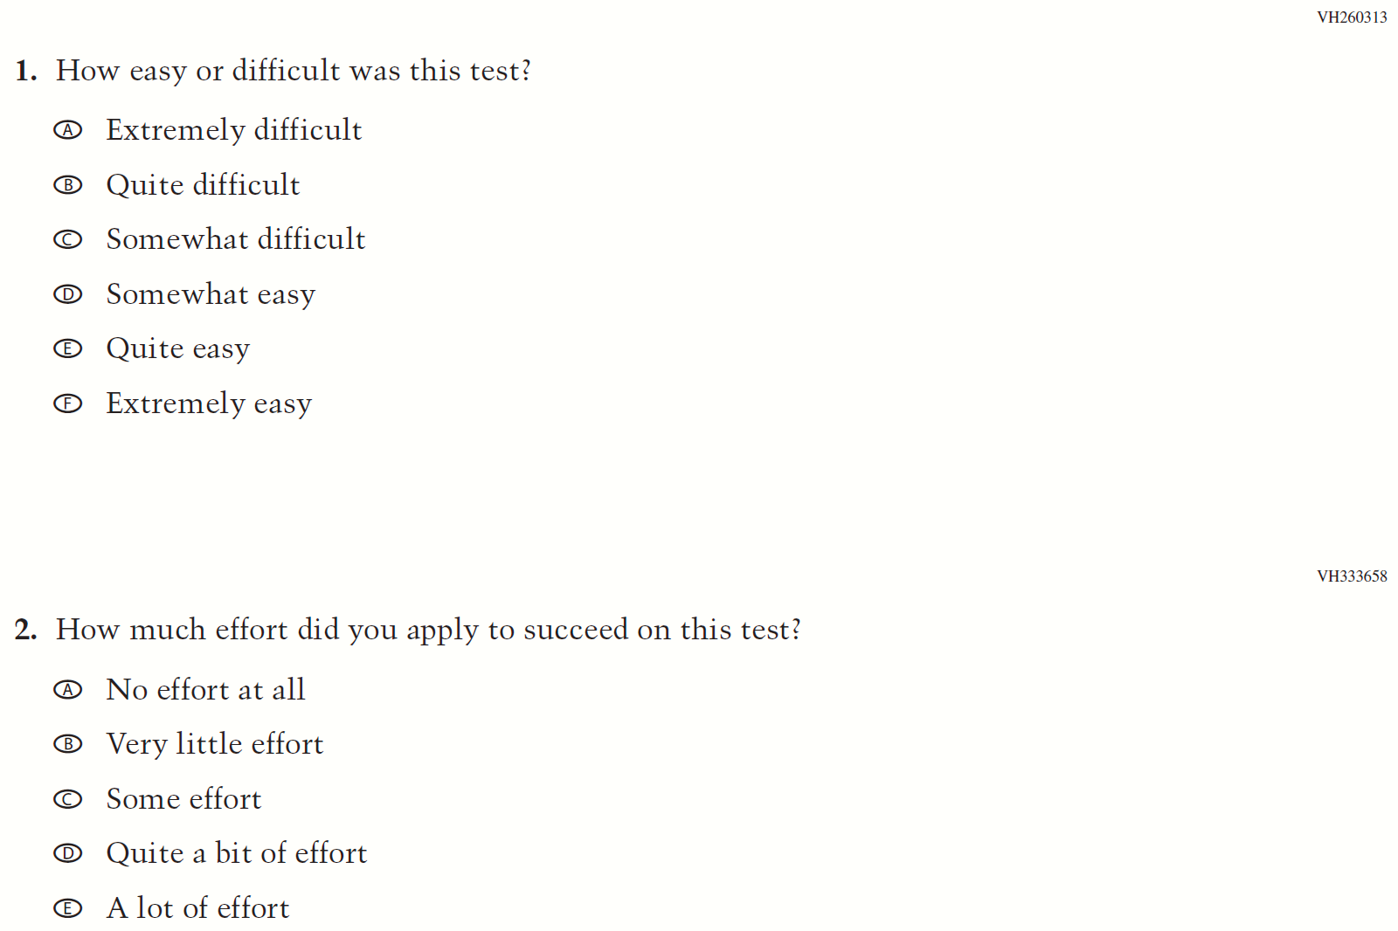

Appendix J1-21: Operational Grade 4 COVID-19 Student Items (ELA)
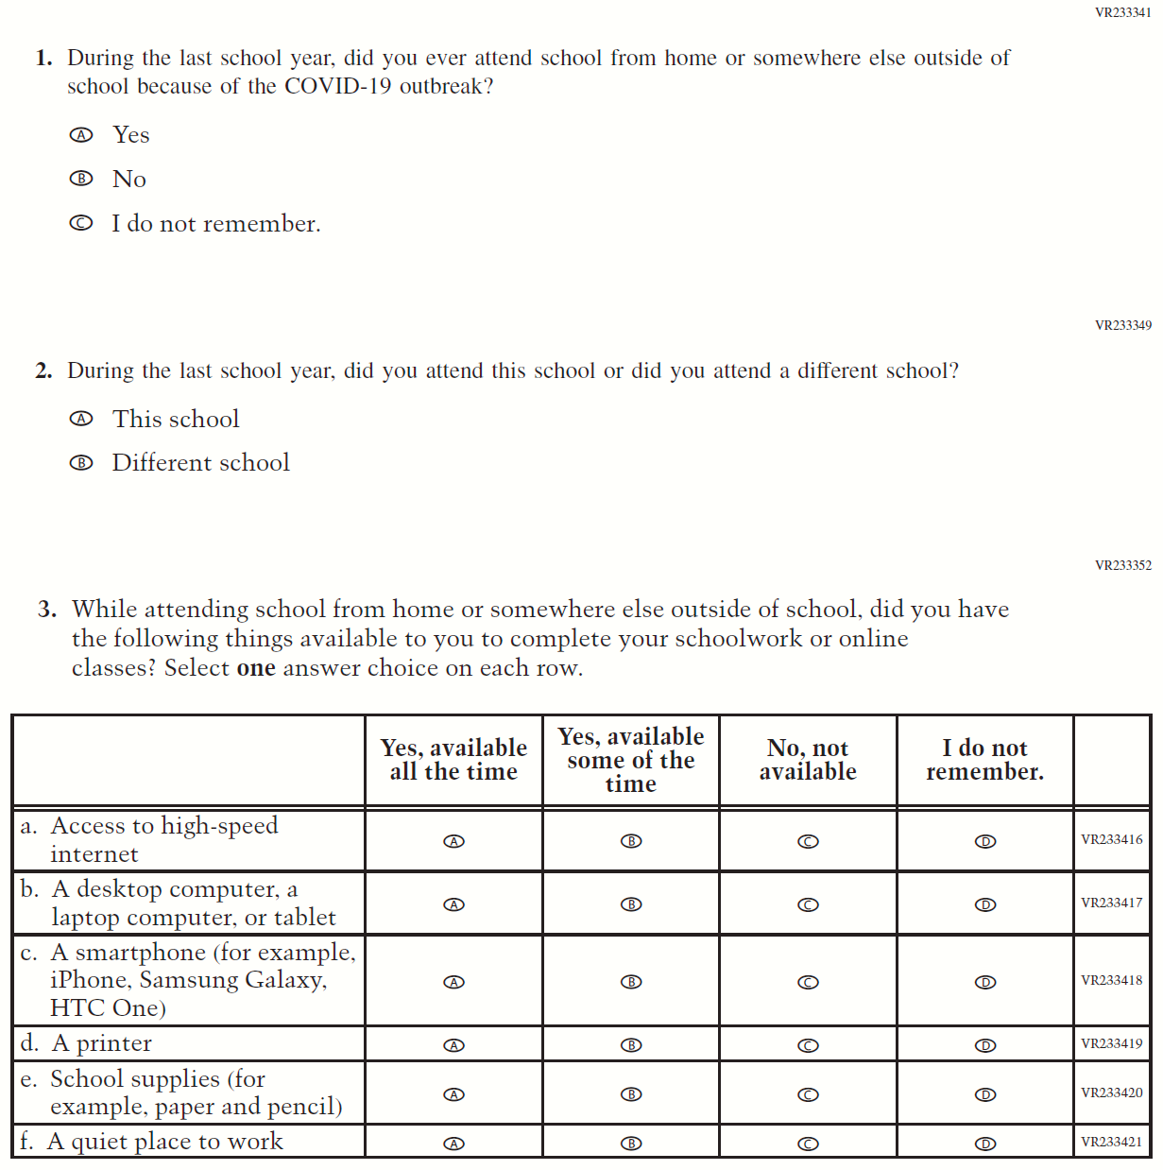

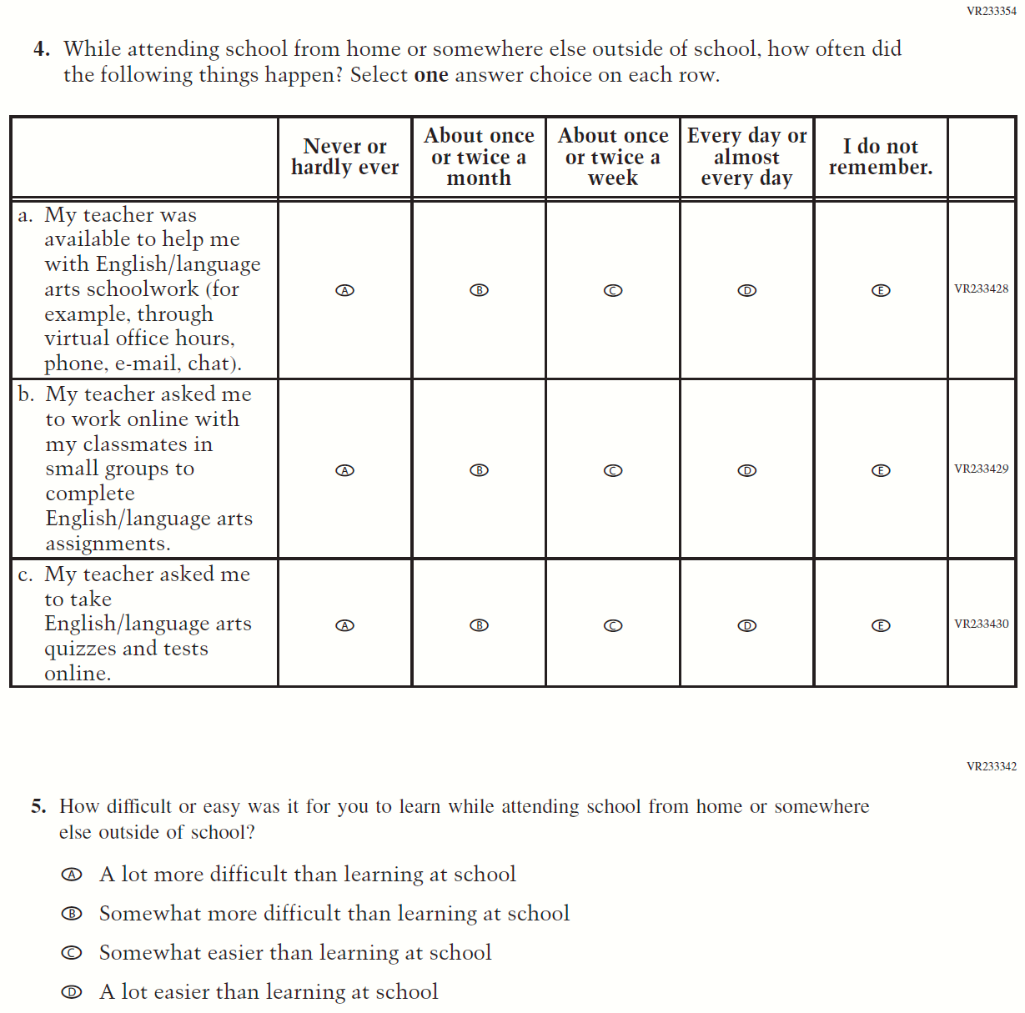

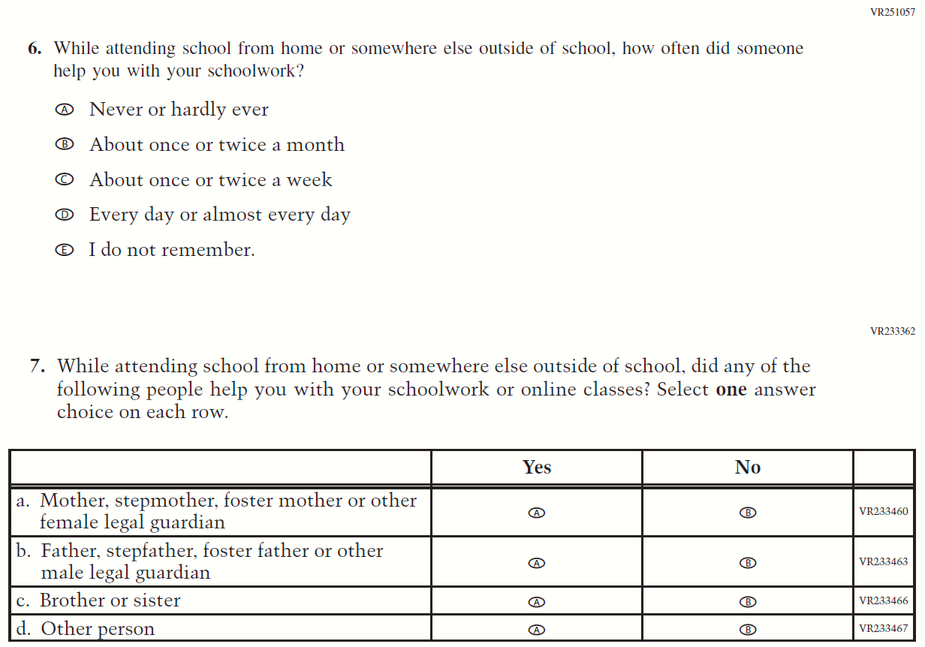
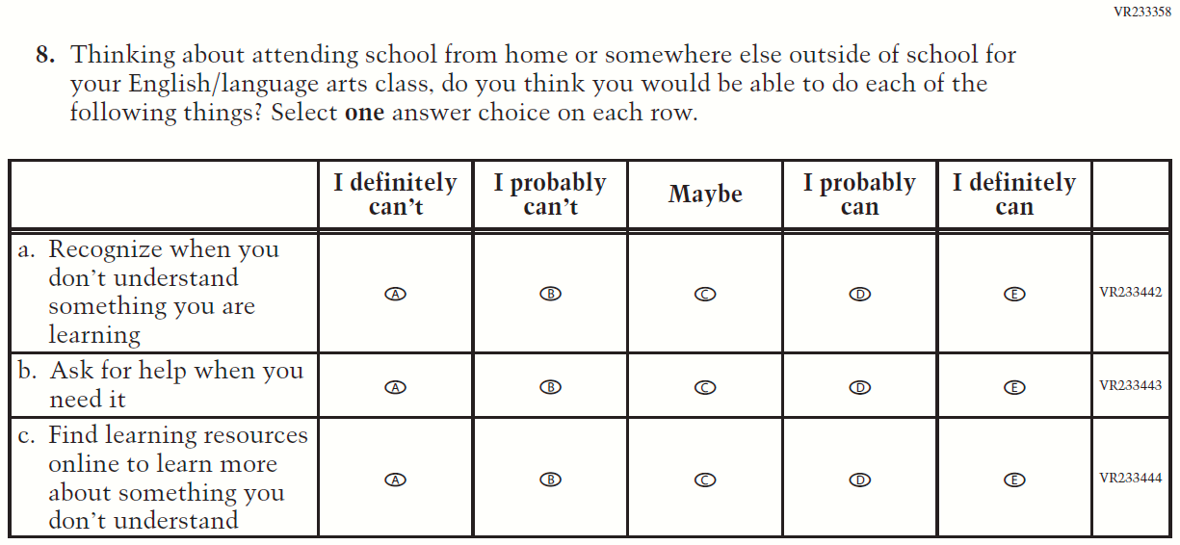

Appendix J1-22: Operational Grade 8 COVID-19 Student Items (ELA)

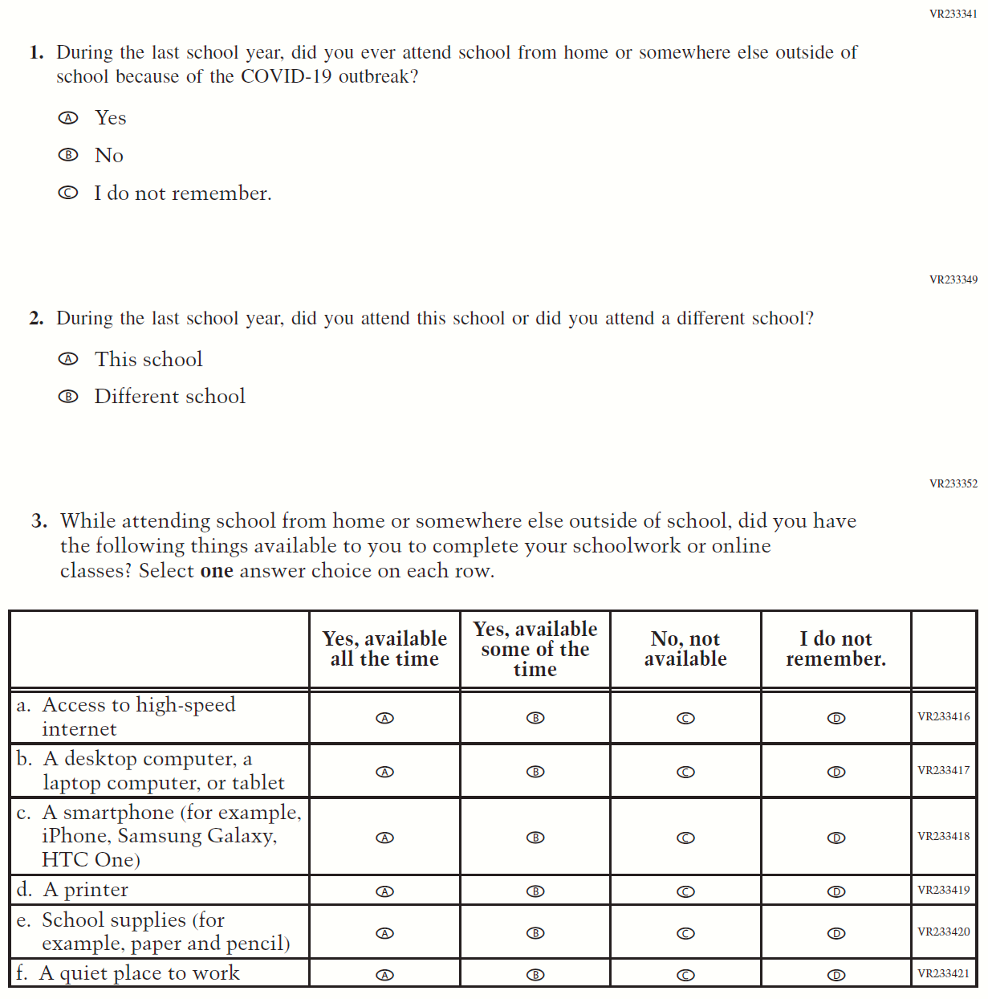

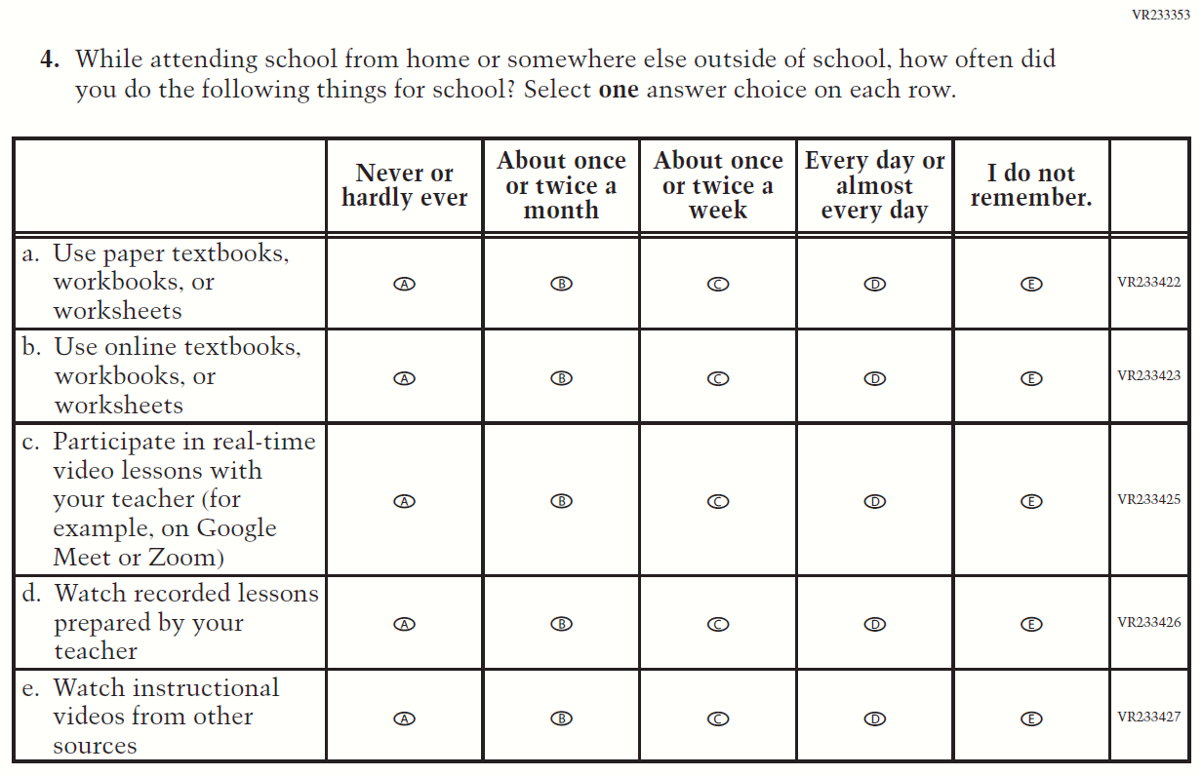

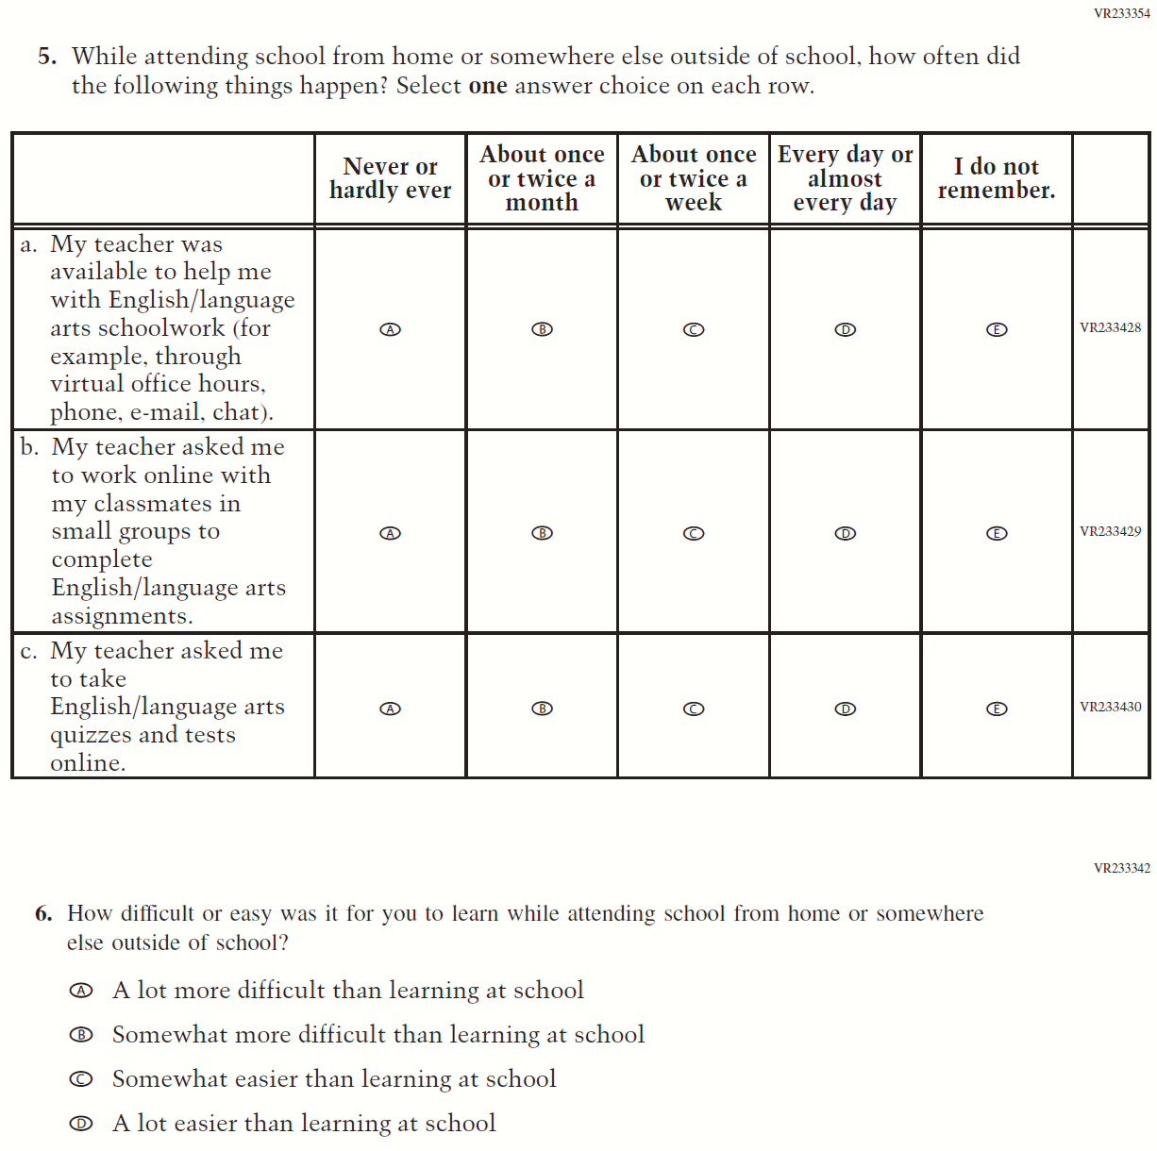

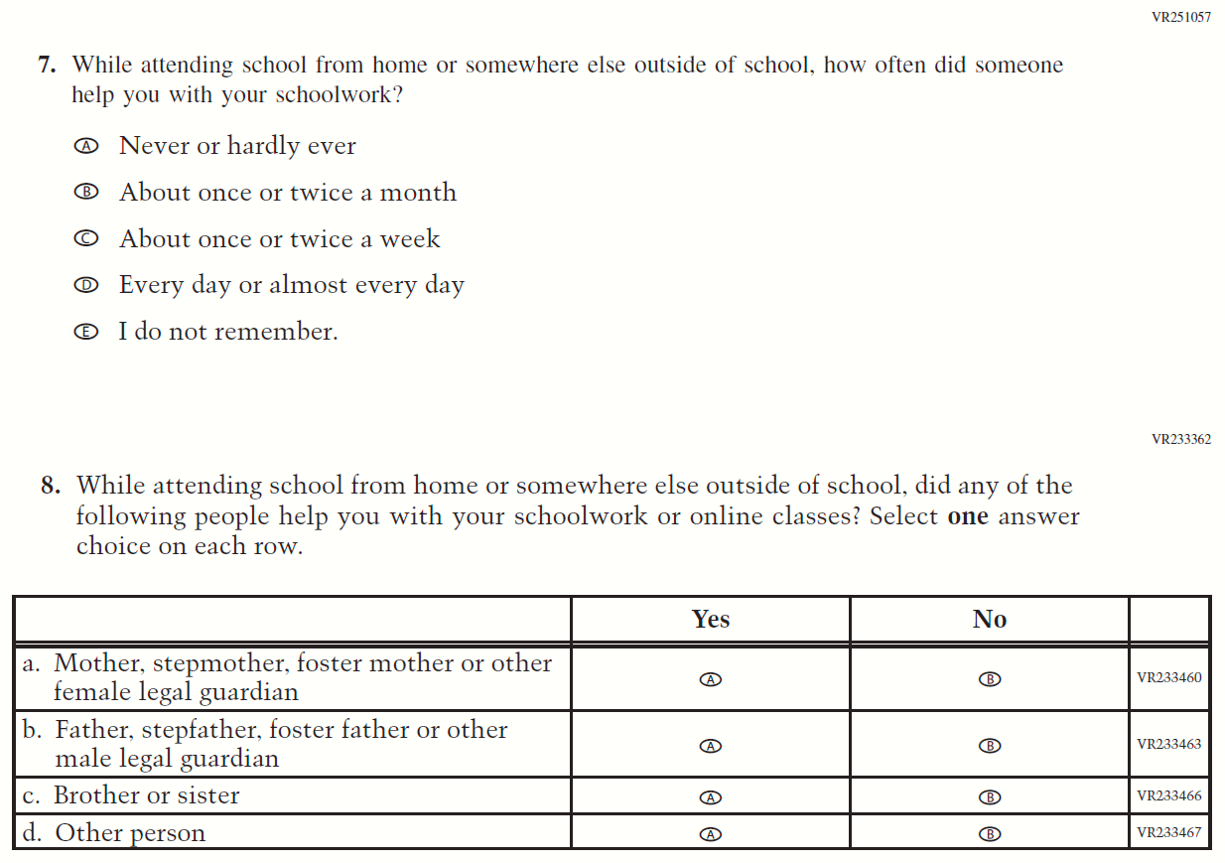
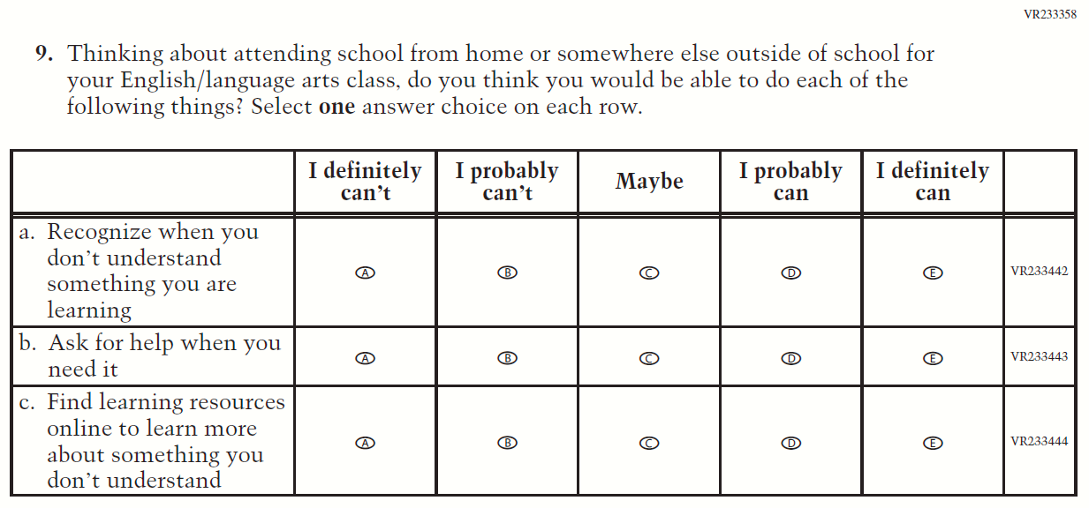

Appendix J1-23: Operational Grade 4 COVID-19 Student Items (Math)
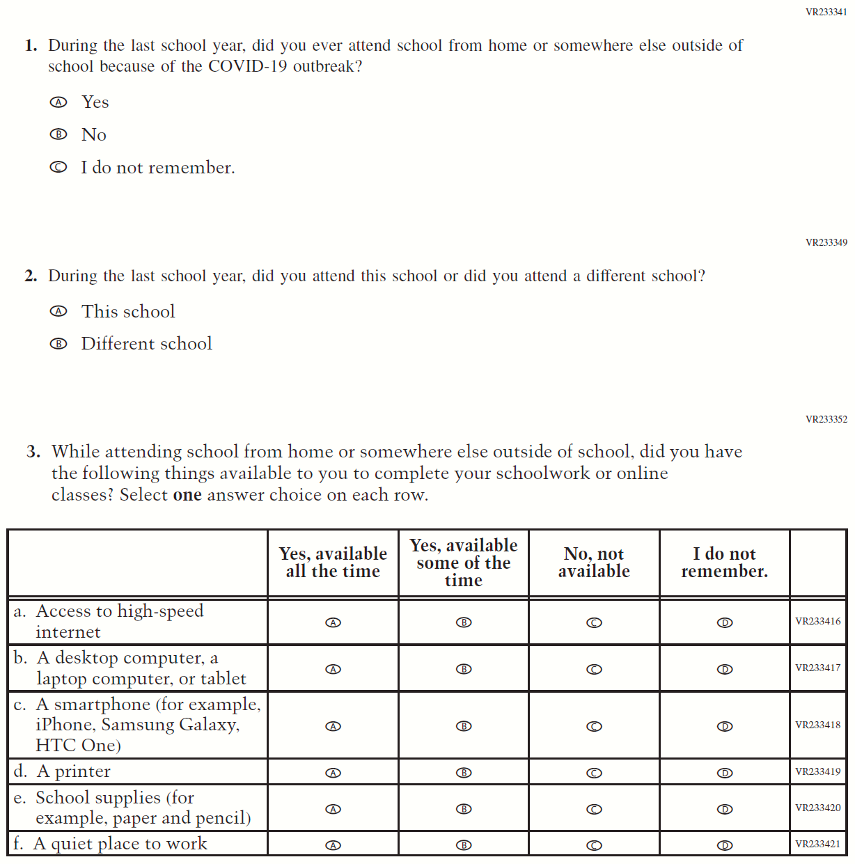

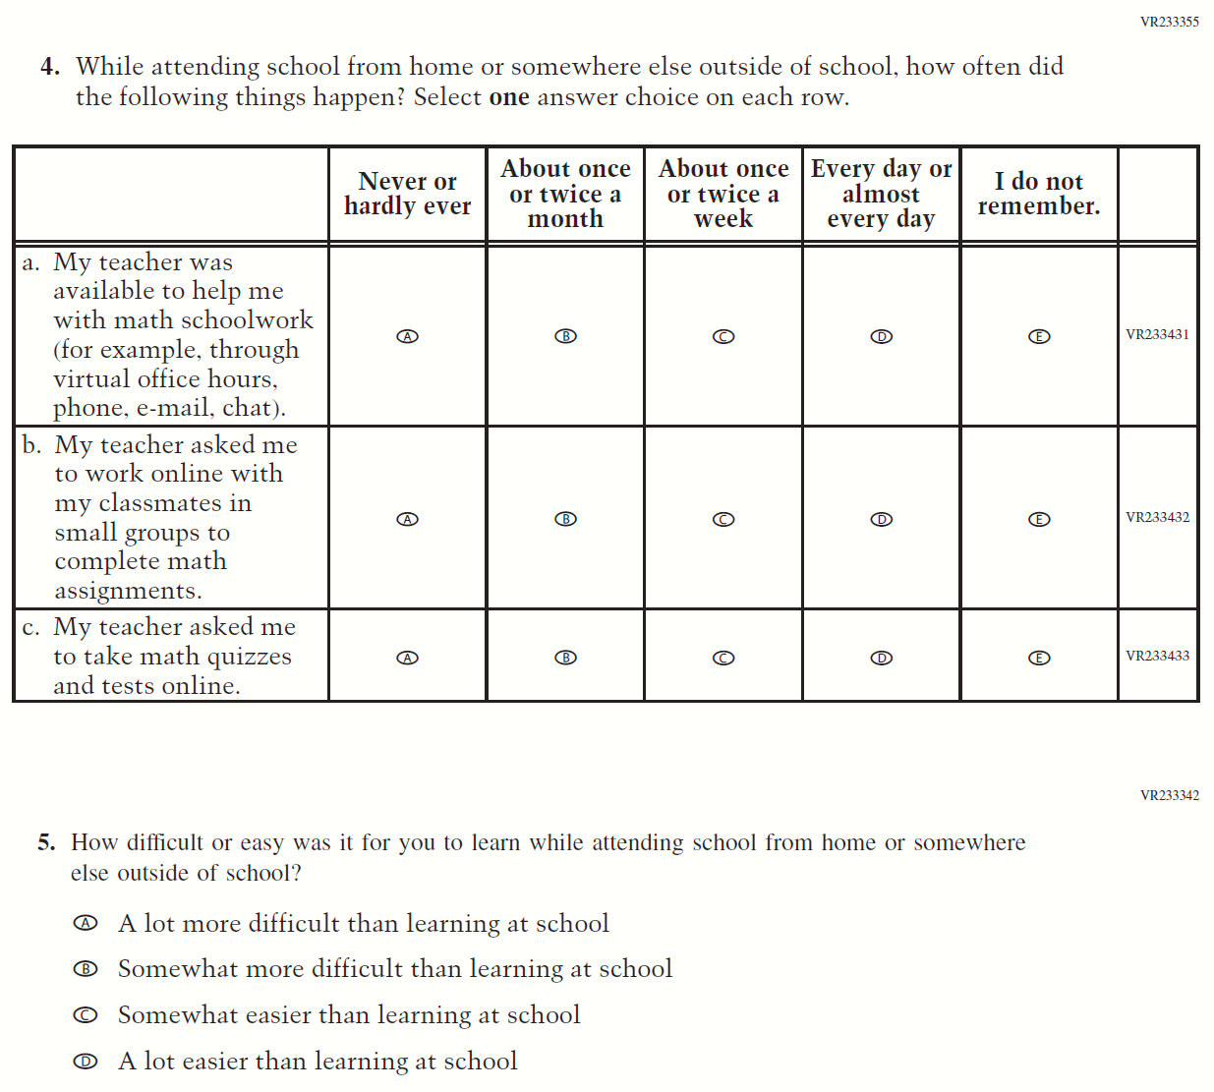

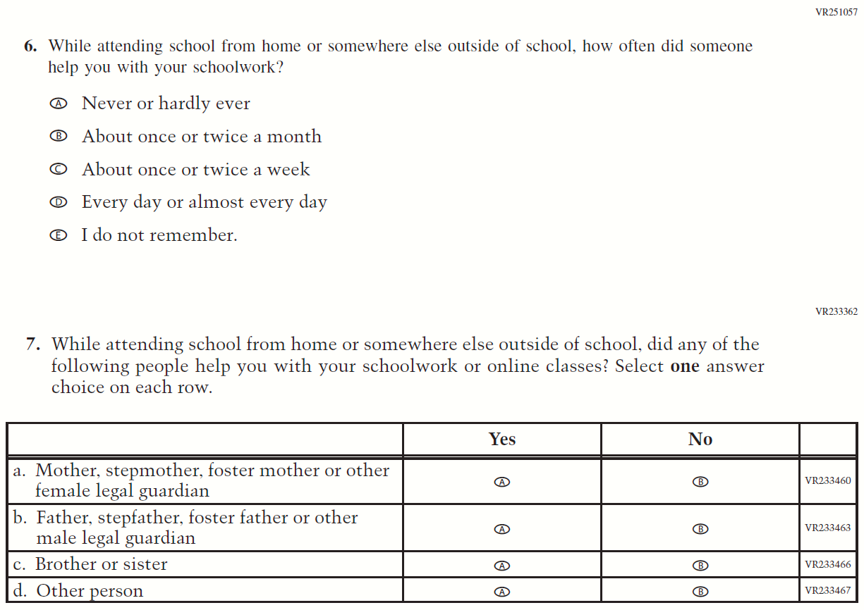

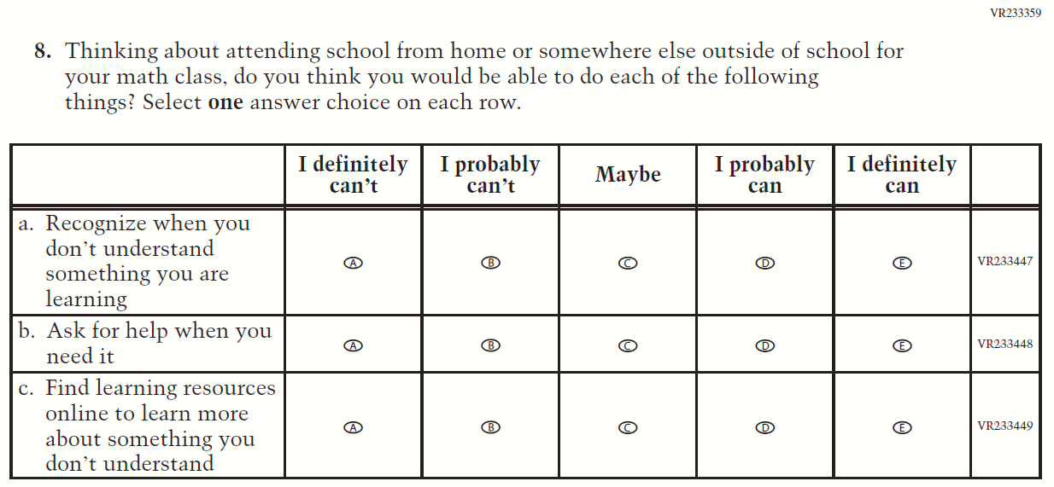

Appendix J1-24: Operational Grade 8 COVID-19 Student Items (Math)
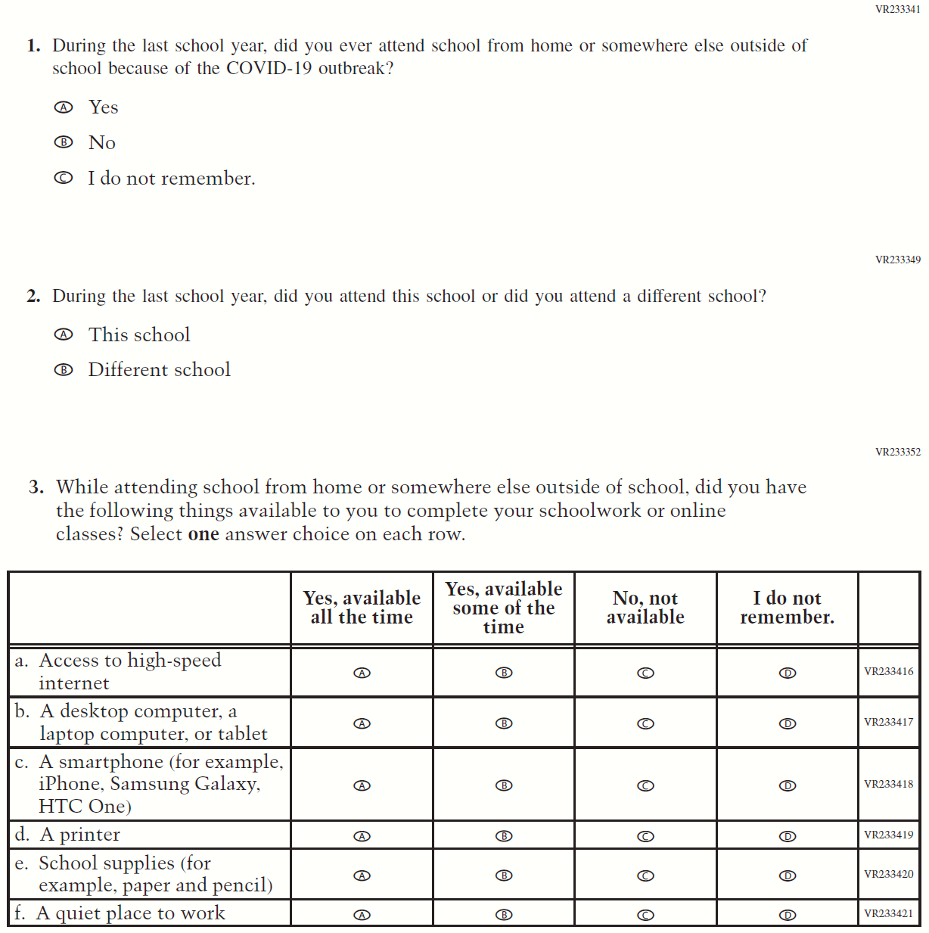

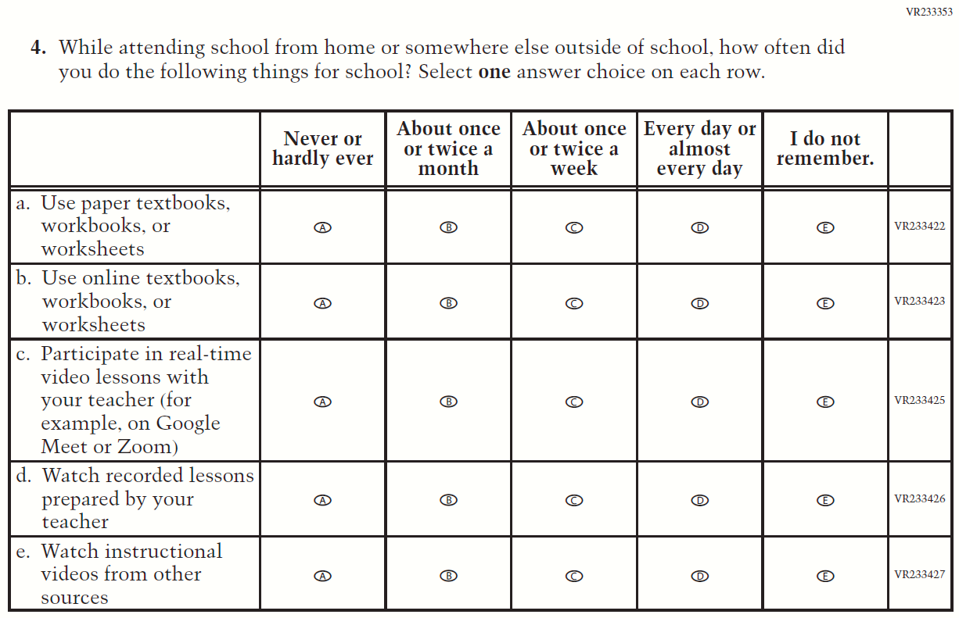

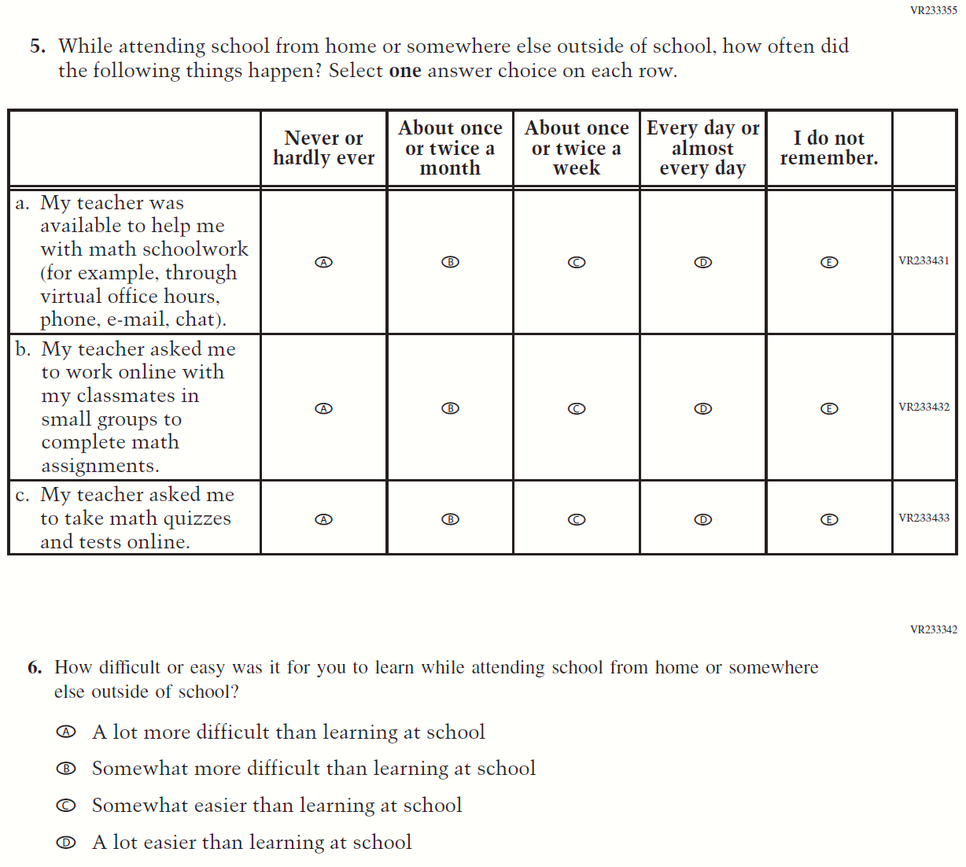

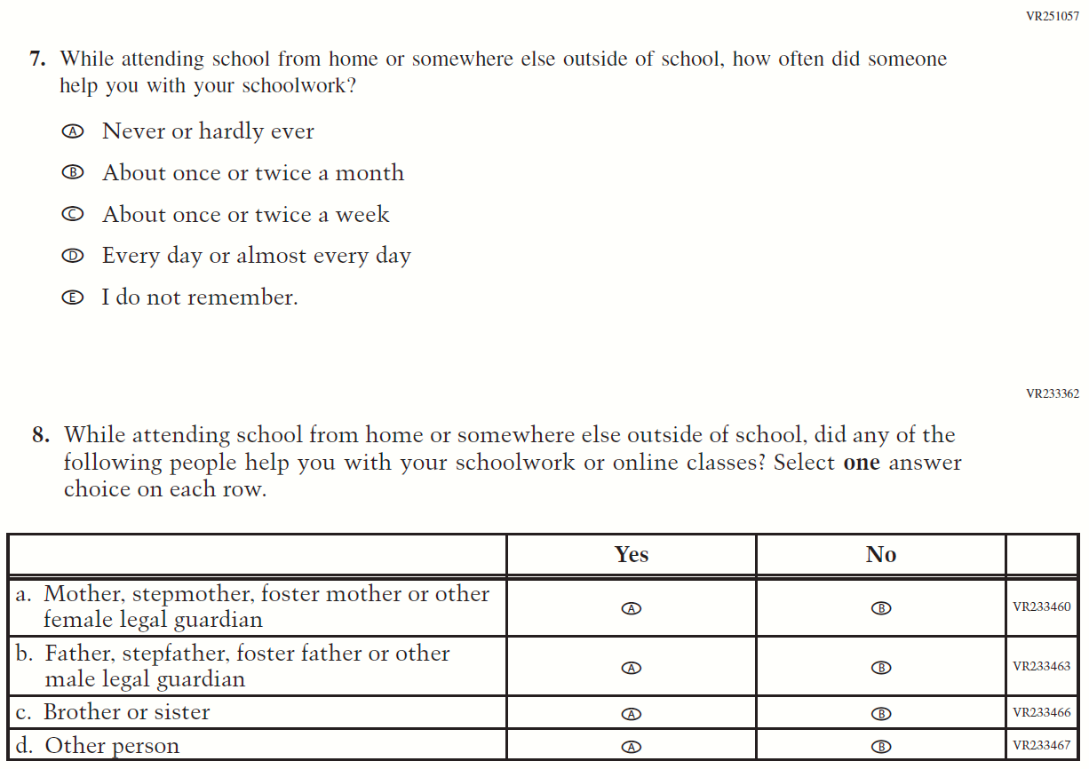
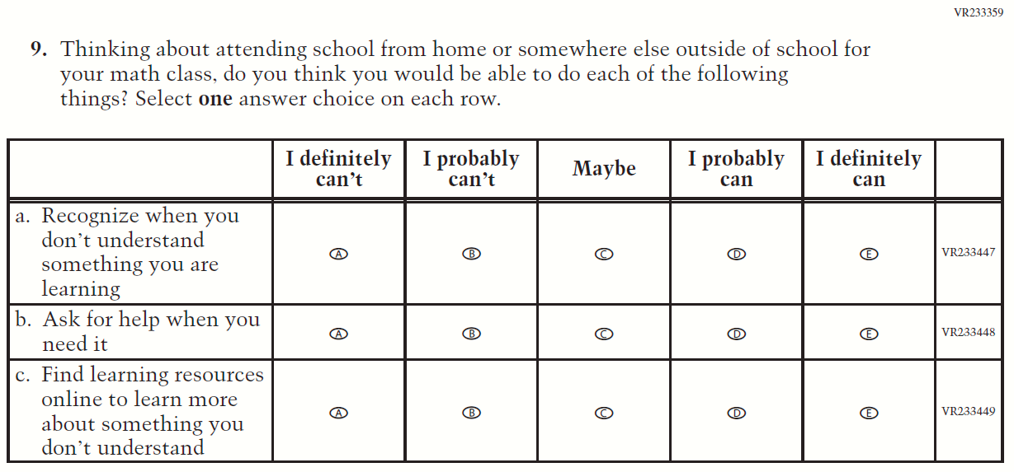

Appendix J1-25: Operational Grade 8 COVID-19 Student Items (Civics)

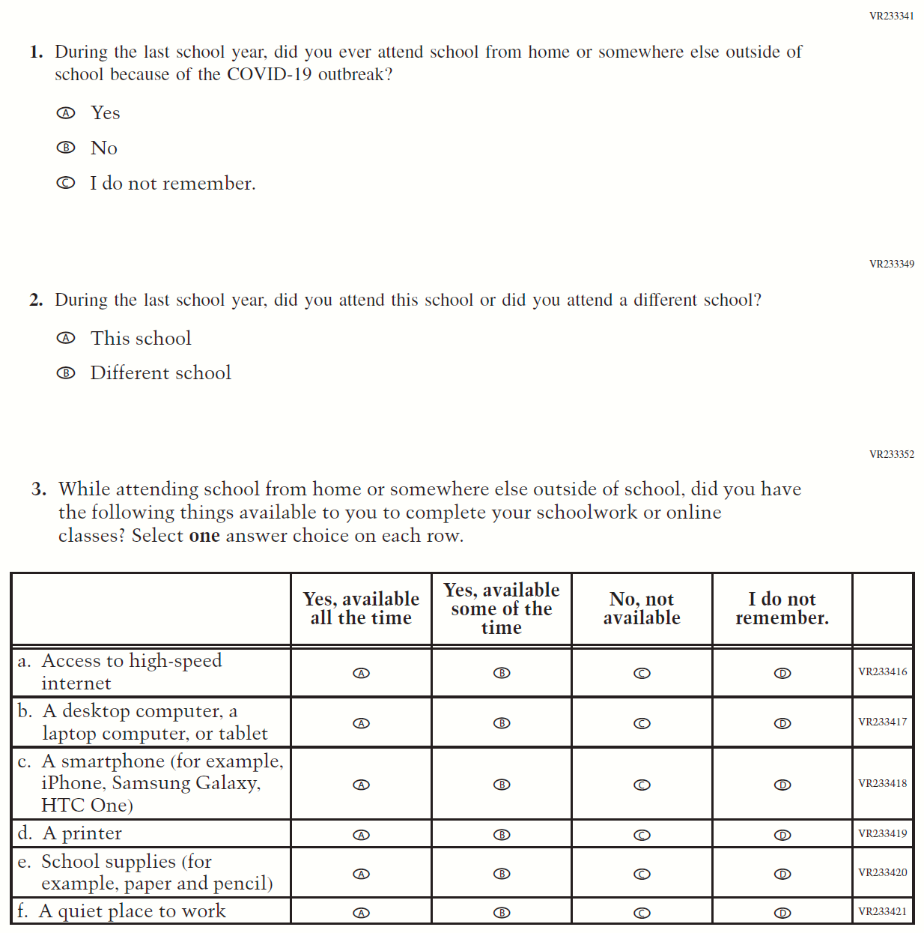

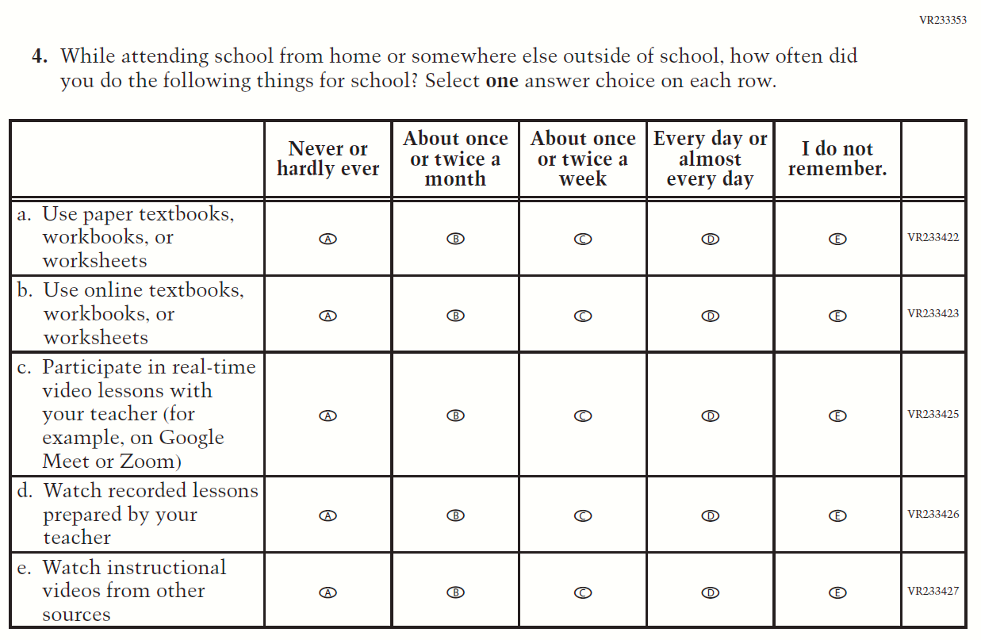

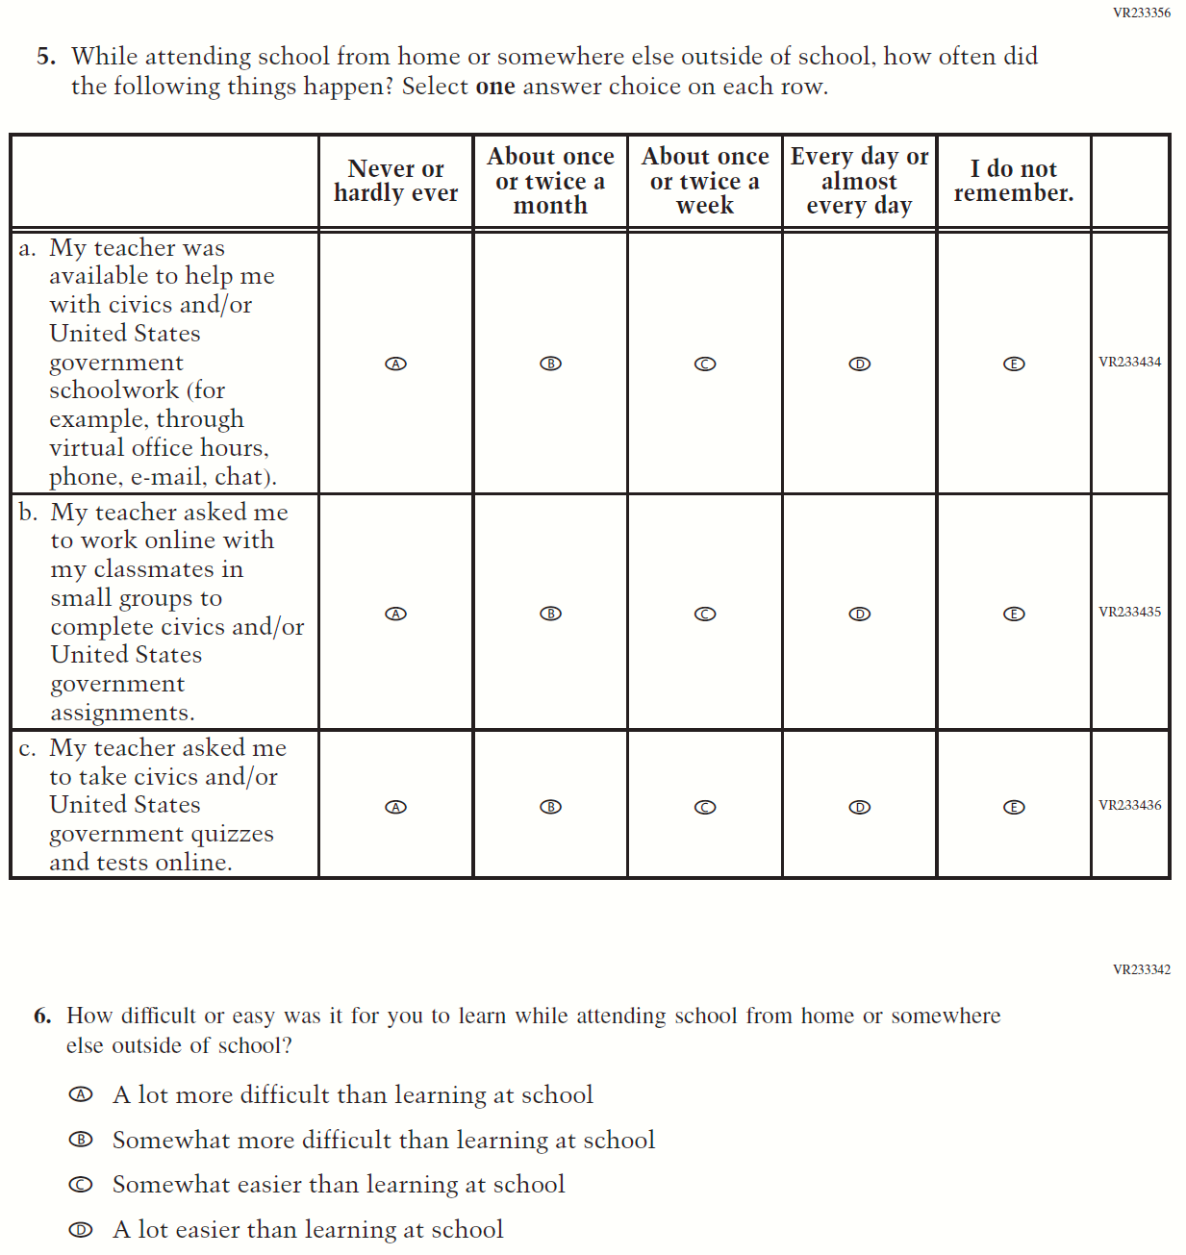

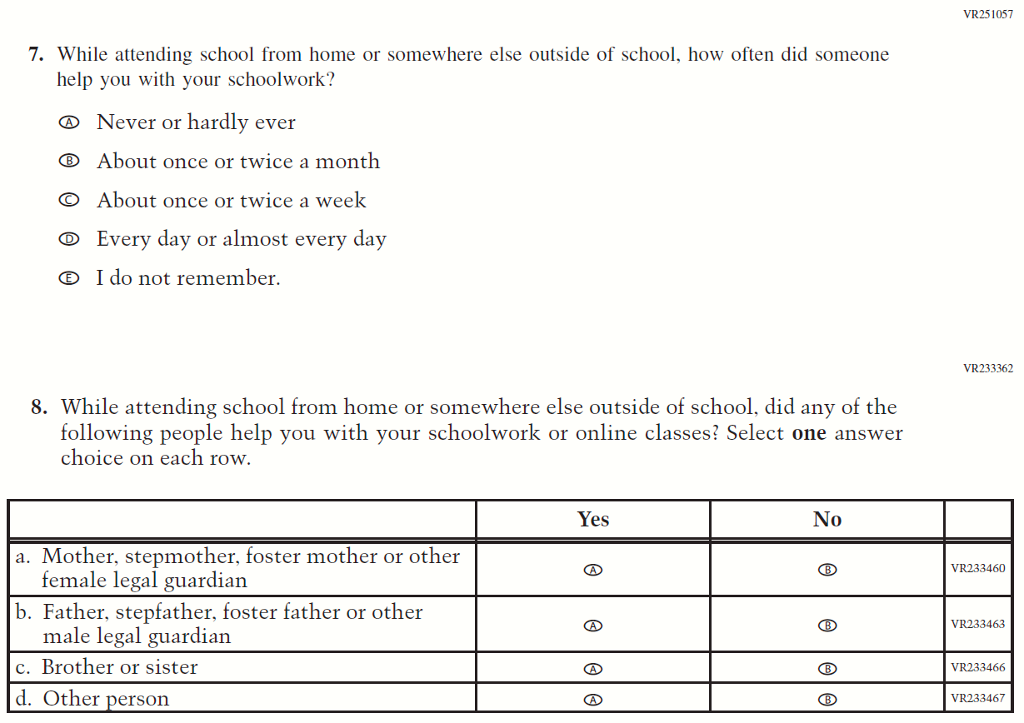
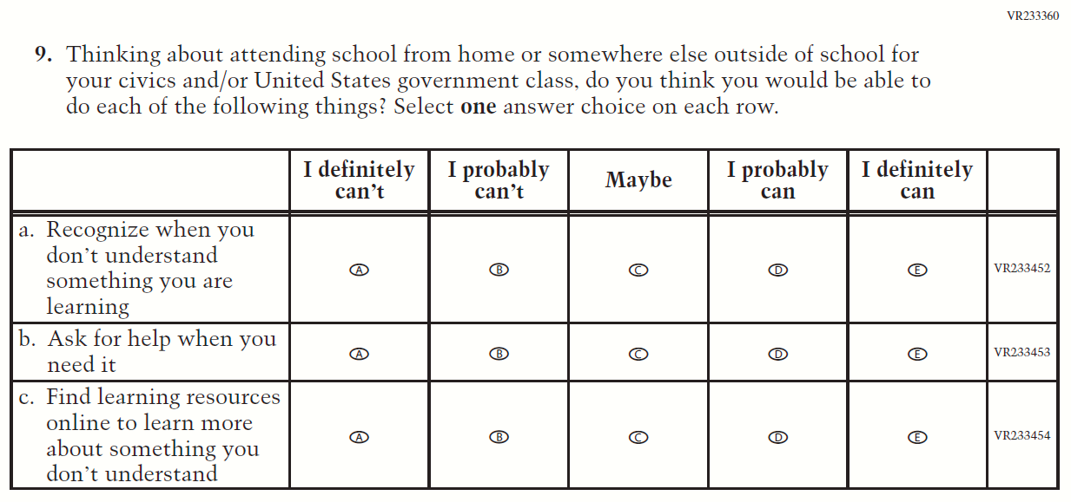

Appendix J1-26: Operational Grade 8 COVID-19 Student Items (U.S. History)
